Case report
Choriodal melanoma in young adult : A case report

Abstract
Choroidal melanoma is an intraocular tumor that develops from the melanocytes of the choroid. It is a rare condition in young adults, where diagnosis are often delayed due to its atypical presentation. Its poor prognosis and inaccessibility to biopsy means that radical treatment is often used. This was the case for our young patient with amblyopia in the right eye, who presented with choroidal melanoma in the left eye, which had been enucleated. Unfortunately, these tumors are sometimes associated with intraocular inflammation, which can delay diagnosis. Multimodal imaging is therefore very useful in making an earlier diagnosis and choosing increasingly conservative treatments.
Keywords: choroidal melanoma ,masquerade syndrome , evisceration, tumor

Introduction
Melanoma is a malignant tumor that originates from melanocytes at various body sites, with the ocular area being the second most common location after the skin. The common presentations of choroidal melanoma include flashes of light, floaters, visual field defects, and reduced vision [16]. Although rare, occurring in 5.1 to 7 cases per million per year [1], choroidal melanoma is the most common malignant intraocular tumor in adults. It counts for 2% of cases in young patients of this proportion [2]. A masquerade syndrome is an ophthalmological entity where another pathology mimics an inflammatory condition. This observation highlights the importance of using multimodal imaging, especially in the presence of inflammatory signs, which can mask more serious pathologies that are life-threatening in some cases.

Case presentation
We report the case of a 30-year-old patient, with a history of amblyopia in the right eye, dark-skinned with phototype 5, who presented a rapid decline of visual acuity without pain or redness in the left eye two weeks ago, preceded by increasingly intense myodesopsia over the previous two months. Ophthalmological examination revealed a white eye on the left side that was painless upon globe movement, with visual acuity limited to finger movement. The annexes and anterior segment were unremarkable, intraocular pressure was 17 mmHg, and at the fundus (Image 1), moderate hyalitis concealed a heterogeneous superior temporal mass, lifting the entire upper part of the retina. In the right eye, visual acuity was 1/10 with a correction of +8D. The rest of the examination was unremarkable.
B-mode ultrasound (Image 2) of the left eye revealed a heterogeneous dome-shaped choroidal mass with retinal detachment, strongly suggesting a medium-sized choroidal melanoma.
The orbital MRI (Image 3) revealed a choroidal melanoma in the left eye, with no locoregional invasion, and the thoracoabdominal pelvic CT scan showed no distant tumor spread.
After consultation in a multidisciplinary meeting, enucleation was proposed due to the size and location of the tumor. The procedure was performed without complications.
Pathological analysis of the surgical specimen (Image 4) revealed (Image 5) dense intra-choroidal tumor proliferation consisting of spindle-shaped and epithelioid cells. The cells had irregular, hyperchromatic nuclei with marked atypia. The overall picture was consistent with a mixed-type malignant pigmented choroidal melanoma, one of the subtypes associated with an intermediate to high risk of progression.
At one month, the silicone ball was spontaneously expelled. Oral corticosteroid therapy was initiated to reduce inflammation, and a second operation was then performed successfully.

Discussion
Choroidal melanoma is a malignant intraocular tumor that develops from melanocytes located in the choroid. It is a tumor with metastatic potential, which makes it particularly dangerous. In this young population, females seem to be the most affected. Risk factors include being over 50 years of age, male, Caucasian, light-colored eyes, exposure to sunlight, occupational/toxic exposure, family history of cancer, not wearing UV glasses, congenital melanocytosis, choroidal nevus, and genetic factors: GNAQ, GNAQ11, and BAP1, CYSLTR2 [3].
Patients may experience visual field loss, pain, decreased visual acuity, phosphenes, myodesopsia, or be completely asymptomatic. The diagnosis is strongly suspected clinically and then confirmed by various additional tests [4]. At the back of the eye, it appears as a pigmented subretinal mass protruding into the vitreous cavity, or as an achromatic, indurated lesion. It may be discovered following intraocular inflammation, which can initially obscure the diagnosis, as was the case with our patient, known as masquerade syndrome [5].
On B-mode ultrasound, it appears dome-shaped, mushroom-shaped, multilobular, or flat and diffuse [6], varying in size, hypoechoic, and homogeneous. A thickness greater than 3 mm is highly suspicious for malignancy. The mushroom shape is pathognomonic of choroidal melanoma. In our patient, the appearance was heterogeneous with hyperechoic areas, which could be due to intra-tumoral hemorrhage or necrosis. B-mode ultrasound also allows associated signs to be detected, such as retinal detachment in our patient. The multilobular shape, detectable by ultrasound, is associated with a higher risk of metastasis and mortality, regardless of the initial tumor size. Fluorescein angiography shows double circulation and a pinpoint appearance. The characteristics observed in optical coherence tomography (OCT) of subretinal fluid associated with choroidal melanoma vary according to tumor size: large tumors show a greater extent of subretinal fluid, small tumors show less alteration of the ellipsoid zone, while medium-sized tumors more frequently show detachment of the bacillary layer [7].
On orbital-cerebral MRI, choroidal melanoma shows T1 hypersignal , T2 hyposignal and gadolinium enhancement, and also allows to study locoregional extension [8,9]. Thoracoabdominal-pelvic CT is used for distant extension, or even PET scan in case of warning signs.
Histological confirmation is crucial in oncology [3]. In some cases, such as ours, it was only performed after enucleation. Cell types (spindle, epithelioid, mixed), rare variants (diffuse, clear cell, balloon cell), and essential immunohistochemical biomarkers (HMB45, S-100, Melan-A, MITF, tyrosinase) [10].
Masquerade syndrome can present in several forms, including anterior chamber inflammation, hyalitis [11], chorioretinitis [12], or even vasculitis [13]. Vitritis is caused by the spread of vitreous cells into the vitreous cavity. In masquerade syndrome, tumor cells form spherical clusters (resembling snowballs) and are distributed in a way that spares the center, whereas in inflammatory vitritis, debris is distributed irregularly [14]. Our patient had snowballs in the periphery and the hyalitis was slightly more pronounced in the periphery. Chew estimates that approximately 5% of cases initially diagnosed as uveitis are actually masquerade syndromes [15].
The differential diagnosis includes benign tumors such as choroidal nevus, hemangioma, schwannoma, osteoma, retinal pigment epithelium hypertrophy, melanocytoma, choroidal detachment, and malignant tumors such as metastases. All of these were easily ruled out in our patient in view of the appearance of the tumor.
The natural progression is toward invasion of intraocular tissues, then spread to orbital structures and distant extension with metastases [16], mainly to the liver [17].
Conservative treatments are offered in the early stages of the disease, including brachytherapy, protontherapy, choroidectomy, and thermotherapy [18,19,20]. Treatment often involves enucleation, due to the location and aggressive nature of this tumor. It is indicated in advanced stages (diameter > 20 mm, thickness > 12 mm), secondary painful glaucoma or total vision loss, and cases with orbital invasion [21].

Conclusion
Always consider a masquerade syndrome in cases of ocular inflammation. It is important to identify melanoma at an early stage in order to avoid radical surgery. This case highlights the importance of early diagnosis and treatment in order to optimize visual and vital prognosis.

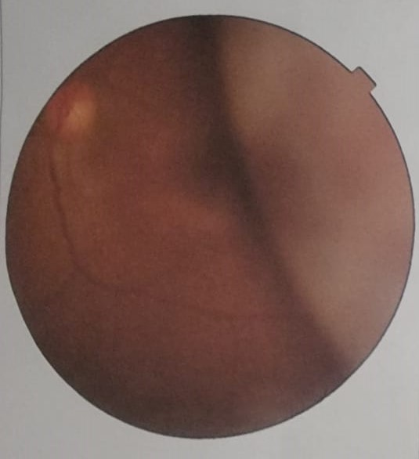  A | 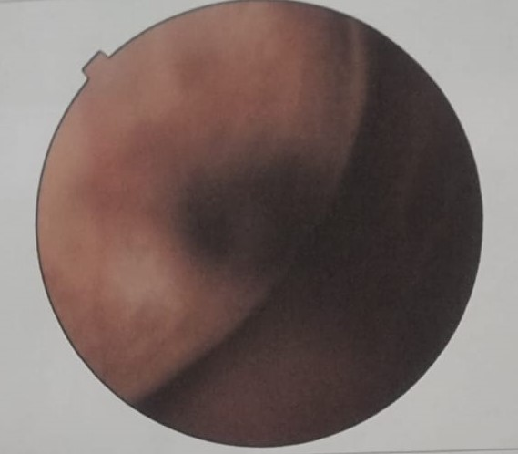  B
Image 1 (A and B): Retinophotograph of the left eye, showing the superotemporal tumor mass lifting the retina associated with hyalitis.

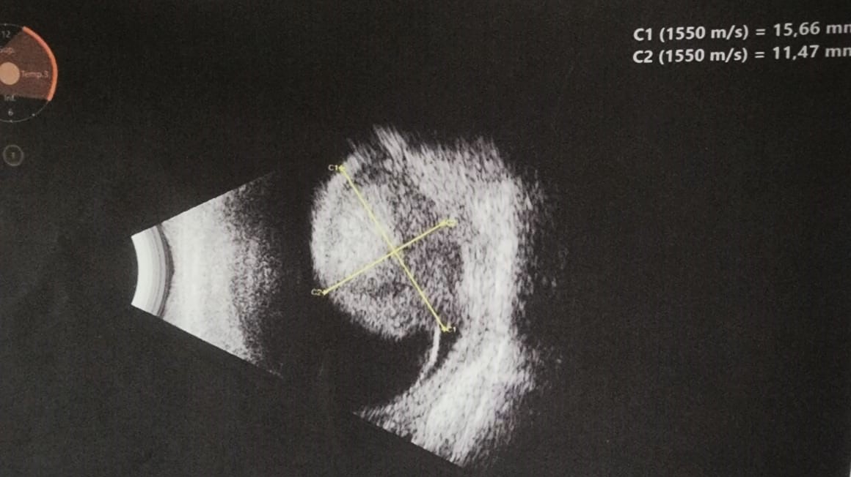
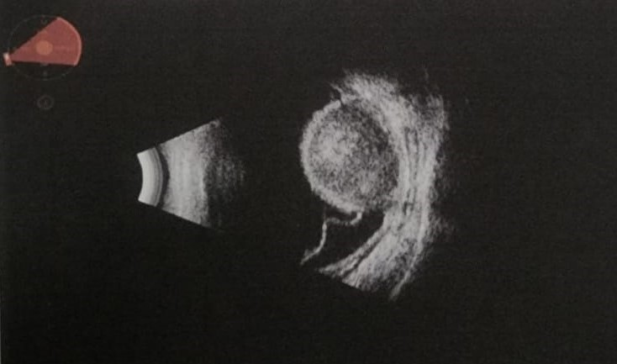
Image 2 : B-mode ocular ultrasound of the left eye showing a dome-shaped, heterogeneous, oval mass with choroidal insertion, measuring 15.66 mm at its base and 11.47 mm thick, lifting the retina (blue arrow).

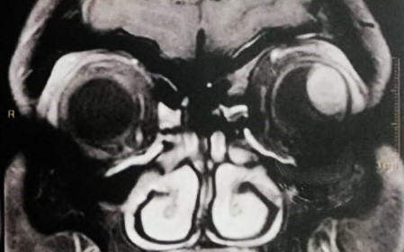  A1 | 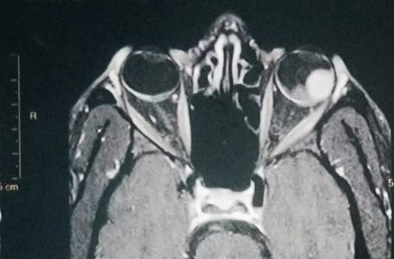  B2  B1
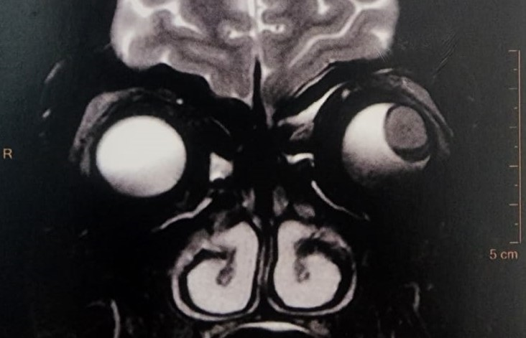  A2 | 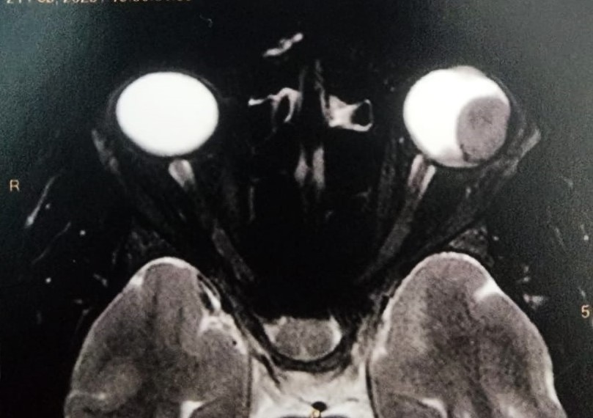
Image 3 : Coronal (A) and transverse (B) MRI scans of the brain: Left posteromedial intraocular mass, T1 hypersignal (A1, B1) and T2 hyposignal (A2, B2) with post-injection enhancement, measuring approximately 15 mm at the base, with no signs of extraocular extension, consistent with choroidal melanoma. No invasion of the optic nerve or orbital tissues. Right globe without abnormality.

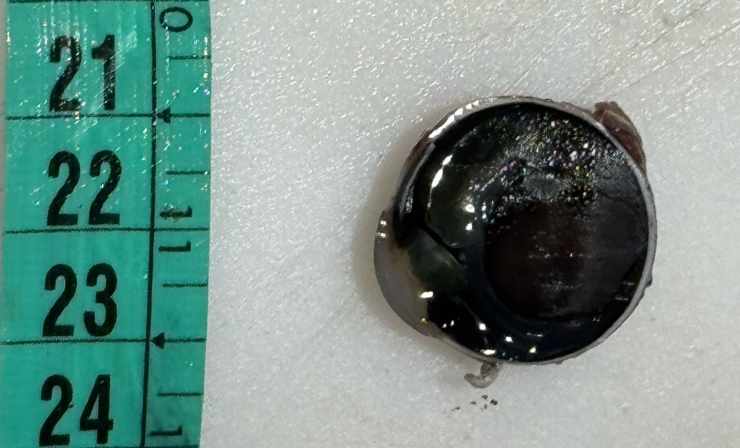
Image 4: Cross-section of the left eye after enucleation showing a homogeneous black lesion (orange arrow) measuring 1.8 cm along its longest axis. The very dark appearance is characteristic of melanin-rich melanocytic proliferation. The sclera behind is intact and there is no extrascleral extension (blue arrow).

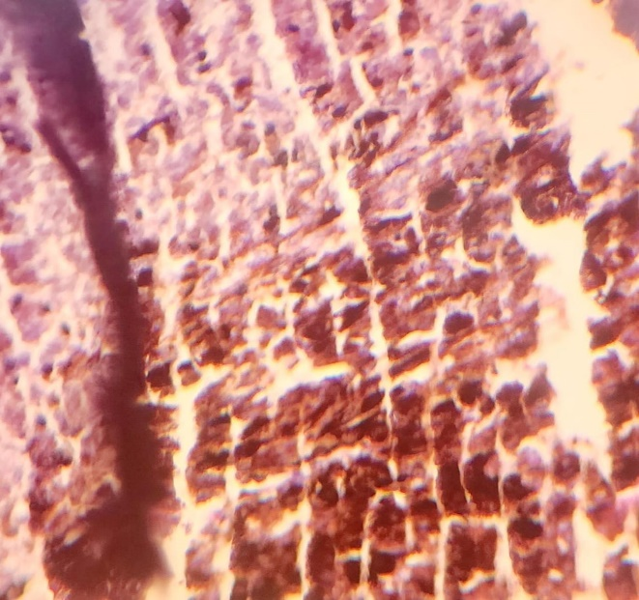 | 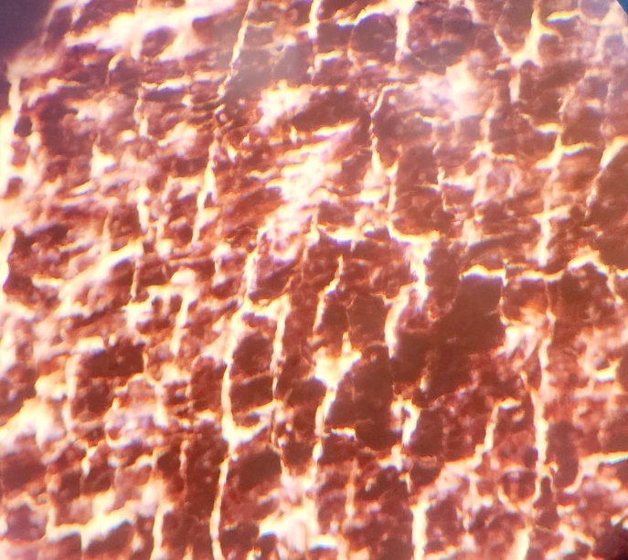
Image 5 : an infiltrating choroidal proliferation consisting of highly pigmented spindle-shaped and epithelioid cells, organized in disorganized clusters and bundles. The nuclei are irregular and hyperchromatic, with marked atypia. The blue arrow shows the tumor invasion front toward a healthy area.

Ethical Approval:

As per international standards or university standards written ethical approval has been collected and preserved by the author(s).
Consent
The authors certify that they have obtained all appropriate patient consent forms. The patient has consented for his images and other clinical information to be reported in the journal.

Disclaimer (Artificial intelligence)
Author(s) hereby declare that NO generative AI technologies such as Large Language Models (ChatGPT, COPILOT, etc.) and text-to-image generators have been used during the writing or editing of this manuscript.

Bibliography
[1] Zako C, Nisanova A, Weinberg V, Scholey J, Swason C, Afshar AR, Quivey J, Daftari IK, Tsai T, Park SS, Seider M, Johnson RN, Char DH, Mishra KK. Long-term clinical outcomes for adolescent and young adult uveal melanoma patients treated with proton-beam and helium-ion radiation. Ophthalmology. 2025;132(5):1012-1020.
[2] Solnik M, Paduszyńska N, Czarnecka AM, Synoradzki KJ, Yousef YA, Chorągiewicz T, et al. Imaging of uveal melanoma – current standard and methods in development. Cancers (Basel). 2022;14(13):3147. doi: 10.3390/cancers14133147.
[3] Nisanova A, Park SS, Amin A, Zako C, Wilson MD, Scholey J, Afshar AR, Tsai T, Char DH, Mishra KK. Novel Risk Factors for Uveal Melanoma in Adolescent and Young Adult Patients: A Comprehensive Case-Control Analysis. Ophthalmol Sci. 2024 Dec 24;5(4):100687. doi: 10.1016/j.xops.2024.100687. PMID: 40242369; PMCID: PMC12002997.
[4] Soliman N. Choroidal Melanoma: A Mini Review. Cureus. 2023;15(5):e39085.
[5] Dutta Majumder P, Khetan V, Biswas J. Masquerade syndrome: A review of uveitic imposters. Asia Pac J Ophthalmol (Phila). 2024 Mar-Apr;13(2):100054. doi: 10.1016/j.apjo.2024.100054. Epub 2024 Apr 5. PMID: 38583526.
[6] Ramos-Dávila EM, Dalvin LA, et al. Clinical Implications of Ultrasound-Based Morphology in Choroidal Melanoma. Ophthalmology Retina, avril 2025.
[7] Ferreira TA, Jaarsma-Coes MG, Marinkovic M, et al. MR imaging characteristics of uveal melanoma with histopathological validation. Neuroradiology. 2022;64(1):171-184.
[8] Boussif M, Benbouzid S, Akesbi Y, Elalami I, Elbenaye J, Boudhas A, et al. Radiologic assessment in choroidal melanoma: Integrating MRI and ultrasonography correlations. Sch J Med Case Rep. 2025;13(5):1171-4
[9] Guner, Melis Kabaalioglu MD; Ferenchak, Kevin MD; Olsen, Timothy W. MD; Dalvin, Lauren A. MD. OPTICAL COHERENCE TOMOGRAPHY FINDINGS IN CHOROIDAL MELANOMA-ASSOCIATED SUBRETINAL FLUID. Retina 42(11):p 2159-2168, November 2022. | DOI: 10.1097/IAE.0000000000003578
[10] Broggi G, Russo A, Reibaldi M, Russo D, Varricchio S, Bonfiglio V, Spatola C, Barbagallo C, Foti PV, Avitabile T, Longo A, Caltabiano R. Histopathology and genetic biomarkers of choroidal melanoma. Applied Sciences (Basel). 2020;10(22):8570. doi:10.3390/app10228081.
[11] Gkiala A, Sevas V, Mitropoulos P, Androudi S. Uveal Melanoma: Comprehensive Review of Its Pathophysiology, Diagnosis, Treatment, and Future Perspectives. Biomedicines. 2024 Aug 5;12(8):1758. doi:10.3390/biomedicines12081758. PMID: 39177729; PMCID: PMC11352094.
[12] Diener-West M, Reynolds SM, Agugliaro DJ, Caldwell R, Cumming K, Earle JD, Green DL, Hawkins BS, Hayman J, Jaiyesimi I, Kirkwood JM, Koh WJ, Robertson DM, Shaw JM, Thoma J; Collaborative Ocular Melanoma Study Group Report 23. Screening for metastasis from choroidal melanoma: the Collaborative Ocular Melanoma Study Group Report 23. J Clin Oncol. 2004 Jun 15;22(12):2438-44. doi: 10.1200/JCO.2004.08.194. PMID: 15197206.
[13] Weis E, Surgeoner B, Salopek TG, Cheng T, Hyrcza M, Kostaras X, et al. Management of uveal melanoma: Updated Cancer Care Alberta clinical practice guideline. Curr Oncol. 2024;31(1):24–41. doi: 10.3390/curroncol31010002.
[14] Ou Y, Li Y, Cao X, Kuang G. The surgical effect and safety of a novel intraocular choroidal melanoma resection. Front Med (Lausanne). 2025 May 30;12:1554581. doi:10.3389/fmed.2025.1554581
[15] Bai Y, Yin H, Hou JJ. Current management of uveal melanoma: a review. Clin Exp Ophthalmol. 2023;51(2):164–175. doi:10.1111/ceo.14214.
16. Lai, Yen Sheong, Ismail Shatriah, Yee Lin Lo, Koon Ling Koh, Jayaraman Kogilavaani, Lai Yen Sheong, YEE LIN LO, and Kogilavaani J. Raman. "A Choroidal Melanoma With Ciliary Body Involvement in a Young Female." Cureus 16, no. 3 (2024).

