Hemodialysis in Older Adults: Clinical Considerations and Outcomes

ABSTRACT

Aims It is well established that life expectancy has increased globally, leading to a growing proportion of elderly patients requiring dialysis. In countries such as the US and the UK, the cost of managing these patients has risen substantially, as a significant portion of healthcare expenditure is allocated to dialysis treatment. The aim of the study was to determine whether renal replacement therapy is worthwhile in patients with very advanced age and whether it is easily achievable, providing a satisfactory life for the patient.
Methodology and Material The survival of 69 elderly patients (> 80 years aged 80-96 years old, at the beginning of dialysis, who were treated in a hemodialysis unit from 2004-2019, was studied prospectively.
Results
Overall patient survival was favorable. Participants aged ≥85 years at the initiation of hemodialysis had a median survival of 12 months (range: 1–75 months), whereas those aged <85 years had a median survival of 18.5 months (range: 1–120 months). Serum C-reactive protein (CRP) levels were significantly lower among patients younger than 85 years compared with those aged 85 years or older; however, this difference was not associated with survival outcomes.
A total of 52.2% of patients younger than 85 years reported a good quality of life, compared with 21.7% of those aged 85 years or older. Smoking status, hypertension, and diabetes mellitus were not significantly associated with survival. In contrast, cardiovascular disease as the underlying cause of chronic kidney disease showed a positive correlation with increased mortality risk.
Conclusions Our study demonstrates that elderly patients undergoing hemodialysis have favorable survival outcomes and maintain a good quality of life in a considerable proportion of cases. These findings suggest that the initiation of hemodialysis in elderly individuals should not be discouraged solely based on age, as many can continue to live with dignity and satisfactory well-being for several years.

Key Words: Hemodialysis, elderly, survival, c-reactive protein, quality of life, dialysis catheter

1. INTRODUCTION

Hemodialysis is not suitable for all patients with end-stage renal disease (ESRD). The decision to start or not this treatment should be made mainly by the patient himself and his relatives. patients should be informed about the potential benefits (in terms of quality and duration of life), and risks (discomfort, pain, and suffering) (Tattersall, 2005).
It has been argued whether the elderly patients with ESRD, who often have multiple comorbidities, truly benefit from renal replacement therapy such as hemodialysis. Understanding the significant differences between elderly and young patients, is crucial for efficient care.
Bibliographically the expectancy of life for dialysis patients is significantly reduced, compared to that of the general population. Thus a 40-year-old dialysis patient has a median survival of 8 years, compared to 50 years for a person of the same age group of the general population. Similarly in the elderly, the impact of dialysis on expected survival is relatively smaller. Thus, in individuals > 80 years old, the average expected survival on dialysis is less than 2 years, compared to 8 years in younger individuals on dialysis (Chanda et al., 1999). Thus, the chance of survival for 1 and 2 years, in those who started dialysis after the age of 80 in the US is 58% and 37%, respectively, compared to 78% and 62% for all patients undergoing dialysis.
In this study, all patients over 80 years old at the beginning of hemodialysis were retrospectively recorded, to determine the survival rate and the factors that affect it, as well as their quality of life.

2. MATERIAL AND METHODS

Patients
This retrospective study included 69 elderly patients over 80 years old who underwent chronic hemodialysis, during the period 1/1/2004 - 1/6/2019. During their inclusion in the study, anthropometric and clinical features, data from their medical history and results from biochemical serum tests were recorded.
In addition to age and sex, the primary cause of chronic kidney disease (CKD), co-morbidity (coexistence of hypertension, diabetes mellitus, cardiovascular disease and malignancy), the type of vascular access (fistula, central venous dialysis catheter) and various laboratory parameters (averages of two measurements per year during the hemodialysis period were used for serum albumin, parathormone and C-reactive protein [CRP]).
The study was conducted in accordance with the Helsinki Declaration of Human Rights and all patients signed a consent form.

Monitoring Period and Endpoint
Patient follow-up and endpoint data were obtained from the monthly tests until their death or the end of the study (June 2019). At the same time the total number of hospitalizations, causes of hospitalization and the causes of death were recorded.

Statistical analysis
The statistical analysis was performed using the SPSS software (IBM Statistical Package for Social Sciences, 18.0 for Windows, Chicago, IL, USA). The Kolmogorov-Smirnov test was used to examine the distribution of each variable. Variables were expressed as mean and standard deviation (mean ± SD) if they were normally distributed and as a median with range (minimum - maximum values) if they did not follow a normal distribution. The differences between the groups were calculated by the non-parametric Mann-Whitney U test method for continuous variables and by the chi-square test method for bisected variables. The Kaplan-Meier curve and the log-rank test for comparison with survival curves were used to estimate total mortality. Cox's single-factor and multifactorial survival analysis was used to assess the adjusted Hazard Ratio-HR, with the corresponding Confidence Interval (CI) for correlation with risk factors and endpoint of the study. At first, all variables were considered as continuous and bisected in Cox single-factor analysis and only variables that were statistically significantly related to total mortality were included in the multifactorial analysis. Statistical significance was defined as p <0.05.

3. RESULTS

The study included 69 elderly patients with ESRD who underwent hemodialysis, with a median age of 83 years (80-96) at the beginning of the dialysis, while 23 were over 85 years old. Over fifty two percent (52.2%) of patients were male, 43.5% had arterial hypertension (AH), 36.2% had diabetes mellitus (DM), 10.1% had neoplastic disease and 69.6% had cardiovascular disease (CVD). About twenty-one percent (21.7%) of patients smoked. 85.5% had a permanent double lumen central venous dialysis catheter as vascular access for hemodialysis. The mean hemoglobin concentration was 10.64 ± 1.29 gr/dl, the mean serum albumin was 36 ± 4 gr/L, the mean serum parathormone levels was 24.5 pmol/L (normal range 1.6-126.3) and the mean CRP mean was 1.33 mg/L (normal range 0-62.8) (mean value found from two values per year [June-December] in years undergoing hemodialysis]). The cause of ESRD was recorded in the patients: 6 had obstructive uropathy, 8 AH, 23 DM, 8 heart failure and 24 unknown causes.
Table 1 contains the differences in laboratory data and quality of life (% of good) between patients ≥85 years and <85 years old. Compared to those over ≥85 years, patients younger than 85 years had significantly lower serum CRP values (0.88 vs 1.58, p = .021, Kruskal Wallis test), lower hemoglobin levels (10.9 vs 10, p =.006, Kruskal Wallis test) and higher serum parathormone levels (321 vs 207, p =.002, Kruskal Wallis test). 52.2% of patients under 85 years old described their quality of life as good, while the corresponding percentage in the group over 85 was only 21.7% (p=.04, chi-square test). Serum albumin levels, sex, smoking status, presence of AH, DM, CVD and hospitalizations did not differ significantly between the two groups. Patients over 85 at the beginning of hemodialysis (23/69) had a median survival of 12 months (1-75), in contrast to those under 85 who had median survival of 18.5 months (1-120).
Have 2 tables. 1 table for patient demographics and other characteristics such as age, sex, smoking status, comorbidities, cause of CKD and hospitalizations. Another table for biochemical parameters.

Table 1: Differences in anthropometric, clinical and laboratory data between patients over and lower 85 years old (PTH=parathormone)
 | Patients with age ≥85 years old at the beginning of hemodialysis | Patients with age <85 years old at the beginning of hemodialysis | p=
Age (y) | 88 (85-96) | 81 (80-84) | .001
CRP (mg/L) | 0.88 (0-4.5) | 1.58 (0-6.6) | .021
Hb (gm/dl) | 10±1.5 | 10.9±1.1 | .006
PTH (pmol/L) | 34 (3.07-126.3) | 21.9 (1.6-67.5) | .002
Quality of life (% of good) | 21.7% | 52.2% | .04

It is worth noting that from our patients very elderly patients lived for many months with renal replacement therapy (Fig. 1).

Figure 1: It presents the ages of very elderly patients and their survival with hemodialysis

During the median follow-up period of 18 months (1-120), 32 patients died (13 over 85) and 48 were hospitalized (29 for one time, 8 for two, 6 for three, 1 for five, 2 for seven and 1 for 8 times), most because of CVD (33/48). Kaplan-Meier curves (p =.04, log-rank test, Figure 2) showed that patients with lower median CRP had a higher risk of overall mortality: of the 32 deaths, 20 were noted in the group with lower CRP (20/34 patients) and 12 in the high CRP group (12/35 patients).
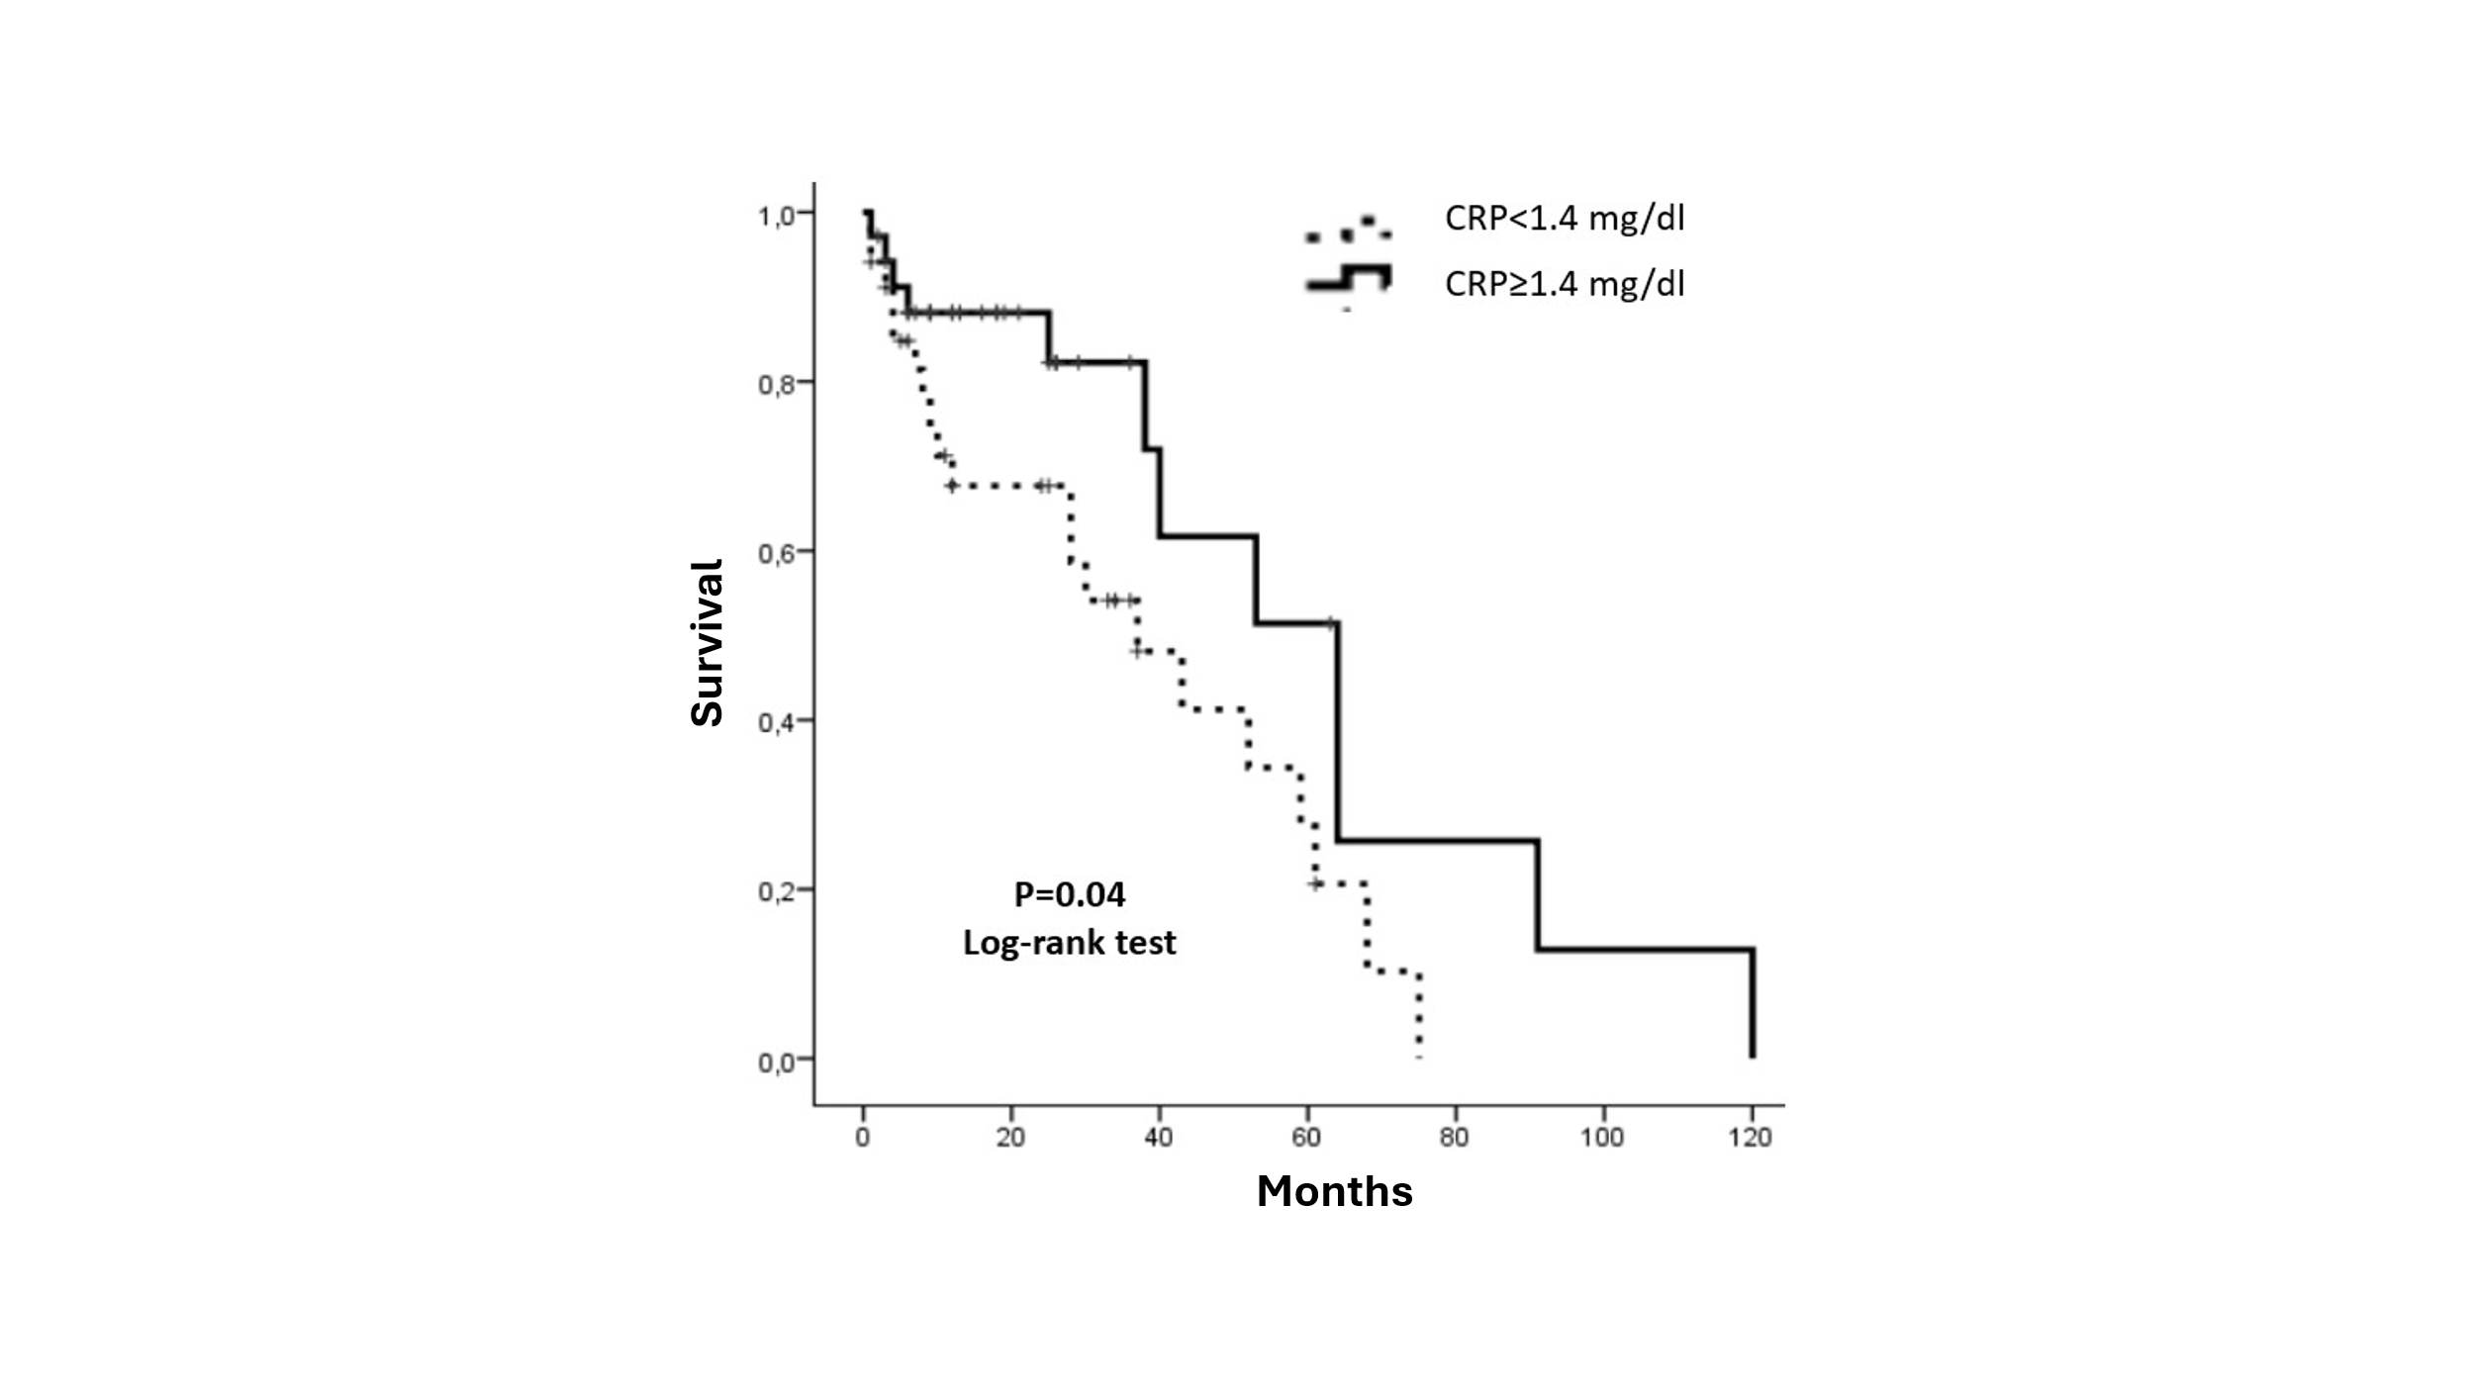
Figure 2: Kaplan-Meier survival curve for total mortality in elderly patients undergoing hemodialysis with low and high CRP (median 1.33 mg/L)

When comparing the groups according to their age, Kaplan-Meier curves (p = .06, log-rank test, Figure 3) showed patients older than 85 years had a non-significant higher risk of total mortality, (p = .06).
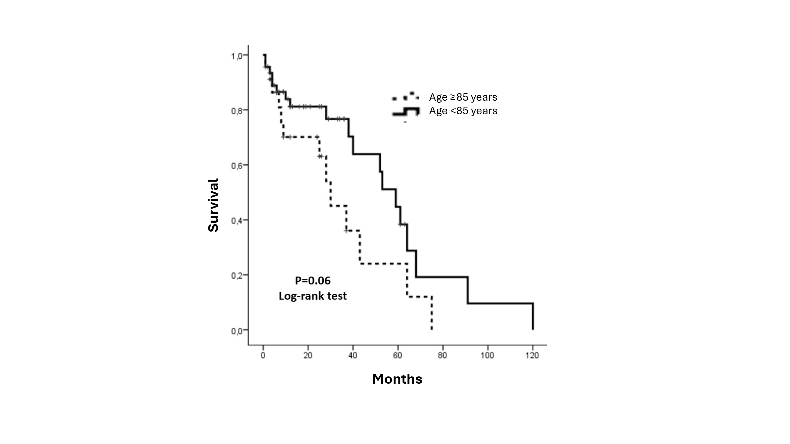
Figure 3: Kaplan-Meier survival curve for total mortality in elderly patients undergoing hemodialysis ≥85 years and <85 years old

The Kaplan–Meier survival analysis indicated that, compared with other causes of end-stage renal disease (ESRD), patients whose primary cause was cardiovascular disease had a higher mortality risk (4 deaths among 8 patients; p = 0.03, log-rank test), whereas those with obstructive uropathy as the underlying cause showed lower mortality (1 death among 6 patients).Cox single-factor analysis showed that age (p = .013, HR = 1.13, 95% CI: 1.03-1.24) and the lower CRP (p = .047, HR = 2.17, 95% CI: 1.01-4.66), were associated with the total mortality of the patients. Hemoglobin, serum parathormone and albumin, sex, smoking, type of vascular access, hospitalizations, DM, AH, CVD and cancer were not associated with the endpoint of the study. Cox multivariate analysis was then performed by placing only the variables related to mortality in the single-factor analysis (age, low CRP and causes of ESRD) it was found that only age remained an independent prognostic factor of total mortality in elderly patients under hemodialysis (Table 2).

Table 2: Single-factor and multifactorial Cox analysis for total mortality in elderly patients over 80 years old under hemodialysis (CRP=C-reactive protein)
Total mortality
 | Hazard Ratio | 95% CI | p=
Model 1: Single factor
Age | 1.13 | 1.03 – 1.24 | .013
Lower CRP | 2.17 | 1.01 – 4.66 | .047
Model 2: Multivariate analysis
Age | 1.11 | 1.01 – 1.22 | .033
Lower CRP | 1.94 | 0.9 – 4.23 | .10

4. DISCUSSION

Elderly patients have become the norm rather than the exception in dialysis units. This population represents the most rapidly growing group among individuals receiving dialysis, indicating that the overall average age of dialysis patients will continue to rise in the coming years. This rapid increase is probably accompanied by an increase in spending more money on treatment per patient. So, in Germany in 2012, 20% of all hemodialyzed patients were ≥80 years old (Leimbach et al., 2015). In Japan in 2004, 14% of all hemodialyzed patients were ≥80 years old and respectively in 2006 was 16%, in 2008 18%, in 2010 19% and in 2012 at 22% (Nakai et al., 2014) and that number showed to increase progressively each year (Hatakeyama et al., 2013).
About 7% of all patients who began dialysis in the UK in 2003 were > 80 years old, while in the US 13%. There were about 2,500 patients undergoing dialysis over the age of 80 years per million population in the UK (in the US the patients > 80 years old undergoing dialysis during the same period were 3,400).
DM is an important disease particularly in the elderly (in our patients 36.2% had DM). These people had higher rates of premature death, functional disability, accelerated muscle loss and co-morbidity (arterial hypertension, coronary heart disease and stroke) compared to people without DM. Elderly patients with diabetes are also at greater risk than elderly adults without DM for many usual geriatric problems, such as polypharmacy, cognitive impairment, falls with concomitant bone fractures, and persistent pain. These conditions can affect the self-care skills of the elderly with DM (Kirkman et al., 2012).
It is not surprising that mortality is much higher in elderly hemodialyzed patients, compared to the elderly who don’t need dialysis. Unfortunately, the survival of elderly patients in dialysis is generally worse than most cancers (Brown et al., 2015). Kurella et al. found that in the US, patients undergoing dialysis aged 80-84 years old, had an average survival of 15.6 months, while the average survival for patients 85-89 years old was 11.6 months and for patients > 90 years old was 8.4 months (Kurella et al., 2007).
Hatakeyama et al. studied retrospectively from 1988-2013, 141 hemodialyzed patients ≥80 years old. They found an average survival of 2.6 years, when the expected survival for the group without renal failure was 7.6 years (more specifically patients aged 80-84, 85-89 and > 90 years old survived 3.0, 2.5 and 0.9 years, respectively), with the highest percentage of patients (46%) dying at the first year of dialysis (Hatakeyama et al., 2013). In another study, almost half of those with ages 80-89 and 90-99 years died in the first year from the start of dialysis (Robinson et al., 2014), as others have found for the second group (Kurella et al., 2007). Particularly, Zingerman et al. found survival in 1, 2 and 5 years, 80%, 65% and 20%, respectively, in patients > 85 years old at the beginning of dialysis (Zingerman et al., 2014). In corresponding age groups, we have found particularly very high survival, both in those who were 81-84 years old (120 months) and those who were > 85 years old (> 70 months).
It is worth noting that survival is significantly influenced by comorbidity. Elderly patients have a higher prevalence of comorbidities, which greatly impairs survival on dialysis, compared to the younger dialysis patients (Byrne et al., 1994, Canaud et al., 2011). The higher comorbidity, and especially the dependence for ADLs (activities of daily living) are very bad prognostic factors which reduced the survival in people of these ages.
The better survival of our elderly patients may be due to the high efficacy of dialysis, to the lower comorbidity that may have existed in our patients, to the fact that in our country the insurance funds do not limit the doctor's therapeutic options for each patient, while at the same time there is very rarely the option of patients stopping renal replacement therapy, which is quite common in other countries.
In our patients who had heart disease as a primary cause of ESRD had a higher risk of mortality (4 deaths in 8 patients), while the risk is less in patients with obstructive uropathy as a cause of renal disease (1 death in 6 patients). Smoking, hospitalizations, DM, AH, CVD, cancer were not related to the endpoint of our study (especially in terms of hospitalizations, most of them had very good survival, namely 120 months with 8 hospitalizations, 61 months with 7 hospitalizations and 38 months with 5 hospitalizations). This means that comorbidity did not play a significant role in the survival of our patients.
As for serum CRP, it was checked to find out whether there were often episodes of infections in our patients, as 85.5% had a central venous dialysis catheter. Indeed, it was found at elevated levels in patients over 85 years old, compared to those under 85 years old, and this may have contributed to morbidity and mortality. However, the statistical analysis found exactly the opposite results. In other words, patients with a lower CRP had a higher risk of overall mortality, which cannot be interpreted, given that infections are the second cause of death of hemodialysis patients.
Those who had good nutrition and those who had fistula as vascular access for dialysis had better survival (Sladoje-Martinovic et al., 2014). Fistula positively affects survival, which was considered by researchers to be able to create it in patients over 80 years old (Leimbach et al., 2015), while the use of central venous catheters was significantly associated with increased mortality (Zingerman et al., 2014). In our patients, however, no such correlation was found, as 85.5% had a central venous dialysis catheter as vascular access, and their survival was particularly high.
Olsha et al. studied 134 patients with ESRD over 80 years old to create vascular access. They created 128 fistulas and placed 18 arteriovenous grafts. They found that age alone should not exclude patients over 80 years old from the attempt to create internal arteriovenous anastomosis, nor should anyone be excluded due to age of "first to create a fistula" (Olsha et al., 2015). In fact, 2006 K/DOQI does not distinguish between younger and elderly patients to create internal vascular access. They also found that most patients ≥80 years old have vessels that were suitable for creating autogenous vascular access and only 12% needed prosthetic graft. There were no significant differences between patients with and without DM (Olsha et al., 2015). Unlike these findings, majority of our patients had a dialysis catheter because it was not possible to create fistula and not because such a choice was made arbitrarily.
Perhaps the most difficult clinical decision that nephrologists must make nowadays is whether their elderly patients, with ESRD, are likely to benefit from dialysis (Swidler et al., 2012). However, when evaluating these patients with ESRD for renal replacement therapy, several additional parameters, such as their life expectancy, which is often small due to comorbidity, including DM and generalized vascular diseases, should be considered (Reindl-Schwaighofer et al., 2017). Patients with expected poor dialysis prognosis may choose to be treated conservatively (Verberme et al., 2016).
The benefit of dialysis is undoubtedly the expectation of survival in people with ESRD (Jassal & Watson, 2009). It has been found that the survival rate is reduced in dialysis patients with the advancing age (the 1-year survival rate is 54% in people ≥80 years old), as there is increased comorbidity (64% with 2 or more comorbidities) (Lamping et al., 2000). In addition, in elderly patients with multiple comorbidities, the onset of dialysis does not appear to extend life compared to conservative treatment (Foote et al., 2016), while increasing the risk of hospitalization, as some investigators support (Wongrakpanich et al., 2017).
Sladoje-Martinovic et al. studied 78 patients with ESDR (from 1987-2012), aged > 80 years old at the beginning of dialysis. In this study, almost one-third of them were ≥80 years old and survived for 12-24 months and one-third of them survived as long as 24-60 months (Sladoje-Martinovic et al., 2014).
Kwok et al. also studied a total of 558 patients with ESRD, where 126 (22.6%) chose to start dialysis and 432 (77.4%) conservative treatment. The group that chose dialysis had better average survival (44.6 months), compared to the conservative treatment group (10 months). The advantage of the survival of the group under dialysis was lost in patients > 85 years old and to those who had high comorbidity or reduced mobility (Kwok et al., 2016). On the contrary, others found that the survival for 12 months in patients over 80 years old was not significantly greater in those who started dialysis, compared to patients who chose conservative treatment (van Loon et al., 2019 The survival of our patients was consistently higher across all categories, and there was never any consideration of choosing conservative management over dialysis. Rosansky declared that "the decision to start dialysis must be common and taken by the patients themselves (and their relatives) and the nephrologists, as all possible implications and benefits are known over not being treated with dialysis” (Rosansky, 2012).
In a German study from a center, the results of the dialysis of all those who were > 80 years old were analyzed between 2001 and 2012 (n = 76). One year survival was 87%, 3 years of 52%, 5 years 27% and 10 of 9%. Thirty patients had received long-term nephrological care before the beginning of dialysis, and this seems to have been of paramount importance for the successful outcome of elderly dialysis therapy, especially those aged 80-89 and 90-99 years old (Leimbach et al., 2015).
Regardless of mortality, quality of life is an important factor in making decisions on the beginning of dialysis in elderly patients. A study found that most of them choose dialysis, basically to relief their symptoms of uremia and not just for longer survival. However, they are at higher risk of suffering from hypotensive episodes during the dialysis session (Davenport, 2006), which makes them feel very exhausted. It was probably found that timely and intensive care before starting of dialysis is the key to a successful dialysis treatment in people 80-99 years old. A study by the National Registry of Slovenia (170 patients ≥ 80 years old) confirmed these results (Gubensek et al., 2014). Others also noted that novel instruments are likely needed to elicit the basic themes of well-being by older adults on dialysis (Hall et al., 2020).
Lamping et al. did not find significant differences in the quality of life between elderly patients in dialysis and people with the same age of the general population in the UK and the US (Lamping et al., 2000). 52.2% of our patients under 85 years old described their quality of life as good, while the corresponding rate in the group over 85 years old was only 21.7%.
Please elaborate more on the possible reasons why CRP/Comorbidities and having a vascath did not affect the survival in your study population.
5. CONCLUSION

Our study found that hemodialysis patients over 80 years old at the beginning of dialysis with a variety of comorbidities, had excellent survival and good quality of life. The fact that one 84-year-old patient at the beginning of dialysis lived more than 10 years suggests that age cannot be a barrier to this treatment.

Ethical Approval and CONSENT
All procedures were in accordance with the International Ethical Guidelines and Declaration of Helsinki 1975, as revised in 2013. Written consent has been collected and preserved by the author(s).

COMPETING INTERESTS DISCLAIMER:
Authors have declared that they have no known competing financial interests OR non-financial interests OR personal relationships that could have appeared to influence the work reported in this paper.

REFFERENCES

Brown, M.A., Collett, G.K., Josland, E.A., Foote, C., Li, Q., Brennan, F.P. CKD in elderly patients managed without dialysis: Survival, symptoms, and quality of life. Clinical Journal of the American Society of Nephrology 2015;10(2):260-268.doi: 10.2215/CJN.03330414.
Byrne, C., Vernon, P., Cohen, J.J. Effect of age and diagnosis on survival of older patients beginning chronic dialysis. JAMA 1994;271(1):34-36.
Canaud, B., Tong, L., Tentori, F., Akiba, T., Karaboyas, A., Gillespie, B., et al. Clinical practices and outcomes in elderly hemodialysis patients: Results from the Dialysis Outcomes and Practice Patterns Study (DOPPS). Clinical Journal of the American Society of Nephrology 2011;6(7):1651-1662. doi:10.2215/CJN.03530410
Chandna, S.M., Schulz, J., Lawrence, C., Greenwood, R.N., Farrington, K. Is there a rationale for rationing chronic dialysis? A hospital-based cohort study of factors affecting survival and morbidity. British Medical Journal 1999;318(7178):217-223.doi: 10.1136/bmj.318.7178.217.
Davenport, A. Intradialytic complications during hemodialysis. Hemodialysis International 2006;10(2):162-167.doi:10.1111/j.1542-4758.2006.00088.x.
Foote, C., Kotwal, S., Gallagher, M., Cass, A., Brown, M., Jardine, M. Survival outcomes of supportive care versus dialysis therapies for elderly patients with end-stage kidney disease: a systematic review and meta-analysis. Nephrology (Carlton) 2016;21(3):241-253.doi: 10.1111/nep.12586.
Gubensek, J., Ponikvar, R., Ekart, R., Buturovic-Ponikvar, J. Very old patients on hemodialysis: how they start and can we predict survival? Blood Purification 2014;38(1):74-79.doi: 10.1159/000367681.
Hall, R.K., Cary, Jr M.P., Washington, T.R., Colón-Emeric, C.S. Quality of life in older adults receiving hemodialysis: a qualitative study. Quality of Life Research. 2020;29(3):655-63. doi:10.1007/s11136-019-02349-9
Hatakeyama, S., Murasawa, H., Hamano, I., Kusaka, A., Narita, T., Oikawa, M., et al. Prognosis of elderly Japanese patients aged ≥80 years undergoing hemodialysis. Scientific World Journal 2013 Oct 9; 2013:693514.doi: 10.1155/2013/693514.eCollection 2013.doi:10.1155/2013/693514
Jassal, S.V., Watson, D. Dialysis in late life: Benefit or burden. Clinical Journal of the American Society of Nephrology 2009;4(12):2008-2012.doi: 10.2215/CJN.04610709.
Kirkman, S., Briscoe, V.J., Clark, N., Florez, H., Haas, L.B., Halter, J.B., et al. Diabetes in older adults. Diabetes Care 2012; 35(12): 2650-2664.doi: 10.2337/dc12-1801.
Kurella, M., Covinsky, K.E., Collins, A.J., Chertow, G.M. Octogenarians and nonagenarians starting dialysis in the United States. Annals of Internsl Medicine 2007;146(3):177-183.doi: 10.7326/0003-4819-146-3-200702060-00006.
Kwok, W-H., Yong, S-P., Kwok, O-L. Outcomes in elderly patients with end-stage renal disease: Comparison of renal replacement therapy and conservative management. Hong Kong Journal of Nephrology 2016;19:42-56. doiI:10.1016/j.hkjn.2016.04.002
Lamping, D.L., Constantinovici, N., Roderick, P., Normand, C., Henderson, L., Harris, S., et al. Clinical outcomes, quality of life, and costs in the North Thames dialysis study of elderly people on dialysis: a prospective cohort study. Lancet 2000;356(9241):1543-1550.doi: 10.1016/S0140-6736(00)03123-8.
Leimbach, T., Kron, J., Czerny, J., Urbach, B., Aign, S., Kron, S. Hemodialysis in patients over 80 years. Nephron 2015;129(3):214-218.doi: 10.1159/000375501.
Nakai, S., Hanafusa, N., Masakane, I., Taniguchi, M., Hamano, T., Shoji, T, et al. An overview of regular dialysis treatment in Japan (as of 31 December 2012). Therapeutic Apheresis Dialysis 2014;18(6):535-602.doi: 10.1111/1744-9987.12281.
Olsha, O., Hijazi, J., Goldin, I. Shemesh, D. Vascular access in hemodialysis patients older than 80 years. Journal of Vascular Surgery 2015;61(1):177-183.doi: 10.1016/j.jvs.2014.07.005.
Reindl-Schwaighofer, R., Kainz, A., Kammer, M., Dumfarth, A., Oberbauer, R. Survival analysis of conservative vs. dialysis treatment of elderly patients with CKD stage 5. PLoS ONE 2017;12(7):e0181345. doi.org/10.1371.
Robinson, B.M., Zhang, J., Morgenstern, H., Bradbury, B.D., Ng, L.J., McCullough, K.P., et al. Worldwide, mortality risk is high soon after initiation of hemodialysis. Kidney International 2014;85(1):158-165.doi: 10.1038/ki.2013.252.
Rosansky, S.J. The sad truth about early initiation of dialysis in elderly patients. JAMA 2012;307(18):1919-1920.doi: 10.1001/jama.2012.3522.
Sladoje-Martinovic, B., Mikolasevic, I., Bubic, I., Racki, S., Orlic, L. Survival of chronic hemodialysis patients over 80 years of age. Clinical Interventions in Aging 2014;9:689-696.doi: 10.2147/CIA.S58976.
Swidler, M.A. Geriatric renal palliative care. The Journal of Gerontology, Series A Biological Sciences and Medical Science 2012;67(12):1400-1409.doi: 10.1093/gerona/gls202.
Tattersall, J. Dialysis in the over-80s. Age and Ageing 2005;34(2):100-101.doi:10.1093/ageing/afi056
van Loon, I.N., Goto, N.A., Boereboom, F.T.J., Verhaar, M.C., Bots, M.L., Hamaker, M.E. Quality of life after the initiation of dialysis or maximal conservative management in elderly patients: a longitudinal analysis of the Geriatric assessment in OLder patients starting Dialysis (GOLD) study. BMC Nephrology 2019;20(1):108-115.doi:10.1186/s12882-019-1268-3
Verberne, W.R., Tom, Geers, A.B.M., Jellema, W.T., Vincent, H.H., van Delden, J.J.M, Bos, W.J.W. Comparative survival among older adults with advanced kidney disease managed conservatively versus with dialysis. Clinical Journal of the American Society of Nephrology 2016;11(4):633-640.doi: 10.2215/CJN.07510715.
Wongrakpanich, S., Susantitaphong, P., Isaranuwatchai, S., Chenbhanich, J., Eiam-Ong, S., Jaber, B.L. Dialysis therapy and conservative Management of Advanced Chronic Kidney Disease in the elderly: a systematic review. Nephron 2017;137(3):178-189. doi:10.1159/000477361
Zingerman, B., Korzets, A., Ori, Y., Herman-Edelstein, M., Rozen-Zvi, B., Gafter, U., et al. The very old on hemodialysis: 8 years’ experience in a single unit. Blood Purification 2014;37(1):12-17. doi:10.1159/000357016

