Assessing Knowledge and Attitudes Toward Simulation-Based Learning: A Descriptive Study Among Nursing Students in Mangalore, Karnataka, India

Abstract
Background: Simulation-based learning is increasingly incorporated into nursing curricula to enhance clinical competence, critical thinking, teamwork, and patient-safety skills.
Objectives: To assess the level of knowledge and attitude regarding simulation-based learning among nursing students; to determine the correlation between knowledge and attitude; and to identify the association of knowledge and attitude with selected baseline variables.
Methods: A descriptive correlational design was adopted among 100 B.Sc. Nursing students (2nd- and 4th-year) were selected using convenience sampling. Data were collected using a structured knowledge questionnaire (25 items) and a Likert-type attitude scale (19 items). Descriptive statistics, Chi-square test, and Karl Pearson’s correlation were used for analysis.
Results: The majority (60%) of students had moderately adequate knowledge, while 20% had adequate and 20% had inadequate knowledge. Attitude results showed that 50% had favourable and 50% had moderately favourable attitudes. No students demonstrated unfavourable attitudes. The correlation between knowledge and attitude was weak and not significant (r = 0.19). Significant associations were found between knowledge and variables such as year of study, age, number of times the simulation was attended, and source of knowledge. Attitude was significantly associated with gender, the number of times the simulation was attended, and the source of knowledge.
Conclusion: Nursing students demonstrated moderately adequate knowledge and favourable attitudes toward simulation-based learning. Strengthening simulation exposure and structured teaching may further enhance competency.
Keywords: Simulation-based learning, nursing education, knowledge, attitude, clinical competency.
INTRODUCTION
Simulation-based education is increasingly recognised as a vital element of contemporary nursing programmes. It gives students a safe environment to learn and refine clinical skills before they provide care to real patients. As healthcare systems become more complex, nursing education must incorporate innovative methods that help students apply theoretical learning to real-world situations. Simulation supports this need by recreating clinical scenarios through high-fidelity manikins, task trainers, standardised patients and digital technologies. Such experiences help learners practice assessment, decision-making, communication and hands-on procedures without compromising patient safety.
Relying solely on classroom instruction and traditional clinical postings may not fully prepare nursing students for the fast-changing and unpredictable nature of current clinical practice. Simulation serves as a bridge between theory and practice by offering repeated exposure to realistic situations, opportunities for immediate feedback and structured reflection. This experiential learning promotes critical thinking, strengthens clinical judgement, enhances teamwork and boosts student confidence before they transition into actual care environments.
Global research indicates that simulation-based learning contributes to better skill mastery, reduced anxiety, safer patient care practices and higher learner satisfaction. For example, a meta-analysis by Kim et al. highlighted significant improvements in knowledge, skill performance and satisfaction among nursing students trained through various levels of simulation fidelity, reinforcing its value as a key instructional method.
Although the benefits are well-documented, students’ knowledge and attitudes toward simulation may differ depending on institutional resources, curriculum structure and previous learning experiences. Assessing these aspects is essential for improving teaching strategies and advancing competency-based education.
Therefore, the present study focuses on evaluating the knowledge and attitudes related to simulation-based learning among nursing students in a selected college in Mangalore, and examines how these may be influenced by selected demographic variables.

Statement of the Problem:
A Descriptive study to assess the knowledge and attitude regarding simulation-based learning among nursing students in a selected nursing college, Mangalore.
Objectives:
- To assess the level of knowledge regarding simulation-based learning among nursing students in the selected nursing college, Mangalore.
- To assess the attitude regarding simulation-based learning among nursing students in the selected nursing college, Mangalore.
- To determine the correlation between knowledge and attitude scores regarding simulation-based learning
- To find out the association between knowledge and attitude score with baseline variables.

METHODS
Study Design: A descriptive correlational research design was used.
Study Setting: The study was conducted at the selected College of Nursing, Mangalore, Karnataka, India.
Study Population: B.Sc. Nursing students enrolled in the 2nd and 4th years in a selected Nursing college.

Sample Size Sampling Technique
The sample for the present study consists of 100 nursing students studying in 2 nd year and 4th year BSc nursing in a selected college, Mangalore. The participants for the study were selected using a purposive sampling method. This involved deliberately choosing nursing students who met the inclusion criteria of being enrolled in either the 2nd or 4th year of the B.Sc. Nursing program at Sahyadri College of Nursing, Mangalore. Only those students who were available and willing to participate were included in the study, ensuring that the sample was relevant to the research objectives.
Inclusion Criteria
- Students present during data collection.
- Students willing to participate.
Data Collection Tools
A structured knowledge questionnaire is designed to collect relevant information from nursing students regarding their knowledge of simulation-based learning.
The research instrument used to assess knowledge and attitudes toward simulation-based learning was subjected to expert validation to ensure its content validity and relevance. A panel of seven experts in nursing, including experienced faculty members and clinicians with simulation-based education expertise, reviewed the tool. Each expert critically evaluated the items for clarity, appropriateness, relevance, and comprehensiveness in relation to the study objectives.
Feedback from the expert panel was carefully considered, and necessary modifications were incorporated to enhance the accuracy, clarity, and relevance of the instrument. This process ensured that the tool adequately captured the cognitive and affective domains related to simulation-based learning and was suitable for use with undergraduate nursing students.

The tool is divided into three parts,
Part I: Demographic Performa – this is designed to elicit the demographic information from respondents consists of 8 items
Part II: Structured knowledge questionnaire- 25 items regarding the knowledge of nursing students on simulation-based learning.
Part III: Attitude scale -it consists of 19 items regarding the attitude of nursing students on simulation-based learning.

Knowledge Scoring | Attitude Scoring
- 0–8: Inadequate  - 9–16: Moderate  - 17–25: Adequate | - 19–44: Unfavourable  - 45–70: Moderately favourable  - 71–95: Favourable

Data Collection Procedure
Prior permission was obtained from the concerned principal of Sahyadri College of Nursing, Mangalore. The research group collected the data from the sample after obtaining consent. For maximum cooperation, the investigator introduced themselves to the respondent and the willingness of participants was assured. The respondents were assured of the anonymity and confidentiality of the information provided by them. The research data were collected after obtaining informed consent from the subjects. The researchers themselves have collected data from the samples.
STEP 1: The Demographic Performa is designed to elicit demographic information from respondents and consists of 8 items
STEP 2: Assessment of knowledge was done by a structured knowledge questionnaire, and attitude by a Likert-type attitude scale. The respondents were assured the anonymity and confidentiality of the information provided by them. Data was collected on 31/07/2025. The study samples consisted of 100 nursing students. The objectives of the study were explained to the nursing students. Data were collected by administering the structured knowledge questionnaire and attitude scale, and it took participants nearly 30to 40 minutes by the participants
Data Analysis
Data were analysed using descriptive statistics such as frequency, percentage, mean and standard deviation, while inferential statistics, including the Chi-square test and Karl Pearson’s correlation coefficient, were used to determine associations and the relationship between knowledge and attitude. A significance level of p < 0.05 was considered for all analyses.

Result:
The study included 100 nursing students, and their demographic characteristics are summarised in Table 1. The majority of participants were female (87%), reflecting the predominance of women in the nursing profession, while only 13% were male. Regarding age distribution, half of the students (50%) were in the 21–22-year age group, representing the typical age of students in the second and fourth years of nursing programs. Another 45% of participants were aged 19–20 years, and only a small proportion (5%) were above 23 years, indicating that most of the sample comprised young adults within the standard age range for undergraduate nursing students.
In terms of religious affiliation, the majority of participants were Hindus (61%), followed by Christians (24%) and Muslims (15%), which may reflect the cultural and regional composition of the study population. A higher proportion of students resided in urban areas (67%) compared to rural areas (33%), suggesting that urban students may have greater access to educational resources and simulation-based learning opportunities.
Prior exposure to simulation-based learning was reported by more than half of the participants (53%), indicating that many students had some experience with practical, hands-on learning methods. Similarly, 55% of students reported having pre-existing knowledge of simulation-based learning, with classroom teaching being the primary source of this knowledge (49%), followed by workshops, articles, and other means. This demonstrates that formal education plays a significant role in providing foundational knowledge, while experiential and peer learning opportunities remain limited.
Overall, the demographic profile highlights a sample that is predominantly female, young adult, urban-dwelling, and culturally diverse, with moderate prior exposure to simulation-based learning. These characteristics are important for understanding the context in which knowledge and attitudes toward simulation-based learning were assessed, and they may influence both learning outcomes and engagement with simulation activities.

Table 1: Frequency & Percentage Distribution of Students According to the Baseline Variables
N= 100
Sl No | Particulars | Demographic Variables | Frequency | Percentage
1 | Year | 2ND Year | 50 | 50
1 | Year | 3RD Year | 0 | 0
1 | Year | 4TH Year | 50 | 50
2 | Gender | Female | 87 | 87
2 | Gender | Male | 13 | 13
3 | Age Group | 19-20 | 45 | 45
3 | Age Group | 21-22 | 50 | 50
3 | Age Group | 23 Above | 5 | 5
4 | Religion | Christian | 24 | 24
4 | Religion | Hindu | 61 | 61
4 | Religion | Muslim | 15 | 15
5 | Residential Area | Urban | 67 | 67
5 | Residential Area | Rural | 33 | 33
6 | Attended a simulation before | Yes | 53 | 53
6 | Attended a simulation before | No | 47 | 47
7 | Pre - knowledge | Yes | 55 | 55
7 | Pre - knowledge | No | 45 | 45
8 | If yes how many | 1-2 | 44 | 44
8 | If yes how many | 3-5 | 7 | 7
8 | If yes how many | More than 5 | 2 | 2
9 | Source of knowledge | Class room | 49 | 49
9 | Source of knowledge | Work shop | 3 | 3
9 | Source of knowledge | Peer | 0 | 0
9 | Source of knowledge | Articles | 2 | 2
9 | Source of knowledge | Other | 1 | 1
10 | Individual /group simulation | Individual | 4 | 4
10 | Individual /group simulation | Group | 50 | 50
10 | Individual /group simulation | Both | 46 | 46

Table 2: Frequency and percentage distribution of the level of knowledge on simulation-based learning
N=100
Knowledge  Level | Score | Number | Percentage
Adequate | 0-8 | 20 | 20
Moderate | 9-16 | 60 | 60
In Adequate | 17-25 | 20 | 20

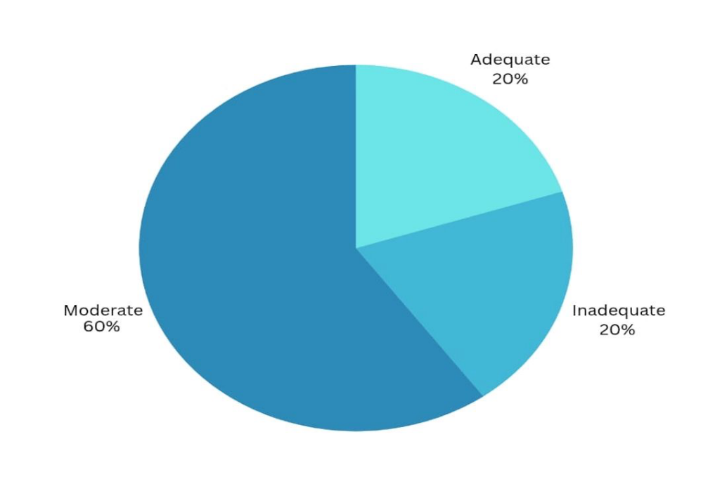
Figure 1: Diagram showing the level of knowledge on simulation-based learning
The assessment of knowledge regarding simulation-based learning among the 100 nursing students is presented in Table 2 and Figure 1. The majority of students (60%) demonstrated a moderate level of knowledge, indicating a fair understanding of simulation principles and practices. Only 20% of participants exhibited adequate knowledge, reflecting a comprehensive grasp of simulation-based learning, while another 20% had inadequate knowledge, suggesting gaps in understanding that may limit effective engagement with simulation activities.
These findings highlight that although most students possess a basic familiarity with simulation-based learning, there is considerable room for improvement. This emphasizes the need for enhanced educational strategies, including structured simulation training, repeated hands-on sessions, and supplementary learning resources, to ensure that all students attain a higher level of competency.
The results provide insight into areas where targeted interventions could strengthen knowledge, thereby supporting more effective utilization of simulation in nursing education.

Table 3: Frequency and percentage distribution of attitude based on simulation-based learning.
N=100
Attitude level | Score | Number | Percentage
Unfavorable | 19-44 | 0 | 0
Moderate | 45-70 | 50 | 50
Favorable | 71-95 | 50 | 50

Figure 2: Diagram showing the level of Attitude on simulation-based learning

The attitudes of the nursing students toward simulation-based learning are summarised in Table 3 and illustrated in Figure 2. The findings revealed that exactly half of the participants (50%) exhibited a favourable attitude, indicating a high level of interest, engagement, and positive perception toward the use of simulation in their learning process. The remaining 50% demonstrated a moderately favourable attitude, reflecting a generally positive outlook but with some reservations or limited confidence in simulation-based learning. Importantly, no students reported an unfavourable attitude, suggesting that all participants recognised the value of simulation as an educational tool.
These results indicate an overall positive acceptance of simulation-based learning among nursing students. The balanced distribution between favourable and moderately favourable attitudes highlights that while students generally appreciate the benefits of simulation, there may be factors such as limited prior experience, confidence in performing simulations, or lack of exposure to advanced simulation techniques that influence the degree of positivity in their attitudes.

Table 4: Mean, SD, Mean percentage and correlation of knowledge and attitude of simulation-based learning

Aspect | Mean | SD | Mean percentage | Correlation coefficient
Knowledge | 12.5 | 5.40 | 12.5% | 0.1903
Attitude | 70.25 | 12.8 | 70.25% | 0.1903
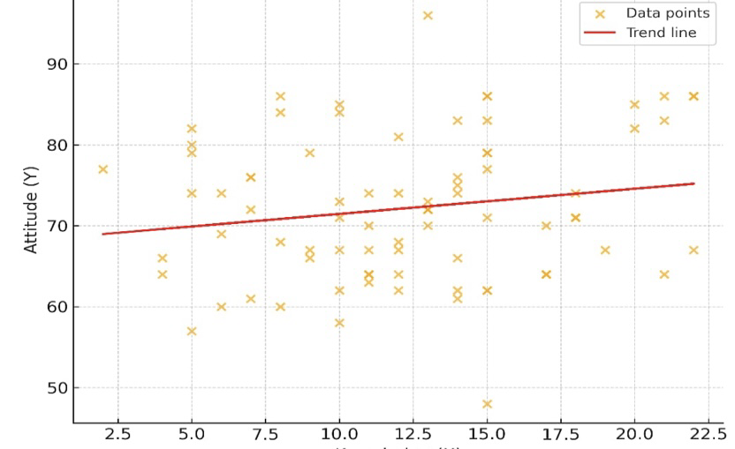

Figure 3: Diagram showing the correlation of knowledge and Attitude on simulation-based learning
The relationship between nursing students’ knowledge and attitude toward simulation-based learning is presented in Table 4 and illustrated in Figure 3. The analysis using Pearson’s correlation coefficient revealed a value of r = 0.19, indicating a weak and statistically nonsignificant relationship between knowledge and attitude scores.
This finding suggests that higher knowledge levels did not necessarily correspond to more positive attitudes toward simulation-based learning. In other words, students who were well-informed about simulation principles did not always exhibit the most favourable attitudes, and conversely, students with moderate or limited knowledge could still hold positive perceptions of simulation-based learning.

Table 5: Association Between Knowledge Score and Selected Demographic Variables
Chi-square test was used to test the association between knowledge on simulation-based learning and selected demographic variables.
Demographic Variables | DF | (X)2 | Table value | Inference
Year of study | 4 | 15.066 | 9.488 | S
Gender | 4 | 7.307 | 9.488 | NS
Age group | 4 | 10.905 | 9.488 | S
Religion | 6 | 2.438 | 12.592 | NS
Residential area | 2 | 3.427 | 5.992 | NS
Attended simulation (yes/no) | 2 | 1.704 | 5.991 | NS
How many times | 4 | 27.832 | 9.488 | S
Pre knowledge | 2 | 4.307 | 5.991 | N S
Source of knowledge | 8 | 27.027 | 15.507 | S
Individual /group | 4 | 4.303 | 9.488 | N S

Table 6: Association Between Attitude Score and Selected Baseline Variables
Demographic variables | DF | (X)2 | Table value | Inference
Year of study | 4 | 1.44 | 9.488 | NS
Gender | 4 | 13.928 | 9.488 | S
Age group | 4 | 1.474 | 9.488 | NS
Religion | 6 | 2.068 | 12.592 | NS
Residential area | 2 | 5.47 | 5.991 | NS
Attended simulation (yes/no) | 2 | 0.038 | 5.991 | NS
How many times | 4 | 43.327 | 9.488 | S
Pre knowledge | 2 | 0.362 | 5.991 | NS
Source of knowledge | 8 | 26.065 | 15.507 | S
Individual/group | 4 | 0.166 | 9.488 | NS

Association analyses between knowledge scores and demographic variables revealed significant associations with year of study, age group, frequency of simulation attendance, and source of knowledge (Table 5). Meanwhile, gender, religion, residential area, prior exposure to simulation, and pre-existing knowledge were not significantly associated with knowledge levels. Regarding attitude scores, significant associations were observed with gender, frequency of simulation attendance, and source of knowledge, whereas no significant association was found with other variables such as year of study, age, religion, residence, prior knowledge, or type of simulation (Table 6).

Discussion
The present study explored the knowledge and attitudes of nursing students toward simulation-based nursing education. The findings revealed that the majority of participants demonstrated moderately adequate knowledge, indicating a fair understanding of simulation concepts, principles, and applications. This observation is consistent with prior research conducted both in India and internationally, where moderate knowledge levels were similarly reported among nursing students and faculty members. Such consistency suggests that while simulation is widely recognized as an effective teaching–learning strategy, a comprehensive understanding of its theoretical framework, technological components, and practical implementation remains in development across various educational settings.
In addition to knowledge, the study found that most participants exhibited a moderately favourable attitude toward simulation-based learning. This aligns with existing literature indicating that nursing students generally perceive simulation positively, appreciating its interactive, safe, and experiential learning environment. Simulation not only enhances clinical confidence and competence but also provides opportunities for skill refinement without posing risk to patients. The findings underscore the perception of simulation as an innovative pedagogical approach that bridges the gap between theory and practice, thereby fostering better preparedness for real-world clinical situations.
Interestingly, despite the overall positive attitudes and moderate knowledge levels, the correlation analysis revealed a weak and statistically non-significant relationship between knowledge and attitude. This suggests that although students value simulation as an educational tool, their conceptual understanding and practical expertise may not yet be sufficient to fully translate positive attitudes into higher knowledge scores. This finding highlights the importance of structured and repeated simulation experiences, continuous skill-based reinforcement, and faculty capacity-building to strengthen both cognitive and affective learning domains.
The study also identified significant associations between knowledge levels and exposure-related variables, such as prior simulation experience. These results indicate that hands-on practice and repeated engagement with simulation activities enhance both understanding and retention of knowledge. Furthermore, gender-based differences in attitudes were observed, which may reflect variations in learning preferences, self-confidence, or social and cultural factors. Such differences should be carefully considered when designing and implementing simulation instructional strategies to ensure that all students can benefit optimally from these learning experiences.
These findings are further supported by the work of Chauee, Yumnam, and Sngi Chyrmang, who conducted a descriptive survey assessing the knowledge and attitudes of B.Sc. Nursing students toward simulation-based education. Their study reported that the majority of students had moderately adequate knowledge (68%) and moderately favourable attitudes (84%), with only a small proportion exhibiting high knowledge or highly favourable attitudes. This parallels the current study and reinforces the need for targeted interventions to enhance both knowledge and attitudes in simulation-based learning contexts.
Overall, the aggregated evidence emphasises the critical importance of integrating simulation systematically into nursing curricula. Ensuring regular and progressively structured simulation sessions, improving accessibility to simulation laboratories, and providing guidance from trained educators are essential steps to enhance both cognitive competence and positive perceptions. By addressing these factors, nursing institutions can better equip students for complex clinical decision-making, safe patient care, and the practical application of theoretical knowledge.
In conclusion, this study highlights that while nursing students generally hold positive perceptions toward simulation-based education, there is a clear need to strengthen both knowledge acquisition and experiential learning opportunities. Structured curricular enhancements, increased hands-on exposure, and faculty development initiatives are vital to maximise the educational benefits of simulation and prepare students effectively for the demands of modern clinical practice

Implications
The findings of this study have several important implications for nursing education and practice:
- Curriculum Enhancement: Nursing programs should integrate structured and progressive simulation-based learning modules to improve both knowledge and practical competencies.
- Faculty Development: Educators need targeted training and capacity-building to effectively facilitate simulation sessions, provide feedback, and guide reflective learning.
- Student Engagement: Regular and repeated exposure to simulation can enhance student confidence, motivation, and clinical readiness, bridging the gap between theory and practice.
- Resource Allocation: Institutions should ensure adequate access to well-equipped simulation laboratories, technological resources, and supportive learning environments.
- Evidence-Based Improvement: Ongoing assessment of knowledge and attitudes can inform strategic improvements in teaching methodologies and learning outcomes, fostering better preparedness for clinical practice.

Conclusion
Nursing students exhibited moderate knowledge and favourable attitudes toward simulation-based learning. Although the correlation between knowledge and attitude was weak, exposure frequency significantly influenced both. Enhancing simulation resources and integrating structured simulation sessions may further improve competency development.

Limitations
Despite providing valuable insights, the study has certain limitations:
- Sample Size and Setting: The study was conducted among 100 students in a single nursing college, which may limit the generalizability of the findings to other institutions or regions.
- Self-Reported Measures: Knowledge and attitudes were assessed through self-reported tools, which may be subject to response bias or overestimation.

Ethical Approval and Consent:
Prior permission was obtained from the concerned principal of Sahyadri College of Nursing, Mangalore. The research group collected the data from the sample after obtaining written consent from participants.

Disclaimer (Artificial intelligence)
The author (s) hereby declare that generative AI technologies such as Large Language Models, etc. have been used during the writing or editing of manuscripts. This explanation will include the name, version, model, and source of the generative AI technology and as well as all input prompts provided to the generative AI technology
Details of the AI usage are given below:
1. I acknowledge the use of generative AI technology during the preparation of this manuscript. The tool used was ChatGPT (GPT-5.1), developed by OpenAI. It was utilised only to support language refinement, grammar correction, and formatting of references. All intellectual content, research concepts, data interpretation, results, and conclusions were developed by the authors. The authors have thoroughly reviewed and verified the final manuscript to ensure accuracy and originality.

REFERENCES
- Koukourikos K, Tsaloglidou A, Kourkouta L, Papathanasiou IV, Iliadis C, Fratzana A, Panagiotou A. Simulation in clinical nursing education. Acta Inform Med. 2021 Mar;29(1):15-20. doi: 10.5455/aim.2021.29.15-20. PMID: 34012208; PMCID: PMC8116070.
- Elendu C, Amaechi DC, Okatta AU, Amaechi EC, Elendu TC, Ezeh CP, Elendu ID. The impact of simulation-based training in medical education: a review. Medicine (Baltimore). 2024 Jul 5;103(27):e38813. doi: 10.1097/MD.0000000000038813. PMID: 38968472; PMCID: PMC11224887.
- Kim, J., Park, J. H., & Shin, S. (2016). Effectiveness of simulation-based nursing education depending on fidelity: a meta-analysis. BMC Medical Education, 16, 152. https://doi.org/10.1186/s12909-016-0672-7
- Aebersold, M. (2018). Simulation-based learning: No longer a novelty in undergraduate education. OJIN: The Online Journal of Issues in Nursing, 23(2). https://doi.org/10.3912/OJIN.Vol23No02PPT39
- Kim, J., Park, J., & Shin, S. (2016). Effectiveness of simulation-based nursing education depending on fidelity: a meta-analysis. BMC Medical Education. https://doi.org/10.1186/s12909-016-0672-7
- Chabchera, C., Dobrowolska, B., Jackson, C., Kane, R., Kasimovskaya, N., Kennedy, S., Lovrić, R., Palese, A., Treslova, M., & Cabrera, E. (2021). Simulation in nursing education programs: Findings from an international exploratory study. Clinical Simulation in Nursing, 59, 23–31. https://doi.org/10.1016/j.ecns.2021.05.004
- Wikipedia contributors. (2023). Nurse education. Wikipedia. https://en.wikipedia.org/w/index.php?title=Nurse_education&oldid=1196128321
- Sawaya, R. D., Mrad, S., et al. (2021). Simulation-based curriculum development: lessons learnt in Global Health education. BMC Medical Education, 21(1), 33. https://doi.org/10.1186/s12909-020-02430-9
- Sharma, K. S. (2018). Nursing research and statistics (3rd ed.). Reed Elsevier India Private Limited. https://www.medtree.co.in/nursing-research-and-statistics-3rd-edition.html
- Tamilselvan, C., Chua, S. M., Chew, H. S. J., & Devi, M. K. (2023). Experiences of simulation-based learning among undergraduate nursing students: A systematic review and meta-synthesis. Nurse Education Today, 121, 105711. https://doi.org/10.1016/j.nedt.2023.105711
- Sterner, A., Nilsson, M. S., & Eklund, A. (2023). The value of simulation-based education in developing preparedness for acute care situations: An interview study of new graduate nurses’ perspectives. Nurse Education in Practice, 67, 103549. https://doi.org/10.1016/j.nepr.2023.103549
- Koukourikos, K., Tsaloglidou, A., Kourkouta, L., Papathanasiou, I. V., Iliadis, C., Fratzana, A., & Panagiotou, A. (2021). Simulation in Clinical Nursing Education. Acta Informatica Medica. https://doi.org/10.5455/aim.2021.29.15-20
- Chang, Y. Y., Chao, L. F., Xiao, X., & Chien, N. H. (2021). Effects of a simulation-based nursing process educational program: A mixed-methods study. Nurse Education in Practice, 56, 103188. https://doi.org/10.1016/j.nepr.2021.103188
- Fawaz, M., & Alsalamah, Y. (2022). Clinical competence and self-efficacy of Lebanese and Saudi nursing students participating in simulation-based learning in nursing education. Nursing Forum. https://doi.org/10.1111/nuf.12673
- Bø, B., Husebø, A. M. L., Rokne, B., Bjørknes, A. M., & Haraldstad, K. (2022). Nursing students' experiences with simulation-based education as a pedagogic method in low-resource settings: A mixed-method study. Journal of Clinical Nursing, 31(9–10), 1362–1376. https://doi.org/10.1111/jocn.15996
- Solheim, E., & Flo, J. (2023). Nurses’ experiences of simulation-based learning, 12–18 months after the simulation: A qualitative study. Nordic Journal of Nursing Research, 43(1), 20571585211032774. https://doi.org/10.1177/20571585211032774
- Edward, M. I., & Chukwuka, L. (2020). Simulation in nursing education: Implications for nurse educators and nursing practice. African Journal of Health, Nursing and Midwifery, 3(1), 13-23. https://www.abjournals.org/african-journal-of-health-nursing-and-midwifery-ajhnm/simulation-in-nursing-education-implications-for-nurse-educators-and-nursing-practice/
- Sarı, D., & Erdem, H. (2017). The use of high fidelity simulation in nursing education: A literature review. Journal of Human Sciences, 14(4), 3690–3707. https://www.j-humansciences.com/ojs/index.php/IJHS/article/view/4882
- Sengupta, M., & Tungoe, L. C. (2021). Knowledge on Simulation based learning in Nursing Education among Nursing Fraternity in selected Nursing Institutions of India. Asian Journal of Nursing Education and Research, 11(3), 409–414. https://doi.org/10.52711/2349-2996.2021.00098
- Akhter, Z., Malik, G., & Plummer, V. (2021). Nurse educator knowledge, attitude and skills towards using high-fidelity simulation: A study in the vocational education sector. Nurse Education in Practice, 53, 103048. https://doi.org/10.1016/j.nepr.2021.103048

