The Incipient Establishment of the Near Threatened Red-breasted Parakeet (Psittacula alexandri) (Linnaeus, 1758) in Patna, Bihar: First evidence of occurrence

Abstract: The Red-breasted Parakeet (Psittacula alexandri), a Near Threatened psittacid traditionally restricted to the sub-Himalayan and North-eastern tracts of India, is here documented for the first time in the urban landscape of Patna, Bihar. This extra-limital record and incipient establishment were confirmed through opportunistic field observations and fixed-point counts conducted at Patna University and the National Institute of Technology (NIT) Patna between November 2025 and December 2025. A stable population of up to four individuals, including at least one confirmed male and one female, persists within these institutional green spaces. Ecological data confirms a dietary reliance on the fruits of Neolamarckia cadamba (Kadam) and documents active interspecific competition with the House Crow (Corvus splendens). These sightings represent a significant southward range expansion in Bihar, identifying urban university campuses as functional refugia and biological corridors for this species within the Gangetic plains. The study provides definitive evidence of the species’ ability to navigate and utilize fragmented urban matrices outside its historical distribution range.

Keywords: Psittacula alexandri, New locality record, Patna (Bihar, India), Urban avifauna, Interspecific competition, Range expansion.

I. Introduction: The Context of an Extra-Limital Psittacid Record

1.1. Species Profile, Taxonomy, and Global Conservation Status
The Red-breasted Parakeet, Psittacula alexandri (Linnaeus, 1758), is a widespread psittacid native primarily to continental Southeast Asia and parts of South Asia (Linnaeus, 1758). This species, recognizable by its distinct salmon-pink breast patch, is currently classified as Near Threatened (NT) on the IUCN Red List (version 3.1) (BirdLife International. (2017). The global population trend is recognized as decreasing due to intense trapping pressure and habitat loss across its native range (John et al., 2016). In India, the native distribution of P. alexandri typically extends along the sub-Himalayan tracts, including specific regions such as Uttarakhand, northern Uttar Pradesh, northern Bihar, Sikkim, northern West Bengal, Assam, and Tripura (Yadav et al., 2025; Choudhury, 2016). The successful establishment of feral populations of this species outside its indigenous range, driven primarily by the cage bird trade, has been documented in major metropolitan areas globally, including Mumbai, Chennai, Bangalore, and Singapore (Linnaeus, 1758; John et al., 2016).
​1.2 Historical Distribution in the Indian Subcontinent
​The historical range of P. alexandri is traditionally defined by the humid deciduous forests of the Himalayan foothills. Documentation from the early 20th century by ornithologists like Whistler (1949) and Ali & Ripley (1987) established its presence from Dehradun in the west, through Nepal and Bhutan, into the Brahmaputra valley of Assam. However, the "central" Gangetic plains, particularly South Bihar, were historically considered a gap in its distribution. The recent sightings in Patna (2025) mirror a growing trend of "urban colonization" by psittacids. For instance, Yadav et al. (2025) recently documented the species in Haryana, marking a westward expansion, while John et al., (2016) noted its presence as far south as Kerala. These records raise a fundamental biogeographical question: is the species truly expanding its natural range, or are we witnessing the establishment of a "feral" population derived from the caged bird trade?
​1.3 The Global Wildlife Trade and Psittacid Persistence
​The Red-breasted Parakeet is one of the most heavily traded bird species in Asia. Between 1981 and 2005, thousands of individuals were exported globally under CITES Appendix I regulations (Convention on International Trade in Endangered Species of Wild Fauna and Flora, 1973). In the Indian context, despite the ban on the trade of indigenous birds under the Wildlife (Protection) Act, 1972, P. alexandri remains a common sight in clandestine pet markets.
​Urban centres like Patna, situated along historical trade routes, often become hubs for accidental releases. Studies on invasive species (Strubbe & Matthysen, 2009) suggest that psittacids are uniquely "pre-adapted" for urban survival. Their high intelligence, generalist diet, and long lifespans allow them to exploit urban niches that more specialized forest birds cannot. In Patna, the presence of large, mature fruiting trees on university campuses mimics the "forest edge" habitat that the species prefers in its native range.
​1.4 Urban Ecology and "Campus Biodiversity"
​University campuses in India often act as unintended biodiversity hotspots (Guthula et al., 2022). The Patna University and NIT Patna campuses represent a "relict landscape"—a fragment of the older, greener Patna that has survived the city's rapid concrete expansion. These areas provide vertical complexity (tall trees) and a lack of intensive agriculture, which reduces pesticide exposure for foraging birds. This study builds on the work of local naturalists who have argued for the formal protection of "Institutional Green Spaces (IGS)" as critical corridors for migratory and extra-limital avian species. These IGS provide a degree of vertical complexity through their stands of mature, large-stature trees, which is often absent in modern residential or commercial developments (Nagendra & Gopal, 2011). The importance of campuses like NIT Patna, Patna University lies in their structural heterogeneity. Research indicates that urban green spaces with high canopy cover and minimal intensive agriculture significantly reduce pesticide exposure for foraging birds, a factor that is often a leading cause of avian decline in rural agricultural fringes (Mitra et al., 2020). Furthermore, these campuses offer “soft” edges and lower levels of human-wildlife conflict compared to high-density urban zones. The presence of aged colonial-era buildings and old-growth trees provides a plethora of natural and artificial cavities, which are essential for the nesting requirements of hole-nesting psittacids like P. alexandri (Miranda et al., 2018). This study builds upon the burgeoning work of local naturalists and urban ecologists who argue for the formal protection of “Institutional Green Spaces” not merely as aesthetic assets, but as critical corridors. These corridors facilitate the movement of migratory species and provide “stopover sites” for extra-limital visitors. As noted by Singh et al. (2023), the preservation of specific flora such as Neolamarckia cadamba within these campuses creates a localized “food-web” that supports species traditionally restricted to moist deciduous forests. The institutional green spaces (IGS) of Patna function as critical biological refugia, providing the necessary structural heterogeneity for Near Threatened species to navigate fragmented urban matrices.
​

1.5. Rationale for Documenting the Patna Sighting
The observation of two pairs (four individuals) of P. alexandri within the Patna Metropolitan Area (PMA) represents a significant geographical disjunction from the species' established northern Bihar range (Yadav et al., 2025; Choudhury, 2016). Avifaunal records confirm the native presence only in Northern Bihar, confirming this observation as the first confirmed record for this specific central region of the state (Maheswaran et al., 2025).
The significance of this record is qualitatively elevated by direct evidence of reproductive activity. The presence of four individuals operating as two pairs, coupled with the confirmed use of a tree burrow as a nest, suggests these birds are not temporary vagrants but rather an incipient reproducing unit (Cornell Lab, 2025). Documenting successful breeding activity is critical for classifying the species as a successfully established, localized alien species, necessitating further ecological monitoring (John et al., 2016).

II. Methods and Ecological Characterization of the Sighting Locality

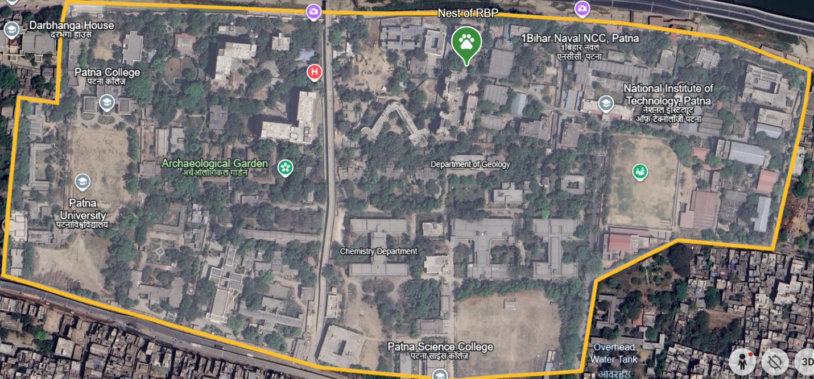
2.1. Study Site Description and Floral Resources
Figure 1. Geospatial distribution and nesting site of P.alexandri within the urban institutional matrix of Patna, Bihar, India.
The sighting occurred within the campus of the National Institute of Technology (NIT), Patna (26.621311, 85.170201) (Figure.1) which functions as a concentrated "Green Island" within the highly urbanized PMA. While the overall urban area has seen significant habitat loss, the institutional campus maintains an important reservoir of mature vegetation Kadam tree (Neolamarckia cadamba (Roxb.) (Bosser, 1984) which is a large, rapidly growing tropical tree known to provide extensive canopy cover and is an established nesting site for various avian species in India (Singh et al., 2023; Pandian, 2021). Table 1 shows the coordinates of key places of study area. Patna University main campus and Patna Science College are included to know the potential sites where RBP can be found foraging or perching.
Table 1. Geographic coordinates & details of Study area.
Study Site | Latitude (N) | Longitude (E) | Elevation (m) | Habitat Type
Patna University (Main Campus) | 25.6199° | 85.1653° | ~53m | Urban Institutional Green Space
Patna Science College | 25.6179° | 85.1698° | ~53m | Foraging & potential dispersal corridor
NIT Patna (Ashok Rajpath) | 25.6208° | 85.1720° | ~51m | Riparian Urban Corridor (Ganges Bank)
Sighting Point: Kadam Tree Site | 25.6213° | 85.1702° | ~52m | Fragmented Urban Matrix

While the overall urban area has seen significant habitat loss, the institutional campus maintains an important reservoir of mature vegetation Kadam tree (Neolamarckia cadamba (Roxb.) (Bosser, 1984) which is a large, rapidly growing tropical tree known to provide extensive canopy cover and is an established nesting site for various avian species in India (Singh et al., 2023; Pandian, 2021).
Climatic Characteristics of the Patna Region:
Patna features a Humid Subtropical Climate. During the study period (Nov–Dec 2025), the region typically experiences mean temperatures of 18°C to 25°C, with nocturnal minimums dipping to 7°C–10°C. The study coincides with the "Post-Monsoon/Winter" transition. This period is characterized by low relative humidity and minimal rainfall (averaging <10mm/month), which influences the fruiting phenology of N. cadamba (Kadam). The stable temperatures during these months likely facilitate the survival of P. alexandri (a species typically found in the humid sub-Himalayan tracts) within the urban heat island of Patna.
The documented presence of this specific tree species and other key resources, such as Ficus religiosa and Mangifera indica, confirms the availability of both reliable nesting substrates and foraging resources necessary to support a psittacid population (Pandian, 2021).

2.2 Observation Techniques and Ethical Standards
Fieldwork followed the ethical guidelines for non-invasive avian research. Observations were conducted using the “Fixed-radius point count” method (Richard et al., 1986).
For each sighting, we recorded:
Group Size: To determine if the birds were solitary or social.
Interaction Type: Categorized as neutral, aggressive (intra/interspecific), or cooperative.
Video Recording: Vocalizations were recorded using a smartphone and camera which further distinguishes the calls from different parakeets which are frequently observed in the region like Rose-ringed parakeets.
Data Validation:
Photographic evidence was cross-referenced with the “eBird” database and “iNaturalist” to verify that no prior verified sightings had occurred in the same micro-locality. Taxonomic identification and sexual dimorphism were independently validated through expert morphological analysis of high-resolution photographic evidence, confirming diagnostic plumage and bill characteristics.
2.3. Primary Data Documentation Protocol

The documentation of this extra-limital sighting was conducted adhering to established ornithological standards for rare species reporting, which requires meticulous and complete observational details to ensure scientific validity (Cornell Lab, 2025; BirdLife International, 2024).
Essential documented information includes:
- Species and Count: Four individuals (P. alexandri), observed as two pairs.
- Date, Location & Equipment: 4th November to 10th December 2025, NIT Patna Campus (26.621311, 85.170201), Camera used: Sony DSC-HX400V & Kodak AZ241.
- Specific Habitat/Nesting Site: Confirmed use of a burrow (cavity) in a Kadam tree (N. cadamba) as a nest.
- Interspecific Interactions: Noted aggressive competition with other avian species at the nesting site.
- Co-occurring Congeners: Presence of 10–15 Rose-ringed Parakeets (Psittacula krameri) on the same Kadam tree, with one or more individuals also utilizing a separate burrow/cavity on the same tree.
This specific detail of an occupied nest (burrow) on the Kadam tree is classified as a high level of breeding certainty (Adult Entering, Occupying, or Leaving Nest Site—AE) and validates the conclusion of local establishment (Cornell Lab, 2025).

III. Observation and Competition Dynamics

3.1. Chronological Log of P. alexandri Sightings

Table 2: Chronological Sighting Log and Behavioural Dynamics of P.alexandri at NIT Patna Campus (2025)
Date | Time Period | Observation Details | Individuals | Behaviour/Activity
04 Nov | 14:30 | Initial detection via distinct vocalization. | 1 Female | Perching on Neolamarckia cadamba (Kadam)
05 Nov | 14:00 – 16:30 | Secondary sighting at same location. | 1 Female | Foraging/Perching
12 Nov | 07:30 | First male-female pair observation. | 1 Pair (M/F) | Social interaction
13–15 Nov | 07:30 & 14:00 | Frequent diurnal sightings. | 1 Pair (M/F) | Male (Morning); Female (Noon)
16 Nov | 14:45 – 15:15 | Mating ritual observed. | 1 Pair (M/F) | Copulation on nearby trees; frequent return to Kadam
19 Nov | 07:00 – 08:30 | Second pair arrival. | 2 Pairs | Gregarious behaviour
20 Nov | 14:00 | Occupation of tree cavity. | 1 Pair | Entering/Exiting Kadam tree burrow
21 Nov – 05 Dec | 07:00 – 08:30 & 14:30 – 16:00 | Stable presence/Monitoring. | At least 1 Pair | Consistent occupancy of nesting site

3.2. Sighting Details and Breeding Confirmation

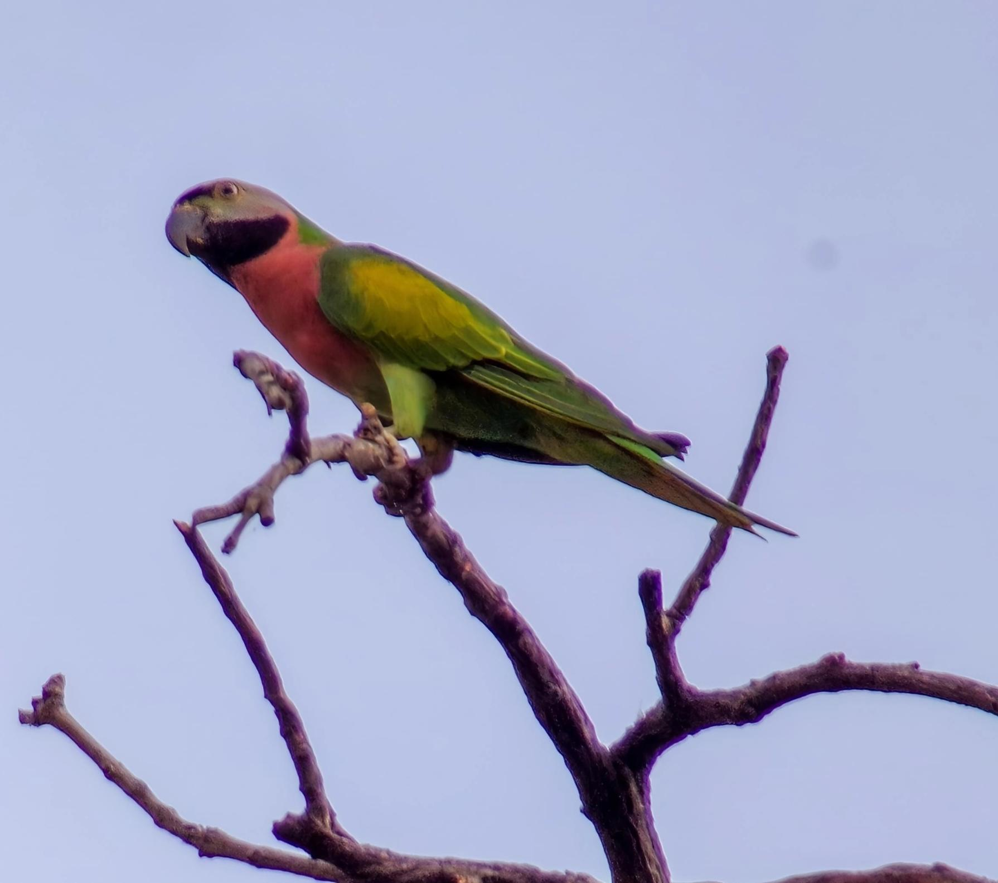
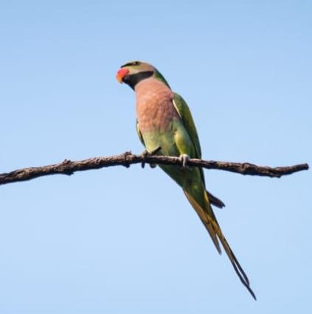
The four Red-breasted Parakeets were observed in close association, confirmed as two distinct pairs, suggesting reproductive synchrony. The time of observation was noted for the male was initially in the morning at 7:30 to 9:00 4th November 2025 (Table.2). The female usually observed in the noon roosting the Kadamb tree and the nearby Mango tree 2:30 to 4:30 4th November 2025. After that the male was also seen at noon together with the female in noon 2:00 to 3:30 10th December, 2025. They are currently getting habituated with the surrounding and easily observed in the noon near their burrow. Identification was confirmed by the species' diagnostic morphological features (Figure 2), notably the large, salmon-pink breast patch and the uniform grey-blue head (Yadav et al., 2025; Linnaeus, 1758). Sexual dimorphism was noted by the presence of a red upper bill in males and a black upper bill in females.
Figure 2.B. Female
Figure 2.A. Male
Figure 2. Diagnostic morphological markers of sexual dimorphism in P.alexandri.
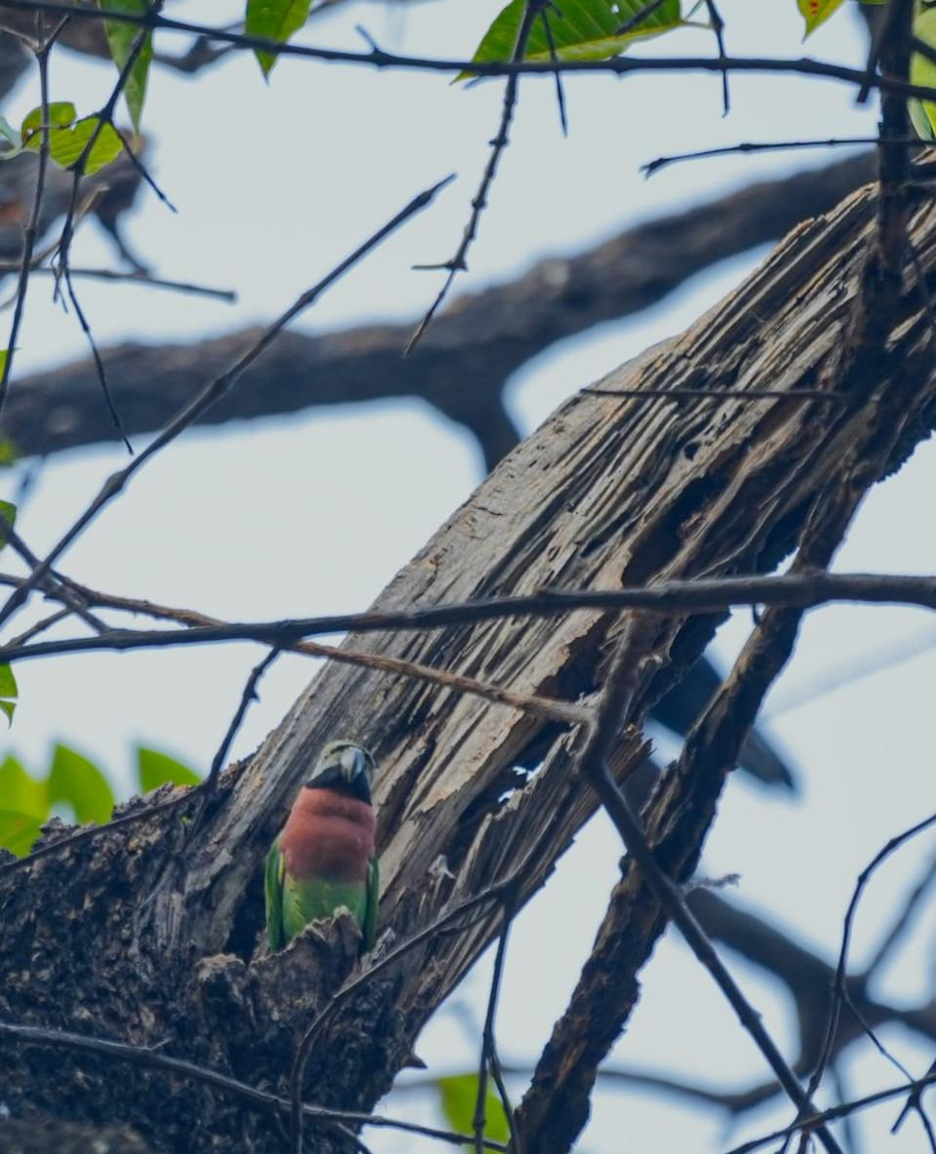
The most critical primary observation was the use of a natural burrow/cavity in the trunk of a Neolamarckia cadamba (Kadam) tree as a nest site (Figure 3). This direct evidence of nesting, coupled with the observation of two established pairs, provides definitive proof of a functional, reproductively active population (Cornell Lab, 2025).
Figure 3. Nest-site selection and cavity occupancy by P.alexandri in Neolamarckia cadamba.

3.2. Competition for Resources: Psittacid Congeners and Predation Risk
The concentration of both P. alexandri and a larger group of 10–15 P. krameri on the same Kadam tree highlights the immediate and intense pressure on limited resources in this urban green space. Both species are obligate cavity-nesters, and their simultaneous presence on the same tree, both utilizing burrows, indicates active interspecific competition for vital nesting sites (Dodaro & Battisti, 2014). Psittacula species are known to be competitively superior cavity-nesters, capable of displacing smaller native hole-nesting birds (Strubbe et al., 2009). Furthermore, competition has been documented between these two specific invasive congeners; in Singapore, P. alexandri has been recorded as increasing in frequency and slowly replacing the feral P. krameri population (Soh et al., 2024). The Patna sighting provides a snapshot of this competitive dynamic at the moment of establishment.
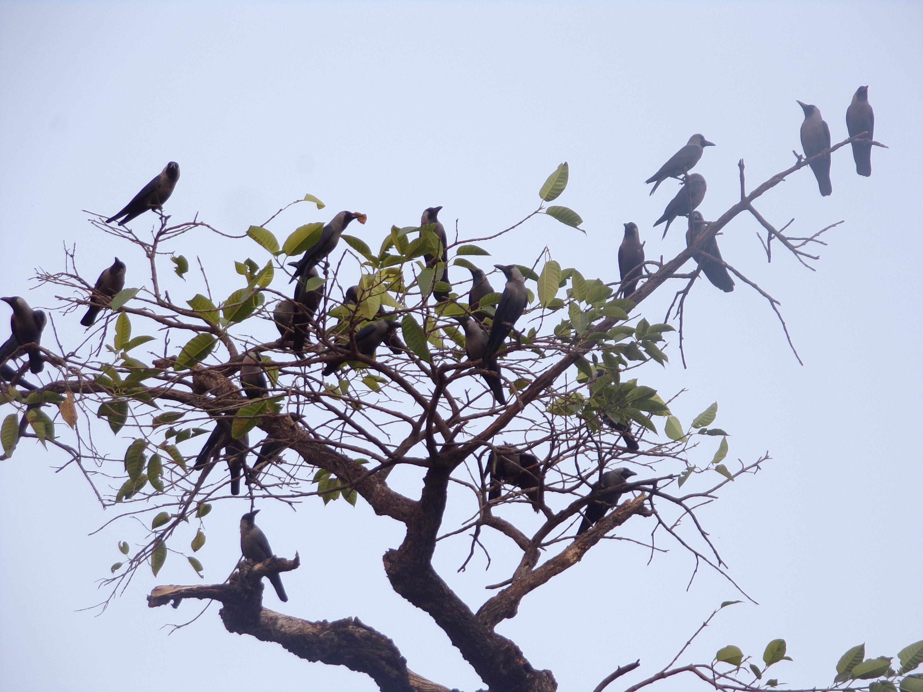
Interference competition and active displacement, with Corvus splendens exhibiting agonistic behaviours toward P. alexandri. The crows gather in a group near the burrow of parakeets (Figure 4). This interaction introduces the risk of predation and harassment by the House Crow (Corvus splendens), an urban invasive known to actively attack, harass, and prey upon the eggs and nests of native and introduced bird species, which poses a significant threat to the successful fledging of young parakeets (Ryall, 1992).
Figure 4. Interspecific competition and nest-site harassment by C.splendens.

IV. Discussion: Biogeographical Origin and Establishment Dynamics

4.1. Feral Origin Hypothesis
The geographically isolated nature of the Patna population, separated from the continuous native range in Northern Bihar, strongly argues against a natural range expansion (Choudhury, 2016). As confirmed feral populations of P. alexandri are already established in distant Indian cities like Mumbai and Chennai, the evidence overwhelmingly supports the hypothesis that the Patna population originated from escaped individuals associated with the ubiquitous pet trade (Linnaeus, 1758; John et al., 2016). Despite regulatory efforts, illegal capture and commerce persist, providing a constant source population for such urban introductions.

4.2. Ecological Implications of Successful Breeding
The successful nesting on the Kadam tree confirms the population has moved beyond a transient phase and is ecologically established. This success is directly linked to the availability of mature trees, such as the Neolamarckia cadamba, which provide the necessary large, robust cavities for nesting—a resource severely limited in the rapidly deforested surrounding urban matrix (Strubbe et al., 2009). The confirmed breeding of an alien parakeet in Patna mandates a local assessment of its status as an Alien Invasive Species. The ecological impacts will intensify with population growth, specifically through:
- Resource Competition: Direct competition with both the highly successful feral Rose-ringed Parakeet (P. krameri) and native hole-nesting avifauna for limited tree cavities (Dodaro & Battisti, 2014; Soh et al., 2024).
- Seed Ecology Alteration: Psittacula species play a dual role as both seed dispersers and destructive seed predators. Their consumption patterns, recorded as the removal of entire unripe fruits, can reduce the overall food resource base for native frugivores, potentially disrupting urban seed dispersal networks (Soh et al., 2024).
- Predation/Stress: The observed harassment by crows introduces a continuous source of stress and nest-site failure, which may regulate the initial growth of this nascent P. alexandri population (Ryall, 1992).
​4.4 Interspecific Competition and the "Urban Bully" Hypothesis
​One of the most significant ecological challenges faced by the Red-breasted Parakeet (Psittacula alexandri) in Patna is the presence of the House Crow (Corvus splendens). During our observations, we recorded multiple instances of "mobbing" and aggressive displacement. The House Crow is a notorious generalist and a highly territorial "urban adaptor" that often views any new, colourful, or vocal avian species as a threat or a target for kleptoparasitism (Ryall, 1992). In Patna, the crows were observed dive-bombing the parakeets while they attempted to feed on the Neolamarckia cadamba fruits.
This form of interference competition has several physiological costs:
​Reduced Foraging Efficiency: The parakeets are forced to spend more time in "vigilance" and less time in "consumption."
​Energy Expenditure: Frequent take-offs and evasive manoeuvres significantly deplete the energy reserves of the parakeets, which is particularly dangerous during the colder winter months.
​Nest-Site Competition: While we did not confirm nesting, the scarcity of suitable tree cavities in Patna means that parakeets must compete not only with crows but also with the aggressive Rose-ringed Parakeet (P. krameri) and the Common Myna (Acridotheres tristis) for limited reproductive space.
​The fact that P. alexandri continues to persist in these sites despite such intense pressure suggests a high degree of "urban resilience." This resilience may be bolstered by the parakeets' communal roosting habits, which allow for better predator detection and collective defence.
​4.5 Anthropogenic Noise and Acoustic Adaptation
​Urban Patna is characterized by significant noise pollution, primarily from vehicular traffic along the Ganga Path and residential construction. Our preliminary analysis of the parakeets' vocalizations suggests that they may be adjusting the frequency and amplitude of their calls to be heard over the urban "noise floor." This "Lombard Effect"—where birds increase their vocal effort in noisy environments—is common in urban-adapted psittacids. A failure to communicate effectively could lead to the fragmentation of the small group (maximum 4 individuals) we observed, as they rely on contact calls to stay together during foraging flights.
​4.6 Conservation Implications: The "Patna Population" as a Genetic Ark?
​Given the "Near Threatened" status of P.alexandri on the IUCN Red List (IUCN, 2025), the emergence of any population outside its traditional range carries profound conservation significance. This sighting in Patna presents a dual hypothesis regarding its origin, both of which necessitate specialized management strategies.
If the Patna individuals are derived from escaped pets, they represent a "captive-to-feral" transition. While often viewed through the lens of invasive species biology, such populations in urban centres can function as an ex-situ reservoir of the species' genetic material. In an era of rapid habitat loss in the North-east, these "accidental" urban colonies may provide a hedge against extinction, preserving genetic diversity that is currently under threat in the wild (Edelaar et al., 2015). Conversely, if this represents a natural range expansion—potentially driven by the degradation of sub-Himalayan Forest corridors—it indicates a critical behavioural shift where the species is prioritizing urban refugia over their native, increasingly fragmented habitats (Prugh et al., 2008). In this context, urban Patna ceases to be a mere city and becomes a vital landscape for avian range-shifting under climate change.
To safeguard this incipient population, local government and university administrations must move beyond passive observation and implement active conservation protocols:
1. Green-belt Protection and Flora Management
The survival of P. alexandri in Patna is intrinsically linked to the presence of old-growth "heritage trees," particularly Ficus religiosa and Neolamarckia cadamba. Institutional administrations must implement strict prohibitions on the felling of these mature trees. Beyond providing seasonal fruit, these trees offer high-altitude nesting cavities that are vital for the reproductive success of secondary hole-nesters (Sengupta et al., 2013). The preservation of these trees aligns with the concept of "reconciliation ecology," where anthropogenic landscapes are modified to support wild species without hindering human utility (Rosenzweig, 2003).
2. Public Awareness and Community Stewardship
The vulnerability of these birds to poaching and harassment in a high-density urban area cannot be overstated. A "Campus Biodiversity Stewardship" program should be established at Patna University and NIT Patna. Educational campaigns, informed by social-ecological research, have been proven to reduce the "persecution" of urban wildlife (Liu et al., 2021). By framing these parakeets as "Flagship Species" for Patna's urban heritage, the local community can be transformed into a citizen-scientist network that monitors the birds and reports illegal trapping activities to the Forest Department (Singh et al., 2023).
V. Limitations and Future Scope
While this study provides the first documented evidence of P. alexandri in the urban landscape of Patna, it is subject to several methodological constraints that define the trajectory for future research. Primarily, the short temporal scale of the observation period (November 2025 to December 2025) limits our understanding of the population's seasonal phenology. Furthermore, the absence of molecular data prevents a definitive conclusion regarding the genetic provenance of these individuals—whether they are natural range-shifters or escapees from the illegal wildlife trade.
To address these gaps and provide a robust framework for urban avian conservation in Bihar, future research must focus on the following three pillars:
5.1 Molecular Analysis and DNA Barcoding
The taxonomic complexity of the P. alexandri group, which comprises eight recognized subspecies, necessitates the use of molecular phylogenetics to determine the origin of the Patna population. Future studies should employ non-invasive DNA sampling, such as collecting molted feathers or faecal matter, to perform DNA barcoding using mitochondrial markers like cytochrome b (Cytb) and NADH dehydrogenase subunit 2 (ND2) (Kundu et al., 2012). This approach would allow researchers to trace the birds back to their geographic origins—distinguishing between the Himalayan subspecies (P. a. fasciata) and Southeast Asian variants often found in the pet trade—thereby resolving the "natural expansion vs. feral escapee" debate (Jackson et al., 2015).
5.2 Long-term Monitoring of Breeding Biology
Current observations were restricted to the winter months, providing no data on the reproductive success of the species in co-limital zone. The breeding window for Psittacula species in the Indian subcontinent typically aligns with the pre-monsoon and monsoon seasons (Ali & Ripley, 1987). Continuous monitoring is required to document active nesting in tree cavities and to evaluate fledgling survival rates in the face of interspecific competition with House Crows (Corvus splendens) and Rose-ringed Parakeets (P. krameri). Understanding these breeding dynamics is essential to determine if the Patna sighting represents a "sink population" or a self-sustaining "source population" (Prugh et al., 2008).
5.3 Telemetry and Spatial Ecology
To understand how these birds navigate the fragmented urban matrix of Patna, the use of high-resolution tracking technology is imperative. GPS tagging or radio telemetry would provide critical insights into their diurnal movement patterns between the riparian corridors of the Ganges and the inland "institutional green islands" like Patna University and NIT Patna. Such data would reveal their habitat preference, home range size, and the "bottleneck" areas where they are most vulnerable to anthropogenic stressors. Furthermore, telemetry can help identify the specific corridors used for extra-limital dispersal, providing a blueprint for regional conservation planning (John et al., 2016).
VI. Conclusion
This report validates the first confirmed record of a breeding population of the Near Threatened Red-breasted Parakeet (P. alexandri) in Patna, Central Bihar, resting on the direct observation of a nest in a Kadam tree (N. cadamba). This disjunct population is almost certainly feral in origin. The incipient establishment of P. alexandri in Patna is a testament to the adaptive plasticity of psittacids. While the urban environment poses significant threats—from aggressive crows to anthropogenic noise—the presence of mature fruiting trees on university campuses provides a viable “lifeboat” for this Near Threatened species. This sighting should serve as a wake-up call for urban planners in Bihar to integrate avian conservation into the development of “Smart Cities,” ensuring that urban growth does not come at the cost of biological diversity. Given the ecological pressures from congeners (P. krameri) and generalized predators (Corvus splendens), immediate, targeted monitoring is required. Scientific action should focus on establishing a long-term observational program to quantify the population’s growth rate and assess the degree of competitive interference with native cavity-nesting species, ensuring this record contributes proactively to conservation and management planning for Patna’s urban avifauna.

Ethical Approval:

As per international standards or university standards written ethical approval has been collected and preserved by the author(s).

Disclaimer (Artificial intelligence)

Option 2:
Author(s) hereby declare that generative AI technologies such as Large Language Models, etc. have been used during the writing or editing of manuscripts. This explanation will include the name, version, model, and source of the generative AI technology and as well as all input prompts provided to the generative AI technology
Details of the AI usage are given below:
1. Spell check (Chat GPT)
2.Grammatical corrections (Claude a.i)
3. Rephrasing and condensing sentence length (Gemini and perplexity)

References
- Ali, S., & Ripley, S. D. (1987). Compact handbook of the birds of India and Pakistan: Together with those of Bangladesh, Nepal, Bhutan and Sri Lanka (2nd ed.). Oxford University Press.
- BirdLife International. (2024). Handbook of the Birds of the World and Bird Life International digital checklist of the birds of the world. Version 9. Accessed on 10th Mar 2025.
- BirdLife International. (2017). Psittacula alexandri (amended version of 2016 assessment). The IUCN Red List of Threatened Species. https://doi.org/10.2305/IUCN.UK.2017-1.RLTS.T22685505A111371703.en
- Bosser, J. (1981). 108. Rubiacées. In Flore des Mascareignes, La Réunion, Maurice, Rodrigues. Sugar Industry Research Institute; O.R.S.T.O.M.; Royal Botanic Gardens, Kew. https://books.google.com/books?id=2_0_AQAAIAAJ.
- Choudhury, A. (2016). Bird observations from Valmiki Tiger Reserve, Bihar. Indian BIRDS, 11(3), 57–63.
- Convention on International Trade in Endangered Species of Wild Fauna and Flora, Mar. 3, 1973, 993 U.N.T.S. 243. https://cites.org/eng/app/appendices.php.
- Cornell Lab of Ornithology. (2025). How to document your sightings. eBird Support. https://support.ebird.org/en/support/solutions/articles/1000074890-how-to-document-your-sightings
- Dodaro, G., & Battisti, C. (2014). Rose-ringed parakeet (Psittacula krameri) and starling (Sturnus vulgaris) syntopics in a Mediterranean urban park: evidence for competition in nest-site selection?. Belgian Journal of Zoology, 144(1), 5–14. https://doi.org/10.26496/bjz.2014.61
- Edelaar, P., Roques, S., Hobson, E. A., Gonçalves da Silva, A., Avery, M. L., Russello, M. A., Senar, J. C., Wright, T. F., Carrete, M., & Tella, J. L. (2015). Shared genetic diversity across the global invasive range of the monk parakeet suggests a common restricted geographic origin and the possibility of convergent selection. Molecular ecology, 24(9), 2164–2176. https://doi.org/10.1111/mec.13157
- Guthula, V. B., Shrotriya, S., Nigam, P., Goyal, S. P., Mohan, D., & Habib, B. (2022). Biodiversity significance of small habitat patches: More than half of Indian bird species are in academic campuses. Landscape and Urban Planning, 228, 104552. https://doi.org/10.1016/j.landurbplan.2022.104552
- IUCN. (2025). The IUCN Red List of Threatened Species. Version 2025-2. IUCN. https://www.iucnredlist.org
- Jackson, H., Strubbe, D., Tollington, S., Prys-Jones, R., Matthysen, E., & Groombridge, J. J. (2015). Ancestral origins and invasion pathways in a globally invasive bird correlate with climate and influences from bird trade. Molecular ecology, 24(16), 4269–4285. https://doi.org/10.1111/mec.13307
- John, L., Gopalan, S.V., Priyanka, S., & Laladhas, K.P. (2016). Sighting of Red-breasted Parakeet Psittacula alexandri (Linnaeus, 1758) (Psittaciformes: Psittaculidae) from Vellayani, Thiruvananthapuram, Kerala, India. Journal of Threatened Taxa, 8(4), 8732–8735. https://doi.org/10.11609/jott.2201.8.4.8732-8735
- Kundu, S., Jones, C. G., Prys-Jones, R. P., & Groombridge, J. J. (2012). The evolution of the Indian Ocean parrots (Psittaciformes): extinction, adaptive radiation and eustacy. Molecular Phylogenetics and Evolution. https://doi.org/10.1016/j.ympev.2011.09.025
- Linnaeus, C. (1758). *Systema Naturae per Regna Tria Naturae, Secundum Classes, Ordines, Genera, Species, cum Characteribus, Differentiis, Synonymis, Locis* (10th ed.). Impensis Laurentii Salvii. https://www.biodiversitylibrary.org/item/10277
- Liu, J., Zhao, Y.-P., Si, X., Feng, G., Slik, F., & Zhang, J. (2021). University campuses as valuable resources for urban biodiversity research and conservation. Urban Forestry & Urban Greening. https://doi.org/10.1016/j.ufug.2021.127255
- Maheswaran, G., Alam, I., Majumder, A., & Naskar, A. (2025). Significant new bird records from Valmiki Tiger Reserve, Bihar, India. Records of the Zoological Survey of India, 125(3), 255–278. https://doi.org/10.26515/rzsi/v125/i3/2025/172944
- Pal, M., Pop, P., Mahapatra, A., Bhagat, R., & Hore, U. (2018). Diversity and Structure of bird assemblages along urban-rural gradient in Kolkata, India. Urban Forestry & Urban Greening. https://doi.org/10.1016/j.ufug.2018.11.005
- Mitra, A., Chatterjee, S., Sarkar, M., & Gupta, D. K. (2020). Toxic effects of pesticides on avian fauna. Environmental Biotechnology Vol. 3, 55-83. https://doi.org/10.1007/978-3-030-48973-1_3
- Nagendra, H., & Gopal, D. (2011). Tree diversity, distribution, history and change in urban parks: studies in Bangalore, India. Urban Ecosystems, 14(2), 211–223. https://doi.org/10.1007/s11252-010-0148-1
- Pandian, M. (2021). Nest tree preference shown by Ring-necked Parakeet Psittacula krameri (Scopoli, 1769) in northern districts of Tamil Nadu, India. Journal of Threatened Taxa. https://doi.org/10.11609/jott.5991.13.5.18189-18199
- Prugh, L. R., Hodges, K. E., Sinclair, A. R., & Brashares, J. S. (2008). Effect of habitat area and isolation on fragmented animal populations. Proceedings of the National Academy of Sciences of the United States of America, 105(52), 20770–20775. https://doi.org/10.1073/pnas.0806080105
- Hutto, R. L., Pletschet, S. M., & Hendricks, P. (1986). A Fixed-radius Point Count Method for Nonbreeding and Breeding Season Use. The Auk, 103(3), 593–602. https://doi.org/10.1093/auk/103.3.593
- Rosenzweig, M. L. (2003). Win-win ecology: How the earth’s species can survive in the midst of human enterprise. Oxford University Press. https://doi.org/10.1093/oso/9780195156041.001.0001
- Ryall, C. (1992). Predation and harassment of native bird species by the Indian house crow Corvus splendens, in Mombasa, Kenya. Scopus, 16, 1-8. https://www.biodiversitylibrary.org/item/130706
- Sengupta, S., Mondal, M., & Basu, P. (2013). Bird species assemblages across a rural urban gradient around Kolkata, India. Urban Ecosystems. https://doi.org/10.1007/s11252-013-0335-y
- Singh, M., Kumar, P. P., Singh, H., Kumar, A. A., Kumar, A., &amp; Kumar, R. (2023). Neolamarckia cadamba: A Comprehensive review on its Physiological, Ecological, Phytochemical and Pharmacological Perspectives. Eco. Env. &amp; Cons., 29(April Suppl. Issue), S241–S250. https://doi.org/10.53550/eec.2023.v29i02s.042.
- Strubbe, D., & Matthysen, E. (2009). Experimental evidence for nest-site competition between invasive ring-necked parakeets (Psittacula krameri) and native nuthatches (Sitta europaea). Biological Conservation. https://doi.org/10.1016/j.biocon.2009.02.026
- Soh, M. C. K., Goh, M. W. X., Ng, B. X. K., Han, H. Z., Khoo, M. D. Y., Leong, D. Y. W., Lee, B. P. Y.-H., Loo, A. H. B., & Er, K. B. H. (2024). Urban bird commensals maintain coexistence under extreme food shortages. Journal of Applied Ecology, 61(11), 2822-2836. https://doi.org/10.1111/1365-2664.14776
- Whistler, H. (1949). Popular handbook of Indian birds (N. B. Kinnear, Ed.; 4th ed.). Gurney and Jackson.
- Yadav, A., Rai, D., Goyal, P., Anju Anju, Bhura, R. P., & Arya, A. K. (2025). First photographic record of Red-breasted Parakeet Psittacula alexandri (Linnaeus, 1758) (Psittaciformes: Psittaculidae) from Haryana state in India. Rivista italiana di Ornitologia – Research in Ornithology, 95(2), 1–7. https://doi.org/10.4081/rio.2025.903

Photoplates
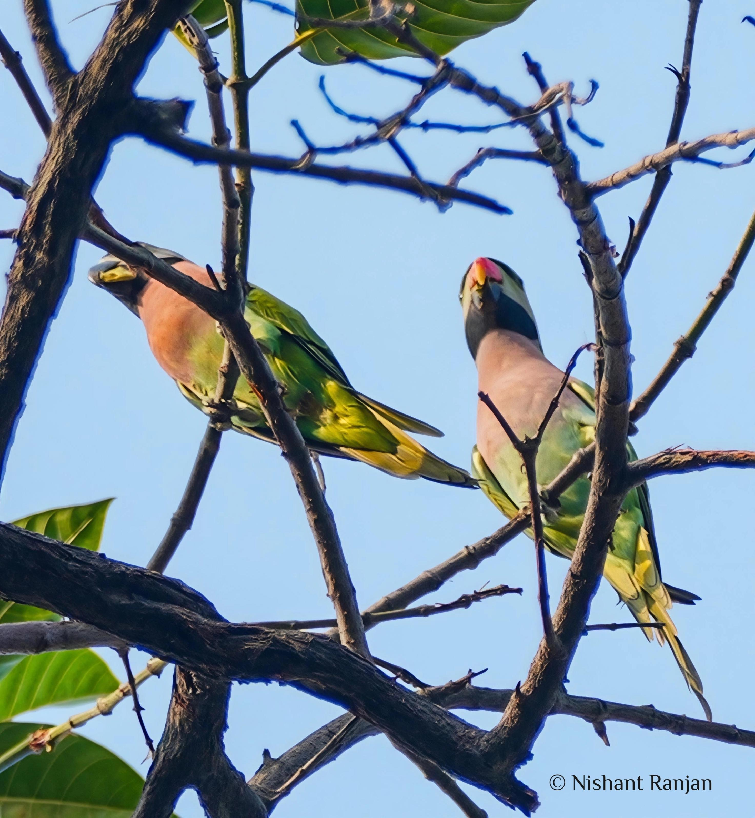
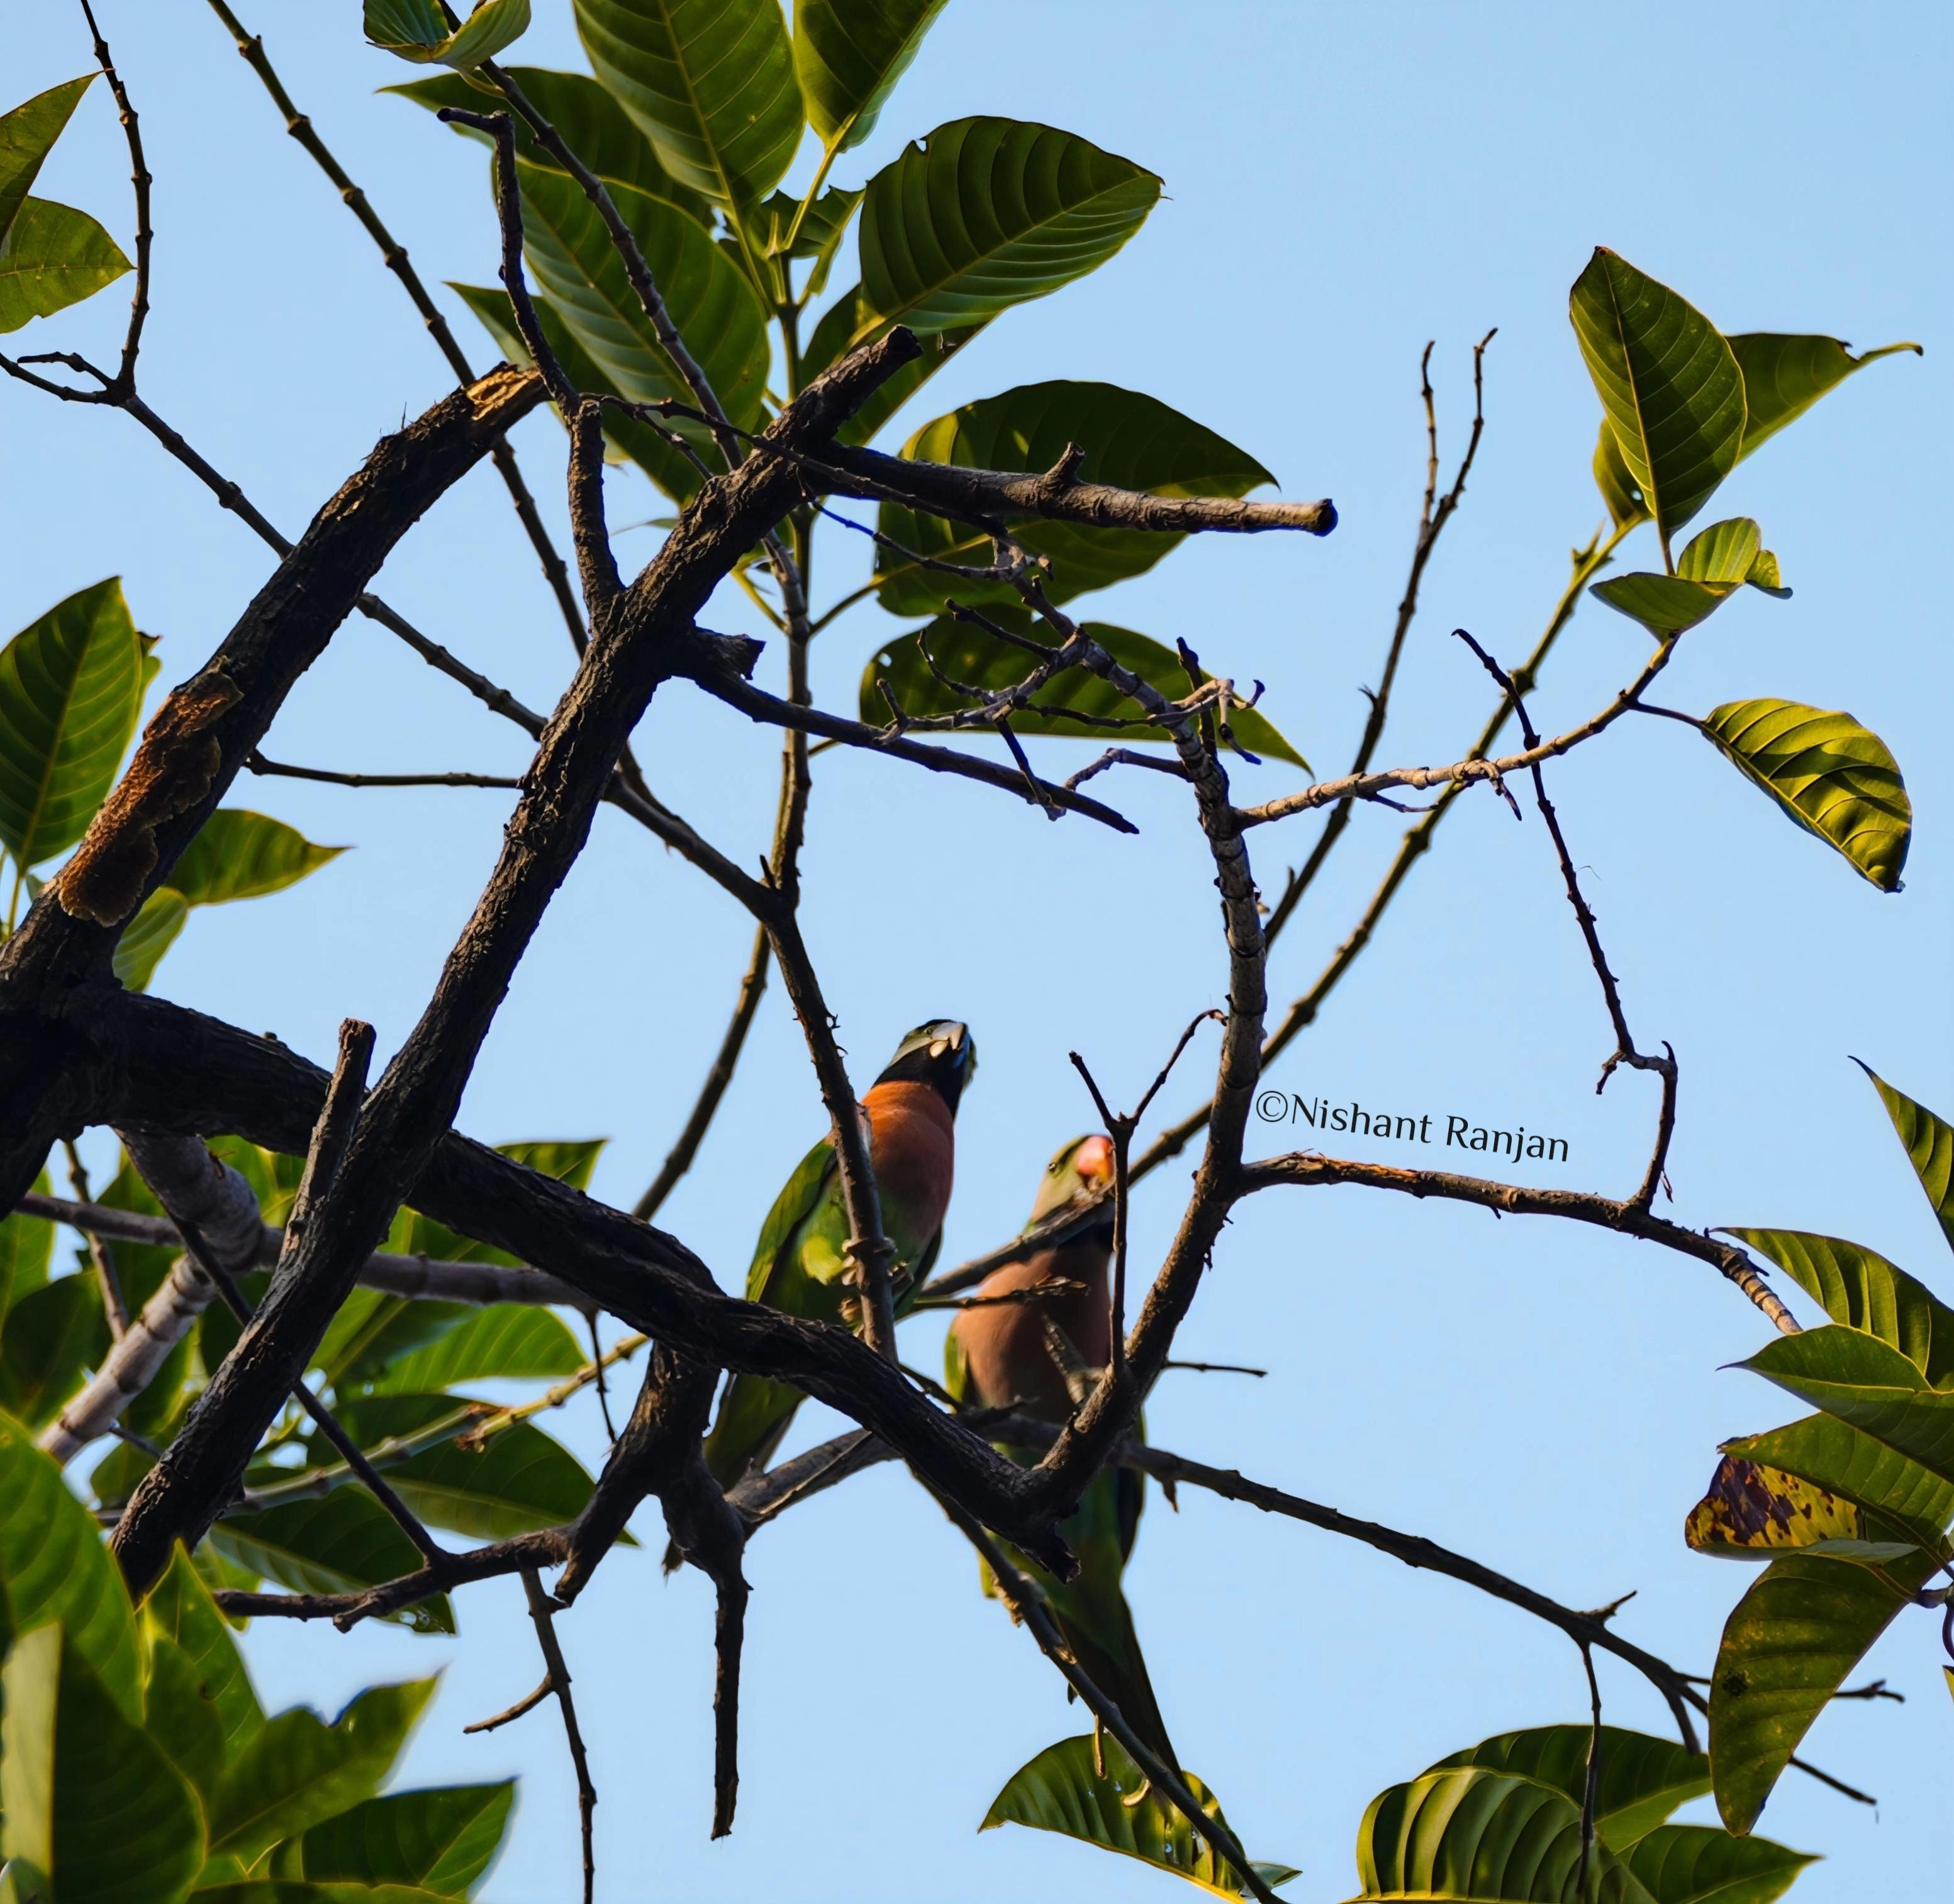
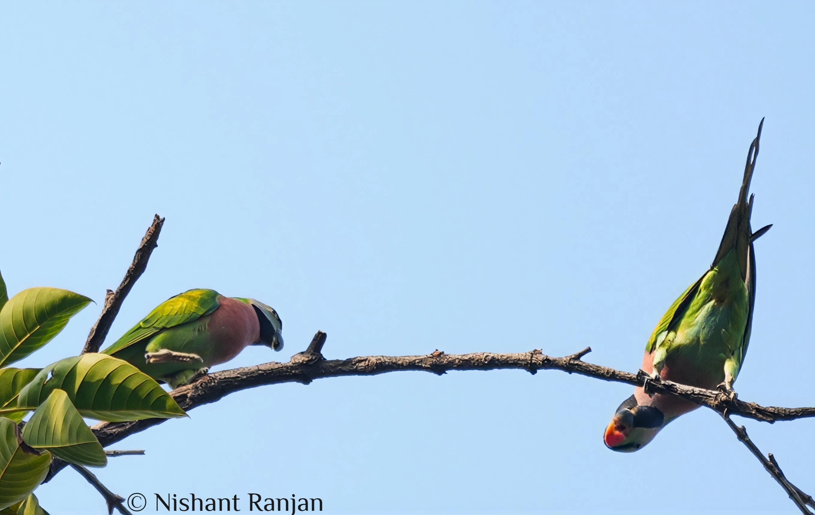
Image 1. Pair of Red-breasted parakeet on trees
Image 2 Red-breasted parakeet near and in the burrow.
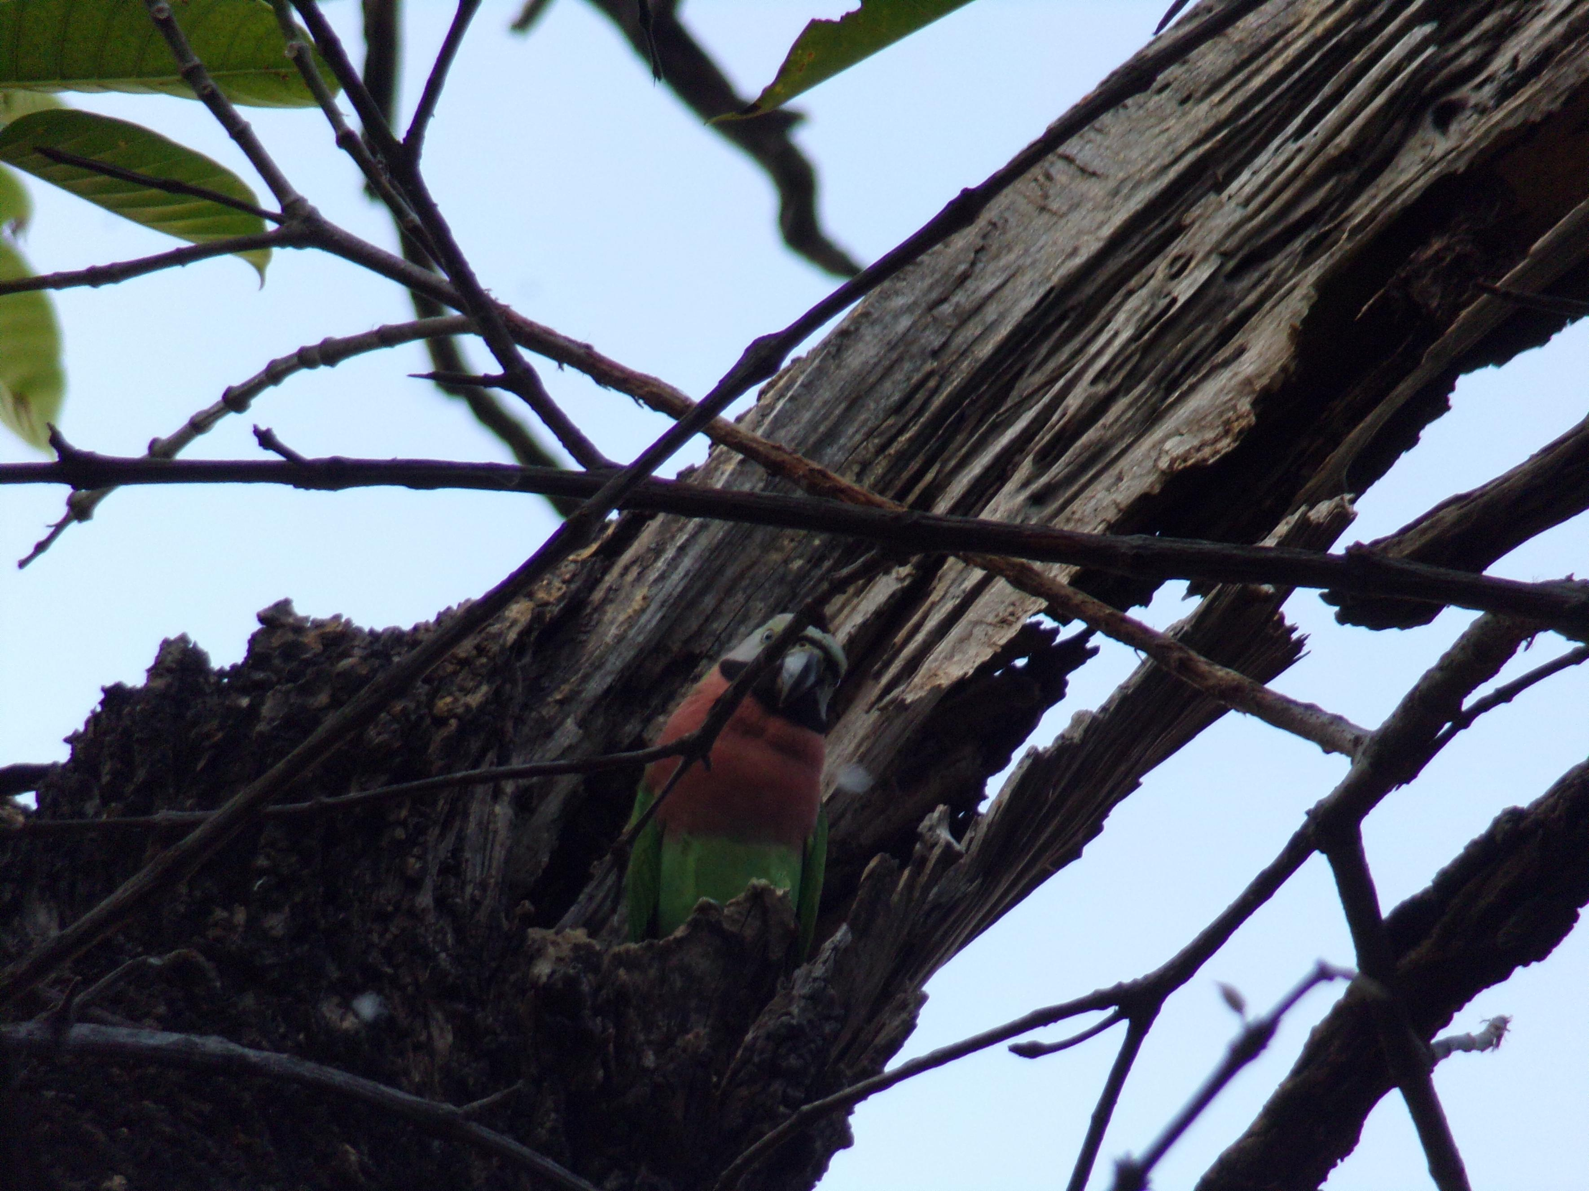
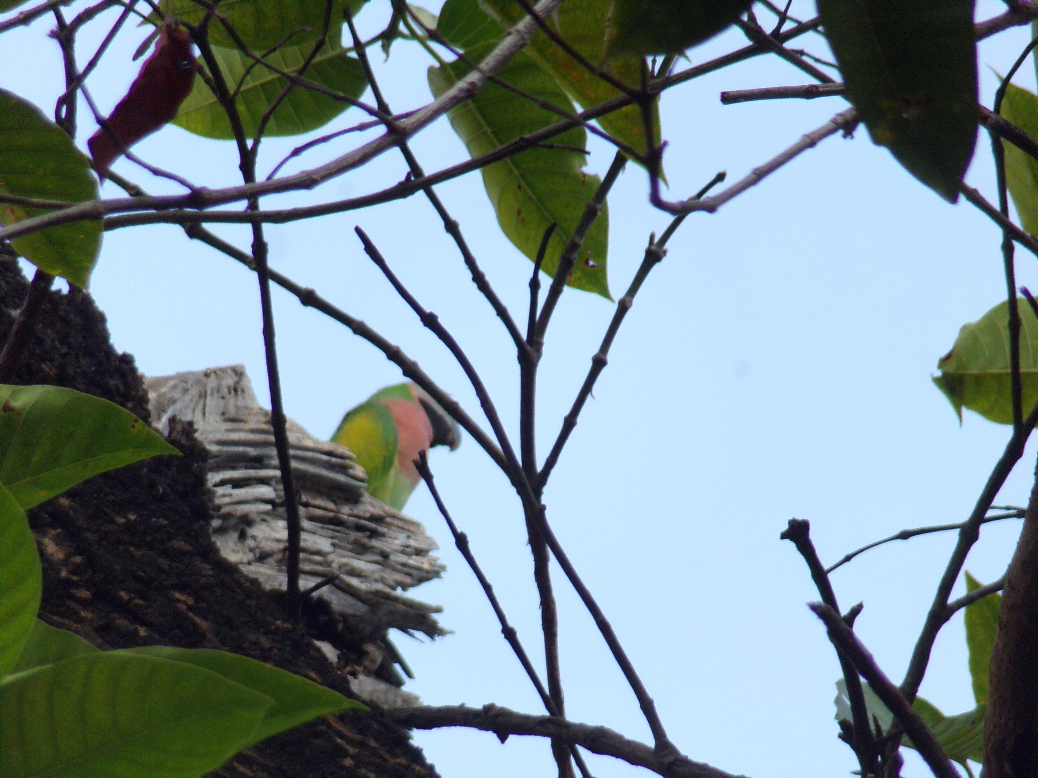

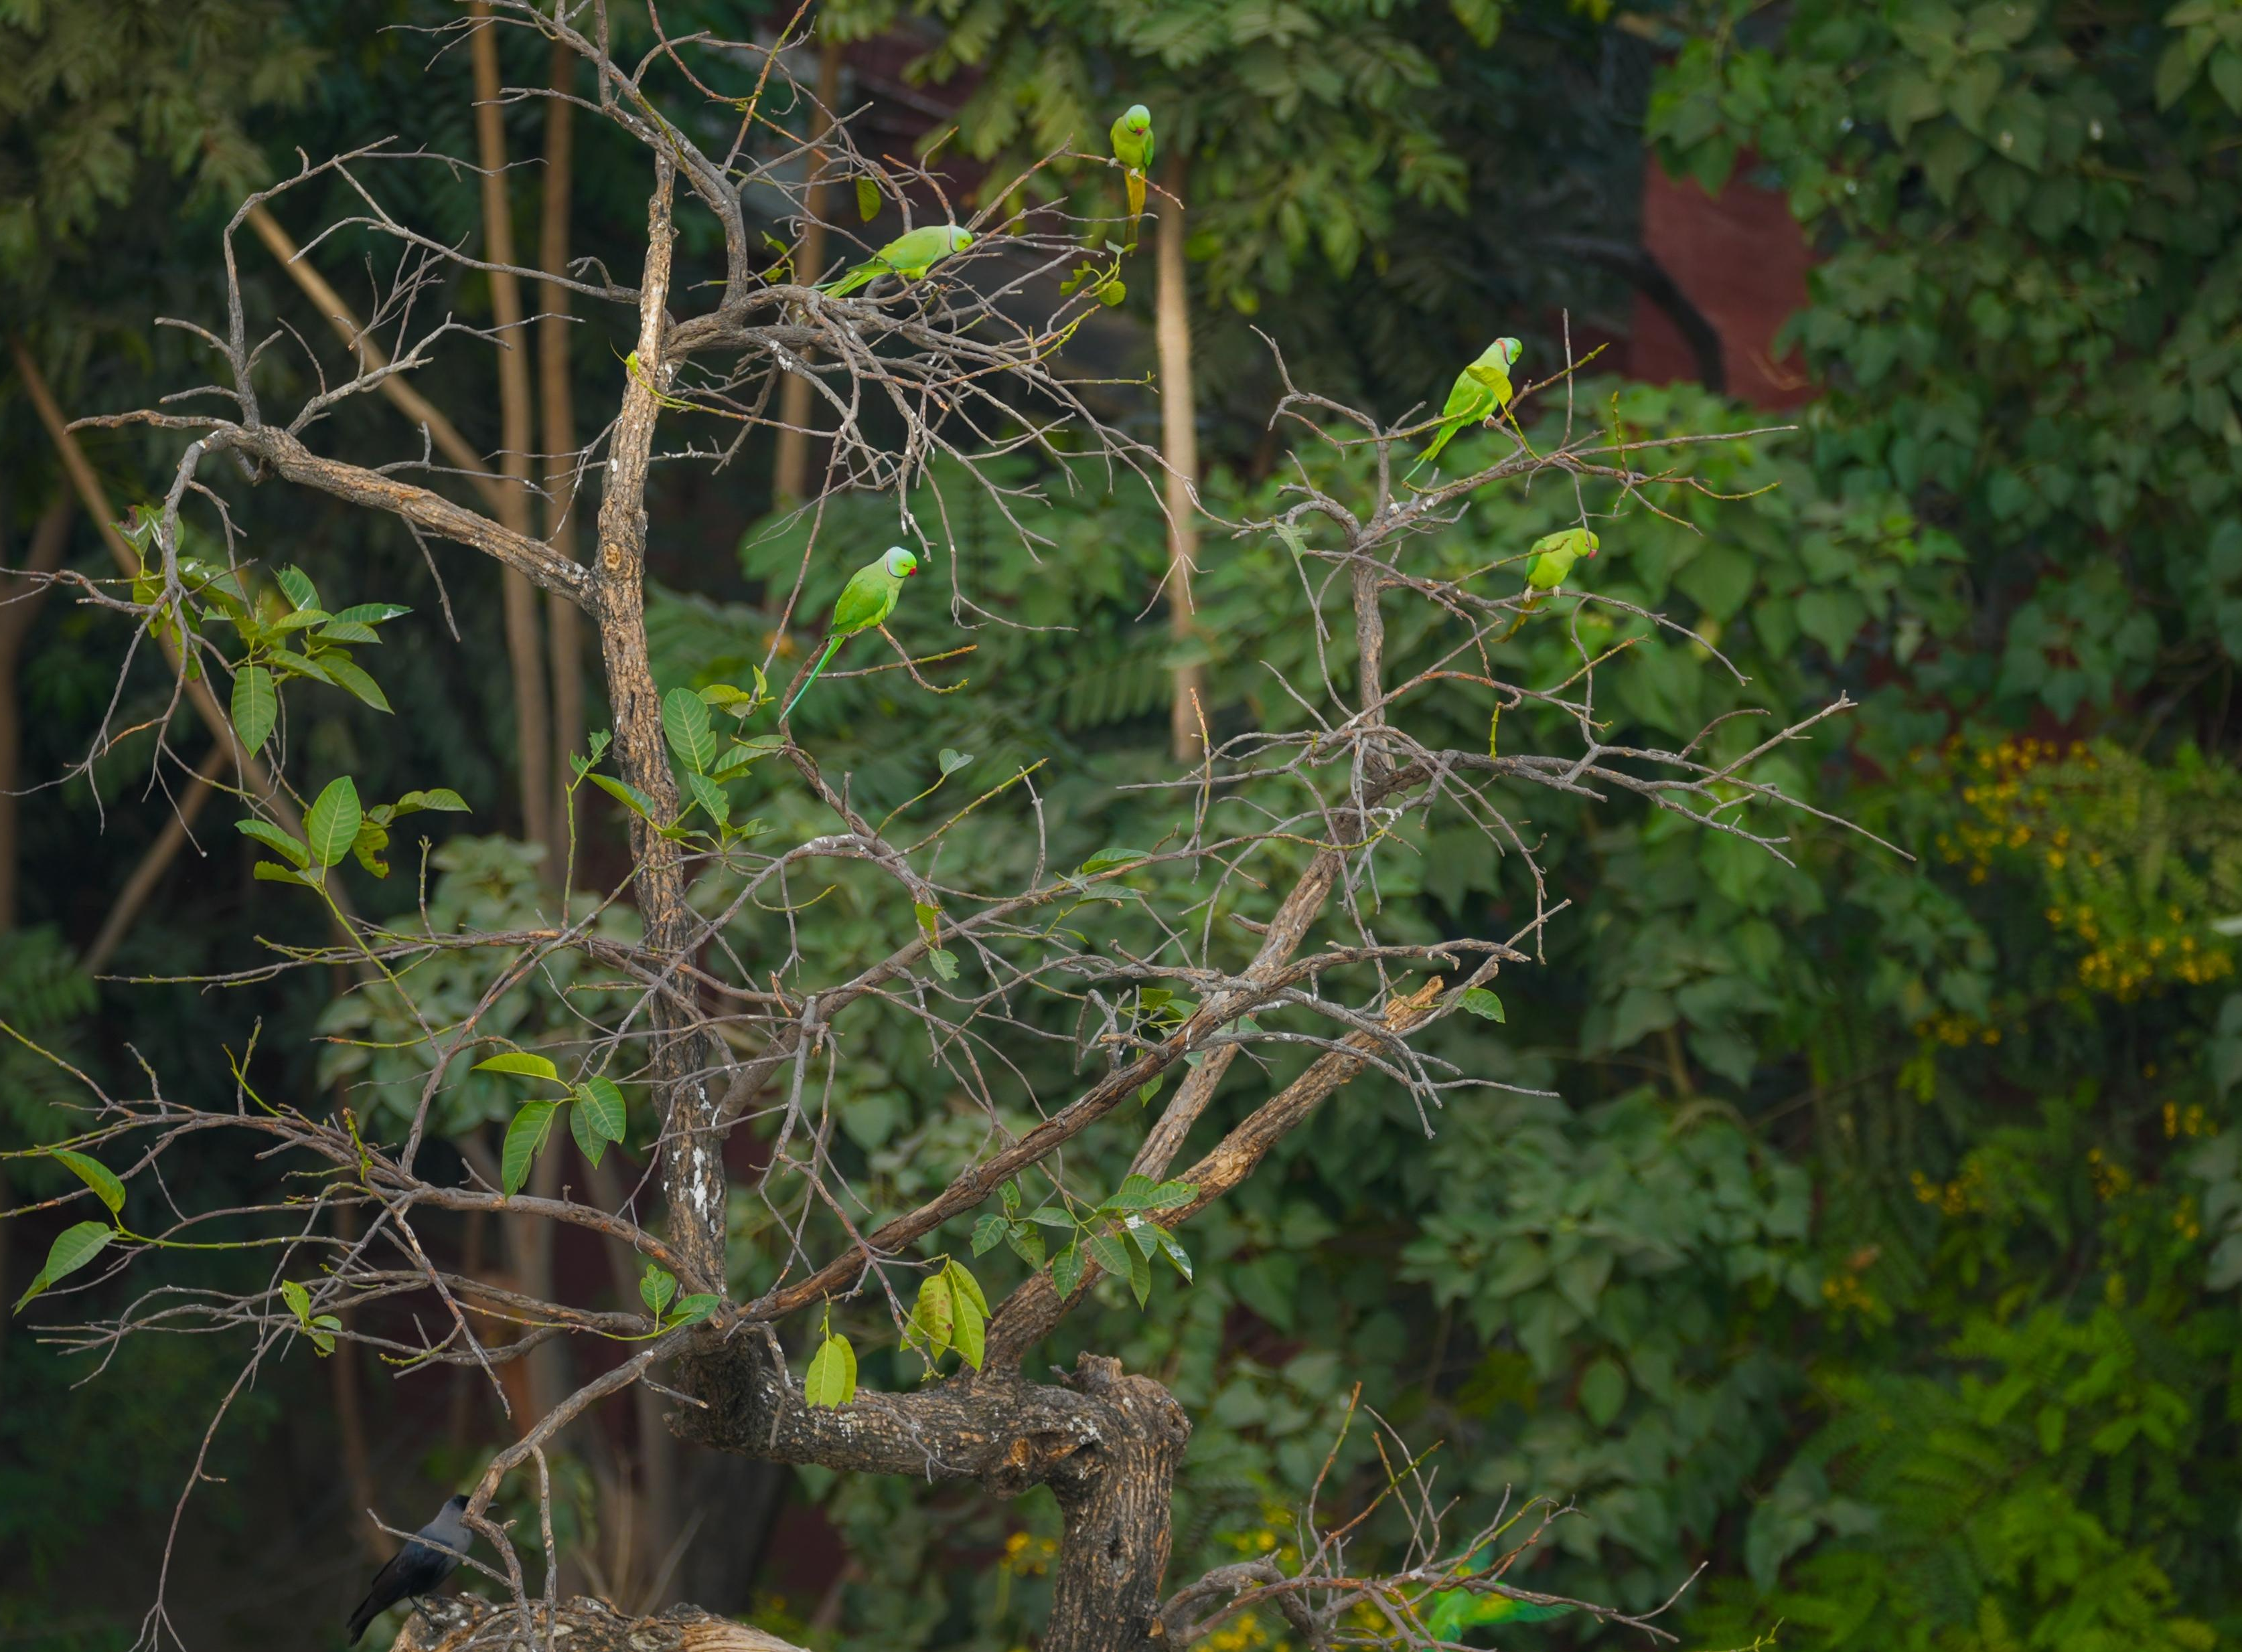
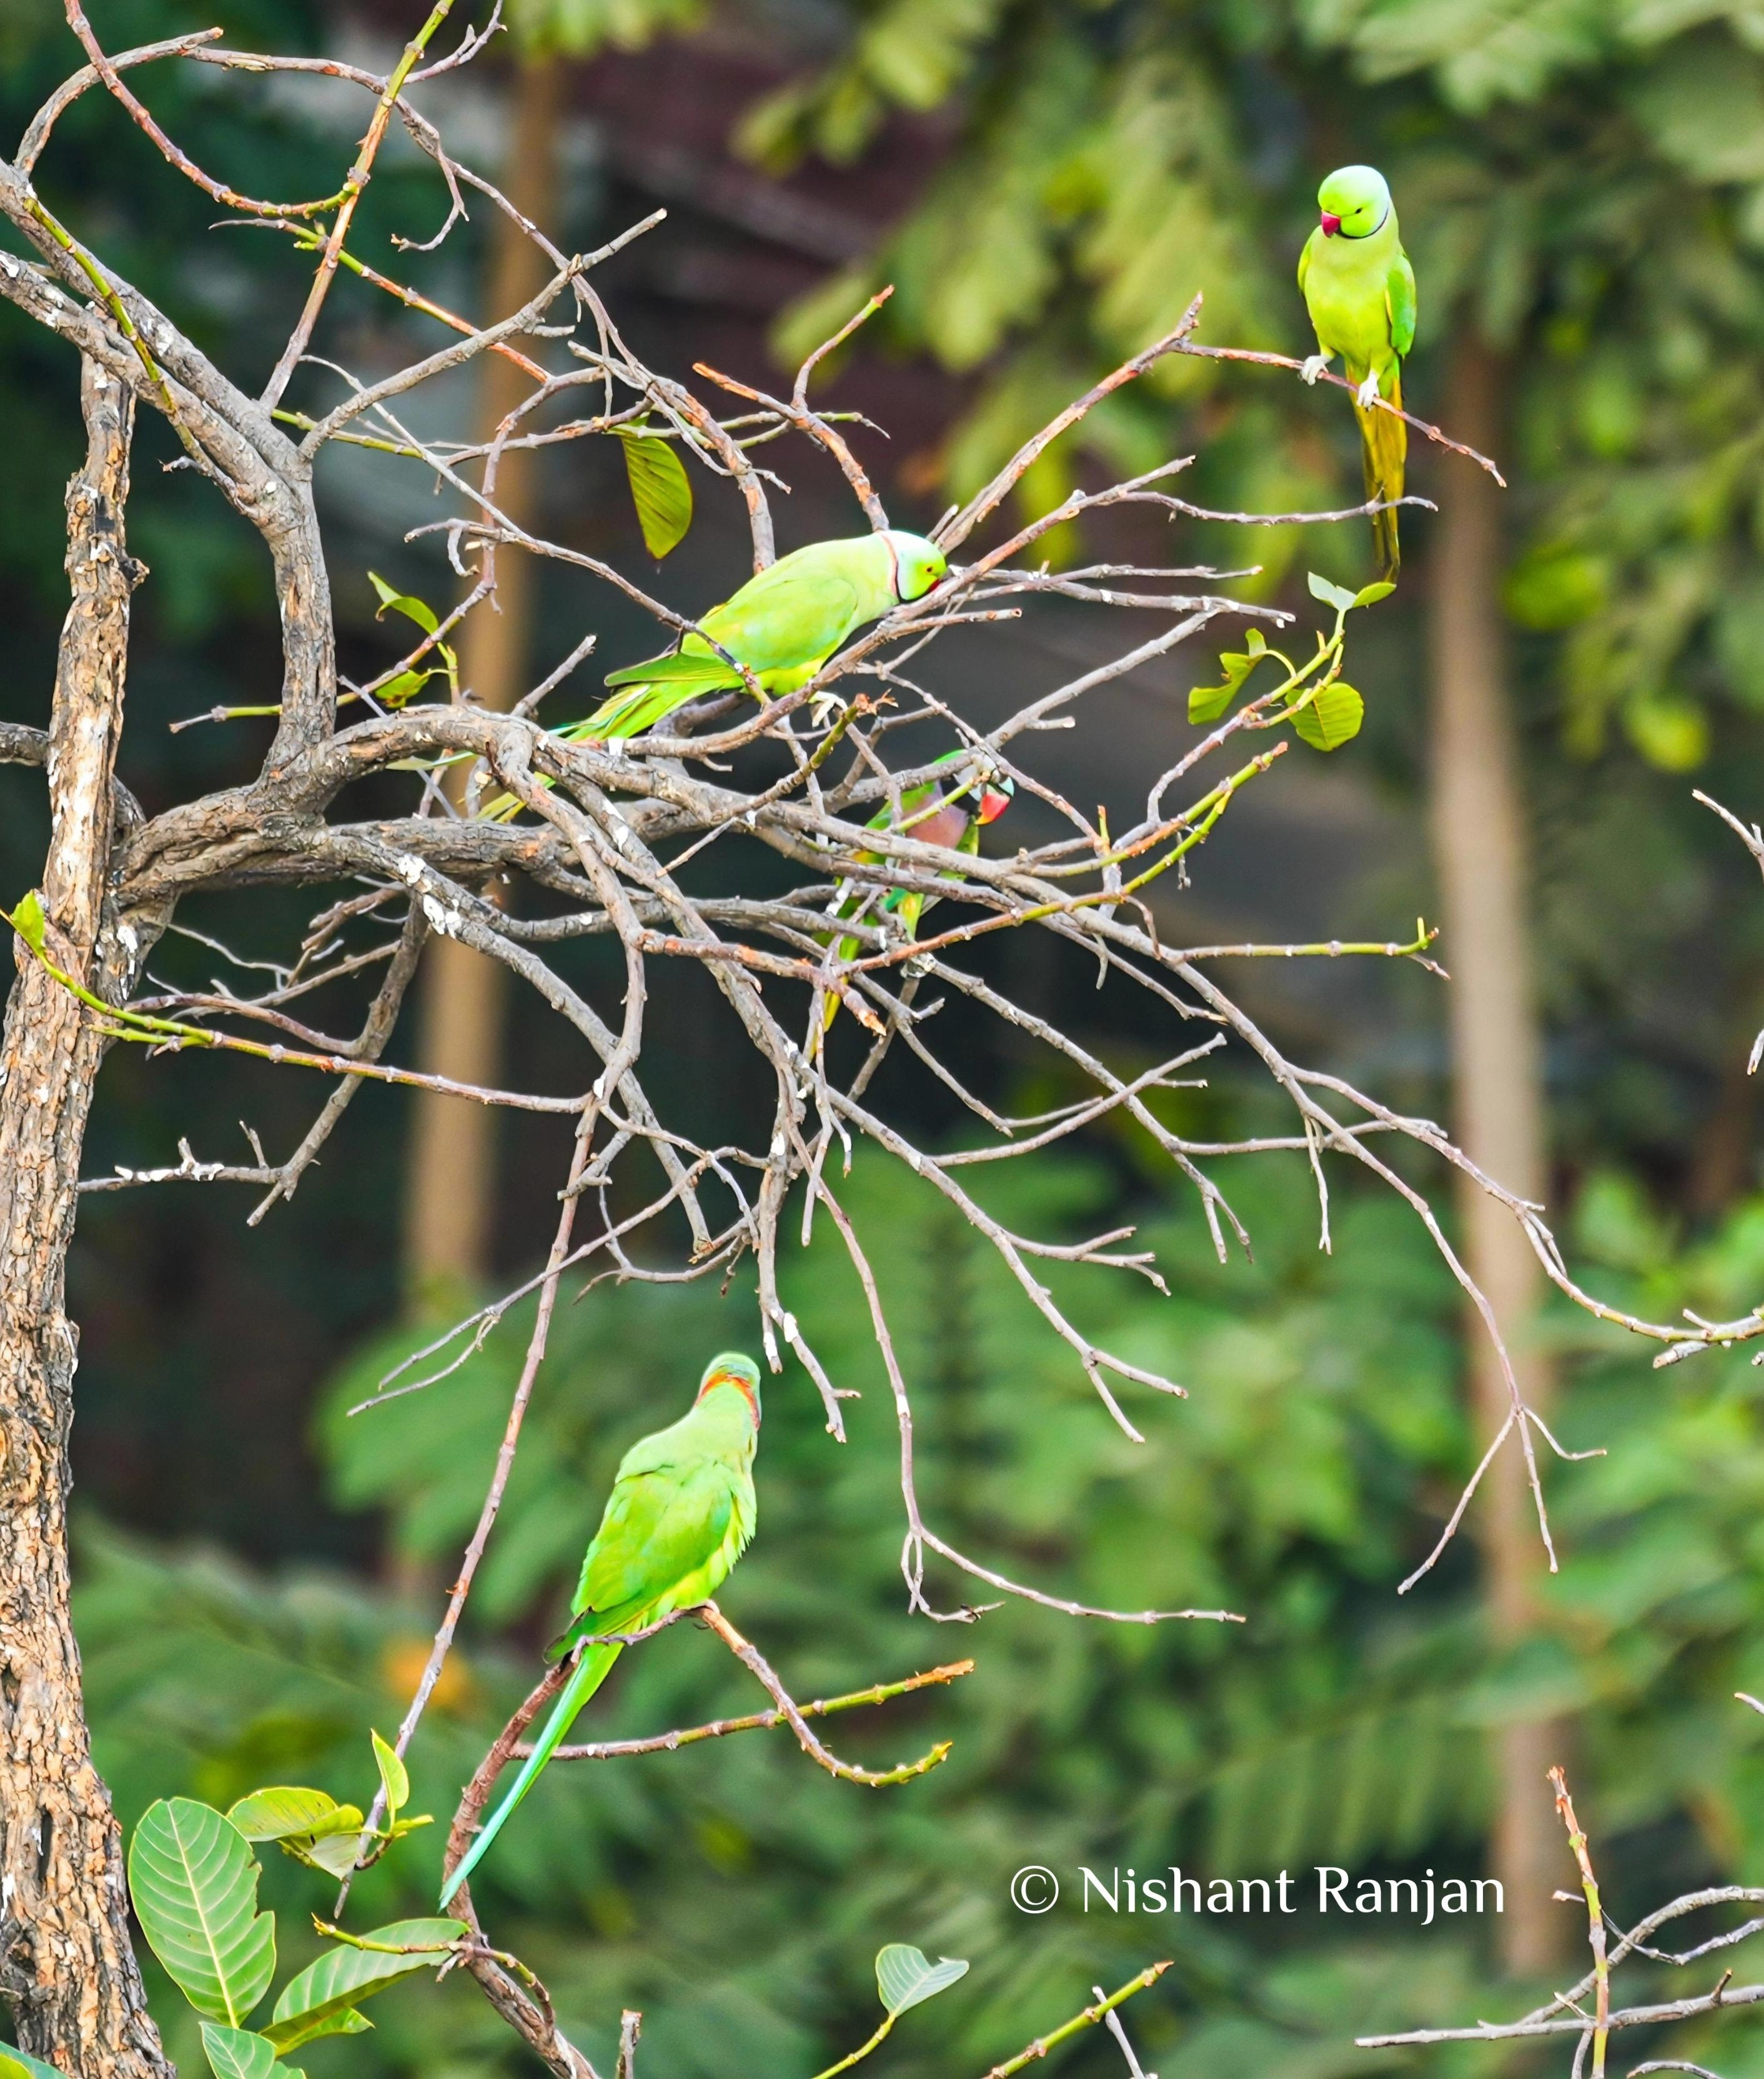
Image 3. Rose-ringed parakeets on same trees

