Original Research Article
New Distribution of Two Cobweb (Araneae: Theridiidae Sundevall, 1833) Spiders in Chhattisgarh State, India

ABSTRACT
The present study documents the new distributional records of two cobweb spiders (family Theridiidae Sundevall, 1833) from Chhattisgarh State, India. Although the Theridiidae constitute one of the most diverse and widely distributed spider families globally, their regional diversity within central India remains poorly understood. The study reports the presence of Coleosoma blandum (Pickard-Cambridge, 1882) and Euryopis episinoides (Walckenaer, 1847) for the first time from Chhattisgarh, thereby significantly expanding their known geographical range within the Indian subcontinent. Further systematic surveys are recommended to assess the full extent of Theridiidae diversity in the region. The spider species recorded in the present study have added two new species to the spider fauna list of Chhattisgarh, resulting in an increase of two spider species. This enhances our knowledge of spiders in this state and helps in understanding spider diversity in a high-diversity region like Chhattisgarh. Both recorded spider species have already been recorded in different states of India and are important invertebrate creatures in the biodiversity of those regions, but this is the first time they have been recorded in this particular state. This knowledge is very important from the perspective of Chhattisgarh’s spider fauna, because only a few cobweb spiders have been recorded in this state, and compared to other states in India, there is very little knowledge about them in Chhattisgarh. This study helps to fill this knowledge gap. Spider fauna is very important for biodiversity. If the spider species of a particular region are unknown, then their ecological, economic, and applied importance in that region cannot be understood. Therefore, this study is very important.
KEYWORDS : Chhattisgarh, Cobweb spider, Coleosoma, distribution, diversity, Euryopis, Gariaband, species, spider, Theridiidae.

INTRODUCTION
The family Theridiidae is the fifth largest spider family, containing over 2622 species belonging to 136 genera. Spider species in this family are found throughout the world except in Antarctica (WSC, 2025). The spiders in this family are known as cobweb, tangle web, and comb-footed spiders. These are modern spiders, also known as Araneomorphae spiders. They are ecribellate and entelegyne. Cobweb spiders are quite different from spiders of other spider families because they can be easily identified by their body shape. Their abdomen is much larger in size than the cephalothorax. They have eight simple eyes arranged in two rows, with four median eyes in the center and two pairs of lateral eyes arranged on the lateral sides. The formula of their legs is 1423 in which the first leg is the largest and the third leg is the smallest (Singh, 2021).
A total of 126 cobweb spider species have been documented in India so far, belonging to 41 genus, of which 49 species are endemic to India. Kerala has the highest number of cobweb spider species recorded so far, at 58 (Singh et al., 2023).
Nichat et al., 2024 documented three cobweb spider species from the Deobhog area of Gariaband district in the state of Chhattisgarh, belonging to three genera: Argyrodes argentatus, Meotipa multuma, and Nesticodes rufipes. (Chaudhary et al., 2025) recorded two spider species Ariamnes flagellum and Nesticodes rufipes in Raigarh and Sarguja districts. (Nichat et al.,2025) collected four cob web spider species from the north east region of Gariaband in Chhattisgarh, which are Nihonhimea mundula, Nesticodes rufipes, Argyrodes argentatus, Meotipa multuma. (Nayak et al., 2025) described a new distribution of a cobweb spider species Meotipa sahyadri (Kulkarni et al, 2017) in Gariaband district of Chhattisgarh. According to the data published till now, only six species of cobweb spiders have been recorded in Chhattisgarh state which belong to five genera. In this region, cobweb spider species have been recorded only in three districts Gariaband, Sarguja and Raigarh, in which maximum five species have been documented from Gariaband, two species from Raigarh and two species from Sarguja (Nichat et al, 2024; 2025; Chaudhary et al., 2025). Recently some spiders species of the Salticidae, Oxyopidae and Zodaridae families have been recorded in this region (Nayak et al., 2025b; 2025d, 2025e; Nayak and Sori, 2025a; 2025b; Nayak, 2025)
Till now ten species of Coleosoma are accepted in the whole world (WSC, 2025), out of which only two species have been recorded in India (Raju et al., 2021). Coleosoma blandum O. Pickard-Cambridge, 1882 was first recorded in Gujarat (Patel & Pillai, 1988; Sebastian, 1988) and then Coleosoma floridanum (Banks, 1900) was recorded in West Bengal (Levi, 1959). Till date Coleosoma blandum has been recorded in five states of India. While 82 species of Euryopis (Menge, 1868) are accepted worldwide, only four species have been documented in India (WSC, 2023; Singh, 2023). These are Euryopis episinoides, Euryopis nubila, Euryopis sagittata and Euryopis venutissima. Euryopis episinoides have been documented only in two states in India: Tamil Nadu and Maharashtra (Rajoria, 2016; Sangavi et al., 2023).
MATERIAL AND METHODS
In this study, specimens of two spider species were collected from the Gariaband district of Chhattisgarh state in India. Both species were collected from same study region of Gariaband district. One specimen of Coleosoma blandum (Pickard-Cambridge, 1882) (Lat. 20.513254° & Long. 82.027120°) and two specimens of Euryopis episinoides (Walckenaer, 1847), (Lat. 20627242° & Long. 82.067432°) were collected from Gariaband (Fig.1). Both specimens were preserved in 70% alcohol and deposited in the Department of Zoology at Govt. D. B. Girls P. G. College, Raipur. All live photographs of the specimens were taken with the INFINIX Smart HD camera. Published literature was used to identify these specimens. All specimens were identified based on their morphology, leg arrangement, body color, and parts.

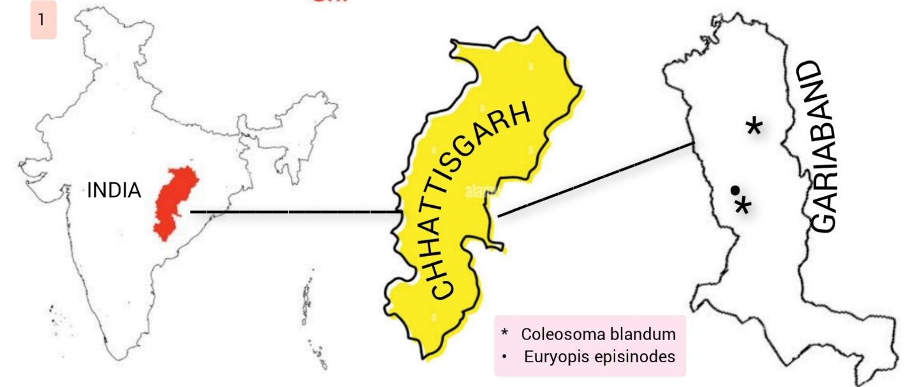
Figure 1: The figure represents new distribution of two cobweb spider species in Chhattisgarh region. © Jashavant Nayak

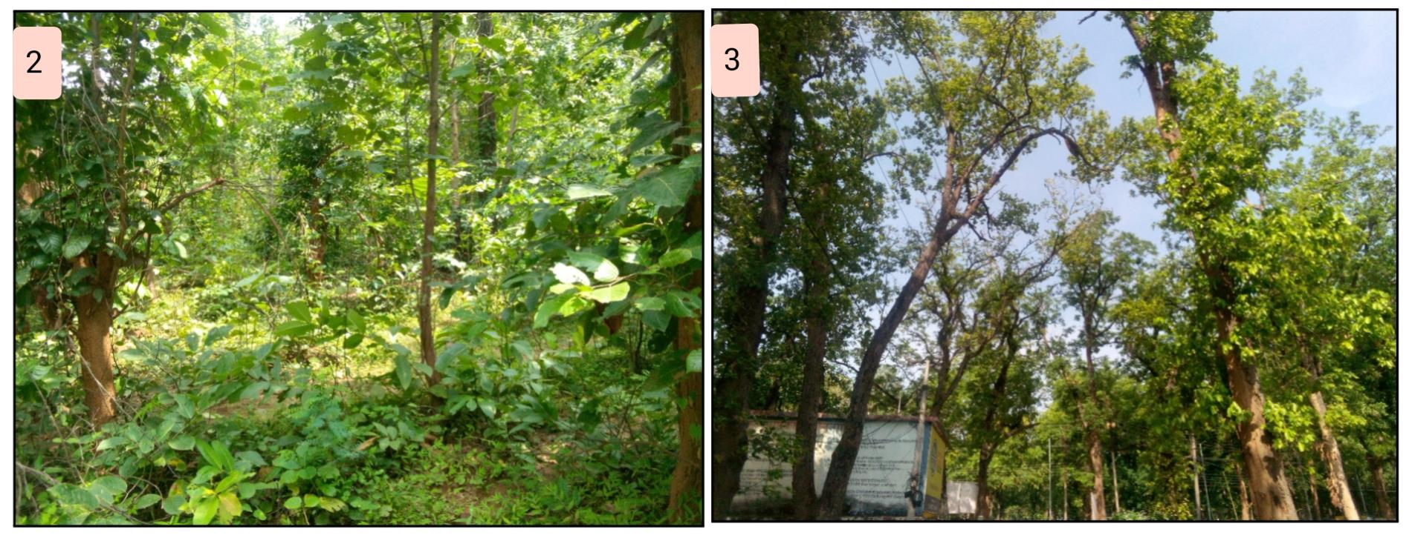
Figure (2&3): Region of Chhattisgarh where the specimens are collected, 2. Bhuteshwar nath forest area, 3. Dakbangla area of Gariaband district. © Jashavant Nayak
RESULT AND DISCUSSION
TAXONOMY
Family: Theridiidae Sundevall, 1833
Genus. Coleosoma O. Pickard-Cambridge, 1882
Coleosoma blandum O. Pickard-Cambridge, 1882
(Fig. 4-9)
Material Examined: 2 male and 1 female are collected from in Dakbangla region of Gariaband district, Chhattisgarh (Lat. 20.513254° & Long. 82.027120°), on 29.vi. 2025 (01:14 PM GTM +05:30). Male and female spider were Calotropis procera plant. Second male was collected from Bhuteswar nath forest region of Gariaband, Chhattisgarh (20°36’35”N/20°36’05”N & 42°02’45”E/42°02’55”E), India. All three specimens were deposited in Department of Zoology of Govt. D. B. Girls P. G. College Raipur, Chhattisgarh, India. Specimens are preserved by 70% alcohol in glass vial.

Description
Male
The spider is appeared like ant. Cephalothorax is oval shaped, dark brown in color, lateral region is yellow green, bearing a pair of medium sized padipal. Non tarsus part is longer than tarsus part of padipals, embolus is long and contain two apophysis, eyes are small. Opisthosoma or abdomen is long and conical with narrow between anterior and posterior region. Transverse stripe present on both side of abdomen. Legs are pale in color with dark black rings. Leg I is larger than all legs but leg III is smaller than all legs. Legs formula is 1423.
Female
Carapace is less elongated than male carapace, female body length is smaller than male, cephalothorax is round and dark brown in color, abdomen is round and conical in shape, anterior and posterior region is black. Legs are pale in color, leg formula is 1423, Leg I is larger than all legs and leg III is smaller than all.
Identification
All specimen was identified by published literature Rajoria, 2016. The main keys that are helpful to identification of specimen are: Dark chocolatey colored body, heart shaped abdomen and shield like sternum, hair absent on coxa etc (Rajoria, 2016).
Global Distribution
Seychelles, India, India, Sri Lanka, Bangladesh, Myanmar, Thailand, Philippines, China, Japan. Introduced to Seychelles, Hawaii (WSC, 2025; Zhu, 1998).

Distribution
Goa (Pandit & Dharwadkar, 2020), Gujarat (Patel & Pillai, 1988; Sebastian, 1988; Solanki et al., 2020), Kerala (Dhali & Sureshan, 2016; Malamel & Sudhikumar, 2020), Odisha (Prasad et al., 2020), Uttarakhand (Sarkar et al., 2022a), present study in Chhattisgarh.

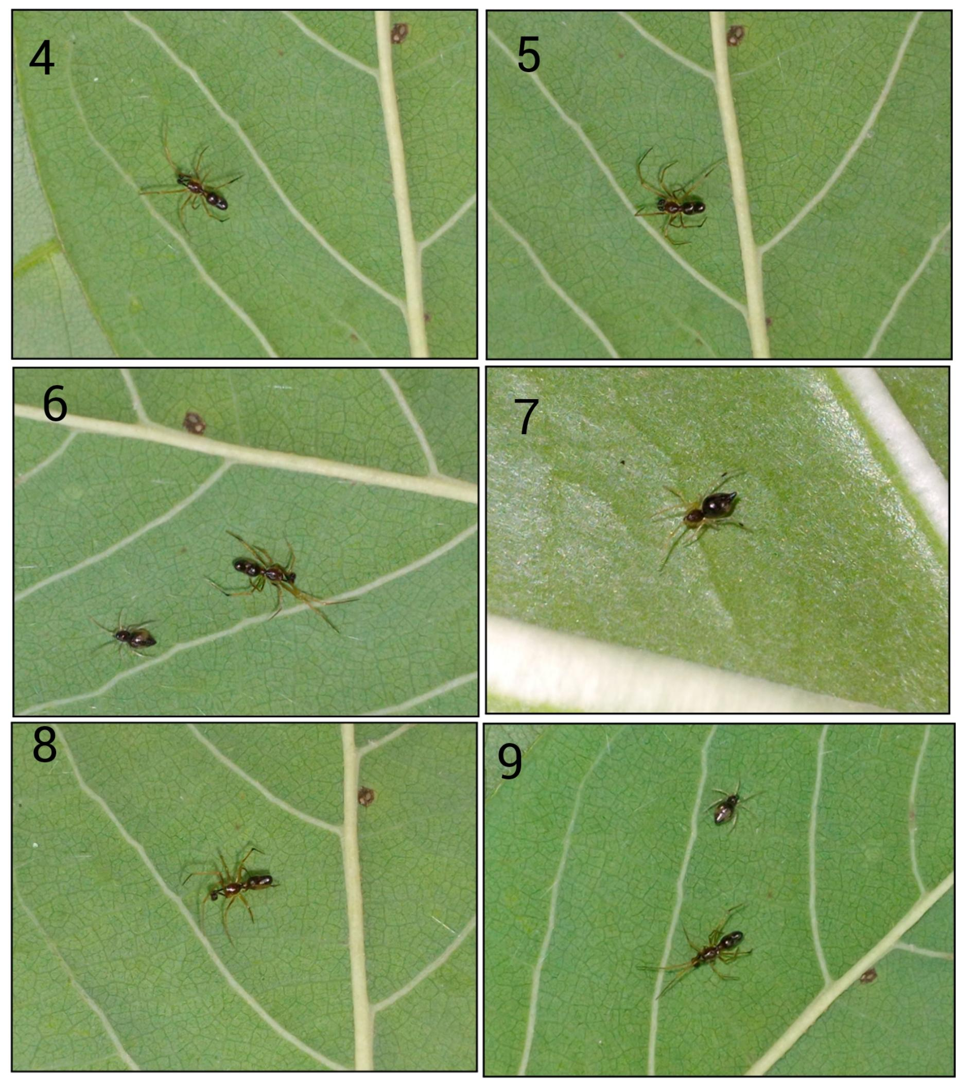
Figure 4-9: Habitus general appearance of Coleosoma blandum (O. Pickard-Cambridge, 1882), 4, 5, 8; male dorsal view, 7; female dorsal view, 6, 7; both male and female spider on leaf. © Jashavant Nayak

Genus. Euryopis Menge, 1868
Euryopis episinoides (Walckenaer, 1847)
(Fig. 10-15)
Material Examined: 2 male in Chhattisgarh, Dakbangla region of Gariaband district, Chhattisgarh (Lat. 20627242° & Long. 82.067432°), on 29.vii. 2025 . One specimen was collected from ground of the region and second was collected from a Calotropis procera plant leaf. Specimens will be deposited in Department of Zoology of Govt. D. B. Girls P. G. College Raipur, Chhattisgarh, India. Specimens are preserved by 70% alcohol in glass vial.

Description
Male
Cephalothorax is dark chocolaty colored, wide and oval shaped, anterior portion of cephalothorax is narrow and bearing two rows of eyes, sternum is brown and heart shaped. Eight eyes area arranged in two rows, anterior median eyes are larger than all eyes. Palpal organ is small, oval shaped, brown and bearing numerous small hairs.
Opisthothorax is called abdomen which is covered by numerous small and medium sized hairs, dark chocolaty colored, anterior portion is wider than posterior part, white transverse stripe present on both side of dorsal abdomen.
Legs are arranged in laterigrade arrangement, 4th legs are larger than all legs and 3rd legs are smaller than all legs, legs are covered by setae, Hairs absent in coxa and trochanter but tibia, fibula and claws are completely covered by numerous hairs. Legs formula is 1423.

Identification
The spider specimen was identified by published literature Rajoria, 2016. The main keys that are helpful to identification of specimen are: Dark chocolatey colored body, heart shaped abdomen and shield like sternum, hair absent on coxa etc (Rajoria, 2016).

Global Distribution
Cape Verde, Mediterranean to Turkey, Georgia, Israel. Introduced to South Africa, Reunion, India, China (WSC, 2025).
Distribution
Maharashtra (Rajoria, 2016), Tamil Nadu (Sangavi et al., 2023), present recorded in Chhattisgarh.

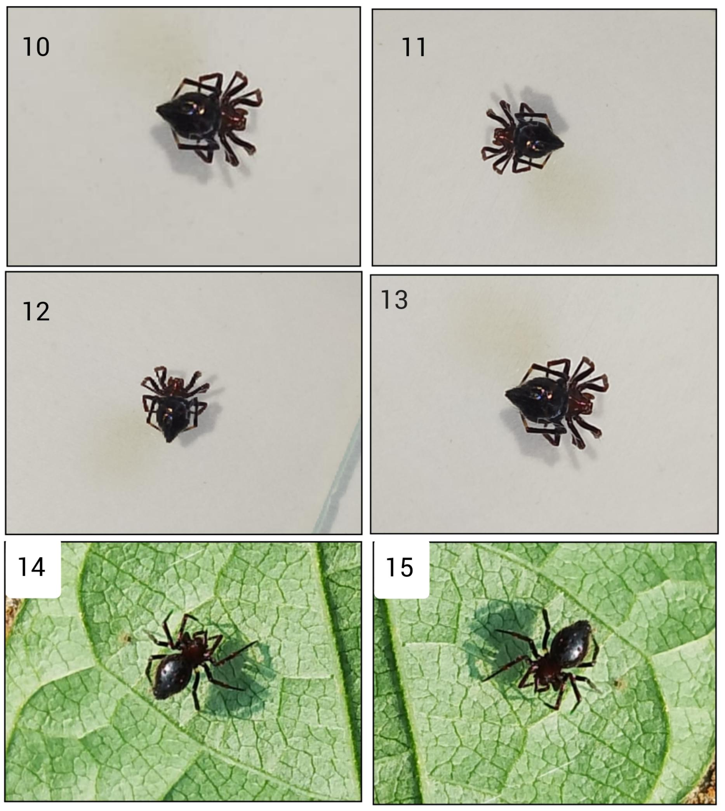
Figure 10-15 : Habitus General appearance of Euryopis episinoides (Walckenaer, 1847) 12–13 Female; 14–15 female; (dorsal view) © Jashavant Nayak

This study describes the new distribution of two cobweb spider species Coleosoma blandum Pickard-Cambridge, 1882 Euryopis episinoides (Walckenaer, 1847) in the Chhattisgarh region. Both spider species belong to the family Theridiidae and were collected from the Gariaband district of Chhattisgarh. Coleosoma blandum is found in five states of India, and Euryopis episodes has been recorded in two states so far, but this time both of these species have been recorded in Chhattisgarh state. These two species are new additions to the Chhattisgarh state fauna list of spiders. In a highly biodiverse region like Chhattisgarh, the number of Theridiidae spider species is not as high as expected for such a diverse area. The reason for this is that very few scientific studies have been conducted on spiders in this region, which means we don’t have a good understanding of the spider diversity in Chhattisgarh. However, some studies are currently underway that are describing the distribution of new spider species in the state. For spiders, area doesn’t matter; they show a great deal of diversity even in a small area. This doesn’t mean they break the species-area relationship rule. They are quite small, which allows them to live in small areas, such as places where the temperature is moderate, food is available in adequate quantities, and the environment is dense. Studies conducted in dense jungles (like the Western Ghats) have documented the highest number of spider species. Therefore, more studies related to spiders are needed in this region so that more new species can be discovered.

CONCLUSION
Two new records of cobweb spiders in Chhattisgarh have added two new spider species to the Chhattisgarh spider fauna list. This study provides new knowledge about the spiders found in Chhattisgarh. This study indicates a new distribution of cobweb spiders in Chhattisgarh, specifically in the Gariaband district. This study is very important because, in a biodiversity-rich region like Chhattisgarh, only six Theridiidae spider species have been recorded so far. It's not that these spider species don't exist here, but rather that they haven't been properly searched for, which is why new species and information about them are not being discovered. The present study provides concrete evidence that these two cobweb spiders are found here and have been recorded from the Gariaband district.
DISCLAIMER (ARTIFICIAL INTELLIGENCE)
Author(s) hereby declare that no AI technologies have been used during the writing or editing of manuscripts. All photographs and manuscript is real without used of any AI tools.

REFERENCE
- Banks, N. (1900a). Some new North American spiders. The Canadian Entomologist 32(4): 96-102. Doi: 10.4039/Ent3296-4
- Choudhury, S. R., Nirmalkar, Y., Singh, A. K., & Anand, A. (2024). Spider fauna of Chhattisgarh: An updated checklist of spiders of Chhattisgarh, India with new additions. Serket, 20(3), 311–334.
- Dhali, D.C. & Sureshan, P.M. (2016). First report on spiders (Araneae: Arachnida) From the Paddy Fields of Wayanad district, Kerala, India. Zoo’s Print, 29(12): 22-24.
- Dippenaar-Schoeman, A. S., Haddad, C. R., Foord, S. H., & Lotz, L. N. (2021). The Theridiidae of South Africa. Part 1 (A-P). Version 1. South African National Survey of Arachnida Photo Identification Guide, Irene. https://doi.org/10.5281/zenodo.5554000
- Knoflach, B. & Pfaller, K. (2004). Kugelspinnen – eine Einführung (Araneae, Theridiidae). In: Thaler, K. (ed.) Diversität und Biologie von Webspinnen, Skorpionen und anderen Spinnentieren. Denisia 12: 111-160.
- Kulkarni, S., Vartak, A., Deshpande, V., & Halali, D. (2017). The spiny theridiid genus Meotipa Simon, 1895 in India, with description of a strange new species with translucent abdomen and a phylogenetic analysis about the genus placement (Araneae, Theridiidae). Zootaxa, 4291(3), 504-520. https://doi.org/10.11646/zootaxa.4291.3.4
- Levi, H. W. (1959). The spider genus Coleosoma (Araneae: Theridiidae). Breviora, Museum of Comparative Zoology, 110, 1–8. https://biostor.org/reference/283291
- Levy, G., & Amitai, P. (1981). Spiders of the genera Euryopis and Dipoena (Araneae: Theridiidae) from Israel. Bulletin of the British Arachnological Society, 5(4), 177-188. https://www.britisharachnologicalsociety.org.uk/bulletin/050408.pdf
- Malamel, J. J., & Sudhikumar, A. V. (2020). An investigation of diversity and bioecology of araneofauna of Pathiramanal Island in Vembanad Lake, a Ramsar site, Kerala, India. Zoology and Ecology, 30(2), 126-137. https://doi.org/10.35513/21658005.2020.2.7
- Menge, A. (1868). Preussische Spinnen. II. Abtheilung. Schriften der Naturforschenden Gesellschaft in Danzig (N. F.), 2, 153-218. https://www.biodiversitylibrary.org/item/106000#page/167/mode/1up
- Nayak, J., Sori, P., & Sahu, L. (2024). Thanatosis Behaviour in the Indoxysticus minutus Tikader, 1960 (Aranae: Thomisidae) in Gariyaband, Chhattisgarh, India. International Journal of Research in Academic World, 3(12), 94-95. https://academicjournal.ijraw.com/media/post/IJRAW-3-12-24.1.pdf
- Nayak, J., Sori, P., Sahu, L., & Bharti, D. (2025a). A new observational record of jumping spider (Aranae: Salticidae: Aelurillini: Aelurillina) Stenaelurillus metallicus Caleb & Mathai, 2016 in Chhattisgarh, India. International Journal of Biology Research, 10(1), 19-21. https://www.biologyjournal.in/assets/archives/2025/vol10issue1/10007-1740555118544.pdf
- Nayak, J., & Sori, P. (2025a). Description of a New spider Meotipa sahyadri Kulkarni, Vartak, Deshpande & Halali, 2017 (Aranae: Theridiidae) in Chhattisgarh, India. International Journal of Research Publication and Reviews, 6(2), 4518-4521. https://doi.org/10.55248/gengpi.6.0225.1026
- Nayak, J., & Sori, P. (2025b). Hamadruas hieroglyphica Thorell, 1887 (Aranae: Oxyopidae): First Description of a lynx Spider In Chhattisgarh, India. International Research Journal of Modernization in Engineering Technology and Science. https://doi.org/10.56726/IRJMETS68434
- Nayak, J., Warte, H. K., Sori, P., & Sahu, L. (2025b). Study on Jumping Spiders (Aranae: Araneomorphae: Salticidae) Diversity in Shraddha Public School Campus Gariaband, Chhattisgarh, India. International Journal Of Latest Technology In Engineering, Management & Applied Science, 14(3), 350-353. https://doi.org/10.51583/IJLTEMAS.2025.140300037
- Nayak, J. (2025). Stenaelurillus jagannathae Das, Malik & Vidhel, 2015: First Description in Chhattisgarh, India. Bioscience Discovery, 16(3):37-40. http://biosciencediscovery.com/Archive.html#
- Nayak, J., Warte, H. K., Sahu, L., & Rajanikant. (2025c). First description of a crab spider Species Stiphropus sangayus Barrion & Litsinger, 1995 (Araneae: Araneomorphae: Thomisidae) in Odisha, India. International Journal of Zoology, Environment, and Life Sciences, 2(3), 7–10. https://doi.org/10.70604/ijzels.v2i3.73
- Nayak, J., Warte, H. K., & Chaure, M. (2025d). A brief study of jumping spider (Arachnida: Araneae: Salticidae) diversity around Tandula Dam, Balod, Chhattisgarh, India. Journal of Science Research International, 11(8), 1–8. https://doi.org/10.5281/zenodo.17442064
- Nayak, J., Chaure, M., Warte, H. K., Majumdar, M., Harris, K. K., & Nichat, A. R. (2025e). A new distribution of the spider genus Storenomorpha Simon, 1884 (Araneae: Zodariidae) in Chhattisgarh State, India. Asian Journal of Research in Zoology, 8(4), 127–133. https://doi.org/10.9734/ajriz/2025/v8i4224
- Nichat, A. R., Warte, H. K., & Nayak, J. (2024). Spider diversity (Arachnida: Aranae) in Deobhog region Gariyaband Chhattisgarh India. International Journal of Innovation and Science and Engineering, 11 (8), 39–45. https://ijiset.com/vol11/v11s8/IJISET_V11_I08_03.pdf
- Nichat, A. R., Harris, K. K., Warte, H. K., Dubey, M., Sori, P., & Nayak, J. (2025). Spiders Diversity in North East Gariaband Forest Regions of Chhattisgarh, India. UTTAR PRADESH JOURNAL OF ZOOLOGY, 46(4), 119-127. https://doi.org/10.56557/upjoz/2025/v46i44808
- Pandit, R., & Dharwadkar, M. (2020). Preliminary checklist of spider fauna (Araneae: Arachnida) of Chandranath Hill, Goa, India. Journal of Threatened Taxa, 12(11), 16597–16606. https://doi.org/10.11609/jott.6096.12.11.16597-16606
- Pickard-Cambridge, O. (1872). General list of the spiders of Palestine and Syria, with descriptions of numerous new species, and characters of two new genera. Proceedings of the Zoological Society of London. https://doi.org/10.1111/j.1469-7998.1872.tb00489.x
- Pickard-Cambridge, O. (1876). Catalogue of a collection of spiders made in Egypt, with descriptions of new species and characters of a new genus. Proceedings of the Zoological Society of London. https://doi.org/10.1111/j.1096-3642.1876.tb02595.x
- Pickard-Cambridge, O. (1882). On new genera and species of Araneidea. Proceedings of the Zoological Society of London, 50(3), 423-442. https://doi.org/10.1111/j.1096-3642.1882.tb02749.x
- Patel, B. H., & Pillai, G. K. (1988). Studies on the spider fauna of groundnut fields in Gujarat, India. *Journal of Biological Control*, *2*(2), 83-88. https://www.isbc.org.in/jbc/index.php/jbc/article/view/100/99
- Prasad, P., Tyagi, K., & Kumar, V. (2020). First report of the cob-web spider Coleosoma blandum O. Pickard-Cambridge (Araneae: Theridiidae) with comments on its distribution from India. Munis Entomology & Zoology, 15(1), 96-99. https://www.researchgate.net/publication/338670000_FIRST_REPORT_OF_THE_COB-WEB_SPIDER_COLEOSOMA_BLANDUM_O_PICKARD-CAMBRIDGE_ARANEAE_THERIDIIDAE_WITH_COMMENTS_ON_ITS_DISTRIBUTION_FROM_INDIA
- Rajoria, A. (2016). Newly recorded species: Euryopis episinoides (Walckenaer, 1847) from India (Araneae: Theridiidae). Serket, 15(1), 56-59. https://biostor.org/reference/301152
- Raju, A., Rahman, S. J., Rahman, S. M. A. S., Jagadeeshwar, R., & Reddy, S. N. (2021). Identification, documentation and relative abundance of predatory spider fauna in rice ecosystems of Telangana state. The Pharma Innovation Journal, 10(10S), 704-711. https://www.thepharmajournal.com
- Sangavi, D., Anisha, P. S., Vinothini, G., & Nathan, P. T. (2023). Diversity of spiders (Arachnida: Araneae) in natural and altered ecosystems in Salem district, Tamil Nadu, India. Journal of Animal Diversity, 5(1), 113–126. https://doi.org/10.52547/JAD.2023.5.1.8
- Sarkar, I. D., Iyer, N., Siliwal, M., & Uniyal, V. P. (2022). First report of Coleosoma blandum O. Pickard-Cambridge, 1882 (Araneae: Theridiidae) from the Northern Indo-Gangetic Plains, India. Munis Entomology and Zoology, 17(2), 1120-1123. https://www.munisentzool.org/yayin/munis-entomology-zoology-2022-vol-17-number-2/
- Sarkar, I. D., Siliwal, M., & Uniyal, V. P. (2023). Indian Arachnology (order: Araneae) in the 21st century: trends, gaps and future prospects. Current Science, 124(11), 1270-1281. https://doi.org/10.18520/cs/v124/i11/1270-1281
- Sebastian, P. A. (1988). Studies on the biology of some predaceous spiders on Insect pests of some major crops of north Gujarat. (Ph.D. thesis). Maharaja Krishnakumarsinhji Bhavnagar University. http://hdl.handle.net/10603/89947
- Singh, R. (2021). Faunal diversity of Theridiidae (Araneomorphae, Araneae, Arachnida) in India, An updated checklist. International Journal of Biological & Environmental Investigations. https://doi.org/10.33745/ijbei.2021.v01i01.003
- Singh, R., Verma, A. K., Singh, B. B., & Singh, G. (2023). Spider Fauna of India. Asian Biological Research Foundation & Nature Light Publications. ISBN: 978-81-959483-4-5
- Solanki, R., Siliwal, M., & Kumar, D. (2020). A preliminary checklist of spiders (Araneae: Arachnida) in Jambughoda Wildlife Sanctuary, Panchmahal District, Gujarat, India. Journal of Threatened Taxa, 12(11), 16576–16596. https://doi.org/10.11609/jott.3094.12.11.16576-16596
- Tharmarajan, M., & Benjamin, S. P. (2021). New records of Coleosoma blandum O. Pickard-Cambridge, 1882 and C. floridanum Banks, 1900 from Sri Lanka (Araneae: Theridiidae). Arachnology, 18(8), 833-837. https://doi.org/10.13156/arac.2021.18.8.833
- Walckenaer, C. A. (1847). Dernier Supplément. In C. A. Walckenaer & P. Gervais (Eds.), Histoire naturelles des Insects. Aptères. Tome quatrième (pp. 365-596). Roret. https://doi.org/10.5962/bhl.title.61095
- World Spider Catalog. (2025). World Spider Catalog. Version 26. Natural History Museum Bern. https://doi.org/10.24436/2
- Zhu, M. S. (1998). Fauna Sinica: Arachnida: Araneae: Theridiidae. Science Press, Beijing, 436 pp.

