Original Research Article

Biomarker Responses in Fish and Crustaceans Exposed to Heavy Metals and Petroleum Hydrocarbons in the Qua Iboe Estuary, Niger Delta

Abstract
Aquatic organisms inhabiting petroleum-impacted estuaries of the Niger Delta are frequently exposed to complex mixtures of heavy metals and hydrocarbons capable of inducing biochemical and physiological stress. This study evaluated the concentrations of Pb, Cd, Hg, As, Cr, and total petroleum hydrocarbons (TPH) in Tilapia sp., Clarias gariepinus, and Macrobrachium vollenhovenii collected from the Qua Iboe Estuary, Akwa Ibom State, Nigeria, and assessed corresponding biomarker responses as indicators of pollutant-induced oxidative stress. Heavy metals were quantified using atomic absorption spectrophotometry, while TPH was determined through Soxhlet extraction. Catalase (CAT), glutathione S-transferase (GST), and malondialdehyde (MDA) were analysed as enzymatic and oxidative stress markers. Metal concentrations ranged from 0.40–0.55 µg/g (Pb), 0.02–0.03 µg/g (Cd), 0.08–0.13 µg/g (Hg), 0.11–0.16 µg/g (As), and 0.29–0.36 µg/g (Cr), while TPH values were between 3.5 and 4.5 mg/kg. Clarias gariepinus accumulated the highest pollutant levels, corresponding with the strongest biomarker responses (CAT: 52 U/mg protein; GST: 38 U/mg protein; MDA: 3.2 nmol/mg). Seasonal comparisons showed higher wet-season TPH (3.8–4.5 mg/kg), Pb (0.42–0.57 µg/g), and MDA (2.6–3.4 nmol/mg), indicating increased contaminant influx during periods of runoff. Findings show that fish and crustaceans in the Qua Iboe Estuary experience significant oxidative stress linked to chronic exposure to petroleum-derived and metal contaminants. These biomarker alterations provide early warning evidence of ecological degradation and highlight potential human health concerns for communities dependent on these species for food. Strengthened environmental monitoring and targeted pollution-control measures are urgently required to mitigate further ecological and public health risks.
Keywords: Biomarkers; heavy metals; petroleum hydrocarbons; Qua Iboe Estuary; Niger Delta
1.0 Introduction
Estuarine ecosystems in the Niger Delta are exposed to increasing levels of anthropogenic contamination resulting from petroleum exploration, gas flaring, artisanal refining, pipeline leakages, industrial effluents, and poorly managed domestic waste disposal (Aghanwa et al., 2025). These activities introduce persistent pollutants into the aquatic environment, including heavy metals and petroleum-derived hydrocarbons, which readily accumulate in sediments and biota (Umueni et al., 2025a). Numerous studies across the Niger Delta have documented elevated pollutant loads in surface water, sediment, fish, and crustaceans, reflecting decades of environmental degradation associated with oil and gas activities (Okpoji et al., 2025a). The ecological sensitivity of estuarine environments, coupled with their socio-economic importance, makes them particularly vulnerable to pollutant inputs transported through atmospheric fallout, river discharge, stormwater runoff, and tidal exchange.
Heavy metals such as lead (Pb), cadmium (Cd), mercury (Hg), arsenic (As), and chromium (Cr) are of particular concern due to their ability to persist in aquatic ecosystems and bioaccumulate through the food chain. They originate from drilling fluids, corroded pipelines, industrial combustion, and effluent discharge (Ekpe et al., 2025). Unlike organic contaminants, heavy metals cannot be degraded and therefore accumulate in fish and crustaceans, often reaching concentrations capable of eliciting toxicological effects (Okpoji et al., 2025b). Elevated levels of these metals have been reported in aquatic organisms across Nigeria and other developing regions, with documented risks to both ecological and human health (Oghenekohwiroro & Osaro, 2017).
Petroleum hydrocarbons, including total petroleum hydrocarbons (TPH) and polycyclic aromatic hydrocarbons (PAHs), constitute another major contaminant class in the Niger Delta. Chronic gas flaring releases soot and semi-volatile organic compounds into the atmosphere, which are later deposited into water bodies through rainfall and dry deposition (Okpoji et al., 2025c). These processes have been confirmed as significant pathways for hydrocarbon dissemination in coastal zones (Kallenborn et al., 2015). PAHs such as benzo[a]pyrene are classified as Group 1 carcinogens (IARC, 2015), and their presence in estuarine species has been repeatedly reported in smoked fish, raw fish, sediments, and surface waters from petroleum-impacted environments (Ekwere et al., 2025a; John et al., 2025). TPH contamination in particular is a hallmark of regions with active petroleum production and serves as a proxy for petrogenic hydrocarbon exposure.
In recent years, biochemical biomarkers have emerged as powerful tools for assessing sub-lethal toxic effects in aquatic organisms. Antioxidant enzymes such as catalase (CAT) and glutathione S-transferase (GST) respond rapidly to xenobiotic exposure by neutralising reactive oxygen species generated during contaminant metabolism. Malondialdehyde (MDA), a lipid peroxidation product, serves as a sensitive indicator of oxidative damage to cell membranes (Wania et al., 2006). Biomarker responses have been used globally to evaluate contaminant-induced stress in fish and crustaceans and are particularly valuable for early detection of pollutant effects before overt clinical or population-level changes occur (Ernesto et al., 2021; Ekwere et al., 2025b).
Despite extensive research on environmental contamination in the Niger Delta, integrated assessments linking chemical pollutant loads with enzymatic and oxidative stress biomarkers across multiple aquatic species remain limited (Anarado et al., 2023). Additionally, seasonal variations, which influence contaminant transport through rainfall-driven runoff and hydrodynamic shifts, are often overlooked. This study, therefore, investigates the concentrations of heavy metals and petroleum hydrocarbons in Tilapia sp., Clarias gariepinus, and Macrobrachium vollenhovenii collected from the Qua Iboe Estuary in Akwa Ibom State. It further evaluates biomarker responses—catalase, glutathione S-transferase, and malondialdehyde—as indicators of contaminant-induced oxidative stress and examines seasonal differences in pollutant loads.
2.0 Materials and Methods

2.1 Study Area
The study was carried out in the Qua Iboe Estuary in Akwa Ibom State, situated in the southeastern section of the Niger Delta, Nigeria. The estuary lies between Latitude 4°32′N–4°38′N and Longitude 7°50′E–8°02′E, and is characterised by an extensive network of tidal creeks, mangrove wetlands, intertidal flats and brackish channels that drain directly into the Atlantic Ocean. The region experiences a humid tropical climate with a well-defined wet season from April to October during which high rainfall and surface runoff strongly influence water quality, followed by a dry season from November to March characterised by reduced freshwater inflow and increased tidal flushing. Petroleum-related activities—including crude-oil loading operations, vessel transport, and artisanal refining—occur frequently in the area, contributing to hydrocarbon inputs and trace-metal enrichment. The estuary also supports substantial artisanal fishing, making it a key ecological and socio-economic system for surrounding communities.
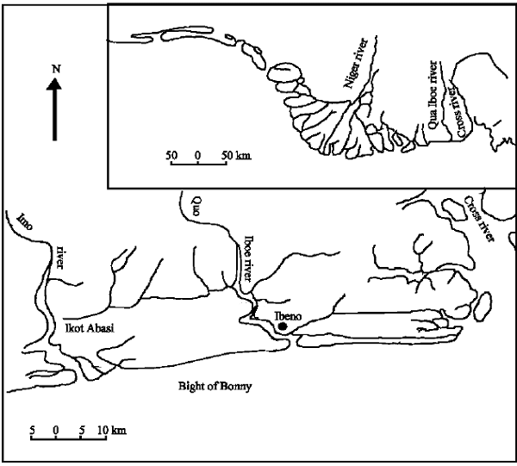
Figure 1: Study Area Map of the Qua Iboe Estuary, Akwa Ibom State, Nigeria

2.2 Sample Collection
Three aquatic organisms commonly consumed by residents of the estuary—Tilapia sp., Clarias gariepinus and Macrobrachium vollenhovenii—were collected during both wet and dry seasons to assess seasonal differences in contaminant exposure and oxidative-stress responses. Sampling followed established guidelines in APHA (2017) and FAO/WHO (2003). The organisms were obtained at three artisanal landing points using fishing nets and baited traps customarily used by local fishermen. Immediately after capture, each specimen was placed into pre-labelled ice-cooled containers and transported within three to four hours to the laboratory to preserve biochemical integrity and minimise enzymatic degradation. No anaesthetic or chemical treatment was used, as sampling involved naturally harvested organisms from open-access waters.

2.3 Tissue Dissection and Preparation
In the laboratory, all samples were washed with distilled water to remove mud, mucus and external debris. Muscle tissues were dissected using acid-washed stainless-steel scalpels to prevent trace-metal interference, in accordance with USEPA biological sample-handling guidelines. Approximately five grams of muscle tissue were homogenised in a pre-cooled glass homogeniser to ensure uniformity. Subsamples for heavy-metal analysis and total petroleum hydrocarbon (TPH) determination were stored at −20°C until analysis, whereas those intended for enzymatic biomarker assays were processed immediately after homogenisation to prevent loss of enzyme activity.

2.4 Heavy Metal Determination
Heavy metals—lead (Pb), cadmium (Cd), mercury (Hg), arsenic (As) and chromium (Cr)—were quantified using standard wet-digestion and atomic absorption spectrophotometric methods based on APHA Method 3030E and Methods 3111B/3112B (APHA, 2017). One gram of homogenised tissue was placed in a digestion flask and treated with ten millilitres of a 3:1 mixture of concentrated nitric acid (HNO₃) and perchloric acid (HClO₄). Digestion was carried out on a temperature-controlled hot plate at 120–150°C until a clear solution was obtained. The digested sample was then cooled, filtered through a 0.45-micrometre membrane, and diluted to a final volume of twenty-five millilitres using deionised water. Metal concentrations were measured using a PerkinElmer atomic absorption spectrophotometer, with mercury analysed via cold-vapour AAS. Calibration curves were prepared using certified multi-element standards traceable to NIST, and reagent blanks and duplicate samples were included to ensure analytical accuracy and precision in accordance with USEPA (2001) quality-control requirements.

2.5 Determination of Total Petroleum Hydrocarbons
Total petroleum hydrocarbons in muscle tissue were quantified using Soxhlet extraction following USEPA Method 3540C and APHA Method 5520B. Approximately two grams of homogenised tissue were placed in a cellulose extraction thimble and refluxed with n-hexane for six hours. The resulting extract was concentrated to near-dryness using a rotary evaporator at 40°C, after which it was reconstituted and quantified spectrophotometrically at 420 nm. The absorbance values were converted to TPH concentrations using standard curves prepared from known hydrocarbon mixtures. Results were expressed in milligrams per kilogram wet weight.

2.6 Biomarker and Enzyme Assays
To evaluate contaminant-induced biochemical stress, three biomarkers were analysed: catalase (CAT), glutathione S-transferase (GST) and malondialdehyde (MDA). Catalase activity was measured following the method of Aebi (1984), which is based on monitoring the decomposition rate of hydrogen peroxide at 240 nm. Glutathione S-transferase activity was quantified according to the method of Habig, Pabst and Jakoby (1974) using 1-chloro-2,4-dinitrobenzene (CDNB) as the conjugation substrate, with absorbance monitored at 340 nm. Lipid peroxidation was quantified by determining malondialdehyde formation using the thiobarbituric acid reactive substances (TBARS) method of Buege and Aust (1978), and absorbance was measured at 532 nm. All enzyme activities were normalised to protein concentrations, which were determined using the Lowry method (Lowry et al., 1951). Enzymatic assays were carried out immediately after homogenisation to ensure integrity and reproducibility.

2.7 Seasonal Assessment
To assess the influence of hydrological variability on contamination and biomarker responses, Tilapia sp. and Clarias gariepinus were sampled during both the wet and dry seasons. Concentrations of TPH and Pb, together with CAT, GST and MDA levels, were compared to interpret the effects of rainfall-driven runoff, erosion, sediment resuspension and tidal flushing on contaminant distribution and oxidative-stress induction.

2.8 Quality Assurance and Quality Control
All reagents used in the analysis were of analytical grade. Glassware was soaked in ten percent nitric acid for a minimum of twenty-four hours and then rinsed thoroughly with deionised water before each use. Instrument calibration for AAS and spectrophotometric analyses achieved correlation coefficients greater than 0.995. Method recoveries for digestion and extraction ranged between 85 and 105 percent, meeting APHA (2017) acceptance criteria. Certified reference materials (CRM-Fish) were used to verify accuracy, and procedural blanks, duplicates and spiked samples were included with each batch of analyses following USEPA (2001) protocols. All biomarker assays were conducted in triplicate to ensure reliability and reproducibility.

3.0 Results
This study examined hydrocarbon and heavy metal concentrations in selected fish and crustacean species, alongside biomarker responses indicative of oxidative stress resulting from pollutant exposure. In addition, seasonal variations in total petroleum hydrocarbons (TPH), heavy metals, and oxidative stress markers were assessed for Tilapia sp. and Clarias gariepinus. The results are presented in Tables 1–3.

3.1 Hydrocarbon and Heavy Metal Levels in Tissues
The concentrations of Pb, Cd, Hg, As, Cr, and total petroleum hydrocarbons (TPH) varied across species (Table 1). Lead (Pb) levels ranged from 0.40–0.55 µg/g, with Clarias gariepinus recording the highest concentration (0.55 µg/g). Cadmium (Cd) remained low across species (0.02–0.03 µg/g), while mercury (Hg) ranged from 0.08–0.13 µg/g, again with Clarias gariepinus showing the highest value. Arsenic (As) concentrations were between 0.11 and 0.16 µg/g, and chromium (Cr) ranged from 0.29 to 0.36 µg/g. TPH values ranged from 3.5–4.2 mg/kg, showing measurable hydrocarbon exposure in all species. Clarias gariepinus consistently exhibited the highest concentrations of all measured contaminants, indicating its strong susceptibility to bioaccumulation, possibly due to benthic feeding habits and increased contact with sediment-associated pollutants as shown in Figure 2.
Table 1: Hydrocarbon & Heavy Metal Levels in Tissues (µg/g; TPH in mg/kg)
Species | Pb | Cd | Hg | As | Cr | TPH (mg/kg)
Tilapia sp. | 0.40 | 0.02 | 0.09 | 0.11 | 0.29 | 3.5
Clarias gariepinus | 0.55 | 0.03 | 0.13 | 0.16 | 0.36 | 4.2
Macrobrachium vollenhovenii | 0.42 | 0.02 | 0.08 | 0.12 | 0.31 | 3.8

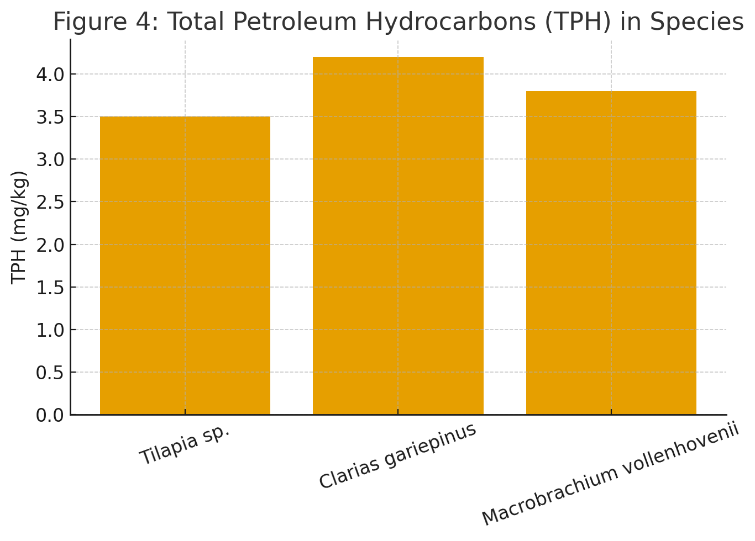

Figure 2: Total Petroleum Hydrocarbons (TPH) in Species)

3.2 Biomarker Responses (Enzymatic and Oxidative Stress Indicators)
Biomarker responses measured through catalase (CAT), glutathione S-transferase (GST), and malondialdehyde (MDA) showed species-specific variations (Table 2). CAT activity ranged from 45–52 U/mg protein, with Clarias gariepinus displaying the highest value (52 U/mg protein) as shown in Figure 3
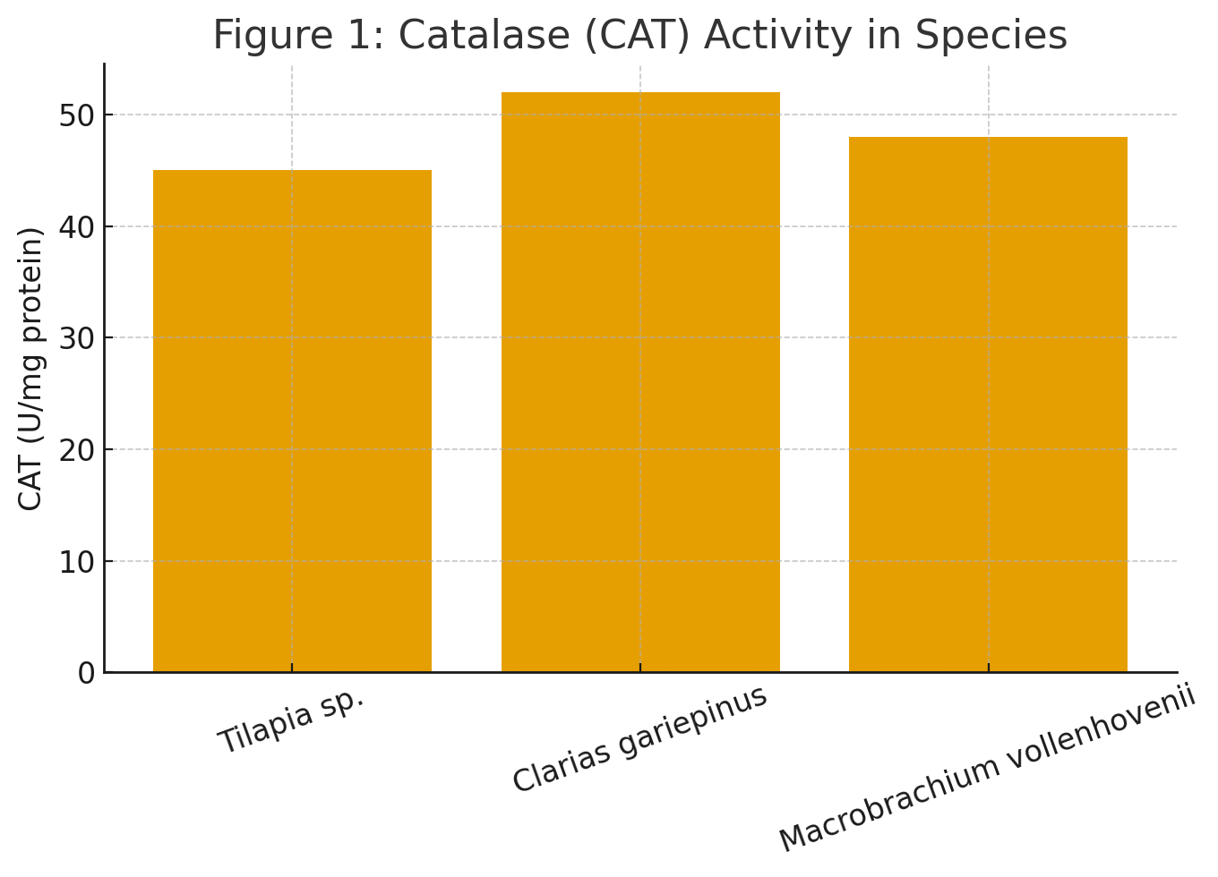
Figure 3: Catalase (CAT) Activity in Species
GST activity followed a similar pattern, with Clarias gariepinus recording the highest value (38 U/mg protein) and Tilapia sp. the lowest (30 U/mg protein), as shown in Figure 4.

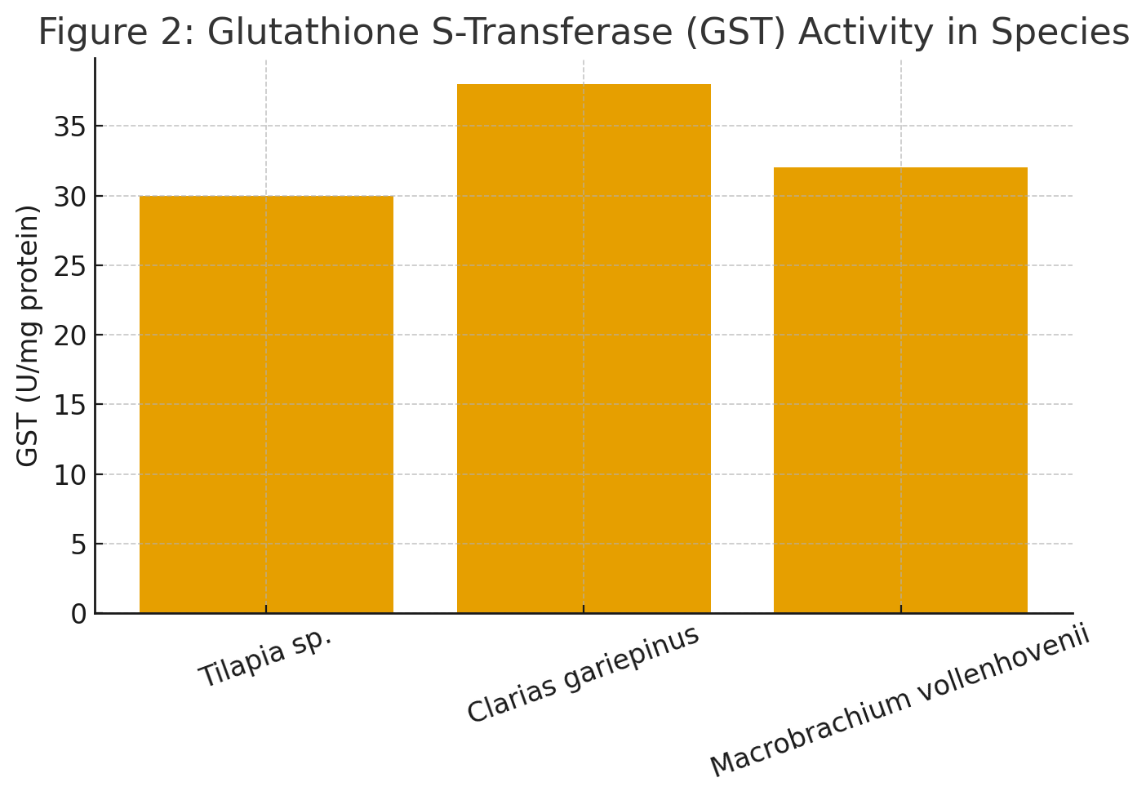Figure 4: Glutathione S-Transferase (GST) Activity in Species)
MDA, an indicator of lipid peroxidation and oxidative damage, ranged from 2.5–3.2 nmol/mg protein, again highest in Clarias gariepinus (3.2 nmol/mg) as shown in Figure 5.
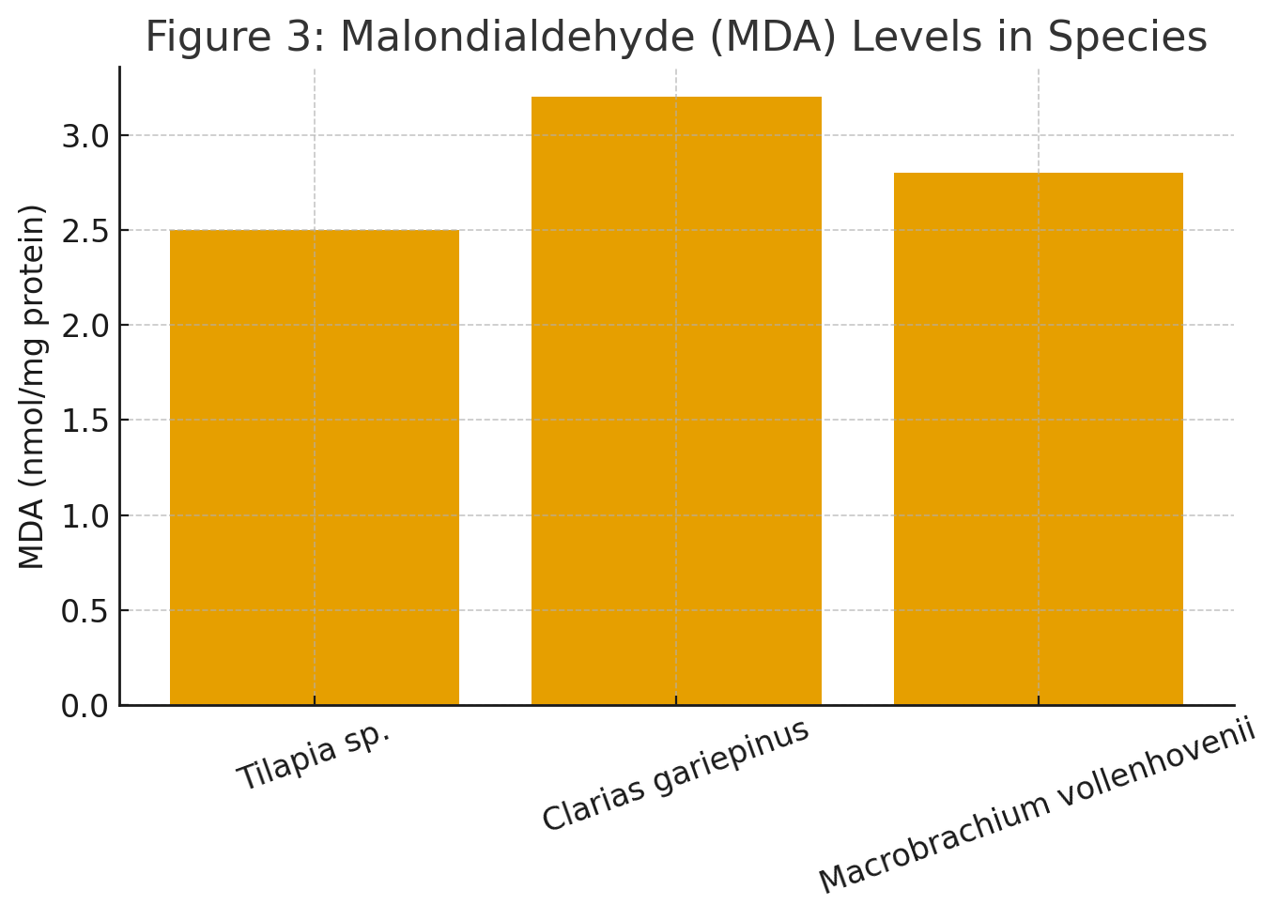
Figure 5: Malondialdehyde (MDA) Levels in Species
These trends indicate that species with higher contaminant burdens exhibited stronger oxidative stress responses, supporting the relationship between toxicant exposure and biomarker activation.
Table 2: Biomarkers (Enzymatic & Oxidative Stress)
Species | CAT (U/mg protein) | GST (U/mg protein) | MDA (nmol/mg protein)
Tilapia sp. | 45 | 30 | 2.5
Clarias gariepinus | 52 | 38 | 3.2
Macrobrachium vollenhovenii | 48 | 32 | 2.8

3.3 Seasonal Comparison (Wet vs Dry Season)
Seasonal differences in TPH, Pb, and MDA were observed for Tilapia sp. and Clarias gariepinus (Table 3). TPH concentrations were higher during the wet season (Tilapia sp.: 3.8 mg/kg; Clarias gariepinus: 4.5 mg/kg) than the dry season (3.2 and 3.9 mg/kg, respectively). Wet-season Pb values were also slightly elevated relative to the dry season.
MDA levels followed the same pattern, indicating greater oxidative stress during the wet season, likely due to increased runoff transporting hydrocarbons and metals into the aquatic environment.
Table 3: Seasonal Comparison (Wet vs Dry)
Species | TPH Wet | TPH Dry | Pb Wet | Pb Dry | MDA Wet | MDA Dry
Tilapia sp. | 3.8 | 3.2 | 0.42 | 0.38 | 2.6 | 2.4
Clarias gariepinus | 4.5 | 3.9 | 0.57 | 0.53 | 3.4 | 3.0

4.0 Discussion
The results of this study demonstrate clear evidence that fish and crustaceans inhabiting the Qua Iboe Estuary are continuously exposed to petroleum hydrocarbons and heavy metals, resulting in measurable biochemical stress responses. The elevated concentrations of lead, mercury, arsenic, chromium, and total petroleum hydrocarbons (TPH) observed in Tilapia sp., Clarias gariepinus, and Macrobrachium vollenhovenii indicate chronic pollution from multiple anthropogenic sources typical of the Niger Delta. Similar pollution signatures have been documented in aquatic ecosystems subjected to gas flaring, pipeline leakages, petroleum handling activities, and domestic effluent discharge (Okpoji et al., 2025f; Ekpe et al., 2025). The contaminant levels recorded in Clarias gariepinus were consistently higher across all parameters, suggesting greater susceptibility due to its benthic feeding behaviour and frequent interaction with sediment-bound pollutants.
The heavy metal concentrations observed in this study align with patterns previously reported in various aquatic organisms within the Niger Delta. Studies by Okpoji et al. (2025h) and Eyenubo et al. (2024) similarly showed elevated Pb, As, and Cr levels in fish and sediments from petroleum-impacted rivers and creeks, emphasising the persistence of metal contaminants in estuarine environments. Metals such as Pb, Cd, and Hg are of particular concern due to their non-biodegradable nature, strong affinity for tissues, and potential for biomagnification (ATSDR, 1997). Their presence at measurable concentrations across species reflects long-term ecological stress, as seen in other contaminated tropical ecosystems (Ernesto et al., 2021; Oghenekohwiroro & Osaro, 2017).
The TPH concentrations recorded (3.2–4.5 mg/kg) further confirm hydrocarbon exposure in the study organisms. Petroleum hydrocarbons enter estuaries through direct spills, gas flaring emissions, atmospheric fallout, and urban runoff (Okpoji et al., 2025g). Atmospheric deposition of soot-associated hydrocarbons, as described by Aghanwa et al. (2025), remains an important pathway for hydrocarbon contamination in coastal ecosystems of the Niger Delta (Etesin et al. 2025). Global studies also indicate that volatile and semi-volatile hydrocarbons can undergo long-range atmospheric transport before deposition (Kallenborn et al., 2015; Wania et al., 2006), supporting the likelihood of both local and regional input pathways into the Qua Iboe Estuary.
The biomarker responses (CAT, GST, and MDA) observed in this study provide strong biochemical evidence that the organisms are undergoing oxidative stress as a result of contaminant exposure. Higher CAT and GST activities in Clarias gariepinus and Macrobrachium vollenhovenii correspond with their elevated metal and hydrocarbon levels, reinforcing the relationship between contaminant dose and antioxidant enzyme activation. These biomarkers are sensitive indicators of exposure to xenobiotics, including PAHs, petroleum hydrocarbons, and heavy metals, as reported in previous studies across the Niger Delta and other polluted aquatic systems (Ekwere et al., 2025b; John et al., 2025). Elevated MDA levels indicate lipid peroxidation, suggesting cellular membrane damage induced by reactive oxygen species generated during the biotransformation of toxicants.
Seasonal differences in TPH, Pb, and MDA show a consistent pattern of higher values during the wet season. This aligns with earlier studies demonstrating that heavy rainfall mobilises contaminants from surrounding land, increasing pollutant influx into estuaries (Ekpe et al., 2025; Umueni et al., 2025b). Wet-season runoff can transport petroleum residues, metals, and organic pollutants from industrial zones, farmlands, and urban settlements directly into aquatic systems. Conversely, slightly lower dry-season values likely reflect reduced surface runoff and dilution but do not indicate the absence of pollution, given the persistent nature of the contaminants (Ogbaji, et al., 2025).
The oxidative stress responses observed in this study are biologically significant. Elevated MDA levels in Clarias gariepinus (3.2 nmol/mg protein) suggest that hydrocarbon and metal exposure is inducing measurable cellular damage (Ekesiobi, et al., 2025). This is consistent with findings from contaminated aquatic environments where chronic exposure to PAHs and metals results in increased lipid peroxidation, enzyme inhibition, and biochemical disruption (ATSDR, 1997; IARC, 2015). Hydrocarbon metabolites—such as reactive quinones—are known to induce oxidative stress, and heavy metals like Pb and Cr disrupt antioxidant defence mechanisms, further increasing cellular damage (Okpoji et al., 2025e).
The results underscore broader ecological and human health implications. Fish and prawns form a major protein source for surrounding communities, and their contamination poses potential risks of dietary exposure to carcinogens and neurotoxic metals. Studies have reported human health risks associated with the consumption of contaminated aquatic organisms from petroleum-impacted Niger Delta waterways (Okpoji et al., 2025h; Ekwere et al., 2025a). Given that benzo[a]pyrene—an IARC Group 1 carcinogen—is commonly associated with petroleum residues, the biochemical stress observed in this study may serve as an early warning indicator for both ecological health and food safety concerns.

Conclusion
This study demonstrates that aquatic organisms inhabiting the Qua Iboe Estuary are consistently exposed to mixtures of heavy metals and petroleum hydrocarbons, resulting in measurable biochemical stress. The elevated concentrations of Pb, Hg, As, and TPH across species, particularly in Clarias gariepinus, indicate chronic contamination typical of petroleum-impacted systems in the Niger Delta. The strong activation of antioxidant enzymes (CAT and GST) and increased levels of MDA provide clear evidence of oxidative stress and cellular membrane damage induced by these pollutants.
Seasonal variations further revealed that wet-season runoff significantly increases contaminant inflow, intensifying physiological stress in exposed organisms. These findings emphasise the ecological risks posed by ongoing petroleum-related activities and highlight the urgent need for enhanced environmental regulation, continuous biomarker-based monitoring, and pollution mitigation strategies. Protecting estuarine biodiversity and safeguarding human health require targeted interventions to reduce pollutant sources and ensure sustainable management of aquatic resources in the region.

Disclaimer (Artificial intelligence)
Option 1:
Author(s) hereby declare that NO generative AI technologies such as Large Language Models (ChatGPT, COPILOT, etc.) and text-to-image generators have been used during the writing or editing of this manuscript.

Reference
- Agency for Toxic Substances and Disease Registry (ATSDR). (1997). Toxicological Profile for Polychlorinated Biphenyls (PCBs). Public Health Service, U.S. Department of Health and Human Services, Atlanta, GA.
- Aghanwa, C. I., Umueni, U. E., Etukudo, N. J., Amachree, J. B., Okpoji, A. U., Ejeka, C. J., & Ekwere, I. O. (2025). Atmospheric deposition of soot and heavy metals from gas flaring into surface waters of Ebocha, Rivers State, Nigeria. Asian Journal of Environment & Ecology, 24(11), 137–147. https://doi.org/10.9734/ajee/2025/v24i11822
- Anarado, C. J. O., Okpoji, A. U., & Anarado, C. E. (2023). Bioaccumulation and health risk assessment of lead, cadmium, arsenic, and mercury in blue crabs found in creeks in Bayelsa State of the Niger Delta region of Nigeria. Asian Journal of Environmental & Ecology, 21(4), 46–59.
- Ekesiobi, S. U., Ekpe, J. E., Okpoji, A. U., Hassan, D. H., Ekwere, I. O., Awortu, R. C., Etesin, M. U., Nwofia, U., Okeke, C. F., & Nwankwo, A. O. (2025). Hydrochemical characterisation and health-risk assessment of drinking water sources in Brass Island, Bayelsa State, Nigeria. Asian Journal of Chemical Sciences, 15(6), 64–76. https://doi.org/10.9734/ajocs/2025/v15i6406
- Ekpe, J. E., Okpoji, A. U., Ekwere, I. O., Anarada, C. J., Ewuola, A. A., Ufuoma, V. O., Okpanachi, C. B., Okonkwo, C. O., & Obunezi, O. A. (2025). Physico-chemical transport of pesticides and nutrients in irrigation water and their fate in agro-ecosystems of Rivers State, Nigeria. Palgo Journal of Agriculture, 9(2), 30–37. https://doi.org/10.5281/zenodo.17148360
- Ekwere, I. O., Okpoji, A. U., Igwegbe, K. C., Okonkwo, C. O., Yekeen, A. A., Obunezi, O. C., Okpanachi, C. B., Garuba, M. H., Ogini, O. R., & Odibo, U. E. (2025). Nutritional–Toxicological Trade-Off: Comparative study of polycyclic aromatic hydrocarbons in smoked and oven-dried Nile tilapia (Oreochromis niloticus). Journal of Environment, Climate, and Ecology, 2(2), 90–97. https://doi.org/10.69739/jece.v2i2.952
- Ekwere, I. O., Okpoji, A. U., Ufuoma, V. O., Akinola, A. E., Raymond, C. A., Clement, R. O., Alaekwe, I. O., Etesin, M. O., & Edodi, I. O. (2025). Nutritional evaluation of Nile tilapia (Oreochromis niloticus) processed by different drying methods in Akwa Ibom State, Nigeria. Journal of Sustainable Research and Development, 1(2), 11–17. https://doi.org/10.69739/jsrd.v1i2.1033
- Ernesto, O. Z. A. B., Dioselina, O. F. H., Marina, R. R. O., Hector, M., & Miguel. (2021). Bioaccumulation of PCBs and PBDEs in fish from a tropical Lake Chapala, Mexico. Toxics, 9(1). https://doi.org/10.3390/toxics9100241
- Etesin, M. U., Ezeabsili, P. I., Agu, M. O., Okeke, C. F., Olotu, O. N., Aligwo, M. C., Eze, V. C., Nwankwo, A. O., Okpoji, A. U., & Ekong, I. U. (2025). Determination of polychlorinated biphenyls in soils and industrial effluents and health risks assessment in Uyo, Akwa Ibom State, Nigeria. Journal of Medical Science, Biology, and Chemistry, 2(2), 285–292. https://doi.org/10.69739/jmsbc.v2i2.1258
- Eyenubo, O. B., Peretomode, V. O., Egharevba, F., Osakwe, S. A., & Avwioro, O. G. (2024). Polychlorinated biphenyls (PCBs) in sediments and fish from dredged tributaries and creeks of River Ethiope, South-South Nigeria: Sources, risk assessment and bioaccumulation. Journal of the Nigerian Society of Physical Science, 6, 1951. https://doi.org/10.46481/jnsps.2024.1951
- IARC (International Agency for Research on Cancer). (2015). Agents Classified by the IARC Monographs, Volumes 1–112. http://monographs.iarc.fr/ENG/Classification/ClassificationsAlphaOrder.pdf
- John, E. E., Emah, O. A., Ifiok, O. E., Okpoji, A. U., Iyam, O. E., Henderson, O. O., Akinola, A. E., Gloria, N. A., & Charles, N. O. (2025). Health risk implications of polycyclic aromatic hydrocarbons in smoked and dried fish consumed in Nigeria. Journal of Medical Science, Biology, and Chemistry, 2(2), 192–199. https://doi.org/10.69739/jmsbc.v2i2.1045
- Kallenborn, R., Hung, H., & Brorström-Lundén, E. (2015). Atmospheric long-range transport of persistent organic pollutants (POPs) into polar regions. In Comprehensive Analytical Chemistry (Vol. 67, p. 411). Elsevier. https://doi.org/10.1016/B978-0-444-63299-9.00013-2
- Ogbaji, H. O., Akpan, N. A., Ijioma, C. C., Okpoji, A. U., Eze, V. C., Obi, J. N., Martins, N. P., & Etesin, M. U. (2025). Seasonal variation in hydrocarbon contamination of sediments and biota in Bonny Estuary, Rivers State, Nigeria. Asian Journal of Geographical Research, 8(4), 330–338. https://doi.org/10.9734/ajgr/2025/v8i4341
- Oghenekohwiroro, E., & Osaro, I. (2017). Assessment of the levels of polychlorinated biphenyls (PCBs) in Oroodo River sediment, Agbor, Delta State, Nigeria. Annals of Chemistry, 28, 25. https://intapi.sciendo.com/pdf/10.1515/auoc-2017-0005
- Okagbare, U. V., Umueni, U. E., Ekpe, J. E., Etukudo, N. J., Okpoji, A. U., Okoye, P. I., Ekwere, I. O., Etesin, M. U., Okpanachi, C. B., & Okafor, C. A. (2025). Geophysical and hydrochemical assessment of groundwater vulnerability to oil pollution in Yenagoa, Bayelsa State, Nigeria. Journal of Environment, Climate, and Ecology, 2(2), 138–146. https://doi.org/10.69739/jece.v2i2.1078
- Okpoji, A. U., Anarado, C. O., Mmuta, E. C., Ekwere, I. O., Alaekwe, I. O., Odibo, U. E., Igwegbe, K. C., Eboj-Ajoku, I. O., & Obunezi, O. C. (2025). Toxicological evaluation of Pb, Cd, As, and Hg in blue crab from oil-polluted creeks in the Niger Delta. Journal of Life Science and Public Health, 1(1), 24–31. https://doi.org/10.69739/jlsph.v1i1.879
- Okpoji, A. U., Chinyere, U. E., Nwokoye, J. N., Ezekwuemen, O. I., Alaekwe, I. O., Odidika, C. C., Owughara, C. N., Enyi, C. M., & Kolawole, O. O. (2025). Environmental assessment of heavy metals and hydrocarbon pollution in surface waters of oil-bearing communities in Andoni, Rivers State, Nigeria. International Journal of Modern Science and Research Technology, 3(8), 22–30.
- Okpoji, A. U., Eboh-Ajoku, I. O., Mmuta, E. C., Ndubuisi, J. O., Alaekwe, I. O., Odibo, U. E., Nwoka, N. G., Okafor, C. A., & Obunezi, O. C. (2025). Integrated environmental risk assessment of BTEX and PAHs in water and sediment samples from the Bonny River, Nigeria. ISA Journal of Multidisciplinary (ISAJM), 2(4), 14–21. https://doi.org/10.5281/zenodo.16921896
- Okpoji, A. U., Ekwere, I. O., Igwegbe, K. C., Anarado, C. J. O., Ogbonna, C., Ewuola, A. A., Odibo, U. E., & Garuba, M. H. (2025). Volatile organic compounds from gas flaring and their atmospheric implications in the Niger Delta. Journal of Life Science and Public Health, 1(1), 32–39. https://doi.org/10.69739/jlsph.v1i1.962
- Okpoji, A. U., Etesin, M. U., Ekwere, I. O., Martins, N. P., Okpanachi, C. B., Adisa, O. J., & Okonkwo, C. C. (2025). Geochemical speciation and ecological risk of heavy metals in estuarine sediments of the Qua Iboe River, Nigeria. Asian Journal of Chemical Sciences, 15(6), 20–31. https://doi.org/10.9734/ajocs/2025/v15i6402
- Okpoji, A. U., Ndubuisi, J. O., Eboh-Ajoku, I. O., Emem, J. A., Ekwere, I. O., Alaekwe, I. O., Odibo, U. E., Igwegbe, K. C., Onoja, C. R., Warder, A. B., & InyangAbia, A. J. (2025). Trematode infections and histopathological effects in Chrysichthys nigrodigitatus from the polluted Andoni River, Niger Delta, Nigeria. Journal of Agriculture, Aquaculture, and Animal Science, 2(2), 66–72. https://doi.org/10.69739/jaaas.v2i2.882
- Okpoji, A. U., Ogbaji, H. O., Hassan, D. H., Orji-Azuka, L. N., Rasheed, H. O., Ohaturuonye, S. O., Ejeka, J. C., Okpanachi, C. B., & Ekwere, I. O. (2025). Physico-chemical transport of volatile organic compounds (VOCs) from gas flaring into surface waters of Ogoniland, Rivers State, Nigeria. Asian Journal of Physical and Chemical Sciences, 13(4), 151–159. https://doi.org/10.9734/ajopacs/2025/v13i4271
- Okpoji, A. U., Ugwanyi, G. C., Etesin, U. M., Ugwuanyi, G. C., Okpanachi, C. B., Ewuola, A. A., Mojisola, K. M., & Ezekwueme, O. I. (2025). Solar-enhanced photocatalytic degradation of pharmaceutical residues in wastewater using Fe-, Cu-, and Zn-doped TiO₂ nanomaterials. Journal of Environment, Climate, and Ecology, 2(2), 56–62. https://doi.org/10.69739/jece.v2i2.961
- Onoja, C. R., Ogbaji, H. O., Edodi, I. O., Mmuta, E. C., Igwegbe, K. C., Ogini, O. R., Odibo, U. E., Ewuola, A. A., Mahmoud, A. B., & Okpoji, A. U. (2025). Heavy metal contamination and health risk assessment of smoked-dried fish sold in Eke-Awka market, Anambra State, Nigeria. Journal of Sustainable Research and Development, 1(2), 18–25. https://doi.org/10.69739/jsrd.v1i2.1044
- Stewart, P., Reihman, J., Lonky, E., Darvill, T., & Pagano, J. (2000). Prenatal PCB exposure and neonatal behavioral assessment scale (NBAS) performance. Neurotoxicology and Teratology, 22(1), 21–29. https://doi.org/10.1016/S0892-0362(99)00056-2
- Umueni, U. E., Etukudo, N. J., Okoye, P. I., Okpoji, A. U., Eze, V. C., Aningo, G. N., Ekwere, I. O., & Garuba, M. H. (2025). Geochemical and ecological risk assessment of petroleum hydrocarbons in sediments of the Forcados River, Delta State. Asian Journal of Geographical Research, 8(4), 287–298. https://doi.org/10.9734/ajgr/2025/v8i4337
- Umueni, U. E., Rasheed, H. O., Edodi, I. O., Aningo, G. N., Okpoji, A. U., Etesin, M. U., Okonkwo, C. C., Ekwere, I. O., Okeke, C. F., & Anarah, S. E. (2025). Nutrient enrichment and eutrophication potential of agricultural runoff in Otuoke, Bayelsa State, Nigeria. Asian Journal of Agricultural and Horticultural Research, 12(4), 154–163. https://doi.org/10.9734/ajahr/2025/v12i4424
- USEPA (United States Environmental Protection Agency). (2011). Regional Screening Level (RSL) Table for Chemical Contamination at Superfund Sites. https://www.epa.gov/risk/regional-screening-levels-rsls
- Wania, F., Bereik, K., Persson, N. J., & McLachlan, M. S. (2006). A fugacity-based dynamic multi-compartmental mass balance model of the fate of persistent organic pollutants. Environmental Modelling & Software, 21, 868. https://doi.org/10.1016/j.envsoft.2005.04.003
- World Bank. (2014). Life expectancy data. https://data.worldbank.org/indicator/SP.DYN.LE00.IN

