Prescribing Patterns Among Elderly Patients in a Tertiary Care Hospital in Bangladesh: A Cross-Sectional Study

ABSTRACT

Background: The health care issues among the aging population in Bangladesh have their characteristics that require specific approaches regarding the medications for elderly patients. It has been discovered that identifying the trends of the prescribers that patients receive the most prescriptions from is significant in enhancing elder patient care.
Objective: To identify the prescription practices for elderly patients in the tertiary care facility in Bangladesh and assess the adherence to standardized drug utilization using the World Health Organization core indicators.
Methods: This was a cross-sectional study done from April to August 2025 at the Dhaka Medical College Hospital, with the sample comprising 110 in-patients aging 60 years or older. Demographic information, health status and medications were obtained by a self-completed, structured questionnaire. The 2012 Beers Criteria and World Health Organization (WHO) core drug-use indicators are used to assess prescription trends and find potentially inappropriate drugs (PIMs).
Results: The average number of drugs per prescription was 7.52, significantly higher than World Health Organization (WHO) standards. Only 10.1% of drugs were prescribed by generic name. 17.27% of patients received at least one potentially inappropriate drug (PIM). Female patients received significantly more drugs than males (9.04 vs. 7.07 on average).
Conclusion: This study shows that a significant incidence of potentially inappropriate drugs (PIMs), low rates of generic prescribing, and broad multidrug combination therapy are characteristics of prescribing for older patients. These trends draw attention to important gaps in geriatric pharmacotherapy and emphasize the necessity of focused interventions to maximize older individuals' medication safety. The integration of electronic prescribing systems, ongoing geriatric pharmacology-focused professional development programs, more encouragement of the use of generic medications, and prompt medication reconciliation are all necessary to improve prescribing procedures. More broadly, our results encourage the creation of evidence-based geriatric prescribing guidelines and healthcare policies that lower medication-related hazards and enhance therapeutic results in older populations.
Keywords: Elderly, Prescribing pattern, Beers criteria, Polypharmacy.

Introduction
The increased numbers in the elderly group of people is one of the most notable trends in the world demographics. This is changing mostly within the developing nations where today, over one third of the world old population is residing. The number of people who are 60 years of age or older is predicted to increase from 962 million in 2017 to 2.1 billion in 2050 and 3.1 billion in 2100, more than doubling by 2050 and more than tripling by 2100. The population of those over 60 is expanding more quickly than any other age groups worldwide (Ummah, 2017; World Health Organization, 2024). This quick changing of demographic is a two-sided sword to the healthcare in the world and in most institutions, particularly dealing with the various and complex health conditions of the elderly. Demographic change is a phenomenon that is becoming a reality experienced by most developing nations such as Bangladesh (Osareme, Muonde, Paschal, Olorunsogo, & Omotayo, 2024). This essay argues that the healthcare sector in the country is currently grappling with the issue of ensuring that sufficient care is delivered to a soaring, and aging population. To make such a transition, one should know the condition of the elderly, medication needs, and procedures of giving prescriptions to the elderly in Bangladesh (Sarker, 2025; Sarker et al., 2023). It is universally evident that as people grow old so do they acquire or gain more chronic diseases and numerous morbidities. Old age is a risk factor in which individuals are highly susceptible to contracting a number of diseases which include cardiovascular diseases, diabetic diseases, rheumatic diseases like arthritis, and neurological diseases like Alzheimer disease (Prasad, Sung, and Aggarwal, 2012). These disorders are normally addressed and treated using a number of drugs; therefore, most of the citizens of nations undergo various medicines. Besides, it should be noted that older patients are more susceptible to ADRs due to the change in pharmacokinetics and pharmacodynamics with age. They have the ability to alter the uptake, distribution, biotransformation and clearance of the drug and this could lead to an abnormal or exaggerated drug response (Ngcobo, 2025). The decreased renal clearance, modifications of body structures, and hepatic metabolic changes are some of the factors that influence the behavior of medications in the elderly. Polypharmacy or a combination of multiple drugs concurrently is common in the elderly patients. Polypharmacy is risky even though it is sometimes unavoidable in the case of a combination of various chronic illnesses. These risks are drug/drug interactions, drug administration errors, and adverse drug occurrences (Alhumaidi et al., 2023). There can also be multiple and intricate dosing schedules, unrestrained doses and without of administration, special preparation, and combination of drugs, which are part of the reasons that precipitate poor adherence, influence treatment results and safety (Sarker, Zabeen, Khanam, Akter, and Ali, 2023). The medical dilemma is that the issue of administering full treatment of the patient should be balanced against the risks of the medications given. This will be a position that requires an understanding of the pharmacology of the drugs in geriatric patients and the creation of a more patient-centered attitude to drug administration (Roller -Wirnsberger, Thurner, Pucher, Lindner, and Wirnsberger, 2020). Potential Inappropriate medications (PIMs) have recently come into the limelight as far as geriatric care is concerned (Idrisnur et al., 2024). PIMs are medications that possess toxic effects at therapeutic doses or medications that might not possess therapeutic worth in aged persons as compared to the youth. The results emphasized that using PIMs has a connection with the increased risk of AE, hospitalization, and mortality among the elderly. To do so a number of criteria and guidelines have been developed and this assists the caregivers in diagnosing and preventing PIMs in the elderly. Among them, Beers criteria developed by the American Geriatrics Society can be regarded as one of the most notoriously familiar and used filters (American Geriatrics Society, 2023). Beers (“American Geriatrics Society 2023 Updated AGS Beers Criteria® for Potentially Inappropriate Medication Use in Older Adults,” 2023) criteria provide a definite idea of which medications should be applied with high caution or selected against elderly patients due to the deleterious effect they may have (Young, 2012). Therefore, the prescription issues in the elderly are not different in any of the countries but rather increased in the developing world particularly Bangladesh. The issue of successful work with the elderly patients is associated with the lack of resources, ineffective access to the health care system, and the lack of geriatric specialists. In addition, EHR and medication database are inadequate, which can be a barrier to measuring and controlling the prescriptive practices. Even rational use of drugs, which according to WHO implies the ability of patients to receive the appropriate drug regimen to address a disease, in the most optimal doses, at the most optimal duration and at the lowest possible cost to the patient and the rest of the society is still a challenge in most developing countries (WHO, 2024). Evidence based barriers to prescribing include; access to drugs is limited, there are no resources to buy drugs, and the prescribers are not well knowledgeable. This finding of valuable prescriptive tendencies of elderly patients in developing countries has considerable implications due to various reasons (Lau, Lun, Ang, Tan, and Ding, 2020). To begin with, it can be described as a summary of the performance measure of healthcare provision as it can show the degree of adherence to best practices adopted by physicians. It assists in ensuring that the old patients under the health occasion receive high quality care. Secondly, they analyze compliance of the existing prescribing practice with the established standards of practice and identify aspects of practice that are not fully compliant to help plan the focused educational interventions (Singh & Bajorek, 2014). Besides, these trends assist in strategizing proper use of healthcare resources such as acquisition and distribution of drugs, which is essential in a resource-limited setting. In addition, the information acquired through such analyses can be used in formulating policies and protocols that would satisfy the needs of geriatric patients in the local environment. Finally, the prescription pattern will also be analyzed, thus, contributing to the identification of the possible medication safety issues and adverse drug reactions that could potentially be more common among the geriatric patients. It enables the healthcare practitioners and policymakers to enhance the standard of patient care and treatment, ramp up the efficiency and effectiveness of therapeutic interventions and care interventions of the elderly in the developing countries (Tay et al., 2021).
In order to monitor and compare the practices of rational drug use across health systems, the WHO has provided a list of core drug use indicators. These indicators provide a framework for assessing key aspects of prescription practices, including:

- Average number of drugs per encounter
- Percentage of drugs prescribed by generic name
- Percentage of encounters with an antibiotic prescribed
- Percentage of encounters with an injection prescribed
- Percentage of drugs prescribed from national essential drugs list

The indicators give quantifiable benchmarks of assessing trends in prescribing in diverse settings and periods and hence the determination of critical issues of change (Anwar, Daud, and Hussain, 2025). Bangladesh is a young old population with a switching health care system and as such, it is an ideal setting to discuss the theme of prescriptions to the aged patients. The healthcare system of the country is characterized by both the public and the private sector providing, which is rather inhomogeneous regarding the availability and quality of healthcare services across the areas that can be defined as urban and rural. The awareness of what such factors might do to the prescribing of the elderly patients would help to influence interventions and policies. All these factors make the far-reaching research on geriatric prescribing in Bangladesh highly justified because this country is characterized by numerous peculiar factors. Thus, the proposed study will address the mentioned gap in the literature by providing an in-depth understanding of the prescription practices of the elderly patients in a tertiary care center in Bangladesh.
The particular objectives of this research are to evaluate the prescription of elderly patients in a tertiary care hospital in Bangladesh considering the health care facilities in Bangladesh and the calculation of the drug utility ratios with the WHO core drug use ratio. We will suggest measuring the percent of patients who use potentially inappropriate medicines based on the Beers criteria and establish the determinants that are related to polypharmacy and the use of PIM among these patients. Besides, the paper will also propose purposeful recommendations to optimize geriatric pharmacotherapy in the Bangladeshi context. The proposed research is likely to offer a reflection of the existing knowledge about geriatric pharmacotherapy in developing nations, which will answer the set objectives. The results will be leverageable to comprehend the prevailing condition, as well as, to formulate future policies to optimize medication utilization among the older patient population, which will improve health and quality of life to the frail aged. Therefore, such a study is interesting because Bangladesh is also struggling with its demographic transition, and consequently, evidence-based healthcare policies and practices should exist. The results of this research will be capable of changing the practice in the clinical setting, educating the professionals, and assisting the organizations with their policies formulation on which areas to invest to improve the health condition of the elderly in Bangladesh and other related nations.

Methods
Study setting: The study was conducted at the general inpatient department of Dhaka Medical College Hospital, a tertiary care center in Dhaka, Bangladesh. The study protocol received approval from the respective authority of Dhaka Medical College Hospital (DMCH), Dhaka, Bangladesh, and ethical permission was granted for data and record collection.
Study design and period: This was a cross-sectional study carried out from April to August 2025.
Study population: The study included 110 inpatients aged 60 years and above.
Data collection
A standardized, interviewer-administered questionnaire was used to gather sociodemographic data, medical history, and prescription information. The device was divided into three separate sections: (1) Age, gender, and job status; (2) medical history and comorbidities; and (3) a comprehensive pharmaceutical profile that includes the generic name and mode of administration. Prior to the primary data collection, the questionnaire was pre-tested (piloted) on a sample of 20 older hospital in-patients to guarantee clarity and comprehension among the elderly population. This resulted in minor adjustments for enhanced flow and linguistic simplicity. The data was collected using a custom questionnaire (see Appendix)
Drug utilization evaluation
WHO core drug use indicators were used to assess prescribing practices (WHO, 1993):
- Average number of drugs per encounter
- Percentage of drugs prescribed by generic name
- Percentage of encounters with an antibiotic prescribed
- Percentage of encounters with an injection prescribed
- Percentage of drugs prescribed from the national essential drugs list
The 2012 version of the Beers criteria, developed by the American Geriatrics Society, was used to identify potentially inappropriate medications.

Data analysis
The data was recorded in Microsoft Excel 2016, and statistical analysis was done with the help of SPSS version 17. Quantitative data descriptive analyses such as mean, frequency, and percentage were computed. To determine the factors related to the number of prescribed medications, multiple linear regression analysis was conducted.

Results and discussions
This cross-sectional study was carried out from April to August 2025 in the Dhaka Medical College Hospital, Bangladesh, involving 110 inpatients, aged 60 years and above. The particulars considered for the study included an analysis of the prescription pattern among the elderly patients in a tertiary care hospital.
The demographic data of the participants that formed the study population are presented in Table 1. The patients were between the ages of <60 and >70 years of age, with 43 (39.1%) within the age bracket of 65-70 years, 37 (33.6%) within the age bracket of 60-64 years, and 30 (27.3%) above 70 years of age. The gender distribution was skewed, whereby seventy-five of them were male (77.3%) and twenty-five were females (22.7%), thus giving a male-female ratio of 1:0.29. As to place of residence, 70 patients (63.6%) were from the rural areas, while 40 patients were from the urban areas (36.4%). In relation to the economic classification, the majority of patients 50 (45.5%) were classified as low income, while the rest 60 (54.5%) were classified as middle income. None of the patients were considered to be in a high income bracket. Lifestyle-related risk factors such as smoking and betel leaf chewing habits were also taken. Among the patients, 56.36% had a previous smoking history, while 43.63% were non-smokers. Currently, 15.46% are smokers, while 84%.55% are non-smokers. For betel leaf habits, 46 commodities were detected positively. 53% were consumers only in the most basic sense of the term, and 36% of the respondents were defined as consumers/consumption contributors. 63% were non-consumers.

Table 1: Demographic Characteristics of the patients (N=110)
Demographic Variables |  | Frequency | Percent
Gender | Male | 85 | 77.3%
Gender | Female | 25 | 22.7%
Residence | Rural | 70 | 63.6%
Residence | Urban | 40 | 36.4%
Patient's age | 60-64 years | 37 | 33.6%
Patient's age | 65-70 years | 43 | 39.1%
Patient's age | >70 years | 30 | 27.3%
Economic status | Low | 50 | 45.5%
Economic status | Middle | 60 | 54.5%
Economic status | High | 0 | 0.0%
Department | Cardiology | 49 | 44.5%
Department | Medicine | 40 | 36.4%
Department | Nephrology | 13 | 11.8%
Department | Surgery | 4 | 3.6%
Department | Emergency | 4 | 3.6%
Total |  | 110 | 100%

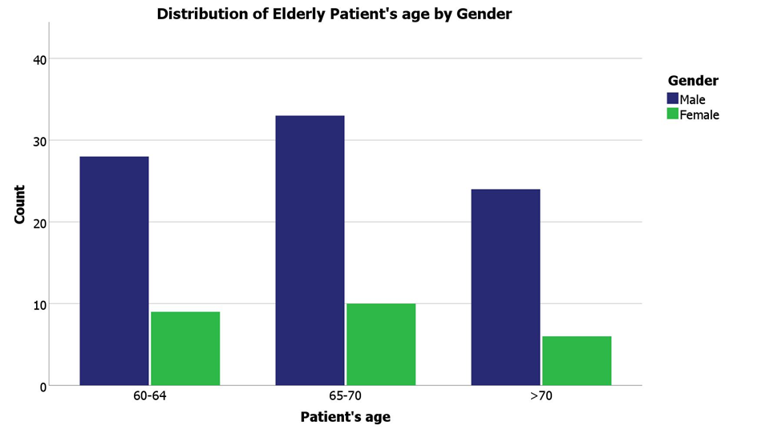

Figure 1: Distribution of Elderly patient’s age by Gender.
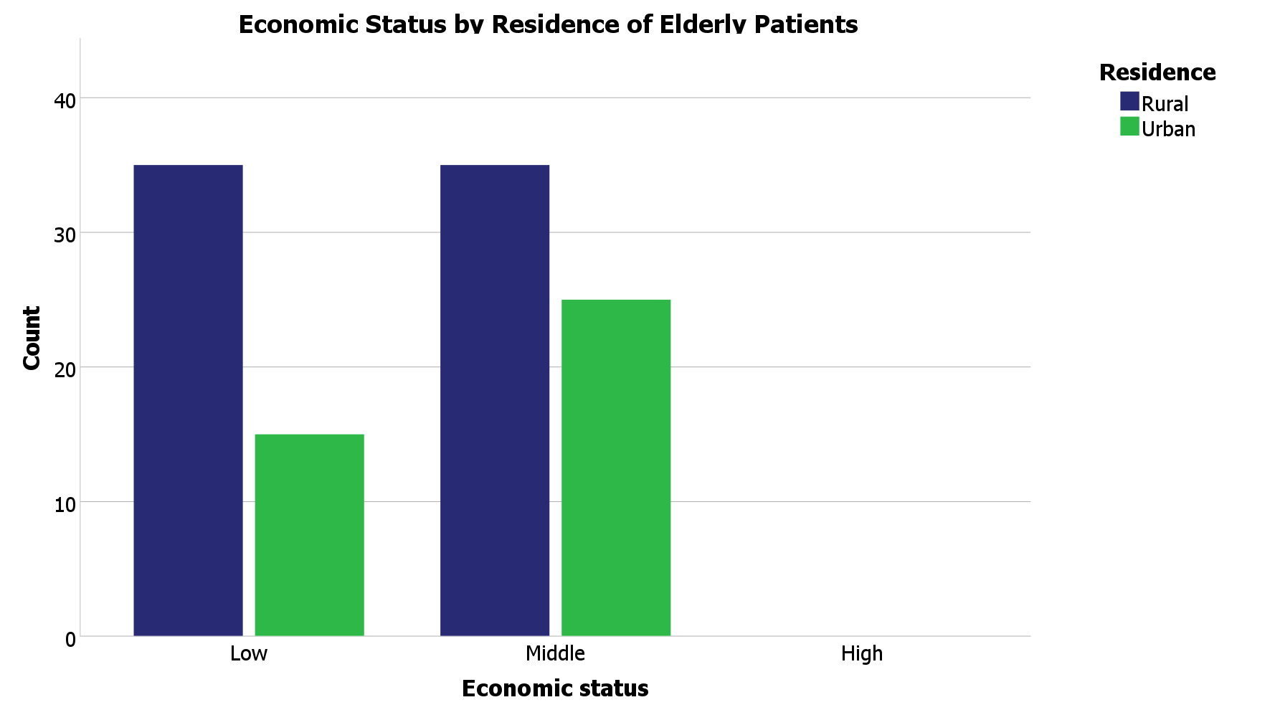

Figure 2: Economic Status by Residences of Elderly Patients.

Various prescribing indicators are described below in Table 2. In the whole year, 827 drugs were prescribed, an average of 7.52 drugs per prescription. These prescription medicines were prescribed by generic names with only 84 drugs (0.76 per prescription). Injectable drugs were frequently used, with 238 prescribed (2.16 per prescription).Important drugs that were prescribed are essential drugs and antibiotics for 177 times, whereas the average essential drugs written per prescription is 1.61 and the antibiotics were prescribed 98 times with a 0.89 average per prescription. Combination drugs were prescribed 76 times (0.69 per prescription), and topical preparations were rarely prescribed, with only 2 instances (0.02 per prescription).Syrups were prescribed 24 times with an average prescription of 0.22 per prescription.

Table 2: Values obtained for prescribing indicators

 | Sum | Average
Number of Drugs | 827 | 7.52
Number of generic drugs | 84 | .76
Number of injectables | 238 | 2.16
Number of drugs from essential list | 177 | 1.61
Number of antibiotics | 98 | .89
Number of combination Drugs | 76 | .69
Number of topical preparations | 2 | .02
Number of syrups | 24 | .22

A total of 827 drugs were prescribed to the 110 patients. Table 3 shows how the number of medicines given is spread out.The average number of drugs per prescription was 7.52, with a range of 2-14 drugs. Only 84 drugs (10.158%) were prescribed by generic name. Antibiotics were prescribed in 98 encounters (11.85%), while injections were prescribed in 238 encounters (28.78%). About 21.40% of prescribed drugs were from the national essential drugs list.
Compared to WHO standards, the average number of drugs per prescription (7.52) was significantly higher than the ideal range of 1.6-1.8. The percentage of drugs prescribed by generic name (10.158%) was much lower than the 100% WHO standard. The percentage of encounters with antibiotics prescribed (11.85%) was within the WHO range of 20-26.8%. However, the percentage of encounters with injections (28.78%) exceeded the WHO range of 13.4-24.1%. The percentage of drugs prescribed from the essential drugs list (21.40%) was far below the 100% WHO standard.

Table 3: Values obtained for prescribing indicators versus WHO standards. (N=110)

Prescribing indicator | Values obtained | WHO standard
Average number of drugs per prescription | 7.52(2-14) | 1.6-1.8
% of drugs prescribed as generics | 10.158 | 100
% of antibiotics per prescription | 11.85 | 20-26.8
% of injections per prescription | 28.78 | 13.4-24.1
% of drugs prescribed from national essential drugs list | 21.40 | 100

% calculated from a total of 110 patients.
Table 4 highlights the prescribing patterns based on age and gender. Patients aged 60-64 years received an average of 7.54 drugs per prescription, while those aged 65-70 years were prescribed slightly fewer, averaging 7.40 drugs. The highest average, 7.67 drugs per prescription, was observed in patients over 70 years of age. In terms of gender, male patients received an average of 7.07 drugs, whereas female patients had a significantly higher average of 9.04 drugs per prescription.

Notably, the use of generic drugs was highest in the >70 age group, with an average of 0.83 per prescription, while females had the lowest rate, at just 0.48 per prescription. Injectable drugs were most frequently prescribed to patients over 70 years, averaging 2.47 per prescription. Antibiotics were most commonly given to patients aged 60-64 (1.08 per prescription), and combination drugs were more frequently prescribed to both the >70 age group (0.93) and female patients (0.96 per prescription).

Table 4: Prescribing indicators by Patient’s age and Gender: (Sum and Average)

 | Patient's age |  |  | Gender
 | 60-64 | 65-70 | >70 | Male | Female
Number of Drugs | 279  (7.54) | 318  (7.40) | 230  (7.67) | 601  (7.07) | 226  (9.04)
Number of generic drugs | 26  (0.70) | 33  (0.77) | 25  (0.83) | 72  (0.85) | 12  (0.48)
Number of injectables | 70  (1.89) | 94  (2.19) | 74  (2.47) | 184  (2.16) | 54  (2.16)
Number of drugs from essential list | 63  (1.70) | 69  (1.60) | 45  (1.50) | 137  (1.61) | 40  (1.60)
Number of antibiotics | 40  (1.08) | 29  (0.67) | 29  (0.97) | 83  (0.98) | 15  (0.60)
Number of combination Drugs | 25  (0.68) | 23  (0.53) | 28  (0.93) | 52  (0.61) | 24  (0.96)
Number of topical preparations | 1  (0.03) | 0  (0.00) | 1  (0.03) | 2  (0.02) | 0  (0.00)
Number of syrups | 8  (0.22) | 9  (0.21) | 7  (0.23) | 14  (0.16) | 10  (0.40)

Hypertension was the most common diagnosis, present in 64 patients (58.19%). This was followed by diabetes mellitus in 40 patients (36.36%), kidney diseases in 28 patients (25.46%), and heart diseases in 27 patients (24.55%).

Other common conditions included dental problems (23 patients, 20.19%), asthma (21 patients, 19.09%), and arthritis (17 patients, 15.45%) (Table 5).

Table 5: Patient’s comorbidities Frequencies

Comorbidities | Responses |  | Percent of Cases
Comorbidities | N | Percent | Percent of Cases
Diabetes | 40 | 17.2% | 42.6%
Hypertension | 64 | 27.5% | 68.1%
Heart Diseases | 27 | 11.6% | 28.7%
Arthritis | 17 | 7.3% | 18.1%
Asthma | 21 | 9.0% | 22.3%
Liver Disease | 1 | 0.4% | 1.1%
Kidney Diseases | 28 | 12.0% | 29.8%
Haematological Disorder | 5 | 2.1% | 5.3%
Cancer | 4 | 1.7% | 4.3%
Dental | 23 | 9.9% | 24.5%
Others | 3 | 1.3% | 3.2%
Total | 233 | 100.0% | 247.9%

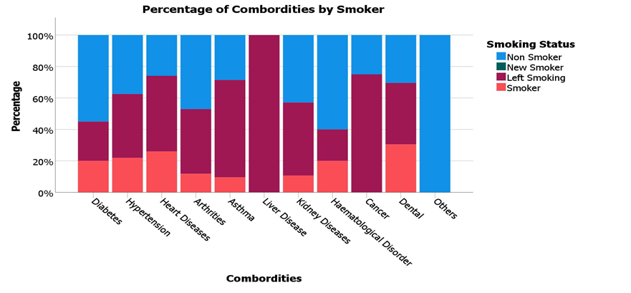
Figure 3: Percentage of Comorbidities by Smoker
Table 6: Regression Analysis for Number of Drugs

Figure 3 illustrates the percentage of comorbidities by smoking status. The figure suggests a relationship between smoking status and the prevalence of certain comorbidities among the elderly patients.
 | Coefficients | Std. Error | t | Sig.
Constant | 5.405 | .970 | 5.569 | .000
Age (60-64)
65-70 | .048 | .556 | .086 | .931
>70 | .324 | .608 | .532 | .596
Gender (Male)
Female | 1.723 | .600 | 2.872 | .005
Fever | .969 | .494 | 1.962 | .052
History of Smoking | -1.051 | .537 | -1.958 | .053
Currently Smoking | .851 | .690 | 1.234 | .220
R² = 0.162, Adjusted R² = 0.113, Std. Error = 2.459

Table 6 presents a regression analysis examining factors influencing the number of drugs prescribed. Gender emerged as a significant factor, with female patients receiving 1.723 more drugs on average than male patients (p = 0.005). Age, however, did not significantly impact the number of drugs prescribed. The presence of fever was associated with an
increase of 0.969 drugs, but this finding was only borderline significant (p = 0.052). Similarly, a history of smoking was linked to a reduction of 1.051 drugs, another borderline result (p = 0.053). In contrast, current smoking status led to an increase of 0.851 drugs, although this relationship was not statistically significant (p = 0.220). Overall, the regression model accounted for 16.2% of the variance in the number of drugs prescribed, as reflected by the R² value of 0.162.

Table 7: Patients Complaints

Complaints | Responses |  | Percent of Cases
Complaints | N | Percent | Percent of Cases
Vision | 38 | 21.0% | 45.2%
Hearing | 15 | 8.3% | 17.9%
Walking | 22 | 12.2% | 26.2%
Swallowing | 9 | 5.0% | 10.7%
Sleeping | 45 | 24.9% | 53.6%
Urination | 13 | 7.2% | 15.5%
Memory | 25 | 13.8% | 29.8%
Pain | 14 | 7.7% | 16.7%
Total | 181 | 100.0% | 215.5%

The most frequent patient complaints were related to sleeping problems (53.6%), vision issues (45.2%), and memory concerns (29.8%).

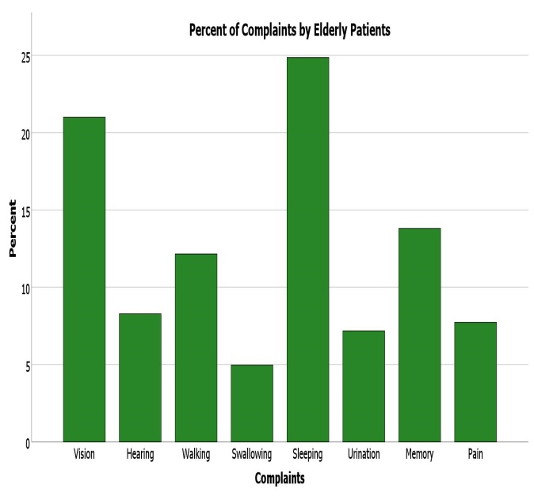
Figure 4: percents of Complaints by Elderly Patients

Antiulcerants were the most commonly prescribed drug type (76.1% of cases), followed by antibiotics (66.1%) and antihypertensives (61.5%).

Table 8: Frequency of prescribed drugs

Drug type | Responses |  | Percent of Cases
Drug type | N | Percent | Percent of Cases
Antidiabetics | 34 | 6.2% | 31.2%
Antibiotics | 72 | 13.1% | 66.1%
Antiulcerants | 83 | 15.1% | 76.1%
Anticancer | 3 | 0.5% | 2.8%
Antipsychotics | 13 | 2.4% | 11.9%
Vitamins | 12 | 2.2% | 11.0%
Anticoagulants | 39 | 7.1% | 35.8%
Hormones | 29 | 5.3% | 26.6%
Antihypertensives | 67 | 12.2% | 61.5%
Anxiolytics | 13 | 2.4% | 11.9%
Analgesics | 49 | 8.9% | 45.0%
Antianginal | 17 | 3.1% | 15.6%
Minerals | 33 | 6.0% | 30.3%
Lipid LA | 52 | 9.5% | 47.7%
Antiasthmatics | 10 | 1.8% | 9.2%
Antiemetics | 24 | 4.4% | 22.0%
Total | 550 | 100.0% | 504.6%

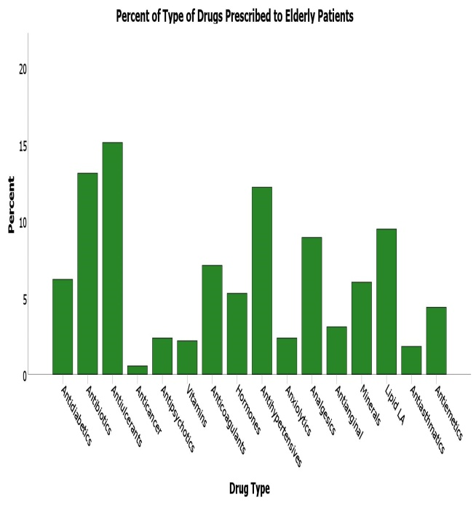
Figure 5: Type of drug Prescribed to Elderly Patients

Table 9 outlines the distribution of patients with multiple comorbidities. A significant portion, 38.19%, had one comorbid condition, while 37.28% had two.
Additionally, 18.19% of patients had three comorbidities, 5.46% had four, and 0.9% had five. Overall, 61.81% of patients had multiple comorbidities, underscoring the complexity of care required for elderly individuals.

Table 9: List of patients simultaneously suffering with comorbid illness.

No of disease | No of patients (%)
1 | 38.19
2 | 37.28
3 | 18.19
4 | 5.46
5 | 0.9
Total | 100

Regarding the route of administration, oral medications were most common (68.682% of drugs), followed by parenteral (28.17%), rectal (1.82%), inhaled (1.08%), and topical (0.24%). No drugs were prescribed for vaginal or ophthalmic routes.
Table 10: Frequency of drugs dosage forms
Route of Administration | Percentage
Oral | 68.682
Parenteral | 28.17
Rectal | 1.82
Topical | 0.24
Inhaled | 1.08
Vaginal | 0
Ophthalmic | 0

Fixed-dose combinations were prescribed in 55 cases (50% of prescriptions). The most common combinations were amlodipine+olmesartan (10 prescriptions, 9.09%), olmesartan+medoxomil (9 prescriptions, 8.18%), and clopidogrel+aspirin (7 prescriptions, 6.36%).
Table 11: Fixed Dose Combination used in elderly patients (% consumptions out of 110 prescriptions)
Combinations used | No of prescriptions
Amlodipine + Olmesartan | 10  (9.09%)
Frusemide + Spirolactone | 6  (5.45%)
Olmesartan + Medoxomil | 9  (8.18%)
Hydrochlorothiazide + Losartan | 1  (0.9%)
Secubitril + Valsartan | 1  (0.9%)
Pepericillin + Tazobactam | 1  (0.9%)
Cefuroxime + Clavulanic acid | 4  (3.63%)
Amoxicillin + Clavulanic acid | 5  (4.54%)
Clopidogrel + Aspirin | 7  (6.36%)
Metformin + Glimepiride | 1  (0.9%)
Carvidopa + Levodopa | 2  (1.82%)
Amlodipine + Alenolol | 1  (0.9%)
Amlodipine + Telmisartan | 2  (1.82%)
Others | 5  (4.54%)
Total | 55(50%)

Table 11 lists the 10 most frequently prescribed drugs. Omeprazole topped the list, appearing in 49.09% of prescriptions, followed by Atorvastatin in 37.27%. Ceftriaxone, an antibiotic, was prescribed in 35.45% of cases, while Aspirin was used in 32.72% of prescriptions. Paracetamol accounted for 25.45%. Other frequently prescribed drugs included Dexamethasone, Amlodipine, Pantoprazole, Frusemide, and Quetiapine.
Table 12: List of 10 most frequently prescribed drugs
Name of the drug | No of prescriptions | Percentage
Omeprazole | 54 | 49.09
Atorvastatin | 41 | 37.27
Ceftriaxone | 39 | 35.45
Aspirin | 36 | 32.72
Paracetamol | 28 | 25.45
Dexamethasone | 16 | 14.55
Amlodipine | 15 | 13.63
Pantoprazole | 14 | 12.72
Frusemide | 12 | 10.90
Quetiapine | 10 | 9.09

Based on the 2012 Beers Criteria, 19 patients (17.27%) were prescribed at least one potentially inappropriate medication (PIM). Out of the 827 drugs prescribed, 19 (2.29%) were identified as PIMs, most of which fell under Category 1, indicating medications to avoid in older adults. Spironolactone was the most common, accounting for 7 cases (36.84%), followed by Prazosin with 5 cases (26.31%) and Clonazepam with 4 cases (21.05%). Diclofenac and Ibuprofen were each prescribed once (5.26%). In Category 3, Carbamazepine was prescribed in 1 case (5.26%).

Table 13: Potentially inappropriate medication uses for the elderly based on Beers Criteria

Category | Name of the drug | Total =19 | Percentage
1 | Medications and class to avoid in older adults:
 | Diclofenac | 1 | 5.26%
 | Spironolactone | 7 | 36.84%
 | Chlorzoxazone
 | Indomethacin
 | Ibuprofen | 1 | 5.26%
 | Hydroxyzine
 | Prazocin | 5 | 26.31%
 | Amiodorone
 | Nitrofurantoin
 | Clonazepam | 4 | 21.05%
 | Diazepam
 | Gluburide
 | Piroxicam
2 | To be avoided in combination with specific comorbidity
3 | Medications to be used with caution in older adults
 | Carbamazepine | 1 | 5.26%

Discussion
This cross-sectional survey, which was conducted at Bangladesh's Dhaka Medical College Hospital, offers insightful information about the prescription habits of the elderly patients in the tertiary care unit. The results have identified some of the key elements utilized in geriatric pharmacotherapy and have highlighted several issues that need further attention. The study's participants reported a shift in the sex ratio, with males predominating over females at a ratio of 1:0.29. However, this cannot be explained by a number of other research on the elderly, most of which showed a higher frequency of female patients. Giri and Khan (2020), who found a male-to-female ratio of 1.20:1 among old people in Nepal, offer an example of regional variations in healthcare availability and utilization. This may be the case because men in South Asian countries like Bangladesh have easier access to medications, are more educated, and have more financial freedom; sociocultural factors influence this group's healthcare-seeking behavior, which is why the majority of the patients who used the service were men. The extremely high percentage of polypharmacy, an average of 7.52 medications per prescription is among the most startling findings. This is significantly higher than the WHO's basic threshold of 1.6–1.8 medicines per interaction, as well as greater than many other relevant research. For example, Argentina (6.1±2.7) and Nepal (5.56) by Sarwar et al. (2018) disclosed the medications prescribed to senior patients. Interestingly, Giri and Khan (2020) found that older patients in Nepal used an average of 8.04 medications per prescription, which is consistent with our results and highlights the prevalence of polypharmacy in South Asian settings. Additionally, polypharmacy raises the risk of side effects, poor medication adherence, and drug-drug interactions, particularly in older patients. The results of this study raise concerns about potential drug interactions and side effects related to polypharmacy, especially in older individuals.
Additionally, the survey revealed a very low percentage of generic medicine prescriptions (10.158%), which is still much below the WHO guideline of 100%. In contrast, Atif et al. (2016) reported that only 2.6% of medications were prescribed using their generic names in their study conducted in Pakistan. Prescribing generic names would significantly save expenses and improve patient compliance, as many older patients have little financial means. The prescription of antibiotics was 11.85%, compared to the WHO-recommended percentage of 20–26.8%, which is worth emulating. However, the overall average of injectable drugs (28.78%) was rated higher than the WHO recommendation of 13.4–24.1%. Such an observation was also made by Sapkota et al. (2011) in a Nepalese context, where the prevalence of the same ranged at 32.2%, meaning 32.2% of prescriptions were of injectable nature. In many cases, making a recommendation for an injection is contingent on the patient, the price, the prescriber’s routine, and the possibility of administering the medicine through the parenteral method. This is a very high rate of injectable use, and the elderly are at greater risk of complications or developing healthcare-associated infections. Diabetes and hypertension were untreated comorbidities, with positive diagnoses in 36.36% and 58.19% of patients, respectively. This is consistent with other global aging societies. The research population supports the findings of Kaur et al.'s (2019) North Indian sample, which showed that diabetes and hypertension were the most common comorbidities among older adults. The cardiovascular group of medications was listed as one of the most common drug categories in another comparable study by Jyothsna et al. (2019) and other Indian studies, maybe as a result of the high prevalence of hypertension in older adults. This is rather expected due to the high incidence of multiple coexisting diseases; 61. 81% of patients had two or more diseases; this brings out the rationale for complex and multiple medications (polypharmacy) as reported in this study. A multivariate regression analysis was conducted to determine which parts of drug management are most important, even though the study advocates for effective medication management to reduce drug interactions and related negative effects. Age was utilized as the independent variable and the number of drugs taken as a dependent variable in relation to the individuals' characteristics. The quantity of medications a patient was taking and their age with comorbid diseases did not significantly correlate, according to an analysis of the 110 patients' records. Omeprazole (49.09%), atorvastatin (37.27%), and ceftriaxone (35.45%) were the most often prescribed medications. The widespread usage of proton pump inhibitors, such as omeprazole, is in line with earlier research on older populations. For example, Jyothsna et al. (2019) found similar results when examining drug use trends in senior patients in India. However, considering the possibility of long-term negative consequences, more research is necessary to determine whether such broad PPI usage in the elderly is suitable. Although the advantages and hazards of statin therapy in the very old (>75 years) are still up for debate in the medical profession, the high frequency of cardiovascular risk factors in this population is reflected in the frequent usage of atorvastatin. According to the 2012 Beers Criteria, 17.27% of patients were prescribed at least one PIM, according to the study. Compared to numerous other research, this prevalence is lower. It is alarming that a large number of prescriptions contain PIMs such prazosin and spironolactone. This is consistent with research conducted in Pakistan by Sarwar et al. (2018), who found that 48.8% of elderly patients had at least one PIM prescribed. PIM use raises the risk of hospitalization and adverse medication reactions in the older population, indicating areas where prescribing procedures may need to be improved.
The substantial gender-based disparity in the number of medications prescribed females were prescribed an average of 9.04 medications, while males received an average of 7.07, was an intriguing discovery. Other studies have noted this gender gap in prescribing, such as Alwhaibi et al. (2023) in the US, who discovered that older women were more likely than men to obtain inappropriate drugs. Further investigation is necessary to determine the causes of this discrepancy, which could include variations in how patients seek medical attention, how their symptoms manifest, or prescriber biases. It is notable that 50% of prescriptions frequently include fixed-dose combinations (FDCs). FDCs may raise the risk of side effects and drug interactions even while they can enhance compliance in patients with numerous comorbidities. Each FDC's suitability should be carefully considered, particularly when it comes to geriatric pharmacotherapy.

Limitations and Future Directions
While this study provides valuable insights, it has some limitations. The sample size is relatively small, and the study was conducted at a single tertiary care center, which may limit the generalizability of the findings. Future research should consider larger, multi-center studies to provide a more comprehensive picture of prescribing patterns among elderly patients in Bangladesh. Additionally, the study did not assess the appropriateness of prescriptions in relation to specific diagnoses or the severity of comorbidities. Future studies could incorporate these factors to provide a more nuanced understanding of prescribing quality.

Conclusion
This study identifies key concerns in prescribing practices for elderly patients in Bangladesh, particularly high levels of polypharmacy, low use of generic drugs, and the prevalence of potentially inappropriate medications (PIMs). These findings highlight the urgent need for targeted interventions to enhance prescribing practices. One approach could be implementing electronic prescribing systems equipped with alerts for potential drug interactions and inappropriate medications. Additionally, continuous education for healthcare providers on geriatric pharmacotherapy and the use of tools like the Beers Criteria is essential. Promoting generic drug use through policy reforms and patient education is another critical step. Regular medication reviews for elderly patients, especially those with multiple comorbidities, can help identify and address inappropriate prescriptions. Further research is needed to understand the gender disparities observed in prescribing patterns and to develop effective, targeted interventions. By tackling these issues, healthcare providers can improve medication management for the elderly, potentially reducing adverse drug events and improving overall health outcomes.
Disclaimer (Artificial intelligence)
Option 1:
Author(s) hereby declare that NO generative AI technologies such as Large Language Models (ChatGPT, COPILOT, etc.) and text-to-image generators have been used during the writing or editing of this manuscript.
Option 2:
Author(s) hereby declare that generative AI technologies such as Large Language Models, etc. have been used during the writing or editing of manuscripts. This explanation will include the name, version, model, and source of the generative AI technology and as well as all input prompts provided to the generative AI technology
Details of the AI usage are given below:
1.
2.
3.

References
Alhumaidi, R. M., Bamagous, G. A., Safaa Alsanosi, Alqashqari, H. S., Qadhi, R. S., Alhindi, Y., … Falemban, A. H. (2023). Risk of Polypharmacy and Its Outcome in Terms of Drug Interaction in an Elderly Population: A Retrospective Cross-Sectional Study. Journal of Clinical Medicine, 12(12), 3960–3960. https://doi.org/10.3390/jcm12123960
Alwhaibi M, Balkhi B. (2023). Gender Differences in Potentially Inappropriate Medication Use among Older Adults. Pharmaceuticals (Basel), 16(6):869. doi: 10.3390/ph16060869
American Geriatrics Society. (2023). American Geriatrics Society 2023 updated AGS Beers Criteria for potentially inappropriate medication use in older adults. Journal of the American Geriatrics Society, 71(7). https://doi.org/10.1111/jgs.18372
American Geriatrics Society 2023 updated AGS Beers Criteria®... (2023). Journal of the American Geriatrics Society, 71(7), 2052–2081. https://doi.org/10.1111/jgs.18372
Anwar, M. F., Daud, N. A. A., & Hussain, R. (2025). From prescribing indicators to rational drug use: a medication safety perspective. Journal of Pharmaceutical Policy and Practice, 18(1). https://doi.org/10.1080/20523211.2025.2544656
Idrisnur, S., Abdu, N., Yohannes, F., Tewelde, T., Russom, N., & Tesfamariam, E. H. (2024). Potentially Inappropriate Use of Medication and Its Determinants Among Ambulatory Older Adults… Clinical Interventions in Aging, 19, 1177–1187. https://doi.org/10.2147/CIA.S466649
Lau, S., Lun, P., Ang, W., Tan, K. T., & Ding, Y. Y. (2020). Barriers to effective prescribing in older adults… BMC Geriatrics, 20(1). https://doi.org/10.1186/s12877-020-01766-7
Ngcobo, N. N. (2025). Influence of Ageing on the Pharmacodynamics and Pharmacokinetics… Clinical Pharmacokinetics, 64(1), 335–367. https://doi.org/10.1007/s40262-024-01466-0
Osareme, J., Muonde, M., Paschal, C., Olorunsogo, T. O., & Omotayo, O. (2024). Demographic shifts and healthcare… International Journal of Science and Research Archive, 11(1), 383–395. https://doi.org/10.30574/ijsra.2024.11.1.0067
Prasad, S., Sung, B., & Aggarwal, B. B. (2012). Age-associated chronic diseases require age-old medicine… Preventive Medicine, 54(1), S29–S37. https://doi.org/10.1016/j.ypmed.2011.11.011
Roller‐Wirnsberger, R., Thurner, B., Pucher, C., Lindner, S., & Wirnsberger, G. H. (2020). The Clinical and Therapeutic Challenge… British Journal of Clinical Pharmacology, 86(10), 1904–1911. https://doi.org/10.1111/bcp.14074
Sarker, A. R., Zabeen, I., Khanam, M., Akter, R., & Ali, N. (2023). Healthcare-seeking experiences of older citizens in Bangladesh… PLOS Global Public Health, 3(2), e0001185. https://doi.org/10.1371/journal.pgph.0001185
Sarker, A. R. (2025). Healthcare service utilization and treatment costs among elderly citizens in Bangladesh. Archives of Gerontology and Geriatrics Plus, 2(4), 100218. https://doi.org/10.1016/j.aggp.2025.100218
Singh, S., & Bajorek, B. (2014). Defining “elderly” in clinical practice guidelines for pharmacotherapy. Pharmacy Practice (Internet), 12(4). https://doi.org/10.4321/s1886-36552014000400007
Tay, Y. L., Abu Bakar, N. S., Tumiran, R., Ab Rahman, N. H., Mohd Ma’amor, N. A. A., Yau, W. K., & Abdullah, Z. (2021). Effects of home visits on quality of life… Systematic Reviews, 10(1). https://doi.org/10.1186/s13643-021-01862-8
Ummah, M. S. (2017). World Population Prospects: The 2017 Revision… Sustainability (Switzerland), 11(1), 91. (Multiple links as provided)
WHO. (1993). How to Investigate Drug Use in Health Facilities. WHO Policy Perspectives on Medicines, 73.
WHO. (2024). Promoting rational use of medicines. Retrieved from WHO website.
World Health Organization. (2024, October 1). Ageing and health. Retrieved from WHO website.
Young, Y. (2012). American Geriatrics Society Updated Beers Criteria… Journal of the American Geriatrics Society, 60(4), 616–631. https://doi.org/10.1111/j.1532-5415.2012.03923.x

Appendix
A.Patient’s Information: Name:
1.Age: 60-64 /65-70 / >70 | 2. Sex: Male / Female
3. Residence: Rural / Urban | 4. Contact No:
5.Economic status: Low / Middle / High | 6. Hospital status: Indoor / Outdoor
B.Patient Diagnisis:
7.Diseases type: Communicable / Noncommunicale
8. Comorbidities: Diabetes / Hypertension / Heart diseases / Arthrities / Asthma / Liver Disease / Kidney Diseases / Haematological Disorder / Cancer / dental problems /others
C.Clinical Findings:
BGL:_________ SBP:________mm DBP:________mm
Fever: Yes / No HB:________g/dl Creatinine:________mg/dl

Complaints:Vision / Hearing / Walking / Swallowing / Sleeping / Urination / Pain / Memory / etc
History of Smoking: Yes / No Currently Smoking: Yes / No Habits of betel leaf: Yes / No

D. Prescription Pattern:
9.Number of Drugs:__________ 10.Number of generic drugs:_______
11.Number of injectables:_______ 12.Number of drugs from essential list:_____
13.Number of antibiotics:________ 14.Number of combination Drugs:
15.Number of topical preparations:______ 16.Number of syrup:_____
17.Types of drugs:
Antidiabetics:______________________ Antihypertensives:____________________
Antibiotics:________________________ Anxiolytics:__________________________
Antiulcerants:______________________ Analgesics:__________________________
Anticancer:_________________________ Antiasthmatics:______________________
Antipsychotics:_____________________ Minerals:____________________________
Vitamins:__________________________ Antianginal:__________________________
Anticoagulants:_____________________ Lipid Lowering agents:__________________
Hormones:________________________ Others:
Antiemetics:________________________
18.Dosage forms: Oral ( ) / Topical ( ) / Rectal ( ) / Parenteral ( ) / Vaginal ( ) / Inhaled ( ) / Ophthalmic( ) / Otic ( )
Consent forms: I agree with the terms and conditions of the above proposed research . I am giving my full consent to use my personal data . copyright to Abdullah Al Noman,DU and reproduction requires his prior permission.

