HISTOPLASMOSIS: A RARE CAUSE OF GRANULOMATOUS CUTANEOUS DISEASE

ABSTRACT:
Introduction:
Histoplasma capsulatum is the causative agent of the mycotic infection histoplasmosis. Histoplasmosis is uncommon in India. Only 13 of the 144 cases of histoplasmosis in India that were included in a review of reports published between 1994 and 2017 came from Delhi. Up to 17% of histoplasmosis patients have cutaneous lesions, which can range from papules to erythema nodosum. Here, we describe a rare case of granulomatous cutaneous disease diagnosed as primary cutaneous histoplasmosis on histopathology.

Case Report:
A 56-year-old male car mechanic presented with a one-and-a-half-month history of small, pinhead-sized raised lesions over the cheeks and forehead, which increased in size and character to involve the chest, abdomen, and both arms. A skin biopsy was done. Microscopically, the biopsy revealed granulomatous inflammation. Various investigations identified intracellular and extracellular fungi in capsulated yeast forms, which were proven to be Histoplasma capsulatum.

Conclusion:
An opportunistic fungal infection that is more prevalent in immunocompromised people is histoplasmosis. It has varied presentations, including pulmonary, progressive disseminated, chronic cavitatory, and primary cutaneous forms. Primary cutaneous histoplasmosis is a very rare condition, and we have hereby reported such a case.

Keywords: Case report, Histoplasmosis, mycotic, intracellular, India

INTRODUCTION:
Samuel Darling first identified histoplasmosis in Panama, where it was known as a common granulomatous lung disease [1]. Histoplasma capsulatum is the causative agent of the mycotic infection histoplasmosis. A review of reports from 1995 to 2018 in India found 388 cases of histoplasmosis, only 26 of which were reported from Delhi [2]. Up to 17% of histoplasmosis patients have cutaneous lesions, which can take the appearance of papules, pustules, plaques, ulcers, molluscum, or wart-like lesions, and, in rare cases, erythema nodosum. Because histoplasmosis is not taken into consideration, people in countries with a high burden of tuberculosis are misdiagnosed and managed with anti-tubercular drugs [3]. Here we present a case of granulomatous disease in an immunocompetent individual, presenting with cutaneous manifestations.

CASE PRESENTATION:
A 56-year-old diabetic and hypertensive male, a car mechanic, presented with a 1.5-month history of skin-colored to dull red, small, pinhead-sized raised lesions over the cheeks and forehead, which increased in size and character to involve the chest, abdomen, and both arms. This was followed by the development of reddish raw areas over the hard palate. (Figure 1)
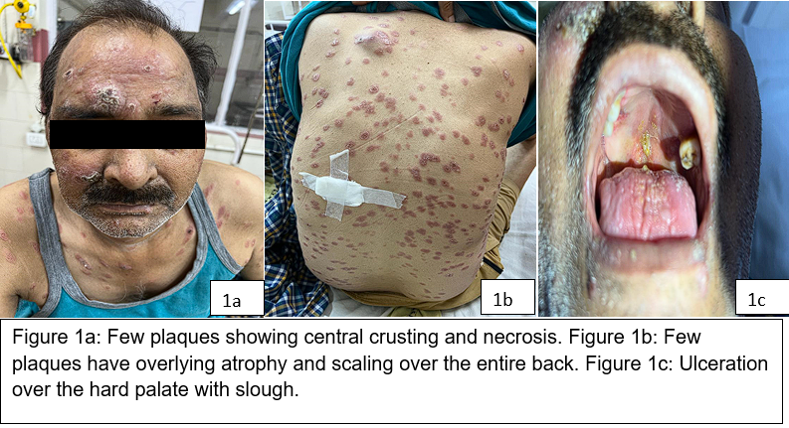

About 1 week before admission, he started experiencing fever with occasional cough. Past history: Pulmonary tuberculosis 6 years back, for which he took antitubercular treatment for 9 months. His hematological and biochemical parameters were within normal limits. Viral serologies, such as Human Immunodeficiency Virus (HIV), Hepatitis B surface Antigen (HBsAg), and Hepatitis C Virus (HCV), were nonreactive. Sputum for Acid Fast Bacilli (AFB) and Truenat were negative. After proper consent, skin biopsy from the left flank was performed, which, on microscopy, revealed granulomatous inflammation with lymphocytic cuffing in the dermis, along with an unremarkable epidermis. Intracellular and extracellular fungi in capsulated yeast forms were identified (Figures 2, 3).
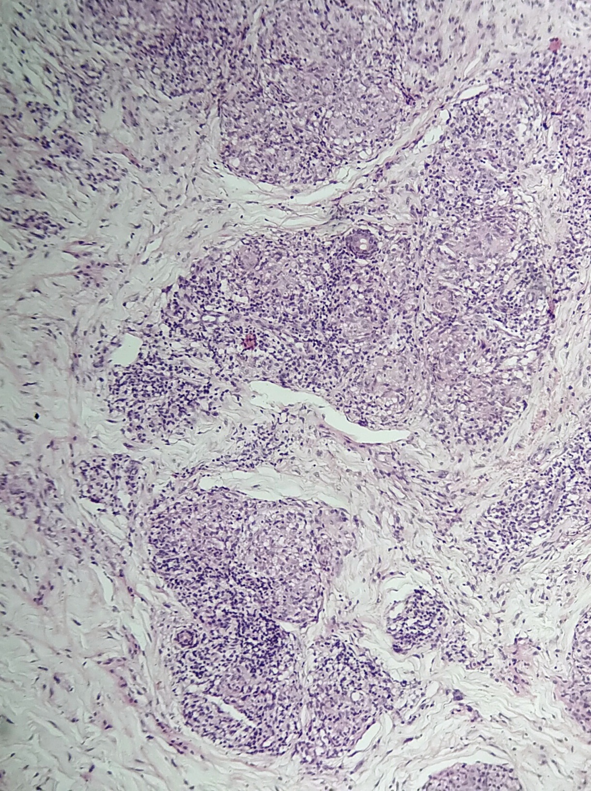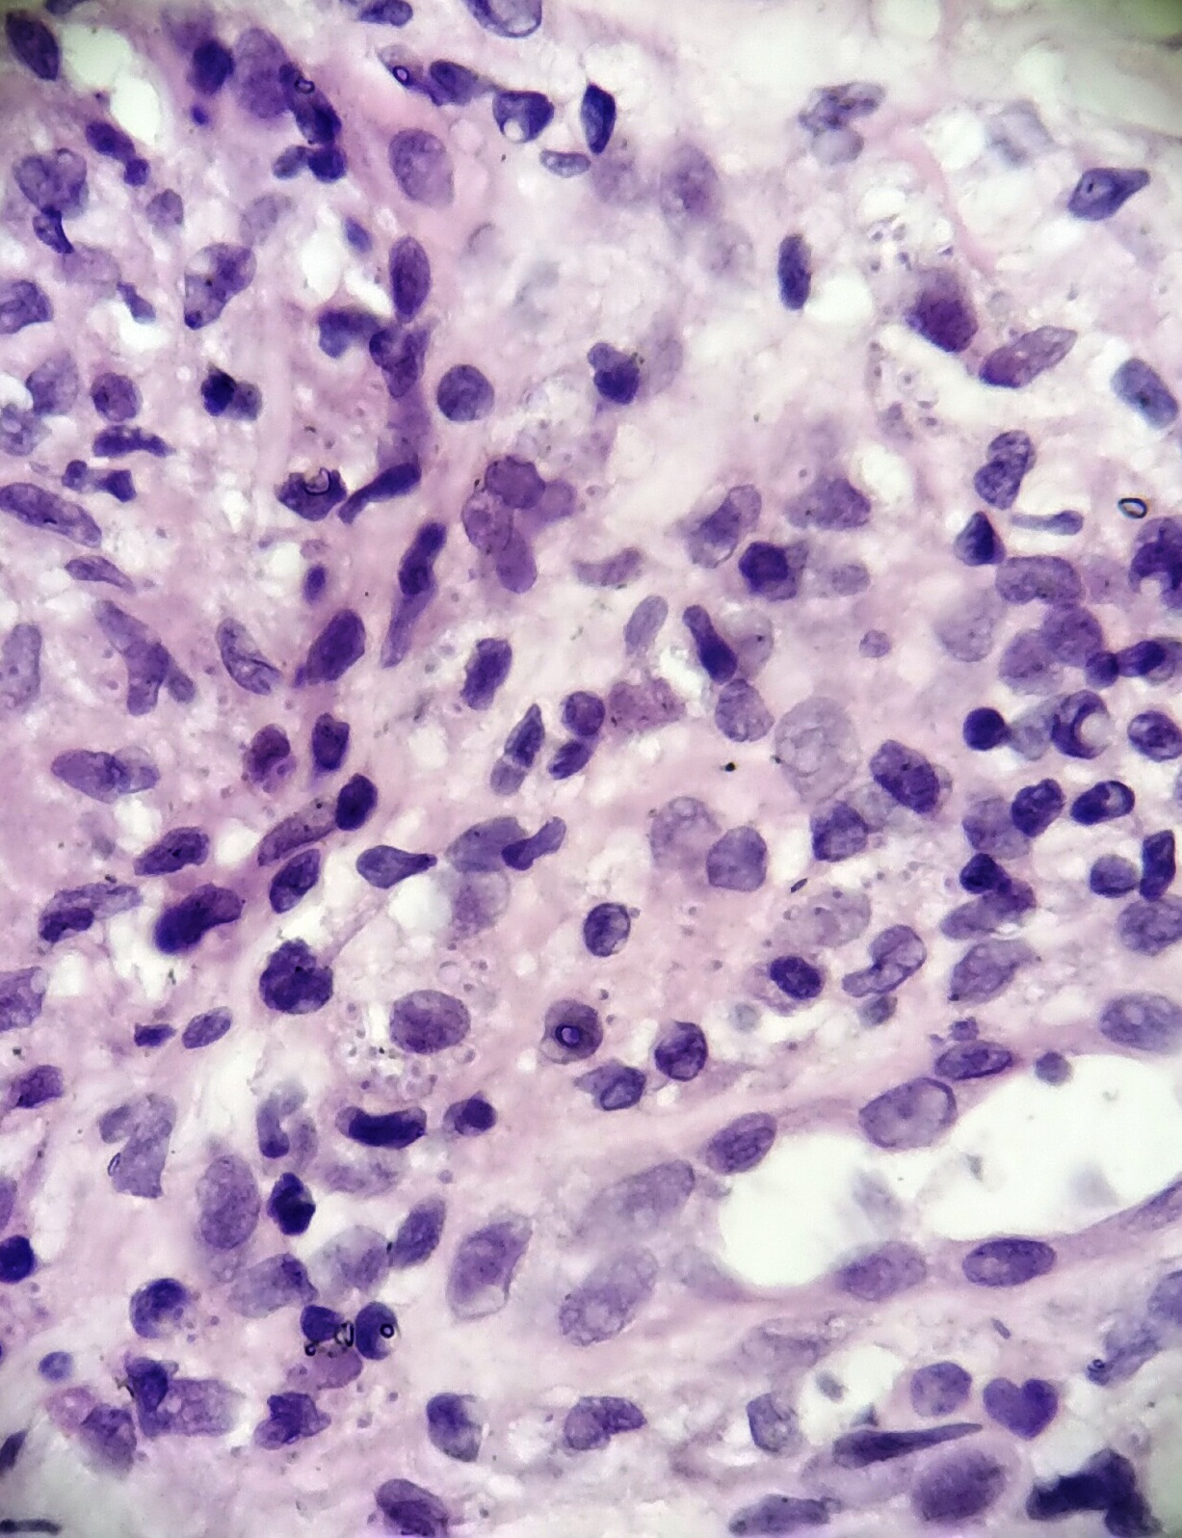
Fig 2 - Intracellular and extracellular fungi in capsulated yeast at 10X objective in Hematoxylin and Eosin stain.
Fig 3 - Intracellular and extracellular fungi in capsulated yeast at 100X objective in Hematoxylin and Eosin stain.

Fig 2
Fig 3

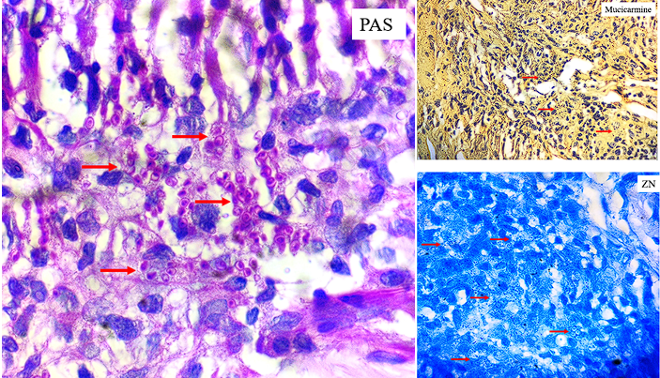
Fig 4- Periodic Acid-Schiff (PAS) staining confirming the presence of fungus
Fig 5 a, b- Negative results for ziehl neelsen and mucicarmine stain

Figure 5b

Figure 5a
Figure 4

Periodic Acid Schiff (PAS) confirmed the presence of fungus (Figure 4). Stains for acid-fast bacilli and mucicarmine were negative (Figures 5a and 5b).

These findings were further corroborated by a potassium hydroxide (KOH) smear, which showed a budding yeast form. A diagnosis of cutaneous histoplasmosis was given considering the clinical picture, investigations, and histopathology. The patient was started on Cap. Itraconazole and Inj. Liposomal Amphotericin B, which led to the resolution of lesions.

DISCUSSION:
Histoplasmosis is not considered as endemic in India, with the first case published by Panja and Sen in 1954 [4]. Some cases have been reported recently in Delhi [5]. The majority of reported cases are case reports, primarily from India’s north and northeast regions [6]. However, the increasing number of sporadic reports suggests that histoplasmosis may be underdiagnosed rather than truly rare in the Indian subcontinent [7].
Occupations that disturb soil rich in bat and bird guano, such as agriculture, outdoor construction, and renovation of old buildings inhabited by birds, are recognized risk factors for acquiring the disease [5]. It is believed that inhalation of microconidia from contaminated soil or air is the primary route of infection, following which the spores convert into yeast forms that disseminate through the reticuloendothelial system [8]. Although disseminated disease is more commonly seen in immunocompromised individuals, immunocompetent patients may also develop localized or cutaneous disease, particularly in areas of heavy exposure [9].
Cutaneous manifestations of histoplasmosis are often polymorphic and nonspecific, ranging from papules and nodules to ulcers and plaques, frequently leading to misdiagnosis. In tuberculosis-endemic countries like India, such granulomatous lesions are commonly attributed to tuberculosis, resulting in unwarranted initiation of antitubercular therapy [7]. The present case highlights this diagnostic pitfall, especially in a patient with a prior history of pulmonary tuberculosis.
Histopathological examination remains a cornerstone in diagnosis, particularly in resource-limited settings where fungal culture, antigen detection, and molecular assays may not be readily available [10]. Histoplasma capsulatum exists in tissue as small, ovoid yeast forms measuring less than 5 µm, often seen within macrophages. The organism characteristically shows a basophilic center surrounded by a clear halo, giving the appearance of a capsule [11]. Special stains such as Periodic acid–Schiff (PAS) and Gomori’s methenamine silver (GMS) reliably highlight the organism in tissue sections.
The differential diagnosis includes other fungal and protozoal infections. Although the size and morphology may resemble Candida species, H. capsulatum lacks pseudohyphae formation, aiding differentiation. It also differs from Pneumocystis jirovecii, which shows paired dense capsular thickening, and from Coccidioides immitis, which produces large spherules containing endospores [11]. Recognition of these subtle histomorphological features is essential for accurate diagnosis.
The present patient, a car mechanic by occupation, may have been exposed to contaminated soil during occupational activities, emphasizing that non-traditional occupations should not exclude suspicion of histoplasmosis. According to current treatment guidelines, mild to moderate disease is treated with itraconazole, while severe or disseminated disease warrants initial therapy with amphotericin B followed by prolonged itraconazole therapy [9, 12, 13]. The excellent clinical response observed in this case further supports the diagnosis and underscores the importance of early antifungal therapy in preventing disease progression and reducing morbidity.

CONCLUSION:
Although histoplasmosis has traditionally been considered non-endemic in India, an increasing number of isolated cases—particularly from northern regions—are now being reported. This case highlights the importance of including histoplasmosis in the differential diagnosis of granulomatous diseases, even in immunocompetent individuals presenting with cutaneous lesions. In tuberculosis-endemic settings, the significant clinical overlap often leads to misdiagnosis and inappropriate start of antitubercular treatment. Accurate diagnosis of Histoplasma capsulatum requires careful histopathological evaluation supported by special stains. A thorough environmental and occupational history can provide key diagnostic clues. Early recognition and timely initiation of appropriate antifungal therapy can help in excellent clinical outcomes, as demonstrated in this patient. Therefore, histoplasmosis should be considered when evaluating granulomatous cutaneous lesions.
This report emphasizes the need for heightened clinical awareness and adds to the limited Indian literature on cutaneous histoplasmosis. Greater case reporting will strengthen diagnostic vigilance and improve understanding of histoplasmosis epidemiology in India.

Disclaimer (Artificial intelligence)
Author(s) hereby declare that generative AI technologies such as Large Language Models, etc. have been used during the writing or editing of manuscripts. This explanation will include the name, version, model, and source of the generative AI technology and as well as all input prompts provided to the generative AI technology

REFERENCE:
- Aregala P, Marda S, Gowda S, Kelkeri MV, Jyoshna TM. Histoplasmosis masquerading as tongue carcinoma: a rare case report in an immunocompetent male. Int Surg J. 2025;12:1387-90. DOI: https://dx.doi.org/10.18203/2349-2902.isj20252296
- Randhawa HS, Gugnani HC. Occurrence of histoplasmosis in the Indian sub-continent: an overview and update. J Med Res Pract. 2018;7(3):71-83. DOI: 10.20936/jmrp/07/03/02
- Rozaliyani, A., & Setianingrum, F. (2020). The Review of Histoplasmosis Endemicity and Current Status in Asia. In *Histoplasma and Histoplasmosis*. IntechOpen. DOI: 10.5772/intechopen.92448
- Soni J, Gogia A, Aggarwal A. Histoplasmosis in India: clinical insights from a tertiary care hospital. BMC Infect Dis. 2025 Nov 7;25(1):1524. DOI: 10.1186/s12879-025-11862-x.
- Hajjeh, R. A., Pappas, P. G., Henderson, H., Lancaster, D., Bamberger, D. M., Skahan, K. J., Phelan, M. A., Cloud, G., Holloway, M., Kauffman, C. A., & Wheat, L. J. (2001). Multicenter case-control study of risk factors for histoplasmosis in human immunodeficiency virus-infected persons. Clinical Infectious Diseases, 32(8), 1215–1220. DOI: 10.1086/319756
- Gupta, A., Ghosh, A., Singh, G., & Xess, I. (2017). A twenty-first-century perspective of disseminated histoplasmosis in India: Literature review and retrospective analysis of published and unpublished cases at a tertiary care hospital in North India. Mycopathologia, 182(11-12), 1077-1093. DOI: 10.1007/s11046-017-0191-z
- Kauffman, C. A. (2007). Histoplasmosis: a clinical and laboratory update. Clinical Microbiology Reviews, 20(1), 115–132. DOI: 10.1128/CMR.00027-06
- Efrim DN, Dumea E, Cernat RC. Epidemiology of histoplasmosis [Internet]. In: Infectious Diseases. London: IntechOpen; 2023 [cited 2025 Dec 23]. Available from: http://dx.doi.org/10.5772/intechopen.110901
- Ray U, Dutta S, Sutradhar A. Histoplasmosis—more common than we realize. IDCases. 2025;39:e02180. DOI: 10.1016/j.idcr.2025.e02180.
- Guimarães, A. J., Nosanchuk, J. D., & Zancopé-Oliveira, R. M. (2006). Diagnosis of histoplasmosis. Brazilian Journal of Microbiology, 37(1), 1–13. DOI: 10.1590/S1517-83822006000100001
- Truong C. Pathology of the case [Internet]. Oklahoma City (OK): University of Oklahoma Health Sciences Center, Department of Pathology; [cited 2025 Dec 18]. Available from: https://www.ouhsc.edu/pathologyJTY/OUMC/OUMC-COM/Com05/Com505-2-Diss.htm
- Benedict, K., Beer, K. D., & Jackson, B. R. (2020). Histoplasmosis-related Healthcare Use, Diagnosis, and Treatment in a Commercially Insured Population, United States. Clinical Infectious Diseases, 70(6), 1003-1010. DOI: 10.1093/cid/ciz324
- Gupta P, Kuntal K, Gupta N, Srivastava A. A case report of disseminated histoplasmosis not responding to primary treatment by itraconazole. Curr Med Mycol. 2025;11:1613. DOI: 10.22034/cmm.2025.345248.1613.

