Phytotherapy of anaemia in individuals infected with human immunodeficiency virus: An ethnobotanical survey in lower casamance and sine-saloum (Senegal)

Abstract
Background: Anaemia is a common opportunistic disease in people living with human immunodeficiency virus (HIV), contributing significantly to morbidity and mortality in resource-limited countries. Aim: The aim of this ethnobotanical study was to identify medicinal plants used in the treatment of HIV-associated anaemia in Lower Casamance and Sine-Saloum (Fatick and Kaolack regions), two areas with high seroprevalence. Methods: we carried out an ethnobotanical survey using 76 questionnaire during the period of february to march 2023. In addition, the information sought included the age of the participants, the name of the plant family, the number of times the plants were mentioned, the part used and the method of use.
Results: A field survey was conducted among 76 interviewees (traditional practitioners, herbalists and traditional knowledge holders) selected for their recognition within their communities. Data were collected through structured interviews designed by the Pharmacognosy Laboratory of Cheikh Anta Diop University (Dakar). The results showed that Pterocarpus erinaceus, Khaya senegalensis, and Ximenia americana were the most frequently cited (46.7% in Casamance; 34.8% in Sine-Saloum). Leaves and roots were the most commonly used parts, mainly prepared as infusions, macerations, or fresh plant juices.
Conclusion: This ethnobotanical study is a first step in identifying local medicinal plants used to treat anaemia in people living with HIV in Senegal. As anaemia is often inflammatory in nature in this context, plants with anti-inflammatory properties could be of particular therapeutic interest. Analysis of this knowledge has shown that several of the listed plants promoted anti-anemia activity and could become the basis for in-depth scientific investigations.

Keywords: Antianaemia, Ethnobotanical survey, Interviewees, Medicinal plant, Casamance and Sine- saloum.

- Introduction
According to UNAIDS, Senegal is classified as a country with low prevalence of human immunodeficiency virus (HIV), with an estimated national rate of 0.5% [1]. However, certain regions, notably Casamance and the areas of Fatick and Kaolack that make up Sine-Saloum, have higher seroprevalence rates, reaching or exceeding 1%, compared to a national average of 0.5%. Several factors may explain this disparity, including the social vulnerability of these areas marked by population displacement, early sexual activity, and certain socio-cultural practices such as female genital mutilation and circumcision [2].
HIV infection causes a gradual weakening of the immune system, promoting the development of opportunistic infections, which are often the first clinical manifestations of HIV in Africa. Among these, anaemia is a common condition, responsible for high morbidity and mortality in developing countries. Consequently, the fight against HIV also involves effective management of these opportunistic conditions, including anaemia [3].
Anaemia is a condition marked by a decrease in circulating red blood cells or hemoglobin levels, leading to a reduced capacity of the blood to carry oxygen [4]. It results from multiple risk factors that may occur alone but often coexist. These include hereditary disorders such as hemoglobinopathies, blood loss due to menstruation, infections like malaria and intestinal parasites, chronic diseases such as tuberculosis, cancer, and AIDS, as well as nutritional deficiencies, particularly iron deficiency and deficiencies in vitamins and minerals including folic acid, vitamins A and B12, riboflavin, and copper [5]. In addition, prolonged use of non-steroidal anti-inflammatory drugs and other hemotoxic medications, as well as long-term exposure to toxic chemicals such as phenylhydrazine, has been associated with the development of anaemia [6]. A deficiency in well-functioning red blood cells results in a reduced oxygen-carrying capacity, which manifests as generalized weakness, fatigue, pallor, exertional dyspnea, increased cardiac output, vasodilation, higher morbidity and mortality, and an overall reduction in quality of life [7].
Limited access to conventional treatments, which are often expensive, leads many people to turn to traditional medicine. In the regions of Casamance, Fatick and Kaolack, where medicinal plants are abundant and inexpensive, herbal medicine is a preferred therapeutic alternative. The aim of this ethnobotanical survey was conducted among traditional practitioners and herbalists in these regions to identify the plants used in the treatment of anaemia in people living with HIV.
- Methodology
2.1. Study of area
The survey was conducted among traditional practitioners and herbalists in the regions of Casamance, Fatick and Kaolack.
  - Lower Casamance
The Ziguinchor region is located at 12°33' North Latitude and 16°16' West Longitude, with a magnetic declination of 13°05. Its altitude is 19.30 m in the south-western part of Senegal.
It is bordered to the north by the Republic of Gambia, to the south by the Republic of Guinea-Bissau, to the east by the regions of Kolda and Sédhiou, and to the west by the Atlantic Ocean.
The region covers an area of 7,339 km², or 3.7% of the national territory. Its tropical sub-Guinean climate gives it the richest flora and the most extensive hydrographic network in the country [8]. The figure 1 shows the map of Ziguinchor region.
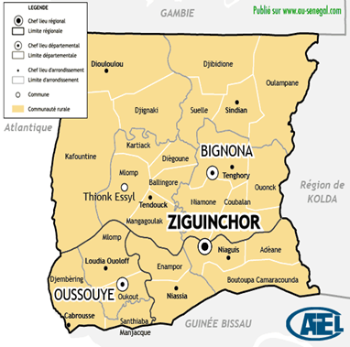
Fig.1. Map of the Ziguinchor region
- Sine-Saloum
In 1984, the Fatick region was created by Law 84-22 of 22 February, dividing the Sine-Saloum region into two regional entities (Kaolack and Fatick).
It underwent a new administrative division introduced by Law No. 2008-14 of 18 March 2008 and covers an estimated area of 6,685 km² compared to 7,535 km² before the division.
It is bordered to the east by the Kaolack region, to the south-west by the Atlantic Ocean, to the north by the Diourbel region, to the north-east by the Gossas department, to the north-west by the Thiès region (Mbour department), and to the south by the Saloum River, which flows through Foundiougne. The figure 2 shows the map of Fatick region.
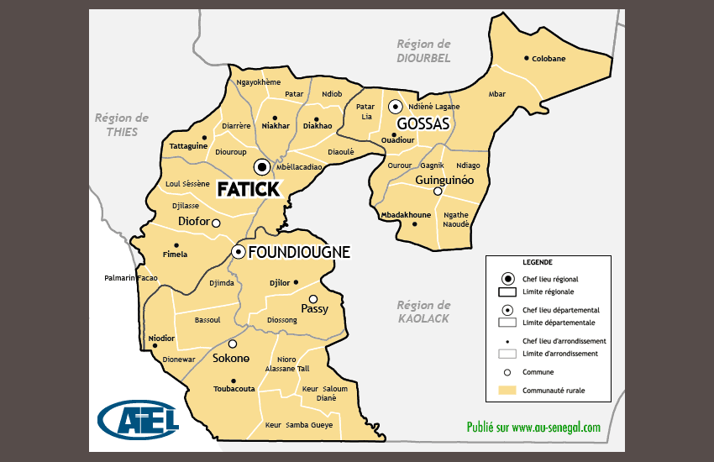
Fig. 2. Map of the Fatick region
The Kaolack region is located between 14°30' and 16°30' west longitude and 13°30' and 14°30' north latitude. Before 2008, its territory covered an area of 16,010 km², or 14% of the national territory.
It was created in 1984 from the division of the former Sine-Saloum region, but its configuration is the result of the 2008 reforms following the establishment of the former Kaffrine department as a region, and those of 2010 and 2011. It covers an area of 5,289 km², or approximately 2.8% of the national territory.
It is located between the southern Sahelian zone and the northern Sudanese zone, forming the heart of the peanut basin together with the regions of Kaffrine, Fatick and Diourbel [9]. The figure 3 shows the map of Kaolack region.
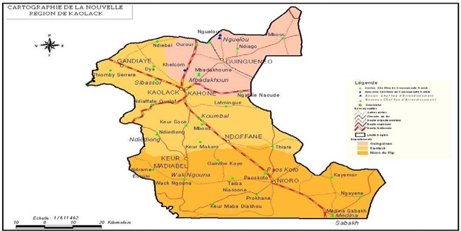
Fig.3. The map of Kaolack region.

  - Study period
The survey covered the period from February to April 2023. It mainly involved administering the survey questionnaire to participants selected primarily on the basis of their popularity and consent.
  - Type of study
The study was conducted in the form of individual surveys of herbalists, traditional healers, and individuals designated by their communities as custodians of traditional knowledge.Outils de collecte de données
  - Botanical identification
Most of the plants were identified in the field. The identifications were then confirmed at the Botany and Pharmacognosy Laboratory of Cheikh Anta Diop University using reference works such as Berhaut's La Flore du Sénégal and the APG III and IV classification at the family level.
  - Data processing
To process the data collected, we used the method of calculating percentages or citation frequencies (CF), which is the ratio of the number of times the species was cited (n) to the total number of players (N).
CF= n/N

  - Statistical Analysis
The database software, SPSS version 3 was used for data linkage and processing.Regular statistics (percentage) were displayed for the frequency of plants quoted. We have used as quantitative analysis such as Use- Value (UV).
- Results and discussion
3.1. Results
A total of 76 traditional practitioners were interviewed (30 in Casamance and 46 in Sine-Saloum). The medicinal plant sector is dominated by men: 100% of tradipraticians in Casamance and 96% in Sine-Saloum, giving an overall average of 98%. Les participants âgés de plus de 40 ans représentaient la majorité : 89% en Casamance et 81 % au Sine-Saloum. The most represented age groups were those aged 40–60 (40% in Casamance and 34% in Sine-Saloum) and 60–80 (49% and 47% respectively). Figure 4 shows Distribution of actors by age.

Fig.4. Distribution of actors by age
In Casamance, 19 plants were cited (Table 1), with the following frequencies of citation: Pterocarpus erinaceus 46.7% (14/30 actors), Afzelia africana 20% (6/30 actors), Parkia biglobosa 16.7% (5/30 actors), Combretum nigricans 10% (3/30 actors), Icacina oliviformis, Khaya senegalensis and Xylopia aethiopum 6.67% (2/30 actors), all other species in the list were cited by a single actor, resulting in a frequency of 3.33%.

Table.1. Plants cited for treating anaemia
 | Latin binomial | Parts used | Preparations
1 | Afzelia africana (Annonaceae) | Stem | Infusion
2 | Bridelia micrantha (Euphorbiaceae) | Root | Infusion
3 | Calycobolus africana (Convolvulaceae) | Bark | Infusion
4 | Carica papaya (Caricaceae) | Unripe fruit | Infusion
5 | Combretum molle (Combretaceae) | Fresh leaves | Maceration
6 | Combretum nigricans (Combretaceae) | Bark | Decoction
7 | Cordyla pinnata (Annonaceae) | Bark | Infusion
8 | Ficus exasperata (Moraceae) | Dead leaf | Infusion
9 | Icacina oliviformis (Icacinaceae) | Leaf | Infusion
10 | Khaya senegalensis (Meliaceae) | Bark | Decoction
11 | Parkia biglobosa (Mimosaceae) | Dry leaf | Infusion
12 | Psorospermum senegalense (Annonaceae) | Root | Infusion
13 | Pterocarpus erinaceus (Fabaceae) | Bark | Infusion
14 | Cassia undulata (Simaroubaceae) | Bark | Infusion
15 | Sarcocephalus latifolius (Rubiaceae) | Leaves | Infusion
16 | Terminalia macroptera (Combretaceae) | Root | Infusion
17 | Vitex doniana (Verbenaceae) | Leaf | Infusion
18 | Ximenia americana (Olacaceae) | Root | Infusion
19 | Xylopia aethiopum (Annonaceae) | Root | Infusion

In Sine Saloum, 28 plants were cited (Table 2), with the following frequencies of citation: Pterocarpus erinaceus 34.78% (16/46 actors), Lannea acida 19.5% (9/46), Ficus thonningii and Prosopis africana 15.21% (7/46), Ficus sycomorus 13.04% (6/46), Hibiscus sabdariffa 6.52% (3/46), Cochlospermum tinctorium, Combretum micrantum, Khaya senegalensis, Lepisanthes senegalensis and Sclerocarya birrea 4.34% (2/46), all other species in the list were mentioned by only one actor, giving a frequency of 2.17%.
Pterocarpus erinaceus, Khaya senegalensis and Ximenia americana are the only species cited as anti-anaemic in both Casamance and Sine-Saloum (Table 2).
Table 2. Repertory of plants cited for treating anaemia in Sine-Saloum
 | Latin binomial | Parts used | Preparations
1 | Anacardium occidentale (Anacardiaceae) | Bark | Decoction
2 | Lannea acida (Anacardiaceae) | Bark | Decoction
3 | Ozoroa benguellensis (Anacardiaceae) | Roots | Decoction
4 | Sclerocarya birrea (Anacardiaceae) | Bark | Decoction
5 | Adansonia digitata (Bombacaceae) | Bark | Decoction
6 | Cassia absus (Caesalpiniaceae) | Whole plant | Decoction
7 | Cassia sieberiana (Caesalpiniaceae) | Bark | Decoction
8 | Detarium microcarpum (Caesalpiniaceae) | Bark | Decoction
9 | Detarium senegalense (Caesalpiniaceae) | Bark | Decoction
10 | Piliostigma reticulatum(Caesalpiniaceae) | Bark | Decoction
11 | Boscia senegalensis (Capparidaceae) | Roots | Decoction
12 | Cochlospermum tinctorium (Cochlospermaceae) | Leaves | Macerate
13 | Combretum glutinosum (Combretaceae) | Leaves | Macerate
14 | Combretum micranthum (Combretaceae) | Leaves | Macerate
15 | Terminalia avicennoides (Combretaceae) | Bark | Decoction
16 | Pterocarpus erinaceus (Fabaceae) | Bark or leaves | Decoction
17 | Hibiscus sabdariffa (Malvaceae) | Petals | Macerate
18 | Khaya senegalensis (Meliaceae) | Bark | Decoction
19 | Acacia seyal (Mimosaceae) | Bark | Decoction
20 | Prosopis africana (Mimosaceae) | Bark and leaves | Decoction
21 | Ficus glumosa (Moraceae) | Roots | Decoction
22 | Ficus lutea (Moraceae) | Roots | Decoction
23 | Ficus sycomorus (Moraceae) | Bark or roots | Decoction
24 | Ficus thonningii (Moraceae) | Bark | Decoction
25 | Ximenia americana (Olacaceae) | Roots | Decoction
26 | Ziziphus mauritiana (Rhamnaceae) | Fruit | Consume when ripe
27 | Gardenia ternifolia (Rubiaceae) | Bark | Decoction
28 | Lepisanthes senegalensis (Sapindaceae) | Leaves | Macerate

For all of the plants listed, we noted greater use of the barks (41%) leaves (21%) and roots (21%). Other parts of plants used include root and/or trunk bark, fruit, petals, the whole plant, sap or juice (17%). The figure 5 shows the distribution according to the parts of plants used.
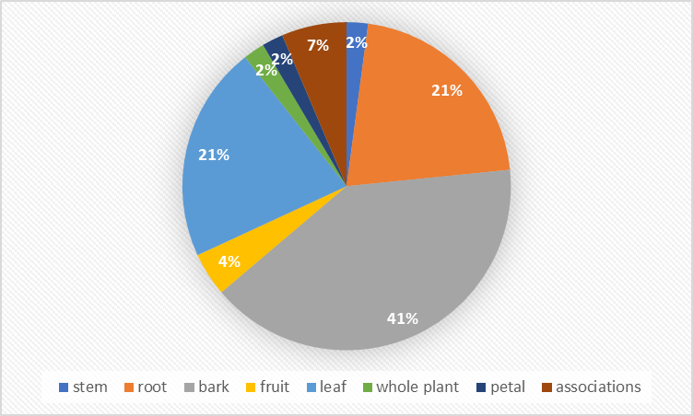
Fig.5. Distribution according to the parts of plants used.
With regard to preparations, decoctions (43%) was used most frequently, followed by infusions (36%), then macerations (19%), and finally other methods (2%).
Figure 6 shows the methods of preparation.

Fig. 6. Distribution according to the methods of preparation.

- Discussion
Our survey was conducted in the regions of Casamance, Fatick and Kaolack.
This study reports that 98% of respondents were men. The same predominance is found in surveys conducted by [10], who recorded 72% men in his study population. This can be explained by the fact that it is rare for women to inherit traditional knowledge.
With regard to the actors, whether herbalists or traditional practitioners, all age groups were represented, with a minimum age of 24 and a maximum age of 91. The majority of traditional practitioners were over 40 years old. A study conducted by [10] on antidiabetic plants reveals a predominance of people over 40 years of age, accounting for 46.66%. This shows that the transmission of traditional knowledge and authorisation to practise occur late in life, as they often only take effect after the death of the legator or in old age. The study showed that Pterocarpus erinaceus was the most commonly used plant for treating anaemia, cited by 14 out of 30 respondents in Casamance and 16 out of 46 respondents in Sine-Saloum. Oral administration of 250 and 500mg/kg body weight of aqueous and ethanolic extract of Pterocarpus erinaceus stem bark shows significant increase (p>0.05) in haematological parameters, haematological indices and immunological parameters [11], which shows that Pterocarpus erinaceus may have anti-anaemic properties. In vivo studies in an anemic rat model demonstrated restoration of hematological parameters and improvement in organ histology, suggesting the efficacy of the developed PHF through erythropoiesis, iron regulation, and oxidative stress reduction [12].
However, anaemia in HIV infection is often inflammatory in nature [13. The anti-anaemic action of Pterocarpus erinaceus could therefore be explained by its anti-inflammatory properties.
Khaya senegalensis and Ximenia americana, although only mentioned by one actor in each area, are, along with Pterocarpus erinaceus, the three species described as having anti-anaemic properties in both Casamance and Sine-Saloum. Khaya senegalensis is known to have several pharmacological properties, including anti-inflammatory properties, particularly in its bark [14]. Similarly, the aqueous extract of Ximenia americana bark contains anti-inflammatory properties [15].
Indeed, studies by [16] have shown that the anti-inflammatory properties of Ximenia americana are linked to the presence of flavonoids, alkaloids and saponins.
The other plants cited in anti-anaemic phytotherapy in order of importance were Afzelia africana (6/30 actors), Parkia biglobosa (5/30 practitioners), Combretum nigricans (3/30 practitioners), Icacina oliviformis, Khaya senegalensis and Xylopia aethiopum (2/30 practitioners), Lannea acida (9/46), Ficus thonningii and Prosopis africana (7/46), Ficus sycomorus (6/46), Hibiscus sabdariffa (3/46), Cochlospermum tinctorium, Combretum micrantum, Khaya senegalensis, Lepisanthes senegalensis and Sclerocarya birrea (2/46).
The results of studies on Afzelia africana leaf extract have shown anti-inflammatory properties [17] , as have the bark of Lannea acida stems[18].
Pectin derived from Parkia biglobosa pulp has demonstrated anti-inflammatory activity by inhibiting the production of pro-inflammatory cytokines and NO (nitric oxide) [19]. The plants most frequently cited in this study as effective against anaemia are plants with anti-inflammatory properties.
As anaemia in HIV infection is inflammatory and/or deficiency-related [20], the action of the plants cited in this study against anaemia would therefore be due to their anti-inflammatory properties, thus inducing an anti-anaemic action.
- CONCLUSION
This ethnobotanical study is a first step in identifying medicinal plants used locally to treat anaemia in people are living in Senegal with HIV.
As anaemia is often inflammatory in nature in this context, plants with anti-inflammatory properties such as Pterocarpus erinaceus may have potential therapeutic benefits. The latter was also the plant most frequently cited by traditional practitioners.
Further pharmacological and clinical investigations are needed to scientifically validate the efficacy and safety of these plants and potentially integrate them into appropriate therapeutic protocols.

COMPETING INTERESTS DISCLAIMER:
Authors have declared that they have no known competing financial interests OR non-financial interests OR personal relationships that could have appeared to influence the work reported in this paper.

- REFERENCES
- Programme commun des Nations Unies sur le VIH/sida. (2020). Rapport mondial actualisé sur le SIDA 2020 – Agissons maintenant – Pour combattre les profondes inégalités et mettre fin aux pandémies. https://www.unaids.org/fr/resources/documents/2020/global-aids-update-2020
- Agence Nationale de la Statistique et de la Démographie (ANSD) [Sénégal], et ICF. (2018). Sénégal : Enquête Démographique et de Santé Continue (EDS-Continue 2017). https://dhsprogram.com/publications/publication-FR345-DHS-Final-Reports.cfm
- Agence Nationale de la Statistique et de la Démographie. (2018). Situation Economique et Sociale de la Région de Ziguinchor, édition 2017-2018. https://core.ac.uk/download/pdf/442646955.pdf
- Coulibaly O. Study of anemia associated with HIV/AIDS in the infectious diseases department of the Point “G” University Hospital. Doctoral dissertation, Medical thesis, Faculty of Medicine and Odontostomatology of Mali, USTTB, 2020. 49 p.
- Kushwaha, H., Joshi, A., Malviya, S., & Kharia, A. (2017). Anti-Anemic activity of Hydro-alcoholic extract of Calotropis procera flower on phenylhydrazine-induced anaemic rats. *International Journal of Comprehensive and Advanced Pharmacology*, *2*(1), 6-10. https://www.innovativepublication.com/journal-archive/IJCAAP
- Srinivasan, S., Thenmozhi, M., & Vijayalakshmi, S. (2022). Finest medicinal plants governing Hematinic Property – Review. International Journal of Food and Nutritional Sciences, 11(7), 1-13. https://www.ijfans.org/volume-11-issue-7-2022/finest-medicinal-plants-governing-hematinic-property-review/
- Martinez-Torres, V., Torres, N., Davis, J. A., & Corrales-Medina, F. F. (2023). Anemia and Associated Risk Factors in Pediatric Patients. Pediatric Health, Medicine and Therapeutics, 14, 267-280. https://doi.org/10.2147/PHMT.S389105
- Abubakar, A. M., & Ibrahim, R. B. (2019). Review of medicinal plants with antianaemic activity found in Nigeria. Scholars International Journal of Biochemistry, 2(8), 225-229. https://doi.org/10.21276/sijb.2019.2.8.3
- Agence Nationale de la Statistique et de la Démographie. (2023). Situation Economique et Sociale de la Région de Ziguinchor, Édition 2022-2023. ANSD. https://www.ansd.sn/publications/ses-regionales/ses-regionale-ziguinchor-2022-2023-24-mar-2025
- National Agency for Statistics and Demography (ANSD) [Senegal]. Economic and Social Situation of the Kaolack and Fatick Regions, 2023.
- Diatta, K., Diatta, W., Mbaye, A. I., Sarr, A., Dieng, S. I. M., Seck, A., & Fall, A. D. (2024). Phytotherapy Anti-Diabetic: Ethnobotanical Surveys among in the District of Mbour (Senegal). *Asian Journal of Research in Botany*, *7*(2), 286-297. https://journalajrib.com/index.php/AJRIB/article/view/228
- Ibrahim Mohammed, Hauwa’u Shuaibu Mohammed, Modibbo Abdullahi Abubakar. Effect of Pterocarpus erinaceus Stem Bark Extracts on Haematological Parameters in Malaria Induced Anaemic Mice. American Journal of Chemical and Biochemical Engineering. 2021; 5(1): 21-25. https://doi.org/10.11648/j.ajcbe.20210501.13
- Bharati, D., Nirhali, S., Puri, A., Mohite, P., & Singh, S. (2025). Development, Molecular Docking, and Anti-Anemia Potential of Polyherbal Formulation. *Biology*, *14*(8), 1052. https://doi.org/10.3390/biology14081052
- Attinsounon, C. A., Dovonou, C. A., Alassani, C. A., Gomina, M., Agbodandé, K. A., Wanvoegbe, F. A., Bokpé, R., Ahanhanzo-Glele, R., Azon-Kouanou, A., & Zannou, D. M. (2017). Prévalence et facteurs associés à l’anémie chez les adultes infectés par le VIH à l’initiation du traitement antirétroviral. *Médecine et Maladies Infectieuses*, *47*(4), S135-S136. https://doi.org/10.1016/j.medmal.2017.03.327
- Ouédraogo, S., Yoda, J., Belemnaba, L., Ouédraogo, G. G., Ilboudo, S., Ouédraogo, N., Kini, F., Lompo, M., & Ouédraogo, S. (2020). Etude des propriétés physicochimiques et de la qualité microbienne de matières premières à base d'écorces de tronc de khaya senegalensis A. Juss (Meliaceae) utilisées dans la production de crème et gel anti inflammatoires. International Journal of Innovation and Applied Studies, 28(3), 617-629. http://www.ijias.issr-journals.org/abstract.php?article=IJIAS-19-302-02
- da Silva BAF, Pessoa RT, da Costa RHS, de Oliveira MRC, Ramos AGB, de Lima Silva MG, da Silva LYS, Medeiros CR, Florencio SGL, Ribeiro-Filho J, Coutinho HDM, Raposo A, Yoo S, Han H, de Menezes IRA, Quinor Jútans Jútanis L.J. and anti-inflammatory properties of Ximenia americana L. (Olacaceae) bark extract in experimental models of inflammation. Biomed Pharmacother.2023;166:115249. doi: 10.1016/j.biopha.2023.115249. PMID: 37597323.
- Gaichu, D. M., Mathabe, P., & Ngugi, M. P. (2023). Evaluation of cardiopreventive effects of Ximenia americana (Linn.) and Pappea capensis (Eckl. and Zeyh.) leaf aqueous extracts in rat models with myocardial infarction. Future Journal of Pharmaceutical Sciences. https://doi.org/10.1186/s43094-023-00491-3
- Kengne Kamkui, L., Tebue, R., Pondy Bias, M. A., Foutse, Y., Djoko, E., Wona, J. P., Dimo, T., & Wouessidjewe, D. (2023). P2 Investigation of the phytochemical composition and anti-inflammatory properties of Afzelia africana leaves. Journal Africain de Technologie Pharmaceutique et Biopharmacie (JATPB), 2(3). https://doi.org/10.57220/jatpb.v2i3.132
- Owusu, G., & Ofori-Amoah, J. (2017). Anti-inflammatory and Analgesic Effects of an Aqueous Extract of Lannea acida Stem Bark. British Journal of Pharmaceutical Research, 16(6), 1-8. https://doi.org/10.9734/BJPR/2017/33266
- Ibraheem, S. A., Abdulameed, H. T., Jaafar, M., Tanimu, F. B., Anchau, H. G., Micah, M. M., Bashir, S. O., Barminas, J. T., & Sabiu, S. (2022). Functional characterization and biological properties of pectin from Parkia biglobosa pulp. Bioactive Carbohydrates and Dietary Fibre, 27, 100300. https://doi.org/10.1016/j.bcdf.2021.100300
- Araújo-Pereira, M., Sheikh, V., Sereti, I., Barreto-Duarte, B., Arriaga, M. I. B., Tibúrcio, R., Vinhaes, C. L., Pinto-de-Almeida, M., Wang, J., Rupert, A., Roby, G., Shaffer, D., Ananworanich, J., Phanuphak, N., Sawe, F., & Andrade, B. B. (2022). Association between severe anaemia and inflammation, risk of IRIS and death in persons with HIV: A multinational cohort study. eBioMedicine, 85, 104309. https://doi.org/10.1016/j.ebiom.2022.104309

