Cefixime induced cutaneous hypersensitivity vasculitis: A rare case report

ABSTRACT
Cutaneous hypersensitivity vasculitis (CHV) is a small-vessel inflammatory condition often triggered by medications. Although antibiotics are common culprits, Cefixime, a third-generation cephalosporin, is rarely associated with CHV. This case report is of a 46-year-old male who developed multiple, palpable, purpuric lesions over both lower extremities following a short course of Cefixime. Clinical examination and laboratory results with inflammatory markers and normal differential counts were suggestive of cutaneous vasculitis. Hence, the patient was treated with systemic corticosteroids and supportive care. The lesions gradually resolved with the treatment. Therefore, this case highlights the need for clinician awareness regarding rare but significant cutaneous adverse reactions to Cefixime and other cephalosporins, careful antibiotic selection, and timely management to ensure desired improvement in patients’ condition. It also represents the pharmacovigilance value of reporting unusual adverse drug reactions.
KEYWORDS: Cefixime, Cutaneous hypersensitivity vasculitis, Drug induced vasculitis, Cephalosporin adverse reaction
1. INTRODUCTION
Cutaneous vasculitis, also termed hypersensitivity vasculitis, is a condition causing inflammation and damage to the blood vessels, especially within the skin. It presents with cutaneous symptoms such as clinically evident palpable purpura predominantly on the lower extremities in symmetrical fashion and may occasionally involve bullae, vesicles, and ulcerations (Alpsoy E., 2022; Tang W et al., 2022; K. S. B. Ramanees et al., 2025). It affects males and females equally and has an annual incidence rate of about 30 cases per million (Almasoudi AA et al., 2022). This condition occurs due to numerous etiologies, including infections, carcinomas, autoimmune diseases, and drugs. Drug-induced cutaneous vasculitis reactions occur where antibiotics like penicillins, trimethoprim-sulfamethoxazole and diuretics like hydrochlorothiazide play a major role, whereas the incidence of cephalosporin-induced adverse reactions is less frequently reported (Tang W et al., 2022, Kumar J et al., 2025). Among the cephalosporins, cefixime being widely prescribed for respiratory and urinary infections, reports of cefixime-induced cutaneous hypersensitivity vasculitis remain extremely rare in published literature (Dhali D et al., 2016, Shrestha AB et al., 2022). Many cases of drug induced cutaneous manifestations may go unrecognized, particularly in rural areas where patients may not report or associate symptoms with drug intake (Shukla S et al., 2024, Badar V et al., 2018). Here we report a case of cutaneous hypersensitivity vasculitis in a patient induced by cefixime, a third-generation cephalosporin, which is rarely associated with this condition as a trigger. Therefore, documenting rare presentations plays a crucial role in pharmacovigilance and helps prevent avoidable complications (Zhou L et al., 2023).
2. CASE PRESENTATION
A 46-year-old male reported to the department of dermatology with the complaints of multiple purpuric lesions, ulceration with pain and mild itching and burning sensations over both lower extremities from the past 15 days, as shown in figure 1. The patient had no history of swelling, infections, discharge of pus or fluids from the skin lesions, fever, joint pains, systemic symptoms, or previous similar episodes. 5 days prior to the onset of symptoms, cefixime 200 mg twice daily was prescribed for a mild upper respiratory tract infection. Clinical examination showed multiple erythematous to violaceous palpable purpura and crusted ulcers over the bilateral lower limbs (pretibial region), and the laboratory data during admission is shown in Table 1. Certain parameters such as serum IgE or extended autoimmune panel were not performed due to clinical stability and the absence of systemic involvement. Additional blood investigation including fasting blood sugar was reviewed. The patient consumed cefixime 200 mg for 5 days (total dose of 2 g) and lactulose 15 ml once daily for constipation. The patient had no previous history of allergy to the given drugs. No lymphadenopathy was observed. Vital signs were stable.
Table 1. Laboratory tests (on admission)
Lab Parameters | Values | Reference range | Interpretation
WBC | 12.9 K/Cummª (mild leucocytosis) | 4,000– 11,000/Cumm | Mild elevation
Monocytes | 10.6% | 2–8% | elevated
Basophils | 0.1% | <1% | normal
Neutrophils | 63% | 40–70% | Normal
Eosinophils | 6% | 1–6% | Normal
Lymphocytes | 22% | 20–40% | Normal
ESR | 20 mm/hr^{b} | 0 – 15 mm/hr | elevated
CRP | 18.1 mg/L^{c} | < 5 mg/L | elevated
TSH | 9.15 µIU/mL^{d} | 0.4 – 4.0 µIU/mL | elevated
HDL | 30mg/dLe | > 40 mg/dL | reduced
LDL | 104mg/dL^{f} | < 100 mg/dL | Mild elevated
Total cholesterol / HDLC | 5.4 | < 3.5 | elevated
ªWBC- White blood cells, ^{b}ESR- Erythrocyte sedimentation rate, ^{c}CRP- C- reactive protein, ^{d}TSH- Thyroid stimulating hormone, ^{e}HDL- High density lipoproteins, ^{f}LDL- Low density lipoproteins.
Figure 1. Multiple purpuric lesions during first Visit.
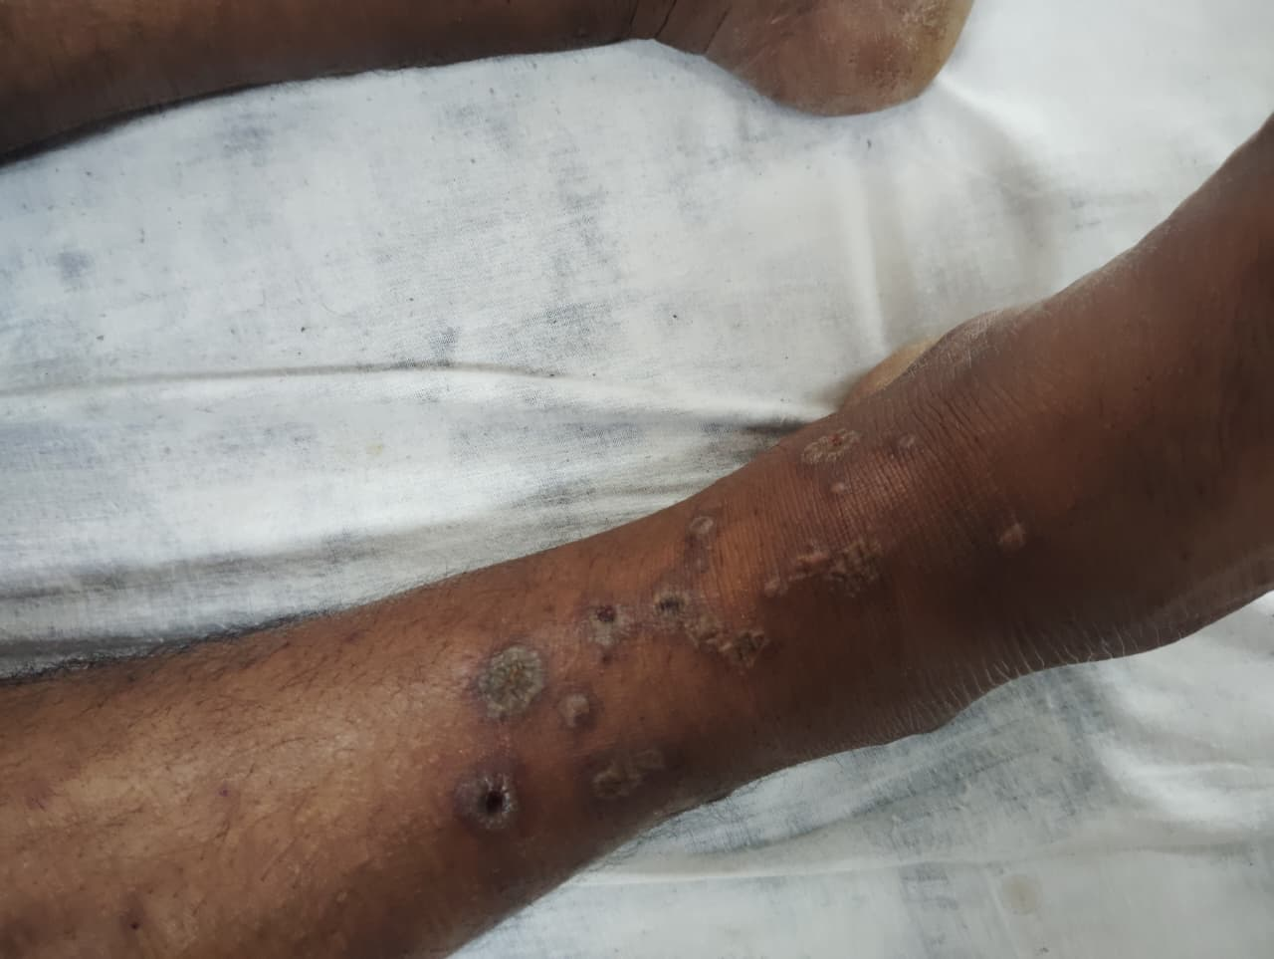
Footnote:Multiple palpable purpuric lesions were observed on the lower limbs, consistent with cutaneous vasculitis
A diagnosis of cutaneous hypersensitivity vasculitis associated with cefixime was determined based on clinical features and a temporal correlation with cefixime intake, which was confirmed with the Causality Assessment: Naranjo scale. The patient had no occupational exposure to chemicals or irritants known to trigger vasculitis.
The patient discontinued cefixime one day prior to the hospital visit. Upon hospital admission, the patient was managed with Inj Dexamethasone 8 mg and Inj Pheniramine Maleate 22.75 mg (2 ml), including local wound care. However, rechallenge was not performed. Over one week, the patient showed significant resolution of symptoms with no new lesions (Figure 2).
Figure 2 - Multiple purpuric lesions improvement after treatment.
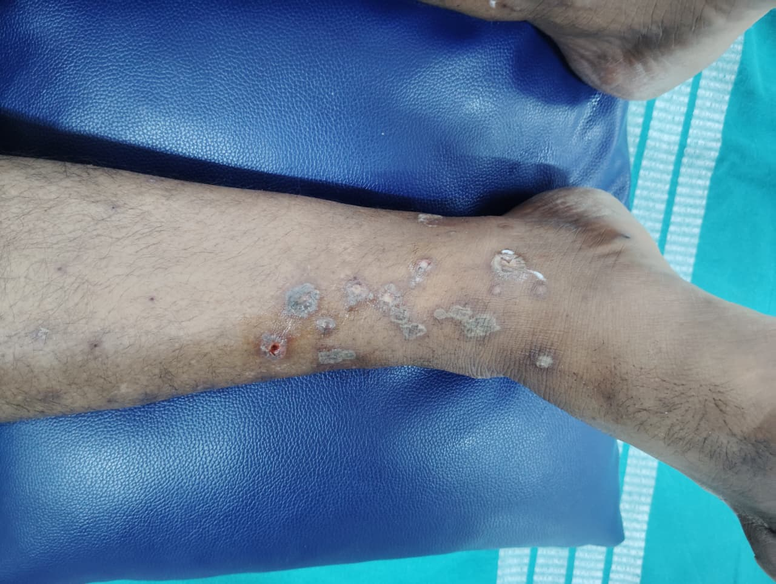
Footnote:Multiple palpable purpuric lesions over the lower extremities demonstrating significant resolution following treatment, consistent with clinical improvement in drug-induced vasculitis.
3. DISCUSSION
Cutaneous hypersensitivity vasculitis (CHV) is a kind of small-vessel vasculitis predominantly involving the skin, which is commonly triggered by an illness or medication. This condition does not affect medium or large vessels or other organs (eg, the glomeruli or pulmonary capillaries). An immune complex-mediated mechanism is thought to be responsible for the majority of the cases of hypersensitivity vasculitis (Type III hypersensitivity reaction). Here triggering agent forms antigen- antibody complex by binding to the circulating immunoglobulins, which then deposit within the walls of small blood vessels, initiating an inflammatory response that leads to vessel damage (MacLeod B et al., 2021; Imboden JB et al., 2013; Princess J. G. et al., 2024). Clinically, it manifests as palpable purpura, which is localized to the lower limbs.
However, drug-induced cutaneous hypersensitivity vasculitis contributes to a major portion of reported cases; reports of cephalosporin-induced hypersensitivity reactions remain infrequent and underreported (Kumar J et al., 2025). Cefixime inhibits bacterial cell wall synthesis, bacterial to bacterial cell death. It is usually well-tolerated, but like other beta lactam antibiotics, in susceptible individuals, it has a potential to act as a hapten, binding to proteins and forming antigenic complexes that settle in small blood vessels and cause an immune response that leads to inflammation and vasculitis (Pichler WJ et al., 2011). As of the current scenario, reports of cefixime-induced cutaneous hypersensitivity vasculitis are rare.
Symptoms appearing days to weeks after cefixime align with our patient’s timeline. Mild leukocytosis and monocytosis suggest a nonspecific inflammatory response. Normal neutrophil levels do not rule out leukocytoclastic vasculitis, which primarily affects small skin vessels.
Although a skin biopsy with direct immunofluorescence is the gold standard for confirmation (Chango Azanza et al., 2020), it could not be performed on the patient due to practical constraints. This can present as a potential limitation of the present case. However, in clinical practice, a diagnosis of cutaneous vasculitis can be made in most cases based on clinical presentation, supportive laboratory evidence, and a time-dependent link with drug exposure.
Cefixime has been identified as the causative agent in this case by the strong temporal correlation between cefixime consumption and symptom onset, the lack of other alternative causes, and a Naranjo adverse drug reactions probability scale score, which indicates a probable drug reaction (TABLE 2).
Alternative causes or triggering factors for cutaneous vasculitis include chemicals, systemic and neoplastic diseases, infections and drugs, vaccinations, and inflammatory bowel diseases (Almasoudi AA et al., 2022). Here the patient did not have any of these exposures except a mild respiratory illness for which cefixime was used. This diagnosis is further strengthened by the patient's significant clinical improvement after withdrawal of cefixime and starting systemic corticosteroids.
TABLE 2: Naranjo Adverse Drug Reaction Probability Scale
Naranjo Adverse Drug Reaction Probability Scale

Question | Yes | No | Do Not Know | Score
1. Are there previous conclusive reports on this reaction? | +1 | 0 | 0 | 0
2. Did the adverse event appear after the suspected drug was administered? | +2 | ‐1 | 0 | +2
3. Did the adverse reaction improve when the drug was discontinued or a specific antagonist was administered? | +1 | 0 | 0 | +1
4. Did the adverse event reappear when the drug was re‐administered? | +2 | ‐1 | 0 | 0
5. Are there alternative causes (other than the drug) that could on their own have caused the reaction? | ‐1 | +2 | 0 | +2
6. Did the reaction reappear when a placebo was given? | ‐1 | +1 | 0 | 0
7. Was the drug detected in blood (or other fluids) in concentrations known to be toxic? | +1 | 0 | 0 | 0
8. Was the reaction more severe when the dose was increased or less severe when the dose was decreased? | +1 | 0 | 0 | 0
9. Did the patient have a similar reaction to the same or similar drugs in any previous exposure? | +1 | 0 | 0 | 0
10. Was the adverse event confirmed by any objective evidence? | +1 | 0 | 0 | +1
TOTAL SCORE: |  |  |  | 6
Footnote: Score ≥9 = Definite drug reaction, 5–8 = Probable drug reaction, 1–4 = Possible drug reaction, and ≤0 = Doubtful drug reaction. Modified from: Naranjo CA et al. A method for estimating the probability of adverse drug reactions. Clin Pharmacol Ther 1981; 30: 239­245.
This case contributes to the limited but growing evidence showing cephalosporin-induced CHV, particularly caused by cefixime. It also underscores that cefixime-induced CHV can occur even in patients without prior allergy history. Therefore, obtaining detailed medical history, early recognition and withdrawal of the offending drug, are critical to prevent progression and complications. As demonstrated by this patient's favorable outcome, supportive treatment and corticosteroids are usually prescribed in these situations.
4. CONCLUSION
Cutaneous Hypersensitivity Vasculitis is a rare but important adverse reaction to cephalosporins like cefixime. Early recognition, withdrawal of the offending drug, and corticosteroid treatment can lead to rapid clinical improvement and prevent complications. Pharmacovigilance and clinical judgment are necessary in such situations. Awareness of such drug reactions is essential for early diagnosis and effective patient care. Further case series and larger epidemiologic studies are needed for confirmation.
DISCLAIMER (ARTIFICIAL INTELLIGENCE):
Authors hereby declare that any use of AI assistance was limited to language editing and authors retain full responsibility for the accuracy and integrity of the manuscript.
CONSENT:
All authors declare that ‘written informed consent was obtained from the patient for publication of this case report and accompanying images. A copy of the written consent is available for review by the Editorial office/Chief Editor/Editorial Board members of this journal.

REFERENCES
- Alpsoy E. Cutaneous vasculitis: an algorithmic approach to diagnosis. Front Med (Lausanne). 2022; 9:1012554. doi:10.3389/fmed.2022.1012554.
- Tang W, Tan J. Cephalexin-induced leukocytoclastic vasculitis. Cureus. 2022;14(7):e26545. doi:10.7759/cureus.26545.
- Almasoudi AA, Bablghaith ES, Alaauldeen SI, Falemban AM, Sherbeeni AA, Bulkhi AA. Ceftriaxone-induced leukocytoclastic vasculitis: a case report and literature review of antibiotic-induced leukocytoclastic vasculitis. J Int Med Res. 2022;50(5):3000605221097768. doi: 10.1177/03000605221097768
- Kumar J, Prakash M. Hydrochlorothiazide-induced cutaneous vasculitis: a case report. South East Eur J Public Health. 2025:2077–2079. doi:10.70135/seejph.vi.5426.
- Dhali D, Halder U, Santra R, Biswas MC. Cefixime-induced Stevens-Johnson syndrome: a case report and review of literature. Int J Contemp Med Res. 2016;3(5):1426-1427.
- Shrestha AB, Shrestha S, Yadav PK, Adhikari L, Yadav A. Cefixime induced Steven Johnson syndrome: A case report from Bangladesh. Ann Med Surg (Lond). 2022; 79:104089. doi: 10.1016/j.amsu.2022.104089.
- Shukla S, Sharma P, Gupta P, Pandey S, Agrawal R, Rathour D, et al. Current scenario and future prospects of adverse drug reactions (ADRs) monitoring and reporting mechanisms in the rural areas of India. Curr Drug Saf. 2024;19(2):172–90. doi:10.2174/1574886318666230428144120
- Badar V, Parulekar VV, Garate P. A surveillance study of cutaneous adverse drug reactions in a tertiary care teaching hospital in India. Int J Basic Clin Pharmacol. 2018;7(12):2439–46. doi:10.18203/2319-2003.ijbcp20184862
- Zhou L, Yang J, Xiao M, Shan H, Liu M, Lu Y, Zou Y, Wu B. Severe cutaneous adverse reactions due to antibiotic therapy: a pharmacovigilance analysis of FDA adverse event reporting system events. Expert Opin Drug Saf. 2023;1–8. doi:10.1080/14740338.2023.2278685.
- MacLeod B, Koponen M. Educational case: hypersensitivity vasculitis. Acad Pathol. 2021;8:1–5. doi:10.1177/23742895211030650.
- Stone JH. Hypersensitivity vasculitis. In: Imboden JB, Hellmann DB, Stone JH, editors. Current Diagnosis & Treatment: Rheumatology. 3rd ed. New York: McGraw-Hill; 2013. Chapter 37.https://accessmedicine.mhmedical.com/content.aspx?bookid=506&sectionid=42584923
- Princess JG, Bhushan A, Naikwad HM. Amikacin-induced cutaneous small vessel vasculitis. World J Pharm Res. 2024;13(12). doi:10.20959/wjpr202412-33122
- Pichler WJ, Naisbitt DJ, Park BK. Immune pathomechanism of drug hypersensitivity reactions. J Allergy Clin Immunol. 2011;127(3 Suppl):S74–81. doi:10.1016/j.jaci.2010.11.048
- Chango Azanza JJ, Calle Sarmiento PM, Lopetegui Lia N, Alexander SA, Modi V. Leukocytoclastic vasculitis: An early skin biopsy makes a difference. Cureus. 2020;12(5):e7912. doi:10.7759/cureus.7912
- K. S. B. Ramanees, K. Sathiya Murthy, Thamilselvi Ramachandran & Gowri Sankar R. (2025). Direct Immunofluorescence in Vasculitis: A Critical Tool in Diagnostic Dermatopathology. Journal of Pharmaceutical Research International, 37(8), 26–34. https://doi.org/10.9734/jpri/2025/v37i87732
ABBREVIATIONS:
CHV - Cutaneous hypersensitivity vasculitis
WBC- White blood cells
ESR- Erythrocyte sedimentation rate
CRP- C- reactive protein
TSH- Thyroid stimulating hormone
HDL- High density lipoproteins
LDL- Low density lipoproteins

