Review Article

Object Detection: Comparing Convolutional Neural Networks (CNNs) and Vision Transformers (ViTs) Performance

.
ABSTRACT
This review studies the evolution of object detection methodologies, from traditional to modern deep learning techniques, including CNNs (Convolutional Neural Networks), YOLO (You Only Look Once) variants (v1–v8), and ViTs (Vision Transformers). A systematic analysis of 49 studies shows that CNNs are robust on small datasets and in real-time applications. In contrast, ViTs excel at handling complex relationships and adversarial conditions due to their self-attention mechanisms. Hybrid models combining CNNs and ViTs show promise for improved accuracy and efficiency but usually require further validation. Key challenges include computational demands, dataset diversity, and generalisation across domains. Despite significant progress, there is limited consolidated analysis comparing CNNs, YOLO, and ViTs across diverse datasets and real-world constraints. The comparison in this study may level the ground for researchers to explore new gaps in the future, and results not only in reinforcing the potential of object detection techniques but also provide useful insights for researchers and practitioners aiming to balance performance with computational cost in real-world detection scenarios. Future research should prioritise hybrid architectures, edge deployment, and standardised benchmarking to advance object detection in different domains such as surveillance, healthcare, quality control, inventory management, and autonomous systems.

Keywords: Computer Vision; CNNs (Convolutional Neural Networks); YOLO (You Only Look Once) YOLOv1–v8; Vision Transformers (ViTs)

1. INTRODUCTION
Object detection is a crucial area in computer vision, which is widely used in domains such as healthcare, finance, industries, driverless vehicles, control systems, and surveillance [1] [2]. Numerous techniques and methodologies have been developed over the years to deal with the particular difficulties presented by object detection in crowded environments, e.g, high object density, viewpoint variation, deformation, illumination condition, textured background, variety, occlusion, and different object scales [3]. The main objectives of this research are to evaluate and examine the development of object detection methodologies, with a particular emphasis on the benefits and drawbacks of some important strategies like CNNs, YOLO, and ViTs [3] [4]. Object detection has been impacted by the emergence of CNNs [45]. CNN-based models, such as R-CNN (regions with convolutional neural networks), Fast-R-CNN (fast regions with convolutional neural networks), and Faster R-CNN (faster regions with convolutional neural networks), have shown remarkable performance in object segmentation, object localisation, object detection, object identification, and feature extraction [49]. However, some of these models have some difficulties in processing images in real-time [5] [46]. In addition, their performance is greatly affected by occlusion and textured backgrounds [4]. As a result, a pattern shift toward real-time object detection has been observed with the development of the YOLOv1 to YOLOv8 models and ViTs. [3] [47]. YOLO models, such as the most recent version released in 2023, YOLOv8, place an in height priority on speed without sacrificing accuracy [47]. They divide the image into a grid, making them quite effective in forecasting bounding boxes and class probabilities at the same time. [4]. However, YOLO models have some limitations in identifying small objects and detecting sharp differences in object sizes in busy settings, which makes the YOLO family less sophisticated compared to ViTs in detecting an object in a close environment [4] [47].
Using the self-attention tool to detect feature interdependence and global context, ViTs break an image into patches of equal size to classify and predict the class of an object within it [3]. This mechanism allows ViTs to capture complex relationships in images or video frames in dense environments [4] [6]. Despite its apparent benefits, the technique used to detect subtle differences in seemingly similar objects presents problems for realistic deployment because it is computationally demanding and needs a large amount of datasets for efficient training [7]. The strengths and weaknesses of these methods (CNNs and ViTs), as highlighted in the literature, will be systematically examined in this review. Through a critical analysis of the current literature, the research seeks to find gaps and put forward a strategy that combines the advantages of CNNs and ViTs to improve objectiveness. By resolving the existing issues in the object detection mechanism in the real world and pushing the boundaries of this discipline, the incorporation of these techniques aims to develop the precision, efficiency, and resilience of object detection. We aim to present up-to-date research on object detection, highlighting the development of approaches and their implications for applied uses. The review aims to ease the creation of an innovative mix model, leading to more effective methods of detection of objects of interest in congested areas contained in an image or video.
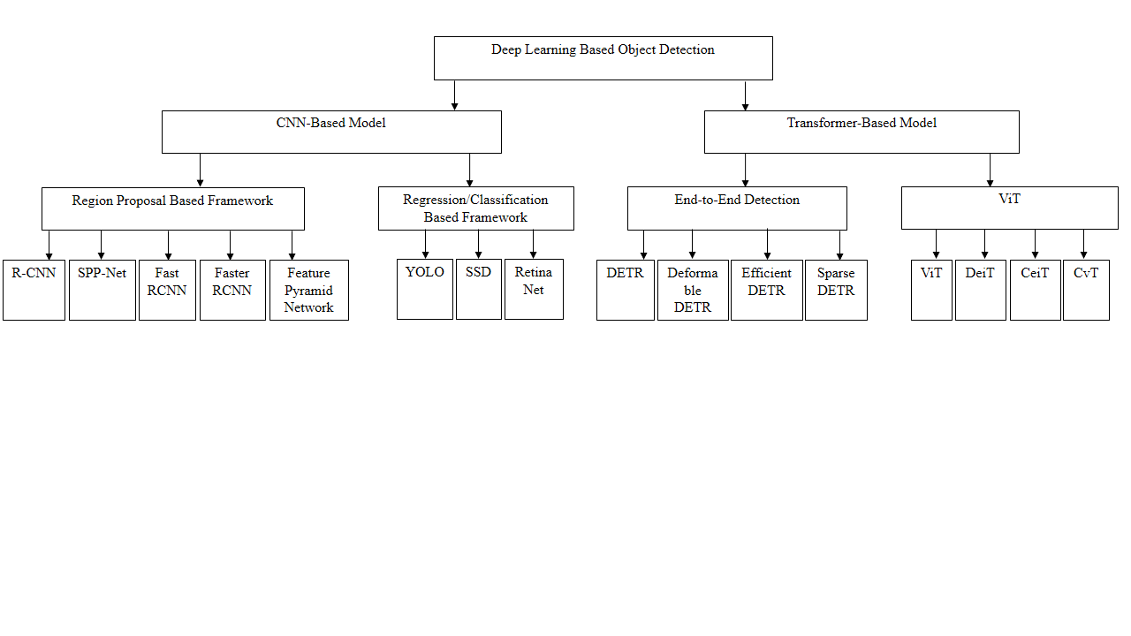
Figure 1: Classification diagram of Deep Learning Methods [48]

2. TRADITIONAL METHOD
The early objection techniques relied on handcrafted features for object detection, which are ineffective in detecting smaller objects and differentiating among objects with a high degree of similarity. One of the first effective frameworks for real-time face identification and detection was the Viola-Jones detector. The proposed method employed an AdaBoost classifier to detect faces in photos and videos using Haar-like characteristics [9]. Despite its effectiveness, this technique is limited in its ability to detect objects in the presence of occlusions and complex backgrounds, which are frequent in dynamic environments. The histogram of oriented gradients (HOG) was developed for identifying humans in digital photos as an improvement over some of the earliest face detection techniques [9]. To determine the magnitude and direction of gradients, the method applies horizontal and vertical gradient filters to the input images. The images are then filtered and divided into 8 × 8-pixel cells, which are further grouped into 2 × 2 cell blocks with 50% overlay. For each cell, orientation histograms are generated by quantising gradient directions into nine bins ranging from 0° to 180°, with the corresponding gradient sizes serving as votes. A feature vector representing the HOG is then formed by concatenating the histograms of all cells within a block. To account for variations in lighting and contrast, these vectors are normalised. The final HOG descriptor, comprising all normalised blocks, is input into a support vector machine (SVM) to detect the presence of humans in an image. Although the HOG algorithm's dense grid approach increases computational cost and performs less efficiently in the presence of occluded objects, it effectively reduces false positives compared to Haar wavelets.
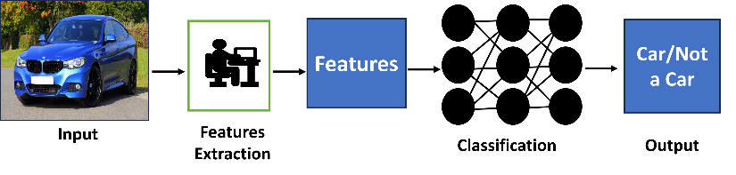
Figure 2 : Traditional Object Detection Method [9]

2.1 CHALLENGES FOR THE TRADITIONAL METHOD
Trade-offs are difficult to avoid when using traditional computer vision and deep learning-based methods. The early algorithms, despite being widely recognised, clear, and fine-tuned for efficiency in both performance and power, have several challenges, which make them inefficient in dealing with variability in object appearance, occlusion and have limited robustness against noise and difficulty in handling complex scenes, which necessitated the need to develop more advanced object detection techniques. While deep learning models provide enhanced accuracy and flexibility, they require high computing resources for effective training and deployment. Hybrid methods that combine traditional and deep learning offer the benefits and traits of both methodologies. These techniques can provide high accuracy at the expense of more computational complexity. For example, these two approaches can be combined to create a surveillance system where a feature of an object extracted by one model is fed into another model within the same framework for classification. This brings the benefit of reducing the time it may require for a single model to perform the entire operation [9].
The fusion of machine learning and deep neural network frameworks has become very popular because ensemble models introduce a performance advantage and can deliver 130X-1,000X reduction in multiply-accumulate operations and about 10X improvement in frame rates, in tasks where videos are used, compared to a pure deep learning solution. Furthermore, hybrid implementations generally use about half of the memory bandwidth and require significantly lower CPU resources [9].

3. CONVOLUTIONAL NEURAL NETWORKS (CNNS)
The introduction of CNNs, which have proven to be particularly effective for image and video processing tasks, led to a significant shift in object detection techniques [9]. In various computer vision applications, CNNs have outperformed traditional techniques due to their ability to learn hierarchical feature representations [9]. CNNs, however, struggle with object localisation because pooling layers lose precise spatial information, which is a hindrance in tasks that need object location or size. Consequently, R-CNN, which uses CNNs as the feature extraction backbone for object detection, was introduced. The emergence of R-CNN revolutionised object detection by paving the way for more advanced versions such as Fast R-CNN and Faster R-CNN. In addition to setting the foundation for future work, R-CNN has also proven to be fast, robust in handling objects of varying sizes and shapes, and flexible due to its ability to adapt to other tasks. Notwithstanding, R-CNN, despite its advantages, faced the challenge of slow inference speed, which makes it unsuitable for real-time applications [10].
Subsequent advancements of R-CNN, Fast R-CNN and Faster R-CNN addressed its computational inefficiencies. The training time was greatly shortened by Fast R-CNN compared to plain CNN by introducing a single-stage training procedure and the use of Region of Interest (RoI) pooling [11]. By incorporating a region proposal network (RPN) that shared convolutional features with the detection network (DN), Faster R-CNN enabled near real-time object identification, hence improving efficiency even further compared to the Fast-R-CNN method [11].
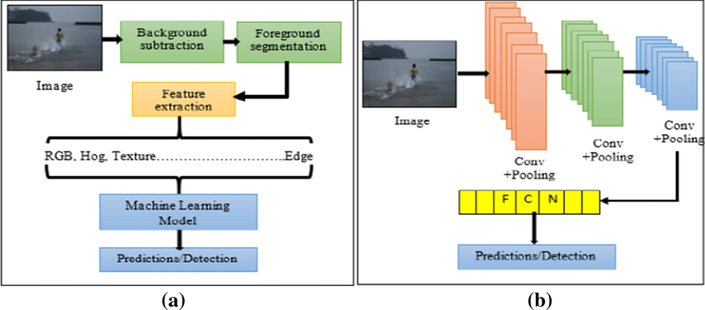
Figure 3 : Convolutional Neural Networks (CNNs) Architecture [9]

4. ONE-STAGE METHODS
The main characteristics of one-stage anchor-based detectors are their efficiency during computation and runtime [3]. Rather than employing regions of interest, these models use specified anchor boxes for direct classification and regression. The SSD was the first well-known object detector in this category. However, the imbalance between positive and negative samples is the primary limitation of one-stage techniques. To address this issue, several strategies were proposed, including multi-layer context information fusion, training from scratch, feature enrichment and alignment, and anchor refinement and matching [12]. Additional efforts have been focused on creating new architectures and loss functions; these methods of object detection involve the use of YOLO and Single Stage Methods (SSD) [3].

4.1 YOLO – YOU ONLY LOOK ONCE
YOLO was introduced to the computer vision community via a paper release in 2015 by Joseph Redmon [13] titled 'You Only Look Once: Unified, Real-Time Object Detection'. The research paper redefined object detection, framing it as a straightforward regression task that begins with image pixels and progresses to determining bounding box coordinates and class probabilities [13].
The proposed approach, based on the ‘unified’ concept, enabled the simultaneous prediction of multiple bounding boxes and class probabilities, improving both speed and accuracy compared to traditional object detection and convolutional neural networks [13]. The YOLO series has experienced rapid advancements since its launch in 2016 up to 2023. Although the original creator, Joseph Redmon, ceased further contributions to computer vision with YOLO-v3, multiple authors have expanded on the effectiveness and potential of the fundamental ‘unified’ concept; the most recent version to join the YOLO series is YOLO-v8. Figure 4 presents the YOLO evolution timeline [13].
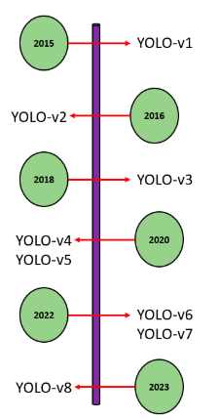
Figure 4: YOLO Evaluation [16]
It is a state-of-the-art, real-time object detection system that offers extreme levels of speed and accuracy [13]. YOLO, as the name suggests, looks at the image only once, i.e., there is only a single network evaluation, unlike the approach of previous systems like the R-CNN and its family, which require thousands of evaluations for a single image (2000). This is the secret to the extreme speed of a YOLO model (almost 1000x faster than R-CNN, 100x faster than the Fast R-CNN, and 10x faster than the Faster R-CNN model) [13]. In this approach, the model uses a predefined set of boxes (bounding boxes) that look for objects in their regions. For the SxS grid cells drawn for each image, YOLO predicts X boundary boxes, each with its confidence score, and each box can predict only one object. [13]. YOLO also generates Y conditional class probabilities for the likelihood of each object class [6], [14] and [15].

From the review in this work, it is clear that the YOLOv1 to YOLOv4 variations have progressed; later versions, in particular, YOLOv5 to YOLOv7, have focused on constrained edge deployment, a key requirement for many manufacturing and industrial applications. Because there are no copyright and patent restrictions on these techniques, research anchored around the YOLO architecture, i.e., real-time detection, lightweight, accurate detection, can be conducted by any individual or research organisation in computer vision, which has also contributed to the popularity of this variant [16]. As research groups such as Ultralytics and Meituan Technical Team focus on the evolution of YOLO architectures designed for edge-friendly deployment, further advancements in YOLO’s architectural footprint can be expected. To accommodate the exigencies of energy-constrained environments, these innovations will need to prioritise energy efficiency while ensuring high inference speeds [17].
Furthermore, we envision the proliferation of YOLO architectures into production facilities to help with quality inspection pipelines, as well as providing stimulus for innovative products, as demonstrated by [16] with an automated pallet racking inspection solution. With the ability to integrate into various hardware and IoT devices, YOLO has the potential to explore new fields where computer vision can enhance existing images, ultimately boosting the performance of a single-shot detector [16].

5. SSD – SINGLE SHOT DETECTION
Similar to YOLO, SSDs take only a single shot to detect all the classes in a scene that the model was trained on [2] and therefore, like YOLO, they are much faster than the traditional two-stage methods that require two shots (one for generating region proposals and another for detecting objects in each proposal). SSDs implement techniques such as multi-scale features and default boxes, which allow them to obtain similar levels of accuracy as that of a Faster R-CNN model using lower resolution Images and enhance the processing speed of a single-shot detector [2]. SSD uses VGG16 to extract feature maps from a scene and then uses a Conv43 layer to detect objects from the extracted features [2].
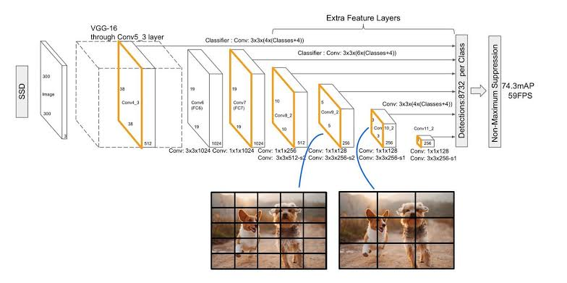
Figure 5: SSD Architecture [6]

5.1 VISION TRANSFORMERS (ViTs)
ViTs splits the image into a form of patches by providing the sequence of linear embedding of these patches as an input to a transformer [18]. The model processes the patches as a sequence of words, like tokens of the same size, processed in natural language processing. [18]. A constant latent vector was used to flatten and map the patches into a vector of size with a trainable projection in all the transformer layers. A multilayer perceptron (MLP) with one hidden layer was used during the classification and pre-training time, and a single layer at the fine-tuning stage [19].
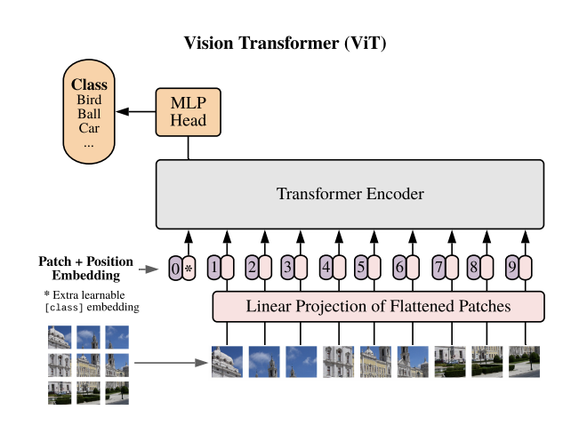
Figure 6: Vision Transformer Architecture [20]

6. CHALLENGES IN OBJECT DETECTION
Despite the benefits, implementing object detection algorithms in different domains, from self-driving cars, healthcare, industries, etc comes with challenges. Viewpoint variation and speed are some of the critical issues, as highlighted below.
- Viewpoint variation: one of the greatest difficulties of object detection is that an object viewed from different angles may look completely different [39].
- Deformation: look at the images of football players in different poses. If the object detector is trained to find a person only in a standing or running position, it may not be able to detect a player who is lying on the field or preparing to make a manoeuvre by bending down [40].
- Occlusion: sometimes objects can be obscured by other things, which makes it difficult to read the signs and identify these objects [41].
- Illumination conditions: lighting significantly affects how objects are defined. The same objects will look different depending on the lighting conditions [42].
- Cluttered or textured background: objects that need to be identified may blend into the background, making it difficult to identify them [43].
- Variety: the same object can appear in entirely different forms and dimensions. Computer vision needs to do a lot of research to read an object and understand what it means [44].
- Speed: for video analysis, detectors must be trained to operate effectively in a continuously changing setting. This implies that object detection algorithms need to not only successfully classify significant objects but also maintain a high speed during predictions to detect objects that are in motion [44].

7. REVIEW OF RELATED STUDIES
A summary of the research studies selected from the research papers is shown in Table 1. However, this evidence summarises the authors' approach after the review has been done, and the findings, datasets, techniques, and other architectures that were used to build a comparative study between CNNs and ViTs have been identified.
Therefore, this section offers an overview of the data found, the methodology used, as well as results found in the collected papers.
In a study presented in [21], the authors aimed to compare the two object detection architecture approaches (i.e., CNNs and ViTs), as well as the creation of a hybrid model that corresponded to the combination of these methods. The experiment for this research was conducted using the ImageNet dataset, and perturbations were applied to the dataset image. Based on the findings, it was established that ViTs can outperform and exhibit greater robustness in image classification under both natural and adverse conditions compared to CNNs. The results also showed that merging these two object detection models can cause the model to perform better, resulting in a 10% percent improvement in accuracy.
The work done in [10] compared ViTs with CNNs to reconstruct amplitude in digital holography. Additionally, the phase involved measuring the distance of the object from the hologram. In this research work, ViT-B/16, ViT-B32, DenseNet201, DenseNet169, EfficientNetB4, EfficientNetB7, and ViT-L/16 architectures were used to experiment on 3,400 images. The authors separated these images into four datasets: original images without filters, original images with filters, negative images with filters, and negative images without filters. It was concluded that ViTs, despite having the same accuracy as CNNs, were more robust as a result of their self-attention mechanism of the technique, which enables them to learn the entire hologram instead of a specific area.
A study to compare ViTs with state-of-the-art CNNs to classify UAV images that could be used to monitor weeds and crops in a farmland was conducted in [22]. The researchers compared the influence of the training dataset size on the performance of the architectures. ViTs performed well with fewer images than CNNs in terms of F1-Score. The result also showed that ViT-B/16 was the best model for weed and crop monitoring. In comparison with CNNs, ViTs could learn the patterns of images in small datasets, making a better choice than CNNs.
Similarly, in the research work in [23], a comparison between CNNs and ViTs models for breast ultrasound image classification was carried out. The investigation utilised two distinct datasets, the first comprised 780 images and the second included 163 images for the training and evaluation of the models. The following architectures were selected for the study: VGG-16, ResNet50, NASNET, Inception, ViT-S/32, ViT-B/32, R + ViT-Ti/16 , ViT-Ti/16, and R26 + ViT-S/16. From the results, ViTs models performed better than CNNs for image classification. The researcher also highlighted that ViTs models perform better when trained with small datasets because of the attention mechanism, which enables them to extract more information from different patches of the same size instead of collecting features or information directly from the image.
A similar study in [11] compared ViTs models with the MLP-Mixer layer architecture and CNNs. The authors sought to evaluate which architecture among the three is more robust in the classification of adversarial images. The result showed that ViTs were more robust than CNNs to adversarial attacks. Similarly, the researchers also described that the shift variance property of CL (convolutional layers) is perhaps the main cause of the lack of robustness of the architecture in the image classification task that involves adversarial images.
The authors of [24] analysed ViTs and CNNs models to detect deep fake images. The experiment was conducted using the forgery net dataset, which consisted of about 2.9 million images and 220 thousand video clips, together with three different image manipulation techniques. The authors trained the models with real and manipulated images. By training EfficientNetV2 and ViT-B model networks, the researchers demonstrated that the CNNs generalised better and produced higher training accuracy.
Another study was implemented in [25] to compare ViTs with CNNs models in image classification for the detection of skin cancer in the human body. The experiment was conducted using a publicly available dataset, HAM10000, which contains clinical images of skin cancer collected through dermoscopy. A multi-scale image approach and an overlapping sliding window technique were implemented to serialise the images, and a contrastive learning was employed to boost the inter-class similarity among various labels while reducing the intra-class similarity. Thus, the proposed ViTs model proved to be superior for skin cancer classification.
In a research carried out in [26], the authors tried to find in ViTs an alternate solution to CNNs for concrete crack and asphalt detection. The researchers concluded that ViTs, due to the self-attention mechanism, had better performance in crack detection images with strong noise compared to convolutional neural networks. In contrast, CNNs suffered from a high number of FN rates (false negative rates) in classifying the images.
The work done in [27] compared CNNs with ViTs models for the classification of diabetic foot ulcer images from diabetes datasets. The authors decided to use architectures like EfficientNet, Big Image Transfer (BiT), ViT-base and Data-efficient Image Transformers (DeIT) on a dataset comprising about 15,683 images. The study also aimed to compare the performance of deep learning models using stochastic gradient descent (SGD) with sharpness-aware optimisation (SAM) [28]. SAM minimises the value of the sharpness loss and the loss function, looking for parameters in the neighbourhood with a low loss. Consequently, this study found that the SAM optimiser led to improvements in AUC, F1-Score, Precision and Recall across all architectures utilised. However, the researchers did not provide the training and testing metrics necessary to assess the models' generalisation enhancement. Notwithstanding, the BiT-ResNetX50 model paired with the SAM optimiser achieved the highest performance in classifying Diabetic Foot Ulcer images, with an AUC of 87.68%, F1-score of 57.71% and a Precision = 57.74% and Recall = 61.88%.
In a related study, some authors in [29] and [30] went deeper into object detection with the aim of understanding how the learning process of vision transformers takes place. The authors in [30] intended to analyse the internal representations of ViTs and CNNs structures in image classification benchmarks and establish the differences between them. A key distinction emerged wherein ViTs exhibit a greater resemblance between high and low layers compared to CNNs, which require additional lower layers to generate the same representations in smaller datasets. This is due to the self-attention layers implemented in ViTs, which allow it to combine information from other spatial locations within an image or video, vastly different from the fixed field sizes in CNNs. It was also noted that in the lower layers of self-attention, ViTs can access information from both local heads (small distances) and global heads (large distances), whereas CNNs primarily obtain local information in their lower layers.
On the other hand, the authors in [31] systematically analysed the transfer learning techniques' capacity in the two architectures. The research involved comparing the efficacy of ViTs and CNNs for both single and multi-task learning challenges using the ImageNet dataset. The authors concluded that the transformer-based ViTs architecture contained more transferable representations compared to CNNs for fine-tuning, which makes it present better performance and robustness in multi-task learning problems.
Another study carried out in [29], attempt to verify whether ViTs were more robust than CNNs, as shown by some recent studies. The authors compared the robustness of the two architectures, the ViTs and CNNs, using two types of approaches: argumentative samples, which consist of evaluating the robustness of CNNs architectures in images with artificial perturbations and out-of-distribution samples, which consist of evaluating the robustness of the architectures in classification image benchmarks. Through this experiment, it was demonstrated that by replacing the activation function, such as ReLU, with the activation function of transformer-based architecture, GELU, the CNNs network performed better than ViTs in classifying adversarial samples. In this study, it was also demonstrated that CNNs networks were more robust than ViTs in patch-based attacks. Ultimately, the authors argued that the self-attention mechanism was critical to the robustness of transformer-based architectures in the experiments.
In [32], the authors aimed to detect early illness to enable medical experts to deliver the best care to patients and increase the likelihood of a full recovery. In this work, the author showed that the proposed system is based on explainable artificial intelligence to detect COVID-19 from CXR images using several cutting-edge models, including both CNNs models and ViT models. This gives doctors and other medical professionals a second option to support their decisions. The proposed approach incorporated certain image preprocessing techniques, such as employing a UNet model for the segmentation of the area of interest and the utilisation of rotation augmentation. CNNs processed pixel arrays, while ViTs break down images into visual tokens. For the experiments, a publicly accessible dataset (COVID-QU-Ex) was utilised. The outcomes of the experiments indicated that CNN-based and ViT-based models performed on a comparable level. The highest accuracy achieved was 99.82% by the EfficientNetB7 model, followed closely by the SegFormer.
In [33], the authors systematically analysed the comparison between CNNs and ViTs in an object detection task. The research was conducted by comparing the performance of the architectures in handling complex medical datasets using the ImageNet X-Ray dataset. The authors concluded that the proposed CNNs architecture outperformed the transformer-based architecture in terms of robustness.
The work done in [34] compared CNNs with ViTs models in a racing competition. This research investigates CNNs and ViTs models for action recognition and assesses the balance between accuracy and complexity in the performance of the two architectures. In addition, the authors also investigated the commonality of relevant studies that highlight the advantages of each of the two approaches and their associated results.
The work done in [35] aimed at the adversarial robustness of vision transformers versus convolutional neural networks. This work introduced a novel and systematic method to assess and compare the adversarial robustness of ViTs against CNNs, specifically focusing on the image classification task. The covered broad experiments using state-of-the-art adversarial attacks such as the fast gradient sign method (FGSM), projected gradient descent (PGD), and deepfool attack (DFA). The results suggested that CNNs are more robust against more straightforward attacks such as FGSM. Nonetheless, ViTs displayed remarkable resilience against more sophisticated attacks such as the PGD and DFA methods
Another study carried out in [36] attempted to find an alternative solution to the computational cost between the ViTs and the CNNs. The authors aimed to address this issue and develop a network that can outperform not only the canonical transformers but also the high-performance convolutional models. The authors propose a new transformer-based hybrid network by taking advantage of transformers to capture long-range dependencies and CNNs’ ability to extract local information. The combination gave birth to an architecture called CMTs, obtaining a much better trade-off for accuracy and efficiency than previous CNN-based and ViT-based models. Specifically, the CMT-S achieved a top-1 accuracy of 83.5% on ImageNet while being 14 times and 2 times smaller in terms of FLOPs than the current DeiT and EfficientNet, respectively.
In a related study, [37] aimed at comparing the ViTs model with CNNs to perform image classification for the detection of glaucoma disease. The experiment used a public HAM10000 dataset. A multi-scale image approach and overlapping sliding windows were utilised to serialise the images. The authors also implemented contrastive learning to enhance the distinction of different labels while reducing the similarity among the same labels. Consequently, it was concluded that the ViT model developed performed better for glaucoma disease detection. However, the authors did not specify the size of the dataset used in the experiment.
Table 1. Overview of Selected Studies
Reference | Datasets | Images Size | Number of  Classes | Hardware | Evaluated  Archectures | Best Architecture | Best Results
[10] | ImageNet-C benchmark | 224 × 224 | 2 | NVIDIA Quadro A6000 | ViT-L/16, CNN, hybrid model (BiT-M + ResNet152 × 4 | Hybrid model | 99.20% Acc
[11] | ImageNet-C benchmark | Not Available | 1000 | Not Available | Mixer and ViT Architecture | ViTs and MLP-Mixer | Not Available
[38] | 10,265 images collected by Pilgrim technologies UAV with Sony ILCE-7R-36 megapixels | 64 × 64 | 5 | Intel Xeon E5-1620 V4 3.50  GHz with 8 processors, 16  GB RAM; NVIDIA Quadro M2000 | EfficientNetB , EfficientNetB1 , ViT-B/16, ViT-B/32, and ResNet50 | ViT-B/16 | 99.8% Acc
[21] | Public dataset 1 with 780 images; Public dataset 2 [26] with 163 images | 224 × 224 | 3 | Not Available | ViT-S/32, ViT-B/32, ViT-Ti/16, R + Ti/16, R26 + S/16, VGG, Inception and NASNET | ViT-B/32 | 86.7% Acc and 95% AUC
[22] | ImageNet-1K (more than 1.431 M images) for training and ImageNet-C for validation | 224 × 224 | 2 | Not Available | Mixer-B/16, , ViT-B/16, ViT-L/16, RN18 and RN50 and RN18 (SWSL), RN50 (SWSL), | ViT-L/16 | 82.89% of Acc
[23] | 943 images of breast ultrasound collected from the hospital | Not Available | 2 | Not Available | NASNET, ViT-S/32, ResNet50, VGG-16, Inception, ViT-B/32, ViT-Ti/16, R + ViT-Ti/16 and R26 + ViT-S/16 | ViTs | Not Available
[24] | 2.9 million images and 220 thousand video clips | Not Available | 3 | Not Available | EfficientNetV2 | CNNS | Not Available
[25] | HAM10000 dataset (10,015 images); 1016 images collected by dermoscopy | 224 × 224 | 3 | Intel i7; 2x NVIDIA RTX 3060, 12 GB | InceptionV2, MobileNetV2, ResNet50, , ViT and Proposed ViT model | Proposed ViT model | 94.10% Acc, 94.10% precision, and  94.10% F1-Score
[26] | CrackTree260 (260 images); Ozegenel (458 images); Lab’s on dataset (80,000 images) | 256 × 256; 448 × 448 | 2 | Not Available | TransUNet, U-Net, DeepLabv3+ and CNN + ViT | CNN  + ViT | 99.55% Acc and 99.57% precision
[27] | Dataset provided in the DFUC 2021 challenge  (15,683 images) | 224 × 224 | 4 | NVIDIA GeForce RTX 3080, 10 GB memory | EfficientNetB3, BiT-ResNeXt50, ViT-B/16 and DeiT-S/16 | BiT-ResNeXt50 | 88.49% AUC, 61.53%  F1-Score, 65.59% recall, and  60.53% precision
[29] | ImageNet-A, ImageNet-C, and Stylised ImageNet | 224 x 224 | Not Available | Not Available | DeiT-S and ResNet50 | ViT | Not Available
[30] | ImageNet-A, ImageNet-C, and Stylised ImageNet | 224 x 224 | Not Available | Not Available | ResNet50 and DeiT-S | ViT | Not Available
[31] | A total of 1130 cataract and non-cataract fundus images were collected and augmented to 4746 images | Not Available | 4746 | Not Available | , Inception-v3, and ResNet-50, MobileNet, VGG-16, VGG-19 | ViTs-CataractNet | Accuracy (99.13%), precision (99.08%), recall (99.07%), specificity (99.17%), MCC (98.23%), and f1-score (99.07%).
[32] | 21,165 CXR medical images | 256 × 256 | 21,165 | CPU E5-2640v3 3.00-GHz processor, 2 TB of hard disk space, 16 GB of RAM, and a CUDA-enabled NVIDIA GTX 1080 Ti 11-GB graphical processing unit. | MiT-B5 and VGG16 | CNN-based model | 99.82%, obtained by the EfficientNetB7 (CNN-based) model
[33] | Medical images | Not Available | Not Available | Not Available | Not Available | CNN-based model | Not Available
[34] | Action Recognition Dataset | Not Available | Not Available | Not Available | Not Available | Hybrid Model | Not Available
[35] | CIFAR10  60,000 images | 224 x 224 | 60,000 | Not Available | MobileNet, DenseNet, ViT-b16, ViT-b32, ViT-L16, ViT-L32, ResNet50, VGG19, | CNNS | 90.00%, obtained by the DenseNet (CNN-based) model
[36] | ImageNet, dataset | 224 x 224x3 and 16×16×3 per patch | Not Available | Not Available | DeiT-S (ViT-S) and ResNet-50, and CMT-S | CNNS perform better | CIFAR10 (99.2%)
[37] | HAM10000 | 224 x 224 | Not Available | Not Available | ConViT and VGG19 | ViT-based | Not Available
* Overview of Selected Studies
From the table shown above, after the reviewed of the related studies, the results can be summarised as follows: ViTs have shown higher performance and greater resilience when dealing with images that have natural or artificial perturbations in comparison to CNNs. The authors [38], [21],[29], [30], [31] concluded that ViTs are more robust because of their ability to scan the images rather than just a specific area. Additionally, ViTs have been shown to exceed CNNs in the detection of pneumonia from chest X-ray images, as well as in the classification of UAV images used for monitoring crops and weeds with limited datasets [22]. Similarly, these architectures outperformed CNNs in breast ultrasound image classification, especially with small datasets. [23]. Another study [11] found that ViTs are more robust to adversarial attacks and that CNNs are more sensitive to high-frequency features in detecting non-helmeted personnel. The authors of [24] found that CNNs have higher training accuracy and better generalisation, but ViTs showed potential to reduce bias in anomaly detection of deepfake images. In [25], the authors claimed that the ViTs model showed better performance for skin cancer classification

In [26], the authors investigated the use of ViTs for asphalt and concrete crack detection and found that ViTs performed better due to the self-attention mechanism, especially in images with intense noise and biases. In [27], the authors used several models for diabetic foot ulcer image classification and compared SGD and SAM optimisers, concluding that a CNNs architecture in combination with the SAM optimiser can outperform a ViT model in some image classification tasks. This clearly shows that the ViTs models are more efficient and robust compared to the CNNs architecture in image classification and object detection tasks owing to their attention mechanism, which allows them to break images into patches, study them and extract meaningful features that are key to identifying the object of interest in an image.

8. FUTURE RESEARCH DIRECTIONS/CONCLUSION
Future research work should focus on addressing the limitations and gaps of current object detection models established from this review and exploring new algorithms that can further enhance detection accuracy and interpretability. Furthermore, there is also a need for more studies that validate these models across different contexts and datasets to ensure their generalisability and robustness.
After the review, the following gaps were found:
- Performance on Small Datasets: ViTs are known to require large datasets for effective training due to their self-attention mechanism, while CNNs are generally more effective with smaller datasets. However, there is limited research comparing their accuracy and efficiency on small datasets, especially in specialised domains like medical imaging, home appliances or satellite imagery.
- Dataset Diversity and Generalisation: many studies compare CNNs and ViTs on standard datasets like ImageNet or COCO, but there is limited research on their performance on diverse and specialised datasets, such as those from medical imaging, agriculture, and industrial applications.
- Efficiency in Low Computational Power Environments: CNNs are generally more computationally efficient than ViTs, but there is limited research comparing their efficiency on low computational power systems such as edge devices or IoT systems. ViTs are computationally demanding and may not be suitable for resource-constrained environments.
- Consistency Across Different Datasets: while CNNs and ViTs have been shown to perform well on specific datasets, there is limited research on their consistency across different datasets, especially in terms of accuracy and robustness. For example, a model that performs well on ImageNet may not generalise well on a medical imaging dataset.
- Training Efficiency on Small Datasets: ViTs typically require large datasets for effective training, but there is limited research on their training efficiency on small datasets. CNNs, on the other hand, are known to perform well with smaller datasets, but their training efficiency in such scenarios has not been thoroughly compared with ViTs.
- Accuracy in Low-Resource Scenarios: there is limited research comparing the accuracy of CNNs and ViTs in low-resource scenarios, where both computational power and dataset size are limited. This is particularly relevant for applications in developing regions or resource-constrained environments.

Disclaimer (Artificial intelligence)
Option 1:
Author(s) hereby declare that NO generative AI technologies such as Large Language Models (ChatGPT, COPILOT, etc.) and text-to-image generators have been used during the writing or editing of this manuscript.
Option 2:
Author(s) hereby declare that generative AI technologies such as Large Language Models, etc. have been used during the writing or editing of manuscripts. This explanation will include the name, version, model, and source of the generative AI technology and as well as all input prompts provided to the generative AI technology
Details of the AI usage are given below:
1.
2.
3.

9. REFERENCE
[1] Han, K., Wang, Y., Chen, H., Chen, X., Guo, J., Liu, Z., Tang, Y., Xiao, A., Xu, C., Xu, Y., Yang, Z., Zhang, Y., & Tao, D. (2023). A Survey on Vision Transformer. IEEE Transactions on Pattern Analysis and Machine Intelligence, 45(1), 87–110. https://doi.org/10.1109/TPAMI.2022.3152247
[2] Khan, A., Rauf, Z., Sohail, A., Khan, A. R., Asif, H., Asif, A., & Farooq, U. (2023). A survey of the vision transformers and their CNN-transformer-based variants. *Artificial Intelligence Review*, *56*, 2917–2970. https://doi.org/10.1007/s10462-023-10595-0
[3] Ali, M. A. M., Aly, T., Raslan, A. T., Gheith, M., & Amin, E. A. (2024). Advancing Crowd Object Detection: A Review of YOLO, CNN and ViTs Hybrid Approach. Journal of Intelligent Learning Systems and Applications, 16(3), 175–221. https://doi.org/10.4236/jilsa.2024.163011
[4] Jiang, P., Ergu, D., Liu, F., Cai, Y., & Ma, B. (2022). A review of Yolo algorithm developments. Procedia Computer Science, 199, 1066–1073. https://doi.org/10.1016/j.procs.2022.01.135
[5] Zhao, X., Wang, L., Zhang, Y., Han, X., Deveci, M., & Parmar, M. (2024). A review of convolutional neural networks in computer vision. Artificial Intelligence Review, 57(4). https://doi.org/10.1007/s10462-024-10721-6.
[6] Alyamkin, S., Ardi, M., Berg, A. C., Brighton, A., Chen, B., Chen, Y., Cheng, H.-P., Fan, Z., Feng, C., Fu, B., Gauen, K., Goel, A., Goncharenko, A., Guo, X., Ha, S., Howard, A., Hu, X., Huang, Y., Kang, D., Kim, J., Ko, J. G., Kondratyev, A., Lee, J., Lee, S., Lee, S., Li, Z., Liang, Z., Liu, J., Liu, X., Lu, Y., Lu, Y.-H., Malik, D., Nguyen, H. H., Park, E., Repin, D., Shen, L., Sheng, T., Sun, F., SViTov, D., Thiruvathukal, G. K., Zhang, B., Zhang, J., Zhang, X., & Zhuo, S. (2019). Low-Power Computer Vision: Status, Challenges, and Opportunities. IEEE Journal on Emerging and Selected Topics in Circuits and Systems, 9(2), 411–421. https://doi.org/10.1109/JETCAS.2019.2911899
[7] Jiao, L., Yang, F., Tang, X., Feng, Y., Li, S., Liu, Z., & Zhang, R. (2019). A survey of deep learning-based object detection. IEEE Access, 7, 128837–128868. https://doi.org/10.1109/ACCESS.2019.2939201
[8] Nalliyanna, V. K., et al. (2020). Improved Salient Object Detection Using a Hybrid Convolution Recurrent Neural Network. Expert Systems with Applications, 166, 114064. https://doi.org/10.1016/j.eswa.2020.114064
[9] O'Mahony, N., Campbell, S., Carvalho, A., Harapanahalli, S., Velasco-Hernandez, G., Krpalkova, L., Riordan, D., & Walsh, J. (2020). Deep Learning vs. Traditional Computer Vision. In Advances in Computer Vision: Proceedings of the 2019 Computer Vision Conference (CVC), Volume 1 (pp. 128–144). Springer Nature Switzerland AG. https://doi.org/10.1007/978-3-030-17795-9
[10] Cuenat, S., & Couturier, R. (2022). Convolutional Neural Network (CNN) vs Vision Transformer (ViT) for Digital Holography. 2022 2nd International Conference on Computer, Control and Robotics (ICCCR 2022). https://doi.org/10.1109/ICCCR54399.2022.9790134
[11] Benz, P., Ham, S., Zhang, C., Karjauv, A., & Kweon, I. S. (2021). Adversarial Robustness Comparison of Vision Transformer and MLP-Mixer to CNNs. 32nd British Machine Vision Conference (BMVC). https://doi.org/10.48550/arXiv.2110.02797.
[12] Ragab, M. G., Abdulkadir, S. J., Muneer, A., Alqushaibi, A., Sumiea, E. H., Qureshi, R., Al-Selwi, S. M., & Alhussian, H. (2024). A Comprehensive Systematic Review of YOLO for Medical Object Detection (2018 to 2023). IEEE Access, 12, 57815–57836. https://doi.org/10.1109/ACCESS.2024.3386826
[13] Plastiras, G., Kyrkou, C., & Theocharides, T. (2018). Efficient ConvNet-based Object Detection for Unmanned Aerial Vehicles by Selective Tile Processing. Proceedings of the 12th International Conference on Distributed Smart Cameras. https://doi.org/10.1145/3243394.3243692
[14] Ezzeddini, L., Ktari, J., Frikha, T., Alsharabi, N., Alayba, A., Alzahrani, A. J., Jadi, A., Alkholidi, A., & Hamam, H. (2024). Analysis of the performance of Faster R-CNN and YOLOv8 in detecting fishing vessels and fishes in real time. PeerJ Computer Science, 10, e2033. https://doi.org/10.7717/peerj-cs.2033
[15] Amjoud, A. B., & Amrouch, M. (2023). Object Detection Using Deep Learning, CNNs and Vision Transformers: A Review. IEEE Access, 11, 35479–35516. https://doi.org/10.1109/ACCESS.2023.3266093
[16] Hussain, M. (2023). YOLO-v1 to YOLO-v8, the Rise of YOLO and Its Complementary Nature toward Digital Manufacturing and Industrial Defect Detection. Machines, 11(7), 677. https://doi.org/10.3390/machines11070677
[17] Vijayakumar, A., & Vairavasundaram, S. (2024). YOLO-based Object Detection Models: A Review and its Applications. Multimedia Tools and Applications. https://doi.org/10.1007/s11042-024-18872-y
[18] Chen, Z., Xie, L., Niu, J., Liu, X., Wei, L., & Tian, Q. (2021). Visformer: The Vision-friendly Transformer. 2021 IEEE/CVF International Conference on Computer Vision (ICCV), 589–598. https://doi.org/10.1109/ICCV48922.2021.00063
[19] Arnab, A., Dehghani, M., Heigold, G., Sun, C., Lučić, M., & Schmid, C. (2021). ViViT: A Video Vision Transformer. Proceedings of the IEEE/CVF International Conference on Computer Vision (ICCV) https://doi.org/10.1109/ICCV48922.2021.00676
[20] Bai, Y., Mei, J., Yuille, A., & Xie, C. (2021). Are Transformers More Robust Than CNNs? Advances in Neural Information Processing Systems. https://doi.org/10.48550/arXiv.2111.05464.
[21] Filipiuk, M., & Singh, V. (2022). Comparing Vision Transformers and Convolutional Nets for Safety Critical Systems. CEUR Workshop Proceedings, 3087. http://ceur-ws.org/Vol-3087/paper_31.pdf
[22] Reedha, R., Dericquebourg, E., Canals, R., & Hafiane, A. (2022). Transformer Neural Network for Weed and Crop Classification of High Resolution UAV Images. Remote Sensing, 14(3), 592. https://doi.org/10.3390/rs14030592
[23] Gheflati, B., & Rivaz, H. (2022). Vision Transformers for Classification of Breast Ultrasound Images. Annu Int Conf IEEE Eng Med Biol Soc. https://doi.org/10.1109/EMBC48229.2022.9871809
[24] Coccomini, D. A., Caldelli, R., Falchi, F., Gennaro, C., & Amato, G. (2022). Cross-Forgery Analysis of Vision Transformers and CNNs for Deepfake Image Detection. In *Proceedings of the 1st International Workshop on Multimedia AI against Disinformation (MAD '22)*. https://doi.org/10.1145/3512732.3533582
[25] Xin, C., Liu, Z., Zhao, K., Miao, L., Ma, Y., Zhu, X., Zhou, Q., Wang, S., Li, L., Yang, F., Xu, S., & Chen, H. (2022). An improved transformer network for skin cancer classification. Computers in Biology and Medicine, 149, 105939. https://doi.org/10.1016/j.compbiomed.2022.105939
[26] Asadi Shamsabadi, E., Xu, C., Rao, A. S., Nguyen, T., Ngo, T., & Dias-da-Costa, D. (2022). Vision transformer-based autonomous crack detection on asphalt and concrete surfaces. Automation in Construction. https://doi.org/10.1016/j.autcon.2022.104316
[27] Galdran, A., Carneiro, G., & Ballester, M. A. G. (2022). Convolutional Nets Versus Vision Transformers for Diabetic Foot Ulcer Classification. In Diabetic Foot Ulcers Grand Challenge (Lecture Notes in Computer Science, vol. 13183, pp. 21–29). Springer. https://doi.org/10.1007/978-3-030-94907-5_2
[28] Foret, P., Kleiner, A., Mobahi, H., & Neyshabur, B. (2021). Sharpness-Aware Minimization for Efficiently Improving Generalization. ICLR 2021 - 9th International Conference on Learning Representations. https://openreview.net/forum?id=LzYy_b-YgD
[29] Bai, Y., Mei, J., Yuille, A. L., & Xie, C. (2021). Are Transformers More Robust Than CNNs?. *Advances in Neural Information Processing Systems, 34*, 26831–26843. https://proceedings.neurips.cc/paper/2021/file/9d99197e2ebf03fc388d09f1e94af89b-Paper.pdf
[30] Raghu, M., Unterthiner, T., Kornblith, S., Zhang, C., & DosoViTskiy, A. (2021). Do Vision Transformers See Like Convolutional Neural Networks? *Advances in Neural Information Processing Systems 34 (NeurIPS 2021)*. https://proceedings.neurips.cc/paper_files/paper/2021/hash/f3f27a324736617f8a612d630dd9677d-Abstract.html
[31] Zhou, H. Y., Lu, C., Yang, S., & Yu, Y. (2021). ConvNets vs. Transformers: Whose Visual Representations are More Transferable?. 2021 IEEE/CVF International Conference on Computer Vision Workshops (ICCVW). https://doi.org/10.1109/ICCVW54120.2021.00252
[32] Nafisah, S. I., Muhammad, G., Hossain, M. S., & AlQahtani, S. A. (2023). A comparative evaluation between convolutional neural networks and vision transformers for COVID-19 detection. Mathematics, 11(6), 1489. https://doi.org/10.3390/math11061489
[33] Takahashi, S., Sakaguchi, Y., Kouno, N., Takasawa, K., Ishizu, K., Akagi, Y., Aoyama, R., Teraya, N., Bolatkan, A., Shinkai, N., Machino, H., Kobayashi, K., Asada, K., Komatsu, M., Kaneko, S., Sugiyama, M., & Hamamoto, R. (2024). Comparison of Vision Transformers and Convolutional Neural Networks in Medical Image Analysis: A Systematic Review. Journal of Medical Systems, 48(1), 84. https://doi.org/10.1007/s10916-024-02105-8
[34] Moutik, O., Sekkat, H., Tigani, S., Chehri, A., Saadane, R., Tchakoucht, T. A., & Paul, A. (2023). Convolutional Neural Networks or Vision Transformers: Who Will Win the Race for Action Recognitions in Visual Data? Sensors, 23(2), 734. https://doi.org/10.3390/s23020734
[35] Ali, K., Bhatti, M. S., Saeed, A., Athar, A., Al-Sharafi, M. A., & Almotairi, S. H. (2024). Adversarial Robustness of Vision Transformers Versus Convolutional Neural Networks. *IEEE Access*, *12*, 105281–105293. https://doi.org/10.1109/ACCESS.2024.3435347
[36] Guo, J., Han, K., Wu, H., Tang, Y., Chen, X., Wang, Y., & Xu, C. (2022). CMT: Convolutional Neural Networks Meet Vision Transformers. 2022 IEEE/CVF Conference on Computer Vision and Pattern Recognition (CVPR). https://doi.org/10.1109/CVPR52688.2022.01186
[37] Alayón, S., Hernández, J., Fumero, F. J., Sigut, J. F., & Díaz-Alemán, T. (2023). Comparison of the Performance of Convolutional Neural Networks and Vision Transformer-Based Systems for Automated Glaucoma Detection with Eye Fundus Images. Applied Sciences, 13(23), 12722. https://doi.org/10.3390/app132312722
[38] Siebert, F. W., Riis, C., Janstrup, K. H., Lin, H., Kristensen, J., Gül, O., & Hüttel, F. B. (2024). Automated detection of bicycle helmets using deep learning. Journal of Cycling and Micromobility Research, 2, Article 100013. https://doi.org/10.1016/j.jcmr.2024.100013
[39] L. He, Y. Zhou, L. Liu, W. Cao, and J. Ma, “Research on object detection and recognition in remote sensing images based on YOLOv11,” pp. 1–25, 2025.
[40] C. V Aug, “Contextual Object Detection with Multimodal Large Language Models,” no. i.
[41] A. T. Balarabe and I. Jordanov, “A Deeper Look Into Remote Sensing Scene Image Misclassification by CNNs,” IEEE Access, vol. 12, no. December 2023, pp. 123078–123098, 2024, doi: 10.1109/ACCESS.2024.3354976.
[42] A. T. Balarabe and I. Jordanov, “INTERPOLATION AND CONTEXT MAGNIFICATION FRAMEWORK FOR CLASSIFICATION OF SCENE IMAGES,” pp. 93–100, 2022.
[43] J. E. Gallagher and E. J. Oughton, “Surveying You Only Look Once ( YOLO ) Multispectral Object Detection Advancements , Applications , and Challenges,” IEEE Access, vol. 13, no. January, pp. 7366–7395, 2025, doi: 10.1109/ACCESS.2025.3526458.
[44] Y. Yuan, L. Tang, Y. Chen, C. Chen, Y. Huang, and X. Ding, “ASGS : Single-Domain Generalizable Open-Set Object Detection via Adaptive Subgraph Searching,” pp. 20911–20921.
[45] A. T. Balarabe and I. Jordanov, “LULC IMAGE CLASSIFICATION WITH CONVOLUTIONAL NEURAL NETWORK Anas Tukur Balarabe and Ivan Jordanov
[46] S. Park, “IM-LUT : Interpolation Mixing Look-Up Tables for Image Super-Resolution,” pp. 14317–14325.
[47] Z. He, K. Wang, T. Fang, L. Su, R. Chen, and X. Fei, “Comprehensive Performance Evaluation of YOLOv5 on Object Detection of Power Equipment,” 2024.
[48] H. Zhang, K. Liu, Z. Gan, and G. Zhu, “Aerial Vehicle Imagery”.
[49] M. Zhou, T. Li, C. Qiao, D. Xie, G. Wang, and N. Ruan, “DMM : Disparity-guided Multispectral Mamba for Oriented Object Detection in Remote Sensing,” pp. 1–12.

