Data Mining Analytics Approach-Based System for Crime Prediction along Kaduna–Abuja Highway, Nigeria

Abstract
Criminal activities in the Kaduna-Abuja Highway have been an enormous security risk to the commuters, residents, and economic growth in Northern Nigeria. Conventional law enforcement approaches are still reactive and lack data, which restricts the anticipatory and preemptive actions. This paper describes Data Mining Analytics Approach-Based System of forecasting the occurrence of crime along the Kaduna-Abuja highway, using developed models of machine learning. The analysis used three supervised learning algorithms which include Support Vector Machine (SVM), K-Nearest Neighbor (KNN) and Random Forest (RF) to represent crime patterns and predict potential types of crime, time and location. These algorithms were selected because they are widely used for classification problems, handle and have shown strong performance in similar prediction studies. Artificial data of 1,500 entries that cited five years of criminal incidences was created and prepared. Class imbalance was dealt with with the help of SMOTE (Synthetic Minority Oversampling Technique), hyperparameters optimization with the help of the GridSearchCV. The experimental outcomes showed that the KNN classifier performed best having an accuracy of 71% then SVM and Random Forest with 66.5% respectively. Analysis of the importance of features showed that the most significant predictors were month, day of the week, number of victims, year, and time of day. Study evidences that predictive analytics based on data can complement the proactive policing practices and help the security agencies to predict the high-risk times and locations along the transport corridors in Nigeria that are critical.
Keywords: Crime Prediction, Data Mining, Machine Learning, Kaduna–Abuja Highway, Predictive Policing, KNN, SVM, Random Forest

1. Introduction
Crime and insecurity are acute socio-economic issues of concern to most countries and especially in the developing world whereby criminal activities still interfere with normal course of life, economic growth as well as national development. According to reports by the United Nations Office on Drugs and Crime, organized crime, violent attacks, and kidnapping represent a substantial portion of security incidents in the developing countries (UNODC, 2023). On the same note, Apene et al. (2024) highlighted the fact that Nigeria is under constant security menaces, and the trends in organized crimes and technologically advanced criminal groups are increasing.
Most African countries, such as Nigeria, have traditional policing systems designed primarily to be reactive i.e. aimed at investigation and punishment, but not early detection and prevention (Schultze-Kraft, 2018). But with the emergence of predictive policing, the world has changed the way security is conducted. Predictive policing is the combination of data mining, machine learning, and artificial intelligence that examines past crime data, discovers latent trends and predicts crime (Saxena, 2025; Stefanoaia and Rus, 2025). The implementation of such systems in countries has also resulted in crime reduction to up to 30 per cent, which indicates that predictive analytics is a very successful strategy (RAND, 2022).
Security situation in Nigeria has become more frequent and sophisticated. According to the Nigeria Security Tracker (2024), over 5,000 kidnappings and 2,600 armed robbery cases took place in 2019-2024. Kaduna- Abuja Highway is one of the most notorious highways in the country where kidnapping, armed robbery, and homicide have been rampant. In one year, the corridor was kidnapped and killed over 500 people and over 150 (Punch, 2023; Premium Times, 2024; CFR, 2023).
Despite this alarming trend, policing in Nigeria remains largely reactive, with limited deployment of data-driven tools for proactive monitoring and intervention. Security agencies still rely on manual data collection systems, which restrict the ability to generate predictive intelligence. This creates a pressing need for robust crime prediction models capable of forecasting crime types, time, and location.
Recent advances in machine learning have opened new opportunities for developing crime forecasting systems that convert raw crime records into actionable intelligence. Studies have demonstrated the effectiveness of various supervised and unsupervised learning methods for detecting crime patterns, hotspots, and temporal trends. Machine learning-based systems such as PredPol in the U.S. and the Crime Early Warning System in Chicago have achieved up to 85% accuracy in predicting high-risk hotspots (RAND, 2021).
Against this backdrop, this study develops a data-mining analytics-based crime prediction system tailored specifically for the Kaduna–Abuja Highway. The system employs Support Vector Machines (SVM), K-Nearest Neighbors (KNN), and Random Forest classifiers to forecast crime types using temporal, spatial, and situational features. By integrating synthetic yet realistic datasets, applying SMOTE for class balancing, and using GridSearchCV for model optimization, this research aims to advance predictive policing in Nigeria. Ultimately, the goal is to support proactive security deployment along one of Nigeria’s most critical highways.

2. Related Works
The application of machine learning and data mining to crime prediction has expanded significantly, with many studies demonstrating the role of predictive analytics in enhancing crime prevention. Early research established the value of clustering, correlation analysis, and classification in uncovering spatial and behavioral patterns in crime (Hosseinkhani et al. , 2014). Similarly, Kadhim and Swadi (2011) used Decision Trees and K-Means to identify relationships between suspect characteristics and criminal behaviors, laying the foundation for automated crime modeling.
Further work has explored the use of fuzzy association rule mining to enhance interpretability in community-level crime analysis by handling the uncertainty inherent in crime datasets (Rashid et al. , 2016; Mishra et al. , 2018). Support Vector Machines (SVMs) have also been applied for spatiotemporal crime prediction, proving effective for analyzing assault and burglary incidents using geographic and temporal features (Patel & Bhattacharya, 2019).
Recent studies emphasize hotspot detection and spatial clustering. Cesario et al. (2024) introduced the Multi-Density Crime Predictor (MD-CrimePredictor), demonstrating that multi-density clustering combined with SARIMA and LSTM models can effectively forecast crime trends in metropolitan cities. Their system analyzed more than two million crime events in Chicago with strong accuracy in spatial-temporal forecasting.
Several crime prediction systems also apply classical machine learning techniques. Sathyadevan et al. (2014) applied data-mining procedures to detect patterns in daily crime records, while Okeke & Oranyelu (2021) used real-time and location datasets from Calabar, Nigeria, to identify crime-prone areas and forecast crime types. These studies highlight the importance of integrating spatial and temporal variables into predictive models.
More advanced methods combine ensemble models, regression algorithms, and neural networks. Jakkula and Babu (2023) highlighted how classification algorithms such as Naïve Bayes, SVM, Random Forest, and ANN can improve crime prediction accuracy, particularly when integrated with visualization tools. Likewise, Syed and Albalawi (2024) proposed the CPR algorithm, which combines feature engineering, ensemble learning, and model optimization to achieve high-precision crime pattern recognition.
Deep learning approaches have also gained prominence. Wang et al. (2020) developed a hybrid CNN-LSTM model capable of modeling spatial-temporal crime dynamics, while Mansour Salah and Xia (2022) conducted large-scale big data analytics using datasets from Chicago and San Francisco to uncover hidden patterns using deep learning and visualization methods.
Crime severity and behavioral analysis have also been explored using machine learning. Osmani et al. (2025) developed a system that predicts crime severity using data mining techniques, enabling visualization of crime-prone regions and forecasting future criminal activities.
Studies focused on African contexts remain limited. Ogunleye and Adewale (2022) examined kidnapping patterns on Nigerian highways using logistic regression, but without incorporating modern ML techniques. Abudu et al. (2021) showed the potential of ensemble classifiers such as Random Forest and Gradient Boosting in the Nigerian context, but their focus was on urban terrorist incidents rather than highway crime.
The present study extends this body of knowledge by providing a localized, machine learning-based predictive framework specifically designed for the Kaduna–Abuja Highway. By integrating SMOTE balancing, GridSearchCV optimization, and a multi-model comparison (SVM, KNN, and RF), the study advances the potential of predictive policing in Nigeria’s high-risk transportation corridors.

3. Materials and Methods
The paper is centered on the Kaduna-Abuja Highway, a giant 160km transport network, connecting the state of Kaduna in Northwestern Nigeria and the Federal Capital Territory (FCT), Abuja. It is a very important economic and movement pathway which has over the years with recent years; however, been infused with violent crimes like kidnapping, armed robbery and homicide. According to the Nigeria Security Tracker (NST, 2024) and Federal Road Safety Corps (FRSC) reports, more than 500 abductions and more than 150 fatalities were registered in the area in 2020-2024 along this route. The selection of this area is due to its strategic value and recurrent security weaknesses that makes it a good case study in illustrating the effectiveness of data-driven crime prediction systems in Nigeria.

3.2 Data Description and Simulation
Because of the inaccessibility and secrecy of real-time security data, a fake dataset of 1,500 records of crimes was created. Data were created to be very much reflective of actual crime rates recorded by the Nigeria Police Force (NPF) and the associated literature (Ogunleye & Adewale, 2022). The records denote discrete criminal events, and they are defined as follows:
Table 1: Data Description
Feature | Description
Date | Calendar date of the incident
Time of Day | Categorical variable (Morning, Afternoon, Evening, Night)
Day of Week | Monday to Sunday
Month | Numeric (1–12)
Year | Range from 2020–2024
Location | Specific areas such as Rijana, Katari, Doka, and Tafa
Latitude/Longitude | Geographical coordinates of the incident site
Weapon Used | Type of weapon (Gun, Knife, Unknown, etc.)
Victims | Number of individuals affected
Casualties | Number of fatalities recorded
Arrest Made | Binary categorical feature (Yes/No)
Target Variable | Crime Type (Kidnapping, Robbery, Rape, or Homicide)

This synthetic formulation approach has been widely adopted in computational criminology for modeling data-scarce regions. It enables controlled experimentation while maintaining the statistical integrity of observed crime distributions.

3.3 Data Preprocessing
The preprocessing phase aimed to ensure consistency and suitability of the dataset for machine learning models.
- Categorical Encoding:
All nominal variables (e.g., time of day, day of week, weapon used, and arrest made) were transformed into numeric codes using Label Encoding to facilitate algorithmic interpretation.
- Feature Scaling:
Numerical variables such as latitude, longitude, and number of victims were standardized using the StandardScaler to normalize feature ranges and prevent bias toward variables with larger magnitudes.
- Class Balancing:
Preliminary inspection revealed class imbalance, where kidnapping and robbery cases significantly outnumbered rape and homicide incidents. To address this, the Synthetic Minority Oversampling Technique (SMOTE) was applied. SMOTE generates artificial examples of minority classes by interpolating between existing samples, thus balancing the dataset without data duplication. After resampling, each crime type contained 630 instances, ensuring equitable class representation for training.
3.4 Model Development
Three supervised machine learning algorithms were implemented using the scikit-learn framework:
- Support Vector Machine (SVM):
A maximum-margin classifier effective in high-dimensional spaces, particularly useful for non-linear data when combined with the Radial Basis Function (RBF) kernel.
- K-Nearest Neighbors (KNN):
A distance-based algorithm that classifies a sample according to the majority vote of its k nearest neighbors. KNN was chosen for its simplicity and strong performance in spatially distributed datasets.
- Random Forest (RF):
An ensemble learning method combining multiple decision trees to improve classification accuracy and reduce overfitting. RF also provides feature importance measures, facilitating model interpretability.
Each model was trained on 75% of the dataset and evaluated on the remaining 25% using stratified sampling to maintain class balance during splitting.

3.5 Hyperparameter Optimization
To achieve optimal predictive performance, each model underwent hyperparameter tuning using GridSearchCV with 3-fold cross-validation.
- For SVM, parameters CCC, γ\gammaγ, and kernel type were varied.
- For KNN, optimal values for kkk (number of neighbors) and weighting scheme were tested.
- For Random Forest, the number of estimators (trees), maximum depth, and minimum split size were optimized.
This systematic tuning approach ensures that the chosen models generalize effectively without overfitting.

3.6 Model Evaluation
The standard classification metrics, that is Accuracy, Precision, Recall and F1-score, calculated based on the confusion matrices, were used to evaluate the model. The accuracy measure was used to measure the overall performance whereas precision and recall measured the predictive reliability of the model in predicting a certain type of crime. Multi-class comparison of classifiers was done in terms of the macro-averaged F1-score. Results were visualized with Matplotlib and Seaborn which helped to graphically understand the behavior of the model and the relative accuracy.

3.7 Implementation Tools
The entire system was implemented in Python 3.12 using libraries such as pandas, numpy, scikit-learn, imblearn, matplotlib, and seaborn. All experiments were conducted in a Jupyter Notebook environment for reproducibility and visualization consistency.
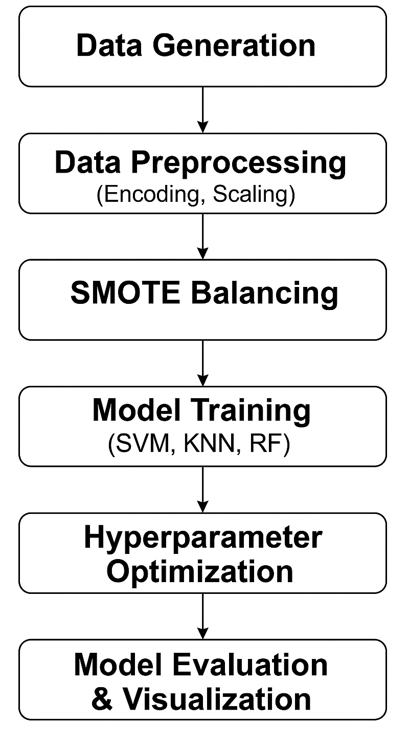
Fig. 1: System Development Flowchart

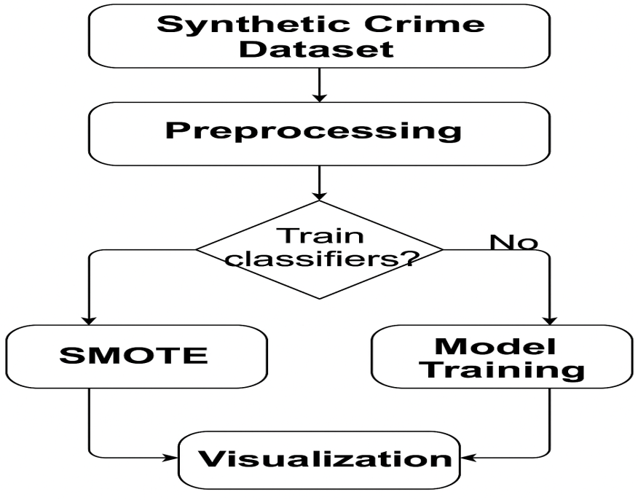

Fig. 2: Data Flow Diagram

4. Results and Discussion
The machine learning models developed for this study were evaluated after rigorous preprocessing, resampling, and hyperparameter optimization. Following Synthetic Minority Oversampling Technique (SMOTE) balancing, the dataset contained 630 instances for each of the four crime types—Kidnapping, Robbery, Rape, and Homicide—ensuring equal representation across classes.
The optimal hyperparameters obtained through GridSearchCV were as follows: for the Support Vector Machine (SVM), C=10C = 10C=10, kernel = rbf, and γ=scale\gamma = \text{scale}γ=scale; for the K-Nearest Neighbors (KNN) classifier, n_neighbors=3n\_neighbors = 3n_neighbors=3 and weights = distance; and for the Random Forest (RF) model, n_estimators=150n\_estimators = 150n_estimators=150, max_depth=None\text{max\_depth} = \text{None}max_depth=None, and min_samples_split=2\text{min\_samples\_split} = 2min_samples_split=2. The overall performance results for all classifiers are summarized in Table 2.

Table 2: Model Performance Comparison after Optimization
Model | Accuracy (%) | Precision | Recall | F1-Score
Support Vector Machine (SVM) | 66.5 | 0.64 | 0.66 | 0.64
K-Nearest Neighbors (KNN) | 71.0 | 0.70 | 0.71 | 0.67
Random Forest (RF) | 66.5 | 0.67 | 0.66 | 0.67

4.1 Model-Specific Findings
The Support Vector Machine (SVM) classifier, illustrated in Figure 3, achieved a predictive accuracy of 66.5%. It performed strongly in classifying Homicide and Rape cases (F1 = 0.83 each) but exhibited moderate recall for Kidnapping (0.31), indicating possible overlap between Kidnapping and Robbery features within the dataset.
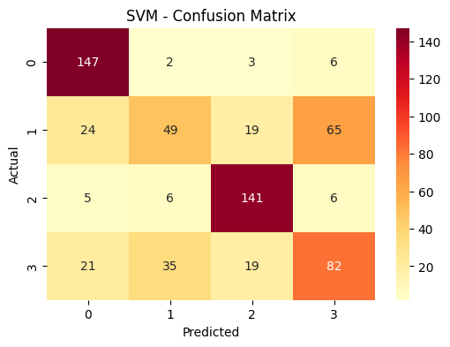
Figure 3: SVM Confusion Matrix

The KNN model (see Figure 4) demonstrated the highest accuracy of 71%. It achieved near-perfect recall for Homicide (0.99) and high F1-scores for Rape (0.82) and Robbery (0.64). However, Kidnapping remained the most difficult to classify accurately due to similarity in spatiotemporal attributes shared with Robbery events. The superior performance of KNN can be attributed to its sensitivity to local neighborhood structures, which effectively capture spatial variations in the dataset.
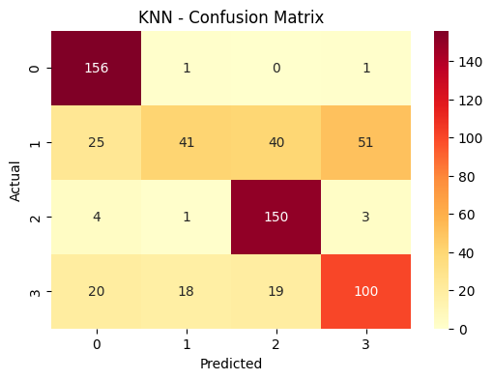
Figure 4: KNN Confusion Matrix
The Random Forest model (see Figure 5) achieved an identical accuracy of 66.5%, demonstrating balanced precision and recall across classes. Its ensemble learning capability provided stable predictions, and its feature importance metrics facilitated interpretability. Homicide (F1 = 0.87) and Rape (F1 = 0.78) were the most accurately predicted classes, suggesting that these crimes are characterized by distinct feature patterns in terms of timing, weapon used, and location.

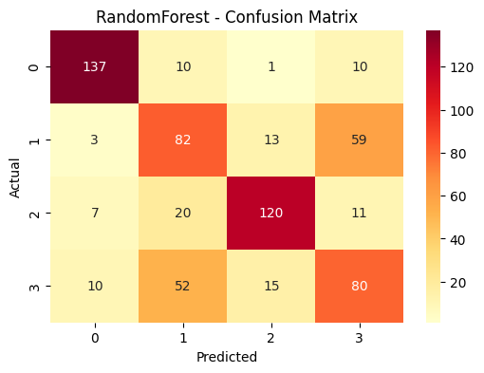
Figure 5: Random Forest Confusion Matrix

4.2 Comparative Analysis
A comparative evaluation of the three classifiers is presented in Figure 6. The results indicate that KNN achieved the highest classification accuracy, followed by SVM and Random Forest. The application of SMOTE and hyperparameter optimization through GridSearchCV significantly enhanced the models’ performance, particularly by reducing bias toward majority classes.
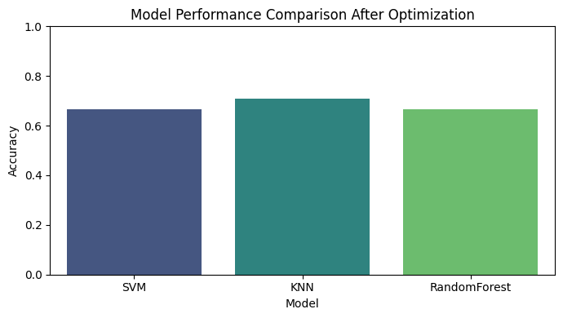

Figure 6: Model Performance Comparison after Optimization

The findings highlight that KNN’s neighborhood-based classification is more effective for datasets characterized by geographical and temporal clustering, as observed along the Kaduna–Abuja Highway. On the other hand, the comparable performance of SVM and RF reinforces the importance of tuning and ensemble methods in handling nonlinear and mixed-type crime data.

4.3 Feature Importance and Predictive Insights
Feature importance analysis conducted using the Random Forest model provided deeper insights into the predictive structure of the data. As shown in Table 3 and visualized in Figure 7, the variables month, day of week, number of victims, year, and time of day were identified as the most influential predictors of crime type.

Table 3: Top Predictive Features from Random Forest Model
Rank | Feature | Importance Score
1 | Month | 0.145
2 | Day of Week | 0.133
3 | Victims | 0.129
4 | Year | 0.123
5 | Time of Day | 0.100

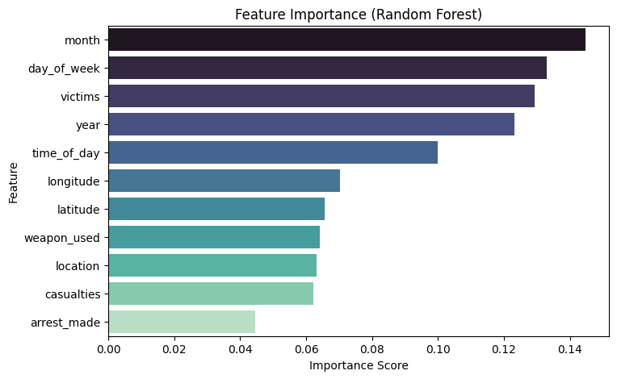

Figure 7: Feature Importance Analysis

This analysis implies that temporal and situational variables are key determinants of criminal activity along the Kaduna–Abuja corridor. For example, month and day of week correlate with movement density and socio-economic cycles, while time of day and number of victims reflect situational risk exposure. These findings align with the situational crime prevention theory, which asserts that the opportunity structure of time and place significantly influences the likelihood of criminal events.

5. Discussion
The results of the present paper prove that machine learning-based methods could be successfully able to model and predict criminal events in case that temporal, spatial, and contextual characteristics are systematically combined. The findings indicate that K-Nearest Neighbor (KNN) classifier had the best predictive accuracy (71%), as compared to the Support Vector Machine (SVM) and the Random Forest (RF). This greater performance can be explained by the nature of the KNN to model non-linear spatial-temporal relationships based on the analyzing of neighborhood proximity between feature vectors. As crimes in the Kaduna-Abuja Highway are usually concentrated in certain geographic areas as well as time frames, the focus of the algorithm on the local structure makes it especially applicable in this task.
The significance of time characteristics, namely month, day of the week, time of day as the most famous predictors supports the factual observation in the real world that crimes are regularly cyclic and seasonal. An example is that kidnapping cases are more likely to be higher during the festive or holiday seasons when there is an increase in highway traffic but cases of armed robbery are usually common during late evenings or early mornings when there is poor visibility. The predictive importance of the number of victims and year also reveals the role of the situational and longitudinal forces on criminal behavior patterns.
Practically, the outcomes emphasize that predictive analytics may be used as a side instrument of law enforcement agencies. Using predictions of the probability of certain forms of crime in terms of time and place, security operatives can be able to take a proactive approach in terms of placing patrol units in advance, covering surveillance areas more efficiently, and using resources more efficiently. In addition, the combined use of SMOTE balancing and hyperparameter optimization have shown a great improvement in model stability and fairness, which promotes the idea that despite the disparities between training data or limited data, machine learning models can provide valuable information when optimally configured.
The methodology of the study also adheres to the concept of predictive policing where algorithmic intelligence supplements the decision-making of human beings. Although the dataset used was not real-life, its structure reflected patterns that can be empirically observed, which makes it a valid testbed to show the potential of AI-based crime forecasting in the Nigerian environment. As a result, the findings open the way to introducing data-oriented approaches to crime prevention on the national and regional levels, in particular, in the high-risk transport corridors.
6. Conclusion and Future Work
In this paper, a machine learning-based predictive model was designed and tested to predict and categorize crimes along the Kaduna-Abuja Highway. Training and optimization of three supervised learning models, SVM, KNN, and Random Forest, were done using temporal, spatial, and behavioral variables in order to identify the underlying crime patterns. The overall best accuracy was experienced with the K-Nearest Neighbor classifier (71%) which substantiates the appropriateness of the model to model geographically and temporally correlated data. The interpretation of results in the Random Forest model was also easy using feature importance ranking, which serves to show that number of victims, day of the week and month are crucial factors determining whether the crime occurred.
The results highlight the possibility of data mining and artificial intelligence to be applied to policing activities to transform crime management operations toward being proactive instead of reactive. The designed framework is a prototype of employing predictive intelligence systems capable of supporting the decision-makers in the process of resources allocation, scheduling patrol, and planning the prevention of crimes.
This research will be developed in various ways in the future. To begin with, the incorporation of real and anonymized police data will increase the level of realism and external validity of the model. Second, it will be possible to visually display the hotspots of crimes along the highway dynamically by including geospatial mapping with the help of Geographic Information Systems (GIS) and remote sensing data. Third, the implementation of the model in the form of a web application created with the help of Streamlit will simplify the real-time prediction, visualization, and decision support of law enforcement agencies. Also, going into ensemble deep learning designs and explainable AI systems like SHAP and LIME would be more beneficial in increasing interpretability and accuracy of predictions.
To sum up, the study shows that crime analytics powered by machine learning can offer a strong basis of developing smart policing in Nigeria and other countries. Such systems can be used to minimize crime rates, secure transportation paths, and benefit the general feeling of security among the citizens and people who commute to work when properly applied.

Disclaimer (Artificial intelligence)
Option 1:
Author(s) hereby declare that NO generative AI technologies such as Large Language Models (ChatGPT, COPILOT, etc.) and text-to-image generators have been used during the writing or editing of this manuscript.
Option 2:
Author(s) hereby declare that generative AI technologies such as Large Language Models, etc. have been used during the writing or editing of manuscripts. This explanation will include the name, version, model, and source of the generative AI technology and as well as all input prompts provided to the generative AI technology
Details of the AI usage are given below:
1.
2.
3.

References

- Abudu, A., Bello, T., & Onifade, M. (2021). Ensemble machine learning for crime detection in Northern Nigeria. Journal of Applied Data Science, 4(2), 88–99.
- Apene, O. Z., Blamah, N. V., & Aimufua, G. I. O. (2024). Advancements in Crime Prevention and Detection: From Traditional Approaches to Artificial Intelligence Solutions. https://doi.org/10.59324/ejaset.2024.2(2).20
- Cesario, E., Lindia, P., & Vinci, A. (2024). Multidensity crime predictor: An approach to forecast criminal activities in multidensity crime hotspots. Journal of Big Data, 11(75). https://doi.org/10.1186/s40537-024-00935-4
- Council on Foreign Relations (CFR). (2023). Nigeria security tracker data summary. Retrieved from https://www.cfr.org/nigeria-security-tracker
- Jakkula, B., & Babu, G. P. (2023). Predictive modeling using data mining techniques for crime analysis. IJRASET.
- Kadhim, B., & Swadi, A. (2011). Framework for crime data analysis using decision tree and K-means algorithms. Journal of Kufa for Mathematics and Computer Science.
- Mansour Salah, M., & Xia, K. (2022). Big crime data analytics and visualization. ICCDA ‘22 Proceedings, 24–28.
- McCue, C. (2006). Data mining and predictive analytics in public safety and security. IT Professional, 8(4), 12–18.
- Nigeria Security Tracker (NST). (2024). Database on conflict and criminal incidents in Nigeria (2019–2024).
- Ogunleye, F., & Adewale, K. (2022). Spatiotemporal modelling of kidnapping incidents in Northern Nigeria. African Journal of Security Informatics, 2(1), 14–27.
- Okeke, O. C., & Oranyelu, F. O. (2021). Crime analysis and prediction using data mining and real-time location data. International Journal of Engineering Applied Sciences and Technology, 5(10), 99–103.
- Osmani, M. A. A., Rasheed, M., Siddiqui, M. S., & Lakadaram, V. (2025). Behavioral analysis and crime severity prediction using machine learning. International Journal of Information Technology and Computer Engineering, 13(2s), 204–209.
- Patel, D., & Bhattacharya, S. (2019). Crime prediction using support vector machines in spatiotemporal contexts. International Journal of Computational Intelligence Systems, 12(4), 567–576.
- Premium Times. (2024). Highway insecurity: Tracking rising kidnappings in Northern Nigeria.
- Punch Newspapers. (2023). Kaduna–Abuja road: 150 killed, 500 kidnapped in three years.
- RAND Corporation. (2021 & 2022). Evaluating predictive policing systems in urban environments. RAND Corporation Reports.
- Rasheed, O. A., Adeyemi, A. A., Yusuf, K. Y., & Bello, T. M. (2020). Comparison of supervised machine learning techniques in prediction of recurrence in cancer. International Journal of Medical Informatics, 4(3), 45–56.
- Rashid, M., Rahman, M., & Kabir, M. (2016). Data mining techniques for crime prediction: A comparative study. Journal of Information Security Research, 6(3), 145–153.
- Sabin, T. T., Archana, R., Lithisha, K. J., & Vikhyath, P. (2023). A crime prediction model/tool for hotspot mapping. International Journal of Advanced Research in Science, Communication and Technology.
- Sam, A., & Bamini, A. M. A. (2024). Criminal activity forecasting using machine learning. ICACCS 2024, 2151–2156. https://doi.org/10.1109/ICACCS60874.2024.10717111
- Sathyadevan, S., Devan, M. S., & Gangadharan, S. S. (2014). Crime analysis and prediction using data mining. First International Conference on Networks & Soft Computing, 406–412. https://doi.org/10.1109/CNSC.2014.6906719
- Saxena, S. C. (2025). Predictive Policing and Ethical Implications in Forensic Science. Journal of Advances in Science and Technology, 22(2), 533–545. https://doi.org/10.29070/6104qh22
- Schultze-Kraft, M. (2018). Organised Crime, Violence and Development: Topic Guide Update. https://opendocs.ids.ac.uk/opendocs/handle/20.500.12413/14186
- Sophia, B., Lavanya, R., Kanisha, R., & Madhurusha, G. (2022). Predictive analytics of crime data using supervised and ensemble learning. ICESC 2022, 1599–1603.
- Ştefănoaia, M., & Rus, M. (2025). AI in crime prediction: current trends and challenges. 2(1), 1–8. https://doi.org/10.33422/worldsecurityconf.v2i1.1189
- Syed, S., & Albalawi, E. M. (2024). Transforming law enforcement: Exploiting big data science and analytics for crime pattern anticipation. https://doi.org/10.21203/rs.3.rs-4677394/v1
- United Nations Office on Drugs and Crime (UNODC). (2023). Global study on homicide and organized crime trends.
- Varadaraj, R., E., B. acirc rbat B., & Kavyashree, G. J. (2025). Predictive Crime Analytics: A Machine Learning Strategy for High-Risk Area Identification and Crime Hotspot Prediction. Indian Scientific Journal Of Research In Engineering And Management, 09(08), 1–9. https://doi.org/10.55041/ijsrem51857

