Patterns of Mobile Awareness and Security Practices: A Clustering Analysis on
College Faculty and Students

ABSTRACT

Cyber malware attacks, coupled with a lack of digital learning skills, can create significant issues in educational spheres where digitalization is in its infancy. This research integrates Educational Data Mining (EDM) methodologies to address the lack of actionable, predictive analytics in these environments. This research must (1) determine the malware awareness level and the demographic characteristics of the students and staff, (2) determine the malware awareness and the corresponding defensive strategies, (3) utilize cluster analysis in the detection of trends relative to protection and awareness, and (4) identify and describe the significant deficiencies in malware awareness and in the respective countermeasures. Using Google Colab and Python, survey data were cleaned and preprocessed, and a K-Means clustering analysis was performed, with 180 faculty and 188 students as respondents in the study. The analysis initially showed three different profiles in cybersecurity awareness: one cluster showed high awareness of traditional malware, while social engineering was less known, a second cluster had high knowledge of phishing, smishing, and vishing, accompanied by negative security; and a third cluster showed equilibrium in awareness but a lack of enacted security. The ANOVA test showed significant differences across all variables of malware awareness and security practices (p < .05), especially for social engineering threats, which were the highest. There were also significant gaps in the use of basic security practices, such as antivirus software, safe browsing, and keeping systems updated, indicating a lack of alignment between knowledge and practice. The results show significant gaps in defending against cyberattacks, as well as strong practices within the educational industry. This research elaborates on the need for the design of specific, targeted, revised training programs that address the specific goals of the SDGs for Quality Education, Industry Innovation, and Infrastructure. The silos of personalized adaptive responses and the flows of information regarding emerging threats must tap into educators' and learners' potential to amplify Digital Resilience.

Keywords: clustering, cybersecurity, demographics, educational data mining, malware awareness, pattern, security practices.

1. INTRODUCTION

In our everyday lives, both personally and professionally, mobile devices have become indispensable. As mobile devices have become prevalent, they are under unprecedented threats posed by malware. Mobile malware, malicious software designed to exploit weaknesses in mobile device operating systems, has become a threat to individuals and institutions alike. With the advancement of mobile technology, the quantity and complexity of mobile malware have become a cause for concern and require a study to be conducted to identify the trends and develop mobile malware user awareness, prevention studies, and cyber threat mitigation in line with technology's's maliciously advanced (Dwivedi, Hughes, et al., 22021) (ingh & Gautam, 2022). A significant concern is the recent increase in mobile malware volume, especially in the form of malware-driven apps and phishing (Gupta, Abdelsalam, Khorsandroo, Mittal, 2020). Malware can spread to smartphones through several means, including installing dubious software from unverified app stores and clicking links in text messages from unknown contacts (Charfeddine, Kammoun, Hamdaoui, Guizani, 2024).
Such mitigation strategies will help improve overall cybersecurity posture. The lack of awareness among people about mobile malware, even as more dangers associated with it continue to emerge, is a significant concern. Most people have general knowledge of cyber threats, but they lack specific information on mobile malware and how to prevent it (Shaukat et al., 2020). To bridge this gap, an intensive educational campaign is needed to inform individuals about mobile malware and promote safe practices (Sundaram, 2017). Accordingly, this study investigates educational data mining (EDM) at the San Jose Campus of Occidental Mindoro State College. It aims at improving learning outcomes in education while enhancing institutional efficiency through student and faculty data analysis. The research, therefore, seeks to identify trends and patterns that can inform more effective teaching methods. This study complies with Sustainable Development Goal (SDG) 4: Quality Education, which promotes an inclusive and equitable system of education at all levels and supports lifelong learning opportunities for all (United Nations, 2023).

Cybersecurity poses a significant challenge for Philippine higher education institutions, threatening students' intellectual capital, crucial information, and financial stability. This vulnerability stems from various cybersecurity threats and challenges (Ramos & Esponilla, 2022). As technology continues to evolve at an unprecedented pace, institutions of higher learning need to go beyond mere rhetoric about technology's potential to transform education (Jandrić et al., 2020). A study examining cybersecurity awareness among college students in Laguna, Philippines, found that although students generally possess knowledge of cybersecurity, there are both strengths and gaps in institutional efforts to educate and support students and faculty against evolving cyber threats (Florendo et al., 2025).

The paper also applies data mining techniques to determine what influences students’ performance or progress, hence supporting targeted interventions in efforts towards improving quality and equity in education (Dwivedi et al., 2022) (United Nations, 2023). The paper further supports SDG 9: industry, innovation, and infrastructure, which focuses on promoting innovation and building resilient infrastructure (UN, 2023). For this reason, the study employs modern data mining methods to demonstrate how technological innovations can enhance universities, thereby creating a platform for future research. (Dwivedi, Ismagilova, et al., 2021). San Jose Campus attempts, through these means, to deliver sophisticated analytical frameworks that confront today’s challenges while remaining focused on technology-enabled transformative change in educational outcomes (Aronowitz et al., 2017).

Additionally, it is crucial to examine awareness and prevention strategies for mobile malware among faculty and students. Hence, their mixed cultural backgrounds offer valuable insights into the efficacy of current cybersecurity initiatives and into identifying areas requiring support (Budhwar et al., 2023). Therefore, this research seeks to reveal how prevalent malware is within the subject population or age group, what levels of awareness exist presently, and to suggest possible targeted solutions designed for such groups’ needs (Singh et al., 2022). The purpose of the present research is to provide a comprehensive insight into how students and teachers perceive and mitigate malware threats. It will concentrate on threat trends, user awareness, and preventive measures (Makhdoom et al., 2019). This method aims to bridge the gap between knowledge and actual security practices to develop better strategies for handling malware in educational settings (Christen et al., 2022).

This research examines mobile malware behavior among college faculty and students, focusing specifically on their knowledge and reactions to various malware types. It seeks to describe sociological variables that influence the likelihood of malware exposure and awareness, investigate existing levels of malware-related knowledge and security behavior, and use K-Means clustering to examine differences in malware awareness and security practices. Also, this study seeks to test whether significant differences exist across the identified clusters in knowledge of malware and security measures, to better understand how practical these security measures are and where there is a need for educational focus.

2. Materials and Methods

2.1 Research Paradigm

The diagram in Figure 1 presents a planned approach to conducting educational data mining (EDM) research, including the important stages of data collection, preparation, analysis, and interpretation. These aim to investigate student performance and related variables within the context of a study (Alyahyan & Düştegör, 2020). Data collection involves administering surveys and questionnaires to students to gather detailed information about their performance, involvement, and demographic characteristics (Lu et al., 2019). Using correlation analysis, significant associations and distinctions are found that explain how different elements converge and affect student results (Rajabalee & Santally, 2021). Preparing data for analysis requires cleaning and preprocessing to ensure accuracy, after which it undergoes clustering (K-Means) to enhance the analytical process by organizing similar data points (Sen, 2021).

The EDM methodologies are based on the application of rationalized theory-based patterns to identify and analyze attributes (Yang et al., 2022). Sequences in performance and engagement on the student profiles enable further segmentation through clustering (Sedrakyan et al, 2020). The dissection of educational analysis into components of a model also offers the potential to close in on specific components (Dwivedi, Hughes et al., 2021). The framework also assists in shaping data-derived actionable research questions through the entire spectrum of data gathering, processing, analysis, and interpretation (Couture et al, 2023). The actionable insights derived from the data apply to education and enhance evidence-based decision-making practice (Kung et al., 2023).
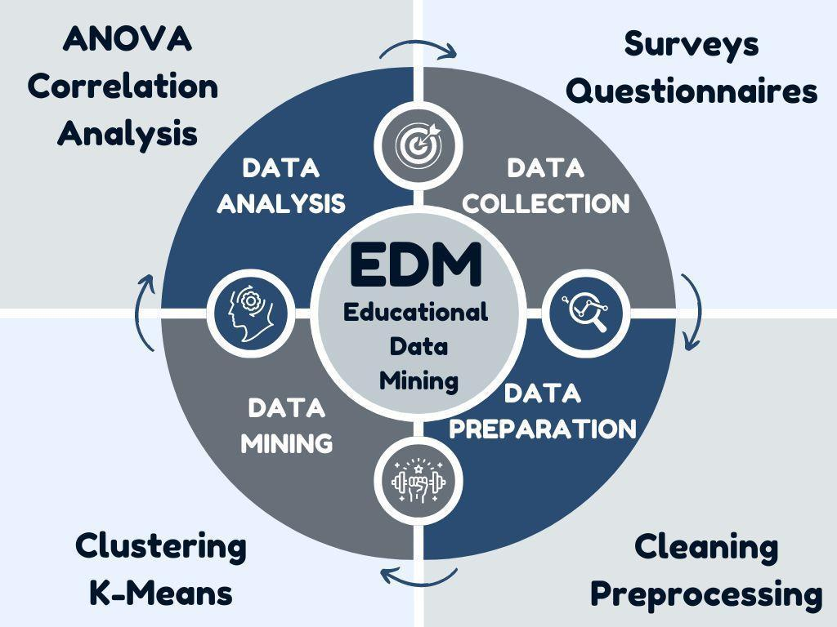
Figure 1: Research Paradigm.

2.2 Respondents of the Study

The research was conducted at Occidental Mindoro State College, San Jose Campus. A total of 368 individuals participated in the study, comprising 180 faculty members and 188 students, yielding a faculty-to-student ratio of 1:1. This distribution ensured balanced representation of the primary academic groups, allowing the analyst to capture varying levels of cybersecurity awareness and behavior among institutional stakeholders. Thus, the students' appraisal offered insight into the educational support intended to address learning deficiencies and the academic milieu (Mohajan, 2018). Hence, this provided a clearer perspective on the construction of students’ malware awareness (Pham et al., 2020).

2.3 Survey Design

A meticulously planned survey was conducted to gather comprehensive information on the types and prevalence of malware experienced by students and teachers. Participants in the research were required to describe various malware types, including rogue security software, Trojan horses, and adware (Paste & Wadkar, 2021). The Mobile Malware awareness level assessed students and faculty regarding different types of malware (Beaman et al., 2021). Knowledge regarding preventive measures was ascertained, including the use of antivirus software, safe surfing practices, and the importance of regularly updating software (Lopes et al., 2024). The background data pertained to participants' demographic and behavioral characteristics, including age, sex, mobile phone, and operating system used (Wang & Deng, 2021).

2.4 Data Collection

For ease and penetration, this tool was implemented via Google Forms, an online platform. Thus, for effective campaigns, deans and departmental heads had to be coordinated beforehand. To reach out to many students and comply with school rules regarding this kind of study, permission was sought via an official correspondence letter (Ronimus et al., 2019). Doing it electronically enabled easier data management and a more thorough review before analysis could commence (Zou et al., 2016).

2.5 Data Analysis

Descriptive statistics were used to evaluate the demographic characteristics of the respondents and their levels of awareness and security practices. This included notifications from antivirus and manual detection (Jain et al., 2021). Frequency analysis and percentages were used to examine general trends in the occurrence of specific malware pools and the interactions between malware pools and users’ behavior (Page et al., 2021). K-means clustering was used as the primary unsupervised learning method to classify participants based on cybersecurity behavior attributes. This technique was selected for it efficiency, scalability, and suitability. K-Means clustering was used to group respondents based on their awareness and security practice levels (Hancock & Khoshgoftaar, 2020). Google Colab and Python were used for data processing and visualization. The analytical tasks included estimating the types and frequencies of malware environments and constructing bar charts and other illustrations to represent the security practices. In addition, internal and external analyses, such as a correlation matrix, K-Means clustering (using the elbow method to determine the optimal number of clusters), and a heatmap, were used to provide deeper insight into the data, along with other external analyses.

2.6 Data Interpretation

The analysis provided insight into the relationship between certain factors and the likelihood of different malware appearing. User activity, security measures, and some demographic factors were investigated to identify patterns in malware occurrence. The research bypassed the traditional analysis tools of Microsoft Excel and SPSS, adopting statistical packages such as Google Colab and Python for data analysis and visualization (Petrů et al., 2020). Using frequency analysis, correlation tests, and K-Means clustering, other aspects of the relationship between malware incidents and user practices were explored. However, the study also found that certain behaviors among users’ specific security protection appliances and their recognition of phishing attacks increase the chances of malware infection. As a result of this activity, the study aimed to enhance students' and staff's mobile device security awareness through pattern recognition. These results demonstrate the need not only to update the security technologies embedded in systems and software but also to invest in targeted awareness programs, such as those aimed at common malware threats (İçen, 2022).

3. results and discussion

Types and Frequency of Malware Encounters
Participants' ages, genders, mobile device usage, operating systems, and types of malware were considered in Table 1, which examined the frequencies and the specific categories of malware users encounter. 282 respondents, or 76.6% of all malware users, across all ages, malware threats, Canada, spamming, scamming, mobile device users aged 18 - 24, and malware encounters. In terms of gender, the total number of malware and spam threats, as well as the number of malware reports, was higher across constructions. As a result, the mobile devices that were actively exposed during encounters with 136 (37.0%) devices were reported to remain active for 6 hours and to report malware. 322 (87.5%) of participants were Android users, while 46 (12.5%) were iOS users. Among the reported adware malware encounters, 118 (32.1%) were documented. Phishing encounters were also reported, with 87 (23.6%) documented subsequently. Trojan malware was reported 86 times (23.4%), while 54 (14.7%) were documented as spyware, with 23 (6.3%) reported as ransomware. This distribution shows that adware and phishing are the most prevalent types of malware encountered by participants. Malware encounters are most common among younger users, particularly females, and those who use their mobile devices extensively. Additionally, Android users experience a higher incidence of malware than iOS users. The findings also indicate that adware and phishing are the most frequent types of malware encountered. The user behavior is a foundational factor in strengthening or weakening cybersecurity resilience (Moustafa et al., 2021).

Table 1 Types and Frequency of Malware Encounters by Faculty and Students.
Category | Frequency | Percentage
Age
18-24 | 282 | 76.6
25-34 | 18 | 4.9
35-44 | 18 | 4.9
45 and above | 6 | 1.6
Under 18 | 44 | 12.0
Gender
Female | 212 | 57.6
Male | 152 | 41.3
Prefer not to say | 4 | 1.1
Mobile Device Use
1-3 hours per day | 106 | 28.8
4-6 hours per day | 102 | 27.7
Less than 1 hour per day | 24 | 6.5
More than 6 hours per day | 136 | 37.0
Mobile OS
Android | 322 | 87.5
iOS | 46 | 12.5
Malware Type
Adware | 118 | 32.1
Phishing | 87 | 23.6
Ransomware | 23 | 6.3
Spyware | 54 | 14.7
Trojan | 86 | 23.4

Malware Awareness of Faculty and Students
Figure 2 presents an assessment of faculty and students' average knowledge of and awareness of different malware types. The y-axis corresponds to the average score in the ‘malware awareness’ section on a 0 to 3.5 scale, with the higher numbers indicating a better level of understanding of cybercrime. The x-axis depicts the different categories of malware, as indicated by the legend colors, including adware, phishing, ransomware, smishing, spyware, trojans, vishing, man-in-the-middle attacks, zero-day exploits, and other malware types. The chart also shows the two groups used in the survey: faculty members (indicator Respondent Type 1) and students (indicator Respondent Type 2). Faculty members' attitudinal aspects, between 2.5 and 3.0, do not change across most types of malware from one faculty to another, with Adware, Spyware, and other higher classes of malware being the most familiar. In contrast, the Phishing alertness of the image-clicking faculty members is approximately 2.0.
However, the students recorded slightly higher awareness levels, with a score of 3.5. Vishing, Zero-day exploits, and general Types of malware are the most well-known threats among students. Katuk et al. (2023) demonstrated that structured training significantly improves students’ ability to identify malicious software, recognize digital threats, and adopt safer online practices. This is not the case with Phishing and Ransomware, which remain at the lower end of students' awareness, but students always have a better understanding of these threats than faculty. In other words, malware awareness is moderate to high among both faculty and students. However, students demonstrate better comprehension than faculty, especially regarding advanced threats such as Zero-day exploits and Vishing. On the other hand, phishing awareness in both groups was lower than for other types of malware. These disparities reflect the complexity of user behavior in cybersecurity, where individuals often differ in risk perception, attention, and susceptibility to manipulation (Baltuttis et al, 2024).

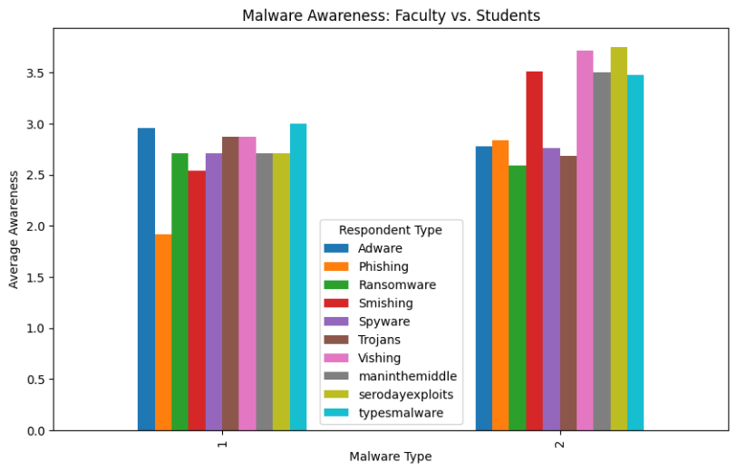
Figure 2: Malware Awareness of Faculty and Students
3.1 Security Practices of Faculty and Students

Table 2 presents a comprehensive analysis of security practices by faculty and students, focusing on their use of preventive measures against malware. Most respondents, including 222 individuals, use preventive measures against malware, with a slightly higher percentage of faculty members. Antivirus software is also widely used: 178 respondents reported using it, with a slight advantage for faculty. One hundred seventy-six respondents follow safe browsing practices, with 20 faculty members (47.6%) and 156 students (54.2%) practicing them. Regular software and system updates are performed by 186 respondents, with faculty members (61.9%) and students (55.6%) participating. Both groups show strong adherence to keeping their software up to date, with faculty members slightly ahead. Lastly, 160 respondents reported avoiding unknown app sources, with 18 faculty members (42.9%) and 142 students (49.3%), with students having a marginally higher percentage. This table shows that both faculty and students are proactive in their approach to security. However, faculty use antivirus software, regularly update their systems, and employ more preventive measures than students do. However, it should be noted that students are more engaged in safe browsing practices and in avoiding unknown app sources. Clearly, there is commitment from both categories of people, though the prioritized methods differ.
Table 2: Security Practices of Faculty and Students
Security Measures |  | Faculty | Students | Total
Preventive Measures | % within respondents | 0.0% | 3.5%
 | Count | 30 | 192 | 222
Antivirus software | % within respondents | 71.4% | 66.7%
 | Count | 26 | 152 | 178
Safe browsing | % within respondents | 61.9% | 52.8%
Practices | Count | 20 | 156 | 176
Regular updates | % within respondents | 47.6% | 54.2%
 | Count | 26 | 160 | 186
Avoiding unknown | % within respondents | 61.9% | 55.6%
app sources | Count | 18 | 142 | 160

Figure 3 compares the average security practices of faculty members and students. The y-axis, or vertical axis, shows the average underestimate score for each investigation criterion, on a scale of 0-7, indicating how often, or how effectively, each group of faculty members uses standard security practices. The x-axis of the graph shows the two groups of respondents; in this case, type 1 is faculty members and type 2 are students. Each chart features five security practices: Antivirus, Regular Updates, Safe Browsing, Security Measures, and Unknown Applications. Most practices, such as Antivirus, Regular Updates, Safe Browsing, and Anonymous Unknown Application Recognition, have an average score of around two among faculty members. However, a very high score is attributed to their compliance with an ambiguous term noted in red in the ‘Security Measures’ chart, where faculty members again scored 7 out of a possible 7 for this part, indicating that they understand or practice general security measures.

In the same vein, some students have been found to achieve relatively low average scores (2-3) regarding the extent of implementation of specific security-related practices, such as using antivirus software, regularly updating software, and being careful when dealing with unknown applications. As with faculty, students also show a significant shift in their scores for Security Measures (7), indicating that students' overall security postures and procedures are more naturally aligned with such practices. In short, both faculty members and students follow basic security rules strictly but do not pay much attention to them, nor do they perform many specific security-related tasks, such as installing antivirus software or performing regular updates. This means that an emphasis on overall security approaches is applied to both groups. However, specific groups may benefit from using measures, training, or campaign approaches to better leverage specific actions.

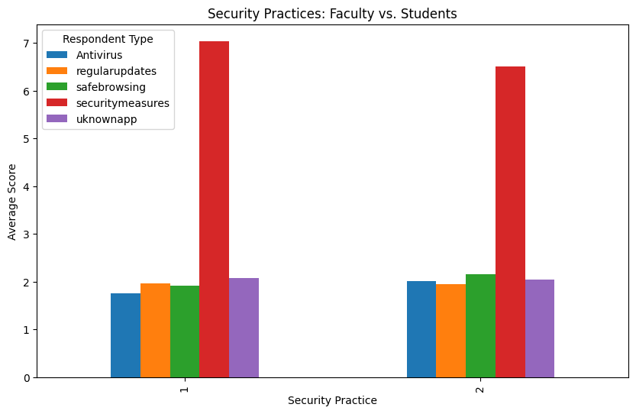
Figure 3: Security Practices

3.2 Correlation Analysis of Malware Awareness and Security Practices

Figure 4 investigates in detail the relationship between the different malware awareness types and security practices, as depicted in the correlation matrix. Each cell in the matrix represents a correlation coefficient ranging from -1 to +1, measuring the extent and character of the relationship between the two variables. In this case, as positive means attention or practice of the other variable also increases, the focus is critical in the inverse case. The interpretation is enhanced by color gradation: dark red indicates strong positive correlations, dark blue indicates negative ones, and light colors indicate no correlation. There is a strong correlation between phishing awareness (0.77) and Smishing (SMS phishing), indicating that if one threat is known to an individual, it is likely others are too. Likewise, zero-day exploits account for 0.73, while Man-in-the-middle is also on the account, indicating some level of awareness of these advanced security threats. There is a moderate correlation, such as that between Antivirus usage and Safe Browsing at 0.58, which suggests that users who practice safe browsing are most likely to have antivirus software. Likewise, Regular Updates correlate with Safe Browsing at a coefficient of 0.52, indicating that frequent updates are often associated with safe browsing, as Wibowo et. Al (2025) emphasizes that cyber resilience depends not only on awareness but also on the consistent practice of proactive behaviors across all user groups.

There are also some negative correlations. For instance, the relationship between Phishing and Man-in-the-middle attacks carried out by someone (-0.24) or Phishing and Vishing (-0.22) instances proves that one comprehension of phishing is not inclusive of the other’s phishing comprehension. There are also negative correlations that may apply in more nuanced areas of this spectrum. Phishing practices and Adware awareness had a low negative correlation of -.26, suggesting a lack of knowledge about the distinction between these malware types. It is fascinating that almost no correlation (0.08) between antivirus usage and security behavior was found, implying that having an antivirus does not enforce other security habits. Other malware, such as Trojans, also showed weak or no positive relationships with several security practices, suggesting that knowledge of Trojans does not relate to overall security practices. The critical points in the correlation matrix indicate that, although there is at least one common consensus on awareness of threats like phishing and smishing, the recognition and understanding of more advanced threats like Man-in-the-Middle or Vishing remain elusive. It was also observed that even basic security measures, such as Antivirus, Safe Browsing, and Regular Updates, are clustered together. In contrast, more advanced measures or awareness of, say, zero-day attacks are likely to be rare among the respondents. In this regard, this study calls for targeted security awareness programs to address these gaps and foster a comprehensive understanding of malware threats and the necessary measures to address them. Strengthening user capability, particularly in recognizing social engineering threats and adopting secure digital habits, is crucial for building institutional cyber resilience, as recommended by Wibowo et al. (2025).

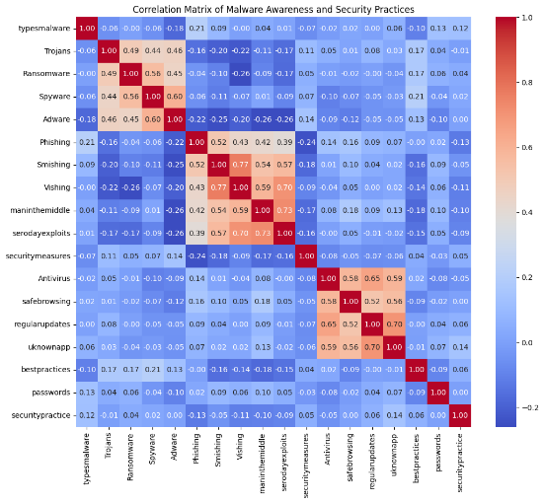
Figure 4 Correlation Analysis of Malware Awareness and Security Practices

Table 3 presents the K-means clustering results, which produced three unique clusters indicating different levels of malware awareness and differing security practices across respondents. In the first iteration, respondents were aware of malware types with high levels of Trojans (M=3.56), Ransomware (M=3.52), Spyware (M=3.48), and Adware (M=3.89). Security practices were also subordinated, with employees practicing overall security (M=7.91). In contrast, awareness of social engineering threats (phishing (M=1.63), smishing (M=1.87), and vishing (M=2.11)) was significantly lower. Iteration 2 indicated a different concentration, giving rise to a new cluster that allocates higher mean scores to social engineering threats, phishing (M=3.69), smishing (M=4.12), vishing (M=4.08), and also a man-in-the-middle attack (M=4.27). Awareness of zero-day exploits also increased (M=4.15). Moderate engagement was noted regarding the use of security practices, including antivirus (M=4.11) and safe browsing (M=4.08). Malware awareness values were more balanced in iteration 3 and were in the range of 2.29 and 3.50, while social engineering threat levels were moderate (phishing M=2.94; smishing M=3.84; vishing M=4.12). Compared with iteration 2, the antivirus (M=1.50), safe browsing practices (M=1.69), regular updates (M=1.49), and unknown app verification (M=1.53) showed decreases in security practices. Across the three clusters, three profiles suggest a cluster of heightened awareness of malware but less awareness of social engineering, a cluster of social engineering threat awareness and moderate security practice adoption, and a cluster low in social engineering threat awareness and minimal practice adoption. The clustered patterns in this study echo findings by Dockalova Burska et al. (2024), who showed that data clustering can effectively uncover trainee behavioral patterns in cybersecurity education.
Table 3: K-Means Clustering of Malware Awareness and Security Practices
Iteration | 1 | 2 | 3
Malware | 3.10 | 3.60 | 3.50
Trojans | 3.56 | 2.42 | 2.43
Ransomware | 3.52 | 2.31 | 2.29
Spyware | 3.48 | 2.35 | 2.55
Adware | 3.89 | 2.04 | 2.53
Phishing | 1.63 | 3.69 | 2.94
Smishing | 1.87 | 4.12 | 3.84
Vishing | 2.11 | 4.08 | 4.12
Man-in-the-middle attack | 2.07 | 4.27 | 3.74
Zero-day Exploits | 2.26 | 4.15 | 4.04
Security Measures | 7.91 | 5.69 | 6.23
Antivirus software | 1.96 | 4.11 | 1.50
Safe browsing practices | 2.08 | 4.08 | 1.69
Regular Updates | 1.93 | 4.00 | 1.49
Unknown App | 2.10 | 4.15 | 1.53

Table 4 presents the ANOVA, which examined whether the identified clusters differed significantly in their levels of malware awareness and security practices. Results revealed statistically significant differences across all variables included in the analysis. For traditional malware threats, significant differences were found for Trojans (F = 14.138, p < .001), Ransomware (F = 3.979, p = .047), Spyware (F = 5.478, p = .020), and Adware (F = 33.933, p < .001). These results indicate that cluster membership meaningfully influenced respondents’ awareness of common malware types. Highly significant differences were also observed for social engineering-related threats. Phishing (F=219.146, p <.001).Smishing (F = 347.926, p < .001), Vishing (F = 235.593, p < .001), man-in-the-middle attacks (F = 307.151, p < .001), and zero-day exploits (F = 175.764, p < .001) all reported large F-values, suggesting substantial variation in awareness across clusters. Security practices likewise demonstrated significant differences, as indicated by antivirus software usage (F = 13.419, p < .001), safe browsing practices (F = 27.436, p < .001), regular updates (F = 15.032, p < .001), and avoiding unknown app sources (F = 15.245, p < .001). These results collectively reveal that respondents’ security behaviors varied significantly across clusters. All malware awareness and cybersecurity behavior variables yielded statistically significant ANOVA results, confirming that the K-means-derived clusters represent distinct groups with respect to cybersecurity knowledge and practices. These variations are consistent with broader observations in higher education, where institutions face increasingly sophisticated digital threats that require differentiated mitigation strategies (Ibrahim & Rajalakshmi, 2025).

Table 4: The ANOVA results of Malware Awareness and Security Practices
 | Cluster Mean Square | Df | Error Mean Square | df | F | Sig.
Trojans | 15.155 | 1 | 1.072 | 366 | 14.138 | .000
Ransomware | 4.432 | 1 | 1.114 | 366 | 3.979 | .047
Spyware | 6.783 | 1 | 1.238 | 366 | 5.478 | .020
Adware | 42.688 | 1 | 1.258 | 366 | 33.933 | .000
Phishing | 344.033 | 1 | 1.570 | 366 | 219.146 | .000
Smishing | 418.727 | 1 | 1.203 | 366 | 347.926 | .000
Vishing | 281.826 | 1 | 1.196 | 366 | 235.593 | .000
Man-in-the-middle attack | 361.415 | 1 | 1.177 | 366 | 307.151 | .000
Zero-day Exploits | 225.546 | 1 | 1.283 | 366 | 175.764 | .000
Antivirus software | 20.014 | 1 | 1.491 | 366 | 13.419 | .000
Safe browsing practices | 47.438 | 1 | 1.729 | 366 | 27.436 | .000
Regular Updates | 22.696 | 1 | 1.510 | 366 | 15.032 | .000
Avoiding Unknown App Sources | 22.438 | 1 | 1.472 | 366 | 15.245 | .000

3.3 Discussion

Cybersecurity instruction derived from differences in knowledge regarding malware and digital security behavior among the faculty and students at Occidental Mindoro State College; these differences are important. According to the results of the cluster analysis, students are more aware of sophisticated cyber threats than their teachers, such as zero-day attacks and vishing. On the other hand, faculty members seem more compliant with basic security practices, such as regularly updating their software and using antivirus programs. This brings important implications. The gap must be a lack of safe behavior, as awareness does not translate into action, and the lack of deep cyber knowledge does not mean the absence of safe behavior.

The assumption of equal exposure to malware and, therefore, to its preventive measures is shown to be false in the study, which examines age, gender, mobile usage, and different operating systems as diverse demographic factors. Protective measures appear ineffective, highlighting the lack of action. The behavioral gaps and misuse of available technologies cry out for educational intervention, and this need remains undeniable.

Considerations on cybersecurity training specific to educational institutions and the application of the evidence must not rely on a generalized approach. Educational institutions should consider a more approach. Educators may benefit from training that emphasizes practical, applied instruction on current threats, such as phishing and smishing. Students bring considerable knowledge; however, they would benefit from greater emphasis on the consistent, sustained application of proactive security practices. The results support integrating targeted cybersecurity modules into academic curricula to address gaps in awareness and practice. Courses and workshops focusing on threat recognition could help enhance foundational knowledge across all academic roles.

More specifically, extending the current initiatives to the identified clusters of focused cybersecurity training, not just implementation, but impact assessment over time, is needed. To track changes in awareness and, more importantly, behavior, a time must be allotted. To add evidence of specific behavioral and balance changes within a particular practice, a controlled cybersecurity training approach is needed, rather than a generalized one.

To conclude, this research shows how educational data mining can be used to obtain behavioral patterns and develop model educational approaches to cultivating cybersecurity awareness. Once educational institutions understand how to fill gaps in their understanding and application of cybersecurity, they will enhance their cybersecurity and, consequently, be able to play a more significant role in fulfilling their broader cybersecurity and digital literacy objectives.

The clustering analysis indicates that respondents in this study exhibit varying levels of awareness of and behavioral engagement with cyber threats. Respondents in cluster one are aware of most malware but are still victims of social engineering attacks. This shows how malware attacks are understood, but the other types of attacks lack understanding. Respondents in cluster 2 were more concerned about fraudulent communications, indicating that the users in question adopted minimal cybersecurity defense practices but failed to engage in proactive defense measures. In cluster 3, users who demonstrated moderate knowledge of the various weaknesses in a defense system were documented to practice at different levels of security. It is these corresponding combinations of behaviors that suggest cybersecurity knowledge and awareness are not uniform in behaviors considered secure. The clusters illustrate behavioral patterns, showing strength, but the gaps in weaknesses also emphasize the need for differential, custom-designed systems, social engineering awareness, and the behavioral practitioner of security.

The different clusters in K-means are likely due to differences in cyber awareness, cyber-K adoption, cyber practices suggested by ANOVA, etc. Differences in cyber awareness can be attributed to prior training, which has exposed users to different cyber threats, malware, and vectors. Equally concerning is this gap in threat awareness, particularly regarding social engineering, suggesting users may not recognize such attacks. In the same way, the minimal threat knowledge and the corresponding inadequate security practice behavior suggest that the absence of threat knowledge is not synonymous with a bypass of the threat. The data indicate substantial differences in respondents' cyber resiliency, underscoring the need for tailored approaches. Regarding the various risks and behavioral security gaps, there is a need for awareness of social engineering and cyber practices.

4. Conclusion

A review examining the risks of mobile malware among students and professors found that adware, malware, phishing, and Trojan horse campaigns are concerning and underappreciated threats in higher education research. Currently, there are no protective measures, and the mobile and web technologies used within the sector silently carry the risk of attack. Users from the sector were grouped into three clusters using the K-means algorithm based on their behaviors and awareness of cybersecurity, their susceptibility to social-engineering malware, and the sophistication of the malware. Based on the results of the first group, participants showed awareness of the risks associated with malware; however, they showed no awareness of the risks associated with social engineering. The second group was the target of communication attacks, and there was an evident lack of security awareness; this, however, was not the case with the third group, which demonstrated a balanced disposition.

Gaps across datasets were identified using ANOVA. Regarding the security practice of varying levels vs. malware awareness, every variable in the data set presented was relevant. The most significant gaps, however, resided within the awareness of the four attack vectors, namely phishing, smishing, vishing, and man-in-the-middle. There was enough evidence from this segment of the research to determine that the awareness and behavior that was the norm within the disconnection was relatively secure. The most basic cybersecurity practices, such as keeping your systems updated, safe browsing, and malware protection, should be known to both user groups, students and faculty. There is a need to educate these primary user groups, as evidenced by the findings. Teaching personnel about social engineering attacks and/or teaching students to adopt preventive behavior practices will help organizations mitigate these risks and better protect their digital environments. The academic community must educate and raise awareness to improve its posture in the face of the growing mobile malware threat.

Disclaimer (Artificial intelligence)
Option 1:
Author(s) hereby declare that NO generative AI technologies such as Large Language Models (ChatGPT, COPILOT, etc.) and text-to-image generators have been used during the writing or editing of this manuscript.
Option 2:
Author(s) hereby declare that generativ AI technologies such as Large Language Models, etc. have been used during the writing or editing of manuscripts. This explanation will include the name, version, model, and source of the generative AI technology and as well as all input prompts provided to the generative AI technology
Details of the AI usage are given below:
1.
2.
3.

References

Alqahtani, M. A. (2022). Factors Affecting Cybersecurity Awareness among University Students. Applied Sciences (Switzerland), 12(5). https://doi.org/10.3390/app12052589
Alyahyan, E., & Düştegör, D. (2020). Predicting academic success in higher education: literature review and best practices. International Journal of Educational Technology in Higher Education, 17(1). https://doi.org/10.1186/s41239-020-0177-7
Aronowitz, T., Aronowitz, S., Mardin-Small, J., & Kim, B. R. (2017). Using Objective Structured Clinical Examination (OSCE) as Education in Advanced Practice Registered Nursing Education. Journal of Professional Nursing, 33(2), 119–125. https://doi.org/10.1016/j.profnurs.2016.06.003
Baltuttis, D., Teubner, T., & Adam, M. T. P. (2024). A typology of cybersecurity behavior among knowledge workers. Computers & Security, 140, 103741. https://doi.org/10.1016/j.cose.2024.103741
Beaman, C., Barkworth, A., Akande, T. D., Hakak, S., & Khan, M. K. (2021). Ransomware: Recent advances, analysis, challenges and future research directions. Computers and Security, 111, 102490. https://doi.org/10.1016/j.cose.2021.102490
Buckner, C. A., Lafrenie, R. M., Dénommée, J. A., Caswell, J. M., Want, D. A., Gan, G. G., Leong, Y. C., Bee, P. C., Chin, E., Teh, A. K. H., Picco, S., Villegas, L., Tonelli, F., Merlo, M., Rigau, J., Diaz, D., Masuelli, M., Korrapati, S., Kurra, P., …
Mathijssen, R. H. J. (2016). We are IntechOpen, the world’s leading publisher of Open Access books. Built by scientists, for scientists. TOP 1%. Intech, 11(tourism), 13. https://www.intechopen.com/chapters/17746
Budhwar, P., Chowdhury, S., Wood, G., Aguinis, H., Bamber, G. J., Beltran, J. R., Boselie, P., Lee Cooke, F., Decker, S., DeNisi, A., Dey, P. K., Guest, D., Knoblich, A. J., Malik, A., Paauwe, J., Papagiannidis, S., Patel, C., Pereira, V., Ren, S., … Varma, A. (2023). Human resource management in the age of generative artificial intelligence: Perspectives and research directions on ChatGPT. Human Resource Management Journal, 33(3), 606–659. https://doi.org/10.1111/1748-8583.12524
Chandarman, R., & Niekerk, B. Van. (2017). Students’ Cybersecurity Awareness at a Private Tertiary Educational. The African Journal of Information and Communication (AJIC), 20, 133–155.
Christen, M., Gordijn, B., & Loi, M. (2022). The Ethics of Cybersecurity. In CrimRxiv. https://doi.org/10.21428/cb6ab371.d27262ff
Couture, F., Jarzabkowski, P., & Le, J. K. (2023). Triggers, Traps, and Disconnect: How Governance Obstacles Hinder Progress on Grand Challenges. Academy of Management Journal, 66(6), 1651–1680. https://doi.org/10.5465/amj.2020.1716
Dwivedi, Y. K., Hughes, L., Baabdullah, A. M., Ribeiro-Navarrete, S., Giannakis, M., Al-Debei, M. M., Dennehy, D., Metri, B., Buhalis, D., Cheung, C. M. K., Conboy, K., Doyle, R., Dubey, R., Dutot, V., Felix, R., Goyal, D. P., Gustafsson, A., Hinsch, C., Jebabli, I., … Wamba, S. F. (2022). Metaverse beyond the hype: Multidisciplinary perspectives on emerging challenges, opportunities, and agenda for research, practice and policy. International Journal of Information Management, 66(July), 102542. https://doi.org/10.1016/j.ijinfomgt.2022.102542
Dwivedi, Y. K., Hughes, L., Ismagilova, E., Aarts, G., Coombs, C., Crick, T., Duan, Y., Dwivedi, R., Edwards, J., Eirug, A., Galanos, V., Ilavarasan, P. V., Janssen, M., Jones, P., Kar, A. K., Kizgin, H., Kronemann, B., Lal, B., Lucini, B., … Williams, M. D. (2021). Artificial Intelligence (AI): Multidisciplinary perspectives on emerging challenges, opportunities, and agenda for research, practice and policy. International Journal of Information Management, 57(July), 0–1. https://doi.org/10.1016/j.ijinfomgt.2019.08.002
Dwivedi, Y. K., Ismagilova, E., Hughes, D. L., Carlson, J., Filieri, R., Jacobson, J., Jain, V., Karjaluoto, H., Kefi, H., Krishen, A. S., Kumar, V., Rahman, M. M., Raman, R., Rauschnabel, P. A., Rowley, J., Salo, J., Tran, G. A., & Wang, Y. (2021). Setting the future of digital and social media marketing research: Perspectives and research propositions. International Journal of Information Management, 59(July 2020), 102168. https://doi.org/10.1016/j.ijinfomgt.2020.102168
Dočkalová Burská, K., Mlynárik, J. R., & Ošlejšek, R. (2024). Using data clustering to reveal trainees’ behavior in cybersecurity education. Education and Information Technologies, 29, 16613–16639. https://doi.org/10.1007/s10639-024-12480-x
Florendo, R. B., Ranit, J., Filamor, E. J., & Armeza, M. J. (2025). Examining Cybersecurity Awareness Among College Students Across Various Year Levels in the Province of Laguna. International Journal For Multidisciplinary Research, 7(3). https://doi.org/10.36948/ijfmr.2025.v07i03.41945
Erendor, M. E., & Yildirim, M. (2022). Cybersecurity Awareness in Online Education: A Case Study Analysis. IEEE Access, 10, 52319–52335. https://doi.org/10.1109/ACCESS.2022.3171829
Gill, S. S., Xu, M., Ottaviani, C., Patros, P., Bahsoon, R., Shaghaghi, A., Golec, M., Stankovski, V., Wu, H., Abraham, A., Singh, M., Mehta, H., Ghosh, S. K., Baker, T., Parlikad, A. K., Lutfiyya, H., Kanhere, S. S., Sakellariou, R., Dustdar, S., … Uhlig, S. (2022). AI for next generation computing: Emerging trends and future directions. Internet of Things (Netherlands), 19, 1–43. https://doi.org/10.1016/j.iot.2022.100514
Hancock, J. T., & Khoshgoftaar, T. M. (2020). CatBoost for big data: an interdisciplinary review. Journal of Big Data, 7(1). https://doi.org/10.1186/s40537-020-00369-8
Ibrahim, N., & Rajalakshmi, N. R. (2025). Examining the influence of advanced persistent threats on higher education institutions and investigating appropriate cybersecurity strategies. U. Porto Journal of Engineering, 11(2), 96–119.
İçen, M. (2022). The future of education utilizing artificial intelligence in Turkey. Humanities and Social Sciences Communications, 9(1), 1–10. https://doi.org/10.1057/s41599-022-01284-4
Jain, A. K., Sahoo, S. R., & Kaubiyal, J. (2021). Online social networks security and privacy: comprehensive review and analysis. Complex and Intelligent Systems, 7(5), 2157–2177. https://doi.org/10.1007/s40747-021-00409-7
Jandrić, P., Hayes, D., Truelove, I., Levinson, P., Mayo, P., Ryberg, T., Monzó, L. D., Allen, Q., Stewart, P. A., Carr, P. R., Jackson, L., Bridges, S., Escaño, C., Grauslund, D., Mañero, J., Lukoko, H. O., Bryant, P., Fuentes-Martinez, A., Gibbons, A., … Hayes, S. (2020). Teaching in the Age of Covid-19. Postdigital Science and Education, 2(3), 1069–1230. https://doi.org/10.1007/s42438-020-00169-6
Kung, T. H., Cheatham, M., Medenilla, A., Sillos, C., De Leon, L., Elepaño, C., Madriaga, M., Aggabao, R., Diaz-Candido, G., Maningo, J., & Tseng, V. (2023). Performance of ChatGPT on USMLE: Potential for AI-assisted medical education using large language models. PLOS Digital Health, 2(2), e0000198. https://doi.org/10.1371/journal.pdig.0000198
Lopes, A., Mamede, H. S., Reis, L., & Santos, A. (2024). Common Techniques, Success Attack Factors and Obstacles to Social Engineering: A Systematic Literature Review. Emerging Science Journal, 8(2), 761–794. https://doi.org/10.28991/ESJ-2024-08-02-025
Lu, L., Cai, R., & Gursoy, D. (2019). Developing and validating a service robot integration willingness scale. International Journal of Hospitality Management, 80(July 2018), 36–51. https://doi.org/10.1016/j.ijhm.2019.01.005
Makhdoom, I., Abolhasan, M., Lipman, J., Liu, R. P., & Ni, W. (2019). Anatomy of Threats to the Internet of Things. IEEE Communications Surveys and Tutorials, 21(2), 1636–1675. https://doi.org/10.1109/COMST.2018.2874978
Moustafa, A. A., Bello, A., & Maurushat, A. (2021). The role of user behaviour in improving cyber security management. Frontiers in Psychology, 12, Article 561011. https://doi.org/10.3389/fpsyg.2021.561011
Nyagwencha, J. (2024). An Information Security Awareness Model For Bring Your Own Devices: Case Study of a University in Kenya. 1–13. Page, M. J., Moher, D., Bossuyt, P. M., Boutron, I., Hoffmann, T. C., Mulrow, C. D., Shamseer, L., Tetzlaff, J. M., Akl, E. A., Brennan, S. E., Chou, R., Glanville, J., Grimshaw, J. M., Hróbjartsson, A., Lalu, M. M., Li, T., Loder, E. W., Mayo-Wilson, E., Mcdonald, S., … Mckenzie, J. E. (2021). PRISMA 2020 explanation and elaboration: Updated guidance and exemplars for reporting systematic reviews. The BMJ, 372. https://doi.org/10.1136/bmj.n160
Paste, D., & Wadkar, T. (2021). Malware: Detection, Classification and Protection. International Research Journal of Engineering and Technology. www.irjet.net
Petrů, N., Kramoliš, J., & Stuchlík, P. (2020). Marketing tools in the era of digitization and their use in practice by family and other businesses. E a M: Ekonomie a Management, 23(1), 199–214. https://doi.org/10.15240/tul/001/2020-1-014
Ramos, N. M. D., & Esponilla, F. D. (2022). Cybersecurity program for Philippine higher education institutions: A multiple-case study. International Journal of Evaluation and Research in Education (IJERE), 11(3), 1198. https://doi.org/10.11591/ijere.v11i3.22863
Rajabalee, Y. B., & Santally, M. I. (2021). Learner satisfaction, engagement and performances in an online module: Implications for institutional e-learning policy. In Education and Information Technologies (Vol. 26, Issue 3). Education and Information Technologies. https://doi.org/10.1007/s10639-020-10375-1
Ronimus, M., Eklund, K., Pesu, L., & Lyytinen, H. (2019). Supporting struggling readers with digital game-based learning. Educational Technology Research and Development, 67(3), 639–663. https://doi.org/10.1007/s11423-019-09658-3
Sedrakyan, G., Malmberg, J., Verbert, K., Järvelä, S., & Kirschner, P. A. (2020). Linking learning behavior analytics and learning science concepts: Designing a learning analytics dashboard for feedback to support learning regulation. Computers in Human Behavior, 107, 105512. https://doi.org/10.1016/j.chb.2018.05.004
Sen, J. (2021). Machine Learning Algorithms, Models and Applications Edited by Jaydip Sen (Vol. 7). http://dx.doi.org/10.5772/intechopen
Shaukat, K., Luo, S., Varadharajan, V., Hameed, I. A., & Xu, M. (2020). A Survey on Machine Learning Techniques for Cyber Security in the Last Decade. IEEE Access, 8, 222310–222354. https://doi.org/10.1109/ACCESS.2020.3041951
Singh, R., Gehlot, A., & Buddhi, D. (2022). Comparative Analysis of Different Machine Learning Classifiers for the Prediction of Chronic Diseases. 1–380. https://doi.org/10.13052/rp-9788770227667
Sundaram, A. (2017). Understanding and Protecting Yourself against Threats in the Internet. Asian Social Science, 13(12), 201. https://doi.org/10.5539/ass.v13n12p201
Wang, M., & Deng, W. (2021). Deep face recognition: A survey. Neurocomputing, 429, 215–244. https://doi.org/10.1016/j.neucom.2020.10.081
Wibowo, B., Yuswanto, A., Hidayat, T., & Ibrahim, N. (2025). Cyber resilience to digital threats for education institutions 4.0. International Journal of Management Science and Application, 4(1), 35–45.
Yang, G., Ye, Q., & Xia, J. (2022). Unbox the black-box for the medical explainable AI via multi-modal and multi-centre data fusion: A mini-review, two showcases and beyond. Information Fusion, 77(May 2021), 29–52. https://doi.org/10.1016/j.inffus.2021.07.016
Zou, Y., Zhu, J., Wang, X., & Hanzo, L. (2016). A Survey on Wireless Security: Technical Challenges, Recent Advances, and Future Trends. Proceedings of the IEEE, 104(9), 1727–1765. https://doi.org/10.1109/JPROC.2016.2558521

