Effects of Portulaca oleracea extract on experimentally induced gastric lesions in Wistar rats: Antioxidative action in gastroprotection
Abstract
Background: Gastric ulcer, a mucosal lesion resulting from an imbalance between aggressive factors (HCl, pepsin) and gastric defenses (mucus, bicarbonate, blood flow), remains a common pathology. Although treatments such as proton pump inhibitors (PPIs) and H₂-receptor antagonists are effective, their prolonged use can lead to various side effects, including gastrointestinal and metabolic disorders, among others. Nowadays, natural treatments are gaining increasing interest. Portulaca oleracea is a medicinal plant known for its gastrointestinal relieving properties. Thus, the scientific validation of this plant in treating gastric problems is worthwhile.
Objective: To evaluate the protective effect of the ethanol extract of Portulaca oleracea against ethanol-induced gastric ulcers in Wistar rats.
Methods: The ethanol extract of the aerial parts of Portulaca oleracea was obtained by maceration. The phytochemical screening of the as-prepared extract was performed using standard protocols. Gastric ulcer was induced by an oral administration of 20°C ethanol (10 mL/kg) to rats for 7 days. The ethanol-induced ulcerogenic rats were further treated orally with P. oleracea extract at 150, 300, and 600 mg/kg, and sucralfate (350 mg/kg ; positive control). Parameters such as body weight gain, ulcer surface area, hematological parameters, oxidative stress (MDA, GSH, SOD, and catalase), and inflammatory (CRP, TNF-α, and IL-10) markers, as well as the histology sections of the stomach were evaluated. An acute toxicity test was conducted on female Wistar rats according to the OECD guidelines.
Results: Daily oral administration of 20°C ethanol caused weight loss, gastric mucus reduction, ulceration, oxidative stress (↑ MDA, ↓ GSH, ↓ SOD, ↓ CAT), and a marked inflammatory response (↑ CRP, ↑ TNF-α, ↓ IL-10), along with histological damage to the gastric epithelium. Treatment with Portulaca oleracea, especially at 150 and 300 mg/kg doses, significantly restored mucus levels, normalized oxidative markers, and modulated the inflammatory mediators, with optimal efficacy observed at 300 mg/kg. Noteworthy, 50.58, 80 and 42.35% reduction of the ulcer surface area was observed at 150, 300 and 600 mg/kg, respectively.
Conclusion: The ethanol extract of P. oleracea exhibits significant anti-ulcer activity, mediated by its antioxidant, and cytoprotective properties. Portulaca oleracea represents a promising avenue for the development of phytomedicines against gastric ulcers.
Keywords: Portulaca oleracea , Gastric ulcer , Oxidative stress , Inflammation , Cytokines , Wistar rats.
1. Introduction
The proteins, lipids, and polysaccharides that make up most of the food we eat must be broken down into smaller molecules before our cells can use them either as a source of energy or as building blocks for other molecules (Hall, 2020). However, most of these nutrients must first be broken down in the gastrointestinal tract before they can be absorbed. The stomach is a hollow organ that is part of the gastrointestinal system, and it is responsible for functions including the formation of chyme, synthesis of proteins necessary for vitamin absorption, microbial defenses, and propagates the peristaltic reflex (Haschek et al., 2010 ; Gartner and Hiatt, 2011). The gastric mucosa is protected by a mucobicarbonate barrier, a layer that creates an alkaline microenvironment to neutralize stomach acid (hydrochloric acid), thus maintaining a neutral pH at the epithelial surface. It also physically traps the enzyme pepsin, thus preventing it from reaching and damaging the stomach lining (Allen and Flemström, 2005)
Gastric ulcers are open sores on the stomach lining, caused by an imbalance between stomach-protecting factors (mucus, bicarbonate and phospholipids) and aggressive factors (dietary factors like spices, alcohol, etc.), medications (non steroidal anti-inflammatory drugs, NSAIDs), psychogenic factors (stress) and infectious bacteria (Helicobacter pylori), which erode the protective lining of the stomach. This imbalance, where aggressive factors overwhelm protective mechanisms, leads to the ulceration of the protective mucosal layer (Périco et al., 2020 ; Kawade et al., 2020).
Manifestations of gastric ulcers include burning abdominal pain, especially in the upper abdomen, which can worsen after eating. Other common symptoms are indigestion, heartburn, bloating, and nausea. More serious signs of a gastric ulcer involve vomiting blood, black tarry stools, bleeding, among others (Vakil, 2024). An unmanaged gastric ulcer can lead to gastrointestinal bleeding (leading to anemia or life-threatening hemorrhage), perforation (a hole in the stomach or intestinal wall requiring emergency surgery), obstruction (a blockage that prevents food passage), and, in cases of H. pylori infection, an increased risk of developing gastric cancer. While the most common causes of ulcers are H. pylori bacterial infection and long-term use of nonsteroidal anti-inflammatory drugs (NSAIDs), certain lifestyle factors can worsen symptoms and delay healing (Fattorusso, 2004). Gastric ulcers account for an estimated lifetime prevalence of 5–10% and an annual incidence of 0.1–0.3% in the general population in Western countries (Xie et al., 2022). In Cameroon, approximately 31.65% of gastroenterology consultations are diagnosed to be gastric ulcers (Ankouane et al., 2026). Treatment for gastric (stomach) ulcers typically involves antibiotics (vonoprazan, amoxicillin-metronidazole combination) if caused by H. pylori infection, or proton pump inhibitors (PPIs) if caused by NSAID medications (Majumdar and James, 2019 ; Kamada et al., 2021 ; Ali and AlHussaini, 2024). Lifestyle changes such as quitting smoking, reducing alcohol intake, and managing stress are effective ways to prevent and manage gastric ulcers (Yegen, 2018). Antacids offer short-term relief by neutralizing stomach acid, and in severe cases, surgical intervention may be necessary to treat major complications (Holle, 2010). Limitations of antiulcer drugs include side effects like gastrointestinal discomfort, headache, and, for proton pump inhibitors, an increased risk of infections due to reduced stomach acidity. The rise of antibiotic resistance in Helicobacter pylori treatment is also a significant challenge (Périco et al., 2020). Although there is a need of rigorous scientific validation, the World Health Organization (WHO) acknowledges the importance of traditional medicine and medicinal plants for health care, including for treating gastric ulcers, due to their accessibility, lower cost, and potential for fewer side effects compared to modern drugs (Prayoga et al., 2024 ; Sahu et al., 2025, WHO, 2025). Accumulated scientific evidence supports the traditional use of medicinal plants for treating gastric ulcers, identifying several herbs like Curcuma longa L, Carica papaya Linn., Mangifera indica, Aloe vera (L.) Burm.f, Capsicum annuum L, Solanum nigrum L, and Panax ginseng with demonstrated gastroprotective, anti-inflammatory, and antimicrobial properties (Saikat Sen and Chakraborty, 2017). Another plant species from the Portulacaceae family (Portulaca oleracea) is widely used in traditional medicine to alleviate a wide range of diseases including gastrointestinal diseases, respiratory problems, liver inflammation, kidneys and bladder ulcers, fever, insomnia, severe inflammations, headaches, and other health promoting properties [10] (Gadekar et al., 2010 ; Srinivas et al., 2013 ; Iranshahy et al., 2017 ; Tadesse et al., 2022).
Based on the foregoing, this study aims to evaluate the protective effects of the ethanol extract of Portulaca oleracea against gastric ulcers induced in Wistar rats. More specifically, the anti-inflammatory and antioxidant activities of the crude extract of Portulaca oleracea is evaluated, followed by the acute toxicity study and the protective effects of the ethanol extract in Wistar rats.
2. Material and methods
2.1. Material
2.1.1. Animals
The experimental animals used in this study were adult female Wistar rats, aged 12 to 14 weeks, weighing from 130 to 170 grams. These animals were bred and maintained in the animal facility of the Laboratory of Phytobiochemistry and Medicinal Plants, part of the Department of Biochemistry at the University of Yaoundé I. The rats were housed in groups of five in specific cages within a controlled environment with a consistent 12-hour light and 12-hour dark cycle. The animals had free access to standard diet and tap water. The diet administered was formulated using local ingredients and consisted of 40% corn flour, 20% wheat flour, 24% dried fish, 7% palm kernel, 3% peanut, 2% cotton seed, 2% bone powder, 1.98% iodized salt, and 0.02% vitamin complex.
2.1.2. Plant material
The aerial parts of Portulaca oleracea were collected at Sangmelima, Southern Cameroon in December 2024. The plant was identified by Mr NGANSOP T. Eric (Botanist, Systematist and Taxonomist) at the National Herbarium of Cameroon, where a voucher specimen of the species was deposited under number NO49303/HNC.
2.2. Methods
2.2.1. Plant extraction
The aerial parts (leaves and stems) of Portulaca oleracea were dried at room temperature, then ground using an electric grinder. After that, one thousand grams (1000 g) of plant powder was weighed using an electronic balance (KERN EMB series) and macerated in 300 mL of 95° ethanol for 48 hours. Next, the preparation was filtered using a filter paper Whatman number 1, and the filtrate was concentrated under reduced pressure at 60°C using a rotary evaporator (Rotavapor® R-100). Thereafter, the yield of extraction was calculated using the following formula :
$$\left(Yield of extraction (\%)\right)=\frac{Weight of crude extract}{Weight of the plant powder }x 100$$
The as-prepared extract was stored at 4°C for further tests.
2.2.2. Phytochemical screening of the ethanol extract of Portulaca oleracea
The phytochemical analysis of Portulaca oleracea extract was performed according to previously described protocols by Harborne (1973), Trease and Evans (1989), Alsaedi and Aljeddani (2022) for the determination of terpenes and steroids, flavonoids, alkaloids, phenolic compounds and tannins.
2.2.2.1. Shinoda test
The Shinoda assay was used to detect the presence of flavonoids in the plant extract. Briefly, a few milligrams of the extract to be analysed were dissolved in methanol. Thereafter, a few drops of concentrated hydrochloric acid and magnesium shavings were added to the solution. The appearance of a purple colour marked the presence of flavonoids in the test sample (Alsaedi and Aljeddani, 2022).
2.2.2.2. Liebermann-Burchard assay
The Liebermann-Burchard assay was used to determine the presence or absence of triterpenes and steroids in the extract. Briefly, a few milligrams of the extract were dissolved in 1 mL of chloroform. Next, a few drops of acetic anhydride were added, followed by the addition of drops of concentrated sulphuric acid. The purple-red colour indicated the presence of triterpenes, whereas the blue-green highlighted the presence of steroids (Alsaedi and Aljeddani, 2022).
2.2.2.3. Ferric chloride test
The ferric chloride assay was used to determine the presence or absence of phenolic compounds and tannins in the extract. Briefly, 1 mg of the extract is dissolved in ethanol, and then a few drops of iron trichloride are added to the preparation. The formation of blue and purple colours indicated respectively the presence of phenolic compounds and tannins in the extract (Harborne, 1973).
2.2.2.4. Dragendorff test
The Dragendorff test was used to screen the presence or absence of alkaloids in the extract. In brief, thin layer chromatography was performed using a few drops of an ethanolic solution of plant extract. After TLC development, the spots were sprayed with the Dragendorff's reagent (potassium tetraiodobismuthate). The presence of alkaloids was observed in visible light by the appearance of orange spots (Alsaedi and Aljeddani, 2022).
2.2.2.5. Molisch test
The presence of sugars in the plant extract was determined by using the Molisch assay. Briefly, a few milligrams of the plant extract were dissolved in ethanol in a test tube, followed by an addition of 1% ethanol solution of α-naphthol. The as-prepared solution was homogenized and then a few drops of concentrated sulphuric acid were added to the test tube. The appearance of a purplish-red ring attested the presence of sugars in the plant extract (Trease and Evans, 1989).
2.2.3. Preparation of solutions
2.2.3.1. Ethanol solutions
The ulcerogenic solution of ethanol was prepared from 90° ethanol. To this end, ethanol solutions were prepared at 70° and 20° using the Gay Lussac's table for alcohol dilution (Gay Lussac, 2025).
2.2.3.2. Sucralfate solution
The sucralfate solution (10 mg/mL) was prepared by dissolving one sachet of sucralfate (1 g) in distilled water to obtain a final volume of 100 mL. The as-prepared solution was further then administered to the animals at a dose of 100 mg/kg.
2.2.3.2. Buffered solution of formalin
The buffered solution of formalin was prepared at 10% by adding 6.5 g of hydrated disodium phosphate (Na₂HPO₄; H₂O) and 4 g of hydrated monosodium phosphate (NaH₂PO₄; H₂O) to 100 mL of 37% formaldehyde (HCHO). The volume of the resulting solution was adjusted to 1000 mL by adding distilled water.
2.2.3.3. Preparation of 50 mM Tris-HCl buffer ; pH = 7.4
The 50 mM Tris-HCl buffer was prepared by dissolving 1.21 g of Tris base (NaHPO4) and 2.79 g of potassium chloride (KCl) in 250 mL of distilled water. The pH was adjusted to 7.4 by adding hydrochloric acid (HCl, 11.8 N) and the volume was normalized to 500 mL with distilled water.
2.2.4. Acute toxicity
The acute toxicity was performed according to the OECD protocol (2002), guideline number 423 (OCDE, 2002). Nine adult, non-pregnant female rats were used for toxicity study. These animals were randomly divided into three groups of three animals each. The animals were fasted for 12 hours before the start of the experiment and for 4 hours afterwards. Group 1 was administered with a single dose of distilled water (10 mL/kg), whereas group 2 and 3 received a single oral dose of 2000 and 5000 mg/kg of the extract, respectively. After treatment, the animals were observed individually for the first 4 hours and daily for 14 days. Mortality and clinical signs such as aggression, mobility, tremors, convulsions and other obvious signs of toxicity were recorded during the experiment. The animals were weighed every other day to monitor the effect of the extract on the body weight of the rats. At the end of the experiment, the animals were sacrificed, their organs (liver, kidneys, spleen, lungs and heart) were removed, cleaned and weighed.
2.2.5. Evaluation of the protective effects of Portulaca oleracea extract in ethanol-induced gastric ulcerogenic in rats
2.2.5.1. Effects of Portulaca oleracea extract on gastric lesions in ulcerogenic rats
The lesions were induced to rats with ethanol treatment for 7 days according to a previously described protocol (Tan et al., 1996). Briefly, thirty female rats (30), which were subjected to 24 hours fast, were divided into 6 groups of 5 animals each. Group 1 and 2 received respectively the ulcerogenic solution (negative control) and distilled water at 10 mL/kg (normal control), whereas group 3, 4 and 5 received P. oleracea extract at 150, 300 and 600 mg/kg, respectively. Animals in group 6 were administered with sucralfate (350 mg/kg) and were used as positive control rats. Five days after administration of the extract and sucralfate, the rats were sacrificed (euthanasia) after sedation (anesthesia) with the combination of ketamine and diazepam. Lesions in the glandular portion were measured and the mucus collected was weighed. Lesion scores were assigned according to the method described by Marshall and Warren.
Table 1 : Distribution of experimental animals for treatment
N° | Groups | Substance administered | Codes | Volumes or doses | Number of animals per group | Route of administration
1 | Normal control | Distilled water | NrC | 10 mL/kg | 5 | Per os
2 | Negative control | EtOH | NgC | 10 mL/kg | 5 | Per os
3 | Positive control | Sucralfate | Suc350 | 350 mg/kg | 5 | Per os
4 | Test 1 | Portulaca oleracea | PO 150 | 150 mg/kg | 5 | Per os
5 | Test 2 | Portulaca oleracea | PO 300 | 300 mg/kg | 5 | Per os
6 | Test 3 | Portulaca oleracea | PO 600 | 600 mg/kg | 5 | Per os
NC= Normal control ; NgC = Negative control ; Suc350 = Sucralfate at 350 mg/kg; PO 150, PO 300, and PO 600 : Ethanol extract of Portulaca oleracea at the doses of 150, 300 and 600 mg/kg, respectively.

2.2.5.2. Scoring of gastric ulcers

Scoring of ethanol-induced ulcerogenic was attributed as previously described by Tan et al. (1996) (Table 2).

Table 2 : Distribution of scores based on the ulcerated surface area
Ulcerated surface ( US) (mm²) | Score
US = 0.0 | 0.0
0.0 <US ≤0.5 | 0.1
0.5 <US ≤ 2.5 | 0.2
2.5 <US ≤ 5.0 | 0.3
5.0 <US ≤ 10.0 | 0.4
10.0 < US ≤15.0 | 0.5
15.0 <US ≤ 20.0 | 0.6
20.0 <US ≤ 25.0 | 0.7
25.0 < US ≤ 30.0 | 0.8
30.0 < US ≤ 35.0 | 0.9
US > 35.0 | 1.0

US : Ulcerated surface area

2.2.5.3. Determination of the ulcer index
The ulcer index (UI) is the average ulcer score for each treatment.
2.2.5.4. Effects of P. oleracea extract on haematological parameters in rats
The haematological parameters of experimental animals were evaluated using a Mindray BC-5300 haematology analyser at the Haematology Laboratory of the Chantal Biya International Reference Centre (CIRCB) in Yaounde, Cameroon. This hematology analyser is an automated device that counts the number of white blood cells, erythrocytes and platelets of blood collected in an EDTA tube and measures haemoglobin levels and haematocrit. Overall, red blood cell count (RBC), haematocrit (HCT), haemoglobin (HGB), white blood cell count (WBC), platelet count (PLT), mean corpuscular volume (MCV), lymphocytes (LYM), monocytes (MON) and granulocytes (GRA) were recorded from the machine.
2.2.5.5. Effects of P. oleracea extract on selected parameters of oxidative stress
2.2.5.5.1. Measurement of nitrite
The level of nitrite was measured according to the protocol described by Fermor et al. (2001). In the presence of amino-4-benzenesulfonamide (sulfanilamide) and N-(naphthyl-1)-diamino-1,2-ethane dichloride (N-1-naphthyl ethylenediamine) in an acidic environment, nitrites undergo a diazotization reaction. The product obtained is proportional to the amount of nitrites present in the test sample (Fermor et al., 2001). A calibration curve was obtained by measuring optical densities of NaNO₂ solution at different concentrations (0-1 µM). From the calibration curve, the concentration of nitrites was determined using the equation y = 4.1315x, where y represents the optical density and x stands for the concentration NaNO₂. In each test sample, the concentration of nitrites was determined using the following formula :
[Nitrites] = Concentration of nitrites (µmol/g of organ) ;
ΔDO = OD test - OD Blank ;
a = Slope of the calibration curve (4.1315) ;
m = Weight of the organ (g).

[Nitrites] = $\frac{ΔDO }{a*m}$

2.2.5.5.2. Reduced glutathione assay
A reduced glutathione (GSH) assay measures the concentration of the antioxidant GSH in a sample using various methods, including a colorimetric assay. In this experiment, the reduced glutathione was estimated using a previously described protocol (Davies et al., 1984). Briefly, 100 μL of sample homogenate or 100 μL of 50 mM Tris-HCl buffer, pH = 7.4 (control) were added to the test tubes, followed by the addition of 1500 μL of the Ellman's reagent. The tubes were homogenised and incubated for 60 minutes at room temperature, and the absorbance was read against the blank at 412 nm. The concentration of reduced glutathione (GSH) was determined using the following formula :
L = Optical path (1cm)
ε = Molar extinction coefficient (13600 mol⁻¹. Cm⁻¹)
[𝐆𝐒𝐇] = Glutathion concentration (μmol/g of organ)
ΔOD = OD test-OD blank
m = Masse of organ (0.4g)
[𝐆𝐒𝐇] = $\frac{10^{6}× ∆DO}{ ε x L x m}$

2.2.5.5.3. SOD assay
The level of superoxide dismutase (SOD) in samples was quantified according to a previously reported protocol (Misra and Fridovich, 1972). Briefly, 134 μL of the stomach homogenate was added to the test tubes, whereas 134 μL of carbonate buffer (0.05 M; pH 10.2) was added to the blank tube. Then, 1666 μL of carbonate buffer (0.05 M, pH 10.2) were added to all tubes, followed by an addition of 200 μL of adrenaline (0.3 mM). Next, the absorbance of the preparations was measured at 480 nm successively after 20 and 80 seconds against the blank. The SOD activity was determined using the following formula :
% inhibition = 100 - (ΔAtest x 100/ΔAblank) = number of SOD units.
ΔA (min) = A20S (Absorbance measured at 20 seconds) - A80S (Absorbance measured at 80 seconds);
The specific activity of SOD (units of SOD/mL/g of organ) = number of units of SOD/mL/g of organ.
2.2.5.5.4. Malondialdehyde assay
The malondialdehyde (MDA) assay was performed according to the protocol reported by Grotto et al. (2009). In brief, in test tubes containing 250 μL of stomach homogenate (sample tubes) or 250 μL of 50 mM Tris-HCl buffer; pH : 7.4 (blank tube), were added 125 μL of 20% trichloroacetic acid (TCA) and 250 μL of 0.67% thiobarbituric acid (TBA). The tubes were sealed with glass beads, heated at 90°C in a water bath for 10 minutes, then cooled with tap water and centrifuged at 3000 rpm at room temperature for 15 minutes. The supernatant was collected and the absorbance read at 530 nm using a spectrophotometer (Tecan Infinite M200), against the blank. The MDA concentration was determined using the formula :
[MDA] = Concentration of malondialdehyde (mmol/g oforgan)
ΔDO = OD test – OD blank
L = Optical path (1cm)
ε = Molar extinction coefficient (15600 mol⁻¹. cm⁻¹)
m = Mass of the organ (0.4 g)
[MDA] = $\frac{∆DO}{ ε x L x m}$

2.2.5.5.5. Catalase assay
The catalase assay was performed according to the protocol described by Grotto et al. (2009). Hydrogen peroxide is broken down in the presence of catalase. This destroyed peroxide binds with potassium dichromate to form an unstable blue-green precipitate of perchloric acid, which is then decomposed by heat to form a green complex that absorbs at 570 nm (Grotto et al., 2009). A calibration curve was plotted by using the absorbance of the standard versus the concentrations of H₂O₂. The specific activity of catalase was determined using the following formula :

CAT = Activity of catalase (µmol de H₂O₂/min/g of organ)
ΔDO = OD test-OD blank
a = Slope of the calibration curve (0.0052)
t = duration of the reaction (1 minute)
m = Weight of the organ (0.4g).

$$CAT=\frac{ΔDO}{a x t x m}$$

2.2.5.5.6. Estimation of levels of the cytokines IL-10 and TNF-α, and C-reactive protein (CRP)
The levels of the cytokines IL-10 and TNF-α, and the C-reactive protein (CRP) were determined with specific kits (SIGMA Aldrich) using the enzyme-linked immunosorbent assay (ELISA) method. Briefly, 100 µL of standard IL-10, TNF-α and CRP solutions at different concentrations were introduced respectively into the wells of the first column of each pre-sensitised ELISA microplate. Moreover, 100 µL of each sample was added into the other wells of the microplate. The microplates were sealed and incubated for 2 hours and 30 minutes at room temperature with agitation. After incubation, the wells were washed four times by adding 300 µL of washing buffer, then the microplate was dried by turning it upside down on an absorbent paper. A detection antibody (100 µL) specific to each protein coupled with biotin was added to each well. The preparations were covered again and incubated for 1 hour at room temperature with agitation. Thereafter, the plates were washed 4 times with 300 µL of washing buffer per well and then spun. After washing, 100 µL of peroxidase-coupled streptavidin substrate was added to each well and the preparation was incubated for 45 minutes at room temperature in the dark, followed by a series of 4 successive washes. Next, 100 µL of tetramethylbenzidine solution was added to each well, then incubated again for 30 minutes. After incubation, the reaction was terminated by adding 50 µL of a stop solution. Then, the absorbance was measured at 450 nm using a microplate reader (TECAN Infinite M200). The concentrations of IL-10 and TNF-α were expressed in pg/mL, whereas that of CRP was expressed in ng/mL. These concentrations were determined from the corresponding calibration curves established from the kit data using Graphpad Prism software version 8.0.1.
2.2.5.5.7. Histological analyses
After the sacrifice of animals, a part of the stomach of each rat was removed, cleaned and fixed in 10% buffered formalin. The histological analysis was performed sequentially as follows :
a. Step 1 : Trimming
Each fixed organ was cut into thin sections using a scalpel. The as-prepared slices were further stored in plastic cassettes.
b. Step 2 : Dehydration
Three phases were involved in the dehydration process. These include Removal of water and electrolytes, clearing and impregnation.
b1. Removal of water and electrolytes : The cassettes were placed successively in baths containing ethanol at various concentrations of increasing order as follows : 50° ethanol (1 hour) → 70° ethanol (1 hour) → 95° ethanol number (no.) 1 (1 hour) → 95° ethanol no. 2 (1 hour 30 minutes) → 100° ethanol no. 1 (1 hour) → 100° ethanol no. 2 (1 hour 30 minutes) → 100° ethanol no. 3 (2 hours).
b2. Clearing : The cassettes were placed successively in two baths containing xylene for 1 hour and 1 hour 30 minutes, respectively.
b3. Impregnation : The organ sections were impregnated with paraffin by treatment in three baths containing paraffin at 60°C for 1 hour, 1 hour 30 minutes and 2 hours, respectively. c. Step 3: Embedding The tissues were placed in a mold filled with molten paraffin wax that solidified into a block when cooled.
d. Step 4: Sections
Sections that are 5 µm thick were cut using a microtome. The as-prepared sections were flattened in a water bath at 40°C, and the best sections were collected and placed on microscope slides. Then, the slides were kept in an oven (45°C) to dry for 24 hours.
e. Step 5: Staining
The haematoxylin-eosin (HE) staining technique was used in this study. Basophilic haematoxylin stains nuclear components blue-black and acidophilic eosin stains cytoplasmic components pink-red. Prior to staining, the preparation was deparaffinized and rehydrated.
e1. Deparaffinization and rehydration : The sections were deparaffinized and rehydrated by successive bathing xylene and ethanol as follows : xylene no. 1 (5 min) → xylene no. 2 (5 min) → xylene no. 3 (5 min) → 100° ethanol no. 1 (10 min) → ethanol 100° no. 2 (10 min) → ethanol 100° no. 3 (10 min) → ethanol 95° (5 min) → ethanol 70° (5 min). The slides were then rinsed with distilled water.
e2. Staining : The sections were immersed for 10 min in a container containing Mayer's haematoxylin, then rinsed under running tap water. They were then placed in a 95° ethanol bath for 5 min, then immersed for 5 min in 0.5% alcoholic eosin. The sections were then dehydrated in three baths of 100° ethanol (5 minutes each) and clarified in three baths of xylene (5 minutes each).
3. Results and discussion
3.1. Results
3.1.1. Yield of extraction
The extraction of 1000 g of Portulaca oleracea with ethanol yielded 46.6 g of extract, to produce an extraction yield of 4.66%.
3.1.2. Phytochemical composition of the P. oleracea extract
The phytochemical analysis of the ethanol extract of P. oleracea revealed the presence of alkaloids, tannins, steroids, flavonoids, phenolic compounds, and terpenoids.
3.1.3. Acute toxicity
3.1.3.1. Effects of on the mortality and morbidity of rats
The acute toxicity study of the ethanol extract of P. oleracea (2000 and 5000 mg/kg) was performed in Wistar rats according to the OECD guidelines. The animals were administered with a single oral dose of P. oleracea extract at 2000 and 5000 mg/kg. After 14 days of observation of the treated animals, there were no death and clinical signs (aggressivity, shivering, sensitivity to touch, and mobility) of toxicity. The half lethal dose for ethanol extract of P. oleracea was found to be more than 5000 mg/kg (Table 3).

Table 3 : Effects of the ethanol extract of Portulaca oleracea on selected clinical parameters in rats
Parameters | Vehicle control |  |  | PO 2000 mg/kg |  |  | PO 5000 mg/kg
 | 30  min | 4 Hours | 14  Days | 30  min | 4  Hours | 14 Days | 30  min | 4  Hours | 14 Days
Number of deaths | 0 | 0 | 0 | 0 | 0 | 0 | 0 | 0 | 0
Shivering | 0/3 | 0/3 | 0/3 | 0/3 | 0/3 | 0/3 | 0/3 | 0/3 | 0/3
Agressivity | 0/3 | 0/3 | 0/3 | 0/3 | 0/3 | 0/3 | 0/3 | 0/3 | 0/3
Mobility | 3/3 | 3/3 | 3/3 | 3/3 | 3/3 | 3/3 | 3/3 | 3/3 | 3/3
Aspect of faeces | N | N | N | N | N | N | N | N | N
Horripilation | 0/3 | 0/3 | 0/3 | 0/3 | 0/3 | 0/3 | 0/3 | 0/3 | 0/3
Sensibility to touch | 3/3 | 3/3 | 3/3 | 3/3 | 3/3 | 3/3 | 3/3 | 3/3 | 3/3
Sensibility to noise | 3/3 | 3/3 | 3/3 | 3/3 | 3/3 | 3/3 | 3/3 | 3/3 | 3/3
PO 2000 mg/kg : Ethanol extract of Portulaca oleracea at 2000 mg/kg ; PO 5000 mg/kg : Ethanol extract of Portulaca oleracea at 5000 mg/kg ; N : Normal.
3.1.3.2. Effects of Portulaca oleracea extract on rat body weights
Figure 1 illustrates the evolution of the body weights of rats administered with a single oral dose of P. oleracea ethanol extract at 2000 and 5000 mg/kg. There was no significant change in body weights of treated animals following the 14 days’ observation period, versus the control group (animals that received only distilled water).

Figure 1 : Effects of Portulaca oleracea ethanol extract on body weights in treated rats.
Each value represents the mean ± SEM ; n=3 ; Negative control : Rats administered with distilled water ; PO 2000 mg/kg and PO 5000 mg/kg: rats treated with the ethanol extract of Portulaca oleracea at 2000 and 5000 mg/kg, respectively.
3.1.3.3. Effects on the ethanol extract of Portulaca oleracea on the relative organ weights Figure 2 illustrates the effects of Portulaca oleracea extract on the relative weights of liver, kidney, heart and lungs of rats administered with the ethanol extract Portulaca oleraceaat 2000 and 5000 mg/kg. After 14 days’ post-treatment, there was no variation in the relative organ weights in rats administered with the plant extract, versus the negative control group (animals that received only distilled water).

Figure 2 : Effects of Portulaca oleracea ethanol extract on relative organ weights of treated rats. Each value represents the mean ± SEM ; n=3; Negative control: Rats administered with distilled water; PO 2000 mg/kg and PO 5000 mg/kg: rats treated with the ethanol extract of Portulaca oleracea at 2000 and 5000 mg/kg, respectively.

3.1.4. Effects of Portulaca oleracea extract on ethanol-induced ulcerogenic rats.
3.1.4.1. Evolution of body weights of ethanol-induced ulcerogenic rats upon treatment with P. oleracea extract
Figure 3 illustrates the body weights of ethanol-induced ulcerogenic rats treated with P. oleracea extract at 150, 300, and 600 mg/kg. The oral administration of the ethanol extract of P. oleracea extract (150 and 300 mg/kg) to ethanol-induced gastric ulcer rats for 12 days induced a significant (p<0.05) increase in body weights (9.05% on day 7) compared to the negative and normal control groups. On the 10th day of the experiment, a significant increase (p<0.05) in body weights of animals treated with the extract at 150 mg/kg and 300 mg/kg, and sucralfate (350 mg/kg) with percentages of 10.17%, 5.00% and 8.75%, respectively, compared to the negative control group. At the end of the experiment, a significant increase in body weight (p<0.001) was observed in groups treated with P. oleracea extract at 150, 300, and 600 mg/kg with percent increase of 15.54%, 12.95%, and 12.60%, respectively, compared to the negative control (Figure 3).
Figure 3 : Changes in body weights of ethanol-induced ulcerogenic rats and administered with the ethanol extract of Portulaca oleracea and sucralfate
Each bar represents the mean value ± SEM; n = 5; p < 0.05 ; p < 0.001 : significant difference compared to the normal control, αp < 0.05, βp < 0.01, and γp < 0.001 : significant difference compared to the negative control, NC : normal control; NgC ; negative control; suc350 : sucralfate at a dose of 350 mg/kg; PO 150, 300, and 600 :EtOH extract of Portulaca oleracea at 150, 300 and 600 mg/kg, respectively.
3.1.4.2. Effects of the ethanol extract of Portulaca oleracea on acute gastric ulcers induced in rats
a. Effects of the ethanol extract of Portulaca oleracea on the stomach lining
The oral administration of the ethanol solution to rats induced ulcers in the glandular region of the stomach. The ulcers appeared as black bands or lesions. The normal control group did not receive any ethanol treatment, and the animals showed no gastric ulcers. In the negative control group, the animals presented marked gastric ulcers in the lining of their stomach. The oral administration (150, 300, and 600 mg/kg) of Portulaca oleracea extract to ethanol-induced ulcerogenic rats induced a significant dose-dependent reduction of the number and size of gastric ulcers. Sucralfate (Suc 350 mg/kg), which was used as a positive control, significantly reduced the size and number of gastric ulcers (Figure 4).

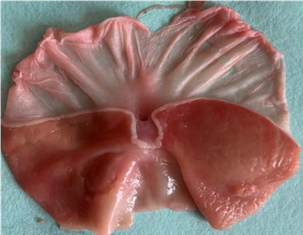
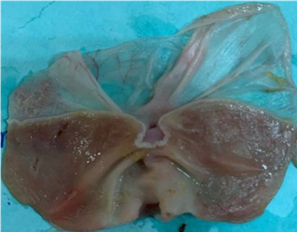
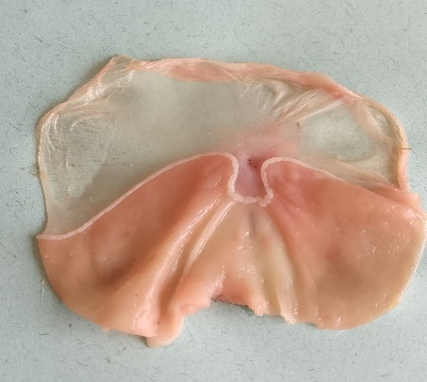
PO150
NgC
NC
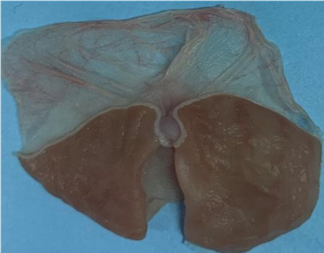
Figure 16

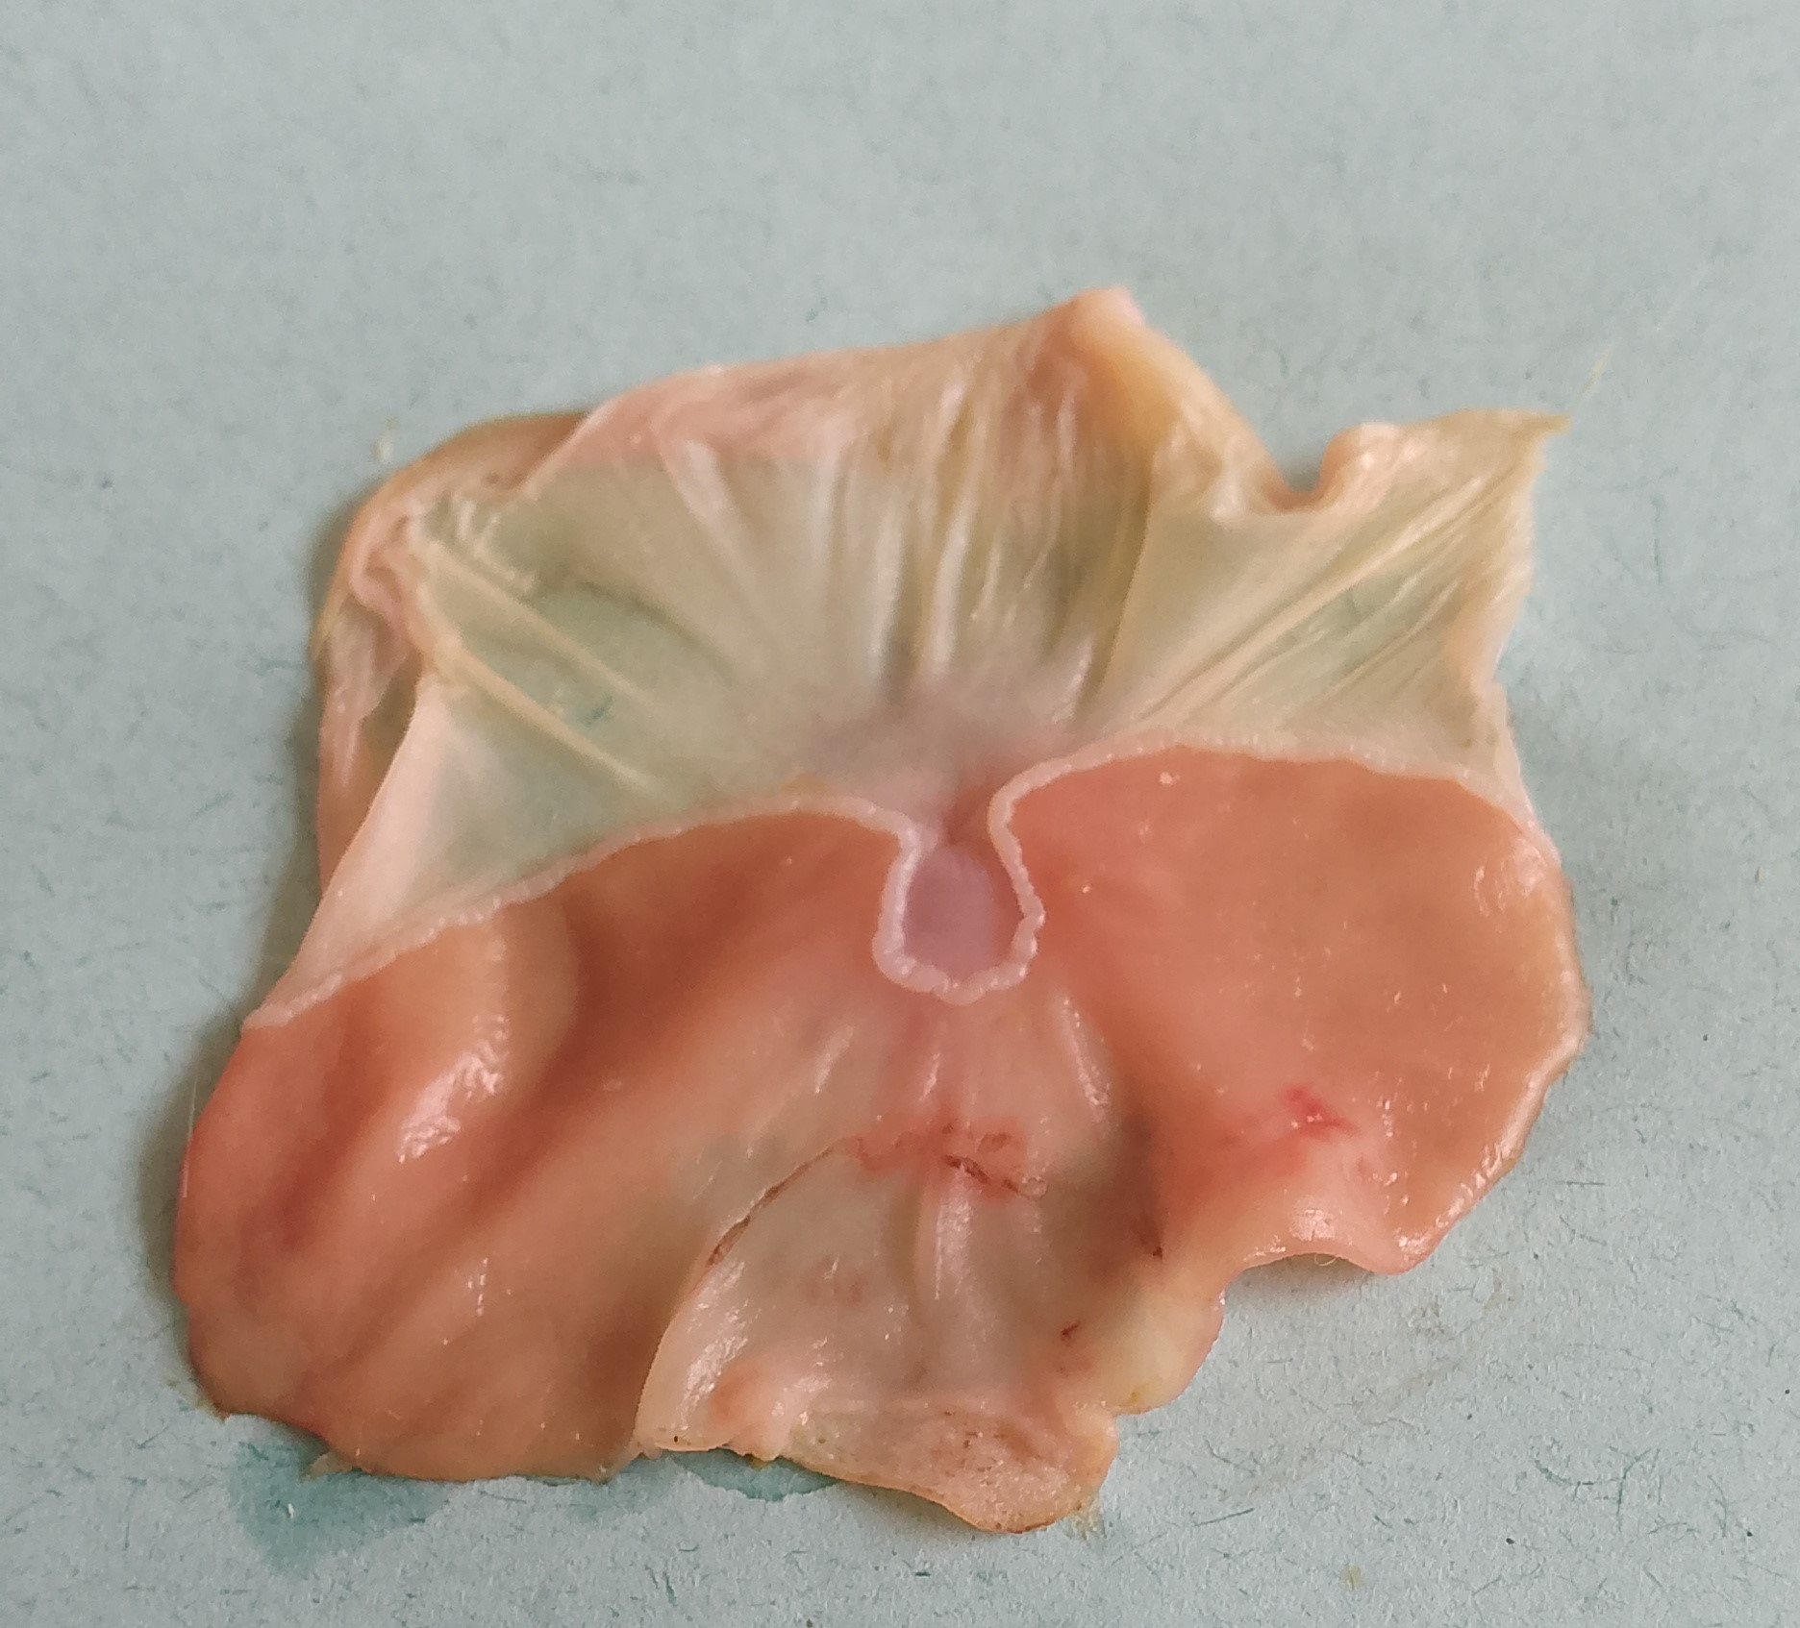
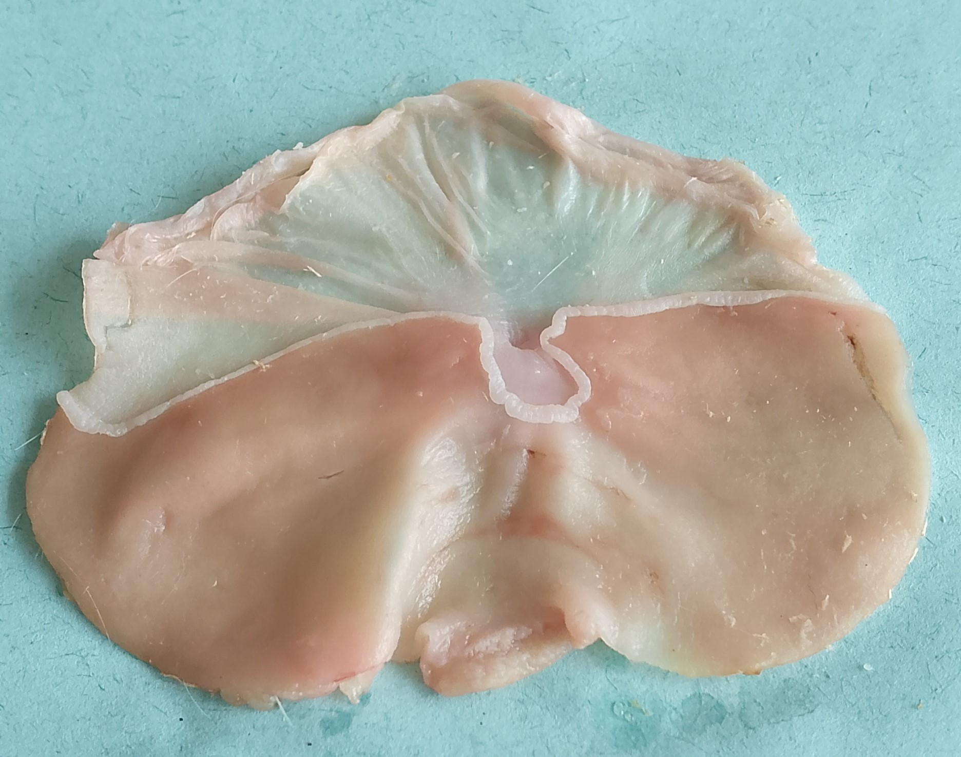

Suc350
PO600
PO300

Figure 4 : Effects of the ethanol extract of Portulaca oleracea on the stomach lining.
b. Effects of Portulaca oleracea extract on the ulcer surface
Figure 5 shows the effects of P. oleracea extract on the ulcer surface in the stomach lining. According to figure 5, the single oral dose of ethanol for 7 days caused gastric lesions with a well marked ulcer area of 0.085 mm². Further treatment of the ulcerogenic animals with the extracts resulted in a decrease (p<0.001) in the ulcer surface area with percent reduction of 50.58%, 80.00%, and 42.35% at 150 mg/kg, 300 mg/kg, and 600 mg/kg, respectively, compared to the negative control (Figure 5). Treatment of the ulcerogenic rats with sucralfate (350 mg/kg) resulted in a decrease (p<0.001) in ulcer area (percent reduction : 55.29%), when compared with the untreated animals (negative control).
Figure 5 : Effects of Portulaca oleracea extract on the ulcersurface area.
Each bar represents the mean value ± SEM ; n : number of animals per group=5; cp < 0.001: significant difference compared to the normal control, γp < 0.001: significant difference compared to the negative control;, NC : normal control; NgC : negative control; suc350 : sucralfate at 350 mg/kg; PO 150, 300, 600 : EtOH extract of Portulaca oleracea at 150, 300 and 600 mg/kg, respectively.
c. Activity of Portulaca oleracea extract on the secretion of mucus

The oral treatment of rats with ethanol for 7 days induced a significant (p < 0.001) decrease in the mucus’s secretion (60.98%) compared to the normal control group of animals. Further treatment of the ethanol-induced ulcer rats with P. oleracea extract at 150 mg/kg and 600 mg/kg led to a significant (p < 0.001) increase in the mucus secretion by 165.02% and 185.24%, respectively (Figure 6).
Figure 6 : Activity of the ethanol extract of Portulaca oleracea on the secretion of mucus.
Each bar represents the mean value ± SEM ; n : number of animals per group = 5 ; cp < 0.001: significant difference compared to the normal control, γp < 0.001: significant difference compared to the negative control, NC : Normal control ; NgC : negative control ; suc350 : sucralfate at 350 mg/kg ; PO 150, 300, and 600 : EtOH extract of Portulaca oleracea at 150, 300 and 600 mg/kg, respectively.
d. Activity of the ethanol extract of Portulaca oleracea on the haematological parameters in rats
The effects of the ethanol extract of P. oleracea on haematological parameters of rats are summarised in Table 4. The treatment of rats with ethanol for 7 days led to a significant increase (p < 0.001) in levels of hemoglobin (185.13%), lymphocytes (495.65%), granulocytes (257.54%) and monocytes (1064.51%), compared with the normal control. The oral gavage of the P. oleracea extract at 150 mg/kg and 300 mg/kg, and the positive control sucralfate (350 mg/kg) induce a significant decrease in the levels of hemoglobin (38.07%, 46.46%, and 49.88%), lymphocytes (68.75%, 70.65%, and 63.50%), granulocytes (62.70%, 67.10%, and 67.28%) and monocytes (71.74%, 83.65%, and 85.04%), compared to the negative control group of animals. At 600 mg/kg, P. oleracea extract also induced a decrease in levels of granulocytes (42.65%) and monocytes (51.80%).

Table 4 : Activity of the ethanol extract of Portulaca oleracea on the haematological parameters in rats.
Parameters | NC | NgC | Sucr350 | PO150 | PO300 | PO600
WBC (10⁶/mm³) | 7.60± 0.18 | 21.67±2.05^{c} | 10.86±0.75^{β} | 13.42±1.63^{α} | 11.60±0.92^{β} | 16.98±2.91
RBC (10⁶/mm³) | 9.59±0.40 | 8.39±0.39 | 8.58±0.20 | 9.14± 0.24 | 8.77±0.45 | 8.01±0.57
PLA (10³/mm³) | 372.6±18.03 | 839.25±68.74^{c} | 429.80±33.79^{β} | 415.80±12.11 ^{β} | 398.80±36.80^{γ} | 367.20±41.20^{β}
HGB (g/dl) | 15.28±0.73 | 12.00±1.21 | 14.28±0.63 | 15.04±1.07 | 13.32±0.85 | 10.54±1.51
HCT (%) | 42.76±.,00 | 40.45±3.18 | 40.96±1.37 | 43.32±2.51 | 39.28±2.76 | 34.54±2.36
VGM (fl) | 96.2±2.87 | 92.00±4.41 | 88.80±2.90 | 92.40±1.72 | 91.6±1.96 | 84.20±4.74
TCMH (pg) | 37.88±0.66 | 33.25±1.95 | 31.10±2.67 | 32.96±2.28 | 32.84±2.17 | 30.22±2.97
CCMH (g/dl) | 38.96±1.61 | 35.725±1.07 | 33.10±1.28 | 35.34±1.35 | 32.38±1.40 | 29.84±2.12
LYM (%) | 2.3±0.32 | 13.7±1.53^{c} | 5.00±0.75^{β} | 4.28±1.38^{β} | 4.02±0.78^{β} | 8.58±2.67
GRA (%) | 3.18±0.09 | 11.37±1.13^{c} | 3.72±0.39^{γ} | 4.24±0.67^{γ} | 3.74±0.37^{γ} | 6.52±1.73^{α}
MON (%) | 0.62±0.08 | 7.22±0.5^{c} | 1.08±0.28^{γ} | 2.04±0.69^{γ} | 1.18±0.18^{γ} | 3.48±1.48^{α}
Each value represents the mean value ± SEM ; n : number of animals per group = 5 ; p < 0.001: significant difference compared to the normal control, αp < 0.05 ; βp < 0.01 ; γp < 0.001: significant difference compared to the negative control, NC : normal control ; NgC : negative control ; suc350 : sucralfate at 350mg/kg ; PO 150, PO 300, and PO 600 : EtOH extract of Portulaca extract at 150, 300 and, 600 mg/kg, respectively. RBC : red blood cells, WBC : white blood cells, PLA : blood platelets, HGB : haemoglobin level, HCT : haematocrit, MCV : mean corpuscular volume, MCH : mean corpuscular haemoglobin, MCHC : mean corpuscular haemoglobin concentration, LYM : lymphocytes, GRA : granulocytes, MON : monocytes.

3.1.4.3. Effects of Portulaca oleracea extract on selected biomarkers of oxidative stress
a. Effects of extract of Portulaca oleracea on the production of nitrites
Figure 7 illustrates the effects of the oral administration of the plant extract on the production of nitrites. The induction of gastric ulcer in rats using ethanol solution resulted in a significant (p < 0.001) increase (93.96%) in concentration of nitrites, compared to the normal control group. Further oral treatment of the ethanol-induced ulcerogenic rats with the plant extract at 150, 300 and 600 mg/kg led to a significant (p < 0.001) decrease in levels of nitrite by 45.52%, 64.00%, and 64.98%, respectively, compared to the negative control. Moreover, the nitrite level was also decreased in animals treated with the positive control sucralfate (350 mg/kg) also induced a significant (p < 0.001) decrease (42.60%) in the level of nitrite.
Figure 7 : Effects of Portulaca oleracea extract and sucralfate on the nitrite levels
Each bar represents the mean value ± SEM ; n : number of animals per group = 5 ; cp < 0.001: significant difference compared to the normal control, γp < 0.001: significant difference compared to the negative control ; NC : Normal control ; NgC : Negative control ; Suc350 : sucralfate at 350 mg/kg; PO 150, 300, and 600 : Ethanol extract of Portulaca oleracea at 150, 300, and 600 mg/kg, respectively.

b. Activity of Portulaca oleracea extract on the levels of malondialdehyde
Figure 8 reveals the effects of the plant extract on the MDA levels. The oral gavage of rats with 20% ethanol revealed a significant (p < 0.001) increase in the MDA’s concentration by 39.81%, compared to the normal control group. Interestingly, the oral treatment of ethanol-induced ulcerogenic rats with sucralfate (350 mg/kg) and plant extract (150, 300, and 600 mg/kg), revealed a significant (p < 0.001) decrease in the MDA levels with decrease percentages of 27.81, 33.19, 38.84, and 29.44%, respectively, compared to the negative control group (Figure 8).
Figure 8 : Activity of Portulaca oleracea extract on the levels of malondialdehyde in rats.
Each bar represents the mean value ± SEM ; n : number of animals per group = 5 ; cp < 0.001: significant difference compared to the normal control, γp < 0.001: significant difference compared to the negative control ; MDA : Malondialdehyde, NC : Normal control ; NgC : Negative control ; Suc350 : Sucralfate at 350 mg/kg ; PO 150, 300, and 600 : EtOH extract of Portulaca oleracea at 150, 300, and 600 mg/kg, respectively.

b. Effects of Portulaca oleracea extract on catalase
The effects of P. oleracea on the catalase activity are shown in Figure 9. There were no significant changes regarding the levels of catalase in all groups of animals considered in this study (Figure 9).
Figure 9 : Effects of Portulaca oleracea extract on the levels of catalase
Each bar represents the mean value ± SEM ; n : number of animals per group = 5 ; NC = Normal control ; NgC : Negative control; Suc350 : Sucralfate at 350 mg/kg; PO 150, 300, and 600 : EtOH extract of Portulaca oleracea at 150, 300, and 600 mg/kg, respectively.

c. Activity of ethanol extract of Portulaca oleracea on superoxide dismutase (SOD)
The oral administration of ethanol to animals for 7 days led to a significant decrease (p<0.001) in superoxide dismutase (SOD) activity, compared to the normal control. Further treatment of the ethanol-induced ulcer rats with the plant extract (150, 300, and 600 mg/kg) and sucralfate (350 mg/kg) restored the SOD levels (percentages of increase : 1.24%, 34.77%, 48.56%, and 34.77%, respectively) to normalcy, compared to the negative control group (Figure 10).
Figure 10 : Activity of Portulaca oleracea extract on the levels of superoxide dismutase in rats.
Each bar represents the mean value ± SEM ; n : number of animals per group = 5 ; cp < 0.001: significant difference compared to the normal control, αp < 0.05 and βp < 0.01: significant difference compared to the negative control, SOD : superoxide dismutase, NC : Normal control ; NgC : Negative control ; Suc350 : sucralfate at 350 mg/kg; PO 150, 300 and 600 : EtOH extract of Portulaca oleracea at 150, 300 and 600 mg/kg, respectively.
d. Effects of Portulaca oleracea extract on reduced glutathione in rats
Figure 11 illustrates the effects of Portulaca oleracea on reduced glutathione levels in rats. The oral administration of ethanol to Wistar rats induced a significant (p<0.001) decrease (p<0.001) in the concentration (30.07%) of reduced glutathione (GSH), compared to the normal control. Further oral gavage of different doses (150, 300, and 600 mg/kg) of the plant extract and the positive control sucralfate (350 mg/kg) reverted the levels of GSH (percent of increase : 37.46, 62.89, 54.66, and 41.71%) to normalcy, compared to the negative control.

Figure 11 : Effects of Portulaca oleracea extract on reduced glutathione levels in rats.
Each bar represents the mean value ± SEM ; n : number of animals per group = 5 ; cp < 0.001: significant difference compared to the normal control, βp < 0.01 and γp < 0.001: significant difference compared to the negative control, NC : Normal control ; NgC : Negative control ; Suc350 : Sucralfate at 350 mg/kg ; PO 150, 300, and 600 : EtOH extract of Portulaca oleracea at 150, 300, and 600 mg/kg, respectively.
3.1.4.4. Activity of Portulaca oleracea extract on selected pro-inflammatory cytokines
Figure 12 reveals the effects of Portulaca oleracea extract on the levels of the cytokines TNF-α and IL-10 and the protein C-reactive protein (CRP). The oral administration of ethanol to the animals for 7 days induced a significant increase (p < 0.001) in the levels of CRP (115.06%) and TNF-α (96.50%) and a decrease (p < 0.01) in the level of IL-10 (48.27%), compared to the normal control. Further treatment of the ethanol-induced ulcerogenic rats with the plant extract (300 and 600 mg/kg) and sucralfate (350 mg/kg) reverted the levels of TNF-α (55.14, 40.71, and 43.34%) and the protein CRP (61.56, 40.06, and 34.10%) to normalcy (Figure 12). Meanwhile, 600 mg/kg P. oleracea extract could normalize the level of IL-10 by 73.74% in rats, compared to the negative control group (untreated animals).

Figure 12 : Activity of Portulaca oleracea extract on the levels of IL-10, TNF-α and CRP.
Each bar represents the mean value ± SEM ; n : number of animals per group = 5 ; p < 0.001: significant difference compared to the normal control ; αp < 0.05 and p < 0.01 : significant difference compared to the negative control ; CRP : C-reactive protein ; IL-10: Interleukin 10; TNF-α : Tumour necrosis factor alpha; NC : Normal control; NgC : Negative control; Suc350 : Sucralfate at 350 mg/kg; PO 150, 300 and 600 : EtOH extract of Portulaca oleracea at 150, 300 and 600 mg/kg, respectively.
3.1.4.5. Activity of Portulaca oleracea extract on the histology of the stomach lining
Figure 13 illustrates the micro architecture of the stomach of treated (animals that received single oral dose of ethanol for 7 days and administered with 150, 300, and 600 mg/kg plant extract and sucralfate at 350 mg/kg) and untreated (animals that received single oral dose of ethanol for 7 days and left untreated) rats. The histology of the stomach of normal control (NC) rats reveals a normal architecture of the stomach, consisting of a serosa (first layer), muscularis (thick layer of circular smooth muscles that enables gastric motility), the submucosa (middle layer of connective tissue that supports the mucosa), and the mucosa (the innermost layer with circular folds housing finger-like projections called gastrointestinal villi). These villi are covered with a columnar epithelium that absorbs nutrients from digested food into the bloodstream. The induction of gastric ulcer to rats using ethanol has led to the disorganisation of the structure of the stomach, mainly characterised by an inflammation of the musculature (myositis) and villous atrophy. Further administration of P. oleracea extract (150, 300, and 600 mg/kg) and the positive control sucralfate (350 mg/kg) to ethanol-induced ulcer rats repaired their tissue damage, as evidenced by the normal architecture (similar to that of the normal control group) of the stomach of treated rats (Figure 13).
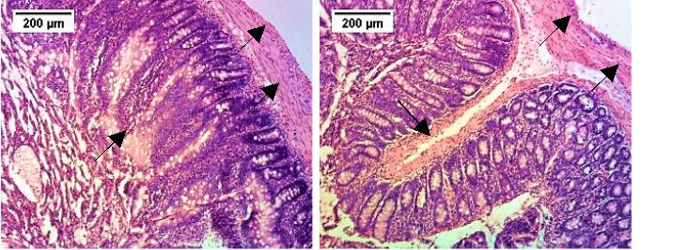
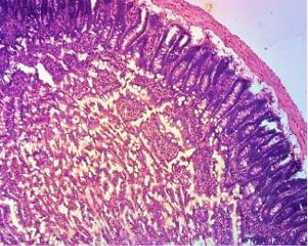
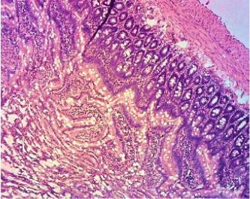
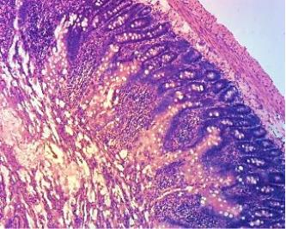
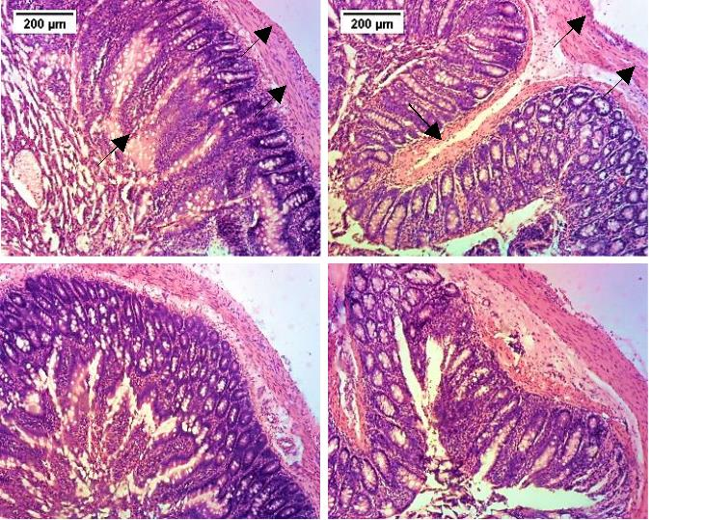
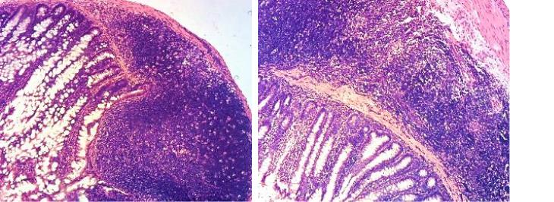
IMus
Mus
NC
NgC
Suc 350
PO 150
PO 300
PO 600
Se
Se
Lu
Vi
Mu
SM
AVi
Lu

Figure 13 : Effects of Portulaca oleracea extract and sucralfate on the microarchitecture of the stomach in ethanol-induced ulcer rats.
Lu : Gastric lumen ; Mu : Mucosa ; SM : Submucosa ; Mus : Muscularis ; Se : Serosa ; IMus : Inflammation of the muscularis ; Vi : Gastrointestinal villi ; AVi : Villous atrophy. NC : Normal control ; NgC : Negative control ; Suc350 : Sucralfate at 350 mg/kg ; PO 150, PO 300 and PO 600 : EtOH extract of Portulaca oleracea at 150, 300 and 600 mg/kg, respectively.

3.2. Discussion
Bioactive metabolites of plant origin are most often found in low concentrations in natural matrices (Twaij and Hasan, 2022 ; Han et al., 2024). Therefore, careful selection of the extraction method is a crucial step, both to maximise yields and to preserve the integrity and efficacy of the extracted active ingredients (Farooq et al., 2022). The maceration of 1,000 g of Portulaca oleracea powder yielded 46.6 g of crude extract (yield of extraction : 4.66%). In fact, ethanol is one of the most widely used polar solvents for the extraction of bioactive compounds of plant origin, due to its favourable physicochemical properties and its toxicological advantages (Bourgou et al., 2016). It is a polar solvent capable of dissolving a wide range of hydrophilic and moderately lipophilic compounds (flavonoids, phenols, alkaloids, tannins, and glycosides) (Bourgou et al., 2016). Accumulated evidence has shown that these classes of secondary metabolites offer significant protection against ulcers in rats through diverse mechanisms that target both aggressive factors (acid, pepsin, and reactive oxygen species) and defensive factors (mucus, bicarbonate, and prostaglandins) of the gastric mucosa (Sumbul et al., 2011 ; Zhang et al., 2020). The phytochemical analysis of the crude ethanol extract of Portulaca oleracea revealed the presence of flavonoids, phenolic compounds, tannins, triterpenes, steroids and alkaloids. Recently, Sheikh et al. (2025) reported the presence of tannins, terpenoids, flavonoids, alkaloids, phenols, and saponins in the methanolic extract of Portulaca oleracea seeds (Sheikh et al., 2025). Before that, other authors have also demonstrated the abundance of secondary metabolites, such as flavonoids, alkaloids, phenolic compounds, tannins, steroids, terpenoids, saponins, and cardiac glycosides in different organs of Portulaca oleracea (Wasnik and Tumane, 2014 ; Okafor and Ezejindu, 2014 ; Ghorani et al., 2023). The acute toxicity study of the ethanol extract of Portulaca oleracea at 2000 and 5000 mg/kg did not induce any mortality or signs of toxicity to wistar albino rats, and the median lethal dose (LD₅₀) was found to be more than 5000 mg/kg. Body weights and relative organ weights of treated animals remained unchanged after 14days of observation period. These results suggest that Portulaca oleracea extract can be classified in category 5, according to the Globally Harmonised System of Classification (GHS), a class of products, which are free of toxicity (OCDE, 2002). The oral administration (150, 300, and 600 mg/kg) of Portulaca oleracea extract to ethanol-induced ulcerogenic rats exhibited a significant dose-dependent reduction of the number and size of gastric ulcers. Sucralfate (Suc 350 mg/kg), which was used as a positive control, significantly reduced the size and number of gastric ulcers. Also, this treatment decreased the ulcer surface area with percent reduction of 50.58%, 80.00% and 42.35% at 150 mg/kg, 300 mg/kg and 600 mg/kg, respectively, compared to the negative control. The plant extract also induced a significant increase in the mucus secretion in rats. The antiulcer activity of Portulaca oleracea extract might be attributed to the presence of secondary metabolites such as flavonoids, alkaloids, phenolic compounds, tannins, steroids, terpenoids, saponins, and cardiac glycosides in this plant species. As a matter of fact, flavonoids exert their antiulcer effects through multiple mechanisms that help to restore the balance between aggressive factors (gastric acid, pepsin, oxidative stress, etc.) and protective factors (mucus, bicarbonate, prostaglandins, antioxidants) of the gastric mucosa (Zhang et al., 2020 ; Serafim et al., 2020). Phenolic compounds and other polyphenols are reported to exhibit antiulcer effects through their anti-secretory, cytoprotective, and antioxidant actions (Sumbul et al., 2011). The antiulcer mechanisms of action for naturally derived terpenoids and steroids primarily involve enhancing gastric mucosal protection and reducing aggressive factors such as gastric acid secretion, inflammation, and oxidative stress (Sharifi-Rad et al., 2018 ; Shen et al., 2025). Moreover, the antiulcer mechanisms of action for alkaloids are diverse and involve both strengthening the gastric mucosal defense system and mitigating aggressive factors like gastric acid and reactive oxygen species (Shahzad et al., 2024). Thus, it is most likely that the antiucler activity Portulaca oleracea extract is due to at least one of these mechanisms of action.
The oral gavage of the P. oleracea extract at 150 and 300 mg/kg, and the positive control sucralfate (350 mg/kg) induced a significant decrease in the levels of hemoglobin, lymphocytes, granulocytes and monocytes, compared to the negative control group of animals. At 600 mg/kg, P. oleracea extract also induced a decrease in levels of granulocytes (42.65%) and monocytes (51.80%). Oxidative stress is intricately involved in the pathogenesis of several diseases including gastric ulcers (Suzuki et al., 2012 ; Miranda et al., 2023). The ethanol extract of P. oleracea revealed a significant (p<0.001) decrease in the levels of nitrite in ethanol-induced ulcerogenic rats by 45.52%, 64.00%, and 64.98% at 150, 300, and 600 mg/kg, respectively, compared to the negative control. Growing evidence has shown that the decrease of nitrite levels might be an indicator of an anti-inflammatory effect that contributes to ulcer healing, particularly when excessive nitric oxide synthase (iNOS) activity is present during inflammation (Oliveira et al., 2014 : Venturini et al., 2024). In addition, P. oleracea extract downregulated the level of MDA by 27.81, 33.19, 38.84, and 29.44% at 150, 300 and 600 mg/kg, respectively. Moreover, the treatment of the ethanol-induced ulcer rats with the plant extract (150, 300 and 600 mg/kg) and sucralfate (350 mg/kg) restored the SOD and GSH levels to normalcy. Furthermore, the treatment of the ethanol-induced ulcerogenic rats with the plant extract (300 and 600 mg/kg) and sucralfate (350 mg/kg) reverted the levels of the cytokines TNF-α (55.14, 40.71, and 43.34%) and the protein CRP (61.56, 40.06, and 34.10%) to normalcy. Meanwhile, 600 mg/kg P. oleracea extract could normalize the level of IL-10 by 73.74% in rats.
Antiulcer agents exert their effects by downregulating oxidative markers to restore the balance between protective and destructive factors in the gastric mucosa (Suzuki et al., 2012). This involve several mechanisms, including (i) decreasing oxidative stress by lowering the levels of malondialdehyde, a key marker of lipid peroxidation and cell membrane damage caused by free radicals, and by increasing the activity and levels of endogenous antioxidant enzymes such as superoxide dismutase (SOD), catalase (CAT), and glutathione (GSH) to neutralize free radicals ; and (ii) by modulating inflammatory pathways through downregulation of pro-inflammatory mediators (TNF-α) and upregulation of anti-inflammatory mediators (IL-10) (Jabbar et al., 2023 ; Ermis et al., 2023 ; Wetchaku et al., 2024 ; Prayoga et al., 2024). The downregulation of TNF-α and the upregulation of IL-10, and the decrease in the MDA levels and increase in SOD, CAT and GSH levels, induced by the treatment with the ethanol extract of P. oleracea might have contributed to its antiulcer activity. On the other hand, P. oleracea extract (150, 300, and 600 mg/kg) and the positive control sucralfate (350 mg/kg) restored the normal architecture of the stomach lining to the ethanol-induced ulcerogenic rats. It is well known that plant extracts restore the architecture of the stomach primarily through a combination of mechanisms that enhance the mucosal defense barrier, exert potent anti-inflammatory and antioxidant effects, and promote tissue regeneration (Sharifi-Rad et al., 2018 ; Rezvan et al., 2025). Overall, this novel contribution demonstrates the protective roles of the ethanol extract of P. oleracea extract in ethanol-induced ulcer rats. The antioxidative nature of P. oleracea extract contributed to its antiulcer effects. Thus, P. oleracea can be prospected as a baseline for the discovery of novel antiulcer drugs. However, in depth toxicity and pharmacokinetic studies, as well as the antiulcer mechanisms of action of P. oleracea extract are warranted for the successful utilization of this plant in anti-ulcer drug discovery.
4. Conclusion
The present study suggests that the Portulaca oleracea extract possesses potent antiulcer activity against ethanol-induced gastric ulcer with significant in vivo antioxidative effects. The extract showed effectivity by reducing the number and size of gastric ulcers, and the area of ulcers. Portulaca oleracea extract significantly restored the morphology of ulcerated stomach to normalcy. The phytochemical screening of Portulaca oleracea extract revealed the presence of flavonoids, phenolic compounds, tannins, triterpenes, steroids, and alkaloids. The ethanol extract of P. oleracea did not reveal any signs of toxicity upon acute toxicity study, and the LD₅₀ was found to be above 5000 mg/kg. Thus, ethanol extract of Portulaca oleracea may be used further in antiulcer drug discovery campaigns. Nevetheless, additional studies, including in vitro tosicity and pharmacokinetics, as well as the antiulcer mechanisms of actions are warranted.

COMPETING INTERESTS DISCLAIMER
Authors have declared that they have no known competing financial interests OR non-financial interests OR personal relationships that could have appeared to influence the work reported in this paper.
DISCLAIMER (ARTIFICIAL INTELLIGENCE)
Author(s) hereby declare that NO generative AI technologies such as Large Language Models (ChatGPT, COPILOT, etc) and text-to-image generators have been used during writing or editing of this manuscript.

References
Ankouane, F., Ngatcha, G., Kowo, M., Ndjitoyap Ndam, A. W., Tagni-Sartre, M., Dang, I., Njoya, O., Biwolé Sida, M., Tzeuton, C., & Ndjitoyap Ndam, E. C. (2016). Analyse démographique et endoscopique des patients atteints d'ulcère gastroduodénal à Yaoundé au Cameroun : qu'est ce qui a changé depuis les années 1990 ?. Médecine d'Afrique Noire (En ligne), 63(7), 409-415. https://pesquisa.bvsalud.org/portal/resource/pt/biblio-1266202
Allen, A., & Flemström, G. (2005). Gastroduodenal mucus bicarbonate barrier: protection against acid and pepsin. American Journal of Physiology-Cell Physiology, 288(1), C1-19. https://doi.org/10.1152/ajpcell.00102.2004
Ali, A., & AlHussaini, K. I. (2024). Helicobacter pylori: A Contemporary Perspective on Pathogenesis, Diagnosis and Treatment Strategies. Microorganisms, 12(1), 222. https://doi.org/10.3390/microorganisms12010222
Alsaedi, S., & Aljeddani, G. (2022). Phytochemical Analysis and Bioactivity Screening of Primary and Secondary Metabolic Products of Medicinal Plants in the Valleys of Medina Region Saudi Arabia. Advances in Biological Chemistry, 12(4), 92-115. https://doi.org/10.4236/abc.2022.124009
Bourgou, S., Beji, R. S., Medini, F., & Ksouri, R. (2016). Effet du solvant et de la méthode d’extraction sur la teneur en composés phénoliques et les potentialités antioxydantes d’Euphorbia helioscopia. Journal of New Sciences, 28, 1649-1655. https://www.journal-of-new-sciences.com/index.php/JNS/article/download/12/12
Davies, M. H., Birt, D. F., & Schnell, R. C. (1984). Direct enzymatic assay for reduced and oxidized glutathione. Journal of Pharmacological Methods, 12(3), 191-194. https://doi.org/10.1016/0160-5402(84)90059-7
Ermis, A., Aritici Colak, G., Acikel-Elmas, M., Arbak, S., & Kolgazi, M. (2023). Ferulic Acid Treats Gastric Ulcer via Suppressing Oxidative Stress and Inflammation. Life, 13(2), 388. https://doi.org/10.3390/life13020388
Trease, G. E., & Evans, W. C. (1989). Trease and Evans' pharmacognosy (13th ed.). Baillière Tindall.
Farooq, S., Mir, S. A., Shah, M. A., & Manickavasagan, A. (2022). Extraction techniques. In S. A. Mir, A. Manickavasagan, & M. A. Shah (Eds.), Plant extracts: Applications in the food industry (pp. 23-37). Academic Press. https://doi.org/10.1016/B978-0-12-822475-5.00005-3
Fattorusso, V., & Ritter, O. (2004). Vademecum clinique: du diagnostic au traitement. Masson. https://openlibrary.org/works/OL15700000W/Vademecum_clinique
Fermor, B., Haribabu, B., Weinberg, J. B., Pisetsky, D. S., & Guilak, F. (2001). Mechanical stress and nitric oxide influence leukotriene production in cartilage. Biochemical and Biophysical Research Communications, 285(3), 806-810. https://doi.org/10.1006/bbrc.2001.5237
Gadekar, R., Singour, P. K., Chaurasiya, P. K., Pawar, R. S., & Patil, U. K. (2010). A potential of some medicinal plants as an antiulcer agents. Pharmacognosy Reviews, 4(8), 136-146. https://doi.org/10.4103/0973-7847.70906
Gartner, L. P., & Hiatt, J. L. (2011). Digestive System: Alimentary Canal. In Concise Histology (pp. 238-249). Elsevier. https://doi.org/10.1016/B978-0-7020-3114-4.00017-8
Académie d'Aix-Marseille. (2020). Table pour la dilution de l'alcool (Table de Gay-Lussac). https://www.pedagogie.ac-aix-marseille.fr/upload/docs/application/pdf/2020-02/dilution-alcool-gay-lussac.pdf
Ghorani, V., Saadat, S., Khazdair, M. R., Gholamnezhad, Z., El-Seedi, H., & Boskabady, M. H. (2023). Phytochemical Characteristics and Anti-Inflammatory, Immunoregulatory, and Antioxidant Effects of Portulaca oleracea L.: A Comprehensive Review. Evid Based Complement Alternat Med. https://doi.org/10.1155/2023/2075444
-Grotto D, Maria L, Valentini J, Paniz C, Schmitt G, Garcia S, et al. Importance of the lipid peroxidation biomarkers and methodological aspects FOR malondialdehyde quantification. Quimica Nova - QUIM NOVA. 2009;32(1):169‑74.
Hall, J. E., & Hall, M. E. (2020). Guyton and Hall textbook of medical physiology (14th ed.). Elsevier. https://www.elsevier.com/books/guyton-and-hall-textbook-of-medical-physiology/hall/978-0-323-59712-8
Han, T., & Miao, G. (2024). Strategies, Achievements, and Potential Challenges of Plant and Microbial Chassis in the Biosynthesis of Plant Secondary Metabolites. Molecules, 29(9), 2106. https://doi.org/10.3390/molecules29092106
-Harborne JB (Jeffrey B). Phytochemical methods : a guide to modern techniques of plant analysis. London : Chapman & Hall ; New York : [Distributed in the USA by Halsted Press, a Division of John Wiley & Sons]; 1973. 298 p.
Haschek, W. M., Rousseaux, C. G., & Wallig, M. A. (2010). Gastrointestinal Tract. In W. M. Haschek, C. G. Rousseaux, & M. A. Wallig (Eds.), *Fundamentals of toxicologic pathology* (Second edition, pp. 163-196). Academic Press. https://doi.org/10.1016/B978-0-12-370469-6.00008-8
Holle, G. E. (2010). Pathophysiology and modern treatment of ulcer disease. International Journal of Molecular Medicine. https://doi.org/10.3892/ijmm_00000368
Iranshahy, M., Javadi, B., Iranshahi, M., Jahanbakhsh, S. P., Mahyari, S., Hassani, F. V., & Karimi, G. (2017). A review of traditional uses, phytochemistry and pharmacology of Portulaca oleracea L. Journal of Ethnopharmacology, 205, 158–172. https://doi.org/10.1016/j.jep.2017.05.004
Jabbar, A. A. J., Mothana, R. A., Abdulla, M. A., Abdullah, F. O., Ahmed, K. A., Hussen, R. R., Hawwal, M. F., Fantoukh, O. I., & Hasson, S. (2023). Mechanisms of anti-ulcer actions of Prangos pabularia (L.) in ethanol-induced gastric ulcer in rats. Saudi Pharmaceutical Journal, 31(12), 101850. https://doi.org/10.1016/j.jsps.2023.101850
Kamada, T., Satoh, K., Itoh, T., Ito, M., Iwamoto, J., Okimoto, T., Kanno, T., Sugimoto, M., Chiba, T., Nomura, S., Mieda, M., Hiraishi, H., Yoshino, J., Takagi, A., Watanabe, S., & Koike, K. (2021). Evidence-based clinical practice guidelines for peptic ulcer disease 2020. Journal of Gastroenterology, 56(4), 303-322. https://doi.org/10.1007/s00535-021-01769-0
Kawade, D., Shahu, N., Bahadurkar, P., Hiradewe, P., & Dhote, N. (2020). Peptic ulcer: A review on its etiology, pathogenesis and pharmacotherapy. World Journal of Pharmaceutical Research, 9(5), 558-583. https://www.wjpr.net/abstract/peptic-ulcer-a-review-on-its-etiology-pathogenesis-and-pharmacotherapy-16000.html
Miranda, M. R., Vestuto, V., Moltedo, O., Manfra, M., Campiglia, P., & Pepe, G. (2023). The Ion Channels Involved in Oxidative Stress-Related Gastrointestinal Diseases. Oxygen. https://doi.org/10.3390/oxygen3030022
Misra, H. P., & Fridovich, I. (1972). The role of superoxide anion in the autoxidation of epinephrine and a simple assay for superoxide dismutase. Journal of Biological Chemistry, 247(10), 3170–3175. https://doi.org/10.1016/s0021-9258(19)45228-9
OCDE. (2002). Essai n° 420: Toxicité orale aiguë - Méthode de la dose prédéterminée. Lignes directrices de l'OCDE pour les essais de produits chimiques, Section 4. https://doi.org/10.1787/9789264070950-fr.
Okafor, I. A., & Ezejindu, D. N. (2014). Phytochemical studies on Portulaca oleracea (purslane) plant. *Global Journal of Biology Agriculture and Health Sciences*, *3*(1), 132-136. https://www.walshmedicalmedia.com/open-access/phytochemical-studies-on-portulaca-oleracea-purslane-plant-2319-5584.1000132.pdf
Oliveira, F. A., Andrade, L. N., de Sousa, E. B., & de Sousa, D. P. (2014). Anti-ulcer activity of essential oil constituents. Molecules, 19(5), 5717-5747. https://doi.org/10.3390/molecules19055717
Périco, L. L., Emílio-Silva, M. T., Ohara, R., Rodrigues, V. P., Bueno, G., Barbosa-Filho, J. M., Rocha, L. R. M. D., Batista, L. M., & Hiruma-Lima, C. A. (2020). Systematic Analysis of Monoterpenes: Advances and Challenges in the Treatment of Peptic Ulcer Diseases. Biomolecules. https://doi.org/10.3390/biom10020265
Rezvan, M., Hossini, S. E., Sarmast, K., & Khamesipour, F. (2025). The Efficiency of Plant Extracts in the Prevention of Gastric Cancer: A Systematic Review. Health Science Reports. https://doi.org/10.1002/hsr2.71251
Rezvan, M., Hossini, S. E., Sarmast, K., & Khamesipour, F. (2025). The Efficiency of Plant Extracts in the Prevention of Gastric Cancer: A Systematic Review. Health Science Reports. https://doi.org/10.1002/hsr2.71251
Sahu, D., Rathor, L. S., Singh, M. R., & Singh, D. (2025). Exploration of some medicinal plants for peptic ulcer disease: In-silico approach for wound management. In Silico Research in Biomedicine. https://doi.org/10.1016/j.insi.2025.100027
Sen, S., & Chakraborty, R. (2017). Herbs, gastrointestinal protection, and oxidative stress. In Gastrointestinal tissue, oxidative stress and dietary antioxidants (pp. 259-274). Academic Press. https://doi.org/10.1016/B978-0-12-805377-5.00019-9
Serafim, C., Araruna, M. E., Júnior, E. A., Diniz, M., Hiruma-Lima, C., & Batista, L. (2020). A Review of the Role of Flavonoids in Peptic Ulcer (2010–2020). Molecules, 25(22), 5431. https://doi.org/10.3390/molecules25225431
Sharifi-Rad, M., Fokou, P. V. T., Sharopov, F., Martorell, M., Ademiluyi, A. O., Rajkovic, J., Salehi, B., Martins, N., Iriti, M., & Sharifi-Rad, J. (2018). Antiulcer Agents: From Plant Extracts to Phytochemicals in Healing Promotion. Molecules. https://doi.org/10.3390/molecules23071751
Shahzad, N., Ibrahim, I. A. A., Alzahrani, A. R., Al-Ghamdi, S. S., Alanazi, I. M. M., Ahmad, M. P., Singh, A. K., Alruqi, M. A., Shahid, I., Equbal, A., & Azlina, M. F. N. (2024). A comprehensive review on phytochemicals as potential therapeutic agents for stress-induced gastric ulcer. J. Umm Al-Qura Univ. Appl. Sci., 10, 793–808. https://doi.org/10.1007/s43994-024-00140-2
Sheikh, K. A., Mir, R. H., Dar, M. O., Wali, A. F., Qadir, I., Nazir, S., Zargar, M. I., Talath, S., Sridhar, S. B., Shareef, J., & Masoodi, M. H. (2025). Phytochemical screening, antioxidant, and antimicrobial analysis of Portulaca oleracea seeds with in-silico molecular docking insights. Journal of Genetic Engineering and Biotechnology, 23(3). https://doi.org/10.1016/j.jgeb.2025.100516
Shen, C., Zhang, S., Di, H., Wang, S., Wang, Y., & Guan, F. (2025). The Role of Triterpenoids in Gastric Ulcer: Mechanisms and Therapeutic Potentials. International Journal of Molecular Sciences, 26(7), 3237. https://doi.org/10.3390/ijms26073237
Srinivas, T. L., Mohana Lakshmi, S., Neelufar Shama, S., Koteswara Reddy, G., & Prasanna, K. R. (2013). Medicinal Plants as Anti-Ulcer Agents. Journal of Pharmacognosy and Phytochemistry, 2(4), 91-97. https://www.jpp.co.in/article/medicinal-plants-as-anti-ulcer-agents/
Sumbul, S., Ahmad, M. A., Mohd, A., & Mohd, A. (2011). Role of phenolic compounds in peptic ulcer: An overview. Journal of Pharmacy & Bioallied Sciences, 3(3), 361-367. https://doi.org/10.4103/0975-7406.84437
Suzuki, H., Nishizawa, T., Tsugawa, H., Mogami, S., & Hibi, T. (2012). Roles of oxidative stress in stomach disorders. J Clin Biochem Nutr, 50(1), 35-39. https://doi.org/10.3164/jcbn.11-115SR
Tadesse, T. Y., Zeleke, M. M., & Dagnew, S. B. (2022). Review of Ethnobotanical and Ethnopharmacological Evidence of Some Ethiopian Medicinal Plants Traditionally Used for Peptic Ulcer Disease Treatment. Clinical and Experimental Gastroenterology. https://doi.org/10.2147/CEG.S384395
Tan, P. V., Nditafon, N. G., Yewah, M. P., Dimo, T., & Ayafor, F. J. (1996). Eremomastax speciosa: effects of leaf aqueous extract on ulcer formation and gastric secretion in rats. Journal of Ethnopharmacology, 54(2-3), 139-142. https://doi.org/10.1016/s0378-8741(96)01461-4
World Health Organization. (2024). Médecine traditionnelle: Questions-réponses. https://www.who.int/fr/news-room/questions-and-answers/item/traditional-medicine
Twaij, B. M., & Hasan, M. N. (2022). Bioactive Secondary Metabolites from Plant Sources: Types, Synthesis, and Their Therapeutic Uses. International Journal of Plant Biology. https://doi.org/10.3390/ijpb13010003
Vakil, N. B. (2024). Peptic ulcer disease: Clinical manifestations and diagnosis. https://www.uptodate.com/contents/peptic-ulcer-disease-clinical-manifestations-and-diagnosis
Venturini, C. L., Damazo, A. S., Silva, M. J. D., Muller, J. D. A. I., Oliveira, D. M., Figueiredo, F. D. F., Di Serio, B. F., Arunachalam, K., & Martins, T. D. O. D. (2024). Antiulcer activity and mechanism of action of the hydroethanolic extract of leaves of Terminalia argentea Mart. In different in vivo and in vitro experimental models. Journal of Ethnopharmacology, 318(Part B), 116972. https://doi.org/10.1016/j.jep.2023.116972
-Wasnik DD, Tumane PM, 2014. Preliminary phytochemical screening and evaluation of antibacterial activity of Portulaca oleracea L. against multiple drug resistant (mdr) pathogens isolated from clinical specimen. World Journal of Pharmaceutical Research. Volume 3, Issue 10, 920-931.
Wetchakul, P., Net-Anong, S., Goon, J. A., & Sanpinit, S. (2024). Anti-oxidative stress and gastroprotective effect of Tri-Tharn-Thip tea against ethanol-induced gastric ulcer in rats. *South African Journal of Botany*, *170*, 130-136. https://doi.org/10.1016/j.sajb.2024.05.027
Xie, X., Ren, K., Zhou, Z., Dang, C., & Zhang, H. (2022). The global, regional and national burden of peptic ulcer disease from 1990 to 2019: a population-based study. BMC Gastroenterology, 22(1), 58. https://doi.org/10.1186/s12876-022-02130-2
Yegen, B. C. (2018). Lifestyle and Peptic Ulcer Disease. Current Pharmaceutical Design, 24(18), 2034-2040. https://doi.org/10.2174/1381612824666180510092303

Zhang, W., Lian, Y., Li, Q., Sun, L., Chen, R., Lai, X., Lai, Z., Yuan, E., & Sun, S. (2020). Preventative and Therapeutic Potential of Flavonoids in Peptic Ulcers. Molecules, 25(20), 4626. https://doi.org/10.3390/molecules25204626

