Original Research Article

Molecular characterization of Polyethylene degrading bacteria and fungi from a refuse dump in Portharcourt, Rivers State Nigeria

Abstract
This study was aimed at identifying and characterizing Polyethylene degrading bacterial isolates from a refuse dump in Amadi-Ama Portharcourt Rivers State Nigeria. The microorganisms were isolated from plastic polyethylene wastes deposited in the soil of a refuse dump in Amadi-Ama, Port Harcourt, Rivers State. Molecular studies were done to identify and characterize the bacteria and fungi involved in the degradation of the polyethylene. The identified Ethylene utilizing bacteria species include Bacillus sp., Micrococcus sp. and Pseudomonas sp. while the fungal species include Alternaria sp. and Fusarium sp. The obtained 16s rRNA and Internal Transcribed Spacer (ITS) sequence from the isolate produced an exact match during the megablast search for highly similar sequences from the National Center for Biotechnology Information (NCBI) non-redundant nucleotide (nr/nt) database. The 16S rRNA and Internal Transcribed Spacer (ITS) of the isolates showed a percentage similarity to other species at 100%. The evolutionary distances computed using the Jukes-Cantor method were in agreement with the phylogenetic placement of the 16S rRNA and Internal Transcribed Spacer (ITS) of the isolates within the Bacillus and Lysinibacillus sp and revealed a closely relatedness to Bacillus safensis and Lysinibacillus sphaericus as well as within the Aspergillus and Fusarium sp and revealed a closely relatedness to Aspergillus flavipes and Fusariun ketaroplasticum. Bacteria and fungi species degraded the polyethylene from the refuse dump in in Amadi-Ama Portharcourt Rivers State Nigeria. The bacterial species identified to be involved in the degradation of polyethylene from the refuse dump were Bacillus sp., Micrococcus sp. and Pseudomonas sp. with Bacillus safensis and Lysinibacillus sphaericus being the bacterial organisms found to be present while the fungal species were Alternaria sp. and Fusarium sp. with Aspergillus flavipes and Fusariun ketaroplasticum being the fungal organisms found to be present.

Keywords: bacterial isolates, fungal isolates, polyethylene, degradation, refuse dumpsite

INTRODUCTION
Urbanization and industrialization have led to a significant accumulation of plastic waste in the environment. Plastics are used in many aspects of our lives because of their diverse applications. Mostly derived from petrochemicals that are subsequently further synthesized to produce long-chain polymers, plastics are high molecular weight, long hydrocarbon chain polymers [1]. Despite their advantages, these plastics are still not biodegradable, and the large volume of waste they produce makes it difficult to remove from the environment. A biodegradation approach to the increasing amount of plastic waste in the environment is starting to become apparent as a necessary remedy due to its environmental friendliness. The three main methods for handling plastic waste are recycling, landfilling, and incineration; each has drawbacks of its own, such as exorbitant expenses, protracted decomposition periods, and the emission of toxic gases into the atmosphere [1,2]. Microbial degradation is a low-cost and environmentally responsible method of disposing of plastic waste [3].
As plastic production and waste accumulation increase, a large amount of gaseous substances that are harmful to both human health and the environment are released into the atmosphere, making improper disposal of plastic waste a serious environmental issue. These compounds include nitrogen oxides, dioxins, carbon monoxide, and hydrogen cyanide [4]. Furthermore, these plastic materials persist in the environment, moving from lower to higher trophic levels and becoming part of the food chain [5].
Many microorganisms have been identified as responsible for the breakdown of plastic waste, but Arthrobacter sp., Aspergillus sp., and Pseudomonas sp. are believed to be more effective [6]. According to Takei et al. [7], PE is known to be degraded by Rhodococcus sp. TMP2 and Rhodococcus erythropolis NRRL B-16531. Furthermore, studies reveal that Phormidium lucidum [8], Serratia marcescins [9], Bacillus sp. YP1 [10], Achromobacter xylosoxidans [11], Phormidium borkumensis [12], and Zalerion maritimum [8] are among the microbial species utilized for PE degradation. The main way that microbes break down plastics is by using their enzymes, which bind to the material and depolymerize it into its monomers without producing a hazardous substrate that is bad for the environment, making it environmentally friendly [13]. A particular gene codes for each of these enzymes, and the alk B gene of P. aeruginosa is one of the genes that breaks down polyethylene [14].
A recent study found that managing plastic waste has become a major environmental concern as a result of the exponential growth in plastic production. Plastic waste products, both liquid and solid, are being disposed of in soil and aquatic environments [13]. These plastic wastes take a long time to break down and they end up in landfills. Plastic-derived toxins combine with soil and water, eventually building up in living organisms and undergoing biomagnifications [15]. Tons of plastic waste are dumped into the ocean each year, killing marine mammals, fish, birds, and sea turtles. Serious action is needed to decrease plastic production and increase its removal from the environment [3]. This study identified and characterized bacterial and fungal isolates that are capable of degrading plastic waste from the environment.
MATERIALS AND METHODS
Study Area
The study was carried out on a waste dump site in Port Harcourt area of the Niger Delta region. Bulked surface and sub-surface soil samples were collected from the study area in Amadi-Ama, Port Harcourt, Rivers State at three different points. The points included: 4° 48' 54.991"N, 7° 4' 17.608"E; 4° 48' 55.003"N, 7° 4' 17.577"E and 4° 48' 55.033"N, 7° 4' 17.576"E. Samples of waste polyethylene were collected from the same points and transported to the Laboratory for analytical purposes. Geographical co-ordinates were obtained from the points of sample collection and interpreted using an ARC-GIS tool. Maps were produced using Google Earth Pro software 12.
Fungal and Bacterial Genomic DNA Extraction
Extraction was done using a ZR fungal/bacterial DNA mini prep extraction kit supplied by Inqaba South Africa. A heavy growth of the pure culture of the fungal isolates was suspended in 200 microliters of isotonic buffer into a ZR Bashing Bead Lysis tubes, 750 microliters of lysis solution was added to the tube. The tubes were secured in a bead beater fitted with a 2ml tube holder assembly and processed at maximum speed for 5 minutes. The ZR bashing bead lysis tube were centrifuged at 10,000xg for 1 minute. Four hundred (400) microliters of supernatant were transferred to a Zymo-Spin IV spin Filter (orange top) in a collection tube and centrifuged at 7000 xg for 1 minute. One thousand two hundred (1200) microliters of fungal/bacterial DNA binding buffer were added to the filtrate in the collection tubes bringing the final volume to 1600 microliters, 800 microliters were then transferred to a Zymo-Spin IIC column in a collection tube and centrifuged at 10,000xg for 1 minute, the flow through was discarded from the collection tube. The remaining volume was transferred to the same Zymo-spin and spun. Two hundred (200) microliters of the DNA Pre-Was buffer was added to the Zymo-spin IIC in a new collection tube and spun at 10,000xg for 1 minute followed by the addition of 500 microliters of fungal/bacterial DNA Wash Buffer and centrifuged at 10,000xg for 1 minute. The Zymo-spin IIC column was transferred to a clean 1.5 microliters centrifuge tube, 100 microliters of DNA elution buffer were added to the column matrix and centrifuged at 10,000xg for 30 seconds to elute the DNA. The ultra-pure DNA was then stored at -20 degree for other downstream reaction [16-18].
DNA Quantification
The extracted genomic DNA was quantified using the Nanodrop 1000 spectrophotometer. The software of the equipment was lunched by double clicking on the Nanodrop icon. The equipment was initialized with 2 ul of sterile distilled water and blanked using normal saline. Two microlitre of the extracted DNA was loaded onto the lower pedestal, the upper pedestal was brought down to contact the extracted DNA on the lower pedestal. The DNA concentration was measured by clicking on the “measure” button [16-18].
16S rRNA Amplification
The 16s rRNA region of the rRNA genes of the isolates were amplified using the 27F: 5'-AGAGTTTGATCMTGGCTCAG-3’ and 1492R: 5'-CGGTTACCTTGTTACGACTT-3' primers on an ABI 9700 Applied Biosystems thermal cycler at a final volume of 50 microlitres for 35 cycles. The PCR mix included: the X2 Dream taq Master mix supplied by Inqaba, South Africa (taq polymerase, DNTPs, MgCl), the primers at a concentration of 0.4M and the extracted DNA as template. The PCR conditions were as follows: Initial denaturation, 95ºC for 5 minutes; denaturation, 95ºC for 30 seconds; annealing, 52ºC for 30 seconds; extension, 72ºC for 30 seconds for 35 cycles and final extension, 72ºC for 5 minutes. The product was resolved on a 1% agarose gel at 120V for 15 minutes and visualized on a UV transilluminator [16-18].
Internal Transcribed Spacer (ITS) Amplification
The ITS region of the rRNA genes of the isolates were amplified using the ITS1F: 5'-CTTGGTCATTTAGAGGAAGTAA-3' and ITS4: 5'- TCCTCCGCTTATTGATATGC-3, primers on an ABI 9700 Applied Biosystems thermal cycler at a final volume of 50 microlitres for 35 cycles. The PCR mix included: the X2 Dream Taq Master mix supplied by Inqaba, South Africa (Taq polymerase, DNTPs, MgCl), the primers at a concentration of 0.4M and the extracted DNA as template. The PCR conditions were as follows: Initial denaturation, 95ºC for 5 minutes; denaturation, 95ºC for 30 seconds; annealing, 53ºC for 30 seconds; extension, 72ºC for 30 seconds for 35 cycles and final extension, 72ºC for 5 minutes. The product was resolved on a 1% agarose gel at 120V for 15 minutes and visualized on a UV transilluminator [16-18].

Sequencing of 16SRNA and ITS
Sequencing was done using the BigDye Terminator kit on a 3510 ABI sequencer by Inqaba Biotechnological, Pretoria South Africa. The sequencing was done at a final volume of 10ul, the components included 0.25 ul BigDye® terminator v1.1/v3.1, 2.25ul of 5 x BigDye sequencing buffer, 10uM Primer PCR primer, and 2-10ng PCR template per 100bp. The sequencing conditions were as follows 32 cycles of 96°C for 10s, 55°C for 5s and 60°C for 4 min [16-18].
Phylogenetic Analysis
Obtained sequences were edited using the bioinformatics algorithm Trace edit, similar sequences were downloaded from the National Center for Biotechnology Information (NCBI) data base using BLASTN. These sequences were aligned using ClustalX. The evolutionary history was inferred using the Neighbor-Joining method in MEGA 6.0 [18]. The bootstrap consensus tree inferred from 500 replicates [17] is taken to represent the evolutionary history of the taxa analysed. The evolutionary distances were computed using the Jukes-Cantor method [16].

RESULTS
Figure 1 is the electrophoretic band and Figure 2 is the phylogenetic tree showing the evolutionary distance between the bacterial isolates. The obtained 16s rRNA sequence from the isolate produced an exact match during the MEGABLAST search for highly similar sequences from the NCBI non-redundant nucleotide (nr/nt) database. The 16S rRNA of the isolates showed a percentage similarity to other species at 100%. The evolutionary distances computed using the Jukes-Cantor method were in agreement with the phylogenetic placement of the 16S rRNA of the isolates within the Bacillus and Lysinibacillus and revealed a closely relatedness to Bacillus safensis and Lysinibacillus sphaericus.
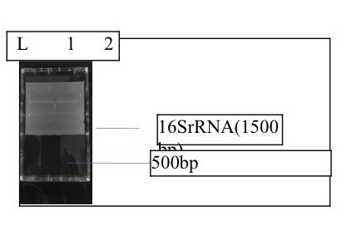
Figure 1. Agarose gel electrophoresis showing the amplified 16srRNA .
Lanes 1-2 represent the amplified 16srRNA at 1500bp while lane L represents the 100bp DNA ladder

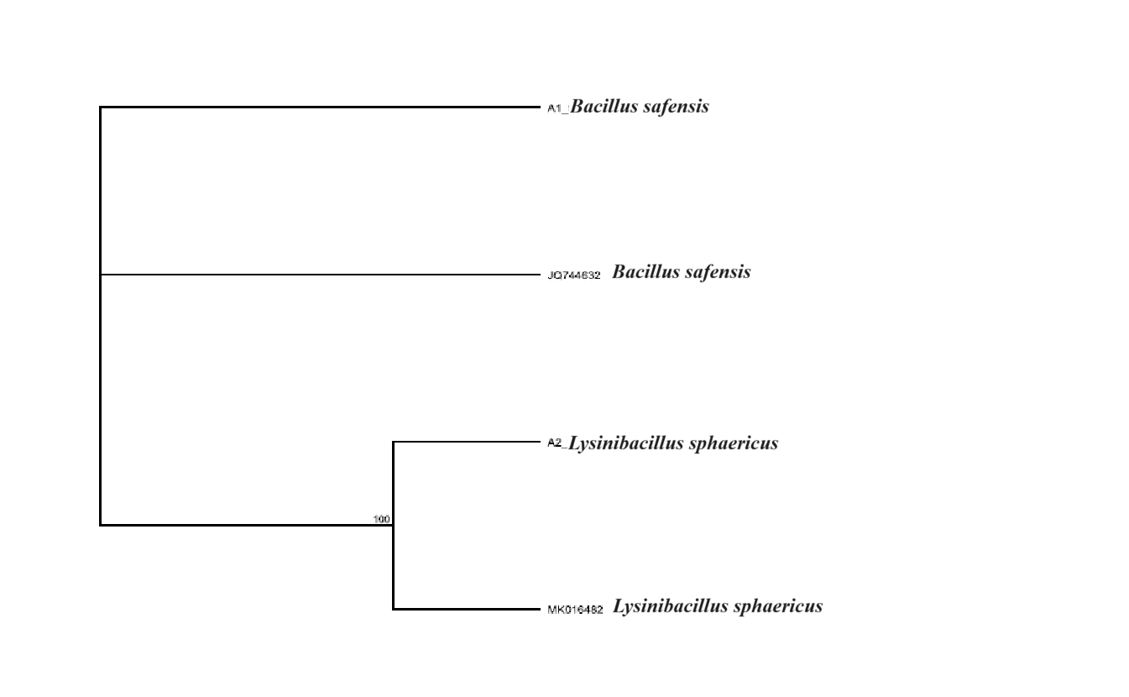
Figure 2. Phylogenetic tree showing the evolutionary distance between the bacterial isolates

Figure 3 is the electrophoretic band and Figure 4 is the phylogenetic tree showing the evolutionary distance between the fungal isolates. The obtained ITS sequence from the isolates produced an exact match during the MEGABLAST search for highly similar sequences from the NCBI non-redundant nucleotide (nr/nt) database. The ITS of the isolates showed a percentage similarity to other species at 100%. The evolutionary distances computed using the Jukes-Cantor method were in agreement with the phylogenetic placement of the ITS of the isolates within the Aspergillus and Fusarium sp. and revealed a closely relatedness to Aspergillus flavipes and Fusariun ketaroplasticum.

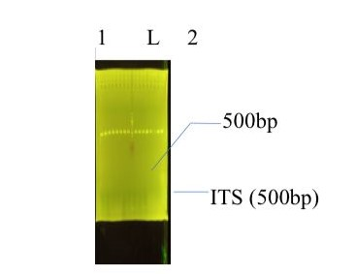
Figure 3. Agarose gel electrophoresis showing the amplified ITS fragment.
Lane 1 and 2 represent the ITS bands at 500bp while lane L represent the 100bp DNA ladder.
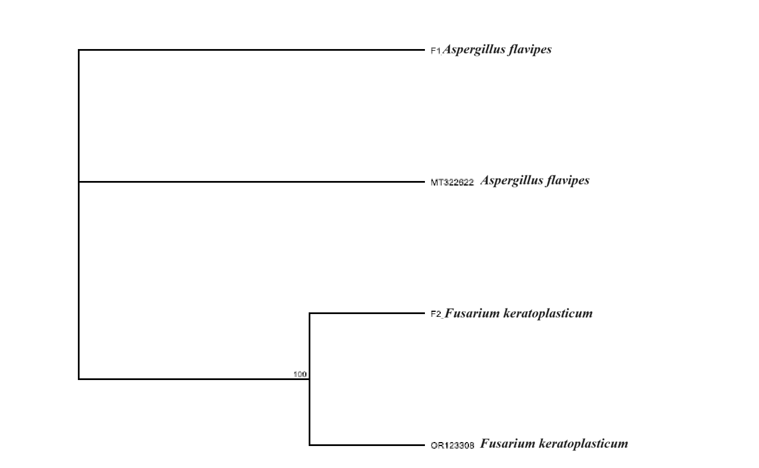
Figure 4. Phylogenetic tree showing the evolutionary distance between the fungal isolates
DISCUSSION
Dumpsite accommodates numerous and diverse microorganisms, some of which are pathogenic to other environmental inhabitants such as plants, animals and humans [19]. Internal Transcribed Spacer (ITS) region has been reported for its importance in biodiversity study and is proven to be more reliable in distinguishing fungal species [20]. Molecular investigation revealed two different bacteria and fungi genera, including Bacillus, Lysinibacillus, Aspergillus and Fusariun (Figures 1, 2, 3, 4). Based on phylogenetic analysis and top hit sequence similarity results, and supported by a high bootstrap value, the bacterial species identified include Bacillus safensis and Lysinibacillus sphaericus while the fungal species include Aspergillus flavipes and Fusariun ketaroplasticum. It was reported by Amin et al. [21] that the Bacillus spp. is very common in soil. For their successful colonization in various environmental habitats, their highly resistant endospores help them.
The works of other researchers, who employed the traditional cultural method of characterization, revealed similar fungi species with the ones isolated in this study, with species of the Aspergillus genus being predominant in the different waste dumpsites studied. Simon-Oke and Alade [22] carried out a study on two dumpsites in Akure metropolis in Nigeria and isolated Aspergillus spp among other fungal and bacterial species. The authors suggested that the low bacteria and fungi count in one of the dumpsites may be as a result of smaller size of the dumpsite and the low human activities in the area. Eleanya et al. [23] reported the isolation of Aspergillus spp, Fusarium spp., Rhizopus spp. and Mucor spp. from dumpsites in Bwari, Federal Capital Territory, Nigeria. Williams and Hakam [24] isolated Aspergillus, Fusarium, Mucor, Penicillium and Saccharomyces species from dumpsites in Port Harcourt.
CONCLUSION
The bacterial species identified to be involved in the degradation of polyethylene from the refuse dump were Bacillus sp., Lysinibacillus sp. and Pseudomonas sp. with Bacillus safensis and Lysinibacillus sphaericus being the bacterial organisms found to have the highest degradation potential while the fungal species were Aspergillus sp. and Fusarium sp. with Aspergillus flavipes and Fusariun ketaroplasticum being the fungal organisms found to have the highest degradation potential.
Disclaimer (Artificial intelligence)
Author(s) hereby declare that NO generative AI technologies such as Large Language Models (ChatGPT, COPILOT, etc.) and text-to-image generators have been used during the writing or editing of this manuscript.

References
- Gan, Z., Zhang, H., 2019. PMBD: a comprehensive plastics microbial biodegradation database. Database 2019, baz119.
- Al-Salem, S.M., Lettieri, P., Baeyens, J., 2009. Recycling and recovery routes of plastic solid waste (PSW): a review. Waste Manag. 29, 2625–2643.
- Nedi, E.G., Ebu, S.M., Somboo, M., 2024. Identification and molecular characterization of Polyethylene degrading bacteria from garbage dump sites in Adama, Ethiopia. Environmental Technology & Innovation 33, 103441
- Ali, S.S., Elsamahy, T., Koutra, E., Kornaros, M., El-Sheekh, M., Abdelkarim, E.A., Zhu, D., Sun, J., 2021. Degradation of conventional plastic wastes in the environment: a review on current status of knowledge and future perspectives of disposal. Sci. Total Environ. 771, 144719
- John, R.C., Essien, J.P., Akpan, S.B., Okpokwasili, G.C., 2012. Polycyclic aromatic hydrocarbon-degrading bacteria from aviation fuel spill site at Ibeno, Nigeria. Bull. Environ. Contam. Toxicol. 88, 1014–1019.
- Munir, E., Sipayung, F.C., Priyani, N., Suryanto, D., 2018. Potential of bacteria isolated from landfill soil in degrading low density polyethylene plastic. IOP Conf. Ser.: Earth Environ. Sci. 126, 012144
- Takei, D., Washio, K., Morikawa, M., 2008. Identification of alkane hydroxylase genes in Rhodococcus sp. strain TMP2 that degrades a branched alkane. Biotechnol. Lett. 30, 1447–1452.
- Paço, A., Duarte, K., da Costa, J.P., Santos, P.S., Pereira, R., Pereira, M.E., Freitas, A.C., Duarte, A.C., Rocha-Santos, T.A., 2017. Biodegradation of polyethylene microplastics by the marine fungus Zalerion maritimum. Sci. Total Environ. 586, 10–15.
- Azeko, S.T., Etuk-Udo, G.A., Odusanya, O.S., Malatesta, K., Anuku, N., Soboyejo, W.O., 2015. Biodegradation of linear low density polyethylene by Serratia marcescens subsp. marcescens and its Cell Free Extracts. Waste Biomass-.-. Valor 6, 1047–1057.
- Yang, J., Yang, Y., Wu, W.-M., Zhao, J., Jiang, L., 2014. Evidence of polyethylene biodegradation by bacterial strains from the guts of plastic-eating waxworms. Environ. Sci. Technol. 48, 13776–13784.
- Kowalczyk, A., Chyc, M., Ryszka, P., Latowski, D., 2016. Achromobacter xylosoxidans as a new microorganism strain colonizing high-density polyethylene as a key step to its biodegradation. Environ. Sci. Pollut. Res 23, 11349–11356.
- Delacuvellerie, A., Cyriaque, V., Gobert, S., Benali, S., Wattiez, R., 2019. The plastisphere in marine ecosystem hosts potential specific microbial degraders including Alcanivorax borkumensis as a key player for the low-density polyethylene degradation. J. Hazard. Mater. 380, 120899.
- Skariyachan, S., Megha, M., Kini, M.N., Mukund, K.M., Rizvi, A., Vasist, K., 2015. Selection and screening of microbial consortia for efficient and ecofriendly degradation of plastic garbage collected from urban and rural areas of Bangalore, India. Environ. Monit. Assess. 187, 4174
- Smits, T.H.M., Balada, S.B., Witholt, B., van Beilen, J.B., 2002. Functional analysis of alkane hydroxylases from gram-negative and gram-positive bacteria. J. Bacteriol. 184, 1733–1742.
- John, R.C., Essien, J.P., Akpan, S.B., Okpokwasili, G.C., 2012. Polycyclic aromatic hydrocarbon-degrading bacteria from aviation fuel spill site at Ibeno, Nigeria. Bull. Environ. Contam. Toxicol. 88, 1014–1019.
- Jukes, T.H., Cantor, C.R., 1969. Evolution of protein molecules. In Munro HN, editor, Mammalian Protein Metabolism, pp. 21-132, Academic Press, New York.
- Felsenstein, J. (1985). Confidence limits on phylogenies: An approach using the bootstrap. Evolution 39:783-791.
- Saitou, N., Nei, M., 1987. The neighbor-joining method: A new method for reconstructing phylogenetic trees. Molecular Biology and Evolution 4:406-425.
- Ogbuji, N.G., Ataga, A.E., Tari-Ukuta, P.M., Olisedeme, C.J., 2021. Molecular Characterization of Fungi Associated with Dump Site Soil. J Adv Biol Biotechnol 24(9): 19-30.
- Schoch, C.L., Seifert, K.A., Huhndorf, S., Robert, V., Spouge, J.L., Levesque, C.A., et al. 2012.Nuclear ribosomal internal transcribed spacer (ITS) region as a universal DNA barcode marker for fungi. PNAS USA. 09(16):1-6.
- Amin, M., Rakhisi, Z., Zarei, A.A. 2015. Isolation and identification of Bacillus species from soil and evaluation of their antibacterial properties. Avicenna J. Clin. Microbiol. Infect. 2, 23233.
- Simon-Oke, I.A., Alade, T., 2018. Survey and identification of bacteria and fungi associated with two dumpsites in Akure metropolis. Microbiol Res Int. 24(5):1-8.
- Eleanya, E.U., Oyegue, T.O., Rwang, P.G., Ozoude, T.O., Okey-Ndeche, N.F.. (2017). Microbiological analysis of dumpsites in Bwari, Federal Capital Territory, Nigeria. Microbiol Res Int. 22(3):1-6.
- Williams, J.O., Hakam, K., 2016. Microorganisms associated with dumpsite in Port Harcourt Metropolis, Nigeria. J Ecol Nat Environ. 8(2):9-12.

