Effect of methanol extract of Acanthus montanus leaf on some neuroprotective markers (C-reactive protein, catalase and glutathione peroxidase) in mercury-intoxicated Wistar rats

Abstract
Acanthus montanus (Acanthaceae), also called Bear Breech or Mountain Thistle, is a medicinal and decorative plant, which grows in shady and damp conditions in tropical West Africa and is reported to be antioxidant. The intoxication of mercury chloride (HgCl₂) causes oxidative stress which causes structural and functional damage of the brain. In this research, the authors aimed to examine the neuroprotective capability of the methanol leaf extract of A. montanus on HgCl₂-intoxicated Wistar rats. Sixteen adult men rats were separated in four groups: Group 1 (control) was given food and water alone, Group 2 was given HgCl₂ and a common drug (Diazepam), Group 3 was given HgCl₂ alone, and Group 4 was given HgCl₂ and the plant extract. Oral therapy was given over a period of 21 days and the data were analyzed by one-way ANOVA, controlling t-test with Bonferonni. The antioxidant parameters (CRP, GPx, CAT) and the histological parameters of the cerebrum and cerebellum were determined. There was significant improvement in GPx levels in the extract treated group (p < 0.05) as compared to the standard drug treated group and no significant difference existed between the extract treated and the normal control. The use of A. montanus with HgCl₂ reduced the effects of mercury on oxidative and histopathological changes. To conclude, the Acanthus montanus methanol extract had significant neuroprotective properties against the oxidative stress and microanatomical brain damage caused by HgCl₂ in Wistar rats.
Keywords: Mercury chloride, antioxidant, Acanthus montanus, C-reactive protein, glutathione peroxidase, catalase
INTRODUCTION
“Neuroprotection is the process of sustaining the structural and functional integrity of neurons of the central nervous system. It is mainly preoccupied with stopping the advancement of the disease, reducing secondary damage, and inhibiting the loss of neurons” (Lalkovičová & Danielisová, 2016). Neuroprotective agents are those compounds that can sustain normal brain functions and protect the brain structures. They can be used to treat chronic neurological disorders in their therapeutic uses to reduce the impact of the disease on the neurons and cerebral volume and ultimately, cognitive and motor functions.
“Two important processes, oxidative stress and excitotoxicity, are the targets of neuroprotective strategies. The two processes alone cause cell death in neurons, but when they co-exist, they act in a synergistic way and cause more damage than their respective effects. One of the most prevalent neuroprotective therapies is antioxidant therapy. Endogenous antioxidants, including superoxide dismutase (SOD), glutathione peroxidase (GPx), and catalase (CAT), are produced by the body and play an important part in cancelling the effects of the free radicals and reducing the effects of oxidative stress. Of these, SOD, GPx, and CAT are of great interest since they can be increased in response to the production of free radicals, thus making neurons less susceptible to damage and limiting the extent of oxidative and excitotoxic damage” (Engwa et al., 2022).
Neurodegenerative diseases like Alzheimer and Parkinson disease are long-term progressive diseases that involve progressive dysfunction and loss of neuronal structure. They are a serious health issue of the world, especially in the aging population, and their influence has been growing with the rising life expectancy (Shah et al., 2018). The conditions in question cause a significant burden on the individuals concerned, their families, and healthcare systems across the globe (Chand & Subramanian, 2025). Oxidative stress and chronic inflammation are central to the onset and the progression of these diseases, and both processes enhance neuronal damage. Following the inefficiency of some of these treatments there has been an increasing scientific interest in medicinal plants with high levels of bioactive compounds with potent antioxidant and anti-inflammatory effects. These natural products are currently under strong investigation as potential sources of the new neuroprotective therapeutic agent development (Pompermaier et al., 2018).
One of such plants that are of interest is the so-called Bear Breech /Mountain Thistle Acanthus montanus (family Acanthaceae). It is also an ornamental and medicinal plant that grows well in wet and shady environment in tropical West Africa. The leaves are employed in the treatment of a great number of diseases in traditional African medicine. The leaf decoction is commonly applied as a folk medicine towards gastrointestinal diseases whereas the root is applied as a pain reliever. The root is purported as a successful cure over abscess, the leaf extract has been employed in curing instances of threatened abortion, abdominal pains, and pains of acute gastritis, and it is also said to be an antacid. The phyto-chemical examination of the leaves indicates that the leaves possess saponins, alkaloids, flavonoids, phenols, tannin, and glycosides (3-O-2D-glucopyranoside) (Okorie et al., 2023; Ndukwe et al., 2023). Plant preparations have been used to treat abscesses that were already mature, to clear a cough, treat chest complaints and to be used as a purgative or emetic in children. It has also been employed in rheumatism, in addition, is reported to have a diuretic effect (Ghaque, 2010).
“Its conventional applications are also supported by pharmacological studies. Research has also established that A montanus methanol extracts possess several biological effects, which are anti-inflammatory, antipyretic, antimicrobial, analgesic, and immunomodulatory” (Ndukwe et al., 2023). Such bioactivities indicate that the plant can be of great neuroprotective value, especially in alleviating the impact of inflammation and oxidative stress-induced neuronal injury. Therefore, by examining the impact of methanol extracts of Acanthus montanus leaves on neuroprotective biomarkers, including C-reactive protein (CRP), catalase (CAT), and glutathione peroxidase (GPx), in test animals, e.g. Wistar rats, one might gain useful information about the potential efficacy of this substance in terms of prevention of neurodegeneration.

MATERIALS AND METHODS
Collection of plant materials
Acanthus montanus was collected from the back of Ahia Umudike, Ikwuano LGA, Abia state. The plant was identified by Dr Garuba Omosun of the Department of Plant Science and Biotechnology Department of the Michael Okpara University of Agriculture, Umudike and was thoroughly examined to ensure that they were disease-free before being authenticated by the Herbarium section of the Plant Science and Biotechnology Department of the Michael Okpara University of Agriculture, Umudike, Nigeria.
Reagents/chemicals
The reagents used in this study include 2mg/kg Diazepam (Roche, Lagos, Nigeria), 10% formalin, 70% methanol, distilled water, and 0.24g/kg HgCl₂ (Roche, Lagos, Nigeria) for intoxication.
Dosage, preparation, and administration of the extract
The leaves of the Acanthus montanus plant were collected, hand-separated from the stem, the leaf were air-dried for one week, and milled into a fine powder using an electric blender (Moulinex) at the National Root Crops Research Institute (NRCRI), Umudike.
Seven hundred millilitres of distilled methanol was used to dissolve 100g of powdered sample in a conical flask and allowed to stand for 48hours. The suspensions were filtered, and the filtrate concentrated using a mild heat (50 °C with a water bath) to dryness.
For each fresh preparation, one gram of the extract was dissolved in 2ml of twin 80 and 8 mL of distilled water to make the stock solution termed Acanthus montanus methanol extract. Based on the method of Ajao and Akindele (2013), 400 mg/kg body weight was administered.
Dosage, preparation, and administration of mercuric chloride.
A sample of mercury chloride of 0.25g was dissolved in 50 mL of distilled water to form a solution. 250mg/kg b.w of mercury chloride was administered daily for 21 days based on the method of Sheikh et al. (2013) orally using a garage.
Experimental design
A total of sixteen (16) rats were randomly divided into four groups of 4 rats each, which received varying doses of extract, standard drug and toxicant daily for two (2) weeks, orally.
Group 1: Control
Group 2:(extract group): Mercury chloride induced (250mg/kg) + Acanthus. monthanus
at a dose of 400 mg/kg b.w
Group 3: (standard group): Mercury chloride induced(250mg/kg) + Diazepam standard drug at a dose of 2 mg/kg b.w
Group 4: (untreated group): Mercury chloride induced(250mg/kg)

Estimation of Catalase
The activity of catalase was assayed by the method of Sinha (1972).
Principle: Dichromate in acetic acid was converted to chromic acetate upon heating with hydrogen peroxide, resulting in the creation of per chromic acid as an unstable intermediary. The chromic acetate produced was assessed at 590 nm. Catalase was permitted to decompose H2O2 for varying durations. The reaction was halted at various time intervals through the addition of a dichromate and acetic acid mixture, and the residual H2O2 was quantified by calorimetric measurement of chromic acetate after heating the reaction mixture
Procedure: To 0.9 ml of phosphate, 0.1 ml of plasma and 0.4 ml of H₂O₂ was added. The reaction was initiated by adding 2 ml of the dichromate acetic acid mixture. The tubes were kept in a boiling water bath for 10 minutes, cooled and the colour developed was read at 530 nm at intervals of 30 minutes for 2 hrs. Standards in the concentration range of 20-100 micromoles were processed for the test. The activity of catalase was expressed as U/ml for plasma (U- micromoles of H₂O₂ utilised / second).
Estimation of Glutathione Peroxidase
This was done according to the method of Paglia and Valentine (1967).
Principle: Glutathione Peroxidase (GP_{X}) catalyses the oxidation of Glutathione (GSH) by Cumene Hydroperoxide. In the presence of Glutathione Reductase (GR) and NADPH, the oxidised Glutathione (GSSG) is immediately converted to the reduced form with a concomitant oxidation of NADPH and NADP^{+.} The decrease in absorbance at 340 nm is measured.
2GSH + ROOH GSSG + ROH + H₂0
GSSG + NADPH + H⁺ NADP+ + 2GSH
Procedure: A known volume, 0.05 ml of heparinised whole blood, was diluted with 2 ml of diluting reagent, and this was used for the assay. A volume, 50 μL of diluted sample was mixed with1ml of R1 and R2, respectively. The initial absorbance of both test and blank was read after 1 min, and the timer started simultaneously. Absorbances were read again after 1- and 2-mins intervals at 340 nm.
Glutathione Peroxidase activity was calculated from the formula below.
U/L of hemolysate = 8412 x ΔA 340 nm/minute.
Estimation of C-reactive protein
TURBILYTE-CRP is a turbidimetric immunoassay for the determination of C-reactive protein in human serum and is based on the principle of agglutination reaction. The test specimen is mixed with activation buffer [R1], TURBILYTE-CRP latex reagent [R2] and allowed to heat. The presence of CRP in the test specimen results in the formation of an insoluble complex, producing a turbidity, which is measured at 630nm wavelength. The increase in turbidity corresponds to the concentration of CRP in the specimen.
Concentration of CRP = Absorbance of Sample X conc. of standard
Absorbance of standard

Histopathological Examination
Tissue preparation
The surviving experimental rats were humanely sacrificed at the end of the study. Sections of the cerebrum and cerebellum from the animals in the experimental groups were collected for histopathological examination. The samples were fixed in 10% phosphate-buffered formalin for a minimum of 48 hours. The tissues were subsequently trimmed, dehydrated in 4 grades of alcohol (70%, 80%, 90% and absolute alcohol), cleared in 3 grades of xylene and embedded in molten wax. On solidifying, the blocks were sectioned, 5µm thick with a rotary microtome, floated in water bath and incubated at 60˚C for 30 minutes. The 5µm thick sectioned tissues were subsequently cleared in 3 grades of xylene and rehydrated in 3 grades alcohol (90%, 80% and 70%). The sections were stained with Hematoxylin for 15 minutes. Bluing was done with ammonium chloride. Differentiation was done with 1% acid alcohol before counterstaining with Eosin. Permanent mounts were made on degreased glass slides using a mountant, DPX.
Slide examination
The prepared slides were examined with a Motic™ compound light microscope using x4, x10 and x40 objective lenses. The photomicrographs were taken using a Motic™ 5.0 megapixel microscope camera at x160 and x400 magnification.
Statistical analysis
Analysis of variance (ANOVA) followed by a multiple two-tailed t’ test with Bonferroni modification was used for statistical analysis of the collected data. Differences were considered significant when p<0.05.

Results and discussion
Effect of Methanol leaf extract of Acanthus montanus on GPx in cerebrum and cerebellum in Wistar rats

Fig 1: Effect of the Methanol extract of Acanthus montanus on the GPx of the Wistar rat
Effect of Methanol leaf extract of Acanthus montanus on CAT in cerebrum and cerebellum in Wistar rats

Fig. 2: Effect of the Methanol leaf extract of Acanthus montanus on CAT in Wistar rats

Effect of Methanol leaf extract of Acanthus montanus on C-reactive protein in cerebrum and cerebellum in Wistar albino rats

Figure 3: Effect of Methanol leaf extract of Acanthus montanus on C-reactive protein in Wistar albino rats

Plate 1 : Histological sections of the Cerebrum

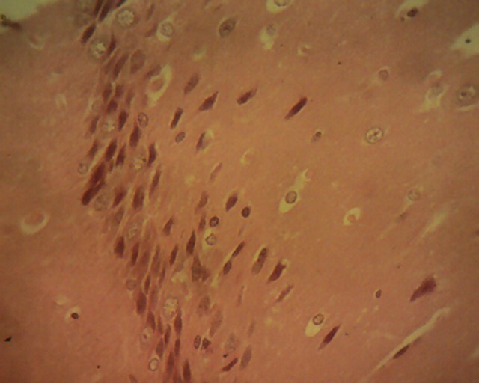
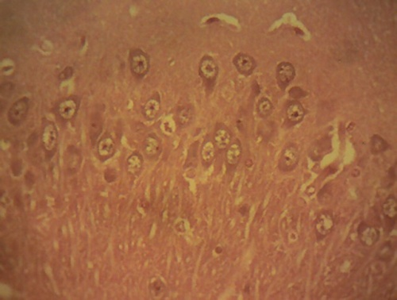
Np
Np
G
N
CONTROL GROUP: These sections of the cerebrum showed normal histological features of the grey and white matter of the brain parenchyma. Normal neuronal cell bodies (N) which appeared to vary in size and in shape were observed. They show large amount of pale blue cytoplasm and centrally located, vesicular nuclei with prominent nucleolus. The neurons are embedded in a coarse, richly vascularized framework of glial cells (G), capillaries and neuropil (Np).

EXTRACT (ACANTHUS MONTANUS): Sections of the Cerebrum collected from the animals in this group showed a marked widespread neuronal degeneration and necrosis in both the gray and white matter. The neurons of the hippocampus appear to be mostly affected. The necrotic neurons (white arrow) are shrunken with deeply basophilic cytoplasm and pyknotic nuclei. Relatively normal neuron (Blue arrow); Neuropil (Np). H and E x400.

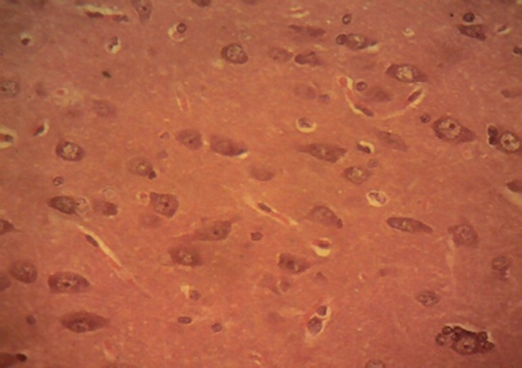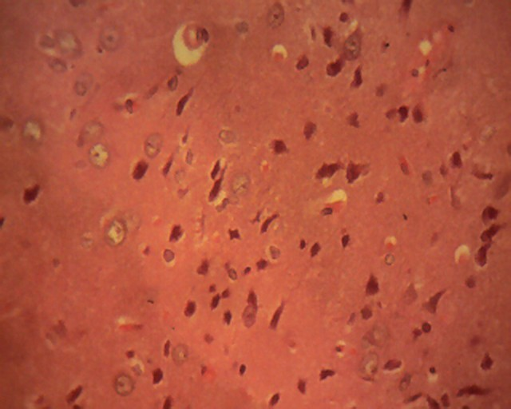
UNTREATED GROUP: Sections of the Cerebrum collected from the animals in this group showed a marked widespread neuronal degeneration and necrosis in both the gray and white matter. The neurons of the hippocampus appear to be mostly affected. The necrotic neurons (white arrow) are shrunken with deeply basophilic cytoplasm and pyknotic nuclei. The astrocytes were swollen (black arrow). Relatively normal neuron (Blue arrow);Neuropil (Np). HandE x400.

8
STANDARD DRUG: Sections of the cerebrum collected from the animals in this group showed the normal cerebral histomorphology. See the control group for details. Neurons (white arrow); Astrocytes (black arrow); blood capillary (blue arrow); Neuropil (Np). HandE x400.

plate 2: Histological Sections Of The Cerebellum

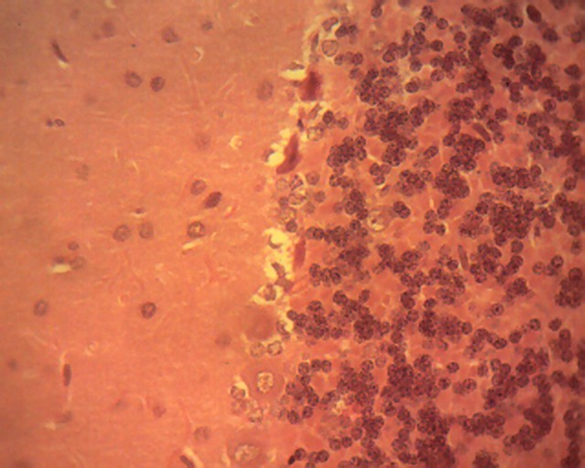
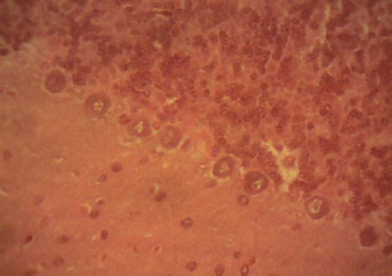
EXTRACT(ACANTHUS MONTANUS):Sections of the cerebellum collected from the animals in this group showed a marked purkinje cell degeneration and necrosis (black arrow) leading to a decrease in the observable numbers of purkinje cells. The cells of the granular layer also showed marked cellular necrosis with nuclear pyknosis (white arrow). Molecular layer (M); granular layer (G). H and E x400.

STANDARD DRUG: Sections of the cerebellum collected from the animals in this group showed a very mild purkinje cell degeneration and necrosis (white arrow). Molecular layer (M); normal purkinje cells (black arrow); granular layer (G). H and E
CONTROL GROUP: The cerebellum showed its normal histolomorphological features. The neuronal cell bodies of the molecular layer (M), the Purkinge cells (black Arrow) and the granular cells of the granular layer (G) all showed their normal histomorphological features. H and E x400
G
M
G
M
G

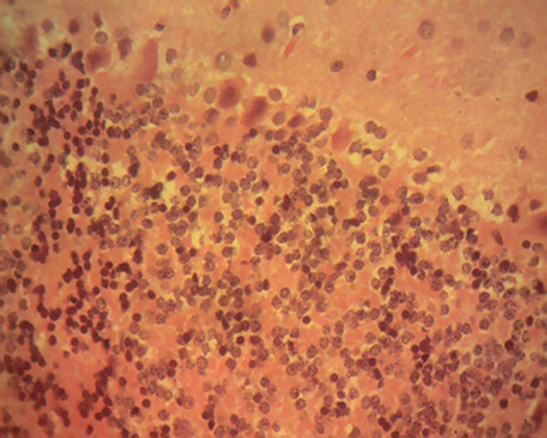

“Mercury chloride (HgCl₂) is a highly toxic and corrosive chemical substance. Several studies were focused on the implementation of free radicals and oxidants (such as hydrogen peroxide) in the brain injury induced by HgCl₂” (Jha et al., 2019). “It is also already known that HgCl₂ also demolishes protective antioxidants, and reduces free radical scavenging systems, such as superoxide dismutase (SOD), Catalase (CAT) and glutathione peroxidase (GPx)” (Ibrahim, 2015). Aerobic organs employ a battery of defense mechanisms such as antioxidant enzymes (SOD, Catalase, Glutathione, Nitric Oxide and glutathione peroxidase) to mitigate or prevent oxidative tissue damage.
The result in Figure 1 showed a significant (p≤0.05) increase in glutathione peroxidase (GPx) concentration in the untreated group when compared to other treated groups. “However, the highest level of GPx was shown in the group that received methanol extract of Acanthus montanus leaves in cerebrum and there was a reduced level of GPx in cerebellum when compared with intoxicated + std drug and normal control, though, the lowest level of glutathione peroxidase is recorded in the normal control group of cerebrum in figure 1.GPx protects your vision, boosts your immune system, helps turn carbohydrates into energy, and prevents the build-up of oxidized fats that may contribute to atherosclerosis. Glutathione sulfide reductase is responsible for converting GSSG to GSH. GPx is a marker of oxidative stress’” (Csiszár et al. 2016). “This finding is in agreement with our result, as observed in the elevated level of GPx in the intoxicated + untreated group. The elevation in the activities of GPx and CAT may be an adaptive process to counter the increased free radicals generated by HgCl₂ exposure in the brain, which agrees with reports” (Abubakar et al., 2024). “However, we observed the significant elevation of the GSH by Acanthus montanus administration. The antioxidant activity of this plant is attributable to the presence of flavonoids as bioactive compounds in this extract. Particularly, the methanol extract (that we used in this study) was reported to possess a higher total phenol, reducing power and free radical scavenging ability than the ethanolic extract” (Oboh et al., 2010). Parcheta et al. (2019) asserted that “the antioxidant activity of phenolic compounds is mainly due to their redox properties, which play an important role in absorbing and neutralising free radicals, quenching singlet and triplet oxygen, or decomposing peroxides. This property also accounts for the significant reduction of GPx activities, having been augmented by the antioxidant content of Acanthus montanus. Activities of antioxidant enzymes were also restored concomitantly when compared to the HgCl₂ control rats after Acanthus montanus administration”.
Figure 2: showed a significant (p≤0.05) increase in CAT level in intoxicant + (400mg/kg Acanthus montanus) in cerebellum and cerebrum of male Albino rats of mercury chloride-induced neurotoxicity and treated with Acanthus montanus. There was a recorded significant (p≤0.05) decrease in CAT level in the untreated group when compared to other treated groups (intoxicant + std drug, and intoxicant + extract group) and normal control. “However, there was a significant (p≤0.05) increase in the level of CAT in all the intoxicant + extract group when compared to the std drug group. Catalase is an enzyme used to protect the cell from oxidative damage by reactive oxygen species” (Gebicka & Krych-Madej, 2019). “Catalase is the only antioxidant enzyme increased both at the mRNA and at the activity levels during human lung morphogenesis towards term” (Lei et al., 2016). “Individuals with acatalasemia, a rare congenital condition with catalase deficiency in erythrocytes and lower levels of catalase activity in other tissues, seem to be asymptomatic” (Ando et al., 2024), although an increased incidence of diabetes mellitus has been reported. “Both polyethene glycol conjugated catalase and liposome-entrapped catalase protect against oxygen toxicity, but greater benefits are accomplished with the combination of PEG-SOD and PEG-CAT” (Li et al., 2018) or liposome-entrapped SOD and CAT.
The data of the result in the figure. 3 shows the effect of Acanthus montanus on C-reactive protein (CRP) had a significant (p≤0.05) decrease in all the intoxicated + Extract (Acanthus montanus) in cerebrum and cerebellum when compared with the untreated. “However, there was a significant decrease in intoxicated + standard drug when compared with the normal control. C-reactive protein (CRP) has been the most extensively studied marker of inflammation. It is a novel plasma marker of atherothrombotic disease. The level of C-reactive protein (CRP) in the peripheral blood is used as a biomarker of systemic inflammation and is associated with increased risk of coronary heart disease, vascular death, and cancer death” (Shrivastava et al., 2015). “CRP is synthesised in hepatocytes and plasma. CRP concentrations are transiently and significantly elevated during acute inflammation” (Shrivastava et al., 2015). This finding concurs with our result as observed in the elevation of CRP level in the untreated groups of cerebrum and cerebellum.
“In the histological analysis, the neurotoxicity of HgCl₂ in the rat hippocampus was well demonstrated by the neuronal degeneration noted by the pyknotic neurons in the granule layer of the dentate gyrus (DG) of the rats, which is in agreement with a previous report” (Enogieru & Ezennia, 2024). “Similarly observed was the HgCl₂-induced death of pyramidal neurons of the cerebrum and cerebellum in the untreated group, with distortion of the layered microanatomy of the neurons, with some neurons showing features compatible with pyknosis and some with karyolysis. The degeneration of Purkinje cells observed in HgCl₂–treated cerebellum, especially the complete loss of nuclear materials, clearly shows the damage to DNA by its toxicity” (Bittencourt et al., 2021). “The eosinophilia, lack of nuclear material, death of the Purkinje cells, and loss of basophilia agree with previous reports (Morales-Camacho et al., 2024). Similarly, since is the focal neuron of the cerebellum, Purkinje cell death will inevitably affect the coordinating role of the cerebellum as regards movement of voluntary skeletal muscle, posture and gait, leading to such features as muscular hypotonia, intentional tremor, and nystagmus” (Snell, 2006).

Conclusion
In conclusion, the results seen biochemically and histologically across all groups treated simultaneously with Acanthus montanus and HgCl2 indicate the strong antioxidant capability of Acanthus montanus to eliminate or lessen many of the aforementioned effects in the affected rats. This reinforces earlier findings by Rao & Owoeye (2015) that toxicity from HgCl2 due to oxidative damage can be reduced by antioxidants, as shown in this experiment with Acanthus montanus. Acanthus monthanus has been considered one of the promising medicinal plants in modern ethnomedicine. In conclusion, our findings suggest that Acanthus montanus has the capacity to protect the Wistar rat brain from HgCl₂-induced oxidative stress and degeneration of the cerebellum and cerebrum, possibly via its antioxidant capacity.

Conflict of interest
No conflict of interest.

Disclaimer (Artificial intelligence)
Option 1:
Author(s) hereby declare that NO generative AI technologies such as Large Language Models (ChatGPT, COPILOT, etc.) and text-to-image generators have been used during the writing or editing of this manuscript.
Option 2:
Author(s) hereby declare that generative AI technologies such as Large Language Models, etc. have been used during the writing or editing of manuscripts. This explanation will include the name, version, model, and source of the generative AI technology and as well as all input prompts provided to the generative AI technology
Details of the AI usage are given below:
1.
2.
3.

References
Abubakar, M. G., Agbon, A. N., Musa, S. A., Hamman, W. O., & Oladele, S. B. (2024). Biochemical, morphological and molecular assessments of n butanol fraction of Phoenix dactylifera L. following exposure to inorganic mercury on the liver of Wistar rats. Laboratory Animal Research, 40(1), 15.
Ando, M., Fukushima, K., & Nishizaki, K. (2024). The discovery of acatalasemia (lack of catalase in the blood) and its significance in human genetics. Proceedings of the Japan Academy, Series B, 100(7), 353-367.
Bernhoft R.A. (2012): Mercury Toxicity and Treatment: A review of the literature. J Environ and Pub Health, Article ID 460508, 10 pages doi:10.1155/2012/ 460508.
Bittencourt, L. O., Chemelo, V. S., Aragão, W. A. B., Puty, B., Dionizio, A., Teixeira, F. B., ... & Lima, R. R. (2021). From molecules to behavior in long-term inorganic mercury intoxication: unraveling proteomic features in cerebellar neurodegeneration of rats. International Journal of Molecular Sciences, 23(1), 111.
Chand, J., & Subramanian, G. (2025). Neurodegenerative disorders: types, classification, and basic concepts. In Multi-factorial approach as a therapeutic strategy for the management of Alzheimer’s disease (pp. 31-40). Singapore: Springer Nature Singapore.
Csiszár, J., Horváth, E., Bela, K., & Gallé, Á. (2016). Glutathione-related enzyme system: glutathione reductase (GR), glutathione transferases (GSTs) and glutathione peroxidases (GPXs). In Redox state as a central regulator of plant-cell stress responses (pp. 137-158). Cham: Springer International Publishing.
Engwa, G. A., Nweke, F. N., & Nkeh-Chungag, B. N. (2022). Free radicals, oxidative stress-related diseases and antioxidant supplementation. Alternative Therapies in Health & Medicine, 28(1).
Enogieru, A. B., & Ezennia, M. C. (2024). Mercury chloride-induced hippocampal toxicity in Wistar rats: antioxidant activity of folic acid. Journal of Phytomedicine and Therapeutics, 23(2), 1598-1606.
Gebicka, L., & Krych-Madej, J. (2019). The role of catalases in the prevention/promotion of oxidative stress. Journal of inorganic biochemistry, 197, 110699.
Ibrahim, A. T. A. (2015). Effects of mercury chloride on oxidative stress biomarkers of some tissues of the African catfish Clarias gariepinus (Burchell, 1822).
Lalkovičová, M., & Danielisová, V. (2016). Neuroprotection and antioxidants. Neural regeneration research, 11(6), 865-874.
Lei, X. G., Zhu, J. H., Cheng, W. H., Bao, Y., Ho, Y. S., Reddi, A. R., ... & Arnér, E. S. (2016). Paradoxical roles of antioxidant enzymes: basic mechanisms and health implications. Physiological reviews, 96(1), 307-364.
Li, R., Zhou, X., Liu, D., & Feng, W. (2018). Enhancing the activity and stability of Mn-superoxide dismutase by one-by-one ligation to catalase. Free Radical Biology and Medicine, 129, 138-145.
Morales-Camacho, R. M., Caballero-Velázquez, T., Borrero, J. J., Bernal, R., & Prats-Martín, C. (2024). Hematological Neoplasms with Eosinophilia. Cancers, 16(2), 337.
Ndukwe, G. I., Okoronkwo, O. F., & Jack, I. R. (2023). Phytochemical contents and in vitro pathogenic microbial growth inhibitory activities of Acanthus montanus root and leaf extracts. Nigerian Journal of Chemical Research, 28(2), 128-141.
Oboh G., Nwanna E., Elusiyan C. (2010): Antioxidant and Antimicrobial Properties of Telfairia occidentalis (Fluted pumpkin) Leaf Extracts. J Pharmacol Toxicol 2010; 5(8), 539-547.
Owoeye O., Farombi E.O. (2015): Tomato pomace protects against mercuric chloride-induced neurodegeneration and motor abnormality in adult rat. Int. J. Biol. Chem. Sci. 9(3), 1142-1153
Parcheta, M., Świsłocka, R., Orzechowska, S., Akimowicz, M., Choińska, R., & Lewandowski, W. (2021). Recent developments in effective antioxidants: The structure and antioxidant properties. Materials, 14(8), 1984.Jha, A., Saidullah, B., & Bubber, P. (2019). A study on prooxidative and neurotoxic effects of mercury chloride in rats. EC Pharmacology and Toxicology, 7, 112-124.
Pompermaier, L., Marzocco, S., Adesso, S., Monizi, M., Schwaiger, S., Neinhuis, C., ... & Lautenschläger, T. (2018). Medicinal plants of northern Angola and their anti-inflammatory properties. Journal of Ethnopharmacology, 216, 26-36.
Rao M., Purohit A. (2011): Neuroprotection by Melatonin on Mercury Induced Toxicity in the Rat Brain. Pharmacology & Pharmacy. 2, 375-385
Shrivastava, A. K., Singh, H. V., Raizada, A., & Singh, S. K. (2015). C-reactive protein, inflammation and coronary heart disease. The Egyptian Heart Journal, 67(2), 89-97.
Sinha, A. K. (1972). Colorimetric assay of catalase. Analytical biochemistry, 47(2), 389-394.
Snell R.S. (2006): Clinical Neuroanatomy. (6th edn). Lippincott Williams & Wilkins Co.: Philadelphia, 298-308.

Uma C., Poornima K., Surya S., Raviku2mar G., Gopalakrishnan V.K. (2012): Nephroprotective effect of ethanolic extract of Tabernaemontana coronaria in mercuric chloride induced renal damage in Wistar albino rats. J Environ Pub Health, Article ID 460508, 10 pages. doi:10.1155/2012/460508
Okorie, N. H., Ali, I. J., Nnadi, C. O., & Ani, D. I. (2023). Anti-ulcer activity of crude extract and fractions of Acanthus montanus (Nees) T. Anderson on Indomethacin-Induced Ulcer. Trop J Nat Prod Res, 7(5), 3017-3021.
Ndukwe, G. I., Okoronkwo, O. F., & Jack, I. R. (2023). Phytochemical contents and in vitro pathogenic microbial growth inhibitory activities of Acanthus montanus root and leaf extracts. Nigerian Journal of Chemical Research, 28(2), 128-141.
Shah, N., Nariya, A., Pathan, A., Patel, A., Chettiar, S. S., & Jhala, D. (2018). Neuroprotection effects of Celastrus paniculatus seed oil against monosodium glutamate in human IMR-32 cells. Annual Research & Review in Biology, 24(2), 1–9.

