Caesarean section followed by ovariohysterectomy: a successful surgical intervention of dystocia due to emphysematous fetuses in a queen persian cat
Abstract
A 3-year-old female persian short-haired cat was presented at Teaching and Training Pet Hospital and Research Center (TTPHRC), Dhaka with a 24-hour history of unproductive labor and restlessness. Physical examination revealed abdominal distension and purulent vaginal discharge. Radiographic evaluation demonstrated a single retained fetus with gas opacity within the uterus, consistent with fetal emphysema, indicating fetal death and decomposition. A diagnosis of dystocia due to emphysematous fetus was established. An emergency cesarean section was performed under general anesthesia, and the decomposed fetus was removed. Because of the high risk of metritis and potential future reproductive complications, an ovariohysterectomy was performed during the same surgical session. Postoperative management included fluid therapy, broad-spectrum antibiotics, and analgesics. The queen recovered from anesthesia uneventfully and was discharged from hospital from recovery.
Keywords: Fetal emphysema, Dystocia, Caesarean section, Ovariohysterectomy

Introduction
“Dystocia, or difficult labor, is a condition where the mother is unable to deliver the fetus naturally without the aid of medicine or surgery” [8]. “Dystocia is less common in small animals like dogs and cats. According to research, between 3.3% and 5.8% of all births in cats result in dystocia” [7]. “Fetal and maternal factors are the two main causes of dystocia. Preterm birth is caused by several factors, including small pelvic size, anomalies of the caudal reproductive system, primary or secondary uterine inertia, starvation, parasitism, other abnormalities of the uterus, aberrant ejection induced by causes other than uterine, and other maternal factors” [7].
According to [1] “uterine inertia, often known as ineffective or nonexistent uterine contractions after parturition, is the most frequent reason for maternal dystocia”. There are two types of this condition: primary and secondary inertia [6]. “The primary cause of uterine inertia is the uterine muscle's inability to contract sufficiently due to a range of physiological or chemical factors. Medication is typically used to manage emergencies related to pregnancy. Surgery is necessary when medical treatment for the emergency condition is ineffective. According to a study, between 60 and 80 percent of bitch and queen dystocia instances require surgical intervention” [11]. “When dystocia persists or when fetal death and emphysema are suspected, cesarean section (C-section) becomes the recommended and often life-saving procedure. Early surgical intervention markedly improves maternal outcomes and prevents complications such as metritis, toxemia, or retained fetal tissues” [9]. “Advances in anesthetic safety, perioperative stabilization, and neonatal resuscitation protocols support the use of C-section as an effective and reliable method for managing complicated dystocia in queens” [4]. Therefore, understanding the causes and clinical implications of dystocia including fetal emphysema is essential for ensuring optimal reproductive outcomes. Recently, the pet population mostly cats is being increased and more dystocia cases are being found. Here, this study employs radiographic and ultrasonographic tools to diagnose the presence of three emphysematous fetuses in the uterus, leading to an emergency cesarean section in a Persian cat followed by ovariohysterectomy.
Materials and methods
i. Case Presentation
On October 17, 2023, a 3-year-old Persian queen cat (Fig. 1) with dystocia symptoms and a body weight of 4.5 kg was brought to the Teaching and Training Pet Hospital and Research Center (TTPHRC). The cat was mated naturally and fulfilled the 65 days of gestation. The cat displayed parturition symptoms such as anorexia, panting, agitation, and straining throughout the day. When there was no more improvement and the cat became depressed, the cat was sent to the hospital.
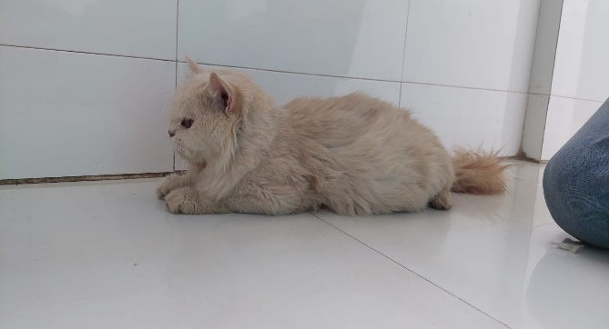

Figure 1: A Persian cat presented to TTPHRC
ii. Case Diagnosis
The abdomen was tight and swollen upon clinical examination. A vaginal examination revealed edematous vulvar lips with bloody discharge but no visible fetus or fetal component. Additionally, the case was referred to diagnostic unit for ultrasound scanning and radiographic examination of the abdomen, both of which revealed the presence of three dead and emphysematous fetuses (Fig. 2). Dystocia was diagnosed in the case and suggested emergency cesarean section. A cesarean section was performed followed by an ovariohysterectomy to remove the dead emphysematous fetuses.
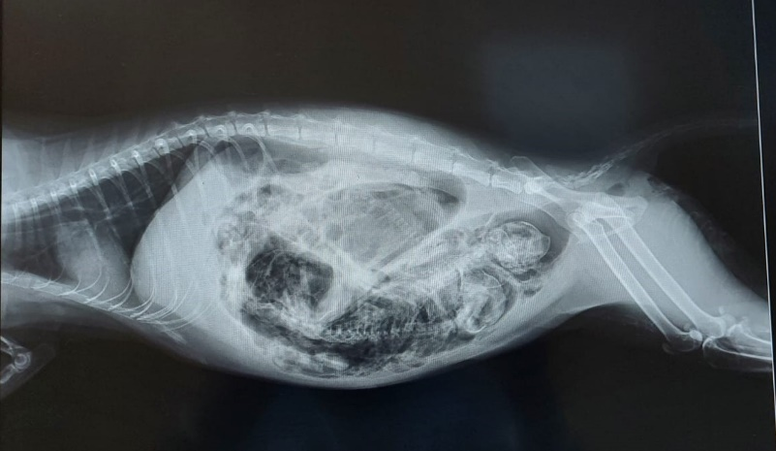

Figure 2: X-ray reveals the presence of emphysematous fetuses
iii. Surgical procedure
First, the queen cat was given an intramuscular (IM) injection of xylazine (xylazine®, Modern Agencies Ltd.) at a dose of 1 mg/kg of body weight. After fifteen minutes, the cat was sedate and it was secured to the operating table with side ropes and cushions to help it stay in place. The surgical site was then clipped, shaved, and disinfected with povidone-iodine (Povisep®, Jayson Pharmaceuticals Ltd.). Finally, the patient was covered with a surgical draper. After that, the cat was given a ketamine (Ketalar®, Popular Pharmaceuticals Ltd.) injection at a dose of 8 mg/kg of body weight to induce general anesthesia.
A 5–6 cm incision was made at the ventral abdominal midline, and caudal to 1 cm below the umbilicus. Subsequent incisions were made in the skin, subcutaneous tissue, linea alba, and peritoneum. To avoid major blood arteries and the placental belt, a longitudinal incision was made on the larger curvature of the uterus around the point where the uterine horns divide. The left uterine horn was used to remove the three fetuses. Ovariohysterectomy was then begun.
The left ovary was promptly grasped using artery forceps, and the distal arteries were clamped off. The procedure was repeated for the right ovary. Then we tied up the uterine veins that ran down each side. An arterial forceps was used to access the uterine body. Polyglactin 910 2−0 was employed to form a strong ligature around the cervix. The uterus and ovaries were isolated from other components using sterile scissors and sterile artery forceps.
One centimeter up the cranium, the uterus and cervix were separated. The crushing stopped the bleeding. To remove more blood, a surgical mop was employed. Before closing the abdominal wound, we carefully checked for any indications of bleeding. The muscles, subcutaneous tissue, and peritoneum were closed with simple continuous sutures made of Polyglactin 910 2−0.
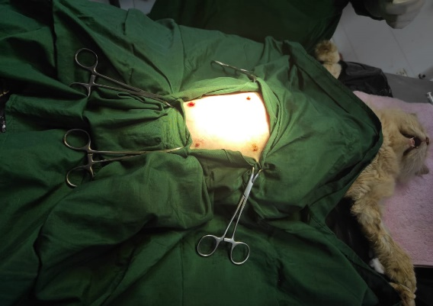  (a) operative site with surgical drape | 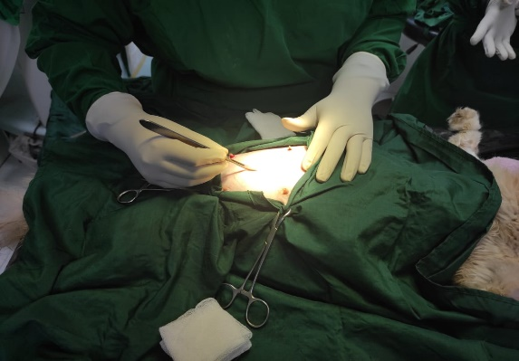  (b) Incision on the surgical site
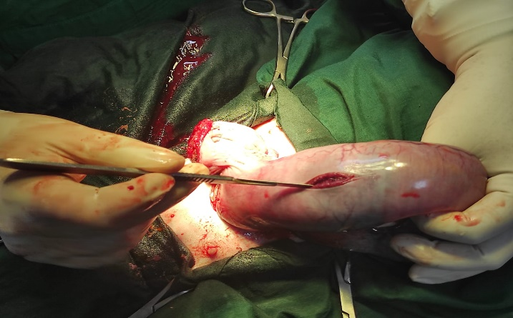  (  c) Removal of the dead fetuses from the horn | 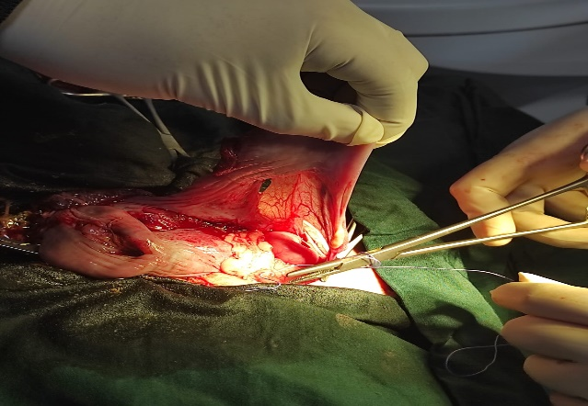  (d) Ligation of ligament cranial to the ovary by suture material for ovariohysterectomy
Figure 3: Different steps of C-section and Ovariohysterectomy in cat (a - d).
iv. Post-operative care
The queen was also given a painkiller (Mel-Vet®, Acme Laboratories Ltd.) at 0.2 mg/kg body weight, subcutaneously once daily for two days, and a broad-spectrum antibiotic called ceftriaxone (Triject-Vet®, Eskayef Pharmaceuticals Ltd.) at 50 mg/kg body weight IM at 24-hour intervals for seven days. External skin stitches were removed after full healing.
DISCUSSION
Dystocia in the queen is an uncommon but potentially life-threatening reproductive emergency that may arise from maternal or fetal causes [12]. Fetal causes include malpresentation, fetal oversize, and fetal death, while maternal causes involve uterine inertia, pelvic narrowing, or uterine torsion [10]. In the present case, dystocia was attributed to the presence of a dead and emphysematous fetus, which likely resulted in mechanical obstruction and secondary uterine inertia. Fetal emphysema is a post-mortem change occurring within the uterus due to bacterial invasion of fetal tissues, leading to gas formation and putrefaction [4]. The condition is usually associated with prolonged intrauterine retention of a dead fetus, which predisposes the dam to endotoxemia and septic metritis [3]. In such cases, medical management with oxytocin or calcium is rarely successful, as the uterus becomes atonic and unable to expel the decomposed fetus [10]. Therefore, surgical intervention via cesarean section is considered the treatment of choice when fetal death or emphysema is suspected [12]. Radiography is a valuable diagnostic tool in differentiating emphysematous fetuses, as the presence of gas within the uterus or fetal structures is pathognomonic [5]. In this case, radiographic findings of intrauterine gas confirmed the diagnosis and guided the decision for immediate surgical correction. Similar findings were reported by [9] in a feline dystocia case caused by emphysematous fetuses, where prompt cesarean section was essential for the survival of the queen. Following removal of the nonviable fetus, ovariohysterectomy was performed to prevent postoperative uterine infection and recurrence of reproductive complications. Performing ovariohysterectomy in such cases is supported by previous reports recommending it when the uterus is contaminated, necrotic, or severely distended [4]. Moreover, concurrent removal of the uterus eliminates the risk of pyometra, endometritis, or future dystocia, improving long-term prognosis [4]. Postoperative recovery was uneventful in this case, consistent with earlier studies indicating that early surgical management combined with broad-spectrum antibiotics, analgesia, and fluid therapy results in favorable outcomes [2].
CONCLUSION
This case emphasizes the importance of early recognition and timely surgical intervention in feline dystocia, particularly when complicated by emphysematous fetal death. Radiographic evaluation plays a vital role in identifying nonviable fetuses and determining the need for cesarean section. Concurrent ovariohysterectomy can be an effective therapeutic and preventive measure in such cases. With proper perioperative care, affected queens can recover completely and maintain good health post-surgery.
Acknowledgements
The authors would like to thank all faculties and staffs Teaching and Training Pet Hospital and Research Center, CVASU for their support and effort to conduct this study.
Conflict of interest
The authors declare no conflict of interest, financial, or otherwise.

Disclaimer
This paper is an extended version of a Thesis document of the same author.
The Thesis document is available in this link: http://dspace.cvasu.ac.bd/jspui/bitstream/123456789/2607/1/Junayed%2c%20Roll-14-12.pdf

Disclaimer (Artificial intelligence)
Option 1:
Author(s) hereby declare that NO generative AI technologies such as Large Language Models (ChatGPT, COPILOT, etc.) and text-to-image generators have been used during the writing or editing of this manuscript.
Option 2:
Author(s) hereby declare that generative AI technologies such as Large Language Models, etc. have been used during the writing or editing of manuscripts. This explanation will include the name, version, model, and source of the generative AI technology and as well as all input prompts provided to the generative AI technology
Details of the AI usage are given below:
1.
2.
3.

References
[1] Barolia Y, Purohit GN, Kumar P, Prajaput LN, Yadsv S.Dystocia due to secondary uterine inertia in a bitch. J. canine develops. 2010 Res., 6:66-68. DOI: 10.13140/RG.2.2.29601.45928
[2] de Jonge SW, Boldingh QJ, Solomkin JS, Dellinger EP, Egger M, Salanti G, Allegranzi B, Boermeester MA. Effect of postoperative continuation of antibiotic prophylaxis on the incidence of surgical site infection: a systematic review and meta-analysis. The Lancet Infectious Diseases. 2020 Oct 1;20(10):1182-92.20. 10.1016/S1473-3099(20)30084-0..
[3] Dohmen, MJW, Joop K, Sturk A,Bols PEJ, Lohuis JACM. Relationship between intra-uterine bacterial contamination, endotoxin levels and the development of endometritis in postpartum cows with dystocia or retained placenta. Theriogenology. 2000. 54. 1019-32. 10.1016/S0093-691X(00)00410-6.
[4] Feldman EC, Nelson RW, Reusch C, Scott-Moncrieff JC. Canine and feline endocrinology-e-book. Elsevier health sciences; 2014 Nov 14.
[5] Forsberg CL. Pregnancy diagnosis, normal pregnancy and parturition in the bitch. InBSAVA Manual of canine and feline reproduction and neonatology 2010 Jan 1 (pp. 89-97). BSAVA Library.Ettinger, S. J., & Feldman, E. C. (2017). Textbook of Veterinary Internal Medicine (8th ed.).Elsevier. DOI: 10.22233/9781905319541.10
[6] Gendler A, Brourman JD, Graf KE. Canine dystocia: medical and surgical management. Compendium on continuing education for the practising veterinarian-north american edition-. 2007 Sep 1;29(9):551.
[7] Pretzer SD. Medical management of canine and feline dystocia. Theriogenology. 2008 Aug 1;70(3):332-6. 10.1016/j.theriogenology.2008.04.031
[8] Sahoo AK, Nath H, Nahak A, Behera SS, Parija D, NAYAK S. Surgical management of dystocia due to secondary uterine inertia in dog‐case report. EC Veterinary Science. 2018;3(1):260-5.
[9] Talat Naoman U. Causes and treatment of feline dystocia. Journal of Applied Veterinary Sciences. 2021 Oct 1;6(4):28-31. 10.21608/javs.2021.87891.1093.
[10] Talukder AK, Das ZC, Rahman MA, Rahman MT, Rahman AN. Caesarean section followed by ovariohysterectomy in a Bangladeshi domestic cat: A surgical intervention for management of dystocia due to partial primary uterine inertia. Veterinary Medicine and Science. 2021 Sep;7(5):1564-8.DOI: 10.1002/vms3.501
[11] Traas AM. Surgical management of canine and feline dystocia. Theriogenology. 2008 Aug 1;70(3):337-42. 10.1016/j.theriogenology.2008.04.014
[12] UÇMAK ZG, Ucmak M, Cetin AC, TEK Ç. Uterine prolapse in a pregnant cat. Turkish Journal of Veterinary & Animal Sciences. 2018;42(5):500-2.DOI: 10.3906/vet-1803-90.

