Case report
Bone within a bone: unravelling a rare case with an unusual co-existence
Abstract
Background: a well known radiological finding “bone within a bone”isseen in a variety of conditions of which ‘Osteopetrosis’ is one. “Osteopetrosis of infantile origin” is one of its rare and aggressive subtypes which is inherited as autosomal recessive and often leads to death due to recurrent infections and multi system involvement.
Case presentation: A 2 year male child presented with fever, loose stools and gum bleeding since 2 days with regression of milestones. There was past history of blood transfusion and two sibling male deaths in the family. Examination revealed severe malnutrition with significantly enlarged lymph nodes and hepatosplenomegaly. All necessary investigations sent revealed pancytopenia with ‘atypical cells’, deranged kidney function test and transaminitis. Pathognomic finding of “bone within a bone” was seen on X-ray. Child succumbed to death due to severe sepsis despite the treatment.

Discussion: Increased bone density in osteopetrosis causes encroachment of marrow space leading to all other consequences. Children diagnosed in early infancy often succumb to death due to severe sepsis. Its definitive treatment is not found yet but Hematopoietic Stem Cell Transplant (HSCT) is thought to be a potential cure and is still under research.
Conclusion – Malignant infantile osteopetrosis is a rare but fatal condition and its resemblance to other disease conditions often masks the diagnosis. Creating awareness about osteopetrosis along with genetic counselling and antenatal diagnosis plays important role in managing it. Although rare, its co-existence with lymphoma should always be ruled out.
Key words: bone within a bone, osteopetrosis, lymphoma, co-existence

Introduction
A well known radiological finding “bone within a bone” is seen in a variety of conditions. “Osteopetrosis” which is a primary hereditary group of rare bone disorders produces similar radiological picture of increased bone density termed as “bone within a bone” appearance(Williams et al; 2004). It is also called ‘marble bone disease’ and is inherited as autosomal dominant with an incidence of 1 in 20,000 births, autosomal recessive with incidence of 1 in 250,000 or X-linked (Stark et al; 2009). It occurs due to the impaired activity of osteoclast leading to defective absorption resulting in high bone mass (Wu et al; 2017).Infantile malignant osteopetrosis is a type of osteopetrosis which is inherited as autosomal recessive disorder and is the severe of all forms (Abdulsalam et al; 2025). Here, we have discussed about a case of malignant form of osteopetrosis with its varied and severe clinical course, prognosis, urgent need for treatment and its likely association with haematological malignancy like lymphoma.
Case presentation
Two years one month old severely malnourished male child; born out of non-consanguinous marriage was brought to emergency with chief complaint of fever and loose stools since two days. Fever was sudden in onset, undocumented, continuous, not associated with rigors or any type of rash. Child also developed loose stools two days back with the frequency of three to four episodes per day, watery in consistency, non-blood stained. It was not associated with vomiting, pain abdomen. There was one episode of bleeding from gums which was minimal in amount and resolved on its own.
There was significant past history of hospital admission at the age of one year and six months for loose stools and fever; where he was observed to have dysmorphic facies with global developmental delay with anaemia and was suspected to have somecongenital disease. He was transfused with Packed Red Blood Cell (PRBC) and was advised to have further work up. This patient had history of multiple visits to multiple doctors but remained undiagnosed of his condition.
Family history came out to be very significant as there was history of two male sibling deaths. One of them expired at two years of life with respiratory distress and the other one expired at day one of life also due to respiratory failure. The eldest girl is 11 years old and is healthy. Antenatal and birth history was uneventful as our index case was born healthy, at term gestation with a birth weight of 3500 grams. He was developmentally normal till six months of age but did not achieve further milestones and hence had global developmental delay after that. The child was immunized till nine months of age as per National Immunization Schedule (NIS) with no optional vaccination.
On examination, child was very sick looking, lethargic; had signs and symptoms suggestive of severe dehydration and high grade fever at the time of admission. His vitals were Heart Rate (HR) – 163 beats per minute with normal rate and rhythm; Respiratory Rate (RR) – 42 per minute, Blood Pressure (BP) – 82/66 mm Hg, saturation – 100 percent on oxygen support (oxygen via face mask) and temperature of 104 degrees Fahrenheit. Head to toe examination showed severe pallor, wrist and ankle widening, depressed nasal bridge, bilateral proptosis, pupils mid dilated and sluggishly reactive to light, minimal gum bleeding, bowing of legs (figure 1). All groups of lymph nodes were significantly enlarged with left and right axillary lymph nodes measuring 4x2 centimetre (cm) and 2x2 cm respectively; right and left inguinal lymph node measuring 4x3 cm each and popliteal lymph nodes measuring 4x4 cm (figure 2).
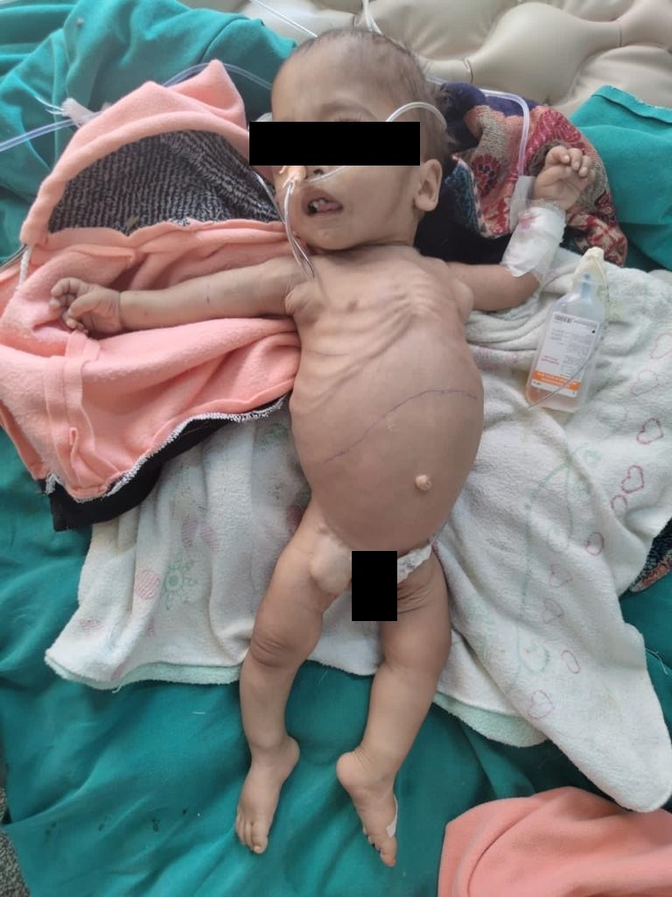
Figure 1. Severely malnourished child
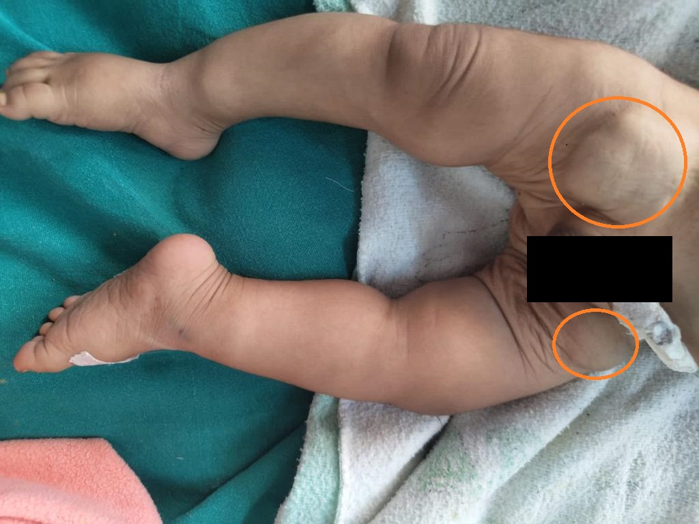
Figure 2. Enlarged inguinal lymph nodes
Anthropometric measures were suggestive of Severe Acute Malnutrition (SAM).On gastrointestinal system examination, this child had hepatosplenomegaly with liver palpable six cm below right costal margin with a span of 8 cm and spleen was palpable seven cm below left costal margin in mid clavicular line. Rest of the systemic examination was normal. On investigating, he had severe anaemia, neutropenia with absolute neutrophilc count of 1200, thrombocytopenia (platelet- 40,000) and peripheral blood film showing atypical cells. He had deranged Renal Function Tests (RFTs), transaminitis, hypernatremia, raised alkaline phosphatase and increased CRP (C-Reactive Protein). Thyroid Stimulating Hormone (TSH) was raised (7.5 mIU/L). Serum calcium, parathormone levels were normal whereas, vitamin D levels were low (12mg/ml). To our surprise, X-Ray of left wrist done to look for signs of vitamin D deficiency revealed “bone within bone appearance” along with the signs of vitamin D deficiency (figure 3). Hence, X-ray of other bones done also showed similar picture of “bone within bone appearance” (figure 4 and 5). Hence, X-ray of other bones done also showed similar picture of “bone within bone appearance”. CT scan was done which showed moderate dilatation of ventricles with thickening of posterior fossa imitating a mass lesion. Unfortunately, MRI brain was planned but could not be done due to financial constraints and critical condition of the child. Therefore, with an impression of Acute Gastroenteritis with severe dehydration with pancytopenia, complicated SAM, Acute Kidney Injury, Global Developmental Delay (GDD) with dysmorphic facies, provisional diagnosis of hypothyroidism with osteopetrosis with haematological malignancy (?lymphoma)was made. Considering the age and severity of the disease, the diagnosis which fitted the most was infantile malignant osteopetrosis. Bone biopsy and Whole Genome Sequencing (WGS) was planned but cannot be performed due to resource limiting setting and financial constraints.
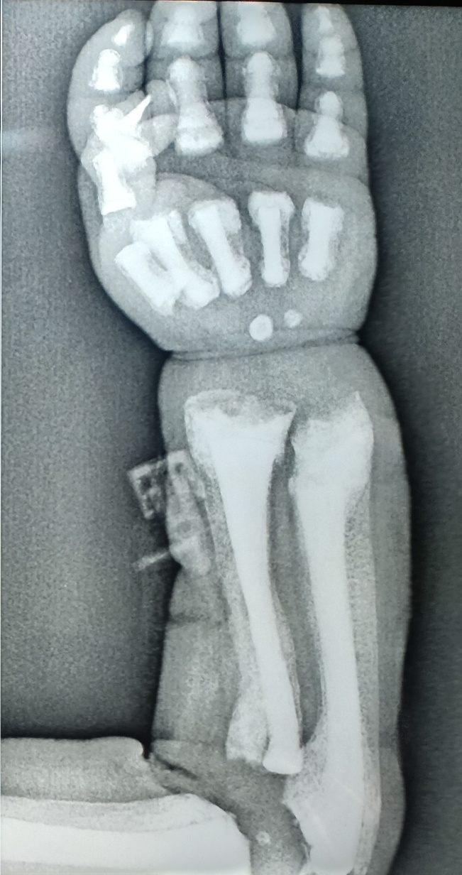
Figure 3. signs of vitamin D deficiency (cupping, fraying, splaying)
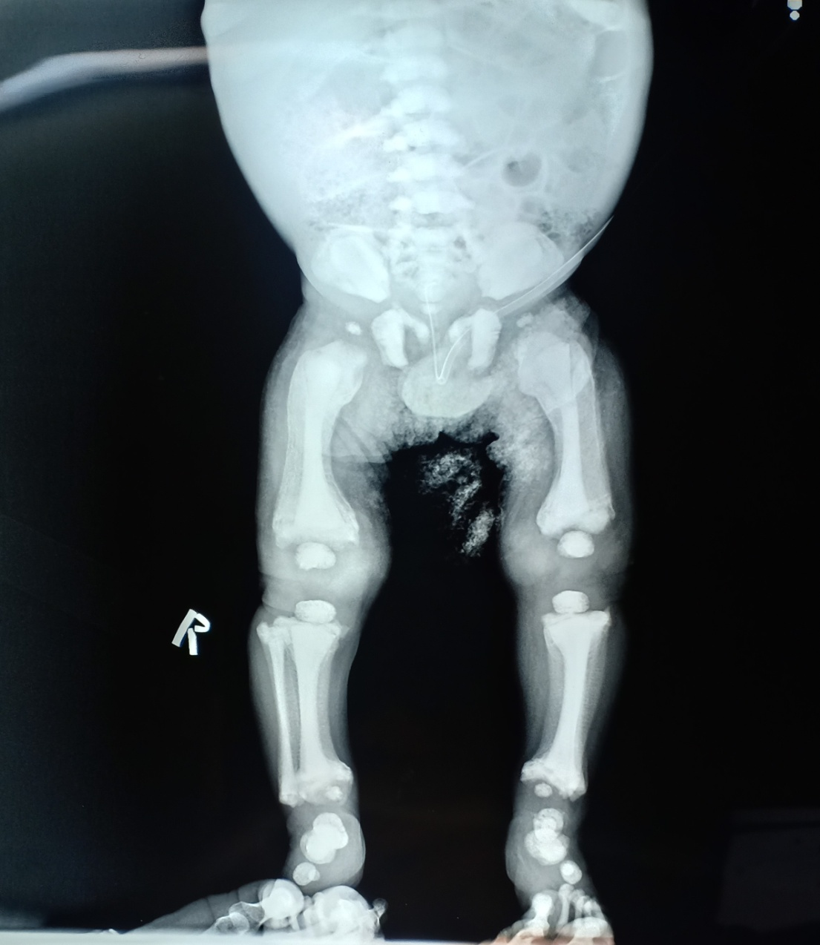
Figure 4. bone within bone appearance of long bones
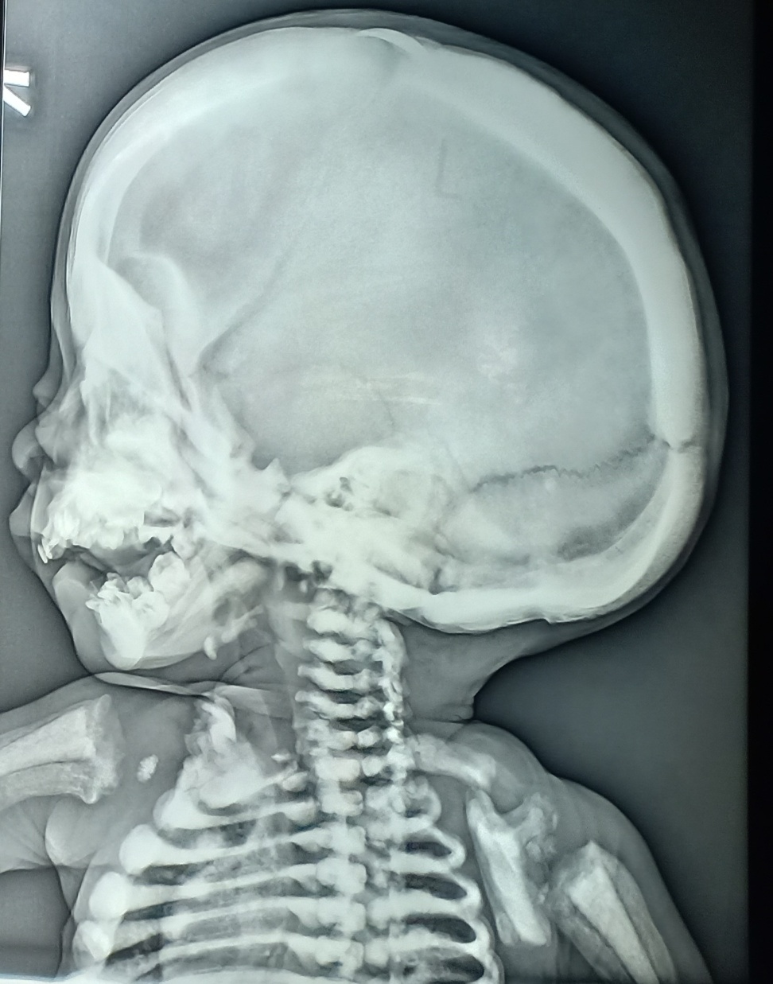
Figure 5. X-ray of skull showing thickening of skull bones especially; posterior fossa
Dehydration, hypernatremia, RFTs improved after giving correction for severe dehydration as per criteria of SAM. One unit of Packed Red Blood Cells (PRBC) and platelets were transfused. Bone marrow aspiration and cytology with flow cytometry was planned to look for its association with haematological malignancy and referral for hematopoietic stem cell transplantation (HSCT) was planned but child succumbed to death due to severe sepsis.
Discussion
Osteopetrosis is a rarely diagnosed bone disorder due to its varied clinical course and multisystem involvement with due course of time. Though, osteopetrosis has different inheritance patterns; but one of its autosomal recessively inherited type called Infantile malignant osteopetrosis is the rare and the most fatal type of osteopetrosis (Abdulsalam et al; 2025). The pathognomic feature of osteopetrosis is the radiographic appearance of “bone within bone” but to identify its type further workup is required (Wu et al; 2017). Autosomal dominant form is usually less severe and is compatible with life whereas recessive form is fatal and presents as early as first few months of life (Stark et al;2009). Despite clinico-radiological diagnosis, genetic analysis is the most accurate method of diagnosing the type of osteopetrosis and deciding its treatment options. Till date, we have been successful in identifying mutations in only 70% of the case of osteopetrosis whereas; 30% cases still remain under research (Nadyrshina et al;2023). Bone biopsy can be a helpful method in distinguishing osteoclast rich form from osteoclast poor form of autosomal recessive osteopetrosis when genetic testing is not available or is inconclusive (Laridi et al; 2025).
Based on the age, history and clinical course of disease, our case fits in the diagnosis of infantile malignant osteopetrosis (Usta et al; 2012; Abdulsalam et al; 2025). Our case presented in the first year of life with fatal disease course leading to mortality which supports the diagnosis. It has been reported that these children presents with recurrent infections, bleeding tendencies and severe malnourishment as noticed in our index case also (Prasad et al; 2013).
Affected children usually have marrow failure due to increased bone density leading to pancytopenia, hepatosplenomegaly, abnormal facies, multiple fractures and nerve entrapment leading to hearing loss(Prasad et al; 2013). Similar features were seen in our case except fractures and impairment of hearing. Definitive diagnosis can only be achieved by genetic analysis. Antenatal diagnosis of osteopetrosis can be made by performing amniocentesis and sending the sample for Whole Genome Sequencing (WGS) (Sathyalakshmi et al; 2024).

Rare feature which our case has is non tender, firm and significantly enlarged all group of lymph nodes. Though there has been reports of mild swelling of lymph nodes due to recurrent infections in patients of osteopetrosis but only one case has been reported which showed the association of haematological malignancy (Non Hodgkins Lymphoma) with osteopetrosis (Hashino et al; 2001). Also, presence of atypical cells in peripheral blood film with enlarged lymph nodes favours towards the association of lymphoma with osteopetrosis in our case.
Management of osteopetrosis is usually symptomatic requiring multidisciplinary approach (Stark et al; 2009). Haematopoetic stem cell transplantation (HSCT) may prove helpful in some types of osteopetrosis but definite cure is still under research (Abdulsalam et al; 2025). Specific gene affected helps us in deciding definitive treatment options. It has been found that HSCT, the potential treatment option is beneficial only in intrinsic osteoclast defect and is ineffective in those cases which are caused by mutation in TNFSF11, CLCN7 and OSTM1 (Penna et al; 2021)
Conclusion
Osteopetrosis is rare and its autosomal recessive type, infantile malignant osteopetrosis is even rarer but is fatal leading to death in most of the cases. Increased bone density leading to multisystem involvement like bone marrow failure causing pancytopenia, hepatosplenomegaly, nerve entrapment resulting in visual and auditory abnormalities and mimicking other common disease conditions often mask the diagnosis of osteopetrosis. Thus, reaching the diagnosis late leads to fatal outcomes and patient succumbs to death by the time diagnosis is made. Moreover, when diagnosed, its association with lymphoma though very rare should always be ruled out as suspected in our child but could not be confirmed due to fatal disease course leading to mortality in few days. As it is a congenital condition, genetic counselling and prenatal diagnosis also plays a very important role in early diagnosis and treatment. Hence, it becomes important to create awareness about this condition among medical professionals and general public as well.
Acknowledgment
We sincerely thank Sanjana, Preeti, Archita, Urvashi for providing assistance in manuscript preparation
Competing interest
Authors have declared that no competing interests exist
Consent
As per international standard or university standard, patient(s) written consent has been collected and preserved by the author(s).
Ethical Approval
As per international standard or university standard written ethical approval has been collected and preserved by the author(s).
Disclaimer (Artificial intelligence)
Author(s) hereby declare that NO generative AI technologies such as Large Language Models (ChatGPT, COPILOT, etc.) and text-to-image generators have been used during the writing or editing of this manuscript.

References
1. Williams, H. J., Davies, A. M., & Chapman, S. (2004). Bone within a bone. Clinical Radiology, 59(2), 132-144. https://doi.org/10.1016/s0009-9260(03)00337-4
2. Stark, Z., & Savarirayan, R. (2009). Osteopetrosis. Orphanet Journal of Rare Diseases, 4(1), 5. https://doi.org/10.1186/1750-1172-4-5
3. Wu, C. C., Econs, M. J., DiMeglio, L. A., Insogna, K. L., Levine, M. A., Orchard, P. J.,et al. (2017). Diagnosis and management of osteopetrosis: Consensus guidelines from the osteopetrosis working group. Journal of Clinical Endocrinology and Metabolism, 102(9), 3111-3123. https://doi.org/10.1210/jc.2017-01127.
4. Abdulsalam, T. A., Elmiaari, M., ALRomithi, L. D., Al-Fakih, E. O., & Alzarooni, F. J. (2025). Malignant Infantile Osteopetrosis With Neurological and Hematological Complications: A Case Review. Cureus. https://doi.org/10.7759/cureus.372027
5. Nadyrshina, D.D, Khusainova RI (2023). Clinical, genetic aspects and molecular pathogenesis of osteopetrosis. Vavilov J Genet Breed, 27(4), 383–92.https://doi.org/10.18699/VJGB-23-46
6. Laridi A, Jabbari C, Laasri I, Hassar S, Allali N, Chat L, et a.l. (2025). Radiological diagnosis of infantile osteopetrosis in a 1-year-old with macrocephaly and jaundice. Radiol Case Re, 20(9), 4226–30. doi:10.1016/j.radcr.2025.05.047
7. Usta, M., Gulec, S. G., Karaman, S., Erdem, E., Emral, H., & Urgancı, N. (2012). A case report of malignant infantile osteopetrosis. Iranian Journal of Pediatrics, 22(3), 421-424.https://doi.org/10.1111/j.1399-3046.2012.01758.x.
8. Prasad, R., Jaiswal, B. P., Mishra, O. P., & Singh, U. K. (2013). Association of possible osteopetrosis with acute myeloid leukaemia in a child. BMJ Case Reports.https://doi.org/10.1136/bcr-2013-009765.
9. Sathyalakshmi B, Jothi VT (2024). Malignant Infantile Osteopetrosis Masquerading as Isolated Fetal Femoral Fracture: First Indian Case Report and Review of Literature. J Fetal Med, 11(01), 081–4. https://doi.org/ 10.1055/s-0044-1780491. ISSN 2348-1153.
10. Hashino, S., Hirota, G., Hasegawa, M., Chiba, K., Toyoshima, N., Suzuki, S., Kurosawa, M., Musashi, M., & Asaka, M. (2001). Peripheral T-cell lymphoma in a patient with osteopetrosis. Annals of Hematology. https://doi.org/10.1007/s002770000284.
11.Penna S, Villa A, Capo V (2021). Autosomal recessive osteopetrosis: mechanisms and treatments. Dis Model Mech, 14(5),dmm048940. https://doi.org/10.1242/dmm.048940

