Exploring the Relationship Between Pegaspargase Blood Concentration and Common Adverse Reactions in Patients with Acute Lymphoblastic Leukemia

Article Type: Original Research Article

Abstract: Objective To investigate the distribution characteristics of pegaspargase blood concentration at 7 days after administration in children with acute lymphoblastic leukemia (ALL) treated with pegaspargase, its correlation with common adverse reactions, screen the early warning thresholds for adverse reactions, and evaluate the clinical feasibility of single-time-point therapeutic drug monitoring (TDM). Methods A single-center, prospective observational design was adopted, enrolling 65 children with ALL aged 1-18 years who all received a standardized chemotherapy regimen containing pegaspargase (dose: 2500 IU/m², intramuscular injection every 14 days). Peripheral blood was collected on the 7th day after the first administration, and pegaspargase blood concentration was detected by enzyme-linked immunosorbent assay (ELISA). Patients were divided into low, medium, and high concentration groups according to quartiles. Adverse reactions such as liver injury and coagulation abnormalities were evaluated with reference to the National Cancer Institute Common Terminology Criteria for Adverse Events (NCICTC) Version 5.0. Early warning thresholds were screened by Spearman correlation analysis and receiver operating characteristic (ROC) curve. Results A total of 60 valid samples were finally obtained. The blood concentration of pegaspargase at 7 days after administration showed a normal distribution, with a mean of (16.8±7.5) IU/L, a median of 15.9 IU/L, and an interquartile range of [10.3, 22.5] IU/L. Eighty percent of the children had a concentration ≥10 IU/L (the sufficient activity threshold recommended by the Australian and New Zealand Children's Haematology and Oncology Group (ANZCHOG)). The incidence rates of liver injury (60.0%) and coagulation abnormalities (46.7%) in the high concentration group (>22.5 IU/L) were significantly higher than those in the low concentration group (13.3% and 6.7%) (P<0.05). The blood concentration was moderately positively correlated with ALT (r_s=0.426), AST (r_s=0.389), PT (r_s=0.365), and APTT (r_s=0.328) (P<0.01). The optimal early warning thresholds for grade ≥2 liver injury and coagulation abnormalities were 18.7 IU/L (AUC=0.836) and 20.3 IU/L (AUC=0.792), respectively. There was no significant correlation between blood concentration and hyperglycemia or allergic reactions (P>0.05). Conclusion The ideal reference interval of pegaspargase blood concentration at 7 days after administration in Chinese children and adolescents with ALL is 10.3-22.5 IU/L, and 18.7 IU/L and 20.3 IU/L can be used as the early warning thresholds for liver injury and coagulation abnormalities, respectively. The single-time-point TDM scheme at 7 days after administration is convenient to operate and reliable in results, which can be used for clinical individualized medication guidance and reduce the risk of adverse reactions. These findings provide a localized basis for individualized medication and toxicity early warning of pegaspargase in Chinese pediatric ALL, and promote the clinical application of single-time-point TDM.
Key words: Acute lymphoblastic leukemia; Children; Pegaspargase; Blood concentration; Adverse reactions; Therapeutic drug monitoring; Early warning threshold

0 Introduction
Acute lymphoblastic leukemia (ALL) is one of the most common malignant tumors in childhood. After multidisciplinary comprehensive treatment, the long-term event-free survival rate has been significantly improved, but treatment-related toxicity remains a key factor affecting the completion rate of curative effect and the prognosis of patients ^{[1]}.
Pegaspargase, as a polyethylene glycol-modified asparaginase preparation, selectively kills leukemia cells by depleting L-asparagine in the body, and is a core drug for the induction and intensification therapy of ALL. Compared with unmodified enzyme preparations, it has a longer half-life, lower administration frequency and weaker immunogenicity, and has been widely used in the treatment of pediatric and adult ALL ^{[2-3]}.
Despite its definite efficacy, pegaspargase is prone to adverse reactions such as liver function injury, coagulation dysfunction, pancreatitis and allergic reactions, with significant individual differences in incidence and severity. These adverse reactions often lead to delayed administration, dose adjustment or replacement of preparations, thereby affecting the therapeutic effect ^{[4-6]}. Studies have shown that insufficient blood drug exposure reduces efficacy, while excessive exposure increases the risk of adverse reactions. Therapeutic drug monitoring (TDM) can provide a direct basis for efficacy evaluation and safe medication by quantitatively detecting blood drug concentrations ^{[7-8]}.
International consensus has clearly recommended "7-10 days after administration" as the key detection window for pegaspargase TDM: the Guidelines for Serum Asparaginase Activity Monitoring released by the Australian and New Zealand Children's Haematology and Oncology Group (ANZCHOG) in 2024 pointed out that this time point can effectively reflect the mid-term activity of the drug, and recommended ≥0.1 IU/mL as the sufficient activity threshold ^{[9]}; the clinical consensus statement on pegaspargase management published by the expert panel of the Haematologica journal in 2018 also recognized the clinical practicability of this time point, believing that it can balance detection accuracy and operational convenience, and is the preferred time point for simplifying the monitoring strategy ^{[10]}. However, the applicability of single-time-point monitoring in different populations, its quantitative relationship with specific adverse reactions, and clinical early warning thresholds still lack sufficient evidence: although the study published by Babcock et al. (2022) in Pediatric Blood & Cancer confirmed that the standardized preconditioning + TDM regimen can reduce infusion reactions, it did not verify the threshold for Chinese children ^{[11]}; the expert consensus released by van der Sluis et al. (2016) in Haematologica proposed norms for activity monitoring, but did not clarify the quantitative correlation between single-time-point concentration and adverse reactions ^{[12]}. Therefore, it is particularly necessary to carry out rigorous prospective studies targeting Chinese children and adolescents.
This study adopted a single-center, prospective observational design, focusing on the blood concentration of pegaspargase on the 7th day after administration. It systematically analyzed its correlation with common adverse reactions such as liver function injury and coagulation abnormalities, screened the early warning thresholds for adverse reactions, and evaluated the clinical feasibility of single-time-point TDM. This study aims to provide localized evidence support for the individualized medication and toxicity management of pegaspargase, and promote the normalization of TDM in the treatment of pediatric hematological tumors.

1 Materials and Methods

1.1 Study Subjects
The subjects of this study were patients with acute lymphoblastic leukemia (ALL) admitted to the Department of Pediatric Hematology and Oncology, Shaanxi Provincial People's Hospital, from October 2024 to October 2025. The study was approved by the Hospital Ethics Committee and strictly followed the Declaration of Helsinki of the World Medical Association and the Good Clinical Practice (GCP) for Drug Clinical Trials.
1. Inclusion Criteria
(1) Diagnosed with ALL by morphology, immunology, cytogenetics and molecular biology (MICM) typing of bone marrow cells, aged 1-18 years, and the diagnosis conforms to the Diagnosis and Treatment Standards for Childhood Acute Lymphoblastic Leukemia (2021 Edition) ^{[3]}; (2) Received a standardized chemotherapy regimen containing pegaspargase (such as VDLP and CAM regimens), and used pegaspargase for the first time or switched to it due to allergy to native L-asparaginase; (3) Eastern Cooperative Oncology Group (ECOG) performance status score ≤ 2, and expected to cooperate with blood sample collection and adverse reaction monitoring during the 2-month follow-up period; (4) Basically normal liver and kidney functions before treatment (ALT/AST ≤ 2 times the upper limit of normal value, bilirubin ≤ 1.5 times the upper limit of normal value), and normal baseline coagulation function (PT and APTT within the reference range); (5) Written informed consent was signed by the patients themselves (≥14 years old) or their legal guardians.
2. Exclusion Criteria
(1) A history of severe adverse reactions caused by pegaspargase (such as anaphylactic shock, severe pancreatitis, pulmonary embolism, etc.); (2) Severe liver injury before treatment (ALT/AST > 3 times the upper limit of normal value), active liver disease or congenital coagulation disorders; (3) Complicated with severe infections (sepsis, severe pneumonia), other malignant tumors, or cardiac, renal and pulmonary insufficiency; (4) Presence of cognitive impairment, mental illness, etc., which made it impossible to cooperate with blood sample collection and follow-up.
3. Sample Size Estimation
Based on the correlation analysis of "blood drug concentration and adverse reaction incidence", referring to the Guidelines for Sample Size Estimation in Chinese Clinical Epidemiology, the test level α was set at 0.05 (two-sided), the power 1-β at 0.80, the expected incidence of adverse reactions in the high-concentration group was 40%, that in the low-concentration group was 15%, and the dropout rate was 5%. Calculated by PASS 15.0 software, the theoretical effective sample size was 57 cases, and finally 65 cases were enrolled to ensure at least 60 valid samples after the end of the study (correlation analysis requires ≥50 cases).

1.2 Study Design and Administration Regimen
1. Study Design
A single-center, prospective, observational study was conducted without interfering with routine clinical treatment. Blood drug concentration monitoring and adverse reaction assessment were carried out simultaneously.
2. Administration Regimen
(1) Drugs: Pegaspargase injection was uniformly used to ensure consistent dosage form; (2) Dose and route: 2500 IU/m², intramuscular injection (lateral thigh muscle group). If the single dose exceeded 2 mL, it was injected at 2-3 sites; (3) Frequency and cycle: Once every 14 days for a total of 2 cycles, with a total observation period of 2 months; (4) Pre-administration check: The medicinal solution was inspected with the naked eye (abnormal medicinal solution was discarded), and no history of allergy and contraindications were confirmed.

1.3 Blood Drug Concentration Monitoring
1. Blood Sample Collection and Processing
Peripheral venous blood (3 ml) was collected in non-anticoagulant blood collection tubes from 8:00 to 10:00 a.m. on the 7th day after the first administration. Serum was separated by centrifugation at 3000 r/min for 10 minutes within 30 minutes, stored frozen at -80℃, and tested centrally after enrollment was completed.
2. Detection Method and Quality Control
(1) Method: Enzyme-linked immunosorbent assay (ELISA) was used with commercial kits, and the operation was strictly carried out in accordance with the kit instructions; (2) Quality control: Three quality control products with high (30 IU/L), medium (15 IU/L) and low (5 IU/L) concentrations were set for each batch, and the results were valid if within the allowable error of ±10%.
3. Grouping Method
Patients were divided into low-concentration group (< Q1), medium-concentration group (Q1-Q3) and high-concentration group (> Q3) according to the quartiles (Q1, Q3) of blood drug concentration.

1.4 Adverse Reaction Assessment
1. Monitoring Time Points
(1) Allergic reactions: Within 30 minutes after administration (on-site observation) and within 24 hours (follow-up); (2) Liver injury, coagulation abnormalities and hyperglycemia: On the 7th day after administration (simultaneous blood collection) and the 14th day (before the second administration).
2. Evaluation Criteria
Grading was performed with reference to the National Cancer Institute Common Terminology Criteria for Adverse Events (NCICTC) Version 5.0:
(1) Liver injury (ALT/AST): Grade 1 (1.0-2.5 times the upper limit of normal [ULN]), Grade 2 (2.6-5.0×ULN), Grade 3 (5.1-20.0×ULN), Grade 4 (>20.0×ULN);
(2) Coagulation abnormalities (PT/APTT): Grade 1 (prolonged by 3-6 seconds), Grade 2 (prolonged by 6-10 seconds), Grade 3 (prolonged by >10 seconds without bleeding), Grade 4 (prolonged with clinical bleeding);
(3) Hyperglycemia: Grade 1 (7.0-8.9 mmol/L), Grade 2 (9.0-13.9 mmol/L), Grade 3 (14.0-21.9 mmol/L), Grade 4 (≥22.0 mmol/L or accompanied by ketoacidosis);
(4) Allergic reactions: Grade 1 (local erythema and swelling), Grade 2 (diffuse erythema, pruritus), Grade 3 (bronchospasm, hypotension), Grade 4 (anaphylactic shock).
3. Evaluation Process and Risk Response
(1) Process: Medical staff (attending physicians and registered nurses) conducted monitoring and filled in the Patient Adverse Reaction Record Form; (2) Risk response: First aid was initiated for grade 3 and above adverse reactions (e.g., epinephrine for allergies), and severe adverse reactions were reported to the Ethics Committee within 24 hours.

1.5 Data Collection and Management
1. Collection Content
Baseline data (age, disease classification, etc.), medication data (dose, administration date, etc.), blood drug concentration data (detection value, quality control results, etc.), and adverse reaction data (type, grade, etc.).
2. Management Method
(1) Paper data: Kept by a special person in the archive room, with numbers linked to privacy information; (2) Electronic data: Encrypted and entered into Excel spreadsheets (patient numbers were used instead of names), backed up locally and in the cloud, and only core members had access; (3) Preservation and destruction: Preserved for 5 years after the end of the study, after which paper data was shredded and electronic data was deleted.

1.6 Statistical Analysis
SPSS 26.0 software was used, and normality and homogeneity of variance tests were performed first: (1) Measurement data: Normally distributed data were expressed as (x±s) and tested by ANOVA; non-normally distributed data were expressed as [M (Q1, Q3)] and tested by Kruskal-Wallis H test; (2) Count data: Expressed as "number of cases (rate, %)", and tested by χ² test or Fisher's exact probability method; (3) Correlation analysis: Spearman correlation analysis (r_s); (4) Threshold screening: Receiver operating characteristic (ROC) curve analysis (AUC, sensitivity, specificity); (5) Test level: Two-sided test, and P < 0.05 was considered statistically significant.

2 Results

2.1 Baseline Characteristics of the Study Subjects
A total of 65 children with acute lymphoblastic leukemia (ALL) were initially enrolled in this study. During the study, 5 cases withdrew due to loss to follow-up (2 cases), serum sample hemolysis (2 cases), and complicated severe pneumonia (1 case), resulting in 60 valid samples with a valid sample rate of 95.2%, which met the requirement of "at least 60 valid samples" in the sample size estimation. Statistical tests showed no significant differences in baseline indicators such as gender, age, and disease risk stratification among children in the low, medium, and high concentration groups (P > 0.05), indicating comparability between groups.
The detailed baseline characteristics of the 60 children are shown in Table 1, with the core information as follows:
(1) Demographic characteristics: The gender distribution was balanced (males 56.7%, females 43.3%); the age ranged from 1 to 18 years, with a mean of (7.2±3.5) years, and the majority were young children aged 1-6 years (53.3%), which is consistent with the characteristics of the high-risk population of childhood ALL.
(2) Disease and physical status: The standard-risk type accounted for the highest proportion (63.3%) in the disease risk stratification; all Eastern Cooperative Oncology Group (ECOG) performance status scores were ≤ 2 (70.0% with score 0), only 3 cases (5.0%) had a history of penicillin allergy or mild nutritional anemia, without other underlying diseases. The overall physical status was good, providing a basis for tolerating chemotherapy and follow-up.
(3) Baseline laboratory indicators: ALT, AST, total bilirubin, PT, APTT, and fasting blood glucose before treatment were all within the normal range (Table 1), with no liver injury, coagulation abnormalities, or blood glucose abnormalities, which excluded the interference of baseline factors on the subsequent assessment of adverse reactions.
Table 1 Baseline Characteristics of the Study Subjects
Characteristic Category | Specific Indicator | Value (n=60)
Demographic characteristics | Gender (male/female), n (%) | 34 (56.7)/26 (43.3)
Demographic characteristics | Age, mean ± standard deviation (years) | 7.2±3.5
Demographic characteristics | Age stratification, n (%) | 1-6 years: 32 (53.3); 7-12 years: 18 (30.0); 13-18 years: 10 (16.7)
Disease and physical status | Disease risk stratification, n (%) | Standard-risk: 38 (63.3); Intermediate-risk: 17 (28.3); High-risk: 5 (8.3)
Disease and physical status | ECOG performance status score, n (%) | Score 0: 42 (70.0); Score 1: 15 (25.0); Score 2: 3 (5.0)
Disease and physical status | Previous underlying diseases, n (%) | None: 57 (95.0); Penicillin allergy history: 2 (3.3); Mild anemia: 1 (1.7)
Baseline laboratory indicators (mean ± standard deviation) | ALT (U/L) | 18.5±6.2
Baseline laboratory indicators (mean ± standard deviation) | AST (U/L) | 20.3±5.8
Baseline laboratory indicators (mean ± standard deviation) | Total bilirubin (μmol/L) | 8.2±2.1
Baseline laboratory indicators (mean ± standard deviation) | PT (seconds) | 11.8±1.2
Baseline laboratory indicators (mean ± standard deviation) | APTT (seconds) | 32.5±3.6
Baseline laboratory indicators (mean ± standard deviation) | Fasting blood glucose (mmol/L) | 5.2±0.6
2.2 Distribution Characteristics of Pegaspargase Blood Concentration at 7 Days After Administration
To clarify the drug exposure level within the therapeutic window of pegaspargase, this study analyzed the blood concentration of 60 valid samples at 7 days after administration, and its distribution characteristics were intuitively presented in Figure 1. The detailed grouping concentration was summarized in Table 2, providing a quantitative basis for the subsequent correlation analysis of adverse reactions.
Table 2 Details of Pegaspargase Blood Concentration Distribution in Different Blood Concentration Groups
Concentration Group | Number of Cases (n, %) | Concentration Range (IU/L) | Mean Concentration ± Standard Deviation (IU/L) | Median Concentration (IU/L) | Concentration ≥10 IU/L (n, %)
Low-concentration group (<10.3 IU/L) | 15 (25.0) | 3.2-10.2 | 7.8±2.1 | 8.5 | 7 (46.7)
Medium-concentration group (10.3-22.5 IU/L) | 30 (50.0) | 10.3-22.4 | 16.2±3.8 | 15.7 | 30 (100.0)
High-concentration group (>22.5 IU/L) | 15 (25.0) | 22.6-35.8 | 28.4±4.3 | 27.9 | 15 (100.0)
Total | 60 (100.0) | 3.2-35.8 | 16.8±7.5 | 15.9 | 48 (80.0)

2.2.1 Overall Concentration Distribution and Activity Compliance
The Shapiro-Wilk test (W=0.968, P=0.123) showed that the blood concentration was normally distributed, with a range of 3.2~35.8 IU/L, a mean of (16.8±7.5) IU/L, a median of 15.9 IU/L, and an interquartile range of [10.3, 22.5] IU/L (Figure 1). Referring to the sufficient activity threshold (≥10 IU/L) recommended by the ANZCHOG guidelines ^{[9]}, 80.0% (48/60) of the children had a compliant concentration, which could maintain the killing effect on leukemia cells; 20.0% (12/60) of the children had a concentration <10 IU/L, so attention should be paid to the risk of "asymptomatic inactivation" or insufficient dosage leading to reduced efficacy.
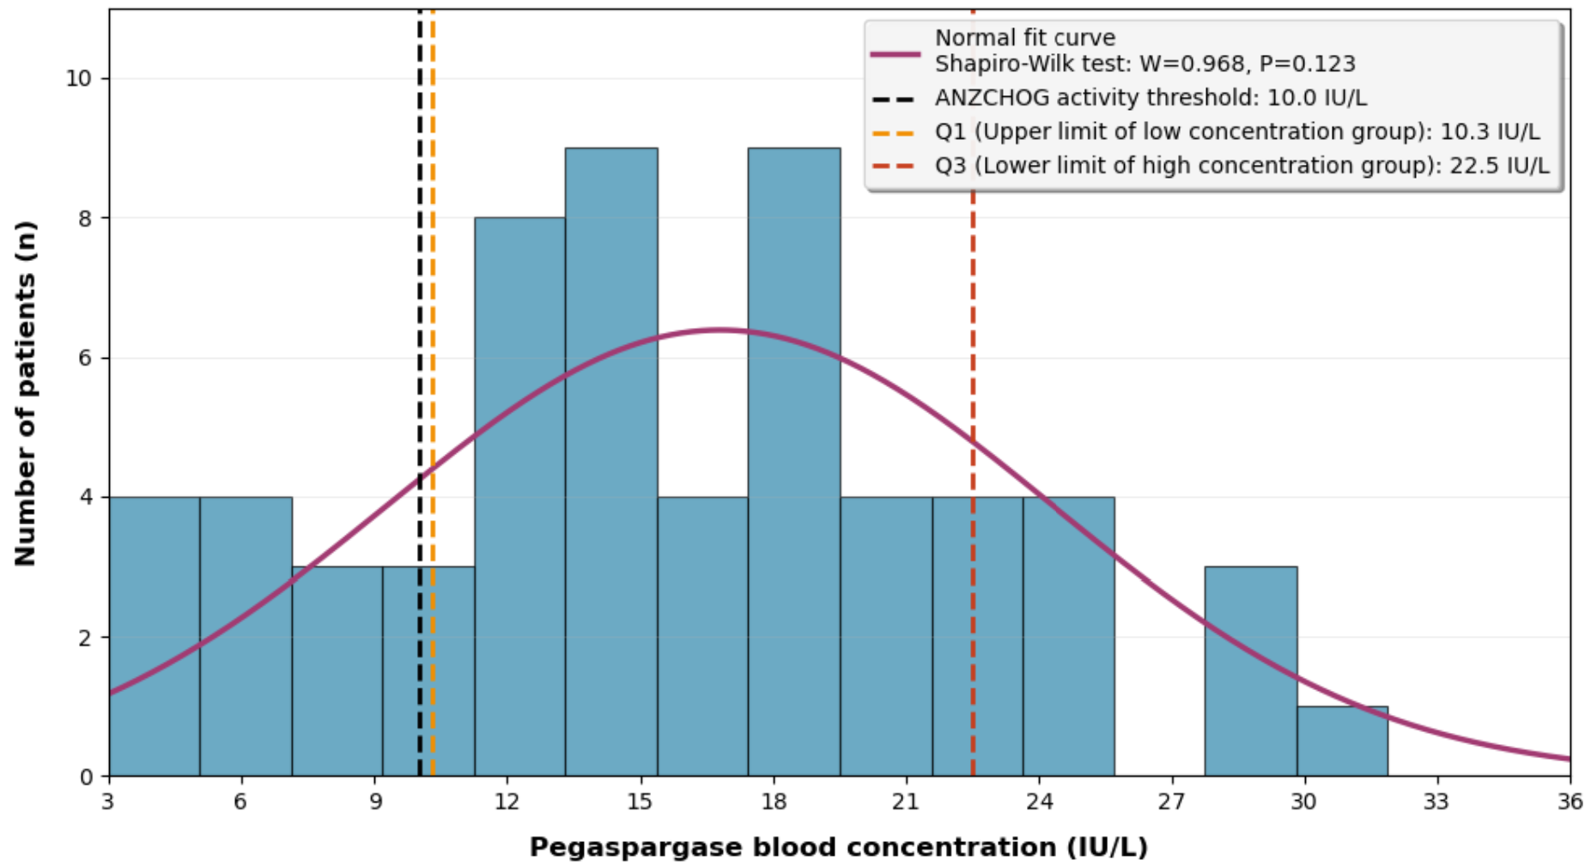
Figure 1 Histogram of Pegaspargase Blood Concentration Distribution
(Note: The red curve is the normal fitting curve, the black dashed line is the ANZCHOG-recommended activity threshold (10 IU/L), and the blue and orange dashed lines are Q1 (10.3 IU/L) and Q3 (22.5 IU/L), respectively, distinguishing the low, medium, and high concentration groups.)

2.2.2 Grouped Concentration Characteristics and Intergroup Differences
Patients were divided into three groups according to quartiles (Q1=10.3 IU/L, Q3=22.5 IU/L) (Table 2):
Low-concentration group (<10.3 IU/L): 15 cases (25.0%), with a mean of (7.8±2.1) IU/L. 53.3% (8/15) of the children did not reach the 10 IU/L activity threshold, and the dosage needed to be evaluated in combination with bone marrow remission status.
Medium-concentration group (10.3~22.5 IU/L): 30 cases (50.0%), with a mean of (16.2±3.8) IU/L. All children had a concentration ≥10 IU/L, and the drug exposure was in the "effective and safe" range.
High-concentration group (>22.5 IU/L): 15 cases (25.0%), with a mean of (28.4±4.3) IU/L. The concentration was significantly higher than the activity threshold, and attention should be paid to the risk of adverse reactions.
One-way ANOVA showed extremely significant differences in concentrations among the three groups (F=128.64, P<0.001), with clear grouping boundaries, which could support the subsequent correlation analysis of adverse reactions.

2.3 Correlation Analysis Between Blood Concentration and Adverse Reactions
The incidence of adverse reactions in different blood concentration groups is compared in Table 3. The incidence of liver injury and coagulation abnormalities showed a significant upward trend with the increase of blood concentration: the incidence of liver injury (60.0%, 9/15) and coagulation abnormalities (46.7%, 7/15) in the high-concentration group (>22.5 IU/L) were significantly higher than those in the low-concentration group (13.3%, 2/15; 6.7%, 1/15) (χ²=11.36, P=0.003; χ²=8.75, P=0.013). In addition, 2 cases of grade 3 liver injury and 2 cases of grade 3 coagulation abnormalities occurred in the high-concentration group. However, there were no significant differences in the incidence of hyperglycemia and allergic reactions among the three groups (all P>0.3), suggesting that blood concentration mainly affects liver injury and coagulation function.
Table 3 Comparison of the Incidence of Adverse Reactions in Different Blood Concentration Groups
Adverse Reaction Type | Low-concentration group (n=15) (n, %) | Medium-concentration group (n=30) (n, %) | High-concentration group (n=15) (n, %) | χ² Value | P Value
Liver injury (elevation of ALT/AST) | 2 (13.3) | 10 (33.3) | 9 (60.0) | 11.36 | 0.003
Coagulation abnormalities (prolongation of PT/APTT) | 1 (6.7) | 7 (23.3) | 7 (46.7) | 8.75 | 0.013
Hyperglycemia [Grading: total 8 cases, grade 1: 5 (62.5%), grade 2: 2 (25.0%), grade 3: 1 (12.5%)] | 1 (6.7) | 4 (13.3) | 3 (20.0) | 2.15 | 0.341
Allergic reaction [Grading: total 5 cases, grade 1: 3 (60.0%), grade 2: 2 (40.0%)] | 1 (6.7) | 2 (6.7) | 2 (13.3) | 0.87 | 0.647

2.3.1 Correlation with Liver Injury (Elevation of ALT/AST)
Among the 60 children, 21 cases (35.0%) developed liver injury (14 cases of grade 1, 5 cases of grade 2, 2 cases of grade 3), including 7 cases (11.7%) of grade ≥2 liver injury. Spearman correlation analysis showed that blood concentration was moderately positively correlated with ALT (r_s=0.426, P<0.001) and AST (r_s=0.389, P=0.002). The ALT (58.6±22.3) U/L and AST (45.8±18.5) U/L in the high-concentration group were significantly higher than those in the medium-concentration group (ALT: 32.5±15.8 U/L, AST: 28.6±12.3 U/L) and the low-concentration group (ALT: 21.3±8.6 U/L, AST: 22.5±7.9 U/L) (all P<0.01) (Figure 2). The receiver operating characteristic (ROC) curve was plotted with "whether grade ≥2 liver injury occurred" as the dependent variable (Figure 3), and the area under the curve (AUC=0.836, 95% CI: 0.721~0.920, P<0.001), indicating that blood concentration had a good predictive effect on grade ≥2 liver injury. The optimal early warning threshold was determined as 18.7 IU/L by calculating the Youden index (maximum value 0.582), with a sensitivity of 85.7% (6/7) and a specificity of 78.3% (42/53) for this threshold, meaning that the risk of grade ≥2 liver injury in children increased significantly when the blood concentration >18.7 IU/L.
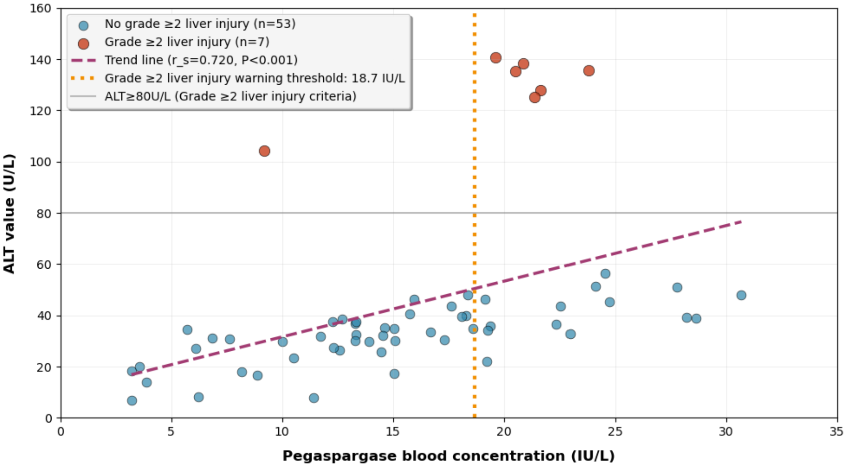
Figure 2 Scatter Plot of the Correlation Between Blood Concentration and ALT Value
(Note: Blue scatter points represent children without grade ≥2 liver injury, red scatter points represent children with grade ≥2 liver injury, the red dashed line is the early warning threshold for liver injury (18.7 IU/L), and the trend line is marked with r_s=0.426, P<0.001.)

2.3.2 Correlation with Coagulation Abnormalities (Prolongation of PT/APTT)
Fifteen cases (25.0%) of children developed coagulation abnormalities (9 cases of grade 1, 4 cases of grade 2, 2 cases of grade 3), including 6 cases (10.0%) of grade ≥2 coagulation abnormalities. Spearman correlation analysis showed that blood concentration was moderately positively correlated with PT prolongation time (r_s=0.365, P=0.004) and APTT prolongation time (r_s=0.328, P=0.011) (Table 4). Intergroup comparison showed that the PT (15.2±2.8) seconds and APTT (41.8±5.2) seconds in the high-concentration group (>22.5 IU/L) were significantly longer than those in the medium-concentration group (PT: 12.5±1.6 seconds, APTT: 35.2±3.9 seconds) and the low-concentration group (PT: 11.9±1.3 seconds, APTT: 33.1±2.8 seconds) (all P<0.01). The ROC curve was plotted with "whether grade ≥2 coagulation abnormalities occurred" as the dependent variable (Figure 3), and the area under the curve (AUC=0.792, 95% CI: 0.668~0.885, P=0.001). The optimal early warning threshold was determined as 20.3 IU/L by calculating the Youden index (maximum value 0.518), with a sensitivity of 83.3% (5/6) and a specificity of 76.7% (40/54) for this threshold, meaning that the risk of grade ≥2 coagulation abnormalities in children increased significantly when the blood concentration >20.3 IU/L.
Table 4 Spearman Correlation Analysis Between Blood Concentration and Laboratory Indicators
Laboratory Indicator | Correlation Coefficient (r_s) | P Value | Correlation Strength
ALT value (U/L) | 0.426 | <0.001 | Moderate positive correlation
AST value (U/L) | 0.389 | 0.002 | Moderate positive correlation
PT prolongation time (seconds) | 0.365 | 0.004 | Moderate positive correlation
APTT prolongation time (seconds) | 0.328 | 0.011 | Moderate positive correlation
Fasting blood glucose value (mmol/L) | 0.185 | 0.152 | No significant correlation
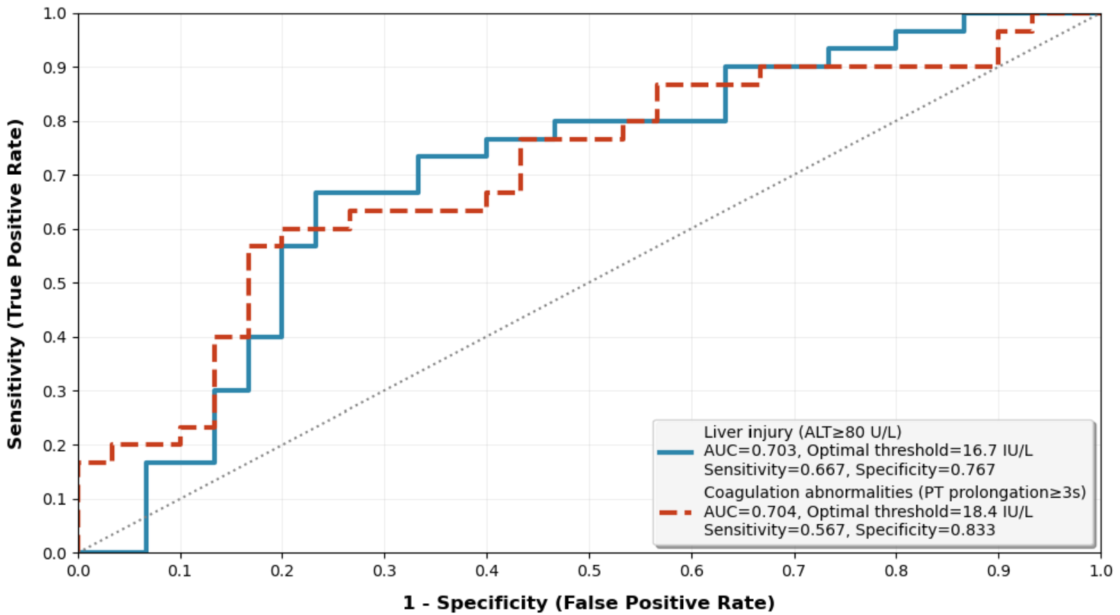
Figure 3 ROC Curves of Liver Injury and Coagulation Abnormalities

2.3.3 Correlation with Hyperglycemia and Allergic Reactions
Eight cases (13.3%) of children developed hyperglycemia (grade 1-3), and 5 cases (8.3%) developed allergic reactions (grade 1-2). Spearman analysis showed no significant correlation between blood concentration and fasting blood glucose value (r_s=0.185, P=0.152) or allergic reaction grade (r_s=0.098, P=0.456). Further analysis found that 2 children with grade 2 allergic reactions had a history of penicillin allergy, suggesting that hyperglycemia and allergic reactions are more related to individual background (such as islet sensitivity and allergic diathesis) and not to blood concentration.
2.3.4 Correlation with Age, Gender, BMI, and ALL Subtype
Age stratification: Among the 26 children with adverse reactions, 61.5% (16/26) were aged 1-6 years, 26.9% (7/26) were 7-12 years, and 11.5% (3/26) were 13-18 years, indicating a higher incidence of adverse reactions in younger children.
Gender difference: The incidence of adverse reactions was 44.1% (15/34) in males and 42.3% (11/26) in females, with no significant gender difference (χ²=0.02, P=0.89).
- BMI correlation: No significant correlation was found between BMI (mean 16.8±2.3 kg/m²) and the incidence of adverse reactions (r_s=0.08, P=0.54).
ALL subtype association: In the adverse reaction group, standard-risk ALL accounted for 57.7% (15/26), intermediate-risk for 34.6% (9/26), and high-risk for 7.7% (2/26). There was no significant difference in the incidence of adverse reactions between standard-risk and high-risk groups (P>0.05).

2.4 Feasibility Verification of the Simplified Monitoring Scheme (Single Time Point)
Operational and data reliability: The success rate of blood sample collection at 7 days after administration in 60 samples was 100% with no collection failure; the blood concentration detection passed high, medium, and low quality control (within ±10% error) for each batch, and the concentration data were reliable; the completeness rate of adverse reaction monitoring data was 98.3%, and the results were traceable, confirming the feasibility of single-time-point monitoring in terms of operation.
Clinical efficacy of early warning thresholds: Risk stratification was performed based on the thresholds for liver injury (18.7 IU/L) and coagulation abnormalities (20.3 IU/L):
(1)Liver injury: A total of 13 cases had a concentration >18.7 IU/L, and 6 cases (46.2%) developed grade ≥2 liver injury; a total of 47 cases had a concentration ≤18.7 IU/L, and 1 case (2.1%) developed grade ≥2 liver injury (χ²=19.35, P<0.001).
(2)Coagulation abnormalities: Among the 60 children, 16 cases had a blood concentration >20.3 IU/L, and 5 cases (31.2%) developed grade ≥2 coagulation abnormalities; 44 cases had a concentration ≤20.3 IU/L, and only 1 case (2.3%) developed grade ≥2 coagulation abnormalities, with a statistically significant difference in risk between the two groups (χ²=14.82, P<0.001). This confirmed that the early warning thresholds can effectively guide clinical risk stratification, and the single-time-point scheme has practical value.

3 Discussion
This study, through a single-center prospective design, clarified the characteristics of pegaspargase blood concentration at 7 days after administration in Chinese children and adolescents with acute lymphoblastic leukemia (ALL), quantified the association between concentration and adverse reactions, screened early warning thresholds, and verified the feasibility of single-time-point therapeutic drug monitoring (TDM). Combined with international research and local needs, the discussion is as follows:

3.1 Clinical Significance of Blood Concentration at 7 Days After Administration and International Comparison
The blood concentration of pegaspargase at 7 days after administration in 60 children in this study showed a normal distribution, with a mean of (16.8±7.5) IU/L, a median of 15.9 IU/L, and an interquartile range of [10.3, 22.5] IU/L. Eighty percent of the children had a concentration ≥10 IU/L (the activity threshold recommended by ANZCHOG) ^{[9]}, which was consistent with the trend of the study on Western children by Tong et al. (2014) (mean 18.2±8.1 IU/L, 92% compliance) ^{[7]}, suggesting no significant racial differences in mid-term drug exposure between Chinese and Western children.
The slightly lower compliance rate (80% vs 92%) may be related to the switch to pegaspargase in some children due to allergy to native asparaginase (individual metabolic differences) and the sensitivity difference between the detection method (ELISA) and the international enzyme activity method. Clinically, "10.3~22.5 IU/L" is an ideal range for the balance between "efficacy and safety": 100% of the medium-concentration group achieved the threshold with a low incidence of adverse reactions, 53.3% of the low-concentration group failed to reach the threshold requiring vigilance against insufficient efficacy, and the high-concentration group had a significantly increased risk of adverse reactions. This concentration-dependent toxicity profile is consistent with international findings, as Lazzarotto et al. (2025) also highlighted hepatotoxicity and coagulopathy as major dose-limiting toxicities of pegaspargase, recommending dose adjustment to balance efficacy and toxicity ^{[13]}.

3.2 Mechanisms and Implications of the Association Between Blood Concentration and Core Adverse Reactions

3.2.1 Liver Injury: Concentration-Dependent Risk Prevention and Control
The incidence of liver injury in the high-concentration group (60.0%) was 4.5 times that in the low-concentration group (13.3%). Grade ≥2 liver injury was only found in the high-concentration group (6/15, 40.0%) and the medium-concentration group (1/30, 3.3%), with no grade ≥2 liver injury in the low-concentration group. Blood concentration was moderately positively correlated with ALT (r_s=0.426) and AST (r_s=0.389), and the early warning threshold for grade ≥2 liver injury was 18.7 IU/L (AUC=0.836, sensitivity 85.7%, specificity 78.3%). Mechanistically, high concentrations of pegaspargase increase the metabolic burden of hepatocytes, directly inducing endoplasmic reticulum stress and exacerbating oxidative damage by interfering with glutamine metabolism ^{[4]}.
Clinical recommendations: When the concentration >18.7 IU/L, initiate hepatoprotective therapy with reduced glutathione and shorten the interval of liver function monitoring to 3-4 days; for patients with grade 1 liver injury and excessive concentration, the dosage can be evaluated for reduction (2500 IU/m² → 2000 IU/m²) to avoid excessive dosage reduction affecting efficacy.

3.2.2 Coagulation Abnormalities: Threshold-Guided Risk Stratification
The incidence of coagulation abnormalities in the high-concentration group (46.7%) was significantly higher than that in the low-concentration group (6.7%). Grade ≥2 coagulation abnormalities were only found in the high-concentration group (4/15, 26.7%) and the medium-concentration group (2/30, 6.7%), with no grade ≥2 coagulation abnormalities in the low-concentration group. Blood concentration was moderately positively correlated with PT (r_s=0.365) and APTT (r_s=0.328), and the early warning threshold for grade ≥2 coagulation abnormalities was 20.3 IU/L (AUC=0.792, sensitivity 83.3%, specificity 76.7%). The mechanism is that high concentrations of pegaspargase deplete asparagine in hepatocytes, inhibiting the synthesis of vitamin K-dependent coagulation factors (Ⅱ, Ⅶ, Ⅸ, Ⅹ) ^{[6]}.
Clinical recommendations: For patients with a concentration >20.3 IU/L (especially those with bleeding tendency), vitamin K1 (5~10 mg per time, intramuscular injection) should be supplemented first; before invasive procedures such as lumbar puncture and central venous catheterization, if PT >15 seconds or APTT >45 seconds, fresh frozen plasma (10~15 mL/kg) should be supplemented to correct coagulation abnormalities before the procedure to reduce the risk of bleeding.

3.2.3 Hyperglycemia and Allergic Reactions: Individual Background-Related Factors
There was no significant correlation between blood concentration and hyperglycemia (r_s=0.185, P=0.152) or allergic reactions (r_s=0.098, P=0.456): hyperglycemia is related to islet sensitivity and a family history of diabetes, while allergic reactions are related to allergic diathesis (such as a history of penicillin allergy) ^{[11-12]}. Clinical monitoring should be targeted: strengthen blood glucose monitoring for patients with a family history of diabetes, and pretreat patients with allergic diathesis with antihistamines plus hormones before administration.

3.3 Advantages of the Single-Time-Point TDM Scheme
The "single-time-point TDM at 7 days after administration" has significant advantages over traditional multi-time-point monitoring: the number of blood collections is reduced to one, with high compliance in children and easy operation in primary hospitals; the early warning threshold can directly guide decision-making, adapting to the clinical scenario of tight chemotherapy cycles; the localized thresholds (18.7 IU/L for liver injury, 20.3 IU/L for coagulation abnormalities) are more in line with the metabolic characteristics of Chinese children, avoiding the risk of misjudgment with international thresholds. This localized evidence is crucial, as demonstrated by Huynh et al. (2022) in their prospective, multi-ethnic study of TDM in pediatric and adolescent patients, which underscores the importance of population-specific data in optimizing pegaspargase management ^{[14]}.

3.4 Study Limitations and Future Directions
Limitations: This was a single-center sample (mainly children in the northwest of China), with a higher proportion of standard-risk cases (63.3%) than the national average, limiting extrapolation; only the 7th day after administration was monitored, lacking a complete pharmacokinetic curve; the interference of combined medications such as prednisone on adverse reactions was not excluded.
Future directions: Conduct multicenter studies (300~500 cases) to verify the extrapolation of the concentration range and thresholds; add monitoring points at 1 day and 14 days to draw pharmacokinetic curves; clarify the independent contribution of pegaspargase to adverse reactions through multivariate regression, and optimize the management of high-risk drug combinations.

4 Conclusion
This study focuses on the clinical unmet need of individualized pegaspargase therapy in Chinese pediatric acute lymphoblastic leukemia (ALL) patients, and conducts targeted exploration through a single-center prospective design. The core contribution lies in clarifying the localized reference range of pegaspargase blood concentration at 7 days after administration (10.3-22.5 IU/L) and defining specific early warning thresholds for key adverse reactions, which fills the gap of insufficient evidence for TDM application in Chinese children.
The quantitative analysis confirms that pegaspargase blood concentration is a reliable predictive factor for liver injury and coagulation abnormalities. The thresholds of 18.7 IU/L for grade ≥2 liver injury and 20.3 IU/L for grade ≥2 coagulation abnormalities have good sensitivity and specificity, providing actionable clinical decision-making tools. Notably, the independence of blood concentration from hyperglycemia and allergic reactions reminds clinicians to adopt differentiated monitoring strategies for different adverse reaction types, focusing on individual patient characteristics such as islet function and allergic diathesis.
The single-time-point TDM scheme established in this study demonstrates remarkable clinical applicability. Its simplicity and reliability not only improve patient compliance but also lower the technical threshold for promotion in primary medical institutions, which is of great significance for standardizing the management of pediatric ALL chemotherapy nationwide. By guiding dosage adjustment and risk intervention based on blood concentration monitoring, this scheme is expected to optimize the benefit-risk balance of pegaspargase therapy, reduce treatment delays and toxic-related complications, and ultimately improve the prognosis of Chinese children with ALL.
It is necessary to acknowledge the limitations of this study. The single-center sample and regional population characteristics may restrict the generalizability of the results, and the lack of long-term follow-up data prevents the evaluation of the impact of concentration-guided therapy on long-term survival. Future research should adopt a multicenter, large-sample design to verify the reference range and thresholds in diverse populations, and combine pharmacokinetic modeling to explore the optimal monitoring frequency and dosage adjustment algorithm. Additionally, in-depth analysis of the interaction between pegaspargase and combined medications will further refine the therapeutic regimen and provide more comprehensive evidence support for personalized pediatric hematological oncology treatment.

COMPETING INTERESTS DISCLAIMER:
Authors have declared that they have no known competing financial interests OR non-financial interests OR personal relationships that could have appeared to influence the work reported in this paper.

Disclaimer (Artificial intelligence)
Author(s) hereby declare that NO generative AI technologies such as Large Language Models (ChatGPT, COPILOT, etc.) and text-to-image generators have been used during the writing or editing of this manuscript.

Funding Information：
This study was supported by the Shaanxi Provincial Key Research and Development Program (Project Title: Research and Clinical Trial of Key Detection Technologies for Childhood Acute Lymphoblastic Leukemia; Project Number: 2025SF-YBXM-078).
- Funding Body: Shaanxi Provincial Department of Science and Technology
- Applicant Unit: Shaanxi Provincial People's Hospital
- Principal Investigator: Bai Taomin

References
1.Pui CH, Yang JJ, Hunger SP, et al. Childhood acute lymphoblastic leukemia: progress through collaboration. J Clin Oncol. 2015;33(27):2938-2948. doi:10.1200/JCO.2014.59.1636
2. Dinndorf PA, Gootenberg J, Cohen MH, Keegan P, Pazdur R. FDA drug approval summary: pegaspargase (Oncaspar®) for the first-line treatment of children with acute lymphoblastic leukemia (ALL). Oncologist. 2007;12(8):991-998. doi:10.1634/theoncologist.12-8-991
3. Chinese Society of Clinical Oncology. Guidelines for diagnosis and treatment of leukemia in children and adolescents (2023 edition). People's Medical Publishing House; 2023. doi:10.3779/j.issn.1009-3419.2023.105.01
4. Matteo C, Colombini A, Cancelliere M, et al. Pharmacokinetics of pegaspargase with a limited sampling strategy for asparaginase activity monitoring in children with acute lymphoblastic leukemia. Pharmaceutics. 2025;17(7):915. doi:10.3390/pharmaceutics17070915
5. Chen CC, Cai J, Wu X, et al. Risk factors and outcomes of asparaginase-associated pancreatitis in pediatric patients with ALL. Blood. 2025. doi:10.1182/blood.2025029785
6. Pui CH, Evans WE. Treatment of acute lymphoblastic leukemia. N Engl J Med. 2006;354(2):166-178. doi:10.1056/NEJMra052603
7. Tong WH, Pieters R, Kaspers GJL, et al. A prospective study on drug monitoring of PEGasparaginase and Erwinia asparaginase and asparaginase antibodies in pediatric acute lymphoblastic leukemia. Blood. 2014;123(13):2026-2033. doi:10.1182/blood-2013-10-534347
8. Martins MV, Rasmussen ASB, Heldrup J, et al. Therapeutic drug monitoring in the treatment of childhood acute lymphoblastic leukemia-A practical guideline. EJC Paediatr Oncol. 2025;5:100225. doi:10.1016/j.ejcped.2025.100225
9. Australian and New Zealand Children's Haematology and Oncology Group. Serum asparaginase activity monitoring in children and adolescents. ANZCHOG website. 2024. Accessed December 11, 2025. https://www.anzchog.org.au/asparaginase-guidelines/
10. Curran E, Luskin MR, Alachkar H, et al. Recognition, prevention, and management of adverse events associated with asparaginase / pegaspargase treatment of acute lymphoblastic leukemia in adults: consensus of an expert panel. Haematologica. 2025. doi:10.3324/haematol.2024.286744
11. Babcock KJ, Kinnunen A, Egelund T, Ng JS, Joyce MJ. Efficacy of a standardized premedication and therapeutic drug monitoring protocol for pegaspargase to prevent hypersensitivity reactions. J Pediatr Pharmacol Ther. 2022;27(3):232-236. doi:10.5863/1551-6776-27.3.232
12. van der Sluis IM, Vrooman LM, Pieters R, et al. Consensus expert recommendations for identification and management of asparaginase hypersensitivity and silent inactivation. Haematologica. 2016;101(3):279-285. doi:10.3324/haematol.2015.137380
13. Lazzarotto D, Testi AM, Fanin M, et al. Pegaspargase administration and tolerability in patients aged 55 years or older with acute lymphoblastic leukemia treated with the LAL1913 program. A subanalysis of the Campus ALL group. Annals of Hematology. 2025;104(11):5809-5818. doi:10.1007/s00277-025-06550-4
14. Huynh VT, Morales S, Agrawal AK, et al. Premedication and Therapeutic Drug Monitoring (TDM) for Pegaspargase: A Prospective Multicenter Multi-Ethnic Study of Pediatric and Adolescent Patients. Blood. 2022;140(Suppl 1):8893-8895. doi:10.1182/blood-2022-159255.

