Accidental Ingestion of Naphthalene Induced Methemoglobinemia: A Rare Case Report

Abstract:

Introduction: Naphthalene poisoning is an uncommon type of toxicity and presents diagnostic and treatment difficulties owing to its complex clinical progression. It is readily absorbed through oral, dermal, and inhalation routes and is metabolized into reactive epoxides and quinone metabolites via cytochrome P450 oxidation. It is eliminated in urine as mercapturic acids, methylthio derivatives, and glucuronide conjugates. Following liver metabolism, the most active derivative, alpha-naphthol, leads to hemolysis and the formation of Heinz bodies. Exposure frequently leads to headache, changed mental state, nausea, diarrhea, stomach pain, and fever. It frequently leads to hemolytic anemia and methemoglobinemia.

Case presentation: A 2 year 5 month old developmentaly normal male child was brought with complaints of fever for two days, high grade intermittent and not associated with chills and rigors, an alleged history of ingestion of approximately 1/4 of naphthalene ball (about 1 gm) at home. History of vomiting and passing of dark coloured urine for the past one day.
Blood investigation showed CRP positive, methemoglobin 7.6%, Hb 6.7gm%, Total count 29,140 cells/mm3, Hyperbilirubinemia with indirect fraction predominence, elevated LDH, Peripheral smear study showed severe anemia, with marked anisopoikilocytosis and occasional normoblast suggestive of hemolytic picture, neutrophilic leucocytosis with toxic changes, and reactive thrombocytosis. Dark coloured urine with albumin +++ noted.
In view of anemia exchange transfusion was done and child was treated with oxygen via NRM, ascorbic acid, and NAC infusion further treatment given symptomatically and appropriately for 6 days and discharged on recovery with advice.
Conclusion: This case highlights the importance of early recognition and prompt management of naphthalene - induced methemoglobinemia and hemolytic anemia. A thorough history, clinical examination, and appropriate laboratory investigation are essential for accurate diagnosis. Public awareness and preventive education about the potential toxicity of naphthalene-containing products in households with young children are very crucial.
Keywords: Methemoglobinemia, Hemolytic anemia, Neutrophilic leucocytosis, Hyperbilirubinemia, Anisopoikiocytosis, Thrombocytosis.
Introduction:
“Naphthalene is commonly found in moth-repellent products such as mothballs in developing countries. It is well absorbed following oral, dermal, and inhalation exposure. As little as one mothball can result in toxicity in children, and deaths have been reported following its ingestion” (1,2 ). “Naphthalene toxicity is a rare form of poisoning and poses diagnostic and therapeutic challenges due to its complicated clinical course” (3). “Lack of adequate history regarding the intake of toxic substances, especially in the pediatric age group, is a major hurdle in the management of these cases” (4). “In toddlers, the presentation is often vague, and risk of complication is much higher in children compared with adults following ingestion of the same dose due to altered toxicokinetics”.(5). “Exposure often causes headache, altered mental status, vomiting, diarrhea, abdominal pain, and fever” (6). “It commonly causes hemolytic anemia and methemoglobinaemia” (7). Acute intravascular hemolysis following naphthalene ingestion can lead to anemia, hematuria, and leukocytosis with neutrophil predominance. Laboratory workup demonstrates hyperbilirubinemia with indirect predominance, hemolytic anemia, methemoglobinemia, and renal dysfunction. We present a review and management of a case of accidental naphthalene ingestion in a 2-year-5-month-old developmentally normal male child who presented with anemia, methemoglobinemia, and leukocytosis with informed consent from parents.

Case Report:
A 2-year-5-month-old developmentally normal male child was brought with complaints of fever for two days, high-grade, intermittent, and not associated with chills and rigors. There was a history of one episode of non-bilious, non-projectile, blood-stained vomiting and passage of blood in urine (two episodes) over the past one day. There was an alleged history of ingestion of approximately ¼ of a naphthalene ball at home.
There was no history of cough, cold, fast breathing, throat pain, abdominal pain, loose stools, ear discharge, rashes, urinary disturbances, altered level of consciousness, seizures, or bleeding manifestations. For the above complaints, the child was initially treated at an outside hospital, where investigations revealed anemia with elevated total count. He was referred to our hospital for further management.
. On examination, the child was alert and febrile (T 100.5°F), HR 160/min, pulse well felt, CRT <2 sec, SpO₂ 78% in room air, (hypoxemia due to low Hb) BP 102/60 mmHg, CBG 172 mg/dL. Icterus and pallor were present. CVS: S1S2 (+), no murmur. RS: bilateral air entry present, no added sounds. P/A: soft, no organomegaly or distension. CNS: alert, normal tone, bilateral pupils equally reactive to light, no meningeal signs, no focal neurological deficit. Genitalia: no phimosis, bilateral testes descended.
VBG with co-oximetry revealed methemoglobin 7.6%, pH 7.33.(Table 1) The child was suspected to have methemoglobinemia secondary to naphthalene ball ingestion and was started on oxygen via NRM and shifted to PICU for further management. The child was kept NPO and started on IV fluids. A central venous line was secured in the right femoral vein. IV cefotaxime and high-flow oxygen (60% FiO₂) were administered. Suspecting methemoglobinemia, the child was started on ascorbic acid injection and N-acetylcysteine infusion.
Blood investigations showed CRP positive (15.07 mg/L), negative for ANA, dengue NS1, DCT, malarial parasite, and COVID-19. Peripheral smear showed severe anemia (Fig1) with marked anisopoikilocytosis and occasional normoblasts (Fig 2)suggestive of a hemolytic picture, neutrophilic leukocytosis (Fig 3) with toxic changes, and reactive thrombocytosis. Dark-colored urine with albumin (+++) was noted.
Ultrasound abdomen showed diffuse GB wall edema, mild splenomegaly, and minimal free fluid in the abdomen. ECHO showed mild pulmonary arterial hypertension, normal biventricular function, normal IVC, no pericardial effusion, EF 76%. Chest X-ray was normal.
In view of anemia, one unit of PRBC transfused, and a single-volume exchange transfusion was done with three units of PRBC and one unit of FFP. Post-procedure course was uneventful. The child improved, with oxygen saturation of 98% on 40% FiO₂. The hematologist advised high-dose ascorbic acid for five days, Tab. Riboflavin, and Tab. Folic acid, along with avoiding oxidizing agents and maintaining adequate hydration for intravascular hemolysis.
The child improved clinically, was weaned off HNFC to room air after 36 hours, NAC infusion was stopped after 48 hours. Full oral feeds were started, and the central venous line was removed on day 5 of admission. The child remained hemodynamically and neurologically stable and was shifted to the ward.
Repeat investigations showed Hb 16 g/dl, PCV 47.2%, TC 10,200 cells/mm³, Platelets 1.58 lakhs/mm³, Urea 18 mg/dL, Creatinine 0.28 mg/dL, CRP negative, and normal peripheral smear. The child was afebrile, stable, tolerating oral feeds well, and discharged with advice to avoid oxidizing drugs and review after five days.
Table 1: Laboratory Investigation on Admission to Discharge
ND denotes Not done
Parameter | Normal Range | Day 1 | Day 2 | Day 3 | Day 5 | Day 6
Hb g/dl | 11.1 - 14.1 | 5.4 | 16.3 | 12.8 | 15.1 | 16
PCV% | 30 - 38 | 17.3 | 50.1 | 38.9 | 46.2 | 47.2
Total WBC million/mm | 3.9 - 5.1 | 26 | 21.83 | 11.95 | 8.82 | 10.2
Platlet10^3/ul | 200 - 550 | 628 | 178 | 98 | 108 | 158
T.Bilirubin mg/dl | 0.1 - 1.2 | 3.67 | 2.51 | 1.07 | ND | ND
D. Bilirubin mg/dl | 0.0 - 0.2 | 0.12 | 0.42 | 0.41 | ND | ND
ID. Bilrubin mg/dl | 0.0 - 0.9 | 3.55 | 2.09 | 0.66 | ND | ND
AST U/L | 20 - 60 | 99 | 90 | ND | ND | ND
ALT U/L | 0 - 45 | 17 | ND | ND | ND | ND
LDH U/L | 85 - 222 | ND | 1559-4am  1774-6am | 1434 | 789 | ND
Methemoglobin % | 0.5 - 1.0 | 7.6 | 3.9-1am  1.2-6am | 0.8 | ND | ND
G6PD IU/million RBCs | 202 - 522 |  | 115 | ND | ND | ND
Urine colour | straw yellow | Dark brown | Brownish yellow | Amber | ND | ND
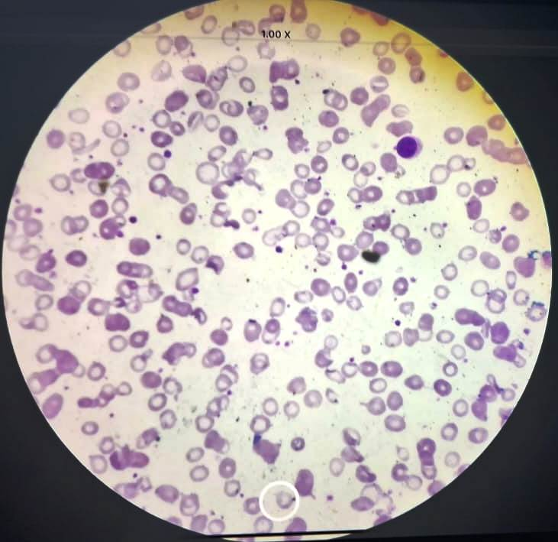
Fig 1:severe anemia with reduced RBC count ,teardrop cells , helmet cells and reactive thrombocytosis
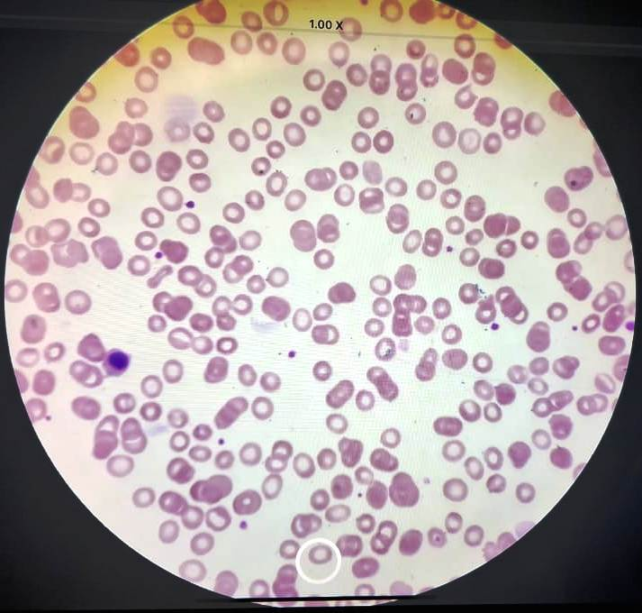
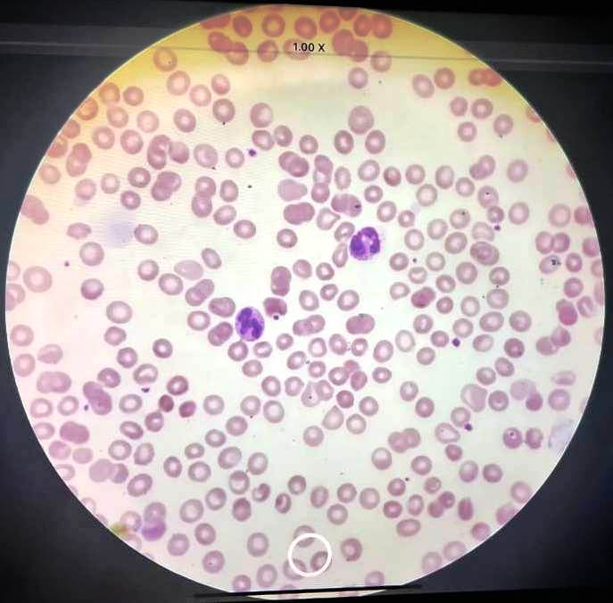
Fig. 2: Normoblast Fig 3 : Neutrophilic leukocytosis

Discussion:
“Naphthalene is a bicyclic aromatic hydrocarbon that is poorly soluble in water. Depending on size, one mothball can contain between 0.5 to 5 g of naphthalene” (8). “After exposure, it is readily absorbed and metabolized into reactive epoxides and quinone metabolites by cytochrome P450 oxidation. It is excreted in urine as mercapturic acids, methylthio derivatives, and glucuronide conjugates. After hepatic metabolism, the most potent derivative, α-naphthol, causes hemolysis and Heinz body formation. Naphthalene causes oxidative stress by enhancing free radical production, resulting in lipid peroxidation and DNA damage” (9). “Hemolysis is particularly seen in patients with low tolerance to oxidative stress, such as those with G6PD deficiency” (9)(10). “G6PD is essential in red cell metabolism due to its role in the pentose phosphate pathway. It provides resistance to oxidative stress by generating the reduced form of NADP” (11). “The presence of G6PD likely reduces the severity of naphthalene poisoning” (12). “The oxidative stress produced by naphthalene results in methemoglobinemia due to oxidation of Fe²⁺ to Fe³⁺ in hemoglobin, rendering it incapable of carrying oxygen and shifting the oxyhemoglobin curve to the left” (13).
“Naphthalene poisoning can impact various organ systems, including the nervous system, blood cells , respiratory system, and gastrointestinal tract (GIT).The degree of systemic damage depends on chemical absorption by small intestine and the functional state of the liver. Naphthalene itself has no hemolytic property, but its oxidative metabolite, alpha-napthol, possess potent hemolytic properties. The toxicity of naphthalene arises from its generation of excessive oxygen free radicals, leading to lipid peroxidation and DNA damage. Naphthalene undergoes metabolism in the liver, and resulting metabolities such as alpha-napthol, contribute to hemolysis and hemoglobinuria” (14)
“Several case studies on naphthalene toxicity suggest that patients initially present with recurrent vomiting, headache, and dark urine” (6). “Hemolytic anemia and methemoglobinemia are characteristic of naphthalene poisoning; severe neutrophilic leukocytosis and acute kidney injury are also observed” (15). “Hyperbilirubinemia with indirect fraction predominance, elevated LDH, and decreased haptoglobin are common findings” (12). “All these symptoms, clinical, and diagnostic features were observed in our case except AKI (probably due to lesser quantity ingestion and early treatment initiation). No clinical cyanosis was observed in our case (cyanosis is detectable when methemoglobin >10%). also No intra vascular hemolysis and hemaglobinuria ( Dark coloured urine probably due to excretion of Mercapturic acid and other metabolites of Naphthalene) Methemoglobin estimation by co-oximetry was very useful initially to start treatment protocols with oxygen via NRM, ascorbic acid, and NAC infusion. Ascorbic acid functions as an antioxidant that can help alleviate the oxidative stress caused by naphthelene, NAC treatment should be used as a reducing agent to treat methemoglobinemia, especially in individuals with G6PD deficiency” (16)
“In patients with methemoglobinemia, measurement by pulse oximetry is unreliable. Conventional pulse oximeters use two wavelengths of light, which cannot detect methemoglobin. Co-oximetry, however, measures methemoglobin by spectrophotometry using multiple wavelengths of light to simultaneously quantify different hemoglobin species in blood—oxyhemoglobin, deoxyhemoglobin, carboxyhemoglobin, and methemoglobin. This method is considered the gold standard for accurate measurement” (17). “Specific treatment of methemoglobinemia includes methylene blue, which accelerates the reduction of methemoglobin to hemoglobin” (13). “However, methylene blue can induce hemolysis in patients with G6PD deficiency. Methylene blue is reduced to leucomethylene blue by accepting electrons from NADPH, which then donates an electron to reduce methemoglobin to hemoglobin. G6PD-deficient individuals have low NADPH levels” (18,19). Hence, G6PD testing should be performed before administering methylene blue.
In our case, G6PD was low; therefore, supportive management with ascorbic acid (a free radical scavenger), NAC (a reducing agent), and exchange transfusion was adopted. The patient responded well and recovered quickly.
This case study reinforces the importance of managing naphthalene toxicity with laboratory support through critical investigations such as methemoglobin, G6PD, peripheral smear, bilirubin, and urine analysis (Table 1). importance of early diagnosis and prompt mangement especially in children.
Conclusion:
This case highlights the importance of early recognition and prompt management of naphthalene-induced methemoglobinemia and hemolytic anemia. A thorough history, clinical examination, and appropriate laboratory investigations are essential for accurate diagnosis. In patients with G6PD deficiency, methylene blue should be avoided, and alternative therapies such as ascorbic acid, N-acetylcysteine, and exchange transfusion should be considered. Supportive management and timely intervention can significantly improve patient outcomes and prevent severe complications. This case further emphasis the potential danger posed by mothballs, a common house hold item, when they are kept within the reach of susceptible children. It underscores the importance of taking utmost care and precaution to safety store guard these potentially hazardous household substances to prevent accidental ingestion by children, further public awareness and preventive education about the potential toxicity of naphthalene-containing products are crucial, especially in households with young children.

Consent
We present a review and management of a case of accidental naphthalene ingestion in a 2-year-5-month-old developmentally normal male child who presented with anemia, methemoglobinemia, and leukocytosis with informed consent from parents.

Disclaimer (Artificial intelligence)
Option 1:
Author(s) hereby declare that NO generative AI technologies such as Large Language Models (ChatGPT, COPILOT, etc.) and text-to-image generators have been used during the writing or editing of this manuscript.
Option 2:
Author(s) hereby declare that generative AI technologies such as Large Language Models, etc. have been used during the writing or editing of manuscripts. This explanation will include the name, version, model, and source of the generative AI technology and as well as all input prompts provided to the generative AI technology
Details of the AI usage are given below:
1.
2.
3.

References:
- Earl Siegel, Suman Wason, Mothball toxicity, Pediatric Clin N Am 1986;33:369-374.
- Lim HC, Paulose V, Tan HH, Acute naphthalene poisoning following the non-accidental ingestion of mothballs, Singapore Med.J.2009;50(8) 298-301.
- Sarangi R, Pradhan S, Prusty BK, Mahapatra S. Acute intravascular hemolysis following accidental ingestion of naphthelene : A rare case report. J Appl Hematol 2016;7:76-8.
- Sekar A, Paudel S, Sivakumar SP, Verma A, Methemoglobinemia and uremia from an unusual poison. L, Clin Toxicol 2014;4 217.
- Kavinda Dayasiri, K Pathiraja, H. & Thadchanamoorthy V. Acute hemolytic crisis complicated with ischemic cardiac injury and methemoglobinaemia following ingestion of naphthalene: a case report. J Med Case Reports 18,637 (2024). https://doi.org/10.1186/s13256-024-04980-8.

- Rahman MM, Mangni Mowla SG, Rahim A, Hasan MN: Severe haemolytic anemia due to ingestion of naphthelene (mothball) containing coconut oil. J. Coll Phsicians Surg Pak 2012, 22:740-741
- Sillery JJ, Lichen stein R, Barrueto FJ, Teshome G: Hemolytic anemia induced by ingestion of paradichlorobenzene mothballs. Pediar. Emerg. Care. 2009,25:252-254.
- Sarangi, et, al, Acute intravascular hemolysis following naphthelene poisoning Journal of Applied Haematology Vol 7, Issue 2, April-June 2016.
- Bagchi M, Bagachi D, Balmoori J, stohs SJ: Naphthelene induced oxidative stress and DNA damage in cultured macrophage J 744A.I Cells. Free Radic Biol Med. 1998, 25:137-43,
- Chugh KS, Singhel PC, Sharma BK, Mahakur AC, Pal Y, Datta BN, Das KC: Acute renal failure due to intravascular hemolysis in the North Indian patients, Am. J. Med Sci. 1977, 274: 139-46.
- Hassan KS, Al-Riyami AZ, Al-Haneini M, Al-Farsi K, Al- Khabori M: Methemoglobinemia in an elderly patient with glucose-6-phosphate dehydrogenese deficiency: a case report. Oman Med J. 2014, 29; 135-137.
- Trecisan A, Rossi di Schio M, Pieno M: Hemolytic anemia after self-giving of naphthelene- containing oil. J. Appl. Toxicol. 2001, 21: 393-396.
- Volney G, Tatusor M. Yen AC, et al., (August 15, 2018 ) Naphthelene Toxicity, Methemoglobinemia and Acute Intravascular Hemolysis. Cures 10 (8): e3147.DOI 10.7759/cureus. 3147.
- Sravanthi K, Patil MG, Mane S, et al. (May 29, 2024) Naphthalene Ball Ingestion Leading to Intravascular Hemolysis and Acute Kidney Injury. Cureus 16(50: e61291. DOI10.7759/cureus. 61291

- Kundra TS, Bhauttatani V, Gupta R, Kaur P: Naphthelene poisoning following ingestion of mothbolls: a case report J. clin Diagn es. 2015, 9:01-02.
- Ghada Alqahtani et al. Saudi J Er Med. 2024(3):261-263 DOI: 10.24911/SJEMed.72-1710893584

- Haematology Reference: Methemoglobinemia Workup Dipen B Khanapara, MD, Emmmanuel C, Besa, MD., updated: Dec 7, 2023.
- Nascimento TS, Pereira ROL, Mello HLD, Costa J. Methemoglobinemia: From diagnosis to treatment. Rev Bras Anestesiol 2008;58;651-64.

- Wright RO, Lewander WJ, Woolf AD. Methemoglobinemia; Etiology, pharmacology and clinical management . Ann Emerg Med 1999; 34;646-56.

