Etiological profiles and therapeutic challenges of Pediatric Shock in Senegal

ABSTRACT
Introduction: Shock is a failure of the circulatory system, resulting in an imbalance between oxygen supply and tissue demand. The objective of this study was to evaluate the etiological profiles and therapeutic challenges of shock in children.
Patients and methods: This was a prospective, descriptive, observational, and analytical study conducted from October 10, 2022, to October 23, 2023 (12 months), including all children hospitalized for shock in the emergency and pediatric intensive care units at the Albert Royer National Children's Hospital (CHNEAR).
Results: During this period, 146 patients presented with shock, representing a hospital prevalence of 11.33%. The mean age was 43.12 months. The sex ratio was 0.82. Signs of tissue hypoperfusion were present in almost all patients. Arterial hypotension was found in 45.52% of cases. Septic shock was predominant (55.00%), followed by hypovolemic shock (31.43%) and cardiogenic shock (10%). The outcome was unfavorable in most cases, with 69.18% of deaths due mainly to septic shock (47.29%), the main causes of death being refractory shock (48.51%), renal failure (32.19%), and disseminated intravascular coagulation (15.07%).
Conclusion: Shock is a diagnostic and therapeutic emergency in which the delay in treatment and the duration of shock are important factors in the prognosis.
Keywords: shock, challenge, pediatrics, limited resources

Introduction
Shock is a diagnostic and therapeutic emergency, and delays in treatment lead to increased mortality. It is a failure of the circulatory system, resulting in an imbalance between oxygen supply and peripheral tissue demand. Rapid identification of the mechanisms involved, the etiology of shock, and its severity guides optimal therapeutic management (1). Shock accounts for one-third of diagnoses in patients admitted to intensive care units (2). Depending on the clinical situation, there may be quantitative (decreased cardiac output) or qualitative (abnormal distribution or extraction of oxygen) alterations in arterial oxygen transport, which can lead to cellular dysoxia (3). There are four pathophysiological mechanisms: hypovolemic (true and hemorrhagic shock), distributive shock (septic and anaphylactic), obstructive shock (tamponade, pneumothorax, pulmonary embolism), and cardiogenic shock (4). Pediatric shock has some specific characteristics; questioning, medical history, clinical examination (looking for signs of tissue hypoperfusion), and cardiac ultrasound are important in determining the cause (5). In developing countries, delayed diagnosis and difficult access to care are factors that contribute to poor prognosis. The objective of this study was therefore to evaluate the etiological profiles and therapeutic modalities of shock in children.
Materials and methods:
We conducted a prospective, descriptive, observational, and analytical study over a one-year period (October 10, 2022, to October 23, 2023) in the emergency department and pediatric intensive care unit of the Albert Royer Children's Hospital. All children aged 0 to 18 years old who met the criteria for shock were included. The criteria for shock were: tachycardia, thready pulse, cold extremities, prolonged skin recoloration time (TRC greater than 2 seconds), and possibly low blood pressure. In addition to the signs of shock, the type of shock was defined by a set of criteria. Hypovolemic shock was diagnosed based on medical history (diarrhea, vomiting, hemorrhage, extensive burns, diabetic ketoacidosis, etc.) and the disappearance of signs of shock after fluid resuscitation. Septic shock was diagnosed when signs of shock persisted despite adequate fluid resuscitation, an infectious focus (gastroenteritis, pneumonia, meningitis, etc.) and abnormal infectious test results. The anaphylactic shock following exposure to an allergen, skin and mucous membrane reactions (hives, edema, pruritus, erythema, etc.) or respiratory reactions (dyspnea, bronchospasm, etc.). Cardiogenic shock was diagnosed in the presence of signs of heart failure, heart disease (congenital, rheumatic, or hypokinetic dilated cardiomyopathy, etc.) and impaired LVEF on cardiac ultrasound. Obstructive shock was considered in the presence of ultrasound signs of tamponade, pneumothorax on chest X-ray, or signs of pulmonary embolism (chest pain, desaturation, S1Q3 pattern on ECG).
Results
- Epidemiological data
During this period, 146 patients presented with shock, representing a hospital prevalence of 11.33%. The average age was 43.12 months, with a slight predominance of females (sex ratio of 0.82). The most representative age groups were between 7 and 48 months, followed by those under 6 months. Figure 1 illustrates the distribution by age group.
- Clinical data
- Signs of shock:
Tachycardia (92.46%), cold extremities (98.63%), prolonged TRC (97.26%), thready pulse (78.76%). Low blood pressure was found in 45.52% of our patients and could not be measured in 24.83% of cases. Oligoanuria was present in 33.56% of cases.
- Associated signs:
Neurological: impaired consciousness (54.11%), convulsions (23.97%), meningeal syndrome (12.33%), intracranial hypertension (8.22%). Respiratory: respiratory distress (49.32%) with hypoxemia (36.30%), pulmonary condensation syndrome (17.12%). Other: heart failure (10.96%), severe dehydration (7patients), hemorrhagic syndrome (5 patients).
- Etiological data
Distributive shock was the most common type of shock, accounting for 55.00% of cases, followed by hypovolemic shock (31.43%) and cardiogenic shock (10%). The different etiological types of shock are illustrated in Figure 2.
- Distributive shock:
Among the distributive shocks observed in our study, no cases of anaphylactic shock were recorded; all cases were exclusively septic shock. The most common causes were meningitis (38.27%), followed by pneumonia (22.22%) and acute gastroenteritis (6.84%). Germs were isolated in 23 cases (15.75%) by blood culture (15 cases), CSF (4 cases), viral testing in stool samples (4 cases), skin swabs (1 case), and nasopharyngeal viral PCR (1 case). The most commonly found germs were S. aureus (8 cases), K. pneumoniae (5 cases), pneumococcus (2 cases), and E. coli (2 cases). Other causes included severe malaria (2 cases), subperiosteal abscess (1 case), and healthcare-associated infections (4 cases).
- Hypovolemic shock
Acute gastroenteritis was the most common cause, accounting for 76% of cases of hypovolemic shock. It was mainly viral (71.42%). Other causes of acute dehydration: severe burns (2 cases), dehydration due to insufficient intake in newborns (2 cases), diabetic ketoacidosis (2 cases), and salt-wasting syndrome in the context of congenital adrenal hyperplasia (1 case). Causes of hemorrhagic shock (3 cases) included massive gastrointestinal hemorrhage secondary to abdominal trauma and a gastroduodenal ulcer, and 1 case of acute toxic hepatitis in the context of liver disease.
- Cardiogenic shock
The most common underlying heart conditions were congenital heart disease (71.42%), rheumatic heart disease (14.28%), and hypokinetic dilated cardiomyopathy (9.5%). Several decompensating factors, mainly infectious in nature (94.11%), were identified.
- Obstructive shock: no cases of obstructive shock were reported.
Therapeutic approach
- Unspecified measures
Resuscitation measures were effective in almost all patients: label sheet (97.26%), monitoring (97.26%), urinary catheter (62.33%), nasogastric tube (40.41%), central venous access (17.12%), performed without ultrasound guidance, mainly in the femoral vein, which was used in 22 patients (88%), oxygen therapy (91.78%). Vascular filling (82.19%) was performed in all patients in hypovolemic or septic shock with crystalloid boluses of 10 to 20 ml/kg. Crystalloids were the first-line fluid replacement solution (82.19%), mainly consisting of 0.9% NaCl (95.83% of cases). Antibiotic therapy was used in 84.24% of cases. Figure 3 illustrates the distribution of patients according to antibiotic therapy.

- Specific measures
- Septic shock
Regarding vasopressor amines, norepinephrine was the most commonly used amine (36.98%), followed by epinephrine (24.64%) and dopamine (2.05%). Antibiotic therapy was systematic in septic shock and was administered as soon as the diagnosis was made. Corticosteroid therapy was used in refractory septic shock in 40.41% of patients.
- Cardiogenic shock
For cardiogenic shock, dobutamine was used in 12.33% of cases, diuretics in 16.44% and conversion enzyme inhibitors in 6.85%.
Progression and prognosis
Progression was unfavorable in most cases, with 69.18% of deaths due mainly to septic shock (47.29%), the main causes of death being refractory shock (48.51%), renal failure (32.19%), and disseminated intravascular coagulation (15.07%). Statistically, data analysis showed a significant association between death and septic shock, with a highly significant p-value (Table 1).
Discussion
The most representative age groups were between 7 and 48 months, followed by under 6 months. However, it is lower in Malawi, with an average age of 15 months (6), and in Egypt, with an average age of 18 months (7). The young age could be explained by the prevalence of congenital heart disease, the high number of viral gastroenteritis cases in infants, overcrowding, and low socioeconomic status in our contexts. Tachycardia is the most common finding on physical examination in children in shock. Persistent tachycardia in a calm, febrile child should raise concern in the physician and prompt a search for signs of tissue hypoperfusion (5).
In countries with limited resources, diagnosing shock is a real challenge. The lack of key tools such as cardiac ultrasound, blood gas analysis, and lactate testing significantly limits the hemodynamic and metabolic assessment of patients. As a result, clinicians often rely on purely clinical criteria and basic laboratory tests, which can sometimes delay rapid and appropriate management. In our series, the diagnosis was based primarily on clinical signs of tissue hypoperfusion (cold extremities, prolonged skin recoloration time, tachycardia) and signs of cellular hypoxia (impaired consciousness, oligoanuria). Septic shock was the most common, followed by hypovolemic shock and cardiogenic shock. This high prevalence could be explained by the low socioeconomic status of most of our patients, which is the cause of delayed diagnosis. Similar results have been found in the literature (1,8). The etiologies vary depending on the type of shock, but sepsis remains a major cause of morbidity and mortality in children worldwide (5). Rapid identification of the pathogen and the source of infection is essential for appropriate antibiotic therapy, but remains a challenge in our settings. Pathogens were isolated in 23 cases (15.75%) by blood culture. This low isolation rate can be explained by several factors: logistical difficulties (shortage of reagents, long delays between sampling and culture, contamination of samples, insufficient blood volumes, etc.), prior antibiotic therapy, and lack of automated culture techniques. Vascular filling is titrated according to hemodynamic status and signs of fluid overload, in boluses of 10 to 20 mL/kg. Crystalloids are the solutes of choice, with a theoretical advantage of balanced solutions over 9‰ NaCl in terms of the onset of hyperchloremic acidosis (9–11). The child must be reevaluated regularly after each fluid bolus to assess the response and check for signs of fluid overload (12,13). With regard to vasopressor amines, no clinically relevant advantage of adrenaline over noradrenaline has been found in the literature (14–16). They are both inotropic and vasopressive drugs, with noradrenaline having a predominantly vasopressive effect and adrenaline having a predominantly inotropic effect. While the new recommendations are clear on the superiority of these two agents over dopamine, they do not specify which vasoactive agent should be used as first-line treatment. Noradrenaline is preferred to increase vascular resistance in the absence of myocardial dysfunction, and adrenaline in cases of myocardial dysfunction, but it has been shown that the clinical distinction is not always easy and may (9). The new recommendations are clear on the urgency of starting probabilistic antibiotic therapy within one hour of clinical suspicion of severe sepsis, along with rapid identification and treatment of the site(s) of infection. Blood cultures should be obtained before starting antibiotic therapy and without delaying its administration. It is recommended to start broad-spectrum antibiotic therapy with one or more antimicrobials to cover the likely pathogens. For children with no history of severe community-acquired sepsis, a third-generation cephalosporin may be sufficient, but an aminoglycoside may be added to broaden the spectrum. Vancomycin should be added in settings where methicillin-resistant Staphylococcus aureus or third-generation cephalosporin-resistant pneumococci are common. For immunocompromised patients or hospital-acquired sepsis, antimicrobial treatment should begin with a higher-generation cephalosporin (cefepime), a combination of penicillin and a broad-spectrum beta-lactamase inhibitor (piperacillin/tazobactam), or a broad-spectrum carbapenem (meropenem) (17). Evidence for the use of steroids in pediatric shock is limited and yields conflicting results. One study showed that children with septic shock who received corticosteroids did not experience an improvement in mortality, the number of days on vasoactive infusion, or length of hospital stay (18). Similarly, a recent meta-analysis showed no difference in mortality rates between those who received steroids and those who did not (19). However, some studies have nevertheless demonstrated the potential benefit of corticosteroids in a comparative study of two groups of patients, one using vasopressins alone and the other combining vasopressins with corticosteroids (20). In our series, corticosteroid therapy was used only in patients with refractory septic shock (40.71%), mainly with hydrocortisone.
Dobutamine is the most commonly used inotropic agent in heart failure and cardiogenic shock, but there are other positive inotropes such as milrinone, enoximone, and levosimendan (13).
The death rate in our series was 69.17% and was mainly due to septic shock, which accounted for 47.29%. Mortality during septic shock is equally high in the literature (1,7,21,22). The most common causes of death were refractory shock, renal failure, and DIC. The same etiologies were found in the literature (10,23). The lack of resources such as diagnostic and therapeutic means (blood gas analysis, bedside cardiac ultrasound, non-invasive ventilation, lack of monitoring equipment and human resources) contributes to the increase in mortality and thus constitutes an obstacle to optimal care.
Conclusion
Shock is a common condition in pediatric hospitals, with significant morbidity and mortality. Early identification through tachycardia and other signs of tissue hypoperfusion, as well as blood pressure measurement, is essential for rapid initiation of appropriate treatment and referral to specialists for possible transfer. The main challenge in our settings remains access to treatment, especially in cases of late diagnosis.

Disclaimer (Artificial intelligence)
Author(s) hereby declare that NO generative AI technologies such as Large Language Models (ChatGPT, COPILOT, etc.) and text-to-image generators have been used during the writing or editing of this manuscript.

References
1. Durand A, Cartier L, Duburcq T, Onimus T, Favory R, Preau S. États de choc : grands cadres étiologiques, prise en charge initiale. La Revue de Médecine Interne. déc 2019;40(12):799‑807.
2. Babaev A, Frederick PD, Pasta DJ, Every N, Sichrovsky T, Hochman JS, et al. Trends in management and outcomes of patients with acute myocardial infarction complicated by cardiogenic shock. JAMA. 27 juill 2005;294(4):448‑54.
3. van Beest PA, Brander L, Jansen SP, Rommes JH, Kuiper MA, Spronk PE. Cumulative lactate and hospital mortality in ICU patients. Ann Intensive Care. 27 févr 2013;3:6.
4. Carcillo JA, Fields AI, American College of Critical Care Medicine Task Force Committee Members. Clinical practice parameters for hemodynamic support of pediatric and neonatal patients in septic shock. Crit Care Med. juin 2002;30(6):1365‑78.
5. Mendelson J. Emergency Department Management of Pediatric Shock. Emergency Medicine Clinics of North America. mai 2018;36(2):427‑40.
6. Impact of HIV infection and exposure on survival in critically ill children who attend a paediatric emergency department in a resource-constrained setting - PubMed [Internet]. [cité 15 mars 2024]. Disponible sur: https://pubmed.ncbi.nlm.nih.gov/20515902/
7. Ibrahiem SK, Galal YS, Youssef MRL, Sedrak AS, El Khateeb EM, Abdel-Hameed ND. Prognostic markers among Egyptian children with sepsis in the Intensive Care Units, Cairo University Hospitals. Allergol Immunopathol (Madr). 2016;44(1):46‑53.
8. Cecconi M, De Backer D, Antonelli M, Beale R, Bakker J, Hofer C, et al. Consensus on circulatory shock and hemodynamic monitoring. Task force of the European Society of Intensive Care Medicine. Intensive Care Med. déc 2014;40(12):1795‑815.
9. Weiss SL, Peters MJ, Alhazzani W, Agus MSD, Flori HR, Inwald DP, et al. Surviving Sepsis Campaign International Guidelines for the Management of Septic Shock and Sepsis-Associated Organ Dysfunction in Children. Pediatr Crit Care Med. févr 2020;21(2):e52‑106.
10. Pollack MM, Fields AI, Ruttimann UE. Distributions of cardiopulmonary variables in pediatric survivors and nonsurvivors of septic shock. Crit Care Med. juin 1985;13(6):454‑9.
11. Emrath ET, Fortenberry JD, Travers C, McCracken CE, Hebbar KB. Resuscitation With Balanced Fluids Is Associated With Improved Survival in Pediatric Severe Sepsis. Crit Care Med. juill 2017;45(7):1177‑83.
12. van Diepen S, Katz JN, Albert NM, Henry TD, Jacobs AK, Kapur NK, et al. Contemporary Management of Cardiogenic Shock: A Scientific Statement From the American Heart Association. Circulation. 17 oct 2017;136(16):e232‑68.
13. Ponikowski P, Voors AA, Anker SD, Bueno H, Cleland JGF, Coats AJS, et al. 2016 ESC Guidelines for the diagnosis and treatment of acute and chronic heart failure: The Task Force for the diagnosis and treatment of acute and chronic heart failure of the European Society of Cardiology (ESC)Developed with the special contribution of the Heart Failure Association (HFA) of the ESC. Eur Heart J. 14 juill 2016;37(27):2129‑200.
14. Hamzaoui O, Jozwiak M, Geffriaud T, Sztrymf B, Prat D, Jacobs F, et al. Norepinephrine exerts an inotropic effect during the early phase of human septic shock. Br J Anaesth. mars 2018;120(3):517‑24.
15. Rhodes A, Evans LE, Alhazzani W, Levy MM, Antonelli M, Ferrer R, et al. Surviving Sepsis Campaign: International Guidelines for Management of Sepsis and Septic Shock: 2016. Intensive Care Med. mars 2017;43(3):304‑77.
16. Myburgh JA, Higgins A, Jovanovska A, Lipman J, Ramakrishnan N, Santamaria J, et al. A comparison of epinephrine and norepinephrine in critically ill patients. Intensive Care Med. déc 2008;34(12):2226‑34.
17. Levy M, Lacarra B, Naudin J, Dauger S. Sepsis sévère chez l’enfant. Perfectionnement en Pédiatrie. juin 2023;6(2):134‑42.
18. Zimmerman JJ, Williams MD. Adjunctive corticosteroid therapy in pediatric severe sepsis: Observations from the RESOLVE study*. Pediatric Critical Care Medicine. janv 2011;12(1):2.
19. Menon K, McNally D, Choong K, Sampson M. A Systematic Review and Meta-Analysis on the Effect of Steroids in Pediatric Shock. Pediatric Critical Care Medicine. juin 2013;14(5):474.
20. Gordon AC, Mason AJ, Perkins GD, Stotz M, Terblanche M, Ashby D, et al. The interaction of vasopressin and corticosteroids in septic shock: a pilot randomized controlled trial. Crit Care Med. juin 2014;42(6):1325‑33.
21. Analyse de la mortalité au service de réanimation pédiatrique du CHU Mohammed VI de Marrakech.
22. Menif K, Bouziri A, Ben Jaballah N. [Management of the first hour of the pediatric septic shock patient]. Tunis Med. févr 2011;89(2):132‑5.
23. Schlapbach LJ, Watson RS, Sorce LR, Argent AC, Menon K, Hall MW, et al. International Consensus Criteria for Pediatric Sepsis and Septic Shock. JAMA. 27 févr 2024;331(8):665‑74.

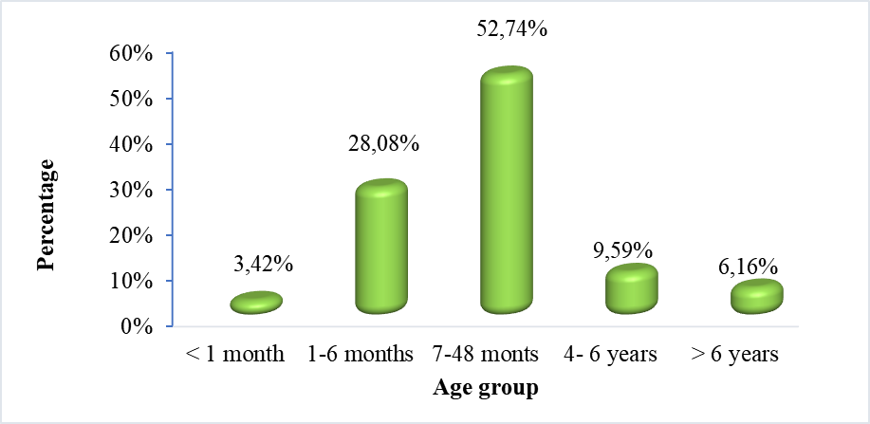
Figure 1: Breakdown by age group

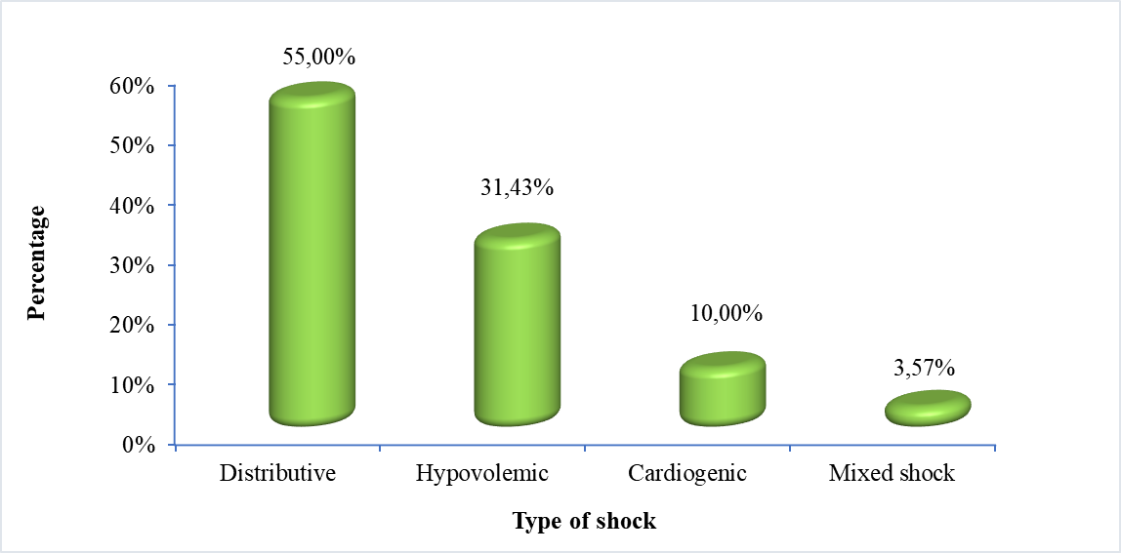
Figure 2: Breakdown by type of shock

Figure 3: Distribution according to antibiotic therapy

Table 1: Relationship between type of shock and death
Characteristic |  | Death |  | Chi² | p-value | OR | IC 95%
 |  | Yes (%) | No (%)
Cardiogenic shock | Yes | 11(78,57) | 3(21,43) | 0,64 | 0,4 | 1,71 | 0,45-6,46
Cardiogenic shock | No | 90(68,18) | 42(31,82)
Hypovolemic shock | Yes | 16(36,36) | 28(63,64) | 31,80 | 0,000 | 0,11 | 0,05-0,25
Hypovolemic shock | No | 85(83,33) | 17(16,67)
Septic shock | Yes | 64(83,12) | 13(16,88) | 14,84 | 0,00 | 4,36 | 1,99-9,11)
Septic shock | Non | 37(53,62) | 32(46,38)
Septic shock with cardiac failure | Yes | 5(100) | 0(0) | 2,31 | 0,13 | ND | ND
Septic shock with cardiac failure | No | 96(68,09) | 45(31,91)

