The Relationship between Population and Labor in the Agricultural Sector: A Regression Model for Dependency Forecasting

Abstract
A sizable section of the population still relies heavily on agriculture for their livelihood, particularly in developing nations. Effective planning, policymaking, and resource allocation require a clear understanding of how population changes influence agricultural dependence. This study develops both linear and exponential regression models to forecast the number of individuals dependent on agriculture by incorporating population growth and key socioeconomic variables. Using historical population and agricultural workforce data, the models identify the strength and direction of the relationship between population size and agricultural dependency. The results show a strong positive correlation, indicating that population expansion continues to place significant pressure on the agricultural sector. These predictive models provide valuable insights for researchers, planners, and policymakers seeking to design sustainable agricultural strategies and promote rural development.

Keywords: Workforce forecasting, population expansion, agricultural reliance, regression analysis, and agricultural planning.

- Introduction
Many nations' economies rely heavily on agriculture, which gives a sizable section of the populace jobs, food security, and revenue. Agriculture is the foundation of rural lives in areas where urbanization and industrialization are still in their infancy. The number of people reliant on agriculture tends to rise with population growth, putting strain on productivity, water availability, and land resources. Designing successful agricultural and rural development programs requires an understanding of the connection between population expansion and agricultural dependency. Descriptive statistics have been used in traditional techniques of studying this connection, but their predictive power is limited. Conversely, regression modeling offers a methodical approach to estimating and predicting the ways in which population changes impact the agricultural. Conventional analytical techniques, like descriptive statistics, offer a summary of current and historical patterns but are not predictive. Regression analysis, on the other hand, provides a strong and methodical way to model and predict connections between variables. It is feasible to measure the impact of population size variations on agricultural reliance and make more accurate predictions about future trends by using linear and multiple regression models.In order to estimate the number of people reliant on agriculture as a function of population growth and other pertinent factors, this study focuses on creating a regression-based prediction model. The study determines the direction and strength of the population-agricultural workforce link by looking at historical data. The findings should aid academics, development planners, and policymakers in predicting shifts in the demand for agricultural jobs, allocating resources as efficiently as possible, and creating policies that support sustainable agriculturalgrowth.
When taken as a whole, these studies offer a comprehensive picture of India's population-agriculture relationship. Their findings support the use of linear and exponential regression models to forecast future dependency as they show a steady long-term trend of population expansion coupled with a slow decline in the proportion of the workforce employed in agriculture. The literature emphasizes that agriculture remains the foundation of rural subsistence and national food security, despite the fact that economic and demographic changes have diversified employment.
- Literature review
The relationship between population dynamics, agricultural development, and rural employment has long been a central focus of research in India and other developing countries. Early foundational studies such as Mehra (1966) highlighted the concept of surplus labour in Indian agriculture, noting that high population pressure created disguised unemployment and low productivity. Dayal (1984) further demonstrated how spatial variations in agricultural productivity were shaped by population density, irrigation, and technological disparities across regions. These early contributions laid the groundwork for understanding how demographic factors influence agricultural performance. Bhalla (1987) added to this discourse by showing how employment trends in agriculture shifted in response to land distribution and mechanisation, providing deeper insights into labour transitions within rural economies. By the 1990s, researchers increasingly focused on the interplay between population characteristics, labour diversification, and rural non-farm employment. Singh (1996) investigated gender wage disparities among agricultural workers, revealing how demographic factors and cultural norms influenced labour markets and agricultural growth. Parthasarathy and Reddy (1998) analysed determinants of rural non-agricultural employment, showing how landholdings, education, and demographic attributes shaped household decisions to diversify away from agriculture. As economic reforms progressed, Lanjouw and Murgai (2009) documented a significant decline in rural poverty between 1983 and 2004, accompanied by rising agricultural wages and the gradual shift of the labour force into the non-farm sector. More recent studies have incorporated econometric modelling to quantify demographic influences on agricultural labour and productivity. Sharma et al. (2016) applied robust regression techniques to examine the number of agricultural workers in India, revealing how structural and demographic variables interact to influence labour availability. Meanwhile, major institutional reports have provided comprehensive evidence on shifting rural dynamics. NITI Aayog’s (2017) report on the changing structure of the rural economy highlights declining agricultural employment and increasing non-farm opportunities, driven partly by demographic transition and migration. Similarly, the National Statistical Office’s PLFS report (2019) revealed declining participation in agricultural occupations, illustrating how demographic and employment patterns are undergoing rapid transformation. Demographic projections from MoHFW (2020) further underscore the significance of population growth and urbanisation in shaping future agricultural challenges. The report predicts sustained population increase, rising dependency ratios, and greater urban pressure, all of which will affect food demand and agricultural resource allocation. At the same time, the FAO’s (2020) global report on water challenges emphasizes that population growth will intensify water scarcity, severely constraining agricultural production unless efficiency improves. Climate-related pressures on agriculture are highlighted in Birthal’s (2022) work, which calls attention to increasing climatic risks faced by Indian farmers and stresses the need for adaptive strategies.
The COVID-19 pandemic introduced new complexities to rural and agricultural labour markets. Tandon et al. (2022) documented changing work structures in urban India, including rising informality and temporary employment, which indirectly impact rural labour mobility and agricultural workforce availability. Recent research provides more nuanced empirical perspectives. Jana and Goli (2023) identified an inverted U-shaped relationship between population growth and agricultural land use, indicating that early phases of population growth expand cultivation, but later phases intensify land pressure. Kumar and Moharaj (2023) explored the farm size–productivity relationship, showing that land fragmentation continues to shape agricultural efficiency. At the global level, Miladinov (2023) and Islam et al. (2025) demonstrated how population growth influences food security outcomes in low- and middle-income countries. For India specifically, Yasir et al. (2025) showed using ARDL models that population growth and urbanisation significantly reduce agricultural land availability, emphasizing the growing demographic pressure on agricultural systems.In order to predict the agricultural workforce, this study presents a novel integrated analytical method that combines regression-based modeling with both linear and exponential population forecasting. By combining these complementary approaches, the study offers a more precise, data-driven, and thorough evaluation of India's future reliance on agriculture, allowing for a deeper understanding of long-term demographic pressures, labor demand, and structural changes within the rural economy.

- Models and Methods
In this study, a comprehensive quantitative analytical framework is employed, integrating both regression modeling and time-series forecasting techniques. These methods enable a systematic assessment of historical data and support evidence-based projections for future demographic and workforce trends. The analysis begins with the application of linear and exponential growth models to estimate future population levels. The linear model helps in understanding steady, constant-rate changes over time, whereas the exponential model captures accelerated or compound growth patterns. Using both models allows for a more robust comparison and provides insights into which pattern better represents the long-term population dynamics of the study region. Following the population projection, regression analysis is utilized to examine the statistical relationship between the total population and the number of agricultural laborers. This step is essential for identifying whether changes in population size significantly influence the agricultural workforce and to what extent. The regression model helps quantify this relationship, providing coefficients that indicate the direction and strength of association.

Description of the Model
(a) Linear Population Growth Model
The population is estimated as a function of year using a straightforward linear regression model:
$$\hat{P_{t}}=β_{0}+β_{1}+\hat{P_{t}}$$Where: $\hat{P_{t}}$= Population prediction at time t
t = Year
$β_{0},β_{1}$= Least squares estimation of the intercept and slope parameters.

(b) Model of Exponential Population Growth
To account for non-linear tendencies in population expansion, an exponential growth model is used:
$$lnP_{t}=a_{0}+a_{1}×t$$
$$\hat{P_{t}}=e^{a_{0}+a_{1}t}$$
Where: $P_{t}$= The population at t
$a_{0},a_{1}$= Coefficients of regression
e = Natural logarithm base
We may use linear regression techniques to an exponential model by taking the population's natural logarithm.
An overview of the methodology
Step 1: Compile past census information.
Step 2: Fit population models using linear and exponential methods.
Step 3: Regress the population by the number of agricultural laborers.
Step 4: Project the workforce and population for 2021–2051.
Step 5: Examine the proportion of the population that depends on agriculture in the two models.

- Applications

The present research applies population and workforce forecasting models using data sourced from the Agriculture Survey 2018, which provides comprehensive information on demographic characteristics, agricultural workforce participation, and long-term labour availability in the rural sector. In order to forecast future population size and the percentage of the labor force involved in agriculture for the years 2021–2051, this dataset serves as the foundation for both linear and exponential growth models. Using the 2018 agricultural labour statistics as the starting reference, the study generates comparative forecasts to understand how changing demographic trends may influence the availability of agricultural workers in the coming decades.

Table 1 :Population and Workforce Forecasts Using Exponential and Linear Growth Models (2021–2051)
Year | Linear Model — Predicted Population | Linear Model — Predicted Workers | Workers (% of Population) | Exponential Model — Predicted Population | Exponential Model — Predicted Workers | Workers (% of Population)
2021 | 1306.4 | 286.3 | 21.92 % | 1534.3 | 329.6 | 21.48 %
2031 | 1450.2 | 313.7 | 21.63 % | 1885.2 | 396.3 | 21.02 %
2041 | 1594.0 | 341.0 | 21.39 % | 2316.4 | 478.2 | 20.64 %
2051 | 1737.8 | 368.3 | 21.19 % | 2846.2 | 578.8 | 20.34 %

- Results
Both the linear and exponential growth models' conclusions provide important new information about India's population-agriculture link. The entire population is expected to rise at a steady and moderate rate, from 1,210.9 million in 2011 to around 1,737.8 million by 2051, according to the linear growth model. In line with this, it is anticipated that there would be 368.3 million agricultural workers by 2051, up from 263.1 million in 2011. A slow but continuous transition away from reliance on agricultural employment is indicated by the progressive drop in the proportion of agricultural workers to the overall population, which went from 21.9% in 2021 to 21.2% in 2051, despite an increase in the absolute number of agricultural workers over time.
The exponential growth model, on the other hand, predicts a greater rate of population expansion, with an estimated 2,846.2 million people by 2051. The number of agricultural workers rises more dramatically as a result, rising from 329.6 million in 2021 to 578.8 million in 2051. The proportion of agricultural workers in the overall population, however, decreases more quickly—from 21.5% in 2021 to 20.3% in 2051—despite this greater rise in absolute numbers. According to this pattern, a decreasing number of individuals will eventually make agriculture their primary employment, despite the fact that the labor force and general population are still growing.
Overall, both models indicate that although population growth is still occurring, reliance on agriculture as a source of income is declining, which suggests that the economy is undergoing structural changes and that workers are gradually shifting to non-agricultural industries. While the exponential model depicts an accelerated development scenario and is helpful for comprehending possible high-growth outcomes, the linear model offers a more cautious estimate appropriate for moderate growth assumptions. When combined, these models offer policymakers useful predictive information for predicting future employment patterns, planning for rural development, and diversifying sources of income.

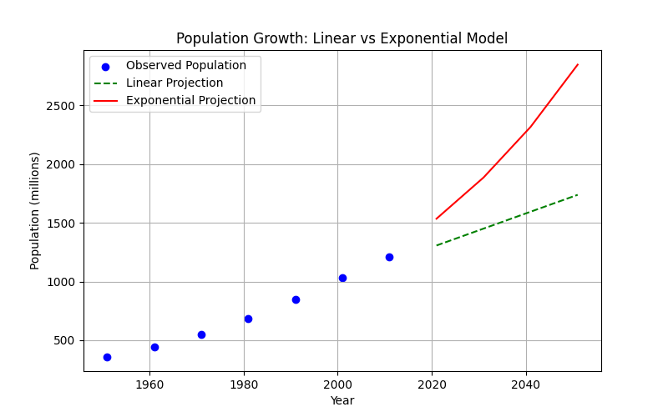
Figure 1: Graphical representation of Population Forecasts Using Exponential and Linear Growth Models (2021–2051)

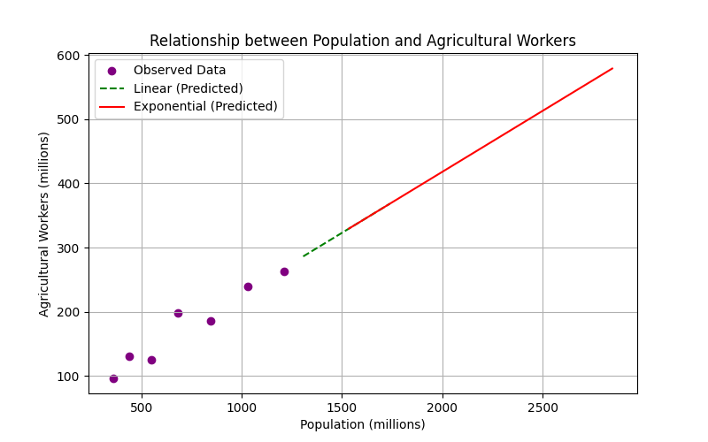
Figure 2: Graphical representation of Agriculture workers Forecasts Using Exponential and Linear Growth Models (2021–2051)

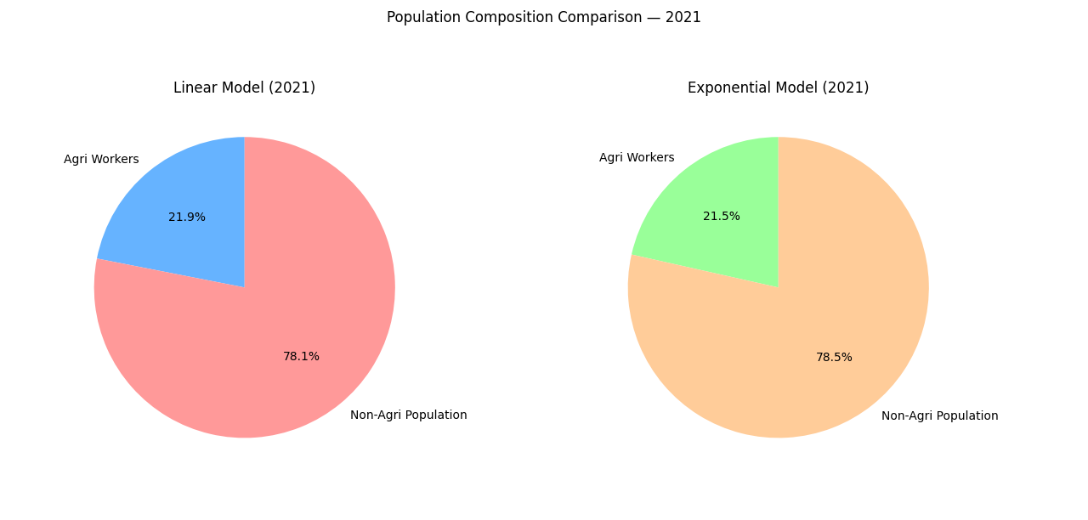
Figure3: Population and Workforce Forecasts Using Exponential and Linear Growth Models 2021

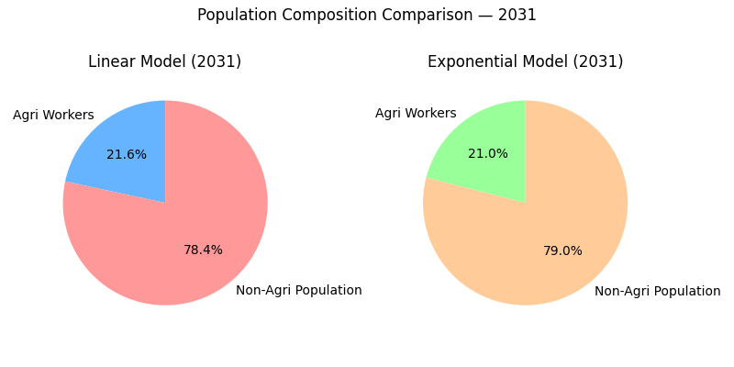
Figure 4: Population and Workforce Forecasts Using Exponential and Linear Growth Models 2031
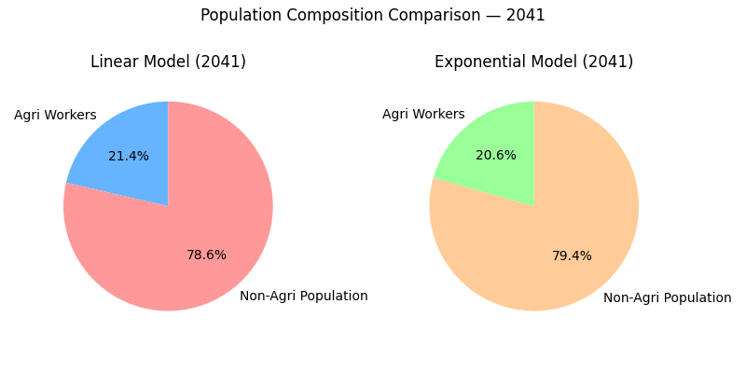
Figure 5: Population and Workforce Forecasts Using Exponential and Linear Growth Models 2041

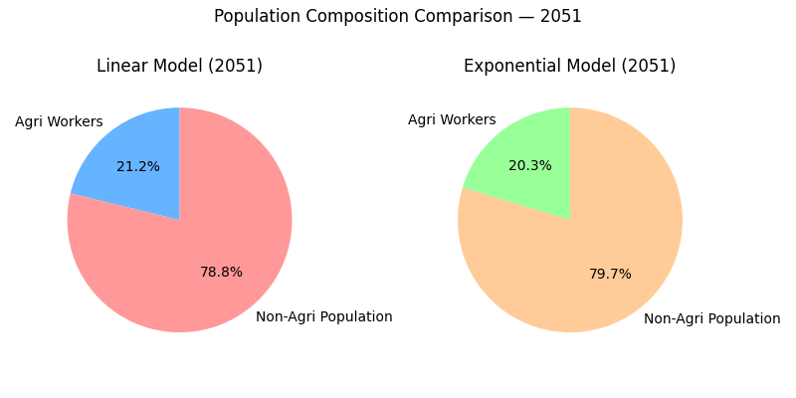
Figure 6: Population and Workforce Forecasts Using Exponential and Linear Growth Models 2051
- Discussion
A thorough examination of the changing relationship between population growth and reliance on agriculture is necessary to comprehend India's long-term demographic and occupational transition. The outcomes of both linear and exponential regression models offer insightful information about these changes and tell a more comprehensive tale of structural change in the Indian economy. India's population is expected to grow steadily over the next thirty years according to both models. However, even as the total number of agricultural workers rises, it is anticipated that the percentage of people whose primary source of income is agriculture will gradually decrease. Deeply ingrained socioeconomic shifts brought about by modernization, technological development, and economic diversification are reflected in this trend.India's population is expected to reach approximately 1.74 billion people by 2051, according to the linear model's moderate and stable growth projection, with an increase in agricultural workers from 263.1 million in 2011 to roughly 368.3 million by that same year. The percentage of the population employed in agriculture decreases from approximately 21.9% in 2021 to 21.2% in 2051, despite this absolute increase. This gradual decline indicates that India's economy is gradually shifting away from traditional farming and toward one that is more industrial and service-oriented.The exponential model, on the other hand, predicts a population of almost 2.85 billion by 2051, indicating a more rapid growth scenario. Additionally, it projects a more rapid increase in the number of agricultural workers, from 329.6 million in 2021 to 578.8 million in 2051. However, despite this significant rise, the proportionate reliance on agriculture decreases more quickly, going from 21.5% to 20.3% during the same time frame. The idea that economic restructuring is taking place is supported by the discrepancy between the absolute number of workers and the proportionate decline: while more people will enter the workforce overall, a smaller percentage will still work primarily in agriculture.These results have important societal and policy ramifications. Opportunities for greater productivity, mechanization, and modernization within the industry are suggested by a declining agricultural share. Resources could be managed more effectively if fewer people were reliant on farming, which could increase output and guarantee better living conditions for those who continue to work in agriculture. But there are difficulties with the shift as well. Inadequate planning could lead to unemployment, income inequality, or social instability, and millions of rural workers will require alternative employment pathways.Policy intervention becomes crucial as a result. To prepare the labor force for non-agricultural jobs, the government must support rural industrialization, skill development, and education. Increasing digital access, supporting small businesses, and fortifying rural infrastructure can all aid in absorbing excess labor and boosting economic resilience. In addition, since agriculture continues to sustain a sizable portion of the rural population, it is imperative to ensure its sustainability and profitability.
- Conclusion
Regression-based analysis of the population-agriculture relationship reveals significant information about India's long-term demographic and occupational transition. Both linear and exponential model projections consistently show that India's population will keep growing over the ensuing decades. However, the percentage of people working in agriculture is steadily declining in tandem with this growth. India's population is projected to reach 1.7 billion by 2051, but by the middle of the century, the proportion of people directly dependent on agriculture is expected to drop from roughly 22% in 2021 to about 21% or even lower. This pattern shows a more extensive structural change in the nation's labor market and economy than just a numerical shift.The growing impact of education, technological advancement, urbanization, and economic diversification are major forces behind this change. There are fewer people who depend entirely on agriculture for their livelihood as opportunities in industry and services grow. This does not necessarily imply a decrease in agricultural productivity; rather, the workforce's makeup is changing. Agriculture's employment share is declining, despite the fact that the overall number of people of working age is still rising. This indicates a slow but steady diversification of rural economic activity. This change points to a shift toward a more diverse and resilient rural economy since more rural households are working in non-farm jobs, small enterprises, services, and wage labor.These findings offer both opportunities and challenges from a wider societal standpoint. Increased productivity, improved mechanization, and modernization of farming techniques are made possible by the decreasing reliance on agriculture. Farmers may become more economically viable, technologically advanced, and efficient if fewer people are reliant on land. However, this decreasing reliance also highlights the necessity of meticulous policy planning. The nation needs to make sure that many rural workers are successfully integrated into other industries as they leave farming. The risk of increasing unemployment, covert labor, and growing income inequality increases significantly in the absence of sufficient employment opportunities.Therefore, the findings highlight how crucial government intervention and strategic planning are. To facilitate this shift, policies that support entrepreneurship, digital literacy, vocational training, rural industrialization, and better access to education will be crucial. Increasing employment opportunities in manufacturing and services and bolstering rural infrastructure can help guarantee that the migrating workforce finds productive and sustainable alternatives outside of agriculture. However, since a sizable portion of the population still depends on agriculture, especially in less developed areas, it must continue to be a top priority in terms of sustainability, profitability, and resilience.
Reference
MoHFW. (2020). Population projections for India and states 2011–2036: Report of the technical group on population projections.
FAO. (2020). The state of food and agriculture 2020. Overcoming water challenges in agriculture. Food and Agriculture Organization of the United Nations.
Aayog, N. I. T. I. (2017). Changing structure of rural economy of India implications for employment and growth. National Institution for Transforming India, Government of India.
India, N. S. O. (2019). Annual Report: Periodic Labour Force Survey (PLFS)(July 2017-June 2018). Nueva Delhi: Gobierno de la India.
Birthal, P. S. (2022). Climate change and risk management in Indian agriculture. Department of Economic Research and Analysis.
Tandon, N., Basu, P., Krishnan, O., & RV, B. (2022). Emerging work trends in Urban India: COVID-19 and beyond. Routledge India.
Dayal, E. (1984). Agricultural productivity in India: a spatial analysis. Annals of the Association of American Geographers, 74(1), 98-123.
Manish Sharma, M. S., Banti Kumar, B. K., Anil Bhat, A. B., Bhat, I. J., &Sunali Mahajan, S. M. (2016). Robust regression model to study the number of Indian agricultural workers.
Parthasarathy, G., & Reddy, B. S. (1998). Determinants of rural non-agricultural employment: the Indian case. Indian Journal of Agricultural Economics, 53(2), 139-154.
Singh, R. D. (1996). Female agricultural workers' wages, male-female wage differentials, and agricultural growth in a developing country, India. Economic Development and Cultural Change, 45(1), 89-123.
Lanjouw, P., &Murgai, R. (2009). Poverty decline, agricultural wages, and nonfarm employment in rural India: 1983–2004. Agricultural Economics, 40(2), 243-263.
Bhalla, S. (1987). Trends in employment in Indian agriculture, land and asset distribution. Indian Journal of Agricultural Economics, 42(4), 537-560.
Mehra, S. (1966). Surplus labour in Indian agriculture. Indian Economic Review, 1(1), 111-129.
Jana, A., &Goli, S. (2023). Gazing at long-term linkages between agricultural land use and population growth in India: an inverted “U-shape” relationship. Journal of Demographic Economics, 1-45.
Kumar, K. K., &Moharaj, P. (2023). Farm size and productivity relationship among the farming communities in India. Outlook on Agriculture, 52(2), 212-227.
Miladinov, G. (2023). Impacts of population growth and economic development on food security in low-income and middle-income countries. Frontiers in human dynamics, 5, 1121662.
Islam, M., Marei, G. A., & Shehzad, F. (2025). Comparative Analysis of Global Food Security Index Components with Population Growth: A Focus on Pakistan and China. Population and Economics, 9(4), 102-114.
Yasir, M., Kour, S., & Sehgal, S. (2025). Impact of Population Growth and Urbanization on Agricultural Land Use: Evidence from India. Advances in Consumer Research, 2(3).

