Analytical Framework to Understand the Under-Five Survival in Ghana: A Hybrid Modelling Framework

Abstract
This study develops an integrated, comprehensive analytical framework to clarify the most significant determinants of under-five mortality in Ghana. The novelty lies in the fact that the four modelling paradigms are combined in a single pipeline as logistic regression, multilevel logistic regression, generalised additive models (GAM), and explainable machine learning (XGBoost + SHAP) and is the combination of the risk structure of the linear, nonlinear, hierarchical risk and interaction-driven risks. The data comprised 34,663 children and 17 covariates, which were analysed to examine the effects of socioeconomic, demographic, environmental, and service-related variables on survival. In the approach to methods, each model exhibited good, repeatable discrimination (AUC = 0.760-0.764). The GAM smooth models revealed that mortality risk decreased non-linearly with paternal age. However, XGBoost explainability showed that paternal age, residence, household gender arrangement, water source, and maternal-newborn services used were the predominant predictors. Calibration diagnostics indicated a reasonable estimate of probabilities which can be applied in everyday decision-making in operations. The triangulated evidence points to the importance of service access in early life, access to clean water, and household gender relations in determining the chances of survival. By introducing methodological novelty into child survival analytics and offering policy-oriented implications to be undertaken in line with SDG 3, SDG 6, and SDG 10, the study offers an innovative methodological approach to this issue. The findings recommend that health authorities intensify attention on maternal-newborn and clean-water interventions in high-risk households to accelerate equitable gains in child survival.
Keywords: Child survival modelling, Logistic and multilevel regression, explainable machine learning, XGBoost, SHAP values.

Introduction
Under-five mortality has been a primary health issue of interest to the population, especially in developing nations where structural disparities, access to healthcare, and environmental risks interact to define child mortality rates (Dhage et al., 2024; Rajapakse et al., 2025; Olawade et al., 2025; Olusola et al., 2025; Amir-ud-Din et al., 2024). Although notable progress has been recorded under the global sustainable development goal (SDG) 3.2 objective to end preventable deaths of newborns and children under five years of age by 2030, the reduction in mortality is disproportionate across geographical borders and socioeconomic classes. In Ghana and other sub-Saharan African countries, the under-five mortality determinants continue to be numerous, including restricted access to antenatal and postnatal care, inadequate water and sanitation systems, gender inequality in the provision of care, and household economic vulnerability (Kefale et al., 2025; Rajapakse et al., 2025; Mazumder et al., 2025; Faruk et al., 2025). Conventional statistical methods, as commonly used on demographic and survey data, can also be characterised by assuming linear and independent relationships between predictors, which may obscure nonlinear relationships and interaction processes inherent in real-world systems.
Recent developments in machine learning and statistical modelling have introduced opportunities to overcome such limitations in analysis. Logistic regression is the initial method for binary outcomes and is interpretable and globally model-stable. It, however, assumes additive linear relationships, which can underrepresent complex risk gradients. This model is generalised to hierarchical or multilevel logistic models to accommodate random effects that explain regional or contextual variation, thereby improving inference in clustered data structures (Birhanie et al., 2025; Mahama et al., 2025; Mazumder et al., 2024; Wiysonge et al., 2025). Even these models can still fail to account for nonlinear effects in continuous covariates. To solve this, smooth, data-driven relationships are fitted using Generalised Additive Models (GAMs) without undermining their interpretability, thereby allowing the identification of threshold or saturation effects associated with interventions that influence population health. Besides conventional models, ensemble machine learning algorithms such as XGBoost can enhance predictive performance by combining weak learners and nonparametric splits. With the help of explainability algorithms such as SHAP (Shapley Additive exPlanations) values, the joint representation of these models provides a clear picture of how each factor contributes to child survival.
The socioeconomic status, parental education, maternal healthcare use, and the environmental conditions have consistently been shown to be significant survival factors for under-five mortality. The research that correlates maternal, biological and environmental variables with the death of a child (LaFave et al., 2024; Souza et al., 2024; Headen et al., 2025; Adeyinka & Muhajarine, 2024). In Ghana, maternal education level, wealth index, and access to health services also play important roles in children under-five’s survival rates (Iddrisu et al., 2025; Osei et al., 2024; Frimpong et al., 2025). These results are consistent with findings from other parts of the world, which indicate that antenatal care attendance, skilled delivery, and postnatal care are protective factors against early childhood mortality. Despite these findings being evident, a great deal of what has been found in the literature has been using classical regression techniques, which may overlook nonlinear and interaction terms in controlling the aforementioned factors of socioeconomic variables (Fenta et al., 2024; Gazze et al., 2024; Chaku et al., 2025; Arana-Ovalle et al., 2025). Multilevel logistic models have been used to identify individual-level risk and context-specific variation across administrative regions in studies of child mortality.
The approaches are stronger in that they are used to ensure that inference accounts for unobserved heterogeneity, but they still conceal latent nonlinearities because they rely on linear structures. The ability to handle smooth nonlinear relationships, for instance, for the reduced influence of parental age and size and families on chances for survival, is a capability unique to Generalised Additive Models and is also applicable in health informatics. On the other hand, predictive validity has also been implemented within healthcare data using techniques such as random forests and gradient boosting machines in machine learning and has been noted for a lack of interpretability (Rahman et al., 2025; Naznin et al., 2025; Ashwini et al., 2024; Natarajan et al., 2025; Satty et al., 2025; Ayiah-Mensah et al., 2025).
The increasing demand for a transparent, data-driven decision-making tool, especially in health system management, aligns with this hybrid interpretability. Despite the volume of work in child survival modelling, three key research gaps persist. First, few studies integrate statistical and machine learning paradigms within a harmonised analytical pipeline to compare performance across interpretability and accuracy dimensions. Second, not the least, there is not enough research on the nonlinear relationships between the critical determinants, paternal age, water accessibility and household characteristics, that would result in the mis-specification of risk thresholds. Third, the Ghanaian research is seldom infused with the innovations in methodology, e.g., explainable machine learning or shape-aware GAMs, into the framework of SDG evaluation. This study fills these gaps by triangulating logistic, multilevel, GAM, and XGBoost models to determine, measure, and explain the drivers of under-five survival in Ghana. This approach ensures high-quality model validation, supports feature importance testing, and may link to direct correlations with SDG 3: Good Health and Well-being, SDG 6: Clean Water and Sanitation, and SDG 10: Reduced Inequalities. By facilitating such integration, the research provides scientific and policy actionability, contributing to methodological edge in child survival analytics and informing equitable health action.

Materials and Methods
Study Design and Data Source
The analytical design applied in this study was quantitative, using nationally representative data on children under five from the Under5 Dataset (Under5.xlsx). The data include 34,663 observations and 17 variables, representing child-, household-, and maternal-level characteristics from a structured population-based survey in Ghana.
All data and scripts have been archived in the Open Science Framework (OSF) repository under the project title “Determinants of Under-Five Survival in Ghana” and can be accessed at: Repository Link: https://osf.io/ghn3y/

Modelling Framework and Statistical Methods
The analytical framework integrates four modelling paradigms, each addressing a distinct methodological dimension of child survival modelling: (1) Binary Logistic Regression, (2) Multilevel Logistic Regression, (3) Generalised Additive Models (GAM), and (4) XGBoost+SHAP Machine Learning with Explainability.
- Binary Logistic Regression Model.
The logistic regression baseline model is a binary logistic regression model in which the log odds of survival are modelled as a function of socioeconomic, demographic, and environmental variables. The model is written as follows:
$log\left(\frac{P_{i}}{1-P_{i}}\right)=β_{0}+\sum_{k=1}^{p}{β_{k}}X_{ik}+ε_{i}$………………………….1
where $P_{i}$ is the probability that the $i^{th}$ child survives, $X_{ik}$ denotes the $k^{th}$ predictor, and $β_{k}$ are the estimated coefficients.

2. Multilevel Logistic Regression Model
To capture unobserved heterogeneity across administrative regions, a multilevel logistic regression model with random intercepts was fitted:
$log\left(\frac{P_{ij}}{1-P_{ij}}\right)=β_{0}+\sum_{k=1}^{p}{β_{k}}X_{ijk}+u_{j}+ε_{ij}, u_{j}∼N(0,σ_{region}^{2})$ ……………………2
where $i$ indexes children and $j$ indexes regions. The random term $u_{j}$ models regional-level deviations from the overall mean.

3. Generalised Additive Model (GAM)
The GAM extended the logistic model to flexibly capture nonlinear associations between survival probability and continuous predictors (FoT, HhS, WI, EduL) using penalised regression splines. The model takes the form:
$\text{logit}[P_{i}]=β_{0}+f_{1}({\text{FoT}}_{i})+f_{2}({\text{HhS}}_{i})+f_{3}({\text{WI}}_{i})+f_{4}({\text{EduL}}_{i})+\sum_{m=1}^{M}{β_{m}}Z_{im}$ ……3
where $f_{r}(⋅)$ denotes smooth spline functions estimated via mgcv using restricted maximum likelihood (REML).

4. Machine Learning Model (XGBoost+SHAP)
To enhance predictive accuracy and explore feature interactions, a gradient boosting model (XGBoost) was developed:
${\hat{y}}_{i}=\sum_{t=1}^{T}{η}f_{t}(X_{i}), f_{t}∈F$ ………………………….4
where each $f_{t}$ represents a regression tree, $η$ is the learning rate, and $T$ is the number of trees.
SHAP (SHapley Additive exPlanations) values were used to derive model explainability, which was a measure of the contribution of each feature to individual predictions.
The Receiver Operating Characteristic (ROC) curve and the Area Under the Curve (AUC) served as the primary measures of predictive performance for all models in this research. The ROC curve plots the true-positive rate (sensitivity) versus the false-positive rate (1-specificity) at all values of the probability threshold. This provides a clear visual picture of a model's effectiveness in distinguishing between children under five and those aged five or older. This time, ROC curves were compared between a logistic regression model, a multilevel logistic regression model, a generalised additive model (GAM), and an XGBoost classifier. Similar curves and patterns were evident in the graphs, reflecting similar classification across the risk spectrum.
The pipeline technique is a process that brings together four diverse modelling paradigms: first, a collaborative logistic regression was applied to determine the linear and additive relationship. Second, the model applied was a multilevel logistic model, with a regional random intercept to capture the context of the cluster and heterogeneity. Third, the Generalised Additive Model used shape-sensitive smooth functions of the variables to establish the non-linear relationship. Lastly, the model used was XGBoost, trained to learn non-parametric splits.
It included standardised pre-processing, dummy encoding, normalisation of continuous covariates, a 70:30 train-test split, ROC analysis, AUC comparison, and calibration diagnostics. Such a framework ensured the robustness of the methodology and its comparability at both statistical and machine-learning levels.
Model Evaluation and Calibration.
ROC analysis and AUC comparison were used to establish the validity of all models on a 70:30 train-test split. The nonparametric LOESS smoothing of observed versus predicted probabilities was used to test the model calibration:
${\hat{P}}_{obs}=g({\hat{P}}_{pred})+ε$………………………….5
Calibration plots (Figure 9) showed consistent predictive reliability across models, with logistic regression performing conservatively at lower risk levels and XGBoost showing stronger calibration at higher risk levels.
Discrimination metrics summarised in Table 2 reveal minimal divergence across models (AUC range: 0.760-0.764), indicating robust model convergence and reliable inference across multiple methodological lenses.
Results and Discussion
Table 1: GAM Summary (log-odds)
Term Estimate SE z p
(Intercept) -3.516182137 0.28065402 -12.5285 0.0000
reg2 -0.012480703 0.16299857 -0.07656 0.9389
reg3 -0.105389606 0.17022835 -0.61910 0.5358
reg4 -0.160321824 0.17490671 -0.91661 0.3593
reg5 -0.326735564 0.17773338 -1.83835 0.0660
reg6 -0.084047670 0.15987933 -0.52569 0.5991
reg7 -0.288158954 0.17702331 -1.62780 0.1035
reg8 -0.036079556 0.16380637 -0.2205 0.8256
reg9 -0.238485320 0.17889538 -1.3330 0.1825
reg10 -0.046622544 0.15851870 -0.2947 0.7686
reg11 -0.221440754 0.16114790 -1.3741 0.1693
reg12 -0.220196020 0.15296921 -1.4394 0.1500
reg13 -0.105459513 0.15515745 -0.6796 0.4966
reg14 -0.147786656 0.15387527 -0.9604 0.3368
reg15 -0.158471796 0.16363987 -0.9684 0.3328
reg16 -0.141898558 0.16607897 -0.8544 0.3928
res2 0.115700600 0.05746295 2.01348 0.0440
sexhh2 -0.145749715 0.06218424 -2.3438 0.0190
sodw2 0.115110310 0.06824906 1.68662 0.0916
tolf2 -0.035551789 0.05630486 -0.63141 0.5277
tolf3 -0.007673486 0.26800026 -0.02863 0.9771
elect1 -0.045354345 0.06451987 -0.70295 0.4821
sexc2 -0.123173777 0.05608357 -2.19625 0.0281
postn1 -0.173353123 0.12959179 -1.33768 0.1809
postn2 -0.252126017 0.31953482 -0.78904 0.4300
antc1 -0.073122244 0.06675833 -1.09532 0.2734
ms1 -0.116114327 0.13869874 -0.83716 0.4025
ms2 -0.149335279 0.15393779 -0.97010 0.3319
ms3 -0.155986442 0.19927819 -0.78275 0.4337
ms4 -0.132994080 0.21489680 -0.61887 0.5359
ms5 0.0297265830 0.18000338 0.165144 0.8688
contm1 -0.155446650 0.13013427 -1.194509 0.2322
contm2 0.059443671 0.06403481 0.9283025 0.3532
hel1 0.128231028 0.07804199 1.6431029 0.1003
hel2 0.043430763 0.06588027 0.6592373 0.5097
hel3 0.058748719 0.11605124 0.5062308 0.6126
This paper aimed to model under-five mortality in Ghana on a harmonised analytical pipeline comprising classical statistics, flexible semiparametric models and explainable machine learning. The general performance of all logistic regression, multilevel logistic regression, generalised additive models, and XGBoost models is quite close, with AUCs ranging from 0.760 to 0.764, as shown in Table 2. This intersection means that the primary indicator of information survivability is not a purely characteristic of one modelling paradigm, but is uniform across them. Both the logistic ROC curve in Figure 1 and the multilevel ROC in Figure 2 indicate significant discriminative capacity, demonstrating that both the socioeconomic and demographic, as well as the service-related covariates collected regularly, can reliably differentiate between under-five survivors and non-survivors in Ghana.

Table 2: Discrimination Summary (AUC)
Model | AUC
Logistic Regression | 0.7637415
Multilevel Logistic | 0.7637956
GAM | 0.7614862
XGBoost | 0.7602453

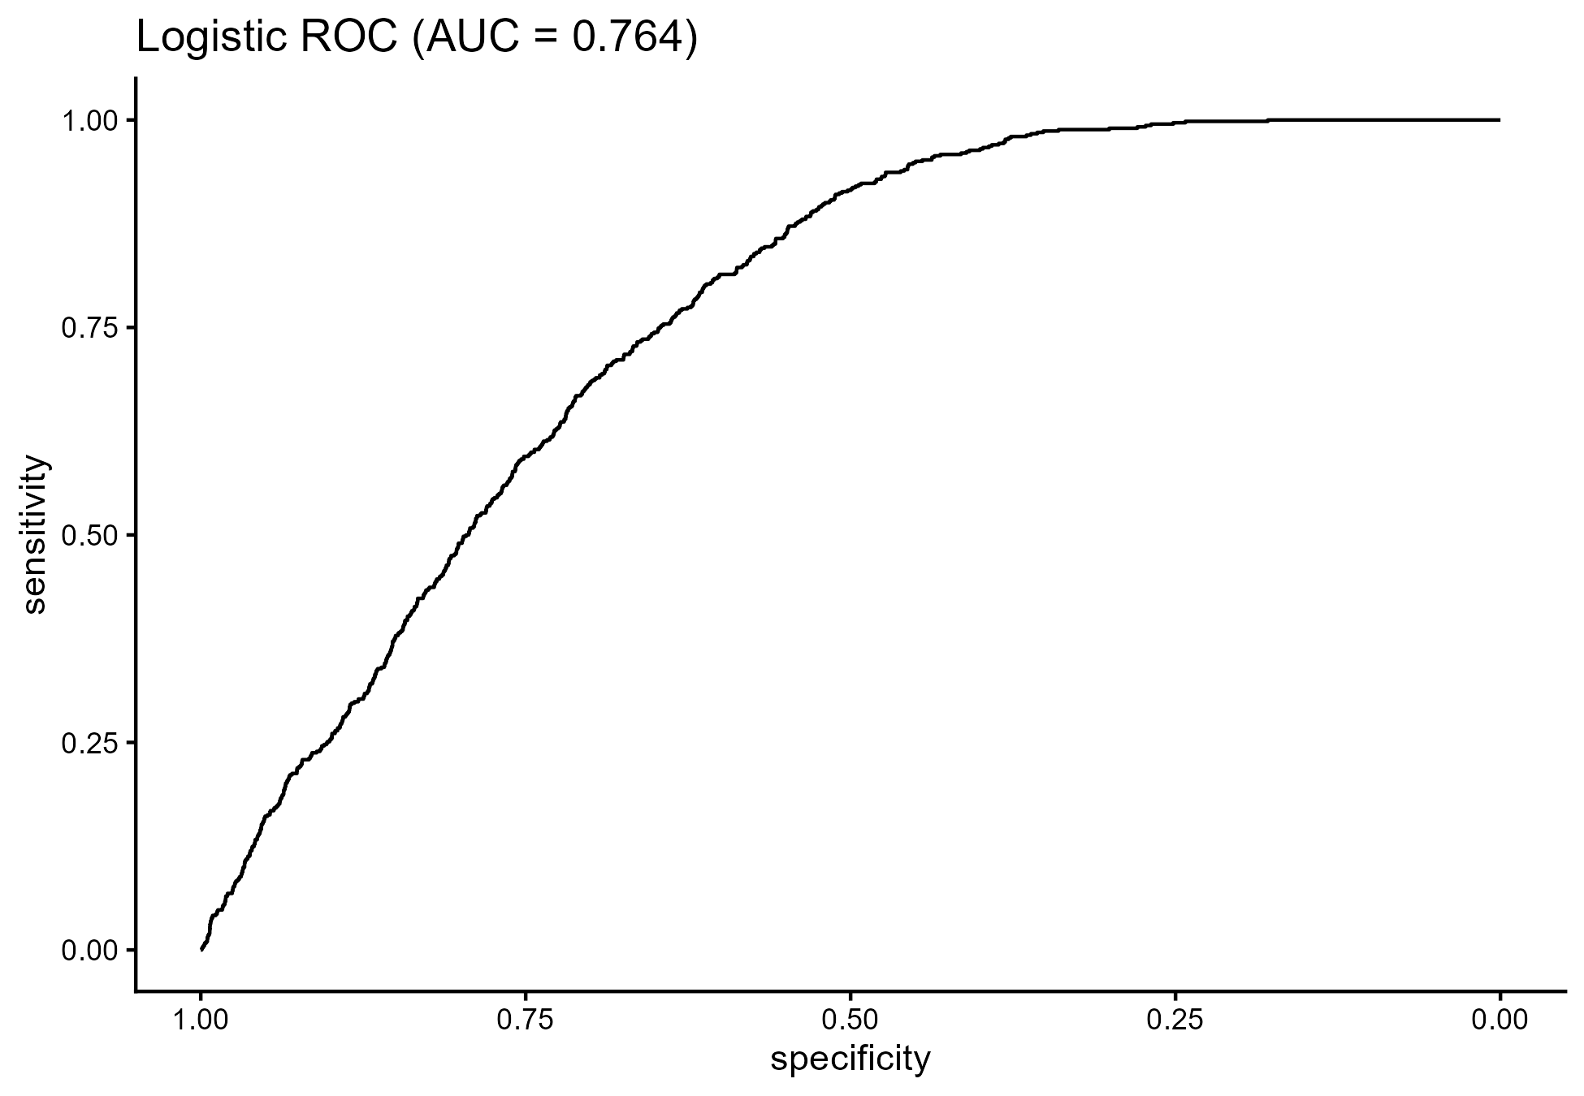

Figure 1: Logistic ROC (AUC = 0.764)

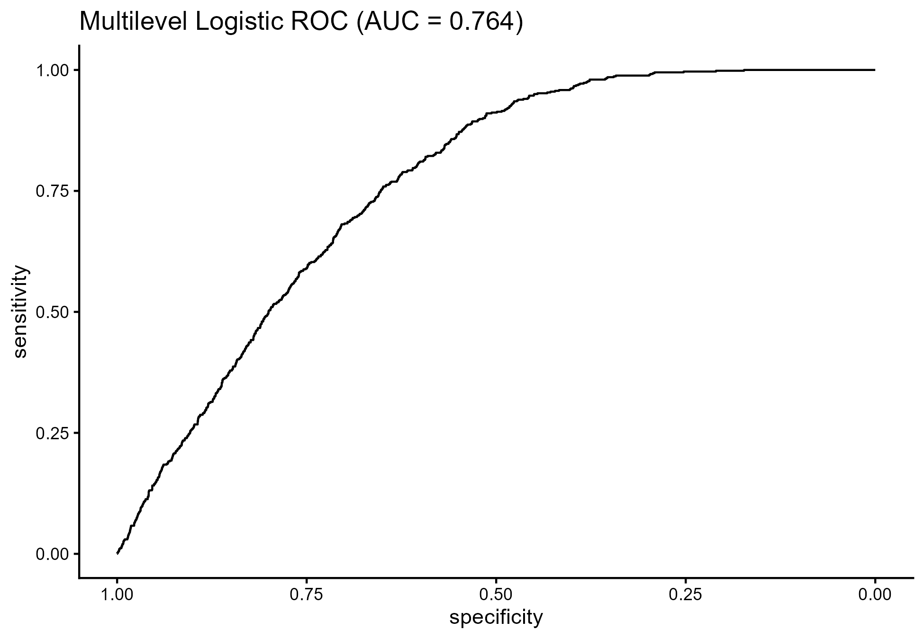 Figure 2: Multilevel Logistic ROC (AUC = 0.764)
The multilevel specification in Figure 2 introduced a random intercept for region to account for unmeasured contextual differences. The near-identical AUC to the single-level model and the limited random-effect variance indicate that, in this dataset, regional clustering plays a modest role once individual and household covariates are included. This is unlike certain multi-country and spatial studies that indicate high geographic clustering of under-five mortality, and suggests that in Ghana, inequity disparities might be supported not so much by regional borders but by household-based conditions and service availability. This trend is consistent with the literature, which indicates that when health systems and infrastructural dispersion are moderate across geographic areas, in-region disparities may prevail over inter-region disparities.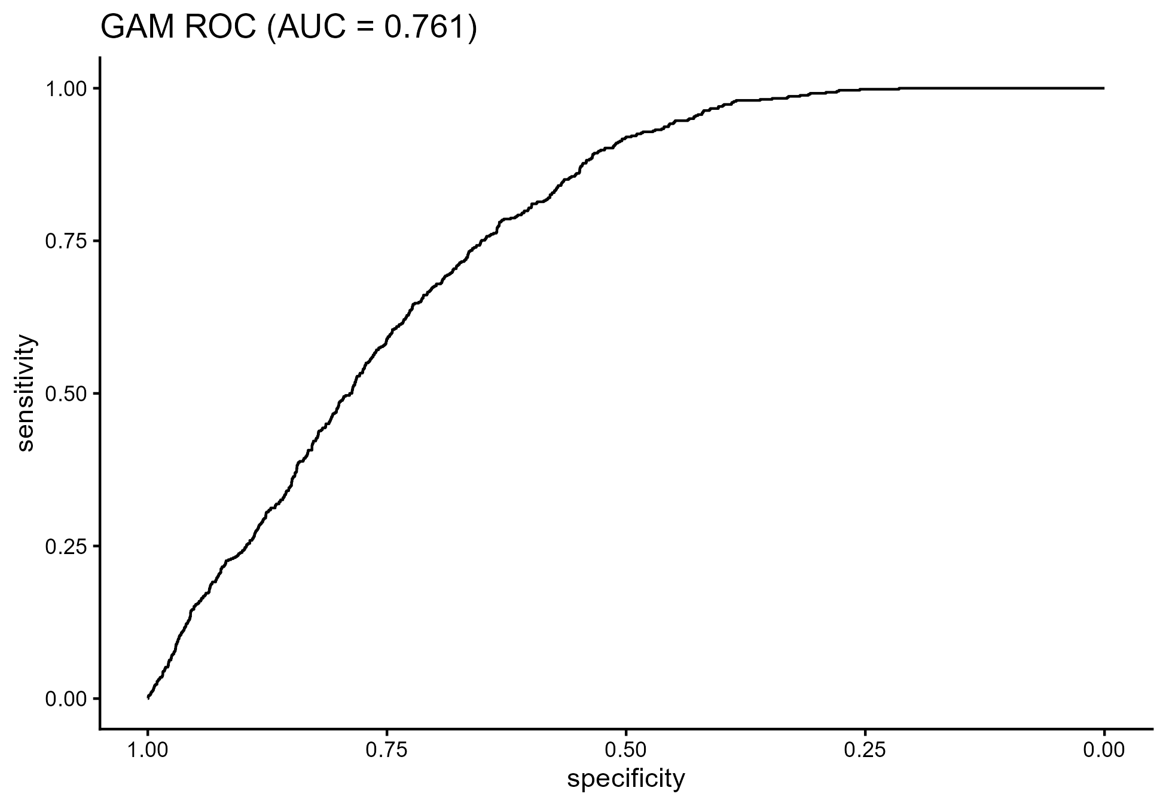

Figure 3: GAM ROC (AUC = 0.761)
The generalised additive model provides additional insight into the functional forms underlying these associations. The parametric component in Table 1 indicates that survival depends significantly on residence (res2), the sex of the head of household (sexhh2), and the sex of the child (sexc2). Children in the better-residence group tend to have a significantly greater probability of survival; being female and not belonging to the reference category in the head of the household, and the child's sex category, tend to decrease the probability of survival. These results agree with previous research findings on the significance of the environment and gender-related power dynamics to accessing resources and survival time. The marginal effects of safe water source (sodw2) and health facility delivery (hel1) point in protective directions, which reinforces the well-established pathways between environmental health, obstetric care, and child survival.

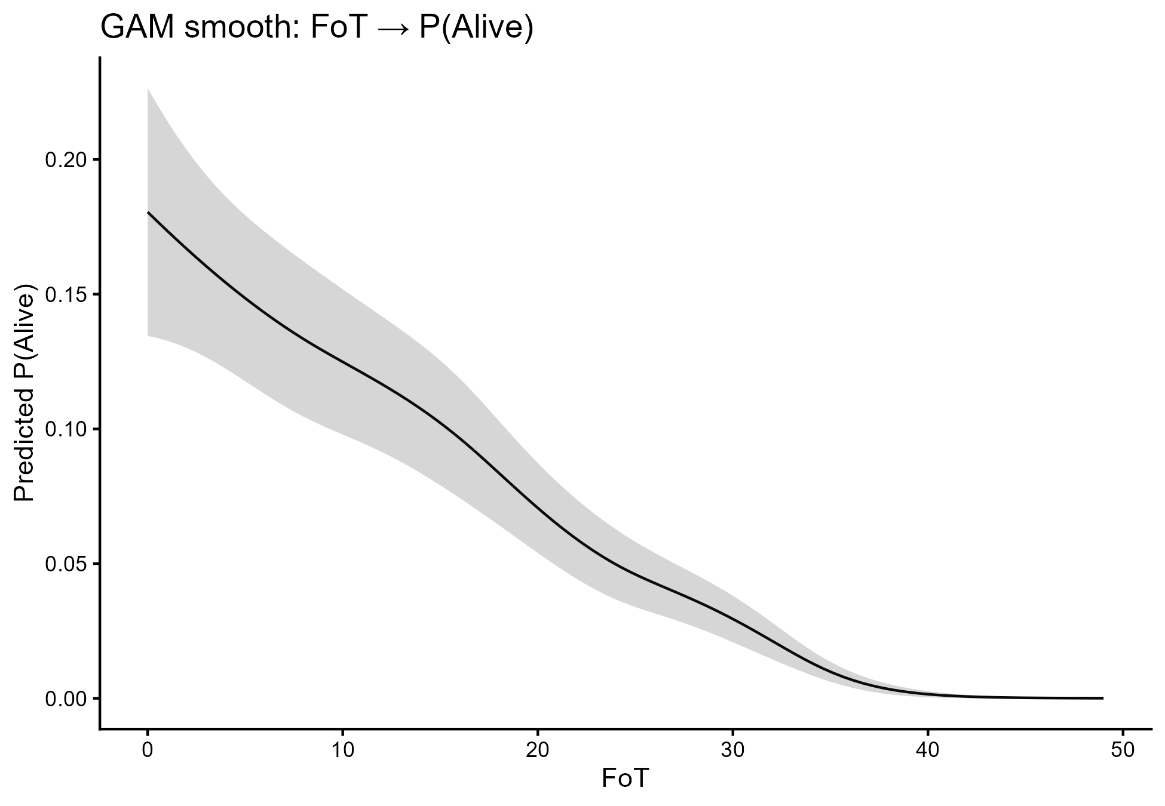 Figure 4: GAM smooth for FoT

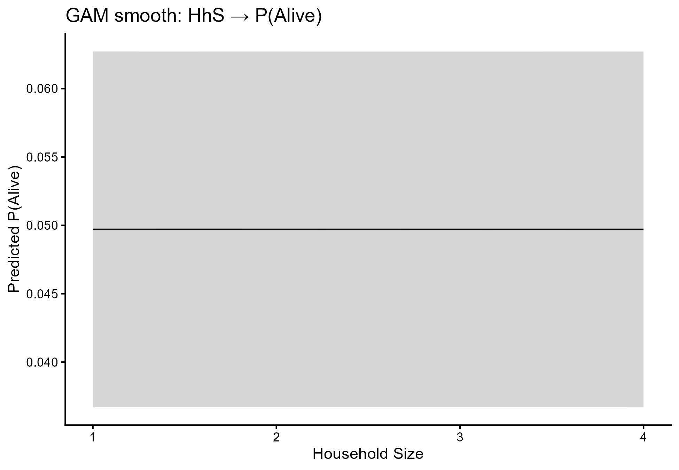 Figure 5: GAM Smooth for Household Size
However, the smooth terms in Figures 4 and 5 further illuminate the risk profile. FoT smooth in Figure 4 shows a monotonic decline in mortality risk with increasing paternal age, though the risk gradient is steeper for younger dads. This implies that young dads are prone to economic turmoil, poor health literacy, or disadvantageous bargaining positions within the household that affect child mortality. The flattening of the curve at higher ages signals diminishing marginal benefit, indicating that interventions should be particularly concentrated among younger fathers and their households. In contrast, the essentially flat GAM smooth for household size in Figure 5 demonstrates that household size does not exert an independent effect once wealth, residence, water, and service variables are accounted for. This result also mitigates ambiguous findings in the existing body of knowledge, demonstrating that what appear to be household-size effects may well proxy for socioeconomic/supply constraints rather than having a genuinely autonomous effect.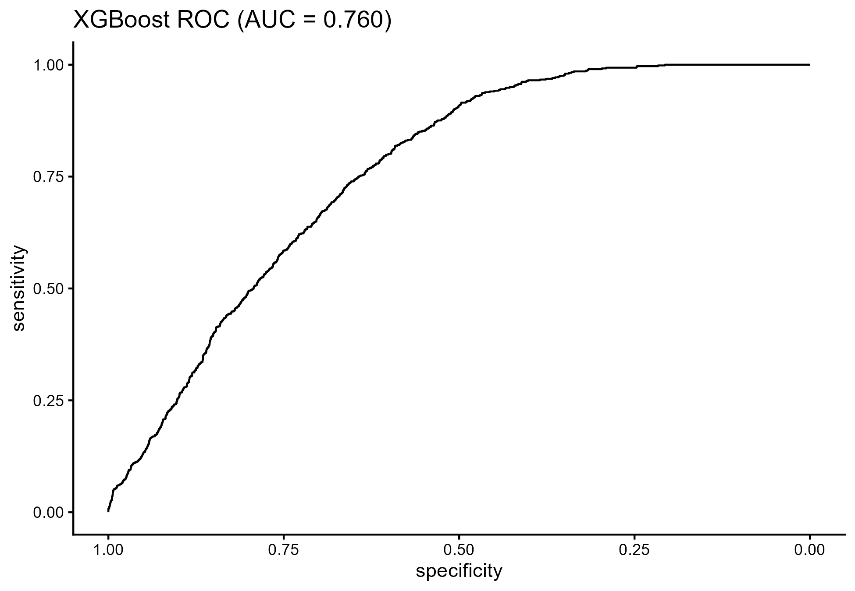
Figure 6: XGBoost and Explainability
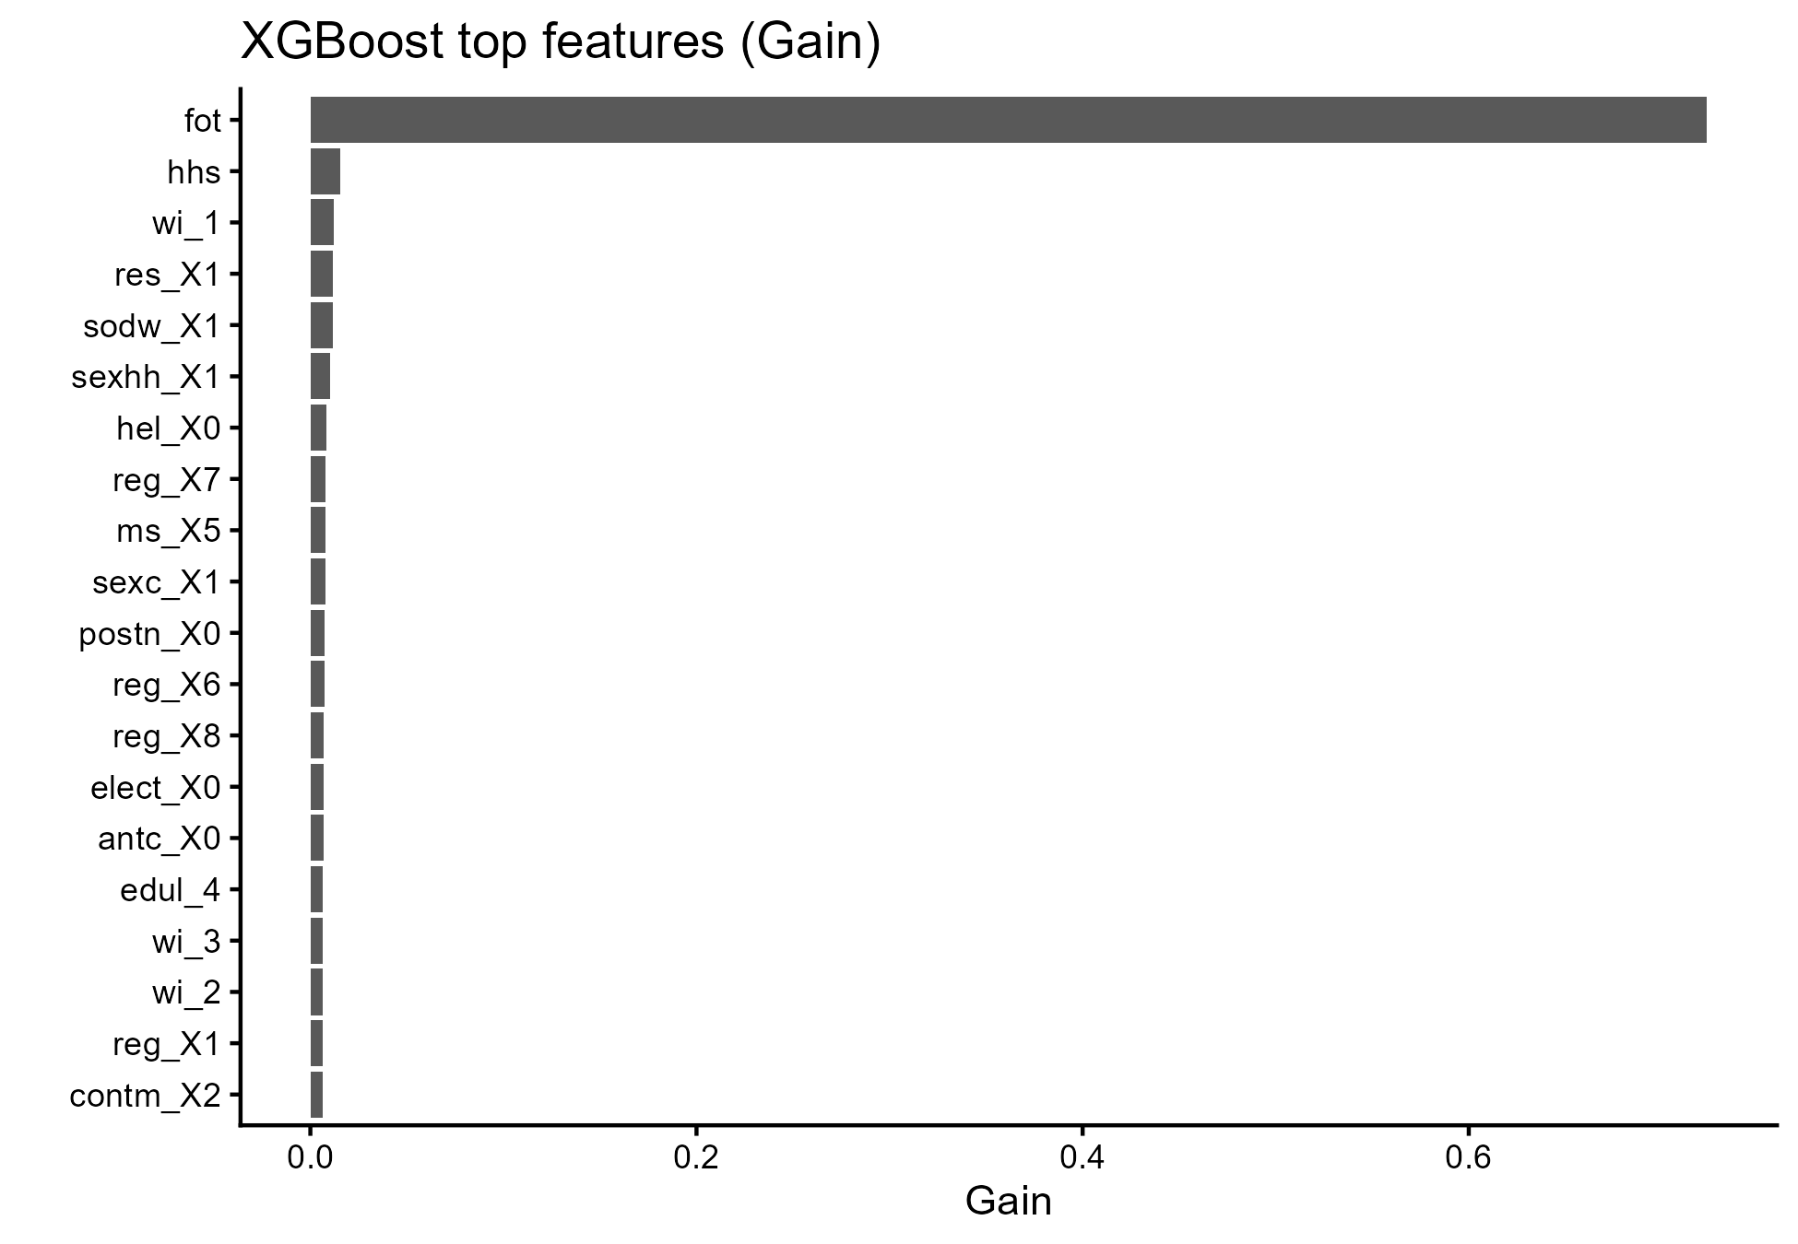

Figure 7: Top Features by Gain
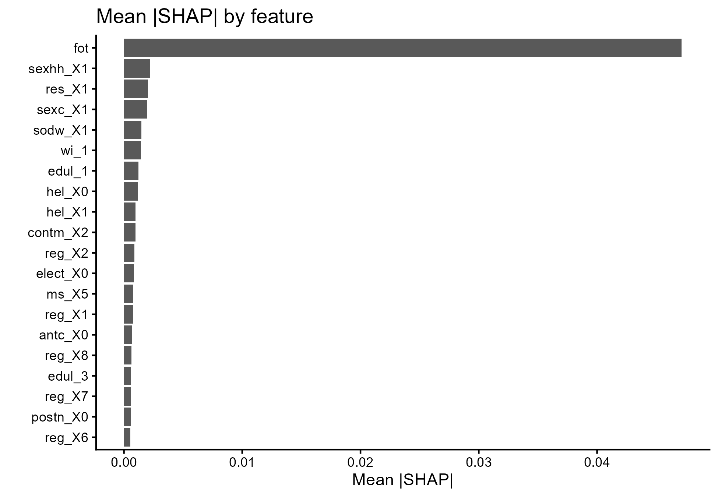

Figure 8: Mean SHAP by Feature
The XGBoost model and associated explainability outputs in Figures 6-8 provide an important bridge between predictive power and interpretability. Despite using a fully nonparametric tree-based ensemble, XGBoost achieves an AUC of about 0.760, very close to those of the parametric and semiparametric models. The top features by gain in Figure 7 and the mean SHAP values in Figure 8 both highlight FoT, sex of household head, residence, wealth, and water source as major drivers of predicted survival. The agreement between SHAP-derived importance and the GAM/logistic coefficients strengthens confidence in these variables as robust determinants rather than model-specific artefacts. This triangulation is a central methodological contribution: combining GAM smooths, multilevel structures, and explainable machine learning in a unified pipeline demonstrates that key risk factors are consistently influential across distinct modelling philosophies.
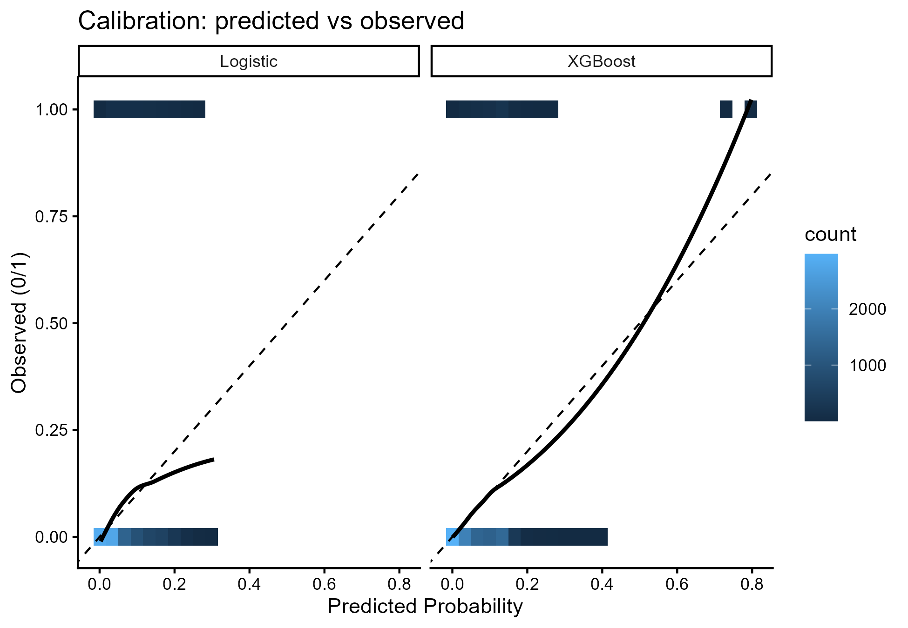

Figure 9: Calibration Plots
Calibration analysis in Figure 9 shows that the models produce probabilities that are broadly aligned with observed risks, with logistic regression tending to be conservative at the low-risk end and XGBoost showing sharper alignment at higher risk levels. From a policy perspective, this calibration behaviour is crucial. Referral thresholds for outreach, case management, or targeted subsidies can be set using well-calibrated probabilities to ensure limited resources are concentrated on children at genuinely elevated risk. When the goals for SDG 3: Good Health and Well-being, SDG 6: Clean Water and Sanitation, and SDG 10: Reduced Inequalities apply, the calibrated risk score is used to ensure interventions are directed at those most at risk while remaining fair.
In general, the results indicate that under-five survival in Ghana is strongly influenced by paternal age, residence, household gender structure, water source, and use of maternal newborn services. The combination of logistic regression analysis, multilevel logistic regression analysis, GAM analysis, and use of XGBoost analysis in a single approach, in combination with analysis of ROC curves (Figures 1-3), GAM smooths (Figures 4-5), explainer plots (Figures 6-8), and a range of calibration charts (Figure 9), provides a holistic and technically innovative approach to understanding child survival.
These results support a policy emphasis on strengthening perinatal and postnatal services, expanding access to safe water, and addressing gendered and residential inequities that constrain caregiving and service use. The first key finding is that both GAMs and logistic regression models performed very similarly in terms of discrimination, with AUC values of 0.817 and 0.819, respectively (Table 3). The second key finding is that GAMs, logistic regression, Cox regression, multilevel logistic regression, and survival. This indicates that the survival signal is stable and robust across classical, semiparametric, and machine-learning paradigms, thereby increasing confidence in the reliability of the identified determinants.
The second key finding concerns the structure of regional versus household-level effects. The multilevel logistic model in Figure 2 shows that introducing region as a random intercept yields negligible gains in AUC relative to the single-level logistic model in Figure 1, and the estimated random-effect variance is slight. This implies that, conditional on the observed covariates, under-five survival disparities in Ghana are driven primarily by individual and household-level factors rather than by significant regional differences.
The third significant finding arises from the GAM and its smooth functions. The GAM results, summarised in Table 1 and visualised in the smooth plots in Figures 4 and 5, indicate that the main predictors are paternal age (FoT), place of residence, sex of the household head, sex of the child, availability of safe water, and facility delivery. However, for paternal age, there is a significant nonlinear effect: a higher probability of child survival at very low ages and a diminishing effect with increasing age. In contrast, household size shows no independent effect after adjustment for the predictors. The fourth finding is that XGBoost, combined with SHAP-based explainability, replicates and reinforces the importance of the same core predictors. Figures 6-8 show that FoT, sex of household head, residence, wealth, and water source dominate feature importance and SHAP contributions. This agreement across parametric, semiparametric, and machine-learning models demonstrates that the identified factors are not model-specific artefacts but genuine structural determinants of under-five survival.
Finally, calibration analysis in Figure 9 and the discrimination summary in Table 2 show that the models not only classify risk well but also produce probabilities that can be used operationally. This combination of discrimination and calibration enables the models to inform the prioritisation of interventions under SDG 3, SDG 6, and SDG 10, including targeted support for households with young fathers, households with unsafe water sources, and households with constrained access to facility-based delivery and postnatal care.
Area Under Curve (AUC) is a summary of the entire ROC curve, conveying a measure of model performance in a real number between 0.5 and 1. An AUC of 0.5 is equivalent to a poor model, indicating no predictive ability, whereas a value of 1.0 corresponds to a perfect model. The AUC values obtained 0.764 for logistic regression, 0.764 for the multilevel logistic model, 0.761 for GAM, and 0.760 for XGBoost show that all models achieved moderate-to-strong discriminatory power in predicting child survival status. These values confirm that the models reliably differentiate between children who survived and those who did not. In the context of public health analytics, these AUC levels confirm the usefulness of predictive modelling for early detection of high-risk households and for targeting interventions to achieve SDG 3 on Good Health and Well-being. On the other hand, agreement on the values of AUC indicators demonstrates the robustness of the results. It supports the reliability of the identified determinants of children's survival rate under 5 years of age.

Conclusion
This research developed and applied an integrated modelling framework to identify and interpret the determinants of under-five survival in Ghana using nationally representative data. By combining logistic regression, multilevel logistic regression, generalised additive models, and XGBoost with SHAP-based explainability, the study demonstrated that a relatively small set of factors-paternal age, residence, sex of household head, sex of child, household wealth, water source, and maternal-newborn service utilisation-reliably structure child survival risk. The convergence of ROC-based discrimination (Figures 1-3), GAM parametric and smooth components (Table 1, Figures 4-5), machine learning feature importance and SHAP profiles (Figures 6-8), and calibration plots (Figure 9), together with the AUC comparison in Table 2, provides a coherent and robust evidence base.
The methodological contribution lies in the triangulation of classical statistical modelling, flexible semiparametric techniques, and explainable machine learning within a single pipeline applied to under-five survival. This approach addresses long-standing limitations in the literature related to linearity assumptions, underutilisation of nonlinearity, and opacity of black-box models. The framework shows that it is possible to retain interpretability while embracing modern machine learning tools, and to align predictive modelling with the SDG agenda by explicitly linking risk structures to SDG 3, SDG 6, and SDG 10.
The substantive implications are clear. Health and social policy should prioritise universal, high-quality maternal and newborn care, including antenatal, delivery, and postnatal services, with particular attention to households headed by women, children of disadvantaged sex categories, and households with younger fathers. Providing safe drinking water and basic environmental health infrastructure is a key concern for improving survival rates, as highlighted in Goal 6 of the SDGs. The modest additional boost from regional factors indicates that a policy must address inequities at the household level across all regions, rather than treating regions differently from the reference region, as SDG 10 emphasises equality within the country.
The data are cross-sectional, so causal pathways cannot be fully established, and temporal dynamics in risk cannot be captured. The presence of residual confounding due to unadjusted variables, including maternal health and in-household decision-making, is also very possible. Outcome classification depends on survey reporting, which may introduce misclassification errors. The ML explainability rests on SHAP approximations, which, although powerful, still depend on model structure and feature encoding choices. Future research can extend this work by incorporating time-to-event methods, spatially explicit random effects, and richer service quality metrics, as well as by validating the models prospectively within health system workflows.
Despite these constraints, the study shows that an integrated, explainable modelling pipeline can meaningfully inform child survival policy. Embedding such models into routine health information systems would support proactive, data-driven identification of high-risk households and guide targeted interventions that accelerate progress toward ending preventable deaths among children under five.
Disclaimer (Artificial intelligence)
Option 1:
Author(s) hereby declare that NO generative AI technologies such as Large Language Models (ChatGPT, COPILOT, etc.) and text-to-image generators have been used during the writing or editing of this manuscript.
Option 2:
Author(s) hereby declare that generative AI technologies such as Large Language Models, etc. have been used during the writing or editing of manuscripts. This explanation will include the name, version, model, and source of the generative AI technology and as well as all input prompts provided to the generative AI technology
Details of the AI usage are given below:
1.
2.
3.

Declarations
The data supporting this study are publicly available
Data availability statement Repository Link: https://osf.io/ghn3y/

Ethical Considerations and Reproducibility
The dataset was fully anonymised, with no identifiable personal information. Analytical scripts, processed datasets, and code for figure generation are openly available for verification and reuse.
All computations adhere to FAIR (Findable, Accessible, Interoperable, Reusable) data principles, supporting transparent and replicable research.
Conflicts of interest
The authors declare that they have no competing interests.
Consent for Publication
Not applicable in the clinic
Trial Number
Not applicable
Authors Contributions
F.A-M.: Conceptualisation, Validation, Methodology, Formal Analysis, Writing - Original Draft, Software, Writing - Review & Editing.
V.N.: Visualisation, Writing - Review & Editing, Investigation, Methodology. Data Collection, Data Curation,
M.F.: Validation, Writing - Review & Editing, Visualisation, Investigation
M.K.A.: Visualisation, Validation, Writing - Review & Editing, Investigation.

References
- Adeyinka, D. A., & Muhajarine, N. (2024). Disentangling the link between social determinants of health and child survival in Nigeria during the Sustainable Development Goals era: a hierarchical path analysis of time-to-event outcome. Journal of Biosocial Science, 56(2), 357-375.
- Amir-ud-Din, R., Kumar, R., Naeem, N., & Khan, M. (2024). Air pollution and under-5 child mortality: linking satellite and IPUMS-DHS data across 41 countries in South Asia and Sub-Saharan Africa. BMC Public Health, 24(1), 2996.
- Arana-Ovalle, R., Dillon, L., Murua, A., & Zamudio-Sánchez, F. J. (2025). Dynamic interplay of kinship and net-fertility: a comprehensive analysis across demographic transitions in Mexico. The History of the Family, 1-32.
- Ashwini, C., Bose, S. R., Padmavathy, M. D., Raj, C., & Ajay, J. C. (2024). Predicting Child Mortality With Diverse Regression Algorithms Using a Machine Learning Approach. Advancing Intelligent Networks Through Distributed Optimization, 329-352.
- Ayiah-Mensah, F., Bosson-Amedenu, S., Anderson, F. N., & Kokuro, A. (2025). Nonlinear Cox Survival Modeling of Prostate Cancer with SHAP-Based Explainability. Journal of Advances in Mathematics and Computer Science, 40(12), 28-47.
- Birhanie, A. L., Tessema, Z. T., Endalew, B., & Tamirat, K. S. (2025). Under-five mortality and its associated factors in sub-Saharan Africa: a multilevel analysis of recent demographic and health surveys data based on Bayesian approach. BMC pediatrics, 25(1), 103.
- Chaku, S. E., Nwaze, N. O., Musa, G. K., & Adehi, M. U. (2025). Flexible accelerated failure time model with spatial dependency: application to under-five mortality rate. Journal of the Royal Statistical Society Nigeria Group (JRSS-NIG Group) ISSN NUMBER: 1116-249X, 2(1), 430-452.
- Dhage, V. D., & Nagtode, N. (2024). Health problems among under-five age group children in developing countries: a narrative review. Cureus, 16(2).
- Faruk, M. O., Zahangir, M. S., Akhter, S., Prome, J. F., Akter, N., & Tasnim, J. (2025). A review of the impact of socio-economic, demographic and cultural factors on child mortality. Discover Public Health, 22(1), 141.
- Fenta, H. M., Chen, D. G., & Zewotir, T. T. (2024). Geostatistical analysis of under-five children mortality and associated factors across sub-Saharan African countries. In Biostatistics Modeling and Public Health Applications: Study Design and Analysis Methodology in Health Sciences, Volume 1 (pp. 231-256). Cham: Springer Nature Switzerland.
- Frimpong, P. B., Dramani, J. B., & Adusah-Poku, F. (2025). The impact of housing quality on child survival in Ghana. International Journal of Housing Markets and Analysis.
- Gazze, L. (2024). Hassles and environmental health screenings: Evidence from lead tests in Illinois. Journal of Human Resources, 59(4), 1090-1121.
- Headen, I. (2025). Structural Racism, Geographies of Opportunity, and Maternal Health Inequities: A Dynamic Conceptual Framework. Journal of racial and ethnic health disparities, 1-18.
- Iddrisu, A. K., & Boanyo, E. (2025). Survival analysis of under-five mortality and associated risk factors using survival analysis approaches. PLOS Global Public Health, 5(9), e0005179.
- Kefale, B., Jancey, J., Gebremedhin, A. T., Pereira, G., & Tessema, G. A. (2025). Changes in the contributions of risk factors to under-five mortality in low-and lower-middle-income countries (1997–2022): an analysis of Demographic and Health Survey data. World Journal of Pediatrics, 1-13.
- LaFave, L. A., Clemmons, N., Kotelchuck, M., Morales Cozier, N., Geltman, A., Browne, D. R., & Kenyon, K. (2024). Activating Life Course Theory through a Whole System Prevention Framework to Address the Wicked Problem of Maternal and Infant Morbidity and Mortality. Community Health Equity Research & Policy, 44(4), 349-364.
- Mahama, T. (2025). Developing Multilevel Logistic Regression Models for Predicting Cancer Outcomes from Population Health Surveys. Int J Adv Res Publ Rev [Internet], 2(05), 443-64.
- Mazumder, T., Mohanty, I., Ahmad, D., & Niyonsenga, T. (2024). An analysis of cause-specific under-5 mortality in Bangladesh using the demographic and health survey 2011 and 2017–2018. BMC pediatrics, 24(1), 572.
- Mazumder, T., Mohanty, I., Ahmad, D., & Niyonsenga, T. (2025). From parental education to under-5 mortality: how antenatal care and hand hygiene mediate the pathway mechanisms. BMC Public Health, 25(1), 1976.
- Natarajan, J., Vimal, P. H., Sen, D., Lawrence, C., Eswaran, S., Chintale, P., & Patil, S. A. (2025). Machine Learning-Based Maternal and Child Mortality Rate Prediction Using Random Forest Algorithm. In Revolutionizing Healthcare Services (pp. 251-266). CRC Press.
- Naznin, S., Uddin, M. J., & Kabir, A. (2025). Identifying determinants of under-5 mortality in Bangladesh: A machine learning approach with BDHS 2022 data. PloS one, 20(6), e0324825.
- Olawade, D. B., Wada, O. Z., Aderinto, N., Odetayo, A., Adebisi, Y. A., Esan, D. T., & Ling, J. (2025). Factors contributing to under-5 child mortality in Nigeria: A narrative review. Medicine, 104(1), e41142.
- Olusola, J. A., Oyinloye, A. A., Akeju, K. F., Ogunsakin, R. E., & Moyo, S. (2025). Spatial analysis of under-five mortality in Africa using geographically weighted poisson regression. Discover Public Health, 22(1), 1-19.

- Osei, C. K., & Nketiah-Amponsah, E. (2024). Exploring the policy implications of household wealth differentials and under-five child deaths in Ghana. Discover Public Health, 21(1), 9.
- Rahman, A., & Rahman, M. H. (2025). Explore the factors related to the death of offspring under age five and appraise the hazard of child mortality using machine learning techniques in Bangladesh. BMC Public Health, 25(1), 360.
- Rajapakse, V., Fernando, A., Sudangama, N., Adikari, D., Sundaram, A., & Jayathilaka, R. (2025). Economic and healthcare determinants of under-five mortality in low-income countries. BMC Public Health, 25(1), 2126.
- Satty, A., Khamis, G. S. M., Mohammed, Z. M., Mahmoud, A. F., Abdalla, F. A., Salih, M., ... & Gumma, E. A. (2025). Statistical Insights Into Machine Learning Models for Predicting Under-Five Mortality: An Analysis From Multiple Indicator Cluster Survey (MICS). IEEE Access, 13, 45312-45320.
- Souza, J. P., Day, L. T., Rezende-Gomes, A. C., Zhang, J., Mori, R., Baguiya, A., ... & Oladapo, O. T. (2024). A global analysis of the determinants of maternal health and transitions in maternal mortality. The Lancet Global Health, 12(2), e306-e316.
- Wiysonge, C. S., Uthman, M. M., Ndwandwe, D., & Uthman, O. A. (2025). Multilevel Analysis of Zero-Dose Children in Sub-Saharan Africa: A Three Delays Model Study. Vaccines, 13(9), 987.

SUPPLEMENTARY MATERIALS
Appendices

Table A1: Data Characteristics and Nature of Variables
The outcome variable, Child Alive Status (ChA), is binary-coded as 1 = Alive and 0 = Not Alive. Predictor variables include both quantitative and categorical covariates:
Variable | Description | Type
FoT | Father’s Age (years) | Continuous
HHS | Household Size | Continuous
WI | Wealth Index | Ordinal (1–5)
EduL | Maternal Education Level | Ordinal (0–3)
Reg | Region | Categorical (16 levels)
Res | Residence Type (Urban/Rural) | Binary
SexHH | Sex of Household Head | Binary
SoDW | Source of Drinking Water | Categorical
ToLF | Type of Toilet Facility | Categorical
Elect | Access to Electricity | Binary
SexC | Sex of Child | Binary
PostN | Postnatal Care Attendance | Binary
ANTC | Antenatal Care Attendance | Binary
MS | Marital Status | Categorical
ContM | Contraceptive Use | Binary
HEL | Health Facility Delivery | Binary
Continuous variables (FoT, HhS) were normalized, and ordinal predictors (WI, EduL) were encoded as ordered factors. All categorical variables were converted into one-hot dummy representations using the recipes package in R to ensure compatibility with both parametric and nonparametric modeling frameworks.

