Securing the Joint:

A comprehensive Review of Contemporary Strategies for Soft-Tissue Coverage of Knee Defects

Abstract
Introduction
The knee region presents unique challenges in reconstructions of soft-tissue defects. These challenges are caused by the limited amount of soft tissue that is present, the number of important structures that need to be protected, and the functional requirements of the knee. The common use of muscle and musculocutaneous flaps has historically been the mainstay of treating these injuries. However, the recent evolution in perforator use, the development of combination flap techniques using both pedicled and free microsurgical reconstruction techniques, has greatly expanded the available options for reconstructive procedures.
Methods
Review of the literature, the objective of this review is to appraise the current published work in the literature and present an updated reconstructive algorithm to treat soft-tissue defects around the knee. The focus is on the coverage of knee defect with theoretical models using pedicled muscle flaps, fasciocutaneous, perforator, combination flap approaches, and microvascular free flap techniques, and an evaluation of clinical outcome, clinical reliability of flaps, donor site morbidities associated with the different flap techniques used, and functional outcome.
Results
The literature over the past several years indicates an increasing movement toward the use of perforator-based reconstruction techniques, as well as the use of combined flap techniques for large, irregular soft-tissue defects. The medial gastrocnemius flap continues to be used as a main flap, especially for reconstructing combined soft tissue that requires coverage of prosthesis.
Discussion
Modern knee reconstruction favors individualized, algorithmic planning. Perforator flaps and free flaps offer reliable, minimally morbid options that preserve function while providing durable coverage. Early plastic-surgery involvement, especially in TKA wound breakdown, is critical. A flexible, defect-based reconstructive algorithm is proposed to guide decision-making.

Key Words
knee soft tissue defect; flap coverage; soft tissue reconstruction; perforator flap; muscle flap; free-flap; gastrocnemius flap; sural artery flap; reconstructive algorithm; knee joint,TKA

Introduction
Soft-tissue defects around the knee are particularly challenging not only because of the limited local tissue but also due to the complexity of the joint and its functional and biomechanical requirements. Recently, the incidence of those defects has increased due to a rise in high-energy trauma, the growing use of total knee arthroplasty (TKA), and improved survival rates in patients with cancer, diabetes, and vascular disease. As surgical interventions become more sophisticated, the demand for reliable soft-tissue coverage options has grown accordingly. Defects that were once managed with amputations or staged, lengthy treatments can now often be salvaged with local, regional, or microvascular reconstruction.
The functional implications of knee soft-tissue loss cannot be overstated. A stable, mobile knee joint is essential for gait, stair climbing, and activities of daily living. Soft-tissue coverage must therefore prioritize durable coverage without compromising tendon function, joint mobility, or the extensor mechanism. Moreover, inadequate early management of knee wounds can lead to long-term sequelae such as chronic infection, arthrofibrosis, or joint stiffness. When the prosthetic components are exposed after TKA, the urgency is even greater, as delays in flap coverage have been consistently linked to higher re-operation rates, deep infection, and prosthesis loss. In this setting, the role of the reconstructive surgeon has expanded. Early multidisciplinary planning and coordination between orthopedic and plastic surgery teams significantly improve outcomes. Advances in perforator anatomy, flap design, and microsurgical techniques have opened the door to more refined, tailored reconstructions. This review integrates contemporary literature and proposes a practical reconstructive approach designed to optimize functional and aesthetic outcomes while minimizing patient morbidity

Anatomy of the knee
The configuration of the bones within the joint acts translates the movements of both the flexor and extensor muscles of the knee. The positioning of the extracapsular, intracapsular ligaments, and muscle extensions that intersect contributes to the stability, counteracting the significant biomechanical forces applied to it. The knee has mainly a movement in a single axis, allowing flexion and extension in the sagittal plane. It also has a small degree of medial rotation while flexing and during the final phase of knee extension, along with lateral rotation during the "unlocking" process of the knee.
The complexity of the knee joint resides in it’s intricate structures that consists of three bones ; femur ,tibia,patella , the ends of the bones are covered with a layer of cartilage, a slick elastic material that absorbs shock and allows the bones to glide easily against one another as they move. Between the tibia and femur bone are two crescent-shaped pads of cartilage that reduce friction and disperse the weight of the body across the joint which are, The lateral meniscus, and The medial meniscus.The bones are held together by a joint capsule, it is made of two distinct layers an outer layer of dense connective tissue and an inner membrane, called the synovium, which secretes a fluid to lubricate the joint. The outer layer of the capsule is attached to the ends of the bones and is supported by these ligaments and tendons, the quadriceps tendon, that attaches the quadriceps to the patella, the medial collateral ligament (MCL), gives stability to the inner part of the knee, lateral collateral ligament (LCL) stabilizes the outer part of the knee, anterior cruciate ligament (ACL) is located in the center of the knee and prevents excessive forward movement of the tibia and the posterior cruciate ligament (PCL). In addition tot his two groups of muscles support the knee which are the Hamstrings and the Quadriceps.

Why Knee Defects Are Particularly Challenging
Anatomical considerations (1; 3 ; 9 ; 14 ; 16) ; the thin soft tissue coverage around the knee and the little local tissue redundancy, can be a real challenge for coverage and even small injuries may reveal deep structures or prosthetic components.
High risk of complications (14 ; 18 ; 19 ; 23) ; especially in post-arthroplasty wound dehiscence or soft tissue necrosis may jeopardize prosthesis integrity and predispose to infection.
Varied etiologies (1;3 ;9) ;defects may arise from trauma, burns, tumor resection, scar contractures, surgical complications or chronic infection, requiring each specific reconstruction modalities. Functional demands (1 ; 9 ; 14) ; Coverage technic must take into consideration knee mobility, avoid contracture, and preserve joint function, Flaps that are bulky, stiff, or prone to shrinkage may impair postoperative mobility.

Vascular Considerations
The vascular anatomy around the knee is equally complex and plays a pivotal role in reconstructive strategy. The genicular arterial network forms a robust anastomotic system between branches of the superficial femoral, popliteal, anterior tibial, and posterior tibial arteries. The superior and inferior medial and lateral genicular arteries, in combination with the descending genicular artery and recurrent tibial branches, create a dense mesh that supports flap perfusion (2 ; 5 ; 12). This system allows for the design of reliable perforator flaps (6 ; 14), but it also requires careful attention during orthopedic procedures, where aggressive soft-tissue handling may disrupt essential perforators.
Understanding the position and consistency of key perforators particularly those from the medial and lateral sural arteries and the descending branch of the lateral circumflex femoral artery is crucial for designing pedicled perforator flaps such as MSAP, LSAP, and VMAP. Preoperative planning with Doppler ultrasound or CT angiography has become increasingly important, helping surgeons avoid inadvertent injury and optimize flap orientation.
Furthermore, the venous drainage around the knee is mainly dependent on paired deep veins and the great and small saphenous systems. Venous congestion remains a key risk in propeller perforator flaps, making careful dissection and postoperative monitoring essential. A thorough understanding of these anatomical and vascular nuances guides flap choice, minimizes complications, and improves long-term outcomes

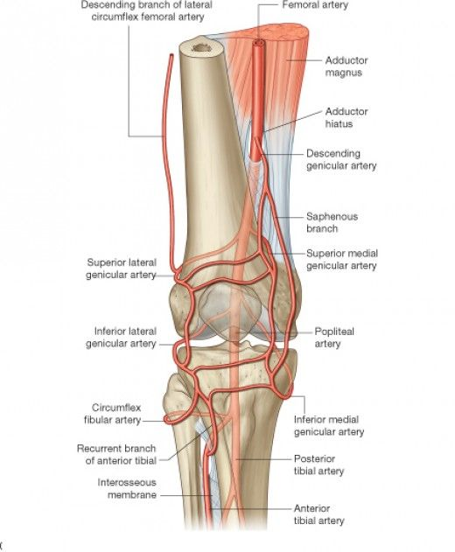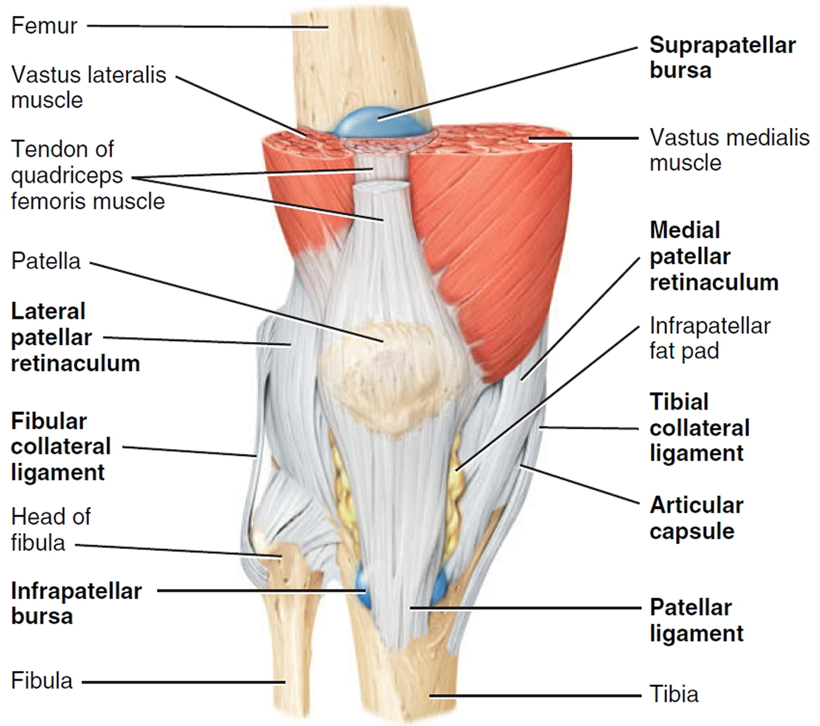

FIG 2. Knee anatomy

FIG 1. Vascular anatomy of the knee

Etiologies of knee defects
Knee defects can be caused by different etiologies that have different modalities of treatement, with different timelines and outcomes :
Trauma (1 ; 9) is one of the most common causes of knee injuries and soft tissue defects usually associated with bone and extensor mechanism lesions, seen most commonly in high impact trafic accidents, and falls. The second most common etiology
is tumor resections (9 ; 14) Can result in big defects depending on the nature and extension of the tumor, the reconstruction is done immediatly or can be delayed, relying upon pathology results and the tissues exposed. Infections such as Necroziting Fascitis (1 ; 14) that causes muscle fascia and subcutaneous tisue necrosis, wich can extend to tendons and articular capsule can causes dramatic complications and be life threatening.
Burn injuries is also a cause of soft tissue knee defects ranging from superficial defect to deep and full thickness burns causing muscular and capsular dammage , the defect can also be secondary to burn contracture release (1 ;14)
Some other etiologies can cause soft tissue knee defects such as post surgical radiation or wound complications following arthroplasty (19; 23)

Overview of Reconstructive Options
The reconstructive ladder for knee soft-tissue coverage has evolved into a more flexible “reconstructive elevator,” recognizing that certain defects require immediate advancement to flap-based reconstruction. While local wound care and negative-pressure therapy remain valuable tools, they rarely suffice when deep structures such as tendon, bone, or hardware are exposed.
The transition to muscle and myocutaneous flaps marked a major advancement, with the gastrocnemius flap historically considered the workhorse for knee coverage. However, the morbidity associated with sacrificing muscle has prompted a shift toward fasciocutaneous and perforator-based flaps, which preserve function and offer more pliable tissue.
Ultimately, flap selection depends on defect size, orientation, depth, infection, and functional considerations. The emergence of perforator mapping, microsurgical precision, and combined flap strategies has significantly broadened reconstructive possibilities and improved outcomes
Multiple reconstructive techniques are described ; the appropriate choice depends on the proper evaluation of defect size and location, depth (skin only or deeper structures), presence of infection, and availability of donor sites.

Local Skin Grafts and Skin Flaps
Skin grafts and local flaps have limited use, especially in complex defects (1; 9). In the case of small, superficial defects without exposure noble structures, skin grafts or local random skin flaps can be sufficient. However, thin soft-tissue envelope and poor vascularity around the knee, can limit the size and perfusion of local flaps.
Local flaps provide a more robust option but are restricted by limited tissue mobility and vascularity. Random-pattern flaps work only for very small defects, while axial-pattern flaps provide more reliable perfusion but still cannot cover many complex or multidirectional defects.
Vacuum assisted closure (VAC) therapy can also help accelerate granulation tissue formation and reduce exudate allowing to reduce the hospitalization time when the defect is deeper with exposed bone or hardware the use of a flap becomes necessary, and any intraarticular infection should be drained and properly irrigated. Split-thickness grafts may achieve temporary coverage but are susceptible to shear forces, desiccation, and breakdown during mobilization. Full-thickness grafts offer better durability but require an ideal wound bed and are rarely sufficient alone.Dermal substitutes and skin substitutes, have expanded options in select cases. These matrices can prepare a wound bed for grafting or decrease the need for bulky flaps; however, they require strict infection control and cannot be used over exposed prostheses or infected wounds.

Muscle and Myocutaneous Flaps
The classical reconstructive choice in knee coverage is muscle flap, most commonly the medial (or lateral) Gastrocnemius muscle, because of its reliable blood supply, and proximity.In order to deal with such limitations, modified techniques can be used, like combining a medial gastrocnemius muscle flap with a perforator flap to broaden the coverage. Most commonly used flaps can be

Medial Gastrocnemius Muscle Flap remains the most widely used flap for knee reconstruction.It has arobust vascular supply (1), an easy dissection and awide arc of rotation, and It can be ideal for patellar tendon and anterior knee defects and an excellent option in infected wounds. However the gastrocnemius flap has several limitations such as elderly or thin patients where the muscle volume may be insufficient. The distal portion may also lack sufficient bulk to cover large defects or reach superior knee areas, and it/s harvesting can cause donor-site functional impact (14; 15) (mild calf weakness)
Lateral Gastrocnemius Flap (1; 9) Useful mainly for lateral knee defects. The muscle is smaller and often less versatile.
Sartorius Sartorius is the longest muscle in the body, it was first used in 1978 to close an exposed knee joint .classified as a Type IV (7; 11 ;28) of mathes and Nahai It is a relatively easy flap to harvest, it’s distal part is supplied by branches of genicular and peroneal arteries, and can be used to cover small defects at the knee and upper third of the leg.
Gracilis Is used on minor pedicle as a distally based flap for coverage of defects above the kne. It is a small muscle than can only be used in small defects (14), and can sometimes be used in association with the gastrocnemius flap.It is not commonly used since it should a staged procedure requiring a prior clamping of the pedicules to make it more reliable.
The soleus muscle that helps in posture stabilization and slow gait is a Type II, proximally based, can be extended to a point 5 cm above its tendinous insertion, in order to allow coverage of the lower portion of the knee. And allowing for minimum functional deficit even with total transfert of the muscle.

Pedicled Perforator Flaps
Fasciocutaneous flaps represent an interesting option in knee coverage, either proximally based from the leg or distally from the thigh, they are disected in the sub fascial plane.
Local perforator flaps are also used, with significant advantages due to their low donor morbidity and better esthetic outcome.
Medial Sural Artery Perforator (MSAP) Flap (2; 5) provides thin, pliable tissue suitable for reconstruction of defects in the lower extremity, hand, and head and neck, with minimal donor-site morbidity and preserved calf function, which has been consistently reported in clinical and anatomical studies.The medial sural artery perforator (MSAP) flap is a versatile fasciocutaneous flap based on perforators from the medial sural artery, a branch of the popliteal artery that runs along the medial head of the gastrocnemius muscle. Anatomical studies show that these perforators consistently go through the medial gastrocnemius, in the proximal to middle third of the posterior calf, and then the deep fascia to supply the overlying skin and subcutaneous tissue. Preoperative localization of perforators with Doppler ultrasound or CT angiography is recommended to optimize flap design. Surgical technique involves careful intramuscular dissection to isolate one or more dominant perforators, followed by elevation of the skin and subcutaneous tissue as a perforator-based flap while preserving the gastrocnemius muscle. Lateral Sural Artery Perforator Flap (1; 14) that Has a big arc of rotation,and is Ideal for lateral defects.The lateral sural artery perforator (LSAP) flap is a fasciocutaneous flap based on perforators originating from the lateral sural artery, a branch of the popliteal artery, which supplies the lateral aspect of the posterior calf. These perforators consistently emerge through the lateral head of the gastrocnemius muscle, in the upper to middle third of the calf, and travel through the deep fascia to supply the overlying skin. The flap can be designed as a propeller or island flap, allowing for coverage of defects around the knee. Surgical technique involves meticulous dissection through the gastrocnemius to isolate a dominant perforator, and careful flap elevation while preserving the surrounding musculature. Literature highlights that the LSAP flap provides reliable vascularity, thin and pliable soft tissue, and minimal donor-site morbidity, making it a versatile option for reconstruction of soft tissue defects in the lower extremity.

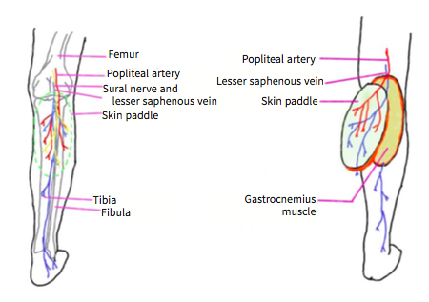
FIG 3. Proximally based sural artery flap

Vastus Medialis Perforator (VMAP) Flap (13; 14), Increasingly popular because of to its ability to reach distant locations and it’s minimal donor morbidity. The perforators come from the descending branch of the lateral circumflex femoral artery. It runs along the inner thigh and sends several good-sized perforators through the vastus medialis muscle. These perforators are usually in the lower third of the thigh, running between muscle bundles to the fascia and skin above. This makes for a reliable fasciocutaneous flap without too much morbidity at the donor site. Studies show that VMP flap has a very reliable vascular pattern, and a very pliable skin. It is important to map out the perforators before surgery, using Doppler or other scans. Then, carefully dissect through the muscle to find the main perforator, and lift the flap as an island based on that perforator. Most of the vastus medialis muscle is spared, which help with blood flow, and keeps a good function of the quadriceps.
These flaps have many advantages such as pedicle length, wide arc of rotation, preservation of muscle function, excellent contour and joint mobility preservation, they can also be applicable where muscle flaps are too bulky and a lower donor morbidity. Their limitations can be that they are technically demanding, Injuring the perforators may compromise viability and their limited bulk for very deep defects.

Combined Flaps
In cases with large or complex defects, a single flap may not be sufficient. Combination of multiple perforators based in order to increase surface area and tailor coverage to defect shape can be necessary in those cases, allowing customization: matching defect size, location, and minimizing donor-site morbidity (2 ;5). Combined gastrocnemius and soleus, or gastrocnemius plus gracilis flaps, have been described to increase bulk and and allow a further reach.

Free Flap Transfer
When local or regional flaps are insufficient free tissue transfer can become an essential tool. Free flaps remain indispensable for large, composite, or recurrently infected defects, most commonly used freeflaps are Anterolateral Thigh (ALT) Flap, Muscle-Sparing Latissimus Dorsi Flap and Gracilis Free Flap. Anterolateral Thigh (ALT) Flap Most commonly used free flap for lower-extremity reconstruction (1; 2 ;5). The ALT flap (24) is based on perforators from the descending branch of the lateral circumflex femoral artery, which traverse the vastus lateralis muscle to supply a large, pliable fasciocutaneous territory with acceptable donor morbidity.The anterolateral thigh (ALT) free flap, latissimus dorsi (LD) muscle-sparing flap, and gracilis free flap are widely utilized in reconstructive microsurgery, each with well-characterized vascular anatomy and reliable surgical techniques. Preoperative perforator mapping with Doppler or imaging guides flap design, and intramuscular dissection allows harvest of a
perforator-based flap while preserving the underlying muscle, minimizing donor-site morbidity. Muscle-Sparing Latissimus Dorsi Flap which is Increasingly favored for knee reconstruction due to It’s long pedicle, the large thin skin and it’s minimal function loss. (22) It is supplied by the thoracodorsal artery and its branches for the skin and underlying muscle segments, allowing selective harvest of either muscle, skin, or both, with preservation of shoulder function; dissection is based on careful identification of the dominant vascular pedicle and separation of minor branches to maintain perfusion.Gracilis Free Flap (1; 21) supplied by the ascending branch of the medial circumflex femoral artery, it offers a thin, pliable muscle or musculocutaneous flap with a long vascular pedicle, useful for small defects or combined tendon defects.

Skin flaps
Local flaps | Fasciocutaneous flap
Perforator based flaps | ALT perforator flap, lateral supragenic- ular artery perforator flap, pedicled vastus medialis perforator flap
Other cutaneous flaps | Medial sural artery flap, saphenous flap, lateral sural cutaneous artery flap
Muscle flaps
Proximally based flaps | Gastrocnemius flap, peroneus longus flap, vastus medialis flap (V-Y flap)
Distally based flaps | Gracilis flap, sartorius flap, vastus medialis flap
Musculocutaneous flaps
Proximally based flaps | Gastrocnemius musculocutaneous flap
Distally based flaps | Reverse ALT flap, split vastus lateralis musculocutaneous flap
Free flaps
Free flaps | ALT flap, latissimus dorsi flap

TABLE1 : Choice of flaps available for defects around the knee

Toward a Reconstructive Algorithm
Developing a practical and adaptable reconstructive algorithm is essential given the diversity of knee defects and the variability in patient factors. Modern reconstructive planning increasingly emphasizes zone-based, defect-oriented decision-making, incorporating not only defect size and depth but also the specific anatomic subregion of the knee and the condition of the recipient-site vascularity.
Assess Defect Characteristics
Size and Depth ; In Small, superficial defects skin graft or local flap should be considered, In Moderate defect without deep structure exposure pedicled perforator flap or muscle flap are a good option (1; 9). On the other hand large defect, deep exposure, or in need for bulk, muscle flap(s), combined perforator flaps, or free flap are the go to option (14) Location ; Zone-based considerations can be particularly helpful. Defects in the anterior peripatellar region commonly require thin, pliable flaps that conform well to the patellar tendon and avoid restricting tendon gliding; perforator-based propeller flaps or the medial gastrocnemius muscle flap remain reliable choices. Medial knee defects often benefit from medially based perforator flaps or the medial gastrocnemius, while lateral defects may require LSAP flaps or free flaps when local perforators are damaged from trauma. Distal thigh and suprapatellar defects generally require flaps with a longer arc of rotation, including VMAP or ALT perforator flaps. Proximal tibial and infrapatellar defects frequently encountered in trauma and infected TKA may require muscle flaps for bulk and vascularity or free flaps when local tissues are compromised.
Infection and Wound Status ; in the setting of Infected, contaminated wounds, or prosthetic exposure there is a need for well vascularized, tick coverage (muscle or free flaps) to improve healing and help with infection. While in stable clean wounds without signs of infection, perforator flaps or combined flaps may be considered.
Patient Factors & Donor-Site Morbidity While young, healthy patients can have broad options of coverage, elderly patients with comorbidities, poor soft tissue quality, or limited donor tissue, can pose a real problem in coverage andther is a necessity to lean toward low-morbidity options (14;22) (perforator flaps if local tissue allows). In some special cases preservation of donor-site function such as in younger patients with high functional demands or athletes, is necessary limiting the options to perforator flaps or muscle-sparing techniques
Reconstructive Goals ; The main goals of reconstruction is achieving a durable, stable and infection resistant coverage, preserving joint mobility , and limb salvage.
Team and Timing Considerations It is necessary to refer patients as soon as possible (14; 18; 19) to plastic reconstructive surgeon, since any delay in coverage correlates with a higher risk of re-infection and amputation it is particularly the case in complex wounds, exposed prostheses, or cases requiring revision TKA. Literature consistently shows that collaborative, timely planning reduces postoperative complications, improves limb-salvage rates, and enhances function.So it is necessary to plan a staged, multidisciplinary protocol, for debridement, coverage, infection control, and eventual reimplantation or reconstruction, to achieve a good outcome.

The reconstructive algorithm must also distinguish between acute, subacute, and chronicwounds.
In acute trauma, early soft-tissue coverage within the first 72 hours remains ideal, decreasing infection risk and improving healing. In subacute wounds (postoperative dehiscence or early necrosis), thorough debridement and temporary negative-pressure therapy may be used before definitive flap coverage. Chronic wounds, especially in the setting of infection or multiple prior surgeries, often require staged procedures: serial debridement, infection control, and ultimately free flap reconstruction.
Ultimately, a modern reconstructive algorithm for knee defects is not linear but dynamic, guided by defect characteristics, patient condition, and available reconstructive resources. Its purpose is to assist in prioritizing durable, high-quality coverage while preserving knee mobility and long-term function
.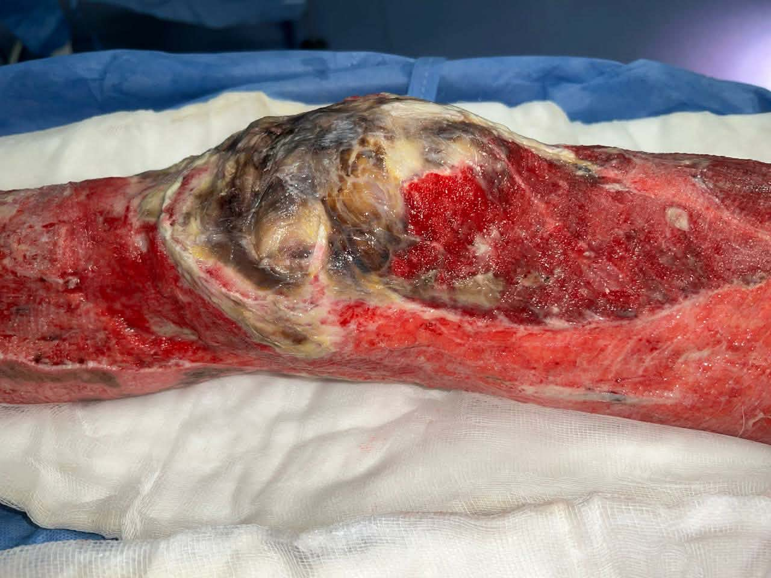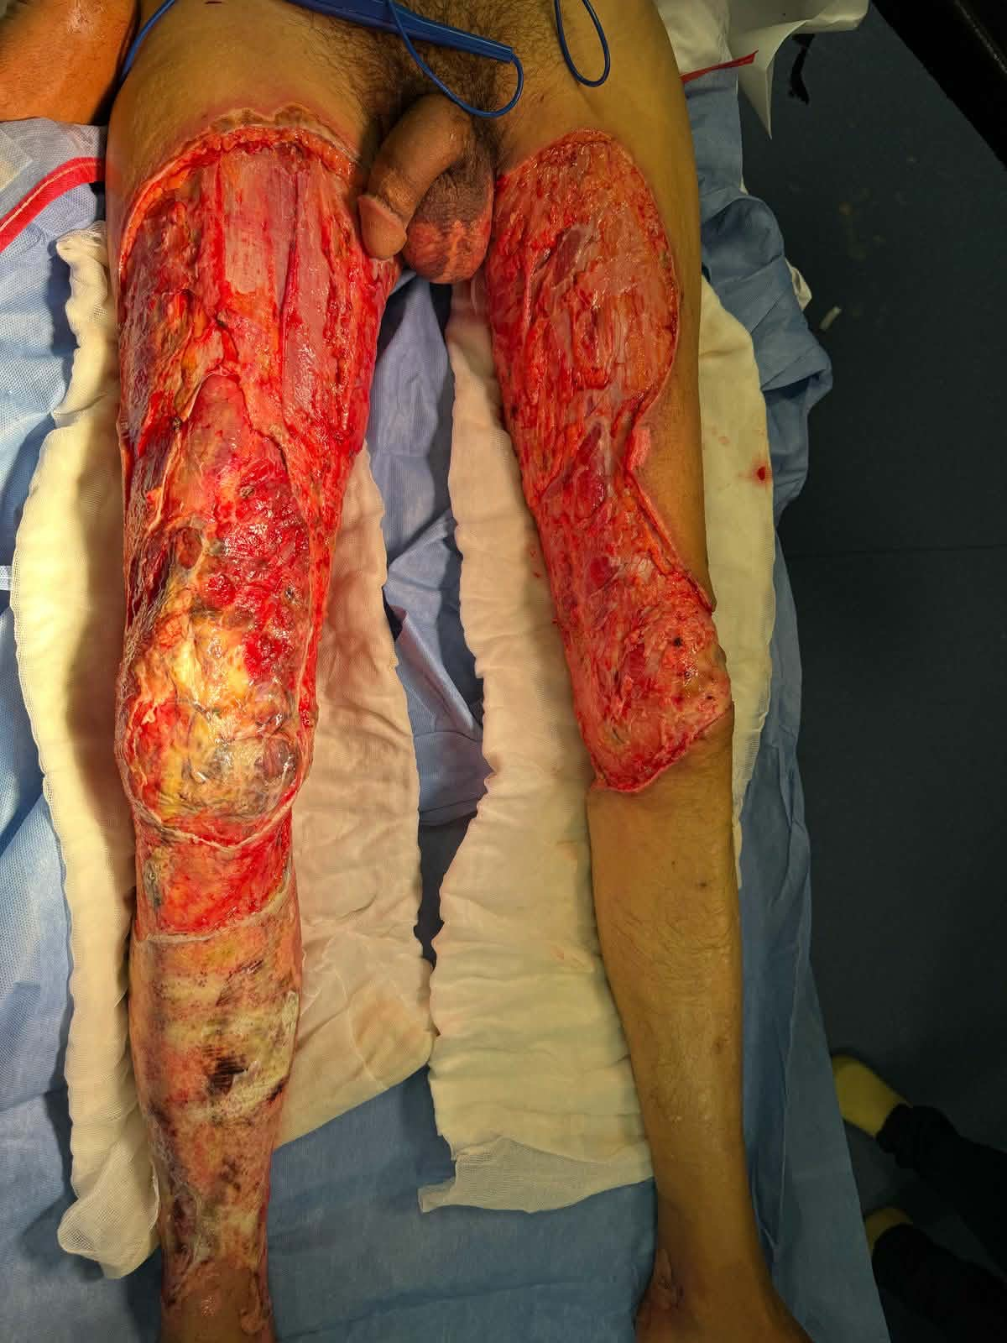
FIG 4. A 40-year-old man suffered a deep burn on both legs and knees right knee was managed by debridement, then medial gastrocnemius flap and a skin graft while the left knee defect could be managed by simple skin graft gastrocnemius flap

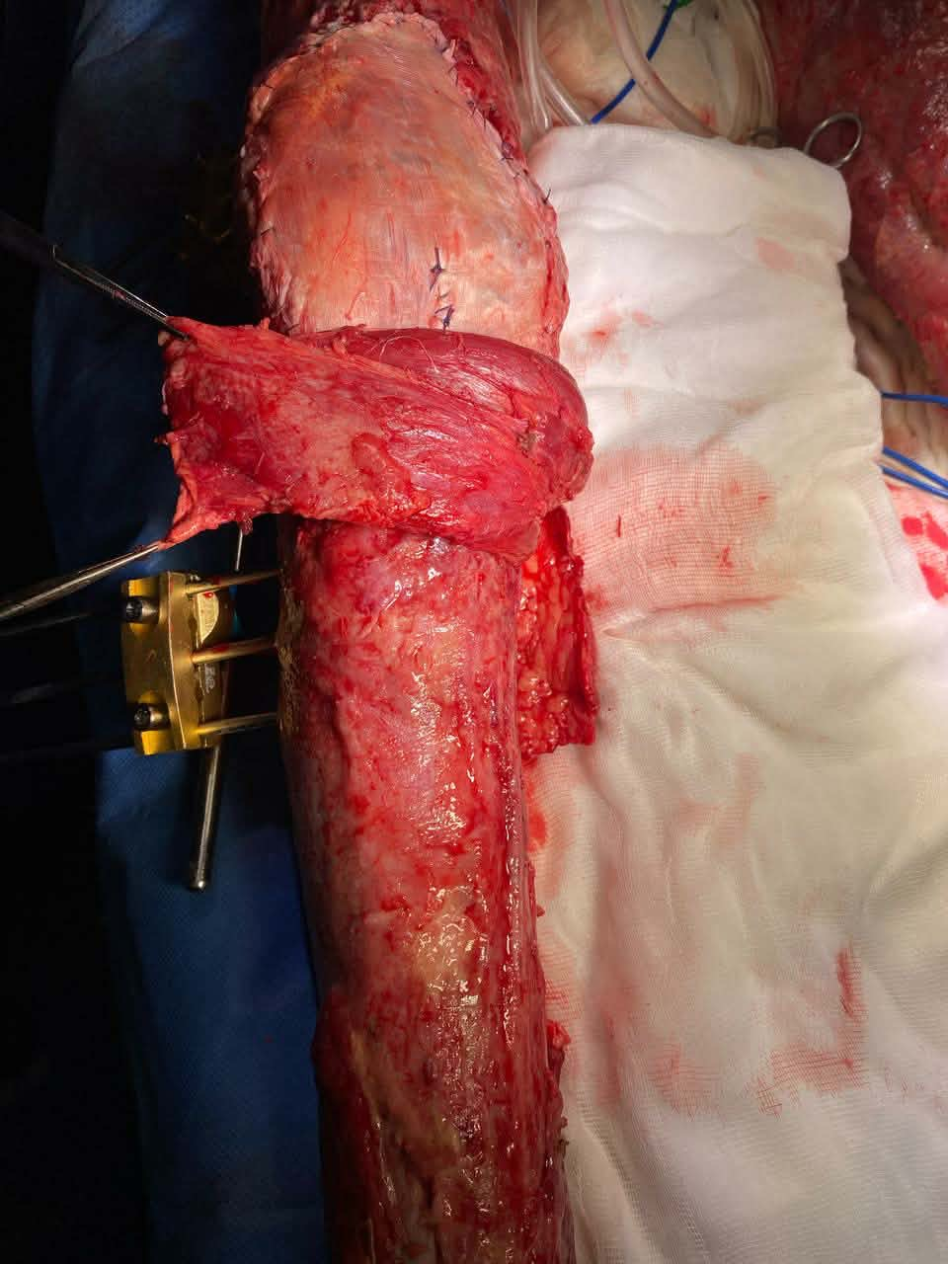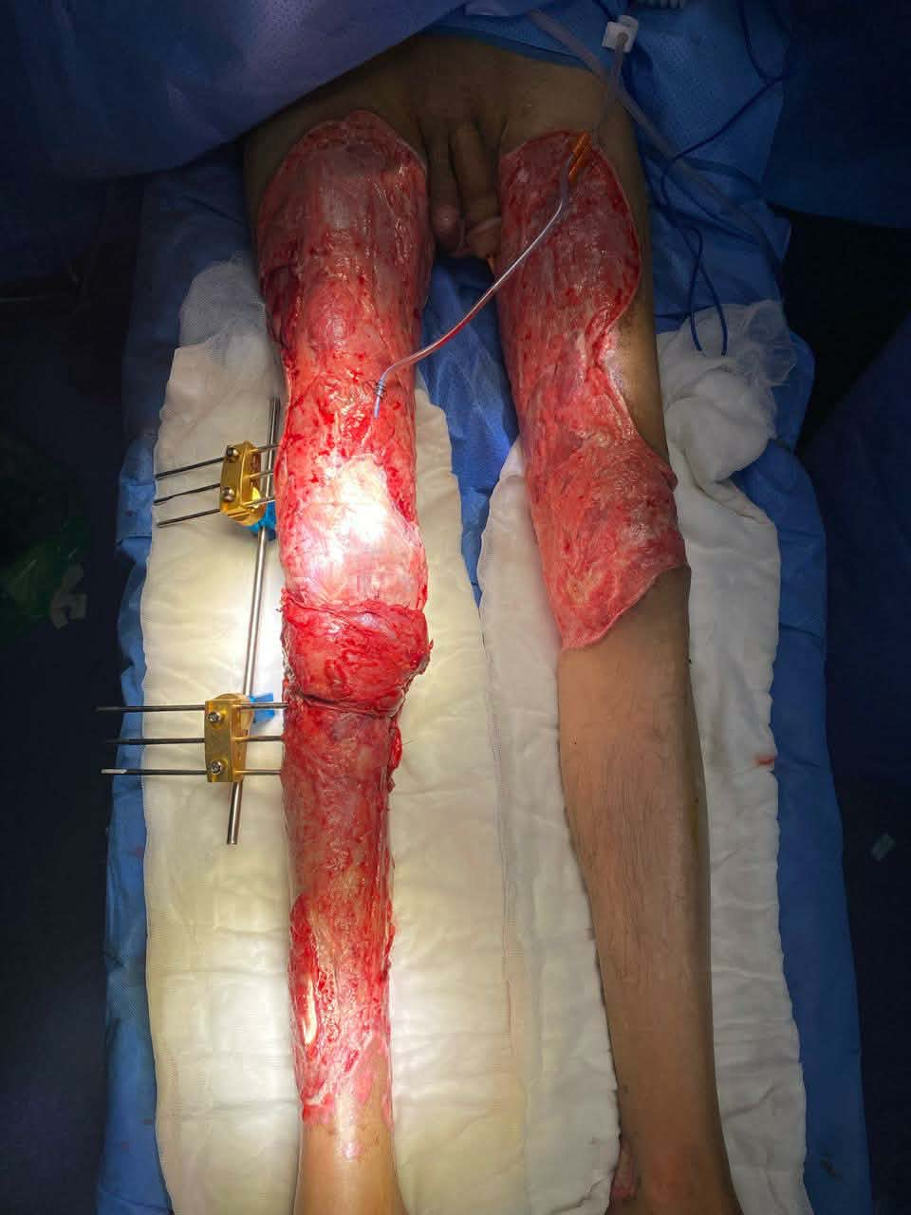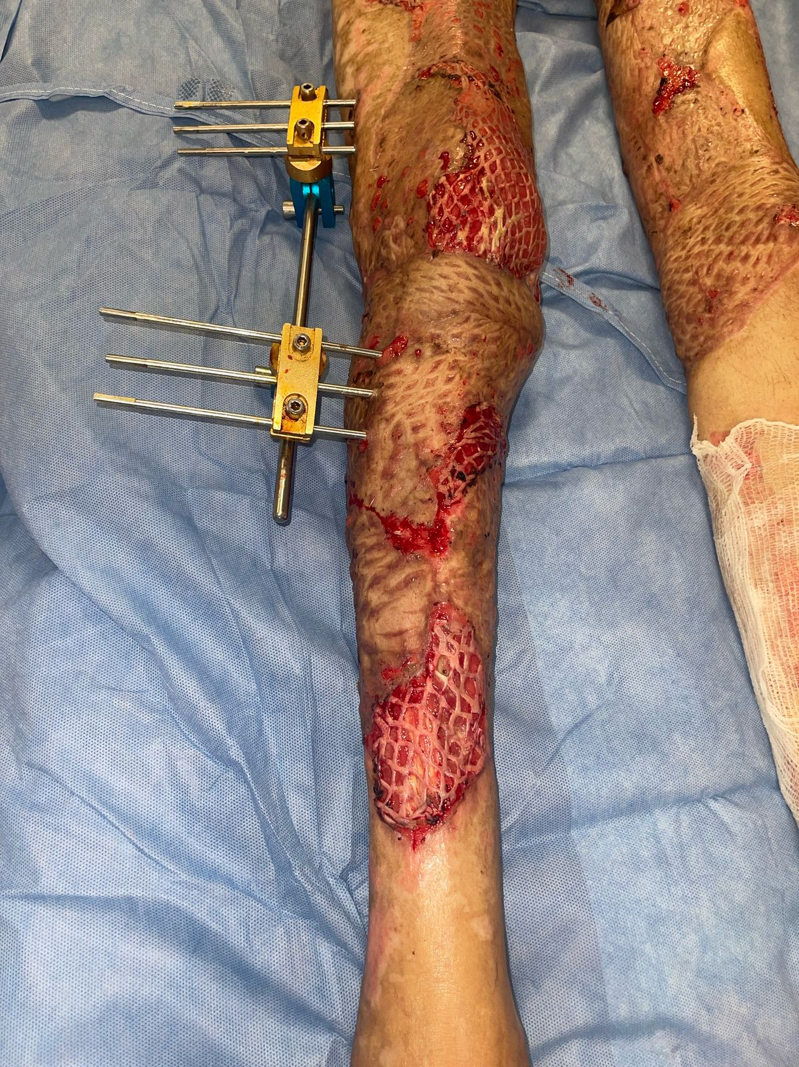
10 days post Op

Per Op

FIG 5. Muscle Flap Transfer/Coverage in Limb Reconstruction FIG 6. Post-Operative View of Meshed Skin Graft on Lower Leg

Challenges of reconstruction
Despite significant advances, reconstruction of knee defects is still a challenge to Plastic and orthopedic surgeons. Several issues persist; There is no universal solution (20) so no single flap design can fit all defects, and the increasing use of combined perforator flaps and free flaps reflects this reality. One of the most persistent issues is the unpredictability of local tissue quality. Chronic infection, repeated surgical debridement, scarring, and radiation can render tissues unreliable, limiting the effectiveness of local and regional flaps and necessitating free-tissue transfer even for defects that might otherwise have simpler solutions.
Donor-site morbidity (22) and functional loss ; remains another concern, especially with muscle flaps. Although muscle-sparing and perforator-based techniques have reduced functional deficits, gastrocnemius harvesting can still lead to calf weakness, reduced push-off strength, or cosmetic asymmetry. Free flaps, while preserving local function, introduce risks at a distant donor site, including seroma, contour deformity, or sensory changes.Infection control represents one of the greatest reconstruction challenges. In cases of periprosthetic joint infection or chronic osteomyelitis, reconstruction must not only provide coverage but also contribute to eradication of infection. Muscle flaps are traditionally favored for their vascularity, yet recent evidence suggests perforator and fasciocutaneous free flaps can also be successful if thorough debridement is achieved.
Complexity and technical demand especially in free tissue transfer though a very good option, access to microsurgical expertise (2;8;14;18),. and postoperative monitoring remains uneven across healthcare settings. In regions lacking microsurgical capability, local and pedicled options may be overused despite suboptimal outcomes. Recipient vessel selection can be challenging, especially in patients with trauma, infection, or prior surgeries that compromise the popliteal, genicular, or tibial vessels. Vessel scarring may limit options for microvascular anastomosis and sometimes necessitates vein grafts or alternative recipient sites, increasing operative complexity and risk of thrombosis (8)
Mechanical forces across the knee joint is also a huge problem. Constant movement, and postoperative rehabilitation all place tension on reconstructed soft tissue. Flaps must therefore be thin enough to maintain mobility yet durable enough to withstand repetitive stress. Excessively bulky flaps may impede flexion, while thin grafts may break down under load. This delicate balance is often difficult to achieve, particularly in defects involving the patellar tendon or extensor mechanism, where gliding surfaces must be restored.
Need for multidisciplinary care ; the coordination between orthopedic and plastic surgery in management, infection control, and rehabilitation is the key to sucess of knee defect reconstructions. Lack of large-scale, high-level evidence (14) ; Literatture shows a multitude of case series and retrospective studies, while randomized controlled trials or large prospective studies comparing different flap types are very rare, and big part of the data is technique based. The absence of high-level evidence, makes decision-making heavily dependent on surgeon experience.
Despite advancements in perforator mapping, microsurgical techniques, and combined flap strategies, several challenges continue to complicate reconstruction of knee soft-tissue defects.
Finally, these persistent challenges highlight the need for careful preoperative planning, multidisciplinary collaboration, and continued research into new reconstructive strategies, biologic materials, and technologies to improve long-term functional results.

Conclusion
Soft tissue defects around the knee remain among the most challenging problems in plastic and reconstructive surgery. Given the unique anatomical and functional constraints of the knee, achieving stable, durable coverage while preserving joint mobility and minimizing donor site morbidity requires careful planning, surgical expertise, and a flexible reconstructive strategy. Recent advances, particularly in perforator flap design, combined flap techniques, muscle-sparing approaches, and free tissue transfer, have significantly broadened the reconstructive "toolbox." Contemporary practice favors individualized, defect-based reconstructive algorithms rather than rigid protocols. Early multidisciplinary intervention, especially in the context of prosthetic joint complications, is critical for optimizing outcomes, limb salvage, and functional recovery. As the field advances, further research especially prospective studies is needed to refine reconstructive strategies, minimize morbidity, and standardize outcomes. For now, tailored, patient centred reconstruction remains the cornerstone of effective knee defect management.
Disclaimer (Artificial intelligence)
Option 1:
Author(s) hereby declare that NO generative AI technologies such as Large Language Models (ChatGPT, COPILOT, etc.) and text-to-image generators have been used during the writing or editing of this manuscript.

References
1. Ravindra Bharathi, R., Ramkumar, S., & Venkatramani, H. (2019). Soft Tissue Coverage for Defects around the Knee Joint. Indian Journal of Plastic Surgery. https://doi.org/10.1055/s-0039-1688536
2. Fu, J., Qing, L., Wu, P., & Tang, J. (2021). Customized reconstruction of a complex soft-tissue defect around the knee with a free perforator flap. American Journal of Translational Research, 13(5), 4401–4411. https://www.ncbi.nlm.nih.gov/pmc/articles/PMC8205711/
3. Kim, D., Kim, J., Jeong, W., Jo, T., & Choi, J. (2021). Modified Medial Gastrocnemius Myocutaneous Flap Technique for Knee Joint Coverage after Total Knee Arthroplasty. Journal of Wound Management and Research, 17(1), 67-71. https://doi.org/10.22467/jwmr.2020.01396
4. Liu, J., Wu, Y., Zhou, M., Liu, H., Kang, Y., Wang, Y., Jia, X., & Rui, Y. (2021). Repair of severe peri-knee soft tissue defect using an anterolateral thigh flap with the descending genicular vessels as the recipient pedicle: a case series of 14 patients. Annals of Palliative Medicine, 10(5), 5341-5350. https://doi.org/10.21037/apm-21-827
5. Fu, J., Qing, L., Wu, P., Zhou, Z., Yu, F., & Tang, J. (2020). Customized Reconstruction of Complex Soft Tissue Defect Around the Knee with Individual Design of Free Perforator Flap. Research Square. https://doi.org/10.21203/rs.3.rs-81464/v1
6. Fyllos, A., Raoulis, V., Mitrousias, V., Banios, K., Chytas, D., & Zibis, A. (2021). Surgical implications of the arterial anatomy around the knee: A cadaveric pictorial essay. Diagnostics, 11(11), 2004. https://doi.org/10.3390/diagnostics11112004
7. Niempoog, S., & Tanariyakul, Y. (2019). Distally Based Sartorius Flap to Cover Knee Joint Defect. Journal of Orthopaedic Case Reports, 9(3), 43-45. https://doi.org/10.13107/jocr.2250-0685.1412
8. Liu, W. C., Chang, C. H., Lu, C. C., Fu, Y. C., & Lu, C. K. (2020). Reconstruction of massive knee defects with extensor mechanism deficiency through concurrent anterolateral thigh flap and autogenous hamstring tendon: A report of two cases. Journal of Orthopaedic Surgery (Hong Kong), 28(2), 2309499020935994. https://doi.org/10.1177/2309499020935994
9. Lankaram, J. J., Rasheedha Begum, U., Karthikeyan, G., & Ramadevi, V. (2019). Analysis of challenging reconstruction of soft tissue defects around the knee joint and evolving a treatment algorithm. International Journal of Research in Orthopaedics, 6(1), 151-157. https://doi.org/10.18203/issn.2455-4510.IntJResOrthop20195809
10. Mahipathy, S. R. R. V., Durairaj, A. R., Sundaramurthy, N., & Jayachandiran, A. P. (2020). Lateral genicular artery flap for reconstruction of defects around the knee: a series of 5 cases. International Surgery Journal, 7(10), 3411-3413. https://doi.org/10.18203/2349-2902.isj20204146
11. Landry, G. J., Carlson, J. R., Liem, T. K., Mitchell, E. L., Edwards, J. M., & Moneta, G. L. (2009). The sartorius muscle flap: An important adjunct for complicated femoral wounds involving vascular grafts. American Journal of Surgery, 197(5), 655-659. https://doi.org/10.1016/j.amjsurg.2008.12.020
12. Yavari, A., Delavari, C., Etemad, O., & Molaei, H. (2024). Propeller Flaps in Reconstruction of Tissue Defects Around Knee. *Japanese Journal of Medical Research*, *2*(2), 1-3. https://doi.org/10.33425/2993-6799.1016
13. Whiteside, L. A. (2013). Surgical technique: Vastus medialis and vastus lateralis as flap transfer for knee extensor mechanism deficiency. Clinical Orthopaedics and Related Research, 471(1), 221–230. https://doi.org/10.1007/s11999-012-2532-z
14. Gravvanis, A., Kyriakopoulos, A., Kateros, K., & Tsoutsos, D. (2014). Flap reconstruction of the knee: A review of current concepts and a proposed algorithm. World Journal of Orthopedics. https://doi.org/10.5312/wjo.v5.i5.603
15. Rao, A. S., Kartheek, B. J., & Yeshwanth, M. (2023). The Role Of Gastrocnemius Myocutaneous Flap In Covering Defects Of Proximal And Middle Third Of Leg. Paripex - Indian Journal Of Research. https://doi.org/10.36106/paripex/2907304
16. Bharathi, R. R., Ramkumar, S., & Venkatramani, H. (2019). Soft Tissue Coverage for Defects around the Knee Joint. Indian Journal of Plastic Surgery. https://doi.org/10.1055/s-0039-1688536
17. Lankaram, J. J., Rasheedha Begum, U., Karthikeyan, G., & Ramadevi, V. (2019). Analysis of challenging reconstruction of soft tissue defects around the knee joint and evolving a treatment algorithm. International Journal of Research in Orthopaedics, 6(1), 151-157. https://doi.org/10.18203/issn.2455-4510.IntJResOrthop20195809
18. Hamrouni, N., Højvig, J., Knudsen, U., Skovgaard, K., Jensen, L., Bonde, C., & Odgaard, A. (2024). Microvascular free flap coverage of complex soft tissue defects after revision total knee arthroplasty: a cross-sectional observation study. Acta Orthopaedica, 95, 186-191. https://doi.org/10.2340/17453674.2024.40183
19. Gupta, R., Weisberger, J., Herzog, I., Roth, J., & Lee, E. (2024). Utilization of the gastrocnemius flap for post-traumatic knee reconstruction: a systematic review. *European Journal of Orthopaedic Surgery & Traumatology*, *34*(5), 2255–2261. https://doi.org/10.1007/s00590-024-03938-2
20. Ri, S. B., Ryu, J. S., Kim, K. C., Kim, K. C., & Rim, C. G. (2025). Reconstruction of Broad Soft Tissue Defect around Knee with Combined Perforator Flaps. International Journal of Clinical and Experimental Physiology, 11(4), 148-152. https://doi.org/10.5530/ijcep.2024.11.4.28
21. Kwon, H., Lee, S., Kim, S., Song, S. H., Oh, S., Kim, J., Kyung, H., Yang, H. J., & Ha, Y. (2023). Reconstruction of complex knee wounds with a distally based gracilis flap and gastrocnemius myocutaneous flap: A case report. Frontiers in Surgery, 10, 1109936. https://doi.org/10.3389/fsurg.2023.1109936
22. Ha, Y., Lee, B. H., Park, J. A., & Kim, Y. H. (2023). Reconstruction of soft tissue defect around knee with thoracodorsal artery perforator flap and muscle-sparing latissimus dorsi flap. Microsurgery, 43(7), 665-675. https://doi.org/10.1002/micr.31024
23. Kim, D., Kim, J., Jeong, W., Jo, T., & Choi, J. (2021). Modified Medial Gastrocnemius Myocutaneous Flap Technique for Knee Joint Coverage after Total Knee Arthroplasty. Journal of Wound Management and Research. https://doi.org/10.22467/jwmr.2020.01396
24. Jeong, S.-H., Baik, S.-H., Namgoong, S., Dhong, E.-S., & Han, S.-K. (2023). An algorithmic approach to soft-tissue reconstruction around the knee using anterolateral thigh perforator flap in patients with post-traumatic knee osteomyelitis. Frontiers in Surgery. https://doi.org/10.3389/fsurg.2023.982669
25. Gravvanis, A., Kyriakopoulos, A., Kateros, K., & Tsoutsos, D. (2014). Flap reconstruction of the knee: A review of current concepts and a proposed algorithm. World Journal of Orthopedics, 5(5), 603-613. https://doi.org/10.5312/wjo.v5.i5.603
26. Amin, N. H., Speirs, J. N., Simmons, M. J., Lermen, O. Z., Cushner, F. D., & Scuderi, G. R. (2019). Total knee arthroplasty wound complication treatment algorithm: Current soft tissue coverage options. Journal of Arthroplasty, 34(4), 735-742. https://doi.org/10.1016/j.arth.2018.12.016
27. Cheon, S. J., Kim, I. B., Park, W. R., & Kim, H. T. (2008). The proximally‐based sural artery flap for coverage of soft tissue defects around the knee and on the proximal third and middle third of the lower leg. Acta Orthopaedica, 79(3), 370–375. https://doi.org/10.1080/17453670710015274
28. Mathes SJ, Nahai F. Thigh. In: Reconstructive Surgery: Principles, Anatomy & Technique. 1a ed. New York: Chuchill Livingstone. 1997; 2:1261-391.
29. Swartz, W. M., Ramasastry, S. S., McGill, J. R., & Noonan, J. D. (1987). Distally based vastus lateralis muscle flap for coverage of wounds about the knee. Plastic and Reconstructive Surgery, 80(2), 255-265. https://doi.org/10.1097/00006534-198708000-00016
30. Yusof, M. N., & Ahmad Alwi, A. A. (2019). Outcome of Islanded Gastrocnemius Musculocutaneous Flap in Orthopaedic Practice. Malaysian Orthopaedic Journal, 13, 25-29. https://doi.org/10.5704/MOJ.1903.004

