Chondrosarcoma of distal radius: a case report

ABSTRACT:

Aims: Chondrosarcomas constitute a rarity in the upper limbs, and their occurrence in the distal radius is even rarer. Early diagnosis through incisional biopsy is essential. Surgical resection with margin control and fibular grafting can be effective.
Presentation of case: We report a case of distal radius chondrosarcoma in a 50-year-old male presenting with progressive pain and swelling of the left wrist over one year. Incisional biopsy confirmed a dedifferentiated chondrosarcoma. Owing to anatomical constraints and the need to preserve wrist and hand function, a marginal resection of the distal radius was performed, followed by reconstruction using a non-vascularized ipsilateral fibular autograft fixed to the carpal bones. At 3-year follow-up, the patient demonstrated satisfactory graft consolidation and no radiological evidence of local.
Conclusion: Chondrosarcoma of the distal radius is very rare; early diagnosis, wide excision and bone reconstruction can improve the prognosis.

Key words: chondrosarcoma; distal radius, plastic surgery, bone graft.

- INTRODUCTION:

“Chondrosarcoma is the second most frequent primary malignant bone tumor after osteosarcoma, accounting for approximately one-third of malignant bone lesions” (13, 14). It occurs in adults after the age of forty, its progression is slow and frequently not very symptomatic. The pelvis and proximal femur represent the most common sites; involvement of the distal radius is exceedingly uncommon, with only a few cases reported. The gold-standard treatment is wide local excision with histologically clear margins. However, wide resection at the distal radius often results in substantial functional impairment, and reconstruction remains a major challenge.
We report a case of chondrosarcoma of the lower end of the radius in a 50-year-old patient who progressed well after wide resection and reconstruction with a non-vascularized fibular graft. The aim of this work is to highlight the epidemiological, clinical, therapeutic and prognostic aspects of this tumor.

- CASE REPORT:

A 50-year-old patient presented with progressive and localized pain in the distal third of the left forearm over one year, without preceding trauma or infection and with preserved general health status. Clinical examination revealed a firm, non-tender mass fixed to deep tissues on the radial side of the distal forearm (Figure 1).

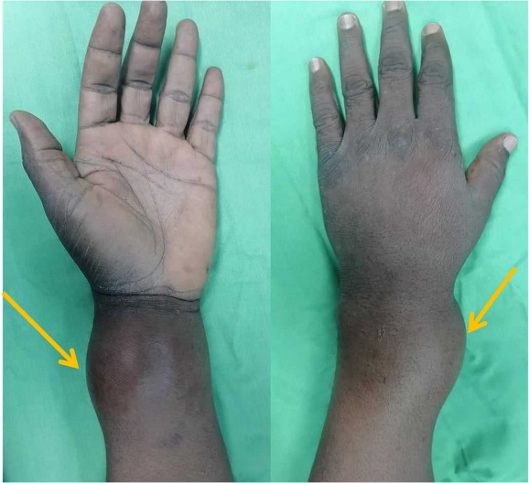
Figure 1: Clinical presentation of the left forearm

Wrist and finger mobility were preserved, and neurovascular examination was normal.
No supra-epitrochlear or axillary lymphadenopathy was found.
Standard radiographs showed a metaphyso-epiphyseal lytic image of the distal radius with cortical disruption and intra-lesional calcifications suggestive of a malignant cartilaginous tumor (Figure 2).

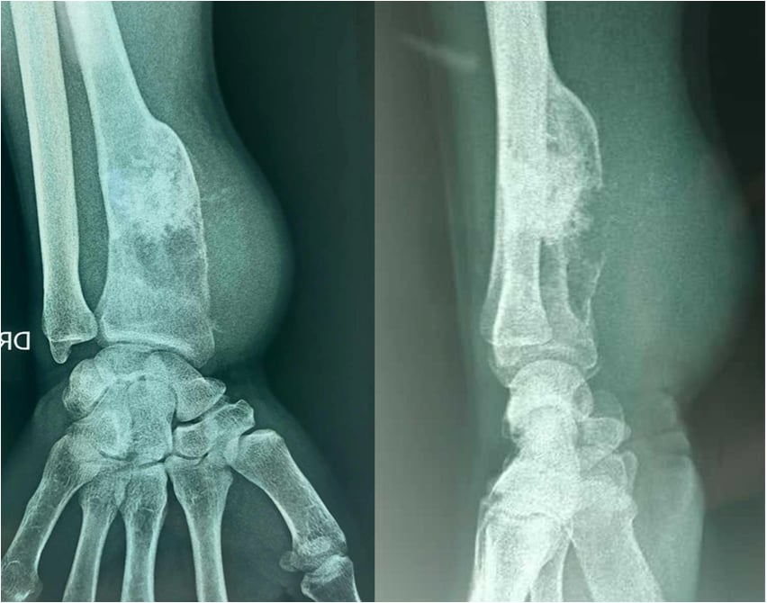
Figure 2: Standard radiographs of the left forearm

MRI confirmed an expansile metaphyso-epiphyseal lesion with intra-articular and peri-articular extension (Figure 3).
Incisional biopsy was performed, confirming the diagnosis of dedifferentiated chondrosarcoma.
The patient underwent a marginal resection of the distal radius (Figure 4). Given the anatomic confines of the wrist, the proximity of neurovascular structures, and the patient’s desire to preserve limb function, wide excision was deemed technically prohibitive. Reconstruction was achieved with a non-vascularized ipsilateral fibular graft, fixed to the carpal bones.

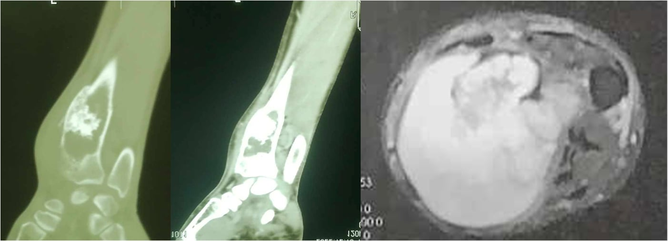

Figure 3: MRI aspect of the tumor

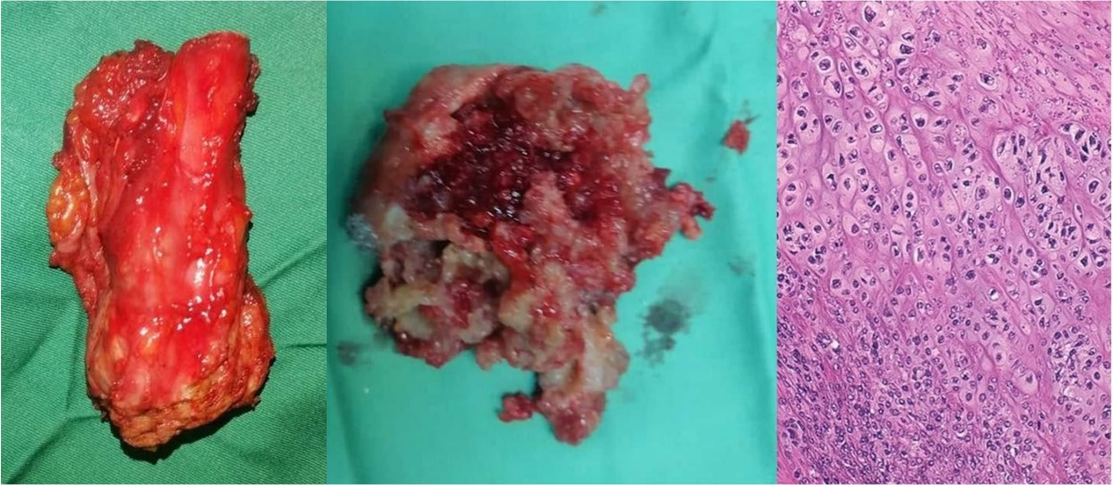

Figure 4: Surgical specimen and its anatomopathological aspect

At 3-year follow-up, radiographs demonstrated complete graft union without evidence of local recurrence (Figure 5). Wrist mobility remained limited but functional, with preserved hand function.
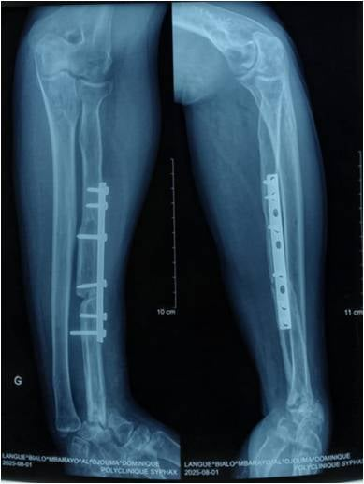
Figure 5: Postoperative radiographs at 3-year follow-up

- DISCUSSION:
“Chondrosarcoma is the most common primary malignant bone tumor after osteosarcoma. It represents 11% to 22% of primary malignant bone tumors” according to Unni (1). According to Unni and Campanacci “Chondrosarcomas are mostly located in the pelvis, ribs and proximal segments of the extremities; they rarely occur in forearm bones” (2). Kosher found one case of “chondrosarcoma of the distal radius out of 24 cases of tumor of distal radius” (3), Maruthainar describe one case of chondrosarcoma of the distal radius out of 13 cases of tumor of distal radius (4).
“The symptoms are often discreet, with an insidious onset reflecting the very slow growth of these tumors. The average duration of symptoms is 1 to 2 years; it is shorter for limb locations than for pelvic locations. The revealing symptoms are, most often, pain or the discovery of swelling by the patient. Pathological fractures are rare (3%); These are most often tumors of high histological grade” (5).
“Biological assessment is usually normal, without inflammatory syndrome. Marcove and Francis demonstrated an intolerance to carbohydrates during induced hyperglycemia in 80% of patients with chondrosarcoma” (6).
“The age at which these tumors appear is mainly between 40 and 70 years old. According to Harrleson, only 4% of patients are under 20 years old and 40% to 47% are over 40 years old” (1). “The discovery of a chondrosarcoma before the age of 20 should raise the diagnosis of chondroblastic osteosarcoma” (2). “Approximately 10% of chondrosarcomas arise from pre-existing bone lesions” (1).
“The diagnosis is often strongly suspected on standard films. The lesion is usually metaphyseal and extends towards diaphysis more than towards epiphysis. These are osteolytic areas, extensive and well defined. The cortex is usually eroded following endosteal resorption. This thinned cortex can be ruptured, and a periosteal reaction is not exceptional. A blown appearance of the cortex can also be visualized. In high-grade tumors, tumor boundaries are less clear, with more extensive cortical lysis. In more than two-thirds of cases, calcifications are visible in the tumor matrix like our clinical case. Flaky, “popcorn” calcifications are the most typical” (7).
CT allows for a more detailed assessment of resorption and possible rupture of the cortex. Intramatrix calcifications are also perfectly visualized with this exam.
“Nuclear magnetic resonance (MRI): It is especially of interest for radiolucent tumors and in the assessment of loco-regional extension. These tumors are hyperintense on T2 and intermediate signal on T1; when they are well differentiated, it is possible to visualize the cartilaginous lobules” (8).
Histology: Chondrosarcomas are made up of tumor lobules of irregular size and shape, delimited by connective septa, and not by osteomedullary tissue as is the case in enchondromas. Fragments of residual sponge bone, encompassed by the proliferation, sometimes persist within these lobules, testifying to the permeation of the osteomedullary tissue by the tumor. This permeation of the spongy bone should not be confused with the foci of intra-tumoral reactive osteogenesis
“Within the lobules, cellularity is often significant, predominating at the periphery. Tumor chondroblasts have a large nucleus with densified chromatin. Binucleation appearances are common. Mitotic activity can sometimes be individualized, mainly in high-grade tumors. The tumor matrix can be chondroid or myxoid. The existence of myxoid zones within a cartilaginous tumor is a criterion pointing towards malignancy. Areas of necrotic changes may be present but are also observed in chondromas. These histological and cytological characteristics are used to establish the grade of chondrosarcomas as proposed by O’Neal and Ackerman” (9). “Grade I chondrosarcomas, low malignancy, are the most difficult to differentiate from chondromas. Their cellularity is greater than that of a chondroma. The cartilaginous cells are slightly atypical with a densified nucleus. The importance of tumor cellularity and cytonuclear atypia increases in grades II (intermediate malignancy) and III (high malignancy).
The treatment is surgical always after a biopsy. Local control of the tumor depends on the quality of the resection; when the surgery is extra-tumoral and even more so large, the risk of recurrence is divided by three. According to Lee et al., the risk of local recurrence is higher for high-grade tumors [15% versus 30%). Still according to Lee et al., the occurrence of a local recurrence is a negative event regarding the occurrence of metastases (49% of metastases in the event of local recurrence versus 16% in the absence of local recurrence) and for survival” (10).
For the localization at the level of the distal radius the problem of bone reconstruction arises, several processes have been described: the graft of the vascularized fibula, the inert graft of the fibula and the prosthetic replacement (3, 4, 11). We found in literature that “excision and reconstruction with fibula graft may be used in cases where there is a large tumor mass with extension into the soft tissue” (12).

- CONCLUSION:
Chondrosarcoma of the distal radius is rare and poses significant therapeutic challenges. While wide excision remains the recommended standard, marginal resection with structural reconstruction may be considered in exceptional cases where anatomical limitations and functional demands preclude wide resection. Long-term monitoring is essential due to the elevated risk of recurrence associated with marginal margins.

DISCLAIMER (ARTIFICIAL INTELLIGENCE)

Author(s) hereby declares that NO generative AI technologies such as Large Language Models (ChatGPT, COPILOT, etc) and text-to-image generators have been used during writing or editing of manuscripts.

CONSENT

As per international standards or university standards, patient(s) written consent has been
collected and preserved by the author(s).

ETHICAL APPROVAL

As per international standards or university standards written ethical approval has been
collected and preserved by the author(s).

REFERENCES
- Harrleson, J. (1980). Bone tumors: general aspects and data on 6,221 cases. Annals of Surgery, 191(4), 511. https://pmc.ncbi.nlm.nih.gov/articles/PMC1344587/.
- Campanacci M. Bone and Soft Tissue Tumors. New York, Springer 1986:267-304.
- Kocher, Mininder S. M.D.; Gebhardt, Mark C. M.D.; Mankin, Henry J. M.D., Boston, Massachusetts. Reconstruction of the Distal Aspect of the Radius with Use of an Osteoarticular Allograft after Excision of a Skeletal Tumor. The Journal of Bone & Joint Surgery 80(3):p 407-19, March 1998.
- N Maruthainar , C Zambakidis, G Harper, D Calder, S R Cannon, T W R Briggs. Functional outcome following excision of tumours of the distal radius and reconstruction by autologous non-vascularized osteoarticular fibula grafting. 2002;27(2):171-4.
- Evans HL, Ayala AG, Romsdhal MM. Prognostic factors in chondrosarcoma of bone. Clinicopathologic analysis with emphasis on histologic grading. Cancer 1977;40:818-831.
- Marcove RC & Francis KC. Chondrosarcoma and alterated cabohydrate metabolism. N Engl J Med 1963;268:1399-13400. DOI: 10.1056/NEJM196306202682506
- Murphey MD, Flemming DJ, Boyea RS. Enchondroma versus chondrosarcoma in the appendicular skeleton :differentiating features. Archives of the AFIP 1998:1213-1236.
- Varma DG, Ayala AG, Carrasco CH, Guo SQ, Kumar R, Edeiken J. Chondrosarcoma: MR imaging with patologic correlation. Radiographics 1992;12:687-704.
- O'Neal LW, Ackerman LV. Chondrosarcoma of bone. Cancer 1952;5:551-577.
- Lee FY, Mankin HJ, Fondren G, Gebhardt MC, Springfield DS, Rosenberg AE, et al. Chondrosarcoma of Bone. An assessment of outcome. J Bone Joint Surg (Am) 1999;81-A:326-338.
- Grzegorz Guzik. The Use of a Custom-made Prosthesis in the Treatment of Chondrosarcoma of Distal Radius. Ortop Traumatol Rehabil. 2016 Jan-Feb;18(1):65-72.
- Badaruddin Sahito , Hussain Haider Shah, Syeda Alishah Zehra, Javeria Saquib, Farea Ahmed , Muhammad Sheheryar Hussain, Tirth Dave. Distal radius chondrosarcoma in a 35-year-old female patient: A case report. 2023 Oct 23;11(10):e8069.
- Nicasio Arriada, Juan Pablo González-Mosqueda, Katiuzka Casares-Cruz, Jose Luis Soto-Hernandez & Martha Lilia Tena-Suck. (2017). Gouty Tophi in Lumbar Region that Mimicked Chondrosarcoma, a Case Report. Journal of Advances in Medicine and Medical Research, 22(7), 1–6. https://doi.org/10.9734/JAMMR/2017/32813
- Anthony Kodzo-Grey Venyo. (2015). Sarcomatoid Carcinoma (Carcinosarcoma) of the Prostate Gland: A Review of the Literature. Journal of Cancer and Tumor International, 2(3), 128–143. https://doi.org/10.9734/JCTI/2015/19516

