Atypical Site Of Chondrosarcoma In Distal Radius: A Case Report.

ABSTRACT:

Purpose: The upper limbs localization of chondrosarcomas is rare, and their occurrence in the distal radius is even rarer. Early diagnosis through incisional biopsy is essential. Surgical resection with margin control and fibular grafting can be effective.
Case Report: We report a case of distal radius chondrosarcoma in a 50-year-old male patient who presented with pain and swelling in his left wrist. Following an initial examination, an incisional biopsy was performed, confirming the diagnosis of dedifferentiated chondrosarcoma. The patient underwent a marginal resection of the distal radius and reconstruction with an inert ipsilateral fibula graft, fixed at the level of the carpal bones. The evolution one year after surgery shows bone consolidation without tumor currency.
Conclusion: Chondrosarcoma of the distal radius is very rare. Early diagnosis, wide excision and bone reconstruction can improve the prognosis.

Key words: chondrosarcoma, distal radius, plastic surgery, bone graft.

- INTRODUCTION:

Chondrosarcoma is a common tumor among primary malignant bone tumors (1/3 of primary malignant bone tumors). It comes second after osteosarcoma. It occurs in adults after the age of 40. Its progression is slow and frequently barely symptomatic. The most common locations are the pelvis and the proximal femur. Location at the lower end of the radius is extremely rare and few publications have been reported. The treatment is based on a wide surgical excision and poses a problem of bone reconstruction. The prognostic factors are essentially: the grade and the quality of the excision. No adjuvant treatment has demonstrated its effectiveness.
We report a case of chondrosarcoma of the lower end of the radius in a 50-year-old patient who progressed well after wide resection and reconstruction with an inert fibula graft. The objective of this work is to see the epidemiological, clinical, therapeutic and prognostic aspects of this tumor.

- CASE REPORT:

A 50 years-old patient presented with swelling and pain in the distal quarter of the left forearm progressively evolving for 1 year without history of trauma or infectious episode. Otherwise no change in general condition. The clinical examination notes a swelling of the external edge of the lower quarter of the left forearm that was hard, painless, fixed to the deep plane (Fig. 1).
Wrist mobility is normal, fingers mobility is preserved. The neurovascular examination is normal. There was no supra-epitrochlean or axillary lymphadenopathy.

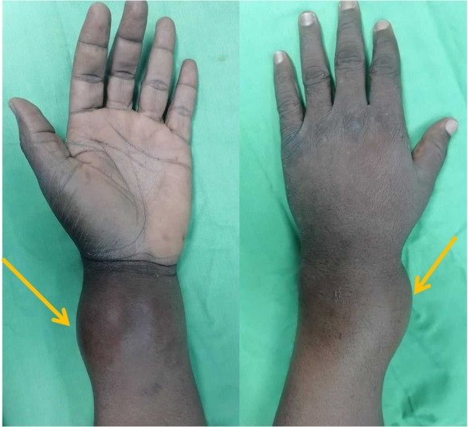

Fig. 1. Clinical aspect (Left Arm)

Radiological exploration showed a lytic metaphyso-epiphyseal image of the distal radius with rupture of the external cortex and site of several osteocondensations, highly suggestive of a malignant tumor
(Fig. 2).

MRI exploration concluded that there was an expansive metaphyso-epiphyseal process distal to the radius with articular and peri-articular extension (Fig.3).

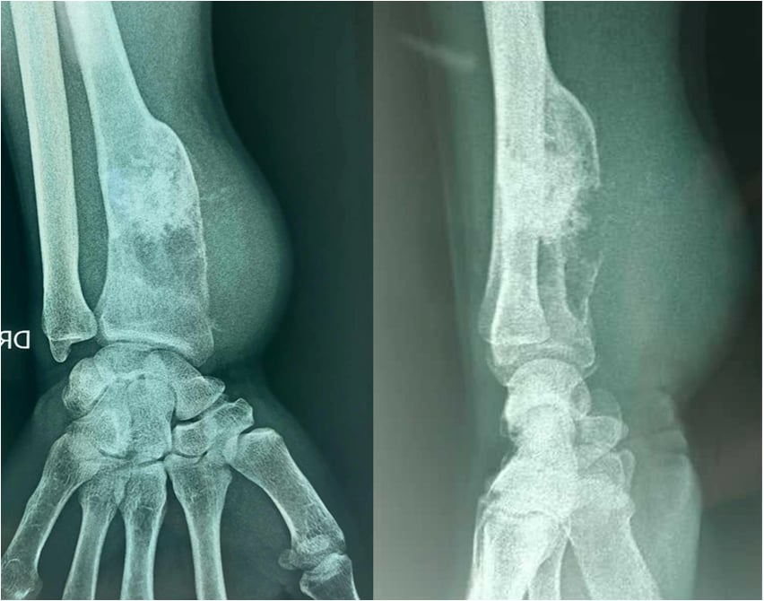

Fig. 2. Radiological aspect (Left Arm)

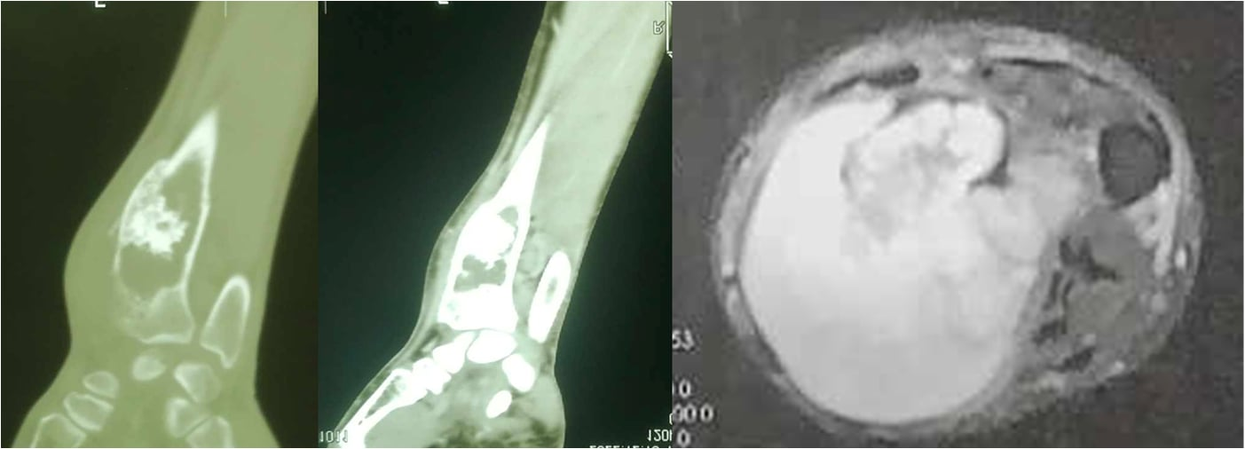
Fig. 3. MRI appearance (Left Arm)

An incisional biopsy was performed, confirming the diagnosis of dedifferentiated chondrosarcoma (Fig.4). The patient underwent a marginal resection of the distal radius (Fig.5, 6) and reconstruction with an inert ipsilateral fibula graft, fixed at the level of the carpal bones (Fig.7).the evolution one year after surgery shows bone consolidation without tumor currency (Fig.8).

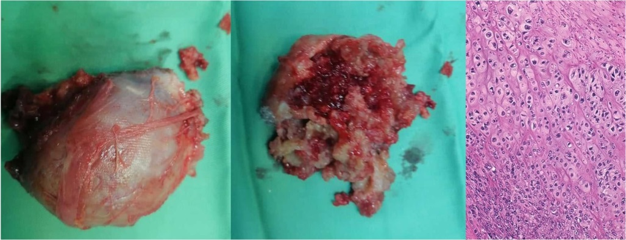
Fig. 4. Biopsy and histological aspect.
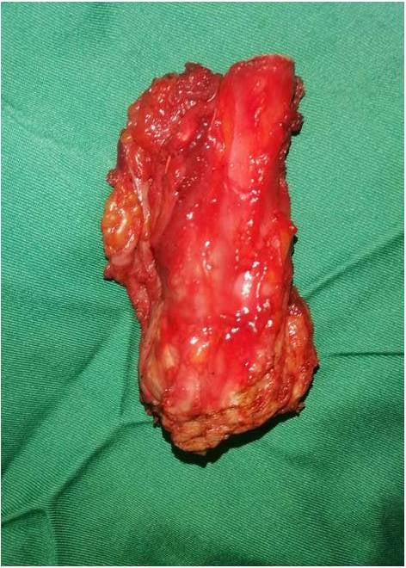
Fig. 5. Resection piece
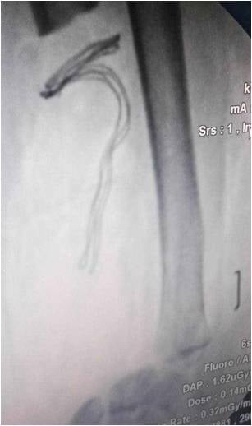
Fig. 6. Radiological appearance after tumor resection (Left Arm)

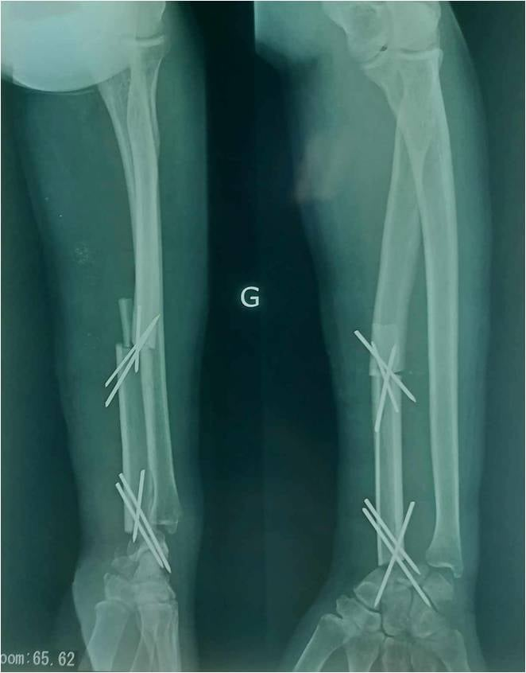
Fig. 7. Reconstruction of the left radius by inert fibula graft
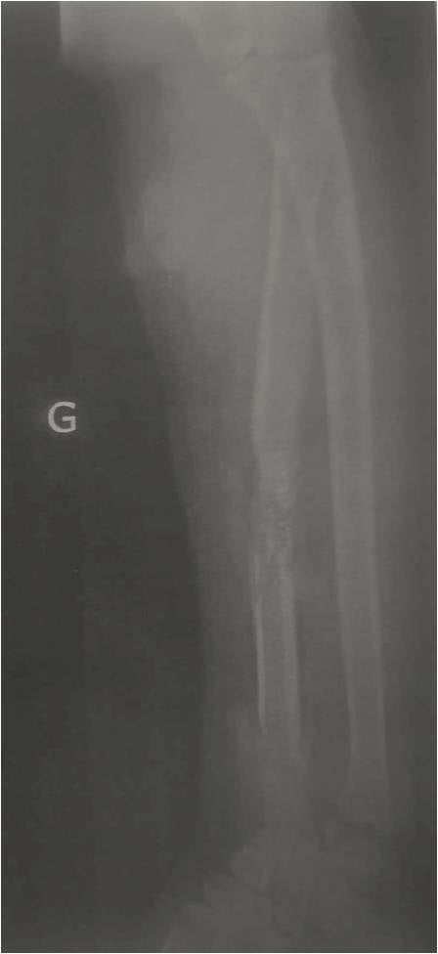
Fig. 8. Radiological result (Left Arm)

- DISCUSSION:

Chondrosarcoma is the most common primary malignant bone tumor after osteosarcoma. It represents 11% to 22% of primary malignant bone tumors according to Unni (1). Chondrosarcomas mainly affect adults and older adults, with men being most commonly affected than women. Its peak age range is 40 to 70 years. The pelvis and proximal femur are the most common sites of Chondrosarcomas (2). Kosher found one case of chondrosarcoma of the distal radius out of 24 cases of tumor of distal radius (3). Maruthainar described one case of chondrosarcoma of the distal radius out of 13 cases of tumor of distal radius (4).
The clinical presentation of chondrosarcomas is often discreet with an insidious onset, reflecting the very slow growth of these tumors. The average duration of progression of symptoms is 1 to 2 years; it is shorter for limb locations than for pelvic locations. The revealing symptoms are, more often, pain or the discovery of swelling by the patient. Pathological fractures are rare (3%). They are widly tumors of high histological grade (5).
The biological assessment is usually normal, without inflammatory syndrome. Marcove and Francis demonstrated an intolerance to carbohydrates during induced hyperglycemia in 80% of patients with chondrosarcoma (6).
The age at which these tumors appear is mainly between 40 and 70 years old. According to Dahlin and Campanacci, only 4% of patients are under 20 years old and 40% to 47% are over 40 years old (1). The discovery of a chondrosarcoma before the age of 20 should raise the diagnosis of chondroblastic osteosarcoma (2). Approximately 10% of chondrosarcomas arise from pre-existing bone lesions (1).
The diagnosis is often strongly suspected on standard films. The lesion is usually metaphyseal and extends towards the diaphysis more than towards the epiphysis. There are extensive and well defined osteolytic areas. The cortex is usually eroded after the endosteal resorption. This thinned cortex can be ruptured, and a periosteal reaction is not exceptional. A blown appearance of the cortex can also be visualized. In high-grade tumors, tumor boundaries are less clear, with more extensive cortical lysis. In more than two-thirds of cases, calcifications are visible in the tumor matrix like our clinical case. Flaky, “popcorn” calcifications are the most typical (7).
Computed Tomography allows a more detailed assessment of resorption and possible rupture of the cortex. Intramatricial calcifications are also perfectly visualized with this exam.
Magnetic Resonance Imagery is interesting in radiolucent tumors and in the assessment of loco-regional extension. These tumors are hyper intense on T2 and intermediate signal on T1; when they are well differentiated, it is possible to visualize the cartilaginous lobules (8).
Histology: Chondrosarcomas are made up of tumor lobules of irregular size and shape, delimited by connective septa, and not by osteomedullary tissue, as is the case in enchondromas. Fragments of residual spongy bone, encompassed by the proliferation, sometimes persist within these lobules, testifying to the permeation of the osteomedullary tissue by the tumor. This permeation of the spongy bone should not be confused with the foci of intra-tumoral reactive osteogenesis
Within the lobules, cellularity is often significant, predominating at the periphery. Tumor chondroblasts have a large nucleus with densified chromatin. Binucleation appearances are common. Mitotic activity can sometimes be individualized, mainly in high-grade tumors. The tumor matrix can be chondroid or myxoid. The existence of myxoid zones within a cartilaginous tumor argues for malignancy. Areas of necrotic changes may be present, but are also observed in chondromas. These histological and cytological characteristics are used to establish the grade of chondrosarcomas as proposed by O’Neal and Ackerman (9). Grade I chondrosarcomas (low malignancy) are the most difficult to differentiate from chondromas. Their cellularity is greater than that of a chondroma. The cartilaginous cells are slightly atypical with a densified nucleus. The importance of tumor cellularity and cytonuclear atypia increases in grades II (intermediate malignancy) and III (high malignancy).
The treatment is always surgical, after proceeding to a biopsy. Local control of the tumor depends on the quality of the resection; when the surgery is extra-tumoral and largest, the risk of recurrence is divided by three. According to Lee et al., the risk of local recurrence is higher for high-grade tumors (15% versus 30%). Still according to Lee et al., the occurrence of a local recurrence is a negative event with regard to the occurrence of metastases (49% of metastases in the event of local recurrence versus 16% in the absence of local recurrence) and for survival (10).
For the localization at the level of the distal radius the problem of bone reconstruction arises. Several processes have been described: the graft of the vascularized fibula, the inert graft of the fibula and the prosthetic replacement (3, 4, 11). We found in literature that excision and reconstruction with fibula graft may be used in cases where there is a large tumour mass with extension into the soft tissue (12). However, in low grade chondrosarcomas, intralesional curettage and cementation seem to be a feasible procedure to reduce morbidity with low complication and recurrence rates (5.49%) (13).

- CONCLUSION:

Chondrosarcoma of the distal radius is a very rare entity. The treatment is surgical on which depends the prognosis. The evolution of plastic surgery has allowed us the possibility of reconstruction of the distal radius after a wide resection of the tumor.

DISCLAIMER (ARTIFICIAL INTELLIGENCE)

Author(s) hereby declare that NO generative AI technologies such as Large Language Models (ChatGPT, COPILOT, etc) and text-to-image generators have been used during writing or editing of manuscripts.

CONSENT

As per international standards or university standards, patient(s) written consent has been collected and preserved by the author(s).

ETHICAL APPROVAL

As per international standards or university standards written ethical approval has been collected and preserved by the author(s).

COMPETING INTERESTS

Authors have declared that no competing interests exist.

REFERENCES

- Dahlin DC. Bone tumors:General aspectand data on 6221 cases. Ed.3 . Springfield, Illinois, Charles C Thomas. 1978:190-225.
- Tlemsani, C., Larousserie, F., De Percin, S., Audard, V., Hadjadj, D., Chen, J., et al. (2023). Biology and management of high-grade chondrosarcoma: an update on targets and treatment options. Int. J. Mol. Sci. 24 (2), 1361. doi:10.3390/ijms24021361
- Kocher, Mininder S. M.D.; Gebhardt, Mark C. M.D.; Mankin, Henry J. M.D., Boston, Massachusetts. Reconstruction of the Distal Aspect of the Radius with Use of an Osteoarticular Allograft after Excision of a Skeletal Tumor. The Journal of Bone & Joint Surgery 80(3):p 407-19, March 1998.
- N Maruthainar , C Zambakidis, G Harper, D Calder, S R Cannon, T W R Briggs. Functional outcome following excision of tumours of the distal radius and reconstruction by autologous non-vascularized osteoarticular fibula grafting. 2002;27(2):171-4.
- Evans HL, Ayala AG, Romsdhal MM. Prognostic factors in chondrosarcoma of bone. Clinicopathologic analysis with emphasis on histologic grading. Cancer 1977;40:818-831.
- Marcove RC, Francis KC. Chondrosarcoma and alterated cabohydrate metabolism. N Engl J Med 1963;268:1399-13400.
- Murphey MD, Flemming DJ, Boyea RS. Enchondroma versus chondrosarcoma in the appendicular skeleton :differentiating features. Archives of the AFIP 1998:1213-1236.
- Varma DG, Ayala AG, Carrasco CH, Guo SQ, Kumar R, Edeiken J. Chondrosarcoma: MR imaging with patologic correlation. Radiographics 1992;12:687-704.
- O'Neal LW, Ackerman LV. Chondrosarcoma of bone. Cancer 1952;5:551-577.
- Lee FY, Mankin HJ, Fondren G, Gebhardt MC, Springfield DS, Rosenberg AE, et al. Chondrosarcoma of Bone. An assessment of outcome. J Bone Joint Surg (Am) 1999;81-A:326-338.
- Grzegorz Guzik. The Use of a Custom-made Prosthesis in the Treatment of Chondrosarcoma of Distal Radius. Ortop Traumatol Rehabil. 2016 Jan-Feb;18(1):65-72.
- Badaruddin Sahito , Hussain Haider Shah, Syeda Alishah Zehra, Javeria Saquib, Farea Ahmed , Muhammad Sheheryar Hussain, Tirth Dave. Distal radius chondrosarcoma in a 35-year-old female patient: A case report. 2023 Oct 23;11(10):e8069.
- Görgün, B.; Özşahin, M.K.; Tok, O.; Davulcu, C.D.; Karaismailoğlu, B.; Hız, M. Intralesional Curettage and Cementation of Low-Grade Chondrosarcomas of the Appendicular Skeleton: Long-Term Results from a Single Center. Acta Orthop. Traumatol. Turc. 2022, 56, 402–407

.

