Physicochemical and chemometric characterization of gum arabic from A. senegal and A. seyal in the Chari-Baguirmi region, Chad

Abstract
Gum arabic is a natural hydrocolloid mainly obtained from Acacia senegal and Acacia seyal, widely used in the food, pharmaceutical and cosmetic industries for its functional properties. This study aims to characterize and discriminate gums from these two species collected in the Chari-Baguirmi province (Chad), by combining standardized physicochemical analyses following FAO (2018) specifications and AOAC (2010) official methods with multivariate chemometric approaches (Principal Component Analysis, PCA; Partial Least Squares – Discriminant Analysis, PLS-DA; Hierarchical Cluster Analysis, HCA). Moisture, ash, insoluble matter, pH and optical rotation were measured on 24 samples comprising A. senegal (n = 12) and A. seyal (n = 12). A. seyal shows a higher mean moisture content (12.43 ± 0.54 %), whereas A. senegal exhibits higher ash content (1.38 ± 0.19 %) and optical rotation (2.20 ± 1.65°). Welch’s t-tests (P < 0.05) confirmed that differences in moisture and ash between species are statistically significant. PCA explains 78.09 % of the total variance on the first two components and reveals a clear separation between the species. The PLS-DA, statistically validated by cross-validation, confirms this discrimination and identifies moisture and ash as the most discriminant variables, while HCA reveals two homogeneous, non-overlapping groups. This work therefore fills an important gap by providing the first combined physicochemical and chemometric characterization of Chari-Baguirmi gum arabic from both species in direct relation to international quality standards.
Keywords: gum arabic; A. senegal; A. seyal; Chari-Baguirmi; physicochemical properties; chemometrics; PCA; PLS-DA.
1. Introduction
Gum arabic is a natural exudate obtained mainly from the trunks of A. senegal and A seyal. A complex biopolymer composed of branched heteropolysaccharides associated with protein and mineral fractions, it is widely used because of its emulsifying, stabilizing and encapsulating properties [1,2]. This resource represents a source of seasonal income for many rural communities, but its economic potential remains underexploited.
Its physicochemical characteristics, such as solubility, viscosity, pH, ash content, moisture and optical rotation, directly determine its industrial performance and commercial value.
The variability of these parameters depends on the botanical species, environmental factors and post-harvest practices [3,4]. In Chad, the Chari-Baguirmi province is a major production area, but the differentiation and valorization of local gums remain limited due to the lack of structured scientific data [5].
Multivariate chemometric approaches (Principal Component Analysis, PCA; Partial Least Squares – Discriminant Analysis, PLS-DA; Hierarchical Cluster Analysis, HCA) are particularly suited to the classification of gums according to their botanical origin [6,7]. Their combination with standardized physicochemical measurements makes it possible to define reliable analytical signatures.
The present study therefore aims to compare gums from A. senegal and A. seyal collected in this region, through an approach combining standardized physicochemical measurements and chemometric analyses (PCA, PLS-DA, HCA), in order to position these characteristics with respect to international FAO standards [8].
2. Materials and methods
2.1. Study area and sample collection
Sampling was carried out at three sites (Massenya, Bousso and Dourbali) in the Chari-Baguirmi province (Chad), a semi-arid region characterized by a dry season (November–May) and a rainy season (June–October). Natural exudates were collected manually in mid-March 2025 from A. senegal and A. seyal trees, with four trees of A. senegal and 4 trees of A. seyal sampled per site, giving a total of 24 gum samples (12 for A. senegal, 12 for A. seyal). After collection, exudates were cleaned to remove impurities (bark fragments, sand) and packed in airtight bags. Botanical identification was performed using distinctive morphological criteria (bark, thorns, pod shape) on trees that had previously been identified at the species level.
2.2. Sample preparation
In the laboratory, the gums were a laboratory roller mills (MMS-401A) equipped with integrated temperature control via electric heating operating at 3000 rpm. During grinding the temperature was monitored and maintained below 30 °C to avoid thermal degradation. The resulting powder was sieved to obtain a particle size of less than 250 µm. The fine powders were then stored in sterile, hermetically sealed polyethylene bottles at room temperature (approximately 22–25 °C) and protected from moisture. These precautions helped to preserve the chemical and physical integrity of the samples prior to analytical measurements.
2.3. Physicochemical methods
Physicochemical analyses were carried out in accordance with FAO [8] and AOAC [9] standards. These analyses made it possible to obtain reliable data used in the comparative characterization of gums from A. senegal and A seyal. For each parameter, measurements were performed in triplicates per sample, using a test portion of approximately 5 g of gum powder, and results are reported as mean ± standard deviation.
Moisture content was determined by drying at 105 °C to constant mass. Approximately 5 g of gum powder were weighed into pre-dried porcelain dishes, dried at 105 °C for 5 h, cooled in a desiccator to room temperature and reweighed . This method allowed precise quantification of the water fraction of each sample.
Ash content was measured after complete incineration of the organic matter in a muffle furnace at 550 °C for 8 h. Approximately 5 g of sample were weighed into porcelain crucibles previously dried and tared. After incineration, crucibles were cooled in a desiccator to room temperature before final weighing to determine the ash content. This procedure provides the mineral residue representing the total inorganic fraction of the gum.
Insoluble matter was determined after treatment in a 3 N HCl solution. For each determination, 5 g of gum were dispersed in 2 mL of 3 N HCl and heated at 103 °C for 60 min under continuous stirring. The suspension was then filtered through Whatman 934 AH: complies with the 2540D method - glass fibre 1.5 µm, thoroughly washed with distilled water, dried at 103 °C to constant mass and weighed. This step ends with weighing of the dry residue, indicating the proportion of material insoluble under controlled acidic conditions.
pH was measured in an aqueous solution at 25 % (w/w). The value obtained reflects the natural acidity and stability of gum arabic solutions.
Finally, optical rotation was measured with a digital polarimeter on a 1 % (w/w) solution at 30.6 °C. This measurement reflects the global optical activity related to the stereochemical configuration of carbohydrate constituents.

2.4. Chemometric methods
Chemometric analyses were performed using Python [10] (v3.11) with the libraries scikit-learn [11] (PCA, PLS-DA), SciPy [12] (matrix calculations), NumPy [13] (preprocessing) and Matplotlib [14]/Seaborn [15] (visualizations). The analyses were reproduced in R [16] (v4.3) with FactoMineR [17] (PCA), chemometrics [18] (PLS-DA) and factoextra [19] (visualization).
Chemometric analyses were used to characterize the global structure of the physicochemical data and to identify the most relevant variables for differentiating gums from A. senegal and A. seyal. The methods applied are based on well-established principles of multivariate analysis [6,7]. Before chemometric analysis, all physicochemical variables were mean centered and scaled to unit variance. The number of components retained in PCA was chosen based on the screen plot and cumulative explained variance and the number of latent variables in PLS-DA were chosen by k-fold cross-validation based on the minimization of prediction error. The robustness of the supervised PLS-DA model was assessed using cross-validated R² and Q² statistics, as well as permutation tests and inspection of residuals and score plots, in order to detect potential overfitting.
Principal component analysis (PCA) aims to reduce the dimensionality of the data while retaining most of the initial variance. It is based on the transformation of the original variables into a set of orthogonal components maximizing total variance [7]. This method allows visualization of the multivariate structure and reveals natural groupings between samples.
Partial least-squares discriminant analysis (PLS-DA) aims to model supervised separation between predefined groups. Its principle is to project the data into a latent space optimized to maximize covariance between explanatory variables and the class variable, thus enabling identification of discriminant parameters [6].
K-means clustering is an unsupervised method whose role is to group samples into homogeneous classes by minimizing the distance between each individual and its cluster center [20]. This method reveals the natural structuring of the data and evaluates the coherence of the groupings obtained.
Hierarchical cluster analysis (HCA) is used to visually represent similarity relationships between samples in a dendrogram. Its principle is based on the progressive agglomeration of individuals according to a distance (often Euclidean) and a linkage criterion such as Ward's method, which minimizes within-cluster variance [21]. This method provides a hierarchical structure consistent with the observed variability between gums.
2.5. Statistical analysis
Differences between the two species for each physicochemical parameter were evaluated using Welch’s t-test for independent samples, which does not assume equality of variances. Tests were two-sided and a P-value < 0.05 was considered statistically significant. For each parameter, results are expressed as mean ± standard deviation for n = 12 samples per species.
3. Results
3.1. Physicochemical characteristics
The results of physicochemical analyses of gums from A. senegal and A. seyal are presented in Table 1.
Table 1. Mean physicochemical parameters of gum arabic from the Chari-Baguirmi region.
Parameter | Mean A. senegal ± SD | Mean A. seyal ± SD | Main observations
Moisture content (%) | 6,11 ± 0,28 | 12,43 ± 0,54 | A. seyal more humid, related to a more hydrophilic structure.
Ash content (%) | 1,38 ± 0,19 | 0,04 ± 0,03 | A. senegal richer in minerals, confirming a more stable composition.
Insoluble matter (%) | 4,74 ± 0,32 | 4,04 ± 0,40 | Slight difference related to purity and solubility of polysaccharides.
pH | 4,91 ± 0,02 | 5,00 ± 0,05 | Small variation; both slightly acidic.
Optical rotation (°) | 2,20 ± 1,65 | 1,53 ± 0,12 | Indicates differences in polysaccharide configuration.

Physicochemical analyses revealed clear differences between gums from A. senegal and A. seyal (Table 1, Figure 1). Moisture content was significantly higher in A. seyal (12.43 ± 0.54 %) than in A. senegal (6.11 ± 0.28 %; Welch’s t-test, P < .001), whereas ash content was much higher in A. senegal (1.38 ± 0.19 %) than in A. seyal (0.04 ± 0.03 %; P < .001). Insoluble matter was slightly but significantly higher in A. senegal (4.74 ± 0.32 %) than in A. seyal (4.04 ± 0.40 %; P= .005), and pH also differed significantly between species although by a small magnitude (4.91 ± 0.06 vs 5.0 ±0.05; P = .010). In contrast, the difference in optical rotation (2.20 ± 1.65° for A. senegal vs 1.53 ± 0.12° for A. seyal) was not statistically significant (P≈ .19).
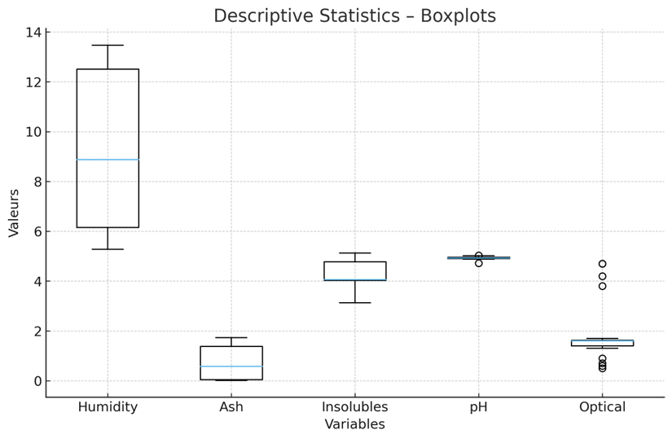
Figure 1. Descriptive statistics of the physicochemical parameters of gum arabic. Boxplots representing the distribution of moisture, ash, insoluble matter, pH and optical rotation.
Insoluble matter and pH remain relatively stable between the species, while the higher optical rotation observed in A. senegal suggests a higher proportion of chiral monomers [22].
3.2. Chemometric characteristics
Principal component analysis reveals a clear separation between the two species (Figure 2). The first two components explain 78.09 % of the total variance (PC1 = 55.17 %; PC2 = 22.92 %). The correlation circle (Figure 3) shows that PC1 mainly opposes moisture (positive correlation) and ash (negative correlation), while PC2 reflects mainly the variability of pH and optical rotation [7].
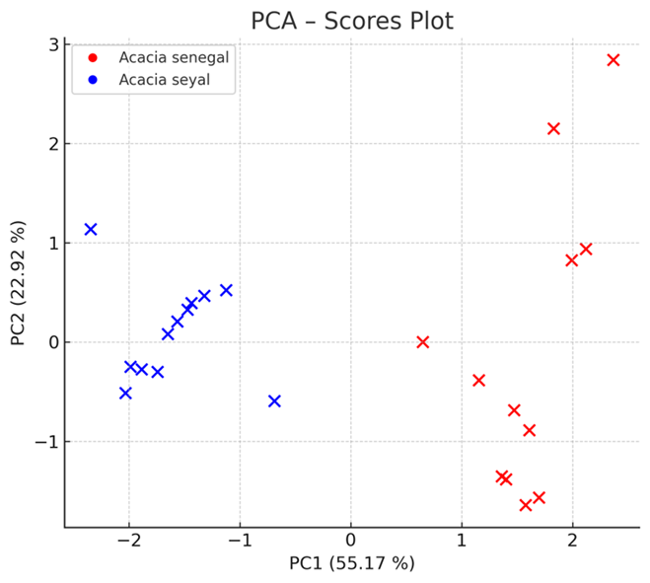

Figure 2. Principal component analysis (PCA) representation of individuals (scores). Projection of samples in the PC1-PC2 factorial plane.

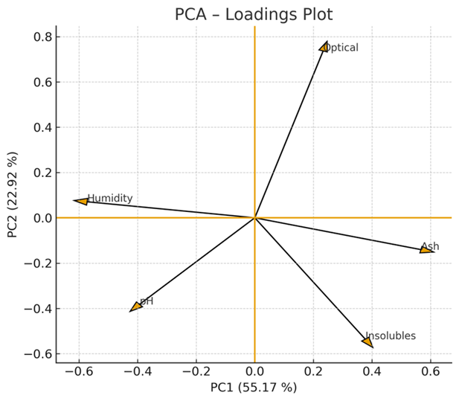
Figure 3. Principal component analysis (PCA) correlation circle (loadings). Contribution of variables to the formation of the main axes.

Partial least-squares discriminant analysis confirms these results. PLS-DA scores (Figure 4) show a clear separation between the two species, with no overlap. VIP scores (Figure 5) identify moisture (VIP = 1.36) and ash (VIP = 1.34) as the most discriminant variables [6].
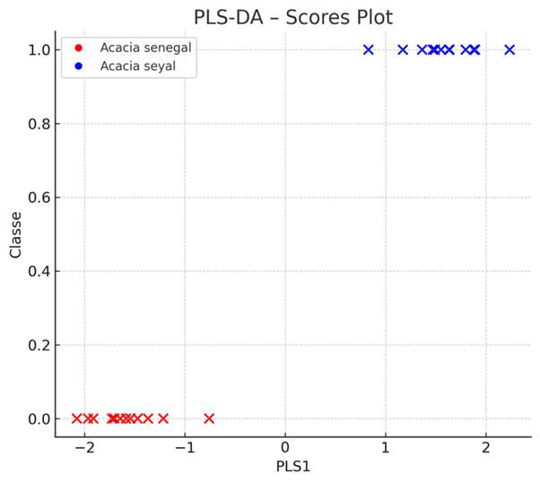

Figure 4. PLS-DA supervised projection of individuals (scores on PLS1). Clear separation between the two species.
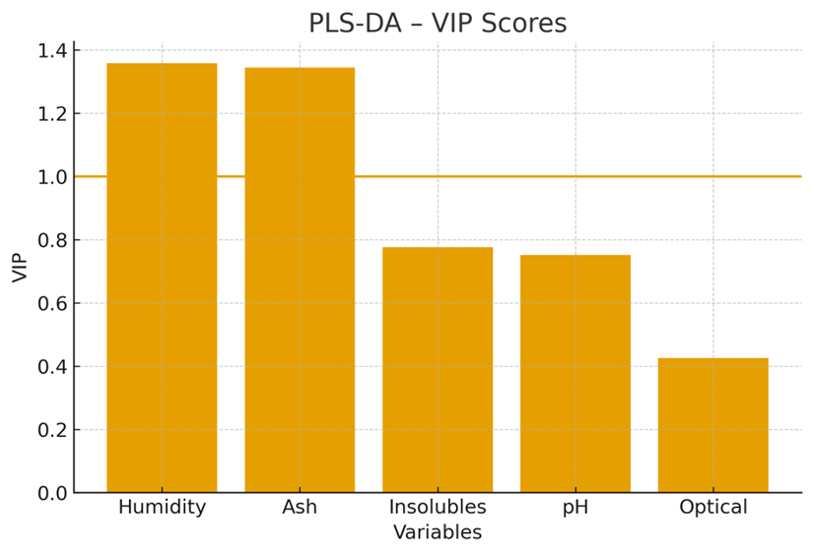

Figure 5. PLS-DA VIP scores. Importance of variables in supervised discrimination.

Unsupervised classification confirms the natural structuring of the data. K-means clustering (Figure 6) perfectly separates the two species, while the dendrogram resulting from HCA (Figure 7) shows two distinct groups corresponding precisely to A. senegal and A. seyal.
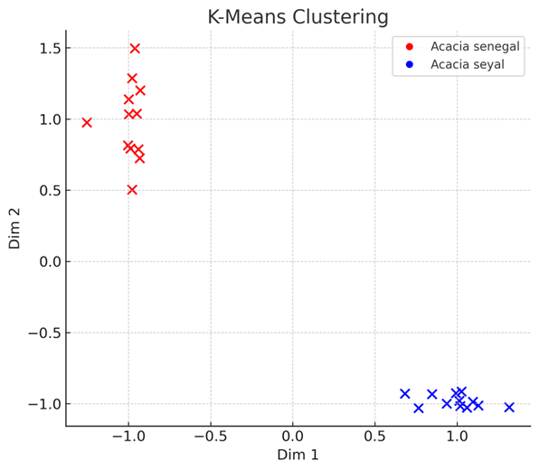
Figure 6. K-means clustering (k = 2). Representation of samples in a normalized space.

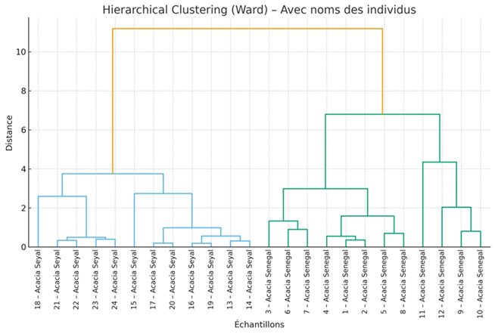
Figure 7. Hierarchical cluster analysis (HCA) dendrogram. Hierarchical clustering of samples.

Finally, the joint PLS1-PLS2 representation (Figure 8) confirms the robustness of supervised discrimination.
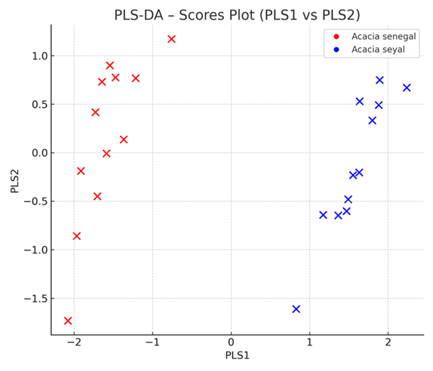
Figure 8. PLS-DA joint representation PLS1 vs PLS2. Visualization of interspecific discrimination

4. Discussion
The results show a clear and consistent differentiation between A. senegal and A. seyal, supported jointly by univariate statistics and multivariate chemometric analyses. Welch’s t-tests for independent samples highlight highly significant interspecific differences in moisture and ash contents, as well as significant but more moderate differences in insoluble matter and pH, whereas optical rotation does not differ significantly between the two species. Together, these findings indicate that water content and mineral fraction are the main univariate drivers of species discrimination, with additional but smaller contributions from matrix purity and acidity. confirming the observations of Daugan et al. [1].
The separation observed in PCA (Figure 2) and in the associated loadings (Figure 3) shows that the dominant variability is explained by the moisture–ash gradient, confirming that these two parameters determine the multivariate structure of the data. PLS-DA (Figures 4 and 8) reinforces this interpretation through a perfectly coherent supervised separation and VIP scores (Figure 5) that place moisture and ash as key variables [6]. This pattern is fully consistent with the Welch t-test results, which identify moisture and ash as the most strongly discriminant physicochemical variables between the two species.
Unsupervised methods provide additional validation of this structural stability. K-means clustering (Figure 6) reproduces a classification identical to that obtained from supervised analyses, demonstrating that botanical separation is embedded directly in the data structure. HCA (Figure 7) also reveals two distinct groups without overlap, confirming the robustness of the approach, in line with the conclusions of Gashua et al. [23] regarding the limited regional variability of Sahelian gums. Although moisture and ash dominate the multivariate structure, the significant yet modest differences observed for insoluble matter and pH, together with the non-significant variation in optical rotation, point to more subtle contributions of matrix purity and acidity to species differentiation.
Overall, Figures 1–8 show that the physicochemical signature of gum arabic from Chari-Baguirmi is stable, reproducible and sufficiently structured to serve as a reliable tool for botanical differentiation. The results demonstrate that simple measurements, combined with appropriate chemometric tools, make it possible to efficiently authenticate the botanical origin of gum arabic intended for international markets.
5. Conclusion
This study provides an in-depth characterization of gum arabic from A. senegal and A. seyal collected in the Chari-Baguirmi province. Physicochemical analyses revealed marked differences between the two species, in particular a significantly higher moisture content in A. seyal and a much higher ash content in A. senegal. These parameters, together with the observed variations in optical rotation, are key indicators of the composition and molecular structure specific to each species. The explicit reporting of p-values and confidence inferences based on Welch’s t-tests strengthens the statistical support for these conclusions.
The chemometric approaches applied, including PCA, PLS-DA, K-means clustering and HCA, confirmed the robustness of these differences. Multivariate projections show a systematic separation between the two species, while VIP scores demonstrate that moisture and ash are sufficient to reliably differentiate the gums. This methodological convergence highlights the internal coherence of the dataset and validates the use of basic physicochemical measurements combined with multivariate statistical tools to authenticate the botanical origin of gum arabic.
Overall, the results reveal a stable and distinct physicochemical signature for each species, reinforcing the possibilities of traceability and certification within production chains. These findings are particularly relevant for the agro-industrial sector, where botanical identification is a central element of quality and commercial valorization. They also pave the way for the development of rapid quality control protocols based on a small number of discriminant variables. Future work should also explore integration with other chemometric methods and rapid in-field screening tools (for example, portable spectroscopic devices) to complement the laboratory-based workflow used here.
Disclaimer (Artificial intelligence)
The author(s) hereby declare that generative AI technologies were used during the writing and/or editing of this manuscript. Specifically, ChatGPT (model: GPT-5.1 Thinking, provider: OpenAI, accessed via the ChatGPT platform at https://chatgpt.com) was used.
ChatGPT was used exclusively for: (i) language correction, (ii) rephrasing and improvement of clarity, (iii) assistance in drafting and refining the Discussion section, (iv) formatting and adaptation of the text to scientific style, and (v) support in organizing and checking references.
No part of the scientific content, data analysis, or interpretation of results was delegated to the AI. All outputs generated by ChatGPT were critically reviewed, verified, and, where necessary, revised by the author(s), who take full responsibility for the final content of the manuscript.
Details of the AI usage are given below:
- Language correction / reformulation
- Assistance with the discussion
- Formatting according to scientific style
- Organization and verification of references
References
[1] Dauqan, E., & Abdullah, A. (2013). Utilization of Gum Arabic for Industries and Human Health. American Journal of Applied Sciences, 10(10), 1270–1279. https://doi.org/10.3844/ajassp.2013.1270.1279
[2] Mohamed, S. A., Elsherbini, A. M., Alrefaey, H. R., Adelrahman, K., Moustafa, A., Egodawaththa, N. M., Crawford, K. E., Nesnas, N., & Sabra, S. A. (2025). Gum Arabic: A commodity with versatile formulations and applications. Nanomaterials, 15(4), 290. https://doi.org/10.3390/nano15040290.
[3] Inegbedion, F., Okojie, V. U., & Egharevba, F. (2020). Physicochemical Properties of Gum Arabic. Organic Polymer Material Research, 2(2), 13–15. https://doi.org/10.30564/opmr.v2i2.2592
[4] Awadasseid, A., Adam, I. M., Jamal, M., & Teia, F. K. F. (2019). Physicochemical properties of Kakamut gum (Acacia polyacantha) and Hashab gum (Acacia senegal): A comparative analysis. International Journal of Applied Agricultural Sciences, 5(6), 138–143. https://doi.org/10.11648/j.ijaas.20190506.12.
[5] Gaiwa, D., Ibrahima, A., Tchobsala, Noiha Noumi, V., & Man-Na Djangrang, M. (2019). Comparison of carbon stocks in Acacia senegal and Acacia seyal stands in Chari-Baguirmi region (Chad). International Journal of Advanced Research in Biological Sciences, 6(2), 195–203. https://doi.org/10.22192/ijarbs.2019.06.02.021
[6] Wold, S., Sjöström, M., & Eriksson, L. (2001). PLS-regression: a basic tool of chemometrics. Chemometrics and Intelligent Laboratory Systems, 58(2), 109-130. https://doi.org/10.1016/S0169-7439(01)00155-1
[7] Bro, R., & Smilde, A. K. (2014). Principal component analysis. Analytical Methods, 6(9), 2812-2831. https://doi.org/10.1039/C3AY41907J
[8] FAO and WHO. 2018. Compendium of Food Additive Specifications. Joint FAO/WHO Expert Committee on Food Additives (JECFA), 86th Meeting June 2018. FAO JECFA Monographs 22. Rome. 167 pp. Licence: CC BY-NC-SA 3.0 IGO.
[9] AOAC International. (2010). Official methods of analysis. Association of Official Analytical Chemists. https://www.aoac.org/scientific-solutions/official-methods-of-analysis/
[10] Python Software Foundation. (2022). Python (version 3.11). https://www.python.org/
[11] Pedregosa, F., Varoquaux, G., Gramfort, A., Michel, V., Thirion, B., Grisel, O., Blondel, M., Prettenhofer, P., Weiss, R., Dubourg, V., Vanderplas, J., Passos, A., Cournapeau, D., Brucher, M., Perrot, M., & Duchesnay, E. (2011). Scikit-learn: Machine Learning in Python. Journal of Machine Learning Research, 12, 2825-2830. https://doi.org/10.5555/1953048.2078195
[12] Virtanen, P., Gommers, R., Oliphant, T. E., Haberland, M., Reddy, T., Cournapeau, D., Burovski, E., Peterson, P., Weckesser, W., Bright, J., van der Walt, S. J., Brett, M., Wilson, J., Millman, K. J., Mayorov, N., Nelson, A. R. J., Jones, E., Kern, R., Larson, E., ... Vázquez-Baeza, Y. (2020). SciPy 1.0: Fundamental algorithms for scientific computing in Python. *Nature Methods*, *17*(3), 261–272. https://doi.org/10.1038/s41592-019-0686-2
[13] Harris, C. R., Millman, K. J., van der Walt, S. J., Gommers, R., Virtanen, P., Cournapeau, D., Wieser, E., Taylor, J., Berg, S., Smith, N. J., Kern, R., Picus, M., Hoyer, S., van Kerkwijk, M. H., Brett, M., Haldane, A., Fernández Del Río, J., Wiebe, M., Peterson, P., ... Oliphant, T. E. (2020). Array programming with NumPy. Nature, 585(7825), 357–362. https://doi.org/10.1038/s41586-020-2649-2
[14] Hunter, J. D. (2007). Matplotlib: A 2D Graphics Environment. Computing in Science & Engineering, 9(3), 90-95. https://doi.org/10.1109/MCSE.2007.55
[15] Waskom, M. L. (2021). seaborn: statistical data visualization. Journal of Open Source Software. https://doi.org/10.21105/joss.03021
[16] R Core Team. (2023). R: A language and environment for statistical computing. R Foundation for Statistical Computing. https://www.r-project.org/
[17] Lê, S., Josse, J., & Husson, F. (2008). FactoMineR: An R Package for Multivariate Analysis. Journal of Statistical Software, 25(1), 1–18. https://doi.org/10.18637/jss.v025.i01
[18] K. Varmuza and P. Filzmoser: Introduction to Multivariate Statistical Analysis in Chemometrics. CRC Press, Boca Raton, FL, 2009. https://cran.r-project.org/web/packages/chemometrics/chemometrics.pdf
[19] Kassambara, A., & Mundt, F. (2020). factoextra: Extract and Visualize the Results of Multivariate Data Analyses. R package version 1.0.7. https://doi.org/10.32614/CRAN.package.factoextra
[20] MacQueen, J. B. (1967). Some methods for classification and analysis of multivariate observations. In L. M. Le Cam & J. Neyman (Eds.), Proceedings of the Fifth Berkeley Symposium on Mathematical Statistics and Probability, Volume 1 (pp. 281-297). University of California Press. https://projecteuclid.org/euclid.bsmsp/1200512992
[21] Ward, J. H. (1963). Hierarchical grouping to optimize an objective function. Journal of the American Statistical Association, 58(301), 236-244. https://doi.org/10.1080/01621459.1963.10500845
[22] Ali, N. E. S., Awad Elkarim, A. M., Fageer, A. S. M., & Nour, A. A. M. (2012). Physicochemical Characteristics of Some Acacia Gums. International Journal of Agricultural Research, 7(8), 406–413. DOI: 10.3923/ijar.2012.406.413
[23] Gashua, I.B., Williams, P.A., Yadav, M.P., Baldwin, T.C. (2015). Characterisation and molecular association of Nigerian and Sudanese Acacia gum exudates. Food Hydrocolloids, 51, 405–413. https://doi.org/10.1016/j.foodhyd.2015.05.037.

