Combine Remote Sensing and Geochemical Techniques for Mineral Exploration in the Soil of Igoba and Ilado Areas, Southwestern Nigeria.

Abstract
Mineral exploration within Nigeria’s Precambrian Basement Complex has been hindered by poor rock exposure, deep weathering, and complex structural patterns that obscure potential mineralized zones. This study integrates remote sensing, field mapping, and soil geochemistry to delineate geochemical anomalies and assess mineralization potential within the southwestern Basement Complex. Sentinel-2A imagery (Scene ID: S2A_MSILC_2023216T095101_N0509_R079_T31NG1_2023216T33019) was processed using ArcMap 10.5, Envi 5.4, Geomatica 2018, and Rockwork 17 for lithological and structural interpretation. Systematic soil sampling at 50-m intervals targeted the B-horizon (0.05–0.3 m depth), yielding fifteen composite samples analyzed at ACME Laboratories, Vancouver, using Inductively Coupled Plasma–Mass Spectrometry (ICP–MS) after Lithium Metaborate fusion. The analytical results revealed significant elemental enrichment across the study area: Zinc (Zn) recorded the highest concentration (136.563 ppm), followed by Thorium (Th) (17.0838 ppm) and Lead (Pb) (63.104 ppm). Arsenic (As) attained 3.116 ppm and spatially coincided with Zn anomalies around Irese–Olufoarm A.K., suggesting hydrothermal sulfide mineralization. Correlation analysis indicated strong positive relationships among Zn–Cu (r = 0.841**), Zn–Pb (r = 0.803**), Cu–Pb (r = 0.671**), and Co–Ni (r = 0.896**), implying common geochemical sources and hydrothermal co-precipitation of elements. Factor analysis defined three geochemical associations: (1) Base-metal factor (Zn, Pb, Cu, As), (2) Ferromagnesian factor (Ni, Co, Cr), and (3) Radioactive-element factor (Th, Fe). Collectively, the findings delineate the north-central Irese–Olufoarm A.K. zone as highly prospective for Zn–Pb–As sulfide mineralization, with elevated Th values reflecting felsic-related radioactive enrichment.
Keywords: Igoba, Ilado, Soils, Sentinel-2A Imagery, Geochemistry, Sulphide Mineralization

1.0 Introduction
Mineral deposits form through various geological processes that enrich the Earth’s crust with economically valuable elements (Adepoju, 2019). Mineral resources remain essential for scientific advancement, industrial growth, and global development, yet they are finite and increasingly depleted (Pavloudakis et al., 2024). Integrating multiple exploration techniques, especially remote sensing and soil geochemical surveys- significantly improves confidence in identifying promising targets. Remote sensing provides synoptic, satellite-based information useful for mapping lithology, detecting structural controls, and delineating hydrothermal alteration zones associated with mineralization (Wu et al., 2020). Soil geochemical surveys complement this by providing direct surface evidence, including trace-element anomalies (e.g., Cu, Zn, Au, Ni) that often reveal concealed ore bodies. They also aid ground-truthing of remotely sensed anomalies and help delineate alteration zones. Although rocks, stream sediments, and termitaria have been used as sampling media, soil remains the most effective, particularly in areas of thick overburden (Donmez et al., 2023). Studies in Nigeria and globally have consistently demonstrated the importance of soil surveys and lithological assessment for mineral exploration (Lingli, 2023). Recent multi-elemental soil work in Songbe, Osun State, revealed subsurface mineralization using XRF and LA-ICP-MS (Alao et al., 2023). Integrating remote sensing with soil geochemistry enhances exploration efficiency by improving targeting, validating anomalies, and optimizing resource allocation. Modern exploration increasingly prioritizes such integrated approaches, especially as global economies diversify from oil and gas into critical minerals, heavy metals, and rare earth elements necessary for advanced technologies (Adepoju, 2019).
2.0 Location and Description of the Study Area.
The study area lies between latitudes 07⁰ 16’00” N and 07⁰ 22’00” N and longitudes 05⁰10’00” E and 05⁰ 15’00” E, respectively, covering approximately 106.22 km² within parts of Akure North and South Local Government Areas, Ondo State, Nigeria (Figure 1). It falls on the eastern part of the Akure NW Topographical Sheet Number 264 at a scale of 1:50,000. The region is underlain by crystalline rocks of the Precambrian Basement Complex of Southwestern Nigeria, part of the Pan-African mobile belt between the West African and Congo Cratons (Rahaman, 1988). Structural and deformational events typical of the Nigerian Basement Complex are evident. The terrain exhibits high relief in areas underlain by porphyritic granites, migmatites, and batholitic granite intrusions, with ridge heights ranging from 300 m to 400 m, while lowlands occur in floodplain areas. Igoba shows lowlands predominantly except where granitic intrusions occur, whereas Ilado exhibits alternating low- and high-relief zones. Drainage patterns are mainly dendritic, reflecting surface slope control, while trellis patterns over ridges indicate structural control (Ocheri et al., 2025). Major rivers include the Ugele, Ilado, and Aaaye, all flowing southwards. River morphology is influenced by slope, lithology, climate, and structural features such as fractures, joints, and foliations, indicating topographic and structural control over drainage (Akeredolu et al., 2022).
.
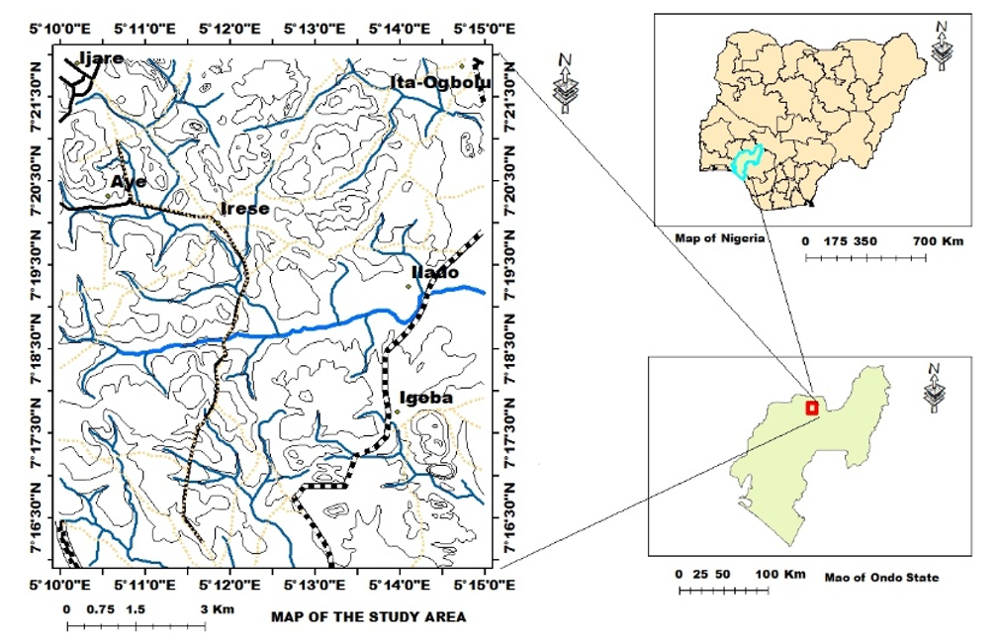
Figure 1: Map of Nigeria, inset the Ondo State and the Study area modified after (Federal Survey Nigeria 2006)

3.0 Materials and Methodology.
Remote sensing, field mapping, and laboratory geochemical analysis were employed in this study. Sentinel-2A optical imagery (Scene ID: S2A_MSILC_2023216T095101_N0509_R079_T31NG1_2023216T33019), previously downloaded from the USGS GLOVIS portal, was clipped and processed using ArcMap 10.5. Additional image processing and lineament extraction were carried out with ENVI 5.4, Geomatica 2018, and RockWorks 17. Soil geochemical mapping involved systematic field traverses along roads and footpaths using a GPS to accurately record sampling locations. Samples were collected with a hand auger and described in the field based on colour, texture, and depth. A systematic sampling technique was adopted, collecting residual soils at approximately 50-m intervals from first- or second-order stream channels (<100 m), avoiding areas disturbed by agriculture. Auger pits were dug at suitable locations, and B-horizon soils were sampled at depths of 0.05–0.3 m, depending on lithology. The collected samples were analyzed for major and trace elements using ICP-MS at ACME Laboratories, East Vancouver, Canada. Sample decomposition involved partial digestion using Lithium Metaborate fusion, which allows complete digestion of silicates and heavy minerals and is suitable for mineral exploration geochemistry (Senda et al., 2014). For each sample, 0.100 g of pulverized soil was fused with 0.600 g lithium metaborate at 900 °C for 10 minutes before dilution in 5% HCl. The resulting geochemical data were subsequently processed, interpreted, and statistically evaluated using Excel, RockWorks, Minitab, ArcGIS 10.5, and Geomatica 2018.

4.0 Results and Discussion
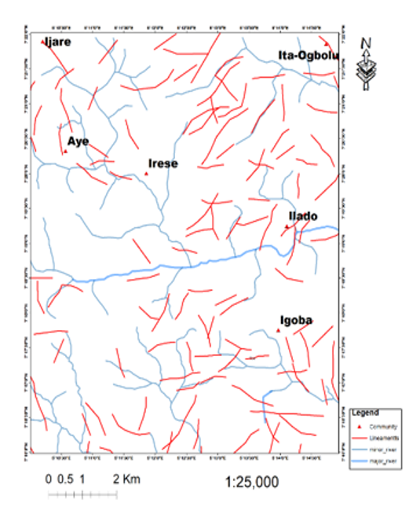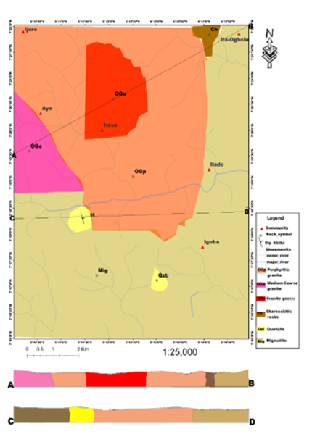
Figure 2: Lineament map of the study area. Figure 3: Geological and cross-sectional maps
After NGSA (2006)
4.1 Lineament Map
The lineament map of the Ijare–Aye–Irese–Ilado–Ita-Ogbolu–Igoba axis (Figure 2) shows a dense structural network of NE–SW and NW–SE trending fractures, representing faults, joints, and shear zones typical of Pan-African deformation within the Nigerian Basement Complex. These dominant orientations align with regional structural trends documented by Rahaman (1988) and reflect tectono-magmatic processes that facilitated deep-seated fracturing (O’Leary et al., 1976). Zones of high lineament density, particularly around Ilado, Irese, and Igoba, correspond to structurally weakened corridors that enhance secondary porosity and act as conduits for hydrothermal fluid migration. Such structurally controlled pathways have been associated with the emplacement of metallic mineral systems, including gold, sulfide, and base-metal deposits in southwest Nigeria (Olatunji 2021). The Ilado–Irese belt, characterized by multiple lineament intersections, represents the most prospective zone, as intersections commonly serve as structural traps for mineralizing fluids. NW–SE shear-related structures around Igoba resemble shear-hosted quartz–sulfide systems noted in other parts of the Basement Complex (Adeoti & Okonkwo, 2016). The Ita-Ogbolu area displays consistent NE–SW vein-parallel trends suggestive of fault-controlled mineral zones. The drainage also aligns with the structural trends, indicating strong structural control on surface processes, a pattern similarly observed in basement terranes (Odeyemi, 1981). The structural–drainage integration highlights the Ilado–Irese–Igoba corridor as the most mineral-prospective zone, with Ita-Ogbolu and Aye–Ijare showing moderate potential for structurally controlled hydrothermal mineralization.
4.2 Geological map and Cross-section
The mapped area around Ijare, Irese, Ilado, Ita-Ogbolu, and Igoba lies within the Southwestern Nigerian Basement Complex, a segment of the Pan-African mobile belt that has experienced multiple episodes of deformation, metamorphism, and magmatism (Rahaman, 1988). (Figure 3) The lithologies include migmatite, granite gneiss, porphyritic and medium- to coarse-grained granites, quartzite, and charnockitic rocks. Migmatite forms the oldest unit, occurring mainly in the south and east, and represents partially melted gneissic material. Granite gneiss, dominant around Ijare and Aye, is strongly foliated and ductilely deformed, forming the basement framework. The porphyritic granite, widespread in the central part (Irese–Ilado–Igoba), intrudes along pre-existing fractures, signifying late-Pan-African emplacement. Medium- to coarse-grained granite around Irese indicates slow post-tectonic crystallization, while isolated quartzite bands near Ilado and Igoba mark metasedimentary enclaves. Small bodies of charnockite at Ita-Ogbolu reflect high-temperature magmatic differentiation during the late Precambrian (Adeoti & Okonkwo 2016). Cross-section A–B (Ijare–Ita-Ogbolu) shows a progression from granite gneiss through porphyritic granite to charnockite, demonstrating a polyphase tectono-magmatic history. Section C–D (Ilado–Igoba) reveals migmatite underlying quartzite and porphyritic granite, suggesting intrusive contact metamorphism and hydrothermal alteration. Structural intersections and lithological contacts, especially within the Ilado–Irese–Igoba axis,
coincide with deformation zones and fractures that likely acted as fluid pathways for mineralization (Olatunji, 2021). The area records a geological evolution from early crustal anatexis to late-stage granitic and charnockitic intrusions, followed by brittle deformation and vein formation. The interplay of lithological diversity, intrusive activity, and structural lineaments enhances its potential for metallic and pegmatitic mineralization. The Ilado–Irese–Igoba zone should therefore be prioritized for detailed geochemical and geophysical follow-up exploration.
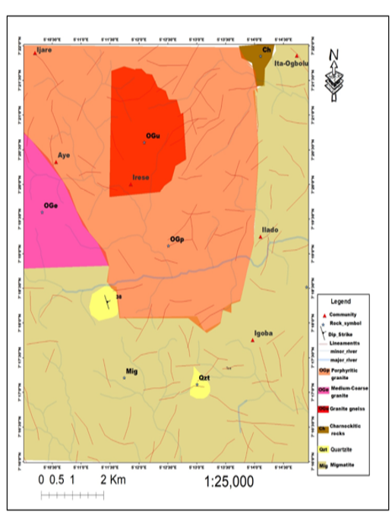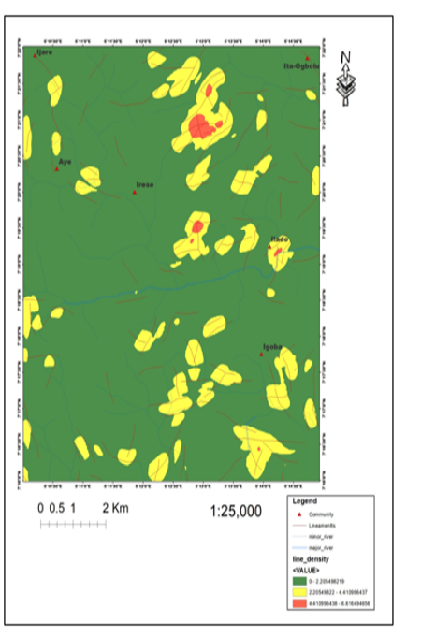
Figure 4: Lineament map superimposed on geology map. Figure 5: Lineament density map of
The Study Area

4.3 Lineament Map Superimposed on Geological Map
The integrated geological lineament map of Ijare, Irese, Ilado, Ita-Ogbolu, and Igoba area (Figure 4) shows the interplay between lithology and structural deformation within the Southwestern Nigerian Basement Complex, part of the Pan-African Mobile Belt (Rahaman, 1988). Mapped lithologies include migmatite (Mig), granite gneiss (OGe), porphyritic granite (OGp), medium- to coarse-grained granite (OGu), charnockite (Ch), and quartzite (Qzt). Lineaments, depicted in red, trend NE–SW and NW–SE, corresponding to major Pan-African tectonic orientations defining regional shear zones and fractures (Adeoti & Okonkwo, 2016). High lineament density occurs around Irese, Ilado, and Igoba, where intersections often serve as conduits for hydrothermal fluid migration and mineral deposition (Olatunji, 2021). Porphyritic and coarse-grained granites along the Irese–Ilado–Igoba zone exhibit intense fracturing, likely facilitating the emplacement of pegmatites and quartz veins associated with metallic and rare-element mineralization (Adepoju 2022). Granite gneiss around Ijare and Aye shows ductile–brittle fractures predating granitic intrusions, while migmatite and charnockite appear more rigid. The NE–SW lineaments reflect influence from the Ifewara–Zungeru transcurrent shear system, highlighting structurally controlled mineralization along the Irese–Ilado–Igoba corridor and warranting further geophysical and geochemical investigation (Adeoti & Okonkwo 2016).
4.4 Lineament Density Map of the study area
The interpreted lineament density map (Figure 5) at a scale of 1:25,000 highlights variations in fracture intensity that shape the geological and hydrological framework of the study area. Lineaments—faults, joints, and shear zones—significantly influence rock deformation, groundwater flow, and mineralization patterns in basement terrains (Oladeji et al., 2018). The mapped area comprises porphyritic granite (OGp), medium- to coarse-grained granite (OGm), granite gneiss (OGge), quartzite (Qzt), migmatite (Mig), and charnockite (Ch), with settlements such as Ijado, Ireṣe, Aye, Igoba, Ilado, Ita-Ogbolu, and Ijarẹ distributed across these lithologies. Lineament density is classified into low (green), moderate (yellow), and high (red) zones. Low-density areas—mainly within migmatite and granite gneiss—indicate structurally resistant rocks with limited secondary porosity and low groundwater potential (Rahaman, 1988). In contrast, moderate- to high-density zones occur around Ireṣe, Ijado, and the western Ita-Ogbolu axis, reflecting zones of intense fracturing, possible fault intersections, and enhanced permeability. These structurally weakened corridors are favorable pathways for hydrothermal fluid migration, mineralization, and groundwater accumulation (Oladeji et al., 2018). The dominant NE–SW and NW–SE fracture orientations align with the Pan-African structural trends that characterize the Southwestern Nigerian Basement Complex (Ajibade & Wright, 1989). The alignment of drainage channels along these structural trends further confirms strong tectonic control on surface processes. The map reveals a generally stable terrain dominated by low-density structures, while the Ireṣe–Ita-Ogbolu–Ijado belt stands out as a structurally active and mineralization-prone corridor.
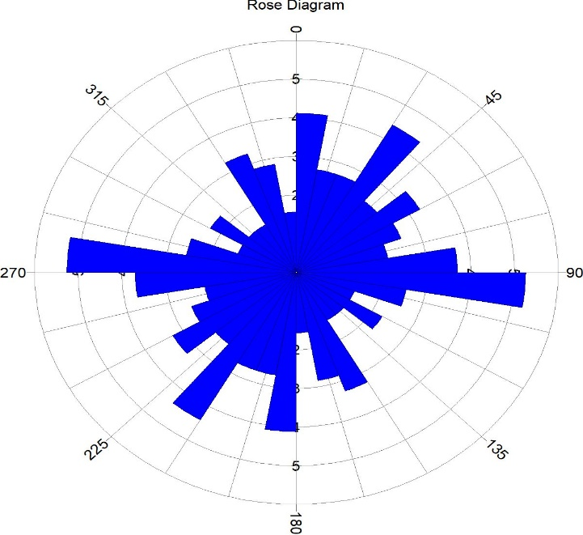
Figure 6: Rose diagram of the study area
4.5 The Rose Diagram
The rose diagram (Figure 6) shows the orientation and frequency of linear geological features, faults, fractures, joints, and dikes, within the study area. Each bar indicates the number of lineaments along a specific azimuth. Dominant trends are East–West (E–W) to East-Northeast/West-Southwest (ENE–WSW; 80°–100°/260°–280°), reflecting principal deformation directions in the basement complex and reactivation of pre-existing fractures during the Pan-African orogeny (Rahaman, 1988; Ajibade & Wright, 1989). A secondary trend, North-Northeast/South-Southwest (NNE–SSW; 15°–30°/195°–210°), represents conjugate or extensional fractures linked to the same tectonic regime, while a minor Northwest–Southeast (NW–SE) trend likely reflects late-stage brittle deformation. The prevalence of E–W and NNE–SSW lineaments indicates conjugate fracture systems developed under a north–south maximum compressive stress (σ1), consistent with regional tectonics in southwestern Nigeria (Rahaman, 1988; Oladeji et al., 2018). Structurally, E–W fractures act as primary conduits for groundwater and hydrothermal fluids, enhancing mineralization potential, whereas NNE–SSW fractures serve as secondary feeder zones. Overall, the rose diagram confirms a structurally controlled terrain with implications for both groundwater accumulation and fracture-hosted mineralization within the Nigerian Basement Complex.
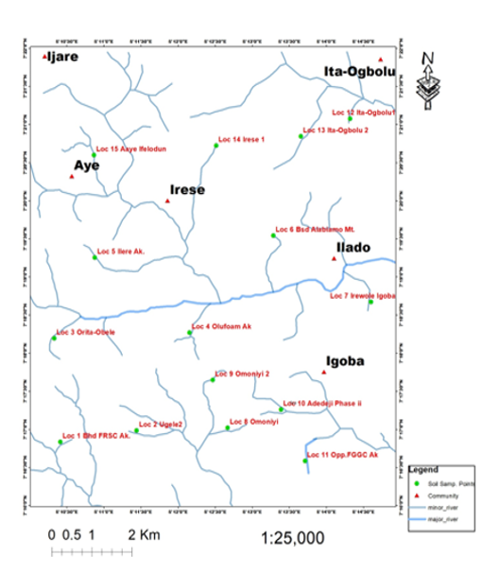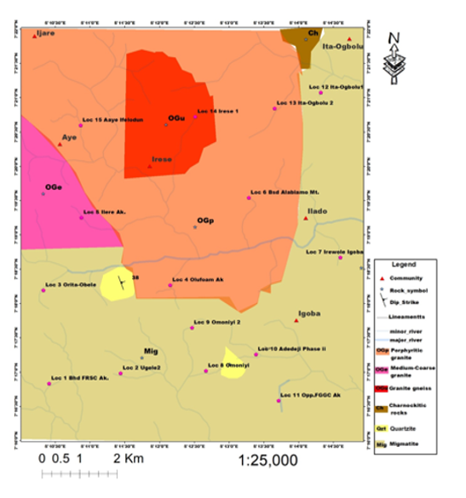

Figure 7: Soil sampling points Figure 8: Soil sampling points
Superimpose on the geological map

4.6 Soil Sampling Points
The (figure 7) above presents the spatial distribution of 15 soil sampling points (Loc 1–Loc 15) across Ilare, Aye, Irese, Ilado, Igoba, and Ita-Ogbolu within the study area, along with key drainage features and settlement patterns for proper identification. The sampling points are broadly distributed to ensure representative coverage of major residential and geological zones rather than a single localized source. Distinct clusters occur in the southwest (Loc 1–5), central region (Loc 6–11), and northeast (Loc 12–13 at Ita-Ogbolu), with additional sites in the northern part (Loc 14–15 at Irese and Aaye Ifelodun). The proximity of several points, such as Loc 4 (Olufoam Ak..), Loc 6 (Bsd. Alabimo Mt.), and Loc 7 (Irewole Igoba) to the major drainage channel indicates a likely influence of fluvial processes on soil geochemistry, as rivers often act as sinks or pathways for metals (Alloway, 2013). Sites along minor streams, including the Ita-Ogbolu and Omoniyi clusters, may also experience redistribution of elements through surface runoff and sediment transport (Chen et al., 2010). Spatial correlation with geochemical data reveals that Loc 4 (Olufoam Ak..), near the main river, exhibits the highest Cu, Zn, and Th concentrations, suggesting possible anthropogenic influence from industrial or vehicular activities (Wuana et al., 2011). Elevated Ni, Co, and Cr levels at Loc 7 (Irewole Igoba) and Loc 14 (Irese) are consistent with lithological control, reflecting mafic or ultramafic sources (Salminen et al., 2005). Meanwhile, the Rb anomalies at Loc 9 (Omoniyi 2) and Loc 13 (Ita-Ogbolu 2) indicate a probable association with felsic rock units occurring discontinuously across the terrain (Wedepohl, 1995). Overall, the figure provides an integrated visualization linking spatial variation in metal concentration with drainage networks, lithology, and human activities, critical for interpreting the geochemical processes governing soil composition in the study area.
4.7 Soil sampling points superimpose on the geological map
The geological map (Figure 8) of the study area shows 15 soil sampling points (Loc 1–Loc 15) distributed across six main lithological units: Medium-Coarse Granite (Ogu), Granite Gneiss (OGe), Porphyritic Granite (OGp), Charnockitic Rocks (CH), Quartzite (Qz), and Migmatite (Mig). Most samples occur on Migmatite (Loc 1, 2, 8–11) and Porphyritic Granite (Loc 4, 6, 7, 12), with others on Medium-Coarse Granite (Loc 14, 15), Granite Gneiss (Loc 3), and Charnockite (Loc 13). The distribution of elements across these units reveals both lithological and anthropogenic influences on soil geochemistry. Elevated Ni, Co, and Cr at Loc 5–7 are indicative of mafic or ultramafic characteristics (Kabata-Pendias, 2011; Reimann & Filzmoser (2000), though their presence within felsic Porphyritic Granite suggests local mafic inclusions, alteration, or external inputs. The influence of anthropogenic activities—such as vehicular emissions or industrial discharge—may also explain these anomalies, particularly near populated areas ( Alloway, 2013). High Rb at Loc 9 (Omoniyi 2, Migmatite) and Loc 13 (Ita-Ogbolu 2, Charnockite) likely reflects natural enrichment in K-bearing minerals like feldspar and biotite (Wedepohl, 1995), indicating mineralogical rather than contamination-driven anomalies. At Loc 4 (Olufoam Ak.), Porphyritic Granite hosts the highest Cu, Zn, and Th concentrations near a drainage channel. While Th enrichment aligns with granitic geochemistry (Salminen et al., 2005), the concurrent Cu and Zn peaks suggest anthropogenic contributions from urban or industrial runoff (Chen et al., 2010). The map demonstrates that felsic rocks dominate the area, but elemental enrichment arises from both geological and human sources. Mafic-associated metals (Ni, Co, Cr) reflect lithological control, while Cu, Zn, and Pb anomalies near drainage and urban zones likely stem from anthropogenic influence. Thus, the trace metal distribution reflects a combined effect of bedrock composition, mineralogy, and human activity shaping the geochemical landscape of the study area.

Table 1 Trace Elements composition of the study area.(ppm)
Sample | Location | Ba | Rb | Zr | Cr | Nb | Sc | Mo | Cu | Pb | Zn | Ag | Ni | Co | Mn | As | Au | Th
LOC 1 | Bhd FRSC | 2357 | 121.6 | 805 | 6 | 33 | 17 | 1.4 | 20.5 | 31.1 | 152 | <0.1 | 2.3 | 3.1 | 574 | 1 | <0.1 | 9.8
LOC 2 | Ugele2 | 1634 | 103.5 | 943 | 6 | 28 | 12 | 1.1 | 22.5 | 28.2 | 125 | <0.1 | 1.9 | 4.4 | 553 | 2 | <0.1 | 10.3
LOC 3 | Orita-Obele | 1865 | 129.7 | 1532 | 25 | 26 | 12 | 2.1 | 20.3 | 63.6 | 145 | <0.1 | 2.7 | 13.2 | 1447 | 3 | <0.1 | 16.2
LOC 4 | Olufoam Ak | 1706 | 121.8 | 40 | 30 | 32 | 20 | 2.8 | 76.5 | 63 | 235 | <0.1 | 3.6 | 15.5 | 792 | 2 | <0.1 | 39
LOC 5 | Ilere Ak. | 891 | 89.5 | 629 | 94 | 33 | 13 | 1.3 | 31.6 | 34.8 | 91 | <0.1 | 33.3 | 72.3 | 5740 | 3 | <0.1 | 26.5
LOC 6 | BsdAlabiamo | 1591 | 89.5 | 1629 | 94 | 43 | 13 | 1.3 | 31.6 | 34.8 | 91 | <0.1 | 33.3 | 72.3 | 5739 | 3 | <0.1 | 26.5
LOC 7 | Irewole Ig. | 1331 | 109.3 | 626 | 140 | 26 | 14 | 1.2 | 51.8 | 46.6 | 201 | <0.1 | 49 | 62.6 | 2784 | 3 | <0.1 | 15.9
LOC 8 | Omoniyi | 1164 | 133.2 | 913 | 8 | 34 | 17 | 1.3 | 20.1 | 32 | 148 | <0.1 | 2.2 | 3.2 | 669 | 1 | <0.1 | 12.4
LOC 9 | Omoniyi2 | 476 | 311.6 | 25 | 5 | 19 | <1 | 0.4 | 6.9 | 24.6 | 7 | <0.1 | 2 | 0.3 | 684 | 2 | <0.1 | 1.5
LOC 10 | Adedeji Phas | 20 | 0.5 | <5 | 12 | <5 | 13 | 1.4 | 15.3 | 1.4 | 17 | <0.1 | 17.4 | 4.8 | 256 | 1 | <0.1 | 0.2
LOC 11 | Opp FGGC Ak. | 1221 | 0.8 | <5 | 14 | <5 | 16 | 1.4 | 15.6 | 1.4 | 16 | <0.1 | 17.8 | 4.6 | 302 | 1 | <0.1 | 0.3
LOC 12 | Ita-Ogbolu1 | 394 | 102.5 | 305 | 13 | 26 | 4 | 2.4 | 23.2 | 22.4 | 71 | <0.1 | 8.9 | 12 | 523 | 2 | <0.1 | 31.3
LOC 13 | Ita-Ogbolu 2 | 476 | 311.6 | 25 | 5 | 19 | <1 | 0.4 | 6.9 | 24.6 | 7 | <0.1 | 1.9 | 0.3 | 662 | 2 | <0.1 | 1.5
LOC 14 | Irese 1 | 1324 | 109.6 | 672 | 140 | 32 | 17 | 1.2 | 50.8 | 42.6 | 207 | <0.1 | 50 | 60.6 | 2789 | 3 | <0.1 | 16
LOC 15 | Aaye ifelodun | 1261 | 121.6 | 593 | 151 | 16 | 15 | 1.1 | 50.8 | 47.1 | 202 | <0.1 | 44 | 63.3 | 2682 | 3 | <0.1 | 13.9

4.8 Trace elements Composition of the Soil
The above (Table 1) presents the different concentrations of the trace elements based on different localities, which reflect mostly the bedrock geology from which the soil samples were weathered in those localities (Adebowale & Anthony, 2022). The analyses revealed that Ba, Cu, Pb, Zr, Cr, Mn, Fe, Zn, Co, Rb, and Li have high concentrations in the migmatite-gneisses and the quartz-schists of the study area. The concentration ranges as follows: Ba (2521-21) ppm, Sr(459-430)ppm, Zr(1629-00)ppm, Cu (76.5-6.9) ppm, Pb (63.5 -1.4) ppm, Zn (235-7) ppm, Cr(151-5)ppm, Co (72.3-0.3)ppm, Rb (311.6-0.5)ppm and Mn(5740-256)ppm respectively. Higher concentration values of Ba at Orita –obele, Ugele, Olufoam, Irewole, Igoba, Omoniyi, and Irese indicate K-feldspar-rich soil samples source (Akinola & Olorun, 2021). Also, it might be due to the initial composition of the magma that formed the rocks from which the soil weathered. Ba, Zr, Pb, Sr, Mn, and Zn have diagnostic values with respect to other element and their value are related to bedrock geology, which suggests the absence of basic and ultrabasic rocks in the area (Wedepohl, 1995). For instance, Ba, Sr, Sc, Cu, Zn, Mn, and Pb have higher concentrations at Olufoam, Irewole Igoba, and Irese. This underscores the nature of the underlying bedrock in that location, suggesting the absence of basic and ultrabasic rocks in the area (Wedepohl, 1995). They have their highest concentration also at IlereAk. And Bsd Alabiamo with value 26.5, Lithium has its highest concentration value of 69.2ppm at Itaogbolu 1, while rhodium has the same concentration value (311.6 ppm) in these two locations, Itaogbolu 2 and Omoniyi 2. Nikel has its highest value, 25.31ppm at Aaye Ifelodun. From the results of the trace elements analyzed it can be deduced that the concentration of gold is too low (<0.1) in all the soil samples analyzed. Therefore, sulphide mineralization is suspected in the study area.

FACTOR ANALYSIS
Table 2: Factor Analysis Result
Variables | Comp. I | Comp. II | Comp.III | Comp.IV | Communualities
Cu | .799 |  |  | .400 | .921
Pb | .747 |  |  |  | .804
Zn | .822 |  |  |  | .817
Ni | .628 | .594 |  |  | .960
Co | .809 | .537 |  |  | .961
Mn | .703 | .588 |  |  | .855
As | .711 |  |  |  | .867
Th | .724 |  |  |  | .762
Cr | .769 | .514 |  |  | .971
Rb |  |  | .765 |  | .885
Fe | .919 |  |  |  | .955
Sr | . | .706 |  |  | .761
Zr | .573 |  |  |  | .876
Y | .769 |  |  |  | .952
Nb | .645 |  | .622 |  | .850
Sc | .600 |  |  |  | .886
Mo |  | .767 |  |  | .765
VAR | 46.15 | 18.42 | 13.21 | 9.57
CVAR | 46.15 | 64.57 | 77.78 | 87.35

COMP. = Components (group of element association) VAR=Variance

CVAR=Covariance %=Percentage

4.9 Factor Analysis Interpretation
The Factor Analysis extracted four significant components explaining 87.35% of the total variance, revealing clear geochemical groupings that reflect distinct mineralization and lithological controls (Reimann and Filzmoser, 2000). (Table 2) Component I (Cu–Pb–Zn–As–Fe–Co–Cr–Mn–Ni–Th–Y–Zr–Sc; 46.15%) represents a hydrothermal polymetallic sulfide association, dominated by base metals (Cu, Pb, Zn) and pathfinders (As, Fe, Co). This suite typifies sulfide mineralization systems where elements such as chalcopyrite, galena, sphalerite, and arsenopyrite precipitate from hydrothermal fluids (Boyle, 1974). The inclusion of Co, Ni, and Cr indicates minor mafic input, while Th, Y, and Zr suggest felsic host-rock influence, implying a structurally controlled hydrothermal system within mixed lithologies. Component II (Ni–Co–Mn–Cr–Nb–Sr; 18.42%) reflects a mafic–ultramafic lithological association, characterized by transition metals typically hosted in ferromagnesian minerals (Naldrett, A. J. (2004). Mn and Sr suggest redox-sensitive behavior, indicating element redistribution during metamorphism or low-grade hydrothermal alteration rather than direct ore formation.
Component III (Rb–Mo; 13.21%) corresponds to lithophile element enrichment in granitic or pegmatitic rocks. Rb substitutes for K in feldspars and micas, while Mo is linked to late-stage granitic or oxidized hydrothermal fluids, indicating felsic magmatic differentiation (Taylor and McLennan, 1985). Component IV (Nb; 9.57%) is dominated by Nb, commonly found in columbite–tantalite and pyrochlore, representing residual felsic or pegmatitic sources (Melcher et al., 2015). Most elements exhibit high communalities (>0.75), confirming strong inter-element relationships and reliable grouping patterns. The factor structure thus identifies two dominant geochemical systems: (1) A hydrothermal Zn–Pb–Cu–As–Fe association representing the main mineralization trend. (2) Mafic–ultramafic and lithogenic controls reflecting background geochemistry. The analysis indicates that Zn, Pb, Cu, As, and Fe define the major hydrothermal mineralization zone, while Co, Cr, Ni, and Nb reflect lithological or metamorphic influences. This confirms a mixed hydrothermal–lithogenic model consistent with polymetallic sulfide mineralization within basement terrains (Rose et al., 1979).
Table 3: Correlation coefficient showing interrelationship between elements
 | Cu | Pb | Zn | Ni | Co | Mn | As | Th | Cr | Rb | Fe | Mo
Cu | 1
Pb | .671** | 1
Zn | .841** | .803** | 1
Ni | .515* | 0.161 | 0.369 | 1
Co | .561* | 0.385 | 0.433 | .896** | 1
Mn | 0.327 | 0.312 | 0.213 | .682** | .912** | 1
As | .464* | .649** | 0.408 | .624** | .794** | .735** | 1
Th | .680** | .608** | .551* | 0.165 | .445* | .444* | .454* | 1
Cr | .639** | 0.426 | .554* | .952** | .934** | .720** | .762** | 0.298 | 1
Rb | -0.254 | 0.201 | -0.183 | -0.348 | -0.238 | -0.141 | 0.134 | -0.177 | -0.197 | 1
Fe | .759** | .631** | .821** | .590* | .679** | .553* | .489* | .541* | .679** | -.523* | 1
Mo | .488* | 0.382 | 0.421 | -0.148 | -0.046 | -0.100 | -0.010 | .725** | -0.099 | -.482* | 0.406 | 1

4.10 Correlation Coefficient Evaluation.
The above (Table 3) presents the Pearson correlation coefficients among twelve elements (Cu, Pb, Zn, Ni, Co, Mn, As, Th, Cr, Rb, Fe, Mo), revealing two major geochemical associations that reflect distinct lithological and mineralization controls. Copper (Cu) shows strong positive correlations with Zn (r = 0.841**), Pb (r = 0.671**), Fe (r = 0.759**), and Th (r = 0.680**), indicating a shared origin through hydrothermal or granitic-related sulfide mineralization (Turekian & Wedepohl, 1961). Lead (Pb) and Zn are strongly correlated (r = 0.803**), suggesting polymetallic sulfide associations within felsic or intermediate lithologies (White et al., 2002). Zinc also correlates moderately with Th (r = 0.551*), reinforcing the felsic–hydrothermal linkage (Rollinson, 1993). Nickel (Ni) exhibits strong correlations with Co (r = 0.896**), Cr (r = 0.952**), and Mn (r = 0.682**), reflecting a mafic–ultramafic affinity typical of Ni–Co–Cr–Mn mineralization (Skinner, 2005). Similarly, Co correlates strongly with Ni, Mn, and Cr (r ≥ 0.896**), confirming derivation from ultramafic rocks and potential for Ni–Co mineralization. Arsenic (As) shows moderate to strong relationships with Cu, Pb, Ni, and Co, implying hydrothermal mobility and its association with sulfide phases (Kabata-Pendias, 2011). Thorium (Th) exhibits moderate correlations with Cu, Pb, Zn, and Fe, reflecting felsic enrichment, while Fe correlates with Cu, Zn, Pb, and Cr, suggesting a role in both sulfide and oxide mineral assemblages (Cameron & Collerson, 2007). Rubidium (Rb) shows weak correlations with other metals, indicating derivation from K-bearing silicates in felsic rocks rather than mineralized zones. Molybdenum (Mo) displays moderate correlations with Cu and Th, implying possible enrichment in felsic magmatic or hydrothermal systems (White et al., 2002). Overall, two dominant geochemical clusters emerge: (1) Felsic granitoid-associated mineralization (Cu–Pb–Zn–Fe–Th–Mo): Suggests hydrothermal sulfide enrichment within or around felsic intrusions, typical of porphyry-style systems. (2) Mafic–ultramafic-associated mineralization (Ni–Co–Cr–Mn–As): Indicates potential Ni–Co–Cr sulfide mineralization in ultramafic units, consistent with greenstone belt settings (McCulloch et al., 1983). These associations highlight the polymetallic potential of the study area, where both felsic-hosted Cu–Pb–Zn mineralization and mafic–ultramafic-hosted Ni–Co–Cr–Mn mineralization coexist, reflecting complex geochemical and lithological evolution controlled by hydrothermal and magmatic processes.

5.0 CONCLUSION
The integrated application of remote sensing, geological mapping, correlation, and factor analyses has provided valuable insights into the geochemical and structural controls of mineralization within the Precambrian Basement Complex of southwestern Nigeria. Lineament interpretation from Sentinel-2A imagery revealed dominant NE–SW and E–W trends, indicating tectonic reactivation and fluid migration pathways favorable for hydrothermal mineral deposition. Geochemically, the area displays variable elemental enrichment patterns. Zinc (Zn) shows the highest concentration, reaching 136.563 ppm, particularly in the north-central sector (Irese–Olufoarm A.K.), suggesting a strong hydrothermal influence. Lead (Pb) values range from 1.206 to 63.104 ppm, with a modest enrichment in the same zone, while Arsenic (As) exhibits widespread high background concentrations up to 3.116 ppm in the north and west, overlapping spatially with the Zn anomaly. Thorium (Th) values, reaching 17.0838 ppm, are concentrated in the north, reflecting felsic or radioactive mineral-bearing lithologies such as granites or pegmatites. These results collectively indicate a geochemical environment conducive to Zn–Pb–As–Th mineralization, possibly associated with hydrothermal alteration along fracture-controlled zones. The correlation coefficient matrix reveals significant positive relationships between several metallic elements, notably Zn–Pb (r = 0.803**), Zn–Cu (r = 0.841**), Cu–Pb (r = 0.671**), and Co–Ni (r = 0.896**), suggesting a common source or co-precipitation during hydrothermal mineralization. These inter-element associations imply a hydrothermal sulfide system enriched in base metals. Conversely, weak correlations between elements such as Mn and Th indicate differing geochemical behaviors and lithological sources. Factor analysis further supports this interpretation, identifying three dominant geochemical associations: Factor 1 (Base-metal factor), characterized by high loadings of Zn, Pb, Cu, and As, which represents hydrothermal sulfide mineralization associated with fault-controlled structures. Factor 2 (Ferromagnesian factor): High loadings of Ni, Co, and Cr, indicating derivation from mafic and ultramafic lithologies. Factor 3 (Radioactive element factor): Dominated by Th and Fe, reflecting felsic igneous contributions and weathering enrichment. The convergence of high Zn–As–Pb concentrations, strong elemental correlations, and factor grouping in the Irese–Olufoarm A.K. zone confirms this area as the principal target for further exploration. The study conclusively demonstrates that combining remote sensing with multivariate geochemical techniques offers a robust approach to identifying and characterizing base-metal and radioactive mineralization potential in basement terrains of Nigeria. Future work should involve detailed geophysical surveys and subsurface drilling to validate these inferred mineralized zones.
Ethical Approval
This article does not contain any studies with human participants or animals performed by any of the authors.
Consent to Publish
All authors have read the manuscript and agreed to its submission to the Asian Journal of Geological Research.

Disclaimer (Artificial Intelligence)
The author (s) hereby declare that generative AI technologies such as Large Language Models have been used during the writing or editing of this manuscript. Details of the AI usage are given below:
1 Name of AI tool: ChatGPT (OpenAI, GPT-5.1)
2. Purpose of use: Only for language refinement, grammar correction, and improving clarity of expression.
3. No AI tool was used to generate data, interpret results, perform analysis, or draw scientific conclusions. All scientific content and interpretations are entirely the authors’ own.

References
- Alao-Daniel, A. B., Adetunji, A., Opuwari, M. A., & Eruteya, O. E. (2023). Integrated multi-elemental soil geochemical survey as a tool in geological mapping in the tropics: A case study of Songbe area of Osun State, West Africa. Journal of Environment and Earth Science, 13(5) https://doi.org/10.7176/JEES/13-5-03
- Adepoju, M. O. (2019). Geochemical soil survey for base and precious metals in Dagbala-Atte district, southwestern Nigeria. International Journal of Geosciences, 10(2), 141–159. https://doi.org/10.4236/ijg.2019.102009
- Adetunla, F. R., Isah, A. G., Oladapo, I. O., Akinbiyi, O. A., & Oji, A. S. (2024). Soil survey and lithogeochemical techniques in mineral exploration. International Journal of Research and Innovation in Applied Science (IJRIAS), 9(3), 390–405. https://doi.org/10.51584/IJRIAS.2024.90336
- Wu, M., Hu, Y., Wang, H., Liu, G., & Yang, L. (2020). Remote sensing extraction and feature analysis of abandoned farmland in hilly and mountainous areas: A case study of Xingning, Guangdong. Remote Sensing Applications: Society and Environment, 20, 100403. https://doi.org/10.1016/j.rsase.2020.100403
- Dönmez, H. (2023). Applications of soil geochemistry in mineral exploration. ISERDAR: International Science and Engineering Reviews: Development, Analysis, and Research. https://doi.org/10.5281/zenodo.10436738
- Lingli. (2023). Towards sustainability in mineral resources. Ore Geology Reviews. https://doi.org/10.1016/j.oregeorev.2023.105600
- Senda, R., Kimura, J.-I., & Chang, Q. (2014). Evaluation of a rapid, effective sample digestion method for trace element analysis of granitoid samples containing acid-resistant minerals: Alkali fusion after acid digestion. Geochemical Journal, 48(1), 99–103. https://doi.org/10.2343/geochemj.2.0280
- Pavloudakis, F., Roumpos, C., & Spanidis, P.-M. (2024). Sustainable Mining and Processing of Mineral Resources. Sustainability, 16(19), 8393. https://doi.org/10.3390/su16198393
- Rahaman, M. A. (1988). Recent Advances in the Study of the Basement Complex of Nigeria. In P. O. Oluyide, W. C. Mbonu, A. E. Ogezi, I. G. Egbuniwe, A. C. Ajibade, & A. C. Umeji (Eds.), *Precambrian Geology of Nigeria* (pp. 11–43). Geological Survey of Nigeria. https://books.google.com/books/about/Precambrian_Geology_of_Nigeria.html?id=200uAAAAMAAJ
- Ocheri, M. I., Umar, D. N., Wuyep, S. Z., Laka, I. S., Odoma, L. A., Ali, P., Onah, M. A., & Tarzoho, P. (2025). A Review of Morphometric Studies of Drainage Basins in Nigeria. British Journal of Earth Sciences Research, 13(2), 42–65. https://doi.org/10.37745/bjesr.2013/vol13n24265
- Akeredolu, B. E., Adiat, K. A., Akinlalu, A. A., & Olayanju, G. M. (2022). The relationship between morpho-structural features and borehole yield in Ilesha Schist Belt, Southwestern Nigeria: Results from geophysical studies. Earth Sciences, 11(1), 16–28. https://doi.org/10.11648/j.earth.20221101.13
- Nigerian Geological Survey Agency – NGSA (2006).Geophysical Mapping of Nigeria: Airborne Radiometric and Magnetic Survey Data.https://ngsa.gov.ng
- Olatunji, S. (2022). Integration of remote sensing and geophysical methods for structural and lithological mapping in a part of Precambrian Basement Rocks, northern Nigeria. Journal of Fundamental and Applied Sciences, 14(1). https://doi.org/10.4314/jfas.v14i1.9
- Odeyemi, I. B. (1981). A review of the orogenic events in the Precambrian basement of Nigeria, West Africa. Geologische Rundschau, 70(3), 897–909. https://doi.org/10.1007/BF01820170
- Adeoti, B., & Okonkwo, C. T. (2016). Structural geology of the basement complex rocks in the Iwaraja area, Southwestern Nigeria. International Letters of Natural Sciences, 58, 16–28. https://doi.org/10.56431/p-m654ru
- O’Leary, D. W., Friedman, J. D., & Pohn, H. A. (1976). Lineament, linear, lineation: Some proposed new standards for old terms. Geological Society of America Bulletin, 87(10), 1463–1469. https://doi.org/10.1130/0016-7606(1976)87<1463:LLLSPN>2.0.CO;2
- Adepoju, M. O. (2022). Structural control of ore mineralization in the southeastern margin of the Western Nigeria Basement. International Journal of Geosciences, 13, 547–556. https://doi.org/10.4236/ijg.2022.137029
- Ajibade, A. C., & Wright, J. B. (1989). The Togo–Benin–Nigeria Shield: evidence of crustal aggregation in the Pan-African belt. Tectonophysics, 165(1–4), 125–129. https://doi.org/10.1016/0040-1951(89)90041-3
- Akinluyi, F. O., Olorunfemi, M. O., & Bayowa, O. G. (2018). Investigation of the influence of lineaments, lineament intersections and geology on groundwater yield in the basement complex terrain of Ondo State, Southwestern Nigeria. Applied Water Science, 8, Article 49. https://doi.org/10.1007/s13201-018-0686-x
- Alloway, B. J. (2013). Heavy metals in soils: Trace metals and metalloids in soils and their bioavailability. Springer. https://doi.org/10.1007/978-94-007-4470-7
- Alloway, B. J. (2013). Heavy metals in soils: Trace metals and metalloids in soils and their bioavailability. Springer. https://doi.org/10.1007/978-94-007-4470-7
- Chen, X., Xia, X., Zhao, Y., & Zhang, P. (2010). Heavy metal concentrations in roadside soils and correlation with urban traffic in Beijing, China. Journal of Hazardous Materials, 181, 640–646. https://doi.org/10.1016/j.jhazmat.2010.05.060
- Wuana, R. A., & Okieimen, F. E. (2011). Heavy metals in contaminated soils: A review of sources, chemistry, risks and best available strategies for remediation. ISRN Ecology https://doi.org/10.5402/2011/402647
- Salminen, R., Batista, M. J., Bidovec, M., Demetriades, A., De Vivo, B., De Vos, W., Duris, M., Gilucis, A., Gregorauskiene, V., Halamic, J., Heitzmann, P., Lima, A., Jordan, G., Klaver, G., Klein, P., Lis, J., Locutura, J., Marsina, K., Mazreku, A., O'Connor, P. J., Olsson, S. Å., Ottesen, R.-T., Petersell, V., Plant, J. A., Reeder, S., Salpeteur, I., Sandström, H., Siewers, U., Steenfelt, A., & Tarvainen, T. (2005). Geochemical Atlas of Europe, Part 1: Background Information, Methodology and Maps. Geological Survey of Finland. http://weppi.gtk.fi/publ/foregsatlas/
- Wedepohl, K. H. (1995). The composition of the continental crust. Geochimica et Cosmochimica Acta, 59(7), 1217–1232. https://doi.org/10.1016/0016-7037(95)00038-2
- Adebowale, A. A., & Bolarinwa, T. A. (2022). Rare Earth and Trace Elements Composition of a Residual Clay from Sosan Akoko, Southwestern Nigeria: Implications for Weathering and Provenance. Environmental and Earth Sciences Research Journal, 9(2), Article 02 01. https://doi.org/10.18280/eesrj.090201
- Akinola, O. O., & Olorun, O. A. O. (2021). Geochemical trends in weathering profiles and their underlying Precambrian basement rocks in Akure, Southwestern Nigeria. Journal of Environmental & Earth Sciences https://doi.org/10.30564/jees.v3i2.3308
- Boyle, R. W. (1979). The geochemistry of gold and its deposits (together with a chapter on geochemical prospecting for the element). Geological Survey of Canada, Bulletin 280. https://doi.org/10.4095/105577
- Reimann, C., & Filzmoser, P. (2000). Normal and lognormal data distribution in geochemistry: death of a myth. Consequences for the statistical treatment of geochemical and environmental data. Environmental Geology, 39(9), 1001–1014. https://doi.org/10.1007/s002549900081
- Naldrett, A. J. (2004). Magmatic Sulfide Deposits: Geology, Geochemistry and Exploration. Springer Berlin Heidelberg. https://doi.org/10.1007/978-3-662-08444-1
- Melcher, F., Graupner, T., Gäbler, H.-E., Sitnikova, M., Henjes Kunst, F., Oberthür, T., Gerdes, A., & Dewaele, S. (2015). Tantalum–(niobium–tin) mineralisation in African pegmatites and rare metal granites: Constraints from Ta–Nb oxide mineralogy, geochemistry and U–Pb geochronology. Ore Geology Reviews, 64, 667–719. https://doi.org/10.1016/j.oregeorev.2013.09.003
- Rose, A. W., Hawkes, H. E., & Webb, J. S. (1979). Geochemistry in Mineral Exploration (2nd ed.). Academic Press. https://catalog.libraries.psu.edu/catalog/623720
- Taylor, S. R., & McLennan, S. M. (1985). The continental crust: Its composition and evolution. Blackwell Scientific Publications. https://commons.library.stonybrook.edu/geo-articles/12/
- Turekian, K. K., & Wedepohl, K. H. (1961). Distribution of the elements in some major units of the Earth’s crust. Geological Society of America Bulletin, 72(2), 175–192. https://doi.org/10.1130/0016-7606(1961)72[175:DOTEIS]2.0.CO;2
- Rollinson, H. R. (1993). Using geochemical data: Evaluation, presentation, interpretation. Routledge. https://doi.org/10.4324/9781315845548
- Kabata-Pendias, A. (2011). Trace Elements in Soils and Plants (4th ed.). CRC Press / Taylor & Francis Group. https://doi.org/10.1201/b10158
- McCulloch, M. T., Collerson, K. D., & Compston, W. (1983). Growth of Archaean crust within the western gneiss terrain, Yilgarn Block, Western Australia. Journal of the Geological Society of Australia, 30(1), 155–160. https://doi.org/10.1080/00167618308729243

