Water Quality and Ecotoxicological Impacts of Surfactants and Heavy Metals in Urban Rivers of Benin City, Niger Delta, Nigeria

Abstract
Urban rivers in Nigeria are increasingly affected by detergent residues, domestic wastewater, and trace-metal inputs associated with rapid urbanisation. This study assessed the physicochemical characteristics, surfactant concentrations, and selected heavy metals in three urban rivers in Benin City, Edo State. Water samples were collected once from midstream points in each river and analysed for pH, dissolved oxygen (DO), biological oxygen demand (BOD), chemical oxygen demand (COD), turbidity, linear alkylbenzene sulfonates (LAS), sodium dodecyl sulfate (SDS), and metals (Ni, Cu, Zn, Mn, Fe) using APHA, MBAS, and AAS methods. pH ranged from 6.5 to 6.9, DO from 4.8 to 5.5 mg/L, BOD from 18 to 22 mg/L, COD from 40 to 50 mg/L, and turbidity from 10 to 15 NTU, with River B consistently exhibiting the poorest water quality. Surfactant concentrations were highest in River B, where LAS reached 0.22 mg/L and SDS 0.12 mg/L. Heavy metals followed the same spatial pattern, with River B recording the highest values of Ni (25 µg/L), Cu (17 µg/L), Zn (60 µg/L), Mn (110 µg/L), and Fe (350 µg/L), the latter exceeding WHO limits.The combined occurrence of organic enrichment, elevated surfactants, and trace metals indicates substantial anthropogenic influence and potential ecological stress, although biological impacts were not directly measured. These findings highlight the need for strengthened wastewater management, regulation of detergent-rich effluents, and routine monitoring to protect vulnerable urban freshwater ecosystems.

Keywords: Surfactants; heavy metals; urban rivers; water quality; Benin City

1.0 Introduction
Urban river systems in Nigeria have become increasingly vulnerable to contamination from detergents, surfactants, and heavy metals due to rapid urbanisation, poor wastewater management, and direct discharge of untreated domestic effluents. These pollutants originate from household laundry activities, car-wash centres, workshops, open drainage channels, and stormwater runoff that mobilise chemical residues into freshwater ecosystems. Similar patterns of contaminant introduction into aquatic environments have been documented in other regions of the Niger Delta, where atmospheric deposition, urban activities, and industrial processes contribute significantly to surface-water degradation (Aghanwa et al., 2025; Ekpe et al., 2025). Although these studies primarily assessed petroleum-related contaminants, the pathways of pollution—rainfall wash-off, wastewater discharge, soot deposition, and diffuse non-point sources—are similar to those that introduce detergents and metal pollutants into urban rivers.
Surfactants such as linear alkylbenzene sulfonates (LAS) and sodium dodecyl sulfate (SDS) are widely used in household cleaning agents and detergents. When released into surface waters, they alter physicochemical properties, reduce dissolved oxygen, increase turbidity, and disrupt biological membranes in aquatic organisms. These physiological disturbances resemble the toxicological responses observed in fish and crustaceans exposed to persistent organic pollutants such as PCBs and PAHs (ATSDR, 1997; Ernesto et al., 2021; John et al., 2025). Chronic exposure to detergent residues may therefore elicit ecological stress comparable to that described in studies involving hydrocarbon-impacted aquatic environments.
Heavy metals represent another critical contaminant category in urban rivers. Metals such as nickel, copper, zinc, manganese, and iron enter waterways through corroded infrastructure, metal workshops, batteries, vehicle emissions, and market runoff. Although the heavy metals examined in earlier studies often include lead, cadmium, arsenic, and mercury, the toxicological principles remain consistent. Research by Okpoji et al. (2025), Eyenubo et al. (2024), and Oghenekohwiroro and Osaro (2017) demonstrated that rivers exposed to continuous contaminant inflow accumulate toxic metals in sediments and biota, leading to ecological degradation and elevated human-health risks. Similar bioaccumulation patterns are expected in rivers impacted by detergent-laden wastewater and urban runoff.
Long-range atmospheric transport can also exacerbate contamination in freshwater systems. Kallenborn et al. (2015) and Wania et al. (2006) reported that airborne chemical residues, including soot particles and semi-volatile pollutants, can settle into aquatic environments through rainfall and dry deposition. Although their studies addressed persistent organic pollutants, detergents and associated chemicals can be distributed through similar physical processes in densely populated areas. This highlights the multifaceted nature of contamination sources affecting urban rivers.
In addition to chemical contamination, the broader context of environmental governance and pollution management plays a crucial role. Kwok (2023) and Lawal (2023) emphasised the need for strengthened regulatory frameworks, community participation, and long-term monitoring strategies to effectively mitigate pollution in vulnerable regions. In complex environments, such as those in Nigeria, remediation and management challenges are heightened by limited infrastructure, economic pressure, and continuous pollutant inflow (Ibe, 2023).
Given the ecological and public-health implications of detergent pollution and metal contamination, assessing the current state of water quality in urban rivers is vital. While several studies in Nigeria have evaluated hydrocarbon, PCB, and PAH contamination in river systems (Ekwere et al., 2025; Okpoji et al., 2025; Umueni et al., 2025), there remains limited research on the combined effects of surfactants and heavy metals in urban freshwater environments. This gap underscores the need for detailed ecotoxicological assessments that capture the multifactorial nature of urban water pollution.
This study, therefore, investigates the physicochemical characteristics, surfactant concentrations, and heavy metal levels in three urban rivers within Benin City, Edo State.

2.0 Materials and Methods

2.1 Study Area
This study was conducted on three urban rivers located within the metropolitan area of Benin City, Edo State, south-central Nigeria. The city lies between latitudes 6.30°N and 6.40°N and longitudes 5.55°E and 5.75°E, forming part of the lowland rainforest belt of southern Nigeria. Benin City is characterised by dense residential settlements, commercial centres, car-wash operations, open drainage channels, markets, laundries, and small-scale industrial workshops, all of which contribute to continuous pollutant inputs into the surrounding aquatic systems.
The three rivers investigated—designated as Rivers A, B, and C—receive various forms of domestic wastewater, laundry effluents rich in surfactants, stormwater runoff from tarred roads, and industrial discharges from fabrication workshops and small manufacturing enterprises. These inputs create complex contaminant pathways and heighten the ecological vulnerability of the rivers. The region experiences a humid tropical climate with a rainy season from April to October and a dry season from November to March. Seasonal differences influence water flow, sediment mobilisation, and the transportation of contaminants, making the hydrological system dynamic and environmentally sensitive.
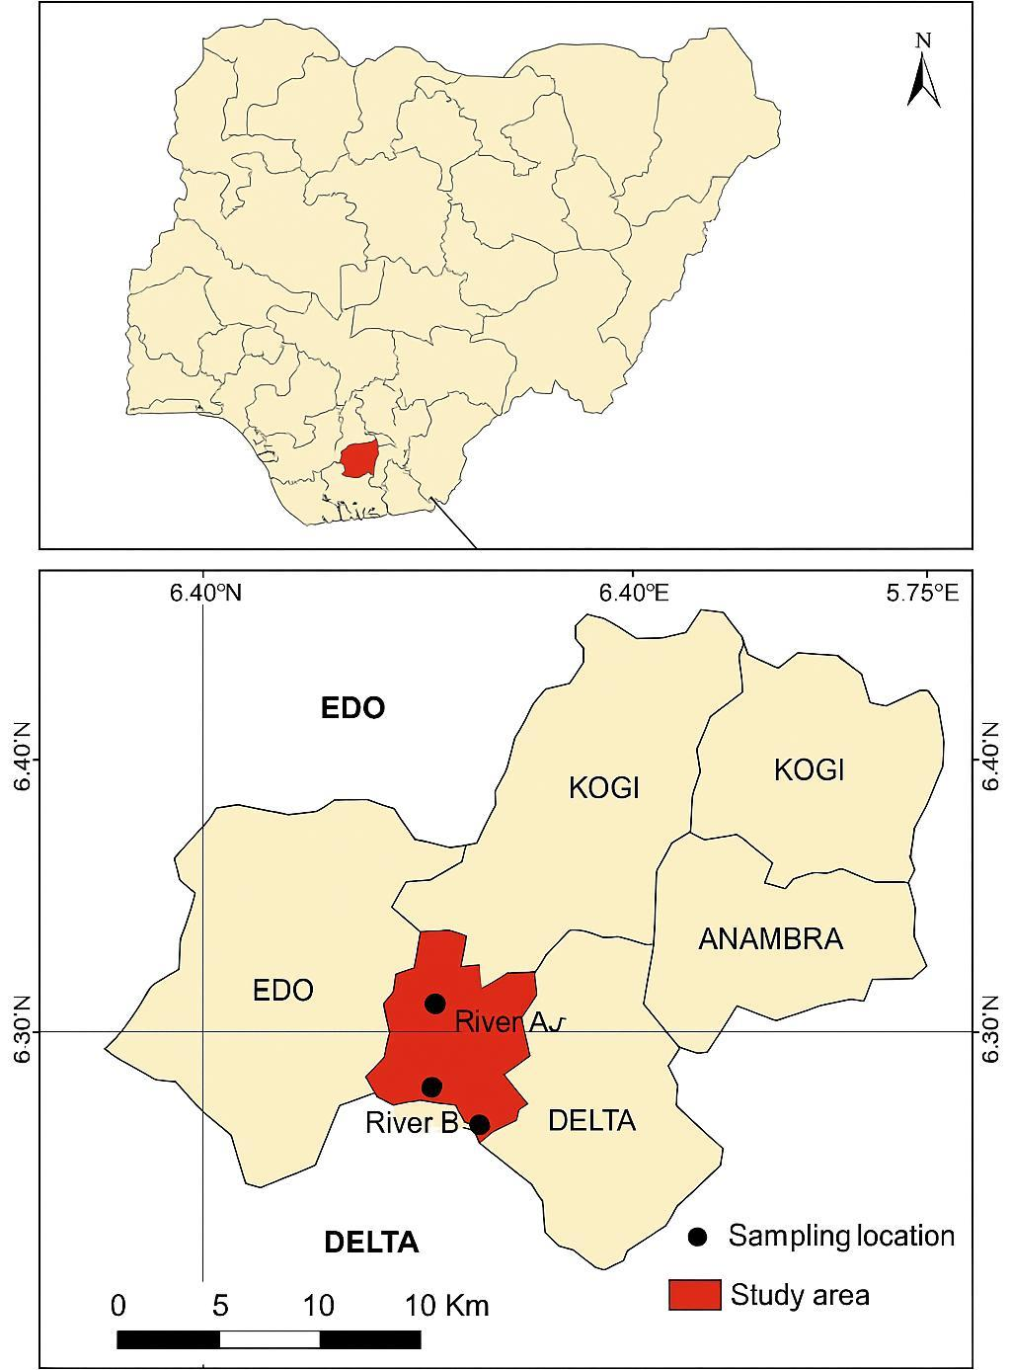
Figure 1: Map of the Study Area Showing Sampling Locations in Benin City, Edo State, Nigeria

2.2 Sample Collection
A cross-sectional sampling design was adopted to assess the physicochemical properties, surfactant concentrations, and heavy metal levels in the rivers. Water samples were collected from midstream points in each river to minimise bank interference and ensure representativeness of river conditions. Three replicate samples were collected from each river, giving a total sample size of nine water samples.
Sampling was carried out using pre-cleaned 1-L polyethylene bottles. Each bottle was rinsed at least three times with the river water at the point of collection. Samples for physicochemical and surfactant analyses were stored in ice chests at 4°C and transported to the laboratory within six hours. Samples for heavy metal analysis were immediately acidified with concentrated nitric acid to reduce the pH below 2.0 and prevent metal adsorption or precipitation during storage.

2.3 Physicochemical Analysis

Physicochemical parameters, including pH, dissolved oxygen (DO), biological oxygen demand (BOD), chemical oxygen demand (COD), and turbidity, were analysed according to Standard Methods for the Examination of Water and Wastewater (APHA, 2017). pH was measured using a calibrated portable meter, DO was determined using a digital dissolved oxygen meter, BOD was analysed using the five-day incubation procedure, COD was measured using the closed reflux dichromate method, and turbidity was determined with a nephelometric meter. Instrument calibration was performed before each field and laboratory session to ensure accuracy.

2.4 Surfactant and Detergent Analysis

Surfactant concentrations, specifically linear alkylbenzene sulfonates (LAS) and sodium dodecyl sulfate (SDS), were determined using the methylene blue active substance (MBAS) spectrophotometric method. Water samples were extracted with chloroform, reacted with methylene blue dye, and the resulting ion pair was measured at an absorbance wavelength of 652 nm using a UV–Visible spectrophotometer. Calibration curves prepared from LAS and SDS standards were used to quantify concentrations in the samples.

2.5 Heavy Metal Analysis

Heavy metals, including Ni, Cu, Zn, Mn, and Fe, were analysed using Atomic Absorption Spectrophotometry (AAS). A 50-ml aliquot of each water sample was digested using a mixture of nitric and perchloric acids on a hot plate until a clear solution was obtained. Digested samples were filtered and diluted to 25 ml with deionised water before analysis. Metal concentrations were subsequently measured using AAS equipped with appropriate hollow cathode lamps. Analytical precision and accuracy were assessed using reagent blanks, duplicate analyses, and certified reference materials.

2.6 Data Treatment and Interpretation

Data for all parameters were compared against World Health Organisation (WHO) and United States Environmental Protection Agency (USEPA) guideline values for freshwater systems. Triplicate results for each river were summarised as mean and standard deviation to describe central tendencies and variability. Spatial variations among the rivers were examined to identify pollution patterns associated with domestic, commercial, and industrial activities within their catchments.

2.7 Quality Assurance and Quality Control

All analytical procedures adhered to strict quality assurance and quality control protocols. Glassware and sample containers were acid-washed and rinsed with deionised water before use. Recovery values for metal analyses ranged between 90% and 105%. Surfactant and heavy metal measurements were conducted in triplicate, and only mean values meeting acceptable precision thresholds were reported. All instruments were calibrated and validated before use to ensure the reliability and reproducibility of the data.

3.0 Results

3.1 Physicochemical Water Quality Parameters
Table 1 shows that all physicochemical parameters exhibited spatial variation across the three rivers. River B consistently recorded the poorest water quality, reflected in its lowest dissolved oxygen (4.80 ± 0.18 mg/L) and highest levels of BOD (22.0 ± 1.2 mg/L), COD (50.0 ± 2.5 mg/L), and turbidity (15.0 ± 1.3 NTU). These patterns indicate substantial organic loading and suspended solids associated with domestic and commercial wastewater discharge. Rivers A and C showed comparatively better conditions, with River C having the highest DO (5.50 ± 0.20 mg/L) and lowest BOD (18.0 ± 0.9 mg/L). The pH range across sites (6.50 ± 0.12 to 6.90 ± 0.08) indicates slightly acidic to near-neutral conditions, typical of urban freshwater systems influenced by runoff and anthropogenic activities.
Table 1: Physicochemical Water Quality Parameters

Parameter | River A (Mean ± SD) | River B (Mean ± SD) | River C (Mean ± SD)
pH | 6.80 ± 0.10 | 6.50 ± 0.12 | 6.90 ± 0.08
DO (mg/L) | 5.20 ± 0.15 | 4.80 ± 0.18 | 5.50 ± 0.20
BOD (mg/L) | 20.0 ± 1.0 | 22.0 ± 1.2 | 18.0 ± 0.9
COD (mg/L) | 45.0 ± 2.0 | 50.0 ± 2.5 | 40.0 ± 1.8
Turbidity (NTU) | 12.0 ± 1.0 | 15.0 ± 1.3 | 10.0 ± 0.8
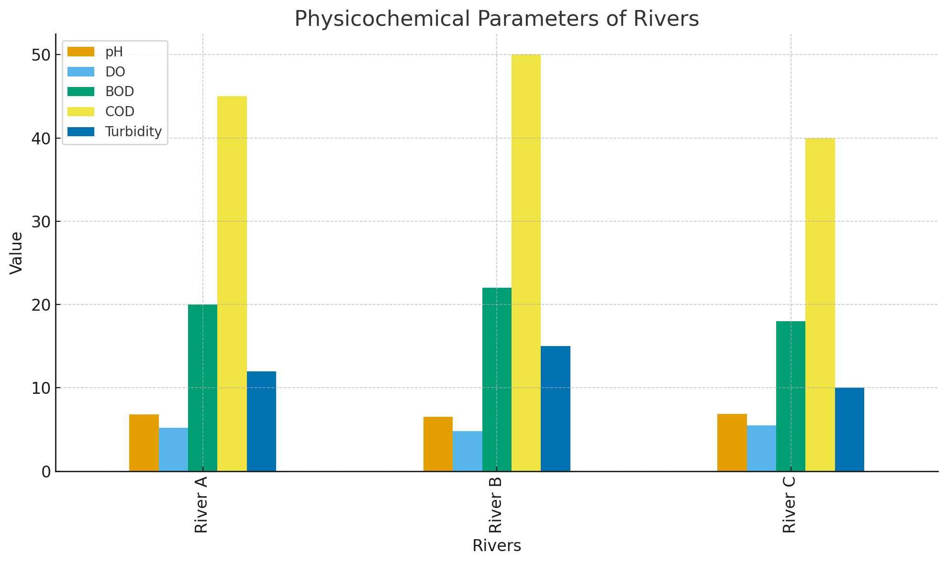
Figure 2: Physicochemical Water Quality Parameters
3.2 Surfactant and Detergent Concentrations
Table 2 demonstrates that surfactant contamination is present in all three rivers, with River B again showing the highest concentrations of both LAS (0.22 ± 0.03 mg/L) and SDS (0.12 ± 0.02 mg/L). These elevated levels are consistent with inputs from laundry effluents, car-wash operations, and domestic discharges concentrated in the River B catchment. River C recorded the lowest surfactant values (LAS: 0.15 ± 0.02 mg/L; SDS: 0.09 ± 0.01 mg/L), indicating comparatively reduced detergent pollution. LAS concentrations in Rivers A and B fall within or exceed the upper WHO/USEPA guideline of 0.2 mg/L, suggesting a risk of ecological stress, particularly in River B, where detergent pollution is most pronounced.
Table 2: Surfactant Concentrations (mg/L)
Parameters | River A (Mean ± SD) | River B (Mean ± SD) | River C (Mean ± SD) | WHO/USEPA Limit
LAS (mg/L) | 0.18 ± 0.02 | 0.22 ± 0.03 | 0.15 ± 0.02 | 0.1–0.2
SDS (mg/L) | 0.10 ± 0.01 | 0.12 ± 0.02 | 0.09 ± 0.01 | –

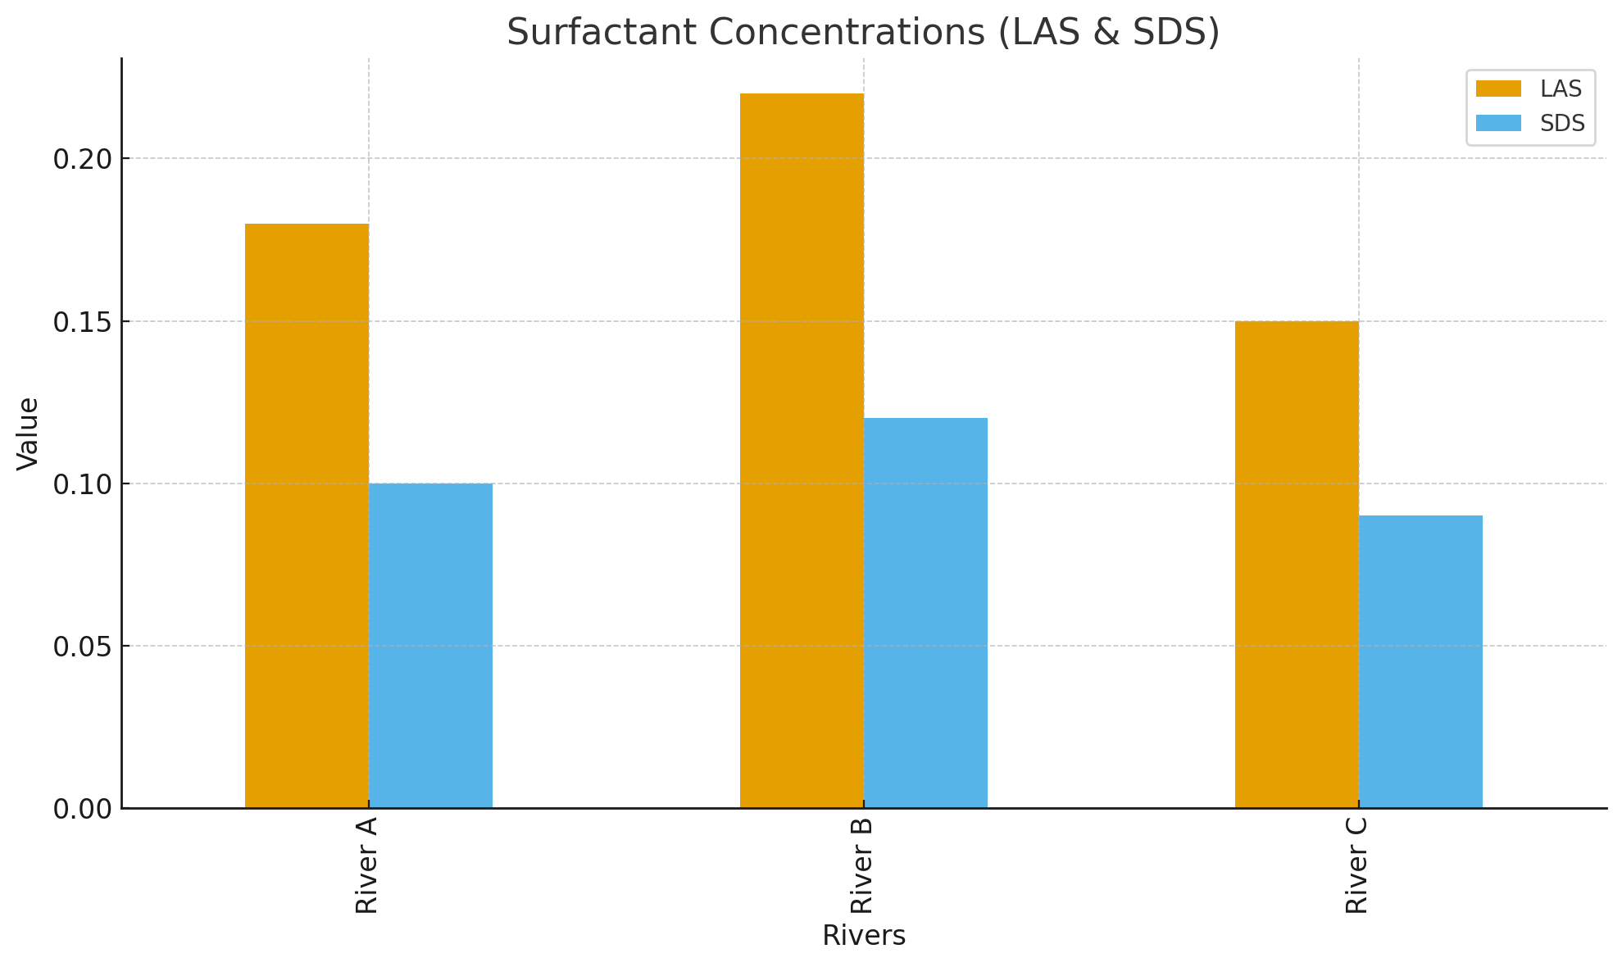
Figure 3: Surfactant Concentrations (mg/L)

3.3 Heavy Metal Concentrations
Table 3 reveals spatial differences in metal contamination across the rivers, with River B exhibiting the highest levels for all metals measured. Nickel, copper, zinc, manganese, and iron all show elevated mean concentrations in River B (e.g., Fe: 350 ± 31 µg/L; Mn: 110 ± 12 µg/L), reflecting intensified inputs from urban runoff, corroded infrastructure, and domestic waste. Rivers A and C recorded comparatively lower metal concentrations, although Fe in River A (300 ± 28 µg/L) reached the WHO threshold for iron in freshwater systems. Despite all metal values remaining within WHO guideline limits, their combined presence with elevated surfactant levels underscores potential cumulative ecological risks. The observed patterns highlight River B as the most impacted system, corresponding with its proximity to high-density residential and commercial activities.
Table 3: Heavy Metal Concentrations (µg/L)
Metals | River A (Mean ± SD) | River B (Mean ± SD) | River C (Mean ± SD) | WHO Limits (µg/L)
Ni | 20.0 ± 2.5 | 25.0 ± 3.0 | 18.0 ± 2.0 | 70
Cu | 14.0 ± 1.8 | 17.0 ± 2.1 | 12.0 ± 1.5 | 2000
Zn | 50.0 ± 5.5 | 60.0 ± 6.2 | 45.0 ± 5.0 | 3000
Mn | 90.0 ± 10.0 | 110.0 ± 12.0 | 80.0 ± 9.0 | 400
Fe | 300.0 ± 28.0 | 350.0 ± 31.0 | 280.0 ± 26.0 | 300
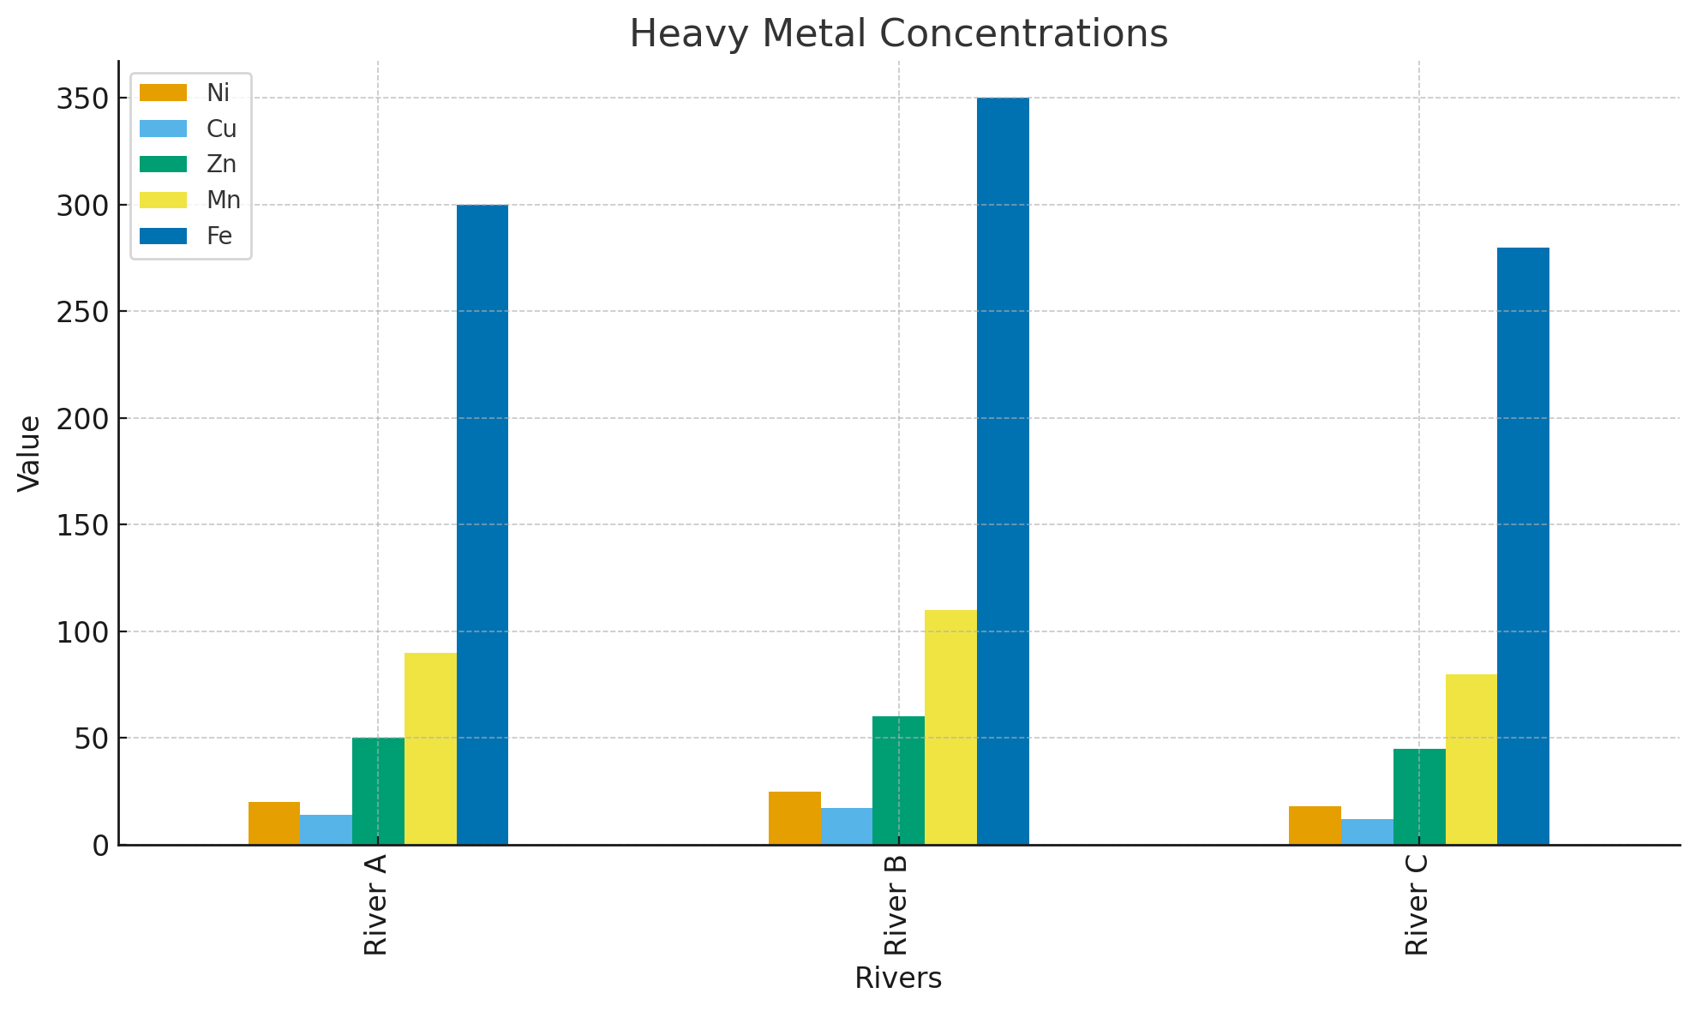
Figure 4: Heavy Metal Concentrations (µg/L)

4.0 Discussion
The findings of this study demonstrate that the three urban rivers in Benin City, within the broader Niger Delta region, are experiencing significant water-quality degradation arising from organic pollution, surfactant contamination, and trace-metal enrichment. Among the three systems, River B consistently exhibited the poorest water quality, indicated by lower dissolved oxygen and higher BOD, COD, and turbidity. These patterns suggest intense organic loading and reduced aeration, likely associated with domestic wastewater, commercial laundries, car-wash activities, and urban runoff typical of rapidly developing Nigerian cities (Aghanwa et al., 2025; Ekpe et al., 2025).
Surfactant concentrations were also highest in River B, reinforcing the influence of detergent-rich effluents from household and commercial activities. Although LAS concentrations lie within or slightly above guideline ranges, the absence of specific regulatory thresholds for SDS necessitates interpretation based on general ecotoxicological evidence rather than direct regulatory comparison. Surfactants are known to interfere with membrane integrity, oxygen transfer, and biochemical processes in aquatic organisms (ATSDR, 1997; IARC, 2015), but it is important to note that the present study did not conduct toxicity assays or biological sampling. Therefore, the ecological implications inferred here arise from physicochemical indicators rather than organism-level measurements.
Heavy metal concentrations followed a similar spatial pattern, with River B recording the highest levels of Ni, Cu, Zn, Mn, and Fe. Notably, iron in River B exceeded the WHO guideline value of 300 µg/L, indicating a clear exceedance of permissible limits. This exceedance may reflect contributions from corroded pipes, eroded soils, and drainage channels, consistent with observations from other anthropogenically stressed river systems in the Niger Delta (Okpoji et al., 2025; Umueni et al., 2025). Although other metals fell within WHO limits, their co-occurrence with high surfactant and organic loads may contribute to cumulative ecological stress, aligning with previous studies that highlight the interactive effects of multiple contaminants in polluted freshwater ecosystems (Okagbare et al., 2025; Eyenubo et al., 2024).
The contamination patterns observed here correspond with established evidence showing that rivers receiving continuous inflows of domestic and industrial effluents accumulate metals and detergent residues in both water and sediments (Oghenekohwiroro & Osaro, 2017; John et al., 2025). However, unlike hydrophobic contaminants such as PAHs and PCBs investigated in related Niger Delta studies (Ernesto et al., 2021; Stewart et al., 2000), the surfactants measured here behave differently in terms of environmental persistence and degradability. Moreover, the MBAS method used in this study quantifies total anionic surfactants and does not fully differentiate LAS and SDS from other anionic species. This analytical limitation means that reported surfactant concentrations are operational values rather than definitive compound-specific measurements (Kallenborn et al., 2015; Wania et al., 2006), and future studies employing chromatographic confirmation such as HPLC or LC-MS would strengthen surfactant speciation.
It is also important to acknowledge that sampling was conducted during a single season, and the results therefore represent water-quality conditions at a specific point in time. Seasonal variability, which strongly influences pollutant transport and dilution in southern Nigeria’s humid tropical climate, was not assessed. Similar limitations have been identified in other regional studies where hydrological seasonality significantly affects contaminant levels (Lawal, 2023; Ekpe et al., 2025). Consequently, while the present findings illustrate clear spatial differences among the rivers, temporal dynamics remain a topic for future research.
Although the physicochemical results indicate potential ecological stress, the study did not conduct bioaccumulation assessments, toxicity tests, or aquatic-organism surveys. Therefore, conclusions regarding biological impacts remain inferential, consistent with literature where physicochemical degradation is used as a proxy for ecological risk in urbanised freshwater systems (Okpoji et al., 2025; Ekwere et al., 2025). A more comprehensive ecological assessment incorporating sediment analysis, organism-level biomarkers, and tissue metal accumulation would provide stronger evidence of ecological impairment.
The patterns observed in this study underscore the cumulative effects of domestic wastewater, detergent-rich effluents, and trace metals on urban rivers in Benin City. River B, in particular, exhibits the highest degree of anthropogenic influence, reflecting the intensity of urban activities within its catchment. These findings align with broader research across the Niger Delta demonstrating that freshwater systems exposed to multiple pollution sources experience pronounced ecological stress and water-quality decline (Aghanwa et al., 2025; Okpoji et al., 2025). Mitigating these impacts will require improved wastewater treatment, regulation of detergent discharges, routine monitoring, and targeted ecotoxicological studies to better understand the implications for aquatic life.

Conclusion
This study demonstrates that the three urban rivers in Benin City are subject to considerable water-quality degradation driven by domestic wastewater, detergent discharges, and trace-metal contamination. River B was the most impacted, exhibiting elevated BOD, COD, turbidity, surfactant concentrations, and trace metals, coupled with reduced dissolved oxygen. These patterns indicate substantial anthropogenic pressure from residential, commercial, and vehicular activities within its catchment.
Although most metals were within recommended guideline values, iron in River B exceeded the allowable limit, highlighting a clear localised exceedance and emphasising the need for improved wastewater and infrastructural management. Surfactant concentrations, particularly LAS and SDS, further reflected detergent-derived pollution. Because SDS lacks formal regulatory limits and the MBAS procedure detects total anionic surfactants rather than individual compounds, the reported surfactant values should be interpreted cautiously.
The study was based on a single-season sampling campaign, and the results therefore represent conditions at one point in time. Seasonal variations, which influence runoff and pollutant dynamics, were not assessed. Furthermore, no ecotoxicological assays or biota analyses were conducted, meaning that ecological implications are inferred from physicochemical indicators rather than direct biological evidence.
Despite these limitations, the findings highlight the cumulative influence of organic pollution, surfactants, and metals on urban river systems in Benin City. Improving wastewater treatment, regulating detergent-rich effluents, enhancing stormwater management, and implementing regular monitoring programmes are essential steps toward restoring the ecological integrity of these rivers. Future work should incorporate seasonal sampling, more specific analytical techniques for surfactant speciation, and biological assessments to better understand pollutant interactions and their effects on aquatic ecosystems.
Disclaimer (Artificial intelligence)
Option 1:
Author(s) hereby declare that NO generative AI technologies such as Large Language Models (ChatGPT, COPILOT, etc.) and text-to-image generators have been used during the writing or editing of this manuscript.

References
Agency for Toxic Substances and Disease Registry (ATSDR). (1997). Toxicological Profile for Polychlorinated Biphenyls (PCBs). Public Health Service, U.S. Department of Health and Human Services, Atlanta, GA. https://sjrda.stuchalk.domains.unf.edu/files/content/sjrda_42.pdf
Aghanwa, C. I., Umueni, U. E., Etukudo, N. J., Amachree, J. B., Okpoji, A. U., Ejeka, C. J., & Ekwere, I. O. (2025). Atmospheric deposition of soot and heavy metals from gas flaring into surface waters of Ebocha, Rivers State, Nigeria. Asian Journal of Environment & Ecology, 24(11), 137–147. DOI: 10.9734/ajee/2025/v24i11822
Ekpe, J. E., Okpoji, A. U., Ekwere, I. O., Anarada, C. J., Ewuola, A. A., Ufuoma, V. O., Okpanachi, C. B., Okonkwo, C. O., & Obunezi, O. A. (2025). Physico-chemical transport of pesticides and nutrients in irrigation water and their fate in agro-ecosystems of Rivers State, Nigeria. Palgo Journal of Agriculture, 9(2), 30–37. DOI: https://doi.org/10.5281/zenodo.17148360
Ekwere, I. O., Okpoji, A. U., Igwegbe, K. C., Okonkwo, C. O., Yekeen, A. A., Obunezi, O. C., Okpanachi, C. B., Garuba, M. H., Ogini, O. R., & Odibo, U. E. (2025). Nutritional–Toxicological Trade-Off: Comparative study of polycyclic aromatic hydrocarbons in smoked and oven-dried Nile tilapia (Oreochromis niloticus). Journal of Environment, Climate, and Ecology, 2(2), 90–97. https://doi.org/10.69739/jece.v2i2.952
Ekwere, I. O., Okpoji, A. U., Ufuoma, V. O., Akinola, A. E., Raymond, C. A., Clement, R. O., Alaekwe, I. O., Etesin, M. O., & Edodi, I. O. (2025). Nutritional evaluation of Nile tilapia (Oreochromis niloticus) processed by different drying methods in Akwa Ibom State, Nigeria. Journal of Sustainable Research and Development, 1(2), 11–17. https://doi.org/10.69739/jsrd.v1i2.1033
Ernesto, O. Z. A. B., Dioselina, O. F. H., Marina, R. R. O., Hector, M., & Miguel. (2021). Bioaccumulation of PCBs and PBDEs in fish from a tropical Lake Chapala, Mexico. Toxics, 9(1). https://doi.org/10.3390/toxics9100241
Eyenubo, O. B., Peretomode, V. O., Egharevba, F., Osakwe, S. A., & Avwioro, O. G. (2024). Polychlorinated biphenyls (PCBs) in sediments and fish from dredged tributaries and creeks of River Ethiope, South-South Nigeria: Sources, risk assessment and bioaccumulation. Journal of the Nigerian Society of Physical Science, 6, 1951. DOI: 10.46481/jnsps 2024.1951
IARC (International Agency for Research on Cancer). (2015). Agents Classified by the IARC Monographs, Volumes 1–112. https://monographs.iarc.who.int/agents-classified-by-the-iarc/
Ibe, U. (2023). Challenges in environmental remediation in complex regions: Case study of the Niger Delta. Journal of Toxic Substance Management, 12(3), 204–219.
John, E. E., Emah, O. A., Ifiok, O. E., Okpoji, A. U., Iyam, O. E., Henderson, O. O., Akinola, A. E., Gloria, N. A., & Charles, N. O. (2025). Health risk implications of polycyclic aromatic hydrocarbons in smoked and dried fish consumed in Nigeria. Journal of Medical Science, Biology, and Chemistry, 2(2), 192–199. https://doi.org/10.69739/jmsbc.v2i2.1045
Kallenborn, R., Hung, H., & Brorström-Lundén, E. (2015). Atmospheric long-range transport of persistent organic pollutants (POPs) into polar regions. In Comprehensive Analytical Chemistry (Vol. 67, p. 411). Elsevier. https://doi.org/10.1016/B978-0-444-63299-9.00013-2
Kwok, F. (2023). Enhancing global cooperation in environmental governance. Global Environmental Politics, 21(1), 77–92.
Lawal, A. (2023). Management strategies for PCBs in the Niger Delta: Achievements and challenges. Environmental Management Review, 29(1), 45–59.
Oghenekohwiroro, E., & Osaro, I. (2017). Assessment of the levels of polychlorinated biphenyls (PCBs) in Oroodo River sediment, Agbor, Delta State, Nigeria. Annals of Chemistry, 28, 25. DOI: 10.1515/auoc-2017-0005
Okagbare, U. V., Umueni, U. E., Ekpe, J. E., Etukudo, N. J., Okpoji, A. U., Okoye, P. I., Ekwere, I. O., Etesin, M. U., Okpanachi, C. B., & Okafor, C. A. (2025). Geophysical and hydrochemical assessment of groundwater vulnerability to oil pollution in Yenagoa, Bayelsa State, Nigeria. Journal of Environment, Climate, and Ecology, 2(2), 138–146. https://doi.org/10.69739/jece.v2i2.1078
Okpoji, A. U., Anarado, C. O., Mmuta, E. C., Ekwere, I. O., Alaekwe, I. O., Odibo, U. E., Igwegbe, K. C., Eboj-Ajoku, I. O., & Obunezi, O. C. (2025). Toxicological evaluation of Pb, Cd, As, and Hg in blue crab from oil-polluted creeks in the Niger Delta. Journal of Life Science and Public Health, 1(1), 24–31. https://doi.org/10.69739/jlsph.v1i1.879
Okpoji, A. U., Chinyere, U. E., Nwokoye, J. N., Ezekwuemen, O. I., Alaekwe, I. O., Odidika, C. C., Owughara, C. N., Enyi, C. M., & Kolawole, O. O. (2025). Environmental assessment of heavy metals and hydrocarbon pollution in surface waters of oil-bearing communities in Andoni, Rivers State, Nigeria. International Journal of Modern Science and Research Technology, 3(8), 22–30. https://www.ijmsrt.com/articles/view/environmental-assessment-of-heavy-metals-and-hydrocarbon-pollution-in-surface-waters-of-oil-bearing-communities-in-andoni-rivers-state-nigeria
Okpoji, A. U., Eboh-Ajoku, I. O., Mmuta, E. C., Ndubuisi, J. O., Alaekwe, I. O., Odibo, U. E., Nwoka, N. G., Okafor, C. A., & Obunezi, O. C. (2025). Integrated environmental risk assessment of BTEX and PAHs in water and sediment samples from the Bonny River, Nigeria. ISA Journal of Multidisciplinary (ISAJM), 2(4), 14–21. DOI: 10.5281/zenodo.16921896
Okpoji, A. U., Ekwere, I. O., Igwegbe, K. C., Anarado, C. J. O., Ogbonna, C., Ewuola, A. A., Odibo, U. E., & Garuba, M. H. (2025). Volatile organic compounds from gas flaring and their atmospheric implications in the Niger Delta. Journal of Life Science and Public Health, 1(1), 32–39. https://doi.org/10.69739/jlsph.v1i1.962
Okpoji, A. U., Etesin, M. U., Ekwere, I. O., Martins, N. P., Okpanachi, C. B., Adisa, O. J., & Okonkwo, C. C. (2025). Geochemical speciation and ecological risk of heavy metals in estuarine sediments of the Qua Iboe River, Nigeria. Asian Journal of Chemical Sciences, 15(6), 20–31. DOI: 10.9734/ajocs/2025/v15i6402
Okpoji, A. U., Ndubuisi, J. O., Eboh-Ajoku, I. O., Emem, J. A., Ekwere, I. O., Alaekwe, I. O., Odibo, U. E., Igwegbe, K. C., Onoja, C. R., Warder, A. B., & InyangAbia, A. J. (2025). Trematode infections and histopathological effects in Chrysichthys nigrodigitatus from the polluted Andoni River, Niger Delta, Nigeria. Journal of Agriculture, Aquaculture, and Animal Science, 2(2), 66–72. https://doi.org/10.69739/jaaas.v2i2.882
Okpoji, A. U., Ogbaji, H. O., Hassan, D. H., Orji-Azuka, L. N., Rasheed, H. O., Ohaturuonye, S. O., Ejeka, J. C., Okpanachi, C. B., & Ekwere, I. O. (2025). Physico-chemical transport of volatile organic compounds (VOCs) from gas flaring into surface waters of Ogoniland, Rivers State, Nigeria. Asian Journal of Physical and Chemical Sciences, 13(4), 151–159. DOI: 10.9734/ajopacs/2025/v13i4271
Okpoji, A. U., Ugwanyi, G. C., Etesin, U. M., Ugwuanyi, G. C., Okpanachi, C. B., Ewuola, A. A., Mojisola, K. M., & Ezekwueme, O. I. (2025). Solar-enhanced photocatalytic degradation of pharmaceutical residues in wastewater using Fe-, Cu-, and Zn-doped TiO₂ nanomaterials. Journal of Environment, Climate, and Ecology, 2(2), 56–62. https://doi.org/10.69739/jece.v2i2.961
Onoja, C. R., Ogbaji, H. O., Edodi, I. O., Mmuta, E. C., Igwegbe, K. C., Ogini, O. R., Odibo, U. E., Ewuola, A. A., Mahmoud, A. B., & Okpoji, A. U. (2025). Heavy metal contamination and health risk assessment of smoked-dried fish sold in Eke-Awka market, Anambra State, Nigeria. Journal of Sustainable Research and Development, 1(2), 18–25. https://doi.org/10.69739/jsrd.v1i2.1044
Stewart, P., Reihman, J., Lonky, E., Darvill, T., & Pagano, J. (2000). Prenatal PCB exposure and neonatal behavioural assessment scale (NBAS) performance. Neurotoxicology and Teratology, 22(1), 21–29. https://doi.org/10.1016/S0892-0362(99)00056-2
Umueni, U. E., Etukudo, N. J., Okoye, P. I., Okpoji, A. U., Eze, V. C., Aningo, G. N., Ekwere, I. O., & Garuba, M. H. (2025). Geochemical and ecological risk assessment of petroleum hydrocarbons in sediments of the Forcados River, Delta State. Asian Journal of Geographical Research, 8(4), 287–298. DOI: 10.9734/ajgr/2025/v8i4337
USEPA (United States Environmental Protection Agency). (2011). Regional Screening Level (RSL) Table for Chemical Contamination at Superfund Sites. https://www.epa.gov/risk/regional-screening-levels-rsls
Wania, F., Bereik, K., Persson, N. J., & McLachlan, M. S. (2006). A fugacity-based dynamic multi-compartmental mass balance model of the fate of persistent organic pollutants. Environmental Modelling & Software, 21, 868. https://doi.org/10.1016/j.envsoft.2005.04.003
World Bank. (2014). Life expectancy data. https://data.worldbank.org/indicator/SP.DYN.LE00.IN

