Original Article
Sedimentary Facies, Depositional Settings and Reservoir Potential of the Owelli Sandstone in Anambra Basin, Southeastern Nigeria

Abstract
The study was undertaken on the Owelli Sandstone for the purpose of evaluation of its lithofacies, depositional settings and reservoir potential. Methodology involves fielding mapping and outcrop logging, lithofacies, paleocurrent and grain size analyses. Seven lithofacies identified were grouped into three lithofacies association; tidal channel, fluvio- Delta and tidal Delta. The rose plots of cross bed azimuths are consistent with the mean vector azimuths, current variance and vector strength, suggesting paleocurrent to be unimodal in the southwesterly directions with dominantly high energy and low variance. Integration of facies association, paleocurrent and grain size data indicated the depositional settings of the Owelli Sandstone to range from marginal to shallow marine. The estimated porosity and permeability range of 45 to 50% and 30.1 to 2301md respectively rated the Owelli Sandstone as good to excellent reservoir. The best reservoirs in the formation is the shallow marine sandstone at Agbogugu area
Keywords: Grain, Porosity, Paleocurrent, Permeability, Fluvio- Delta, Lithofacies

1.0 Introduction
A depositional environment is a geographically restricted part of the earth's surface which is characterized by the complex of physical, chemical and biologic conditions, influences or forces under which sediment accumulates. The complex which distinguishes it from the adjacent areas also determines the properties of the sediments deposited within it (Krumbein and Sloss, 1963; Potter, 1967; Pettijohn, 1975; Selley, 1978; Reineck and Singh, 1980; Slumberger, 1989).
Depositional environment of reservoir sands is a major control on the reservoir quality and heterogeneity (Menachery, 2008; Obi et al., 2013; Okoro et al., 2020). To accurately characterize the potential reservoir, one must address the geologically defined variability in the system. Gross differences in sedimentary facies, as well as more local variations in aspects such as grain size/type, grain sorting, sedimentary structures, and diagenetic overprint, may all influence the internal make up and geometry of the sedimentary deposits, thus, the heterogeneity of potential reservoirs (Grammer, 2004). The geologically based model increases our understanding of reservoir heterogeneity and also provides foundation for which the rest of the reservoir models, ultimately, simulation models can be built.
Moreover, petrophysical properties of reservoir rocks which include the porosity, permeability are influenced by current velocity, degree of current variance, grain size, sorting etc. These properties are partly controlled by facies characteristics which in turn are related to depositional environment (Obi et al., 2013).
Additionally, outcrop models have typically been relied on to generate a proxy for subsurface reservoir distribution (e.g Borer and Harris, 1991; Tyler and Finly, 1991; Grant et al., 1994; Kerans et al., 1994, Grammer et al., 1996; White and Barton, 1999; McLaurin and Steele, 2000; Willis and White, 2000; Willis and Gabel, 2001; Camacho et al., 2002; Okoro et al., 2020; Bello et al., 2023; Ocheli et al., 2025).
Also outcrop analogs provide 2- D and occasionally 3- D views of facies with better details of diagenetic overprint than is found in the subsurface, thus provide a more complete view of both facies and reservoir quality dimensions than can be gleaned from subsurface data alone (Grammer et al., 2004).
Additionally, the heterogeneity of potential reservoir quality in the Joulters Cay Shoal Complex was inferred on the basis of the distribution of depositional facies (Major et al., 1996). The inference of the heterogeneity was on the basis of the mud content, burrowing, and grain type variability.
Since discovery of commercial hydrocarbon in the Anambra Basin by Safrap, north of Onitsha in 1967 (Avbovbo and Ayoola, 1981), series of work have been carried out and more are still on- going on the petroleum system of the basin. Source rock potentials of the Nkporo, Enugu and Mamu Formations have been evaluated (e.g Avbovbo and Ayoola, 1981; Unomah and Ekweozor, 1993; Akaegbobi and Schmidt, 1998; Obaje et al., 1999; Nwajide, 2005; Akande et al., 2007; Ojo et al., 2009; Ogala, 2011; Anozie et al., 2014). Much attention needs to be given to the sandy facies of the basin in terms of reservoir quality assessments.
Studies have shown that about 50% of the world's petroleum reserve is estimated to occur in sandstones (Berg, 1986). Owelli Sandstone is dominantly sandy units. Nwajide (2022) noted the heavy crude petroleum seeps out of the formation in two different localities. Hence, the need to re-evaluate the lithofacies, delineate the depositional environment of the sediments and determine the reservoir potential of the formation.
Studies have proven that reservoir effective porosity or permeability, sediment sorting, reservoir heterogeneity and depositional environments can be estimated from the current variance and vector strength (Obi et al., 2013) as well as grain size data (e.g Okoro et al., 2020; Ocheli et al., 2025). This research will employ the facies analysis, sedimentary texture and paleo-current data in the reconstruction of the environment of deposition of the Owelli Sandstone, determination of its reservoir heterogeneity and estimation of the reservoir Porosity and permeability.

1.1 The Study Area

The study area is bounded by latitudes N6⁰5¹.30¹¹and N6⁰14¹ 30¹¹ and longitudes E7⁰24¹.0¹¹and E7⁰31¹ 0¹¹ of Greenwich meridian. It lies within south eastern Nigeria sedimentary basin (Anambra Basin). It is about 26km from Enugu Metropolis. The area of study is located on Enugu Cuesta precisely Awgu Escarpment and it covers Agbogugu, Mmaku, Achi, Owelli and Ogbaku (Figure 1).
However, the study area is accessible through Enugu-Okigwe Express way. Most of the sand outcrops of the area are accessible through tarred roads, laterite graded roads (minor roads) and footpaths. They are Enugu-Okigwe Express way, Agbogugu-Ogbaku road, Agbogugu-Owelli road, Obeagu-Oweload, Mmaku-Owelli road, Enugu MmakuObeagu road and Obeagu-Achi road.
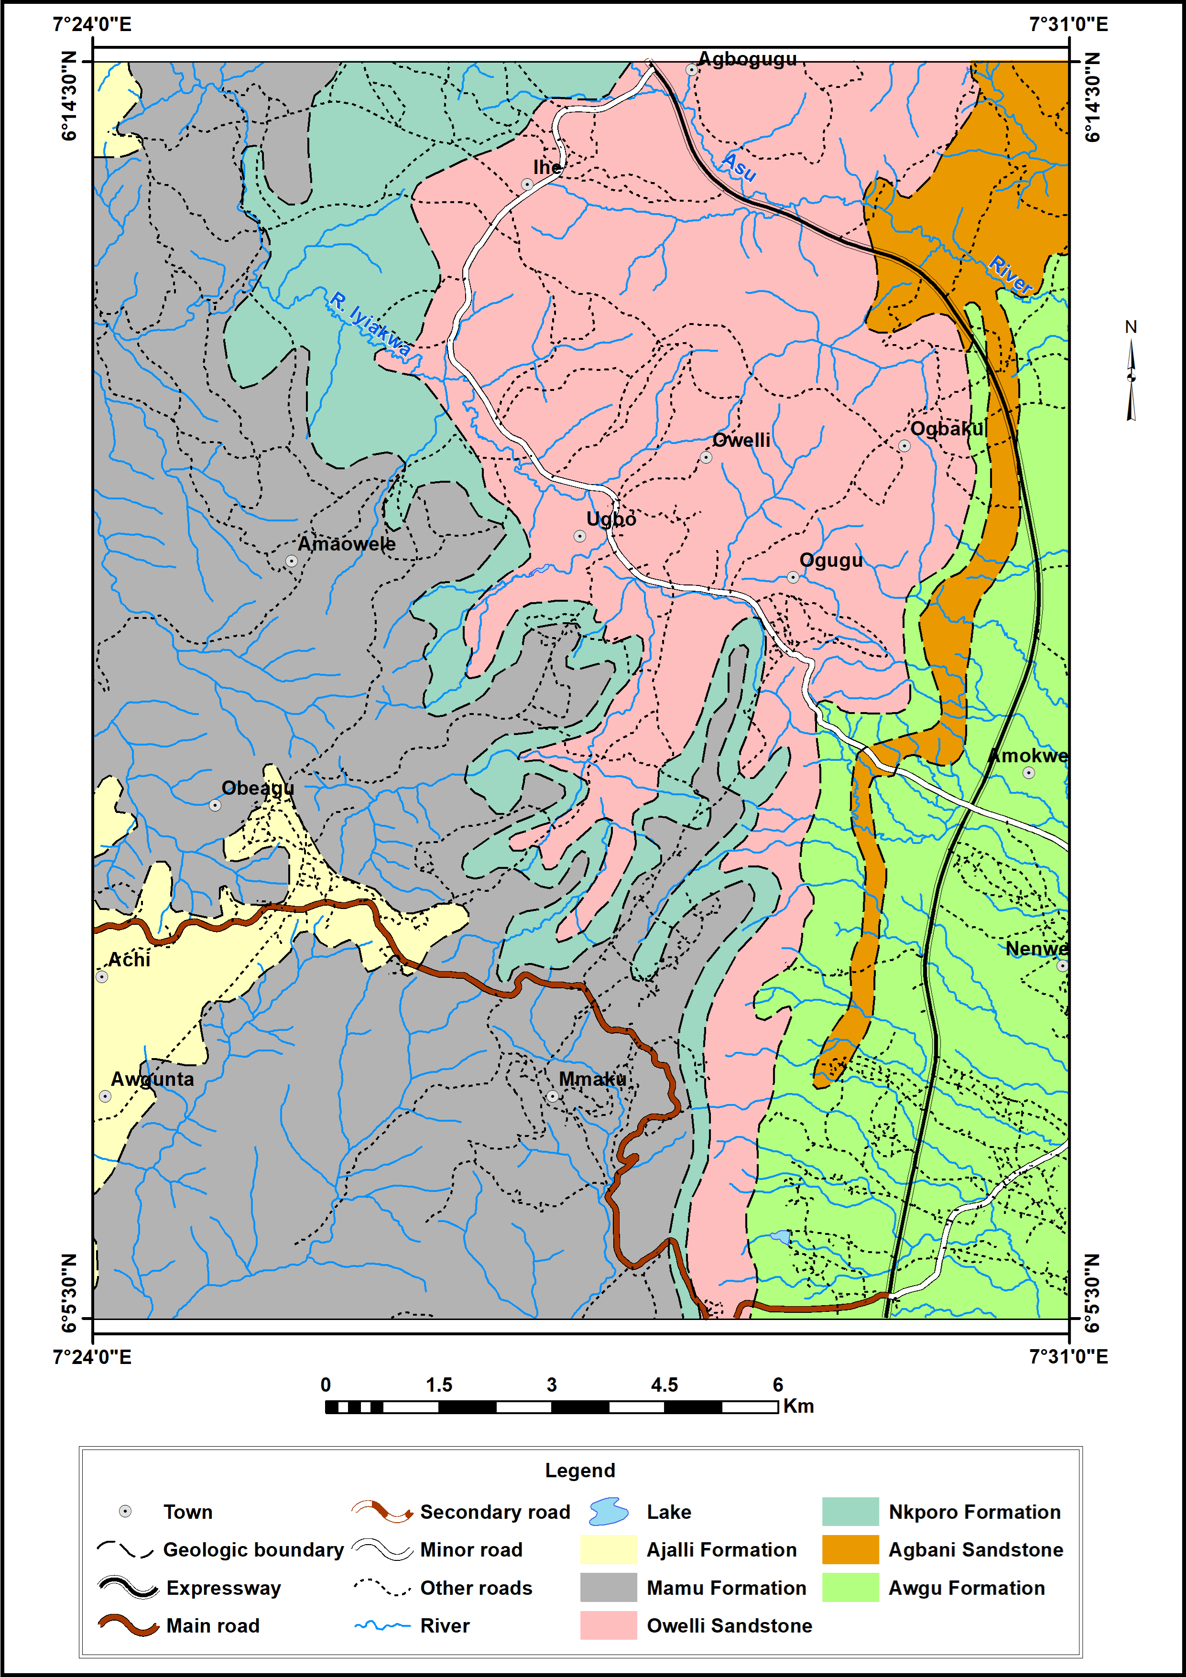
Figure1: Geologic map of the study area.

1.2: Regional Tectonics and Stratigraphic Setting
The origin of the Anambra asin is related to the development of the Benue Trough. Nwajide (2022) described the Benue Trough as a fundamental tectonic-sedimentological feature in the evolution of the Creataceous and Tertiary geology of Nigeria. The Benue Trough formed as the failed arm of RRR trilete rift (aulocogen) during the Gondwana break-up and the subsequent opening of the southern Atlantic Ocean during the Jurassic (Burke et al., 1972; Olade, 1975; Benkhlil, 1982, 1989; Hoque and Nwajide, 1984; Fairhead, 1988).
The position of the Benue Trough in the evolution of Nigeria’s geological features is such that most other sedimentary basins are genetically related to it. It is viewed simply as an elongate intracratonic structure that is over 1000 km long and up to 250km at its widest parts
(Nwajide, 2022). It developed as a pure rift structure in the Pan-African mobile belt.
The initial synrift sedimentation in the embryonic trough occurred during the Aptian to early Albian and comprised of alluvial fans and lacustrine sediments of the Mamfe Formation in the southern Benue Trough (Onuigbo et al., 2016). Two cycles of marine transgressions and regressions from the middle Albian to the Coniacian filled this ancestral trough with mudrock, sandstones and limestones with an estimated thickness of 3,500 m (Murat, 1972; Hoque, 1977). These sediments belong to the Asu River Group (Albian), the Odukpani Formation (Cenomanian), the Ezeaku Group (Turonian) and the Awgu Shale (Coniacian). During the Santonianepeirogenic tectonics the sediments underwent folding and uplifted into the Abakaliki- Benue Anticlinorium (Murat, 1972) with simultaneous subsidence of the Anambra Basin and the Afikpo Sub- Basins to the northwest and southeast of the folded belt respectively (Murat, 1972; Burke, 1972; Obi, 2000; Mode and Onuoha, 2001). Nwajide (2022) noted that the localized subsidence on the western reach of the Southern Benue Trough and the continued sea level rise into the Coniacian, led to the installation of the Anambra Basin. The filling of the Anambra Basin took place within the time interval from Santonian to Early Paleocene (Danian), a time span of absolute Ca. 60My. There were two marine transgressions – a major one (the Nkporo transgression) and a less extensive one (the Nsukka transgression). The stratigraphic packaging of the Anambra Basin is therefore, divided into two namely; the Nkporo Group and the Coal Measures (Nwajide, 2022).The Campanian–early Maastrichtian transgression deposited the Nkporo Group (i.e. the Enugu Formation, Owelli Sandstone, Nkporo Shale, Afikpo Sandstone, Otobi Sandstone and Lafia Sandstone) as the basal unit of the basin, unconformably overlying the Awgu Formation. This was followed by the Maastrichtian regressive event during which the coal measures (i.e the Mamu, the Ajali and the Nsukka Formations) were deposited Onuigbo et al., (2016).
The AbakalikiAnticlinorium later served as a sediment dispersal centre from which sediments were shifted into the Anambra Basin and Afikpo Sub- basin. The Oban Masif, southwestern Nigeria basement craton and Cameroon basement complex also served as sources for the sediments of the Anambra Basin (Hoque and Ezepue, 1977; Amajor, 1987; Nwajide and Reijers, 1996).

2.0 Materials and Methods
A detailed and careful traversing was carried out in the study area and selected exposures or outcrops were studied in terms of the nature of the lithologies, composition and textures. Thickness of individual beds was taken. Type and orientation of burrows which occur in the units were carefully noted. The attitude of the beds (strike, dip amount and dip direction) were taken. Sedimentary structures which occur in the units were properly documented and azimuths of cross beds were measured. The lithologs of the exposures were produced. Photographs of Important features were taken with scale and representative samples of sand were collected for laboratory analyses.
2.1 Laboratory Method
2.1.1: Lithofacies Analysis
The various lithofacies which occur in the area were identified and described based on lithology, texture and sedimentary structures.The lithofacies association and succession were described and employed in the interpretation of environment of deposition.

2.1.2: Paleocurrent Analysis
The trignometric method was used to calculate the mean vector azimuth (MVA), variance (var) and vector strength from the azimuths of many cross beds taken in the field. Mean vector azimuth, vector strength and current variance were determined based on Steinsmetz (1962) stated as equations 1 to 3
MVA=tan-1⁻(∑Sin A/∑Cos A) 1 1
Variance (Var) =∑(A1-A)²/n-1 2
Vector strength =Ѵ (((∑Sin A) ² + (∑Cos A²/n) 3
Where n= no of readings, Sin A and Cos A are the sines and the cosines of the individual readings respectively, and ∑Sin A and ∑Cos A are the sums of the sines and cosines of the individual readings. A1 represents the individual azimuth readings, while A represents the value of the mean vector azimuth (MVA).
Furthermore, the azimuth data from various locations were plotted into rose diagrams for paleocurrent interpretation. The measured azimuths were placed into class intervals of 0 to 30, 31 to 60 until 331 to 360 and the frequency or number of readings within each class interval were counted and recorded. A scale was prepared and the percentage frequency in each class was plotted in a rose diagram.
The Environments of deposition of the sediments were also interpreted based on current variance and Vector Strength. Values of variance greater than 6000 indicate a shallow marine environment while values between 2000 and 6000 suggest fluvio- deltaic environment (Potter and Pettijohn, 1963).
2.1.3: Sieve Analysis
The sand samples that were collected from the outcrops in various locations within the study area were firstly oven dried and disaggregated using mortar before sieving.
Procedure for Sieving
Mechanical sieving method was used in the analysis.
1. The weights of individual sieves were gotten and recorded. The sieve set was arranged such that the coarsest sieve required was at the topmost part of nest of sieves, in which the screen openings become progressively small downwards and with a pan placed beneath the lowest
sieve to retain the fines that will pass through the entire column (as described by Tucker, (1982).
2. 50g each of the dried and disaggregated sand samples were poured into the topmost sieve and
covered with the lid. The nest of sieve was carefully shaken for about 10 to 15 minutes.
3. The weight retained in each sieve, was taken and weight loss or gained by the sieves during
Sieving was accounted for.
4. The cumulative weight percent was calculated and plotted on log probability graph from which the values of percentiles at 5, 16, 25, 50, 75, 84 and 95 were recorded. The percentile values were employed in the calculation of grain size statistical parameters; mean, median,
graphic standard deviation, skewness and kurtosis following the method of Folk and Ward (1957) as shown in equations 4 to 7 and Table 1.
5. The grain size histograms of the sand samples were also produced.
Mean (Mz) is the average grain size in a given distribution. It is the product of source of supply, depositional processes and environment of deposition.
1. Mean = (ɸ16+ɸ50+ɸ84)/3 4
2. Standard Deviation/ Sorting = ɸ84 - ɸ16+ ɸ95 - ɸ5 5
4 6.6
3. Skewness (Sk) represents the asymmetry of the distribution. It is the best of all the parameters
to be used in studying the environment of deposition.
Skewness = (ɸ16+ɸ84-2ɸ50) + (ɸ5+ɸ95-2ɸ50)
2(ɸ84 - ɸ16) 2(ɸ95-ɸ5) 6

4. Kurtosis (KG) measures the ratio of spread in the center part of the distribution to the ratio of
spread at the ends of the distribution.
Kurtosis = ɸ95 - ɸ5
2.44(ɸ75 - ɸ25). 7

Table 1: Descriptive Terms and Scale (Folk and Ward1957)
Parameters | Scales | Description
Mean | 0-1 | Coarse
 | 1-2 | Medium
 | 2-3 | Fine
Sorting | Less than 0.35 | Very well sorted
 | 0.35-0.50 | Well sorted
 | 0.50-1.0 | Moderately sorted
 | 1.00– 2.00 | Poorly sorted
 | 2.00 – 4.00 | Very poorly sorted
 | >4.00 | Extremely poorly sorted
Skewness | -1.0 to -0.30 | Very negatively skewed
 | -0.30 to – 0.10 | Negatively skewed
 | -0.10 to +0.10 | Nearly symmetrical
 | +0.10 to +0.30 | Positively skewed
 | +0.30 to +1.00 | Very positively skewed
Kurtosis | <0.67 | Very platykurtic
 | 0.67 to 0.90 | Platykurtic
 | 0.90 to 1.11 | Mesokurtic
 | 1.11 to 1.50 | Leptokurtic
 | 1.50 to 3.00 | Very leptokurtic
 | >3.00 | Extremely leptokurtic

2.1.4. Environmental Discrimination functions
The multivariate functions; Y1, Y2 and Y3 and Y4 of Sahu (1964) were employed in the
delineation of the environment of deposition and are computed as follows;
Y1= -3.5688mz +3.7016δ² -2.0766SK +3.1135KG (8)
When Y1 is less than -2.7411, Aeolian deposit is indicted but When Y1 is greater than -2.7411
Beach environments is suspected
Y2 =15.6534Mz =65.7091δ² +18.1071SK +18.5043KG (9)
When Y2 is less than 65.350, beach deposition is suggested but when Y2 is greater than 65.350, shallow agitated marine environment (subtidal) is likely indicated.
Y3 =0.2852Mz -8.77604δ²-4.8932SK+0.0482KG (10)
When Y3 is greater than -7.419, it is identified as shallow marine sand but When Y3 is less than -7.419, the sand is identified as a fluvial -deltaic deposit.
Where Mz= mean, δ = graphic standard deviation, SK = skewness and KG = graphic inclusive
kurtosis.
Y4=0.7215Mz – 0.4030δ² + 6.7322SK + 5.2927KG (11)
When the value of Y4 is less than 9.8433, it indicates fluvial process, but when Y4 is greater than 9.8433, it suggests turbidity process.
2.1.4: Estimation and Prediction of the Reservoir Porosity and Permeability
(a) Estimation of the reservoir porosity and permeability from Current Variance and
Vector Strength.
The models of Hsu (1977) and Obi et al. (2013) was employed in the estimation or
prediction of the reservoir porosity and permeability of the Owelli Sandstone from current variance and vector strength were based on the following;
1. The current vector strength is inversely related to the sediment sorting. Therefore, low vector strength values correspond to higher average sorting while higher vector strengths correspond to poorly sorted sands. This implies that with increasing flow energy and turbulence, the sediments become more poorly sorted.
2. Increasing current velocity will deposit reservoir sands of lower effective porosity and vise versa.
3. The permeability of the reservoir sands decreases with increasing vector strength. Therefore, areas where sediments were deposited during higher energy conditions would have low permeability sands. This means that more poorly sorted sediments with lower porosity and permeability are deposited during higher and more turbulent energy conditions.
4. Variations in paleocurrent direction are lower in high energy environments such as tidal or fluvio- deltaic settings.
5. Current variance and sediment sorting are directly proportional to each other. Thus, reservoir sands deposited under low energy conditions(that is highly dispersed current directions or high variance as obtained in shallow marine settings are better sorted than those deposited by high energy currents (that is low variance, typical of tidal or alluvial settings).
6. Better sorted reservoir sands have higher permeability values and vise versa.
(b) Estimation of the Owelli Reservoir Porosity and permeability from Grain Size Data
Porosity and Permeability of the Owelli Sandstone were also evaluated using the grain size data and empirical equations of Hazen (1982) and Krumbein and Monk (1942) respectively. The two empirical equations are stated as follows;
Porosity = 0.255 (1+0.83^{u}) (12)
The empirical formula was estimated using the 10th (d1o) and 60th (d60) percentile values from grain size distribution curves plotted in millimeter (mm) against cumulative weight percent (%).
u is the coefficient of uniformity represented by ratio of d10/d60. d10 = grain size at 10th
percentile and d 60 = grain size at 60th percentile.
Permeability was calculated using Krumbein and Monk (1942); Leverson, 1967; Ogbe and Osokpor, 2021), stated as equation 13.
K = CoDm²e-1.31δ (13)
Where Co = constant = 760darcy/mm,
Dm = geometric mean of grain size diameter in mm
e = exponential
K = permeability
δ = standard deviation in phi.
The classification range for evaluation of Porosity and permeability employed in this work is after Hazen (1982) and Krumbein and Monk (1942) and is shown in Table 2.
Table 2: Classification range for Porosity and permeability evaluation after Hazen (1982) and Krumbein and Monk (1942).

Porosity(ф) | Interpretation | Permeability(md) | Interpretation
0.5  5 -10  15 -20  20 – 25  > 25 – 30 | Negligible  Poor  Good  Very good  Excellent | < 10 -15  15 -50  50 – 250  250 – 1000  > 1000 | Poor – Fair  Moderate  Good  Very good  Excellent

3.0 RESULTS AND DISCUSSION
3.1. Outcrop Descriptions and Lthofacies Analysis
3.1.1. Outcrop 1 (Enugu Mmaku)
Nature of Exposure: Sand Quarry Site
The exposure at Enugu Mmakuis about 12 m thick and composed of sandstone that contains some dispersed clay clasts. Four lithofacies were identified in the succession and are denoted as F1 to F4 from the base to the top of the outcrop respectively and are described below;
F1: Consists of coarse grained planar cross bedded sandstone lithofacies. The unit is about 4 m thick and constitutes the base of the outcrop. The lithofacies contains some dispersed clay clasts and quartz pebbles. The clay clasts are whitish in colour.
F2: Medium grained sandstone lithofacies of about 2 m thick overlies the coarse grained cross bedded sandstone lithofacies (F1). The facies contains some clay chips and mud drapes.
F3: Bioturbated fine grained sandstone lithofacies of about 4 m thick occur at the middle part of the outcrop and is underlain by F2. The vertical cylindrical tubes of ophiomorpha burrows are common in the lithofacies.
F4: Siltstone lithofacies that is 2m thick was found at the topmost part of the outcrop. Lithofacies
association and succession in this locality exhibits a fining upward characteristic. The
environment of deposition of the sediments is therefore inferred to be tidal channel due to the presence of clay clasts, clay chips, mud drapes and Ophiomorphaisp burrows which occur in the stratigraphic unit.
Figures 2a and 2b are the lithologic and outcrop sections of the Owelli Sandstone exposed at Enugu Mmaku.
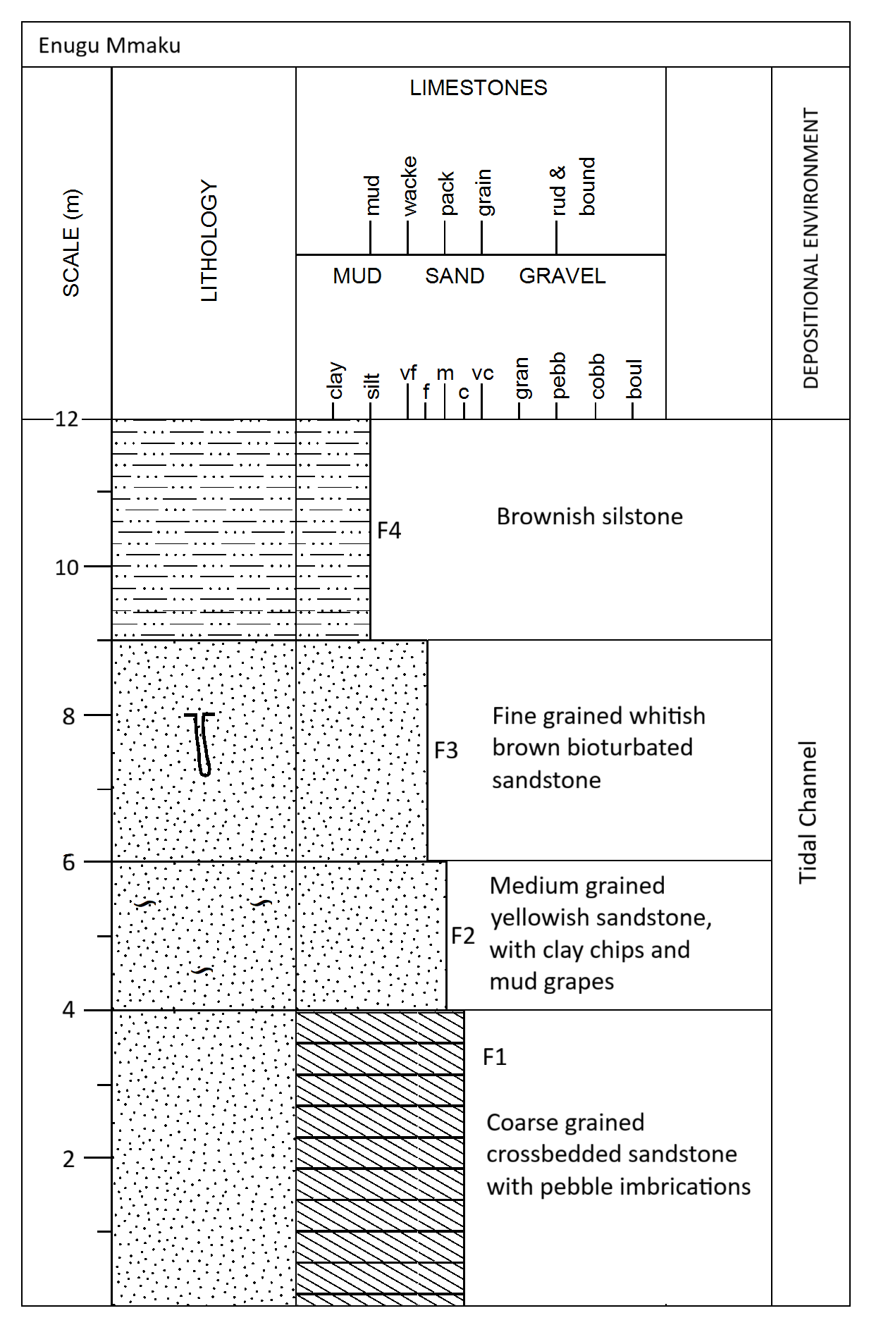
Fig. 2a: Lithologic section of Owelli Sandstone at Enugu Mmaku

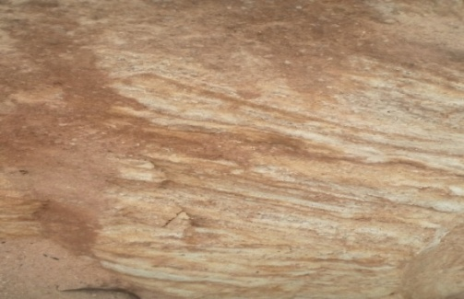
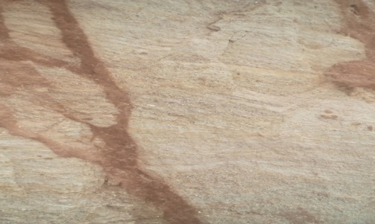
ii
i

Fig. 2b: (i) & (ii): Outcrop of Owelli Sandstone at Enugu Mmaku

3.1.2. Outcrop 2 (Achi)
Nature of Exposure: Sand Quarry
An outcrop of about 20 m thick is exposed at this locality. Five lithofacies (F1, F5, F1, F2 and F4) were identified on the outcrop. ( Fig. 3a and b).
The coarse grained planar cross bedded sandstone lithofacies (F1) is at the base of the outcrop and about 5 m thick. This lithofacie is pebbly and overlain by pebbly sandstone lithofacie (F5).
The pebbly sandstone lithofacies (F5) is about 2 m thick. Pebbles are common in this unit. The lithofacies is followed upwards by cross bedded coarse grained sandstone lithofacies (F1) that is about 5m thick.Medium grained sandstone lithofacies (F2) of about 4 m thick overlies the coarse grained cross bedded sandstone lithofacies (F1). The facies contains some clay chips and mud drapes. Siltstone lithofacies(F4) that is about 4m thick is at the topmost part of the outcrop. (Figs. 3a and 3b).Facies association and succession exhibits a coarsening upward succession at the base and then fines upwards. The environment of deposition is inferred asfluvio- deltaic setting.
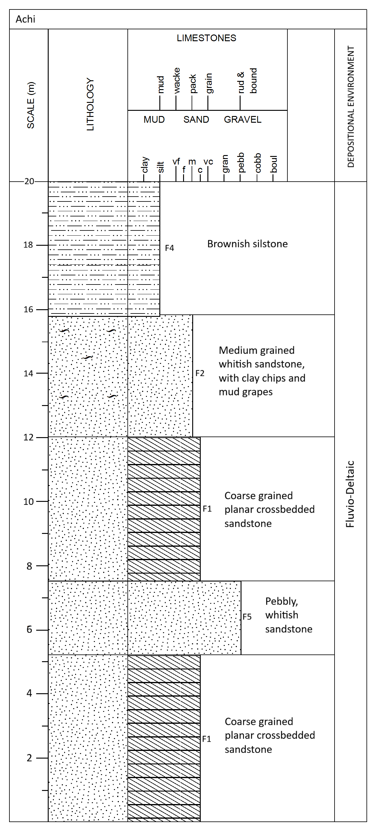
Fig. 3a: Litholog of Owelli Sandstone at Achi

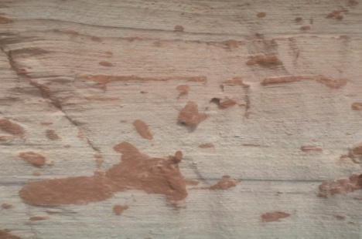
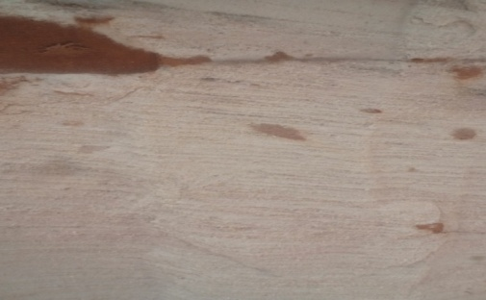
ii
i
bi
Fig. 3b: (i) & (ii): Outcrop of Owelli Sandstone at Achi

3.1.3. Otcrop 3. (Agbogugu)
Nature of Exposure: Road cut
The exposed sedimentary unit is about 8 m thick. Fivelithofacies identified from the base to the
top of the outcrop consist of 3 m thick cross bedded medium grained sandstone (F8).The
lithofacies isbioturbated with long tubes of Ophiomorphaburrows in places. F1 is 2 m thick,
coarsegrained cross bedded sandstone overlies the F8. The F5 is cross bedded pebbly
sandstoneunit.Thelithofacie is about 2 m thick and lies above the F1. The F5 lithofacies overlies
the coarse grained truogh cross bedded lithofacies (F6) that is 3m thick. This lithofacies is
overlain by Siltstone lithofacies(F7)of about 2m thick capped the sedimentary unit and the
Siltstone is intensely bioturbated.(Fig. 4a and 4b).The occurrence of long tubes of
Ophimorphaisp in the sandstone unit suggests high depositional energy. The intensely
biotubated Siltstone lithofacies which occur at the topmost part of the succession indicates a
change from high to lower depositionalenergy.Thelithofacies association is inferred as fluvio-
deltaic setting.
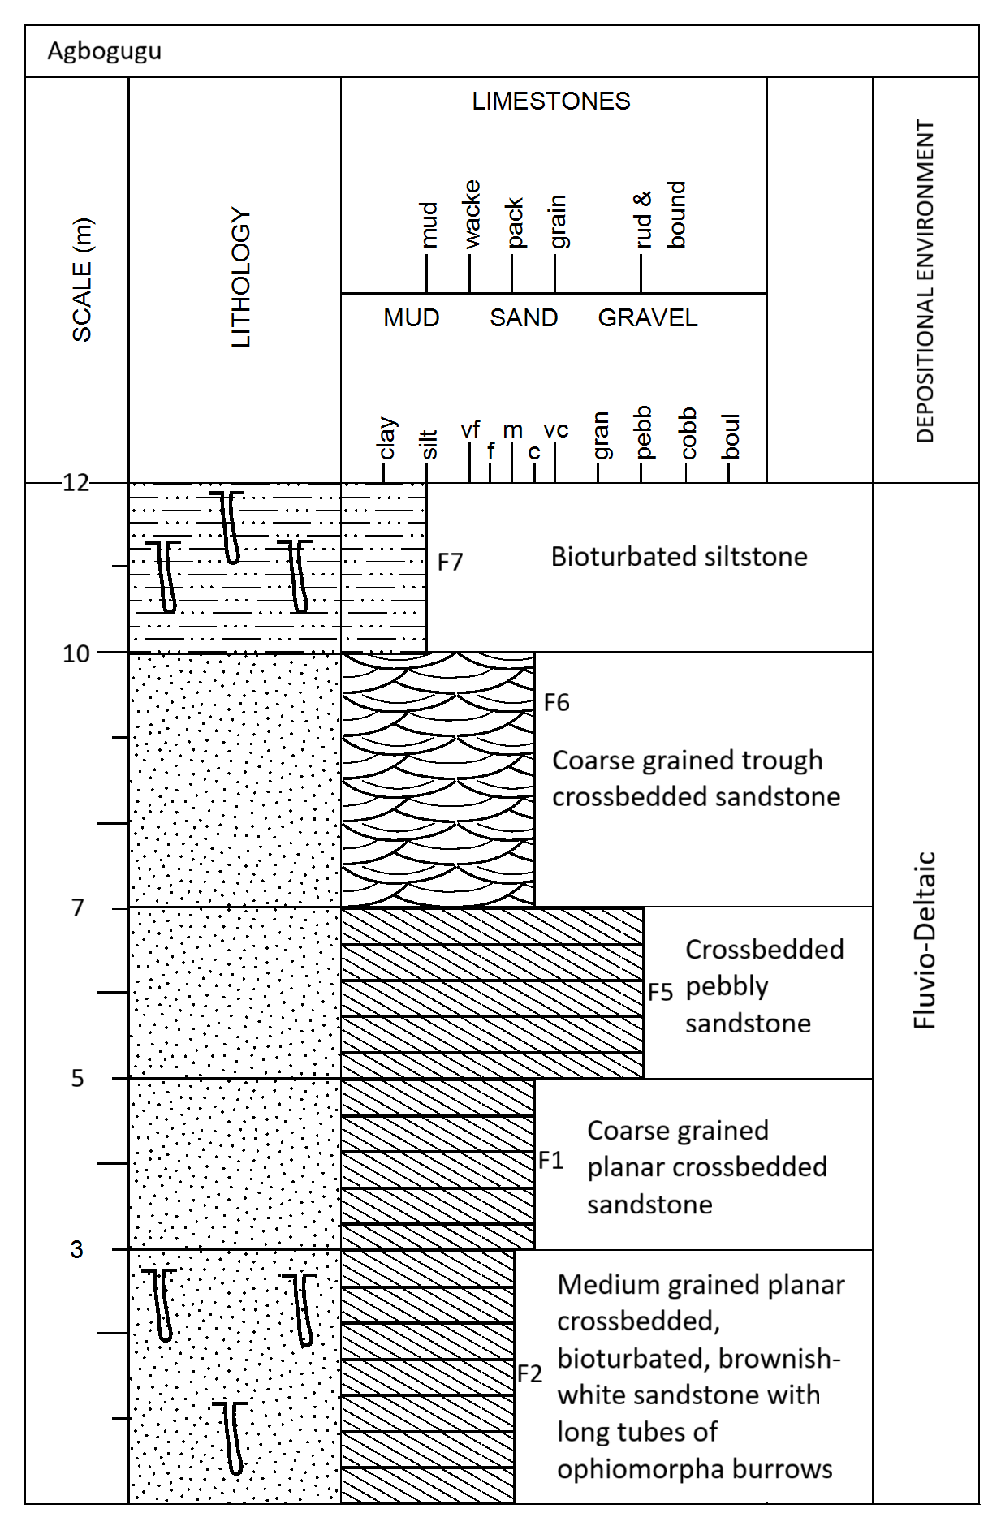
Fig.4a: Stratigraphic log of outcrop 3 at Agbogugu.

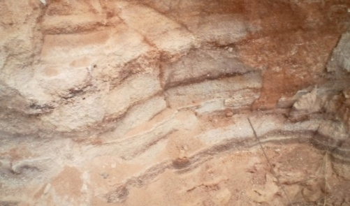
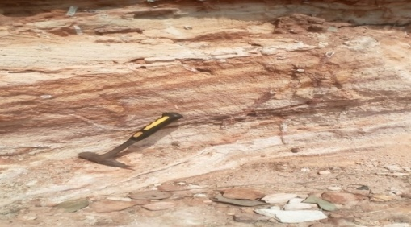
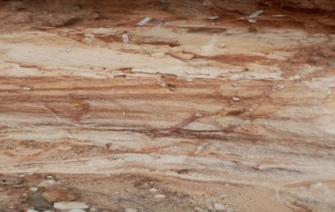
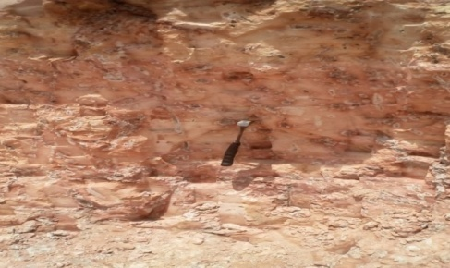
iv
iii
ii
i
Fig. 4b (i) Bioturbated Siltstone at Agbaogugu, (ii) Biotubated Planar cross bedded sandstone at Agbogugu. (iii) Planar cross bedded brownish white sandstone at Agbogugu. (iv) Trough cross bedded micaceous brownish grey coarse to medium grain sandstone at Agbogugu.
i
iii

ii
C
B
F1
3.1.4. Outcrop 4. Ogbaku.
Nature of Exposure: Sand Quarry Site.
This exposure is divided into four major facies types with a total thickness of 18m (Fig. 5a). This lithofacies (F7) is 3m thick. It is a brownish siltstone that is intensely biotubated with much vertical burrows. It is highly consolidated. This lithofacies (F7) is overlain by (F2) lithofacie which is a medium grained 6m thick cross bedded sandstone. This lithofacies has alternate layers of white, yellow and brownish sandstone units. F2 is overlain by 6m planar cross bedded fine grained sandstone (F3). It is a yellowish/white cross bedded sandstone with mud drapes and clay inclusions. This litofacies (F3) is overlain by a brownish siltstone lithofacies (F4) that is 3m thick.
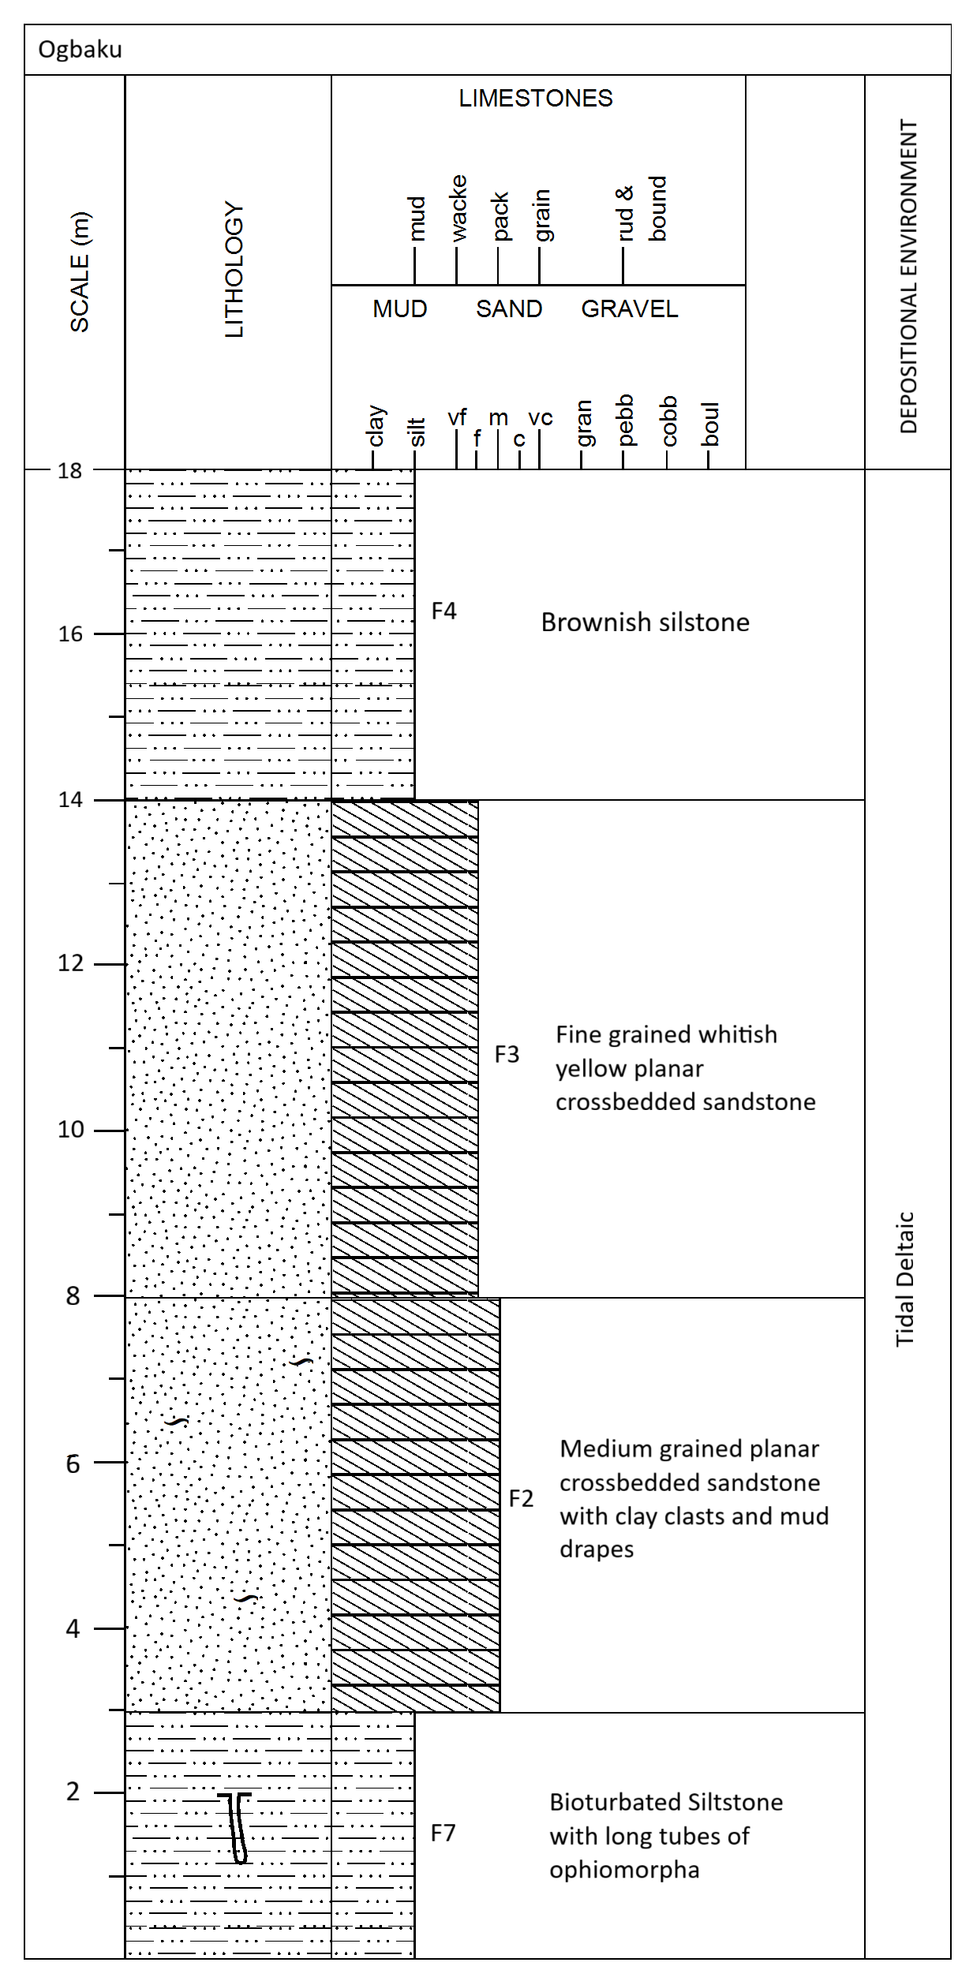
Fig. 5a Sedimentological log of outcrop showing identified stratigraphic succession
exposed at Ogbaku.

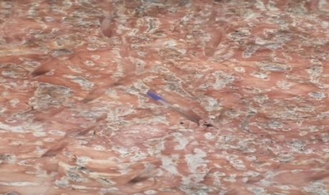
ii
i
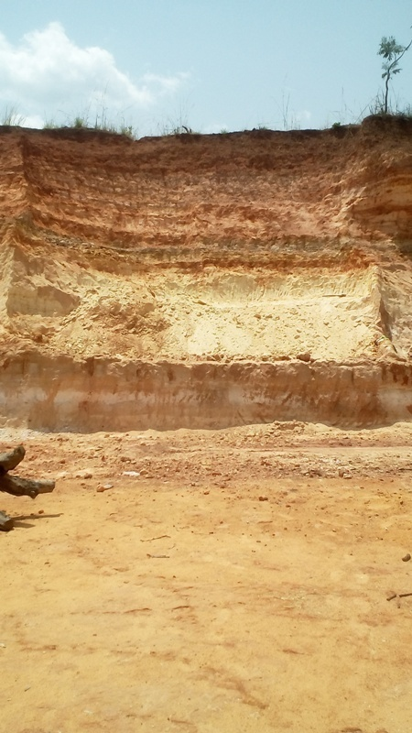
iii
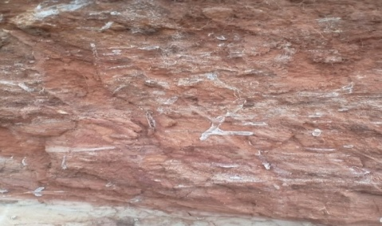
Fig. 5b: (i), (ii). Abundant burrows of Ophiomorphaisp on Siltstone
C
A
B
i
lithofacies (iii) The overlying medium/fine grained Sandstone lithofacies at Ogbaku.
B
F1

3.2. Lithofacies and LithofaciesAssociaton
3.2.1. Lithofacies
Seven Lithofacies identified on the outcrops of the Owelli Sandstone are stated as follows;
F1 – Coarse grained plannar cross bedded sandstone lithofacies.
F2 – Medium grained sandstone lithofacies
F3 – Biotubated fine grained Sandstone lithofacies
F4 – Siltstone Lithofacies
F5 – Pebbly Sandstone Lithofacies
F6 – Coarse grained trough cross bedded Sandstone lithofacies
F7 – Biotubated siltstone Lithofacie.

3.2.2. Lithofacies Association (FA)
The seven lithofacies identified on the outcrop units of the Owelli Sandstone in the studied
locations were grouped into three facies associations (FA1 –FA 3).
FA1: Tidal Channel Facies Association.
The facies Association as exposed at Enugu Mmakuconsisist of a fining upward succession of F1, F2, F3 and F4. Clay clasts and chips are common. Clay drapes and Ophiomorphaisp burrows and cross beds are sedimentary structures which occur on the facies association. Plannar cross beds are common especially on the coarse grained sandstone at the basal part of the facies association. Cross bedding, Ophiomorphaisp burrows and clay clasts are suggestive of high energy depositional setting. The siltstone which capped the facies association indicates much lower energy which occurred in the environment. Clay drapes suggest tidal influence.
FA2: Fluvio – Deltaic Facies Association
At Achi area, the association coarsened upward at the base (i.e F1 is overlain by F5) and then fines upward (i.e. F1 is overlain by F2 and F4) at the upper part of the succession. Cross beds are common at the basal coarse grained sandstone. The pebbly sandstone lithofacies is laminated. The facies association as exposed at Agbogugu that commenced with F2, which is plannar cross bedded and has some Ophiomorphaisp burrows in places. The F2 is overlain by F1, then F5 is overlain by F6, and then F7, which capped the facies association. F7 is intensely biotubated.
The association depicts deposition under fluctuating energy condition.
FA3: Tidal Delta Facies Association
At Ogbaku area, the facies association comprised of the basal biotubatedSiltstonelithofacies F7), with abundant burrows of Ophiomorpha (Fig. 5b), clay chips and clay drapes. Overlying the F7 is F2. But F2 is cross bedded.
3.3. Paleocurrent Studies
The result of paleocurreent analysis of the Owelli Sandstone exposed at Enugu Mmaku, Achi, Agbogugu and Ogbaku is presented as tables 3 to 7 and Figures 6 to 9 respectively. In all the studied locations, the dorminant current as shown from the rose plots of the cross bed azimuths (Fig. 6 to 9) is unimodal and in the southwesterly direction.
Table 3 shows the calculated mean vector azimuth (MVA), Current Variance (Var) and Vector Strenght.The values of MVA for the locations range from 281⁰ at Enugu Mmaku to 255⁰ at Ogbaku. These values indicate the ancient current direction to be consistent with the rose plots
(Fig. 6 - 9) of the cross-bed azimuths. The outcrop at Agbogugu indicated highest current variance (6351.4) and lowest vector strength (0.37). Enugu Mmaku, Achi and Ogbaku indicated low current variance. These calculated values are also consistent with the rose plots of the cross-bed azimuths.

Table. 3. Paleocurrent Evaluation of the Owelli Sandstone
Locality | Current Pattern | MVA | Variance | Vector Strength | Depositional Environment
Enugu  Mmaku | Unimodal | 218⁰ | 4893.5 | 0.49 | Fluvio- delta
Achi | Unimodal | 232⁰ | 6006.2 | 0.62 | Fluvio – delta
Agbaogugu | Unimodal | 230⁰ | 6351.4 | 0.37 | Shallow marine
Ogbaku | Unimodal | 255⁰ | 4806.5 | 0.43 | Fluvio – delta

Current variance measures the variability of the of the flow directions whereas the current vector strength quantifies the degree to which sediments transport was concentrated in a single direction. Current variance is inversely related to current vector strength. This implies that high vector strength corresponds to low current variance and vice versa.
High vector strength indicates a well defined, directional flow and low dispersion of sediment.
The low variance exhibited by the Owelli Sandstone at Enugu Mmaku, Achi and Ogbaku (Figs. 6 to 9 and Table 3) corresponds to High vector strength whereas High variance at Agbogugu area indicated low vector strength. Low vector strength suggests low energy condition.

Table. 4a: Paleocurrent analysis of Owelli Sandstone for Location 1 (Enugu Mmaku)

S/N | Azimuths (AZ) | Sine A | Cos A | ∑(AZ_MVA)²
1 | 220 | -0.6427 | -0.7660 | 4
2 | 350 | -0.1736 | 0.9848 | 17424
3 | 190 | -0.1736 | -0.9848 | 784
4 | 210 | -0.5 | -0.8660 | 64
5 | 190 | -0.1736 | -0.9848 | 784
6 | 170 | 0.1736 | -0.9848 | 2304
7 | 210 | -0.5 | -0.8660 | 64
8 | 200 | -0.3420 | -0.9396 | 324
9 | 190 | -0.1736 | 0.9848 | 784
10 | 200 | -0.3420 | -0.9396 | 324
11 | 150 | 0.5 | -0.8660 | 4624
12 | 170 | 0.1736 | -0.9848 | 2304
13 | 300 | -0.8660 | 0.5 | 6724
14 | 220 | -0.6427 | -0.7660 | 4
15 | 210 | -0.5 | -0.8660 | 64
16 | 250 | -0.9396 | -0.3420 | 1024
17 | 190 | -0.1736 | -0.9848 | 784
18 | 160 | 0.3420 | -0.9396 | 3364
19 | 220 | -0.6427 | -0.7660 | 4
20 | 300 | -0.8660 | 0.5 | 6724
21 | 70 | 0.9396 | 0.3420 | 21904
22 | 200 | -0.3420 | -0.9396 | 324
23 | 210 | -0.5 | -0.8660 | 64
24 | 220 | -0.6427 | -0.7660 | 4
25 | 80 | 0.9848 | 0.1736 | 19044
26 | 330 | -0.5 | 0.8660 | 12544
27 | 190 | -0.1736 | -0.9848 | 784
28 | 200 | -0.3420 | -0.9396 | 3324
29 | 230 | -0.7660 | -0.6427 | 144
30 | 340 | -0.3420 | 0.9396 | 14884
31 | 330 | -0.5 | 0.8660 | 12544
32 | 300 | -0.8660 | 0.5 | 6724
33 | 350 | -0.1736 | 0.9848 | 17424
34 | 320 | -0.6427 | 0.7660 | 10404
35 | 190 | -0.1736 | -0.9848 | 784
∑Sin A & Cos A = |  | -10.5023 | -13.5323 | 166380

Table 4b. Cross bed frequency distribution for Owelli Sandstone at Enugu Mmaku

S/N | Class intervals | Tally | Frequency
1  2  3  4  5  6  7  8  9  10 | 60 – 90  91 – 120  121 – 150  151 – 180  181 – 210  211 – 240  241 – 270  271 – 300  301 – 330  331 – 360  Total | 11  -  1  111  1111 11111111  1111  1  111  111  111  35 | 2  0  1  3  14  5  1  3  3  3

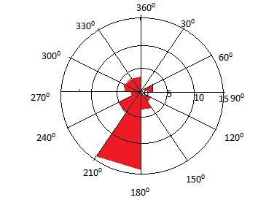

Figure 6: Rose plot of azimuths of cross beds from Owelli Sandstone at Enugu Mmaku.
The rose diagram is Unimodal. Has low variance, high vector strength southwesterly direction.

Table 5a:.Paleocurrent analysis of Owelli Sandstone for Location 2 (ACHI)

S/N | Azimuths (AZ) | Sine A | Cos A | ∑(AZ_MVA)²
1 | 260 | -0.9848 | -0.1736 | 784
2 | 340 | -0.3420 | 0.9396 | 11664
3 | 200 | -0.3420 | 0.9396 | 1024
4 | 220 | -0.6427 | -0.7660 | 144
5 | 240 | -0.8660 | -0.5 | 64
6 | 300 | -0.8660 | 0.5 | 4624
7 | 230 | -0.7660 | -0.6427 | 4
8 | 220 | -0.6427 | -0.7660 | 144
9 | 260 | -0.9848 | -0.1736 | 784
10 | 250 | -0.9396 | -0.3420 | 324
11 | 320 | -0.6427 | 0.7660 | 7744
12 | 330 | -0.5 | 0.8660 | 4624
13 | 300 | -0.8660 | 0.5 | 4624
14 | 150 | 0.5 | -0.8660 | 6724
15 | 60 | 0.8660 | 0.5 | 29584
16 | 160 | 0.3420 | -0.9396 | 5184
17 | 230 | -0.7660 | -0.6427 | 4
18 | 340 | -0.3420 | 0.9396 | 11604
19 | 200 | -0.3420 | -0.9396 | 1024
20 | 230 | -0.7660 | -0.6427 | 4
21 | 220 | -0.6427 | -0.7660 | 144
22 | 160 | 0.3420 | -0.9396 | 5184
23 | 190 | -0.1736 | -0.9848 | 45369
24 | 210 | -0.5 | -0.8660 | 484
25 | 240 | -0.8660 | -0.5 | 64
26 | 230 | -0.7660 | -0.6427 | 4
27 | 210 | -0.5 | -0.8660 | 484
28 | 270 | -1 | 0 | 1444
29 | 200 | -0.3420 | -0.9396 | 1024
30 | 220 | -0.6427 | -0.7660 | 144
31 | 290 | -0.9396 | 0.3420 | 3364
32 | 170 | 0.1736 | -0.9848 | 3844
33 | 260 | -0.9848 | -0.1736 | 784
34 | 190 | -0.1736 | -0.9396 | 45369
35 | 200 | -0.3420 | -0.9396 | 784
Total |  | ∑SinA =-17.2507 | ∑Cos A=-13.3344 | 204.210

Table 5b: Cross bed frequency distribution for Owelli Sandstone at Achi
S/N | Class intervals | Tally | Frequency
1  2  3  4  5  6  7  8  9  10 | 60 – 90  91 – 120  121 – 150  151 – 180  181 – 210  211 – 240  241 – 270  271 – 300  301 – 330  331 – 360 | 11  -  1  111  1111 11  1111 1111  1111  11  111  11 | 1  0  1  3  8  10  5  2  3  2
 |  | Total | 35

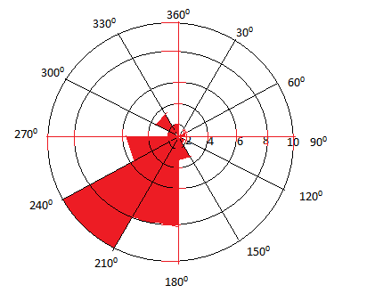
Figure 7: Rose plot of azimuths of cross bed from the Owelli Sandstone at Achi.
The rose diagram has low variance, high vector strength, Unimodal in the Southwesterly
direction.

Table 6a: Paleocurrent analysis data of Owelli Sandstone for Location 3(OGBAKU)
S/N | Azimuths (AZ) | Sine A | Cos A | ∑(AZ_MVA)²
1 | 190 | -0.1736 | -0.9848 | 1225
2 | 160 | 0.3420 | -0.9396 | 4225
3 | 310 | -0.7660 | 0.6427 | 7225
4 | 340 | -0.3420 | 0.9396 | 13225
5 | 200 | -0.3420 | -0.9396 | 625
6 | 210 | -0.5 | -0.8660 | 225
7 | 190 | -0.1736 | -0.9848 | 3025
10 | 230 | -0.7660 | -0.6427 | 25
11 | 160 | 0.3420 | -0.9396 | 4225
12 | 190 | -0.1736 | -0.9848 | 1225
13 | 170 | 0.1736 | -0.9848 | 3025
14 | 210 | -0.5 | -0.8660 | 225
15 | 340 | -0.3420 | 0.9396 | 13225
16 | 320 | -0.6427 | 0.7660 | 9025
17 | 330 | -0.5 | 0.8660 | 11025
18 | 200 | -0.3420 | -0.9396 | 625
19 | 210 | -0.5 | -0.8660 | 225
20 | 210 | -0.5 | -0.8660 | 225
21 | 200 | -0.3420 | -0.9396 | 625
22 | 200 | -0.3420 | -0.9396 | 625
23 | 210 | -0.5 | -0.8660 | 225
24 | 210 | -0.5 | -0.8660 | 225
25 | 200 | -0.3420 | -0.9396 | 625
26 | 350 | -0.1736 | 0.9848 | 15625
27 | 320 | -0.6427 | 0.7660 | 9025
28 | 340 | -0.3420 | 0.9396 | 225
29 | 350 | -0.1736 | 0.9396 | 225
30 | 190 | -0.1736 | -0.9848 | 1225
31 | 160 | 0.3420 | -0.9396 | 4225
32 | 320 | -0.6427 | 0.7660 | 15625
 |  | ∑Sin A | ∑Cos A | 149000

Table 6b: Cross bed frequency distribution for Owelli Sandstone at Ogbaku.

S/N | Class intervals | Tally | Frequency
1  2  3  4  5  6  7  8  9  10 | 60 – 90  91 – 120  121 – 150  151 – 180  181 – 210  211 – 240  241 – 270  271 – 300  301 – 330  331 – 360 | -  -  -  1111  1111 11111111  1  -  -  1111  1111 | 4  -  -  -  15  1  -  -  5  5
 |  | Total | 30

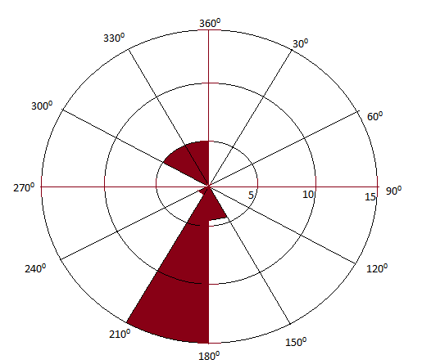

Figure 8: Rose plot of azimuths of cross bed from the Owelli Sandstone at Ogbaku.
The rose diagram has Low variance, High vector strength and southwesterly direction.

Table 7a: Paleocurrent analysis data of Owelli Sandstone for Location 4(AGBOGUGU)

S/N | Azimuths (AZ) | Sine A | Cos A | ∑(AZ_MVA)²
 | 170 | 0.1736 | -0.9848 | 3600
2 | 320 | -0.6427 | 0.7660 | 8100
3 | 210 | -0.5 | -0.8660 | 400
4 | 190 | -0.1736 | -0.9848 | 1600
5 | 200 | -0.3420 | -0.9396 | 900
6 | 190 | -0.1736 | -0.9848 | 1600
7 | 230 | -0.7660 | -0.6427 | 0
8 | 330 | -0.5 | 0.8660 | 10000
9 | 160 | 0.3420 | -0.9396 | 4900
10 | 60 | 0.8660 | 0.5 | 28900
11 | 170 | -0.1736 | -0.9848 | 3600
12 | 210 | -05 | -0.8660 | 400
13 | 320 | -0.6427 | 0.7660 | 8100
14 | 40 | 0.6427 | 0.7660 | 36100
15 | 250 | -0.9396 | -0.3420 | 400
16 | 70 | 0.9396 | 0.3420 | 25600
17 | 170 | 0.1736 | -0.9848 | 3600
18 | 160 | 0.3420 | -0.9396 | 4900
19 | 210 | -0.5 | -0.8660 | 400
20 | 220 | -0.6427 | -0.7660 | 100
21 | 240 | 0.8660 | -0.5 | 100
22 | 200 | -0.3420 | -0.9396 | 900
23 | 220 | -0.6427 | -0.7660 | 100
24 | 280 | -0.9848 | 0.1736 | 2500
25 | 190 | -0.1736 | -0.9848 | 1600
26 | 330 | -0.5 | 0.8660 | 10000
27 | 310 | -0.7660 | 0.6427 | 6400
28 | 300 | -0.8660 | 0.5 | 4900
29 | 160 | 0.3420 | -0.9396 | 4900
30 | 70 | 0.9396 | 0.3420 | 25600
31 | 320 | -0.6427 | 0.7660 | 8100
32 | 280 | -0.9848 | 0.1736 | 2500
33 | 240 | -0.8660 | -0.5 | 100
34 | 310 | -0.7660 | 0.6427 | 6400
35 | 240 | -0.8660 | -0.5 | 4900
36 | 300 | -0.8660 | 0.5 | 4900
 |  | ∑SinA=-10.136 | ∑CosA=-8.6089 | 222300

Table 7b:Cross bed frequency distribution for Owelli Sandstone at Agbogugu
S/N | Class intervals | Tally | Frequency
1  2  3  4  5  6  7  8  9  10  11  12 | 0 - 30  31 - 60  60 – 90  91 – 120  121 – 150  151 – 180  181 – 210  211 – 240  241 – 270  271 – 300  301 – 330  331 – 360 | -  11  11  -  1  1111 1  1111 111  1111 1  1  1111  1111 1  - | -  2  2  -  1  6  8  6  1  4  6  -
 |  | Total | 36

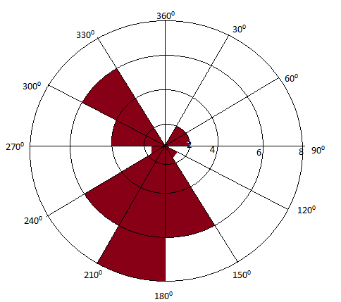
Figure 9: Rose plot of azimuths of cross bed from the Owelli Sandstone at Agbogugu
The rose diagram has High Variance low strength.

3.3.1. Current Variace, Vector Strenght and Depositional Environment.
Current variance and vector strength play an important role in the determination of depositional setting/ process. Potter and Pettijohn (1963) noted that values of current variance that are greater than 6000 indicate a shallow marine environment while values between 2000 and 6000 suggest Fluvio – deltaic environment. This implies that the Owelli Sandstone at EnuguMmaku, Achi and Ogbaku with current variance if between 4000 and 6000 were deposited within high energy Fluvio – deltaic settings. High current variance of 6351.4 and low vector strength of 0.37 which are characteristics of the Owelli Sandstone at Agbogugu suggests Shallow marine depositional setting.
3.3.2. Current Variance, Vector Strenght and Reservoir Porosity and Permeability
Prediction
High vector strength and low current variance will generate reservoir sands with lower
porosity and permeability whereas high current variance and low vector strength will form reservoir sands with high porosity and permeability (Obi et al., 2013). This is because in areas with high current variance and low vector strength, the pore system is more uniform and open, thus allows for higher effective porosity and permeability values. The fluid can move more freely through a less directional and more interconnected network unlike in areas with high vector strength and low current variance where the pore structure is directional. The directional pore structure can limit the available pore space for liquid flow (effective porosity), thus lower
permeability. Obi et al., (2013) also linked the depositional environment to reservoir porosity, permeability as well as reservoir heterogeneity. The best reservoir sand in the Owelli Sandstone is the shallow marine sands exposed at Agbogugu area. The prediction followed after the models of Potter and Pettijohn (1963), Hsu (1977) and Obi et al., (2013). The reservoir effective porosity and permeability at Agbogugu area are expected to be the highest and with lower reservoir heterogeneity. At Enugu Mmaku, Achi and Ogbaku areas, the sediments were laid down under much higher energy in a fluvio – deltaic setting, hence the reservoir effective porosity and permeability are expected to be lower and with higher reservoir heterogeneity.

3.4. Particle Size Distribution
3.4.1 Grain Size Parameters
The result of grain size parameters is shown in Table 7a.
Enugu Mmaku
Grain size varies from medium to coarse but dominantly coarse and sorting is moderate in threesamples while two is poorly sorted. Skewness ranges from very negatively skewed to very positively skewed and Kutorsis varies from very platykurtic to leptokurtic.
Achi
Grain size is generally medium, moderate to poor sorting, very negatively skewed to positively skewed and mesokurtic to leptokurtic.
ForOgbaku area, grain size is fine to medium, sorting is dominantly moderate, negatively skewed, very positively skewed and leptokurtic.
In Agbogugu area, grain size is dominantly coarse, poor to moderate sorting, negatively to very positively skewed and very platykurtic to leptokurtic.
The variable grain sizes and poor sorting is suggestive of a wide range of depositional current
velocities or the fluctuating energy condition of the environment. Coarse grained size fractions
which are predominant at Enugu Mmaku and Agbogugu with moderate sorting of the sands
reflect more uniform and higher energy depositional condition.

Table 7a: Grain size parameters derived from probability curves.
Sample Name & Number | Mean  (Mz) | Value | Sorting (δ) | Value | Skewness  (Ski) | Value | Kurtosis (Kg) | Value
Mmaku 1 | Medium sand | 1.60 | Moderately sorted | 0.93 | Very positively skewed | 0.36 | Mesokurtic | 1.1
Mmaku 2 | Coarse sand | 0.7 | Poorly sorted | 1.20 | Positively skewed | 0.19 | Leptokurtic | 1.12
Mmaku 3 | Coarse sand | 0.23 | Moderately sorted | 0.91 | Positively skewed | 0.12 | Very Platikurtic | 0.23
Mmaku 4 | Coarse sand | 0.40 | Poorly sorted | 1.20 | Very negatively skewed | -0.39 | Very platykurtic | 0.51
Mmaku 5 | Coarse  Sand | 0.50 | Moderately sorted | 1.0 | Very positively skewed | 0.55 | Platykurtic | 0.90
Achi 1 | Medium sand | 1.20 | Moderately sorted | 0.98 | Negatively skewed | -0.08 | Leptokurtic | 1.35
Achi 2 | Medium sand | 1.40 | Poorly sorted | 1.10 | Very negatively skewed | -0.13 | Mesokurtic | 1.06
Achi 3 | Medium sand | 1.8 | Moderatelysorted | 0.99 | Negatively skewed | -0.03 | Mesokurtic | 1.07
Achi 4 | Medium sand | 1.40 | Moderately sorted | 0.96 | Negatively skewed | -0.07 | Mesokurtic | 1.07
Achi 5 | Medium sand | 1.30 | Poorly sorted | 1.10 | Positively skewed | 0.11 | Leptokurtic | 1.50

Table. 7b: Grain size parameters derived from probability curves.

Sample Name & Number | Mean  (Mz) | Value | Sorting (δ) | Value | Skewness  (Sk) | Value | Kurtosis (Kg) | Value
Ogbaku 1 | Fine sand | 2.10 | Moderately sorted | 0.79 | Negatively skewed | -0.19 | Leptokurtic | 1.32
Ogbaku 2 | Fine sand | 2.10 | Poorly sorted | 1.10 | Positively skewed | 0.13 | Leptokurtic | 1.49
Ogbaku 3 | Fine sand | 2.20 | Moderately sorted | 0.90 | Negatively skewed | -0.14 | Leptokurtic | 1.50
Ogbaku 4 | Medium sand | 1.30 | Moderately sorted | 0.64 | Very positively skewed | 0.45 | Leptokurtic | 1.23
Ogbaku 5 | Medium sand | 1.90 | Moderately sorted | 0.66 | Nearly symmetrical | 0.03 | Leptokurtic | 1.15
Agbogugu 1 | Coarse sand | 0.47 | Poorly sorted | 1.30 | Very positively skewed | 1.04 | Very platykurtic | 0.41
Agbogugu 2 | Fine sand | 2.03 | Moderately sorted | 0.70 | Negatively skewed | -0.14 | Leptokurtic | 1.18
Agbogugu 3 | Coarse sand | 0.83 | Poorly sorted | 1.25 | Very positively skewed | 0.48 | Platykurtic | 0.85
Agbogugu 4 | Coarse sand | 0.53 | Poorly sorted | 1.33 | Very positively skewed | 0.53 | Very platykurtic | 0.49
Agbogugu 5 | Coarse sand | 0.37 | Moderately sorted | 1.00 | Very positively skewed | 0.44 | Very Platykurtic | 0.59

Table. 8: Average values for the grain size parameters

Parameters | Values | Interpretations
Mean (MZ) | 1.26 | Medium Sand
Standard deviation (φ) | 0.97 | Moderately well sorted
Skewness (SK) | 0.14 | Positively skewed
Kurtosis (KG) | 1.02 | Mesokurtic

3.4.2. Discrimination of Environment of Deposition from grain size data
The result of the discriminant Functions (Y1, Y2 and Y3) for the Owelli Sandstone is presented as Table 9. Results indicated deposition in fluvio- deltaic and shallow marine settings (Fig. 10a). fig. 10b shows depositions of the sands by turbidity current.
Table 9a: Discriminate function from multivariate analysis and environment of
deposition of the Owelli Sandstone.
Samples names & no | Y1 | Environment of deposition | Y2 | Environment of deposition | Y3 | Environment of deposition
Mmaku 1 | 10.6375 | Beach | 94.2478 | Shallow marine | -7.0142 | Fluvio – deltaic
Mmaku 2 | 10.0021 | Beach | 99.1210 | Shallow marine | -8.4968 | Shallow marine
Mmaku 3 | 4.7712 | Beach | 69.9577 | Shallow marine | -8.4054 | Shallow marine
Mmaku 4 | 7.8201 | Beach | 61.9033 | Beach | -4.1769 | Fluvio – deltaic
Mmaku 5 | 7.2097 | Beach | 88.4011 | Shallow marine | -9.0590 | Shallow marine
Achi 1 | 12.0997 | Beach | 102.0884 | Shallow marine | -7.0989 | Shallow marine
Achi 2 | 12.7771 | Beach | 115.3489 | Shallow marine | -9.1402 | Shallow marine
Achi 3 | 15.3270 | Beach | 145.2339 | Shallow marine | -12.3272 | Shallow marine
Achi 4 | 11.5427 | Beach | 93.9843 | Shallow marine | -6.2968 | Fluvio – deltaic
Achi 5 | 14.8268 | Beach | 165.4238 | Shallow marine | -15.8739 | Shallow marine
Table 9b: Discriminate function from multivariate analysis and environment of
deposition of the Owelli Sandstone.

Sample names & no | Y1 | Environment of deposition | Y2 | Environment of deposition | Y3 | Environment of deposition
Ogbaku 1 | 14.4160 | Beach | 95..3361 | Shallow marine | -3.8666 | Fluvio – deltaic
Ogbaku 2 | 15.6888 | Beach | 133.0858 | Shallow marine | -9.4549 | Shallow marine
Ogbaku 3 | 15.6373 | Beach | 111.2375 | Shallow marine | -5.5629 | Fluvio – deltaic
Ogbaku 4 | 9.8716 | Beach | 81.7726 | Shallow marine | -5.2946 | Fluvio – deltaic
Ogbaku 5 | 12.0677 | Beach | 81.5310 | Shallow marine | -3.4735 | Fluvio – deltaic
Agbogugu 1 | 4.7095 | Beach | 93.7377 | Shallow marine | -12.4550 | Shallow marine
Agbogugu 2 | 13.0230 | Beach | 83.2739 | Shallow marine | -2.9717 | Fluvio – deltaic
Agbogugu 3 | 8.5836 | Beach | 134.6287 | Shallow marine | -16.3604 | Shallow marine
Agbogugu 4 | 11.7711 | Beach | 151.1886 | Shallow marine | -16.8798 | Shallow marine
Agbogugu 5 | 6.5887 | Beach | 100.3764 | Shallow marine | -12.0403 | Shallow marine

Table.10: Discriminate function (Y4) from multivariate analysis and environment of
deposition of each sample of the Owelli Sandstone.

Sample Names and Number | Y4 Values | Environment of deposition
Mmaku 1 | 9.0994 | Turbidity current
Mmaku 2 | 7.5647 | Turbidity current
Mmaku 3 | 1.8562 | Turbidity current
Mmaku 4 | 0.3381 | Turbidity current
Mmaku 5 | 8.7166 | Turbidity current
Achi 1 | 7.1303 | Turbidity current
Achi 2 | 5.2534 | Turbidity current
Achi 3 | 6.1600 | Turbidity current
Achi 4 | 5.8900 | Turbidity current
Achi 5 | 5.7712 | Turbidity current
Ogbaku 1 | 6.9925 | Turbidity current
Ogbaku 2 | 9.8044 | Turbidity current
Ogbaku3 | 9.0912 | Turbidity current
0gbaku 4 | 10.4783 | Fluvial deposit
Ogbaku 5 | 7.5001 | Turbidity current
Agbogugu 1 | 9.3063 | Turbidity current
Agbogugu 2 | 7.4183 | Turbidity current
Agbogugu 3 | 7.2750 | Turbidity current
Agbogugu 4 | 4.2817 | Turbidity current
Agbogugu 5 | 5.9120 | Turbidity current

The Plot of the three discriminate functions (Y1, Y2, Y3) as a bivariate scatter diagram was
used to improve the success rate and refinement of the discrimination of the depositional
environment. Figure (10a) shows the scatter plot of Y2 against Y1. Based on the
classification of depositional environment using Y2 Vs Y1 graph of (Sahu, 1964), about 5% of the samples were plotted within beach/ littoral environment while 95% of samples were plotted
within the field of beach/shallow agitated marine environment. This graph is divided into four
different fields:
(1) The Eolian processes/beach environment,
(2) Beach and littoral environment,
(3) Beach environment/shallow agitated marine deposition and
(4) Eolian process/shallow agitated marine environment (Sahu, 1964).
A similar plot of Y3 Vs Y2 (Sahu, 1964), showed that 80% of the samples plotted in the
fluvial/shallow agitated water while 20% of the samples were plotted within shallow marine/
shallow agitated water (Figure:10b).
Based on the grain size distribution therefore, the Owelli Sandstone shows that the sand represents deposits of Shallow agitated marine environments with some of the sands being brought in by fluvial process. This corresponds to the interpretation of (Nwajide, 2013), that the Owelli Sandstone was deposited by fluviatile depositional conditions.

Figure:10a: Bivariate plot of Y2 against Y1 for Owelli Sandstone (Sahu, 1964).

Figure: 10b: Bivariate plot of Y3 against Y2 for Owelli Sandstone (Sahu, 1964).

3.5. Environment of Deposition
Integration of lithofacies association, paleocurrent variance and vector strength as well as the environmental discriminant functions which was based on the grain size data have indicated that the Owelli Sandstone was laid down in a marginal marine (fluvial channel with tidal influence, tidal delta and fluvio-delta) and shallow marine depositional settings. The environment was characterized by fluctuating but dominantly high energy condition during the sediment deposition. The coarse and moderately sorted sands were deposited under prevailing uniform but higher energy flow whereas poorly sorted sediments were laid down under a fluctuating energy condition. Sediments deposited at Enugu Mmaku and Agbogugu are predominantly coarse sands whereas medium sands are dominant at Achi and fine sands at Ogbaku. Nwajide (2022) noted that the Owelli Sandstone is a stratigraphic unit that is fluviatile in the proximal parts and passes through all transitions to marine basin ward. The paleocurrent pattern indicated that the ancient flow was unimodal in the southwesterly direction.

3.6. Porosity and Permeability of the Owelli Sandstone and its Reservoir Potential
The result of porosity and permeability estimation of the studied sandstones using the empirical equations of Hazen (1988) and Krumbein and Monk (1942) is presented as Table 11. Porosity of the sands varies from 45% to 50%, indicating excellent porosities based on Hazen (1982). Permeability ranges of 30.1md and 2301.9md, is interpreted as good to excellent (Krumbein and monk (1942).
Highest permeability values are recorded at Agbogugu area and least permeability values are recorded at Ogbaku area. These values suggest Owelli Sandstone to be potential reservoir for water and hydrocarbon.
Reservoir properties (porosity and permeability) of the sandstone are controlled by depositional dynamics and energy of the environment. It is generally believed that porosity is largely controlled by sorting, compaction and cementation, while size and shape of the grains control permeability. Other controlling factors on permeability include the amount of fines (silts and clay), presence of cements and fractures. Permeability is governed by the size of the pores; the larger the pore sizes, the higher the permeability (Okoro et al., 2020).

Table 11: Calculated Porosity and Permeability of the Owelli Sandstone.
Sample Name and Number | Diameter (D60) (mm) | Diameter D(10)  (mm) | U=d60/d10 | Diameter (D50) Median (mm) | Sorting δ (φ) | Porosity n (%) | Permeability
Mmaku 1 | 1.866 | 0.758 | 0.7175 | 0.330 | 0.93 | 47% | 81.5md
Mmaku 2 | 0.406 | 1.414 | 0.2871 | 0.500 | 1.20 | 49% | 188.4md
Mmaku 3 | 0.707 | 2.000 | 0.3535 | 0.812 | 0.91 | 49% | 499.9md
Mmaku 4 | 0.707 | 2.000 | 0.3535 | 0.812 | 1.20 | 49% | 499.9md
Mmaku 5 | 0.536 | 1.231 | 0.4354 | 0.616 | 1.10 | 49% | 286.9md
Achi 1 | 0.379 | 1.000 | 0.379 | 0.435 | 0.98 | 49% | 142.5md
Achi 2 | 0.308 | 1.866 | 0.1650 | 0.354 | 1.10 | 50% | 93.8md
Achi 3 | 0.250 | 0.707 | 0.3536 | 0.287 | 0.99 | 49% | 61.3md
Achi 4 | 0.330 | 0.871 | 0.3788 | 0.379 | 0.96 | 49% | 107.9md
Achi 5 | 0.330 | 0.871 | 0.3788 | 0.379 | 1.10 | 49% | 107.7md
Ogbaku 1 | 0.203 | 0.500 | 0.406 | 0.218 | 0.79 | 49% | 35.1md
Ogbaku 2 | 0.189 | 0.707 | 0.267 | 0.218 | 1.10 | 49% | 34.7md
Ogbaku 3 | 0.189 | 0.500 | 0.378 | 0.303 | 0.90 | 49% | 30.1md
Ogbaku 4 | 0.354 | 0.660 | 0.5363 | 0.406 | 0.64 | 48% | 124.4md
Ogbaku 5 | 0.250 | 0.467 | 0.5363 | 0.268 | 0.66 | 48% | 53.7md
Agbogugu 1 | 0.707 | ___ | 0.707 | 1.741 | 1.30 | 47% | 2301.9md
Agbogugu 2 | 0.203 | 0.467 | 0.4346 | 0.233 | 0.70 | 49% | 176.2md
Agbogugu 3 | 0.435 | 2.00 | 0.2175 | 0.660 | 1.25 | 49% | 329.4md
Agbogugu 4 | 0.536 | 2.000 | 0.268 | 0.660 | 1.33 | 49% | 329.3md
Agbogugu 5 | 0.660 | 0.435 | 1.517 | 0.812 | 1.10 | 45% | 499.7md

The estimated permeability values of the Owelli Sandstone show that the poorly sorted coarse sands at Agbogugu have higher permeability values than moderately sorted coarse sands at Enugu Mmaku.The fine sands at Ogbaku area have the lowest permeability values. Ideally, coarse grained sands should have higher permeability than the fine grained sands because of larger pore throat, and with good connectivity of the pore spaces. However, it is expected that with good connectivity of the pore spaces, a moderately sorted coarse sand should have higher permeability than the poorly sorted coarse grained sandstone since finer particles which are present in the poorly sorted ones are known to block pore spaces, hence reduction in permeability.
The values of porosity and permeability obtained in this work using empirical equations of Hazen (1982) and Krumbein and Monk (1942) respectively are overestimated and do not seem idealistic. Pettijohn (1975) noted that porosity of recently deposited and unconsolidated sandstone does not exceed 48%. Therefore, the porosity and permeability of the Owelli Sandstone, with its clay contents (matrix), diagenesis (compaction and cementation) and clay addition due to chemical weathering of feldspar should be much lower than these values obtained from the empirical equations. The over estimation is because the empirical formula models did not consider or include the effects of compaction and other diagenetic processes such as cementation and fines (matrices) in designing the models. Compaction, cementation and matrices which were not taken care of by the models are known to cause reduction in porosity and permeability.
Furthermore, the permeability prediction of the investigated sands using the vector strength and variance revealed that highest permeabilities are associated with the shallow marine sand at Agbogugu area, on the basis of low vector strength and high current variance while other areas (Enugu Mmaku, Achi and Ogbaku) with higher vector strength have lower permeability values. This finding is consistent with the estimated values of permeability using the empirical formula. Therefore, current variance and vector strength is good in predicting the reservoir porosity and permeability and reservoir heterogeneity though it cannot give the values of porosity and permeability. Permeability values gotten in this work is mostly lower (except few especially at Agbogugu area that are within) than the range (200md to 5000md) given by Obi (2000) for the formation. However, his porosity values range of 20 to 30% is lower than values obtained in this work.

Conclusion
This study have shown that Owelli Sandstone is deposited in the environmental settings that range from marginal marine (tidal channel, tidal Delta and fluvio – delta) to shallow marine but dominantly marginal marine. The sediments were laid down under fluctuating energy condition. The paleo – flow was unimodal and in the Southwesterly direction.The estimated porosity and permeability of the Owelli Sandstone and prediction from vector strength and current variance indicated Owelli Sandstone as potential reservoir rocks. Best reservoir rocks of the formation can be traced at Agbogugu area.

Disclaimer (Artificial intelligence)
Option 1:
Author(s) hereby declare that NO generative AI technologies such as Large Language Models (ChatGPT, COPILOT, etc.) and text-to-image generators have been used during the writing or editing of this manuscript.
Option 2:
Author(s) hereby declare that generative AI technologies such as Large Language Models, etc. have been used during the writing or editing of manuscripts. This explanation will include the name, version, model, and source of the generative AI technology and as well as all input prompts provided to the generative AI technology
Details of the AI usage are given below:
1.
2.
3.

References

Akande, S.O.Ogunmoyero, I.B., Peterson, H.I. and Nytoft H.P. (2007). Source Rock Evaluation
of Coals from the Lower MaastrichtianMamu Formation, SE Nigeria. Journal of
Petroleum Geology, 30(4): 303-324.

Akaegbobi, I.M. and Schmitt, M. (1998). Organic facies, hydrocarbon source potential and
reconstruction of the Paleoenvironment of the Campano-MaastrichtianNkporo
Shale in Cretaceous Anambra basin, Nigeria NAPE Bull., v. 3, p. 1-19.

Amajor L.C. (1987). Palco Current petrography and provenance analysis of the Ajali Sandstone
(Upper Cretaceous) Southeastern Benue Trough, Nigeria Sedimentary Geology, Vol.54,
1987, pp 47-60.

Anozie,H.C. Chiaghanam, O.I.andChiadikobi, K.C. (2014). Source rocks and thermal
maturation of Campanian Enugu Shale in Anambra Basin, south–eastern Nigeria.
International Journal of Geology, Earth andEnvironmental Sciences. 4(3):296–307.

Avbovbo, A. A., and Ayoola. (1981). Petroleum prospects of Southern Nigeria’s Anambra Basin Oil Gas J., 79 (, pp. 334-347.

Bello, A.M., Butt, M.N., Hussain, A., Amao, A.O., Olariu, C., Koeshidayatulla, A.I., Malik,
M.H., AL – Hashem, M. and AL – Ramadan, K. (2023). Impact of depositional and
diagenetic controls in reservoir quality of Syn-rift Sedimentary systems; An example from
Oligocene – moicene AI Wajh Formation, northwest Saudi Arabia. Sedimentary Geology
446: 106342.

Benkhehill, J. (1982). Benue Trough and Benue Chain. Geol. Mag. 119:155-168.

Benkhehill, J. (1989). The Origin and evolution of the Cretaceous Benue Trough Nigeria J. Afric.
Earth Sci., 8, 251-282.

Berg, R.R., (1986). Reservoir Sandstones: Prentice-Hall, Inc, Englewood Cliffs, New Jersey,
481p.

Borer J. M., and Haris, P. M. (1991). Lithofacies and cyclicity of the Yates Formation, Permian Basin: implication for reservoir heterogeneity Am. Assoc. pet. Geol. Bull, 75 (4) 726-779.

Burke, K. C., (1972). longshore drift, Submarine canyons and submarine fans in development of
Niger Delta, Am. Assoc. petrol. Geol. Bull., 1650: 1975-1983.

Burke, K.C., Dessavagie, T.F.J. and Whiteman, A.J. (1972). Geological History of the Benue
Valley and its Adjacent Areas, In Geology (Eds) University of Ibadan press, Ibadaan, pp
187-205.
Camacho, H.,Bushy, C.J., and Kneller, B. (2002). A new depositional model for the classticcal
turbidites locality at San Clemente State Beach California AAPG Bulletin 86; 1543- 1560.

Fairhead, J.D. (1988). Mesozoic Plate tectonic reconstruction of the central and South Atlantic
ocean: the role of the West and Central Africa rift system. Tectonophysics., v. 187, p.
191-203. 155: 181- 191.

Grammer, G.M., Haris, P.M.M. and Eberli, G.P. (2004). Integration of Outcrop and Modern
analogs in Reservoir Modelling: Overview with example from the Bahamas, In:
Grammer, G.M., Haris, P.M.M. and Eberli (eds), Integration of Outcrop and Modern
analog in reservoir Modelling AAPG Memoir 80; 1-22.

Grammer, G.M., Eberli, G.P., Van Buchem, F.S.P., Stevenson, G.M., and Homewood, P. (1996).
Application of high-resolution sequence stratigraphy to valuate lateral variability in
outcrop and subsurface desert creek and Are may intervals (Pennsylvanian/Paradox
Basin. In M. Sonnem field and M. Longman (eds) Paleozoic systems of the Rocky
mountainregieon; Mountain section. SEPM special publ. 235-266.

Grant, C.W.,Goggin, D.J. and Harris, P.M. (1994). Outcrop analog for cyclic-shelf reservoirs, San Andreas Formation of Permian Basin: Stratigraphic framework, permeability
distribution, geostatistics, and fluid-flow modeling. AAPG Bulletin 78; 23-5.

Folk, R.L. and Ward, W.C. (1957) A study in the significance of Grain Size parameters Journal
of petrology, Vol. 37. Pp327-354.

Hazen, A., (1982). The reservoir parameters assessement on porosity and permeability of
sandstone and its classification range evaluation. J. sediment. Geol. 36, 107-192.

Hoque, M. (1977). Petrographic differentiation of tectonically controlled Cretaceous
Sedimentary Circles Southeastern Nigeria. Sed. Geol. 17: pp 235-245.

Hoque, M. and Nwajide C. S. (1984). Sedimentary Facies Characterization and depositional
settings of the Ajali Sandstone Journal of Mining Geology, 21, 19-26.

Hoque, M. and Ezepue, (1977). Petrology and paleogeography of the Ajali Sandstone Nigeria. J.
Min. Geol., 14: 16-22.

Hsu, K.J., (1977), Studies of Ventura Field, California, II. Lithology, Compaction, and
Permeability of sands: AAPG Bull., v.61, p.169 – 191.

Kerans, C., Lucia, F.J. and Senger, R.K. (1994). Integrated Characterization of Carbonate Ramp Reservoirs using Permian San Andres Formation outcrop Analogs AAPG Bulletin,
78(2).181-216.

Krumbein W.C, and Sloss, L., (1963). Stratigraphy and sedimentation.Pp.234sediments jour.
Sed. Pet. Vol. 4, p. 65-77.

Krumbein, W.C. and Monk, G.D. (1942). Permeability as a function of the size parameters of
unconsolidated sand. Petroleum Technology, 5: 153 - 163.

Levorsen, A.I. (1967). Geology of Petroleum: San Francisco, Freeman and Company, 724p

Major, R.A., Bebout, D.G. and Haris, P.M. (1996). Facies heterogeneity in modern ooid sand
shoal-An analog for hydrocarbon reservoirs. Bureau of Economic Geology, Geological
circulay 96-1, University of Texas at Austin, 30p.

McLaurin B. T. and Steel, R. J., (2000). Fourth- Order non-marine to Marine Sequences, middle
Castle gate Formation, book Cliffs, Utah. Geology, 28 (4), pp. 359-362.

Menachery, S. (2008). “Source to Sink” Sedimentology and petrology of a dryland fluvial system
and implications for reservoir, Lake Eyre Basin, Central Australia. Unpublishes Phd Thesis, Australia Schoolof Petroleum, the University of Adelaide, Australia 285p.

Mode A.W., and Onuoha,K..M., (2001).Global Journal of Applied Science,, 7, 103- 107.

Murat, R.C. (1972) Stratigraphy and paleogeography of the Cretaceous and lower Tertiary in
southern Nigeria African Geology Department, university of Ibadan, pp. 251-266.

Nwajide, C.S. (2005). Anambra Basin of Nigeria: Synofitic Basin Analysis as a Basin for
Evaluating its hydrocarbon potentials of the anambra Basin Okogbue, C.O (ed) Great
Ap Express publishers ltd, Nigeria. Pp1-46.

Nwajide and Reijers (1996). Geology of Southern Anambra Basin. In REIJERS T.J.A. (ed) selected chapters on Geology pp 148-171.

Nwajide, C.S. (2022). Geology of Nigeria’s Sedimentary Basins 2ndedition., Albashara
Educational publications, Enugu, Nigeria pp. 349-443.

Obaje, N.G., Pearson M.J., Suh, C.E and Daba, S.S. (1999). Organic Geochemical
Characterization of potential hydrocarbon source rocks in the Upper Benue Trough. J.
Mining and Geol., v. 35, p. 137-152.

Obi, G.C., (2000). Deposittional Model for the Campaanian-MaastrichtianAnambra Basin,
Southern Nigera, University of Nigeria Ph. D thesis.

Obi I.S., Mode, A.W., Obi, N.M., Ekwe, A.C., Nnebedum, O.D., Ede, T.A. and Egbu, O.C.
(2013). Paleocurrent analysis as tool for reservoir property estimation: a case studt of
Eocene outcrops in southeastern Nigeria. American Journal of science and industrial
Research 4 (1):137-152.

Ocheli, A., Omoko, E.N., Aigbadon, G.O. and Ogbe, O.B. (2025). Grain size distributions and
petrographic analysis of the outcropped Eocene – Miocene Sedimentary successions, Southeastern Nigeria; Depiositional environments and Petroleum reservoir quality
predictions. Results in Earth Sciences 3: 100068.

Ogala J.E. (2011), Hydrocarbon potentials of the upper Cretaceous coal and Shale units in the
AnambraBasine, southeastern Nigeria. Petroleum and coal.Vol. 53 (10. Pp35-44.

Ogbe O.B and Osokpor, J., (2021). Depositional Facies, Sequence stratigraphy and reservoir
potential of Eocene Nanka Formation of the Ameki Group in Awgu-Awka and Umunya, Southeast Nigeria. Heliyon 7, e05846. https://doi.org/101016/J.heliyon, 2020.e05846, 15p.

Ojoh, O.J., Ajibola, P.H.D., Kolawole, U. and Akande, S.O. (2009). Depositional environments,
organic richness & petroleum generative potential of the Campanian to Maastrichtian
Enugu Formation, Anambra Basin, Nigeria, Pacific J. Sci. Tech.,10:614-628.

Okoro, A.U., Igwe, E.O and Umo, I.A (2020). Sedimentary facies, paleoenvironments and
reservoir potential of the Afikpo Sandstone on Macgregor Hill area in the Afikpo Sub-
basin, Southeastern Nigeria. SN Applied Science 2: 1862.

Olade, M.A. (1975). Evolution of Nigeria’s Benue Trough (aulacogen): A tectonic model. Geol.
Mag., 112: pp 575-581.

Onuigbo, E.N,Okoro A.U., Obiadi I.I and Okoyeh, E.I. (2016).Sedimentary Facies
Characterisation and depositional settings of the Ajali Sandstone, Anambra Basin, Southeastern Nigeria. Journal of Arch. Appl. Sci. Res. 8 (10).16-25.

Pettijohn, F.J., (1975). Sedimentary Rocks: Harper and Row publishers, New York 628p.

Porter, P.E. (1967). Sand bodies and sedimentary environments.A review. AAPG Bulletin 51;
337-365.

Porter, P.E. and Pettijohn F.J. (1963). Paleocurrents and basin analysis. Sringer-verlag, berlin
277p.

Reineck, H.E., and Singh I.B. (1980). Depositional Sedimentary Environments with reference to
Terrigenous clastics, 2nd ed., Springer- Verlag, New York, 549p.

Sahu,B.K. (1964). Depositional mechanisms from the size analysis of clastic sediments. Journal
of sedimentary petrology. 34(1): 73-83.

Selley R. C., (1978). Ancient sedimentary Environments.2nd edition.Xvi + 287pp.

Slumberger, (1989). Log Interpretation, principles and Application, Schlumberger wireline and
Testing Houston.

Steinsmetz, R., (1962). Analysis of vectorial data.J.sed.pet., vol. 32 (4), p. 801-812.

Tucker, M.E. (1982). Sedimentary Petrology: An Introduction. (Geoscience texts volume 3. Oxford (Blackwell Scientific Publications) and Boston (Halsted press). VIII +252 pp.,179.
252p.

Tyler, N. and Finly, R.J. (1991). Architectural controls on the recovery of hydrocarbons from
sandstones reservoirs. In: A.D.Mialli and Tyler (eds), The three-dimensional facies
architecture of terrigenousclastic sediments and its implications for hydrocarbon
discovery and recovery. SEPM concepts in sedimentology and paleontology. 3: 1-5.

Unomah, G. I. and Ekwezor, C. M. (1993). Petroleum Source rock assement of the Campanian
Nkporo Shale, Lower Benue Trough, Nigeria. Nigerian Association of petroleum
Explorationist Bulletin, 8(2). pp. 172-186.

White, C.D and Barton, M.D. (1999). Translating outcrop data to flow models, with applications
to the Ferron Sandstone. SPE Reservoir Evaluation and Engineering 2: 34-350.

Willis B. J. and White, C. D. (2000). Quantitative outcrop data for flow simulation. Journal of
sedimentary Research, 70, 788-802.

Willis, B. J. and Gabel, S. (2001). Sharp-based, tide-dorminated deltas of the Sego Sandstone,
Book Cliffs, Utah, USA. Sedimentology, 48 (3) 479-506.

