Title: Radiometric and geochemical techniques for delineating hydrothermal alteration zones and evaluating the mineralization potentials of the Basement Rocks in Orin-Ekiti and its Environs, Southwestern Nigeria.

ABSTRACT
The Orin-Ekiti area of southwestern Nigeria, within the Pan-African Basement Complex, exhibits marked radiometric and geochemical variations. These variations indicate complex hydrothermal and structural evolution that remains poorly understood. This knowledge gap limits the understanding of mineralization controls and the area’s resource potential. Geological mapping at a scale of 1:25,000 delineated major lithologies comprising charnockite and migmatite, with minor granite gneiss and quartz veins. Thirty-five rock samples were collected across the mapped terrain; 15 were carefully selected for detailed geochemical analysis based on spatial representation and freshness. High-resolution airborne radiometric data (K, Th, and U) from the Nigerian Geological Survey Agency (NGSA) were processed and integrated with geological and geochemical datasets to delineate alteration and mineralization zones. Data processing, performed in Oasis Montaj and ArcGIS environments, included gridding, ratio mapping, and ternary (K–Th–U) image enhancement to identify hydrothermal alteration and radiogenic enrichment patterns. Geochemical analyses involved complete digestion of samples using a four-acid and lithium metaborate/tetraborate fusion method, followed by Inductively Coupled Plasma–Mass Spectrometry (ICP–MS) at ACME Analytical Laboratories, Canada, for trace element determinations. Statistical and multivariate analyses, conducted with Microsoft Excel and SPSS, were used to evaluate compositional variations and identify geochemical associations relevant to mineralization. Factor analysis identified five significant geochemical components explaining 93.87% of total variance. Group I (Cu–Pb–Zn–Mn–Fe) represents base-metal sulfide mineralization associated with hydrothermal alteration, while Groups II and III (Pb–As–Rb) indicate polymetallic and auriferous pathfinder associations. Strong elemental correlations such as Cu–Cr (r = 0.922) and Zn–Pb (r = 0.726) confirmed a common hydrothermal and mafic source. This study provides the first integrated radiometric, geochemical model for delineating uranium, Thorium, and Potassium base-metal potentials in southwestern Nigeria and establishes Orin-Ekiti and its environs as a promising target for future mineral exploration.
Key Words: Orin-Ekiti, Basement Complex, Sulfide Mineralization, Auriferous, Polymetallic
1.0 Introduction
The Nigerian Basement Complex, part of the West African Craton, comprises diverse Precambrian lithologies shaped by multiple tectonothermal events, including the Liberian, Eburnean, and Pan-African orogenies. These events produced migmatites, gneisses, schists, charnockites, and granitoids that dominate southwestern Nigeria (Rahaman, 1988; Ogunyele et al., 2017). In the Orin-Ekiti area, charnockite and migmatite units form the major lithologies, with prominent charnockitic bodies around Orin, Usi, and Ewu, and migmatite complexes toward Iddo-Ekiti, Ora, and Ilogbo. These units reflect strong crustal reworking, partial melting, and metasomatism often linked with hydrothermal alteration and possible mineralization (Christopher et al., 2022). Although the region is geologically significant, few studies have applied integrated radiometric and geochemical techniques to characterize alteration zones. Earlier works emphasized petrography and regional structure, leaving gaps in quantitative radiometric interpretation (Rahaman, 1988; Ogunyele et al., 2017). Nearby studies in southwestern Nigeria (Igonor & Abimbola, 2016; Onyejiuwaka & Nwokeabia, 2020) provided insights into crustal evolution and radiometric patterns but did not fully integrate airborne radiometrics with whole-rock geochemistry. Airborne gamma-ray surveys, which measure K, U, and Th, have proven effective in mapping hydrothermal pathways and metasomatic enrichment zones (Wilford et al., 1997). When combined with trace-element and REE geochemistry, these datasets help distinguish primary magmatic signatures from secondary alteration processes (Onyejiuwaka & Nwokeabia, 2020). Hydrothermal circulation along fractures in Orin-Ekiti likely mobilized elements such as Fe, Cu, Sn, and Nb, producing local enrichment zones; however, the alteration architecture remains poorly constrained due to limited integrated radiometric–geochemical studies. This study, therefore, applies combined radiometric and geochemical methods to delineate alteration halos, identify structural controls, and evaluate the mineralization potential of the Orin-Ekiti basement.
1.1 Location and Description of the Study Area
The study area, Orin-Ekiti and its environs, is located in Ido/Osi Local Government Area of Ekiti State in southwestern Nigeria and lies within the Precambrian Basement Complex terrain within latitudes 7⁰49¹00¹¹N to 7⁰56¹00¹¹N and longitude 5⁰8¹00¹¹E to 5⁰15¹00¹¹E (Figure 1), which hosts significant bauxite and basement rock exposures (Talabi et al., 2018; NSRMEA, 2022). Government records confirm that Orin-Ekiti is situated within Ido/Osi LGA and is underlain by crystalline basement rocks that support known bauxite mineralization (Ekitistate.gov.ng, 2022). Major outcrop lithologies in the surrounding region, particularly charnockite and migmatite, contribute to the rugged topography characterized by inselbergs and elevated ridges (Okoli et al., 2025). The regional climate is tropical with a bimodal rainfall pattern typical of southwestern Nigeria, resulting in intense weathering and the development of lateritic profiles over basement rocks (OlaOlorun et al., 2023). Geoelectric and geophysical investigations in nearby basement terrains such as Ado-Ekiti reveal deeply weathered crystalline rocks, where aquifers occur within both the regolith and fractured bedrock zones (Oyinloye & Ademilua, 2005). Accessibility to Orin-Ekiti is enhanced by major and secondary road networks linking the town to Ilogbo, Ora, Usi, Ewu, and Iddo-Ekiti, facilitating effective geological mapping and sampling (NSRMEA, 2022). The combination of basement-controlled geomorphology, favourable climatic conditions, and good accessibility makes Orin-Ekiti an ideal locality for integrated geological and geophysical investigations into petrogenesis, structural evolution, and mineralization potential within the Nigerian Basement Complex.

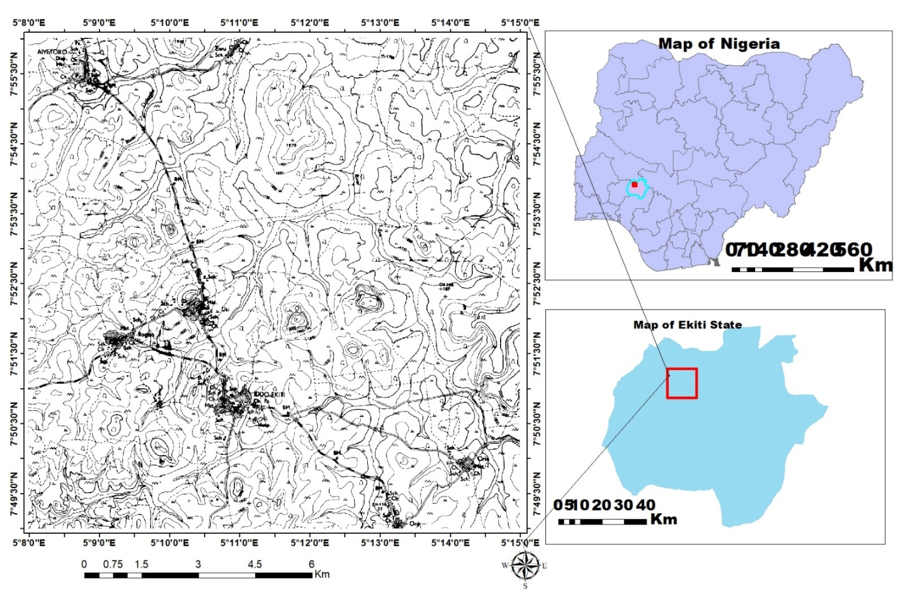
Figure 1: Map of Nigeria, insert the Ekiti State and the Study Areas. Federal Surveys, Nigeria, 2006.

2.0 GEOLOGICAL SETTING
Orin-Ekiti lies within the southwestern Nigerian Basement Complex, part of the Pan-African mobile belt situated between the West African and Congo cratons (Talabi et al., 2018; NSRMEA, 2022). The Nigerian Basement Complex consists of ancient Precambrian crystalline rocks that have experienced multiple phases of deformation, metamorphism, and magmatism associated with major orogenic events such as the Liberian (≈2700 Ma), Eburnean (≈2000 Ma), Kibaran (≈1100 Ma), and Pan-African (≈600 Ma) cycles (Igonor & Abimbola, 2016; Dada, 2008). The region is dominated by polycyclic metamorphic terrains including migmatite–gneiss complexes, charnockitic intrusions, and granitoids, with extensive folding, faulting, and shearing influencing the structural architecture (Okoli et al., 2025; Ogunyele et al., 2017). In Orin-Ekiti, the basement is mainly composed of migmatite and charnockite. Migmatite, the oldest unit, forms the foundation of the terrain and displays alternating light and dark mineral bands of quartz, feldspar, and biotite, with gneissic foliation trending NE–SW. These rocks exhibit stromatic and nebulitic textures, reflecting high-grade metamorphism under amphibolite to granulite facies conditions during Pan-African tectonism (OlaOlorun et al., 2023). Younger charnockitic intrusions occur as massive, coarse-grained bodies composed primarily of orthopyroxene, plagioclase, quartz, microcline, and biotite. Their dark grey to greenish-grey coloration and strong resistance to weathering make them prominent as inselbergs and rugged hills in the study area. Geochemical data classify the charnockites as calc-alkaline to weakly peraluminous, suggesting derivation from crustal melting and subsequent fractional crystallization under high-temperature conditions (Ogunyele et al., 2020). Structurally, Orin-Ekiti is influenced by NE–SW and NW–SE faults, joints, and foliation planes, consistent with Pan-African deformation trends (Akingboye & Ogunyele 2017). Migmatites display strong gneissic banding parallel to tectonic foliation, whereas charnockites show weak to moderate foliation. These structural elements play critical roles in controlling drainage, local topography, and potential mineralization pathways along shear zones where hydrothermal fluids may concentrate ore-forming elements (OlaOlorun et al., 2023; Okoli et al., 2025). The geological framework of Orin-Ekiti reflects the interplay of high-grade metamorphism and late-stage magmatism during the Pan-African orogeny, with migmatites representing the metamorphic basement and charnockites marking the magmatic culmination of crustal evolution in the southwestern Nigerian Basement Complex.

- MATERIALS AND METHODS

3.1 Radiometric Data Acquisition and Processing Workflow
The radiometric dataset for this study was obtained from high-resolution airborne geophysical surveys over Orin-Ekiti, extracted from the Ado-Ekiti Map Sheet 244 (1:25,000). The survey, conducted in 2024 by the Nigerian Geological Survey Agency (NGSA), aimed to map lithological variations and delineate hydrothermal alteration zones within the Nigerian Basement Complex. The main steps involved are summarized below:
- Data Acquisition
  - Airborne surveys were flown at a 50 m altitude with 150 m flight line spacing oriented NW–SE, complemented by NE–SW tie lines for positional control.
  - Natural gamma-ray emissions of potassium (K), uranium (U), and thorium (Th) were measured. Variations in these radioelements indicate lithology, weathering intensity, and hydrothermal alteration associated with mineralization.
- Data Preparation and Processing
  - Raw datasets were supplied in Geosoft-compatible grids and processed using Oasis Montaj™ 8.4 HJ.
  - Processing included clipping, gridding, and corrections for diurnal and cosmic background effects.
- Radiometric Enhancement and Mapping
  - Color composite images were produced for K, Th, U, and potassium deviation (KD) anomalies.
  - A ternary K–Th–U map assigned red, green, and blue channels to visualize lithological contrasts and alteration patterns.
  - KD maps were generated to highlight areas enriched in potassium due to hydrothermal fluids, distinguishing them from unaltered lithologies using the K–Th baseline ratio.

- Integration with Geological and Field Data
  - Radiometric maps were compared with existing geological maps to correlate anomalies with lithological contacts, especially charnockite and migmatite units.
  - Field observations validated anomalies, establishing relationships between radiometric signatures, hydrothermal alteration, and mineralization potential.
- Interpretation
  - Areas with high K but low Th and U were interpreted as hydrothermally altered zones, while high Th and U indicated less altered lithologies.
This workflow follows established methods for Nigerian basement terrains (Talabi et al., 2018; Ogunyele et al., 2017; Adekoya et al., 2020), providing a robust framework for mapping hydrothermal alteration zones and assessing mineralization potential.
KD Calculation:
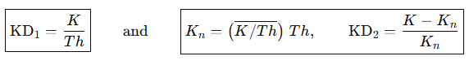
Where K is a measure of Potassium (e.g, wt% or ppm), Th is equivalent to thorium (ppm), and K/Th is the regional background of the K/Th ratio (Ohwon & Soalpe, 2024). Potassic alteration (KD) is a key indicator in many ore systems (e.g., porphyry Cu ± Mo ± Au, high-sulfidation, mesothermal).
3.2 Geochemical Data Acquisition and Processing Workflow
Field-based geological mapping and laboratory geochemical analyses were conducted on rock samples from Orin-Ekiti to validate radiometric anomalies and delineate lithological boundaries. The study workflow is summarized below:
Field Sampling and Geological Mapping
- The outcrops were mapped at a scale of 1:25,000 using Topographic Map.
- Sample locations were recorded using a GPS device.
- A total of 35 representative rock samples were collected at approximately 500 m spacing, of which 15 were selected for geochemical analysis.
Sample Preparation and Digestion
- Collected samples were cleaned, crushed, and pulverized to a fine powder.
- Partial digestion was performed using a combination of four-acid treatment and lithium metaborate/tetraborate fusion (Sanda et al., 2014) to ensure complete extraction of trace elements.

Geochemical Analysis and Data Processing
- Samples were analyzed at ACME Analytical Laboratories, Canada, using inductively coupled plasma mass spectrometry (ICP–MS) for trace elements including Cr, Ni, Zr, Y, Rb, Sr, and Ba.
- Geochemical data were processed using Microsoft Excel, RockWorks 17, and SPSS for statistical and multivariate analyses, including factor and correlation analyses to identify geochemical anomalies, alteration trends, and element associations indicative of hydrothermal processes.
Integration with Radiometric and Field Data
- Geochemical results were integrated with radiometric maps and field observations to validate anomalies and establish relationships between elemental distributions, hydrothermal alteration, and mineralization potential.
- Key geochemical signatures and elemental associations (e.g., pathfinder elements) were used to delineate hydrothermal alteration zones within charnockitic and migmatitic units.
Interpretation
- Geochemical anomalies, combined with structural and radiometric data, facilitated a comprehensive assessment of hydrothermal alteration zones and mineralization potential.
- This workflow provides a transparent and replicable framework for evaluating basement-hosted mineral systems and supports targeted exploration in similar terrains.
- Radiometric Results and Discussion
4.1 Potassium Radiometric Map
The potassium (K%) radiometric map of Orin-Ekiti (Figure 2a) shows clear spatial variations in potassium distribution (0.2–3.0%), expressed as violet–red (high) to green–blue (low). High K anomalies (1.8–3.0%) occur mainly in the central and southwestern zones around Ilogbo, Iddo-Ekiti, and Orin. These areas coincide with granitic and charnockitic rocks enriched in K-feldspar, biotite, and muscovite (Igonor & Abimbola, 2016). The enrichment also suggests potassic hydrothermal alteration, marked by sericitization and secondary K-feldspar, commonly associated with mineralized basement systems (Reilly & Corey, 1988). Moderate K values (1.0–1.7%) follow NE–SW structural belts crossing the central part of the map near Usin and Ilogbo. These linear anomalies likely represent fractures or shear zones that focused fluid flow, consistent with structural controls documented in Nigerian basement terrains (Adepelumi et al., 2008; Akingboye & Ogunyele, 2017). Low potassium zones (≤0.8%) dominate the eastern and northern areas around Aiyetoro, Ewu, and Ora. These correspond to quartz-rich or weakly altered migmatite–gneiss units with inherently low K content, and may also reflect leaching during hydrothermal activity or intense tropical weathering (Ogunyele et al., 2017). The map reveals: (1) K-enriched zones indicating potassic alteration and possible hydrothermal mineralization; (2) moderate anomalies along NE–SW structures, suggesting fault-related mineralizing pathways; and (3) K-depleted zones marking unaltered or silicified rocks. These patterns highlight the central and southwestern regions as priority targets for further structural, geochemical, and geophysical exploration (Onyejiuwaka & Nwokeabia, 2020).
4.2 Potassium Radiometric Reclassified Map
The reclassified potassium radiometric map (Figure 2b) reveals distinct spatial patterns in K distribution across the Orin–Iddo–Ilogbo axis. High-intensity K zones (red) are concentrated around Ilogbo, Usin, Iddo-Ekiti, and parts of Orin, reflecting the presence of potassium-rich granitic and charnockitic bedrock units dominated by K-feldspar, biotite, and muscovite, as previously documented in the area (Igonor & Abimbola, 2016). These high-K zones may also indicate potassic hydrothermal alteration related to sericitization and secondary K-feldspar development, a common signature of mineralized basement systems (Reilly & Corey, 1988). Moderate K anomalies (yellow) occur as NE–SW linear belts, especially near Usin and Ilogbo, suggesting structurally controlled pathways such as fractures or shear zones that channelled migrating hydrothermal fluids, an interpretation consistent with structural patterns in the Nigerian Basement Complex (Adepelumi et al., 2008; Akingboye & Ogunyele, 2017). Low K zones (green), dominant toward Aiyetoro, Ewu, and Ora, correspond to quartz-rich or weakly altered gneissic units with inherently low K contents, or areas affected by weathering and leaching (Ogunyele et al., 2017). Overall, the map delineates: (1) K-enriched alteration zones with potential mineralization significance; (2) structurally guided moderate anomalies marking possible fault-controlled fluid pathways; and (3) K-depleted zones associated with unaltered or silicified lithologies. These features collectively highlight the central and southwestern sectors as the most promising targets for integrated structural, geochemical, and geophysical follow-up investigations (Onyejiuwaka & Nwokeabia, 2020).

4.3 Thorium Radiometric Map
The thorium (Th) radiometric map of Orin-Ekiti and its environs (Figure 3a) shows clear spatial variations in Th concentration that reflect lithological differences, weathering intensity, and structural controls. High thorium values (red–violet zones) dominate around Ilogbo, Iddo-Ekiti, and parts of Orin. These areas correspond to granitic and charnockitic rocks that typically host Th-rich accessory minerals such as monazite, zircon, and allanite (Wilford et al., 1997; Reilly & Corey, 1988). Because thorium is immobile during weathering, these high-Th zones indicate stable felsic lithologies and potential locations of REE-bearing pegmatites or granitic intrusions (Rahaman, 1988; Ogunyele et al., 2017). Moderate thorium anomalies (yellow–green tones) around Usi and Aiyetoro suggest mixed lithologies, with granitic gneiss transitioning into migmatitic complexes. These intermediate signatures may reflect partial melting and hybrid basement rocks with moderate radiogenic content (Christopher et al., 2022). Low thorium values (blue–cyan zones) in Ewu and southern Ora correlate with quartzite, highly weathered terrains, and lithologies deficient in accessory minerals, indicating low mineralization potential (Adepelumi et al., 2008). Structurally, the NE–SW alignment of high-Th anomalies follows the regional tectonic trend and likely represents shear zones, intrusive contacts, or fracture corridors that focused hydrothermal fluids. These structural pathways commonly enhance radiogenic mineral concentration and may indicate favourable zones for REE or uranium mineralization in basement terrains (Onyejiuwaka & Nwokeabia, 2020). The thorium radiometric map highlights granitic–charnockitic intrusions, structurally controlled radiogenic enrichment, and potential REE or U-bearing systems within the Orin-Ekiti basement complex.
4.4 Thorium Radiometric Reclassified Map
The reclassified thorium radiometric map (Figure 3b) reveals distinct spatial variations in Th enrichment across the Orin–Iddo–Ilogbo region. High thorium zones (red) are concentrated around Ilogbo, Iddo-Ekiti, and parts of Orin, reflecting the dominance of granitic and charnockitic rocks known to contain Th-bearing accessory minerals such as monazite, zircon, and allanite (Wilford et al., 1997; Reilly & Corey, 1988). Since thorium is relatively immobile during weathering, these enriched areas mark stable felsic lithologies and may indicate favourable sites for REE-bearing pegmatites or granitic intrusions (Rahaman, 1988; Ogunyele et al., 2017). Moderate thorium anomalies (yellow) around Usi, Aiyetoro, and parts of the central zone suggest transitions between granitic gneiss and migmatitic units, consistent with mixed or partially melted basement rocks displaying intermediate radiogenic signatures (Christopher et al., 2022). Low Th zones (green) in Ewu and southern Ora correspond to quartz-rich, strongly weathered terrains or lithologies lacking significant accessory minerals, implying low radiogenic mineral potential (Adepelumi et al., 2008). The NE–SW alignment of the high-Th clusters mirrors the regional tectonic trend and likely reflects shear zones, intrusive contacts, or fracture networks capable of concentrating radiogenic minerals. Such structural corridors are commonly associated with REE and uranium enrichment in basement settings (Onyejiuwaka & Nwokeabia, 2020). Overall, the map delineates felsic intrusions, structurally enhanced radiogenic enrichment, and potential REE or U-bearing systems within the Orin-Ekiti basement complex.

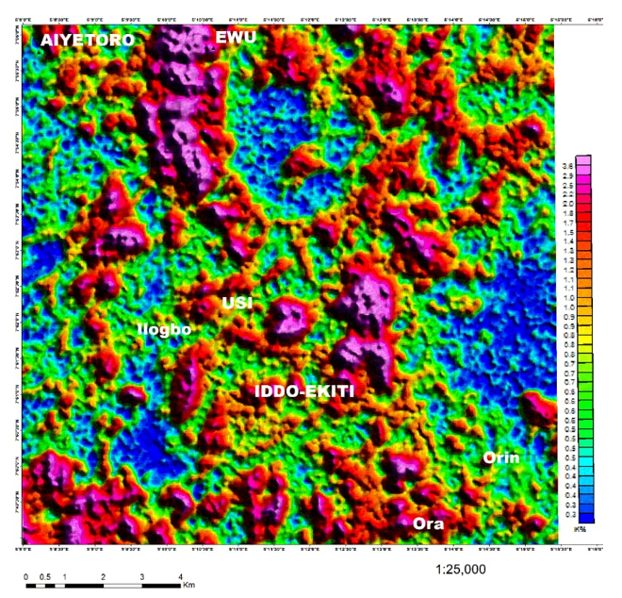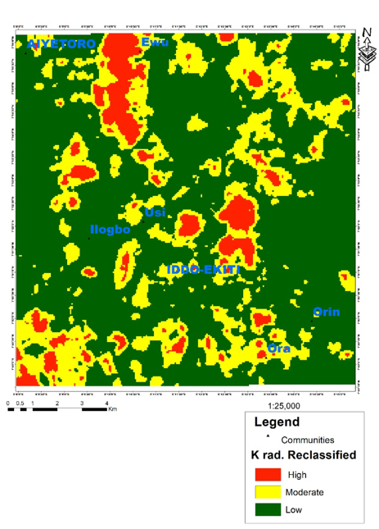
Figure 2a: Potassium Radiometric Map Figure 2b: Potassium Radiometric Reclassified Map

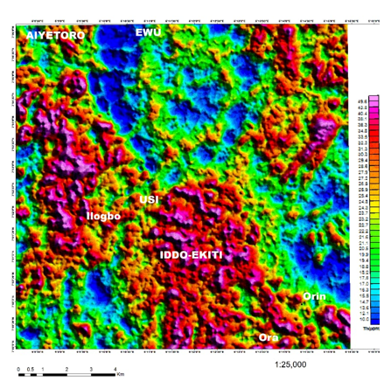
Figure 3a: Thorium Radiometric Map Figure 3b: Thorium Radiometric Reclassified Map

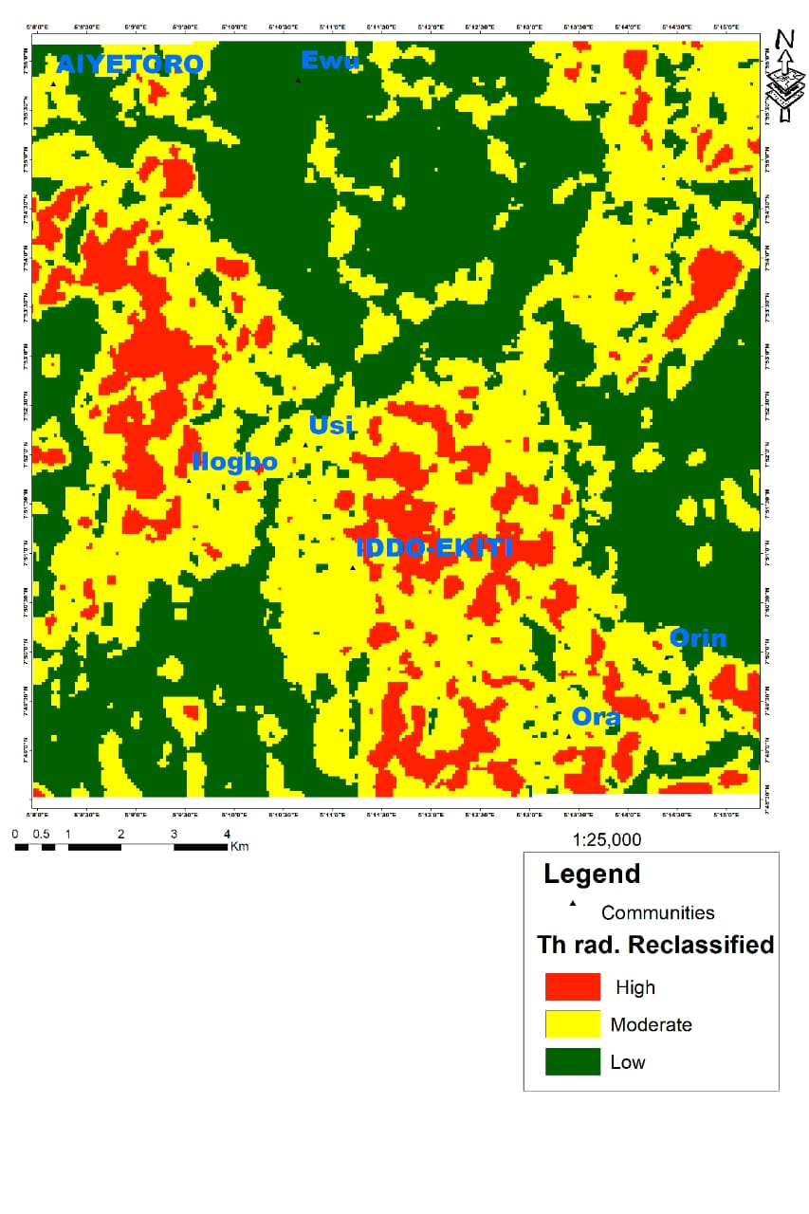
4.5 Uranium Radiometric Map
The uranium (U) radiometric map of Orin-Ekiti and its environs (Figure 4a) shows distinct uranium variations that reflect lithology, alteration processes, and structural controls within the basement terrain. Uranium values range from low (blue–green) to high (red–violet), corresponding to differences in radioelement concentration, weathering behavior, and mobility during hydrothermal alteration (Wilford et al., 1997). High uranium anomalies, mainly around Ilogbo, Iddo-Ekiti, and parts of Orin and Ora, coincide with regions of elevated K and Th in the companion maps. These zones are underlain by felsic lithologies such as granite and charnockite, which are naturally enriched in U-bearing accessory minerals like uraninite, monazite, and zircon (Rahaman, 1988; Ogunyele et al., 2017). The clustering of high U values along fracture and shear zones suggests that hydrothermal fluids mobilized and redeposited uranium along structural pathways (Onyejiuwaka & Nwokeabia, 2020). Moderate U concentrations (green–yellow) in Usi and parts of Aiyetoro likely correspond to migmatitic and granitic gneiss rocks that contain intermediate levels of radiogenic minerals due to partial melting and metamorphic differentiation. In contrast, low uranium signatures (blue–cyan) observed in Ewu and the southern flank of Ora reflect quartzite and intensely weathered units where uranium has been leached by oxidizing fluids (Adepelumi et al., 2008; Ogunyele et al., 2017). Structurally, the NE–SW to ENE–WSW alignment of uranium anomalies aligns with major Pan-African trends, indicating that deformation strongly influenced uranium concentration. These lineament-controlled patterns are typical of secondary uranium mineralization where fluids precipitate U minerals along faults and shear systems (Onyejiuwaka & Nwokeabia, 2020). The uranium distribution highlights key radiogenic and hydrothermal alteration zones. Areas where high U, Th, and K anomalies overlap represent granitoid intrusions and deformation corridors that have strong potential for uranium and rare earth element (REE) mineralization.
4.6 Uranium Radiometric Map Reclassified
The reclassified uranium radiometric map of Orin-Ekiti and its environs (Figure 4b) shows clear spatial variations in uranium concentration that reflect lithological differences, weathering patterns, and structural influences within the Basement Complex. Uranium values range from low to high intensities, corresponding to variable radioelement abundances and mobility during alteration processes (Wilford et al., 1997). High uranium anomalies around Ilogbo, Iddo-Ekiti, and parts of Orin and Ora coincide with elevated K and Th zones and are associated with felsic lithologies such as granite and charnockite, which are naturally enriched in U-bearing accessory minerals including uraninite, monazite, and zircon (Rahaman, 1988; Ogunyele et al., 2017). The concentration of these high-intensity zones along fracture and shear corridors indicates that hydrothermal fluids mobilized and redeposited uranium along structural pathways (Onyejiuwaka & Nwokeabia, 2020). Moderate uranium levels in areas like Usi and parts of Aiyetoro likely reflect migmatitic and granitic gneiss units characterized by intermediate radiogenic mineral contents resulting from partial melting and metamorphic differentiation. In contrast, low uranium signatures observed in Ewu and the southern flank of Ora correspond to quartzite and strongly weathered terrains where uranium has been leached by oxidizing fluids (Adepelumi et al., 2008; Ogunyele et al., 2017). The NE–SW to ENE–WSW structural alignment of the anomalies mirrors major Pan-African deformation trends, highlighting the strong structural control on uranium distribution. Overlapping high U, Th, and K zones mark radiogenic granitoid intrusions and deformation axis that represent key targets for uranium and rare earth element (REE) mineralization potential.
4.7 Potassium Deviation Map
The potassium deviation map of Orin-Ekiti and its environs (Figure 5a) shows variations in potassium concentration relative to the background mean, allowing the identification of alteration zones and prospective mineralized structures. Positive potassium deviations (violet–red colors) mark areas where K values are significantly above average. These high-deviation zones occur mainly around Ilogun, Iddo-Ekiti, and parts of Orin, corresponding to granitic and charnockitic rocks enriched in K-feldspar, biotite, and muscovite (Rahaman, 1988; Christopher et al., 2022). Such enrichment is typical of potassic hydrothermal alteration, which often forms as mineralizing fluids introduce or redistribute potassium within felsic basement rocks (Onyejiuwaka & Nwokeabia, 2020). Moderate potassium deviations (yellow–green shades) appear in transitional zones around Usi and portions of Ilogun, aligning with NE–SW structural trends. These patterns suggest that faults and shear zones facilitated fluid circulation and localized alteration, an observation consistent with structural controls documented in regional basement studies (Adepelumi et al., 2008). Low potassium deviations (blue–cyan colors) dominate Aiyetoro, Ewu, and parts of Ora, where quartz-rich migmatite and strongly weathered lithologies show limited potassic enrichment. These areas represent relatively unaltered or leached terrains with minimal hydrothermal overprinting (Ogunyele et al., 2017).
4.8 Potassium Deviation Reclassified Map
The reclassified potassium deviation map of Orin-Ekiti and its environs (Figure 5b) reveals significant variations in K concentration relative to the regional background, allowing clear discrimination of lithological units, alteration zones, and structurally controlled features within the basement terrain. High potassium deviations (red–violet) occur prominently around Ilogun, Iddo-Ekiti, and parts of Orin, corresponding to granitic and charnockitic rocks enriched in K-feldspar, biotite, and muscovite (Rahaman, 1988; Christopher et al., 2022). These high-deviation zones are diagnostic of potassic hydrothermal alteration, where circulating mineralizing fluids introduce or redistribute potassium within felsic lithologies (Onyejiuwaka & Nwokeabia, 2020). Moderate deviations (yellow–green) define transitional areas around Usi and portions of Ilogun and exhibit a NE–SW structural orientation, reflecting the influence of shear zones and fractures that facilitated fluid flow and localized alteration—patterns consistent with regional structural controls in the Nigerian Basement Complex (Adepelumi et al., 2008). Low potassium deviations (blue–cyan) dominate Aiyetoro, Ewu, and parts of Ora and correspond to quartz-rich migmatite and strongly weathered units characterized by limited potassic enrichment or potassium depletion due to leaching (Ogunyele et al., 2017). The overall distribution, including the elongated geometry of high and low zones, mirrors the NW–SE to NE–SW tectonic grain of the basement. These reclassified deviation patterns therefore delineate granitic intrusions, alteration fronts, and deformation corridors that may represent prospective zones for mineral exploration, particularly where high-deviation anomalies coincide with major structural lineaments.

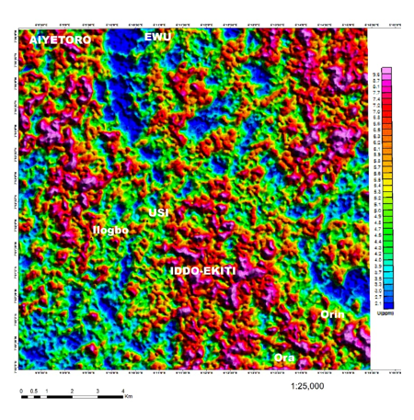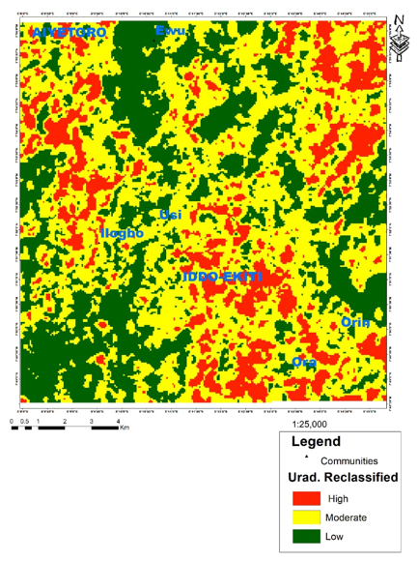
Figure 4a: Uranium Radiometric Map Figure 4b: Uranium Radiometric Map Reclassified

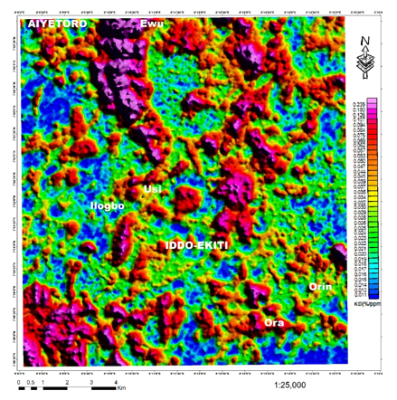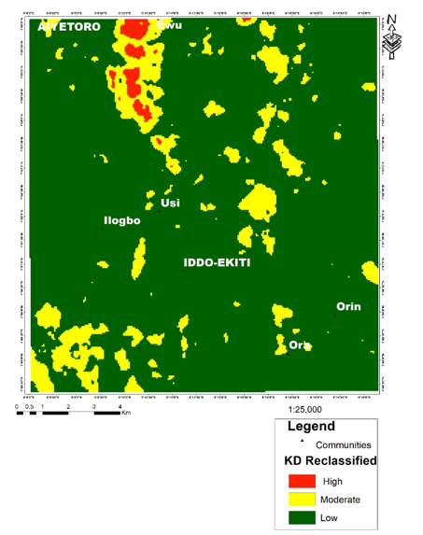

Figure 5a: Potassium Deviation Map Figure 5b: Potassium Deviation Reclassified Map

4.9 Ternary Diagram
The ternary radiometric map (Figure 6) combines potassium (K), thorium (Th), and uranium (U) into a single composite visualization where color variations reflect the relative dominance of the three radioelements. In this system, red indicates K-rich zones, green highlights Th-enriched areas, and blue corresponds to U enrichment, with mixed colors representing proportional combinations (yellow: K+Th, cyan: Th+U, magenta: K+U) (Geoscience Australia, 2021; Wilford, 2002). This integrated approach helps reveal subtle lithological differences and alteration signatures that may not be apparent on single-element maps (IAEA, 2003).In the Orin-Ekiti area, the ternary map delineates two prominent geochemical zones. The central Iddo-Ekiti–Usi–Ilogbo corridor exhibits cyan to blue hues, indicating high Th–U enrichment characteristic of migmatite and charnockite terrain, with pure blue streaks marking possible hydrothermal uranium enrichment controlled by NE–SW fractures. In contrast, the northern Aiyetoro–Ewu region is dominated by red to yellow colors, reflecting K- and Th-rich granitic and charnockitic units with only limited U remobilization. Elevated U/Th ratios in the central corridor point to secondary uranium deposition along structural pathways, whereas lower ratios in the northern sector indicate primary uranium held in relatively unaltered feldspar-rich rocks. These patterns are consistent with structural and lithological controls on radioactive mineral enrichment across the Nigerian Basement Complex (IAEA, 2010).
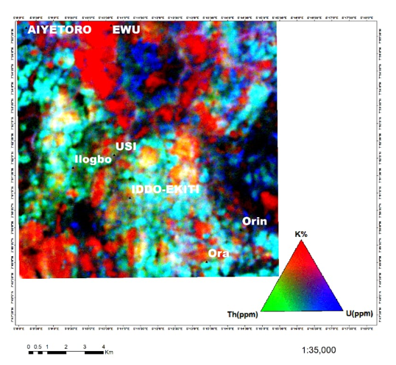
Figure 6: Ternary Diagram
4.10 Geological Map of the Study Area
The geological map of Orin-Ekiti and its environs (Figure 7) reveals two dominant lithological units: Charnockite (Ch) and Migmatite (Mg), characteristic of the Nigerian Basement Complex ( Igonor & Abimbola, 2016). Charnockite, depicted in dark brown, occurs mainly in the northwestern sector, covering Aiyetoro, Ewu, Usi, and Ilogbo, and as a smaller body near Orin. This unit comprises hypersthene-bearing, felsic to intermediate rocks formed under granulite-facies conditions and enriched in radioactive elements such as uranium (U), thorium (Th), and potassium (K), indicating its potential as a source rock for mineralization (Igonor & Abimbola 2016). Migmatite, shown in light brown, dominates the central and southern areas, particularly around Iddo-Ekiti and Ora. These composite rocks, consisting of a dark metamorphic paleosome and a light granitic neosome, are typical high-grade metamorphic units that provide favorable hosts for mineralization, especially along fractures and shear zones (Ogunyele et al., 2017). The spatial relationship between the units suggests that the Charnockite acts as a source of U, Th, and K, while the more extensive Migmatite serves as a structural and geochemical trap for mobilized uranium. The NE–SW orientation of the Migmatite belt through Iddo-Ekiti, Usi, and Ilogbo indicates structural control on fluid pathways and mineral deposition. The map highlights the compositional and spatial contrast between the uranium- and potassium-rich Charnockite and the host Migmatite, providing critical insights into the mineralization potential of the study area
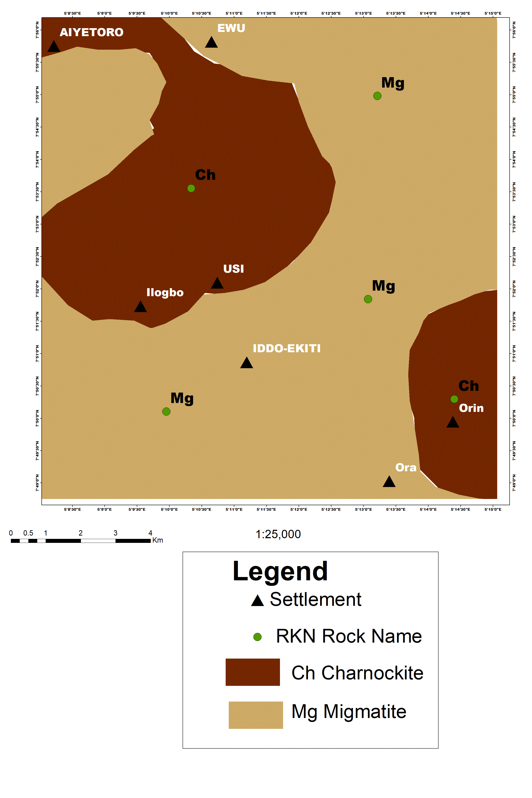

Figure 7: Geological Maps of the Study Area (Parker et al., 1964)

4.11 Potassium Deviation Superimposed on the Geological Map
The Potassium Deviation (KD) map (Figure 8), when superimposed on the geological map, serves as a key geochemical tool for identifying hydrothermal alteration zones and potential mineralization areas. KD anomalies, representing significant positive or negative deviations in potassium concentration, indicate metasomatic or hydrothermal processes linked to ore formation (Wilford et al., 1997). Prominent purple KD zones are observed mainly within the Charnockite, along the Charnockite–Migmatite contact, and locally in Migmatite terrains. In the Charnockite, anomalies north of Usi and south of Ewu likely reflect potassic alteration or potassium leaching, processes commonly associated with uranium mobilization in granitic and metamorphic rocks (Onyejiuwaka & Nwokeabia, 2020). Along the Charnockite–Migmatite contact, linear KD anomalies align with NE–SW and E–W structural trends, indicating enhanced permeability and hydrothermal fluid flow, which control uranium deposition (Ogunyele et al., 2017). Within the Migmatite, smaller KD patches near Iddo-Ekiti and southwest of Ilogbo suggest localized potassic alteration from fluid infiltration, corroborated by coincident high equivalent uranium (eU) zones. These spatial relationships confirm that hydrothermal alteration and structural controls jointly influence uranium mineralization in the study area (Onyejiuwaka & Nwokeabia, 2020).

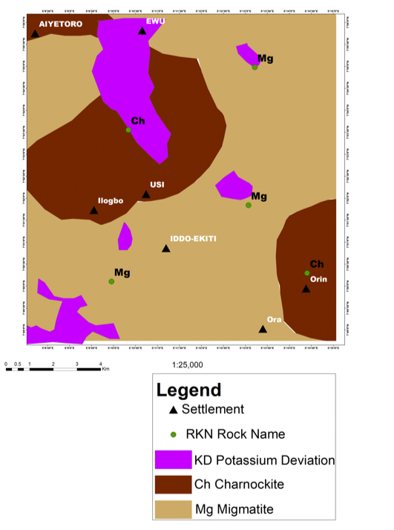

Figure 8: Potassium Deviation Superimposed on Geological Map of the Study Area

4.12: Trace Elements Geochemistry of the Rocks
The trace element data from Orin-Ekiti and surrounding towns such as Ora, Iddo, Ayetoro, Odo-Ora, and Ewu (Table 1) below reveal geochemical variations reflecting lithological diversity and crustal evolution. Barium (Ba) concentrations range from 21 ppm at Ayetoro to 2367 ppm at Orin-Ekiti, indicating variable feldspar content (Taylor & McLennan, 1985). Elevated zirconium (Zr) values, up to 3532 ppm at Iddo, suggest magmatic fractionation and accessory zircon in evolved granitic or migmatitic rocks (Ogunyele et al., 2017). Charnockitic samples from Orin Junction and Iddo show higher Zr, Nb, and Y contents, consistent with ferroan and alkalic characteristics (Frost et al., 2001). Nickel (Ni) and copper (Cu) are moderately enriched in Orin and Iddo samples, with Ni reaching 104 ppm, reflecting mafic contributions or partial melting of metal-bearing sources. Zinc (Zn) and lead (Pb) are higher in Orin-Ekiti and Iddo, indicating hydrothermal influence during crustal reworking (Ogunyele et al., 2017; Igonor & Abimbola, 2016). Samples from Odo-Ora and Ayetoro display low trace element abundances, consistent with less-evolved basement material. The distribution of Ba, Zr, Nb, and Y supports a complex magmatic history with crustal melting and fluid-assisted metasomatism during the Pan-African orogeny, producing migmatitic to charnockitic suites typical of reworked basement terrains in southwestern Nigeria (Rahaman, 1988).

4.13 Trace Element (ppm) Geochemistry Results and Discussion
Table 1: Trace Elements Compositions in ppm
S/n | Samples ID | Longitude | Latitude | Ba | Ni | Zr | Y | Nb | Sc | Mo | Cu | Pb | Zn | Ag
1 | Fadama Office Orin Ekiti | 5°13¹40¹¹ | 7°49¹5¹¹ | 2367 | <20 | 855 | 65 | 33 | 17 | 1 | 19.5 | 31 | 156 | <0.1
2 | Ori Oke Gbogunmi | 5°14¹43¹¹ | 7°49¹20¹¹ | 1724 | <20 | 1043 | 60 | 28 | 12 | 1 | 22.5 | 28 | 125 | <0.1
3 | Beside St Davids Primary School Orin-Ekiti | 5°13¹36¹¹ | 7°49¹22¹¹ | 89 | 24 | 743 | 60 | 28 | 12 | 1 | 22.5 | 28 | 125 | <0.1
4 | Along Orin-Ora-Ekiti Road | 5°13¹28¹¹ | 7°49¹40¹¹ | 78 | 20 | 475 | 51 | 27 | 4 | 1 | 12.5 | 39 | 72 | <0.1
5 | Orin-Ekiti junction | 5°13¹28¹¹ | 7°49¹40¹¹ | 591 | 41 | 1629 | 75 | 43 | 13 | 1 | 31.6 | 35 | 91 | <0.1
6 | Gas station Ora-Iddo Ekiti | 5°13¹26¹¹ | 7°49¹20¹¹ | 591 | 41 | 1629 | 75 | 43 | 13 | 1 | 31.6 | 35 | 91 | <0.1
7 | Ayetoro-Ewu-Ekit | 5°12¹28¹¹ | 7°49¹53¹¹ | 394 | <20 | 305 | 32 | 26 | 4 | 2 | 23.2 | 22 | 71 | <0.1
8 | Close to Fulani settlement Orin-Ekiti | 5°12¹58¹¹ | 7°49¹37¹¹ | 1324 | 87 | 672 | 42 | 32 | 17 | 1 | 50.8 | 43 | 207 | <0.1
9 | Opposite Fadama Orin-Ekiti | 5°12¹39¹¹ | 7°49¹36¹¹ | 1801 | 32 | 337 | 24 | 15 | 12 | 1 | 39.2 | 26 | 74 | <0.1
10 | Ayetoro-Ekiti (Odo Iju) | 5°12¹39¹¹ | °49¹36¹¹ | 21 | 52 | <5 | <3 | <5 | 16 | 1 | 15.6 | 1.4 | 16 | <0.1
11 | Iddo general market | 5°11¹26¹¹ | 7°49¹48¹¹ | 548 | <20 | 375 | 51 | 7 | 4 | 1 | 12.5 | 39 | 72 | <0.1
12 | The rock hotel Iddo/loc | 5°11¹42¹¹ | 7°49¹58¹¹ | 1261 | 104 | 593 | 48 | 16 | 15 | 1 | 50.8 | 47 | 202 | <0.1
13 | Odo Ora (Ilogun) Kabiyesi farm/loc | 5°9¹21¹¹ | 7°54¹38¹¹ | 80 | 50 | 231 | 6 | 15 | <1 | 1 | 15.3 | 1.4 | 17 | <0.1
14 | Besides FMC Iddo-Ekiti/loc | 5°10¹43¹¹ | 7°53¹32¹¹ | 1865 | <20 | 3532 | 70 | 36 | 12 | 2 | 27.3 | 64 | 165 | <0.1
15 | Opposite Baale palace (Ewu-Ekiti)/loc | 5°12¹28¹¹ | 7°49¹53¹¹ | 476 | <20 | 25 | 3 | 19 | <1 | 0 | 6.9 | 25 | 7 | <0.1

4.14 Multivariate Statistics of the Trace Elements.
4.14.1 Factor Analysis
The factor analysis in Table 2 below extracted five significant components with a cumulative variance of 93.87%, capturing most of the geochemical variability. Group I shows a strong association among Cu, Pb, Zn, Mn, and Fe, accounting for 35.24% of the variance, reflecting sulfide mineralization processes where these base metals co-precipitate from hydrothermal fluids under reducing conditions (Govett, 1983). This enrichment suggests that the banded gneiss of Ora-Ekiti, granite gneiss of Orin-Ekiti, and banded gneiss of Iddo-Ekiti may have undergone hydrothermal alteration, forming Cu–Pb–Zn–Mn–Fe mineralization. Groups II and III reveal a Pb–As–Rb association, contributing 24.74% of the variance, elements commonly used as pathfinders for sulfide and gold deposits (Onyejiuwaka & Nwokeabia, 2020), indicating hydrothermal remobilization and metasomatic enrichment along structural conduits. The As–Pb–Rb association implies chemically evolved fluids, likely derived from felsic magmatic sources or reworked basement rocks. Overall, the factor model confirms that mineralization in the area is structurally and hydrothermally controlled, with geochemical signatures characteristic of polymetallic sulfide systems within the Nigerian Basement Complex (Olade, 2020; Rahaman, 1988).
4.14.2 Factor Analysis
Factor analysis established the elemental associations within the rocks, categorising elements based on their role in the mineralization of host rocks and their function as pathfinder elements. The findings from the factor analysis of the rock samples are summarized in Table 2 below.
Table 2: Factor Analysis Result
Variables | Comp 1 |  | Comp 11 | Comp 111 | Comp 1V | Comp V | Communalities
Cu | .761 |  |  |  |  |  | .920
Pb | .562 |  | .700 | .267 |  |  | .930
Zn | .656 |  | .302 |  |  |  | .924
Co |  |  |  |  | .553 |  | .910
Mn | .772 |  |  | .321 | .136 |  | .913
Fe | .778 |  |  |  | .195 |  | .986
As |  |  | .435 | .219 | .563 | .585 | .908
Rb |  |  | .551 | .739 |  |  | .973
Ni | .586 |  |  |  |  |  | .866
Yr | .513 |  | .623 |  | .202 |  | .958
Zr | .487 |  | .674 |  | .117 |  | .924
Mo | .260 |  | .252 | .013 |  | .751 | .941
Al | .922 |  |  | .324 | .124 | .048 | .988
Na | .772 |  | .098 | .601 | .078 | .136 | .991
EV | 4.93 | 3.46 |  | 2.25 | 1.34 | 1.16
VAR (%) | 35.24 | 24.74 |  | 16.09 | 9.55 | 8.25
CVAR (%) | 35.24 | 59.98 |  | 76.07 | 85.62 | 93.87

4.14.3 Correlation Coefficient
The correlation matrix (Table 3) below presents the interrelationship between major and trace elements determined using IBM SPSS 21. Strong positive correlations were observed among several metallic elements, implying a common geochemical origin or similar mobilization mechanisms during mineralization. Copper (Cu) shows significant positive correlations with Chromium (Cr, r = 0.922**), Zinc (Zn, r = 0.731**), Arsenic (As, r = 0.517**), Manganese (Mn, r = 0.548*), and Lead (Pb, r = 0.428*), but a weak negative correlation with Rubidium (Rb, r = –0.317). This association suggests a hydrothermal origin where Cu, Zn, Pb, and As were co-precipitated from metalliferous fluids, likely within structurally controlled sulfide veins (Boyle, 1979; Rose et al., 1979). Similarly, Zn exhibits strong positive correlations with Pb (r = 0.726**), As (r = 0.555*), Cu (r = 0.731**), and Cr (r = 0.593*), indicating their common derivation from hydrothermal solutions and mutual substitution in sulfide lattices such as galena and sphalerite (Govett, 1983). The positive correlations between Co–Ni (r = 0.891**) and Ni–Cr (r = 0.955**) further imply a ferromagnesian association linked to mafic or ultramafic source rocks (Rose et al., 1979). The strong Zn–Cu–Pb–Cr interrelationship suggests that mineralization within the study area is dominated by hydrothermal sulfide deposition, enriched in base-metal and transition-metal elements. The data support the occurrence of polymetallic sulfide mineralization, possibly controlled by shear zones within the Basement Complex (Olade, 2020; Rahaman, 1988).
Table 3: Correlation Matrix showing the inter-relationship between heavy metals
 | Fe | Cu | Pb | Zn | Ni | Co | Mn | As | Th | Cr | Rb
Fe | 1
Cu | 0.169 | 1
Pb | 0.125 | 0.428 | 1
Zn | 0.181 | .731** | .726** | 1
Ni | 0.088 | .869** | 0.202 | 0.426 | 1
Co | 0.111 | .769** | 0.362 | .451* | .891** | 1
Mn | 0.053 | .544* | 0.324 | 0.293 | .691** | .927** | 1
As | 0.147 | .517* | .742** | .555* | .500* | .724** | .701** | 1
Th | 0.133 | -0.105 | .537* | 0.121 | -0.163 | 0.045 | 0.104 | 0.394 | 1
Cr | 0.020 | .922** | 0.439 | .593** | .955** | .908** | .719** | .646** | -0.034 | 1
Pb | -.473* | -0.317 | 0.434 | -0.030 | -0.389 | -0.255 | -0.150 | 0.227 | 0.357 | -0.189 | 1
Correlation is significant at the 0.01 level (2-tailed).
*Correlation is significant at the 0.05 level (2-tailed

5.0 Conclusion
The integrated radiometric and geochemical investigation of Orin-Ekiti and its environs has successfully delineated hydrothermal alteration zones and assessed the mineralization potential of the Basement Complex. Radiometric anomalies in K, Th, and U are concentrated around Iddo-Ekiti, Ilogbo, and Usi, and align with NE–SW shear zones, indicating strong structural control on fluid flow and mineral localization. Potassic alteration halos, identified through K deviation maps and elevated radiometric values, reflect radiogenic enrichment and hydrothermal activity. The Charnockite unit serves as the primary radiogenic source, while the Migmatite hosts secondary concentrations of uranium and other mobile elements along fault-controlled pathways. Geochemical analyses, supported by factor and correlation coefficients, reveal strong elemental associations (Cu–Pb–Zn–Fe–Mn) and pathfinder elements (As, Rb, Pb), confirming polymetallic hydrothermal remobilization. The results support a two-stage mineralization model: (1) primary magmatic enrichment within the Charnockitic suite, and (2) secondary hydrothermal redistribution into Migmatitic hosts along shear and lithological boundaries. This underscores the interaction between magmatism, structural deformation, and fluid flow in the Pan-African Basement Complex. Study Limitations: Limited access to certain field sites and incomplete subsurface geophysical coverage restricted full spatial characterization of alteration zones. Some geochemical analyses were constrained by sample density, potentially affecting the resolution of local anomaly patterns. Recommendations for Future Work: Expanded high-resolution geophysical surveys and systematic geochemical sampling across unstudied sectors are suggested. Future studies could integrate isotopic analyses and 3D modeling to quantify fluid pathways and metallogenic processes better, thereby enhancing predictive exploration for U, Th, K, and base-metal mineralization. Overall, this study provides the first integrated radiometric–geochemical model for the Orin-Ekiti Basement Complex and highlights its significant potential as a target for future mineral exploration.

Disclaimer (Artificial Intelligence)

The author (s) hereby declare that generative AI technologies such as Large Language Models have been used during the writing or editing of this manuscript. Details of the AI usage are given below:
1 Name of AI tool: ChatGPT (OpenAI, GPT-5.1)
2. Purpose of use: Only for language refinement, grammar correction, and improving clarity of expression.
3. No AI tool was used to generate data, interpret results, perform analysis, or draw scientific conclusions. All scientific content and interpretations are entirely the authors’ own.

Competing Interests
The authors declare that they have no financial or personal relationships that could inappropriately influence, or be perceived to influence, the work reported in this manuscript. No employment, consultancies, honoraria, paid expert testimony, patent applications/registrations, or external funding are associated with this study. The authors have declared that no competing interests exist.

Consent
This study does not involve human participants, patient data, or case reports; therefore, informed consent does not apply to this manuscript.

Ethical Approval
This study does not involve human participants, human data, or animal experiments; therefore, ethical approval was not required for this research. The research activities carried out, radiometric analysis, geochemical evaluation, and geological mapping, do not fall under procedures requiring Institutional Review Board (IRB) or Ethical Committee clearance.

REFERENCES
- Adekoya, J.A., Olarewaju, V.O., & Okunlola, O.A. (2020). Evolution of Basement Complex terrains in Southwestern Nigeria. https://www.researchgate.net/publication/344392320
- Anaba, A., Okon, E., & Udofia, A. (2023). Ternary radiometric mapping of K–Th–U ratios for lithology and alteration zones in basement terrains, Nigeria. Geosciences, 13(4), 145. https://www.mdpi.com/2076-3263/13/4/145
- Ekitistate.gov.ng. (2022). About Ekiti State. https://www.ekitistate.gov.ng/about-ekiti
- Frost, B.R., Barnes, C.G., Collins, W.J., Arculus, R.J., Ellis, D.J., & Frost, C.D. (2001). A geochemical classification for granitic rocks. Journal of Petrology, 42(11), 2033–2048. https://openresearch-repository.anu.edu.au/handle/1885/93167
- Govett, G.J.S. (1983). Rock geochemistry in mineral exploration. Handbook of Exploration Geochemistry, Volume 3. Elsevier Scientific Publishing Company. https://api.pageplace.de/preview/DT0400.9781483289700_A23884968/preview-9781483289700_A23884968.pdf
- IAEA (2003). Guidelines for radioelement mapping using gamma ray spectrometry data. IAEA-TECDOC-1363. https://www.iaea.org/publications/6446
- Nigerian Geological Survey Agency. (2023). High-resolution Airborne MagRad data of Southwestern Nigeria (150 m line spacing / 50 m terrain clearance). https://miningdecision.minesandsteel.gov.ng/ngsa_metadata/srv/api/records/d46a4948-261e-11ee-ab7a-a3b637ca321c
- NSRMEA / Nigerian Geological Survey Agency. (2022). 2021 bauxite exploration in Orin-Ekiti and Mambilla region. https://nsrmea.gov.ng/blog/bauxite-exploration-in-orin-ekiti-and-mambilla
- Rahaman, M. A. (1988). Recent Advances in the Study of the Basement Complex of Nigeria. In Precambrian Geology of Nigeria (pp. 11–43). Geological Survey of Nigeria. Available via Science & Education Publishing: https://www.sciepub.com/reference/318092
- Wilford, J., Bierwirth, P., & Craig, M. (1997). Application of airborne gamma-ray spectrometry in soil/regolith mapping and applied geomorphology. AGSO Journal of Australian Geology & Geophysics, 17(2), 201–216. https://d28rz98at9flks.cloudfront.net/81546/Rec1997_44.pdf
- Geoscience Australia. (2021). Radiometric (gamma-ray) method: Measuring potassium, uranium, and thorium. Geoscience Australia. https://www.ga.gov.au/scientific-topics/disciplines/geophysics/radiometrics
- Adepelumi, A.A., Ako, B.D., Ajayi, T.R., Olorunfemi, A.O., Awoyemi, M.O., & Falebita, D.E. (2008). Integrated geophysical mapping of the Ifewara transcurrent fault system, Nigeria. Journal of African Earth Sciences, 52(4–5), 161–166. https://doi.org/10.1016/j.jafrearsci.2008.07.002
- Dada, S.S. (2008). Proterozoic evolution of the Nigeria–Borborema Province.
In: Pankhurst, R.J., Trouw, R., Brito Neves, B., De Wit, M. (Eds.) West Gondwana.
Geological Society, London, Special Publication 294, 121–136.
https://doi.org/10.1144/SP294.7
- OlaOlorun, O.A., Akinola, O.O., & Oyinloye, A.O. (2023).
Petrology and geochemical features of crystalline rocks in Ora-Ekiti, Southwestern Nigeria. Advances in Geological and Geotechnical Engineering Research (AGGER), 5(2), 19–36.
https://doi.org/10.30564/agger.v5i2.5243

Akingboye, A. & Ogunyele, A. (2017). Basement Classification through Enhanced Magnetic Data Reductions in parts of Ekiti State, Southwestern Nigeria. This is published in International Journal of Advanced Geosciences, 6(1), 1–13. full text link: https://sciencepubco.com/index.php/IJAG/article/view/8573 DOI link: https://doi.org/10.14419/ijag.v6i1.8573

Parker, D.H., Fargher, M.N., Carter, J.D., & Turner, D.C. (1964).
Geological Map of Nigeria. Nigeria Geological Survey Series, Director of Federal Surveys, Nigeria. Published ~1965. Full map image: https://colecoes.igc.usp.br/mapas/ZM2562.JPG
- A. O'Reilly & M. C. Corey (1988). The role of airborne gamma-ray spectrometry in bedrock mapping and mineral exploration: case studies from granitic rocks within the Meguma Zone, Nova Scotia. Published in Atlantic Geoscience, 24(1), 47–60. DOI: https://doi.org/10.4138/1639 Direct publisher page / PDF https://journals.lib.unb.ca/index.php/ag/article/view/1639
- Christopher, S. D., Jimoh, O. A., & Martins, O. A. (2022).
Petrography and Geochemical Studies of Basement Rocks around Zango-Daji and Its Environs, North Central Nigeria. Advances in Geological and Geotechnical Engineering Research, 4(4), 14–21. DOI / Publisher page: https://doi.org/10.30564/agger.v4i4.5033. https://journals.bilpubgroup.com/index.php/agger/article/view/5033
- Ogunyele, A.C., Oluwajana, O.A., Ehinola, I.Q., Ameh, B.E. & Salaudeen, T.A. (2020).
Petrochemistry and petrogenesis of the Precambrian Basement Complex rocks around Akungba-Akoko, southwestern Nigeria. Materials and Geoenvironment, 66(3), 173–183 https://doi.org/10.2478/rmzmag-2019-0036. https://sciendo.com/article/10.2478/rmzmag-2019-0036
- Igonor, E. E., & Abimbola, A. F. (2016).
Geochemistry of Pan-African Granitoids, Southwest Nigeria: Evidence of Magmatic Mixing.
Journal of Geography, Environment and Earth Science International, 5(4), 1–17. https://journaljgeesi.com/index.php/JGEESI/article/view/224
- Onyejiuwaka, I.S., & Nwokeabia, C.N. (2020).
Application of airborne radiometric method in geologic mapping of Malufashi area and Environs, Northwestern Nigeria. International Journal of Advanced Geosciences, 8(2), 179–185 DOI / Publisher page / Full text link: https://doi.org/10.14419/ijag.v8i2.31071 https://sciencepubco.com/index.php/IJAG/article/view/31071
- Rose, A.W., Hawkes, H. E., & Webb, J. S. (1979). Geochemistry in Mineral Exploration. London/New York: Academic Press. xvii + 657 pp. https://catalogue.nla.gov.au/catalog/2905023
- IAEA. (2010). Radioelement Mapping. IAEA Nuclear Energy Series No. NF-T-1.3. IAEA, Vienna. Full link / PDF: https://www-pub.iaea.org/MTCD/publications/PDF/Pub1463_web.pdf
- Okoli, E. A., Amadi, C. C., Ihenetu, V., Bakare, L., Agoha, C. C., Onyeanwuna, U. B., Njoku, J., & Okeke, H. M. (2025). Geophysical Investigation of Groundwater Potentials and Shallow Aquifer Vulnerability in Parts of Lagos, Southwestern Nigeria. Physical Science International Journal, 29(6), 66–85. https://doi.org/10.9734/psij/2025/v29i6914
Full article link: https://journalpsij.com/index.php/PSIJ/article/view/914
- Olade, M. A. (2020). Mineral Deposits and Exploration Potential of Nigeria. Prescott Resource Publishers. Full link (Google Books): https://books.google.com/books/about/Mineral_Deposits_and_Exploration_Potenti.html?id=vjj1DwAAQBAJ
- Ogunyele, A., Adegbuyi, O., Odindu, M., & Erinfolami, T. (2017). Geochemical Characteristics and Petrogenesis of Basement Rocks in Idoani Area, Ondo State, Southwestern Nigeria. International Journal of Advanced Geosciences, 5(2), 102–108.
DOI: 10.14419/ijag.v5i2.8377
Full article link / Publisher page: https://sciencepubco.com/index.php/IJAG/article/view/8377
- Oyinloye, A. O., & Ademilua, O. L. (2005). The Nature of Aquifers in the Crystalline Basement Rocks of Ado-Ekiti, Igede-Ekiti and Igbara-Odo Areas, Southwestern Nigeria. Pakistan Journal of Scientific and Industrial Research, 48(3), 154–161.
Full article link: https://v2.pjsir.org/index.php/biological-sciences/article/view/1366
- Ogunyele, A., Adegbuyi, O., Odindu, M., & Erinfolami, T. (2017). Geochemical Characteristics and Petrogenesis of Basement Rocks in Idoani Area, Ondo State, Southwestern Nigeria. International Journal of Advanced Geosciences, 5(2), 102–108.
DOI: 10.14419/ijag.v5i2.8377
Full article / Publisher page: https://sciencepubco.com/index.php/IJAG/article/view/8377
- Ohwo, M. U., & Soalpe, F. S. (2024). Integration of ASTER and Airborne Radiometric Data in the Exploration for Hydrothermal Alteration Zones Associated with Mineral Deposits in Igarra Schist Belt, Nigeria. International Journal of Earth Sciences Knowledge and Applications, 6(2), 220–228. DOI / Full Article Link: https://dergipark.org.tr/en/pub/ijeska/issue/87240/1553919
Publisher / Journal Page: https://ijeska.com/index.php/ijeska/article/view/419
- Senda, R., Kimura, J.-I., & Chang, Q. (2014). Evaluation of a rapid, effective sample digestion method for trace element analysis of granitoid samples containing acid-resistant minerals. Geochemical Journal, 48(1), 99–103. https://www.jstage.jst.go.jp/article/geochemj/48/1/48_2.0280/_article/-char/en
- Talabi, A. O., Oyinloye, A. O., Olaolorun, O. A., Obasi, R. A., Eluwole, A. B., Adebayo, O. F., & Ademilua, O. L. (2018). Petrography and Geochemistry of Orin-Ekiti Basement Rocks, Southwestern Nigeria: Implications on Bauxitization. American Journal of Applied Sciences, 15(4), 230–239. DOI / Full Article Link: https://doi.org/10.3844/ajassp.2018.230.239
Full Text / Publisher Page: https://thescipub.com/abstract/ajassp.2018.230.239
- Wilford, J. (2002). Airborne gamma-ray spectrometry. In Geophysical and Remote Sensing Methods for Regolith Exploration, CRC LEME Open File Report 144. Cooperative Research Centre for Landscape Environments and Mineral Exploration (CRC-LEME). Full Text https://crcleme.org.au/Pubs/OPEN%20FILE%20REPORTS/OFR%20144/07Radiometrics.pdf

