Original Research Article

Origin of metallic pollution of sediments from multi-purpose dams in northern Côte d'Ivoire: Cases of Korhogo, Tengrela, Boundiali, Katiola and Séguela dams

.
ABSTRACT

Aims: To identify potential sources of metallic trace element (MTE) pollution in the sediments of five dams in northern Côte d'Ivoire by analyzing MTE concentrations and correlating them with anthropogenic activities in the watersheds.
Study Design: Metallic trace elements content of sediments samples were analyzed. Then, the pollution origin has been determined through principal component analysis and field surveys.
Place and Duration of Study: Dams in the cities of Korhogo, Boundiali, Séguéla, M'béngué, and Sinématiali, northern Côte d'Ivoire. Sampling was conducted during a defined period (between January and December 2022).
Methodology: Sediment samples were taken from 15 stations across five dams (three stations per dam: entrance, middle, and dike), with both surface and depth (1 m) samples collected. Concentrations of ten metallic trace elements (Hg, Al, Cu, Cn, Cr, Ni, Fe, Mn, Pb, Zn) were determined using inductively coupled plasma atomic emission spectrometry (ICP-AES). Source identification was performed using a two-pronged approach: principal component analysis (PCA) of the geochemical data and a field survey of anthropogenic activities in the surrounding watersheds.
Results: Out of the ten MTEs analyzed, the majority had concentrations below standard thresholds. However, Aluminum (Al) was consistently high across all dams, reaching a maximum concentration of 24,333.33 mg/kg at Boundiali. Chromium (Cr) exceeded the standard limit of 31 mg/kg, with a mean concentration of 396.23 mg/kg at the entrance station of the Séguéla dam. Zinc (Zn) was also of concern in Séguéla (116.83 mg/kg) and Boundiali (99.27 mg/kg). The PCA analysis identified two main sources of pollution: a natural origin, linked to soil erosion and the earth's crust composition, and an anthropogenic origin, associated with urban reinforcement activities (e.g., in Korhogo) as well as domestic and agricultural discharges.
Conclusion: The study confirms that while some MTEs are naturally occurring, anthropogenic activities are significant contributors to metallic pollution in dam sediments. Identifying these non-geogenic sources is crucial for developing targeted management strategies to mitigate water resource degradation and reduce associated health risks. Continuous monitoring and source control are recommended.

Keywords: Keywords: Metallic trace elements, Sediments, Dams, Anthropogenic pollution, Principal Component Analysis.

1. INTRODUCTION

Environmental pollution is a major global challenge, requiring effective remediation strategies to preserve ecosystems and public health. This degradation is mainly due to anthropogenic activities such as urbanization, industrialization and intensive agricultural practices, which generate large amounts of polluting residues dispersed in the environment (UNEP, 2023). Among these residues, sediments transported by erosion and runoff contribute significantly to the siltation of dams, thus reducing their capacity and compromising their optimal functioning (World Bank, 2022), (Meddi, 2015). In Africa, and more particularly in Côte d'Ivoire, several studies have highlighted the socio-economic and environmental impacts of the siltation of hydroelectric and agropastoral dams (Ouechtati et Baldassarre, 2011), (Ettien et al., 2020). Assessment of the contamination of aquatic ecosystems by metallic trace elements (MTEs) can be carried out through water analysis, but it is mainly the study of sediments that is decisive, since they acting as a well for persistent pollutants (Mimba et al., 2018). Although some MTEs originate from natural sources, through rock weathering, anthropogenic inputs now exceed natural flows globally (Tambol et al., 2023). In Côte d'Ivoire, the proximity of water resources to areas of intense human activities, such as gold mining and agriculture, exposes dams in the northern of the country to high risks of contamination (Soussou et al., 2019). The use of chemical products such as fertilizers, pesticides and mercury increases the risk of degradation of these aquatic ecosystems. Faced with these problems, it becomes imperative to identify precisely the sources of metal contamination in order to implement appropriate corrective measures and raise awareness among local stakeholders. This study aims to assess MTE contents in the sediments of five dams in northern Côte d'Ivoire and to determine their origins, whether natural or anthropogenic, by combining analytical and statistical approaches.

2. material and methods

2.1 Sampling
The present study was conducted on five dams located in the Poro, Bagoué, Hambol and Worodougou regions, in northern Côte d'Ivoire. The principles purposes of these dams are : human drinking water, agricultural irrigation and livestock drinking. At each dam, three sampling stations were defined : S1 (inlet), S2 (middle) and S3 (dike). Soft sediment samples have been collected at each station at depths ranging from 0.70 to 9.00 meters. Sediment sampling was carried out using a 1.20 m manual core drill, extended by 1.5 m rods to reach dams bottom. After sampling, samples were packaged in labeled plastic bags and then transported to the laboratory within 24 hours in a cold chain (2-8°C) and protected from light, in accordance with standard NF EN ISO 5667-15 (2009). The below map (Figure 1) presents studied areas in the Northern Cote d’Ivoire.
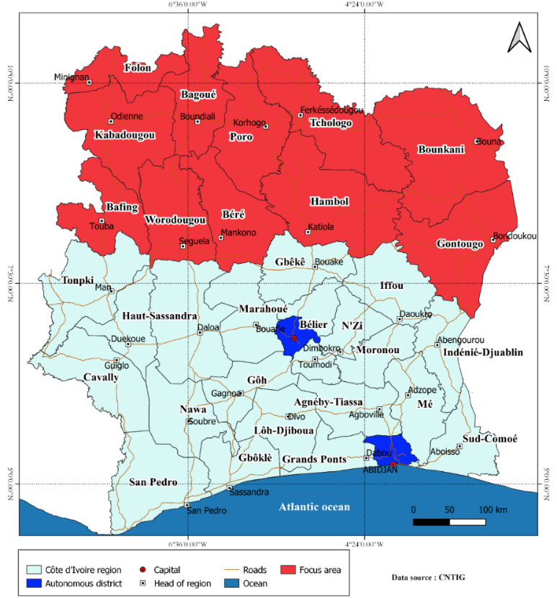

Figure 1: Studied areas in the Northern Cote d’Ivoire (within yellow line)

2.2 Methods of metallic trace elements analyses

Lithological characterization was carried out by observation with a binocular magnifying glass, based on criteria of transparency, hue, color and grain size. Particle size analysis followed AFNOR protocol (1996). After samples pretreatment (120-150 g) by washing, treatment with hydrogen peroxide to remove organic matter, and attack with 16% HCl to dissolve carbonates, sediments were dried at 60° C. 100 g of material were then sieved for 15 minutes on a column of 16 AFNOR sieves, with rejects weighed. Before analysis, sediment samples were dried in an oven at 25° C. Determination of metallic trace elements (Hg, Al, Cu, Cn, Cr, Ni, Fe, Mn, Pb, Zn) contents was carried out by inductively coupled plasma atomic emission spectrometry (ICP-AES) after complete acid mineralization according to HNO₃/Br₂/HF/HCl protocol. The ICP-AES analysis principle is based on the atomization and excitation of elements in solution by an argon plasma. When returning to ground state, each element emits characteristic electromagnetic radiation at specific wavelengths. Intensity of this radiation is proportional to the sample element concentration. Table 1 details standardized analytical methods used for the determination of each parameter.

Table 1 : Sediments analysis Methods
Parameters | Methods
Mercury | EPA 7473
Aluminium | NF X31- 147 :1996
Copper | NF X31- 147 :1996
Cyanide | NF X31- 147 :1996
Chromium | NF X31- 147 :1996
Iron | NF X31- 120 :2003
Manganese | NF X31- 120 :2003
Nickel | NF X31- 147 :1996
Lead | NF X31- 147 :1996
Zinc | NF X31- 120 :2003

2.3 Sediment quality assessment and pollution sources identification

In the absence of specific Ivorian regulations for sediment quality, the assessment was based on recent international benchmarks and guidelines adapted to the African context. The metal contents were interpreted according to the guidance values of USEPA (2021) for freshwater sediments and for tropical ecosystems, allowing classification based on the updated toxicity risk. Measured concentrations were also compared with upper continental crust (UCC) reference values according to revised data from Sun et al. (2022) and regional geochemical seabeds. Reference data, specific to Ivorian context, from the work of Tegan et al. (2023) on the sedimentary basins, were also used as a comparative basis. These multidimensional comparisons were performed for each sampling station (inlet, medium, dike) in order to establish a robust and contextualized assessment of metal contamination. Identification of pollution sources has combined Pearson correlation analysis and Principal Component Analysis (PCA), completed by confirmatory factor analysis (CFA) to validate the structure of identified sources. These methods reduce the data dimensionality and identify associations between variables and samples (Chen et al., 2016). The PCA, particularly efficient for the identification of polluting sources, transforms original variables into uncorrelated main components, with validation by bootstrap. Analyses were performed with R software (version 4.3.1) using the modern FactoMineR and factoextra packages for multivariate analyses, and ggplot2 for advanced visualizations, completed by interactive graphical representations under Microsoft Excel 365.

3. results and discussion

3.1 Metallic trace elements contents

Average concentration of mercury in all dams is 0.022 ± 0.01 mg/kg, with values ranging from 0.01 mg/kg (Seguela, Tengrela) to 0.04 mg/kg (Katiola). These levels, below the threshold of 0.05 mg/kg for tropical aquatic ecosystems, indicate an absence of significant mercury pollution. These results are consistent with recent studies conducted by Kouamé et al. (2023) on dams in Central-Western Côte d'Ivoire, which report similar concentrations in surface sediments. However, these levels remain significantly lower than reported concentrations in areas of intensive gold mining, as documented Yao et al. (2021) in the department of Divo (Ivory Coast) and in North – east sahel zone of Nigeria (Idowu et al., 2008). The spatial distribution of mercury also shows irregular fluctuations between different sites (Figure 2), reflecting the variability of anthropogenic pressures and local geochemical characteristics.

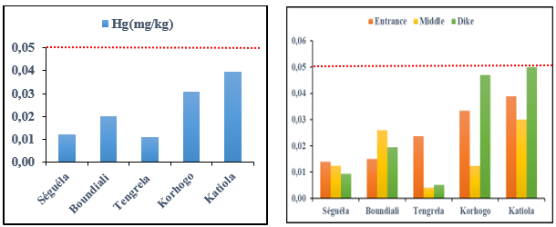

Figure. 2: Average concentration of mercury in Dams Sediments (permissible concentration limit: 0.05 mg/kg)

Analyzed sediments have particularly high aluminum (Al) contents, ranging from 13,333.33 mg/kg to 24,333.33 mg/kg, with an average concentration of 19,822.13±4,549 mg/kg on all five dams. These values are far above the reference threshold of 341 mg/kg for unpolluted sediments (Figure 3) for tropical aquatic environments. Widespread contamination is observed, with maximum concentrations recorded at Boundiali (73 000 mg/kg), followed by Korhogo (71 332 mg/kg) and Tengrela (60 000 mg/kg). These levels significantly exceed those reported in recent studies, notably by Ekissi et al. (2021) in dams of Sassandra River (Côte d'Ivoire), Dalu et al. (2020) in sediments of a Subtropical Ramsar Declared Wetland, and Traore et al. (2021) in the reservoirs of Central-western Côte d'Ivoire. The origin of this aluminum enrichment would probably be natural, linked to geochemical composition of the region soils. As highlighted Tegan et al. (2023) in their regional geochemical study, certain metals such as aluminum, iron and manganese are naturally abundant in the earth's crust and can reach high concentrations in sediments without necessarily reflecting anthropogenic pollution. This hypothesis is corroborated by the lateritic nature of Geochemical Characteristics of Brunified Soils of Anikro and Kahankro (South-Central Côte d'Ivoire), known for their high aluminosilicate content, as confirmed by the work of Yoboué et al. (2018).

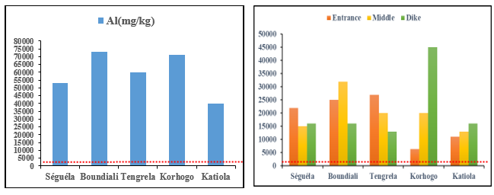

Figure 3: Average concentration of aluminum in dams sediments (permissible concentration limit: 341 mg/kg)

Copper (Cu) contents measured in sediments range from 21.63 mg/kg to 35.35 mg/kg, with an average concentration of 27.07 ± 5.15 mg/kg across all dams. For 4 of the 5 studied dams, these concentrations remain below the reference threshold of 33 mg/kg for unpolluted sediments in tropical areas. However, one notable exception is Boundiali dam, where copper content reaches 35.35 mg/kg, slightly exceeding the norm. Recorded levels in this study are generally lower than those reported by Kone et al. (2025) in sediments of Sénégal River in Mali. Spatial distribution of copper exhibits irregular fluctuations between the different sampling sites (Figure 4), reflecting a heterogeneity of the input sources. Origin of copper in these sediments appears mixed. Natural presence of this metal in geochemical composition of the region soils, documented by Bruce & Limin (2021), Could explain in part measured contents. However, exceedance observed in Boundiali, combined with the agricultural context of watershed (35.45% of annual crops), suggests a potential anthropogenic contribution, linked in particular to the use of plant protection products or fertilizers containing copper.

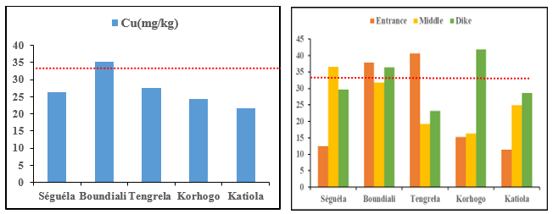

Figure 4: Average concentration of Copper in dams sediments (permissible concentration limit: 33 mg/kg)

Cyanide (Cn) contents measured in sediments range from 0.14 mg/kg in Boundiali to 0.24 mg/kg in Tengrela, with an average concentration of 0.18 ± 0.04 mg/kg across all dams. These values are far below the revised reference threshold of 0.5 mg/kg for freshwater sediments, as well as guidance values for aquatic ecosystems protection (5.2 mg/kg), indicating no significant cyanide contamination in all systems studied. Spatial distribution of cyanide shows fluctuations between different sampling sites (Figure 5), with maximum concentrations observed at Tengrela. Absence of significant cyanide pollution is consistent with the environmental profile of the region, where cyanide releases of industrial activities, likely to be significant (such as certain mining or chemical industries), are limited. Slight variations observed could be explained by diffuse inputs related to agricultural practices according to the work of Yao et al. (2025), although these levels remain well below the thresholds of concern.

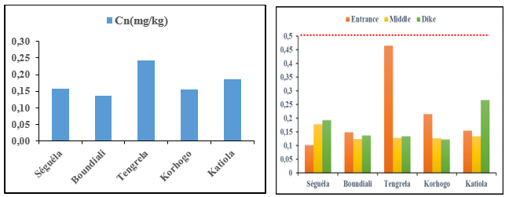

Figure 5: Average concentration of Cyanide in dams sediments (permissible concentration limit: 0.5 mg/kg)

Chromium (Cr) contents measured in sediments have a large amplitude of variation, ranging from 25.2 mg/kg to 396.2 mg/kg, with a mean concentration of 112.2±159.7 mg/kg over all the dams (Figure 6). These values exceed the reference threshold of 31 mg/kg for unpolluted sediments at 60% of studied sites, indicating significant contamination. These levels are well above the concentrations documented by Kaushik et al. (2009) in Indian industrial rivers. Séguéla (396.23 mg/kg), Boundiali (68.67 mg/kg) and Tengrela (44.40 mg/kg) dams have the highest concentrations. Séguéla dam stands out in particular, with a maximum content of 1089 mg/kg recorded at the station entrance (S1). This heterogeneous spatial distribution, marked by a peak located at the dam entrance, is contrary to profiles observed by Ouambeti-Wickon et al. (2025) in agricultural watersheds in the Central African Republic. This contamination could be explained by : a) drainage of chromium-enriched sediments from the watershed, as documented Xu et al. (2023) in agricultural rural area in southern China, b) a source of accidental or chronic pollution located upstream, potentially linked to activities identified by Koca et al. (2024) in European rivers, c) specific anthropogenic activities (such as the reinforcement workshops identified in the study), d) combination of natural erosion processes and targeted anthropogenic inputs, as suggested Wang et al. (2023) in their study. The high concentration at the entrance to Séguéla dam indicates active sediment transport and underlines importance of monitoring upstream inputs in sediment quality management.

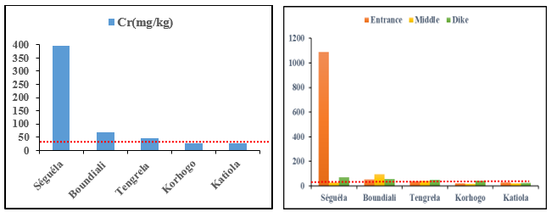

Figure 6: Average concentration of chromium in dams sediments (permissible concentration limit: 31 mg/kg)

Iron (Fe) concentrations measured in sediments range from 8 127.7 mg/kg to 39 333.3 mg/kg, with an average concentration of 23 508.67 mg/kg across all dams (Figure 7). Although these values remain below the revised reference threshold of 41,000 mg/kg for unpolluted sediments, they appear to be significantly higher than those reported in other regional and international studies. The Séguéla dam has the highest content (39,333.3 mg/kg), followed by Boundiali (32,333 mg/kg). These concentrations are far above to those documented by N’dri et al. (2024) in Contamination in Sediments of Bra Kanon Lake (Daloa, Côte d’Ivoire). The origin of these high iron contents is probably natural and linked to the particular geology of the region. Lateritic soils, characteristic of northern Côte d'Ivoire, are naturally rich in iron oxides and hydroxides. The erosion and leaching processes of these soils by runoff thus contribute to the supply and deposition of iron in sediments of dams.

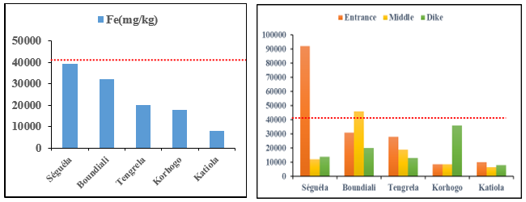

Figure 7: Average concentration of Iron in dams sediments (permissible concentration limit: 41,000 mg/kg)

Manganese (Mn) levels in sediments from the five dams fluctuate between 73.73 mg/kg and 260.67 mg/kg, with a mean concentration of 177.77 mg/kg (Figure 8). All recorded values are below the threshold reference of 770 mg/kg for uncontaminated sediments, indicating no pollution by this element.
Spatial variability is observed between the different sites. Séguéla dam has the highest concentration (260.67 mg/kg), followed by Boundiali (229.33 mg/kg) and Tengrela (143.30 mg/kg). For these three dams, maximum levels are systematically recorded at the inlet stations (S1), suggesting a main input by the upstream tributaries. This values are consistent with observations of Núñez et al. (2021) in water, soils and sediments of La Villa River Basin- Panama where Mn values remain high in the middle and lower basin. This spatial distribution, characterized by a decrease in concentrations from the entrance to the dike, probably reflects: a) a differential sedimentation process along the dam profile, b) the predominant influence of inputs by tributary streams, a mechanism observed by Moshood et al. (2009) in West African watersheds, c) a mainly natural origin, linked to the erosion of manganese-enriched soils in watersheds. These results are consistent with geochemical behavior of manganese, often associated with iron in rock weathering and sediment transport processes, as documented by Li et al. (2014) in alluvial sediments of the Yellow River.

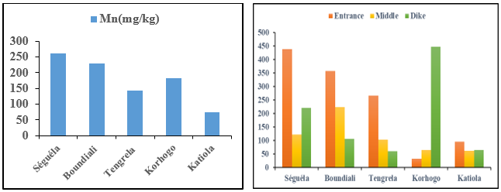

Figure 8: Average concentration of Manganese in dams sediments (permissible concentration limit: 770 mg/kg)

Nickel (Ni) contents in sediments fluctuate between 4.3 mg/kg and 32.5 mg/kg, with an average concentration of 18.87 mg/kg for all dams (Figure 9). For 80% of studied sites, measured values remain below threshold reference of 31 mg/kg for uncontaminated sediments. However, Séguéla dam presents a particular situation with an average content of 32.5 mg/kg slightly exceeding the norm. A particularly high concentration of 81.7 mg/kg is observed at the inlet of this dam, indicating a source of pollution located upstream. This profile is similar to high degree of Ni and Cr contamination identified by Laudiño et al. (2024) about contamination and potential ecological risks of heavy metals in the bottom sediments of Lake Mainit in Philippines. Conversely, the minimum concentration of 1.03 mg/kg recorded at another site reflects the high spatial variability in nickel distribution. This heterogeneous distribution, marked by a hot spot at the entrance to Séguéla dam, suggests : (a potential anthropogenic source located in the upstream watershed, potentially related to activities ; differential transport and sedimentation processes ; the possible superposition of natural origin (alteration of rocks) and anthropogenic (industrial or agricultural activities)). The exceptional value of 81.7 mg/kg at the entrance to Séguéla dam warrants further investigation of potential nickel sources in this specific watershed.

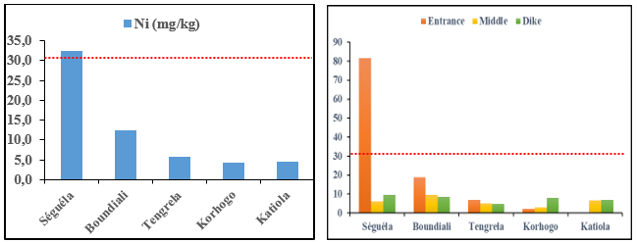

Figure 9: Average concentration of Nickel in dams sediments (permissible concentration limit: 31 mg/kg)

Lead (Pb) levels in sediments range from 4.6 mg/kg to 13.18 mg/kg, with an average concentration of 9.12 ± 3.35 mg/kg across all dams (Figure 10). All measured values are below threshold reference of 19 mg/kg for uncontaminated sediments, indicating no widespread lead pollution. Korhogo (13.18 mg/kg) and Séguéla (11.52 mg/kg) dams have the highest average contents. Several anthropogenic sources can explain this differentiated spatial distribution (discharges of untreated wastewater: absence of a sanitation system in these urban areas leads to direct discharge of rainwater loaded with household waste and domestic wastewater into dams; agricultural practices: use of fertilizers and phytosanitary products for vegetable and food crops along banks constitutes a potential source of lead; urban traffic: geographical position of these cities, subject to heavy road traffic, favors atmospheric deposition of lead). These results corroborate studies of Jeong et al. (2021) which highlight toxic elements pollution such as lead in road deposited sediments around the active smelting industry of Korea. Although current levels do not present an immediate ecological risk, persistence of these anthropogenic sources warrants particular vigilance and implementation of preventive measures to limit future inputs.

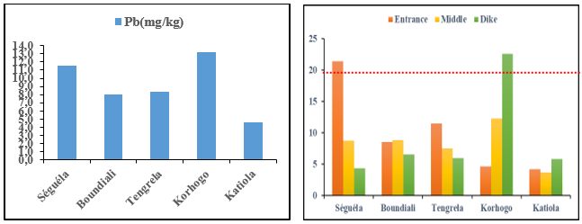

Figure 10: Average concentration of Lead in dams sediments (permissible concentration limit: 19 mg/kg)

Zinc (Zn) concentrations measured in sediments range from 16.2 mg/kg to 116.83 mg/kg, with a mean concentration of 65 ± 44.22 mg/kg across all dams (Figure 11). A clear spatial differentiation is observed between the studied sites, reflecting significant inter-site variability. Séguéla (116.83 mg/kg) and Boundiali (99.27 mg/kg) dams have levels above revised threshold reference of 95 mg/kg for unpolluted sediments, indicating significant zinc contamination in both systems. However, the other three dams have concentrations that meet standards, reflecting satisfactory environmental conditions for this parameter. This contrasting situation is similar to observations of Siwek et al. (2012) in South American reservoirs. Contrasting spatial distribution of zinc suggests different origins (for unpolluted dams : a mainly natural origin, linked to geological composition of basin soils ; for Séguéla and Boundiali dams : a significant anthropogenic contribution, potentially linked to agricultural activities (use of fertilizers and phytosanitary products) and/or domestic and industrial discharges). Comparison with regional studies shows that these values are higher than those reported by Souabera et al. (2024) in the Léré lake basin of Chad (1.45 mg/kg), but comparable to those of Vicat et al. (2023) in Kanem region of Chad. This divergence reflects regional geochemical variability and differences in anthropogenic pressures between the studied basins.

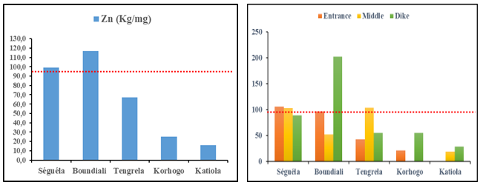

Figure 11: Average concentration of Zinc in dams sediments (permissible concentration limit: 95 mg/kg)

3.2 Multivariate analysis and identification of pollution sources

3.2.1 Principal Component Analysis (PCA)

The results of PCA show a clear structuring of pollution sources. The first main component (F1) accounts for 56.37% of total variance (Table 2) and has a distinctive correlation profile. It is strongly and positively correlated with Fe (r = 0.993), Mn (r = 0.98), Zn (r = 0.884), Ni (r = 0.81) and Cr (r = 0.735). Moderate correlations are observed with Cu (r = 0.635) and Pb (r = 0.551), while a weak correlation exists with Al (r = 0.465). In contrast, this component is significantly and negatively correlated with Hg (r = -0.759) and weakly with Cn (r = -0.464). The strong association of iron with this component, corroborated by recent work by Nomosatryo et al. (2021) on geochemistry of tropical sediments, indicates a mainly natural origin, linked to geochemical nature of the sediments. Therefore, F1 component is interpreted as representing mostly natural sources. Metals Zn, Ni, Cr, Mn and Fe, closely associated with this component, are thus probably the result of natural processes, such as rock weathering and soil erosion, which is consistent with their low geochemical index (Igeo) values and their average concentrations generally close to local geochemical bottoms.

Table 2: Expressed variance for each Factor

Metallic trace elements | F1 | F2 | F3
Hg | -0,759 | 0,106 | 0,477
Al | 0,465 | 0,84 | 0,146
Cu | 0,635 | 0,608 | -0,399
Cn | -0,464 | -0,222 | -0,662
Cr | 0,735 | -0,668 | 0,113
Fe | 0,993 | -0,087 | -0,051
Mn | 0,98 | 0,077 | 0,182
Ni | 0,81 | -0,568 | 0,073
Pb | 0,551 | 0,114 | 0,583
Zn | 0,884 | 0,115 | -0,397

The projection of variables in the F1 × F2 factorial plane (Table 3) allows a clear interpretation of pollution sources. F1 axis, accounting for 56.37% of total variance, is characterized negatively by Hg (r = -0.759) and positively by Fe (r = 0.993), Mn (r = 0.980), Zn (r = 0.884), Ni (r = 0.810) and Cr (r = 0.735). This opposition reflects fundamental distinction between natural sources (carried by F1+) and potential anthropogenic sources (represented by Hg on F1-). F2 axis, accounting for 19.44% of total variance, is mainly defined in its positive part by Al (r = 0.840). This distribution suggests a mixed source for aluminum, which may involve both natural alteration processes and specific anthropogenic contributions, as also observed by Hortellani et al., 2022 in the Billings Reservoir sediments at São Paulo State. Combination of these two axes thus makes it possible to differentiate three groups of metals: (Group 1 (F1+) : metals of natural origin (Fe, Mn, Zn, Ni, Cr) ; Group 2 (F1−) : mercury of potential anthropogenic origin ; Group 3 (F2+) : aluminum of mixed origin). This structuring is consistent with the geology of the region and confirms the importance of natural processes in the distribution of the majority of MTEs studied.

Table 3: Eigenvalue results, percentage of total and cumulative variances

 | F1 | F2 | F3 | F4
Eigenvalues | 5,64 | 1,94 | 1,40 | 2,158
% Total Variance | 56,37 | 19,44 | 13,99 | 10,79
% Cumulative Variance | 56,37 | 75,82 | 89,81 | 100

3.2.1 Analysis of correlations and identification of anthropogenic sources

Correlation analysis has made it possible to establish significant relationships between metals and to identify their potential sources. The analysis reveals several groups of significant correlations (Figure 12) :
Strong positive correlations (r ≥ 0.70): a) Fe-Mn-Zn-Ni-Cr group shows systematic intercorrelations, confirming a common geogenic origin, b) Al-Cu relationship (r = 0.7) suggests a mixed natural-anthropogenic source, similar to the observations of Hortellani et al., 2022, c) Zn-Cu correlation (r = 0.8) indicates a possible common anthropogenic origin
Significant negative correlations: a) strong negative correlations Hg/Fe (r = -0.8), Hg/Mn (r = -0.7) and Hg/Zn (r = -0.8) confirm the distinct origin of mercury, b) negative correlation Cn/Mn (r = -0.6) suggests a different environmental behavior of cyanide. These correlation profiles indicate that the MTEs have been redistributed by similar physico-chemical processes or come from common sources. The strong association between Fe, Mn and the other tracer metals confirms their mainly natural origin, linked to the geochemical composition of the sediments. Anthropogenic pollutants in the study area come mainly from sources such as urban discharges, agricultural activities and handicraft workshops, as documented Kouakou et al. (2024) in their study on pollution sources of Ouangolodougou dam.

Figure 12: Analysis of the correlation matrix

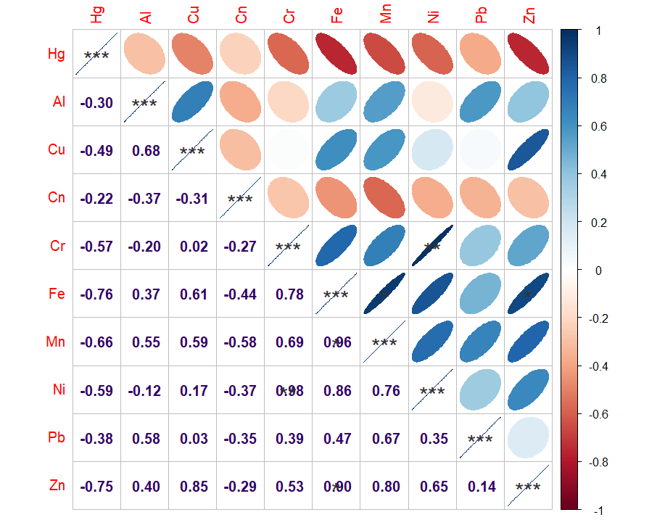

Correlation circle (Figure 13), established from factors F 1 and F 2, allow to distinguish 4 distinct groups of metals, revealing their different origins and environmental behaviors :
Group 1 : Cn (Composition : exclusively cyanide ; Characteristics : Isolated from other metals, suggesting independent sources and transport routes ; Implication : Specific potential anthropogenic source, not linked to general geochemical processes).
Group 2 : Hg (Composition : Mercury only ; Characteristics : Distinct environmental behavior, negative correlations with most other metals ; Implication : Probable anthropogenic origin, linked to specific activities (gold mining, industrial discharges).
Group 3 : Al-Cu-Zn-Pb-Mn (Composition : Aluminum, Copper, Zinc, Lead, Manganese ; Characteristics : Association of metals with mixed origins ; Involvement : Combination of natural sources (alteration of rocks) and anthropogenic sources (urban, agricultural and industrial activities).
Group 4 : Fe-Ni-Cr (Composition : Iron, Nickel, Chromium ; Characteristics : Strong geochemical coherence, high positive correlations ; Implication : Mainly natural origin, linked to the composition of the geological substrate and to the erosion processes).
This classification supports the hypothesis of multiple sources and allow to target management actions according to the predominant origin of each group of contaminants.

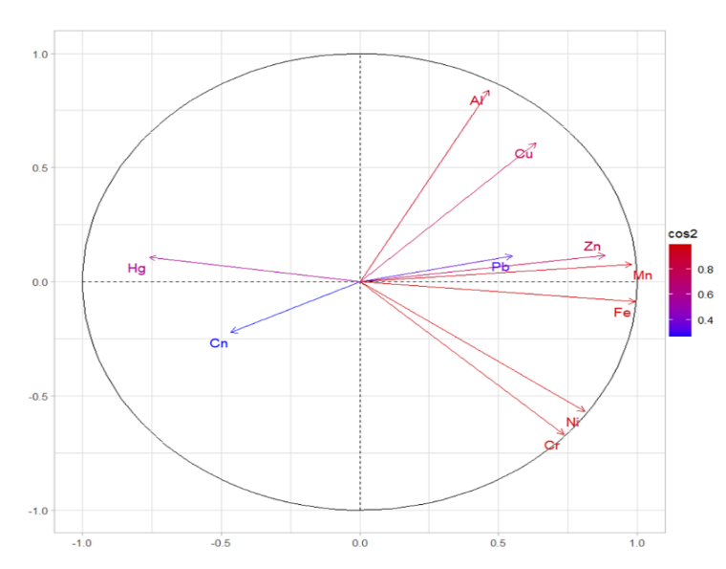

Figure 13: Heavy Metals distribution by F1 and F2 Factors

Results of Principal Component Analysis (PCA) show that the first two axes (F1 and F2) explain 75.82% of the total data variability (Figure 14), indicating a satisfactory representation of the data structure. Analysis of variables projection in the correlation circle reveals that:
Representativeness of the Variables: a) majority of explanatory variables (Cu, Fe, Mn, Zn, Ni, Al, Cr) have a good representation on F1-F2 plane, being located close to the correlation circle, b) three elements (Cn, Hg, Pb) show moderate representativeness, suggesting that other factors not captured by F1 and F2 influence their distribution
Interpretation of the main axes: a) F1 axis (56.37% variance): Strong positive correlation with Cu, Fe, Mn, Zn, Ni → mainly represents natural sources and geochemical processes. Negative correlation with Hg → confirms the distinct origin of mercury, b) F2 axis (19.44% variance): Strong positive correlation with Al, Cu, Cr → reflects mixed natural-anthropogenic sources.
Validation by previous studies: the observed structuring corroborates recent studies of Liu et al., (2025), confirming that metals belonging to the same group share common origins and are influenced by similar environmental processes. This classification allows for more accurate identification of sources of contamination and provides a solid basis for the development of targeted management strategies.

Figure14: Dams projection on F1 and F2 axes

The integration of land-use data and field surveys allowed the establishment of a typology of pollution sources for each dam, as summarized in Table 5. Differentiated analysis by geographical context : a) urban context (Korhogo) : (Dominant source : Lack of sanitation (60.81% of buildings and bare soils); Secondary source: Peri-urban agricultural activities (33.16% of cultivated areas); Main issues: Domestic discharges, contaminated rainwater), b) peri-urban context (Tengrela, Katiola, Séguéla) : (Combined sources : Agriculture (34.84% to 74.20%) and poor sanitation (6.02% to 9.67%) ; Mixed pressures : Agricultural inputs and urban discharges), c) rural context (Boundiali) : (Main source : Intensive agriculture (53.05% of cultivated areas) ; Particularity : Presence of mining/gold activities ; Issues : Use of phytosanitary products and contamination by gold mining). This analysis confirms the correlation between the geographical position of dams and the nature of anthropogenic pressures, providing a solid basis for the development of management strategies adapted to each context. The main sources of pollution identified in watersheds include agricultural activities (intensive use of fertilizers and pesticides in perennial, annual and vegetable crops), sanitation deficits (direct discharges of waste water and solid waste into water bodies) and illegal mining operations (use of mercury and cyanide in artisanal gold mining). These different sources of dam pollution have also been identified in the work of Adia et al. (2025) through the mapping of the land use of the respective watersheds of these dams and a field survey to identify sources of pollution. The results of this study are also consistent with comparative assessment of heavy metals in drinking water sources of Cobbina et al. (2015) two small-scale mining communities in northern Ghana.

Table 5 : Potential sources assessment of dam pollution

 |  |  | Land Use by Human Activities 2024
Classes | Potential Pollution Source | Chemical Parameters | Korhogo | Boundiali | Tengrela | Katiola | Séguéla
Build-up areas and bare soil | Wastewater  Solid Waste | COD, BOD  Heavy Metals | 60,81% | Very Low | 6,02% | 9,67% | 8,87%
Perennial Crops | Agriculture | Pesticides,  Heavy Metals | 10,76% | 17,60% | 20,85% | 21,55% | 21,63%
Annual Crops and Fallow | Agriculture | Pesticides,  Heavy Metals | 22,40% | 35,45% | 13,99% | 48,95% | 52,57%
Quarry | Mining/Artisanal Gold Mining | Heavy Metals | 2,27% | Present | Present | Present | Present
Water Body | Fishing/Fish Farming / Livestock | Heavy Metals | Yes | Yes | Yes | Yes | Yes

4. Conclusion

The assessment of metal trace elements contents in this study, which aimed to highlight the origin of their presence in the sediments of 5 dams in northern Côte d'Ivoire, showed significant contamination for aluminum, chromium and zinc, with concentrations exceeding regulatory thresholds. Aluminum concentrations are higher than the norm on all dams with values reaching 24333.33 mg/kg at Boundiali. Chromium (Cr) concentrations exceed the standard of 31 mg/kg with an average value of 396.23 mg/kg at the entrance to the Séguéla dam. The average zinc content for the Séguéla and Boundiali dams is highest at 116.83 mg/kg and 99.27 mg/kg, respectively. Analysis of the origin of this pollution revealed different origins (human and natural) of the presence of ETMs in the sediments of these dams. The combined approach of multivariate analysis and watershed characterization revealed a dichotomy of metal pollution sources, pitting a natural origin, dominated by soil erosion and local geochemistry, against an anthropogenic origin, mainly attributable to craftsmen, agricultural practices and urban discharges. This study highlights the urgent need for integrated water resources management to preserve aquatic ecosystems and the health of riparian populations. In view of these results, following measures would limit the pollution of reservoirs: a) construct a perimeter of protection, b) set up screens at the various entrances in order to limit the intrusion of solid waste into the dam, c) raise awareness among the local populations on the importance of sanitation in order to avoid contamination of the dam by microorganisms, d) raise awareness and train market gardeners in good practices for the use of fertilizers and pesticides.
In perspective, the implementation of the following recommendations could contribute to improving the quality of the water and sediments of these dams: a) extend monitoring to all MTEs and other dams in the territory, b) implement dredging and treatment of contaminated sediments, c) assess bioaccumulation in aquatic species and impacts on human health, d) strengthen watershed management policies and control of polluting activities.
.
Disclaimer (Artificial intelligence)
Author(s) hereby declare that NO generative AI technologies such as Large Language Models (ChatGPT, COPILOT, etc.) and text-to-image generators have been used during the writing or editing of this manuscript.

References

- United Nations Environment Programme (UNEP). (2023). Assessment of water resource pollution in west Africa. United nations environment programme, Nairobi, Kenya. 245 p.
- World Bank. (2022). Sustainable water resource management in Africa: Technical report No. 145632, World Bank Washington D.C. USA. 312 p.
- Meddi, M. (2015). Contribution to the study of solid transport in northern Algeria. Larhyss journal, 24, 315-336. https://www.asjp.cerist.dz/en/journal/16
- Ouechtati, S., & Baldassarre, G. (2011). Evaluation of solid transport and siltation in the Siliana watershed (Tunisia). Bulletin of engineering geology and the environment, 70. https://doi.org/10.1007/s10064-011-0376-5
- Ettien, D.Z., Koffi, K.E., Koko, K.S. (2020). Effects of siltation on the morphology of the Kan dam lake of Bouaké (Côte d'Ivoire). DaloGéo, 11, 5-15.
- Mimba, M. E., Ohba, T., Nguemhe Fils, S. C., Nforba, M. T., Numanami, N., Tasin, G. B., Tongwa Aka, F., & Suh, C. E. (2018). Regional geochemical baseline concentration of potentially toxic trace metals in the mineralized Lom Basin, East Cameroon: a tool for contamination assessment. *Geochemical Transactions*, *19*, Article 11. https://doi.org/10.1186/s12932-018-0056-5
- Tambol, T., Vodounou, G. M. B., & Moussa, S. (2023). Impacts of mining on the environment in West African Sahel: A review. Environmental Protection Research, 3(2), 263-277. https://doi.org/10.37256/epr.3220232723
- Soussou, Y. I., Akesse, D. P. V., Kouamé, K. V., Yapi, D. A. C., & Yapo, O. B. (2019). Assessment of trace metals contamination in sediments of Kossou Lake (Côte d'Ivoire). Journal of Chemical, Biological and Physical Sciences, 9(3), 217-229. https://doi.org/10.24214/jcbps.D.9.3.21729
- United States Environmental Protection Agency. (2021). Final Technical Support Document: Implementing the 2019 Recommended Human Health Recreational Ambient Water Quality Criteria or Swimming Advisories for Microcystins and Cylindrospermopsin. U.S. Environmental Protection Agency. https://www.epa.gov/sites/default/files/2021-07/documents/epa-823-r-21-002.pdf
- Sun, Y., Gao, R., Li, Z., Wang, A., Han, R., Xi, Y., & Liu, J. (2022). Composition and Evolution of Continental Crust at Orogenic Belts: Constraints From a 3‐D Crustal Model of Southeast China. Journal of Geophysical Research: Solid Earth, 127(12), 1-23. https://doi.org/10.1029/2022JB025057
- Tegan, N. E. S., Kouamelan, A. N., Yao, A. K., Gbele, O., Siagne, Z. H., & N'Dri, K. A. (2023). Geochemical exploration of sediments in the Toumodi region: Origin of metasediments, geological dynamics, and perspectives for regional geological history. *Open Journal of Geology*, *13*(12), 1255-1270. https://doi.org/10.4236/ojg.2023.1312054
- Chen, J., Li, F., Fan, Z., & Wang, Y. (2016). Integrated Application of Multivariate Statistical Methods to Source Apportionment of Watercourses in the Liao River Basin, Northeast China. International Journal of Environmental Research and Public Health, 13(10), 1035. https://doi.org/10.3390/ijerph13101035
- Kouamé, V., Djédjé, M., Yapi, C., Dongui, K., & Tidou, S. (2023). Water and sediments contamination by pesticides in Sassandra river at Guessabo area (Central-western of Ivory Coast). Trends in Applied Sciences Research, 18(1), 94-102. https://doi.org/10.3923/tasr.2023.94.102
- Yao, A. K. S., & Ahoussi, A. K. E. (2021). Assessment of mercury (Hg) and cyanide (CN) pollution in surfacewaters, groundwaters and sediments around industrial mining sites in the department of Divo (Ivory Coast). Journal of Water Resource and Protection, 13(2), 75-91. https://doi.org/10.4236/jwarp.2021.132005
- Idowu, R. T., Inyang, N. M., & Ezenwaji, H. M. G. (2004). Heavy metal concentrations in a west African Sahel reservoir. Animal Research International, 1(1), 12-15. https://doi.org/10.4314/ari.v1i1.40733
- Ekissi, D., Kinimo, K., Tanoh, M.K., & Essétchi, P.K. (2021). Physicochemical Characteristics and Heavy Metals Contamination Assessment in Water and Sediment in a Tropical Hydroelectric Dam of Sassandra River, Côte d’Ivoire. Journal of Environment Pollution and Human Health, 9(2), 27-35. https://doi.org/10.12691/jephh-9-2-1
- Dalu, T., Tshivhase, R., Cuthbert, R. N., Murungweni, F. M., & Wasserman, R. J. (2020). Metal distribution and sediment quality variation across sediment depths of a subtropical Ramsar declared wetland. Water, 12(10), 2779. https://doi.org/10.3390/w12102779
- Traore, Z., Kouassi, N.L.B., Assemian, A.S., Kouassi, K.E., Drogui, P., & Yao, B.K. (2021). Distribution and health risk assessment of trace metals in surface waters and groundwater around artisanal gold mining areas in central-western Côte d’Ivoire, west Africa. International journal of environmental monitoring and analysis, 9(5), 136-151. https://doi.org/10.11648/j.ijema.20210905.15
- Yoboué, K. E., Kouadio, K. P., Blé, L. O., & Yao-Kouamé, A. (2018). Caractéristiques Morphopédologiques et Géochimiques des Sols Brunifiés de Anikro et de Kahankro (Centre-Sud de la Côte d'Ivoire). European Scientific Journal, 14(3), 281-300. https://doi.org/10.19044/esj.2018.v14n3p281
- Kone, H., Yaro, F.K., Ly, O., Traore, M.M., Djiguiba, D., & Doumbia, M.L. (2025). Contamination des sédiments par les pesticides et les métaux lourds dans le bassin du fleuve Sénégal et ses affluents, République du Mali. Afrique science, 26(4), 12-27. http://www.afriquescience.net/publication/Contamination%20des%20s%C3%A9diments%20par%20les%20pesticides%20et%20les%20m%C3%A9taux%20lourds%20dans%20le%20bassin%20du%20fleuve%20S%C3%A9n%C3%A9gal%20et%20ses%20affluents,%20R%C3%A9publique%20du%20Mali.pdf
- Bruce, M., & Limin, M. (2021). Recent Advances on Water Pollution Research in Africa: A Critical Review. International Journal of Scientific Advances (IJSCIA), 2(3), 371-374. https://www.ijscia.com/recent-advances-on-water-pollution-research-in-africa-a-critical-review/
- Yao, K. A. F., Coulibaly, L., Ouattara, I., Ouedraogo, M., Komien, A. M., & Kouakou, K. E. (2025). Influence of agricultural inputs and urban waste on the physicochemical and metal profile of surface waters in Man, Côte d’Ivoire. World Journal of Advanced Research and Reviews, 28(01), 1668-1680. https://doi.org/10.30574/wjarr.2025.28.1.3548
- Kaushik, A., Kansal, A., Santosh, Meena, Kumari, S., & Kaushik, C.P. (2009). Heavy metal contamination of river Yamuna, Haryana, India: Assessment by Metal Enrichment Factor of the Sediments. Journal of Hazardous Materials. https://doi.org/10.1016/j.jhazmat.2008.08.031
- Ouambeti-Wickon, A.J., Gabriel Ngueutchoua, G., Doria Grace Takenne, D.G., Prince Emilien Danguene, P.E., Armand Sylvain Ludovic Wouatong, A.S.L. (2025). Estimation of heavy metal contamination of sediments in the Ouaka River watershed in the Central African Republic. Watershed Ecology and the Environment. 7, 84-96. https://doi.org/10.1016/j.wsee.2025.03.002
- Xu, S., Yu, C., Wang, Q., Liao, J., Liu, C., Huang, L., Liu, Q., Wen, Z., & Feng, Y. (2022). Chromium Contamination and Health Risk Assessment of Soil and Agricultural Products in a Rural Area in Southern China. Toxics, 11(1), 27. https://doi.org/10.3390/toxics11010027
- Koca, D., Porto, A., Márton, P., Milićević, M., & Jovanović, D. (2024). Health risk assessment of potentially toxic elements in the riparian zone of the Sava River (southeastern Europe): effects of high and low water events. Environmental Sciences Europe, 36, 133. https://doi.org/10.1186/s12302-024-00952-3
- Wang, W., Goring-Harford, H., Kunde, K., Woodward, E. M. S., Lohan, M. C., Connelly, D. P., & James, R. H. (2023). Biogeochemical cycling of chromium and chromium isotopes in the sub-tropical North Atlantic Ocean. Frontiers in Marine Science, 10, 1165304. https://doi.org/10.3389/fmars.2023.1165304
- N’dri, S.R., Kouyaté, A., Sanou, I., Kouakou, N.J.L., Konan, K.S., Amon,N.L., Ouattara, L.Y., … & Dibi, B. (2024). Assessment of Heavy Metals Contamination in Sediments of Bra Kanon Lake (Daloa, Côte d’Ivoire) Using Pollution Indices. Journal of Environment Pollution and Human Health. 12(2), 38-46. https://doi.org/10.12691/jephh-12-2-4
- Núñez, J. V., Pineda, A. S., Pérez, J. V., & Zachrisson, I. R. (2021). Assessment of heavy metal concentration in water, soils and sediments of La Villa river basin, Panama. In *Recent progress in plant and soil research, 4* (pp. 56-67). Book Publisher International. https://doi.org/10.9734/bpi/rppsr/v4/3060E
- Moshood, M. K. (2009). Influence of watershed activities on the water quality and fish assemblages of a tropical African reservoir. Turkish Journal of Fisheries and Aquatic Sciences, 9(1), 1-8. https://dergipark.org.tr/en/pub/tjfas/issue/1900
- Li, P., Qian, H., Howard, K.W.F., Wu, J., & Lyu, X. (2014). Anthropogenic pollution and variability of manganese in alluvial sediments of the Yellow River, Ningxia, northwest China. Environmental Monitoring and Assessment, 186(3), 1385-1398. https://doi.org/10.1007/s10661-013-3461-3
- Laudiño, F. A. R., Agtong, R. J. M., Jumawan, J. C., Fukuyama, M., & Elvira, M. V. (2024). Assessment of contamination and potential ecological risks of heavy metals in the bottom sediments of Lake Mainit, Philippines. *Journal of Hazardous Materials Advances*, *15*(2), 100443. https://doi.org/10.1016/j.hazadv.2024.100443
- Jeong, H., Choi, J. Y., & Ra, K. (2021). Potentially toxic elements pollution in road deposited sediments around the active smelting industry of Korea. Scientific reports, 11, 7238. https://doi.org/10.1038/s41598-021-86698-x
- Siwek, H., Włodarczyk, M., & Gibczyńska, M. (2012). Concentration of zinc (Zn) in water and bottom sediments in small water reservoirs located in rural areas. Journal of Elementology, 17, 659–667. https://doi.org/10.5601/jelem.2012.17.4.09
- Souabera, T., Doumnang, J., Rondouba, P., Tarkodjiel, M., & Mahmout, Y. (2024). Evaluation de la contamination par les métaux lourds (Al, Fe, Mn, Ni, Zn, Cr, Cd et Pb) des sédiments du bassin du lac Léré, Mayo-Kebbi Ouest, Tchad. International Journal of Biological and Chemical Sciences, 18(2), 723-736. https://doi.org/10.4314/ijbcs.v18i2.31
- Vicat, J. P., & Mbaigane, J. C. D. (2023). Geochemical composition and heavy metals enrichment of pond sediments of the Kanem region (Republic of Chad). International Journal of Multidisciplinary Research and Publications, 5(12), 161-171. https://ijmrap.com/wp-content/uploads/2023/12/161-171.pdf
- Nomosatryo, S., Tjallingii, R., Schleicher, A. M., Boli, P., Henny, C., Wagner, D., & Kallmeyer, J. (2021). Geochemical characteristics of sediment in tropical lake Sentani (Indonesia) are influenced by spatial differences in catchment geology and water column stratification. Frontiers in Earth Science, 9, 1-16. https://doi.org/10.3389/feart.2021.671642
- Hortellani, M. A., Sarkis, J. E. S., Menezes, L. C. B., Bazante-Yamaguishi, R., Pereira, A. S. A., Garcia, P. F. G., Maruyama, L. S., & Castro, P. M. G. (2013). Assessment of metal concentration in the Billings Reservoir sediments, São Paulo State, Southeastern Brazil. Journal of the Brazilian Chemical Society, 24(1), 58-67. https://doi.org/10.1590/S0103-50532013000100009
- Kouakou, Y. S., Seyhi, B., & N'guessan, K. M. (2024). Impacts of Anthropogenic Activities on Water Quality of Ouangolodougou Dam, Côte d'Ivoire. International Journal of Environment and Climate Change, 14(12), 64-81. https://doi.org/10.9734/ijecc/2024/v14i124607
- Liu, E., Leng, W., Zhang, M., Li, H., Wang, L., & Liu, J. (2025). Heavy metal source apportionment and health risk assessment using APCS-MLR and HHRA models : a case study in a typical industrializing region of China. Journal of environmental chemical engineering, 13(6), 119835. https://doi.org/10.1016/j.jece.2025.119835
- Adia, J. T., Yao, B. A. F., Soro, E. G., Briton, B. G. H., Goula, B. T. A., Kouakou, Y. S., & Kailou, K. (2025). Impacts of anthropogenic activities on the quality of dam lakes in northern Côte d’Ivoire: The case of the Korhogo, Boundiali and Katiola Dams. Journal of Water Resource and Protection, 17(7), 530-548. https://doi.org/10.4236/jwarp.2025.177027
- Cobbina, S. J., Duwiejuah, A. B., Quansah, R., Obiri, S., & Bakobie, N. (2015). Comparative assessment of heavy metals in drinking water sources in two small-scale mining communities in northern Ghana. International Journal of Environmental Research and Public Health, 12(9), 10620-10634. https://doi.org/10.3390/ijerph120910620

