Synthesis, Crystal Structure, Thermal Behavior, and Magnetic Properties of a Tetranuclear Mn(II) Complex Bridged by End-to-End Dicyanamide

ABSTRACT
A new tetranuclear compound [Mn₄(o-vanilin)₆(N(CN)₂)₂(MeOH)₂] (1) has been synthesized under reflux and structurally characterized by elemental analysis, IR, conductance measurement, variable temperature magnetic measurement and single crystal. The complex (1) crystallizes in the triclinic space group P-1 with unit cell dimensions a = 9.1014 (4) Å, b = 11.1169 (4) Å, c = 14.8923 (4) Å, α = 93.698 (3)°, β = 96.960 (3)°, γ = 107.165 (3)°, V = 1421.07 (9) Å³, Z = 1, R₁ = 0.0345 and wR₂ = 0.0798. The compound consist of two units [Mn₂(o-Vanilin)₃(MeOH)] with double μ_{1,5}-η¹,-η¹-dicyanamide (μ_{1,5}-η¹,-η¹-DCA) bridges between neighboring manganese(II) atoms. Two Mn(II) are situated in an O₄N inner, while the two others Mn(II) are encapsulated by an O₅N inner. The two pentacoordinated Mn(II) ions are situated in square pyramidal environment, while the hexacoordinated Mn(II) ions environment is best described as octahedral geometry. Thermogravimetric analyze of the complex were carried out at 20–800 °C and showed that the complex were decomposed into three steps. Variable-temperature (5-300 K) magnetic susceptibility data reveal the existence of weak antiferromagnetic interaction in complex 1. The magnetic behavior is explained by considering the exchange coupled manganese-radical system, which is subjected to the Mn^{II}-O-Mn^{II} intradimer interactions. The least-squares fitting of the data results J = -0.8. Negligible interdimer exchange via Mn-DCA-Mn (Mn∙∙∙Mn of 8.4530(5) Å) was observed.

Keywords: Crystal, manganese, square pyramidal, octahedral, magnetism, TGA.

Introduction
The design of polynuclear transition metal complexes has been the subject of considerable development because they have fascinating structures and functional applications as optical, electronic, catalytic, and magnetic material (Hasan et al., 2024; Kalita et al., 2015; Malinina et al., 2024; Nesterov & Nesterova, 2018; Noritake et al., 2013; Parvarinezhad et al., 2021; Tong et al., 2024; L. Zhang et al., 2015; S. Zhang & Zhao, 2018; Zheng et al., 2015). Particular interest has been given to manganese complexes, widely used in the field of materials, notably for the synthesis of molecular magnets (Anwar et al., 2021; Karmakar et al., 2024; Reis Conceição et al., 2020; Wang & Qin, 2022). These single molecule magnets (SMMs) having the ability to maintain spin orientation at certain temperatures called blocking temperature, have the property of storing information at the nanometer scale. Several types of SMMs are developed with variable numbers of metal atoms (Bhaumik, 2024; Miyasaka et al., 2004; Tasiopoulos et al., 2004; Thompson & Dawe, 2015). The synthesis of these SMMs follows a strategy that consists of designing organic ligands with functional groups possessing particular donor sites and an adapted topology. The addition of co-ligands is an additional asset to increase the number of metal sites in the molecule (Han et al., 2022; S.-H. Zhang, Zhao, Li, Ge, et al., 2014). 2-hydroxy-3-methoxybenzaldehyde, which has three oxygen donor atoms, has been widely used as a ligand for the synthesis of polynuclear complexes due to the ability of the methoxy group to exhibit a variety of bonding geometries, such as chelating, mono- or bidentate bonding (Xu et al., 2017; S.-H. Zhang, Zhao, Li, Zhang, et al., 2014). We are currently interested in the preparation of a series of o-vanillin-chelated model compounds, studying their molecular structures and magnetic properties. The present study reports a novel tetranuclear manganese complex [Mn₄(o-vanilin)₆(N(CN)₂)₂(MeOH)₂] obtained using the o-vanillin ligand and sodium dicyanamide as co-ligand. The crystal structure and physicochemical properties are discussed.

Experimental

Materials and instruments
o-Vanillin, manganese acetate tetrahydrate and sodium dicyanamide were purchased from Sigma-Aldrich and used as received without any purification. All solvents used were of reagent grade. The infrared spectrum of the complex was recorded on a Perkin Elmer Spectrum Two FTIR spectrometer in the region 4000-400 cm⁻¹ . The molar conductance of 1×10⁻³ M in DMF solutions of the metal complex was measured at 25 °C using a WTW LF-330 conductivity meter with a WTW conductivity cell. The magnetic susceptibility of the powdered sample was measured at room temperature using a Johnson Mattey scientific magnetic susceptibility balance (Calibrant: Hg[Co(SCN)₄]).

Synthesis of the complex [Mn₄(o-vanilin)₆(N(CN)₂)₂(MeOH)₂]
o-vanilin (0.402 g, 2.64 mmol) and Mn(OAc)₂.4H₂O (0.324 g, 1.32 mmol) were added in 100 mL flask containing 20 mL of methanol. The mixture was refluxed for one hour. Then, a 10 mL of methanolic solution of sodium dicyanamide (0.118 g, 1.32 mmol) was added. The mixture was brought to reflux for one hour. On cooling the resulting was filtered and the filtrate was left to evaporate slowly. A few days later, orange crystals suitable for X-ray diffraction were collected. Yield: 73%. Anal. Calc for C₅₄H₅₀N₆O₂₀Mn₄ (%): C, 49.03; H, 3.81; N, 6.35. Found: C, 49.00; H, 3.78; N, 6.32. IR (ν, cm⁻¹): 3242; 2300; 2247; 2188; 1623; 1202. Conductance Ʌ (S.cm².mol⁻¹) : 27. μ_{eff} = 5.57 µ_{B}.

Scheme 1. Synthetic scheme for the complex [Mn₄(o-vanilin)₆(N(CN)₂)₂(MeOH)₂] (1)

Determination of crystal structure
Crystals of complex 1 suitable for X-ray diffraction were recovered by slow evaporation of a MeOH solution of the complex. Details of the X-ray crystal structure resolution and refinement are given in Table 1. Diffraction data were collected using an XtaLAB AFC12 (RINC) Kappa diffractometer with graphite monochromatized Mo Kα radiation (λ = 0.71073 Å). All data were corrected for Lorentz and polarization effects. No absorption correction was applied. The structure was solved with the structure solution program olex2.solve using charge flipping and refined with the SHELXL refinement package using least-squares minimization (Dolomanov et al., 2009). Molecular graphics were generated using ORTEP (Farrugia, 2012).

Table 1. Crystalline and structure refinement data of [Mn₄(o-vanilin)₆(N(CN)₂)₂(MeOH)₂] (1).
Crystal data
Chemical formula | C₅₄H₅₀Mn₄N₆O₂₀
Mr (g/mol) | 1322.78
Temperature (K) | 293(2)
Crystal system, space group | Triclinic, P-1
a (Å) | 9.1014(4)
b (Å) | 11.1169(4)
c (Å) | 14.8923(4)
α (°) | 93.698(3)
β (°) | 96.960(3)
γ (°) | 107.165(3)
Volume (Å³) | 1421.07(9)
Z | 1
D_{calc} (gcm⁻³) | 1.546
μ (mm⁻¹) | 0.95
F(000) | 676.0
Crystal size (mm) | 0.10 × 0.07 × 0.06
λ (MoK_{α}) (Å) | 0.71073
θ range (°) | 2.37-27.10
Indices h, k, l | -11 ≤ h ≤ 11, -14 ≤ k ≤ 14, -19 ≤ l ≤ 19
No. of measured reflections | 37629
No. of independent reflections | 6250
No. of observed [I > 2σ(I)] reflections | 4703
R_{int} | 0.0544
R[F² > 2σ(F²)] | 0.035
wR(F²) | 0.092
Goodness-of-fitt (Gof) on F² | 1.08
Data/restraints/parameters | 6250/61/604
Final Indices [I >=2 σ (I)] | R₁ = 0.0345, wR₂ = 0.0798
Final R Indices (for all data) | R₁ = 0.0544, wR₂ = 0.0918
Δρmax , Δρmin (eÅ⁻³) | 0.45, -0.42

Results and discussions

General study
The complex [Mn₄(o-vanilin)₆(N(CN)₂)₂(MeOH)₂] was obtained by mixing o-vanillin ligand, Mn(OAc)_{2.}4H₂O and sodium dicyanamide in a 2:1:1 ratio (Scheme 1). The ν_{C=O} band pointed at 1662 cm⁻¹ in the IR spectrum of the free o-vanillin is shifted to 1623 cm⁻¹ upon coordination of the o-vanillin to the Mn atom. The band at 3242 cm⁻¹ due to the ν_{O-H} of the o-vanillin is not present in the spectrum of the complex. This fact suggests that the o-vanillin acts in its deprotonated form (Gadiaga et al., 2023; Orton et al., 2023). The band due to the phenolic ν_{C-O} vibration which appears at 1253 cm⁻¹ for the free o-vanillin, appears around 1240 cm⁻¹ in the IR spectrum of the complex, suggesting the participation of the phenolic oxygen atom in the coordination. The methoxy oxygen atoms remain uncoordinated as evidenced by the non-shift of its ν_{C-O} band pointed in the two spectra around 1202 cm⁻¹ . The IR spectrum of the complex exhibits also three strong bands pointed at 2300, 2247 and 2188 cm⁻¹. These bands are attributed to the dicyanamide groups which are coordinated in μ_{1,5}-η¹:η¹ bridged mode (Haba et al., 2020; Zhao et al., 2016). The conductimetric measurements of the millimolar solution of the complex were recorded in millimolar DMF solution. The molar conductivity value of the fresh solution of 27 S.cm².mol⁻¹ corresponds to a neutral electrolyte (Geary, 1971). After fifteen days, this value remains quite-constant, indicating that the complex is stable in DMF solution.
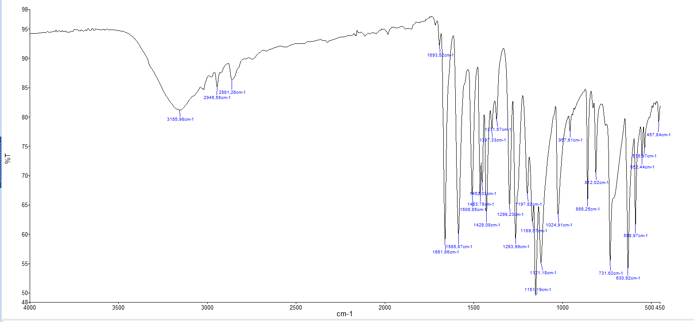
Figure 1. Infrared spectrum of the ortho-vanillin molecule

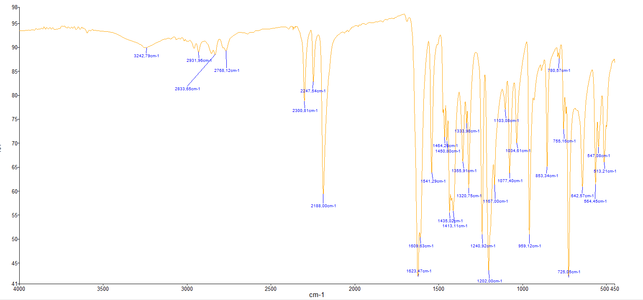
Figure 2. Infrared spectrum of the complex

Crystallographic study of the complex
The complex crystallizes in the triclinic system with a P-1 space group. The ORTEP diagram of the structure of the complex is illustrated in Figure 1a, while selected bond lengths and angles of the coordination environment of the metal centers are listed in Table 2. As shown in Figure 1 the complex is a tetranuclear manganese (II) complex. The asymmetric unit consists of four Mn²⁺ ions, six monodeprotonated o-vanillin molecules, two coordinated μ_{1,5}-η¹:η¹ N(CN)₂ groups, and two coordinated methanol molecules . Thus, the complex is formulated as [Mn₄(o-vanilin)₆(N(CN)₂)₂(MeOH)₂] in which two units of [Mn₂(o-vanilin)₃(N(CN)₂)(MeOH)] are linked by two dicyanamide groups acting μ_{1,5}-η¹:η¹ mode. In each dinuclear unit of [Mn₂(o-vanilin)₃(N(CN)₂)(MeOH)] the two metal centers are bridged by two phenoxo oxygen atoms from two o-vanillin molecules. The third o-vanillin molecule is exclusively coordinated to one of Mn(II) centers through its carbonyl oxygen atom and its phenoxo oxygen atom, yielding a six coordinated Mn(II) ion (Mn2). The second Mn(II) center is coordinated to methanol oxygen atom yielding a pentacoordinated Mn(II) ion (Mn1). The methoxy oxygen atoms of the o-vanillin remain uncoordinated. The Mn1 ion is coordinated by three phenolate oxygen atoms from three o-vanillin molecules, one carbonyl oxygen atom, and one dicyanamide nitrogen atom. The Mn2 ion is coordinated by two phenolate oxygen atoms, two carbonyl oxygen atoms from two ligand molecules, one methanol oxygen atom, and one dicyanamide nitrogen atom. The two metal centers have two different environments Figure 1b. The environment around the pentacoordinated Mn1 ion can be determined by the Addison parameter τ = (α –β)/60, with α and β being the two largest angles around Mn1 (Addison et al., 1984; Ndoye et al., 2018). The τ value of 0.305 indicates a highly distorted square pyramidal environment (Diop et al., 2019). The basal plane is occupied by O1, O2, O5 and N1, while the apical position is occupied by O8. The cissoid angle values are in the range [81.40(6)°-105.14(8)°] while the transoid angle values are O5—Mn1—O2 = 135.16(7)° and O1—Mn1—N1 = 164.69(8)°. Furthermore, the sum of the angles subtended by the atoms occupying the basal plane, which is equal to 362.61°, deviates from the ideal value of 360° and the transoid angles are far from the ideal value of 180°. The values of the bond angles between the atom occupying the apical position (O8) of the pyramid and the atoms in the basal plane are in the range [76.08(6)°-146.38(7)°], deviating strongly from the ideal value of 90°. The geometry around the hexacoordinated Mn2 ion is best described as a distorted octahedron. The basal plane is occupied by O5, O6, O8 and O9. The sum of the cissoid angles subtended by these atoms is close to the ideal value of 360° with a value of 359.55°. The apical positions occupied by O4 and N3 subtend an angle of 170.9(8)° with Mn2. The structure displays that the atoms O5 and O8 act as bridging atoms between two Mn(II) ions [Mn1∙∙∙Mn2 distance of 3.3402(5) Å], which creates a quite coplanar four-membered centrosymmetric ring, with a maximum deviation of Mn2 of 0.067 Å out of the mean plane. The Mn—O—Mn angle values of 102.23(6)° [Mn2—O8—Mn1] and 102.26(6)° [Mn2—O5—Mn1] are quite-equal. The dihedral angle between the mean planes defined by O5/Mn1/O8 and O5/Mn2/O8 is equal to 8.94(2)°. The values of the bond angles between the atoms occupying the vertices O4 and N3 and the atoms in the basal plane are respectively in the intervals [85.53(7)°-89.44(7)°] and [86.88(8)°-100.65(8)°]. The bond lengths of the bridged phenoxo oxygen atoms with the metal centers are 2.1790(15) Å [Mn1—O5], 2.1106(15) Å [Mn2—O5], 2.1693(15) Å [Mn1—O8] and 2.1214(15) Å [Mn2—O8]. The values are comparable to the value reported for a similar complexes in which the manganese atoms are bridged by two phenoxo oxygen atoms (Ding et al., 2013; Sasaki et al., 1998). The bond lengths of the carbonyl oxygen atoms with the manganese ions are 2.1798(17) Å [Mn1—O2], 2.1598(18) Å [Mn2—O6] and 2.1517(18) Å [Mn2—O9] and agree with the value reported in similar complex (Costes et al., 2018). The bond length of the non-bridged phenoxo oxygen atom with Mn of 2.1362(14) Å [Mn1—O1] is longer than the value (1.907(2) Å) reported for the complex [Mn(L)] ((H₂L = N,N′-bis(3-methoxysalicylidene)propylene-1,3-diamine) (Banerjee et al., 2020). The bond parameters of the bridging region are slightly different: 2.177(2) Å [Mn1—N1] and 2.188(2) Å [Mn2—N3], 166.2(2)° [Mn1—N1—C9], and 171.3(2)° [Mn2-N3-C10]. The dicyanamide ligand is slightly bent with a C9—N2—C10 angle of 121.4(3)° and two N—C—N straight linear units with angles values of 173.5(3)° [N1—C9—N2] and 173.0(3)° [N3—C10—N2]. These parameters values are comparable to the values reported for the complex cis-[Mn(bpy)(N(CN)₂)₂]_{n} (bpy is bipyridine) (Escuer et al., 2000). In the structure, only the oxygen atoms from the bidentate o-vanillin coordinated to Mn1 are involved in the hydrogen bond. In fact, strong intramolecular hydrogen bonds between the OH (O4—H4) of the methanol group acting as donor and the phenoxo oxygen atoms (O1) and the methoxy (O3) acting as acceptors are observed [O4_{(methanol)}—H4 … O1_{(phenoxo)} and O4_{(methanol)}—H4 … O3_{(methoxy)}. Additionally, weak hydrogen bond involving the methoxy O—CH₃ as donor and the carbonyl oxygen atom O2 as acceptors (C18—H18C … O2_{(carbonyl)}) is revealed. The molecules of the complexes do not exhibit intermolecular hydrogen bonds (Table 3, Figure 2).

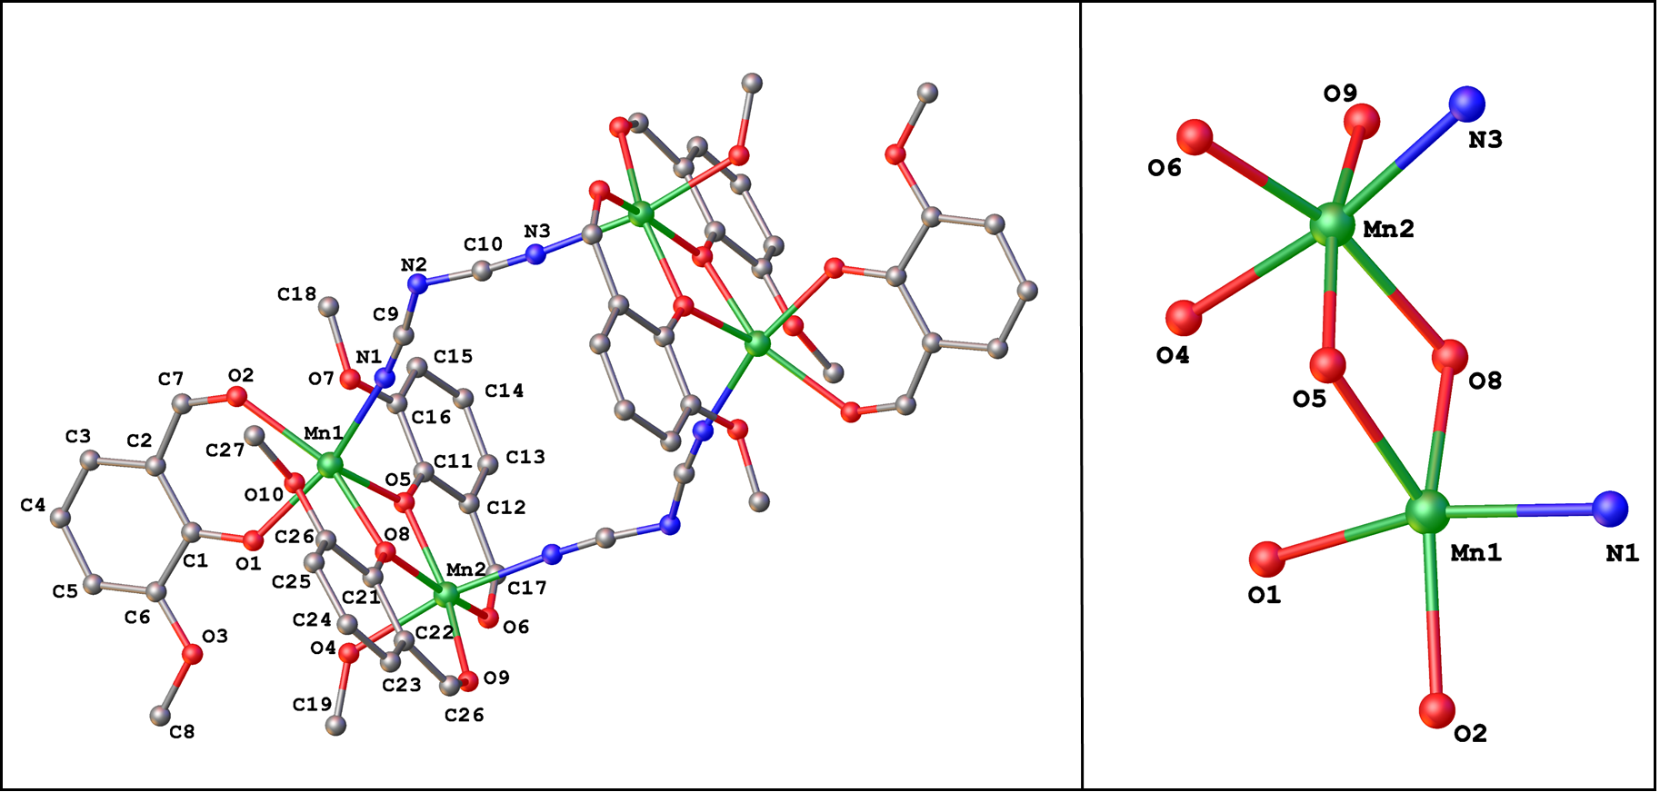
(a) (b)
Figure 3. ORTEP representation of the structure of [Mn₂(o-vanillin)₃(N(CN)₂)(MeOH)]₂. Displacement ellipsoids are drawn at the 50% probability level and H atoms are omitted for clarity.

Figure 4. ORTEP representation of the three-dimensional supramolecular network of the complex.

Table 2. Selected geometric parameters (Å, °) for the complex.
Mn1—O8 | 2.1693(15) | Mn2—O8 | 2.1214(15)
Mn1—O1 | 2.1362(14) | Mn2—O5 | 2.1106(15)
Mn1—O5 | 2.1790(15) | Mn2—O4 | 2.214(2)
Mn1—O2 | 2.1798(17) | Mn2—O9 | 2.1517(18)
Mn1—N1 | 2.177(2) | Mn2—O6 | 2.1518(18)
Mn1∙∙∙Mn2 | 3.3402(5) | Mn1∙∙∙Mn2 | 8.4530(5)
O8—Mn1—O5 | 76.08(6) | Mn2—O5—Mn1 | 102.26(6)
O8—Mn1—O2 | 146.38(7) | C9—N1—Mn1 | 166.2(2)
O1—Mn1—N1 | 164.69(8) | N1—C9—N2 | 173.5(3)
O5—Mn1—O2 | 135.16(7) | N3—C10—N2 | 173.0(3)
O8—Mn2—O6 | 162.80(7) | C10—N3—Mn2^{i} | 171.3(3)
O5—Mn2—O8 | 78.57(6) | C10—N2—C9 | 121.4(2)
Mn2—O8—Mn1 | 102.23(6)
Symmetry code: (i) −x+2, −y+2, −z+1.

Table 3. Hydrogen bonds (Å, °) of the complex.
D—H···A | D—H | H···A | D···A | D—H···A
C18—H18C···O2 | 0.96 | 2.64 | 3.190(4) | 117.2
O4—H4···O1 | 0.76(3) | 2.12(3) | 2.827(3) | 155(3)
O4—H4···O3 | 0.76(3) | 2.41(3) | 2.986(3) | 134(3)

Thermogravimetric study
Thermal decompositions of complex 1 has been investigated using TGA (Figure 3). The complex was heated in temperatures ranging from 30 °C to 800 °C with a flow rate of 10.00 °C/min under N₂ atmosphere. The complex is stable up to 50 °C and then begins to decompose continuously (Figure 3). The mass loss of 4.43 % between 50°C and 184°C corresponds to the loss of the methanol molecule (4.84 % of the molar mass). Between 185°C and 357°C, a mass loss of 6.92 % is noted which corresponds with the loss of dicyanamide molecule (8.32 % of the molar mass). In the range of 358°C - 400°C, the mass loss of 63.75% indicates that the organic molecule has undergone a complete degradation (65.38 % of the molar mass). Beyond this temperature, 24.90 % of the mass remains, which probably corresponds to the formation of manganese oxide. This indicates that this complex may be used as single source precursor for the formation of metal oxide.

Figure 5. TGA curve of complex 1.

Magnetic property of 1
The temperature dependence of the magnetic susceptibility (χ_{M}) of the complex was measured in the temperature range 300 – 1.8 K under a magnetic field of 0.1 T. The curve (χ_{M}) vs Τ is presented in figure 4a and shows a classical paramagnetic Curie C/T where C is the Curie constant. It is more suitable to show χ_{M}T vs T in order to remove the 1/T dependance and focus on the temperature dependance of C (Fig 4b). At high temperature χ_{M}T is temperature independent and we can estimate the value of the spin as well as the g factor using the relation $\frac{{N_{a}g}^{2}μ_{B}^{2}n S(S+1)}{3k_{B}}$ where Na is Avogadro Number, μ_{B} the Bohr magneton, k_{B} the Boltzmann constant (both in cgs unit) and n the number of ions in the unit cell. At room temperature we find χ_{M}T = 17.52 cm³.K.mol⁻¹ which correspond to fours isolated Mn(II) ions (S=5/2) (Abedi et al., 2016; L. Zhang, Wang, & Xu, 2014) with g=2.01. On cooling, the χ_{M}T values decrease slowly reaching a value of 16 cm³.K.mol⁻¹ at 32 K. Below this temperature, the χ_{M}T values decreases more rapidly reaching a value of 8 cm³.K.mol⁻¹ at 2 K. This temperature variation of χ_{M}T suggest the presence of a weak antiferromagnetic interaction between the Mn^{II} centers (Gómez–Saiz et al., 2008; Wałęsa-Chorab et al., 2013).
In order to estimate the intradimer and interdimer magnetic exchange interactions between the metal ions of tetrametallic complex, the magnetic susceptibility data for 1 were fit using Easyspin-Curry program (Stoll & Schweiger, 2006), with the following spin Hamiltonian
$$H=\sum_{i,j=1 i≠j}^{4}{J_{ij}S_{Mni}S_{Mnj}+gμ_{b}H\sum_{i=1}^{4}{S_{Mni}} }$$

The best fit shown a small antiferromagnetic intradimer coupling constant J=0.8 cm⁻¹ via o-vanillin bridge and no significant interdimer coupling constant via dicyanamide bridge. Ultimately, 1 can be magnetically approximated by
$$H=J{(S}_{Mn1}S_{Mn2}+S_{Mn3}S_{Mn4})$$
The negligible interdimer coupling can be explained by the large distance between Mn∙∙∙Mn of 8.4530(5) Å between Mn(II) bridged by dicyanamide ligand ions (Albada et al., 2006). The small and antiferromagnetic interactions between the manganese centers in the same unit [Mn₂(o-Vanillin)₃(N(CN)₂)(MeOH)] [Mn1∙∙∙Mn2 distance of 3.3402(5) Å] can be explained by the angle Mn–O–Mn of the super exchange path-way. That has been shown that the value of the bridging angle M–O–M is an important parameter in the magneto-structural correlation. If the M–O–M angle value is less than 99°, ferromagnetic interaction is observed, while antiferromagnetic interaction is observed when the M–O–M angle value is greater than 99° (Albada et al., 2006; Escuer et al., 1999; Moustapha-Sow et al., 2013). In the case of complex 1 the angle [Mn1–O5–M2 and Mn1–O8–Mn2 are both equal to 102.24 (7)°] is coherent with an AFM but small coupling.
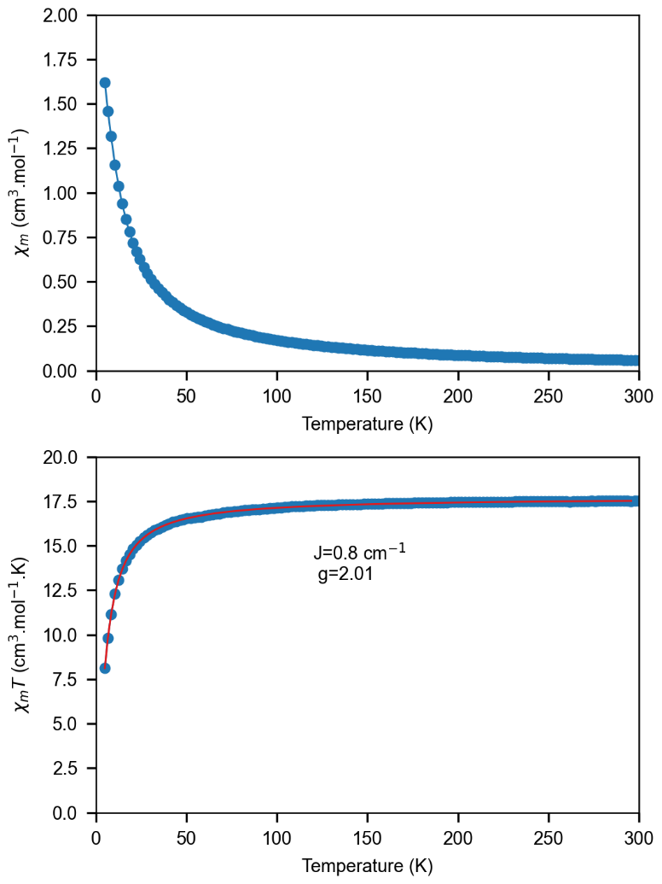

Figure 6. Top (a). Plots of χ_{M} vs T for the tetranuclear manganese [Mn₄(o-Vanillin)₆(N(CN)₂)₂(MeOH)₂]. Bottom (b) Plot of the χ_{M}T product vs T for the tetranuclear manganese [Mn₂(o-vanillin)₃(N(CN)₂)(MeOH)]₂.

Conclusion
The present study is carried out by synthesizing and characterizing a tetranuclear manganese complex [(Mn₂(o-vanillin)₃(N(CN)₂)(MeOH)]₂ (1). The structure of complex 1 is solved by XRD. The complex is composed of two units of [Mn₂(o-vanillin)₃(N(CN)₂)(MeOH)] which are bridged by two dicyanamide groups acting in μ_{1,5}-η¹,-η¹ mode. In the unit [Mn₂(o-vanillin)₃(N(CN)₂)(MeOH)], the two metal centers Mn1 and Mn2 are linked by two bridged phenoxo oxygen atoms. The pentacoordinated Mn1 ion is in a highly distorted square pyramidal environment, while the hexacoordinated Mn2 ion is in an octahedral environment. TGA allowed the study of the behavior of the complex when increasing the temperature. A three-step decomposition of complex 1 is observed, and the residue correspond to the formation of manganese oxide above 400 °C. The variable temperature magnetic measurement shows that two Mn(II) ions bridged by two phenoxo oxygen atoms in the same unit display antiferromagnetic interaction with a coupling constant J of 0.8 cm⁻¹. No significative interaction was observed between Mn(II) ions situated in two different units bridged by dicyanamide group.

Supporting information
CCDC-2425332 contains the supplementary crystallographic data for this paper. These data can be obtained free of charge via https://www.ccdc.cam.ac.uk/structures/, or by contacting The Cambridge Crystallographic Data Centre, 12 Union Road, Cambridge CB2 1EZ, UK;
Disclaimer (Artificial intelligence)
Option 1:
Author(s) hereby declare that NO generative AI technologies such as Large Language Models (ChatGPT, COPILOT, etc.) and text-to-image generators have been used during the writing or editing of this manuscript.
Option 2:
Author(s) hereby declare that generative AI technologies such as Large Language Models, etc. have been used during the writing or editing of manuscripts. This explanation will include the name, version, model, and source of the generative AI technology and as well as all input prompts provided to the generative AI technology
Details of the AI usage are given below:
1.
2.
3.

References
Abedi, M., Yeşilel, O. Z., Mahmoudi, G., Bauzá, A., Lofland, S. E., Yerli, Y., Kaminsky, W., Garczarek, P., Zaręba, J. K., Ienco, A., Frontera, A., & Gargari, M. S. (2016). Tetranuclear manganese(II) complexes of hydrazone and carbohydrazone ligands : Synthesis, crystal structures, magnetic properties, Hirshfeld surface analysis and DFT calculations. Inorganica Chimica Acta, 443, 101‑109. https://doi.org/10.1016/j.ica.2015.12.012
Addison, A. W., Rao, T. N., Reedijk, J., van Rijn, J., & Verschoor, G. C. (1984). Synthesis, structure, and spectroscopic properties of copper(II) compounds containing nitrogen–sulphur donor ligands; the crystal and molecular structure of aqua[1,7-bis(N-methylbenzimidazol-2′-yl)-2,6-dithiaheptane]copper(II) perchlorate. J. Chem. Soc., Dalton Trans., 7, 1349‑1356. https://doi.org/10.1039/DT9840001349
Albada, G. A. van, Tanase, S., Mohamadou, A., Mutikainen, I., Turpeinen, U., & Reedijk, J. (2006). Synthesis, structure and magnetism of two new polymeric double dicyanamido-bridged Mn(II) compounds. Polyhedron, 25(11), 2236‑2240. https://doi.org/10.1016/j.poly.2006.01.022
Anwar, M. U., Al-Harrasi, A., Abbasi, P., Rawson, J. M., & Pilkington, M. (2021). Magneto-structural studies of a one dimensional Mn(II) coordination polymer derived from a flexible polydentate ligand. Polyhedron, 207, 115378. https://doi.org/10.1016/j.poly.2021.115378
Banerjee, S., Ghorai, P., Sarkar, P., Panja, A., & Saha, A. (2020). A rare flattened tetrahedral Mn(II) salen type complex : Synthesis, crystal structure, biomimetic catalysis and DFT study. Inorganica Chimica Acta, 499, 119176. https://doi.org/10.1016/j.ica.2019.119176
Bhaumik, P. K. (2024). Synthetic methodology, structures and properties of trinuclear mixed valence manganese(II/III) complexes with various Schiff bases. Inorganica Chimica Acta, 568, 122081. https://doi.org/10.1016/j.ica.2024.122081
Costes, J.-P., Duhayon, C., Vendier, L., & Mota, A. J. (2018). Reactions of a series of ZnL, CuL and NiL Schiff base and non-Schiff base complexes with MCl2 salts (M = Cu, Ni, Mn) : Syntheses, structures, magnetic properties and DFT calculations. New J. Chem., 42(5), 3683‑3691. https://doi.org/10.1039/C7NJ04347C
Ding, C., Gao, C., Ng, S., Wang, B., & Xie, Y. (2013). Polynuclear Complexes with Alkoxo and Phenoxo Bridges from In Situ Generated Hydroxy-Rich Schiff Base Ligands : Syntheses, Structures, and Magnetic Properties. Chemistry – A European Journal, 19(30), 9961‑9972. https://doi.org/10.1002/chem.201301041
Diop, A., Sarr, M., Diop, M., Thiam, I. E., Barry, A. H., Coles, S., Orton, J., & Gaye, M. (2019). Metal transition complexes of tridentate Schiff base ligands derived from 2-hydrazinopyridine : Synthesis, spectroscopic characterization and X-ray structures. Transition Metal Chemistry, 44(5), 415‑423. https://doi.org/10.1007/s11243-019-00317-3
Dolomanov, O. V., Bourhis, L. J., Gildea, R. J., Howard, J. A. K., & Puschmann, H. (2009). OLEX2 : A complete structure solution, refinement and analysis program. Journal of Applied Crystallography, 42(2), 339‑341. https://doi.org/10.1107/S0021889808042726
Escuer, A., Font-Bardı́a, M., Kumar, S. B., Solans, X., & Vicente, R. (1999). Two new nickel(II) cubane compounds derived from pyridine-2-methoxide (Pym) : Ni₄(Pym)₄Cl₄(CH₃OH)₄ and Ni₄(Pym)₄(N₃)₄(CH₃OH)₄. Crystal structures and magnetic properties. Polyhedron, 18(6), 909‑914. https://doi.org/10.1016/S0277-5387(98)00378-7
Escuer, A., Mautner, F. A., Sanz, N., & Vicente, R. (2000). Two New One-Dimensional Compounds with End-to-End Dicyanamide as a Bridging Ligand : Syntheses and Structural Characterization of trans-[Mn(4-bzpy)₂(N(CN)₂)₂]n and cis-[Mn(Bpy)(N(CN)₂)₂]_{n}, (4-bzpy = 4-benzoylpyridine; bpy = 2,2‘-bipyridyl). Inorganic Chemistry, 39(8), 1668‑1673. https://doi.org/10.1021/ic990905h
Farrugia, L. J. (2012). WinGX and ORTEP for Windows : An update. Journal of Applied Crystallography, 45(4), 849‑854. https://doi.org/10.1107/S0021889812029111
Gadiaga, D., Sy, A., Ndoye, C., Traoré, B., Excoffier, G., Diouf, O., & Gaye, M. (2023). New Fe(III) Trichlorido Complex of a Bidentate N’-(thiophen-2-ylmethylene)isonicotinohydrazide Ligand : Synthesis, X-ray Structure, Spectral Characterization, and Electrochemistry Study. International Research Journal of Pure and Applied Chemistry, 24(2), 49‑60. https://doi.org/10.9734/irjpac/2023/v24i2809
Geary, W. J. (1971). The use of conductivity measurements in organic solvents for the characterisation of coordination compounds. Coordination Chemistry Reviews, 7(1), 81‑122. https://doi.org/10.1016/S0010-8545(00)80009-0
Gómez–Saiz, P., Gil-García, R., Maestro, M. A., Pizarro, J. L., Arriortua, M. I., Lezama, L., Rojo, T., González-Álvarez, M., Borrás, J., & García-Tojal, J. (2008). Structure, magnetic properties and nuclease activity of pyridine-2-carbaldehyde thiosemicarbazonecopper(II) complexes. Journal of Inorganic Biochemistry, 102(10), 1910‑1920. https://doi.org/10.1016/j.jinorgbio.2008.06.015
Haba, P., Sow, M. M., Sarr, M., Thiam, I. E., Diaw, M., Retailleau, P., & Gaye, M. L. (2020). Syntheses, Characterization, and X-ray Crystal Structure of Heteronuclear Zn/Na Assembled with Salen-type Schiff Base. Science Journal of Chemistry, 8(5), 113-118. https://doi.org/10.11648/j.sjc.20200805.13
Han, X., Liu, B., Wang, Z., Craze, A. R., Sun, H., Khan, M. R., Liu, J., Liu, Z., & Li, J. (2022). Structure diversity and magnetic properties of manganese and cobalt coordination polymers with multiple carboxyl bridges. Inorganica Chimica Acta, 533, 120788. https://doi.org/10.1016/j.ica.2021.120788
Hasan, N., Ilmi, R., & Iftikhar, K. (2024). Synthesis, X-ray crystal structure and photophysics of butterfly shape orange and red emanating polynuclear complexes of tris(dibenzoylmethanato)Ln(III) (Ln = Sm/Eu) and exo-bidentate 4,4′-bipyridine. Photochemical & Photobiological Sciences, 23(2), 315‑327. https://doi.org/10.1007/s43630-023-00519-w
Kalita, A., Ghosh, S., & Mondal, B. (2015). Nitric oxide reactivity of a manganese(II) complex leading to nitrosation of the ligand. Inorganica Chimica Acta, 429, 183‑188. https://doi.org/10.1016/j.ica.2014.12.040
Karmakar, M., Das, R., & Chattopadhyay, S. (2024). A comprehensive overview of the synthesis, structure, and application of azide bridged manganese(III) complexes with salen type Schiff base blocking ligands. Inorganica Chimica Acta, 569, 122106. https://doi.org/10.1016/j.ica.2024.122106
Malinina, E. A., Kubasov, A. S., Nikiforova, S. E., Goeva, L. V., Avdeeva, V. V., & Kuznetsov, N. T. (2024). Boron cluster anions [B_{n}H_{n}]₂– (n = 10, 12) in design of polynuclear silver(I) and copper(II) complexes. Polyhedron, 247, 116710. https://doi.org/10.1016/j.poly.2023.116710
Miyasaka, H., Clérac, R., Wernsdorfer, W., Lecren, L., Bonhomme, C., Sugiura, K., & Yamashita, M. (2004). A Dimeric Manganese(III) Tetradentate Schiff Base Complex as a Single-Molecule Magnet. Angewandte Chemie International Edition, 43(21), 2801‑2805. https://doi.org/10.1002/anie.200353563
Moustapha-Sow, M., Diouf, O., Gaye, M., Salam-Sall, A., Castro, G., Pérez-Lourido, P., Valencia, L., Caneschi, A., & Sorace, L. (2013). Sheets of Tetranuclear Ni(II) [2 × 2] Square Grids Structure with Infinite Orthogonal Two-Dimensional Water–Chlorine Chains. Crystal Growth & Design, 13(10), 4172‑4176. https://doi.org/10.1021/cg400885f
Ndoye, C., Diallo, W., Diouf, O., Barry, A. H., Gaye, M., & Gautier, R. (2018). Crystal structure of (μ- trans-1,2-bis{2-[(2-oxido-phenyl)methylidene]hydrazin-1-ylidene}ethane-1,2-diolato-κ³O, O', N)bis[di-tert-butyltin(IV)]. Acta Crystallographica Section E, 74(6), 799‑802. https://doi.org/10.1107/S2056989018007077
Nesterov, D. S., & Nesterova, O. V. (2018). Polynuclear Cobalt Complexes as Catalysts for Light-Driven Water Oxidation : A Review of Recent Advances. Catalysts, 8(12). https://doi.org/10.3390/catal8120602
Noritake, Y., Umezawa, N., Kato, N., & Higuchi, T. (2013). Manganese Salen Complexes with Acid–Base Catalytic Auxiliary : Functional Mimetics of Catalase. Inorganic Chemistry, 52(7), 3653‑3662. https://doi.org/10.1021/ic302101c
Orton, J. B., Diouf, N., Gueye, R. S., Gaye, M., Thiam, I. E., & Coles, S. J. (2023). Synthesis and crystal structures of two related Co and Mn complexes : A celebration of collaboration between the universities of Dakar and Southampton. Acta Crystallographica Section E, 79(12), 1109‑1114. https://doi.org/10.1107/S2056989023009805
Parvarinezhad, S., Salehi, M., Kubicki, M., & Khaleghian, A. (2021). Unprecedented formation of a μ-oxobridged dimeric copper (II) complex : Evaluation of structural, spectroscopic, and electronic properties by using theoretical studies and investigations biological activity studies of new Schiff bases derived from pyrazolone. Applied Organometallic Chemistry, 35(12), e6443. https://doi.org/10.1002/aoc.6443
Reis Conceição, N., Nesterova, O. V., Rajnák, C., Boča, R., Pombeiro, A. J. L., Guedes da Silva, M. F. C., & Nesterov, D. S. (2020). New members of the polynuclear manganese family : Mn^{II}₂Mn^{III}₂ single-molecule magnets and Mn^{II}₃Mn^{III}₈ antiferromagnetic complexes. Synthesis and magnetostructural correlations. Dalton Trans., 49(40), 13970‑13985. https://doi.org/10.1039/D0DT02652B
Sasaki, Y., Akamatsu, T., Tsuchiya, K., Ohba, S., Sakamoto, M., & Nishida, Y. (1998). Solvent and structural effects on catalase-like function of binuclear manganese(II) compounds with μ-phenoxide bridge. Polyhedron, 17(2), 235‑242. https://doi.org/10.1016/S0277-5387(97)00331-8
Stoll, S., & Schweiger, A. (2006). EasySpin, a comprehensive software package for spectral simulation and analysis in EPR. Journal of Magnetic Resonance, 178(1), 42‑55. https://doi.org/10.1016/j.jmr.2005.08.013
Tasiopoulos, A. J., Vinslava, A., Wernsdorfer, W., Abboud, K. A., & Christou, G. (2004). Giant Single-Molecule Magnets : A Mn84 Torus and Its Supramolecular Nanotubes. Angewandte Chemie International Edition, 43(16), 2117‑2121. https://doi.org/10.1002/anie.200353352
Thompson, L. K., & Dawe, L. N. (2015). Magnetic properties of transition metal (Mn(II), Mn(III), Ni(II), Cu(II)) and lanthanide (Gd(III), Dy(III), Tb(III), Eu(III), Ho(III), Yb(III)) clusters and [nxn] grids : Isotropic exchange and SMM behaviour. Coordination Chemistry Reviews, 289‑290, 13‑31. https://doi.org/10.1016/j.ccr.2014.09.004
Tong, L., Yan, Y.-B., Li, X., Sun, Y., Zhang, Y., Dong, W.-K., & Kou, H.-Z. (2024). Synthesis, Crystal Structure, and Magnetic Properties of Polynuclear Salamo Ni(II) Complexes. Crystal Growth & Design, 24(24), 10143‑10151. https://doi.org/10.1021/acs.cgd.4c00943
Wałęsa-Chorab, M., Kubicki, M., Korabik, M., & Patroniak, V. (2013). Novel self-assembled supramolecular architectures of Mn(ii) ions with a hybrid pyrazine–bipyridine ligand. Dalton Trans., 42(26), 9746‑9754. https://doi.org/10.1039/C3DT50352F
Wang, H., & Qin, J. (2022). Two Polynuclear Manganese(II) Complexes Based on Multidentate N-Heterocyclic Aromatic Ligand and V-Shaped Polycarboxylate Ligand : Synthesis, Crystal Structure Analysis and Magnetic Properties. Crystals, 12(2). https://doi.org/10.3390/cryst12020278
Xu, G., Tang, B., Hao, L., Liu, G., & Li, H. (2017). Ligand-dependent assembly of dinuclear, linear tetranuclear and one-dimensional Zn(ii) complexes with an aroylhydrazone Schiff base. CrystEngComm, 19(5), 781‑787. https://doi.org/10.1039/C6CE02292H
Zhang, L., Lin, Y.-J., Li, Z.-H., & Jin, G.-X. (2015). Rational Design of Polynuclear Organometallic Assemblies from a Simple Heteromultifunctional Ligand. Journal of the American Chemical Society, 137(42), 13670‑13678. https://doi.org/10.1021/jacs.5b08826
Zhang, L., Wang, J.-J., & Xu, G.-C. (2014). The [2×2] grid tetranuclear Fe(II) and Mn(II) complexes : Structure and magnetic properties. Inorganic Chemistry Communications, 39, 66‑69. https://doi.org/10.1016/j.inoche.2013.10.048
Zhang, S., & Zhao, L. (2018). Macrocycle-Encircled Polynuclear Metal Clusters : Controllable Synthesis, Reactivity Studies, and Applications. Accounts of Chemical Research, 51(10), 2535‑2545. https://doi.org/10.1021/acs.accounts.8b00283
Zhang, S.-H., Zhao, R.-X., Li, G., Zhang, H.-Y., Zhang, C.-L., & Muller, G. (2014). Structural variation from heterometallic heptanuclear or heptanuclear to cubane clusters based on 2-hydroxy-3-ethoxy-benzaldehyde : Effects of pH and temperature. RSC Adv., 4(97), 54837‑54846. https://doi.org/10.1039/C4RA09687H
Zhang, S.-H., Zhao, R.-X., Li, H.-P., Ge, C.-M., Li, G., Huang, Q.-P., & Zou, H.-H. (2014). Structural variation from heterometallic cluster-based 1D chain to heterometallic tetranuclear cluster : Syntheses, structures and magnetic properties. Journal of Solid State Chemistry, 216, 30‑35. https://doi.org/10.1016/j.jssc.2014.04.014
Zhao, R.-X., Zhang, J.-L., Zhang, S.-H., & Zhang, H.-Y. (2016). Room Temperature Synthesis, Crystal Structure, and Properties of a New Heterometallic One-Dimensional Cu-Na Polymer. Synthesis and Reactivity in Inorganic, Metal-Organic, and Nano-Metal Chemistry, 46(10), 1462‑1467. https://doi.org/10.1080/15533174.2015.1137019
Zheng, S.-R., Pan, M., Wu, K., Chen, L., Jiang, J.-J., Wang, D.-W., Shi, J.-Y., & Su, C.-Y. (2015). Assembly of Binuclear, Tetranuclear, and Multinuclear Complexes from Pincer-Like Mononuclear Metallotectons : Structural Diversity Dependent on Precursors. Crystal Growth & Design, 15(2), 625‑634. https://doi.org/10.1021/cg501306n

