Original Research Article
Agronomic Response of Tomato Varieties TOUNVI and COBRA to Organic, Mineral, and Integrated Soil Fertility Management in Southern Benin.

ABSTRACT
Background : Tomato production in southern Benin is increasingly constrained by declining soil fertility and suboptimal fertilizer management, leading to poor plant growth and low yields. This study evaluated the agronomic response of two tomato varieties, TOUNVI (a local landrace) and COBRA (an improved commercial variety) to different fertilization strategies.
Methodology : A split-plot experimental design was used, with variety as the main plot factor and four fertilization treatments as subplots: (T0) no fertilizer (control), (T1) organic fertilizer (compost), (T2) mineral fertilizer (NPK), and (T3) integrated organic–mineral fertilization. Data were collected on vegetative growth parameters—plant height and stem diameter—at multiple stages throughout the cropping cycle, as well as on reproductive traits, including number of flower clusters, flowers per plant, and fruits per plant.
Results : Results showed that both fertilization regime and variety significantly influenced growth and yield components. The integrated fertilization treatment (T3) consistently produced the highest vegetative growth across all measurement dates. Under this treatment, the number of fruit per plant recorded by TOUNVI and COBRA were 55.5 ± 0.7 and 49 ± 1.41, respectively. Compared with the control, T3 increased fruit number per plant by more than 85%, indicating a strong yield response to combined nutrient inputs. All fertilized treatments significantly outperformed the unfertilized control in reproductive parameters. COBRA exhibited greater vegetative vigor and higher flower production, whereas TOUNVI demonstrated superior fruit set, particularly under integrated fertilization.
Conclusion : These findings highlight the potential of integrated soil fertility management to sustainably enhance tomato productivity in southern Benin, while also underscoring the complementary roles of local and improved varieties in resilient cropping systems.
Keywords : Tomato varieties ; Integrated fertilization ; Soil fertility management ; Yield components ; Southern Benin
1. INTRODUCTION
Tomato (Solanum lycopersicum L.) is one of the most widely cultivated and consumed vegetable crops globally. According to recent FAO statistics, tomato is grown in over 170 countries, with a worldwide production exceeding 189 million metric tons in 2023 (FAO, 2023). It plays a pivotal role in food security, human nutrition, and rural economies, particularly in developing countries (Anokye-Alexander et al., 2025). Tomatoes are rich in essential nutrients, including vitamin C, provitamin A (beta-carotene), the potent antioxidant lycopene, and key minerals, making them a vital component of daily diets for millions of people (Ouattara and Moumouni, 2024).
In Benin, tomato cultivation holds major socio-economic significance, supporting both household subsistence and local-to-regional trade (Ezin et al., 2020). Production is especially concentrated in the southern part of the country, where sub-equatorial climatic conditions, bimodal rainfall patterns, and predominantly ferralitic soils are generally conducive to tomato growth—despite increasing edaphic and climatic constraints (Noukpèzounkou et al., 2021 ; Batamoussi et al., 2016).
Nevertheless, tomato yields in Benin remain low and highly variable, primarily due to soil degradation, inherently low soil fertility, inadequate or inappropriate use of agricultural inputs, and limited adoption of efficient and sustainable fertilization practices (Sikirou et al., 2017 ; Zohoungbogbo et al., 2021). Although soils in southern Benin may appear fertile, they are frequently depleted in organic matter, nitrogen (N), phosphorus (P), and sometimes potassium (K)—nutrients critical for the successful cultivation of nutrient-demanding horticultural crops like tomato (Ezin et al., 2012). These nutritional deficiencies translate into suboptimal and unstable yields, often insufficient to meet the growing domestic market demand (Aïsso et al., 2016).
In this context, improved soil fertility management is recognized as a key lever for enhancing crop productivity. Three main fertilization strategies are commonly considered: (i) organic fertilization (using compost, manure, or crop residues), (ii) mineral fertilization (with synthetic NPK fertilizers), and (iii) integrated (or combined) fertilization, which synergistically combines organic and mineral inputs (Gao et al., 2023). Each approach presents distinct advantages and limitations. Organic amendments improve soil structure, water retention, and long-term fertility but release nutrients slowly and unpredictably, often failing to meet the immediate demands of fast-growing crops. Conversely, mineral fertilizers provide readily available nutrients, yet their excessive or unbalanced use can lead to soil acidification, groundwater contamination, and increased dependency on costly, imported inputs (Ogbomo, 2011). Integrated fertilization seeks to harness the rapid nutrient supply of mineral fertilizers while leveraging the soil-enhancing benefits of organic matter, thereby promoting both short-term productivity and long-term agroecosystem sustainability (Li et al., 2025; Mutetwa et al., 2025).
Equally important is the choice of cultivar, as genotypic differences significantly influence crop response to nutrient management (Zavinon et al. 2022). In Benin, two tomato varieties are of particular interest: TOUNVI and COBRA. TOUNVI is a locally adapted landrace, valued for its disease tolerance (particularly to endemic pathogens) and superior fruit quality, though it typically exhibits modest yields (Sikirou et al., 2017; Mensah et al., 2025). In contrast, COBRA is an improved commercial variety increasingly adopted by farmers due to its vigorous growth, earliness, and high yield potential; however, its agronomic performance under local soil fertility conditions—especially under different fertilization regimes—has not been rigorously assessed.
To date, very few studies in southern Benin have systematically compared the agronomic responses of these contrasting varieties—local versus improved—to organic, mineral, and integrated fertilization. Such evidence is critical to guide farmers, extension agents, and policymakers toward more productive, profitable, and environmentally sound tomato production systems. Therefore, this study aims to evaluate the agronomic performance of TOUNVI and COBRA—specifically in terms of vegetative growth, fruit yield, earliness, and phenological stability—under three fertilization strategies (organic, mineral, and integrated) in the agro-ecological conditions of southern Benin.
2. MATERIALS AND METHODS
2.1. Study Site Description
The experiment was conducted at the experimental site of the Laboratory of Plant Physiology and Environmental Stress Studies, located on the campus of the University of Abomey-Calavi, approximately 12 km north of Cotonou in the commune of Abomey-Calavi (Atlantique Department), southern Benin. The site is characterized by a typical ferralitic soil, representative of coastal agroecological zones in southern Benin. The climate is sub-equatorial, featuring a bimodal rainfall pattern with two rainy seasons (mid-March to mid-July and mid-September to late October) and two dry seasons (November to mid-March and mid-July to mid-September). Average annual rainfall ranges between 1,200 and 1,342 mm, based on available climatic records (Zavinon et al., 2022). Temperatures remain relatively stable throughout the year, varying between 24 °C and 32 °C, creating a warm and humid environment generally suitable for tomato cultivation.

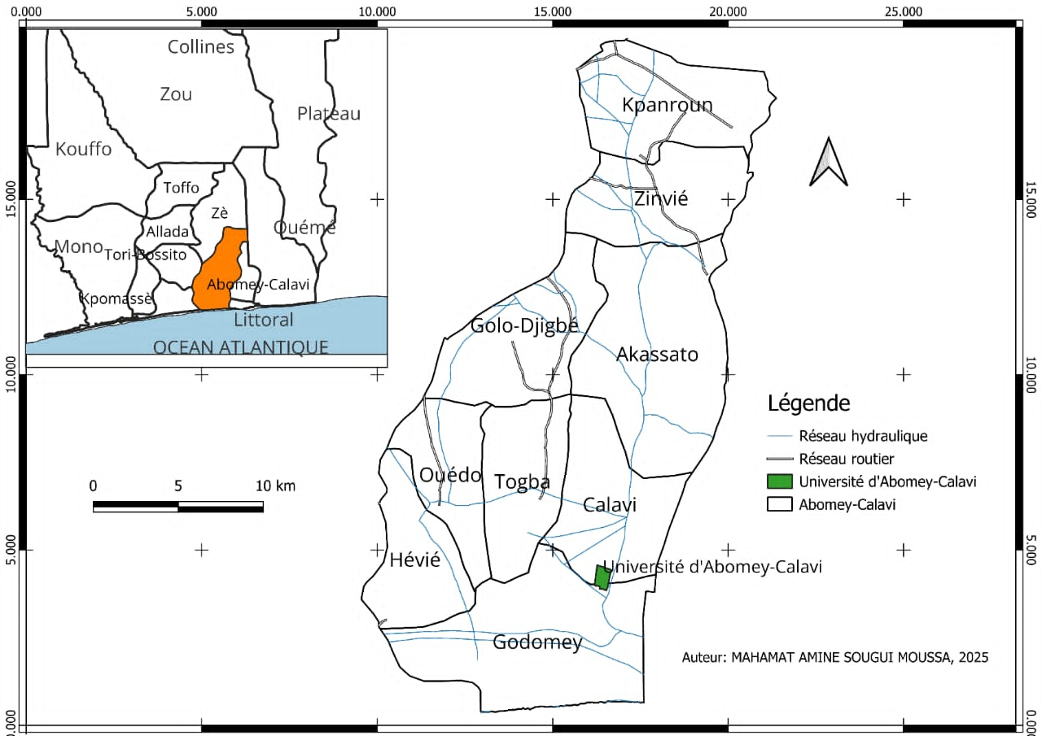

Fig. 1. Geographic location of the experimental site in southern Benin
2.2 Plant Materials
The study used two tomato (Solanum lycopersicum L.) varieties with contrasting agronomic traits: TOUNVI, a locally adapted landrace, and COBRA, an improved commercial variety. TOUNVI is widely cultivated by farmers in southern Benin and is highly valued by consumers for its superior organoleptic qualities, particularly fruit taste and texture. In contrast, COBRA is an improved variety selected for its vigorous growth, relatively high resistance to major diseases (including bacterial wilt), and high yield potential.
Seeds of the TOUNVI variety were sourced from local farmers in the study area, while COBRA seeds were obtained from researchers at the National Institute of Agricultural Research of Benin (INRAB). Key distinguishing characteristics of the two varieties—such as growth habit, fruit type, earliness, and disease resistance—are summarized in Table 1.

Table 1. Comparative agronomic and fruit quality traits of the tomato varieties TOUNVI (local landrace) and COBRA (improved hybrid)
Traits | Varieties
Traits | TOUNVI | COBRA
Type | Local landrace | Improved hybrid
Maturity cycle | Moyen (70-80 Jours) | Court à moyen (60-75 jours)
Plant Height | Petite | Moyenne
Yield potential | Modéré à élevé | Elevé
Disease resistance | Susceptible to several diseases | Relatively resistant to disease
Fruit colour | Bright red | Deep red
Fruit taste | Sweet, flavorful | Slightly acidic

2.3 Description of fertilizers
Two types of fertilizers were used to evaluate their individual and combined effects on tomato growth and yield: (i) an organic fertilizer composed of a locally produced mixture of mature compost and cattle manure, and (ii) a mineral fertilizer consisting of a commercial NPK 15-15-15 compound (containing 15% N, 15% P₂O₅, and 15% K₂O), commonly used in Beninese vegetable production, supplemented with urea (46% N). These fertilizers were selected based on current practices among tomato growers in southern Benin and their recognized role in improving the fertility of organic matter–deficient ferralitic soils.
2.4. Experimental Design and Crop Management
2.4.1. Experimental Design
The study employed a split-plot design with two factors, following established agronomic protocols for evaluating genotype × management interactions (Yao et al., 2022). The main plots corresponded to the two tomato varieties: TOUNVI (local landrace) and COBRA (improved hybrid). The subplots consisted of four fertilizer treatments: T0: Control (no fertilizer), T1: Organic fertilizer (compost + cattle manure), T2: Mineral fertilizer (NPK 15-15-15 + urea) and T3: Integrated (combined organic + mineral) fertilizer.
Each main plot was divided into four subplots, and the entire design was replicated three times, resulting in 24 experimental units. Plants were spaced at 0.80 m × 0.40 m, with 12 plants per subplot, consistent with local smallholder tomato production practices.
2.4.2. Trial Establishment and Crop Management
Prior to transplanting, the experimental field was plowed and harrowed to achieve a fine tilth suitable for planting. Organic amendments for treatments T1 and T3 were incorporated into the soil two weeks before transplanting to allow partial decomposition and gradual nutrient release. Healthy 21-day-old seedlings were manually transplanted into the subplots and immediately irrigated. Uniform manual irrigation was applied three times per week across all experimental units to minimize moisture variability.
Crop maintenance included regular hand weeding to control weed competition and staking using wooden stakes and twine to support plant architecture, improve aeration, reduce lodging, and prevent fruit-soil contact.
Fertilizer application was timed according to crop phenology: Organic fertilizers were applied and incorporated before transplanting ; NPK 15-15-15 was applied at transplanting ; Urea (46% N) was split-applied during the vegetative growth phase to match crop nitrogen demand. In the integrated treatment (T3), half the recommended rate of each fertilizer used in T1 and T2 was applied, in line with integrated soil fertility management (ISFM) principles aimed at optimizing nutrient use efficiency and minimizing input costs (Vanlauwe et al., 2010).
2.5. Data Collection and Statistical Analysis
Data were collected throughout the production cycle following a standardized agronomic protocol (Ogbomo, 2011) to assess the effects of fertilizer treatments and tomato varieties on growth and yield parameters. Two main categories of data were recorded: vegetative growth traits and reproductive (yield-related) traits.
Growth measurements included: (i) Plant height (cm), measured from the collar to the apical tip using a graduated ruler and (ii) stem diameter (mm), measured 2–3 cm above the soil surface with a digital caliper. These two variables were recorded at 30, 45, 65, and 75 days after transplanting (DAT) on four randomly selected plants per subplot. Yield-related parameters were monitored from flowering through fruit development and included: (i) Number of flower clusters per plant, (ii) Number of flowers per cluster and (iii) Number of fruits per plant. Counts were performed manually on the same tagged plants used for growth measurements. Flower clusters were recorded upon emergence, while flowers per cluster and fruits per plant were counted repeatedly as they developed, up to physiological maturity.
All data were compiled in Microsoft Excel and analyzed using R software (version 4.4.0). A mixed-effects analysis of variance (ANOVA) was conducted, with blocks treated as a random effect and variety and fertilizer treatment as fixed effects. When the ANOVA revealed significant effects (p < 0.05), mean comparisons were performed using Tukey’s Honest Significant Difference (HSD) test at the 5% significance level.
3. RESULTS
- 3.1. Effects of Variety and Fertilization on Plant Growth Parameters
The growth parameters—plant height and stem diameter—measured at multiple dates after transplanting, were significantly influenced by both main factors and, in most cases, their interaction. Results from the analysis of variance are summarized in Table 2.
A highly significant effect (p < 0.01) of variety, fertilization treatment, and their interaction was observed for stem diameter at 30, 60, and 75 days after transplanting (DAT). However, stem diameter measured at 45 DAT was not significantly affected by any of the factors tested.
Similar trends were observed for plant height: both variety and fertilization exerted highly significant effects across all sampling dates. Nevertheless, the variety × fertilization interaction was not significant at 45 and 75 DAT, indicating that the two varieties responded similarly to fertilizer treatments at these growth stages.
Table 2. Effects of variety and fertilizer treatment on tomato growth parameters at different days after transplanting (DAT).
Variables | DAT | Variété (V) |  | Fertilisant (F) |  | V x F
Variables | DAT | Mean Sq | P value | Mean Sq | P value | Mean Sq | P value
Diameter at the collar | 30 | 0,75 | < 0,001*** | 1,84 | < 0,001*** | 0,4 | < 0,001***
Diameter at the collar | 45 | 123 | 0,46^{NS} | 4,22 | 0,2^{NS} | 3,77 | 0,23^{NS}
Diameter at the collar | 60 | 1,42 | < 0,001*** | 3,46 | < 0,001*** | 0,32 | 0,002**
Diameter at the collar | 75 | 0,68 | < 0,001*** | 3,47 | < 0,001*** | 0,032 | 0,085^{NS}
Plant Height | 30 | 75,69 | < 0,001*** | 184,41 | < 0,001*** | 40,31 | < 0,001***
Plant Height | 45 | 126 | 0,46^{NS} | 432,34 | 0,2^{NS} | 384,16 | 0,23^{NS}
Plant Height | 60 | 135,72 | < 0,001*** | 331,5 | < 0,001*** | 30,82 | 0,002**
Plant Height | 75 | 68,48 | < 0,001*** | 347,38 | < 0,001*** | 3,22 | 0,084^{NS}
.Significance level from mixed-model ANOVA : p < 0.05 (*), p < 0.01 (**), p < 0.001 (***), ^{NS} = not significant
Mean comparisons of the four fertilizer treatments—conducted separately for each variety (see Table 3)—revealed consistent and significant differences in growth performance. The control treatment (T0; no fertilizer) consistently produced the lowest values for both plant height and stem diameter in both varieties. In contrast, the integrated fertilization treatment (T3; organic + mineral) consistently yielded the highest growth values across all measurement dates and for both varieties.
Although plants receiving mineral fertilizer alone (T2) generally showed greater growth than those under organic fertilizer alone (T1), the differences between T1 and T2 were not statistically significant at most sampling dates and for either variety. This suggests that, under the conditions of this trial, organic inputs can support growth performance comparable to mineral fertilizers—though the combination of both (T3) clearly provided superior results.
Table 3 : Mean comparison of plant height (cm) and stem diameter (mm) of tomato varieties under different fertilizer treatments.
Variables |  | T0 | T1 | T2 | T3
Variables | DAT | TOUNVI
Stem Diameter | 30 | 3,37 ± 0,10^{c} | 4,01 ± 0,01^{b} | 4,8 ± 0,07ª | 5,17 ± 0,07ª
Stem Diameter | 45 | 6,89 ± 0,08^{c} | 7,89 ± 0,03^{b} | 8,40 ± 0,07ª | 8,68 ± 0,07ª
Stem Diameter | 60 | 9,15 ± 0,05^{c} | 9,91 ± 0,31b^{c} | 10,5 ± 0,04^{ab} | 11,22 ± 0,07ª
Stem Diameter | 75 | 9,78 ± 0,07^{c} | 11 ± 0,07^{b} | 11,10 ± 0,07^{b} | 12,08 ± 0,07ª
Plant Height | 30 | 33,75 ± 1,06^{c} | 40,10 ± 0,14^{b} | 48 ± 0,7ª | 51,70 ± 0,70ª
Plant Height | 45 | 69,60 ± 0,84^{c} | 79,75 ± 0,35^{b} | 84,80 ± 0,70ª | 87,70 ± 0,70ª
Plant Height | 60 | 89,7 ± 0,56^{c} | 97,2 ± 3,11b^{c} | 102,9 ± 0,42^{ab} | 110 ± 0,70ª
Plant Height | 75 | 97,80 ± 0,70^{c} | 110,05 ± 0,77^{b} | 111 ± 0,70^{b} | 120,85 ± 0,77ª
 |  | COBRA
Stem Diameter | 30 | 3,06 ± 0,05^{c} | 4,36 ± 0,01ª | 3,63 ± 0,09^{b} | 4,56 ± 0,08ª
Stem Diameter | 45 | 8,11 ± 0,07ª | 9,90 ± 0,07ª | 6,09 ± 4,08ª | 9,99 ± 0,05ª
Stem Diameter | 60 | 9,31 ± 0,14^{c} | 11,33 ± 0,13^{ab} | 10,8 ± 0,04^{b} | 11,72 ± 0,06ª
Stem Diameter | 75 | 10,10 ± 0,13^{b} | 11.63 ± 0,13ª | 11,58 ± 0,07ª | 12,30 ± 0,07ª
Plant Height | 30 | 30,60 ± 0,56^{c} | 43,65 ± 0,49ª | 36.30 ± 0,98^{b} | 45,60 ± 0,84ª
Plant Height | 45 | 81,9 ± 0,7ª | 100 ± 0,7ª | 76,5 ± 20,08ª | 100,9 ± 0,56ª
Plant Height | 60 | 91,3 ± 1,41^{c} | 111,1 ± 1,27^{ab} | 105,8 ± 0,42^{b} | 114,9 ± 0,56ª
Plant Height | 75 | 101,05 ± 1,34^{b} | 116,35 ± 1,34ª | 115,80 ± 0,70ª | 123,05 ± 0,77ª
Values followed by the same letter within a row are not significantly different according to Tukey’s HSD test (p < 0.05).
3.2. Growth Dynamics of the Two Tomato Varieties under Different Fertilization Treatments
A marked variation in growth rates was observed for both tomato varieties in response to the fertilizer treatments. Growth curves presented in Fig. 2 illustrate the temporal evolution of plant height and stem diameter for TOUNVI and COBRA throughout the cropping cycle.
In both varieties, a progressive increase in growth was recorded over time, reflecting normal vegetative development. However, clear differences emerged among fertilizer treatments. The control treatment (T0; no fertilizer) consistently exhibited the lowest growth values at all measurement dates. In contrast, integrated fertilization (T3; organic + mineral) promoted the fastest and most sustained growth, resulting in significantly higher plant height and stem diameter across the entire growth cycle. Treatments with mineral fertilizer alone (T2) and organic fertilizer alone (T1) showed intermediate growth patterns, with T2 generally outperforming T1, although differences were often not statistically significant/
Overall, COBRA displayed more vigorous vegetative growth than TOUNVI, particularly under the integrated fertilization regime (T3), as evidenced by consistently greater plant height and stem thickness from early to late growth stages.
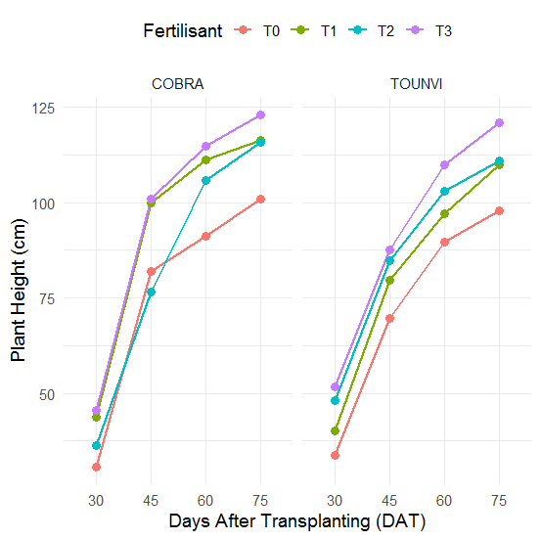
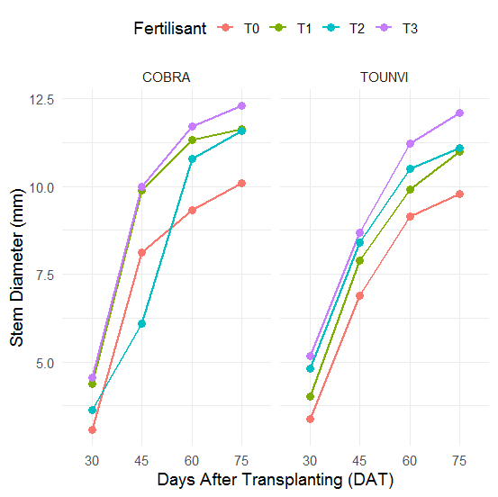
A
B

Fig. 2. Growth curves of tomato varieties TOUNVI and COBRA under four fertilizer treatments: T0 (control, no fertilizer), T1 (organic fertilizer), T2 (mineral fertilizer), and T3 (integrated organic–mineral fertilization). Data represent mean values of (A) stem diameter (mm) and (B) plant height (cm).

3.3. Effects of Genotype and Fertilization on Yield-Related Traits
The reproductive traits evaluated—number of flower clusters per plant, number of flowers per plant, and number of fruits per plant—were significantly influenced by both genotype and fertilization regime. Descriptive statistics for each variety across fertilizer treatments (Table 4) consistently show higher values under fertilized treatments compared to the unfertilized control (T0), regardless of the trait considered.
In COBRA, the lowest mean values—5.5 flower clusters, 5.5 flowers, and 25.5 fruits per plant—were recorded under the control treatment (T0). These values nearly doubled under the integrated fertilization treatment (T3), highlighting the strong positive impact of combined organic–mineral inputs on reproductive performance.
In contrast, TOUNVI exhibited its highest flower cluster and flower numbers under mineral fertilization alone (T2). However, the maximum fruit count (55.5 fruits per plant) was achieved under T3, underscoring the advantage of integrated fertilization for optimizing final fruit yield, even in a locally adapted landrace.
Table 4. Descriptive statistics (means ± standard deviation) of reproductive traits in tomato varieties TOUNVI and COBRA under four fertilizer treatments.
Facteurs de variation |  | No_Bq |  | No_Fl |  | No_Fr
 |  | Moy | SD | Moy | SD | Moy | SD
COBRA | T0 | 5,5 | 0,7 | 5,5 | 0,7 | 25,5 | 4,95
COBRA | T1 | 7,5 | 0,7 | 10,5 | 0,7 | 40 | 4,24
COBRA | T2 | 8,5 | 0,7 | 11,5 | 0,7 | 32 | 1,41
COBRA | T3 | 8,5 | 2,12 | 10,5 | 2,12 | 49 | 1,41
TOUNVI | T0 | 4 | 1,41 | 7,5 | 0,7 | 29,5 | 2,12
TOUNVI | T1 | 5,5 | 0,7 | 8 | 1,41 | 50,5 | 2,12
TOUNVI | T2 | 6,5 | 0,7 | 13 | 1,41 | 45,5 | 0,7
TOUNVI | T3 | 6 | 1,41 | 10,5 | 0,7 | 55,5 | 0,7
No_Bq: number of flower clusters per plant; No_Fl: number of flowers per plant; No_Fr: number of fruits per plant. Treatments: T0 = control (no fertilizer), T1 = organic fertilizer, T2 = mineral fertilizer, T3 = integrated (organic + mineral) fertilization
Results from the ANOVA (Table 5) confirm a highly significant effect of fertilization (p < 0.01) on all three yield-related traits. Genotype had a significant effect on flower cluster number and fruit number, but not on total flower number per plant. Crucially, the genotype × fertilization interaction was non-significant for all traits, indicating that both varieties responded similarly to the fertilizer treatments in terms of reproductive output.
Overall, integrated fertilization (T3) consistently produced the highest yields, followed by mineral fertilization (T2), while organic fertilization alone (T1) and the control (T0) yielded significantly lower fruit numbers.
Table 5 : Mean squares from mixed-model ANOVA testing the effects of variety (V), fertilizer treatment (F), and their interaction (V × F) on tomato reproductive traits
 | Mean Square
 | No_Bq | No_Fl | No_Fr
Variété (V) | 16** | 0,25^{NS} | 297,6***
Fertilisant (F) | 6,16* | 23,41*** | 442,6***
V x F | 0,16^{NS} | 4,08^{NS} | 17,7^{NS}
Residual | 1,375 | 1,375 | 7,1
No_Bq: number of flower clusters per plant; No_Fl: number of flowers per plant; No_Fr: number of fruits per plant. Significance level from mixed-model ANOVA : p < 0.05 (*), p < 0.01 (**), p < 0.001 (***), ^{NS} = not significant
3.4. Differential Response of TOUNVI and COBRA to Fertilization Treatments
Fig. 3 illustrates the contrasting reproductive responses of the tomato varieties TOUNVI and COBRA to the four fertilizer treatments.
For flower cluster number and flower number per plant, the overall trends were broadly similar between the two varieties across all treatments. Although differences were not statistically significant, COBRA tended to produce slightly more flower clusters than TOUNVI, particularly under fertilized conditions (Fig. 3A). Conversely, TOUNVI exhibited marginally higher flower numbers per plant, especially under the control (T0) and mineral fertilizer (T2) treatments (Fig. 3B).
In contrast, fruit number per plant revealed clear and consistent differences between the two varieties across all treatments (Fig. 3C). TOUNVI consistently outperformed COBRA, with the largest gaps observed under integrated fertilization (T3) and organic fertilization (T1). Under T3, TOUNVI produced 55.5 fruits per plant compared to 49.0 for COBRA (see Table 4), highlighting its superior fruiting efficiency despite lower vegetative vigor. This pattern suggests that TOUNVI allocates assimilates more effectively toward fruit set and retention, particularly when organic inputs are included in the fertilization regime.
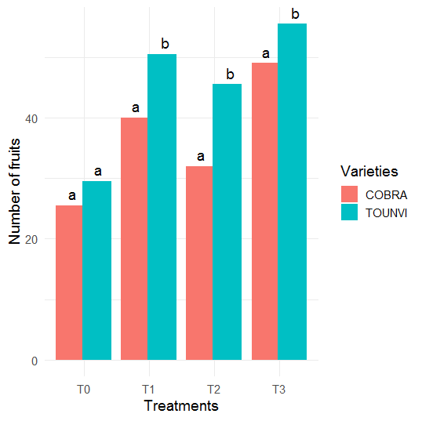
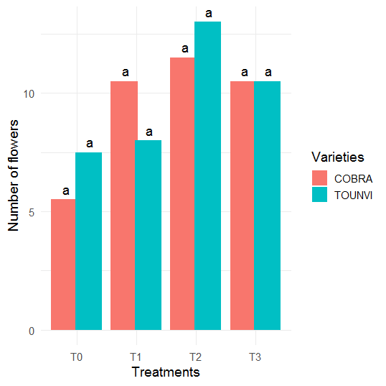
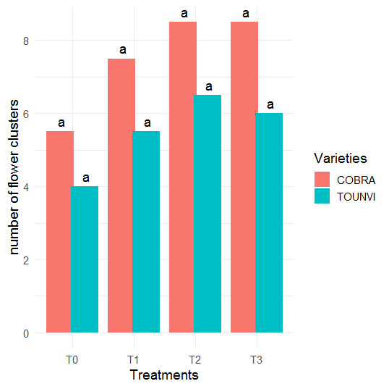
B
A

C

Fig. 3. Comparative response of tomato varieties TOUNVI (and COBRA to fertilizer treatments for reproductive traits: (A) number of flower clusters per plant, (B) number of flowers per plant, and (C) number of fruits per plant.

4. DISCUSSION
Tomato (Solanum lycopersicum L.) is one of the most strategically important vegetable crops in Benin, playing a dual role in enhancing food security and generating income for rural households. However, its productivity remains severely constrained by declining soil fertility, limited access to quality inputs, and ongoing degradation of natural resources. In this context, evaluating organic, mineral, and integrated fertilization strategies is both scientifically relevant and practically essential for developing more productive and sustainable tomato production systems.
Our results confirm that fertilization exerts a highly significant effect on both vegetative growth and reproductive performance of tomato, irrespective of genotype. This aligns with findings from similar studies in Côte d’Ivoire (Boa et al., 2022) and Togo (Tekpa et al., 2024), where nutrient management strongly influenced tomato agronomic traits. Among the tested regimes, integrated fertilization (organic + mineral) consistently outperformed all others, yielding the highest values for plant height, stem diameter, flower cluster number, flower count, and—critically—fruit number per plant.
This superiority can be attributed to the synergistic interaction between organic and mineral inputs (Ekincialp et al., 2025). Organic matter enhances soil structure, water-holding capacity, and microbial activity, while mineral fertilizers provide readily available nitrogen and phosphorus—nutrients commonly deficient in the ferralitic soils of southern Benin (Houngnandan et al., 2020). Given the region’s inherently low organic matter content and limited cation exchange capacity (Vanlauwe et al., 2010), this complementary approach is particularly well-suited to restoring functional soil fertility.
The choice of TOUNVI (a local landrace) and COBRA (an improved hybrid) reflects a socio-agronomic duality relevant to smallholder farming systems. TOUNVI is widely grown for its superior organoleptic qualities and local adaptability (Aïsso et al., 2018), while COBRA is increasingly adopted for its vigor, earliness, and resistance to bacterial wilt—a major constraint in Beninese vegetable production. This local/commercial variety pairing mirrors trends observed across West Africa, where COBRA is routinely included in varietal trials (Boa et al., 2022).
Although both varieties responded positively to fertilization, they exhibited distinct resource allocation strategies. COBRA displayed greater vegetative growth and higher flower production—typical of high-input, improved genotypes. In contrast, TOUNVI, despite lower biomass accumulation, demonstrated superior fruit set, particularly under integrated fertilization. This suggests a more efficient reproductive strategy, possibly linked to local adaptation or optimized assimilate partitioning toward fruit development rather than vegetative expansion. These findings underscore a critical point: varietal performance should not be judged solely on vegetative vigor, but on actual yield stability and fruiting efficiency under real-world conditions.
Notably, the absence of a significant variety × fertilization interaction for most traits indicates that both genotypes respond similarly to nutrient inputs. This is an encouraging result: it suggests that local landraces like TOUNVI are not inherently unresponsive to improved soil fertility management, as sometimes assumed. Instead, they can fully benefit from optimized fertilization—especially when organic and mineral sources are combined. This opens promising pathways for ecological intensification that reconciles the resilience and food sovereignty offered by local seeds with modern agronomic knowledge.
From a practical standpoint, our findings strongly support the promotion of integrated fertilization in agricultural extension programs in Benin. While mineral fertilizers remain costly and subject to supply chain disruptions, organic inputs—such as compost, manure, and crop residues—can be produced locally, reducing farmers’ dependence on imported inputs (Hashimi and Habibi, 2021) Beyond immediate yield gains, this approach enhances long-term sustainability by improving soil health, promoting carbon sequestration, and strengthening resilience to climate variability—key priorities in an era of accelerating environmental change.
5. CONCLUSION
This study highlights the decisive influence of both fertilization regime and genotype on tomato growth and yield in southern Benin. The integrated fertilization strategy—combining organic and mineral inputs—proved the most effective approach, significantly outperforming organic or mineral fertilization applied alone in enhancing both vegetative development and reproductive performance.
The improved variety COBRA exhibited greater vegetative vigor and higher flower production, while the local landrace TOUNVI demonstrated superior fruit set, reflecting its strong local adaptation and efficient use of available nutrients. Given the ongoing challenges of soil degradation and the urgent need for sustainable intensification in smallholder horticulture, integrated soil fertility management emerges as a promising pathway to boost tomato productivity while safeguarding soil health. These findings provide a robust basis for developing context-specific fertilizer recommendations for vegetable growers in southern Benin and lay the groundwork for future research incorporating economic profitability and environmental sustainability into fertilizer decision-making.
COMPETING INTERESTS
Authors have declared that no competing interests exist.
Disclaimer (Artificial intelligence)
Option 1:
Author(s) hereby declare that NO generative AI technologies such as Large Language Models (ChatGPT, COPILOT, etc.) and text-to-image generators have been used during the writing or editing of this manuscript.
REFERENCES
Aisso, C. B. R., Komlan, F. S., M. Vahid Aissi, M. V. et al. (2018). Cultural practices and producers perception on sensoral characteristics of some tomato varieties produced in south benin. Int. J. Adv. Res. 6(10), 854-863 https://doi.org/10.21474/IJAR01/7880
Anokye-Alexander, D., Adjei, E., Poku, I. A., Kennedy, K., Debrah, S., Mensah, F. E., Patrick, A., Prince, A., & Hinneh, S. K. (2025). Socio-economic Determinants of Productivity in Tomato Farming: A Case Study of Gender Dynamics, Age, Education, Household Characteristics, and Land Ownership in Berekum West and Tano North Districts, Ghana. Discoveries in Agriculture and Food Sciences. 13(04), 45-63. https://doi.org/10.14738/tnc.1304.19257
Aytekin Ekincialp, A., Selma Kipcak Bitik, S., Erdinç, Ç., Sensoy, S. (2025). Influence of Combinations of Chemical and Organic Fertilizers on Biochemical Responses of Tomato Fruits in Different Maturity Stages. ACS Omega. 10, 30599−30615 https://doi.org/10.1021/acsomega.5c02531
Batamoussi, M. H., Tovihoudji, P. G., Tokore, O., M., Julien Boulga, J., Michée Iboukoun Essegnon, M., I. (2016). Effect of organic fertilizers on the growth and yield of two tomato varieties (Lycopersicum esculentum) in the commune of Parakou (Northern Benin). International Journal of Innovation and Scientific Research. 24(1): 86-94 http://www.ijisr.issr-journals.org/abstract.php?article=IJISR-16-070-11
Boa, B. B, Y., Tamia Joséphine Ama, T. J., Tacra Thierry Lekadou, T. T., et al. (2022). Agromorphological performance of organic fertilizers on two tomato varieties on sandy soils of the Ivorian coast. International Journal of Progressive Sciences and Technologies. 33(1): 136–149 https://ijpsat.org/index.php/ijpsat/issue/view/33
Ezin, V., Ibouraïma Yabi, I., Ahanchede A/ (2012). Impact of salinity on the production of tomato along the coastal areas of Benin Republic. African Journal of Environmental Science and Technology. 6(4), 214-223 https://doi.org/10.5897/AJEST11.369
Ezin, V., Ibouraïma Yabi, I., Ahanchede A/ (2024). Assessing the Impact of Salinity on Tomato Production in Benin's Coastal Areas. Advanced Journal of Environmental Science and Technology. 15 (8) : 001 – 010. www.internationalscholarsjournals.org
FAO. (2023). Statistical database. Rome, Italy. Available at: https://www.fao.org/faostat
Gao, F., Li, H., Mu, X., Gao, H., Zhang, Y., Li, R., Cao, K., Ye, L. (2023). Effects of Organic Fertilizer Application on Tomato Yield and Quality: A Meta-Analysis. Appl. Sci. 13, 2184. https://doi.org/10.3390/app13042184
Hashimi, R., and Habibi, H., K. (2021). Effects of Organic and Inorganic Fertilizers Applications Levels on Greenhouse Tomato (Solanum lycopersicum) Yield and Soil Quality in Khost Province. Asian Journal of Soil Science and Plant Nutrition. 7(4): 1-10 https://doi.org/10.9734/ajsspn/2021/v7i430117
Houngnandan, H. B., Adandonon, A., Akplo, T. M., Zoundji C. C., Kouelo, A. F., Zeze, A., Houngnandan, P., Bodjrenou, R., Dehoue H., Akinocho J. (2020). Effect of rhizobial inoculation combined with phosphorus fertilizer on nitrogen accumulation, growth and yield of soybean in Benin. Journal of Soil Science and Environmental Management .11(4), 153-163, https://doi.org/10.5897/JSSEM2020.0833
Li, Y., Zhang, R., Zhang, C., Li, Q., Nie, L., Wang, C., Wang X-X. (2025) Integrative approaches to nutrient management in tomato cultivation for improved sustainability and productivity. Front. Plant Sci. 16:1626136. https://doi.org/10.3389/fpls.2025.1626136
Mensah, A. C. G., Koura T. W., Barthélemy B. Yarou B. B. et al. (2025). Tomato production in off-season: Assessment of the influence of transplanting dates on virus incidence and yield in Benin. Agrosyst Geosci Environ. 8:e70068. DOI: 10.1002/agg2.70068
Mutetwa, M., Chifamba, P., Chaibva, P., Rundofa, T., Harrison, W., Chimende, E., Mapwanyire, C., Ndau, B. M., Masaka, J. (2025). Integrating organic and inorganic fertilizers for climate-smart tomato production in Zimbabwe. EUREKA: Life Sciences. 4, 3–13. https://doi.org/10.21303/2504-5695.2025.004007
Noukpozounkou, M. S. P., Gougbe, A., Aboudou, K., Goudjinou, C., Soumanou, M. M. (2024). Endogenous knowledge and post-harvest constraints related to preservation techniques of tomato varieties produced in Southern Benin. Afrique SCIENCE 19(5): 81–95 https://www.afriquescience.info/index.php/afriquescience/article/view/100
Ogbomo, K. E. (2011) Comparison of growth, yield performance and profitability of tomato (Solanum lycopersicon) under different fertilizer types in humid forest ultisols. International Research Journal of Agricultural Science and Soil Science. 1(8), 332-338. http://www.interesjournals.org/IRJAS
Ouattara, S. S. S. and Konate M. (2024). The Tomato: A Nutritious and Profitable Vegetable to Promote in Burkina Faso. Alexandria Science Exchange Journal. 45(1) : 11 – 20 https://doi.org/10.21608/asejaiqjsae.2024.332758
Sikirou, R., Beed, F., Ezin, V., Hoteigni, J., Miller, S.A. (2017). Distribution, pathological and biochemical characterization of Ralstonia solanacearum in Benin. Ann. Agric. Sci. 62, 83–88. https://doi.org/10.1016/j.aoas.2017.05.003
Tekpa, D., Tchabi, A., Kombieni E., Souho, T., Abli, E. A., Ouadja, B. (2024). Comparative effect of organic and mineral fertilizers on the production and preservation of fresh tomatoes (Solanum lycopersicum L.) in the Kozah prefecture of Togo. Int. J. Adv. Res. 12(08), 1670-1680. https://doi.org/10.21474/IJAR01/19414
Vanlauwe, B., Bationo, A., Chianu, J., et al. (2010). Integrated soil fertility management Operational definition and consequences for implementation and dissemination. Outlook on AGRICULTURE. 39(1) :17–24 https://doi.org/10.5367/000000010791169998
Yao, J. J., Kouassi, J. N., Groga, N., Yatty, J. K. (2022). Effect of organic fertilization on the production of two tomato varieties (Lycopersicum esculentum Mill.) cultivated under semi-controlled conditions in Daloa, Central-West, Côte d'Ivoire. Africa SCIENCE. 21(6): 92–101 http://www.afriquescience.net
Zavinon, F., Fonhan, N., Atrokpo, A., Djossou, R., Adoukonou-Sagbadja, H. (2022) Genotype x Environment Interaction and Agronomic Performances Analysis in Exotic Pigeon pea (Cajanus cajan L. Millsp) Cultivars in Benin. International Journal of Applied Agricultural Sciences. 8(6) 251 – 258 https://doi.org/10.11648/j.ijaas.20220806.18
Zohoungbogbo, H.; Quenum, A.; Honfoga, J.; Chen, J.-R.; Achigan-Dako, E.; Kenyon, L.; Hanson, P. (2021). Evaluation of Resistance Sources of Tomato (Solanum lycopersicum L.) to Phylotype I Strains of Ralstonia solanacearum Species Complex in Benin. Agronomy 11, 1513. https://doi.org/10.3390/agronomy11081513

