Effect of Fertilizer Types on Fungal Disease Incidence in Chili Pepper in Burkina Faso

Abstract
Chili peppers (Capsicum annuum) are an important crop in the vegetable farming system of Burkina Faso, particularly as a source of income and nutrients for producers. However, their cultivation faces major challenges, namely fungal diseases, the effects and prevalence of which remain poorly understood in the Kadiogo province. Fertilizers, especially organic ones, are regularly used to improve yields, but their effects on disease proliferation have not been studied. This experiment was conducted using a split-plot design with seven varieties as the variable factor and seven fertilizers as the fixed factor. The incidence and severity of the diseases, as well as their interactions, were evaluated. The pathogens were isolated on PDA medium and identified using morphological criteria. The results highlighted Phytophthora capsici as the major pathogen during our experiment. From week 5 onward, the incidence of disease became significant, with values ​​ranging from 0.92 ± 0.07 (T0) to 1.00 ± 0.00 for treatments T3, T4, T5, and T6. Similarly, the severity index increased progressively during weeks 4, 5, and 6, rising from 0.45 ± 0.12 (T0) to levels between 0.75 ± 0.24 and 0.80 ± 0.16 for the most affected treatments (T1, T2, and T3, respectively). NPK treatments recorded the lowest severity at week 6, at 0.51 ± 0.14, while treatments based on poultry manure (T1) at 0.80 ± 0.16; cow dung (T2) at 0.79 ± 0.18 and compost (T3) at 0.75 ± 0.24 were associated with the highest severities. Fertilization alone is insufficient to control pathogen pressure. However, mineral supplementation helped limit the severity of symptoms, indicating improved plant tolerance. Conversely, organic fertilizers appear to promote disease development. Under the conditions of this study, the use of NPK fertilizers seems to be the most effective option for reducing the impact of fungal diseases on chili peppers.
Keywords: Phytophthora capsici, soil amendments, incidence, severity index, Burkina Faso.

Introduction
In Burkina Faso, chili pepper cultivation plays a key role in market gardening systems. In 2022, national production was estimated at approximately 150,000 tons, with high-production areas located primarily in the Centre-West, Hauts-Bassins, and Boucle du Mouhoun regions (FAO, 2014). In addition to its role in food, chili peppers represent a source of income for small-scale producers and traders in rural areas. Women play a significant role, particularly in processing and sales activities (Sohou et al., 2017).
Despite its nutritional and economic value, chili peppers face numerous challenges, including fungal diseases that compromise yields. These diseases, which affect leaves, stems, fruits, and roots, cause considerable yield losses, sometimes reaching 100% (Thakur and Geisen, 2019). The symptoms and signs of these pathogens are varied, ranging from wilting, rot, and leaf spots to plant death, resulting in both direct and indirect losses (Liu et al., 2016; Moreira Morrillo et al., 2022).
Several studies have highlighted the role of fertilization in plant health. Indeed, balanced nutrition, particularly through the application of organic matter or biofertilizers, can strengthen crops' natural defenses against pathogens (Agbodjato et al., 2018; Igiehon and Babalola, 2017). The use of compost, manure, or plant extracts helps to boost soil biological activity, improve soil structure, and enhance plants' ability to resist biotic stresses. In certain areas of Burkina Faso, particularly in Kadiogo, the interactions between fertilization practices and fungal disease pressure remain poorly understood despite the growing importance of chili pepper cultivation. This deficiency raises, among other things, the following questions: what are the most frequent fungal pathogens in chili pepper crops in Kadiogo? What is the effect of fertilizers on the incidence and severity of these diseases? It is within this framework that the present study is situated, its overall objective being to contribute to the improvement of chili pepper production through the identification of fungal diseases in the Kadiogo region of Burkina Faso.
Material and method
Study Site
The Kadiogo province in Burkina Faso is characterized by a North Sudanese climate, with two distinct seasons: a rainy season generally extending from May to October, and a dry season from November to April. Average annual rainfall in the Kadiogo province ranges from 700 to 900 mm, with an irregular distribution in space and time. Temperatures generally vary between 18°C ​​and 39°C, with extremes ranging from 15°C to 41°C (Weather Spark, 2025). Soil-wise, this region exhibits a wide diversity of soil types: leached tropical ferruginous soils, hydromorphic soils in lowland areas, and sandy-loam soils particularly well-suited to market garden crops such as chili peppers. Although these soils are generally poor in organic matter, their fertility can be enhanced by the adoption of appropriate agroecological practices (INERA, 2019; INSD, 2022). The Kadiogo province is also a major market gardening area, particularly in the peri-urban zones of Ouagadougou such as Koubri, Komsilga, Saaba, Pabré, and Tanghin Dassouri, where chili peppers are widely cultivated, both for personal consumption and for sale. The trial was conducted in the commune of Koubri (located approximately 30 km south of Ouagadougou), specifically in the village of Poedogo. This area is a strategic hub for market gardening production in Burkina Faso. The experimental site is located at an average altitude of 298 m, with geographic coordinates in degrees and decimal minutes (DD°MM.mmm’) of 12°10.361’ N and 001°21.948’ W.
Plant Material
For disease identification, the collected samples consisted of chili pepper leaves, stems, and fruits exhibiting characteristic fungal disease symptoms such as necrosis, chlorosis, whitish spots, wilting, etc. Seven (7) chili pepper varieties were used in the trial, differing in their growing cycle, shape, color, and spiciness.
Fertilizers
Organic fertilizers such as poultry manure, improved compost (made from plant debris and enriched with natural phosphate), and cow manure were used, and mineral fertilizers such as NPK 15-15-15 were applied.
The organic fertilizers were thoroughly decomposed to prevent the spread of diseases and their negative effects on the plants.
Compost is the result of the decomposition of organic matter and is primarily used to improve soil texture, increase water retention, and enhance biodiversity. It is a compost mainly composed of plant debris, activated by cow manure, and enriched with natural phosphate. On average, it contains 3% nitrogen, 2% phosphorus, and 1% potassium, with a pH of 7 to 8, which is favorable to plant growth (Khaing et al., 2019). While it is an excellent way to enrich the soil with essential nutrients and support microbial life, its production is time-consuming, and it is generally less rich in immediate nutrients than other fertilizers such as poultry manure or chemical fertilizers. However, it remains an ideal solution for sustainable and ecological fertilization (Weill and Duval, 2009). Compost is incorporated into the soil during preparation before sowing. Compost was applied as a base fertilizer 5 days before transplanting at a rate of 10 tonnes/hectare.
Cow manure is an organic fertilizer rich in organic matter, which improves soil structure, moisture retention, and supports microbial life. However, it has a low content of nutrients directly available to plants. Decomposed cow manure contains on average 0.35% nitrogen, 0.3% phosphorus, and 0.14% potassium, with a pH between 7 and 8, making it an effective organic amendment for soil fertilization (Tomathouse, 2025). Its action is long-term, gradually improving soil quality, but it sometimes requires composting before use. This type of fertilizer is particularly useful for soils requiring improvement in texture and water retention capacity (Ognalaga et al., 2018). Cow manure is incorporated into the soil one month before sowing to promote better decomposition, improving soil fertility and structure and ensuring a gradual release of nutrients. Cow manure was applied as a base fertilizer five days before transplanting at a rate of 30 tonnes per hectare.
Poultry manure contains approximately 3.03% nitrogen, 2.63% phosphorus, and 1.4% potassium, with a generally alkaline pH of around 8, making it a highly concentrated organic amendment, particularly well-suited to demanding crops (Ball et al., 2024). It stimulates vegetative growth by rapidly supplying essential nutrients to plants. However, excessive use can lead to over-fertilization and harm plants, with a risk of burning due to its high ammonia content. Therefore, it is important to carefully adjust application rates to avoid adverse effects associated with over-fertilization (Ouédraogo, 2016). In this context, poultry manure was used as a base fertilizer, applied five days before transplanting at a rate of 10 tons per hectare.
NPK fertilizers are mineral mixtures that combine nitrogen (N), phosphorus (P), and potassium (K) in a balanced ratio—three elements essential for plant development. Their application allows for rapid and targeted plant nutrition, directly supplying the nutrients necessary for crop growth. However, excessive use of these fertilizers can have harmful effects on the environment, particularly through soil and water pollution. Unlike organic amendments, NPK fertilizers do not improve the physical structure of the soil or its biological activity. NPK 15-15-15 was applied at a rate of 200 kg/ha seven days after transplanting.
Sample Preparation and Incubation
The samples were first thoroughly washed under running water to remove surface impurities. They were then cut into fragments of approximately 2.25 cm², targeting areas near spots, lesions, or necrotic tissue. These fragments were disinfected for a few seconds in a 2% sodium hypochlorite solution and then rinsed with sterile distilled water for 30 seconds. This rinsing was repeated three times to remove any residual disinfectant. This step aims to eliminate exogenous microflora that could interfere with fungal isolation. The fragments were then placed on sterile filter paper (Wattmann type) and allowed to dry for 30 seconds under a fume hood. Finally, they were transferred to previously prepared PDA culture media in sterile Petri dishes (Soura, 2020).
Identification
The identification of the pathogens responsible for the diseases was carried out in two stages: the first based on observation of symptoms in the field, followed by laboratory confirmation. Two approaches were used: macroscopic examination and microscopic examination.
Experimental Methods
The trial was set up in a split-plot design with three replicates or blocks and two variables (Figure 23). The first variable was the treatment (7 treatments), and the second variable was the variety (also 7 varieties). Each block consisted of seven sub-blocks, each corresponding to one of the seven fertilizers. Each sub-block comprised 14 rows, with two rows per variety. The length of each row was 2 m, the spacing between rows was 0.4 m, and the spacing between planting holes was 0.4 m. The distance between sub-blocks was 1 m, and the distance between blocks was 1.5 m. In total, there were 21 sub-blocks. Each sub-block measured 5.2 m long and 2 m wide, for a total area of ​​10.4 m². The total area of ​​the trial was 372 m², with a length of 20 m and a width of 18.6 m. Six (06) chili plants were transplanted per row with a total of 1764 chili plants.
The nursery was established on raised beds rich in organic matter, measuring 1 m x 1 m for each variety (photo 1). The spacing between rows was 25 cm. The seeds were sown loosely on the rows, followed by mulching until germination, and the vigorous seedlings were transplanted 45 days later.

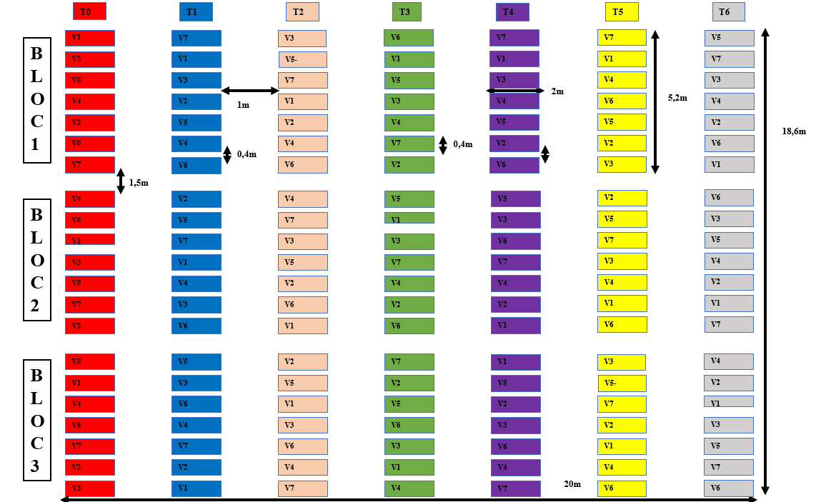
Figure 1: Experimental setup.

Legend:
- T0: control = no treatment
- T1: treatment 1 = poultry manure 10 t/ha
- T2: treatment 2 = cow manure 30 t/ha
- T3: treatment 3 = compost 10 t/ha
- T4: treatment 4 = cow manure 30 t/ha + poultry manure 10 t/ha
- T5: treatment 5 = NPK 200 kg/ha (Adekiya et al., 2020)
- T6: treatment 6 = cow manure 30 t/ha + compost 10 t/ha
- V1 = variety 1 = F1 Angel
- V2 Variety 2 = Thailand +
- V3 = Variety 3 = F1 Geronimo
- V4 = Variety 4 = Bird's Eye Chili
- V5 = Variety 5 = Yellow from Burkina Faso
- V6 = Variety 6 = F1 Tikal
- V7 = Variety 7 = Touty Saf

Parameters evaluated
Incidence: This involves regular observation of the different parts (leaves, stems, and fruit) of the plants to identify the first symptoms of fungal diseases, count the number of diseased plants, and assess disease progression; monitoring was carried out every 7 days. The disease incidence rate was estimated from the ratio of the number of diseased plants to the total number of plants in each plot or variety at a given time (Cooke et al., 2006). Incidence was assessed starting from the 3rd week after transplanting.
Disease Severity: After assessing disease incidence, the same four sample plants from each plot were used to evaluate disease severity. Different plant parts (leaves, stems, flowers, fruits) were observed to identify symptoms. A rating scale from 1 to 5 was used to determine the percentage of affected plants:
- 1 = no symptoms;
- 2 = 1 to 24%;
- 3 = 25 to 49%;
- 4 = 50 to 74%;
- 5 = > 75% of the plant shows symptoms (Moral and Trapero, 2009).
The disease severity index was determined for each plot using the following equation:
IS = (∑(xi×ni))/NZ×100;
where:
Is = Disease severity index for the plot,
xi = Disease severity level i on the plant,
ni = Number of severe plants,
N = Total number of plants observed,
Z = Highest severity level, i.e., 5 (Kranz and Rotem, 1988).
Severity was assessed starting from the 4th week after transplanting and every week thereafter.
Statistical analyses
The data were entered using Microsoft Excel and then analyzed using a two-way ANOVA (treatment and variety) with the R software. The means were compared using Duncan's test at the 5% significance level.
Results and discussion
Identification of Pathogenic Fungi
The collected samples allowed us to isolate five microscopic fungi on PDA (Potato Dextrose Agar) medium. However, macroscopic and microscopic observation of the isolated fungal cultures, along with the use of the identification keys by Samson et al. (2009) and Barnett and Hunter (1987), enabled the identification of one microscopic fungus, Phytophthora capsici. Several fungi do not prefer PDA medium, which complicates their identification. It should also be noted that some species of microscopic fungi (Leveillula taurica) are obligate parasites, which may explain their absence among the isolated fungi. The following descriptions present the characteristics observable with the naked eye and under a light microscope, along with their identification using the identification keys of Samson et al. (2009) and Barnett and Hunter (1987).
Phytophthora capsici
The colonies have a whitish appearance on the front. They are circular, with regular edges, and quickly cover the surface of the substrate. The back of the container shows a distinct light yellow pigmentation. Microscopic observation reveals hyaline, septate, and well-branched hyphae. The conidia are of two types:
- unicellular microconidia with an oval or elliptical shape,
- fusiform and slightly curved macroconidia with 3 to 5 septa.
Based on these morphological characteristics and according to fungal identification keys, this fungus has been identified as Phytophthora capsici.
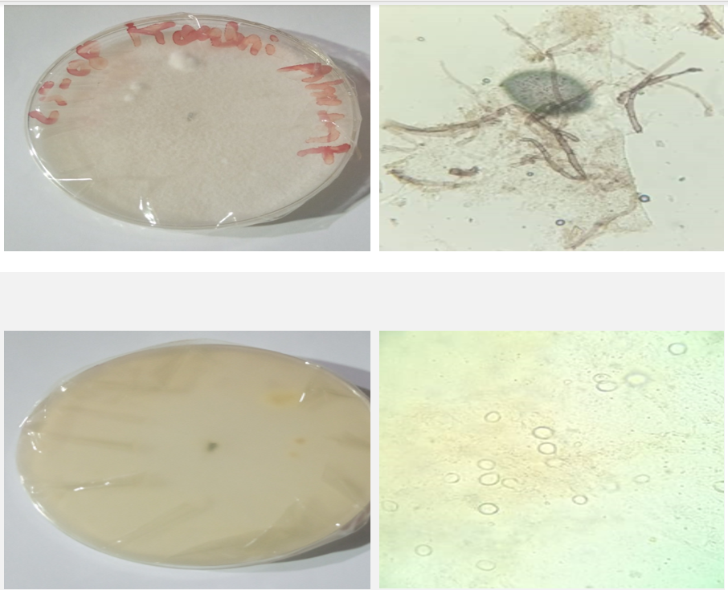
Photo 1: Macroscopic and microscopic observation of Phytophthora capsici
Disease Incidence
The results show that disease incidence did not vary significantly between treatments in weeks 3 and 4, but a significant difference was observed in week 5 (Table 1). At this stage of the study, treatments T3 (compost), T4 (manure + droppings), T5 (NPK), and T6 (manure + compost) all recorded an incidence of 100%, indicating widespread disease transmission across all experimental plots. This trend suggests that neither organic nor mineral inputs effectively controlled the infection. The results of the work by Sanou et al. (2021) corroborate these findings, highlighting a high incidence of chili pepper downy mildew under high humidity conditions, regardless of the type of fertilization used. Fungi of the genus Phytophthora develop rapidly in saturated soil conditions, where the availability of free water promotes the mobility of zoospores, which increases the likelihood of infection of the roots and the collar (Agrios, 2005).
Treatments rich in fresh organic matter, such as manure and uncomposted dung, can increase the soil microbial load and alter microbial balances, indirectly promoting the survival of soilborne pathogens (Bourou et al., 2017). Conversely, work by Kaboré et al. (2019) showed that well-decomposed compost can have an antagonistic effect on Phytophthora capsici by promoting competing microorganisms. This discrepancy highlights that the nature, maturity, and method of application of organic amendments are crucial in the dynamics of the disease.
Table 1 : Interaction between treatment and disease incidence.
Treatment | S3 | S4 | S5
T0 | 0.25 ± 0.04 | 0.68 ± 0.14 | 0.92ª ± 0.07
T1 | 0.39 ± 0.22 | 0.72 ± 0.26 | 0.98^{ab} ± 0.01
T2 | 0.24 ± 0.04 | 0.9 ± 0.13 | 0.97^{ab} ± 0.01
T3 | 0.30 ± 0.08 | 0.89 ± 0.06 | 1^{b} ± 0.00
T4 | 0.23 ± 0.04 | 0.92 ± 0.03 | 1^{b} ± 0.00
T5 | 0.26 ± 0.10 | 0.82 ± 0.07 | 1^{b} ± 0.00
T6 | 0.38 ± 0.04 | 0.97 ± 0.03 | 1^{b} ± 0.00
Probability | 0.42 | 0.06 | 0.04
Significance | NS | NS | S
NS: not sifnificant
S: significant

Disease Severity
Disease severity varied significantly between treatments, with higher values ​​observed in plots treated with poultry manure (T1), cow dung (T2), and compost (T3). The NPK treatment (T5) showed lower severity than the control (T0). These differences suggest a potential influence of nutrient regimes on plant physiology and infection dynamics (Table 2). Increased plant susceptibility to disease is observed in the presence of nitrogen-rich fertilization, particularly in the form of ammonia (Agrios, 2005). This phenomenon could explain the greater severity observed with the manure and dung treatments, whose high nitrogen content can promote the proliferation of pathogens.
Conversely, balanced nutrient inputs, such as those from the T5 treatment (NPK), appear to have contributed to strengthening plant tissues, thus limiting the progression of infection. The work of Lamidi et al. (2019) conducted in Nigeria showed that moderate mineral fertilizer inputs reduce the severity of downy mildew in Capsicum spp., while an overload of unstabilized organic matter tends to intensify pathogen pressure in the soil, which is consistent with our results.
Similarly, Bourou et al. (2017) found that the application of mature compost combined with moderate doses of NPK promotes beneficial microflora capable of inhibiting the development of Phytophthora capsici. In contrast, some work conducted by Kamga et al. (2016) in Cameroon showed that organic fertilization alone, applied at moderate doses, can strengthen the resistance of chili pepper plants by stimulating induced defense mechanisms. These differences in results reflect the strong dependence of the phytosanitary response on the quality of the amendments and local growing conditions.

Table 2 : Interaction between treatment and disease severity index.

Treatment | S4 | S5 | S6
T0 | 0.45ª ± 0.12 | 0.57ª ± 0.17 | 0.55^{ab} ± 0.17
T1 | 0.60^{b} ± 0.18 | 0.60^{ab} ± 0.09 | 0.80^{c} ± 0.16
T2 | 0.60^{b} ± 0.17 | 0.63^{ab} ± 0.14 | 0.79^{c} ± 0.18
T3 | 0.64^{b} ± 0.20 | 0.75^{b} ± 0.15 | 0.75^{c} ± 0.24
T4 | 0.67^{b} ± 0.14 | 0.64^{ab} ± 0.21 | 0.71^{ac} ± 0.19
T5 | 0.60^{b} ± 0.15 | 0.64^{ab} ± 0.13 | 0.51^{b} ± 0.14
T6 | 0.60^{b} ± 0.10 | 0.62^{ab} ± 0.21 | 0.65^{bc} ± 0.22
Probability | 0.01 | 0.011 | 0.000007
Significance | S | S | VHS
VHS:very highly significant

Conclusion
The results of this study show that fertilization, whether organic or mineral, did not have a significant protective effect against infections, even though NPK treatments resulted in lower disease severity compared to other treatments. The high incidence and severity observed reflect the pathogen's strong aggressiveness under high humidity conditions. Uncomposted organic matter inputs even appear to have exacerbated the severity of infections, likely due to excess available nitrogen promoting rapid vegetative growth at the expense of tissue resistance. The results as a whole highlight the need for an integrated approach combining stabilized organic amendments, water management and varietal selection to improve chili pepper health in agroecological production systems in Burkina Faso.
Disclaimer (Artificial intelligence)
Author(s) hereby declare that NO generative AI technologies such as Large Language Models (ChatGPT, COPILOT, etc.) and text-to-image generators have been used during the writing or editing of this manuscript.

Bibliographical references
- Agbodjato, N.A., Noumavo, P.A., Agossou, M., Houngnandan, P., Baba-Moussa, L., (2018). Effets des biofertilisants à base de Trichoderma spp. et PGPR sur la croissance du maïs au Bénin. Journal of Applied Biosciences. 127, 12753–12765.
- Agrios, G.N., (2005). Plant Pathology, 5th edition, Elsevier Academic Press. Amsterdam. https://www.elsevier.com/books/plant-pathology/agrios/978-0-12-044565-3

- Ball, M.E.E., Wright, L.P., Wilson, K., Richmond, H., Cummings, R., Smyth, S., Davison, M., Forbes, K., Thompson, J. and Bryson, P., (2024). The Nutrient Content of Litter and Manure from Different Poultry Systems—Updating and Establishing the Nutrient Profile. Sustainability. 16(15), p.6633. https://doi.org/10.3390/su16156633

- Barnett, H.L., Hunter, B.B., (1987). Illustrated Genera of Imperfect Fungi, 4th edition Macmillan Publishing Company. New York, USA, 218 p. https://www.apsnet.org/apsstore/products/Pages/41922.aspx

- Cooke, B.M., Jones, D.G., Kaye, B. (Eds.), (2006). The Epidemiology of Plant Diseases, Disease Assessment and Yield Loss. Springer Netherlands. Dordrecht, Netherlands 568 p. https://doi.org/10.1007/1-4020-4581-6
- FAO, Food and Agriculture Organization of the United Nations, (2014). Enquête nationale sur les statistiques agricoles au Burkina Faso – Rapport final. FAO. Rome, https://www.fao.org/faostat/
- Igiehon, N.O., Babalola, O.O., (2017). Biofertilizers and sustainable agriculture: Exploring arbuscular mycorrhizal fungi. Applied Microbiology and Biotechnology. 101, 4871–4881. https://doi.org/10.1007/s00253-017-8344-z
- INERA, Institut de l’Environnement et de Recherches Agricoles, (2019). Caractéristiques pédologiques des principales zones agroécologiques du Burkina Faso, INERA. Ouagadougou.
- INSD, Institut National de la Statistique et de la Démographie, (2022). Annuaire statistique de la production agricole, INSD. Ouagadougou, 232 p. https://www.insd.bf/annuaires-statistiques-nationaux/
- Kaboré, D., Traoré, O., et Ilboudo, M., (2019). Effets de différents types de fertilisation sur le rendement du piment dans les sols ferrugineux tropicaux du Burkina Faso. Revue Burkinabè des Sciences et Techniques Agricoles. 8(1), 23–30.
- Kamg, R.T., Kouame, C. et Tchatat, M., (2016). Effect of integrated organic and mineral fertilization on growth and yield of pepper (Capsicum spp.) in the humid tropics of Cameroon. African Journal of Agricultural Research. 11(22), pp. 2010–2018.

- Khaing, T., Win, S.S. and Win, N.N., (2019). Physical and Chemical Properties of Compost Made from Agricultural Wastes. International Journal of Environmental and Rural Development. 10(2), pp.10–20. https://doi.org/10.32115/ijerd.10.2_61
- Kranz, J., Rotem, J., (1988). Experimental Techniques in Plant Disease Epidemiology: Measuring Plant Disease. Springer Berlin Heidelberg, Berlin, Heidelberg, Germany, 299 p. https://doi.org/10.1007/978-3-642-95534-1
- Lamidi, W.A., Oyewole, C.I. & Afolabi, O.A., (2019). Effect of fertilizer sources on growth, yield and disease incidence of pepper (Capsicum spp.) in Nigeria. International Journal of Plant and Soil Science. 28(3), pp. 1–9.

- Liu, F., Tang, G., Zheng, X., Li, Y., Sun, X., Qi, X., Zhou, Y., Xu, J., Chen, H., Chang, X., Zhang, S. & Gong, G., (2016). Molecular and phenotypic characterization of Colletotrichum species associated with anthracnose disease in peppers from Sichuan Province, China [figure 1]. Scientific Reports, 6, 32761. https://doi.org/10.1038/srep32761
- Moreira Morrillo, A.A., Monteros Altamirano, Á., Reis, A., Garcés Fiallos, F.R., (2022). Phytophthora capsici on Capsicum Plants: a destructive pathogen in chili and pepper crops, in: Capsicum – New Perspectives. IntechOpen. London, UK, pp. 1–16. https://doi.org/10.5772/intechopen.104726
- Moral, J., Trapero, A., (2009). Assessing the Susceptibility of Olive Cultivars to Anthracnose Caused by Colletotrichum acutatum. Plant Disease. 93, 1028–1036. https://doi.org/10.1094/PDIS-93-10-1028
- Ognalaga, M., M’Akoué, D., Medza Mve, S.D., & Ovono, P. (2017). Effet de la bouse de vaches, du NPK 15-15-15 et de l’urée à 46% sur la croissance et la production du manioc (Manihot esculenta Crantz var 0018) au Sud-Est du Gabon (Franceville). Journal of Animal and Plant Sciences, 31(3), 5063–5073. https://www.researchgate.net/publication/326320000_Effet_de_la_bouse_de_vaches_du_NPK_15_15_15_et_de_l'uree_a_46_sur_la_croissance_et_la_production_du_manioc_Manihot_esculenta_Crantz_var_0018_au_Sud-Est_du_Gabon_Franceville

- Ouédraogo, S., 2016. Analyse socioéconomique de la filière piment au Burkina Faso. Université Joseph Ki-Zerbo, 84 p.
- Samson, R.A., Houbraken, J., Thrane, U., Frisvad, J.C. & Andersen, B., (2010). Food and indoor fungi: Second edition. CBS-KNAW Fungal Biodiversity Centre. Utrecht, The Netherlands, 390 pp. ISBN 978-90-70351-82-3. https://research.dtu.dk/en/publications/food-and-indoor-fungi-second-edition
- Sanou, S., Yaméogo, A., et Kaboré, W., (2021). Effet des conditions climatiques sur la floraison et le rendement du piment au Burkina Faso. Revue Africaine d’Agronomie et de Production Végétale. 9(4), 77–86.

- Sohou, A., Dossa, K.F., Loko, Y.L., (2017). Influence des modes de fertilisation sur la croissance et la productivité du piment au Bénin. Annales des Sciences Agronomiques. 21, 65–78.
- Soura, B.H.,( 2020). Étude de la cercosporiose du riz ıt (Oryza spp.) causée par ıt Cercospora oryzae Miyake au Sud-Bénin. Lutte biologique par utilisation des extraits végétaux. Université d’Abomey-Calavi, 167 p.

- Thakur, M.P., Geisen, S.,( 2019). Trophic Regulations of the Soil Microbiome. Trends in Microbiology. 27, 771–780. https://doi.org/10.1016/j.tim.2019.04.008
- Tomathouse, 2025. Fumier de vache comme engrais: avantages et composition. https://garden.tomathouse.com/fr/ovoshchi/zhidkij-navoz.html
- Weather Spark, (2025). Climat, météo par mois, température moyenne pour Ouagadougou (Burkina Faso). https://fr.weatherspark.com/y/100000/Climat-et-M%C3%A9t%C3%A9o-moyenne-%C3%A0-Ouagadougou-Burkina-Faso-tout-au-long-de-l'ann%C3%A9e
- Weill, A., & Duval, J. (2009). *Guide de gestion globale de la ferme maraîchère biologique et diversifiée*. Équiterre.

