Agro-Morphological Diversity and Phenological Variation Among Sorghum Genotypes Grown In Southeast Niger

Abstract
Sorghum is a cereal of great importance in several tropical countries of Africa. In Niger, sorghum is the second most important cereal crop after millet. However, this crop faces a significant decline in yield due to numerous biotic and abiotic constraints. The objective of this study was to characterize eighteen sorghum genotypes in order to perform a morpho-phenological evaluation and identify the best-performing genotypes. We conducted the experiments in a complete randomized block design with four replications in Zinder during the rainy season in 2024. The analysis of variance results revealed significant variability among the evaluated genotypes, particularly regarding phenological traits where the 50% flowering stage varied from 71 to 90 days after sowing, morphological traits with plant heights ranging from 125 to 277.80 cm, and agronomic traits with grain yields varying from 984 to 3643 kg.ha⁻¹. Principal Component Analysis (PCA) classified the genotypes into five distinct groups. Phenologically, the genotypes in Group 1 showed good performance. Morphologically, genotypes in Groups 2 and 3 were the most efficient. Studies have shown that varietal differentiation in sorghum is mainly determined by these three criteria, which also influence farmers’ selection preferences. Genotypes that demonstrated superior grain yield performance and could therefore be promoted to enhance sorghum productivity under conditions of climatic variability and striga infestation. Agronomically, genotypes G15, G6, G16, and G2 in Group 2 exhibited the best grain yield performance. These genotypes could be potential lines for breeding new varieties to address crop production challenges under conditions of climatic variability. Their deployment could contribute significantly to improving food security and crop resilience under the current context of irregular rainfall and low soil fertility in Niger and other semi-arid regions.
Keywords: Sorghum bicolor, agronomic characterization, genotypes, abiotic constraints

INTRODUCTION
Cereal crops provide over 75% of human calories and projected increase in the global population necessitates 70–100% increase in cereal food production by 2050. Furthermore, declining availability of required fertile land for expanding under cereal crops and challenges due to changing climatic conditions, make it hard to meet global food demand with prevailing agricultural practices. Due to their adaptation to extreme weather events, requirement of less inputs and possession of high nutritional values and therapeutic clues, climate resilient cereal crops are becoming ideal crops for improving global food security (Ramalingam et al., 2023). Sorghum [Sorghum bicolor (L.) Moench] is a cereal crop traditionally cultivated around the world and belongs to the Poaceae family. Sorghum is a diploid (2n) and monoecious species that reproduces predominantly through self-pollination (Harlan & de Wet, 1972; Doggett, 1988; Smith & Frederiksen, 2000; Navyashree et al., 2024). Sorghum can withstand heat and drought and is genetically adapted to hot, dry agro-ecologies where it is challenging to cultivate other food grains. Better breeding techniques that increase productivity and increase overall production are required to further the progress in sorghum productivity (Premkumar et al., 2022). It is well adapted to hot and dry tropical regions due to its resilience and low water requirements. Sorghum has multiple morphological and physiological drought-adaptation strategies, including a well-developed root system that allows it to tolerate soil and climatic variability (Blum et al., 1989), and the ability to reduce leaf surface area and photosynthetic activity to minimize water loss through transpiration during stress periods (Billot et al., 2013). These features make sorghum a resilient crop in regions where drought and low soil fertility limit agricultural productivity. Climate variability and change including extremity of weather has set new environmental boundaries) occasioned by drought, dry spells, elevated temperatures, variabilities of rainfall (amount, spread, intensities), increased pest pressures. Changes in environmental conditions is expected to affect the area suitable for agriculture, the length of the growing season and yield potentials of crops. Sorghum yield gains across agroecosystems and climate have been credited to advances in from breeding and improvement and agronomic management research (Agele et al., 2025).
Sorghum plays a vital role in several tropical African countries, particularly in Niger, where it ranks second among cereal crops after millet. The grain is primarily used for household consumption in various forms (National Research Council, 1996). Sorghum is also used for construction, animal feed, and as energy. Furthermore, sorghum provides substantial amounts of protein, energy, minerals, and vitamins for millions of people in developing regions (Liu et al., 2019). Because of its relatively low carbohydrate content, sorghum is ideal for diabetic diets, while its high fiber content contributes to satiety and helps prevent gastrointestinal diseases (Liu et al., 2019).
In Africa, sorghum was grown on 27.6 million hectares for a total production of 25.9 million tons, representing an average yield of 939 kg/ha (FAO, 2025). In Niger, sorghum is the second staple cereal after millet, forming the basis of human nutrition and playing a critical role in food security. In 2023, national sorghum production was 1.6 million tons cultivated over 3.7 million hectares, corresponding to a low average yield of 445 kg·ha⁻¹ (FAOSTAT, 2025). In the Zinder region, sorghum is cultivated as a sole crop or intercropped with millet, cowpea, and groundnut. In Niger, sorghum is among the region’s main cereals, but with an average grain yield as low as 361 kg/ha in 2023 and 556 kg/ha in 2025 (MAGEL, 2025). This poor performance can be attributed to numerous abiotic (drought, low soil fertility, high temperatures) and biotic (pests, diseases, and weeds) constraints that affect the crop during its growth cycle. For instance, parasitic weed Striga hermonthica is among the most devastating biotic constraints. A striga infestation can be catastrophic for farmers, leading to yield losses sometimes reaching 70% (Ejeta, 2007).
Given the increasing climatic variability characterized by recurrent droughts, pests, and demographic growth that intensifies land use, the identification of high-yielding sorghum genotypes suitable for rainfed conditions and tolerant to stressors has become a major goal in sub-Saharan Africa. The objective of this study is to evaluate the phenological and agro-morphological traits of newly developed sorghum genotypes resistant to Striga hermothica, to identify the best performers in terms of grain and/or forage yield. Those varieties could be used by the breeding programs as donors of multiple traits preferred by the end-users.
MATERIAL AND METHODS
Study Site and Plant Material
The experiment was conducted during the 2024 rainy season at the experimental station of the Faculty of Science and Technology (FST) of André Salifou University (UAS), located in Zinder, Niger (13°50′46″ N, 8°59′1″ E; Figure 1) in a sandy–clay soil. The climate is Sahelian, characterized by a short rainy season lasting four to five months (June–September) and a long dry season The mean annual rainfall is 460 ± 130 mm (Malam Abdou et al., 2020).
The plant material consisted of eighteen sorghum genotypes obtained from the sorghum breeding program at the National Institute for Agronomic Research of Niger (INRAN). The collection included improved and local genotypes, and newly developed lines for striga resistance (Table 1).
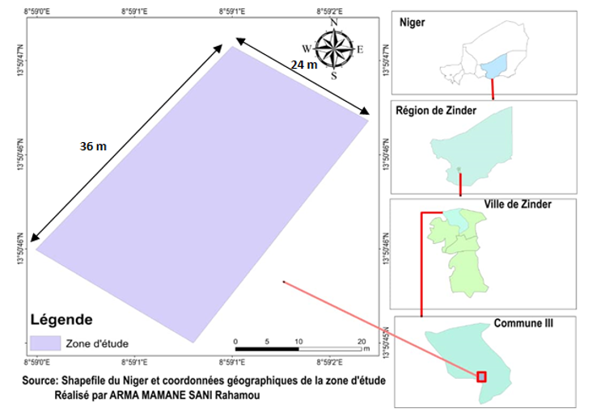
Figure 1. Field phenotyping location in Zinder

Table 1: List of genotypes used in this study
Genotypes | Grain Color | Parents
G01 | Cream | SRN39, MR732
G02 | Cream | SRN39, MR732
G03 | Cream | SRN39, MR732
G04 | Cream | SRN39, MR732
G05 | Cream | SRN39, MR732
G06 | White | -
G07 | White | SRN39, Mota Maradi
G08 | White | SRN39, Mota Maradi
G09 | White | SRN39, Mota Maradi
G10 | White | SRN39, Mota Maradi
G11 | White | SRN39, Mota Maradi
G12 | White | SRN39, Mota Maradi
G13 | White | SRN39, Mota Maradi
G14 | White | SRN39, Mota Maradi
Sepon 82 | Cream | -
MR732 | Cream | -
Mota Maradi | White | -
SRN39 | Cream | -
Experimental Design
A randomized complete block design (RCBD) with four replications was used. Each block contained eighteen elementary plots, with genotypes randomly assigned within each block. Plots measured 6 m² (3 m × 2 m), spaced 1 m apart, with 2 m between blocks (Figure 2). Each plot contained 25 planting hills spaced 50 cm within rows and 75 cm between rows, resulting in a density of approximately 26,667 hills per hectare.
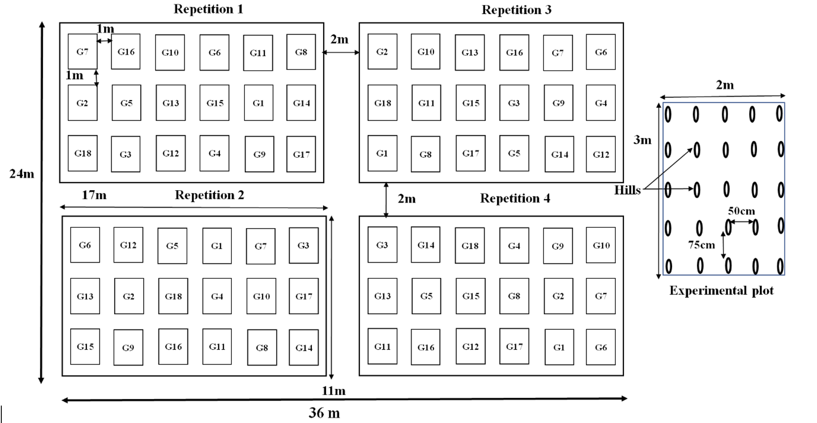
Figure 2. Field layout for the evaluation of 18 sorghum genotypes. The design shows the spatial distribution of genotypes across four full replications, with labels indicating plot dimensions and the placement of individual hills within experimental plots.
Field Management
Sowing was performed manually on 15 June 2024, after a rainfall event >25 mm. Four to six seeds were sown per hill. Seeds were treated with the insecticide–fungicide Caïman Rouge P (25 g/kg permethrin + 250 g/kg thiram). Thinning was done at 20 and 30 days after sowing (DAS) to maintain one plant per hill, with missing hills replanted. Two weedings were performed at 35 and 62 DAS.
Fertilizer was applied via micro-dosing following national recommendations: 6 g of NPK (15-15-15) per hill at 43 DAS and 2 g of urea (46% N) per hill at 65 DAS. An infestation of fall armyworm (Spodoptera frugiperda) was controlled with a broad-spectrum insecticide (Pacha: 10 g/l acetamiprid + 15 g/l lambda-cyhalothrin).
Data Collection
Agro-morphological data were collected from four representative plants in the center of each plot, giving 16 plants per genotype and 288 plants in total. The recorded traits included: plant height at maturity (cm), number of leaves per main stem, panicle length (cm), grain weight per plant (g), number of grains per plant, grain and forage yields (kg/ha).
Phenological data were collected on a plot basis for 50% flowering (number of days from sowing to flowering). All measurements followed the sorghum descriptor guidelines (IBPGR & ICRISAT, 1993).
Data Analysis
Data were subjected to analysis of variance (ANOVA) using GenStat 12th Edition. Treatment means were separated using Tukey’s HSD test at the 5% significance level. Principal Component Analysis (PCA) was performed using R version 4.3.3 to examine trait correlations and classify genotypes based on their agro-morphological characteristics.
RESULTS
Rainfall distribution in the study site
During the 2024 rainy season, sowing was carried out on 15 June following a precipitation event of more than 25 mm. The rainfall pattern during the growing season showed distinct monthly variations, with a total of 39 rainy days recorded (Figure 3). July and August received the highest monthly rainfall, with 329 mm and 325 mm, respectively. In contrast, the initial and final months of the season, May and October, registered considerably lower amounts of 67 mm and 11 mm, respectively. This pattern aligns with the typical growing season in most regions of Niger, which generally starts in mid-June, with the harvest period beginning around the end of September to mid-October. Cumulative rainfall reached 909.5 mm by the end of the season, with the majority (72%) accumulating during July and August, a period critical for sorghum growth and development. The low rainfall at the start and end of the season highlights the risk of water scarcity, which can delay plant growth and limit yield potential in the Zinder region.

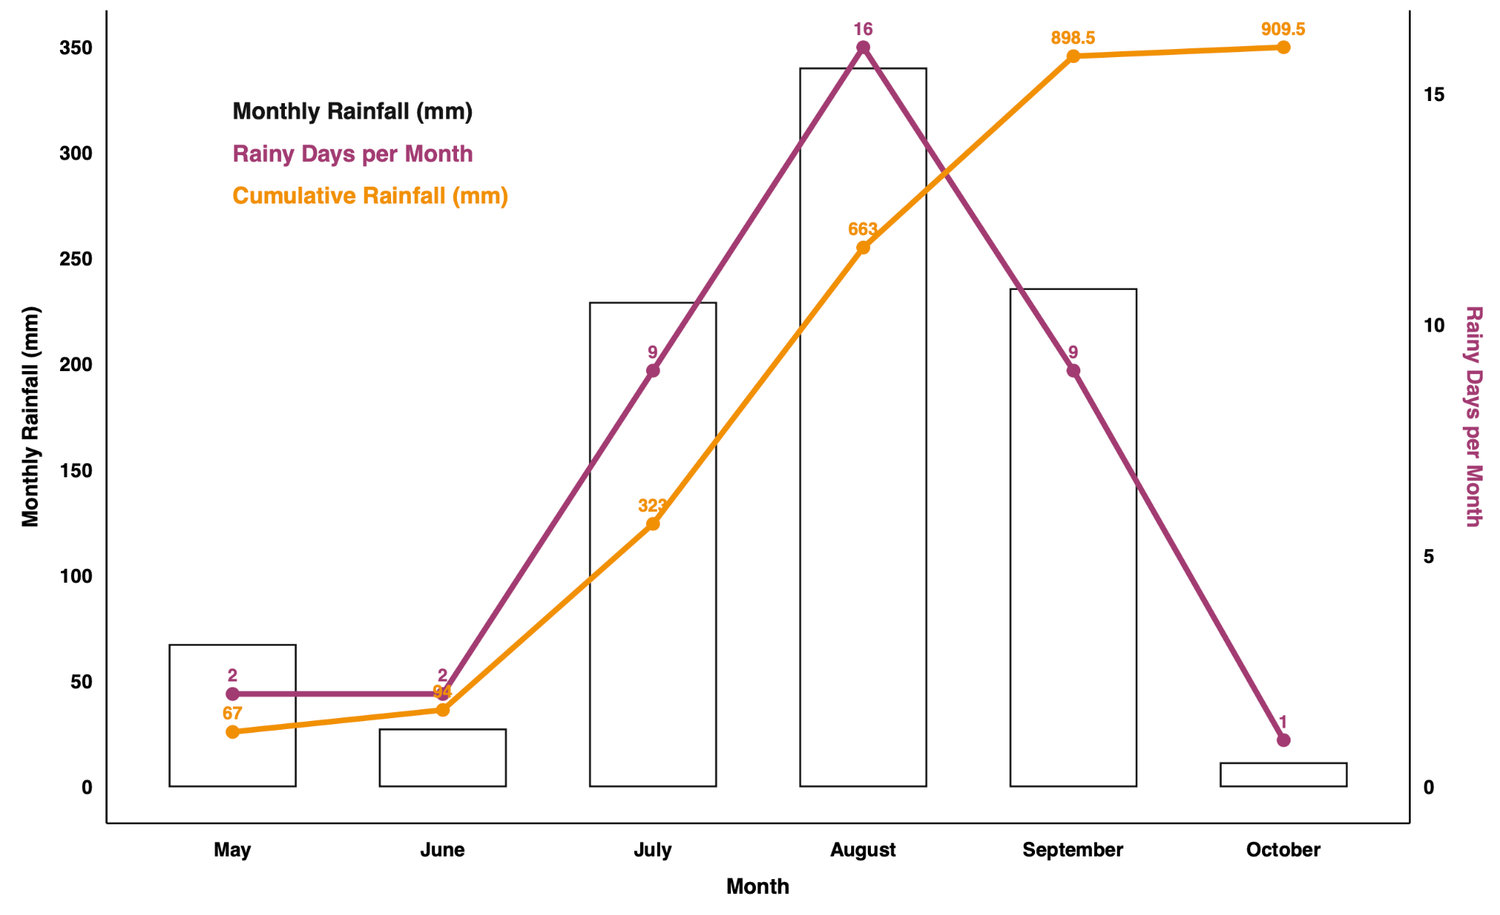
Figure 3. Seasonal rainfall distribution from May to October, showing monthly rainfall (bars), the number of rainy days per month (purple line), and cumulative rainfall (orange line).
Variability in Phenological Traits
Analysis of variance for the other phenological variables revealed highly significant differences among genotypes (Table 1). At the 50 % flowering days, early-flowering genotypes reached anthesis between 71 and 78 DAS (G13 and G10, respectively). Intermediate genotypes flowered between 82 (SNR39) and 85 DAS (G07), whereas late-maturing genotypes required 86 (G01) to 90 DAS (G03). Grain maturity ranged from 83 DAS (Mota Maradi and G13) to 103 DAS (G03), indicating substantial phenological variation among genotypes.
Table 2. Phenological characteristics of sorghum genotypes showing flowering and maturity days
Flowering Group | Genotypes | Days to 50% Flowering | Days to 50% Maturity
Early | G13 | 75±07 | 97±10
Early | Mota Maradi | 72±02 | 91±01
Early | G09 | 77±05 | 98±05
Early | G12 | 75±05 | 97±05
Early | G14 | 76±05 | 97±05
Early | G11 | 79±05 | 99±08
Early | G10 | 80±06 | 99±08
Intermediate | SRN39 | 87±09 | 112±09
Intermediate | G08 | 88±09 | 113±10
Intermediate | G02 | 86±08 | 111±07
Intermediate | G06 | 86±03 | 110±05
Intermediate | MR732 | 88±06 | 112±08
Intermediate | Sepon82 | 87±05 | 111±04
Intermediate | G07 | 87±02 | 112±03
Late | G01 | 91±09 | 117±10
Late | G04 | 90±03 | 116±03
Late | G05 | 91±05 | 116±07
Late | G03 | 93±06 | 119±08

Variability in Morphological Traits
Statistical analyses of morphological traits revealed highly significant differences among the 18 genotypes (p-value < 0.001). Plant height at maturity ranged from 125 cm (G01) to 277.8 cm (G14). Medium plants (>=150 cm) are progenies of SRN39 and MR732, while taller plants (<200 cm) are progenies of SRN39 and Mota Maradi. For the number of leaves, genotype G05 exhibited the highest number of leaves (20), whereas G11 and G13 produced only 15 leaves on average. As for biomass, the results reveal that G06 and G10 are the most performant compared to genotypes SRN39 and G05, which are the least performant. These findings demonstrate substantial morphological diversity among genotypes, particularly in plant height, panicle morphology, and leaf development (Fig 4).
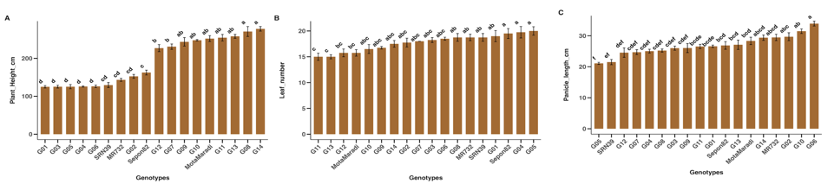
Figure 4: Genotypic differences for morphological traits. With A = plant height, B = leaf number, and C = panicle length.

Variability in Agronomical Traits
ANOVA revealed highly significant genotypic effects for yield and yield-related traits (p-value <0.001). Panicle and grain weights (Fig 5A & 5B) were greatest for Sepon82 (86.91 g and 59.42 g, respectively), which differed significantly from the least-productive genotype G05 (35.69 g and 14.22 g, respectively). The grain number ranged from 1077 (G05) to 4030 (Sepon82) (Fig 5C).
For forage yield (Fig 6A), G08 produced the highest value (23350 kg/ha), whereas G09 recorded the lowest (9395 kg/ha). The highest grain yield (Fig 6B) was achieved by Sepon82 (3643 kg/ha). Overall, marked genotypic variability was observed for agronomic performance across all measured parameters.
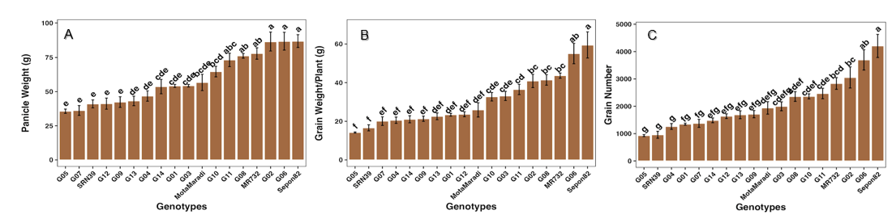
Figure 5: Performance variation of sorghum genotypes for panicle weight (A), grain weight per plant (B) and grain number per plant (C)
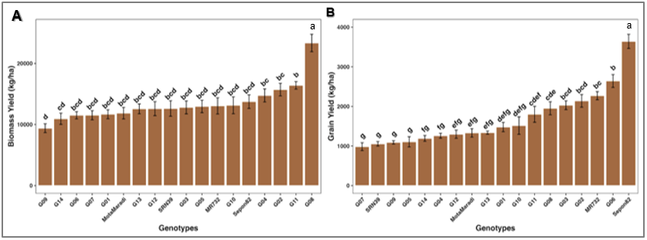
Figure 6: Performance variation of sorghum genotypes for biomass yield (A) and grain yield (B).
Agro-Morphological Diversity Among Genotypes
Principal Component Analysis (PCA) using phenological and agro-morphological traits showed that the first two principal components accounted for 73 % of total variance: Axis 1 (47 %) and Axis 2 (26.9 %) (Figure 5A). The axis 1 shows strong positive correlations with traits such as grain yield, panicle weight, grain number, biomass, panicle length, plant height, flowering, and Leaf number. These traits (mostly yield components) vary together and contribute similarly to the structure captured by the first principal component. Moreover, axis 2 is negatively associated with traits such as plant height, panicle length, grain number, and panicle weight; flowering and leaf number appear to be positively correlated with this axis. This suggests that taller plants with longer panicles and more grains contribute positively to the second axis, whereas earlier flowering and fewer leaves are associated with the opposite direction on this axis.
PCA biplot analysis (Figure 5B) grouped the genotypes into five distinct clusters based on their phenological, morphological, and agronomic characteristics. The first group is composed of Mota Maradi, G09, G12, G13, G11, G10, and G14. Those progenies are derived from Mota Maradi and have taller plants with slender stems and well-exerted panicles. Early flowering and medium grain size are also identified for this group. The second and third groups are composed of MR732 progenies with Sepon82 and SRN39 varieties. They are characterized by a medium height, high grain yield, moderate to late flowering cycle, average leaf number, and poor panicle exertion. The fourth and fifth groups are composed of progenies derived from Mota Maradi variety. They are characterized by a long plant height and moderate flowering time compared to the first group.
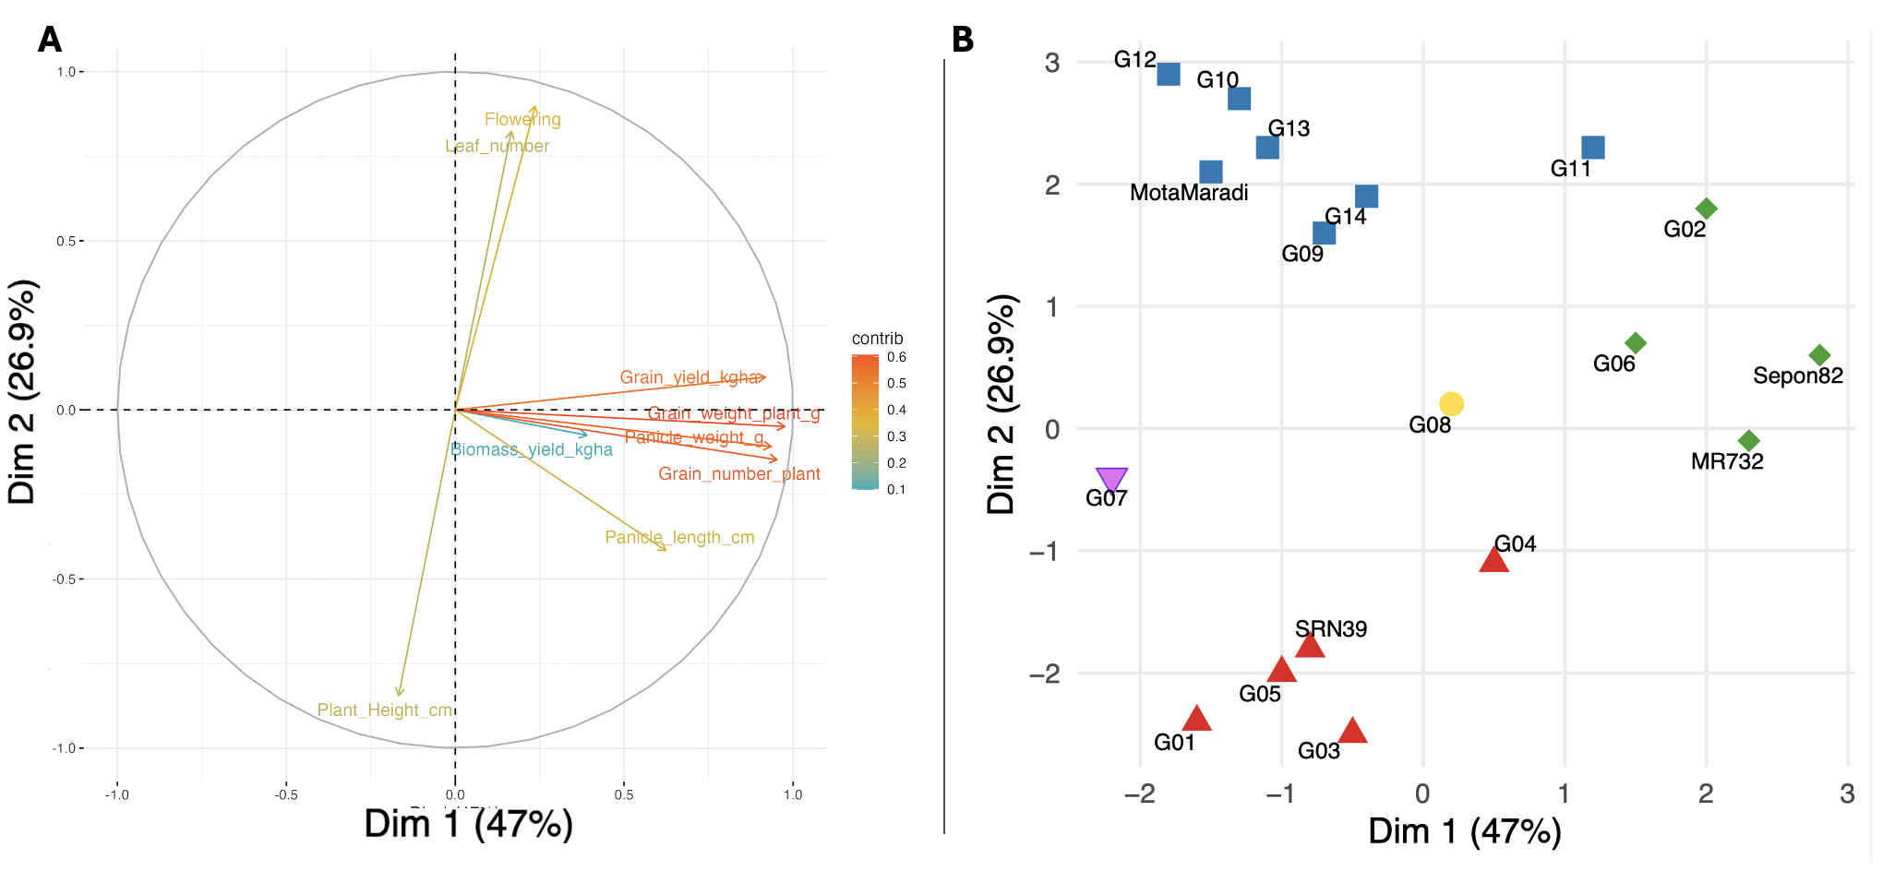
Figure 6. Principal component analysis of agro-morphological and yield traits (A), and the genetic relationships and (B) grouping patterns. Correlation circle showing the loadings of measured traits on the first two principal components (PC1 = 47%, PC2 = 26.9%). Yield-related variables (grain yield, grain weight per plant, grain number per plant, panicle weight) load strongly on PC1, whereas phenological and structural traits (flowering time, leaf number, panicle length, plant height) align primarily with PC2. Arrow length denotes the strength of trait contributions; color intensity reflects relative contribution to overall PCA structure. Colors (red, blue, green, yellow, and purple) in panel B represent the five groups.
DISCUSSION
The comparative analysis of the eighteen sorghum genotypes revealed highly significant differences for most phenological, morphological, and agronomic traits. This indicates that the genotypes exhibit considerable variability and agronomic performance, especially for the progenies which derived from contrasting parental lines.
For the maturity traits, the differentiation of genotypes into early, intermediate, and late groups confirms the existence of a wide range of phenological adaptation to regions where rainfall may be limited towards the end of the season. Early-maturing genotypes are advantageous in areas where the rainy season is short. Thus, the genotypes such as Mota Maradi, G13, G14, G12, G11, G09, and G10 could be of great benefit in such regions of the Sahel. Moreover, G13, G14, G12, G11, G09, and G10 are progenies derived from SRN39 and Mota Maradi, and they recover the early maturity trait of Mota Maradi (~95 days) compared to SRN39 (~118 days). Variations in flowering duration can be attributed to both genetic differences among genotypes and environmental factors such as rainfall distribution and intensity.
Morphological traits also exhibited strong genotypic variation among the genotypes. The differences in plant height, leaf number, and stem thickness suggest inherent genomic differentiation and varying degrees of environmental adaptation. For plant height, genotypes derived from MR732 mostly have medium height compared to genotypes derived from Mota Maradi. These two groups for plant height might cover the needs of farmers and also adapt to growing environments in Niger. The present study also showed that late-maturing genotypes tended to produce more leaves, from 6 to 30 leaves depending on the length of the growth cycle (Smith & Frederiksen, 2000; Blum, 2004).
Agronomic performance further highlighted significant genotypic variability, particularly for yield and its components. The wide range of grain yield values observed can be attributed primarily to the intrinsic genetic potential of the genotypes. The yields obtained in this study (up to 3643 kg/ha) largely exceed the regional and national averages of 361 and 445 kg/ha, respectively in farmers' fields (FAO, 2025; MAGEL, 2025). Good field management and a recommended dose of fertilizer could increase yield under harsh conditions. For instance, Sepon82 exhibited the highest yield (~3000 kg/ha) and related trait values, confirming earlier reports (~3500 kg/ha) (Chantereau et al., 2010; Abdou et al., 2017). This stability across locations likely reflects the genotype’s favorable genetic constitution, which allows it to adapt efficiently to varying edaphic and climatic conditions while maintaining high productivity and broad adaptation. The high rainfall during the trial also favored vegetative growth and effective grain filling. Moreover, Sepon82 demonstrated strong dual-purpose potential (grain and fodder), making it suitable for integrated production systems under current climatic variability (Olembo et al., 2010). In contrast, this variety, released in the early 1990s in Niger, exhibits a still low adoption rate in the country (Ministère de l’agriculture du Niger, 2012; Walker & Alwang, 2015). Varieties with tolerance or resistance to major stressors (drought, striga, midge, etc.) could increase crop performance in the region (Abraha et al., 2015; Ngugi et al., 2016; Atlin et al., 2017).
The PCA results confirmed that the first two axes explained relationships among phenological, morphological, and agronomic traits. Axis 1 represented the relationship between vegetative vigor and grain yield, whereas Axis 2 captured the association between cycle earliness and productivity. Thus, both growth duration and vegetative development have a major influence on grain yield potential. We observed grouping according to plant height, flowering time, and yield components (panicle weight, 100-grain weight). Studies have shown that varietal differentiation in sorghum is mainly determined by these three criteria, which also influence farmers’ selection preferences. Genotypes that demonstrated superior grain yield performance and could therefore be promoted to enhance sorghum productivity under conditions of climatic variability and striga infestation. Additionally, genotypes from Group 1, characterized by early maturity, could serve as parental material for breeding programs to develop early-maturing varieties.
CONCLUSION
This study enabled the phenological and agro-morphological characterization of eighteen sorghum genotypes and evaluated them under the environmental conditions of Zinder. The results revealed significant differences among genotypes for various phenological, morphological, and agronomic traits. Based on phenology, the genotypes were grouped into three categories: early, intermediate, and late maturing. The analysis also demonstrated both positive and negative correlations among traits, emphasizing the strong influence of crop cycle duration and vegetative growth characteristics on grain yield. Multivariate analysis structured the eighteen genotypes into five distinct groups according to flowering time, vegetative attributes, and yield performance. Genotypes belonging to Groups 1 and 2 showed particularly promising performances in terms of earliness and grain yield, respectively. These genotypes represent valuable resources for breeding programs aimed at developing high-yielding and early-maturing cultivars. Their deployment could contribute significantly to improving food security and crop resilience under the current context of irregular rainfall and low soil fertility in Niger and other semi-arid regions.

REFERENCES
Abdou, M. M., Issa, S., Gomma, A. D., Sow, A., & Sawadogo, G. J. (2017). Estimation des rendements et de la rentabilité économique de production de trois cultures : le sorgho, le niébé et la dolique à Djirataoua (Maradi – République du Niger). Journal of Applied Biosciences, 117, 11642–11650. https://doi.org/10.4314/jab.v117i1.1
Abraha, T., Nyende, A.B., Mwangi, S.G., Kasili, R., & Araia, W. (2015). Identification of sorghum (Sorghum bicolor L. Moench) landraces tolerant to post flowering drought stress using drought tolerance indices. Journal of Plant Breeding and Crop Science, 7, 211–218. https://doi.org/10.5897/JPBCS2015.0521
Atlin, G. N., Cairns, J. E., & Das, B. (2017). Rapid breeding and varietal replacement are critical to adaptation of cropping systems in the developing world to climate change. Global Food Security, 12, 31–37. https://doi.org/10.1016/j.gfs.2017.01.008
Billot, C., Ramu, P., Bouchet, S., Chantereau, J., Deu, M., Gardes, L., Noyer, J.-L., Rami, J.-F., Rivallan, R., Li, Y., Lu, P., Wang, T., Folkertsma, R.T., Arnaud, E., Upadhyaya, H.D., Glaszmann, J.-C., & Hash, C.T. (2013). Massive Sorghum Collection Genotyped with SSR Markers to Enhance Use of Global Genetic Resources. PLOS ONE, 8, e59714 https://doi.org/10.1371/journal.pone.0059714
Blum, A. (2004). Sorghum Physiology. In H. T. Nguyen & A. Blum (Eds.), Physiology and Biotechnology Integration for Plant Breeding (pp. 141-224). CRC Press. https://doi.org/10.1201/9780203022030.ch4
Blum, A., Mayer, J., & Golan, G. (1989). Agronomic and physiological assessments of genotypic variation for drought resistance in sorghum. Australian Journal of Agricultural Research, 40, 49–61. https://doi.org/10.1071/AR9890049
Doggett, H. (1988). Sorghum. 2nd Edition.
Ejeta, G. (2007). Breeding for Striga Resistance in Sorghum: Exploitation of an Intricate Host–Parasite Biology. Crop Science, 47(S3), S216–S227. https://doi.org/10.2135/cropsci2007.04.0011IPBS
Food and Agriculture Organization of the United Nations. (2020). FAOSTAT statistical database. http://www.fao.org/faostat/en/#home
Harlan, J. R., & de Wet, J. M. J. (1972). A simplified classification of cultivated sorghum. Crop Science, 12, 172-176. https://doi.org/10.2135/cropsci1972.0011183X001200020005x
International Board for Plant Genetic Resources, & International Crops Research Institute for the Semi-Arid Tropics. (1993). Descriptors for Sorghum [Sorghum bicolor (L.) Moench]. International Board for Plant Genetic Resources; International Crops Research Institute for the Semi-Arid Tropics. https://cgspace.cgiar.org/handle/10568/72941
Chantereau, J., Deu, M., Pham, J. L., Kapran, I., Vigouroux, Y., & Bezançon, G. (2010). Evolution des diversités phénotypique et génétique des sorghos et mils cultivés au Niger de 1976 à 2003. Le sélectionneur français, 61, 33-45. https://www.selectionneurs.asso.fr/le-bulletin/le-bulletin-2010/
Liu, G., Gilding, E.K., Kerr, E.D., Schulz, B.L., Tabet, B., Hamaker, B.R., & Godwin, I.D. (2019). Increasing protein content and digestibility in sorghum grain with a synthetic biology approach. Journal of Cereal Science, 85, 27–34. https://doi.org/10.1016/j.jcs.2018.11.001
Ministère de l'Agriculture et de l'Elevage. (2025). Rapport d'Évaluation de la campagne agricole d'hivernale 2024 et perspectives alimentaire 2024-2025. https://magel.ne/category/publications/
Malam Abdou, M., Saley, B., Mamadou, I., & Issaka Brah, L. (2020). Regards croisés sur l’évolution de la pénurie d’eau de la ville de Zinder (Niger) de 1900 à nos jours. Revue des Sciences de l’Eau / Journal of Water Science, 32, 395–406. https://doi.org/10.7202/1069573ar
Ministère de l’agriculture du Niger. (2012). Catalogue national des espèces et variétés végétales du Niger National Research Council. (1996). Lost Crops of Africa: Volume I: Grains.
Ngugi, K., Ngugi, A. J., Osama, S., & Mugoya, C. (2016). COMBATING STRIGA WEED IN SORGHUM BY TRANSFERRING RESISTANCE QUANTITATIVE TRAIT LOCI THROUGH MOLECULAR MARKER ASSISTED INTROGRESSION. Journal of Plant Breeding and Genetics, 3, 67–76. http://www.escijournals.net/JPBG
Olembo, K.N., M’mboyi, F., Kiplagat, S., Sitieney, J.K., & Oyugi, F.K. (2010). Sorghum Breeding in Sub-Saharan Africa: The Success Stories. African Biotechnology Stakeholders Forum,
Smith, C. W., & Frederiksen, R. A. (2000). Sorghum: Origin, History, Technology, and Production. Wiley Series in Crop Science. https://www.wiley.com/en-us/Sorghum%3A+Origin%2C+History%2C+Technology%2C+and+Production-p-9780471242376

Walker, T. S., & Alwang, J. (2015). Crop improvement, adoption and impact of improved varieties in food crops in Sub-Saharan Africa. CABI. https://doi.org/10.1079/9781780644011.0000

Ramalingam, A.P., Mohanavel, W., Kambale, R. et al. Pilot-scale genome-wide association mapping in diverse sorghum germplasms identified novel genetic loci linked to major agronomic, root and stomatal traits. Sci Rep 13, 21917 (2023). https://doi.org/10.1038/s41598-023-48758-2

Agele, S., Taiwo, G. & Akinseye, M. Growth and yield responses of sorghum (Sorghum bicolor [L.] Moench) varieties to sowing time in a rainforest zone of Nigeria. Sci Rep 15, 34084 (2025). https://doi.org/10.1038/s41598-025-14447-5
Navyashree R, Mummigatti U.V, Nethra P, Basavaraj B, and Hanamaratti N. G. 2024. “Evaluation of Genetic Diversity in Sorghum Genotypes for Drought Tolerance Using Mahalanobis’ D2 Analysis”. Journal of Advances in Biology & Biotechnology 27 (9):90–97. https://doi.org/10.9734/jabb/2024/v27i91277.

V. Premkumar, S. G. Patil, M. Djanaguiraman, and S. Sridevy. 2022. “Assessment of Genetic Diversity in Sorghum (Sorghum Bicolor (L.). Moench) Genotypes Using Principal Components and Cluster Analysis”. International Journal of Plant & Soil Science 34 (21):577–585. https://doi.org/10.9734/ijpss/2022/v34i2131303.

