Original Research Article

Genetic Polymorphism and Relationships in Hybrid Crosses of Butterfly Koi (Cyprinus carpio koi) and Comet Goldfish (Carassius auratus) Using RAPD Markers

ABSTRACT

Cross-breeding of ornamental broodstock with close genetic relatives is one of the causes of the reduction of variations in the colour and body shape of fish offspring. The aim of this study is to analyse polymorphism in hybrid fish from butterfly female or male koi (bFK, bMK) and female or male comet (FC, MC) and other sources (osFC) and the genetic relationships between the offspring and the two parental lines based on Random Amplified Polymorphic DNA. The broodstock bFK, bMK, FC and MC was obtained from the experimental pond Ciparanje and the other comets from Parung. Hybrid fish (FC ꓫ MC, FC ꓫ bMK and OSC ꓫ BMK) were obtained from spawning process. RAPD results showed that the hybrid fish osFCbMK had a higher genetic variation by OPA-02 than by OPA-13. However, OPA-13 primer was able to detect bFKMC and FCbMK polymorphisms in the hybrid fish compared to OPA-02 primer. The OPA-13 phenogram is more suitable for detecting genetic linkage between the hybrid osFCbMK and comet parental (osFC and MC) or koi parental (bFK or bMK) by 40% and bFKMC and offspring (bFK or bMK) by 30%, compared to the OPA-02 phenogram (11% and 24% respectively. The genetic closeness between the FCbMK hybrid and the FC parental is 19% (OPA-13 phenogram) and 2% (OPA-02 phenogram). OPA-13 primer is able to detect hybrid polymorphism of butterfly koi fish and comet goldfish and genetic relationship of koi with comet.
Keywords: Broodstock, Genetic variation, Crossing, Phenogram, Offspring, Primer

1. INTRODUCTION

Comet goldfish and koi carp are extremely important decorative fish commodities in Indonesia. As members of the Cyprinidae family, their unique body forms and color patterns make them especially desirable economically [1, 2, 3]. When brood stock from the same strain is constantly generated during breeding activities, ornamental fish colour and body shape variety tends to decrease [4, 5]. The phenotypic differences of hybrid fish arising from koi and comet crosses can be confirmed using polymorphism and genetic connection tests, as well as RAPD primers suitable for evaluating the inheritance of parental fish features in the hybrid offspring [6, 7].
For ornamental fish hobbyists, selective breeding to improve fish genetics and produce economically significant phenotypes (unique body shapes and specific color variations) has not yet produced the desired results and takes a long time, sometimes several generations [8, 9]. Combining the economically significant phenotypic traits (for food security or color quality) of particular fish species through hybridization has the potential to enhance genetic improvement in fish phenotype [10]. New species can be produced by hybridization between strains or between species, which can result in the development of distinctive phenotypic traits [11, 12, 13]. By crossing broodstocks between strains of the same species, between species in the same genus, or between genera in the same family, these traits are inheritance to offspring through a heterosis effect [2, 8, 10, 14].
Research on the genetic variation of the Carrasius auratus gibelio fish has demonstrated that polymorphism tests, such as the RAPD method, can be used to confirm the phenotypic traits (morphology and color patterns) of hybrid fish [15]. The application usage of hybridization to fish, it can result in genetic variation, which is represented by differences in DNA bands between parents and their hybrid offspring. Genetic relationships between hybrid offspring and the male and female broodstock can be deduced from polymorphic DNA fragments found using RAPD markers [16]. Monomorphic DNA fragments of the same size can be used to identify hybrid fish that are descended from male or female broodstock of different species. Furthermore, it has been demonstrated that amplified polymorphic DNA fragments can indicate the genetic kinship distance between offspring and the male or female parental, as hybrid fish can inherit both parental phenotypic traits [14, 17]. Using RAPD primers that are appropriate for determining the inheritance of parental fish characteristics in the hybrid offspring, polymorphism and genetic relationship tests can verify the phenotypic variations of hybrid fish resulting from koi and comet crosses [18].

2. MATERIAL AND METHODS

2.1 Test fish
This study used broodstocks of the bFK and bMK (Figure 1A, 1B) as well as the FC, MC, and osFC (Figure 2A, 2B, 2C) as test fish. Female and male comet fish and butterfly koi fish (4 fish each) were acquired from the experimental pond of Padjadjaran University's, Faculty of Fisheries and Marine Sciences in Ciparanje, Jatinangor, Bandung, West Java. Female comet fish broodstock was sourced from the Parung, Bogor, West Java ornamental fish center (4 fish each). Both the butterfly male and female koi fish broodstock were 8 months old, weighing 0.45 kg and 11 months old, respectively. Meanwhile for the comet fish broodstock, the female weighed 88.25 g at 10 months of age, while the male weighed 72.50 g at 8 months of age (Figure 2A, 2B). Figure 2C shows that the female comet fish from other sources weighed 98.75 g and was 10 months old.

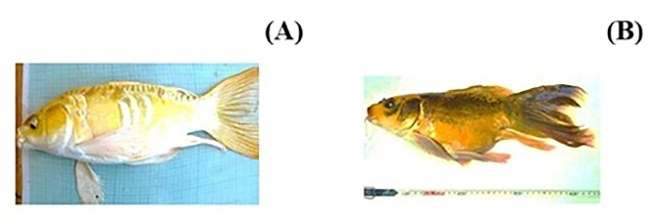

Figure 1. The bFK (A) and the bMK broodstock (B)

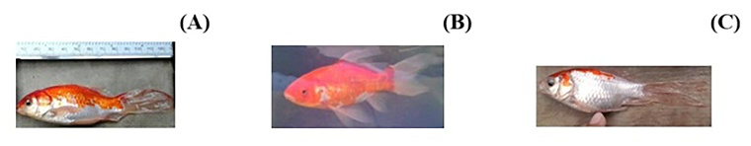
Figure 2. The FC (A), the osFC (B) and the MC broodstock (C)

2.2 Crossbreeding of the butterfly koi and comet

A hybrid fish was produced by crossing a comet koi and a butterfly koi, as shown in Figure 3. By injecting the Ovaprim hormone at a dose of 0.2 mL·kg-¹ for male fish and 0.4 mL·kg⁻¹ for female fish, the koi and comet broodstock pairs were artificially spawned. After 10 hours of Ovaprim hormone injection, the male and female broodstock were stripped, and the gametes of both sexes were gathered in a 25 cm-diameter porcelain dish and agitated with a sterile chopstick before 50 mL of Na-physiology solution was added. After 15 to 20 minutes, the egg-sperm mixture was rinsed with Aquabidest and distributed to five aquariums of 60 x 50 x 50 cm and containing 120 litres of water. The developing egg embryos in the five aquariums are the product of crossbreeding FC ꓫ bMK, ocFC ꓫ bMK, osFC ꓫ MC, bFK ꓫ bMK, and bFK ꓫ MC. An aeration system and water heater were used to maintain the water temperature and dissolved oxygen content at 26 ± 1°C and 3 mg·L⁻¹ during the egg incubation period until larval hatching. The larvae were fed Artemia nauplii at will after two days of hatching.

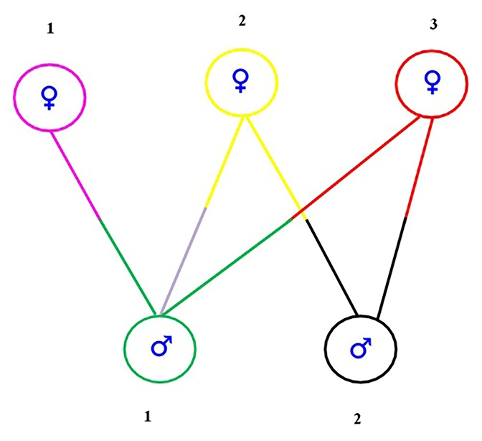
Figure 3. Koi and comet broodstock crossbreeding
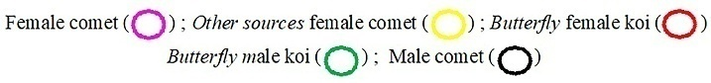

2.3 Rearing of larvae until the fish are 6

months old

The larvae were given Tubifex sp. and kept in an aquarium until they were one month old, with a density of 20 individuals per aquarium. After feeding worms for 10 days, fingerlings are given Prima Feed 500 artificial feed until they are one month old. Additional rearing took place in a circular fiberglass tank with a 1000 L water volume, measuring 1.25 m in diameter and 1.35 m in height. For five months of maintenance, artificial feed Hi-Provite 781 was administered twice daily at a dose of 5% of the biomass weight. Water changes were performed on up to 80% of the total water volume each week.

2.4 Fish tail fin sample (DNA source) and
genomic DNA extraction

Four fish (6 months old) from a cross between female comet ꓫ butterfly male koi (FCbMK), female comet ꓫ butterfly male koi (osFCbMK), female comet ꓫ male comet (osFCMC), butterfly female koi ꓫ butterfly male koi (bFKbMK), and butterfly female koi ꓫ male comet (bFKMC) was used as a source of genomic DNA extracted from the tip of the tail fin of the test fish. Furthermore, the results of DNA isolation from four samples of the caudal fins of the FC, osFC, bFK, bMK, and MC parentals were used for the RAPD-PCR process to analyze the kinship between the parental fish and the hybrid offspring. Following the kit protocol, ten caudal fin tissues were extracted from each of the various fish samples using the Wizard genomic DNA purification kit (Promega, Madison, WI, USA) as a DNA template. Using a NanoDrop 2000 Spectrophotometer (Thermo Scientific, Wilmington, USA), the concentration of genomic DNA was determined.

2.5 RAPD-PCR and DNA band documentation

The selection of RAPD primers (OPA-02, OPA-04, OPA-12, and OPA-13) based on GC content (60–70%) indicated that polymorphic fragments of crossbreeding koi and comet broodfish in Figure 3 could be amplified using OPA-02 and OPA-13 primers (Table 1) [19, 20]. The genetic kinship analysis between broodstock, offspring, and hybrid fish (koi ꓫ comet) was then conducted using OPA-2 and OPA-13 primers.
Polymorphic DNA fragments were amplified using the RAPD-PCR technique and the OPA-02 and OPA-13 primers (Operon Technology Set-A). To amplify the polymorphic fragments of the test fish samples, the PCR reaction mixture included 12.5 µl of GoTaq® green master mix 2X (Promega), 1.25 µl of RAPD primer, 2 µl of sample DNA, and 9.25 µl of Nuclease-free water (NFW). The total volume of the solution was 25 µl. There were 45 cycles with denaturation at 94°C for 1 minute, annealing at 36°C for 1 minute, extension at 72°C for 2 minutes, and final extension at 72°C for 10 minutes. These were the parameters for the RAPD-PCR program. DNA bands were documented using a UV transilluminator (λ-280 nm), and the amplification products were separated using a 1% agarose gel electrophoresis method (50 amperes, 50 volts, 90 minutes).

Table 1. Primers used for polymorphism in butterfly koi and comet fish
Primers | Sequence (5' → 3') | References
OPA-02 | TGCCGAGCTG | [19]
OPA-13 | CAGCACCCAC | [20]

2.6 Data analysis

The amplification of every tested fish sample produced both polymorphic (different DNA band sizes) and monomorphic (same DNA band size) DNA fragments. Based on amplified (1) and unamplified (0) DNA bands by RAPD primers, DNA fragments were interpreted as qualitative data in a binary matrix. The kinship relationship between the test fish samples was then determined through additional analysis. Using the numerical information from the amplified fragments, the dissimilarity index of each DNA sample was calculated to ascertain its relationship and application usage the NTSYS (Numerical Taxonomy and Multivariate Analysis System) software, this dissimilarity index was determined. A phylogenetic tree construction in the form of a dendogram was used to analyze the relationship between the comet parentals, koi parentals, and their hybrid offspring using the Similarity Index (SI) based on the UPGMA (Unweighted Pair Group Method Using Arithmetic Average) program from the NTSYS software [21, 22].

3 RESULT AND DISCUSSION

3.1 Genomic DNA extraction

The extracted genomic DNA showed qualitative results suitable for use as a DNA template to replicate polymorphic fragments of DNA samples from comets, koi, and their hybrid offspring, as shown in Figure 4. This suitability value can be expressed by comparing the absorbance (A) of λ-260 nm to that of λ-280 nm, with the DNA purity value A260/A280 in the range of 1.8-2.0 [22], as presented in Table 2.
The amplification results from 10 test fish samples using OPA-02 and OPA-13 primers showed differences in the number of polymorphic fragments amplified by each of the two primers (Figures 5A and 5B). OPA-13 primer produced more monomorphic fragments than OPA-02 primer, while OPA-02 primer produced more polymorphic fragments (Table 2).

Table 2. Values for the DNA purity of koi, comet, and hybrid fish (10 test samples).
No | Test Sample | A λ-260 | A λ-280 | Ratio
1 | bMK | 0.057 | 0.031 | 1.839
2 | bFK | 0.448 | 0.237 | 1.890
3 | bFKbMK | 1.058 | 0.544 | 1.945
4 | MC | 0.152 | 0.090 | 1.689
5 | FC | 0.072 | 0.046 | 1.565
6 | osFC | 0.045 | 0.028 | 1.607
7 | osFCMC | 0.059 | 0.036 | 1.639
8 | bFKMC | 0.151 | 0.095 | 1.589
9 | FCbMK | 0.164 | 0.094 | 1.745
10 | osFCbMK | 0.185 | 0.099 | 1.869

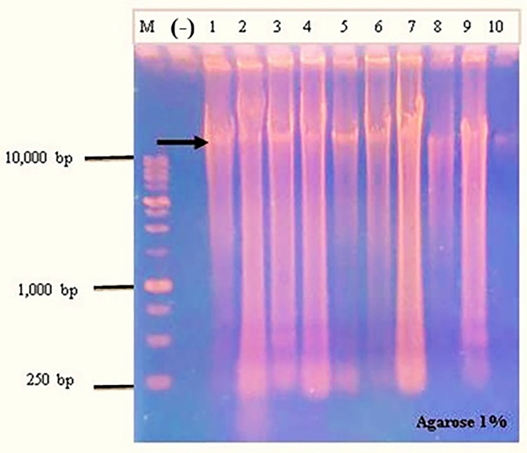
Figure 4. Electropherogram of genomic DNA extraction results from test fish samples
M: 1 kb DNA ladder; (-): negative control without template; 1: bMK; 2: bFK; 3: bFKbMK; 4: MC;
5: FC; 6: osFC; 7: osFCMC; 8: bFKMC; 9: FCbMK; 10: osFCbMK
(Each gel well contains 4 pooled of the test samples)

The A260/A280 values (Table 2) for the broodstock samples (bMK, bFK, MC, FC, and osFC) showed that the test fish DNA samples were of good quality. The ratio were 1.839, 1.890, 1.689, and 1.565, respectively, and were still suitable for use as DNA templates, with the genomic DNA fragment size exceeding 10 kb and producing a thick band despite a slight smear (Figure 4). The study on fin tissue from 29 freshwater fish species revealed that the average A260/A280 value was approximately 1.8, with a value of 1.6 still being appropriate for use as a RAPD-PCR template [23]. DNA samples from hybrid fish (bFKMC, FCbMK, and osFCbMK) with an A260/A280 ratio of 1.589, 1.745, and 1.869, on the other hand, produced a thick band (˃ 10 kb) with good DNA quality that could be used as a template. Similar results were also shown in the fin samples of Leporinus elongatus, Brycon orbignyanus, and Brycon cephalus (A260/A280 values ranging from 1.6-2.1) with a thick DNA band exceeding 10 kb and including faint smears; however, the resulting genomic DNA template was suitable for use in RAPD-PCR [24, 25]. The electropherogram results show a thick DNA band, indicating a reasonably good quality of genomic DNA, even though the broodstock DNA sample and hybrid fish had an average A260/A280 ratio value of 1.6. The DNA's purity and integrity for the PCR amplification process are indicated by the A260/A280 ratio range (1.5–1.8), which is near the minimum value (1.8) [23, 27]. According to test sample DNA extraction results, a reasonably high-quality template can be produced using test samples with an A260/A280 ratio value. However, the quality of DNA samples from the progeny of a cross between a butterfly female koi and a butterfly male koi (bFKbMK) and a cross between a female comet from a different source and a male comet (osFCMC) varied between 1.945 and 1.639 (Table 2), indicating good purity and could be used as a template for amplification of polymorphic fragments using RAPD primers. Each test sample had different amounts of polymorphic fragments replicated, according to PCR results using OPA-02 and OPA-13 primers (Figure 5A, 5B).

3.2 RAPD-PCR products and

polymorphism analysis

Finding the genetic diversity of fish and tracing the origin of hybrid fish offspring can be done with the help of information on genetic variation based on polymorphic fragments from the genome amplification of koi, comet, and hybrid fish [1, 15, 28, 29]. In order to ascertain the genetic diversity of fish populations that are characterized by specific polymorphic fragments related to the character or phenotype of hybrid fish resulting from crossbreeding of broodstock in different species or strains, it is possible to trace the genetic relationship between individual fish and their broodfish in a fish population using RAPD as initial information [30, 31, 32, 33]. Monomorphic fragments display DNA bands of the same size as a sign of genetic kinship, whereas polymorphic fragments are distinct DNA bands that can be seen in hybrid broodstock or offspring and are not present in other samples that represent genetic diversity. Amplification of polymorphic fragments using OPA-02 and OPA-13 primers indicates genetic diversity, as shown in Table 3. The bFKMC sample and FCbMK did not exhibit genetic diversity based on OPA-2 primer, whereas the MC and FC samples did not exhibit genetic diversity based on OPA-02 and OPA-13 primers. However, based on OPA-13, there was genetic diversity in the bFKMC sample (1 polymorphic fragment) and FCbMK (1 polymorphic fragment). Similar to the bFK and bFKbMK samples, which showed no genetic diversity based on the OPA-02 primer, the bFKbMK sample showed genetic diversity (1 polymorphic fragment) based on OPA-13 primer, but the bFK sample did not exhibit any genetic diversity (0 polymorphic fragments). Based on the OPA-02 primer analyses, the osFCbMK sample exhibited a higher level of diversity (5 polymorphic fragments) than the OPA-13 primer (4 polymorphic fragments). The osFC (4 polymorphic fragments) and osFCMC (3 polymorphic fragments) samples also displayed a high degree of diversity when detected using the OPA-02 primer, in contrast to the osFC (2 polymorphic fragments) and osFCMC (0 polymorphic fragments) samples when detected using the OPA-13 primer. On the other hand, the bMK sample based on OPA-02 primer had only one polymorphic fragment, whereas with the OPA-13 detected had two (Table 3). Overall, the OPA-02 primer copied 13 bands of polymorphic fragments, while the OPA-13 primer copied 11 bands. This suggests that the OPA-02 primer was more sensitive for analyzing genetic diversity than the OPA-13 primer. Polymorphism analysis showed that the OSPF sample as brood fish of a comet from another source (Parung Bogor) had a higher diversity by OPA-02 primer (4 polymorphic fragments) compared to OPA-13 primer (2 polymorphic fragments). Similarly, the OPA-2 primer revealed more genetic variation (3 polymorphic fragments) in the results of its cross with a male comet (osFCMC) than in OPA-13 (0 polymorphic fragments). The osFCbMK sample exhibited greater genetic variation, containing five fragments based on the OPA-02 primer and four fragments based on the OPA-13 primer (Table 3; Figure 5A and 5B). The findings of this polymorphism analysis demonstrated that the OPA-02 primer was more sensitive than the OPA-13 primer in detecting genetic diversity in the osFC, osFCMC, and osFCbMK samples. However, the OPA-13 primer was more sensitive than the OPA-02 primer in detecting genetic diversity in the bMK, bFKbMK, bFKMC, and FCbMK samples. The presence of genetic variation related to the body shape phenotype of the bMK and the kumpay fin was indicated by two polymorphic bands that appeared in the bMK sample based on the OPA-13 primer (Figure 1B). In contrast, the OPA-02 primer detected only one polymorphic fragment. A unique polymorphic fragment that expresses distinct phenotypic traits not present in hybrid fish (osFCbMK, FCbMK, bFKMC) samples is complementary to the OPA-13 primer, according to verification of the suitability between polymorphic fragments and phenotypic traits. These findings also align with research on polymorphism inheritance in Atlantic salmon and brown trout interspecific hybridization [17], in catfish hybridization [16] as well as in the crossbreeding of Rutilus rutilus and Abramis brama fish hybridization [30], polymorphisms in hybridization between parentals of different species are associated with the inheritance of dominant traits from the parental fish, which can be reflected in the hybrid fish's phenotype that is absent from both broodstock. This verification demonstrates that the OPA-13 primer can identify the kumpay phenotype of body shape and fins in the butterfly male koi broodstock samples by detecting the appearance of two polymorphic fragments, demonstrating the appropriateness of genetic variation and fish phenotype. In contrast, the OPA-02 primer revealed more genetic variation in the cross between the osFCbMK and the female comet broodstock from a different source than the OPA-13 primer (Table 3). This suggests that a combination of inherited traits from both broodstock (Figures 1B and 2B) contributed to the increase in polymorphic fragments. This genetic variation is linked to differences in body color in female comets from other sources as well as phenotypic characteristics like body shape and fins in butterfly male koi. According to these findings, the OPA-02 primer has a higher sensitivity for identifying genetic diversity in parentals of different species as well as their hybrid offspring. Similar findings were also found in studies on the hybridization of masu and amago salmon [34], in addition to the hybridization of bighead carp, grass carp, and their hybrid progeny [35]. Three polymorphic fragments were found in the osFCMC sample by the OPA-02 primer, but not by the OPA-13 primer. This was because the female comet parental (osFC) source passed on its genetic diversity to its progeny, which is why the OPA-02 primer detected more polymorphic fragments in the osFCMC sample than the OPA-13 primer (Table 3). In contrast, OPA-02 revealed no genetic variation in the bFKMC or FCbMK samples, while OPA-13 saw the appearance of a single polymorphic fragment for bFKMC and one fragment polymorphic for FCbMK. This indication relates to the genetic variation of the parentals, as the male koi (bMK) only had two polymorphic fragments by OPA-13 and one fragment by OPA-02, while the female koi (FC), male koi (MC), and butterfly female koi (bFK) parentals did not have any polymorphic fragments (0 fragments) based on OPA-02 and OPA-13 detection. This consistency demonstrates that when female and male fish hybridize, the offspring of both parentals inherit more polymorphism due to the higher genetic variation of the parentals.

Table 3. Polymorphic and monomorphic DNA fragments (RAPD primer amplification product)

Test sample | Number of DNA fragments
Test sample | OPA-02 |  | OPA-13
Test sample | Polymorphic | Monomorphic | Polymorphic | Monomorphic
- bMK | 1 | 5 | 2 | 4
- bFK | 0 | 1 | 0 | 3
- bFKbMK | 0 | 1 | 1 | 4
- MC | 0 | 5 | 0 | 5
- FC | 0 | 4 | 0 | 6
- osFC | 4 | 0 | 2 | 6
- osFCMC | 3 | 2 | 0 | 4
- bFKMC | 0 | 2 | 1 | 3
- FCbMK | 0 | 3 | 1 | 4
- osFCbMK | 5 | 2 | 4 | 4
Total | 13 | 25 | 11 | 43

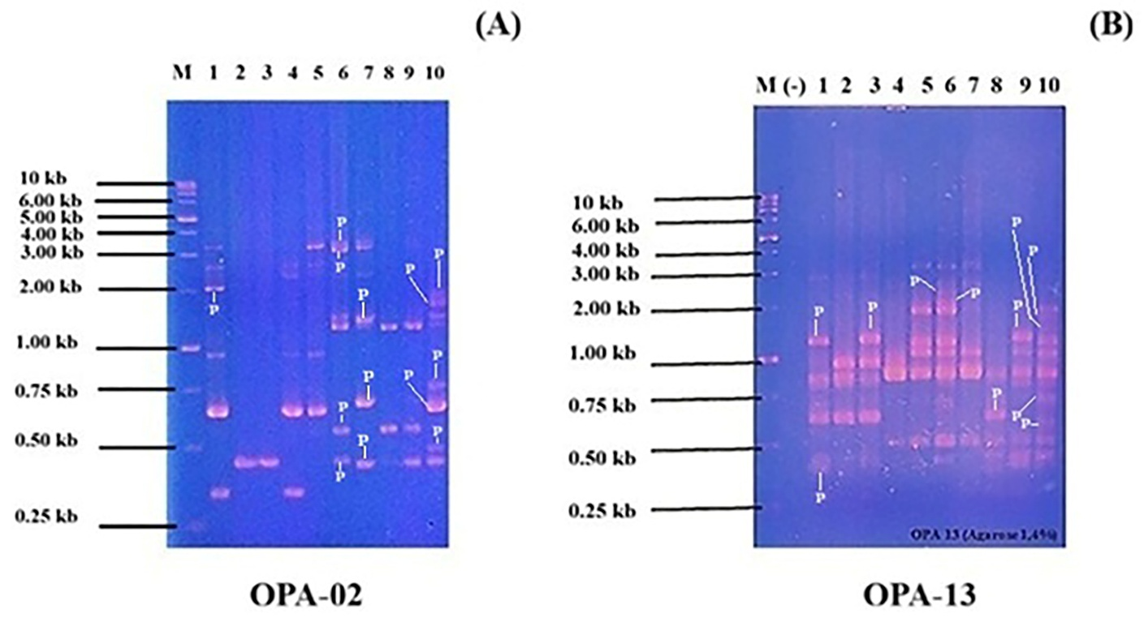
Figure 5. Polymorphic DNA fragments of fish samples with OPA-02 primer (A) and OPA-13 (B)
M: 1 kb DNA ladder marker; (-): negative control without template; 1: bMK; 2: bFK; 3: bFKbMK;
4: MC; 5: FC; 6: osFC; 7: osFCMC; 8: bFKMC; 9: FCbMK; 10: osFCbMK; P: polymorphic fragment

3.3 Genetic relationship analysis of the koi,

comet and koi hybrids ꓫ comet

The genetic similarity index between parentals and offspring (Figures 6 and 7) can be used to trace the origin of the hybrid fish offspring based on the genetic relationship between 10 test samples represented by polymorphic and monomorphic fragments by the OPA-02 and OPA-13. Based on amplification with OPA-02 primer, polymorphic fragments were detected only 4 samples (bMK, osFC, osFCMC, osFCbMK) and monomorphic fragments were detected in 10 samples tested (Table 2, Figure 5A). The OPA-2 primer is unable to identify genetic diversity in bFKbMK samples, which should result in specific phenotypic variations given that the caudal fin, dorsal fin, and anal fin of butterfly male koi are all kumpay-shaped.

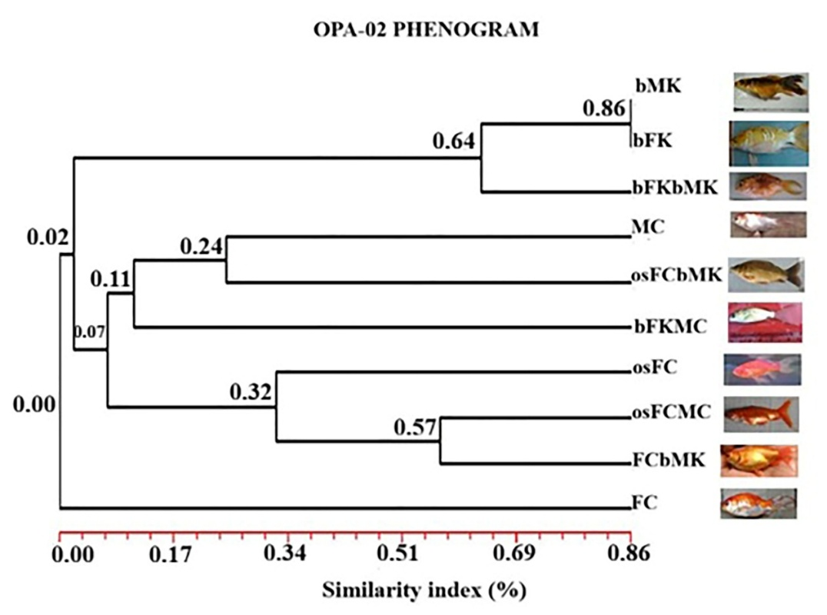
Figure 6. A genetic relationship phenogram of koi, comets, and hybrid koi ꓫ comets (OPA-02)

However, the number of monomorphic fragments (5 in bMK and 1 in bFK) amplified by primer OPA-02 indicates that the bMK and bFK samples have a high genetic relationship (similarity index 86%), while the bFKbMK sample has a relatively close relationship (similarity index 64%). This suggests that this primer is appropriate for tracing the kinship between parentals and offspring in these samples. Previous study presented the findings of studies on F1 and F2 hybrid offspring, which are crosses of two distinct guppy strains and inherit 50% of the phenotypic traits of both parentals [3]. In this study, the hybrid offspring (osFCbMK sample) and its parental (MC sample) had a distant relationship (similarity index 24%, consistent with only two monomorphic fragments and five polymorphic fragments), and it had a very distant relationship with bFKMC (similarity index 11%, consistent with two amplified monomorphic fragments). On the other hand, the kinship line that links the osFC sample to osFCMC and FCbMK is just 32% similar. The genetic relationship between osFCMC and FCbMK is 57%, meaning that both fish produced by crossing a female comet parental from a different source with a male comet and a female comet parental with a butterfly male koi parentals are relatively closely related. The phenotypic traits of the cross-bred fish are similar to those of both the comet and koi parentals (Figure 6). The osFC, osFCMC, and FCbMK samples and the MC, osFCbMK, and bFKMC samples have a very distant kinship (similarity index of 7%), suggesting that the koi and comet, as well as their progeny, are distinct species. No polymorphic fragments (0 fragments) were detected in the MC, FC, bFKMC, and FCbMK samples, suggesting that neither the comet parents nor the progeny of the koi and comet cross exhibited any genetic variation (Table 3). For identifying kinship relationships between FC and osFC parental samples with osFCMC offspring, FCbMK hybrid offspring, and osFCbMK hybrid offspring, the phenogram results on the OPA-02 primer are less appropriate. The inconsistency of the OPA-2 primer for the genetic kinship relationship of the 10 test samples is explained by the number of monomorphic fragments amplified in the bMK sample (5 fragments), osFCMC sample (2 fragments), FCbMK sample (3 fragments), and osFCbMK sample (2 fragments) in Table 3. The FC sample has no kinship relationship (similarity index 0%) with the offspring of the comet parentals and the koi and comet parentals cross, according to the OPA-02 analysis of phenotypic characteristics. These offspring should have a genetic kinship based on the number of monomorphic fragments amplified by the primer (Table 3). Therefore, it is not possible to analyze the genetic kinship of the koi ꓫ comet cross and its hybrid offspring using the OPA-02 primer. Comparing the OPA-13 primer to the OPA-02 primer, the kinship analysis of ten test samples revealed distinct outcomes (Figure 7).

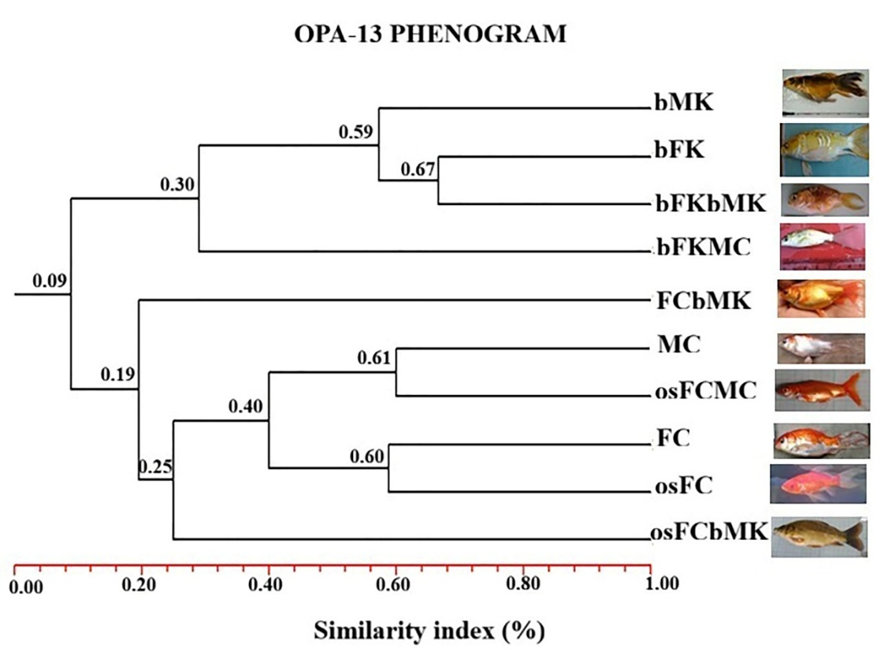

Figure 7. Koi, comet, and hybrid koi ꓫ comet genetic relationship phenogram (OPA-13)

This indication is demonstrated by the differences in phenotypic characteristics between the MC, osFCMC, FC and osFC samples in the osFCbMK (the body shape, colour pattern and tail shape are more typical of the carp phenotype). The 25% genetic similarity of the osFCbMK sample is derived from another source of comet parent (osFC) as dominant phenotype, and this coherence is confirmed by the presence of four monomorphic fragments of the sample of osFCbMK (Table 3). Another offspring is a line combining samples of MC, osFCMC, FC, osFC and osFCbMK and a hybrid fish cross between a comet female and a butterfly male koi (FCbMK), which is more distant (19% similarity). In comparison to the phenotypes of the FC and bMK samples and the osFCbMK hybrid fish, the FCbMK phenotype differs in body shape, tail fin shape, head shape, and body length size (Figure 7). The FCbMK sample shows a more pronounced resemblance to the comet parentals, particularly in colour pattern, body shape and tail shape (which is consistent with the presence of four monomorphic fragments in Table 3). The similarity index of the hybrid fish bFKMC (30%), FCbMK (19%) and osFCbMK (25%) shows that the hybrid fish are of different species, resulting in the creation of a new species. In contrast, the non-hybrid fish samples (BMK, BFK, BFKbMK, MC, FC, OSFC) have a more than 50 percent similarity index, which is in line with the OPA-13 monomorphic fragment presence (Table 3), suggesting that these samples are of the same species. This explanation is also supported by previous research showed that the similarity index of the genetic relationships between fish using RAPD primers is greater than 50% or equal to that, indicating that the population is of the same species [37, 38]. The final line of descent between butterfly koi parental (bMK, bFK) and their progeny (bFK, bFKMC) and comet paentals (MC, FC, osFC) and their hybrid progeny (FCbMK, osFC) is distantly related (9% similarity index) indicating that the butterfly koi and comet fish are different species.

CONCLUSION

In the hybrid fish sample osFCbMK, polymorphism was found more frequently using primer OPA-02 (5 fragments) than primer OPA-13 (4 fragments). In contrast, primer OPA-13 was able to detect polymorphism in the hybrid fish samples bFKMC (1 fragment) and FCbMK (1 fragment); however, primer OPA-02 was unable to detect genetic variation in either hybrid fish sample. As demonstrated by NTSYS analysis, osFCbMK's genetic relationship with osFC (by 40%) and MC (by 40%) was better suited to be identified by OPA-13 phenogram than by OPA-02 phenogram (by 11 and 24%). The genetic relationship of bFKMC to bFK or bMK was 30% by OPA-13 and 7% by OPA-02 phenogram. The hybrid relationship between FCbMK and FC was 19% by OPA-13 phenogram and only 2% by OPA-02 phenogram respectively. The phenotypic characteristics of hybrid fish are more strongly inherited from both female koi and female comet. The OPA-13 primer is more suitable for the analysis of polymorphism and genetic relationships between koi and comet.

DISCLAIMER (ARTIFICIAL INTELLIGENCE)

Author(s) hereby declare that NO generative AI technologies such as Large Language Models (ChatGPT, COPILOT, etc) and text-to-image generators have been used during writing or editing of this manuscript.

COMPETING INTERESTS

Authors have declared that no competing interests exist.

REFERENCES

1. Haynes, G. D., Gongora, J., Gilligan, D.M., et al., 2012. Cryptic hybridization and introgression between invasive Cyprinid species Cyprinus carpio and Carassius arassius in Australia: implications for invasive species management. Animal Conservation, 15(1), 83-94.

2. Hulata, G. 1995. A review of genetic improvement of the common carp (Cyprinus carpio L.) and other cyprinids by crossbreeding, hybridization and selection. Aquaculture, 129(1-4), 143-155.

3. Kohlmann, K., & Kersten, P. 1999. Genetic variability of German and foreign common carp (Cyprinus carpio L.) populations. Aquaculture, 173(1-4), 435-445.

4. David, L., Rajasekaran, P., Fang, J., Hillel, J., & Lavi, U. 2001. Polymorphism in ornamental and common carp strains (Cyprinus carpio L.) as revealed by AFLP analysis and a new set of microsatellite markers. Molecular Genetics and Genomics, 266(3), 353-362.

5. Hänfling, B., Bolton, Harley, P.M, & Carvalho. G.T. 2005. A molecular approach to detect hybridisation between crucian carp (Carassius carassius) and non-indigenous carp species (Carassius spp. And Cyprinus carpio). Freshwater biology, 50(3).

6. Chen, W., Y. Zhao., and C. Yang. 2016. Genetic variation and population history of three Carassius auratus populations in Huaihe River, China. Mitochondrial DNA Part A, 27(6), 4252-4255.

7. Feng, X., Zhu, R., Jia, Y., et al., 2023. Genetic diversity and population structure of the invasive populations of goldfish Carassius auratus complex in Tibet. Biological Invasions, 25(7), 2103-2115.

8. Bakos, J., & Gorda, S. 1995. Genetic improvement of common carp strains using intraspecific hybridization. Aquaculture, 129(1-4), 183-186.

9. Lau, C.C., Mohd Nor, S.A., Tan, M.P., et al., 2023. Pigmentation enhancement techniques during ornamental fish production. Reviews in Fish Biology and Fisheries, 33(4), 1027-1048.

10. Liu, Z., Nichols, A., Li, P., & R.A. Dunham, R.A. 1998. Inheritance and usefulness of AFLP markers in channel catfish (Ictalurus punctatus), blue catfish (I. furcatus), and their F1, F2, and backcross hybrids. Molecular and General Genetics MGG, 258(3), 260-268.

11. Chelomina, G.N., Rozhkovan, K.V., & Ivanov, S.A. 2008. Discrimination of interspecific hybrids in natural populations of Amur sturgeon fish by means of multilocus RAPD-PCR markers. Cytology and Genetics, 42(5), 342-350.

12. Danish, M., Singh, I.I., Giri, P., & Singh, C.P. 2012. Molecular characterization of two populations of catfish Clarias batrachus L. using random amplified polymorphic DNA (RAPD) markers. African journal of Biotechnology, 11(77), 14217.

13. Kumla, S., Doolgindachbaporn, S., Sudmoon, R., & Sattayasai, N. 2012. Genetic variation, population structure and identification of yellow catfish, Mystus nemurus (C&V) in Thailand using RAPD, ISSR and SCAR marker. Molecular Biology Reports, 39(5), 5201-5210.

14. Liu, Z. J., Li, P., Argue, B.J., & Dunham, R.A. 1999. Random amplified polymorphic DNA markers: usefulness for gene mapping and analysis of genetic variation of catfish. Aquaculture, 174(1-2), 59-68.

15. Toth, B., Varkonyi, E., Hidas, A., Edviné Meleg, E., & Váradi, L. 2005. Genetic analysis of offspring from intra‐and interspecific crosses of Carassius auratus gibelio by chromosome and RAPD analysis. Journal of Fish Biology, 66(3), 784-797.

16. Huang, C. F., Lin, Y. H., & Chen, J. D. 2005. The use of RAPD markers to assess catfish hybridization. Biodiversity & Conservation, 14(12), 3003-3014.

17. Elo, K., Ivanoff, S., Vuorinen, J.A., & Piironen, J. 1997. Inheritance of RAPD markers and detection of interspecific hybridization with brown trout and Atlantic salmon. Aquaculture, 152(1-4), 55-65.

18. Liu, Z. J., & Cordes, J.F. 2004. DNA marker technologies and their applications in aquaculture genetics. Aquaculture, 238(1-4), 1-37.

19. Yoon, J. M., & Park, H.Y. 2002. Genetic similarity and variation in the cultured and wild crucian carp (Carassius carassius) estimated with random amplified polymorphic DNA. Asian-australasian journal of animal sciences, 15(4), 470-476.

20. Yoon, J. M., & Kim, Y.M. 2004. Genetic differences within and between populations of Korean catfish (S. asotus) and bullhead (P. fulvidraco) analysed by RAPD-PCR. Asian-australasian journal of animal sciences, 17(8), 1053-1061.

21. Van Dongen, S.T., & Winnepenninckx, B. 1996. Multiple UPGMA and neighbor-joining trees and the performance of some computer packages. Molecular Biology Evolution, 13(2), 309-313.

22. Andriani, T., & Irawan, M. I. 2017. Application of unweighted pair group methods with arithmetic average (UPGMA) for identification of kinship types and spreading of ebola virus through establishment of phylogenetic tree. In AIP Conference Proceedings (Vol. 1867, No. 1, p. 020064). AIP Publishing LLC.

23. Barbas, C.F., Burton, D.R., Scott, J.K., & Silverman, G.J. 2007. Quantitation of DNA and RNA. Cold Spring Harbor Protocols, 2007(11), pdb-ip47.

24. Muhammad, H.H. M., Iqbal, Z.I., Iqbal, M.U., et al., 2016. An efficient method for DNA isolation from fish fin. Pakistan Journal Agriculture Sciences, 53(4), 843-850. DOI: 10.21162/PAKJS/16.3998.

25. Wasko, P.A., & Galetti Jr, P.M. 2002. RAPD analysis in the Neotropical fish Brycon lundii: genetic diversity and its implications for the conservation of the species. Hydrobiologia, 474(1), 131-137.

26. Dwiyitno, D., Hoffman, S., Parmentier, K., & Keer, C,V. 2018. Method comparison of DNA isolation and quantification for fish and seafood authenticity determination. Squalen Bulletin of Marine and Fisheries Postharvest and Biotechnology, 13(3), 115-124.

27. Piskata, Z., Pospisilova, E., & Borilova, G. 2017. Comparative study of DNA extraction methods from fresh and processed yellowfin tuna muscle tissue. International Journal of Food Properties, 20(sup1), S430-S443.

28. Apalikova, O.V., Podlesnykh, A.V., Kukhlevsky, A.D., et al. 2011. Phylogenetic relationships of silver crusian carp Carassius auratus gibelio, C. auratus cuvieri, crucian carp Carassius carassius, and common carp Cyprinus carpio as inferred from mitochondrial DNA variation. Russian Journal of Genetics, 47(3), 322-331.

29. Fayyaz, R., Qureshi, N. A., & Shakeela, P. (2014). Genetic variation among the wild and hatchery raised populations of Labeo rohita (Hamilton, 1822) revealed by RAPD markers.

30. Bardakci, F., & Skibinski, D.O.F. 1994. Application of the RAPD technique in tilapia fish: species and subspecies identification. Heredity, 73(2), 117-123.

31. Chrisanfova, G.G., Ludanny, R.L., Slynko, Y.V., et al., 2004.. RAPD Fingerprinting of Common Bream Abramis brama L., Roach Rutilus rutilus L., and Their F1 Hybrids (A. brama× R. rutilus and R. rutilus× A. brama). Russian Journal of Genetics, 40(10), 1182-1186.

32. Jug, T., P. Dovc., J. Pohar., and A. Snoj. 2004. RAPD analysis as a tool for discriminating marble trout from hybrids (marble trout× brown trout) in the zones of hybridization. Journal of Animal Breeding & Genetics, 121(3), 156-162.

33. Muhammad, H., Iqbal, Z., & Bashir, Q. (2017). Genetic polymorphism among five species of Indus River carps on the basis of random amplified polymorphic DNA (RAPD) analysis. Rendiconti Lincei, 28(1), 73-80.

34. Yamazaki, Y., Shimada, N., & Tago, Y. 2005. Detection of hybrids between masu salmon Oncorhynchus masou masou and amago salmon O. m. ishikawae occurred in the Jinzu River using a random amplified polymorphic DNA technique. Fisheries Science, 71(2), 320-326.

35. Jamshidi, S., Kalbasi, M.R, & Sadehghizadeh, M. 2009. Inheritance of RAPD marker in female grass carp (Ctenopharyngodon idella), male bighead carp (Hypophthalmichthys nobilis) and their F1 hybrids. Iranian Journal of Fisheries Sciences, 8(1), 47-56.

36. Degani, G. 2004. Application of RAPD and cytochrome b sequences to the study of genetic variations in F1 and F2 generations of two different strains of guppy (Poecilia reticulata, Peter 1854). Aquaculture Research, 35(9), 807-815.

37. Cabezas, M.P., Guerra-Garcia, J.M., Baeza-Rojano, E., et al., 2010. Exploring molecular variation in the cosmopolitan Caprella penantis (Crustacea: Amphipoda): results from RAPD analysis. Journal of the Marine Biological Association of the United Kingdom, 90(3), 617-622.

38. Rajanna, K. B., Manjappa, N., Manjunath, N., et al., 2023.. Assessment of genetic variation in Amur common carp (Cyprinus carpio Haematopterus Temminck & Schlegel, 1846: Cypriniformes, Cyprinidae) of three different geographical locations using RAPD marker. Journal of Experimental Zoology India, 26(2).

.

