EXPERIENCE OF ANAESTHESIA IN ORTHOPAEDIC SURGERY AT A TERTIARY HOSPITAL IN SOUTH-SOUTH NIGERIA: A REVIEW (2020-2025)

ABSTRACT
Background:
Orthopaedic surgery accounts for a substantial portion of surgical workload in tertiary hospitals, particularly in low- and middle-income countries where trauma, especially from road traffic accidents, remains a major public health challenge. Anaesthesia for orthopaedic procedures requires careful selection of techniques based on patient characteristics, surgical demands, and resource availability. Objective: To review the anaesthetic management of orthopaedic surgeries over a five-year period in a tertiary hospital in South-South Nigeria, assessing patient demographics, surgical characteristics, and anaesthetic techniques employed. Methods: A retrospective review was conducted on all orthopaedic surgeries performed at the University of Port Harcourt Teaching Hospital between 2020 and 2025. Data extracted from theatre records included demographics, type and site of surgery, ASA classification, and anaesthetic technique. Analysis was performed using SPSS version 25.0 and presented as frequencies and means. Results: A total of 816 orthopaedic procedures were performed. The mean age was 37.4 ± 20.2 years, with patients ranging from 2 to 102 years, M:F ratio of 2:1. Elective surgeries accounted for 67% of cases, while 33% were emergencies. Most patients were ASA I (60.2%), with 12% classified as ASA III–IV. Lower limb surgeries predominated (82.7%), followed by upper limb (7.5%) and spine procedures (7.1%). Spinal anaesthesia was the most frequently used technique (40.4%), followed by general anaesthesia (34.6%) and combined spinal epidural (16.2%). Peripheral nerve blocks (2.5%), epidural anaesthesia (0.5%), intravenous regional anaesthesia (0.4%), local anaesthesia (4.1%), and TIVA (1.5%) constituted the remainder. Conclusion: Orthopaedic surgeries represent a major component of the surgical caseload, predominantly affecting young adults with trauma-related lower limb injuries. Neuraxial anaesthesia particularly spinal anaesthesia was the most used technique. While practice patterns align with regional trends, the limited use of peripheral nerve blocks highlights opportunities for expanding regional anaesthesia capacity through improved training and resource investment. The study also highlights the need for further research into the regional anaesthesia capacity or areas for potential improvement in anaesthetic practices.
Keywords: Orthopaedic surgery, Anaesthesia, Neuraxial anaesthesia, Spinal anaesthesia, Trauma, Tertiary hospital.

INTRODUCTION
Orthopaedic surgery forms a significant proportion of operative procedures performed in tertiary hospitals, due to the rising burden of trauma, degenerative diseases, sports injuries, and congenital musculoskeletal disorders worldwide. In low- and middle-income countries, the increasing incidence of road traffic accidents has further increased the demand for orthopaedic interventions, placing a huge burden on the anaesthetist to ensure safe perioperative care.^{1,2} The provision of anaesthesia for orthopaedic surgery is unique due to the diverse patient population, varying surgical sites, and frequent need for prolonged or technically complex procedures.
Both general and regional anaesthesia techniques are widely employed for orthopaedic operations, with choices guided by patients’ factors, surgical requirements, available resources, and anaesthetist expertise.³ Regional anaesthesia, particularly spinal, epidural, and peripheral nerve blocks, is frequently used due to benefits such as reduced opioid use, improved postoperative analgesia, early mobilisation, and fewer systemic complications.^{4,5,6} However, performing regional techniques may be limited by equipment availability, patient comorbidities, or emergency surgical indications. Thus, general anaesthesia remains essential in settings where regional techniques are unsu or contraindicated.
Evaluating anaesthetic practices within tertiary hospitals is important for understanding patterns of care, resource utilisation, and potential areas for improvement in patient safety and perioperative outcomes. A one-year review of anaesthesia for orthopaedic procedures can provide valuable insights into case distribution, anaesthetic techniques used, perioperative challenges, and complication rates, thereby contributing to evidence-based service improvement and resource planning.
This study aims to review the anaesthetic management of orthopaedic surgical cases conducted over a five-year period in the University of Port Harcourt Teaching Hospital, describing the spectrum of procedures, anaesthetic techniques employed, and perioperative outcomes.

MATERIALS AND METHODS
Study design: A retrospective review of all orthopaedic surgeries carried out between 2020 to 2025 from the theatre records of University of Port Harcourt Teaching Hospital (UPTH).
Study place: This study was carried out in Port Harcourt, the Capital City of Rivers State in Nigeria.
Study setting: The theatre of the University of Port Harcourt Teaching Hospital was the setting for the study. It is a modern theatre with six theatre suites, a recovery with six beds, changing rooms, and a reception.
Study population/participants: Orthopaedic patients of all ages booked and underwent surgery, between 2020 and 2025, in the University of Port Harcourt Teaching Hospital, were included in the study.
Data analysis: Patient’s demographic data, type of surgery, site of the surgery, and type of anaesthesia were recorded. Data were analysed and presented as frequencies and means using Statistical Package for Social Sciences (SPSS) version 25.0.
Ethical consideration: The approval of the Ethics Review Committee of the University of Port Harcourt Teaching Hospital was obtained before commencement of the study. No personal identities of the participants were revealed.

RESULTS
TABLE I; DEMOGRAPHY, ASA CLASSIFICATION, SITE OF SURGERY, ANAESTHESIA TECHNIQUE.
TOTAL 816
Variables Frequency (n ) Percentage %

Age (Mean ± SD) 37.4±20.2 2-102
Surgery type
Elective 547 67.0
Emergency 269 33.0
ASA
I 491 60.2
II 216 26.5
III 97 11.9
IV 12 1.5
Site of surgery
Upper limb 61 7.5
Lower limb 675 82.7
Upper and lower limb 22 2.7
Spine 58 7.1
Anaesthesia Technique
GA 279 34.1
GA + RA 3 0.37
CSE 132 16.2
Epidural 4 0.5
SAB 330 40.4
PNB 20 2.5
IVRA 3 0.4
LA 33 4.1
TIVA 12 1.5

FIG I; AGE DISTRIBUTION
shows the frequency of Age distribution. The younger age groups are more predominant compared to the older age group, with the highest being 0-25 followed by 41-60, 26-40, 61-80 and >100
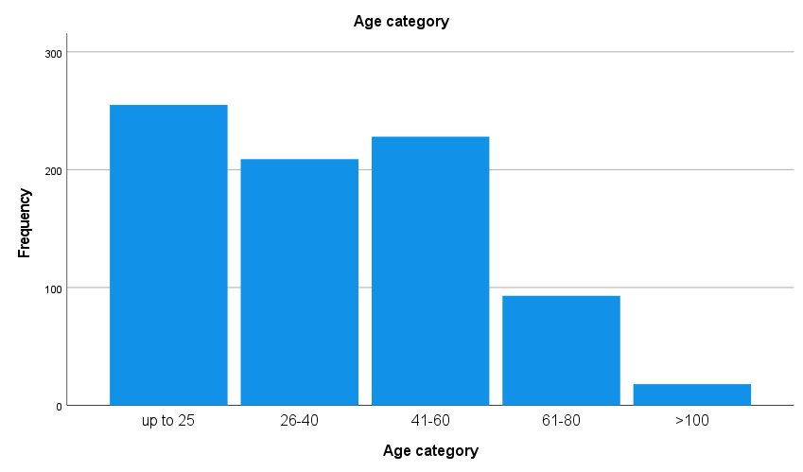
FIG II; SEX DISTRIBUTION

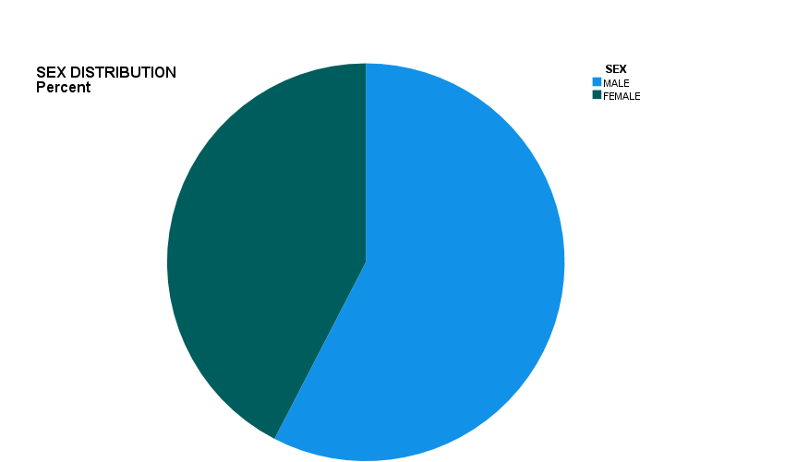

TABLE II; ANAESTHETIC TECHNIQUE AND SITE OF SURGERY
UPPER LIMB Frequency (n) (%)
GA 38 62.3
PNB 12 19.7
LA 5 8.2
TIVA 3 4.9
IVRA 3 4.9
Total 61 100
LOWER LIMB %
GA 168 24.9
SAB 330 48.9
Epidural 4 0.6
CSE 132 19.6
PNB 8 1.2
LA 28 4.2
TIVA 5 0.7
Total 675 100
SPINE %
GA 58 100
Total 58 100
UPPER AND LOWER LIMB
GA 15 68.2
GA±RA 3 13.6
TIVA 4 18.2
Total 22 100

DISCUSSION
This five-year review provides a comprehensive overview of anaesthetic practices for orthopaedic surgery in a tertiary hospital in South-South Nigeria, highlighting the epidemiological characteristics of patients, distribution of orthopaedic procedures, and patterns in anaesthetic techniques used during the study period. The findings reflect the interplay between patient demographics, surgical indications, and resource availability, while also aligning with regional and global trends in orthopaedic anaesthesia.
The mean patient age of 37.4 ± 20.2 years, with an age range of 2–102 years, shows that orthopaedic surgery within the institution is performed within a broad age group. However, the predominance of younger age groups, is consistent with trends reported across sub-Saharan Africa,^{7,8,9} where trauma-related injuries affects individuals in their most active and economically productive years.^{8,9,10} The highest frequency was observed in the 0–25 age group, followed by the 41–60 and 26–40 age groups. This distribution reflects the epidemiology of trauma in developing countries, where children, adolescents, and young adults are more frequently exposed to high-risk environments, including poorly regulated road systems, increased motorcycle use, and limited enforcement of safety measures.^{8,9}
The gender distribution reveals male predominance, similar to findings in Nigeria and other low- and middle-income countries, where males are more likely to sustain injuries from road traffic accidents, industrial work, and sports-related activities.^{11,25} Male involvement in high-risk occupations and greater mobility increases their vulnerability to major trauma, particularly high-energy lower limb fractures and spinal injuries.^{8,11} This gender pattern reinforces the global observation that musculoskeletal injuries are more prevalent among males due to greater exposure to occupational and environmental hazards.^{1,7}
A total of 816 orthopaedic procedures were performed over five years, forming a major part of the hospital's surgical workload. Elective procedures constituted 67% of the cases, while emergency surgeries accounted for 33%. This distribution highlights the dual burden of chronic orthopaedic conditions, such as osteoarthritis and degenerative spine disease, alongside acute trauma requiring urgent operative management.^{2,7} The emergency burden is comparable to findings from other Nigerian hospitals where trauma-related admissions, particularly from motor vehicle crashes and motorcycle accidents, remain high.^{8,20} The relatively high proportion of elective procedures may reflect increased capacity for scheduled orthopaedic surgeries, improved specialist availability, or better coordination within the hospital's orthopaedic and anaesthetic teams.
The ASA physical status classification revealed that most patients were in ASA I (60.2%) and ASA II (26.5%), suggesting that most patients were relatively healthy at the time of surgery. Only 13.4% fell into ASA III and IV categories. These findings are consistent with reports from other centres where most orthopaedic patients are young and free from significant comorbidities.^{14,19} Nevertheless, the presence of patients in higher ASA categories indicates that some patients presented with trauma-related physiological derangements, chronic medical conditions, or advanced age all of which pose additional risks during anaesthesia and surgery.
Lower limb surgeries accounted for the vast majority of procedures (82.7%), followed by upper limb (7.5%), spine (7.1%), and combined upper–lower limb surgeries (2.7%). The predominance of lower limb operations aligns with the known pattern of trauma-related injuries in low-resource settings, where fractures of the femur, tibia, and pelvis are common due to high rates of road traffic accidents and falls from heights.^{10,11,25} This trend has been reported in several studies across Nigeria and other African countries, where lower limb fractures remain the most frequent orthopaedic presentations.^{11,25}
Spine surgeries, comprising 7.1% of the total, reflect the increasing recognition and management of spinal pathologies within Nigerian tertiary hospitals. However, this figure may still be limited by specialist availability, cost constraints, and limited access to advanced surgical equipment, as reported in prior audits of spinal surgery in Nigeria.¹² Furthermore, delays in presentation and socioeconomic factors may lead to underutilisation of spinal surgical services, with many patients opting for conservative or alternative treatments.
The selection of anaesthetic technique was largely shaped by the type of surgery, patient condition, and institutional resources. Regional anaesthesia specifically spinal anaesthesia (40.4%) and combined spinal epidural (16.2%) was more frequently used than general anaesthesia (34.1%). This pattern is in keeping with global evidence supporting the benefits of neuraxial anaesthesia for orthopaedic surgeries, particularly for lower limb procedures.^{4,5,21} Studies have demonstrated that neuraxial blocks offer superior postoperative analgesia, reduced intraoperative blood loss, lower thromboembolic risk, and earlier mobilisation compared to general anaesthesia.^{4,13,18,21} In resource-limited settings, spinal anaesthesia is also cost-effective, easier to administer, and requires less monitoring equipment than general anaesthesia.^{14,23} Administering regional anaesthesia (RA) in low-resource environments, such as many tertiary hospitals in sub-Saharan Africa, presents unique challenges that may influence technique selection, success rates, complication profiles, and overall postoperative outcomes. The relatively low utilisation of epidural anaesthesia (0.5%) and peripheral nerve blocks (2.5%) may reflect several challenges, these include, equipment limitation, limited human resource capacity/training gaps, infrastructure and system issues, drug and consumable constraints, cultural and patient factors.^{16,17,24} The limited use of IVRA (0.4%) and local anaesthesia (4.1%) is expected, given their restricted indications for short-duration or minor limb procedures.
Total intravenous anaesthesia (1.5%) was used sparingly, most likely due to the higher cost of TIVA agents such as propofol, and limitations in infusion pumps and monitoring equipment. This is consistent with findings from other developing countries where TIVA adoption remains limited compared to volatile-based general anaesthesia techniques.¹⁶
The detailed relationship between anaesthetic technique and surgical site provides further insights into clinical decision-making. General anaesthesia was mostly used technique for upper limb procedures (62.3%). This aligns with the challenges associated with upper limb regional blocks, especially in facilities without routine ultrasound guidance. Brachial plexus blocks superior for upper limb surgery has a learning curve and require expertise and supportive equipment that may not always be available.^{17,24,27} Consequently, many centres in Nigeria rely on general anaesthesia for shoulder, humeral, and forearm surgeries, particularly when prolonged tourniquet use is anticipated.
Nevertheless, peripheral nerve blocks (19.7%) were used in a substantial proportion of upper limb cases, indicating increasing acceptance of regional anaesthesia techniques where feasible. Local anaesthesia and IVRA were used in smaller proportions (8.2% and 4.9% respectively), appropriate for minor procedures such as wrist and hand surgeries.
Most lower limb surgeries were conducted under regional anaesthesia, chiefly spinal anaesthesia (48.9%) and CSE (19.6%). This is well supported by literature recommending neuraxial techniques for most lower extremity operations due to their safety, reliability, and haemodynamic stability.^{4,18,21,22} Regional blocks reduce postoperative complications, shorten recovery times, and are particularly advantageous in trauma patients when airway manipulation is risky.^{13,21}
General anaesthesia was used in 24.9% of lower limb procedures, likely reflecting cases involving polytrauma, paediatric patients, anticipated long surgical times, or contraindications to neuraxial blocks. The limited use of peripheral nerve blocks (1.2%) again points to equipment and training gaps. All spine surgeries (100%) were performed under general anaesthesia. This is consistent with worldwide practice since spinal procedures typically require controlled ventilation, prone positioning, and complete muscle relaxation conditions only achievable with general anaesthesia.^{12,23,26} The finding aligns with the existing literature indicating universal preference for general anaesthesia for spinal decompressions, fusions, and instrumentation. Most combined limb surgeries were done under general anaesthesia (68.2%), which is expected given the longer duration and wider operative fields involved. A combination of GA with RA was used in 13.6% of cases, likely for postoperative analgesia, while TIVA accounted for 18.2%.
The overall anaesthetic practices observed in this review align with findings from other studies. Basques et al¹⁵ reported a similar predominance of spinal anaesthesia for lower limb fractures, while Rukewe et al¹⁴ highlighted a mixture of GA and RA use depending on procedure type. In Ethiopia, and Rwanda, studies have similarly shown limited uptake of advanced regional techniques due to resource constraints and inadequate training.^{16,24,28} Global literature also supports the preference for regional anaesthesia in orthopaedic surgery, particularly given its impact on reducing postoperative morbidity, improving pain control, and enhancing recovery.^{4,5,13,21,29}
The findings underscore the need to expand access to modern regional anaesthesia techniques, especially ultrasound-guided nerve blocks. Strengthening training programs, investing in equipment, and fostering continuing medical education can significantly improve postoperative pain outcomes and reduce reliance on general anaesthesia in settings where it may not be essential. It also highlights the importance of investigating the long-term outcomes of regional anaesthesia in orthopaedics and exploring other anaesthetic techniques not commonly used in the hospital, but with potential benefits for patients.

Given the high burden of trauma in young adults, enhanced road safety measures and public health interventions are crucial to reducing the overall orthopaedic workload. Additionally, improving documentation, perioperative protocols, and multidisciplinary collaboration can enhance patient outcomes.
As a retrospective study, the analysis depended on theatre records which may have been incomplete or inconsistent. The study was also single-centre, limiting generalisability. Outcomes such as complications, mortality, and postoperative pain scores were not assessed but could enrich future research.

CONCLUSION
This 5-year review demonstrates that orthopaedic surgery constitutes a major component of the surgical workload in our tertiary hospital, with a predominance of young male patients and trauma-related lower limb procedures. Neuraxial anaesthesia, particularly spinal anaesthesia, remains the most frequently used technique, reflecting both clinical suitability and resource availability. The overall pattern of anaesthesia practice is consistent with trends in many low- and middle-income countries, highlighting both strengths in foundational anaesthetic care and opportunities for improvement in regional anaesthesia capacity, equipment provision, and specialised training. Strengthening these areas may enhance perioperative outcomes, patient satisfaction, and efficiency within orthopaedic services. The study also highlights the need for further research into the regional anaesthesia capacity or areas for potential improvement in anaesthetic practices.

ABBREVIATIONS
GA- General Anaesthesia
RA- Regional Anaesthesia
CSE-Combined Spinal Anaesthesia
SAB- Subarachnoid Block
PNB- Peripheral Nerve Stimulator
IVRA-Intravenous Regional Anaesthesia
LA-Local Anaesthesia
TIVA- Total Intravenous Anaesthesia

REFERENCE
- Mock C, Cherian MN. The global burden of musculoskeletal injuries: challenges and solutions. Clin Orthop Relat Res. 2008;466(10):2306-16.
- World Health Organisation. Global status report on road safety. Geneva: WHO; 2018.
- Miller RD, Cohen NH, Eriksson LI, et al. Miller’s Anaesthesia. 9th ed. Philadelphia: Elsevier; 2020.
- Hutton M., Brull R., Macfarlane, A.J.R. (2018). Regional anaesthesia and outcomes. BJA education. 2017; 18(2), 52–56.
- Memtsoudis SG, Poeran J, Zubizarreta N, et al. Association of Multimodal Pain Management Strategies with Perioperative Outcomes and Resource Utilization: A Population-based Study. Anaesthesiology. 2018 May;128(5):891-902.
- O'Donnell CM, McLoughlin L, Patterson CC, et al. Perioperative outcomes in the context of mode of anaesthesia for patients undergoing hip fracture surgery: systematic review and meta-analysis. Br J Anaesth. 2018;120(1):37-50.
- Mock C, Nugent R, Kobusingye O, Smith K. Injury Prevention and Environmental Health. 3rd ed. Washington DC: World Bank; 2017.
- Solagberu BA, Ofoegbu CK, Nasir AA, et al. Motorcycle injuries in a developing country and the vulnerability of riders, passengers, and pedestrians. Inj Prev. 2006;12(4):266-8.
- Peden M, Scurfield R, Sleet D, et al. World Report on Road Traffic Injury Prevention. WHO; 2004.
- Chichom Mefire A, Etoundi Mballa GA, Azabji Kenfack M, Juillard C, Stevens K. Hospital-based injury data from level III institution in Cameroon: retrospective analysis of the present registration system. Injury. 2013 Jan;44(1):139-43.
- Odatuwa-Omagbemi, D. O., Izuagba, E., Enemudo, R. E., Otene, C. I., & Ijezie, N. C. Epidemiological Pattern of Musculoskeletal Injuries in Children Aged 16 Years and Below in a Regional Trauma Centre in Nigeria. Cureus, 2023;15(4).
- Bankole OB, Arigbabu SO, Kanu OO. Spinal neural tube defects in Lagos University Teaching Hospital, Nigeria. Nig Q J Hosp Med. 2012;22(1):22-4.
- Rodgers A, Walker N, Schug S, et al. Reduction of postoperative mortality and morbidity with epidural or spinal anaesthesia: results from overview of randomised trials. BMJ. 2000; 321:1493.
- Rukewe, A., Fatiregun, A., & Alonge, T. O. (2014). Orthopaedic anaesthesia for upper extremity procedures in a Nigerian hospital. Malawi medical journal: the journal of Medical Association of Malawi, 26(3), 90–92.
- Basques BA, Toy JO, Bohl DD, et al. General compared with spinal anaesthesia for total hip arthroplasty. The Journal of bone and joint surgery. American volume, 2015;97(6), 455–461.
- Ho M, Livingston P, Bould MD, et al. Barriers and facilitators to implementing a regional anaesthesia service in a low-income country: a qualitative study. The Pan African medical journal,2019; 32, 152.
- Admassie BM, Admass BA, Melesse DY. Practice and challenges related to regional anaesthesia in Amhara regional hospitals, Northwest-Ethiopia: a web-based survey study. BMC anesthesiology, 2024; 24(1), 398.
- Kehlet H, Dahl JB. Anaesthesia, surgery, and challenges in postoperative recovery. Lancet. 2003;362(9399):1921–1928.
- Imarengiaye CO, Ogbemudia AO, Akpoduado DD, Akinmola A, Moin M. Transarterial Brachial Plexus Anaesthesia for Upper Limb Surgery: Safety and Efficacy Without Nerve Stimulator. Afr J Anaesth Int Care. 2011; 11:11–14.
- Schnittger T. Regional anaesthesia in developing countries. Anaesthesia. 2007;62:44–47.
- Rukewe A, Fatiregun A. The use of regional anaesthesia by anaesthesiologists in Nigeria. Anaesth Analg. 2010; 110:243–244.
- Chelly JE, Gebhard R, Greger J, Al Samsam T. Regional anaesthesia for out-patient orthopaedic surgery. Minerva Anestesiol. 2001; 67: 227-232.
- Schnittger T. Regional anaesthesia in developing countries. Anaesthesia 2007; 62: 44-47.
- Pavic N, Sakic K, Kirbis IS, Richards R, Martinac M. Cost management of general and regional anaesthesia techniques in context of quality resource management at the department of orthopaedics. Periodicum Biologorum ,2011; 113: 129-36.
- Elniel, A. R., & Giannoudis, P. V. Open fractures of the lower extremity: Current management and clinical outcomes. EFORT open reviews, 2018; 3(5), 316–325.
- Obasuyi BI, Alagbe-Briggs OT, Echem RC. Choice of anaesthesia for orthopaedic surgeries in a developing country: How appropriate? Journal of Medicine and Medical Sciences. 2013; 4:101–106.
- Hamidreza Mosleh, Shahab Aldin Nazeri, Mehdi Mehdizadeh, et al. Using 3D Printing for Pre-planning of Orthopaedic Surgeries, a Review. J. Pharm. Res. Int. [Internet]. 2021. 18, 2025;33(2):53–62.
- Ho CN, Wang WT, Hung KC, et al. Impact of general vs. regional anaesthesia on one-year clinical outcomes and healthcare utilisation after lower limb arthroplasty: a retrospective study. Anaesthesia, 2025; 80: 488-498.
- Amor D., Pai P, Lai Y.H. Outpatient Follow-up after Regional Anaesthesia for Orthopaedic Surgery - Should We Use Apps? Current Best Practices and Future Trends. Curr Anaesthesiol Rep 2024;14, 484–489.

