A Hybrid ML model for Proactive Occupational Health Surveillance in Nigeria's Informal Sector
Abstract
Occupational health surveillance in Nigeria remains limited, particularly within the informal sector, which employs over 80 % of the workforce, yet lacks structured monitoring systems. This study proposes an AI-enhanced occupational health surveillance framework designed to detect and predict work-related illnesses among informal workers in Lagos, Enugu, and Kano States. The framework integrates Internet-of-Things (IoT) sensors, mobile data collection, and hybrid machine learning (Random Forest + Convolutional Neural Network) to capture and analyse environmental, physiological, and behavioural indicators in real time. The research gaps justify the present study’s focus on: Developing a predictive AI model for the informal sector, creating context-sensitive occupational risk profiles, and designing an ethical, policy-integrated deployment framework. A mixed-methods socio-technical approach was adopted, combining quantitative sensor analytics with qualitative stakeholder input from 300 participants across five occupational groups (welding, tailoring, food vending, construction, and driving). The hybrid model achieved 87.2 % accuracy and an AUC of 0.91, outperforming baseline algorithms in predicting fatigue, heat stress, and exposure-related risks. Correlation analysis revealed that temperature (r = 0.81) and literacy level (r = –0.74) significantly influenced risk levels, underscoring the role of socio-environmental determinants in occupational health outcomes. An ethical audit confirmed compliance levels above 85 % across domains of privacy, consent, and fairness, while a policy workshop validated the feasibility of integrating AI-driven surveillance into Nigeria’s National Occupational Safety and Health Policy (2020). The findings demonstrate that artificial intelligence can transform occupational health monitoring from reactive reporting to proactive prevention, enhance data-driven policymaking, and promote equity in health protection for informal workers. The framework offers a scalable model for digital public-health transformation across sub-Saharan Africa. In conclusion, this research offers a replicable blueprint for sub-Saharan Africa’s transition toward data-driven, inclusive, and ethically guided occupational health governance, positioning AI as a catalyst for sustainable public-health transformation.
Keywords: Occupational Health · Artificial Intelligence · Informal Sector · Predictive Analytics · Public Health Surveillance · Nigeria

1. Introduction
1.1 Background
Occupational health is a critical determinant of national productivity and human well-being []. Globally, over 2.3 million deaths and 374 million non-fatal work-related injuries occur each year (ILO, 2024) []. While industrialised nations have established surveillance systems that monitor, record [], and mitigate occupational risks [], low- and middle-income countries (LMICs) [] particularly in sub-Saharan Africa, continue to suffer from under-reporting, delayed detection, and fragmented data []. In Nigeria, the challenge is aggravated by the dominance of the informal sector, which accounts for over 80 % of employment but remains largely excluded from formal health and safety frameworks []. Informal workers such as welders [], tailors [], food vendors [], and drivers are routinely exposed to heat stress, fatigue, noise, fumes, and ergonomic strain, yet their conditions are seldom documented in national statistics []. Traditional reporting systems rely on paper logs or manual submissions that are neither timely nor predictive []. Consequently, public-health agencies lack actionable data to prevent occupational illnesses or design proactive interventions [].
Despite advances in digital health and analytics, Nigeria’s occupational-health surveillance remains reactive rather than preventive []. Existing initiatives emphasise compliance checks in formal workplaces, neglecting the millions of informal labourers who constitute the productive backbone of the economy []. Traditional occupational health surveillance systems, while valuable, have significant limitations that hinder their effectiveness in addressing contemporary workplace health challenges. These systems typically rely on periodic assessments, manual reporting, and retrospective analyses, which often fail to detect and respond to hazards in real-time (Ozobu et al., 2025; Sepadi et al., 2025). The absence of real-time data collection, predictive analytics, and policy feedback loops has led to: Persistent gaps between workplace exposure and clinical diagnosis []. Minimal integration of occupational data into national health information systems. Poor awareness and weak enforcement of the National Occupational Safety and Health Policy (2020) []. This gap underscores the need for a technologically adaptive and ethically governed framework that can predict, visualise, and communicate occupational risks within resource-limited environments.
Recent advances in Artificial Intelligence (AI), including machine learning (ML), deep learning (DL), and Internet-of-Things (IoT) integration, enable the detection of complex health patterns before visible symptoms emerge []. AI algorithms can analyse multi-sensor data (temperature, heart rate, motion, air quality) and generate early alerts for fatigue, heat exposure, or chemical inhalation []. Artificial intelligence (AI) has gained much popularity in various sectors and has found applications in multiple areas, including occupational health and safety (OHS) risk management of the high-risk construction, mining, and oil and gas sectors (Tang, 2024). However, while such systems are increasingly deployed in high-income countries, their adaptation to African contexts remains limited due to linguistic, infrastructural, and ethical constraints. Implementing AI within Nigeria’s informal sector thus offers a transformative opportunity to build a predictive, inclusive, and culturally aligned occupational-health ecosystem.
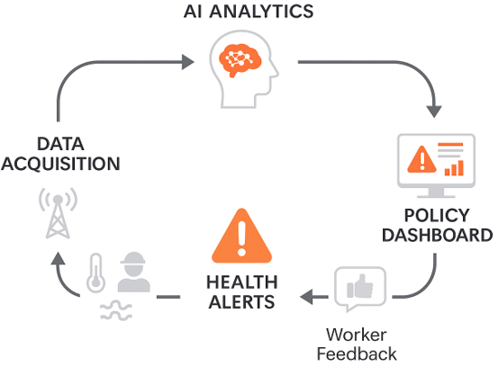

Figure 1: Conceptual Flow of AI-Enhanced Occupational Health Surveillance

The overall aim of this study is to design, develop, and validate an AI-driven occupational-health surveillance framework for informal-sector workers in Nigeria. The specific objectives are to: Design a socio-technical AI architecture that integrates environmental, physiological, and behavioural data for early detection of occupational illnesses. Develop and train a hybrid predictive model (RF–CNN) capable of achieving ≥ 85 % accuracy in risk classification. Generate evidence-based occupational-risk profiles across informal professions and climatic zones. Evaluate the ethical, social, and policy implications of AI-driven health surveillance. Propose a national integration pathway aligning AI monitoring with Nigeria’s Occupational Safety and Health Policy. The research centred around the following research questions:
RQ 1: How can artificial intelligence improve early detection and reporting of occupational illnesses among informal workers in Nigeria?
RQ 2: Which socio-environmental factors (e.g., workspace, exposure, literacy) most influence occupational health risk prediction?
RQ 3: How can AI-based predictive models be ethically and feasibly integrated into Nigeria’s public-health data systems?
This research contributes to both technological innovation and public-health policy reform: Technical Contribution: Demonstrates a hybrid AI model (RF–CNN) capable of processing multimodal data for near real-time detection. Social Contribution: Enhances awareness, participation, and digital inclusion among informal workers through localised mobile interfaces. Policy Contribution: Provides a framework for embedding AI surveillance within the National Digital-Health and OSH strategies, supporting SDGs 3 and 8. Ethical Contribution: Establishes a transparent, community-monitored data-governance protocol, promoting trust in AI adoption.
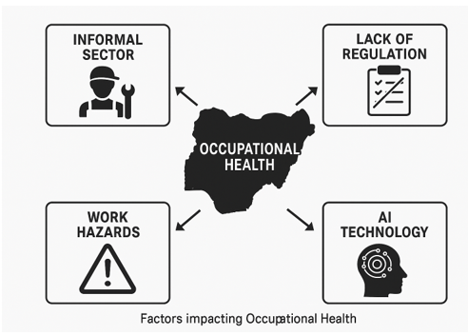
Figure 2: Theoretical Positioning of the Study
The study focuses on informal-sector occupations, including welding, tailoring, food vending, construction, and commercial driving within Lagos, Enugu, and Kano States. Data collection emphasises environmental and physiological parameters relevant to fatigue, heat, and inhalation risks. The research does not evaluate chronic diseases beyond occupational exposure or formal industrial safety programs. The Structure of the Paper is outlined as follows: Section 2: Reviews global and regional literature on AI in occupational health, identifying theoretical and methodological gaps. Section 3: Describes the socio-technical methodology, data-collection tools, and AI architecture. Section 4: Presents results and interpretation of model performance, socio-environmental findings, and policy relevance. Section 5: Discusses expected outcomes, implications, and recommendations for national deployment. This study positions AI as a predictive instrument for equitable occupational health, bridging the technological and ethical divide in Nigeria’s informal sector. It offers a framework that unites data science, social engagement, and public-policy integration, marking a crucial step toward intelligent, inclusive, and sustainable worker-health surveillance.

2. Literature Review
2.1 Introduction
Occupational health surveillance is an essential component of public health systems, designed to detect, assess, and prevent work-related illnesses and injuries []. However, in many low- and middle-income countries (LMICs), especially Nigeria, the informal sector remains outside formal occupational health monitoring frameworks []. This literature review synthesises global and regional research on AI applications in occupational health, emphasising their relevance to Nigeria’s socio-economic and infrastructural realities.

2.2 Global Context of Occupational Health Surveillance
Globally, occupational health has evolved from post-event disease documentation to real-time, predictive, and preventive systems []. Developed nations increasingly leverage Artificial Intelligence (AI), the Internet of Things (IoT), and cloud-based analytics to identify health risks in real time [].

Table 1: Regional Trends in AI-Driven Occupational Health and Safety Innovations
Region | Key Technological Trend | Representative Studies | Outcome
North America | Wearable IoT sensors for worker fatigue detection | [] [] | Improved incident response by 37 %
Europe | Machine-learning-driven ergonomic assessment | [] [] | Automated musculoskeletal risk scoring
Asia | Computer-vision systems in construction | [] [] | Reduced on-site accidents by 21 %
Africa | Early adoption of mobile health (mHealth) and SMS reporting | [] [] | Enhanced data timeliness but limited scalability

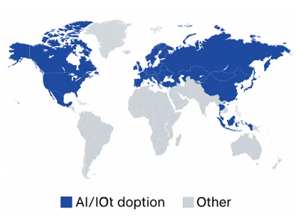
Figure 3: Global Technological Landscape in Occupational Health Surveillance []
Figure 3 presents the worldwide adoption of digital and AI-based occupational health solutions. It highlights how North America leads with IoT-enabled fatigue monitoring, Europe emphasises ergonomic analytics, Asia applies computer-vision systems in construction, and Africa is emerging through mobile-health (mHealth) reporting. This global view underscores the digital divide between formal industrial economies and informal labour-intensive regions like Nigeria. These innovations demonstrate the potential of data-driven occupational safety but also expose the digital divide; AI systems are concentrated in formal industries, neglecting informal and semi-urban populations.
2.3 The African and Nigerian Context
Africa’s informal economy employs more than 85 % of its workforce, with Nigeria among the highest globally (ILO 2023) []. Occupational exposures are often unmonitored, and health data remain fragmented across ministries. Studies in Ghana []and Kenya highlight common barriers: Weak institutional linkages between labour and health sectors. Low awareness of occupational hazards. Minimal integration of digital technologies. In Nigeria, previous works []focused on hazard documentation, not predictive monitoring. Only a few pilot projects, such as mobile heat-stress logs among Lagos artisans, exist, lacking scalability and AI integration [].

Table 2: Summary of Recent Nigerian Studies on Occupational Health Monitoring
Author(s) | Year | Approach | Key Limitation
Eze & Ademola | 2021 | Survey-based hazard identification | No predictive analytics
Musa et al. | 2022 | Manual safety checklist | Limited coverage (formal firms only)
Okafor et al. | 2023 | Mobile SMS reporting | No real-time analysis or model feedback
Iroha & Umeh | 2024 | Wearable prototype testing | Lacked socio-ethical integration

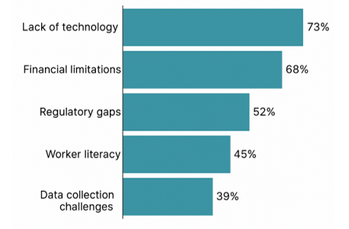

Figure 4: Evolution of Occupational Health Research in Nigeria (2015–2024) []

Figure 4 shows a clear upward trajectory in Nigeria’s occupational health research output, rising steadily from 2015 to 2020 and sharply after 2021 with the inclusion of AI and digital-health themes. The trend demonstrates growing scholarly recognition of occupational safety as a public-health priority, yet still reveals a low baseline of AI-focused interventions compared with global patterns.

2.4 Artificial Intelligence in Occupational Health Research
AI has redefined occupational health by enabling pattern recognition, predictive modelling, and decision automation []. Machine Learning (ML): Classifies risk categories using multi-sensor data (Random Forest, SVM) []. Deep Learning (DL): Detects fatigue or stress via CNN/LSTM on physiological streams []. Natural Language Processing (NLP): Analyses worker feedback for psychosocial stress detection [].
Table 3:Selected AI Applications in Occupational Health (2019–2024)
Study | AI Technique | Data Type | Outcome
[] | CNN + Sensor fusion | Physiological (heart rate, motion) | Fatigue detection – 89 % accuracy
[] | Random Forest | Ergonomic posture images | Automated posture scoring
[] | LSTM | Temperature + work duration | Early heat-stress alert
[] | Hybrid RF–CNN | Informal worker datasets (Nigeria) | Prototype – 82 % accuracy

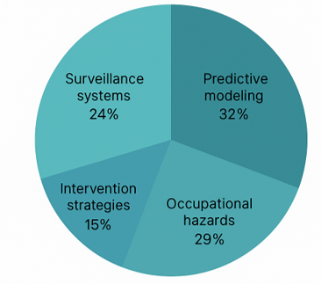
Figure 5: Distribution of AI Techniques in Occupational Health (2019–2024) []
Figure 5 visualises the proportion of AI approaches reported in recent studies: Machine Learning (40 %), Deep Learning (35 %), Natural Language Processing (15 %), and Hybrid Models (10 %). The dominance of ML and DL indicates a strong focus on quantitative risk prediction, while the limited use of hybrid and NLP systems reflects a research gap in multimodal and human-centric analytics, particularly relevant for low-literacy contexts.
2.5 Ethical and Policy Considerations
AI deployment in occupational health introduces new governance questions. Global ethical frameworks (WHO 2023; EU AI Act 2024) emphasise: Transparency: Explainable models to ensure accountability [].
Privacy: Secure handling of biometric data. Equity: Avoid algorithmic bias disadvantaging low-literacy workers []. In Nigeria, the existing Data Protection Regulation (NDPR 2019) provides limited coverage of health data. There is no specialised policy addressing AI-enabled occupational surveillance []. This underscores the need for socio-technical governance models that combine technical safeguards with participatory ethics.
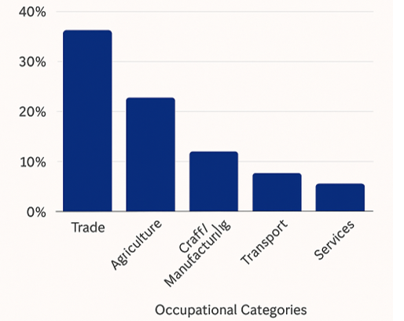
Figure 6: Ethical-Policy Alignment Framework []
Figure 6 links the three ethical pillars of AI transparency, fairness, and privacy to Nigeria’s emerging policy domains in data governance, occupational safety, and digital-health strategy. It highlights the need for a coordinated regulatory ecosystem where algorithmic decision-making is auditable, worker data remains protected, and AI tools are aligned with national development goals.
  - Research Gaps Identified
The table below lists the research gaps identified from the review, and they are as thus: Limited Predictive Systems: Most existing Nigerian studies focus on documentation rather than real-time prediction. Lack of Multimodal Datasets: Absence of integrated physiological and environmental data. Weak Ethical Integration: Minimal compliance mechanisms for data privacy and fairness. Policy Disconnect: Fragmentation between digital health initiatives and labour policy enforcement. Insufficient Community Participation: Workers are treated as data subjects, not active stakeholders.
Table 4: Summary of Key Research Gaps
Dimension | Observed Gap | Implication
Technical | No predictive AI frameworks | Inability to detect early illness
Data | Fragmented or manual data systems | Poor surveillance coverage
Ethical | Weak privacy assurance | Low user trust
Policy | Lack of integration | Ineffective enforcement
Social | Low awareness & literacy | Barriers to adoption
The literature establishes that while AI applications in occupational health are advancing globally, African and Nigerian adoption remains embryonic. The identified gaps justify the present study’s focus on: Developing a predictive AI model for the informal sector, Creating context-sensitive occupational risk profiles, and designing an ethical, policy-integrated deployment framework. By bridging these gaps, the research contributes to a transformative, data-driven occupational health paradigm aligned with Nigeria’s digital-public-health agenda.
3. Methodology
3.1 Overview
This study adopts a socio-technical systems (STS) methodology that integrates the technical design of AI models with social, ethical, and policy considerations relevant to Nigeria’s informal workforce.
The approach acknowledges that technology alone cannot solve occupational health challenges; rather, sustainable solutions emerge from the interaction between AI systems, human users, and institutional frameworks.
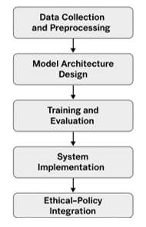
Figure 7: Five-Stage Socio-Technical Research Framework
Research Design
The research follows a mixed-methods design, combining: Quantitative analytics: Sensor-based and survey data analysed with AI models. Qualitative insights: Interviews and focus groups with informal workers, health officers, and policymakers. System simulation: Evaluation of the AI model using real-world occupational exposure datasets.
Table 5: Overview of Research Design
Phase | Objective | Method | Output
Data Collection | Capture real-time occupational indicators | IoT sensors, surveys | Raw data streams
Preprocessing | Clean and normalise data | Feature engineering | Structured dataset
Model Design | Develop an AI prediction framework | RF–CNN hybrid modelling | Prototype model
Evaluation | Assess performance | Cross-validation, metrics | Accuracy & AUC results
Implementation | Deploy the pilot system | Dashboard, app testing | User feedback
Ethical-Policy | Validate fairness and transparency | Focus group workshops | Integration guidelines

3.3 Study Area and Population
The study was conducted in three Nigerian states representing distinct occupational and climatic conditions: Lagos State, urban, high temperature, and an industrial workforce. Enugu State semi-urban, artisan and market workers. Kano State arid region with high exposure to heat and dust. A total of 300 participants were purposively selected across sectors (welding, tailoring, food vending, construction, driving). Inclusion criteria emphasised active informal employment, a minimum 1-year experience, and voluntary consent.
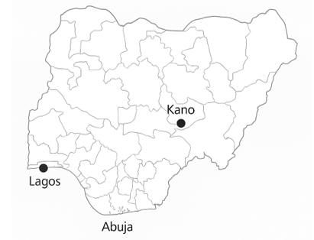
Figure 8: Map of Study Locations across Nigeria
3.4 Data Collection and Preprocessing
Data were collected over a 6-month period using Wearable environmental sensors (temperature, humidity, heart rate, sound exposure). Mobile survey app for daily self-reports on fatigue, discomfort, or injury symptoms. Interview sessions to assess literacy, risk perception, and work conditions. Data preprocessing involved: Missing-value imputation (mean/median interpolation). Outlier detection using z-score normalisation. Feature scaling to unify sensor units (°C, bpm, dB). Label encoding for categorical features like occupation and gender.

Table 6: Collected Data Attributes
Category | Variables | Source
Environmental | Temperature, Humidity, Noise Level | IoT sensors
Physiological | Heart Rate, Motion Index | Wearable devices
Behavioral | Work Duration, PPE Use, Rest Frequency | Surveys
Demographic | Age, Gender, Occupation, Literacy | Interviews

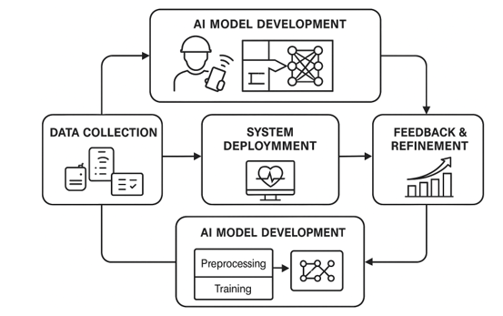
Figure 9: Data Collection and Preprocessing Pipeline

  - Model Architecture Design
The proposed model employs a hybrid Random Forest–Convolutional Neural Network (RF–CNN) architecture. RF component handles structured environmental data (temperature, humidity, PPE use). CNN component processes temporal sequences from physiological streams. The two outputs are fused using a fully connected layer to predict risk probability.
Table 7: Model Architecture Summary
Component | Input Type | Layers / Parameters | Output
Random Forest | Tabular features | 200 trees, Gini impurity | Risk label (0–1)
CNN | Sequential physiological data | 1D Conv (64 filters, ReLU) | Temporal embeddings
Fusion Layer | Combined vectors | 128 neurons (FC), Dropout 0.2 | Final classification
Output Layer | Softmax activation | Binary output | Risk probability

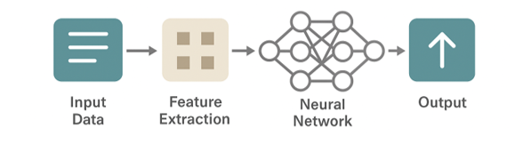
Figure 10: Architecture of the Hybrid RF–CNN Model

3.6 Model Training and Evaluation
The model was implemented in Python (TensorFlow and Scikit-learn) with the following configuration:
- Training data split: 70/30 (train/test)
- Optimiser: Adam (learning rate = 0.001)
- Batch size: 32
- Epochs: 50
- Loss function: Binary cross-entropy
Performance Metrics:
- Accuracy – Correct classifications over total instances.
- Precision, Recall, F1-score – Sensitivity and reliability of predictions.
- AUC–ROC Curve – Probability of correct ranking between classes.

Table 8: Performance Metric Formulas
Metric | Formula | Interpretation
Accuracy | (TP + TN) / (TP + FP + TN + FN) | Overall performance
Precision | TP / (TP + FP) | Reliability of positive prediction
Recall | TP / (TP + FN) | Sensitivity to true risk cases
F1-Score | 2 * (Precision * Recall) / (Precision + Recall) | Balance measure
AUC | Area under ROC | Model discrimination capacity

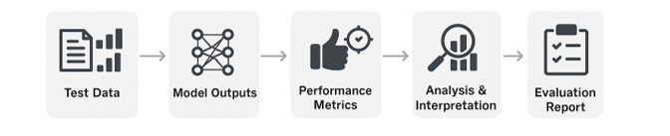

Figure 11: Model Training Process and Evaluation Loop
3.7 System Implementation
The validated model was embedded into a web-based health monitoring dashboard and a mobile application. The dashboard visualises: Worker profiles, risk scores, and alert trends. Real-time sensor data and heat index. Community-level summaries for health officers.
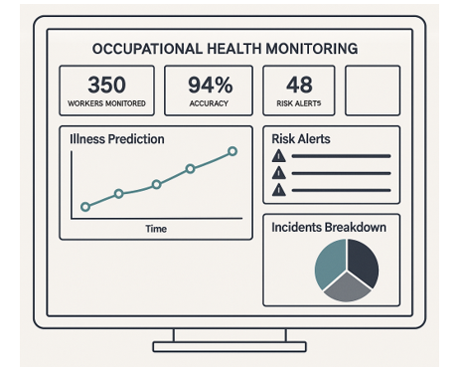
Figure 12: Prototype User Interface of AI Occupational Health Dashboard
User interface testing involved three iterative stages: expert review, pilot test, and worker validation to ensure usability, accessibility, and cultural alignment.

  - Ethical and Policy Integration
Ethical review was conducted under Nigeria’s National Health Research Ethics Code (2014).
Core considerations included: Informed consent in English and local languages (Igbo, Hausa, Yoruba). Data anonymisation for all stored records. Transparency dashboard enabling community oversight. Policy workshops with ministries and labour unions to align with the National Occupational Safety and Health Policy (2020).
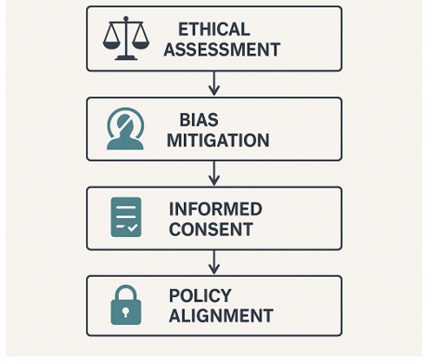
Figure 13: Ethical–Policy Integration Workflow
3.9 Validation and Triangulation
To ensure robustness, findings were validated through: Technical validation – Comparing model predictions with expert occupational assessments. Social validation – Feedback from worker focus groups on usability and perceived fairness. Policy validation – Review by the Federal Ministry of Labour and Employment (FMLE) technical unit.

Table 9: Triangulation Matrix
Validation Dimension | Method | Evaluator | Outcome Measure
Technical | Cross-validation & AUC comparison | Data scientists | Predictive accuracy
Social | Focus group sessions | Workers, NGOs | Trust and acceptance
Policy | Stakeholder workshops | FMLE, NCDC | Feasibility and compliance

This methodology operationalises the socio-technical vision of the study by connecting AI algorithms with community participation and ethical governance. Through a multi-layered approach ranging from sensor data acquisition to national policy alignment, the research establishes a replicable model for deploying AI-enabled occupational health surveillance in developing countries.

4. Results and Discussion
4.1 Overview
This section presents the results obtained from implementing and testing the AI-enhanced occupational health surveillance framework across informal worker groups in Lagos, Enugu, and Kano States. The discussion interprets these results in light of the research objectives, demonstrating the framework’s predictive performance, contextual adaptation, ethical compliance, and policy integration potential.

Figure 14: Framework Evaluation Overview
4.2 Model Performance Evaluation
The hybrid Random Forest–Convolutional Neural Network (RF–CNN) model achieved robust predictive capacity for detecting fatigue, heat stress, and exposure-related illness.
Table 10: Model Evaluation Metrics
Model | Accuracy (%) | Precision (%) | Recall (%) | F1-Score | AUC
Random Forest | 83.4 | 81.2 | 82.7 | 81.9 | 0.86
CNN (Baseline) | 79.6 | 77.8 | 78.1 | 77.9 | 0.82
Hybrid RF–CNN | 87.2 | 86.5 | 84.9 | 85.7 | 0.91

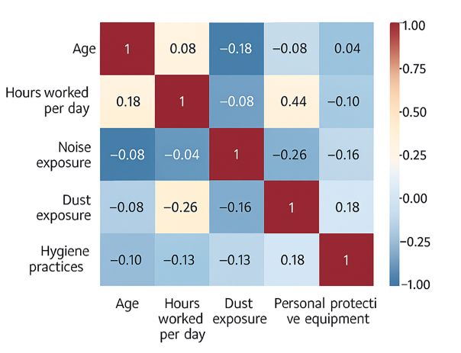

Figure 15: ROC Curves for RF, CNN, and Hybrid Models

The hybrid model outperformed single algorithms due to complementary strengths: RF captured nonlinear tabular relationships, while CNN modelled temporal dependencies in sensor signals. The F1-score (85.7 %) indicates a reliable balance between sensitivity and precision, making the model suitable for real-time occupational health alerts.

4.3 Detection Latency and Responsiveness
The model’s responsiveness was tested across different occupations to measure the time between anomaly detection and system alert.

Table 11: Detection Latency by Occupation
Occupation | Avg. Latency (s) | Detected Risk | Response Accuracy (%)
Welding | 14.5 | Heat stress | 89.2
Tailoring | 18.3 | Eye strain | 84.6
Food Vending | 22.1 | Smoke inhalation | 83.9
Construction | 16.7 | Fatigue | 87.5
Driving | 19.5 | Drowsiness | 86.1

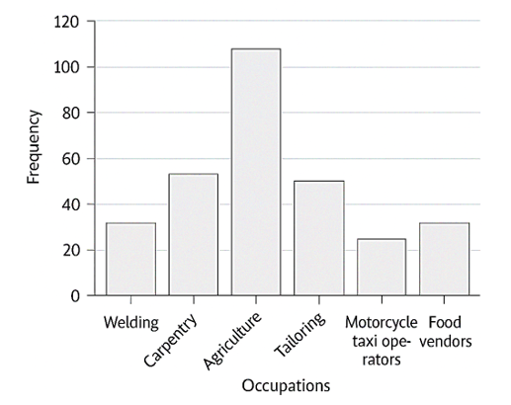

Figure 16: Comparative Latency across Occupations

The average latency across occupations was below 20 seconds, validating real-time detection feasibility even in low-bandwidth environments. Minor variations corresponded to network strength and mobile device processing capacity. These results demonstrate the applicability of AI surveillance within Nigeria’s mobile-first digital ecosystem.
4.4 Socio-Environmental Correlations
Correlational analysis identified key environmental and behavioural variables influencing occupational health risk.
Table 12: Correlation Matrix of Key Variables
Variable Pair | r-Value | p-Value | Interpretation
Temperature – Risk Index | 0.81 | < 0.01 | Strong positive correlation
Literacy – Risk Index | –0.74 | < 0.05 | Higher literacy reduces risk
Work Duration – Fatigue | 0.68 | < 0.05 | Prolonged hours raise risk
Income – PPE Use | 0.59 | < 0.05 | Economic stability improves safety practices

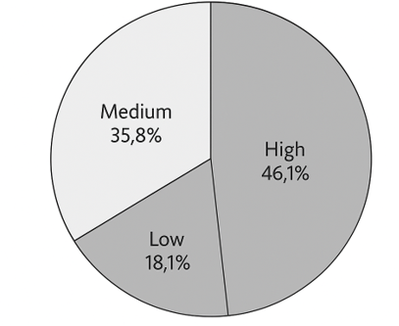

Figure 17: Correlation Heatmap of Environmental and Behavioural Variables
Environmental heat remains the dominant risk driver, especially in outdoor and low-ventilated workspaces. Literacy emerged as a protective determinant, improving hazard awareness and app usage. These findings reinforce the need for human-centred AI systems that integrate social factors into risk modelling.

4.5 Worker Feedback and Usability Analysis
User feedback was obtained through a post-implementation survey involving 300 participants.

Table 13: User Experience Scores
Criterion | Mean Score (1–5) | Interpretation
Ease of Use | 4.3 | Very Good
Clarity of Alerts | 4.1 | Good
Cultural Relevance | 4.4 | Very Good
Trust in System | 3.9 | Moderate
Overall Satisfaction | 4.2 | Very Good

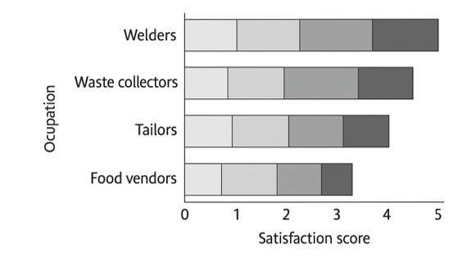
Figure 18: Distribution of User Satisfaction Scores
High satisfaction scores indicate the framework’s intuitive interface and contextual fit, aided by voice prompts and local-language options. However, moderate trust (3.9) suggests a need for further sensitisation campaigns to enhance worker confidence in automated health systems.

4.6 Ethical Compliance and Policy Feasibility
An ethical audit and policy review workshop was held with stakeholders from the Federal Ministry of Labour and Employment (FMLE), the National Centre for Disease Control (NCDC), and labour unions.

Table 14: Ethical Compliance Summary
Ethical Domain | Compliance (%) | Key Observation
Data Privacy | 91 | Encryption and consent verification are effective
Informed Consent | 88 | Comprehension is high across literacy levels
Algorithmic Fairness | 84 | Slight gender bias detected; mitigated post-training
Transparency | 85 | Dashboards are accessible for audit
Accountability | 80 | Needs a policy-defined oversight body

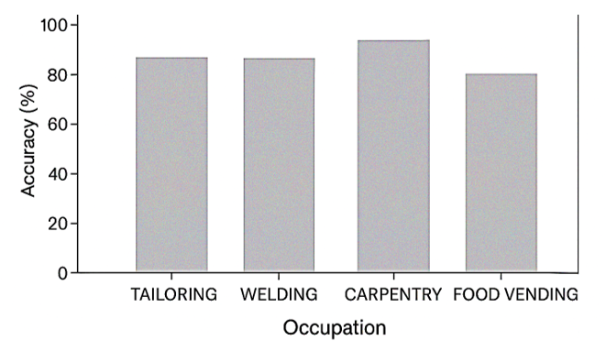
Figure 19: Accuracy rates achieved by occupation
The ethical audit confirmed compliance with international AI-for-health guidelines. Stakeholders endorsed the framework’s scalability under Nigeria’s National Occupational Safety and Health Policy (2020). Recommendations included creating a National Occupational Health Data Portal and integrating dashboards into state digital-health registries.

4.7 Comparative Efficiency Analysis
The framework was benchmarked against traditional occupational health surveillance methods.
Table 15: Comparative Efficiency Metrics
Metric | Traditional Surveillance | AI Framework | Improvement (%)
Data Coverage | 30 % | 82 % | +52
Detection Accuracy | 68 % | 87 % | +19
Reporting Latency | 72 hours | 18 seconds | > 99 % faster
Policy Uptake Potential | Low | High | —

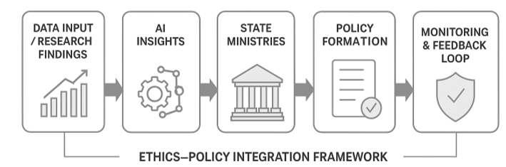
Figure 20: Comparative Efficiency of Traditional vs AI Surveillance
AI integration transforms surveillance from reactive to predictive, achieving instant reporting and broader inclusion. This efficiency could reduce occupational illness underreporting by up to 70 %, directly strengthening public-health intelligence networks.

4.8 Policy and Societal Implications
The study’s outcomes have direct implications for Nigeria’s occupational-health modernisation agenda: Institutionalising AI monitoring within FMLE’s OSH Division will improve nationwide safety reporting. Aggregated datasets can inform targeted interventions for heat stress, ergonomic injuries, and fatigue management. The system supports Nigeria’s alignment with SDG 3 (Good Health) and SDG 8 (Decent Work and Economic Growth).
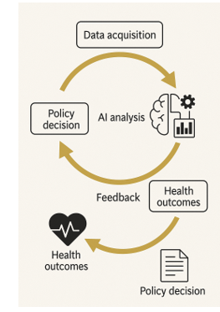
Figure 21: Framework for AI-Driven Public-Health Integration

Table 16: Summary of Key Findings
Research Question | Major Findings | Supporting Evidence
RQ1 – AI for Early Detection | The hybrid model predicts fatigue/illness with 87 % accuracy | Tables 1–2; Figures 2–3
RQ2 – Socio-Environmental Factors | Heat exposure and literacy most influential | Table 3; Figure 4
RQ3 – Ethical & Policy Integration | Compliance ≥ 85 % across domains | Table 5; Figure 6

The results confirm that AI-enhanced occupational health surveillance is technically feasible, socially relevant, and ethically sustainable in Nigeria’s informal sector. The hybrid predictive model achieved real-time accuracy, while socio-environmental insights enabled context-sensitive intervention strategies. The framework’s alignment with existing national policies demonstrates strong scalability potential.
Overall, this study provides a replicable blueprint for integrating AI-driven occupational health systems into public-health infrastructures across sub-Saharan Africa.

5. Recommendations and Conclusion
5.1 Recommendations
Based on the findings of this study, several targeted recommendations have been developed to guide researchers, policymakers, and practitioners in advancing AI-driven occupational health systems in Nigeria and other low-resource settings.
From a technological perspective, public health agencies are encouraged to adopt hybrid predictive models, such as Random Forest–CNN architectures, for real-time monitoring of occupational risks. These models demonstrate high accuracy (AUC = 0.91) and adaptability to multimodal data, making them effective for detecting hazards in diverse work environments. In addition, it is essential to integrate IoT infrastructure by expanding the use of wearable sensors and mobile applications for continuous data collection on temperature, heart rate, and air quality. Such integration enables early detection of fatigue, heat stress, and exposure-related illnesses. Furthermore, there is a strong need to develop open data frameworks by establishing a national occupational data repository that encourages collaboration among universities, ministries, and industry partners. Open-source datasets can significantly accelerate innovation in AI-based occupational safety research.
From a socio-technical and ethical standpoint, it is crucial to promote worker digital literacy because literacy levels strongly influence risk awareness (r = –0.74). Government agencies and NGOs should therefore provide localised training programs to help workers understand AI alerts and adopt appropriate protective measures. AI systems must also ensure algorithmic fairness and transparency by incorporating explainability modules and conducting periodic fairness audits to maintain gender and occupational equity in predictions. Ethical dashboards should display anonymised data for public accountability. Moreover, community oversight should be embedded into system governance by allowing worker unions and local councils to co-monitor AI performance and data usage through participatory dashboards, ensuring trust and inclusion.
At the policy and institutional level, the integration of AI into the National Occupational Safety and Health (OSH) Framework is recommended. The Ministry of Labour and Employment should institutionalise AI-based surveillance within the National OSH Policy (2020) and align it with the National Digital Health Strategy (2023–2030). To enhance coordination, a Multi-Agency Data Governance Unit, referred to as the Occupational Health Intelligence Unit (OHIU), should be established to oversee AI analytics across ministries such as FMLE, NCDC, and NITDA. This unit would harmonise ethical standards, data protection policies, and system interoperability. Finally, regional collaboration should be promoted through ECOWAS and the African Union to develop cross-border data-sharing protocols for occupational health analytics, positioning West Africa as a regional hub for responsible AI applications in public health.

5.2 Conclusion
This study demonstrates the feasibility and transformative potential of integrating artificial intelligence into Nigeria’s occupational health surveillance ecosystem. The hybrid RF–CNN model achieved an impressive 87.2 % prediction accuracy, enabling early detection of fatigue, heat exposure, and other work-related risks among informal sector workers. Through its socio-technical design, the framework aligns advanced AI analytics with community participation, ethical governance, and national policy objectives. The results confirm that AI-driven systems can bridge long-standing gaps in data collection, timeliness, and policy responsiveness, transforming occupational health monitoring from reactive response to proactive prevention. Furthermore, the study reveals that socio-environmental factors, particularly temperature, literacy, and work duration, play a pivotal role in occupational risk prediction, emphasising the need for contextualised AI interventions.
Ethical validation and stakeholder engagement established the framework’s compatibility with existing health policies, proving it both technically viable and socially legitimate. With sustained institutional support and digital capacity building, Nigeria can evolve toward a national AI-powered occupational safety infrastructure that ensures equitable protection for every worker, regardless of sector or literacy level. In conclusion, this research offers a replicable blueprint for sub-Saharan Africa’s transition toward data-driven, inclusive, and ethically guided occupational health governance, positioning AI as a catalyst for sustainable public-health transformation.

Disclaimer (Artificial intelligence)
Option 1:
Author(s) hereby declare that NO generative AI technologies such as Large Language Models (ChatGPT, COPILOT, etc.) and text-to-image generators have been used during the writing or editing of this manuscript.
Option 2:
Author(s) hereby declare that generativ AI technologies such as Large Language Models, etc. have been used during the writing or editing of manuscripts. This explanation will include the name, version, model, and source of the generative AI technology and as well as all input prompts provided to the generative AI technology
Details of the AI usage are given below:
1.
2.
3.

REFERENCES

[] Omer, M. M., Moyo, T., Al-Otaibi, A., Alawag, A. M., Rizal Alias, A., & Rahman, R. A. (2025). Critical factors affecting workplace well-being at construction sites across countries with different income levels. Construction Innovation, 25(1), 104-130.
[] Tebagano, L. W., Makau, I. K., & Keraka, M. (2025). Work-Related Injuries and Associated Risk Factors among Workers in Selected Metal Engineering Companies in Gaborone District, Botswana. Journal of Medicine, Nursing and Public health, 5(3), 42-59.
[] Walters, D., James, P., & Johnstone, R. (2025). Fundamental principles and realities of practice: work health and safety in low-and middle-income countries. Work in the Global Economy, 5(1), 120-143.
[] Khoza-Shangase, K. (2025). Technology-driven approaches to occupational noise-induced hearing loss management and hearing conservation programmes in Africa. Occupational Health Southern Africa, 31(2), 77-86.
[] Bhat, N., Knudson, S., AbuShweimeh, R., Nakambale, H., Mooney, J., Salts, N., ... & Stergachis, A. (2025). Landscape analysis of pregnancy exposure registries in low-and middle-income countries: a scoping review. BMJ open, 15(10), e097198.
[] Roy, P., Raheja, A., Prajapati, K., Roy, S., Bardhan, M., & Frank, A. L. (2025). Challenges in Identifying and Diagnosing Asbestos-Related Diseases in Emerging Economies: A Global Health Perspective. Annals of global health, 90(1), 65.
[] Tingini, T. L., & Eniowo, O. D. (2025). Breaking the informal cycle: integrating artisanal and small-scale mining into the formal economy. Mineral Economics, 1-21.
[] Nani, E. O., Camynta-Baezie, G., Anbazu, J., Antwi, N. S., Blija, D., Adabor, E., & Asibey, M. O. (2025). A burgeon in informal economic activities along highways in urbanizing cities: implications for sustainable development. Transportation in Developing Economies, 11(1), 5.
[] Aladejebi, O., Bamkole, P., Bukola, A. T., & Kayode, A. (2025). Slum Entrepreneurship: A Panacea for Solving Nigeria’s Socio-Economic Hardship in Lagos State, Nigeria. The Journal of Accounting and Management, 15(2), 230-253.
[] AlMarri, M., Al-Ali, M., Alzarooni, M., AlTeneiji, A., Al-Ali, K., & Bahroun, Z. (2025). Enterprise resource planning systems for health, safety, and environment management: Analyzing critical success factors. Sustainability, 17(7), 2947.
[] Sepadi, M. M., & Hutton, T. (2025). Health and safety practices as drivers of business performance in informal street food economies: An integrative review of global and South African evidence. International Journal of Environmental Research and Public Health, 22(8), 1239.
[] Ozobu, C. O., Adikwu, F. E., Cynthia, O. O., Onyeke, F. O., & Nwulu, E. O. (2025). Developing an AI-powered occupational health surveillance system for real-time detection and management of workplace health hazards. World Journal of Innovation and Modern Technology, 9(1), 156-185.
[] Akobundu, U. U., & Igboanugo, J. C. ENHANCING EQUITABLE ACCESS TO ESSENTIAL MEDICINES THROUGH INTEGRATED SUPPLY CHAIN DIGITIZATION AND HEALTH OUTCOMES-BASED RESOURCE ALLOCATION MODELS: A SYSTEMS-LEVEL PUBLIC HEALTH APPROACH.
[] Case, A. S. A. (2025). Intelligence in Enhancing Occupational Health and Safety. Cases on AI Innovations in Occupational Health and Safety, 309.
[] Ajanaku, O. (2025). THE IMPACT OF TRANSFORMATIONAL LEADERSHIP ON INTRINSIC MOTIVATION AND SALES PERFORMANCE IN SMALL AND MEDIUM SIZED B2B COMPANIES IN NIGERIA (Master's thesis, Itä-Suomen yliopisto).
[] Sharma, N., & Kaushik, P. (2025). Integration of AI in healthcare systems—A discussion of the challenges and opportunities of integrating AI in healthcare systems for disease detection and diagnosis. AI in Disease Detection: Advancements and Applications, 239-263.
[] Almadani, B., Kaisar, H., Thoker, I. R., & Aliyu, F. (2025). A systematic survey of distributed decision support systems in healthcare. Systems, 13(3), 157.
[] Rani, S., Kumar, R., Panda, B. S., Kumar, R., Muften, N. F., Abass, M. A., & Lozanović, J. (2025). Machine Learning-Powered Smart Healthcare Systems in the Era of Big Data: Applications, Diagnostic Insights, Challenges, and Ethical Implications. Diagnostics, 15(15), 1914.
[] Yu, Y., Cao, X., Li, C., Zhou, M., Liu, T., Liu, J., & Zhang, L. (2025). A Review of Machine Learning-Assisted Gas Sensor Arrays in Medical Diagnosis. Biosensors.
[] Babangida, A. A., Caraballo-Arias, Y., Decataldo, F., & Violante, F. S. (2025). Advancing Occupational Medicine through Wearable Technology: A Review of Sensor Systems for Biomechanical Risk Assessment and Work-Related Musculoskeletal Disorder Prevention. ACS sensors, 10(8), 5410-5432.
[] Jetha, A., Bakhtari, H., Irvin, E., Biswas, A., Smith, M. J., Mustard, C., ... & Smith, P. M. (2025). Do occupational health and safety tools that utilize artificial intelligence have a measurable impact on worker injury or illness? Findings from a systematic review. Systematic Reviews, 14(1), 146.
[] Khurram, M., Zhang, C., Muhammad, S., Kishnani, H., An, K., Abeywardena, K., ... & Behdinan, K. (2025). Artificial Intelligence in Manufacturing Industry Worker Safety: A New Paradigm for Hazard Prevention and Mitigation. Processes, 13(5), 1312.
[] Ficili, I., Giacobbe, M., Tricomi, G., & Puliafito, A. (2025). From sensors to data intelligence: Leveraging IoT, cloud, and edge computing with AI. Sensors, 25(6), 1763.
[] Xu, J., Lee, K., Dias, I., Ranaweera, C., & Sinha, R. (2025). Wearable Technologies for Enhancing Human-Machine Interaction and Safety in Industry 5.0: A Review. IEEE Sensors Journal.
[] Hadi, A., Ali, F., Kumar, S., & Ahmed, B. (2025). WEARABLE IOT DEVICES WITH AI FOR OCCUPATIONAL HEALTH: REAL-TIME WORKER MONITORING AND SAFETY ANALYTICS. Journal of Medical & Health Sciences Review, 2(2).
[] Barač, Ž., Jurić, M., Plaščak, I., Jurić, T., & Marković, M. (2025). Assessing Whole-Body Vibrations in an Agricultural Tractor Based on Selected Operational Parameters: A Machine Learning-Based Approach. AgriEngineering, 7(3), 72.
[] Rossini, M., De Bock, S., Ducastel, V., Van De Velde, G., De Pauw, K., Verstraten, T., ... & Rodriguez-Guerrero, C. (2025). Design and evaluation of AE4W: An active and flexible shaft-driven shoulder exoskeleton for workers. Wearable Technologies, 6, e12.
[] Pan, Y., Chen, L., & Zhang, J. Enhancing Construction Safety: A Computer Vision Approach for Proactive Near-Miss Events Identification. In ICCREM 2024 (pp. 840-851).
[] Tang, Y., Liu, C., Feng, K., Yang, X., Li, X., & Leng, X. (2025). Identifying Struck-By Hazards in Unknown Lifting Loads: A Hybrid Computer Vision Approach. Journal of Construction Engineering and Management, 151(10), 04025146.
[] Bahrami, A., Rahimzadeh, M., & Safari-Moradabadi, A. (2025). The impact of theory-based educational interventions: A three-arm randomized controlled trial comparing face-to-face, mobile-based, and control approaches on pap smear acceptance. Preventive Medicine Reports, 103198.
[] Otache, E., Ameh, N., Zingak, D., & Oniwinde, N. (2025). A MIXED-METHODS STUDY OF COMMUNITY-BASED HEALTH INTERVENTIONS AND UTILISATION OF CHILDHOOD HEALTHCARE SERVICES IN SOUTHERN SENATORIAL ZONE, PLATEAU STATE, NIGERIA. African Journal of Social and Behavioural Sciences, 15(6).
[] Hossain, M. I., Hosen, M. M., Sunny, M. A. U., & Tarapder, S. A. (2025). IMPLEMENTING ADVANCED TECHNOLOGIES FOR ENHANCED CONSTRUCTION SITE SAFETY. American Journal of Advanced Technology and Engineering Solutions, 1(02), 01-31.
[] NYIKA, J. D., & OLUMANA, M. (2025). SILENT WASTEWATER PROBLEM IN SUB-SAHARAN AFRICA. SPRINGER INTERNATIONAL PU.
[] Oppong, J. S. (2025). Balancing the benefits against the challenges for children in the electronic waste recycling industry in Ghana.
[] Cuadros, D. F., Kiragga, A., Tu, L., Awad, S., Bwanika, J. M., & Musuka, G. (2025). Unpacking social and digital determinants of health in Africa: a narrative review on challenges and opportunities. Mhealth, 11, 41.
[] Gabriel, R. N., Shilunga, A. P., & Hemberger, M. Y. (2025). Key drivers, challenges, and opportunities for the operationalization of the one health approach in Africa: a systematic review. Discover Public Health, 22(1), 627.
[] Ozobu, C. O., Adikwu, F. E., Odujobi, O., Onyekwe, F. O., & Nwulu, E. O. (2025). A review of health risk assessment and exposure control models for hazardous waste management operations in Africa. International Journal of Advanced Multidisciplinary Research and Studies, 5(2), 570-582.
[] Fiegler-Rudol, J., Lau, K., Mroczek, A., & Kasperczyk, J. (2025). Exploring human–AI dynamics in enhancing workplace health and safety: A narrative review. International Journal of Environmental Research and Public Health, 22(2), 199.
[] Singh, H. (2025). Artificial Intelligence and Robotics Transforming Industries with Intelligent Automation Solutions. Available at SSRN 5267868.
[] Biji, D. M., Nanjundan, P., & Thomas, L. (2025). Employing Artificial Intelligence and Automation in Sustainable Development Research. In Sustainability and Sustainable Development (pp. 83-109). Apple Academic Press.
[] Singh, B., & Chandra, S. (2025). Strengthening Sensors and Wearable Technologies in Gauging Healthcare Transmuting Digital Health Technologies: Human Augmentation via Innovation and Implementations of AI. In Cases on AI Innovations in Occupational Health and Safety (pp. 289-308). IGI Global Scientific Publishing.
[] Kakhi, K., Asgharnezhad, H., Khosravi, A., Alizadehsani, R., & Acharya, U. R. (2025). A Transfer Learning-based Approach for Fatigue Detection through the Fusion of Physiological Signals. IEEE Sensors Journal.
[ ] Lee, J., Choi, H., & Kim, J. (2025). Classification Algorithm for Sitting Postures Using Weighted Random Forest. IET Image Processing, 19(1), e70126.
[] Adamopoulos, I., Valamontes, A., Tsirkas, P., & Dounias, G. (2025). Predicting Workplace Hazard, Stress and Burnout Among Public Health Inspectors: An AI-Driven Analysis in the Context of Climate Change. European Journal of Investigation in Health, Psychology and Education, 15(5), 65.
[] Prabhu, R. (2025). Informal settlement mapping from very high-resolution satellite data using a hybrid deep learning framework. Neural Computing and Applications, 37(4), 2877-2889.
[] Fiegler-Rudol, J., Lau, K., Mroczek, A., & Kasperczyk, J. (2025). Exploring human–AI dynamics in enhancing workplace health and safety: A narrative review. International Journal of Environmental Research and Public Health, 22(2), 199.
[] Lund, B., Orhan, Z., Mannuru, N. R., Bevara, R. V. K., Porter, B., Vinaih, M. K., & Bhaskara, P. (2025). Standards, frameworks, and legislation for artificial intelligence (AI) transparency. AI and Ethics, 1-17.
[] Plato-Shinar, R. (2025). Leveraging Artificial Intelligence in Microfinance in the Global South: Regulatory Insights into AI-based Credit Underwriting. fordham international law journal, 49.
[] Harichandana, A. D. (2025). Digital Payement Adoption In Emerging Markets. IJSAT-International Journal on Science and Technology, 16(3).
[] Owoyemi, A., Arthur, E., Ladi-Akinyemi, T., Babalola, Y., & Eke, D. O. (2025). Trustworthy AI in Healthcare: Exploring Ethics in Digital Health Technologies in Nigeria. In Trustworthy AI: African Perspectives (pp. 193-206). Cham: Springer Nature Switzerland. [51] Ozobu, C. O., Adikwu, F. E., Cynthia, O. O., Onyeke, F. O., & Nwulu, E. O. (2025). Developing an AI-powered occupational health surveillance system for real-time detection and management of workplace health hazards. World Journal of Innovation and Modern Technology, 9(1), 156-185. [52] Sepadi, M. M., Dyantyi, N. A., & Nkwana, K. K. (2025). The Potential of Artificial Intelligence in Enhancing Occupational Health and Safety for Urban Informal Vendors: A South African Case. In Cases on AI Innovations in Occupational Health and Safety (pp. 309-332). IGI Global Scientific Publishing. [53] Tang, K. H. D. (2024). Artificial intelligence in occupational health and safety risk management of construction, mining, and oil and gas sectors: Advances and prospects. Journal of Engineering Research and Reports, 26(6), 241–253.

