Original Research Article

Near Real-Time Monitoring and Time Series Analysis of Water Bodies in Coimbatore District Using Google Earth Engine and Machine Learning Algorithms.

.
ABSTRACT

This study presents a Google Earth Engine (GEE)-based web application for near real-time monitoring and time series analysis of water bodies in Coimbatore district using Sentinel-1A SAR data. The application generates dynamic water area maps from 2015 to the present and enables users to select individual lakes and tanks from a dropdown menu for focused analysis. Validation was carried out using five major lakes, where historical water spread data derived from Sentinel-2 NDVI and NDWI indices were compared with SAR-derived results, showing high accuracy. A case study on Kadamparai Dam involved extracting time series data from the platform and applying multiple machine learning models for prediction; the Random Forest Regressor (R2=0.728, MSE=0.005, MAE=0.059) achieved the highest accuracy among other ML algorithms. The tool supports climate change impact assessment and hydrological analysis, and also aids agricultural planning by offering timely and critical insights into water availability trends.

Keywords: Water Body Monitoring, Time Series Analysis, Random Forest, GEE

1. INTRODUCTION

Water bodies play a vital role in supporting agricultural productivity, ecological balance, and local livelihoods, particularly in semi-arid regions like Coimbatore district in Tamil Nadu, India. The region is dotted with tanks and lakes that serve as critical sources of irrigation and drinking water. As water availability becomes increasingly variable due to climate change, monitoring these surfaces water bodies over time has become a key aspect of water resource management [1].
Conventional methods of monitoring water bodies through ground-based surveys are time-consuming and often limited in spatial coverage. Remote sensing has emerged as a valuable alternative, enabling frequent and large-scale assessment of water bodies using optical or radar imagery [2]. While optical sensors such as Sentinel-2 provide vegetation and moisture indices, they are restricted by cloud cover during monsoon seasons. Synthetic Aperture Radar (SAR) data from Sentinel-1, with its all-weather, day-and-night imaging capabilities, offers an effective solution for delineating surface water [3].
Recent advancements in cloud computing platforms, notably Google Earth Engine (GEE), have further revolutionized large-scale geospatial data processing. GEE allows for real-time analysis of vast datasets, offering researchers and decision-makers the ability to monitor environmental changes efficiently [4]. This study presents a GEE-based web application tailored for the monitoring and temporal analysis of water bodies in Coimbatore using Sentinel-1A SAR imagery.
The objectives of this study are as follows:
- To develop an interactive web application using GEE for spatial and temporal analysis of water bodies in the Coimbatore district;
- To map water spread areas from 2015 to the present using Sentinel-1 SAR imagery;
- To validate the SAR-derived water extent against Sentinel-2-based NDVI and NDWI indices;
- To apply machine learning (ML) models to predict future water spread patterns using time series data.
This approach enhances accessibility to hydrological insights and supports climate resilience strategies in water-scarce regions.

2. STUDY AREA

The study area selected for this research is Coimbatore district, situated in the western part of Tamil Nadu, India (Fig. 1). Geographically located between 10°37′N to 11°24′N latitude and 76°39′E to 77°05′E longitude, the district spans approximately 4,723 square kilometers and lies within the rain shadow region of the Western Ghats.

Coimbatore is characterized by a semi-arid climate and depends heavily on seasonal rainfall for surface water replenishment. The district hosts a network of man-made and natural tanks, reservoirs, and lakes, which are essential for irrigation, groundwater recharge, and domestic water use. These water bodies form an intricate part of the local hydrology, particularly important during dry months when groundwater levels decline (Table 1).

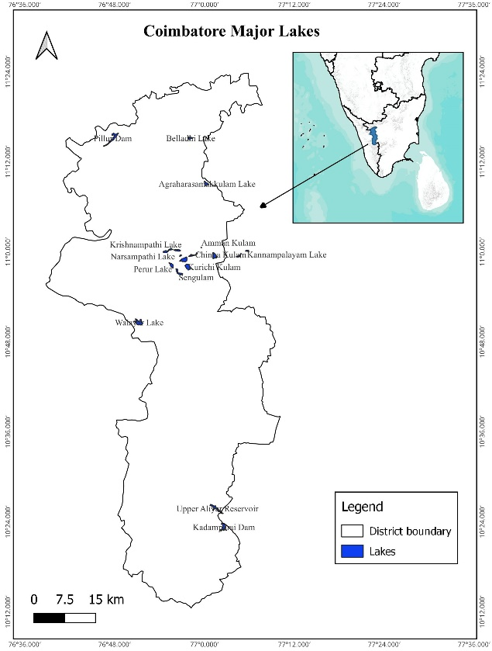
Fig.1 Study area showing the location of maps and surrounding towns where the yellow boundary is the limit.
Table 1. List of major lakes and tanks considered in Coimbatore district

Water Body Name
Pillur Dam | Narsampathi Lake
Walayar Lake | Belladhi Lake
Kurichi Kulam | Pallapalayam Lake
Upper Aliyar Reservoir | Kumaraswamy Lake
Ukkadam Tank | Krishnampathi Lake
Kadamparai Dam | Kannampalayam Lake
Singanallur Tank | Selvampathy Lake
Sengulam | Chinna Kulam
Perur Lake | Selva Chinthamani Kulam
Agraharasamakkulam Lake | Amman Kulam

3. material and methods

This study integrates cloud computing, open-source software, and machine learning techniques to monitor surface water spread across Coimbatore district. The primary data sources include Sentinel-1 Synthetic Aperture Radar (SAR) imagery for water body detection and Sentinel-2 optical data for vegetation and water index validation. SAR data is particularly effective for monitoring water bodies in tropical regions as it penetrates cloud cover and captures surface reflectance under all weather conditions [5]. Optical indices such as the Normalized Difference Vegetation Index (NDVI) and the Normalized Difference Water Index (NDWI) derived from Sentinel-2 were used as baselines for validating water extent.

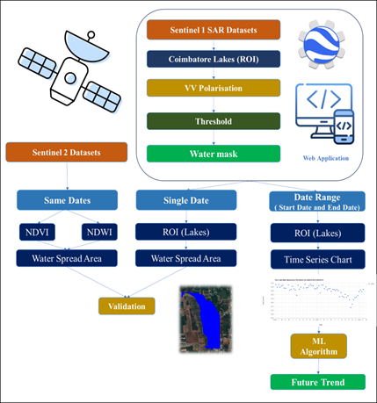
Fig 2. Methodology workflow for water body monitoring and prediction using GEE and machine learning.
Data preprocessing, spatial visualization, and geospatial layer handling were carried out using QGIS. The core water spread detection and time-series analysis were implemented on the Google Earth Engine (GEE) platform using JavaScript, due to its efficient handling of multi-temporal satellite archives [4]. GEE enables large-scale geospatial computations in the cloud, minimizing local storage and processing limitations [6]. Additionally, Python scripts were used in a Jupyter environment to apply statistical modelling and machine learning techniques for predictive analysis.

The methodology (Fig. 2) involved masking the region of interest and preprocessing Sentinel-1 SAR data. A threshold-based classification approach was used to detect water pixels using VV polarization. The results were validated for the Kadamparai Dam using Sentinel-2 NDVI and NDWI indices on near-identical dates. Visual comparisons (Fig. 3) and scatter plots (Fig. 4) were generated, showing high correlations between Sentinel-1 and Sentinel-2-derived water spread values.

The computed accuracy metrics (Table 2) demonstrate strong agreement. These results confirm the effectiveness of SAR-based classification for water delineation in the region.

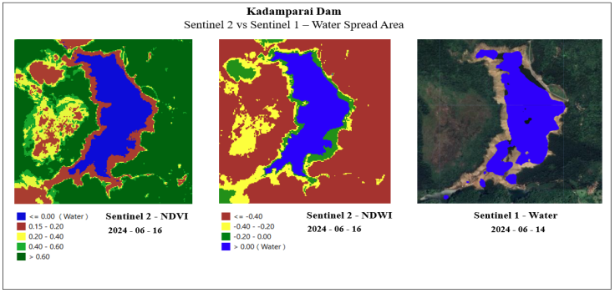
Fig 3. Visual comparison of Sentinel-2 NDVI and NDWI vs. Sentinel-1 SAR-derived water spread areas for selected lakes.

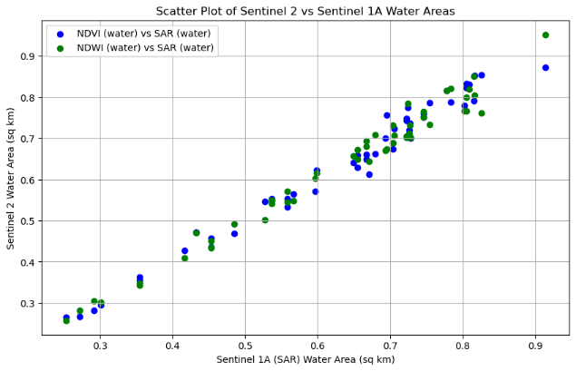
Fig 4. Scatter plot comparison of Sentinel-2 (NDVI and NDWI) and Sentinel-1 SAR water spread area values.

Table 2. Metrics comparing sentinel-2 ndvi and ndwi with sentinel-1 sar-derived water spread area.
 | NDVI vs SAR | NDWI vs SAR
R2 | 0.9792 | 0.9796
MSE | 0.0006 | 0.0006
MAE | 0.0196 | 0.0189

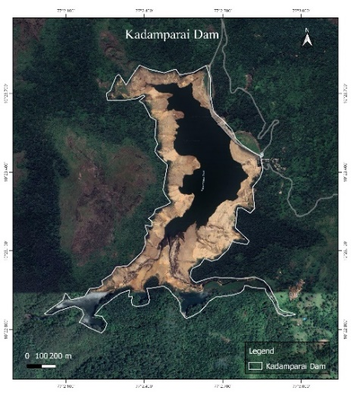
Fig 5. Satellite view of Kadamparai Dam showing study area extent

A focused case study was performed on the Kadamparai Dam (Fig. 5) to forecast future water spread using historical time-series data extracted from the GEE application. The dataset included monthly water spread values from 2015 to 2024.
For predictive modelling, several machine learning (ML) algorithms were trained and evaluated (Table 3).
Table 3: Model performance metrics
Accuracy | MSE | MAE | R2
Random Forest Regressor | 0.005 | 0.059 | 0.728
Support Vector Regressor | 0.016 | 0.104 | 0.151
Decision Tree Regressor | 0.017 | 0.103 | 0.067
Ridge Regression | 0.011 | 0.089 | 0.398
Linear Regression | 0.011 | 0.089 | 0.398
LightGBM Regressor | 0.012 | 0.098 | 0.348
XGBoost Regressor | 0.005 | 0.059 | 0.713
ARIMA | 0.028 | 0.15 | -0.495
SARIMA | 0.015 | 0.097 | 0.19

Among these, the Random Forest Regressor showed the highest performance with the lowest Mean Squared Error (MSE) and highest R² score. Fig. 6 shows the actual vs. predicted water spread trends using the Random Forest model.
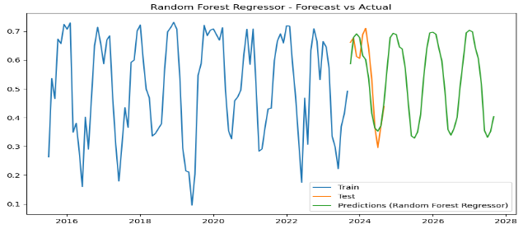
Fig 6. Water spread area prediction for Kadamparai Dam using Random Forest Regressor (Actual vs. Forecast).

These results demonstrate the potential of combining SAR-based time series with machine learning for reliable water forecasting, supporting proactive water management strategies.

4. results and discussion

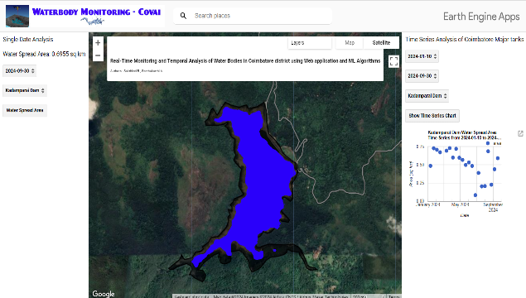
Fig 7. Screenshot of the GEE-based web application interface for Coimbatore district.

The developed Google Earth Engine (GEE)-based web application provides an interactive, map-centric environment for monitoring the spatial and temporal dynamics of water bodies across Coimbatore district https://sakthigis.projects.earthengine.app/view/covaiwater (Fig. 7).

The platform integrates Sentinel 1 SAR time series, lake/tank boundaries, and on-the-fly visualization tools, enabling users to query any selected water body for a given date or period and instantly view the corresponding water spread map and time series chart. This design directly addresses the operational need for a near real-time, user-friendly decision-support system for local line departments, researchers, and farmers. The use of cloud computing also eliminates the need for high-end hardware and enables scalable analysis, which is critical in data-intensive hydrological monitoring scenarios.

4.1 Spatio-temporal dynamics of water spread

The time series analysis from 2015 to 2024 reveals clear seasonal patterns in water spread across the major lakes and tanks in Coimbatore district. During the northeast monsoon months (October to December), most reservoirs and tanks exhibit a marked increase in water spread, whereas pre-monsoon months (March to May) are characterized by significantly reduced extents, particularly in smaller and shallow tanks such as Amman Kulam and Chinna Kulam. These patterns are consistent with the semi-arid climate of the district and its dependence on episodic rainfall and upstream reservoir releases for surface water replenishment [8].

Inter-annual variability is also evident in the time series, where years with below-normal rainfall show sustained low water spread across many tanks, indicating an increased risk of hydrological drought and reduced irrigation potential. For example, in relatively dry years, several minor tanks fail to reach their full capacity even during the monsoon season, while major reservoirs like Pillur Dam and Kadamparai Dam retain a minimum operational storage due to regulated inflows. Such distinctions between major and minor water bodies underscore the importance of tank restoration and conjunctive use strategies for climate-resilient water management [1] .

The ability to visualize temporal anomalies is an important feature of the application. Years with unusually prolonged low water spread, or delayed filling of tanks, can be quickly identified via the time series plots, providing critical information for early warning of water stress. This aligns with previous studies that highlight the role of satellite-based surface water mapping and time series analysis in drought assessment and hydrological anomaly detection [1],[2],[3].

4.2 Performance of Sentinel 1 SAR for water delineation

The comparison between Sentinel 1 SAR-derived water spread and Sentinel 2 NDVI/NDWI-based estimates for selected lakes demonstrates high consistency and accuracy. The validation results (Table 2) show strong coefficients of determination (R² ≈ 0.98) and low error metrics (MSE ≈ 0.0006; MAE ≈ 0.02), indicating that the threshold-based VV-polarization classification strategy is robust for discriminating water and non-water classes in the Coimbatore context. These findings confirm that Sentinel 1 SAR can reliably capture water extent even under cloudy conditions when optical imagery is unavailable, thus ensuring continuous monitoring through monsoon and cyclone seasons.

The high correlations obtained are comparable to, or better than, similar SAR-based water mapping studies that employ automatic thresholding and GEE-based processing workflows in different geographic settings [1],[2],[3]. Recent applications using Sentinel 1 and GEE for flood and surface water monitoring have reported that SAR backscatter histograms of water and land are sufficiently separable to support robust binary classification, provided appropriate speckle filtering and orbit-specific calibration are carried out. The present work aligns with these results, demonstrating that a relatively simple thresholding approach, when implemented within a cloud platform, can yield operational-quality water masks for a large number of small and medium-sized water bodies.

The validation exercise also reveals certain limitations. In narrow channels, highly vegetated littoral zones, or areas with mixed pixels at the water–land boundary, the SAR-based classification may either underestimate or overestimate water extent. Wind-induced roughness, emergent vegetation, and infrastructure (e.g., bridge piers) can alter backscatter signatures and potentially introduce classification noise. Nevertheless, these local uncertainties do not significantly affect the overall accuracy at the lake or tank scale, especially when the objective is to monitor aggregate water spread trends over time rather than exact shoreline positions.

4.3 Functionality and practical utility of the GEE web application

The web application’s interface allows users to select any lake or tank from a dropdown menu, specify a date or time range, and view the corresponding water spread map along with a time series chart of area values (Fig. 7). This level of interactivity is particularly valuable for non-expert stakeholders who may not be familiar with scripting or advanced GIS tools. By encapsulating the data preprocessing, image filtering, and classification logic within the GEE code, the platform presents only the essential outputs such as maps and charts, thereby lowering the entry barrier for data-driven water management [14],[15].

From an operational standpoint, the application supports multiple use cases:

Routine monitoring of reservoir and tank status at weekly or monthly intervals.

Assessment of storage build-up during the monsoon and depletion during the irrigation season.

Identification of tanks with persistent low storage, where desilting or catchment treatment may be prioritized.

Visualization of long-term trends to support climate resilience planning and water policy formulation.

These capabilities resonate with recent efforts to use GEE-based tools for large-scale surface water mapping and flood monitoring, where web applications provide rapid access to processed information for disaster managers and water agencies [1],[2]. The present study extends this concept to a district-level, multi-tank monitoring framework that is tailored to the needs of semi-arid agricultural regions.

4.4 Machine learning-based forecasting of water spread

The focused case study on Kadamparai Dam illustrates how historical Sentinel 1 SAR-derived water spread data can be combined with machine learning (ML) algorithms to forecast future storage conditions. Using monthly water spread values from 2015 to 2024, multiple regression models were trained and evaluated, including Random Forest, XGBoost, and Gradient Boosting regressors (Table 3). Among these, the Random Forest Regressor achieved the best performance, with relatively low MSE and MAE values and the highest R² score, indicating strong agreement between predicted and observed water spread.

The superior performance of Random Forest is consistent with recent hydrological forecasting studies where ensemble tree-based models have outperformed traditional linear and autoregressive models in capturing nonlinear relationships between inputs and water levels or storage [4],[11],[13],[16],[17]. Ensemble methods such as Random Forest and XGBoost are particularly effective in handling noisy, multi-year time series and can model complex interactions between climate drivers, inflows, and reservoir operations [9],[10]. In the present context, the models trained solely on SAR-derived water spread demonstrate that remotely sensed indicators alone can capture sufficient information to generate reasonably accurate short-term forecasts [4],[11],[12].

The prediction results (Fig. 6) show that the Random Forest model closely tracks the seasonal rise and fall in water spread at Kadamparai Dam, including intra-annual fluctuations associated with monsoon inflows and subsequent drawdown. While some deviations occur during extreme events or sudden operational changes, the model is able to reproduce the overall temporal pattern with high fidelity. This suggests that integrating such ML-based forecasts into the web application could provide an early indication of likely storage conditions in upcoming months, thereby assisting irrigation scheduling, power generation planning, and drought preparedness.

4.5 Implications for climate resilience and water governance

Long-term monitoring of lake and tank water spread at high temporal resolution offers valuable insights into the evolving hydrological regime of Coimbatore district under changing climate and land-use conditions. The multi-year time series from 2015 onward allow identification of trends such as progressive shrinkage of certain tanks, delayed filling patterns, or increased frequency of years with low storage. Such observations can guide interventions ranging from catchment conservation, tank rehabilitation, and canal maintenance to demand-side management measures in irrigated agriculture [13].

The integration of near real-time satellite monitoring and data-driven forecasting also supports adaptive and anticipatory water governance. For example, if the early monsoon period shows below-normal replenishment in key irrigation tanks, the forecasts can be used to adjust cropping patterns, promote less water-intensive crops, or schedule supplemental groundwater pumping within safe limits. In this way, the GEE-based application and associated ML models contribute to climate-resilient planning by linking large-scale Earth observation data with actionable local decisions.

At a broader scale, the approach demonstrated in this study can be transferred to other districts and basins with minimal modifications, given that Sentinel 1, Sentinel 2, and GEE are globally available. However, model parameters, threshold values, and ML configurations may require recalibration to account for differences in topography, land cover, reservoir operations, and climate regimes. Future work could also explore hybrid modeling frameworks that combine SAR/optical indices with rainfall, inflow, and evaporation data to further enhance forecast skill and extend lead times [7],[4],[11].

4.6 Limitations and future enhancements

Despite its strengths, the present system has several limitations. First, the SAR-based classification may be sensitive to local noise sources such as emergent vegetation, urban structures, and wind-induced surface roughness, particularly in small or narrow water bodies. Incorporating additional polarization information (e.g., VH), adaptive thresholding, or machine learning-based classification of SAR backscatter could further improve shoreline delineation. Second, the current ML models are trained on a single reservoir, which may limit their generalizability; extending the training dataset to multiple reservoirs and integrating hydro-meteorological variables would likely improve robustness.

From a user perspective, some stakeholders without prior exposure to geospatial tools may initially find it challenging to interpret satellite maps and time series plots. Structured training modules, in-application help, and explanatory dashboards (e.g., showing anomaly indices or standardized storage categories) could enhance usability and uptake. Finally, while GEE provides strong computational capabilities, performance can be affected when large areas, long time spans, or many concurrent users are involved, necessitating optimization of scripts and efficient data handling strategies.

Overall, the study demonstrates that a combination of Sentinel 1 SAR, GEE-based cloud computing, and ensemble machine learning can provide a practical, scalable, and relatively low-cost framework for near real-time water body monitoring and forecasting in semi-arid regions such as Coimbatore district, with clear applications in agricultural planning, drought management, and climate change adaptation.

5.Conclusion
This study successfully developed and validated a Google Earth Engine (GEE)-based web application for real-time monitoring and temporal analysis of water bodies in the Coimbatore district. By utilizing Sentinel-1 SAR imagery, the platform enables users to dynamically visualize and quantify water spread areas across major lakes and tanks. The application’s time series capabilities offer valuable insights into seasonal and interannual variations in water availability, which are critical for informed decision-making in agriculture and water resource management.

Validation against Sentinel-2 NDVI and NDWI indices confirmed the high accuracy of the SAR-derived water maps, reinforcing the reliability of the GEE-based classification approach. Moreover, a case study on the Kadamparai dam demonstrated the effectiveness of machine learning models in forecasting future water trends, with the Random Forest Regressor outperforming other algorithms in terms of prediction accuracy.

Overall, this integrated tool bridges the gap between satellite data processing and user-friendly visualization for stakeholders. It serves as a valuable asset for drought monitoring, cropping pattern planning, climate resilience assessment, and sustainable water management in the region.

Disclaimer (Artificial intelligence):

Author(s) hereby declares that NO generative AI technologies such as Large Language Models (ChatGPT, COPILOT, etc.) and text-to-image generators have been used during the writing or editing of this manuscript.

References

- Madu, I. A. (2007). The underlying factors of rural development patterns in the Nsukka region of Southeastern Nigeria. Journal of Rural and Community Development, 2, 110–122. View Paper
- Huang, H., Li, Q., & Zhang, Y. (2019). Urban residential land suitability analysis combining remote sensing and social sensing data: A case study in Beijing, China. Sustainability. https://doi.org/10.3390/su11082255
- Alsharif, A. A. A., & Pradhan, B. (2014). Urban sprawl analysis of Tripoli Metropolitan City (Libya) using remote sensing data and multivariate logistic regression model. Journal of the Indian Society of Remote Sensing, 42(1), 149–163. https://doi.org/10.1007/s12524-013-0299-7
- Gorelick, N., Hancher, M., Dixon, M., Ilyushchenko, S., Thau, D., & Moore, R. (2017). Google Earth Engine: Planetary-scale geospatial analysis for everyone. Remote Sensing of Environment, 202, 18–27. https://doi.org/10.1016/J.RSE.2017.06.031
- Alpers, W., Holt, B., & Zeng, K. (2017). Oil spill detection by imaging radars: Challenges and pitfalls. In 2017 IEEE International Geoscience and Remote Sensing Symposium (IGARSS) (pp. 1522–1525). https://doi.org/10.1109/IGARSS.2017.8127258
- Roy, D. P., Jin, Y., Lewis, P. E., & Justice, C. O. (2005). Prototyping a global algorithm for systematic fire-affected area mapping using MODIS time series data. Remote Sensing of Environment, 97(2), 137–162. https://doi.org/10.1016/j.rse.2005.04.007
- Bharath, H. A., Chandan, M. C., Vinay, S., & Ramachandra, T. V. (2018). Modelling urban dynamics in rapidly urbanising Indian cities. The Egyptian Journal of Remote Sensing and Space Science, 21, 201–210. https://doi.org/10.1016/j.ejrs.2017.08.002
- Maheshkumar P, Balaji Kannan, Sakthivel R, Geethakarthi A .(2025). Spatiotemporal Analysis of Land Use/Land Cover Changes and Urban Growth Dynamics in Salem District, India (1985–2024): Integrating Elevation and Infrastructure Networks. Madras Agricultural Journal (MAJ). Volume 112, Issue March (1-3), Pages 68-73. https://doi.org/10.29321/MAJ.10.700MA4
- Pal, M., & Mather, P. M. (2003). An assessment of the effectiveness of decision tree methods for land cover classification. Remote Sensing of Environment, 86(4), 554–565. https://doi.org/10.1016/S0034-4257(03)00132-9
- Aburas, M. M., Abdullah, S. H. O., Ramli, M. F., & Asha'Ari, Z. H. (2017). Land Suitability Analysis of Urban Growth in Seremban Malaysia, Using GIS Based Analytical Hierarchy Process. Procedia Engineering, 198, 1128–1136. https://doi.org/10.1016/j.proeng.2017.07.155
- Alpers, W., Holt, B., & Zeng, K. (2017). Oil spill detection by imaging radars: Challenges and pitfalls. In *2017 IEEE International Geoscience and Remote Sensing Symposium (IGARSS)* (pp. 1522–1525). IEEE. https://doi.org/10.1109/IGARSS.2017.8127258
- Chen, Z., Wang, Y., Li, X., Zhang, X., Li, X., Li, X., & Li, X. (2022). Automatic monitoring of surface water dynamics using Sentinel-1 SAR data on the Google Earth Engine platform. Remote Sensing of Environment https://doi.org/10.1016/j.rse.2022.113204
- Gandhi, U. (2020). Google Earth Engine for Water Resources Management: Applications and best practices. Spatial Thoughts. View Paper
- D. V. Manivannan, J. R., S. Pazhanivelan, R. Kumaraperumal, M. Raju, and R. P. Selvi, “Estimation of water spread area in selected tanks of Cuddalore district of Tamil Nadu using Sentinel-1A SAR data,” Int. J. Environ. Clim. Change, vol. 13, no. 9, pp. 3130–3136, Aug. 2023. https://doi.org/10.9734/ijecc/2023/v13i92555
- L. Yang, J. Driscol, S. Sarigai, Q. Wu, C. D. Lippitt, and M. Morgan, “Towards synoptic water monitoring systems: A review of AI methods for automating water body detection and water quality monitoring using remote sensing,” Sensors, vol. 22, no. 6, p. 2416, Mar. 2022.DOI: https://doi.org/10.3390/s22062416
- Linda. T. B, Sakthivel. R, Selvakumar. R and Geethakarthi. A, "Comparative Evaluation of K-Means and Random Forest Algorithms for Oil Spill Detection Using Sentinel-1 SAR Data.," 2025 International Conference on Emerging Techniques in Computational Intelligence (ICETCI), Hyderabad, India, 2025, pp. 1-4, https://doi.org/10.1109/icetci67340.2025.11258068
- Theres, B. L., & Sakthivel, R. (2022). Prediction of Soil Properties Using Quantile Regression Forest Machine Learning Algorithm – A Case Study of Salem and Rasipuram Block, Tamil Nadu, India. International Journal of Environment and Climate Change, 12(11), 2530-2553. https://doi.org/10.9734/ijecc/2022/v12i1131246

