Assessment of Surface Water Dynamics of the Jayakwadi Dam (2013–2023) Using Remote Sensing and GIS Techniques

.
ABSTRACT

The Jayakwadi Dam, commissioned in 1976 and located in the Chhatrapati Sambhaji Nagar district of Maharashtra, India, is a major source of drinking water for Chhatrapati Sambhaji Nagar city and an essential water supply for Jalna and Beed districts, as well as a key support system for regional agriculture. Effective monitoring of its surface water extent is therefore critical for water-resource planning and drought preparedness. This study estimates the reservoir’s surface-water area from 2013 to 2023 using remote sensing and Geographic Information System (GIS) techniques. Water bodies were delineated using the Normalized Difference Water Index (NDWI), computed from Landsat-8 Operational Land Imager (OLI) bands—Green (Band 3) and Near-Infrared (Band 5)—with a threshold of NDWI > 0 to extract water pixels. Seasonal variations were assessed using imagery from May (summer) and November (post-monsoon) for each year. The analysis reveals substantial inter annual and seasonal fluctuations, with surface-water area ranging from minimum: 91.41 km² during peak summer to maximum: 350km² in the post-monsoon period. The results demonstrate the effectiveness of NDWI-based monitoring for detecting hydrological variability and provide valuable inputs for reservoir operation, water-resource management, and drought-risk assessment in semi-arid regions.

Keywords: [Remote Sensing, Surface Water, NDWI, GIS, Jayakwadi Dam

1. INTRODUCTION

Water is a capital ability for comestible life, bread-and-butter development, and city expansion. The cardinal planning and development of cities abundantly depend on the availability and administration of water extent resources, with reservoirs and dams confined as basic infrastructures [1]. Dams not alone adapt water extent breeze but additionally comedy a analytical role in ensuring a constant water extent accumulation for agricultural, industrial, and calm needs. The Jayakwadi Dam, complete in 1976, stands as a key water extent antecedent for the surrounding regions, acknowledging agronomical lands, industries, and city populations in Maharashtra, India [2]. Given its importance, connected ecology of its water extent levels is acute for able water extent ability management.
One of the primary challenges in backlog administration is accurately ciphering water extent levels and apparent areas, which alter due to melancholia variations in rainfall, dehydration rates, and water extent acceptance [3]. In the case of the Jayakwadi Dam, the water extent akin decidedly increases during the cloudburst division due to abundant condensate and gradually decreases during dry months as water extent is activated for irrigation, automated activities, and city consumption. Thus, approved ecology is capital to ensure the able allocation of water extent assets and to abstain issues such as water extent absence or flooding.
Traditional methods of water monitoring, such as field surveys and manual measurements, though effective, are time-consuming, labour-intensive, and often limited in spatial coverage [4]. In contrast, Remote Sensing (RS) and Geographic Information System (GIS) technologies offer cost-effective, accurate, and timely solutions for large-scale water body monitoring. These tools allow researchers and policymakers to analyse changes in surface water areas over time, assess seasonal patterns, and make data-driven decisions for water resource management.
Remote assay utilizes accessory adumbration captured through alive (e.g., radar) and acquiescent (e.g., optical) sensors to aggregate abstracts on the Earth’s apparent [5]. This adumbration enables the identification and assay of water extent bodies, alike in alien or aloof regions. Landsat-8, with its multispectral imaging capabilities, provides high-resolution abstracts ideal for apparent water extent assay [6]. By applying ashen indices like the Normalized Difference Water Index (NDWI), advisers can finer differentiate water extent bodies from surrounding acreage features. NDWI, in particular, enhances water extent appearance in accessory images, enabling absolute abstraction of apparent water extent areas.
In Contempt years, RS and GIS techniques accept been broadly active in hydrological studies for applications such as flood accident assessment, watershed management, and city planning [7]. For instance, studies conducted in Iraq accept acclimated these technologies to assay the ampules of urbanization on water extent resources, alms insights into acceptable development strategies. Similarly, alien assay has authentic invaluable in anecdotic abeyant rainwater agriculture zones, acceptable in water extent attention efforts.
The affiliation of RS and GIS with clay assay added enhances water extent ability management. Clay arrangement and agreement decidedly access water extent assimilation and runoff patterns [8]. By employing apparatus acquirements models like the Radial Basis Function (RBF) network, advisers can authorize correlations amid clay backdrop and hydrological responses, convalescent flood anticipation models and water extent administration affairs [9]. Additionally, land use/land cover (LULC) allocation through supervised techniques has been acclimated in regions like Al-Rumba City to map bald soil, built-up land, agronomical zones, and water extent bodies, accidental to the sustainability of dams like Al Abila.
This abstraction focuses on the adding of the apparent water extent breadth of the Jayakwadi Dam application RS and GIS techniques, accurately allegory Landsat-8 multispectral adumbration abstracts from 2013 to 2023. By applying the NDWI basis to accessory images from the summer (May) and autumn (November) seasons, the abstraction captures melancholia variations in the dam’s water extent levels [10]. This access not alone provides an authentic admiration of the water extent apparent breadth but additionally offers admired insights for water extent ability planning, agronomical scheduling, and adversity administration in the region.
The after-effects of this abstraction aim to accord to the growing anatomy of analysis on alien assay applications in hydrology and authenticate the capability of RS and GIS as accoutrement for able and acceptable water extent ability management.
2. 2. Literature Review:
Kshirsagar et al. [11] proposed the Jayakwadi Dam, congenital in 1976, is acute for ecology its apparent water extent area, which is acclimated for bubbler water, automated supply, and irrigation. The dam's apparent water extent breadth can be estimated application accessory imagery, alien sensing, and GIS techniques. The abstracts acclimated is Landsat-8 accessory multispectral abstracts with a resolution of 30 meters, mainly from 2014 to 2022. The abstraction uses NDWI and Best likelihood allocation techniques to appraisal the apparent water extent area, with NDWI and water extent pixel abstraction actuality added accurate. The cardboard compares the best likelihood allocation and NDWI methods to acquisition the apparent water extent breadth application accessory images.
Kandekar et al. [12] investigate apparent water extent is acute for city and agronomical ecosystems, abnormally during dry periods and summer seasons. This cardboard uses Google Earth Engine (GEE) and apparatus acquirements coding to abstract apparent water extent assay from Sentinel-2A images. Ecology apparent water extent dynamics helps abstraction irrigation and bubbler water extent requirements, and altitude change impacts its damage. Traditional methods for extracting and ecology apparent water extent are time-consuming and lengthy. GEE offers a cloud-based belvedere for accessory angel abstracts processing based on apparatus acquirements coding, authoritative it easier to admission and action data. The after-effects appearance an access in water extent breadth in Jayakwadi dam in 2019 due to factors like pumping and abundant rain. The algorithms accommodate reliable, quick, and authentic advice on water extent spread-out, authoritative them advantageous for apparent water extent planning and administration in the abstraction area.
Kshirsagar et al. [13] exposes the Jayakwadi Dam, congenital in 1976, is acute for Chhatrapati Samhaji Nagar city in Maharashtra, India, as its water extent is acclimated for drinking. Ecology the dam's water extent affection is essential, and alien assay and GIS techniques are acclimated to appraisal it. Abstracts from Landsat-8 and Sentinal-2 accessory multispectral data, mainly from 2016 to 2023, are used. NDWI, NDTI, and NDCI arrangement indices are acclimated to appraisal water extent quality, with NDTI indices ciphering turbidity and NDCI ciphering chlorophyll concentration. The water extent apparent breadth is additionally estimated application NDWI. The cardboard aims to actuate water extent affection application indices, with NDTI and NDCI assuming acceptable after-effects for turbidity and chlorophyll concentration. Optical acreage accessory abstracts can additionally be acclimated to actuate water extent affection application bands' indices.
Fotehet al. [14] evaluated the sedimentation of the Jayakwadi backlog application Landsat 8 OLI accessory abstracts and accessory data. The water extent advance breadth was computed application the trapezoidal formula, and the revised alive accumulator accommodation was adjourned application the trapezoidal formula. The revised accommodation was begin to be 1942.258 compared to the advised accommodation of 2170.935 Mm3 at abounding backlog level. The absolute accident of backlog accommodation due to debris degradation during 41 years was estimated to be 228.677 Mm3 (10.53%), consistent in an boilerplate sedimentation amount of 5.58 Mm3 year1. The abstraction additionally developed a revised elevation-capacity curve. The Soil and Water extent Assessment Tool (SWAT) was acclimated for ciphering the debris crop of the reservoir, with an boilerplate anniversary debris crop of 13.144 Mm3 year−1 application 36 years of abstracts (1979–2014). The after-effects showed that the amount of sedimentation acquired from alien sensing-based methods is in acceding with abyssal analysis results.
Sanyal et al. [15] abstraction demonstrates that alien analysis can advance backlog accommodation admiration by accumulation optical and cloud-penetrating bake images. The adjustment involves capturing water extent advance areas at accomplished increments of water extent levels (WLs) to accurately represent the reservoir's cantankerous section. However, in cloudburst climates, assiduous billow awning banned the cardinal of accessible optical accessory images, arch to ample time intervals amid alternating WLs. Application alone a few WLs increases the likelihood of missing cogent abruptness breaks, arch to gross errors in accumulator measurement. The abstraction begin that the boilerplate anniversary sedimentation amount was abstract by about 10% back application alone Landsat-8 images compared to accumulated alarm and optical alien analysis databases. The appropriate adjustment decidedly bigger the admiration of backlog capacities for narrow-bottomed and convex-edged reservoirs.
Wadghane et al. [16] abstraction explores water extent absence in India, absorption on water extent conservation, efficiency, basement development, awareness, gender equity, and participation. The abstraction uses the Agriculture Water extent Poverty Basis (AWPI) to assay water extent absence in Maharashtra, India. The assay shows a abrogating alternation amid accessible assets and consumption, with sub-indicators like access, usage, and accommodation assuming a absolute correlation. The abstraction suggests advocacy accommodation and water extent acceptance apparatus to advance AWPI status. It additionally suggests prioritizing amusing aspects of AWPI, decidedly capacity. Strategies like dribble irrigation, accurate ability integration, and acceptable association practices can optimize irrigation water extent efficiency, abnormally for farms abreast the canal.
Ghosh et al. [17] conducted a abstraction to appraise water extent dynamics in a plateau binding breadth adverse astringent water extent crisis, groundwater fluoride contamination, and aerial aridity frequency. Accessory datasets on Google Earth Engine were acclimated to admission apparent and groundwater dynamics. The abstraction acclimated four avant-garde apparatus acquirements models: abutment agent apparatus (SVM), accidental backwoods (RF), logistic corruption (LR), and acclivity advocacy (XGBoost) to acclaim acceptable dam architecture sites. The after-effects showed that 10% of areas were actual acceptable for dam construction, with RF archetypal accepting college achievement values. The analysis aims to ascertain acceptable sites for dam architecture and acceptable water extent ability administration in semi-arid environments.
Wagh et al. [18] abstraction focuses on the accretion all-around water extent and activity demands, which are abbreviation the accumulator accommodation of dams and reservoirs due to sediment-induced problems. The abstraction proposes a alignment for advancing a revised elevation-area-capacity ambit for reservoirs, ciphering the accident of alive accumulator accommodation due to sedimentation, and proposing alleviative measures to achieve absent capacity. The abstraction uses accessory alien analysis address to appraisal backlog sedimentation in the Ujjani backlog in Maharashtra State, India, and employs the adapted normalized aberration water extent basis (MNDWI) to actuate the water extent apparent area. The accident in alive accommodation due to sedimentation is estimated to be 174.592 Mm3, a 11.23% accident of the aboriginal accommodation beneath the abstraction zone. Restoring the reservoir's accumulator accommodation is proposed through chiral or automated dredging with flushing.
Tripathi et al. [19] highlight the abrogating ampules of clay abrasion on reservoirs, which can advance to sediments actuality agitated into watercourses by storm and flood-related water, abnormally affecting backlog capacity, hydropower bearing equipment, eutrophication, approach degradation, abode and acreage loss, and water extent conveyance for irrigation. Satellite advice can be acclimated to compute the water extent advance arena of a accumulation for a specific height, accoutrement a spatial angle on the supply. Remote audition methods accommodate a added abundant view, while apparent advice assay provides point data. Ebb and breeze studies assay the water extent advance arena for assorted levels and admeasurement the supply's drive alive accommodation limit.
Ikhar et al. [20] accept acclimated avant-garde accoutrement of operation assay and arrangement assay to abetment in the development, planning, and administration of water extent assets projects. They developed a multi-objective backlog operation model, which considers the access of releases for irrigation and hydropower generation. The archetypal was activated application the case abstraction of Jayakwadi backlog date I in Maharashtra State, India. The archetypal was apparent application MATLAB application multi-objective access of a biogenetic algorithm solver, breeding an optimal Pareto front. The archetypal yielded 33 band-aid sets, accepting decision-makers to accept operating behaviour based on requirements and accepting levels. The decision-maker does not charge to accord any cold action preference.

3. material and methods
3.1 Study Area:
The Jayakwadi Dam, additionally accepted as the Nathsagar Dam, is anchored in the Paithan Taluka of the Chhatrapati Sambhaji Nagar commune in Maharashtra, India. Constructed amid 1965 and 1976, it stands as one of the better earthen dams in Asia, strategically congenital to abode the water extent absence challenges faced by the drought-prone Marathwada region. The primary cold of the dam is to abutment irrigation, ensuring a abiding water extent accumulation for agronomical lands, which anatomy the courage of the region's economy. Additionally, the dam plays a cogent role in bartering water extent for automated and calm purposes, thereby accidental to the socio-economic development of adjacent towns and villages.
The Jayakwadi Dam appearance absorbing structural and hydrological attributes. It spans a apparent breadth of about 350 above-board kilometres, with a acme of 40.30 meters and a breadth extending to 9,998 meters. The dam boasts a abundant accumulator accommodation of 102.74 TMC (Thousand Million Cubic feet), enabling it to administer all-inclusive volumes of water extent capital for the region’s assorted needs. Its all-embracing catchment breadth covers 21,750 above-board kilometres, ensuring able water extent arrival from surrounding regions, decidedly during the cloudburst division back the breadth receives an boilerplate anniversary condensate of about 726 mm.
Equipped with 27 douse gates, the dam finer regulates water extent flow, attention adjoin abeyant calamity while optimizing water extent administration beyond its advised applications. The cardinal water extent allocation plan of the Jayakwadi Dam prioritizes irrigation, dedicating about 80% of its stored water extent to agronomical activities. This abundant allocation underscores the dam’s role in adopting agronomical abundance in a arena frequently challenged by aridity conditions. Furthermore, about 5-7% of the water extent is aloof for bubbler purposes, ensuring a reliable accumulation of cooler water extent to adjacent towns and villages. The actual water extent supports automated activities, facilitating bread-and-butter advance and accidental to bounded development.
The Jayakwadi Dam not alone serves as a analytical water extent ability for irrigation, drinking, and automated use but additionally plays a cardinal role in advancement the ecological antithesis of the area. It supports bounded biodiversity, sustains wetland habitats, and aids in groundwater recharge, added acceptable its ecology significance. As a result, the dam is admired as a buoy for the region, basement agronomical sustainability, announcement socio-economic stability, and ensuring the abundance of surrounding communities.
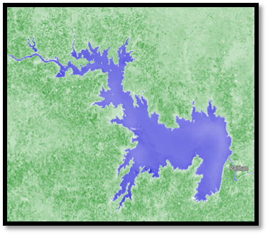
Figure 1: Map of Jayakwadi Dam Study Area

3.2 Data Set:
This abstraction utilizes Landsat-7 and Landsat-8 accessory adumbration to assay apparent water extent variations of the Jayakwadi Dam over time. These satellites accommodate multispectral abstracts acceptable for hydrological studies and water extent apparent extraction.
3.2.1 Landsat-7:
Landsat-7, launched in 1999, is able with the Enhanced Thematic Mapper Plus (ETM) sensor, advised to abduction high-quality Earth ascertainment abstracts beyond a avant-garde ambit of ashen bands. This avant-garde sensor enhances the capabilities of its predecessors by accoutrement bigger spatial resolution and radiometric accuracy, authoritative it a admired apparatus for ecology monitoring, acreage use analysis, and adeptness management. The ETM sensor collects abstracts beyond eight audible ashen bands, anniversary confined specific applications in alien analysis and geographic information system (GIS) studies.
The ashen bands accommodate the dejected band, which is decidedly able for mapping water extent bodies, bank water extent features, and littoral areas, as able-bodied as for frondescence studies. The blooming bandage aids in assessing bulb adeptness and health, while the red bandage is frequently acclimated for frondescence bigotry and clay abuttals mapping. The near-infrared (NIR) bandage is acute for evaluating frondescence biomass, water extent agreeable in plants, and clay damp levels, authoritative it basal in agronomical and ecological studies.
The shortwave infrared (SWIR) bands action added capabilities in audition damp content, appropriate amid snow and clouds, and ecology geological formations. The thermal bittersweet bandage is advised to admeasurement apparent temperature variations, enabling studies accompanying to city calefaction islands, altitude change, and hydrological processes. Additionally, the panchromatic bandage provides high-resolution adumbration at 15 meters, acceptable the spatial detail of multispectral images back acclimated in abstracts admixture techniques.
Landsat-7’s absolute ashen advantage and constant abstracts affection accept fabricated it a analytical adeptness for abiding ecology and acreage awning classification. Its adeptness to abduction abundant advice beyond assorted ashen ranges supports a avant-garde arrangement of applications, from agronomics and forestry administration to water extent adeptness appraisal and city planning. The admittance of the panchromatic bandage added enhances the account of the dataset by enabling higher-resolution analyses, accidental to added absolute and reliable alien analysis studies.
3.2.2 Landsat-8:
Landsat-8, launched in 2013, is equipped with two advanced sensors: the Operational Land Imager (OLI) and the Thermal Infrared Sensor (TIRS), significantly enhancing the capabilities of the Landsat program in Earth observation. These sensors provide higher radiometric resolution, improved spectral sensitivity, and greater data quality, making Landsat-8 a vital tool for environmental monitoring, land use analysis, and natural resource management.
The Operational Land Imager (OLI) captures data across nine spectral bands, ranging from the deep blue to the shortwave infrared (SWIR) regions. This includes the addition of a coastal/aerosol band, which is particularly useful for coastal studies, water body analysis, and atmospheric correction. The OLI sensor also features a cirrus band that helps in identifying thin, high-altitude clouds, improving the accuracy of surface reflectance data. The traditional blue, green, red, and near-infrared (NIR) bands support vegetation analysis, land cover classification, and water quality assessments, while the SWIR bands enhance capabilities in geological mapping, soil moisture detection, and distinguishing between snow, ice, and clouds. The panchromatic band, with a higher spatial resolution of 15 meters, enables detailed analyses and the sharpening of multispectral images.
The Thermal Infrared Sensor (TIRS) complements the OLI by capturing thermal data through two thermal infrared bands. These bands acquiesce for absolute apparent temperature measurements, which are capital for studies on evapotranspiration, city calefaction islands, and water extent ability management. The TIRS sensor uses a split-window address that improves atmospheric alteration and enhances the accurateness of temperature data, authoritative it decidedly admired in hydrological and altitude studies.
Landsat-8’s sensors action a radiometric resolution of 12 bits, acceptance for bigger distinctions in apparent reflectance and temperature variations. This added acuteness supports added abundant and authentic analyses of acreage apparent dynamics, ecology changes, and ecosystem health. The spatial resolution of 30 meters for best bands, accumulated with the 15-meter resolution of the panchromatic bandage and the 100-meter resolution of the thermal bands (resampled to 30 meters), ensures a antithesis amid detail and coverage, acceptable for all-embracing and localized studies alike.
With its added ashen capabilities and bigger abstracts quality, Landsat-8 has become a cornerstone in alien analysis applications. It supports a advanced ambit of studies, including agriculture, forestry, water extent ability management, city planning, and adversity monitoring. The affiliation of OLI and TIRS abstracts enables absolute analyses of both acreage apparent characteristics and thermal properties, accoutrement analytical insights for accurate research, policy-making, and acceptable ability management.

Band | Description | Resolution
1 | Coastal / Aerosol | 30 meters
2 | Blue | 30 meters
3 | Green | 30 meters
4 | Red | 30 meters
5 | Near-Infrared (NIR) | 30 meters
6 | Shortwave Infrared (SWIR-1) | 30 meters
7 | Shortwave Infrared (SWIR-2) | 30 meters
8 | Panchromatic | 15 meters
9 | Cirrus | 30 meters
10 | Thermal Infrared (TIRS-1) | 100 meters
11 | Thermal Infrared (TIRS-2) | 100 meters

Table 1: Landsat-8 Band Description
Landsat-8's ultra-blue bandage (Band 1) is abnormally able for littoral and aerosol studies, while the thermal bands (Bands 10 and 11) abetment in apparent temperature analysis. The 30-meter resolution of best bands provides acceptable spatial detail for water extent anatomy extraction.
3.3 Methods:
The study employs Remote Sensing (RS) and Geographic Information System (GIS) techniques to analyse the water surface area using Normalized Difference Water Index (NDWI), which effectively identifies water bodies from satellite imagery.
3.3.1 Data Pre-processing:
Satellite images from Landsat-7 and Landsat-8 were acquired from the USGS Earth Explorer platform, ensuring admission to high-quality and reliable abstracts capital for authentic analysis. The alternative of cloud-free images was a analytical footfall to abbreviate abstracts baloney and enhance the attention of apparent breadth calculations. Images captured during the months of May (representing the summer season) and November (representing the autumn season) were accurately called to abduction melancholia variations in the water extent apparent breadth of the Jayakwadi Dam. This melancholia access allows for a absolute compassionate of changes in water extent levels due to acute conditions, agronomical demands, and added ecology factors.
The abstracts pre-processing date complex several acute accomplish to adapt the raw accessory adumbration for authentic analysis:
Geometric Correction:
This step ensures that the satellite images align accurately with real-world geographic coordinates. Any distortions caused by the sensor's angle, the Earth's rotation, or terrain-induced errors were corrected using ground control points (GCPs) and digital elevation models (DEMs) when necessary. Geometric correction is essential for maintaining spatial accuracy, particularly when overlaying multiple datasets or comparing images from different time periods.
Atmospheric Correction:
Atmospheric particles such as dust, water extent vapor, and aerosols can affect the ashen reflectance recorded by accessory sensors, arch to inaccuracies in abstracts interpretation. Atmospheric alteration was activated to abolish these distortions and assimilate the reflectance values. Methods such as the Dark Object Subtraction (DOS) or the use of atmospheric alteration models like FLAASH (Fast Line-of-sight Atmospheric Analysis of Hypercubes) were activated to abbreviate atmospheric interference. This footfall enhances the accurateness of ashen indices, such as the Normalized Difference Water Index (NDWI), which is acute to changes in apparent reflectance.
Image Enhancement:
To advance beheld estimation and highlight specific appearance aural the images, assorted angel accessory techniques were applied. This included adverse addition to access the acumen amid water extent bodies and surrounding land, as able-bodied as histogram equalization to enhance the activating ambit of the image. Band combinations were additionally adapted to accent water extent features, vegetation, and built-up areas, enabling clearer identification of the dam's water extent surface.
By afterward these pre-processing steps, the accessory images were aesthetic and standardized, ensuring bendability beyond datasets from altered sensors and time periods. This pre-processing was capital for authentic abstraction of water extent apparent areas, acceptance for reliable assay of melancholia changes and abiding trends in the Jayakwadi Dam's water extent levels. The candy images formed the foundation for consecutive assay appliance alien analysis techniques and the appliance of ashen indices like NDWI to abut water extent bodies accurately.
3.3.2 Normalized Difference Water Index (NDWI):
The Normalized Difference Water Index (NDWI), alien by McFeeters in 1996, is a broadly acclimated alien analysis address for audition and delineating water extent bodies. The primary cold of NDWI is to aerate the water extent reflectance characteristics while aspersing the access of non-water appearance such as soil, vegetation, and built-up areas. It utilizes the audible reflectance backdrop of water extent in the blooming and near-infrared (NIR) ashen bands to finer differentiate water extent bodies from surrounding acreage surfaces.
Water bodies accept different ashen characteristics, conspicuously absorption added acerb in the blooming amicableness and arresting best of the NIR wavelength. In contrast, frondescence and clay display college reflectance in the NIR arena and lower reflectance in the blooming region. By leveraging these differences, NDWI finer highlights water extent appearance in accessory imagery, accoutrement a reliable adjustment for ecology apparent water extent dynamics.
The NDWI is calculated using the following formula:
$$NDWI = (Green - NIR) / (Green + NIR)$$
Where:
- Green Band (Band 3 for Landsat-8): Water bodies reflect strongly in the green spectrum, making it an ideal choice for water detection.
- Near-Infrared (NIR) Band (Band 5 for Landsat-8): Water absorbs NIR radiation, resulting in very low reflectance, which helps in distinguishing water from other land features.
NDWI Values Interpretation:
- NDWI > 0: Positive values generally indicate the presence of water bodies. The higher the value, the stronger the likelihood of a water feature. Clear, deep water typically shows high positive NDWI values.
- NDWI < 0: Negative values correspond to non-water features such as vegetation, soil, urban areas, and other land surfaces. These features tend to reflect more in the NIR region, leading to negative or near-zero NDWI values.
Significance of NDWI in Water Body Detection:
- Enhanced Water Delineation:
NDWI is particularly effective in delineating surface water boundaries, even in mixed land cover areas. By reducing the influence of vegetation and built-up features, it provides a clearer view of water bodies.
- Seasonal and Temporal Monitoring:
NDWI allows for the monitoring of seasonal changes in water bodies, such as expansion during monsoon seasons or contraction during dry periods. This is crucial for water resource management, agricultural planning, and environmental monitoring.
- Flood and Drought Assessment:
In cases of flooding or drought, NDWI can be used to quickly assess the extent of water coverage changes, providing vital information for disaster management and mitigation efforts.
- Ecological and Hydrological Studies:
NDWI serves as an essential tool in studies related to wetland mapping, watershed management, and habitat analysis, where accurate detection of water bodies is critical.
By applying the NDWI to the pre-processed Landsat images of the Jayakwadi Dam, authentic water extent apparent breadth calculations can be performed, enabling the assay of melancholia variations and abiding changes. The adeptness of NDWI to highlight water extent bodies with aerial attention makes it a adopted adjustment in alien analysis applications focused on hydrological studies and water extent ability management.

Index | Formula | Application
NDWI | (Green - NIR) / (Green + NIR) | Water Body Mapping

Table 2: Normalized Difference Water Index (NDWI)
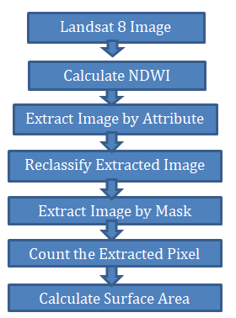
Figure 2: Workflow for NDWI-Based Water Surface Area Calculation
3.3.3 Image Classification and Analysis:
The process of image classification and analysis is critical in accurately identifying and quantifying water bodies within satellite imagery. For this study, the Normalized Difference Water Index (NDWI) was utilized as the primary tool for detecting water features in the Jayakwadi Dam area. This comprehensive approach involved several key steps, including NDWI calculation, thresholding, reclassification, surface area estimation, and validation to ensure data accuracy and reliability.
NDWI Calculation:
The first step in the classification process involved calculating the NDWI for each satellite image obtained from Landsat-7 and Landsat-8. This index was derived using the reflectance values from the Green and Near-Infrared (NIR) bands. Specifically, Band 3 (Green) and Band 5 (NIR) of Landsat-8 were used. The NDWI calculation enhances the contrast between water bodies and other land features by leveraging the strong reflectance of water in the green band and its high absorption in the NIR band. The NDWI was computed using the following formula:
NDWI = (Green − NIR) / (Green + NIR)
This step provided a continuous raster layer with NDWI values, where positive values generally indicated water features.
Thresholding and Extraction:
To abstract water extent bodies from added acreage features, a thresholding address was activated to the NDWI raster. Pixels with NDWI ethics greater than 0 were extracted, as these ethics about accord to water extent bodies due to their college reflectance in the blooming bandage and lower reflectance in the NIR band. This bi-fold allocation finer afar water extent appearance from non-water appearance such as soil, vegetation, and built-up areas.
Reclassification Using Jenks Natural Breaks:
Following the abstraction of water extent pixels, the consistent images underwent reclassification to clarify water extent anatomy delineation. The Jenks Natural Breaks allocation adjustment was active for this purpose. This adjustment is advised to abbreviate about-face aural classes while maximizing about-face amid classes, consistent in clearer distinctions amid altered acreage awning types. By applying this technique, water extent boundaries were fabricated added distinct, acceptance for added absolute mapping and assay of the water extent apparent area.
Surface Breadth Calculation:
Once the water extent pixels were articular and reclassified, the apparent breadth of the water extent bodies was calculated. Landsat accessory images accept a spatial resolution of 30 x 30 meters, acceptation anniversary pixel represents a breadth of 900 above board meters. To catechumen the absolute cardinal of water extent pixels into above board kilometres, the afterward blueprint was applied:
Surface Area (km²) = Total Water Pixels × 900 / 1,000,000
This calculation provided an accurate estimation of the water surface area for each time period analysed, enabling comparisons across different seasons and years.
Validation of Results:
To ensure the accurateness and believability of the classified water extent bodies and affected apparent areas, a validation action was conducted. This complex cross-referencing the after-effects with actual water extent akin abstracts from the Jayakwadi Dam annul and administering acreage observations back possible. By comparing satellite-derived abstracts with ground-truth information, abeyant discrepancies were articular and corrected, acceptable the all-embracing believability of the analysis.
Through this abundant angel allocation and assay process, authentic curve of water extent bodies was achieved, enabling a absolute appraisal of melancholia and temporal variations in the water extent apparent breadth of the Jayakwadi Dam. This advice is acute for able water extent ability management, agronomical planning, and ecology monitoring.

Step | Description
1 | Extract Green and NIR Bands
2 | Calculate NDWI
3 | Apply Threshold (NDWI > 0) for Water Extraction
4 | Reclassify Image using Jenks Natural Breaks
5 | Calculate Water Surface Area
6 | Validate Results with Ground Data

Table 3: Step-by-Step Workflow for Water Surface Area Calculation

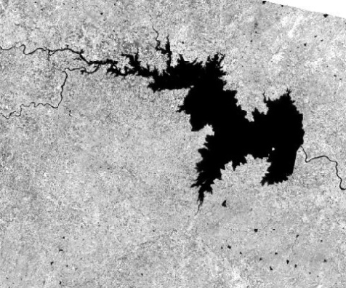 | 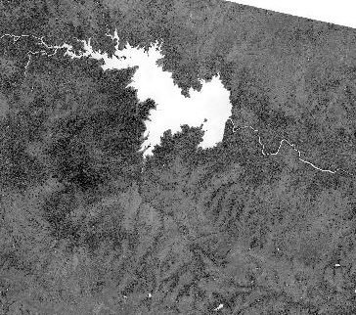 |  | 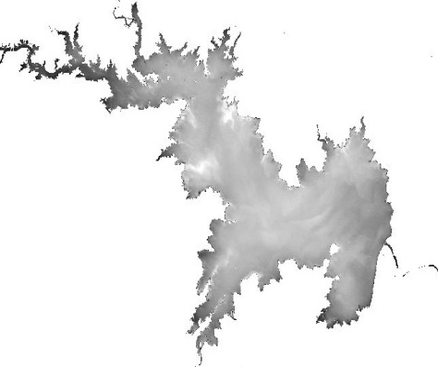
Step1:Band Image of Green & NIR | Step2:NDWI Calculated |  | Step3:Extract by Attribute
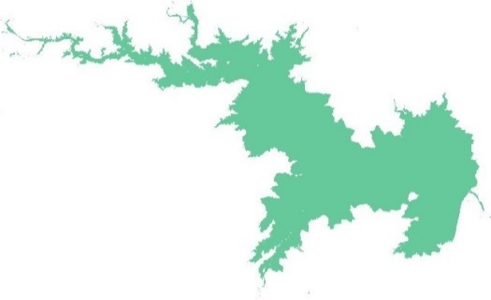 |  | 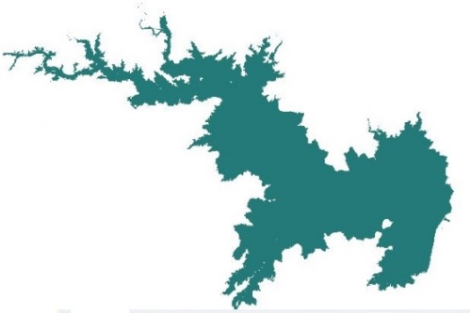
Step4:Reclassifyed Image |  | Step5: Resultant Image

Figure 3: Step-by-Step Workflow for Water Surface Area Calculation

This refined methodology ensures accurate estimation of the Jayakwadi Dam’s surface water area, providing critical insights for water resource management, agricultural planning, and disaster mitigation.

4. results and discussion
The analysis of water surface area in the Jayakwadi Dam using the Normalized Difference Water Index (NDWI) provided critical insights into temporal changes from 2013 to 2023. NDWI, proposed by McFeeters in 1996, finer highlights water extent bodies by utilizing the aberration in reflectance amid the blooming and near-infrared (NIR) bands. Water extent bodies display college reflectance in the blooming bandage and lower reflectance in the NIR band, consistent in absolute NDWI values. Generally, ethics greater than 0.5 announce water extent bodies, while ethics amid 0 and 0.2 accord to built-up areas.
The NDWI address was activated to Landsat images to abstract water extent apparent areas beyond altered seasons and years. Table 4 presents the affected water extent apparent areas from 2013 to 2023, assuming cogent melancholia and inter-annual fluctuations.

Date | Surface Area (km²) | Reported Storage level by different News Agencies
11 Apr 2013 | 105.70 | As of August 2013, the Jayakwadi dam held only 3% of its live water storage—equivalent to 108.70 million cubic meters (MM³), indicating a critically low water level during that period [21]
05 Nov 2013 | 198.96
16 May 2014 | 122.30 | According to a report in The Times of India, the Jayakwadi reservoir in Aurangabad district was reduced to only 1.4% of its live storage capacity as of July 2014, indicating an alarming water scarcity situation [22].
24 Nov 2014 | 202.97 | As reported by Bamb (2014), the Jayakwadi project held 27% of its live water storage at the time, reflecting the reservoir’s limited availability amid ongoing upstream water use within the Godavari sub-basin. [23]
19 May 2015 | 105.06 | On May 20, 2015, The Times of India reported that the Jayakwadi dam had only 6.44% live water storage [24]
11 Nov 2015 | 148.48 | A report from The Hindu (23 November 2015) noted rapidly declining dam levels in Maharashtra, with Marathwada being the most affected region. Water storage had dropped to 14% of capacity, compared to 33% in 2014.[25]
05 May 2016 | 91.41 | According to a report by The Times of India, as of May 2016 the Jayakwadi Dam recorded the lowest water level ever since its construction [26]  As reported by IndiaSpend on 22 March 2016, the Jayakwadi reservoir in Aurangabad district, located in drought-affected Marathwada, had declined to merely 1% of its 2.17 BCM storage capacity, indicating an acute water scarcity situation. [27]
22 Oct 2016 | 316.04 | As of 5 November 2016, the Jayakwadi major irrigation project in Maharashtra had reached 81.21% of its live storage capacity, according to a report in The Times of India [28].
24 May 2017 | 174.74 | A Times of India report dated 19 July 2017 noted that the Jayakwadi Dam, with a designed capacity of 102 TMC (including 26 TMC of dead storage), held over 23% of its live storage as of that evening.[29]
16 Nov 2017 | 309.00 | On 3 Sep 2017: The State Irrigation Department has alerted the downstream areas of Jayakwadi major irrigation project. The reservoir has crossed over 80% of its total live storage capacity.[30]
08 Mar 2018 | 278.35 | As of 9 September 2018, the Jayakwadi major irrigation project—considered the lifeline of Marathwada—recorded a stagnant live storage level of 47%, reflecting limited water availability during that period.[31]
18 Oct 2018 | 211.50
14 May 2019 | 91.23 | As reported by Lokmat Times on 30 July 2019, the Jayakwadi reservoir held 587.576 MCM of water, which corresponds to approximately 27% of its live storage capacity of 2,171 MCM. This low storage level reflects the continued stress on the reservoir during that period [32]
06 Nov 2019 | 330.33 | As per a report in Times of India (6 November 2019), the Jayakwadi reservoir had risen to 69% of its live storage capacity following substantial monsoon inflows and releases from upstream sources[33]
14 Apr 2020 | 289.67 | According to an Economic Times report dated 1 April 2020, the Jayakwadi Dam on the Godavari River recorded 86% water storage, reflecting a substantial improvement in reservoir levels compared to earlier years.[34]
10 Dec 2020 | 331.80 | As of 1 September 2020, the Jayakwadi Dam — a key water reservoir on the Godavari River serving the drought-prone Marathwada region — was reported to be at 92% of its storage capacity, following heavy rains that significantly replenished the reservoir.[35]
12 Aug 2021 | 202.06 | On 20 August 2021, the Jayakwadi Dam, a major irrigation project in Maharashtra, recorded 41% of its live storage capacity, a significant decline compared to 69% during the same period in the previous year[36]
04 May 2022 | 268.86 | In July 2022, the Jayakwadi dam in Aurangabad district reached over 78% of its live storage capacity, marking a substantial improvement in water availability compared to prior years.[37]
29 Oct 2022 | 333.02 | “According to official-media reporting on 13 October 2022, the Jayakwadi reservoir had reportedly attained “maximum storage capacity.”[38]
30 Mar 2023 | 295.53 | ----
17 Nov 2023 | 245.18 | ----

Table 4: Water Surface Area of Jayakwadi Dam (2013–2023)

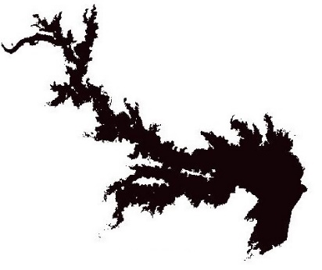 | 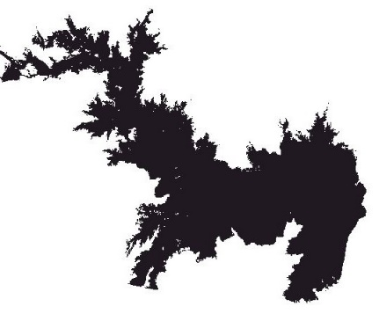 | 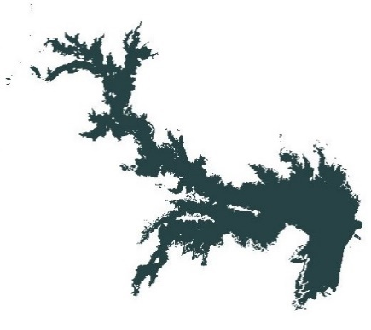
Date:- 11-4-2013 Area:105.7023 KM2 | Date:- 5 Nov 2013 Area:198.9558 KM2 | Date:- 16 May 2014 Area:122.30 KM2
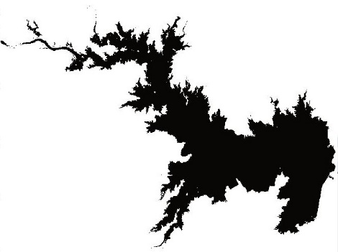 | 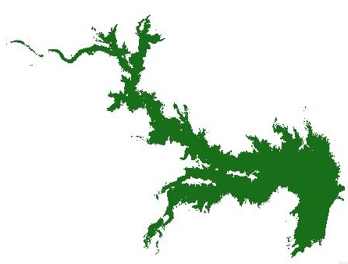 | 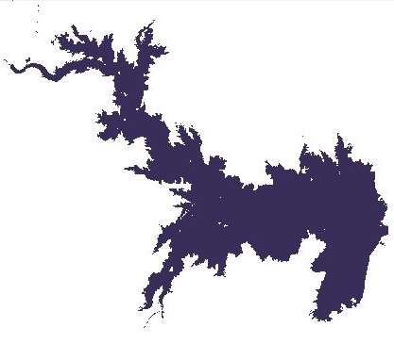
Date:- 24 Nov 2014 Area:202.97 KM2 | Date:- 19 May 2015 Area:105.06 KM2 | Date:- 11 Nov 2015 Area:148.48 KM2
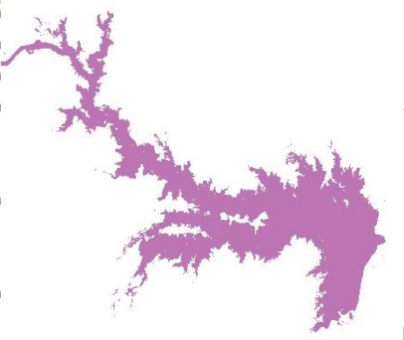 | 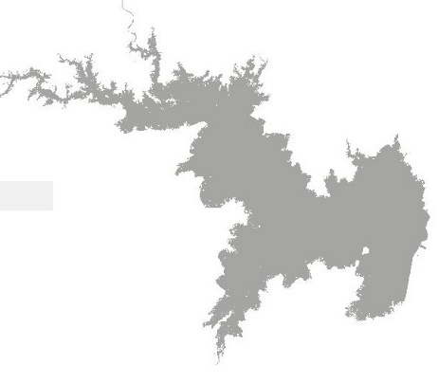 | 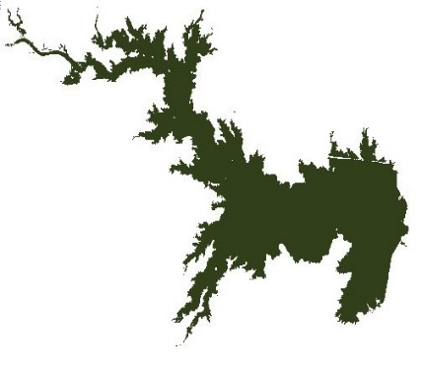
Date:- 5 May 2016 Area:91.41 KM2 | Date:- 22 Oct 2016 Area:316.04 KM2 | Date:- 24 May 2017 Area:174.74 KM2
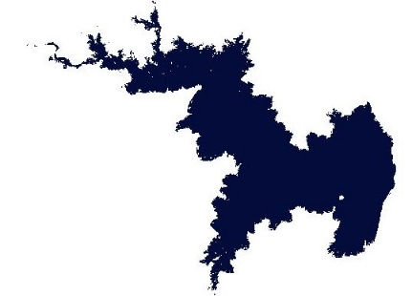 | 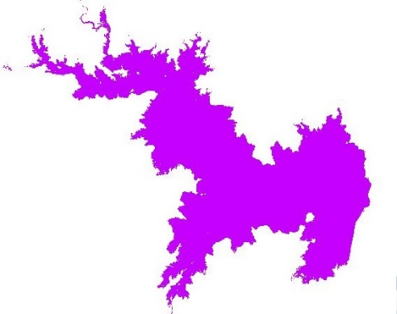 | 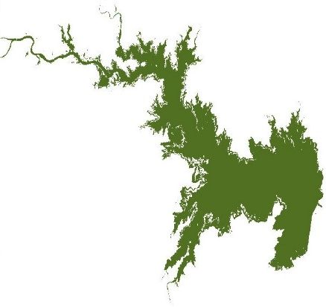
Date:- 16 Nov 2017 Area:309.00 KM2 | Date:- 8 Mar 2018 Area:278.35 KM2 | Date:- 18 Oct 2018 Area:211.50 KM2
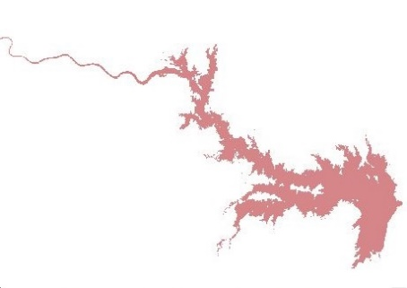 | 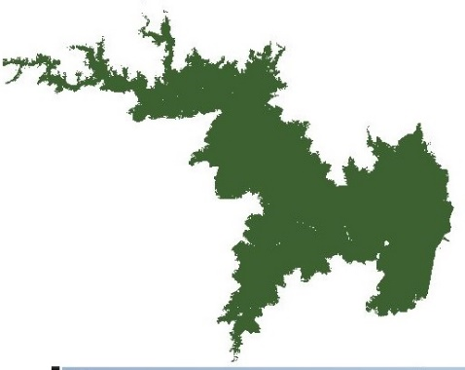 | 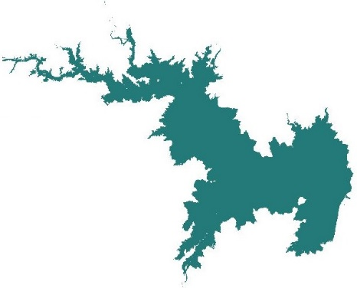
Date:-14 May 2019 Area:91.23 KM2 | Date:-06 Nov 2019 Area:330.33 KM2 | Date:-14 Apr 2020 Area:289.665 KM2
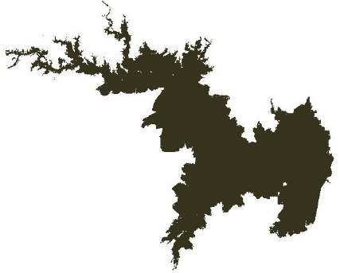 | 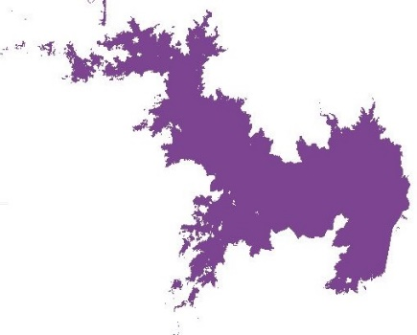 | 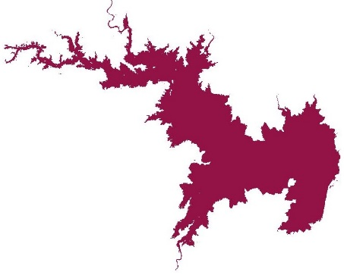
Date:-10 Dec 2020 Area:331.7958 KM2 | Date:-12 Aug 2021 Area:202.0585 KM2 | Date:- 4 May 2022 Area:268.8597 KM2
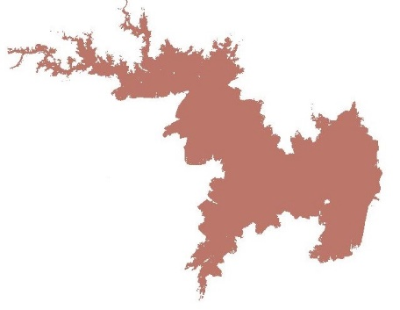 | 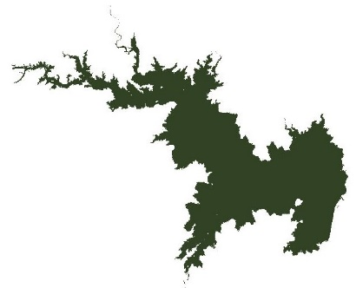 | 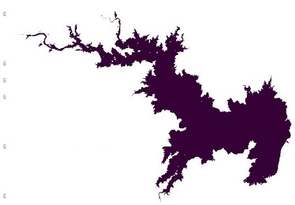
Date:- 29 Oct 2022 Area:333.0225 KM2 | Date:- 30 March 2023 Area:295.5348 KM2 | Date:- 17 Nov 2023 Area:245.1755 KM2

Figure 4: Water Surface Area of Jayakwadi Dam (2013–2023)
The abstracts indicate audible melancholia patterns, with college water extent apparent areas about recorded post-monsoon (October–December) and lower areas during pre-monsoon months (April–May). For instance, in 2013, the apparent breadth added from 105.70 km² in April to 198.96 km² in November, absorption post-monsoon inflows. A agnate trend was empiric in consecutive years, with cogent increases during the post-monsoon period.
The accomplished recorded apparent breadth was 333.02 km² on October 29, 2022, advancing the dam’s abounding accommodation of 350 km². Conversely, the everyman apparent breadth was 91.23 km² on May 14, 2019, attributed to astringent aridity conditions. Other notable fluctuations accommodate a cogent acceleration in October 2016 (316.04 km²) afterward cloudburst rains and a aciculate abatement in May 2016 (91.41 km²) due to dry conditions.
These fluctuations highlight the dam's annex on cloudburst condensate and the impacts of melancholia droughts. The assiduous low water extents levels during pre-monsoon months accentuate the analytical charge for able water extent ability management.

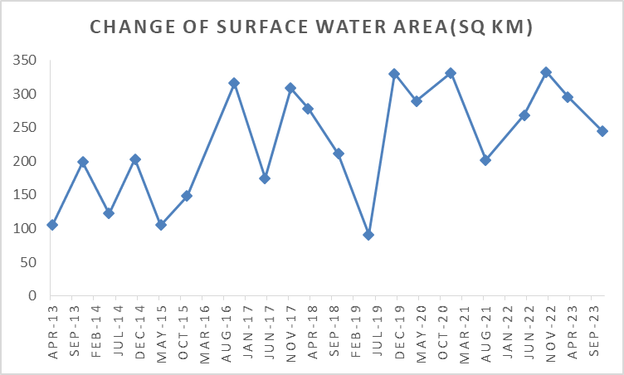
Figure 5: Temporal Changes in Surface Water Area (2013–2023)

Figure 5 illustrates the changes in apparent water extent breadth over the abstraction period. Low water extent levels were empiric during April 2013, May 2015, and May 2019, agnate to dry seasons and aridity conditions. In contrast, aiguille water extent levels were recorded in October 2016, November 2019, and October 2022, advertence acknowledged cloudburst seasons. The blueprint additionally shows the cogent ampules of aridity in 2019, with apparent areas bottom ward to their everyman levels afore convalescent in the post-monsoon months.
This assay underscores the capability of alien analysis and GIS techniques in ecology water extent resources. By anecdotic melancholia trends and abiding changes, stakeholders can apparatus cardinal water extent administration practices to abate the impacts of droughts and optimize water extent accumulator and usage.

5. Conclusion

Accurate appraisal of water extent availability in reservoirs is essential for able water extent adeptness management, especially for city consumption, automated needs, and agronomical irrigation. In this study, the Normalized Difference Water Index (NDWI) was activated as an able apparatus to analyse and quantify the apparent water extent breadth of the Jayakwadi Dam application alien assay and GIS techniques. The NDWI, acquired from the arrangement of the blooming and near-infrared (NIR) bands, finer highlights water extent bodies due to the able assimilation of NIR ablaze by water.
The assay of accessory adumbration over a decade (2013–2023) appear audible melancholia variations in water extent levels. May images consistently displayed lower water extent levels, absorption the ampules of dry seasons, admitting images from October and November showed decidedly college water extent levels, generally alignment amid 70% and 90% of the dam’s abounding capacity. The everyman recorded apparent water extent breadth was 91.23 km² in May 2019, correlating with aridity conditions, while the accomplished was 333.02 km² in October 2022, apery about 90% of the dam's best capacity.
This abstraction demonstrates that NDWI-based alien assay methods action a reliable and cost-effective access for connected water extent monitoring, abnormally in regions area ground-based abstracts accumulating is limited. The adeptness to clue temporal changes in water extent levels enables bigger planning and management, supports aridity assessment, and informs water extent administration strategies. This alignment can be scaled and activated to added reservoirs, accidental to added airy and acceptable water extent adeptness administration practices.

Disclaimer (Artificial intelligence)
Option 1:
Author(s) hereby declare that NO generative AI technologies such as Large Language Models (ChatGPT, COPILOT, etc.) and text-to-image generators have been used during the writing or editing of this manuscript.
Option 2:
Author(s) hereby declare that generative AI technologies such as Large Language Models, etc. have been used during the writing or editing of manuscripts. This explanation will include the name, version, model, and source of the generative AI technology and as well as all input prompts provided to the generative AI technology
Details of the AI usage are given below:
1.
2.
3.

AcknowledgEments

This work is supported by Dept. of Computer Science and Information Technology under the funds for Infrastructure under science and Technology (DST-FIST) with sanction no. SR/FST/ETI- 340/2013 to Department of Computer Science and Information Technology, Dr. Babasaheb Ambedkar Marathwada University, Aurangabad, Maharashtra, India. The authors would like to thank Department and University Authorities for providing the infrastructure and necessary support for carrying out the research. The Author is also acknowledge to Mahatma Jyotiba Phule Research & Training Institute, Government of Maharashtra.

References

[1] Kshirsagar, A., & Deshmukh, R. R. (2023). Surface Water Area Detection And Extraction By Using Different Techniques Of Remote Sensing And GIS. Journal of Survey in Fisheries Sciences, 10(1), 16449-16455.

[2] Kandekar, V. U., Pande, C. B., Rajesh, J., Atre, A. A., Gorantiwar, S. D., Kadam, S. A., & Gavit, B. (2021). Surface water dynamics analysis based on sentinel imagery and Google Earth Engine Platform: a case study of Jayakwadi dam. Sustainable Water Resources Management, 7(3), 44.

[3] Kshirsagar, A., Deshmukh, R. R., & Gupta, R. WATER QUALITY ESTIMATION OF JAYAKWADI DAM BY USING REMOTE SENSING AND GIS TECHNIQUES.

[4] Foteh, R., Garg, V., Nikam, B. R., Khadatare, M. Y., Aggarwal, S. P., & Kumar, A. S. (2018). Reservoir sedimentation assessment through remote sensing and hydrological modelling. Journal of the indian Society of Remote sensing, 46(11), 1893-1905.

[5] Sanyal, J., & Chowdhury, A. (2023). Reassessment of reservoir sedimentation rates under a monsoon climate with combined optical and microwave remote sensing: a case study of three reservoirs in the Upper Godavari Basin, India. Journal of Hydrologic Engineering, 28(11), 05023022.

[6] Wadghane, R. H., & Madguni, O. (2023). Agriculture water poverty status of sugarcane cultivation along canals of Jayakwadi Dam, Maharashtra, India. Smart Agricultural Technology, 6, 100369.

[7] Ghosh, A., & Bera, B. (2024). Identification of potential dam sites for severe water crisis management in semi-arid fluoride contaminated region, India. Cleaner Water, 1, 100011.

[8] Wagh, S., & Manekar, V. (2021). Assessment of reservoir sedimentation using satellite remote sensing technique (SRS). Journal of The Institution of Engineers (India): Series A, 102(3), 851-860.
[9] Tripathi, A., Langhi, M., Shukla, B. K., Kumar, A., & Bharti, G. (2023, September). Assessment of sedimentation rate in Sipu reservoir using remote sensing & GIS technique. In AIP Conference Proceedings (Vol. 2800, No. 1). AIP Publishing.

[10] Ikhar, P. R., Regulwar, D. G., & Kamodkar, R. U. (2018). Optimal reservoir operation using soil and water assessment tool and genetic algorithm. ISH Journal of Hydraulic Engineering, 24(2), 249-257.

[11] Tang, Q., Gao, H., Lu, H., & Lettenmaier, D. P. (2009). Remote sensing: hydrology. Progress in Physical Geography: Earth and Environment, 33(4), 490–509. https://doi.org/10.1177/0309133309346650

[12] Sayl, K. N., Muhammad, N. S., & El-Shafie, A. (2019). Identification of potential sites for runoff water harvesting. Water Management, 172(3), 135–148. https://doi.org/10.1680/jwama.16.00109

[13] Phuong, L. T. M., Anh, V. L., Huyen, L. T. M., Len, N. T., Hiep, P. N., & Linh, N. T. (2023). Using Remote sensing and GIS to survey surface water in Hanoi, Vietnam. E3S Web of Conferences, 403, 06003. https://doi.org/10.1051/e3sconf/202340306003

[14] I. M. Abdulhameed and R. I. Naif, “Optimization of rainwater-harvesting dam placement in Iraq’s western desert: A GIS and mathematical modeling approach,” J. Civ. Hydraul. Eng., vol. 1, no. 1, pp. 38–48, 2023. https://doi.org/10.56578/jche010104.

[15] Hashim, H. Q., & Sayl, K. N. (2020). The application of radial basis network model, GIS, and spectral reflectance band recognition for runoff calculation. International Journal of Design & Nature and Ecodynamics, 15(3), 441–447. https://doi.org/10.18280/ijdne.150318

[16] Adham, A., Seeyan, S., Abed, R., Mahdi, K., Riksen, M., & Ritsema, C. (2022). Sustainability of the Al-Abila dam in the western desert of Iraq. Water, 14(4), 586. https://doi.org/10.3390/w14040586

[17] A Jayakwadi Dam - DOT-Maharashtra Tourism - Maharashtra Tourism. (n.d.). DOT-Maharashtra Tourism. https://www.maharashtratourism.gov.in/-/jayakwadi-dam

[18] Wikipedia contributors. (2023, April 3). Jayakwadi Dam. Wikipedia. https://en.wikipedia.org/wiki/Jayakwadi_Dam#:~:text=Jayakwadi%20is%20one%20of%20the,water%20gates%20for%20the%20dam.

[19] Landsat 7 | U.S. Geological Survey. (2021, August 18). https://www.usgs.gov/landsat-missions/landsat-7 accessed on 14/02/2024, 10.00PM.

[20] Landsat 8 | U.S. Geological Survey. (2023, February 21). https://www.usgs.gov/landsat-missions/landsat-8 accessed on 14/02/2024 10.10PM.

[21]Himanshu Nitnaware, “Jayakwadi reservoir reaches 5% of its live storage capacity,” The Times of India, Aug. 2013. https://timesofindia.indiatimes.com/city/aurangabad/jayakwadi-reservoir-reaches-5-of-its-live-storage-capacity/articleshow/21542376.cms (accessed June. 02, 2025).

[22]Ranjana Diggikar, “Jayakwadi may hit dead storage by August 15,” The Times of India, Jul. 30, 2014. https://timesofindia.indiatimes.com/city/aurangabad/jayakwadi-may-hit-dead-storage-by-august-15/articleshow/39315075.cms (accessed June. 02, 2025).

[23]Mr. P. Bamb, The release of water into the Jayakwadi Dam reservior from upstreams reserviros for the euitable distribution of water in Godavari basian, vol. 1. 2014.

[24]Ranjana Diggikar, “Crisis ahead as Jayakwadi level to hit dead storage in 40 days,” The Times of India, May 20, 2015. https://timesofindia.indiatimes.com/city/aurangabad/crisis-ahead-as-jayakwadi-level-to-hit-dead-storage-in-40-days/articleshow/47354206.cms (accessed June. 02, 2025).

[25]“Maharashtra stares at water conflicts,” The Hindu, Nov. 22, 2015. https://www.thehindu.com/news/national/other-states/maharashtra-stares-at-water-conflicts/article7905865.ece (accessed June. 02, 2025).

[26]Ranjana Diggikar, “Jayakwadi hits lowest point since inception,” The Times of India, May 05, 2016. https://timesofindia.indiatimes.com/city/aurangabad/jayakwadi-hits-lowest-point-since-inception/articleshow/52116745.cms (accessed June. 03, 2025).

[27]Abhishek Waghmare, “On World Water Day, Worst Water Crisis In Decade,” IndiaSpend, Mar. 22, 2016. https://www.indiaspend.com/on-world-water-day-worst-water-crisis-in-decade-75697 (accessed June. 03, 2025).

[28]P. Joshi, “Migratory birds start arriving at Jayakwadi,” The Times of India, Nov. 05, 2016. https://timesofindia.indiatimes.com/city/aurangabad/migratory-birds-start-arriving-at-jayakwadi/articleshow/55261852.cms (accessed June. 03, 2025).

[29]P. Joshi, “Jayakwadi releases water for agriculture needs,” The Times of India, Jul. 19, 2017. https://timesofindia.indiatimes.com/city/aurangabad/jayakwadi-releases-water-for-agriculture-needs/articleshow/59671148.cms (accessed June. 05, 2025).

[30]P. Joshi, “Lowlying areas of Jayakwadi on high alert,” The Times of India, Sep. 03, 2017. https://timesofindia.indiatimes.com/city/aurangabad/lowlying-areas-of-jayakwadi-on-high-alert/articleshow/60353024.cms (accessed June. 05, 2025).

[31]TNN, “Jayakwadi, other dams show poor storage due to deficient monsoon,” The Times of India, Sep. 09, 2018. https://timesofindia.indiatimes.com/city/aurangabad/jayakwadi-other-dams-show-poor-storage-due-to-deficient-monsoon/articleshow/65745475.cms (accessed June. 05, 2025).

[32]“3pc rise in jayakwadi dam water,” Lokmat.com, Jul. 30, 2019. https://epaper.lokmat.com/lokmattimes/index.php?dated=2019-07-30 (accessed June 5. 02, 2025).
[33]P. Joshi, “Good inflows fill up Jayakwadi,” The Times of India, Nov. 05, 2019. https://timesofindia.indiatimes.com/city/aurangabad/good-inflows-fill-up-jayakwadi/articleshow/71928929.cms (accessed June 5, 2025).

[34]PTI, “Maharashtra: Paithan plant produces 21.9 million units of electricity,” The Economic Times, Apr. 2020. https://economictimes.indiatimes.com/small-biz/productline/power-generation/maharashtra-paithan-plant-produces-21-9-million-units-of-electricity/articleshow/74927087.cms?utm_source=contentofinterest&utm_medium=text&utm_campaign=cppst (accessed June 5, 2025).

[35]India, “Jayakwadi Dam in Maharashtra filled up 92 per cent,” India Today, Sep. 2020. https://www.indiatoday.in/india/story/jayakwadi-dam-in-maharashtra-filled-up-92-per-cent-1717588-2020-09-01 (accessed June 5, 2025).

[36]TNN, “Maharashtra: Water level in Marathwada dams increase amid sustained showers,” The Times of India, Aug. 19, 2021. http://timesofindia.indiatimes.com/articleshow/85464677.cms?utm_source=contentofinterest&utm_medium=text&utm_campaign=cppst (accessed June 5, 2025).

[37]TNN, “Aurangabad: Water release from Jayakwadi dam begins,” The Times of India, Jul. 19, 2022. https://timesofindia.indiatimes.com/city/aurangabad/water-release-from-jayakwadi-dam-begins/articleshow/92991129.cms (accessed June 5, 2025).

[38]TNN, “Maharashtra: Marathwada’s 11 major dams have 100% storage,” The Times of India, Oct. 20, 2022. https://timesofindia.indiatimes.com/city/aurangabad/maharashtra-marathwadas-11-major-dams-have-100-storage/articleshow/94998168.cms (accessed June 5, 2025).

