Original Research Article
Correlation Between Land Surface Temperature and Normalized Difference Vegetation Index of North Lakhimpur Revenue Circle of Lakhimpur District, Assam, India

ABSTRACT

Rising Land Surface Temperature (LST) has become a critical indicator of climate change, strongly influenced by urbanization, deforestation, and land use modifications. Vegetation cover, often represented by the Normalized Difference Vegetation Index (NDVI), plays a significant role in regulating surface thermal dynamics. Understanding the relationship between NDVI and LST is therefore essential for monitoring climate impacts at local and regional level. This study analyses the correlation between LST and NDVI over a 20-year period (2001–2021) in the North Lakhimpur Revenue Circle, Assam, India, using multi-temporal Landsat 7 ETM+ and Landsat 8 OLI/TIRS imagery. LST was derived from the thermal bands, while NDVI was computed from the red and near-infrared reflectance values. Geospatial processing and statistical analysis were conducted in ERDAS Imagine 9.1, ArcGIS 10.4.1, and QGIS 3.30.3. Results show a clear warming trend, with mean LST increasing by approximately 2–6 °C over the study period. Seasonal variations were evident: in October, NDVI and LST exhibited a weak positive correlation (R² < 0.02), while in December, the relationship was negative (R² up to 0.05), indicating the cooling effect of vegetation during the dry season. Regression analysis further confirmed that vegetation influence on surface temperature has strengthened in December, despite overall rising baseline temperatures. These findings highlight the dual role of vegetation in modulating thermal environments and the growing importance of sustainable land management to mitigate local climate warming in Northeast India.

Keywords: LST, NDVI, Correlation, Remote Sensing, GIS, Lakhimpur, Assam, India

1. INTRODUCTION
Global climate change is one of the most critical challenges of the twenty-first century, with significant impacts on ecosystems, livelihoods, and regional climate regulation. Rising Land Surface Temperature (LST) is a direct manifestation of these changes, influenced by rapid urbanization, deforestation, and alterations in land use and land cover (LULC). LST serves as a key indicator for studying urban heat island effects, ecosystem health, and climate variability, making its monitoring essential for sustainable planning and environmental management [Guha & Govil, 2022].
Vegetation cover plays a pivotal role in regulating LST through processes such as evapotranspiration, canopy shading, and surface albedo modification. The Normalized Difference Vegetation Index (NDVI), derived from multispectral satellite imagery, is widely used as a proxy for vegetation health and density. Numerous studies have reported an inverse correlation between NDVI and LST, with higher vegetation density generally associated with lower surface temperatures. For instance, Guha & Govil (2022) found strong seasonal variability in the NDVI–LST relationship in Raipur, India, with negative correlations as high as –0.74 during pre-monsoon months. Similarly, Sharma et al. (2022) observed a moderate negative correlation (~–0.45) between NDVI and LST in Gautam Buddh Nagar, highlighting the strong role of vegetation in thermal regulation. In mining-dominated landscapes, Dheeraj et al. (2023) demonstrated persistently strong negative NDVI–LST correlations (R² up to 0.965), despite significant LST increases due to land degradation.
To monitor the correlation between LST and NDVI Remote sensing data, generally from satellite like Landsat, MODIS, Sentinels are very resourceful to know the spatio-temporal changes which may reveal the seasonal pattern and variation of LST and NDVI. While global and national-scale studies emphasize the importance of vegetation in moderating surface thermal environments, evidence from Northeast India remains limited. This region, characterized by fragile ecosystems, rapid demographic growth, and land use transformations, is particularly vulnerable to climate-induced changes. Assam, in particular, has experienced notable land cover modifications in recent decades, yet systematic assessments of NDVI–LST interactions remain scarce.
According to the report of Climate Vulnerability Assessment for Adoption Planning in India- Lakhimpur district of Assam is one of the most affected districts in terms of climate vulnerability, having the rank 32 among the 51 worst affected districts of the country (using a common framework by the Indian Institute of Science, Bangaluru, IIT-Guwahati and IIT-Mandi under the Science and Technology). Continuous cutting down of trees directly affecting the monsoon rainfall pattern of the district.
Therefore, in this context, the present study investigates the correlation between NDVI and LST over a two-decade period (2001–2021) in the North Lakhimpur Revenue Circle, Assam, India. Specifically, the objectives are: (i) to derive multi-temporal LST and NDVI from Landsat 7 ETM+ and Landsat 8 OLI/TIRS datasets; (ii) to examine seasonal variations in the NDVI–LST relationship, with emphasis on October and December; and (iii) to assess long-term changes in vegetation–temperature interactions. The findings are expected to provide critical insights into the role of vegetation in regulating land surface temperatures and to inform sustainable land use planning and climate adaptation strategies in Northeast India.
2. STUDY AREA
The study was conducted in the North Lakhimpur Revenue Circle, located in Lakhimpur district of Assam, India (Fig. 1). Geographically, North Lakhimpur Revenue Circle (R.C.) extends from 26°57' 51'' N to 27°21'55''N latitude and 93°59'12'' E to 94°16'44'' E longitude. The region is characterized by a humid subtropical climate, with hot summers, high monsoonal rainfall, and mild winters. It shares boundary with Nowboicha revenue circle in the West, Kadam revenue circle in the East, Arunachal Pradesh in the North and Majuli district of Assam in the South. The total area of North Lakhimpur is 477 km², out of which 463 km² comes under rural area and 13.74 km² comes under urban area. This revenue circle has 2,50,643 population, out of which urban population is 59,814 and rural population is 1,90,829 persons.
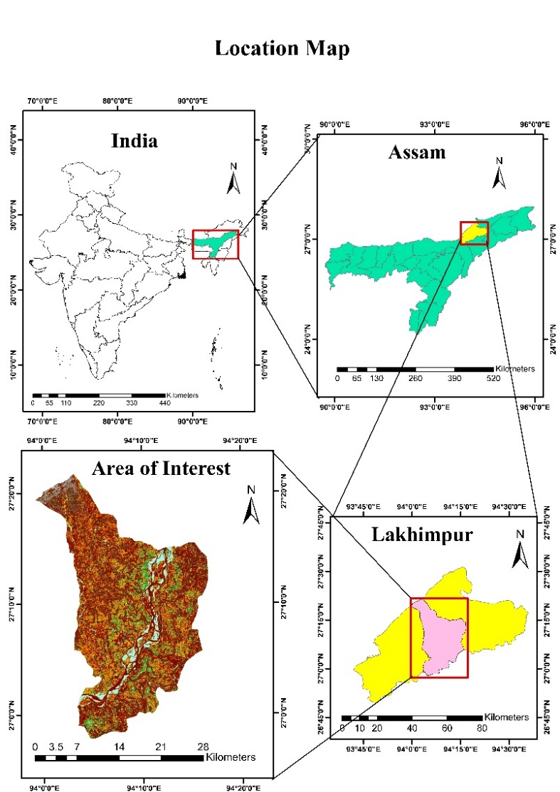

Fig.1: Location Map (North Lakhimpur Revenue Circle, Lakhimpur)
(Source: Survey of India (administrative boundaries) and Landsat Image from USGS Earth Explorer)
North Lakhimpur R.C. is the headquarter and main town region of Lakhimpur district which have administrative facilities, higher education facilities, medical college and hospital, minor industries and so on. The Ranganadi river, a sub-tributary of Brahmaputra River and Subansiri river, the largest tributary of Brahmaputra River flows through the North Lakhimpur revenue circle. A part of Kakoi reserve forest lies in the northern part of the revenue circle. Land use in the study area is dominated by agriculture, tea plantations, wetlands, and dispersed built-up areas, with significant transformations in recent decades due to urban expansion and population growth. The proximity to the Subansiri River and adjoining floodplains further influences the hydrology and vegetation dynamics of the region. Given its ecological sensitivity and exposure to both climatic and anthropogenic pressures, the North Lakhimpur Revenue Circle provides an ideal setting for analyzing vegetation–temperature interactions.
4. MATERIALS AND METHODS
4.1 Data Sources
Two types of satellites datasets were used – i) Landsat data and ii) Ancillary data. Here, for acquiring all the Landsat data for the present study area cloud-free imagery was selected for October and December, representing post-monsoon and winter conditions to capture the seasonal variability. All Landsat datasets were obtained from the United States Geological Survey (USGS) website (https://earthexplorer.usgs.gov) and the administrative boundary shapefiles for the study area were obtained from the Survey of India open datasets (https://www.surveyofindia.gov.in ).
Image preprocessing, NDVI computation, and LST derivation were carried out using ERDAS Imagine 9.1, ArcGIS 10.4.1, and QGIS Desktop 3.30.3. NDVI was calculated using the red and near-infrared bands, while LST was retrieved from the thermal bands following standard radiometric calibration and atmospheric correction procedures. Statistical analyses, including regression modelling, were employed to quantify the correlation between NDVI and LST for both seasons and years.
Table 1: Details of the satellite data used for LST and NDVI Analysis in this study
Season | Year | Satellite Sensor | Spatial Resolution | Path | Row | Source
Post-Monsoon | 2001  October | Landsat 4-5 TM | 30m | 135 | 41 | USGS
Post-Monsoon | 2021  October | Landsat 8 OLI/TIRS
Winter | 2001  December | Landsat 7 ETM+
Winter | 2021 December | Landsat 8 OLI/TIRS
Note: Data generated by the author from collecting the information from Landsat imageries from USGS

4.2 Materials
To analyse the Land Surface Temperature (LST) and Normalized Difference Vegetation Index (NDVI), Landsat 4-5 Thematic Mapper (TM) October, 2001 and Landsat 8 Operational Land Imager/Thermal Infrared Sensor (OLI/TIRS) October, 2021 were processed for post-monsoon season. Landsat 7 Enhanced TM+ December, 2001 and Landsat 8 OLI/TIRS December, 2021 for Winter season. The four imageries have 30 metre spatial resolution, path and row 135/41 with having less than 10 percent cloud cover (Table 1).

  - Methods
LST was derived from the thermal bands of Landsat data following the radiative transfer equation method (Markham & Barker, 1986). To calculate the Land Surface Temperature (LST) of an area there are some important steps which have to done at first then we can prepare the LST. They are given below in details-
4.3.1 Conversion of TOA (Top of Atmosphere) Spectral Radiance:

(Lλ) = M_{L}* Qcal+A_{L}-O_{i}
Lλ=0.0003342*Band10+0.10000-0.29
Where,
Lλ =TOA spectral radiance (Watts/m2*sr*µm)
ML = Radiance Multiplicative Band (No.)
AL = Radiance Add Band (No.)
Qcal = Quantized and calibrated standard product pixel values (DN)
O_{i} = Correction value for band 10 is 0.29
4.3.2 Conversion of TOA Brightness Temperature (BT):
Top of atmosphere brightness temperature involves the measurement and interpretation of electromagnetic radiation emitted by the earth’s surface and observed from space which converted in Meta data format.
Kelvin (K) to Celsius (ºC) Degrees BT = (K₂/ (ln (K₁/ Lλ) +1)) -273.15
Where,
BT = Top of atmosphere brightness temperature (ºC)
Lλ = TOA spectral radiance (Watts/m2*sr*µm)
K1 = K1 Constant Band (No.)
K2 = K2 Constant Band (No.)
4.3.3 Normalized Difference Vegetation Index (NDVI):
The Normalized Difference Vegetation Index calculate the health and richness of vegetation cover of an area using Near-Infrared (NIR) (Band 5) and Red (band 4) bands (Rouse et al., 1974).
NDVI = (NIR-Red) / (NIR+Red)
Where,
Red = DN values from the red band (reflectance in the red band of the electromagnetic spectrum)
NIR = DN values from the Near Infrared band (reflectance in the Near-Infrared band of the electromagnetic spectrum)
4.3.4 Land Surface Emissivity (LSE):
Land Surface Emissivity (LSE) is the average emissivity of the earth surface which emits heat energy in a longwave radiation into the atmosphere and it is calculated from NDVI values (Sobrino et al., 2004).
P_{v} = ((NDVI – NDVI _{min}) / (NDVI _{max} – NDVI _{min}))²
P_{v} = Proportion of Vegetation
NDVI= DN values from NDVI image
NDVI _{min} = Minimum DN values from NDVI image
NDVI _{max} = Maximum DN values from NDVI image
ԑ = 0.004* P_{v} + 0.986
Where,
ԑ = Land Surface Emissivity
P_{v} = Proportion of Vegetation
0.986 corresponds to a correction value of the equation
4.3.5 Land Surface Temperature (LST):
Land surface temperature is the emitted temperature of the earth surface which calculate by observing thermal infrared using top of atmosphere (TOA), brightness temperature (BT), wavelength of emitted radiance, land surface emissivity (LSE).
LST = (BT/ (1+ (λ*BT/c2) * ln (ε)))
Here,
c2 = 14388 µm K
λ = 10.8
where,
BT = Top of atmosphere brightness temperature (ºC)
λ = Wavelength of emitted radiance
ԑ = Land Surface Emissivity
c2 = h*c/s
=1.4388*10⁻² mK
= 14388 mK
h = Planck’s Constant = 6.626*10⁻³⁴ J s
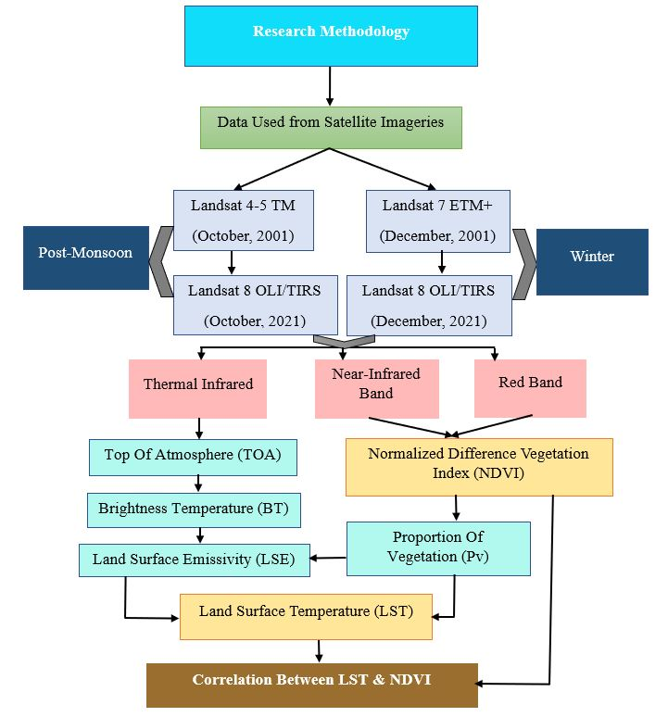

Fig. 2: Flowchart of Research Methodology

4.3.6 Correlation Between LST and NDVI:
To prepare the Correlation between LST and NDVI, fishnet or grid polygon has done by creating random sampling points in arc toolbox in ArcGIS software. The null values have deleted by extraction in the arc toolbox. These same processes have applied in both LST and NDVI imageries. After producing the proper sampling points for study area, it is computed and shown the correlation between LST and NDVI in Linear correlation method using MS Excel software for Post-monsoon and Winter season of 2001 and 2021.

  - Statistical Analysis:
Both univariate and bivariate statistical techniques were applied to examine the relationship between NDVI and LST. Univariate statistics (minimum, maximum, mean, standard deviation and range) were computed to summarize the distribution and variability of LST and NDVI for each year and season. To quantify the vegetation-temperature relationship, bivariate statistics were used, including: Pearson’s correlation coefficient (r) to measure the strength and direction of the NDVI-LST relationship. Simple linear regression analysis, where NDVI was used as the independent variable and LST as the dependent variable. Regression parameters were extracted to determine how strongly vegetation influences surface temperature.

5. RESULTS AND DISCUSSION
To show the variation of Land Surface Temperature and Normalized Difference Vegetation Index of North Lakhimpur R.C., the values are divided into six different classes for Post-monsoon and Winter season from 2001-2021. The six classes are commonly used because they provide a balanced and detailed representation of vegetation conditions, allowing for better analysis and interpretation. J.W. Rouse et. al., developed the NDVI index in 1974 and classified that -1 to 0 as water, snow and cloud. 0 to 0.2 classified as barren soil, built up area, rock, roads etc. 0.2 to 1 classified as low vegetation to highly dense vegetation area.

  - Spatio-temporal Distribution of Land Surface Temperature (LST):
The distribution of LST of Post-monsoon season for October, 2001 in North Lakhimpur R.C., it is observed that the minimum value of LST is 17.93 ºC and the maximum is 34.87 ºC (Fig. 3: a). The observed mean LST and Standard Deviation (S.D.) is 24.41 ºC and 1.41 in that period (Table 2). In post-monsoon season, October, 2021, it is observed that the Value of LST is increased by around 5 ºC since last two decades. Here the minimum LST witnessed in this season is 22.28 ºC and maximum value is 36.41 ºC (Fig. 3: b). The observed mean LST and S.D. is 27.32 ºC and 1.34 respectively.
Table 2: Calculated Data of LST of North Lakhimpur R.C
Data | LST (in ºC)
Data | Maximum | Minimum | Mean | S.D.
October, 2001 | 34.87 | 17.93 | 24.41 | 1.41
October, 2021 | 36.41 | 22.27 | 27.32 | 1.34
December, 2001 | 24.37 | 13.82 | 18.61 | 0.94
December, 2021 | 32.57 | 17.83 | 27.74 | 1.66

Note: Data generated by author from calculated LST.

As for the Winter season of December, 2001, it has decreased due to the seasonal variation. Because in winter season the amount of thermal infrared received and emitted by earth surface is less as compared to other seasons. Here the minimum recorded value of LST is 13.83 ºC and maximum is 24.37 ºC (Fig. 3: c). The mean and standard deviation value of LST is 18.61 ºC and 0.94 respectively. On the other hand, in Winter season, December, 2021 LST map witnessed minimum temperature of 17.84 ºC maximum of 32.58 ºC (Fig. 3: d). both minimum and maximum temperature has increased by around 4 ºC and 8 ºC since December 2001.
By observing the overall distribution of LST in North Lakhimpur R.C over twenty years (Post-monsoon and Winter seasons), it is evident that the town area of North Lakhimpur has experienced higher surface temperatures due to the higher concentration of residential areas, hospitals, educational institutions, commercial and administrative services. The barren surface areas and sand bars of the river Subansiri and Ranganadi rivers experienced relatively moderate surface temperature as compared to town area.
The aforementioned land cover classes have changed over time, and from 2001 to 2021, the area with high to medium temperature concentration increased due to the developments such as the construction of North Lakhimpur Bypass (Connecting Charaimoria to Hatilung) by converting the agricultural land into built-up areas. Along this road, new built-up areas have emerged for residential and commercial purposes. Overall, the town area is expanding, which gradually increases the amount of radiative infrared emitted from the earth’s surface, thereby raising the surface temperature.
The other part of revenue circle, such as the forest area of Kakoi, agricultural land, dense vegetation areas and water bodies, has experienced relatively lower land surface temperatures. This is because forested areas have high evapotranspiration rates and lower albedo, which together reduce solar radiation absorption and enhance cooling.

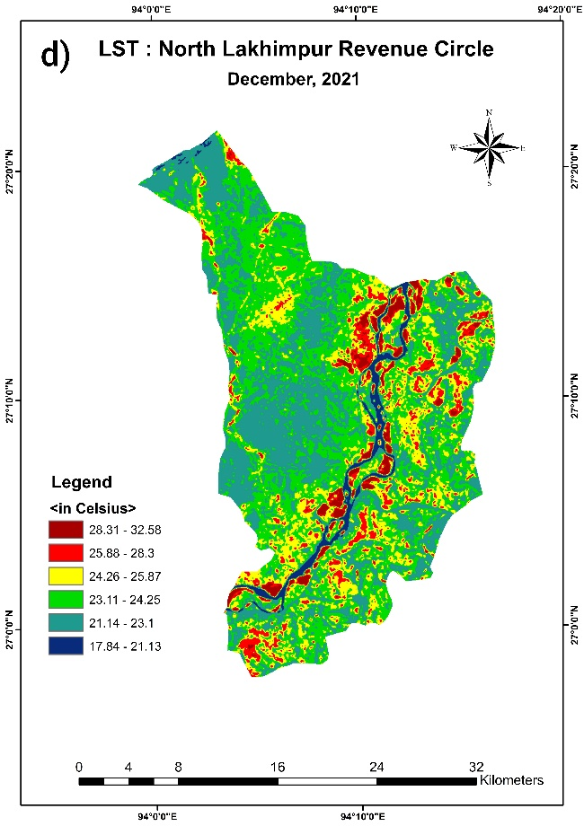
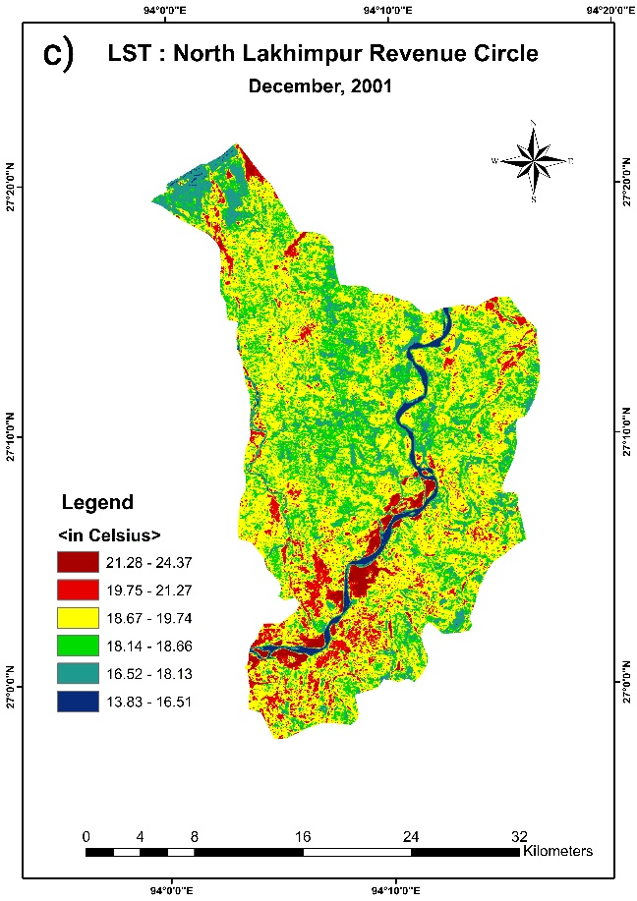
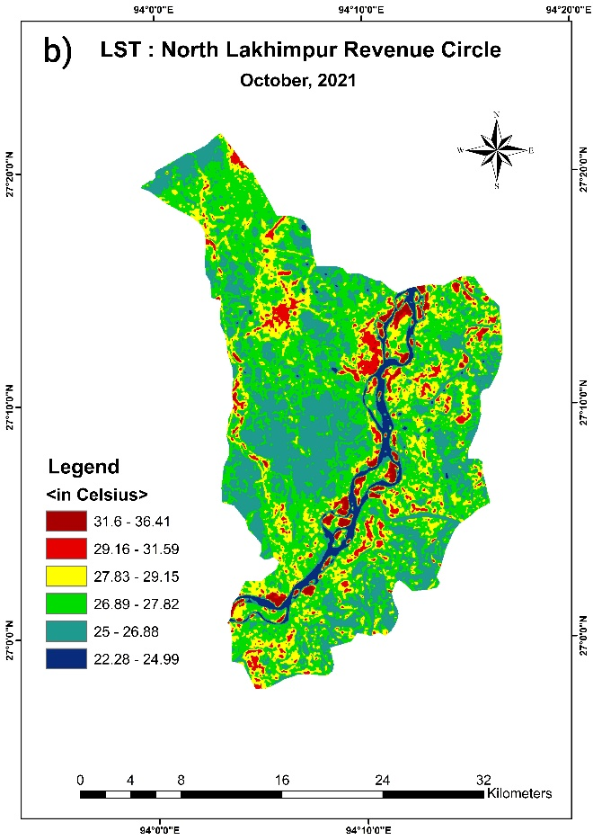
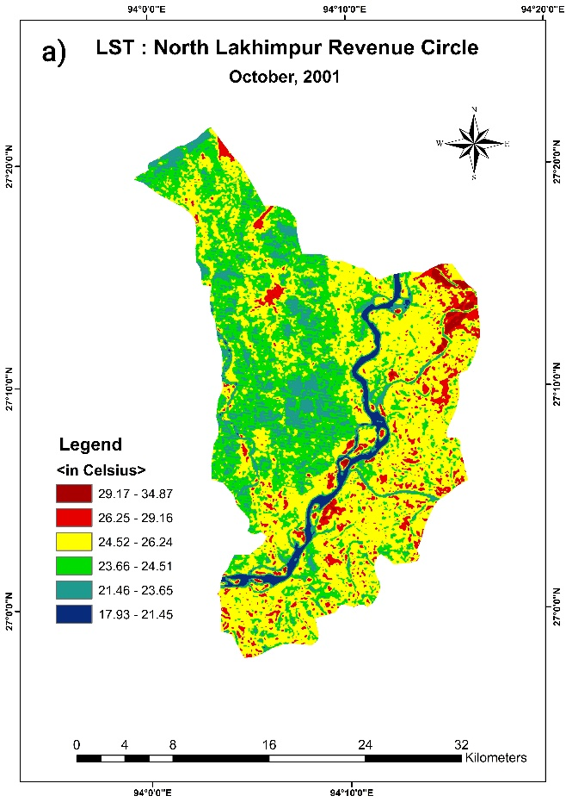
Fig. 3: Distribution of LST Maps of North Lakhimpur R.C. (a) October, 2001 (b) October, 2021 (c) December, 2001 (d) December, 2021
(Source: Landsat 4-5 TM, Landsat 7 ETM+ and Landsat OLI/TIRS; calculated Land Surface Temperature in ArcGIS software)
  - Spatio-temporal Distribution of Normalized Difference Vegetation Index (NDVI):
Vegetation cover of an area changes with time sometimes positively and sometimes negatively. It’s all because of people desires and needs which they fulfilled by destroying the natural resources and it changes positively when people realise or faced the consequence and became aware of it. Here in this present study in post-monsoon season October, 2001 the NDVI value ranges from -0.50 to +0.83 and in October, 2021 it ranges from -0.66 to +0.84.
In the post-monsoon season (October), the maximum NDVI remained almost unchanged (0.83 in 2001; 0.84 in 2021), while the minimum increased markedly from –0.50 in 2001 to 0.70 in 2021. This suggests a reduction in barren, waterlogged, or sparsely vegetated areas and a transition toward more consistently positive vegetation cover. The mean NDVI also improved from 0.47 to 0.53, indicating healthier vegetation conditions across the region. The standard deviation values (0.24 in 2001; 0.25 in 2021) reveal that the variability of NDVI remained stable, implying a uniform distribution of vegetation improvement.
During the winter season (December), NDVI values were lower in both years compared to October, which is consistent with seasonal phenological patterns in vegetation. The maximum NDVI values remained similar (0.54 in 2001; 0.55 in 2021), whereas the minimum declined from 0.28 to 0.13 in 2021. This reduction suggests the presence of patches with lower vegetation cover, likely due to senescence or increased exposure of non-vegetated surfaces. Despite this, the mean NDVI rose from 0.10 in 2001 to 0.25 in 2021, reflecting an overall improvement in vegetation persistence during the dry season. The standard deviation remained constant (0.11), signifying little change in the spatial variability of vegetation.
In post-monsoon season (Oct. 2001-2021), healthy vegetation cover found in North Lakhimpur due to the paddy cultivation in agricultural fields and the presence of forest cover in upper northern part of the revenue circle. Overall, the results indicate a positive long-term trend in vegetation health, particularly in the post-monsoon season, with an increase in mean NDVI values and a shift of minimum NDVI from negative to positive ranges.
Table 3. Calculated Data of NDVI of North Lakhimpur R.C.
Data | NDVI
Data | Maximum | Minimum | Mean | S.D.
October, 2001 | 0.83 | -0.5 | 0.47 | 0.24
October, 2021 | 0.84 | -0.7 | 0.53 | 0.25
December, 2001 | 0.54 | -0.28 | 0.10 | 0.11
December, 2021 | 0.55 | -0.13 | 0.25 | 0.11
Note: Data generated by author from calculated NDVI.

Overall, the NDVI analysis indicated a noticeable improvement in vegetation health and persistence over the two decades. In October, the mean NDVI increased from 0.47in 2001 to 0.53 in 2021, indicating denser post-monsoon vegetation. A stronger change is observed in December, where the mean NDVI rose from 0.10 to 0.25, reflecting better vegetation retention in the dry season. These changes suggest enhanced ecological stability, with vegetation likely contributing to surface cooling through evapotranspiration and shading. Hence, the observed NDVI dynamics form an important basis for evaluating their influence on Land Surface Temperature and their correlation.
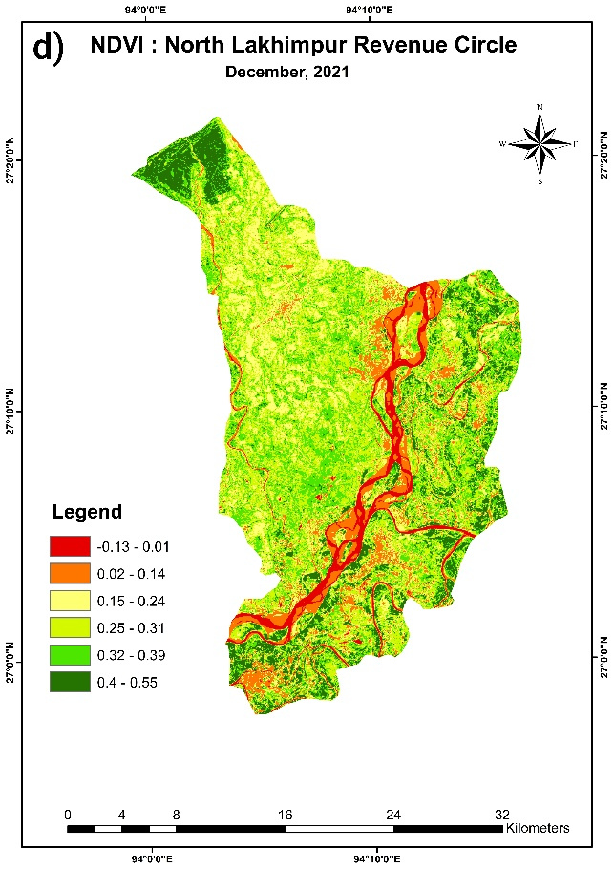
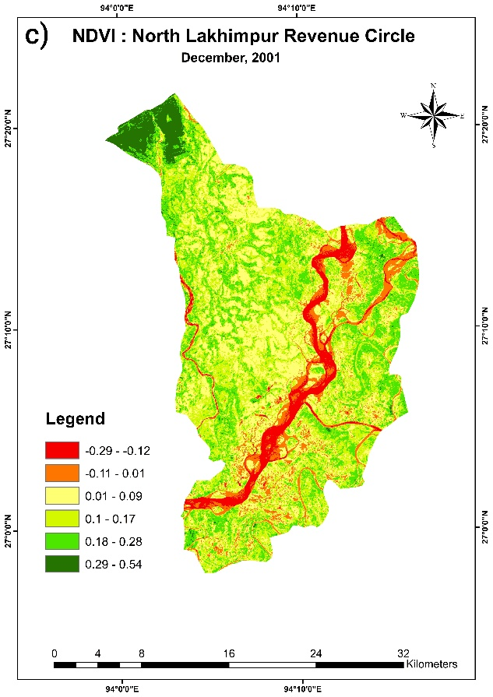
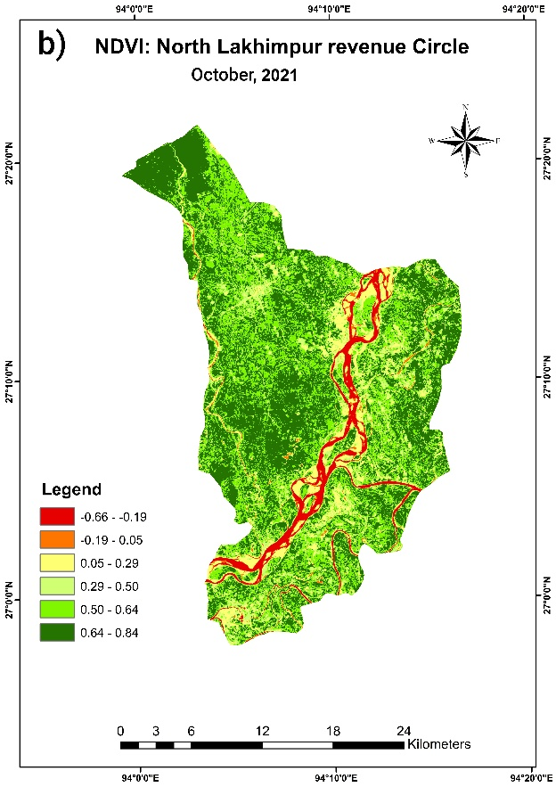
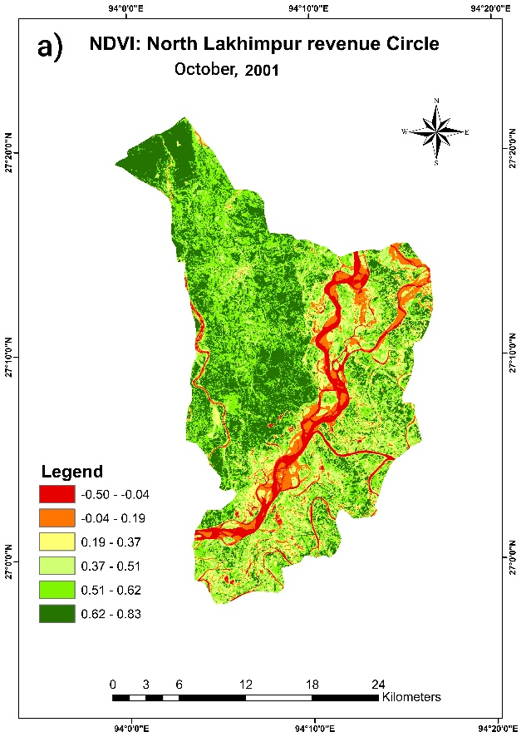
Fig. 4: Distribution of NDVI Maps of North Lakhimpur R.C. (a) October, 2001 (b) October, 2021 (c) December, 2001 (d) December, 2021
(Source: Landsat 4-5 TM, Landsat 7 ETM+ and Landsat OLI/TIRS; calculated Normalized Difference Vegetation Index in ArcGIS software)
  - Correlation Between Land Surface Temperature and Normalized Difference Vegetation Index:
In October 2001 (Fig. 5, a), the relationship was expressed as with a value of 0.01, indicating a weak positive association between NDVI and LST. By October 2021, the slope slightly increased (Fig. 5, b), suggesting that higher vegetation greenness was marginally associated with warmer land surfaces. However, the low R² values in both years highlight that NDVI explained less than 2% of the variability in LST, implying that factors other than vegetation, such as land cover type, urbanization, and soil moisture, played a more dominant role in controlling LST during this season. The increase in the intercept from 24.17 °C in 2001 to 26.99 °C in 2021 reflects a clear warming trend over the two decades.
In contrast, the December results indicated a negative NDVI–LST relationship. In December 2001 (Fig. 5, a), the regression equation was with an, showing that areas with higher NDVI values were associated with lower surface temperatures, consistent with the cooling role of vegetation through evapotranspiration and shading. By December 2021, the slope steepened (Fig. 5, b), demonstrating that vegetation’s cooling effect had become stronger over time, although the explanatory power of NDVI remained modest. The intercept increases from 18.80 °C to 24.56 °C again points to a significant rise in background land surface temperatures.
Comparing the two seasons, October consistently showed a weak positive relationship, whereas December exhibited a negative relationship that intensified between 2001 and 2021. This seasonal divergence may be attributed to post-monsoon soil moisture and vegetation dynamics in October, which can trap surface heat, whereas in December the dominance of evapotranspiration and canopy cover enhances cooling effects. Despite these patterns, the overall low R² values suggest that NDVI alone cannot explain variations in LST, and other environmental and anthropogenic drivers must be considered.

a)

b)

Fig. 5: Correlation Between LST and NDVI, October 2001 (a) October, 2021 (b)

a)

b)

Fig. 6: Correlation Between LST and NDVI, December 2001 (a) December, 2021 (b)

6. Conclusion

The present study analysed the distribution of Land Surface Temperature and Normalized Difference Vegetation Index and their correlation for the month of October and December for the year 2001 and 2021 in North Lakhimpur R.C. of Lakhimpur district. It is observed that the surface temperature and NDVI influence and change with season as well as by land cover changes. The maximum LST values were recorded in the urban and barren land areas whereas minimum LST values occurred over water bodies, and region with healthy vegetation cover area. In October 2001, LST ranged from 17.93 ºC to 34.87 ºC while in October 2021 the minimum and maximum values increased to 22.27 ºC and 36.41 ºC, respectively. During December 2001, LST values varied between 13.82 ºC and 24.37 ºC compared to a range 17.83 ºC to 32.57 ºC in December 2021. In terms of NDVI, values for October 2001 ranged from -0.5 to +0.83, while in October 2021 they varied from 0.7 to +0.84. For December 2001, the NDVI ranged between -0.28 and +0.54 whereas in December 2021 it varied from -0.13 to +0.55.
During the season (Oct. 2001-2021) there is positive correlation between LST and NDVI have seen. In the winter season, due to the harvesting in agricultural fields the range of NDVI decreased. In result of the decrease of NDVI ranges, a weak negative correlation between LST and NDVI have seen. Because vegetation cover provides natural cooling processes like shading and evapotranspiration unlike built-up areas, barren surface areas, sandbar which absorb sun’s energy triggering the land surface and air temperature to increase. The correlation between NDVI and LST varies mainly because of seasonal variation as well as the anthropogenic activities which ultimately changes the land cover. The continuous cutting down of trees has directly impacted the rainfall pattern and since 2015 the pattern of monsoon rain has been abnormal and because of that agricultural land experience deficit rainfall which resultant in decrease in agricultural production. The Lakhimpur district which named after the abundance production of agriculture and paddy (land of Lakshmi) is becoming a myth to new generation.
Overall, the findings highlight both the seasonal contrasts in vegetation–temperature interactions and the long-term warming trend evident from the rising intercepts in both seasons. These results align with broader evidence of regional climatic warming and changing land surface processes, while also underlining the complex and context-dependent role of vegetation in modulating LST.

Consent

All authors agree to publish the manuscript.

Disclaimer (Artificial intelligence)
Author(s) hereby declares that generative AI technologies such as Large Language Models, etc. have been used during the writing or editing of manuscripts. This explanation will include the name, version, model, and source of the generative AI technology and as well as all input prompts provided to the generative AI technology
Details of the AI usage are given below:
1. NA

References

- Abdulkadir, I., Kumar, S. (March, 2021). Exploring the Correlation between Land Surface Temperature, NDBI, NDVI, and NDMI over Gombe Metropolis, Nigeri, Psychology and Education, pp: 2406-2416.
- https://psychologyandeducation.net/pae/index.php/pae/article/view/5033
- Chaudhuri, G., & Mishra, N. B. (2016). Spatio-temporal dynamics of land cover and land surface temperature in Ganges-Brahmaputra delta: A comparative analysis between India and Bangladesh. Applied Geography, 68, 68–83.
- https://doi.org/10.1016/j.apgeog.2016.01.002
- Das, S., & Angadi, D. P. (2020). Land use-land cover (LULC) transformation and its relation with land surface tem perature changes: A case study of Barrackpore subdivi sion, West Bengal, India. Remote Sensing Applications: Society and Environment, 19, 100322.
- https://doi.org/10.1016/j.rsase.2020.100322
- Dheeraj, V.P., Singh, C.S., Kishore, N., (December, 2024). A Study on the Relationship Between Normalised Deferential Vegetation Index and Land Surface Temperature in Coalfield Region, India: An Integrated Approach of Remote Sensing & GIS,
Springer Nature Singapore. http://dx.doi.org/10.1007/978-981-97-1757-6_13

- Gorgani, S.A., Panahi, M. and Rezaie, F. (November, 2013). The Relationship between NDVI and LST in the urban area of Mashhad, Iran, International Conference on Civil Engineering Architecture & Urban Sustainable Development.
- Guha, S., Govil, H., Dey, A., Gill, N. (2018). Analytical study of land surface temperature with NDVI and NDBI using Landsat 8 OLI and TIRS data in Florence and Naples city, Italy. European Journal of Remote Sensing 51(1):1667-1678.
- https://doi.org/10.1080/22797254.2018.1474494
- Guha, S., Govil, H., Diwan, P. (May 2019). Analytical study of seasonal variability in land surface temperature with normalized difference vegetation index, normalized difference water index, normalized difference built-up index, and normalized multiband drought index, Journal of Applied remote Sensing Vol. 13, Issue 2.https://doi.org/10.1117/1.JRS.13.024518
- Guha, S., Govil, H. (September, 2020). Land surface temperature and normalized difference vegetation index relationship: a seasonal study on a tropical city, Springer Nature. https://link.springer.com/article/10.1007/s42452-020-03458-8
- Guha, S., Govil, H., Diwan, P. (June, 2020). Monitoring LST-NDVI Relationship Using Pre-monsoon Landsat Datasets, Advances in Meteorology Volume 2020.
- https://doi.org/10.1155/2020/4539684
- Himayah. S, Ismail, A., Nandi, Ridwana, R., Arrasyid, R., Affriani, A. R., and M Ihsan, M. (2019). Correlation between Land Surface Temperature and Vegetation Greenness using Multi-temporal Images, IOP Conf. Series: Earth and Environmental Science. https://iopscience.iop.org/article/10.1088/1755-1315/286/1/012043
- Hussain, S., and Karuppannan, S. (2023). Land use/land cover changes and their impact on land surface temperature using remote sensing technique in district Khanewal, Punjab Pakistan, GEOLOGY, ECOLOGY, AND LANDSCAPES 2023, VOL. 7, NO. 1, 46–58. https://doi.org/10.1080/24749508.2021.1923272
- Joshi JP, Bhatt B. (2012) Estimating temporal land surface temperature using remote sensing: a study of Vadodara urban area, Gujarat. International Journal of Geology, Earth and Environmental Sciences, 2 (1): 123-130.
- Kayet, N., Pathak, K., Chakrabarty, A., Sahoo, S. (2016). Spatial impact of land use/land cover change on surface temperature distribution in Saranda Forest, Jharkhand. Model. Earth Syst. Environ. (2016) 2:127. https://link.springer.com/article/10.1007/s40808-016-0159-x
- Khan, Z., and Javed, A. (2022). Correlation between land surface temperature (LST) and normalized and normalized difference vegetation index (NDVI) in Wardha Valley difference vegetation index (NDVI) in Wardha Valley Wardha Valley Coalfield, Maharashtra, Central India, Nova Geodesia 2 (3) :53. https://doi.org/10.55779/ng2353
- Kumar A, Agarwal V, Pal L, Chandniha SK, Mishra V (2021). Effect of land surface temperature on urban heat island in Varanasi City, India. J Multidisciplinary Scientific Journal 4(3):420-429. https://doi.org/10.3390/j4030032
- Kumar KS., Bhaskar PU., Padmakumari K. (2012) Estimation of land surface temperature to study urban heat island effect using Landsat ETM+ image. International Journal of Engineering Science and Technology, 2, 771-778.
- Liang BP, Li Y, Chen KZ (2012). A Research on land features and correlation between NDVI and land surface temperature in Guilin City. Remote Sensing Technology and Application 27(3):429-435.
- Li X, Zhou W, Ouyang Z, Xu W, Zheng H (2012) Spatial pattern of greenspace affects land surface temperature: evidence from the heavily urbanized Beijing metropolitan area, China. Landsc Ecol 27(6):887–898
- Markham, B.L., & Barker, J.L. (1986). Landsat MSS and TM post-calibration dynamic ranges, exoatmospheric reflectances and at-satellite temperature. Landsat Technical Notes, 1, 3-8.
- Mukherjee, F., & Singh, D. (2020). Assessing land use–land cover change and its impact on land surface temperature using LANDSAT data: A comparison of two urban areas in India. Earth System Environment, 4(2), 385–407. https://doi.org/10.1007/s41748-020-00155-9
- Mwangi, P.W., Karanja, F.N. and Kamau, P.K. (2018). Analysis of the Relationship between Land Surface Temperature and Vegetation and Built-Up Indices in Upper-Hill, Nairobi. Journal of Geoscience and Environment Protection, 6, 1-16. https://doi.org/10.4236/gep.2018.61001
- Naif, S., Mahmood, D. & Al-Jiboori, M (2020). Seasonal Normalized Difference Vegetation Index Responses to Air Temperature and Precipitation in Baghdad. Open Agriculture, 5(1), 631-637. http://dx.doi.org/10.1515/opag-2020-0065
- Rouse, J. W., Jr., Haas, R. H., Deering, D. W., Schell, J.A., 1973. Monitoring the vernal advancement and retrogradation (green wave effect) of natural vegetation: Progress Report RSC 1978-2. http:ntrs.nasa.gov/archive/nasa/casi.ntrs.nasa.gov/19740004927.pdf
- Manish Sharma
- 1
- 1
- Sharma, M., Bangotra, P., Gautam, A.S., Gautam S. (July, 2021). Sensitivity of normalized difference vegetation index (NDVI) to land surface temperature, soil moisture and precipitation over district Gautam Buddh Nagar, UP, India. Stochastic Environmental Research and Risk Assessment. https://link.springer.com/article/10.1007/s00477-021-02066-1
- Singh P, Kikon N, Verma P (2017) Impact of land use change and urbanization on urban heat island in Lucknow city, Cen tral India. A remote sensing-based estimate. Sustain Cities Soc 32:100–114. https://doi.org/10.1016/j.scs.2017.02.018
- Sobrino, J.A., Jimenez-munoz, J.C., & Paolini, L. (2004). Land surface temperature retrieval from LANDSAT TM 5. Remote Sensing of Environment 92:434-440.
- Sun, D., and M. Kafatos (December, 2007). Note on the NDVI-LST relationship and the use of temperature-related drought indices over North America, Geophysical Research Letters, Volume 34, Issue 24. https://doi.org/10.1029/2007GL031485
- Ullah, W., Ahmad, K., Ullah, S., Tahir, A.A., Javed, M.F., Nazir, A., Abbasi, A.M., Aziz, M., Mohamed, A. (February, 2023). Analysis of the relationship among land surface temperature (LST), land use land cover (LULC), and normalized difference vegetation index (NDVI) with topographic elements in the lower Himalayan region, Heliyon Volume 9, Issue 2. http://dx.doi.org/10.1016/j.heliyon.2023.e13322
- Yue, W., Xu. J., Tan, W. and Xu. L (July 2007). The relationship between land surface temperature and NDVI with remote sensing: application to Shanghai Landsat 7 ETM + data, International Journal of Remote Sensing Vol. 28, Issue 15. https://doi.org/10.1080/01431160500306906
https://www.earthexplorer.usgs.gov/
http://www.surveyofindia.gov.in/

