
Asian Journal of Geographical Research

Volume XXX, Issue XX, Page XX-XX, 20YY; Article no.AJGR.148235
ISSN: 2582-2985

Geogenic Fluoride Enrichment in Dharmapuri District, Tamil Nadu, India:

Hydro-Chemical Patterns and Public Health Implications

Authors’ Name……………………………………………………

Affiliations……………………………………………………….………………

Authors’ contributions
Please check this section
This work was carried out in collaboration among all authors. Authors MA and KM conducted the fieldwork, data collection, and statistical analysis. Author VS assisted in study design, data interpretation, and drafted of the manuscript. Author SK supported in spread sheet diagrammatic work design. All authors read and approved the final manuscript.

Article Information

DOI: 10.9734/AJGR/2025/XXXXX

Open Peer Review History:
This journal follows the Advanced Open Peer Review policy. Identity of the Reviewers, Editor(s) and additional Reviewers, peer review comments, different versions of the manuscript, comments of the editors, etc are available here:

Received: DD/MM/20YY
………… Article
Published: DD/MM/20YY

ABSTRACT

This study investigates geogenic fluoride contamination in groundwater throughout Dharmapuri District, Tamil Nadu, using seven years of hydrogeochemical data and a community health assessment. Water samples from 55 villages were analysed for fluoride and other water quality parameters, such as pH, EC, TDS, calcium, sodium, and bicarbonate, during pre- and post-monsoon seasons from 2011 to 2017. Statistical methods, including Pearson correlation and R² regression, were applied to identify predictors of elevated fluoride levels. A community survey using a 5-point Likert scale captured self-reported symptoms of fluorosis from 1,375 residents. Findings revealed widespread fluoride enrichment, with 30.9% of villages classified as moderate-risk and 12.7% as very high-risk in the pre-monsoon period; post-monsoon, 36.4% were moderate-risk and 10.9% very high-risk. Seasonal comparisons showed that fluoride levels decreased in 24 villages but increased in 31 others, with changes up to 0.36 mg/L. Potassium and bicarbonate were found to be the strongest predictors of fluoride, while sodium had a positive relationship and calcium an inverse one. The health survey indicated high prevalence of yellowish teeth (49%) and joint pain (45%), but only 19% recognised personal fluorosis. The research underscores the geogenic origin of fluoride, its seasonal variability, and the need for bi-seasonal monitoring and targeted mitigation strategies to address public health risks.

Keywords: Fluoride contamination; groundwater quality; geogenic sources; hydro geochemistry; fluorosis; public health,

1. INTRODUCTION

Fluoride in groundwater is recognised as a geogenic contaminant of major concern, particularly when concentrations exceed recommended safety limits. The primary source of fluoride ions in groundwater is the natural weathering and dissolution of minerals containing fluoride, such as fluorite and fluorapatite, present in rock formations. Both the World Health Organization (WHO) and Indian standards have set 1.5 milligrams per litre (mg/L) as the upper safe limit for fluoride in drinking water, while in India, the lower bound of optimal fluoride concentration is considered to be 0.6 mg/L. Chronic intake of water with high fluoride levels is associated with dental and skeletal fluorosis, along with other adverse health effects. In the Dharmapuri District of northwestern Tamil Nadu, the presence of fluoride-rich igneous and metamorphic rocks, including granite and gneiss, increases the susceptibility of groundwater to fluoride contamination. This research investigates the predictive value of key water quality parameters (such as pH, electrical conductivity (EC), total dissolved solids (TDS), calcium (Ca²⁺), sodium (Na⁺), and bicarbonate (HCO₃⁻)) for fluoride concentrations and examines seasonal variations between pre-monsoon and post-monsoon periods. By combining geochemical monitoring with statistical analysis, the study seeks to enhance understanding of fluoride mobilisation processes in Dharmapuri’s aquifers and to support the development of appropriate groundwater management strategies.

The scientific literature on fluoride exposure and its health implications is extensive and covers a range of issues. Taylor et al. (2025) conducted a systematic review and meta-analysis, reporting a significant link between fluoride exposure and lower IQ scores in children, thereby raising concerns about neurodevelopmental impacts. Vasisth et al. (2024) discussed the dual role of fluoride in oral health, noting its benefits in preventing dental caries as well as the risks of excessive exposure, such as dental fluorosis. Srivastava and Flora (2020) presented a global overview of skeletal fluorosis, highlighting the widespread prevalence of fluoride-induced skeletal conditions due to contaminated drinking water. Niazi and Pepper (2023) described the clinical features and long-term consequences of dental fluorosis. Solanki et al. (2022) reviewed fluoride occurrences, health issues, and modern detection and remediation methods, all of which are vital for effective public health interventions.

Recent advances in molecular research, such as those by Manoharan et al. (2024), have shown that microRNAs play a role in the development of fluorosis, affecting dental, skeletal, and soft tissues. Saha et al. (2024) assessed fluoride hazards across India, revealing regional differences and highlighting the urgent need for systematic monitoring of groundwater. Rani et al. (2022) investigated the prevalence of dental fluorosis and dental caries in fluoride-endemic areas, providing epidemiological insights necessary for targeted prevention. Patil et al. (2018) highlighted the severe impact of fluorosis on paediatric health in endemic regions. Khatkar and Nagpal (2023) reviewed both conventional and advanced methods for detecting fluoride in water, essential for surveillance and management of contamination. Collectively, these studies illustrate the complex balance between the preventive benefits of fluoride and its potential for harm, underscoring the need for regular monitoring, informed public health policies, and ongoing research.

Fluoride contamination in groundwater is largely attributed to geogenic processes. Fluorine, the elemental precursor to fluoride, is abundant in geological formations, especially in specific rock types. Weathering and dissolution of fluoride-rich minerals, particularly through rock–water interaction, facilitate the release of fluoride ions into groundwater aquifers. Numerous studies have documented a strong association between elevated fluoride concentrations in Indian groundwater and the prevalence of granitic and gneissic rock formations. Pandit and Jadav (2013) estimated that over 62 million people in India, including about 6 million children, suffer from fluorosis due to chronic exposure to high levels of geogenic fluoride.

In these endemic areas, minerals such as fluorite, apatite, and various micas are the primary contributors to dissolved fluoride. Within Tamil Nadu, especially in the northwestern districts like Dharmapuri, elevated groundwater fluoride levels have been linked to local lithology. The presence of minerals including fluorapatite, biotite, and amphiboles in Dharmapuri has been documented, supporting a geogenic origin for contamination. Although local industrial emissions and agricultural activities can also contribute to fluoride levels, geology remains the principal source. Previous analytical studies have examined the relationships between fluoride levels and other water quality parameters.

The Bureau of Indian Standards (2012) prescribes a fluoride range of 0.6–1.5 mg/L for drinking water (IS 10500:2012). While optimal fluoride levels support physiological processes, both excess and deficiency can result in dental and skeletal fluorosis. Natural weathering of rocks and sediments is a key source of fluoride, and certain Indian regions are more vulnerable due to their geology (Agarwal et al., 1997; Saha et al., 2014). Thus, geological knowledge is crucial for understanding risks in Dharmapuri. Similar geological formations in the area could intensify contamination (Kavisri & Moovendhan 2024). The findings of Agarwal et al.(1997) and Saha et al. (2014) highlight the significance of geology in identifying and addressing fluoride hotspots, directly informing this study’s approach in Dharmapuri.

Fluorine exists naturally in various mineral forms, notably in fluorite, cryolite, and fluorapatite. These minerals can weather and dissolve, releasing fluoride ions into groundwater. Groundwater safety is categorised based on fluoride concentration: less than 0.6 mg/L is deemed safe; 0.6 to 1.0 mg/L is considered at risk; and concentrations above 1.0 mg/L are classified as high hazard. This framework supports informed water management decisions. Regional distribution and geological sources are critical to understanding India’s fluoride problem, with most elevated concentrations attributed to the weathering of granitic and gneissic rocks, especially in areas rich in these lithologies (Tripathy et al., 2005; Pradhan et al., 2018). Fluorosis, first reported in 13 Indian states in 1986, now affects over 19 states, with estimates of 62 million individuals—about 6 million children—impacted by contaminated water (Raju et al., 2009).

In Tamil Nadu, particularly in the northwestern districts, high groundwater fluoride concentrations are linked to minerals such as epidote, hornblende, biotite, apatite, carbonatite, mica, and fluorapatite (Jagadeshan et al., 2015; Brindha et al., 2016). Brindha et al., (2016) for example, analysed rocks from the Vaniyar river basin in Dharmapuri, identifying a complex mineral assemblage conducive to fluoride enrichment. Arid regions overlying these mineralised formations are especially prone to high fluoride. While most groundwater fluoride is of geogenic origin, anthropogenic sources, including coal combustion and industrial processes, can further increase local levels.

Several studies published since 2017 have analysed the correlations and determination coefficients between fluoride and other water quality parameters. Negative correlations with calcium have been observed, indicating that precipitation of CaF₂ plays a role in controlling fluoride levels. However, many studies are limited to single-season data and do not capture the impact of seasonal variations on fluoride dynamics. In Odisha, Behera et al. (2017) found that changes in groundwater chemistry are crucial for elevated fluoride concentrations. Comparable trends have been observed internationally; for example, Alemayehu et al. (2021) found determination coefficients above 0.65 between fluoride and both TDS and sodium in Ethiopia, suggesting the importance of evaporative concentration and silicate weathering.

The present study addresses several key questions regarding groundwater fluoride in Dharmapuri District. First, it seeks to identify which water quality parameters (including pH, EC, TDS, Ca²⁺, Na⁺, HCO₃⁻, and others) are the most indicative of high fluoride levels. Second, it aims to quantify the statistical relationships between fluoride and these physicochemical parameters, using coefficients of determination (R²) for pre- and post-monsoon datasets. Third, it evaluates the health implications of fluoride exposure by analysing self-reported fluorosis symptoms, with a structured questionnaire administered to 1,375 residents across the sampled villages. Symptoms such as dental discolouration, headaches, and joint pain were rated on a 5-point Likert scale. Finally, the combined results will be used to delineate endemic fluoride zones and propose targeted monitoring and intervention strategies. By addressing these questions, the study aims to map areas at risk of fluoride contamination and clarify the broader impacts of water quality on community health.

1.1 Research Gap

Although fluoride levels in Dharmapuri have been assessed across space and time, key gaps remain. The study does not use advanced multivariate modelling to reveal complex interactions among water quality factors, nor does it include epidemiological studies needed to link environmental risks with health outcomes. Micro-scale variations in fluoride, particularly from local contamination or episodic events, are also underexplored due to coarse sampling. More interdisciplinary methods and finer-scale investigations are needed for accurate risk assessment and targeted interventions.

2. MATERIALS AND METHODS

Dharmapuri District in northwest Tamil Nadu spans 4,498 sq. km, with a population of 1.5 million and a literacy rate of 64.71%. Researchers collected groundwater samples from 55 villages (Fig. 1) selected for diverse geology and hydrology, using hydrogeological maps and local insights to target densely populated and historically affected areas. Sampling was conducted pre- and post-monsoon (2011–2017) following standard protocols.

Fluoride concentrations were measured by ion-selective electrodes, while pH and conductivity were analysed with standard instruments. Major cations and anions were determined by titration and ion chromatography; all data were digitized for evaluation. Sampling sites were categorized into five risk zones based on Indian drinking water standards (IS 10500:2012), allowing for nuanced assessment: Very Low (<0.50 mg/L), Low (0.51–0.70 mg/L), Moderate (0.71–0.90 mg/L), High (0.91–1.10 mg/L), and Very High (>1.11 mg/L).

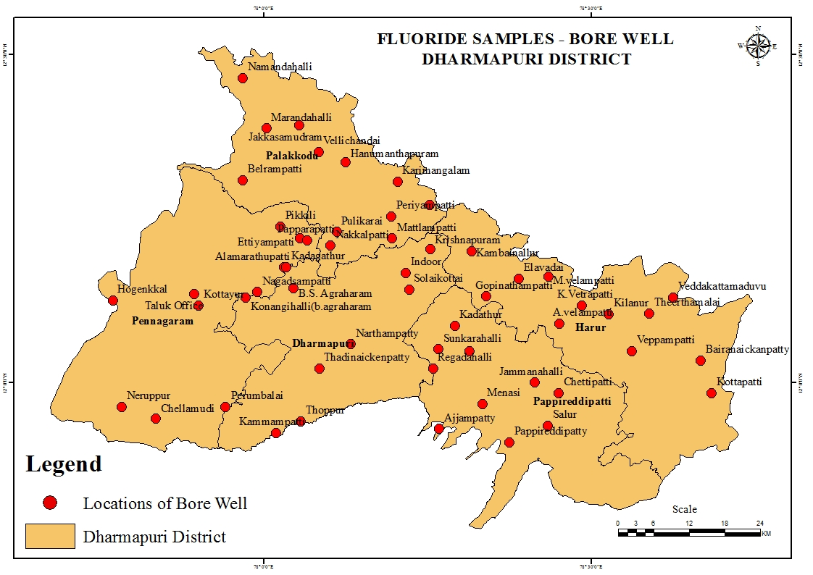

Fig. 1. Fluoride samples bore Well-Dharmapuri District

Statistical analysis included Pearson correlation and linear regression (R_²) between fluoride and other parameters for both seasons, visualized through scatterplots. Additionally, a health survey of 1,375 randomly selected adults used Likert-scale questionnaires to assess symptoms of fluorosis. The prevalence of reported symptoms was calculated as percentages for each response category.

3. RESULTS

3.1 Fluoride Distribution and Seasonal Trends

Fig. 2 summarizes average fluoride concentrations by village. During the pre-monsoon season, most locations were at moderate-to-high risk: 30.9% of villages had fluoride levels ranging from 0.71 to 0.90 mg/L (moderate), 20.0% measured 0.91 to 1.10 mg/L (high), and 12.7% recorded levels exceeding 1.11 mg/L (very high). 9.1% of villages were in the very low category (<0.50 mg/L), and 27.3% were in the low category (0.51–0.70 mg/L). After the monsoon, patterns shifted: only 1.8% of villages remained very low, while 32.7% were low, 36.4% were moderate, 18.2% were high, and 10.9% were very high. This indicates that more villages moved into the moderate category after the monsoon.

A comparative analysis of mean fluoride between seasons revealed mixed trends (Fig. 3). In 24 villages, pre-monsoon fluoride levels were lower than those in post-monsoon periods (decreases of up to 0.36 mg/L), suggesting monsoonal dilution of fluoride. Conversely, 31 villages showed higher pre-monsoon fluoride (increases up to 0.40 mg/L). These spatially heterogeneous changes highlight complex controls: some areas experienced groundwater dilution after rainfall, while others saw increased fluoride mobilization or concentration (possibly due to rock-water interactions or evapotranspiration differences). To contextualize these shifts, the recorded decreases and increases correspond to approximately 24% and 27% of the WHO limit for fluoride concentration in drinking water (1.5 mg/L), respectively, highlighting the substantial impact of seasonal variability on fluoride levels.

Overall, the results provide evidence that Dharmapuri’s fluoride problem is driven by rock–water interactions, requiring integrated management approaches. Mitigation strategies should combine continued water-quality testing (using the identified predictors as early warning indicators) with public health efforts (e.g., dental screenings and education). By aligning hydrogeochemical monitoring with community health data, this work lays the groundwork for targeted intervention and policy in fluoride-affected districts.

3.2 Regression Analysis of Fluoride Predictors

The results summarize the coefficient of determination (R²) between fluoride and each parameter. The strongest relationships observed were generally weak (R² < 0.2), but certain parameters stood out. Potassium (Fig. 4) showed the highest shared variance: post-monsoon R²=18.7% vs. pre-monsoon R² = 10.9%. Bicarbonate (Fig. 5) also showed substantial variance: pre-monsoon R² ≈ 0.150, post-monsoon R² ≈ 0.044. Sodium (Fig. 6) had a moderate positive relationship (post R² ≈ 0.128, pre-R² ≈ 0.064). Calcium (Fig. 7) exhibited an inverse but weak correlation (post R² ≈ 0.095, pre-R² ≈ 0.068), consistent with the idea that Ca²⁺ may precipitate with F⁻ (limiting fluoride mobility). Other parameters (pH (Fig. 8), EC (Fig. 9), TDS (Fig 10), NO₃⁻ (Fig. 11), Cl⁻ (Fig. 12, Mg²⁺ (Fig. 13), SO₄² (Fig. 14), and CO₃²⁻ (Fig. 15) showed very weak shared variance with fluoride (<5%). Notably, the pre-monsoon period generally exhibited higher shared variance for carbonate and pH, while the post-monsoon period was stronger for K⁺ and Na⁺. These findings indicate that potassium and bicarbonate are among the most reliable predictors of fluoride concentration in this dataset.

3.3 Community Survey (Likert Responses)

Fig. 16 presents selected results. Dental symptoms were common: 49% of respondents reported yellowish teeth (Likert “Agree” or “Strongly Agree”), and 44.7% reported chronic joint/bone pain. In contrast, only 19.4% of individuals acknowledged themselves to have fluorosis, whereas 41.6% reported having a family member with fluorosis. Neurological issues were rare (only 10.7% reported any brain problems), whereas headaches were frequent (42.2% reported frequent headaches). About 23% affirmed kidney stone symptoms and 15% stomach pain, but many respondents were neutral or in denial regarding gastrointestinal complaints. Overall, dental discoloration and musculoskeletal complaints were the most frequently self-reported indicators of fluoride exposure, while serious outcomes (fractures, endocrine diseases) were infrequent. These results reflect a community burden of mild to moderate fluorosis symptoms.

Fig. 2. Level of Fluoride (mg/l) During Pre and Post Monsoon Period

Fig. 3. Variations of Fluoride (mg/1) Level Areas (Pre and Post Monsoon 2011-2017) - Dharmapuri District

Fig. 4. Fluoride Versus Potassium

Fig. 5. Fluoride Versus Bicarbonate

Fig. 6. Fluoride Versus Sodium

Fig. 7. Fluoride Versus Calcium

Fig. 8. Fluoride Versus pH

Fig. 9. Fluoride Versus Electrical Conductivity

Fig. 10. Fluoride Versus Total Dissolved Solids

Fig. 11. Fluoride Versus Nitrate

Fig. 12. Fluoride Versus Chloride

Fig. 13. Fluoride Versus Magnesium

Fig. 14. Fluoride Versus Sulphate

Fig. 15. Fluoride Versus Carbonate
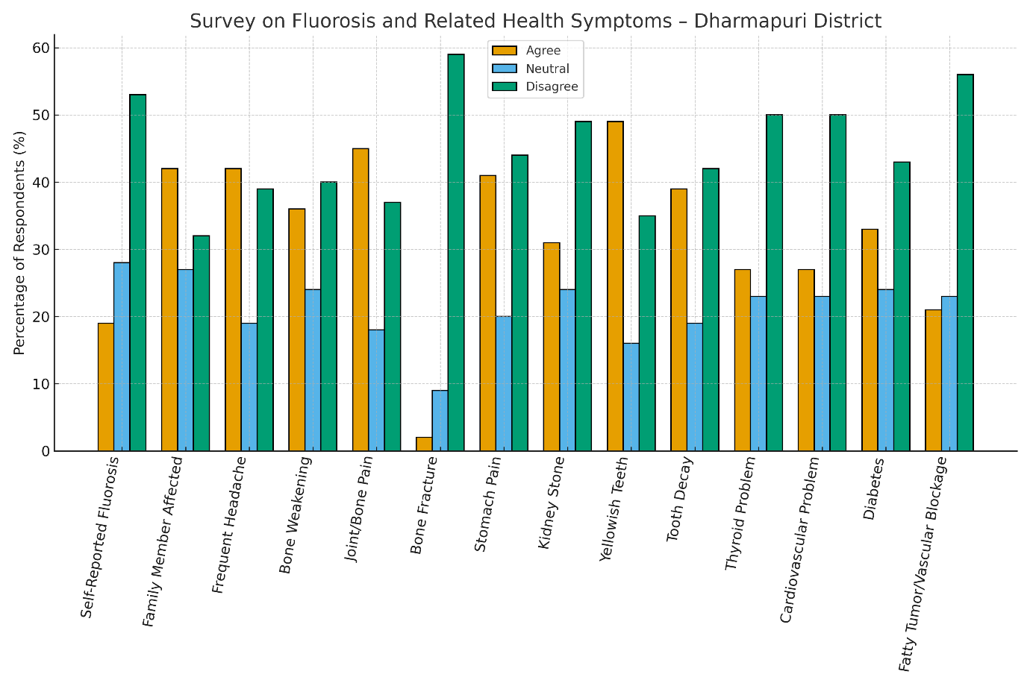

Fig. 16. Survey on Fluorosis and Related Health Symptoms - Dharmapuri District

4. DISCUSSION

The results confirm that fluoride contamination in Dharmapuri is primarily geogenic in origin. Elevated fluoride occurred mostly in villages underlain by granitic and gneissic rock, consistent with the presence of fluoride-bearing minerals in these lithologies. Seasonal differences highlight the role of hydrological recharge: monsoon rains dilute fluoride in some areas (reducing concentration) but can also enhance rock-water contact and mobilization in others. The finding that post-monsoon fluoride levels increased in many villages suggests that groundwater dynamics (e.g., flushing of new groundwater) are complex. This raises important questions for decision-makers: Should limited funds be prioritized for drilling new wells or installing household filters to address this issue? By framing the analysis around such dilemmas, stakeholders can better understand the potential impacts and cost-effectiveness of different interventions, making the scientific insights immediately actionable.

Correlation and regression analyses point to specific geochemical controls. Fluoride correlated positively with sodium and bicarbonate, and negatively (though weakly) with calcium. This pattern aligns with established geochemistry: high pH and Na-rich water (often found in hard-rock aquifers) favours fluoride release, whereas calcium can precipitate with fluoride (e.g., as fluorspar). In this study, potassium emerged as the single strongest predictor of fluoride (post-monsoon R²≈0.187). Potassium often accompanies sodium in saline groundwater facies, so its correlation may reflect overall evaporative concentration processes. Bicarbonate also had substantial shared variance (R²≈0.150 in pre-monsoon), suggesting that areas with higher alkalinity tend to have more dissolved fluoride. In practical terms, monitoring K⁺, Na⁺, and HCO₃⁻ in groundwater could serve as proxies to flag fluoride risk.

Comparing these results with earlier studies, they are broadly consistent with regional patterns. High correlations between fluoride and bicarbonate, and inverse correlations with sodium (and calcium), have been observed in other parts of India, reflecting similar geochemical equilibria. However, most prior work was limited to a single season; our bi-seasonal dataset reveals that the strength of these correlations can vary by season. For example, pH and carbonate were more influential pre-monsoon, while sodium and potassium were more influential post-monsoon. These seasonal dynamics underscore the need for continuous monitoring throughout the year.
The results of the community health survey provide clear evidence of widespread fluoride exposure, as demonstrated by the high proportion of respondents reporting dental discoloration (approximately 53% indicated yellow teeth), a hallmark symptom of endemic fluorosis. Additionally, musculoskeletal complaints, most notably joint pain—were reported by 45% of participants, indicating early manifestations of skeletal fluorosis. Notably, there is a significant statistical discrepancy between the percentage of individuals who acknowledged having fluorosis themselves (19.4%) and those who reported family members with the condition (41.6%). This divergence suggests possible under-recognition, underreporting, or social stigma associated with fluorosis diagnosis at a personal level, despite the acknowledgment of related symptoms or the observation of disease in others. The reluctance to self-identify as affected, even in the presence of classic clinical signs, underscores the necessity for comprehensive community education initiatives and systematic clinical screening to enhance case identification and reduce stigma.

The data does not indicate a strong association between fluoride and systemic diseases (e.g., thyroid, cardiovascular, and diabetes). The prevalence of conditions like diabetes (~33% in respondents) aligns with background rates for rural Tamil Nadu, suggesting that these conditions are mostly independent of fluoride exposure. Thus, the primary health impact of fluoride here appears to be dental and early skeletal fluorosis. The implications are that interventions (such as defluoridation, alternate water sources, and dental surveys) should prioritize the most affected villages and focus on dental health and musculoskeletal well-being.

Some limitations should be noted. The analysis relies on bivariate regressions; multivariate or geospatial modelling could refine predictions. Unmeasured factors (e.g., trace mineral content, land use) may also influence fluoride. The survey was self-reported and cross-sectional, so medical diagnoses were not confirmed clinically. Finally, while the 55-sample framework provided broad coverage, smaller hotspots of contamination could still exist. Future studies could expand spatial sampling density and include isotopic or age-dating analyses to better understand fluoride sources and migration.

5. CONCLUSION

This study demonstrates that groundwater fluoride contamination in Dharmapuri District is primarily influenced by natural geological factors and modulated by seasonal recharge. Geochemical analysis identified bicarbonate, sodium, and potassium as key predictors of fluoride levels, while calcium plays a countervailing role. Fluoride concentrations varied significantly between the pre- and post-monsoon seasons, with many villages experiencing higher fluoride levels in the pre-monsoon season. These findings support bi-seasonal monitoring of groundwater in fluoride-endemic regions. The community survey revealed widespread symptoms of dental fluorosis and significant complaints related to bone/joint issues, although personal awareness of fluorosis was low.

6. FUTURE RECOMMENDATION

To enhance policy effectiveness and support evidence-based groundwater management, future research should expand the spatial coverage of sampling sites and employ high-resolution geological mapping to improve the delineation of fluoride risk zones. Incorporating samples from deeper aquifers and capturing seasonal high-flow periods will enable detection of local-scale contamination events. The monitoring protocol should be broadened to include ancillary indicators such as trace concentrations of silica and phosphate, as well as redox-sensitive parameters, to more accurately characterize geochemical controls on fluoride mobilization. Adoption of multivariate statistical and machine learning approaches is recommended for more robust prediction and mapping of fluoride anomalies. Systematic clinical assessments, particularly targeting children, should be integrated to validate the prevalence and severity of fluorosis. Capacity-building initiatives for health workers are necessary to strengthen early detection and response to fluoride toxicity.

Pilot interventions, such as community-based defluoridation and rainwater harvesting systems, should be implemented in villages identified as high-risk, with tailoring to local sociocultural and economic contexts to enhance uptake and sustainability. A rigorous cost–benefit analysis of available remediation technologies (such as bone char filtration and activated alumina) under region-specific conditions will optimize resource allocation. Policy decisions, including the deployment of interventions and monitoring strategies, should be guided by risk prediction models and spatial risk maps developed from the study data. Finally, intersectoral collaboration among water resource managers, public health authorities, and local governance structures is essential to ensure equitable and coordinated access to safe drinking water.

ETHICAL ISSUES IN THIS STUDY

Several ethical issues arise in the context of this study on fluoride contamination and its health impacts in the Dharmapuri district: Maintaining openness in data collection, analysis, and reporting is critical to ensure scientific accuracy and build public trust. Any lack of transparency could compromise the credibility of the research and misinform stakeholders. When conducting field surveys or health assessments, it is essential to obtain informed consent from participants. Engaging the community in the research process helps ensure that local voices are heard and that interventions are culturally appropriate. Researchers must safeguard the privacy of participants and respect local traditions during outreach or intervention activities. Failure to do so could lead to stigmatization or exploitation of vulnerable groups. Efforts to mitigate fluoride risks—such as providing defluorination technologies or educational programs—should be distributed fairly.

There is an ethical obligation to ensure that interventions do not favor certain communities or individuals over others, thereby preventing health inequities. Care must be taken to avoid labelling or isolating communities identified as high-risk, as this could lead to social or economic disadvantages. Ethical research should prioritize sustainable benefits and the ongoing health and welfare of all affected populations, rather than short-term or superficial solutions. By addressing these ethical issues, the study can contribute to responsible research practices and support public health initiatives that are both effective and just for all communities in the Dharmapuri district.

CONSENT AND ETHICS APPROVAL

This study did not involve any clinical interventions or experiments involving human or animal subjects. Data were collected through a community-level household survey with informed verbal consent obtained from all participants. Ethics approval was not required as per institutional guidelines for non-clinical public health research.

FUNDING

This research was financially supported by the Indian Council of Social Science Research (ICSSR), New Delhi, under the Doctoral Fellowship Scheme.

DISCLAIMER (ARTIFICIAL INTELLIGENCE)

Author(s) hereby declares that generative AI technologies such as Large Language Models, etc have been used during writing or editing of manuscripts. This explanation will include the name, version, model, and source of the generative AI technology and as well as all input prompts provided to the generative AI technology.

Details of the AI usage are given below:

We hereby declare that Grammarly software is used for checking of this manuscript.

ACKNOWLEDGEEMENT

The authors would like to express sincere gratitude to ICSSR, Delhi, India, for their support and funding. Special thanks to the respondents in Dharmapuri district for their participation and cooperation throughout the study.

Competing interests

Authors have declared that no competing interests exist.

REFERENCES

- Agrawal, V., Vaish, A. K., & Vaish, P. (1997). Groundwater quality: Focus on fluoride and fluorosis in Rajasthan. Current Science, 73(9), 743–746.
- Behera, K. S., Mishra, P. S., & Sahoo, S. (2017). Geochemical assessment and impact of fluoride contents in groundwater of selected area of Mayurbhanj District, Odisha, India. Journal of Environmental Chemical Engineering, 5. https://asianpubs.org/index.php/ajchem/article/view/1007
- Bureau of Indian Standards. (2012). IS 10500:2012 – Drinking water specification. https://bis.gov.in/
- Jagadeshan, G., Kalpana, L., & Elango, L. (2015). Major ion signatures for identification of geochemical reactions responsible for release of fluoride from geogenic sources to groundwater and associated risk in Vaniyar River basin, Dharmapuri district, Tamil Nadu, India. Environmental Earth Sciences, 73(7), 67–80.
- Kavisri, M., & Moovendhan, M. (2024). Assessment of groundwater quality and fluoride contamination in Dharmapuri and Krishnagiri districts, Tamil Nadu, India. https://www.citedrive.com/en/discovery/assessment-of-groundwater-quality-and-fluoride-contamination-in-dharmapuri-and-krishnagiri-districts-tamil-nadu-india/
- Khatkar, R., & Nagpal, S. (2023). Conventional and advanced detection approaches of fluoride in water: A review. Environmental Monitoring and Assessment, 195(2), 325. https://doi.org/10.1007/s10661-022-10888-x
- Manoharan, S., Ashfaq, S. S., & Perumal, E. (2024). MicroRNAs in fluorosis pathogenesis: Impact on dental, skeletal, and soft tissues. Archives of Toxicology, 98(12), 3913–3932. https://doi.org/10.1007/s00204-024-03853-9
- Niazi, F. C., & Pepper, T. (2023). Dental fluorosis. In StatPearls [Internet]. Treasure Island (FL): StatPearls Publishing; 2025 Jan–. PMID: 36251814
- Pandit, N., & Jadav, P. (2013). Fluorosis — An update and review. Journal of Integrated Health Sciences, 1(1), 65–67.
- Patil, M. M., Lakhkar, B. B., & Patil, S. S. (2018). Curse of fluorosis. Indian Journal of Pediatrics, 85(5), 375–383. https://doi.org/10.1007/s12098-017-2574-z
- Pradhan, R. M., Biswal, & Kumar, T. (2018). Fluoride in groundwater: A case study in Precambrian terranes of Ambaji region, North Gujarat, India. Proceedings of the International Association of Hydrological Sciences, 379, 351–358. https://piahs.copernicus.org/articles/379/351/2018/
- Raju, N., Dey, S., & Das, K. (2009). Fluoride contamination in groundwaters of Sonbhadra District, Uttar Pradesh, India. Current Science, 96(7), 979–985.
- Rani, R., Singhal, R., Singhal, P., Namdev, R., Sikk, N., Jha, S., & Goel, N. (2022). Prevalence of dental fluorosis and dental caries in fluoride endemic areas of Rohtak district, Haryana. Journal of Indian Society of Pedodontics and Preventive Dentistry, 40(2), 140–145. https://doi.org/10.4103/jisppd.jisppd_185_22
- Saha, D., & Alam, F. (2014). Groundwater vulnerability assessment using DRASTIC and pesticide DRASTIC models in intense agriculture area of the Gangetic plains. Environmental Monitoring and Assessment, India. https://doi.org/10.1007/s10661-014-4041-x
- Saha, R., Wankhede, T., Majumdar, R., & Das, I. C. (2024). Pan India fluoride hazard assessment in groundwater. Journal of Hazardous Materials, 478, 135543. https://doi.org/10.1016/j.jhazmat.2024.135543
- Solanki, Y. S., Agarwal, M., Gupta, A. B., Gupta, S., & Shukla, P. (2022). Fluoride occurrences, health problems, detection, and remediation methods for drinking water: A comprehensive review. Science of the Total Environment, 807(Pt 1), 150601. https://doi.org/10.1016/j.scitotenv.2021.150601
- Srivastava, S., & Flora, S. J. S. (2020). Fluoride in drinking water and skeletal fluorosis: A review of the global impact. Current Environmental Health Reports, 7(2), 140–146. https://doi.org/10.1007/s40572-020-00270-9
- Taylor, K. W., Eftim, S. E., Sibrizzi, C. A., Blain, R. B., Magnuson, K., Hartman, P. A., Rooney, A. A., & Bucher, J. R. (2025). Fluoride exposure and children's IQ scores: A systematic review and meta-analysis. JAMA Pediatrics, 179(3), 282–292. https://doi.org/10.1001/jamapediatrics.2024.5542
- Tripathy, S., Panigrahi, M. K., & Kundu, N. (2005). Geochemistry of soil around a fluoride contaminated area in Nayagarh District, Orissa, India: Factor analytical appraisal. Environmental Geochemistry and Health, 27, 205–216.
- Vasisth, D., Mehra, P., Yadav, L., Kumari, V., Bhatia, U., & Garg, R. (2024). Fluoride and its implications on oral health: A review. Journal of Pharmacy and Bioallied Sciences, 16(Suppl 1), S49–S52. https://doi.org/10.4103/jpbs.jpbs_929_23

Disclaimer/Publisher’s Note: The statements, opinions and data contained in all publications are solely those of the individual author(s) and contributor(s) and not of the publisher and/or the editor(s). This publisher and/or the editor(s) disclaim responsibility for any injury to people or property resulting from any ideas, methods, instructions or products referred to in the content.
_________________________________________________________________________________
© Copyright (2025): Author(s). The licensee is the journal publisher. This is an Open Access article distributed under the terms of the Creative Commons Attribution License (http://creativecommons.org/licenses/by/4.0), which permits unrestricted use, distribution, and reproduction in any medium, provided the original work is properly cited.

