Review Article
Edible Mushrooms as Functional Foods: Phytochemical Composition, Biological Activities, and Health Applications- A Comprehensive Review

Abstract
Edible mushrooms are increasingly recognized as functional foods due to their favorable nutritional profile and rich diversity of bioactive compounds. Beyond their traditional culinary value, mushrooms synthesize structurally diverse secondary metabolites through fungal-specific metabolic pathways, contributing to a wide range of health-promoting effects. This review summarizes the nutritional composition of commonly consumed edible mushrooms and critically examines phenolic compounds as key contributors to their biological activity.
The macronutrient and micronutrient composition of mushrooms, including carbohydrates, dietary fiber, proteins, lipids, vitamins, and minerals, is discussed alongside the influence of cultivation practices, environmental conditions, and processing methods on bioactive content and bioavailability. Emphasis is placed on the classification and occurrence of mushroom phenolics, including phenolic acids, flavonoid-like compounds, tannins, and related derivatives, highlighting species- and substrate-dependent variability. Current evidence regarding the debated origin and biosynthesis of flavonoids in mushrooms is also reviewed.
The biological activities of mushroom phenolics—such as antioxidant, anti-inflammatory, anticancer, and antihyperglycemic effects—are summarized with reference to proposed molecular mechanisms. Interactions between phenolics and other mushroom bioactives, including polysaccharides, tocopherols, terpenoids, and sterols, are considered in the context of functional food and therapeutic applications. Despite promising in vitro findings, limitations related to bioavailability, analytical standardization, and insufficient in vivo and clinical validation remain. This review highlights key research gaps and future directions necessary for the evidence-based development of mushroom-derived functional foods and nutraceuticals.

Keywords: Edible mushrooms, phenolic compounds, antioxidant activity, functional foods, mushroom bio actives, cultivation and processing effects, bioavailability and metabolism, therapeutic potential.

1. Introduction
Edible mushrooms have garnered considerable scientific interest over recent decades due to their dual role as nutrient-dense foods and rich sources of biologically active compounds. In contrast to plants, mushrooms belong to the fungal kingdom, and their metabolic pathways enable the synthesis of unique secondary metabolites with wide-ranging structural diversity and biological functions (Valverde, Hernández-Pérez, & Paredes-López, 2015; Kalač, 2013).
Historically appreciated for their organoleptic qualities—such as flavor, texture, and umami taste—mushrooms are now increasingly recognized as functional foods with evidence suggesting applications in disease prevention and health promotion (Chang & Miles, 2004; Cheung, 2010). Global consumption, however, is limited to a narrow subset of the estimated 14,000–22,000 identified mushroom species, with only a handful cultured on a commercial scale (Kalač, 2013; Heleno et al., 2015).
Among commonly consumed species, Agaricus bisporus, Pleurotus ostreatus, Lentinula edodes, Flammulina velutipes, and Volvariella volvacea are widely marketed for both culinary and potential health-promoting properties (Chang & Miles, 2004; Wasser, 2014). These species provide not only macronutrients—proteins, carbohydrates, and lipids—but also bioactive constituents such as phenolic compounds, polysaccharides, terpenoids, sterols, vitamins, and minerals (Ferreira et al., 2009; Heleno et al., 2015).
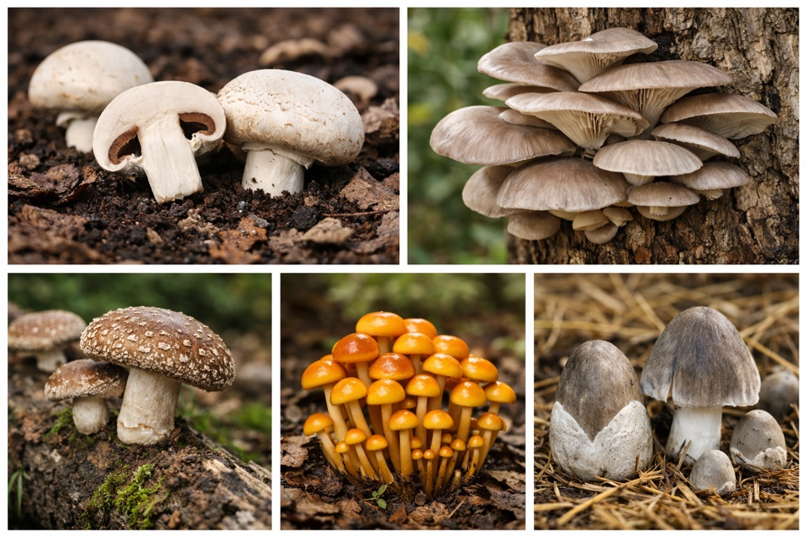
Among the gamut of bioactives, phenolic compounds have attracted scientific attention due to their strong antioxidant capacities and broader biological activities, which may contribute to reduced oxidative stress, anti-inflammatory effects, and chronic disease modulation (Barros et al., 2008; Heleno et al., 2010). This manuscript critically reviews the nutritional composition of edible mushrooms—emphasizing phenolic compounds—their classification, roles in human health, and potential applications in food and pharmaceutical systems.

Fig 1: Agaricus bisporus, Pleurotus ostreatus, Lentinula edodes, Flammulina velutipes, and Volvariella volvacea

2. Nutritional Composition of Edible Mushrooms
Mushrooms possess a unique nutritional profile, characterized by a high-water content, low caloric density, and a combination of macronutrients and micronutrients that support both physiological needs and potential health-promoting effects.

2.1 Carbohydrates and Dietary Fiber
Carbohydrates comprise a significant portion of the dry matter in mushrooms, with polysaccharides and low-molecular-weight sugars being predominant. The sugar alcohol mannitol and disaccharide trehalose are key contributors to flavor and energy value (Cheung, 2010). In addition, structural polysaccharides such as chitin and β-glucans form the rigid framework of the fungal cell wall and contribute to the high dietary fiber content of mushrooms.
Mushroom β-glucans are recognized for their physiological activities, including immunomodulation, reduction of serum cholesterol, and regulation of glycemic responses. These β-glucans resist digestion in the upper gastrointestinal tract and serve as fermentable substrates for gut microbiota, promoting short-chain fatty acid production and gastrointestinal health (Wasser, 2014; Ho et al., 2021).
β-Glucans from edible mushrooms have been shown to enhance innate and adaptive immune responses through interactions with receptors such as Dectin-1 and complement receptor 3 on immune cells (Vetvicka & Vetvickova, 2018).

2.2 Proteins and Lipids
Mushrooms are a notable non-animal source of complete proteins, containing all essential amino acids in varying but nutritionally relevant proportions (Mattila et al., 2001). Protein digestibility and biological value are generally favorable compared to many plant sources, though they vary by species, cultivation conditions, and maturity stage.
The total lipid content in most edible mushrooms is low, fitting well into low-fat diets, yet their lipid fraction is enriched in unsaturated fatty acids such as linoleic and oleic acids (Ribeiro et al., 2009). These unsaturated fatty acids are associated with reduced cardiovascular risk and anti-inflammatory effects (Ribeiro et al., 2009).
Phospholipids and sterols in mushroom lipids also contribute to cell membrane integrity and may support overall metabolic health (Amen et al., 2025).

2.3 Vitamins and Minerals
Edible mushrooms contribute to micronutrient intake, particularly B-complex vitamins including thiamine, riboflavin, niacin, pantothenic acid, and folates (Mattila et al., 2001; Kalač, 2013). Mushrooms are also a notable non-animal source of vitamin D₂ (ergocalciferol), produced through the ultraviolet (UV)-induced conversion of ergosterol—a fungal sterol—upon exposure to sunlight or artificial UV light (Simon et al., 2011; Teichmann et al., 2007).
Mineral composition is rich in potassium, phosphorus, magnesium, iron, and zinc, while selenium content in some species supports antioxidant enzyme systems (Kalač & Svoboda, 2000; Kora, 2020). However, mushrooms may accumulate such as cadmium, lead, and mercury when grown in contaminated substrates, necessitating attention to cultivation conditions and safety evaluations (Kalač & Svoboda, 2000).

2.4 Influence of Cultivation, Processing, and Environmental Factors on Mushroom Bioactives and Health Implications
Bioactive composition in mushrooms is influenced by a complex interplay of cultivation substrates, environmental conditions, and processing techniques (Barros et al., 2008; Heleno et al., 2012).

Table 1. Cultivation and Environmental Factors Influencing Bioactive Composition of Edible Mushrooms
Factor | Key Parameters | Influence on Bioactives | References
Growth substrate | C:N ratio, mineral content, type of agro-waste | Modulates phenolic acids, polysaccharides, and antioxidant capacity | Barros et al., 2008; Heleno et al., 2012
Light exposure | UV-B duration, intensity | Enhances ergosterol → vitamin D₂ conversion | Simon et al., 2011; Teichmann et al., 2007
Temperature | Species-specific optima | Regulates secondary metabolite biosynthesis | Heleno et al., 2012
Humidity and aeration | Moisture, oxygen availability | Affects growth rate and phenolic accumulation | Heleno et al., 2012
Environmental contaminants | Heavy metals, pesticides | Alters mineral composition and food safety | Kalač & Svoboda, 2000

Table 2. Effects of Cooking and Processing on Nutrient Retention and Bioavailability
Processing Method | Effect on Nutrient Retention | Effect on Bioavailability | Overall Impact | References
Boiling | Loss of phenolics and water-soluble vitamins | Reduced bioavailability | Least favorable | Barros et al., 2008; Heleno et al., 2010
Steaming | High retention | Maintains bioaccessibility | Favorable | Heleno et al., 2010; Morales et al., 2024
Sautéing | Moderate retention | Enhanced phenolic release | Highly favorable | Morales et al., 2024; Siddique et al., 2024
Grilling | Variable | Mixed | Moderate | Morales et al., 2024
Microwaving | Maximum retention | Improved bioavailability | Optimal | Morales et al., 2024

Table 3. Relationship Between Processing, Bioavailability, and Health Outcomes
Processing Influence | Bioavailability | Physiological Effect | Health Implication | References
Cell wall disruption | Increased phenolic release | Enhanced antioxidant activity | Reduced oxidative stress | Barros et al., 2008; Morales et al., 2024
Fat-assisted cooking | Improved absorption of sterols | Increased vitamin D₂ uptake | Bone and immune health | Teichmann et al., 2007; Morales et al., 2024
Excessive heat | Degradation of vitamins | Lower bioactive efficacy | Reduced functional value | Barros et al., 2008

3. Phenolic Compounds in Mushrooms
Phenolic compounds are secondary metabolites characterized by one or more hydroxyl groups attached to aromatic rings. They are widely regarded as key contributors to antioxidant and protective biological activities in mushrooms (Heleno et al., 2015; Ferreira et al., 2009).

3.1 Overview and Classification
In mushrooms, phenolic compounds are classified broadly into:
- Phenolic acids
- Flavonoids and flavonoid-like compounds
- Tannins
- Other phenolic derivatives
Each group exhibits distinct chemical structures and bioactivities that influence physiological outcomes.

3.2 Phenolic Acids
Phenolic acids represent the most abundant phenolic group in edible mushrooms, typically found as hydroxybenzoic and hydroxycinnamic acids (Barros et al., 2008). Representative compounds include:
- Hydroxybenzoic acids: gallic acid, protocatechuic acid, p-hydroxybenzoic acid
- Hydroxycinnamic acids: caffeic acid, ferulic acid, cinnamic acid
The profile and concentration of phenolic acids vary by species, growth conditions, and extraction techniques (Barros et al., 2008; Heleno et al., 2012). These compounds exhibit antioxidant, antimicrobial, and enzyme inhibitory activities.
Ferreira et al. (2010) demonstrated that phenolic acids derived from Agaricus and Pleurotus species exhibit significant free-radical scavenging and metal chelating activities, implicating them in oxidative stress modulation.

3.3 Flavonoids and Flavonoid-like Compounds
Although flavonoids are classically associated with plants, several studies report flavonoid-like compounds in mushroom extracts, including quercetin, catechin, rutin, and kaempferol derivatives (Souilem et al., 2017). However, this topic remains debated. Some research suggests mushrooms may absorb flavonoids from the substrate rather than synthesizing them de novo (Gil Ramírez et al., 2016).
Despite this contention, many mushroom extracts show positive reactions in flavonoid-targeted assays, warranting further metabolomic and transcriptomic analyses to clarify biosynthetic capabilities.

3.4 Tannins and Other Phenolic Derivatives
Tannins, which include both hydrolysable and condensed forms, have been identified in selected mushroom species and contribute to antioxidant and antimicrobial activities, albeit typically at lower levels than phenolic acids (Alves et al., 2013). Other phenolic derivatives—including lignans, coumarins, stilbenes, and pyrogallol derivatives—further expand the diversity of mushroom phytochemicals and their potential functional implications (Heleno et al., 2015; Ribeiro et al., 2008).

Table 4. Major Bioactive Compounds in Mushrooms and Associated Health Effects
Bioactive Class | Representative Compounds | Primary Health Effects | Mechanisms of Action | References
Phenolic compounds | Gallic, caffeic, ferulic acids | Antioxidant, anti-inflammatory, cardioprotective | ROS scavenging, enzyme inhibition | Ferreira et al., 2009; Heleno et al., 2010
Polysaccharides | β-glucans | Immunomodulatory, antitumor, hypocholesterolemia | Immune receptor activation, gut microbiota modulation | Wasser, 2014; Zhao et al., 2023
Terpenoids | Triterpenes | Anti-inflammatory, hepatoprotective, anticancer | Apoptosis induction, inflammation regulation | Paterson, 2006
Sterols | Ergosterol | Bone health, immune support | Vitamin D₂ synthesis | Simon et al., 2011; Teichmann et al., 2007
Vitamins | B-complex, tocopherols | Metabolic and antioxidant support | Cellular metabolism, lipid protection | Mattila et al., 2001; Barros et al., 2008

4. Other Bioactive Compounds Associated with Phenolics

4.1 Tocopherols
Tocopherols, collectively known as vitamin E compounds, have been detected in several edible mushroom species (Barros et al., 2008). Alpha (α), gamma (γ), and delta (δ) tocopherols provide lipid-phase antioxidant protection and may act synergistically with phenolic compounds to mitigate oxidative stress in biological membranes.

4.2 Terpenoids and Sterols
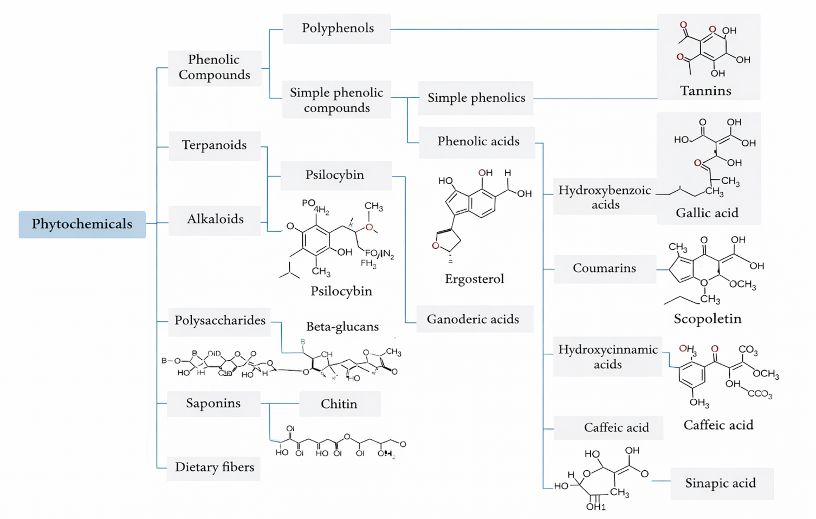
Terpenoids, especially triterpenes, are significant in medicinal mushrooms such as Ganoderma lucidum and are associated with anti-inflammatory, hepatoprotective, and anticancer effects (Paterson, 2006). Sterols such as ergosterol serve as precursors of vitamin D₂ and support nutritional and pharmacological functions (Teichmann et al., 2007). Emerging evidence suggests that sterols and terpenoids also contribute to membrane stability and immunological signaling in mammalian systems (Amen et al., 2025).

Fig 2: Scientific structures of phytochemical compounds present in Edible Mushrooms (Al Qutaibi & Kagne, 2024)

5. Biological Activities of Mushroom Phenolics
The biological activities of phenolic compounds in mushrooms are closely related to their chemical structures, particularly the number and position of hydroxyl groups and the degree of conjugation within the aromatic ring. These structural features enable phenolics to donate hydrogen atoms or electrons, which underlie their strong antioxidant and free-radical-scavenging properties. Additionally, specific substitutions affect their ability to chelate metal ions, modulate enzyme activity, and interact with cellular membranes and signaling pathways. As a result, mushroom-derived phenolic compounds exhibit a range of biological effects, including antioxidant, anti-inflammatory, antimicrobial, and cardioprotective activities, with potency variations largely determined by their structural characteristics. (Valverde, Hernández-Pérez, & Paredes-López, 2015; Heleno et al., 2010; Ferreira et al., 2009)

5.1 Antioxidant Activity
Mushroom phenolics exhibit potent antioxidant effects through multiple mechanisms including:
- Free radical scavenging
- Metal ion chelation
- Inhibition of oxidative enzymes
In vitro assays such as DPPH, ABTS, and FRAP consistently correlate total phenolic content with antioxidant capacity (Heleno et al., 2010; Ferreira et al., 2009).
Barros et al. (2008) reported that Pleurotus ostreatus extracts with higher phenolic content demonstrated superior antioxidant activity compared to other edible species.

5.2 Anticancer Properties
Mushroom phenolic-rich extracts have demonstrated anti-proliferative effects across various cancer cell lines. Proposed mechanisms include induction of:
- Apoptosis
- Cell cycle arrest
- Modulation of oxidative stress pathways
In vitro evidence suggests phenolic-induced inhibition of tumor promoter-mediated pathways, with implications for chemoprevention and adjuvant therapy (Ferreira et al., 2010; Pabasara et al., 2025).

5.3 Anti-Inflammatory and Immunomodulatory Effects
Phenolic compounds suppress pro-inflammatory mediators such as nitric oxide, tumor necrosis factor-alpha, and interleukins, supporting potential roles in mitigating chronic inflammatory conditions (Moro et al., 2012; Garcia-Lafuentea et al., 2010; Wasser, 2011).

5.4 Antihyperglycemic and Enzyme-Inhibitory Activities
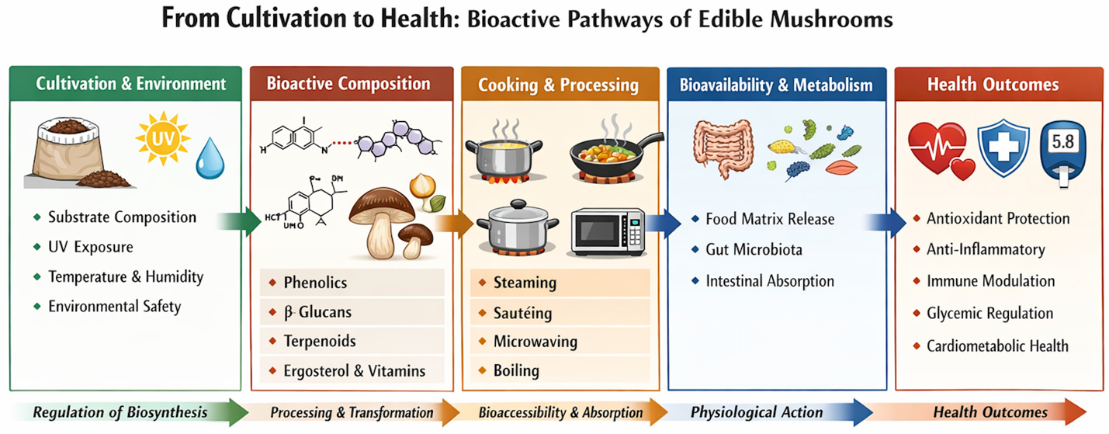
Mushroom phenolics inhibit key carbohydrate-hydrolyzing enzymes, particularly α-amylase and α-glucosidase, attenuating postprandial glucose excursions and contributing to glycemic regulation—a desirable feature for type 2 diabetes management (Aramabašić et al., 2021; Agunloye & Oboh, 2022)

Fig 3: Bioactive Compound Pathways and Functional Mechanisms of Edible Mushrooms

6. Applications in Functional Foods and Therapeutics
Phenolic-rich mushroom extracts are increasingly incorporated into:
- Functional foods
- Dietary supplements
- Nutraceutical formulations
- Natural preservatives
Their inclusion aims to exploit antioxidant, anti-inflammatory, and metabolic regulatory properties (Losoya-Sifuentes et al., 2025; Agunloye & Oboh, 2022). However, challenges remain, including compound stability, bioavailability, standardization of extracts, and regulatory requirements for health claims.

7. Challenges and Future Perspectives
Despite promising results from in vitro and animal studies, several barriers limit the translation of mushroom phenolics into clinical and commercial products:
- Variability in phenolic composition across species and cultivation practices (Heleno et al., 2012)
- Lack of standardized extraction and quantification methodologies (Gil Ramírez et al., 2016)
- Insufficient large-scale human clinical trials (Agunloye & Oboh, 2022)
- Limited understanding of phenolic metabolism and pharmacokinetics in humans (Losoya-Sifuentes et al., 2025)
Future research priorities should emphasize:
- Harmonized analytical approaches for phenolic profiling
- Advanced extraction technologies to maximize yield and preserve bioactivity
- Metabolomic and transcriptomic integration to clarify biosynthetic capabilities
- Mechanistic and clinical studies to validate health effects and inform guidelines

8. Conclusion
Edible mushrooms represent a unique class of functional foods, distinguished not only by their nutrient-dense profile but also by their rich content of bioactive compounds, particularly phenolic compounds, polysaccharides, terpenoids, sterols, and tocopherols. These secondary metabolites confer a broad spectrum of biological activities, including potent antioxidant, anti-inflammatory, anticancer, and metabolic regulatory effects, positioning mushrooms as promising dietary components for the prevention and management of chronic diseases. Phenolic compounds exhibit multifunctional roles, acting as free radical scavengers, metal chelators, enzyme modulators, and regulators of signaling pathways, thereby mitigating oxidative stress, modulating inflammatory responses, suppressing tumor growth, and contributing to glycemic control.
The therapeutic potential of mushrooms extends beyond individual bioactivities, as many of their constituents act synergistically, enhancing overall functional efficacy. For example, the combined presence of phenolics, β-glucans, and triterpenes allows mushrooms to modulate multiple physiological pathways simultaneously, offering a holistic approach to health maintenance and disease risk reduction. The species-specific variation in phenolic profiles and other bioactives highlights the importance of targeted selection of mushroom varieties for functional food and nutraceutical development, emphasizing that not all edible mushrooms contribute equally to health benefits.
Despite promising preclinical evidence, the translation of mushroom phenolics into clinical and commercial applications remains limited. Challenges include variability in bioactive composition due to cultivation conditions, processing methods, and environmental factors, as well as gaps in knowledge regarding bioavailability, metabolism, and long-term safety. Moreover, standardized extraction, quantification, and characterization techniques are needed to facilitate reproducibility and reliable comparison across studies. Well-designed human clinical trials are crucial to validate in vitro and animal model findings and to determine effective dosages and delivery forms for functional food or therapeutic use.
Future research should adopt an interdisciplinary approach, integrating food science, pharmacology, metabolomics, and nutrigenomics to fully elucidate the mechanisms of action of mushroom phenolics and to optimize their functional properties. Furthermore, exploring the development of novel formulations, bioactive-enriched food products, and nutraceuticals will allow practical application of these compounds in promoting health and preventing disease.
In conclusion, edible mushrooms are highly promising functional foods with significant potential to contribute to evidence-based dietary strategies for health promotion. Strategic research and development can unlock their full therapeutic and nutritional benefits, bridging the gap between traditional consumption and modern functional food applications, and ultimately supporting public health and preventive nutrition initiatives globally.

9. Research Gap and Rationale

9.1 Research Gaps
Despite significant advances in characterizing mushroom phytochemicals, critical gaps remain:
- Inconsistent extraction and analytical methods compromise cross-study comparability (Gil Ramírez et al., 2016).
- Debate persists regarding the presence of flavonoids in mushroom tissues versus substrate uptake (Souilem et al., 2017; Gil Ramírez et al., 2016).
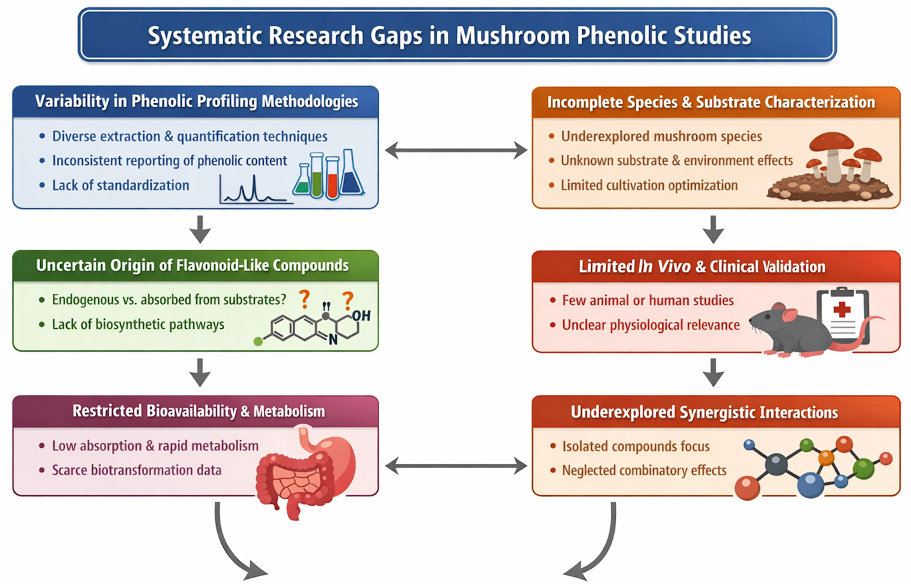
- Limited data on human bioavailability and clinical efficacy of mushroom phenolics.
Fig 4: Systematic Research Gaps in Edible Mushroom Phenolic Studies

9.2 Rationale of the Review
This review provides a comprehensive and systematic synthesis of the current knowledge on phenolic compounds in edible mushrooms, emphasizing both their chemical diversity and functional significance. It critically examines methodological inconsistencies across studies, including variations in extraction procedures, solvent systems, analytical platforms (e.g., HPLC, LC-MS, spectrophotometric assays), and reporting standards, which have historically limited comparability and reproducibility of phenolic profiling. By systematically comparing species-specific phenolic profiles, the review identifies mushroom species that are particularly rich in bioactive phenolics and therefore hold higher functional and therapeutic potential, guiding future selection for both research and commercial applications.
In addition to phytochemical characterization, the review integrates evidence on biological activities, including antioxidant, anti-inflammatory, anticancer, and metabolic regulatory effects, linking chemical composition to functional outcomes. This approach facilitates a more mechanistic understanding of how mushroom-derived phenolics exert their health-promoting effects and underscores the synergistic interactions between phenolics and other mushroom bioactives such as polysaccharides, terpenoids, and sterols. By bridging the gap between chemical profiling and biological efficacy, this review provides a framework for the rational development of mushroom-derived functional foods, nutraceuticals, and therapeutic agents, supporting evidence-based applications in both the food and pharmaceutical industries.
Furthermore, the review identifies critical gaps in current knowledge, including the need for standardized analytical methods, improved bioavailability studies, and well-designed human clinical trials, emphasizing the importance of interdisciplinary research to translate in vitro and animal model findings into practical, health-promoting interventions. Overall, this synthesis serves as a strategic resource for researchers, industry professionals, and policymakers interested in harnessing the nutritional and pharmacological potential of edible mushrooms.

9.3 Significance of the Review
This review aims to:
- Consolidate and Critically Evaluate Existing Data on Phenolic Composition
The review systematically compiles quantitative and qualitative data from recent studies on phenolic profiles across diverse mushroom species. By examining total phenolic content, individual phenolic acids, flavonoid-like compounds, and other derivatives, it highlights species-specific variations, cultivation influences, and the impact of environmental and processing factors. Critical evaluation identifies patterns, inconsistencies, and gaps in the literature, providing a comprehensive understanding of phenolic composition and its functional relevance.
- Clarify Controversies Regarding Flavonoid-Like Compounds in Mushrooms
The presence of flavonoid-like compounds in fungi has been a subject of conceptual debate, with conflicting reports on whether these compounds are synthesized by the mushrooms themselves or absorbed from the growth substrate. This review examines recent analytical evidence, including advanced chromatographic and spectrometric approaches, to resolve ambiguities and clarify the chemical authenticity, origin, and classification of flavonoid-like molecules in edible fungi.
- Strengthen the Foundation for Developing Mushroom-Derived Functional Foods and Nutraceuticals
By linking phenolic profiles with documented biological activities—such as antioxidant, anti-inflammatory, anticancer, and metabolic regulatory effects—the review establishes a rational framework for selecting mushroom species and extracts with the highest functional potential. This integration supports the evidence-based development of functional foods, dietary supplements, and nutraceutical formulations, facilitating the translation of phytochemical research into practical applications in the food and health industries.
- Identify Methodological Priorities for Future In Vivo and Clinical Investigations
Despite promising preclinical evidence, gaps remain in understanding bioavailability, metabolism, and clinical efficacy of mushroom phenolics. The review highlights critical methodological considerations, including standardization of extraction protocols, optimization of analytical techniques, and harmonization of reporting metrics. It also emphasizes the need for well-designed human trials, metabolomic profiling, and interdisciplinary approaches to bridge the gap between in vitro findings and real-world health outcomes.

Abbreviations:
ABTS - 2,2′-Azino-bis (3-ethylbenzothiazoline-6-sulfonic acid)
DPPH - 2,2-Diphenyl-1-picrylhydrazyl
FRAP - Ferric Reducing Antioxidant Power
HPLC - High-Performance Liquid Chromatography
LC-MS - Liquid Chromatography–Mass Spectrometry
α-, γ-, and δ – Alpha, beta and gamma
Competing Interest Declaration: The author has no competing interests to declare that are
relevant to the content of this manuscript.

Disclaimer (Artificial intelligence)

Option 2:
Author(s) hereby declare that generative AI technologies such as Large Language Models, etc. have been used during the writing or editing of manuscripts. This explanation will include the name, version, model, and source of the generative AI technology and as well as all input prompts provided to the generative AI technology
Details of the AI usage are given below:
1. Some of the phrases paraphrased by Quillbot
2. I used Canva for figure development (which is not an AI generative diagram developer)
3.

References
- Agunloye, O. M., & Oboh, G. (2022). Blood glucose lowering and effect of oyster (Pleurotus ostreatus)‐ and shiitake (Lentinus subnudus)‐supplemented diet on key enzymes linked diabetes and hypertension in streptozotocin‐induced diabetic in rats. Food Frontiers, 3(1), 161-171. https://doi.org/10.1002/fft2.111
- Al Qutaibi, M., & Kagne, S. R. (2024). Exploring the phytochemical compositions, antioxidant activity, and nutritional potentials of edible and medicinal mushrooms. International Journal of Microbiology, 2024(1), 6660423. https://doi.org/10.1155/2024/6660423
- Alves, M. J., Ferreira, I. C. F. R., Froufe, H. J. C., Abreu, R. M. V., Martins, A., & Pintado, M. (2013). Antimicrobial activity of phenolic compounds identified in wild mushrooms, SAR analysis and docking studies. Journal of Applied Microbiology, 115(2), 346–357. https://doi.org/10.1111/jam.12196
- Amen, Y., Othman, A., & Shimizu, K. (2025). Phospholipid profiles in mushrooms: A review of extraction, analysis, and functional applications. International Journal of Medicinal Mushrooms, 27(3), 1-10. https://doi.org/10.1615/IntJMedMushrooms.2024057381
- Aramabašić Jovanović, J., Mihailović, M., Uskoković, A., Grdović, N., Dinić, S., & Vidaković, M. (2021). The effects of major mushroom bioactive compounds on mechanisms that control blood glucose level. Journal of Fungi, 7(1), 58. https://doi.org/10.3390/jof7010058
- Barros, L., Correia, D. M., Ferreira, I. C., Baptista, P., & Santos-Buelga, C. (2008). Optimization of the determination of tocopherols in Agaricus sp. edible mushrooms by a normal phase liquid chromatographic method. Food chemistry, 110(4), 1046-1050. https://doi.org/10.1016/j.foodchem.2008.03.016
- Chang, S. T., & Miles, P. G. (2004). Mushrooms: Cultivation, Nutritional Value, Medicinal Effect, and Environmental Impact. CRC Press. https://doi.org/10.1201/9780203492086
- Cheung, P. C. K. (2010). The nutritional and health benefits of mushrooms. Nutrition Bulletin, 35(4), 292–299. https://doi.org/10.1111/j.1467-3010.2010.01859.x
- Ferreira, I. C. F. R., Barros, L., & Abreu, R. M. V. (2009). Antioxidants in wild mushrooms. Current Medicinal Chemistry, 16(12), 1543-1560. https://doi.org/10.2174/092986709787909587
- Ferreira, I. C. F. R., Vaz, J. A., Vasconcelos, M. H., & Martins, A. (2010). Compounds from wild mushrooms with antitumor potential. Anti-Cancer Agents in Medicinal Chemistry, 10(5), 424-436. https://doi.org/10.2174/187152010791509031
- Garcia-Lafuentea, A., Moro, C., Villares, A., Guillamon, E., Rostagno, M. A., D'Arrigo, M., & Martinez, J. A. (2010). Mushrooms as a source of anti-inflammatory agents. Anti-Inflammatory & Anti-Allergy Agents in Medicinal Chemistry (Formerly Current Medicinal Chemistry-Anti-Inflammatory and Anti-Allergy Agents), 9(2), 125-141. https://doi.org/10.2174/187152310791110643
- Gil-Ramírez, A., Pavo-Caballero, C., Baeza, E., Baenas, N., Garcia-Viguera, C., Marín, F. R., & Soler-Rivas, C. (2016). Mushrooms do not contain flavonoids. Journal of Functional Foods, 25, 1–13. https://doi.org/10.1016/j.jff.2016.05.005
- Heleno, S. A., Barros, L., Martins, A., Morales, P., Fernández-Ruiz, V., Glamoclija, J., Soković, M., & Ferreira, I. C. F. R. (2015). Nutritional value, bioactive compounds, antimicrobial activity and bioaccessibility studies with wild edible mushrooms. LWT-Food Science and Technology, 63(2), 799-806. https://doi.org/10.1016/j.lwt.2015.04.028
- Heleno, S. A., Barros, L., Martins, A., Queiroz, M. J. R., Santos-Buelga, C., & Ferreira, I. C. (2012). Phenolic, polysaccharidic, and lipidic fractions of mushrooms from Northeastern Portugal: chemical compounds with antioxidant properties. Journal of agricultural and food chemistry, 60(18), 4634-4640. DOI: 10.1021/jf300739m
- Heleno, S. A., Barros, L., Sousa, M. J., Martins, A., & Ferreira, I. C. (2010). Tocopherols composition of Portuguese wild mushrooms with antioxidant capacity. Food Chemistry, 119(4), 1443-1450. https://doi.org/10.1016/j.foodchem.2009.09.025
- Ho Do, M., Seo, Y. S., & Park, H. Y. (2021). Polysaccharides: bowel health and gut microbiota. Critical Reviews in Food Science and Nutrition, 61(7), 1212-1224. https://doi.org/10.1080/10408398.2020.1755949
- Kalač, P. (2013). A review of chemical composition and nutritional value of wild‐growing and cultivated mushrooms. Journal of the Science of Food and Agriculture, 93(2), 209-218. https://doi.org/10.1002/jsfa.5960
- Kalač, P., & Svoboda, L. (2000). A review of trace element concentrations in edible mushrooms. Food Chemistry, 69(3), 273-281. https://doi.org/10.1016/S0308-8146(99)00264-2
- Kora, A. J. (2020). Nutritional and antioxidant significance of selenium-enriched mushrooms. Bulletin of the National Research Centre, 44(1), 34. https://doi.org/10.1186/s42269-020-00289-w
- Losoya-Sifuentes, C., Cruz, M., del Refugio Rocha-Pizaña, M., Loredo-Treviño, A., & Belmares, R. (2025). Edible Mushrooms: A Nutrient-Rich Ingredient for Healthier Food Products–A Review. Current Nutrition Reports, 14(1), 9. https://doi.org/10.1007/s13668-024-00605-0
- Mattila, P., Könkö, K., Eurola, M., Pihlava, J.-M., Astola, J., Vahteristo, L., Hietaniemi, V., Kumpulainen, J., Valtonen, M., & Piironen, V. (2001). Contents of vitamins, mineral elements, and some phenolic compounds in cultivated mushrooms. Journal of Agricultural and Food Chemistry, 49(5), 2343–2348. https://doi.org/10.1021/jf001525d
- Morales, D., Bal, M. A., Figueredo, S., Soler-Rivas, C., & Ruiz-Rodríguez, A. (2024). Effect of household cooking treatments on the stability of β-glucans, ergosterol, and phenolic compounds in white-button (Agaricus bisporus) and Shiitake (Lentinula edodes) mushrooms. Food and Bioprocess Technology, 17(3), 791-798. https://doi.org/10.1007/s11947-023-03169-z
- Moro, C., Palacios, I., Lozano, M., Dárrigo, M., Guillamón, A., Villares, M. J., García-Lafuente, E., Berná, E., & Martínez-Botella, M. Á. (2012). Anti-inflammatory activity of methanolic extracts from edible mushrooms in LPS activated RAW 264.7 macrophages. Food Chemistry, 130(2), 350–355. https://doi.org/10.1016/j.foodchem.2011.07.049
- Pabasara, G. V. S., Fernando, M. D. M., Abeysekera, W. K. S. M., & Liyanapathirana, L. V. C. (2025). Comparative study on the therapeutic potential of aqueous extracts from commercially cultivated Agaricus bisporus and Lentinula edodes in Sri Lanka: antioxidant, anticancer, antidiabetic, and antibacterial properties. BMC Complementary Medicine and Therapies, 25(1), 233. https://doi.org/10.1186/s12906-025-04984-x
- Paterson, R. R. M. (2006). Ganoderma—a therapeutic fungal biofactory. Phytochemistry, 67(18), 1985–2001. https://doi.org/10.1016/j.phytochem.2006.07.004
- Ribeiro, B. M., de Pinho, P. G., Andrade, P. B., Baptista, P., & Valentão, P. (2009). Fatty acid composition of wild edible mushrooms species: A comparative study. Microchemical Journal, 93(1), 29-35. https://doi.org/10.1016/j.microc.2009.04.005
- Ribeiro, B., Lopes, R., Andrade, P. B., Seabra, R. M., Gonçalves, R. F., Baptista, P., Quelhas, I., & Valentão, P. (2008). Comparative study of phytochemicals and antioxidant potential of wild edible mushroom caps and stipes. Food Chemistry, 110(1), 47-56. https://doi.org/10.1016/j.foodchem.2008.01.054
- Siddique, S. S., Gupta, S., Gupta, S., & Kumar, D. (2024). Impact of cooking and processing on mushroom nutrient retention. In Mushroom Magic: Biochemistry and Nutritional Value of Fungi (pp. 174-190). CRC Press. https://doi.org/10.1201/9781003570257-11
- Simon, R. R., Phillips, K. M., Horst, R. L., & Munro, I. C. (2011). Vitamin D mushrooms: comparison of the composition of button mushrooms (Agaricus bisporus) treated postharvest with UVB light or sunlight. Journal of Agricultural and Food Chemistry, 59(16), 8724-8732. https://doi.org/10.1021/jf201255b
- Souilem, F., Fernandes, Â., Calhelha, R. C., Barreira, J. C. M., Barros, L., Skhiri, F., Martins, A., & Ferreira, I. C. F. R. (2017). Wild mushrooms and their mycelia as sources of bioactive compounds: Antioxidant, anti-inflammatory and cytotoxic properties. Food Chemistry. https://doi.org/10.1016/j.foodchem.2017.03.026
- Teichmann, A., Dutta, P. C., Staffas, A., & Jägerstad, M. (2007). Sterol and vitamin D2 concentrations in cultivated and wild grown mushrooms: Effects of UV irradiation. LWT – Food Science and Technology, 40(5), 815–822. https://doi.org/10.1016/j.lwt.2006.04.003
- Valverde, M. E., Hernández-Pérez, T., & Paredes-López, O. (2015). Edible mushrooms: Improving human health and promoting quality life. International Journal of Microbiology. https://doi.org/10.1155/2015/376387
- Vetvicka, V., & Vetvickova, J. (2018). Glucans and cancer: Comparison of commercially available β-glucans–part IV. Anticancer research, 38(3), 1327-1333. https://doi.org/10.21873/anticanres.12355
- Wasser, S. P. (2011). Current findings, future trends, and unsolved problems in studies of medicinal mushrooms. Applied Microbiology and Biotechnology, 89(5), 1323-1332. https://doi.org/10.1007/s00253-010-3067-4
- Wasser, S. P. (2014). Medicinal mushroom science: Current perspectives, advances, evidences, and challenges. Biomedical Journal, 37(6). https://doi.org/10.4103/2319-4170.138318
- Zhao, J., Hu, Y., Qian, C., Hussain, M., Liu, S., Zhang, A., He, R., & Sun, P. (2023). The interaction between mushroom polysaccharides and gut microbiota and their effect on human health: A review. Biology, 12(1), 122. https://doi.org/10.3390/biology12010122

