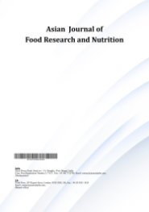
Asian Journal of Food Research and Nutrition

Volume XXX, Issue XX, Page XX-XX, 20YY; Article no.AJFRN.150095

Habit and Availability as Determinants of School-canteen Food Choices among Adolescents in Nansana Municipality, Uganda: A

Cross-sectional Study

Authors’ Name……………………………………………………

Affiliations……………………………………………………….………………

Authors’ contributions

This work was carried out in collaboration among all authors. ‘Author A’ designed the study, performed the statistical analysis, wrote the protocol, and wrote the first draft of the manuscript. ‘Author B’ and ‘Author C’ managed the analyses of the study. ‘Author C’ managed the literature searches. All authors read and approved the final manuscript.

Article Information

DOI: 10.9734/AJFRN/2025/XXXXX

Open Peer Review History:
This journal follows the Advanced Open Peer Review policy. Identity of the Reviewers, Editor(s) and additional Reviewers, peer review comments, different versions of the manuscript, comments of the editors, etc are available here:

Received: DD/MM/20YY
Original Research Article
Published: DD/MM/20YY

ABSTRACT

Purpose: The study predicted the determinants of school canteen food choices among school-going adolescents in Nansana Municipality in Uganda.
Methods: An observational cross-sectional design was employed. The data were primarily collected from 4900 adolescents, aged 10-19 years, in senior one through senior three classes attending different secondary schools in Nansana Municipality. Sample size was computed using the Taro Yamane formula, which yielded a sample of 1174. The multiple regression model was employed to analyze the relationship between the choices of adolescents and the nutrition practices. The model was tested for the assumptions of linearity and normality.
Results: The regression model based on skewed data for only adolescents was a good fit but with a low explanatory power. The results indicated that while the taste of food at the canteen and the availability of consumption were significant, the single most significant determinant of unhealthy food choices at school canteens by the adolescents was the routine dietary practices.
Conclusions: The study shows that school-going adolescent students easily gravitate towards foods they are used to eating, reflecting a stronger effect of habitual eating patterns.
Policy Implications: There is a need for a shift in intervention from simply individual taste and environment to more habitual patterns and improving the availability of healthier options, while also ensuring those options are palatable.

Keywords: Food choices; dietary intakes and preferences; school-going adolescents; regression model; students.

1. INTRODUCTION

Food choices and diet quality have become a global area of concern, especially among school-going adolescents, amidst the rising cases of non-communicable diseases in developing countries (Chattaraj, 2025). School canteens have become a hub for the intake of an unhealthy diet among school-going adolescents, associated with a potential lack of physical activity, which worsens the global risks to health (Balakrishnan, 2025). In Mexico, there was a recent ban on ultra-processed foods and sugar-sweetened beverages in schools due to rising fears of excess calories, higher glucose levels, and increasing risks such as obesity and diabetes (Balakrishnan, 2025). Many studies have pointed out school canteens as dangerous spots for delivering more than just food. For instance, Bennett et al. (2025) views school lunchboxes as a collective, multiscale social problem. Whitton et al. (2025) revealed that the most fascinating outdoor food advertisements comprise unhealthy foods. Another study by Lauren D Devine, Alison M Gallagher, et al. (2023) indicated that many adolescents prioritize the sensory appeal of food, such as taste, over its health benefits in the canteen. (Lauren D Devine, Alison M Gallagher, et al., 2023; Kubik et al., 2003). In the UK, Lauren D Devine, Alyson J Hill and Alison M Gallagher (2023) criticized post-primary schools for promoting unhealthy diets at their canteens as compared to primary and lower classes. Cartagena (2014) also indicated that the majority of students across all academic levels purchase and consume unhealthy foods and drinks at the school canteens (Cartagena, 2014). Moreover, studies indicated that even with a supportive, healthier canteen implementation in Dutch schools, learners are not willing to change their dietary behaviors (Evenhuis et al., 2020). Gubbels (2020) revealed that the school's physical environment influences the dietary choices of students. This was supported by Azeredo et al. (2016) and Story et al. (2009) who revealed that canteen food availability was associated with poor and unhealthy dietary intake. Additionally, Andretti et al. (2021) revealed that about 60% of the school canteen foods contain zero nutritional value. Nonetheless, Hermans et al. (2017) maintained that if communities and schools seek to promote healthy food choices at canteens, then they ought to think about the price and taste as factors.

Studies in Sub-Saharan Africa show that dietary choices among school-going adolescents are determined by demographic, socioeconomic, individual student, and school factors. For example, Madzorera et al. (2025) revealed that in Sub-Saharan Africa, diet quality did not vary by adolescent age or sex, but older adolescents had higher fish and lower red meat consumption, and boys consumed unhealthy foods less frequently. A study in Ghana revealed that family practices are positively associated with better diet quality (Klemm et al., 2025). In the same context, Hormenu (2022) showed increased frequency in the consumption of soft drinks and sweets among the in-school adolescents. In Zambia, Mukanu et al. (2022) showed that individual factors such as weekly pocket money, self-identified poverty, and a guardian's employment. Iyassu et al. (2024) indicated that the dietary choice of adolescents is influenced by peer influence, nutrition knowledge and perceptions, availability/accessibility, and safety of foods. A study in Gambia highlighted social and cultural factors (gender norms, mother-led decision-making, and ceremonies) as key determinants of dietary intakes among school-going adolescents (Janha et al., 2021). This brings us to a very interesting discussion of how these choices are made.

According to the World Health Organization, school-based healthy diet intake thwarts malnutrition in all forms, preventing a wide range of noncommunicable diseases (NCDs). However, this is determined by a range of factors, including urbanization, changing lifestyles, and other multifaceted factors. Karunanayaka (2024) and Kubik et al. (2003) highlighted individual and school-based factors as food choices. Another study showed that pupil-led initiatives, peer influence, and the school environment were to blame for the rampant poor food choices at school canteens (L. D. Devine et al., 2023). Various studies point out taste as the leading cause of poor dietary choices in school canteens, see, for instance, Neumark-Sztainer et al. (1999); Shannon et al. (2002) and Ghaffar et al. (2019). Other scholars point to the lack of better alternatives as a key factor in promoting unhealthy foods Bhatt et al. (2019), while Gilmour et al. (2020) points out convenience in a bid to avoid longer queues, leaving the students with no choice but to junk. Other studies assume that the price of the foods at various school canteens plays a significant role in determining choice (French, 2003). Other studies attribute it to the students' lack of knowledge about nutrient content (Gracey et al., 1996). On the other hand, Iyassu et al. (2024) acknowledged students' lack of knowledge about nutrient content as a contributing factor to their unhealthy food choices. Differently, Neumark-Sztainer et al. (2005) looks more into media messages and social norms as determinants of unhealthy eating habits at school canteens. Furthermore, the availability of attractive snacks and soft drinks strongly influences their food choices (Wouters et al., 2010). This was in line with Mesch et al. (2025) who revealed that the appealing nature of canteen foods attracts the students to adopt a poor feeding practice. Therefore, there is a multiplicity of factors that shape the student' choices of their food at their canteens. However, what remains unclear is that factors such as habitual food preference and food familiarity have not been extensively explored.

2. METHODOLOGY

2.1 Introduction

This part of the paper provides the methods used. It comprises the study design, the study population, the sample size, the data collection methods, the data analysis techniques, and the ethical considerations as follows.

2.2 Study Design

An observational study design was utilized. It involved collecting data, analyzing it, and writing the results based on the stated study hypotheses. Particularly, a cross-sectional study design was employed. This involved collecting a snapshot of information from both the exposures and the outcomes that have already occurred, without making follow-ups.

2.3 Study Population

A population of 4900 adolescents aged 10-19 years in senior one, two and three, attending different government-owned or government-aided secondary schools in Nansana Municipality, Wakiso District, Uganda was considered.

2.4 Sample Size

The Taro Yamane formula (1967) was employed to compute the sample size from a population of 4900, using the margin of error of 2.54% as seen in Equation 1. This approach, as emphasized in a study by Chaokromthong and Sintao (2021) provides an appropriate way of estimating the sample size when the finite population is known with a certain level of precision.

$n= \frac{N}{1+N {\left(e\right)}^{2}}$ (Eq. 1)

Whereby, n = desired sample size, N = finite population, and e = margin of error. Substituting the figures above into the equation yields the following

$\frac{4900}{1+4900{(0.0254)}^{2}}$ = 1178

Therefore, out of 1178 school-going adolescents, 1174 were included in the study, accounting for the non-response of four adolescents. The desired sample size was not acquired because four school-going adolescents did not consent to the questionnaire.

2.5 Data Collection Methods

Data collection was conducted using paper-based questionnaires. Data entry, sorting, cleaning, and verification were done in MS Excel, and analysis was done in Stata version 18. Each participant was assigned an identity number to ensure accurate tracking and avoid duplication. The database was scrutinized for errors stemming from flawed measurements or data entry mistakes. Quantitative data were gathered using five-point Likert scale statements to facilitate analytical insights.

2.6 Data Analysis Techniques

The study performed a quantitative analysis. The outcome variable was nutrition practice, while the independent variables were factors expected to influence the students’ choice of dietary intakes. These were taste, color, bandwagon, what is available at the canteen, what is consumed at home, and what the student is used to eating at home. The study aimed to estimate the average food diet regression line, predicting the factors that influence the choice of food diet at the canteen. Therefore, a multiple linear regression was performed under two key assumptions. The first assumption was the linearity of the dependent variable (nutrition diet) and the normality of the error terms (zero mean and constant variance of the error term).

3. RESULTS AND DISCUSSION

3.1 Demographic Profile for the Adolescents

The study comprised adolescents primarily aged 14–16 years (middle adolescence), who constituted the largest proportion of participants (71%), followed by those aged 17–19 years (22%), and a smaller group aged 10–13 years (7%). Females represented a greater share of the sample (59%) compared to males (41%), indicating a fairly balanced but female-leaning distribution. Participants were almost evenly drawn across lower secondary school classes, with 35% in Senior Three (S.3), 34% in Senior One (S.1), and 31% in Senior Two (S.2). Overall, the demographic distribution reflects adequate representation across gender, age brackets, and school classes, providing a diverse sample suitable for understanding adolescent nutrition-related behaviors.

3.2 Assessment of Linearity, Homo-scedasticity, and Normality of Residual

The residual versus fitted plot, as seen in Fig. 1 indicates no observable pattern, an indication that linearity could be reasonable. Secondly, the plot shows an even spread of points across a range of fitted values, omitting the violation of heteroskedasticity. Also, although a few points fall far from zero, they are not so extreme as to suggest possible identifier and outlier values.

The normality test was conducted with the aid of the histogram of the residuals. This test was conducted under the null hypothesis that the residuals were normally distributed against non-normality for the alternative. A clear observation of Fig. 2 shows that the residuals are roughly bell-shaped, suggesting symmetry. Also, the normal curve aligns well with the bars, implying the residuals follow the normal pattern closely. The whole Fig. 2 does not indicate any form of skewness in the tails and kurtosis on the peaks and dips of the residual curve.

3.3 Regression Model for Predicting School Canteen Food Choices Among Adolescents

The coefficient of determination indicates that approximately 3% of the variation in the nutrition practices is explained by variation in the considered factors. The regression coefficient suggests that if the taste of food goes up by one unit, the average nutrition practices would go up by about 4% (Coef = .037, SE = .017, t = 2.18, p < 0.01, 95% CI [.004, .07]). Consistent with the previous findings, the taste of the item sold at the canteen is crucial in detecting nutritional diet intakes. For instance, Fagerberg et al. (2019) found that food taste is a significant predictor for variations in food intake among adolescents at canteens. van Kleef et al. (2019) added that unhealthy snacks in the canteen are more appealing and have better taste than healthy foods. Moving on, results indicated that when available items go up by one unit, the nutrition practices improve by 4 percent, leaving other factors constant (Coef = .04, SE = .017, t = 2.36, p < 0.01, 95% CI .007, .073]). This is consistent with the argument advanced by Lauren D Devine, Alison M Gallagher, et al. (2023) who reported that dietary intakes are determined by the prevailing setup of the canteens, such as queue length, seating availability, and food availability.

Table 1. Demographic profile for the adolescents

Variable | Category | Frequency (Freq.) | Percent
Gender | Male | 474 | 41%
 | Female | 691 | 59%
Total |  | 1165 | 100%
Age Bracket | 10–13 years (Early adolescents) | 80 | 7%
 | 14–16 years (Middle adolescents) | 832 | 71%
 | 17–19 years (Late adolescents) | 257 | 22%
 |  | 1169 | 100%
Class | S.1 | 399 | 34%
 | S.2 | 361 | 31%
 | S.3 | 411 | 35%
 |  | 1171 | 100%

Table 2. Regression model for predicting school canteen food choices among adolescents

Nutrition factor | Coef. | St.Err. | t-value |  | p-value | [95% Conf |  | Interval] | Sig
Taste | .037 | .017 | 2.18 |  | .029 | .004 |  | .07 | **
Color | .008 | .018 | 0.46 |  | .645 | -.027 |  | .044
Bandwagon effect | .001 | .019 | 0.06 |  | .951 | -.036 |  | .039
Anything available at the canteen | .04 | .017 | 2.36 |  | .019 | .007 |  | .073 | **
What we eat at home | .012 | .017 | 0.69 |  | .492 | -.021 |  | .044
What I am used to eating | .059 | .017 | 3.54 |  | .000 | .027 |  | .092 | ***
Constant | -.505 | .1 | -5.06 |  | .000 | -.7 |  | -.309 | ***
Mean dependent var | -0.000 |  |  | SD dependent var |  |  | 0.775
R-squared | 0.027 |  |  | Number of obs |  |  | 1153
F-test | 5.325 |  |  | Prob > F |  |  | 0.000
Akaike crit. (AIC) | 2666.216 |  |  | Bayesian crit. (BIC) |  |  | 2701.567
*** p<.01, ** p<.05, * p<.1

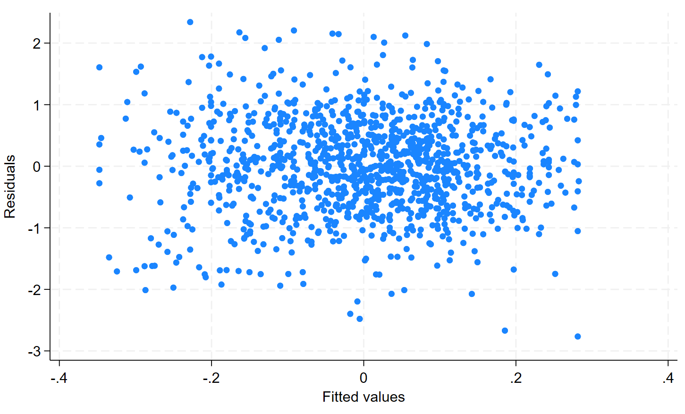

Fig. 1. Residual versus fitted plot
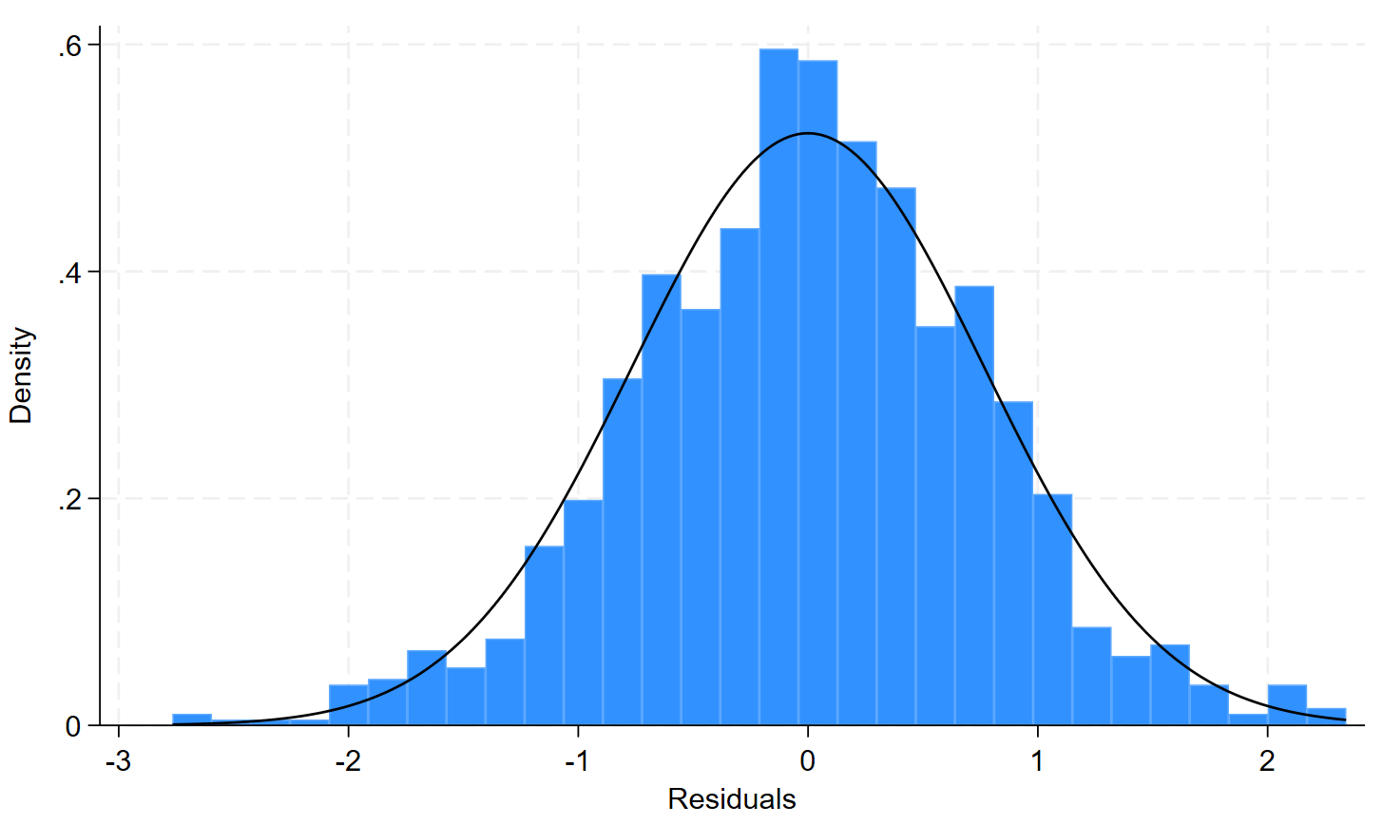

Fig. 2. Normality assumption of the residuals

On the contrary, a Dutch study by Evenhuis et al. (2020) revealed that 90% of their students brought food items from home, and a few relied on canteen food availability. Lastly, and most importantly, the expected dietary intake would improve by approximately 6% if routine eating practices go up by one unit, ceteris paribus (Coef = 0.059, SE = 0.017, t = 3.54, p < 0.01, 95% CI [0.027, 0.092]). These findings are reflective of earlier findings that dietary quality is exacerbated as children grow up, suggesting that evolving eating habits lead to lower consumption of healthy foods (Naeeni et al., 2014).

4. CONCLUSION

Findings indicate that the school diet nutrition choice among secondary school-going adolescents was determined partly by taste, canteen available items, and by the routine dietary preference and practices. Specifically, the study showed that food choices of school-going adolescents in Nansana Municipality are driven by a mix of sensory, environmental, and habitual consumption patterns. Taste was found to play a key role, as students were found to purchase canteen items, they found appealing and fascinating. Secondly, the availability of food items also played a key role in determining their practices, with students tending to consume what is easily and readily available at the school canteens. Besides, the study found routine dietary preference as the single most important determinant of dietary intake. The study shows that school-going adolescent students easily gravitate towards foods they are used to eating, reflecting a stronger effect of habitual eating patterns.

5. POLICY IMPLICATIONS

Interventions aiming to shift adolescents’ canteen choices in Nansana should prioritize changing habitual patterns and improving the availability of healthier options, while also ensuring those options are palatable; however, because the model explains little variance, complementary qualitative work or additional predictors (price, peer influence, parental education, canteen pricing/marketing) would likely be needed to design effective programs.

CONSENT

Written informed consent was obtained from the adolescent students.

ETHICAL APPROVAL

The ethical approval (Ref: MUREC-2025-1761) was granted by the Mildmay Uganda Research Ethics Committee.

DISCLAIMER (Artificial intelligence)

Authors hereby declare that NO generative AI technologies such as Large Language Models (ChatGPT, COPILOT, etc.) and text-to-image generators have been used during the writing or editing of this manuscript.

COMPETING INTERESTS

Authors have declared that they have no known competing financial interests OR non-financial interests, OR personal relationships that could have appeared to influence the work reported in this paper.

REFERENCES

Andretti, B., Goldszmidt, R. B., & Andrade, E. B. (2021). How changes in menu quality associate with subsequent expenditure on (un)healthy foods and beverages in school cafeterias: A three-year longitudinal study. Preventive Medicine, 146, 106456.
Azeredo, C. M., de Rezende, L. F. M., Canella, D. S., Claro, R. M., Peres, M. F. T., do Carmo Luiz, O., França-Junior, I., Kinra, S., Hawkesworth, S., & Levy, R. B. (2016). Food environments in schools and in the immediate vicinity are associated with unhealthy food consumption among Brazilian adolescents. Preventive Medicine, 88, 73–79.
Balakrishnan, V. S. (2025). Mexico's school junk food ban to foster healthier futures. The Lancet Child & Adolescent Health, 9(11), 761–762.
Bennett, J., Broom, A., & Raubenheimer, D. (2025). The school lunchbox as a social problem. Health, 13634593251397669.
Bhatt, R., Madan, J., & Moitra, P. (2019). Determinants of food choice in a school environment. Indian Journal of Public Health Research & Development, 10(9).
Cartagena, R. S. (2014). Are the foods and drinks in your school canteen healthy? An assessment of the nutritional value of the foods and drinks sold at the school canteens of De La Salle Araneta University. Research Congress.
Chaokromthong, K., & Sintao, N. (2021). Sample size estimation using Yamane and Cochran and Krejcie and Morgan and Green formulas and Cohen statistical power analysis by G* Power and comparisons. Apheit International Journal of Interdisciplinary Social Sciences and Technology, 10(2), 76–86.
Chattaraj, D. (2025). Food literacy and the Global South. In Food literacy, curriculum, and the Global South: Examples from South Asia (pp. 31–60). Springer.
Devine, L. D., Gallagher, A. M., Briggs, S., & Hill, A. J. (2023). Factors that influence food choices in secondary school canteens: A qualitative study of pupil and staff perspectives. Frontiers in Public Health, 11, 1227075. https://doi.org/10.3389/fpubh.2023.1227075
Devine, L. D., Hill, A. J., & Gallagher, A. M. (2023). Improving adolescents' dietary behaviours in the school-setting: Challenges and opportunities. Proceedings of the Nutrition Society, 82(2), 172–185.
Evenhuis, I. J., Jacobs, S. M., Vyth, E. L., Veldhuis, L., de Boer, M. R., Seidell, J. C., & Renders, C. M. (2020). The effect of supportive implementation of healthier canteen guidelines on changes in Dutch school canteens and student purchase behaviour. Nutrients, 12(8), 2419.
Fagerberg, P., Langlet, B., Glossner, A., & Ioakimidis, I. (2019). Food intake during school lunch is better explained by objectively measured eating behaviors than by subjectively rated food taste and fullness: A cross-sectional study. Nutrients, 11(3), 597.
French, S. A. (2003). Pricing effects on food choices. The Journal of Nutrition, 133(3), 841S–843S.
Ghaffar, S. A., Talib, R. A., & Karim, N. A. (2019). Food choices and diet quality in the school food environment: A qualitative insight from the perspective of adolescents. Malaysian Journal of Medical and Health Sciences, 45, 15.
Gilmour, A., Gill, S., & Loudon, G. (2020). Young adolescents’ experiences and views on eating and food. Young Consumers, 21(4), 389–402.
Gracey, D., Stanley, N., Burke, V., Corti, B., & Beilin, L. (1996). Nutritional knowledge, beliefs and behaviours in teenage school students. Health Education Research, 11(2), 187–204.
Gubbels, J. S. (2020). Environmental influences on dietary intake of children and adolescents. MDPI, 12, 922.
Hermans, R. C., De Bruin, H., Larsen, J. K., Mensink, F., & Hoek, A. C. (2017). Adolescents’ responses to a school-based prevention program promoting healthy eating at school. Frontiers in Public Health, 5, 309.
Hormenu, T. (2022). Dietary intake and its associated factors among in-school adolescents in Ghana. PLoS ONE, 17(5), e0268319.
Iyassu, A., Laillou, A., Tilahun, K., Workneh, F., Mogues, S., Chitekwe, S., & Baye, K. (2024). The influence of adolescents' nutrition knowledge and school food environment on adolescents' dietary behaviors in urban Ethiopia: A qualitative study. Maternal & Child Nutrition, 20, e13527.
Janha, R. E., Hardy-Johnson, P., Kehoe, S. H., Mendy, M. B., Camara, I., Jarjou, L., Ward, K., Moore, S. E., Fall, C., & Barker, M. (2021). Exploring influences on adolescent diet and physical activity in rural Gambia, West Africa: Food insecurity, culture and the natural environment. Public Health Nutrition, 24(16), 5277–5287.
Karunanayaka, M. M. S. T., Rajapaksha, I., Madurangi, A., Indramali, O., Perera, T., Mohotti, J., Hunter, D., & Silva. (2024). Drivers of adolescents’ food choices: Exploring the influence of the school food environment. 2024 Delivering for Nutrition in South Asia Conference, Sri Lanka.
Klemm, J., Muli, S., Oluwagbemigun, K., Parlasca, M., Crentsil, A., Ogum, D., Quartey, P., Laar, A., Lartey, A., & Borgemeister, C. (2025). Individual-level drivers of food choices and diet quality among adolescents in urban West Africa: Evidence from Accra, Ghana. Maternal & Child Nutrition, 21(2), e13775.
Kubik, M. Y., Lytle, L. A., Hannan, P. J., Perry, C. L., & Story, M. (2003). The association of the school food environment with dietary behaviors of young adolescents. American Journal of Public Health, 93(7), 1168–1173.
Madzorera, I., Bromage, S., Mwanyika-Sando, M., Vandormael, A., Sherfi, H., Worku, A., Shinde, S., Noor, R. A., Baernighausen, T., & Sharma, D. (2025). Dietary intake and quality for young adolescents in sub-Saharan Africa: Status and influencing factors. Maternal & Child Nutrition, 21, e13463.
Mesch, A., Hoefnagels, F., Gulikers, J., Wesselink, R., Winkens, L. H., Raghoebar, S., & Haveman-Nies, A. (2025). The food environment through the eyes of adolescents: Exploring socioecological factors and opportunities for healthy and sustainable food choices. BMC Public Health, 25(1), 2177.
Mukanu, M. M., Delobelle, P., Thow, A. M., & Mchiza, Z. J.-R. (2022). Determinants of dietary patterns in school going adolescents in urban Zambia. Frontiers in Nutrition, 9, 956109.
Naeeni, M. M., Jafari, S., Fouladgar, M., Heidari, K., Farajzadegan, Z., Fakhri, M., Karami, P., & Omidi, R. (2014). Nutritional knowledge, practice, and dietary habits among school children and adolescents. International Journal of Preventive Medicine, 5(Suppl 2), S171.
Neumark-Sztainer, D., French, S. A., Hannan, P. J., Story, M., & Fulkerson, J. A. (2005). School lunch and snacking patterns among high school students: Associations with school food environment and policies. International Journal of Behavioral Nutrition and Physical Activity, 2(1), 14.
Neumark-Sztainer, D., Story, M., Perry, C., & Casey, M. A. (1999). Factors influencing food choices of adolescents: Findings from focus-group discussions with adolescents. Journal of the American Dietetic Association, 99(8), 929–937.
Shannon, C., Story, M., Fulkerson, J. A., & French, S. A. (2002). Factors in the school cafeteria influencing food choices by high school students. Journal of School Health, 72(6), 229–234.
Story, M., Nanney, M. S., & Schwartz, M. B. (2009). Schools and obesity prevention: Creating school environments and policies to promote healthy eating and physical activity. The Milbank Quarterly, 87(1), 71–100.
van Kleef, E., Meeuwsen, T., Rigterink, J., & Van Trijp, H. (2019). Moving towards a healthier assortment in secondary and vocational school food environments: Perspectives of Dutch students and school food policy professionals. British Food Journal, 121(9), 2052–2066.
Whitton, C., Klug, F., Bivoltsis, A., Trapp, G. S., & Pulker, C. E. (2025). Restricting outdoor advertising of unhealthy food: Can Australia’s food category-based classification system be applied consistently? Health Promotion International, 40(4), daaf128.
Wouters, E. J., Larsen, J. K., Kremers, S. P., Dagnelie, P. C., & Geenen, R. (2010). Peer influence on snacking behavior in adolescence. Appetite, 55(1), 11–17.

Disclaimer/Publisher’s Note: The statements, opinions and data contained in all publications are solely those of the individual author(s) and contributor(s) and not of the publisher and/or the editor(s). This publisher and/or the editor(s) disclaim responsibility for any injury to people or property resulting from any ideas, methods, instructions or products referred to in the content.
_________________________________________________________________________________
© Copyright (2025): Author(s). The licensee is the journal publisher. This is an Open Access article distributed under the terms of the Creative Commons Attribution License (http://creativecommons.org/licenses/by/4.0), which permits unrestricted use, distribution, and reproduction in any medium, provided the original work is properly cited.

