Short communication

First record of the Rhadinorhynchus trachuri (Acanthocephala, Rhadinorhynchidae) parasite on the Auxis rochei from the marine waters of Lattakia, Syria

.
ABSTRACT
The aim of this research was to deal with identification of the types of endoparasites observed in the fish species A. rochei caught in the marine waters of Lattakia, the site of infection and prevalence of the parasites found during the current study to be protected from the damages of this parasite. They research was carried out in Department of Zoology, Faculty of Sciences, Latakia University between October 2021 and September 2023. during the research, 263 live specimens of A. rochei were collected; they were taken from the commercial fishermen from Ras Al Basit – Lattakia. All specimens were transferred fresh to laboratory of Hydrobiology in Faculty of Science at Latakia University. Eleven fish were infected by parasites.
Fish were dissected and then their body cavities and internal organs were examined. Some parasites were observed inside intestines of some fish; these parasites were collected, counted, processed, examined and saved, and classified according to criteria applied in similar studies. Infection prevalence (%) and mean intensity follow the recommendations of (Bush et al., 1997).
In the result, 11 out of 263 examined specimens of A. rochei were infected with 27 parasites found in their intestines. The infection prevalence was 4.18% and its density was 2.45 parasite/ fish. Morphological features (body, eggs, and hooks) of Rhadinorhynchus trachuri agreed with study of Amin (2020). Worms collected were mature females with an orange color, body composed of proboscis, neck and trunk. trunk elongated, sub-cylindrical, somewhat swollen anteriorly, a spinose, and covered with transverse striated cuticle. Proboscis is cylindrical, stout, claviform, densely armed with 12 alternating rows of strongly re-curved 23–25 hooks. In conclusion, the result of this study showed the presence of the parasite R. trachuri inside the intestines of the A. rochei fish that inhabiting the marine waters of the Syria coast of Lattakia. This is the first record of infection of A. rochei fish by R. trachuri in Mediterranean Sea generally and Syrian marine waters especially. In our knowledge, this article will contribute to the ichthyhelminthological studies of marine fish in Syria.

Keywords: Acanthocephala; Rhadinorhynchus trachuri; Auxis rochei; bony fish parasites.
1. INTRODUCTION

The genus Auxis [Cuvier, 1829] is a genus of the family Scombridae, order Perciformes, class Osteichthyes. According to Collette and Nauen (1983) and Collette and Graves (2019), it includes two species: bullet tuna Auxis rochei (Risso, 1810) and frigate tuna, A. thazard (Lacepède, 1800).
Auxis rochei is wide distributed species in tropical and subtropical waters around the world (Sabatés and Recasens, 2001). It is an epi-pelagic or meso-pelagic fish that has a seasonal coastal distribution in temperate and tropical areas including the Mediterranean Sea (Uchida, 1981; Collette, 1986; Valeiras and Abad, 2010).
Acanthocephalans, or thorny-headed worms, are obligate endoparasites of vertebrates intestine in their adult stages (Nickol, 1985; Marcogliese, 1995; Garey et al., 1996; Nickol et al., 2002, Taraschewski, 2005), and they are permanent parasites of most vertebrates including humans (Kennedy, 2006).
Genus Rhadinorhynchus belongs to the Acanthocephalan is characterized by a long cylindrical proboscis armed with longitudinal rows of hooks with dorso-ventral asymmetry, cuticular spines on the anterior trunk, and elongated cement glands and uterus (Golvan, 1969), revised Amin et al. (2011).
Rhadinorhynchus trachuri (Harada, 1935) is probably one of the most widely distributed acanthocephalan species in the world. Till now, it has been detected from at least 19 marine fish species belonging to seven families: its range extends from the Sea of Japan through the Indian Ocean into the southern Pacific and north along the Pacific coast of South and North America all the way to British Columbia, Alaska, and the Bering Sea (Amin, 2020). George-Nascimento (2000) reported presence of Rhadinorhynchus trachuri [Harada, 1935] off Chile coasts. In general, there are few studies carried out on the parasite R. trachuri on species of Scombridae; the study of Chen and Yang (1973) on Thunnus albacores and Katsuwanus pelamis, the study of George (1976) on Rastrelliger kanagurta, and they study of Amin (2020). on Auxis thazard.

The importance of this research comes from identifying endo-parasites observed in the A. rochei caught in the marine waters of Lattakia (The Syrian Coast) as this fish has an economic importance. Also, the ichthyhelminthological studies of marine fish of Syria are relatively few, and based on our current knowledge, there is a small number of works on parasites in Auxis rochei, so this research is a contribution to the knowledge of this issue. Also, this article will contribute to the ichthyhelminthological studies of marine fish and participates in founding data related to marine parasites on fish in general.

2. MATERIAL AND METHODS
In this study, 263 live specimens of A. rochei were collected during 2021-2023 from the commercial fishermen from Ras Al Basit – Lattakia (35º51'N, 35º48'E). All specimens were transferred fresh to laboratory of Hydrobiology in Faculty of Science at Latakia University. Eleven individuals of this fish species were infected by parasites.

Fish were dissected and then their body cavities and internal organs were examined. Some parasites were observed inside intestines of some fish individuals; these parasites were collected, counted and placed in a petri dish containing a physiological solution for 5-10 minutes to make it relax to be preserved later in alcohol (70%) for further identification studies.
Parasites were treated with lactic acid to make the skin transparent and to reveal the internal organs of the parasites and their distinctive taxonomical characters (Køie, 2000 a, b) then microscopic examinations were carried out. After that, the worms were mounted in the drop of heated glycerin gelatin on glass slides then covered with the coverslip (Figure 1). The prepared material was examined and identified based on the taxonomical character's key of Amin (2020) by using light microscope.
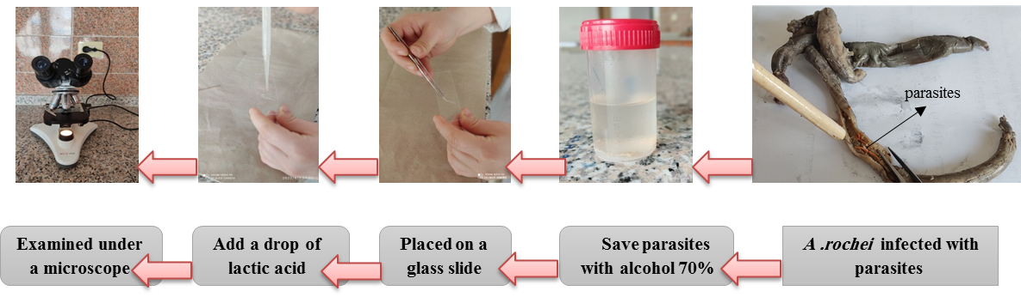
Figure 1. Schematic diagram showing steps of laboratory works in this study
Infection prevalence (%) and mean intensity follow the recommendations of (Bush et al., 1997). The prevalence (%) was calculated as the percentage of the total number of fish infected out of the total number of fish examined. The mean intensity was calculated as the number of parasites in infected fish.
3. results and discussion

Parasites are useful tags to investigate the biology, ecology, migration and population structure of marine organisms (Mackenzie and Abaunza, 2014), and they have also been successfully used to clarify taxonomic relationships between hosts (Whittington, 2005).
In the present study, 11 out of 263 examined specimens of A. rochei were infected with 27 parasites within their intestines. The infection prevalence was 4.18% and its density was 2.45 parasite/ fish. Morphological features (body, eggs, and hooks) of Rhadinorhynchus trachuri agreed with those found in the study of Amin (2020).
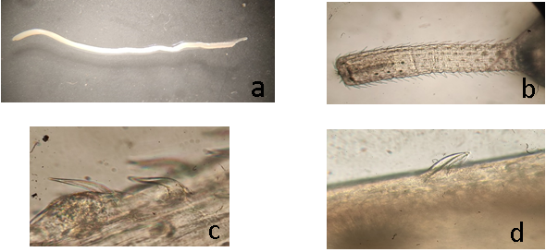
Figure 2: Microscope figures of adult specimens of R. trachuri from A. rochei hosts caught in Rasalbasit – Syrian marine waters.
a: General shape of R.trachuri. b: The anterior end of a female specimen showing the proboscis, c: dorsal hooks showing the roots, d: A larger posterior trunk spine.
Eggs are fusiform, with marked polar prolongation of fertilization membrane (Figure. 3) this description agrees with Amin et al. (2011).
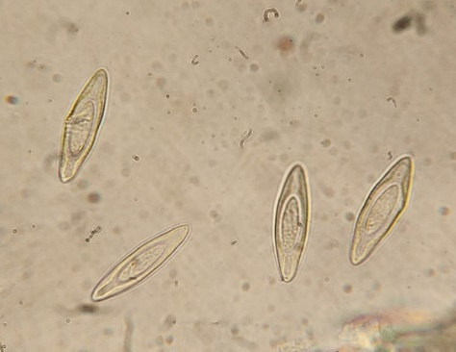
Figure 3: Eggs showing polar prolongation of fertilization membrane
Morphological features agree with features of genus Rhadinorhynchus. Characteristics of the body, eggs, and hooks coincided with Amin (2020).
Feeding behivour (Figure. 4): The A. rochei is a predatory fish that consumes fish and cephalopods as well as smaller food items mostly crustaceans following Jasmine (2013) and Mostarda et al. (2007) that make up acanthocephalan intermediate hosts.
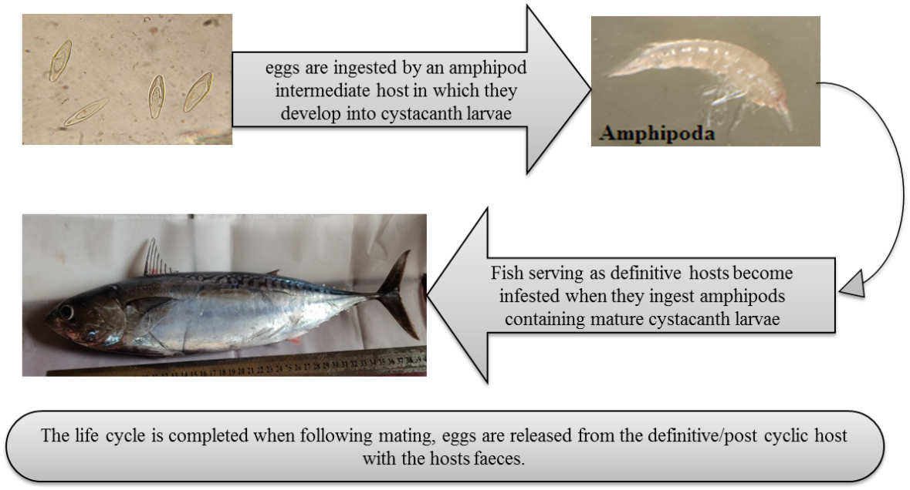
Figure 4. Scheme for the general life cycle of the R. trachuri (by authors)
Morphology of R. trachuri: Worms was a Mature female with an orange color, body composed of proboscis, neck and trunk. trunk elongated, sub-cylindrical, somewhat swollen anteriorly, a spinose, and covered with transverse striated cuticle. Proboscis is cylindrical, stout, claviform, densely armed with 12 alternating rows of strongly re-curved 23–25 hooks. (Figure. 2)
This is agreed with finding of Amin's (2020) who said that the presence of R. trachuri is clearly apparent due to the wide range of its marine fish hosts. However, this is due to the availability of the proper intermediate hosts of crustaceans and partially due to reported fish paratenic hosts.
4. Conclusion

The result of this study showed the presence of the parasite, R. trachuri inside the intestines of the A. rochei fish inhabiting the marine waters of the Syria coast of Lattakia. This is the first record of infection of A. rochei fish by R. trachuri in Mediterranean Sea generally and Syrian marine waters especially.
In future work, we will study parasites on other marine fish species, and also we will check if there are parasite species will be detected on them.

Disclaimer (Artificial intelligence)
Option 1:
Author(s) hereby declare that NO generative AI technologies such as Large Language Models (ChatGPT, COPILOT, etc.) and text-to-image generators have been used during the writing or editing of this manuscript.
Option 2:
Author(s) hereby declare that generative AI technologies such as Large Language Models, etc. have been used during the writing or editing of manuscripts. This explanation will include the name, version, model, and source of the generative AI technology and as well as all input prompts provided to the generative AI technology
Details of the AI usage are given below:
1.
2.
3.

References

Amin, O. M., Heckmann, R. A., & Van Ha, N. (2011). Description of two new species of Rhadinorhynchus (Acanthocephala, Rhadinorhynchidae) from marine fish in Halong Bay, Vietnam, with a key to species. Acta Parasitologica, 56(1), 67–77. https://doi.org/10.2478/s11686-011-0004-3

Amin, O. M. (2013). Classification of the Acanthocephala. Folia Parasitologica, 60, 273–305. https://doi.org/10.14411/fp.2013.031

Amin, O. M. (2020). Redescription of Rhadinorhynchus trachuri Harada, 1935 (Acanthocephala: Rhadinorhynchidae) from marine fish in Vietnam and California with a discussion of its zoogeography. Acta Parasitologica, 65, 77-89. https://doi.org/10.2478/s11686-019-00130-z

Chen, C-J., &Yang R-T. (1973). Parasites of yellowfin tuna in the waters southwest off Taiwan. Acta Oceanograph. Taiwa 3:181–198.

Collette, B. B. (1986). Scombridae (including Thunnidae, Scomberomoridae, Gasterochismatidae and Sardidae). In P. J. P. Whitehead, M.-L. Bauchot, J.-C. Hureau, J. Nielsen, & E. Tortonese (Eds.), Fishes of the North-eastern Atlantic and the Mediterranean (Vol. 2, pp. 981–997). UNESCO. https://unesdoc.unesco.org/ark:/48223/pf0000063661

Collette, B. B., & Nauen, C. E. (1983). Scombrids of the world: An annotated and illustrated catalogue of tunas, mackerels, bonitos and related species known to date (FAO Fisheries Synopsis, No. 125, Vol. 2). Rome, FAO. 137. https://www.fao.org/publications/card/en/c/CB0020EN/

Collette, B., & Graves, J. (2019). Tunas and Billfishes of the World. Johns Hopkins University Press. 352. https://jhupbooks.press.jhu.edu/title/tunas-and-billfishes-world

Garey, J. R., Near, T. J., Nonnemacher, M. R., & Nadler, S. A. (1996). Molecular evidence for Acanthocephala as a subtaxon of Rotifera. Journal of Molecular Evolution, 43(3), 287–292. https://doi.org/10.1007/BF02338837

George, P.V. (1976). Studies on the Acanthocephalid worms in Kerala. Unpublished Thesis, Univ Kerala, India.

George-Nascimento, M. (2000). Geographical variations in the jack mackerel Trachurus symmetricus murphyi populations in the southeastern Pacific Ocean as evidenced from the associated parasite communities. Journal of Parasitology, 86, 929–932. https://doi.org/10.1645/0022-3395(2000)086[0929:GVITJM]2.0.CO;2

Golvan, Y. J. (1969). Systématique des Acanthocéphales (Acanthocephala Rudolphi 1801) L'ordre des Palaeacanthocephala Meyer 1931 – La superfamille des Echinorynchoidea (Cobbold 1876) Golvan et Houin (1963). *Mémoires du Muséum national d'Histoire naturelle. Série A, Zoologie, 57*, 1-373. https://www.biodiversitylibrary.org/item/109000.

Jasmine, S., Rohit, P., Abdussamad, E. M., Koya, K. P. S., Joshi, K. K., Kemparaju, S., Prakasan, D., Elayathu, M. N. K., & Sebastine, M. (2013). Biology and fishery of the bullet tuna, Auxis rochei (Risso, 1810) in Indian waters. Indian Journal of Fisheries, 60(2), 13-20. https://eprints.cmfri.org.in/id/eprint/9600/.

Kennedy, C. R. (2006). Ecology of the Acanthocephala. Cambridge University Press. https://doi.org/10.1017/CBO9780511541902

Køie, M. (2000). Life cycle and seasonal dynamics of Cucullanus cirratus O.F. Müller, 1777 (Nematoda, Ascaridida, Seuratoidea, Cucullanidae) in Atlantic cod, Gadus morhua L. Canadian Journal of Zoology, 78(2), 182-190. https://doi.org/10.1139/z00-009

Køie, M. (2000). Metazoan parasites of teleost fishes from Atlantic waters off the Faroe Islands. Ophelia, 52(1), 25-44. https://doi.org/10.1080/00785236.1999.10409417

Mackenzie, K., & Abaunza, P. (2005). Parasites as biological tags. In S. X. Cadrin, K. D. Friedland, & J. R. Waldman (Eds.), Stock Identification Methods: Applications in Fishery Science (pp. 211–226). Academic Press. https://doi.org/10.1016/B978-012154351-8/50012-5.

Marcogliese, D. J. (1995). The role of zooplankton in the transmission of helminth parasites to fish. Reviews in Fish Biology and Fisheries. https://doi.org/10.1007/BF00043006

Mostarda, E., Campo, D., Castriota, L., Esposito, V., Scarabello, M. P., & Andaloro, F. (2007). Feeding habits of the bullet tuna Auxis rochei in the southern Tyrrhenian Sea. Journal of the Marine Biological Association of the United Kingdom, 87(4), 1007-1012. https://doi.org/10.1017/S0025315407055440

Nickol, B. B., Heard, R. W., & Smith, N. F. (2002). Acanthocephalans from crabs in the southeastern U.S., with the first intermediate hosts known for Arhythmorhynchus frassoni and Hexaglandula corynosoma. Journal of Parasitology, 88(1), 79–83. https://doi.org/10.1645/0022-3395(2002)088[0079:AFCITS]2.0.CO;2

Nickol, B. B. (1985). Epizootiology. In D. W. T. Crompton & B. B. Nickol (Eds.), Biology of the Acanthocephala (pp. 307-346). Cambridge University Press. https://www.cambridge.org/core/books/biology-of-the-acanthocephala/9780521105118

Sabatés, A., & Recasens, L. (2001). Seasonal distribution and spawning of small tunas (Auxis rochei and Sarda sarda) in the Northwestern Mediterranean. Scientia Marina. https://doi.org/10.3989/scimar.2001.65n295

Taraschewski, H. (2005). Acanthocephala (thorny or spiny-headed worms). In K. Rohde (Ed.), Marine parasitology (pp. 116–121). CABI Publishing. https://doi.org/10.1071/9780643093072

Uchida, R. N. (1981). Synopsis of biological data on frigate tuna, Auxis thazard, and bullet tuna, A. rochei. NOAA Tech. Rep. NMFS Circ., (436). https://repository.library.noaa.gov/view/noaa/10000/noaa_10000_document.pdf

Valeiras, J., & Abad E. (2010). ICCAT Manual. Chapter 2.1.10.2. Description of Bullet Tuna (BLT). ICCAT Manual Chapter 2. Description of Species, First Edition (January 2010), p. 315, Madrid.

Whittington, I. D. (2005). Monogenea Monopisthocotylea (ectoparasitic flukes). In K. Rohde (Ed.), Marine parasitology (pp. 63–72). CABI Publishing. Wallingford. https://doi.org/10.1071/9780643093072.

