Utilization of Shrimp Shell Waste for Nutritional Enhancement of Edible Oils: A Case Study Using Sunflower Oil
Abstract:
Shrimp shell waste, a major by-product of India’s seafood industry, presents both an environmental challenge and a valuable opportunity for sustainable resource utilization. This study explores the nutritional fortification of sunflower oil through thermal extraction of bioactive compounds from shrimp shell waste. A simple boiling process facilitated the migration of protein and essential minerals; potassium, calcium, sodium and zinc into the oil phase, resulting in a measurable enhancement of its nutritional profile. Protein content increased from 0 to 0.06%, while mineral concentrations also showed significant enrichment. Comparative analysis with existing literature confirmed the nutrient density of shrimp shell byproducts, including their high ash content and balanced amino acid composition. The findings underscore the potential of shrimp shell waste as a functional ingredient for food, feed and nutraceutical applications, while promoting circular economy principles and waste valorisation in seafood processing.
Keywords: Edible oil, Minerals, Nutritional enhancement, Protein, Shrimp shell waste
Introduction
Shrimps, a widely consumed crustacean, is esteemed for its nutritional richness and growing significance in global diets (Maia et., 2022 & Dayal et al., 2013). It serves as an excellent source of high-quality protein, essential vitamins, astaxanthin and minerals such as phosphorus, calcium, selenium, copper, zinc and iodine (Dayal et al., 2013). Food and Agriculture Organization (FAO) indicate that global shrimp consumption reached approximately 12.6 million tons in 2020, reflecting a steady upward trend (FAO, 2021). By 2022, shrimp and prawns ranked among the most economically valuable aquatic species traded worldwide, second only to salmonids (FAO, 2024). However, the expansion of shrimp production has led to substantial environmental challenges, particularly due to the generation of bio-waste, which accounts for nearly 50% of the raw shrimp mass (Fawaaz et al., 2021). If unmanaged, this waste primarily composed of shells and heads poses serious risks to both environment and public health (Fawaaz et al., 2021 & Muniyappan et al., 2019). Notably, shrimp waste contains a wide array of bioactive compounds, including chitin, chitosan, proteins, polyunsaturated fatty acids, pigments such as astaxanthin, and essential minerals (Senadheera et.al., 2023 & AlFaris et al., 2022). According to Simat et. al (2022), only 20–25% of the harvested crustacean biomass is utilized for meat, up to 80% is discarded annually. To address this inefficiency, circular bioeconomy models are being explored to transform shell waste into high-value products such as peptides, omega-3 fatty acids, marine calcium, and functional food ingredients (Wani et. Al., 2024; Vakkachan et al., 2024; Burke & Kerton, 2023 and Tremblay et al., 2020). These approaches not only reduce ecological impact but also enhance the sustainability and economic viability of seafood production systems (Kumar et al., 2020 & Song et al., 2022). The strategic utilization of these waste materials has been increasingly recognized as essential for advancing sustainability across both food and non-food sectors. Their integration into diverse industrial applications reflects a growing imperative to adopt circular economy principles and reduce environmental burden (Al Hoqani et al., 2021).
Extensive research has been conducted on various aspects of shrimp and its derivatives internationally. Studies have explored the physicochemical properties of salt-fermented shrimp (Mok & Song, 2000; Mok et al., 2000), the assessment of shrimp freshness during cold storage (Lee & Um, 1995), etc. Investigations into shrimp by-products have focused on protease activity and biochemical composition (Doke & Ninjoor, 1987; Shahidi & Synowiecki, 1991), as well as the extraction of natural antioxidants (Pasqual & Babbitt, 1991).
Significant attention has been given to the valorisation of shrimp shell by-products, particularly for the recovery of caroteno-proteins (Camo-Lopez et al., 1987; Simpson & Haard, 1985), chitin (Shahidi et al., 1999) and chitosan (Benjakul & Sophanodora, 1993; Chung et al., 1996; Simpson & Haard, 1985). These compounds have demonstrated potential applications in food processing and functional ingredient development (Jeon et al., 2000; Shahidi et al., 1999).
Even though, extraction of protein, chitin, chitosan and different pigments from shrimp shell waste has been studied extensively and is popular in industrial level, the possibility of extraction and utilisation of minerals from shrimp shell waste is not much studied in India. In this background, this study investigates the potential of shrimp shell waste as a natural fortifying agent for edible oils, focusing on its ability to enhance the protein and mineral content. By integrating waste valorization with food innovation, the research aims to contribute to sustainable seafood processing, reduce environmental burden and promote the development of nutrient-enriched edible oils.
Despite these advancements, relatively few studies have addressed the comprehensive utilization of shrimp processing by-products including heads, shells, and tails for nutritional enhancement. The present study aims to investigate the compositional attributes and nutritional quality of these by-products, thereby exploring their potential for incorporation into value-added food products. This study examines the influence of shrimp shell waste on the nutritional enhancement of sunflower oil through fortification. The study addresses critical gaps in current knowledge and provides food scientists with innovative yet practical approaches to simultaneously reduce the environmental burden of shrimp shell waste and improve the nutrient density of conventionally used sunflower oil.
Materials and methods
Preparation of shrimp oil
Initially, shrimp shells preferably including heads and exoskeletons are mechanically fragmented into smaller pieces to increase surface area and facilitate compound release. These fragments are then introduced into a heavy-bottomed vessel containing a small volume of edible oil, typically under high heat conditions and sauté for 5 minutes. Subsequently, the remaining oil is added in sufficient quantity to fully submerge all solid components, ensuring uniform heat transfer and solvent contact. The mixture is maintained at high heat for approximately 5 minutes before being reduced to low heat and simmered for a minimum of one hour. After cooking, the system is allowed to cool passively for 2 hours to prevent thermal degradation of sensitive compounds. The oil is then separated from solids via filtration through a fine mesh sieve and the residual solids are drained thoroughly to recover maximum yield. The final product is a nutrient enriched shrimp shell oil, characterized by its reddish colour, enhanced nutrient profile and potential applications in functional food formulations, culinary enhancement or nutraceutical development.
Nutritional analysis of shrimp oil
Estimation of Protein
Protein content in shrimp shell oil was estimated using micro Kjeldal method (Table.1). The method involves digestion of the sample in concentrated sulfuric acid with a catalyst, followed by distillation and titration of liberated ammonia. Nitrogen content is calculated and converted to protein using an appropriate factor, typically 6.25. This approach ensures precise quantification of protein in complex matrices and is widely accepted in seafood and aquaculture product analysis. The proteincontent was expressed as percentage.
Estimation of Calcium
The concentration of calcium were analyzed in accordance with the protocol specified in SOP No. FQLAB/SOP/C/FF/7224 (Table.1), as issued by the Bureau of Indian Standards (BIS). This method was employed to ensure standardized and reliable quantification of mineral content in the sample.
Estimation of Sodium
Sodium content was estimated following the standard procedure outlined in SOP No. FQLAB/SOP/C/FF/7224 (Table.1), issued by the Bureau of Indian Standards (BIS). The method involves sample preparation, digestion and quantification using flame photometry. All reagents and instruments were calibrated according to laboratory standards and results were expressed in mg/kg of sample.
Estimation of Potassium
Potassium content in the sample was estimated following the standardized procedure outlined in SOP No. FQLAB/SOP/C/FF/7224 (Table.1), issued by the Bureau of Indian Standards (BIS). The method involves sample preparation, followed by digestion to release bound minerals. Quantification of potassium was carried out using flame photometry, calibrated with potassium standard solutions to ensure accuracy and reproducibility. All glassware and instruments were pre-cleaned and validated according to laboratory protocols. The results were expressed in milligrams per kg of sample (mg/kg) and each analysis was performed in triplicate to ensure statistical reliability.
Estimation of Zinc
Estimation of zinc content was carried out in accordance with SOP No. FAQLAB/SOP/C/HM/7208, Issue No. 02 Apr 01 (Table.1). The procedure involves sample digestion, followed by quantification of zinc. The concentrations of zinc were expressed in milligrams per kilogram (mg/kg) of sample and each analysis was conducted in triplicate to ensure precision and reproducibility.
Table: 1. Methods Used for Testing Nutritional Quality of Shrimp Oil
Sl. No | Parameters | Test method
1 | Protein | Micro kjeldal
2. | Calcium | IS 9497:1980 (RA 2015)
3. | Sodium | IS 9497:1980 (RA 2015)
4. | Potassium | IS 9497:1980 (RA 2015)
5. | Zinc | SOP No-FAQLAB/SOP/C/HM/7208 Issue no 02 Apr 01

Results and Discussion

Shrimp constitutes a major component of India's marine export portfolio, representing a significant share of the country's total seafood export volume and value. Whether it is processed or not, it has better acceptance among consumers. Despite of the consumer acceptance, it has became a severe problem that disposal of shell waste or how decompose it without getting any harm. Several studies have investigated the nutritional potential of shrimp shell waste, highlighting its suitability for value-added applications. Among the various components protein, chitin, calcium carbonate, lipids, minerals and pigments have been identified as particularly significant in terms of both concentration and functional relevance. Shrimp shell by-products are consistently reported as nutrient-rich, containing 9.3–11.6% crude protein and a well-balanced amino acid profile, with essential amino acids contributing nearly 70% of the total composition (Liu et., 2021). Such characteristics highlight their potential as valuable protein sources for functional foods, nutraceuticals and aquaculture feeds (Heu et al., 2003). Quantitative analysis revealed that shrimp shell flour possesses a notably high ash content, measured at 47.27%, indicating a substantial mineral load (Yulianto et al., 2021). Furthermore, experimental trials utilizing shrimp shell flour as a biofertilizer demonstrated its richness in essential macronutrients; nitrogen (N), phosphorus (P) and potassium (K) which collectively underscore its potential as an effective organic fertilizer (Rusmini et al., 2017).
This study aimed to prepare fortified edible oil and to evaluate its nutritional quality by incorporating shrimp waste. Shrimp oil was extracted through thermal processing (boiling) of shrimp waste in sunflower oil, specifically, 550 g of shrimp waste obtained from one kilogram shrimp was subjected to heat treatment in 1 liter of sunflower oil. The process facilitated the transfer of lipid-soluble bioactive compounds into the oil phase. Following filtration to remove residual solids, the final yield of shrimp-infused oil was one liter. This method demonstrated a sustainable approach to utilising crustacean byproducts, with potential applications in fortification and enrichment of food products. The shrimp oil prepared was analysed for its nutritional composition, protein has been tested in both internal and a certified external laboratory and minerals have been tested in external certified laboratory. The primary objective was to assess the enhancement of nutritional quality through the incorporation of shrimp shell-derived compounds into the oil. The analysis focused on protein content and selected minerals such as potassium, calcium, sodium and zinc.
The protein content of the oil showed a measurable increase, rising from zero in raw sunflower oil to 0.06% (Table 2) in the shrimp-infused oil. This indicates the successful migration of proteinaceous compounds and minerals from the shrimp shell waste into the lipid phase during thermal processing. Although the percentage is modest, it confirms the presence of bioavailable protein in the final product, which is typically absent in conventional sunflower oil. Protein is a vital nutrient which plays a fundamental role in human growth and development, its contribution to cellular structure and function is largely attributed to its nitrogen content, which is essential for the synthesis of amino acids. These amino acids serve as the primary building blocks of proteins, facilitating the formation and maintenance of body tissues. Therefore, enhancing the protein content of food products offer significant nutritional benefits. Shrimp shell had been utilised as an alternate raw for mariculture and analysis showed that protein content of shrimp shell flour is 27.4% which can be utilised for feed applications.
A comparable trend of increased protein content following the incorporation of shrimp shell has been reported across various food products by multiple authors. Djalal et al., 2023 studied the increment in protein constitution of tempeh steak by adding shrimp shell flour as a constituent. The result of the study showed that there is increment in protein concentration of the product and reached upto 21.79% by adding 20% of the SSF which was only 17.67% without shrimp shell flour. They have evidences that increase in protein was only due to the available protein content of the shrimp shell flour. Liu et al. (2021) compared the crude protein and mineral content of different shrimp species and it showed that, even though crude protein content was less in shell, tails and head when compared to meat, it amounted 6.56 to 9.97 g/100g in head and 7.98 to 11.30 g/100g in shell and tail. Hossain & Shahidi (2024) also evaluated the protein content of shrimp shell waste and found out to be 10.73%. Our result is in accordance with the findings of Guo et al, 2019 and Abuzar et al., 2023 in which optimal protein content of shrimp head had been studied and reported.
Mineral profiling revealed significant enrichment across all tested elements. Potassium content increased from 0 to 73.05 mg/kg, calcium from 0 to 3.03 mg/kg, sodium from 0 to 65.46 mg/kg and zinc from 0 to 33.54 mg/kg (Table 2, Fig.1.). These findings suggest that shrimp shell waste is a rich source of essential minerals and a simple boiling in oil is sufficient to facilitate their transfer into the oil phase. The presence of these minerals enhances the nutritional value of the oil and may contribute to dietary intake when used in culinary or feed applications.
The enhancement of mineral content through the incorporation of shrimp shell has been consistently documented across various food matrices by multiple researchers. Incorporation of shrimp shell flour (SSF) into tempeh steak formulations has been shown to enhance specific nutritional attributes without altering the overall macronutrient balance. Djalal et al. (2023) reported that increasing SSF concentrations progressively elevated the product’s protein and ash (mineral) content while reducing moisture levels, with no significant effects on fat or carbohydrate content. The ash content increased from 1.65% in the control to 5.35% at 20% SSF, reflecting the high mineral composition of shrimp shells. These findings indicate that SSF serves as an effective functional ingredient for improving the nutritional quality of tempeh-based products. Adeyeye & Aremu (2016) reported that shrimp shell is notably rich in minerals, with calcium being particularly abundant. Liu et al. (2012) conducted a comparative assessment of crude protein and mineral composition across multiple shrimp species, demonstrating that the ash/mineral content in the shell, tail, and head consistently exceeded that of the meat, with values ranging from 4.11 to 13.45 g/100 g depending on the species examined. Heu et al., 2003 studied shrimp by-products (heads, shells and tails) derived from Northern pink shrimp and spotted shrimp which exhibit a mineral-rich profile, with calcium contributing over 60% of the total mineral content (approximately 3000–3371 mg/100 g), followed by notable levels of phosphorus, sodium, magnesium and potassium, collectively complementing the higher protein concentration typically found in shrimp muscle. Kim et al. (1998) reported that although shrimp shell contains less calcium than fish bone, its calcium content remains sufficiently high to support its utilization for human dietary applications. These findings emphasize shrimp shell waste as a sustainable, nutrient-dense raw material with applications in food, feed and resource recovery industries, while simultaneously supporting waste minimization in seafood processing. Mansyur et al 2021 evaluated the mineral content of shrimp shell waste and found out that Potassium content is 7.40 g/kg, Calcium 46.4 g/kg and Sodium 33.4 g/kg. Optimal mineral content of shrimp head had been studied and reported by Phuong et al, 2017 and Abuzar et al., 2023 whose results are in line with the present study. Sagar & Lynum (2025) developed an Environment Friendly Biodegradable Sprayable Shrimp Waste Fertilizer and proved it can be utilised as a biofertiliser because of its rich nutrient content especially minerals. Abirami et al. 2022 compost from shrimp shell and conducted plant growth study using it and found out that it helps to induce plant growth performances. Indratmi et al., 2024 utilised shrimp shell waste to increase the yield of shallots and in their analysis potassium content and calcium content of shrimp shells found to be 1114.4 mg/L and 56.32 mg/L respectively.
This study demonstrates that shrimp shell waste can be effectively utilized to enhance the nutritional composition of edible oils through a simple thermal extraction method. The approach not only utilises seafood by-products but also aligns with sustainable food processing and circular economy principles. The resulting shrimp-enriched oil shows potential for application in functional foods, aquafeed formulations and nutraceutical development. Initial analysis of sunflower oil revealed the presence of fats and fat-soluble vitamins, with negligible levels of protein and essential minerals such as potassium, calcium, sodium and zinc. However, post-treatment with shrimp shell waste led to a measurable increase in these nutrients, indicating that bioactive constituents from shrimp shells can be harnessed to improve the nutritional quality of edible oils
Table: 2. Result of Nutritional Analysis of Shrimp Oil
Sl No. | PARAMETERS | UNIT | TEST METOD | RESULT
1 | Protein | % | Micro-Kjeldal | 0.06
2 | Calcium | Mg/kg | IS 9497:1980 (RA 2015) | 3.03
3 | Sodium | Mg/kg | IS 9497:1980 (RA 2015) | 65.46
4 | Potassium | Mg/kg | IS 9497:1980 (RA 2015) | 73.05
5 | Zinc (as Zn | Mg/kg | SOP No. - FQLAB/SOP/C/HM/7208  Issue No. 02 Apr 01 | 33.54

Fig.1. Constitution of tested minerals in shrimp oil (in mg/kg)

CONCLUSION
The present study demonstrates that shrimp shell waste, an abundant and underutilized by-product of the seafood industry, can be effectively valorised to enhance the nutritional profile of edible oils. Through a simple boiling process, measurable quantities of nutrients, protein (0.06%) and minerals such as potassium (73.05 mg/kg), sodium (65.46 mg/kg), zinc (33.54 mg/kg) and calcium (3.03 mg/kg) were successfully transferred from shrimp shell material into sunflower oil. The fortified oil exhibited clear improvements in nutrient content compared to raw sunflower oil, confirming the feasibility of using crustacean by-products as natural fortifying agents. These findings align with previous studies highlighting the nutrient density of shrimp shells and emphasize their potential applicability in food, feed and nutraceutical formulations.
The method adopted in this study is low-cost, scalable and adaptable to existing food-processing environments, offering a practical pathway for integrating circular-economy practices within the seafood sector. Nevertheless, further research is required to evaluate other nutrients, sensory attributes, storage stability, consumer acceptance and regulatory compliance of shrimp enriched edible oils. Expanding the work to include biochemical profiling of bioactive compounds and assessment of antioxidant potential would also provide deeper insights into the functional value of the product.
Overall, this study provides a promising foundation for the sustainable utilization of shrimp shell waste and illustrates an innovative approach in developing nutrient-enriched edible oils with added functionality.
Limitation of the Study
This investigation was conducted as part of a second-semester undergraduate project, and the experimental approach originated from a simple demonstration observed on YouTube. The procedure was exploratory in nature, without an initially established scientific hypothesis. Only during the analytical phase did we realize that the fortified oil indeed contained measurable levels of proteins and minerals that were absent in the original sunflower oil. As a result, the study lacks the depth of controlled experimental design and optimized methodology typically seen in advanced research. Future work should incorporate standardized extraction protocols, controlled processing conditions, and repeat trials to validate and expand upon these preliminary findings.

AcknowledgEments

Authors are grateful to Principal, MES Asmabi College, P. Vemballur, Kodungallur for granting permission and for the support to conduct the study.
DISCLAIMER (ARTIFICIAL INTELLIGENCE)
Author(s) hereby declare that NO generative AI technologies such as Large Language Models (ChatGPT, COPILOT, etc) and text-to-image generators have been used during writing or editing of this manuscript.
COMPETING INTERESTS
Author has declared that they have no known competing financial interests or non-financial interests or personal relationships that could have appeared to influence the work reported in this paper.
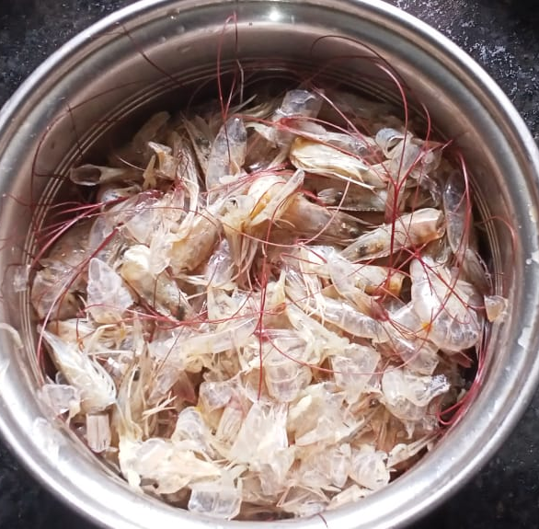 | 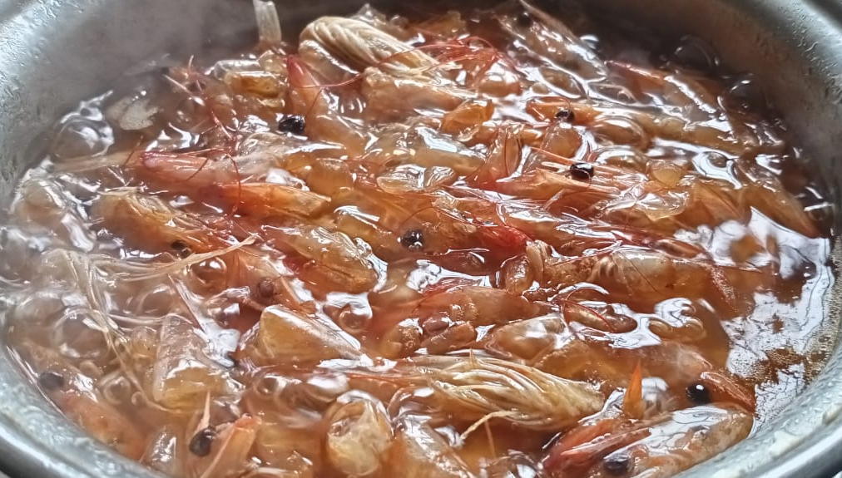  Photo. 2. Shrimp shell in sunflower oil
Photo. 1. Washed prawn shell waste
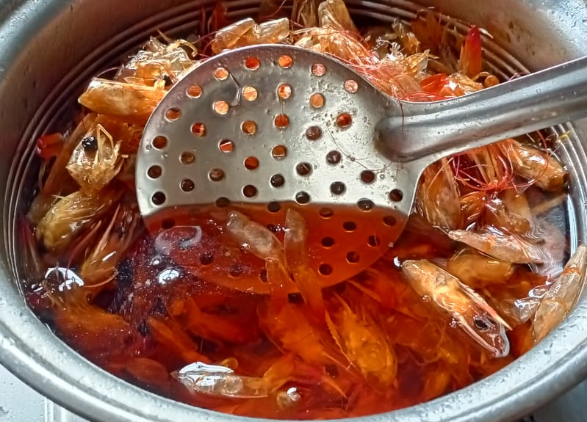 | 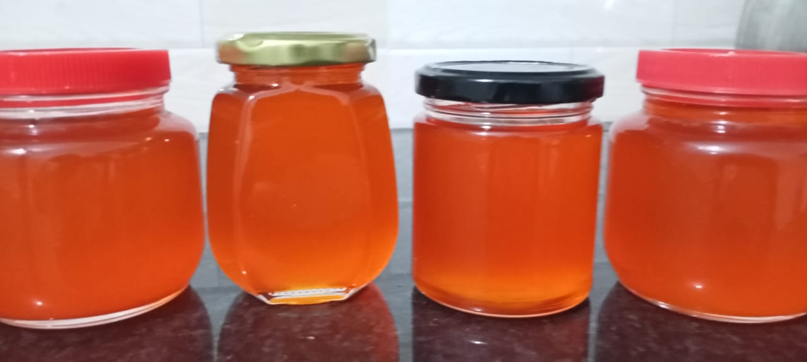  Photo. 4. Prepared shrimp oil
Photo. 3. After 30 minutes of heating, water evaporated and oil turned brown

References
- Abirami S., Gnanamuthu G., Nagarajan D. (2022). Bioconversion of Shrimp Shell Waste into Compost Preparation and its Plant Growth Study . Indian Journal of Agricultural Research. 56(5): 588-593. doi: 10.18805/IJARe.A-5214.
- Abul Hossain and Fereidoon Shahidi (2024). Upcycling Shellfish Waste: Distribution of Amino Acids, Minerals, and Carotenoids in Body Parts of North Atlantic Crab and Shrimp. Foods 2024, 13(17), 2700; https://doi.org/10.3390/foods13172700
- Abuzar, Hafiz Rizwan Sharif, Mian Kamran Sharif, Rizwan Arshad, Abdur Rehman, Waqas Ashraf, Aiman Karim, Kanza Aziz Awan, Husnain Raza, Waseem Khalid, Turky Omar Asar & Mayada Ahmad Al-Sameen (2023) Potential industrial and nutritional applications of shrimp by-products: a review, International Journal of Food Properties, 26:2, 3407-3432, DOI: 10.1080/10942912.2023.2283378
- Adeyeye E I and Aremu M O 2016 Chemical Composition of Whole Shrimp, Flesh and Shell of Pandalus borealis from Lagos Atlantic Ocean FUW Trends Sci. Technol. J. xxx@gmail.com 1 26–32
- Al Hoqani, H. A. S.; Al Shaqsi, N. H. K.; Hossin, M. A.; Al Sibani, M. A. Structural Characterization of Polymeric Chitosan and Mineral from Omani Shrimp Shells. Water Energy Nexus. 2021, 4(2021), 199–207. DOI: 10.1016/j. wen.2021.11.002.
- AlFaris, N.A.; Alshammari, G.M.; AlTamimi, J.Z.; AlMousa, L.A.; Alagal, R.I.; AlKehayez, N.M.; Aljabryn, D.H.; Alsayadi, M.M.; Yahya, M.A. Evaluating the effects of different processing methods on the nutritional composition of shrimp and the antioxidant activity of shrimp powder. Saudi J. Biol. Sci. 2022, 29, 640–649.
- Burke, H.J.; Kerton, F. Sequential extraction of valuable bio-products from snow crab (Chionoecetes opilio) processing discards using eco-friendly methods. Mar. Drugs 2023, 21, 366.
- Benjakul, S. and Sophanodora, P. Chitosan production from carapace and shell of black tiger shrimp. ASEA", Food J. 8(4):145-148; 1993.
- Chung JS, Wilkinson MC, Webster SG. Determination of the amino acid sequence of the moult-inhibiting hormone from the edible crab, Cancer pagurus. Neuropeptides 1996; 30: 95–101.
- A. Cano-Lopez, B. Simpson, and N. Haard (1987) "Extraction of Carotenoprotein from Shrimp Process Wastes with the Aid of Trypsin from Atlantic Cod" Journal of Food Science 1987, 52 (2), 503À506 Science
- Dayal, J.S.; Ponniah, A.G.; Khan, H.I.; Babu, E.P.M.M.; Ambasankar, K.; Vasagam, K.P.K.K. Shrimps—A nutritional perspective. Curr. Sci. 2013, 104, 1487–1491.
- Muspirah Djalal, Nurul Fathanah, Serli Hatul Hidayat, Andi Fadiah Ainani, Dewi Sisilia Yolanda, Kasmira and A Nur Farahdiba Suriadi (2023) IOP Conf. Ser.: Earth Environ. Sci. 1230 012178
- DOKE, S.N. and NINJOOR, V. 1987. Characteristics of an alkaline proteinase and exopeptidase from shrimp (Penaeus indicus) muscle. J. Food Sci. 52, 1203–1208.
- FAO Food Supply—Livestock and Fish Primary Equivalent. FAOSTAT 2021.
- FAO. 2024. The State of World Fisheries and Aquaculture 2024 – Blue Transformation in action. Rome. https://doi.org/10.4060/cd0683en
- Fawwaz, M.; Pratama, M.; Hasrawati, A.; Sukmawati; Widiastuti, H.; Rahmawati; Abidin, Z. Total carotenoids, antioxidant and anticancer effect of penaeus monodon shells extract. Biointerface Res. Appl. Chem. 2021, 11, 11293–11302.
- Guo, N.; Sun, J.; Zhang, Z.; Mao, X. Recovery of Chitin and Protein from Shrimp Head Waste by Endogenous Enzyme Autolysis and Fermentation. J. Ocean Univ. China. 2019, 18(3), 719–726. DOI: 10.1007/s11802-019- 3867-9.
- Heu, M.S.; Kim, J.S.; Shahidi, F. Components and nutritional quality of shrimp processing by-products. Food Chem. 2003, 82, 235–242
- Jeon J.S., Lee S., Jung K.H., Jun S.H., Jeong D.H., Lee J., et al. (2000) T-DNA insertional mutagenesis for functional genomics in rice. Plant J. 22: 561–570.
- Kim, J. S., Choi, J. D., & Kim, D. S. (1998). Preparation of calciumbased powder from fish bone and its characteristics. Korean Agricultural Biotechnology, 41, 147–152.
- Kumar, A.; Saini, K.; Bhaskar, T. Advances in design strategies for preparation of biochar based catalytic system for production of high value chemicals. Bioresour. Technol. 2020, 299, 122564.
- ee YC, Um YS. Quality determination of Shrimp (Penaeus japonicus) during iced and frozen storage. Korean J Food Sci Tech. 1995;27(4):520-4.
- Liu, Z.; Liu, Q.; Zhang, D.; Wei, S.; Sun, Q.; Xia, Q.; Shi, W.; Ji, H.; Liu, S. Comparison of the Proximate Composition and Nutritional Profile of Byproducts and Edible Parts of Five Species of Shrimp. Foods. 2021, 10 (11), 2603. DOI: 10.3390/foods10112603.
- Maia, L.; Almeida, A.; Soares, C.; Silva, L.M.S.; Delerue-Matos, C.; Calhau, C.; Fernandes, V. Minerals and fatty acids profile of Northwest Portuguese coast shrimps. J. Food Compos. Anal. 2022, 112, 104652.
- Mok, C. K., & Song, K. T. (2000). High hydrostatic pressure sterilization of putrefactive bacteria in salted and fermented shrimp with different salt content. Korean Journal of Food Science and Technology,32,598–603.
- Mok, C. K., Lee, J. Y., Song, K. T., Kim, S. Y., Lim, S. B., &Woo, G. J. (2000). Changes in physico chemical properties of salted and fermented shrimp at different salt levels. Korean Journal of Food ScienceandTechnology,32,187–191.
- Muniyappan, J.; Varadharajan, V.; Namadevan, P. Biochemical Screening and Determination of Bioactive Components of Commercially Cultured Pacific White Shrimp Penaeus vannamei. Pharmacogn. Res. 2019, 11, 140–146.
- N.I Mansyur, E Hanudin, B.H Purwanto and S.N.H Utami (2021) IOP Conf. Ser.: Earth Environ. Sci. 748 012013
- Pasqual, L. J., de, R., & Babbitt, J. K. (1991). Isolation and partial characterization of a natural antioxidant from shrimp (Pandalus jordant). Journal of Food Science, 56, 143–145.
- Phuong, P. T. D.; Minh, N. C.; Cuong, H. N.; Van Minh, N.; Han, N. T.; Van Hoa, N.; Yen, H. T. H.; Trung, T. S. Recovery of Protein Hydrolysate and Chitosan from Black Tiger Shrimp (Penaeus monodon) Heads: Approaching a Zero Waste Process. J. Food Sci. Technol. 2017, 54(7), 1850–1856. DOI: 10.1007/s13197-017- 2616-6.
- Rusmini P., Cristofani R., Galbiati M., Cicardi M. E., Meroni M., Ferrari V., et al. (2017). The role of the heat shock protein B8 (HSPB8) in motoneuron diseases. Front. Mol. Neurosci. 10:176. 10.3389/fnmol.2017.00176
- Senadheera, T.R.L.; Hossain, A.; Shahidi, F. Marine bioactives and their application in the food industry: A review. Appl. Sci. 2023, 13, 12088.
- Shahidi, F. and Synowiecki, J. (1991) Isolation and Characterization of Nutrients and Value-Added Products from Snow Crab (Chinoecetes opilio) and Shrimp (Pandalus borealis) Processing Discards. Journal of Agriculture and Food Chemestry, 39, 1527-1532.
- Shahidi, F., Arachchi, J.K.V. and Jeon, Y.J. (1999) Food Applications of Chitin and Chitosan. Trends in Food Science Technology, 10, 37-51. http://dx.doi.org/10.1016/S0924-2244(99)00017-5
- Šimat, V.; Rathod, N.B.; ˇ Cagalj, M.; Hamed, I.; Mekini´c, I.G. Astaxanthin from crustaceans and their byproducts: A bioactive metabolite candidate for therapeutic application. Mar. Drugs 2022, 20, 206.
- The use of proteolytic enzymes to extract carotenoproteins from shrimp wastes BK Simpson, NF Haard Journal of applied biochemistry 7 (3), 212-222
- Song, Y. M., A. N. Huang, and H. S. Chen, 2022: The persistence and reemergence of atmospheric anomaly signals in soil temperature. J. Geophys. Res. Atmos., 127, e2022JD037218, https://doi.org/10.1029/2022JD037218.
- Tremblay, A.; Corcuff, R.; Goulet, C.; Godefroy, S.B.; Doyen, A.; Beaulieu, L. Valorization of snow crab (Chionoecetes opilio) cooking effluents for food applications. J. Sci. Food Agric. 2020, 100, 384–393.
- Vakkachan, P.; Gopakumar, S.T.; Janardhanan, R.K.; Pootholathil, S.; Surendran, S.; Nair, A.V.; Raveendran, R.K.; Suresh, G.; Subramanian, S.; Pananghat, V. Degradation of marine crustacean shell wastes through single-stage co-fermentation using proteolytic and chitinolytic bacteria. Environ. Sci. Pollut. Res. 2024, 31, 62329–62345.
- Wani, A.K.; Akhtar, N.; Mir, T.U.G.; Rahayu, F.; Suhara, C.; Anjli, A.; Chopra, C.; Singh, R.; Prakash, A.; El Messaoudi, N.; et al. Eco-friendly and safe alternatives for the valorization of shrimp farming waste. Environ. Sci. Pollut. Res. Int. 2024, 31, 38960–38989.
- Yulianto, T., Putri, D. S., Miranti, S., & Putra, W. K. A. (2021). Utilization of Shrimp Shell Waste as Alternative Raw for Mariculture. E3S Web of Conferences, 324, 3–6.https://doi.org/10.1051/e3sconf/202132403006R. Rusmini, R.R. Manullang, D. Daryono, Nusantara Biosci., 9,3: 260‒267 (2017) https://doi.org/10.13057/nusbiosci/n090304

