Original Research Article

Dietary Analysis of Sardinella maderensis (Lowe, 1938) in the Marine Waters off the Latakia Coast (Syria), Eastern Mediterranean: A Two-Year Seasonal Study

ABSTRACT:

Dietary studies play a vital role in understanding the balance of marine ecosystems and sustainable fishery practices. This research examines the feeding habits of Sardinella maderensis, a commercially important Clupeidae species, in the marine waters off Latakia, eastern Mediterranean.
1,200 specimens were collected using gillnets and chinchilla nets, following local fishing practices, between October 20, 2021, and September 14, 2023. The sampled individuals displayed a standard-length range of 9.32–23.18 cm (mean 14.67±4.2 cm) and a weight range of 12.41–116.1 g (mean 44.28±28.37 g), with a maximum body height averaging 3.49±1.26 cm.
Dietary analysis indicated that S.maderensis is a planktivorous species, feeding on 15 planktonic species categorized into seven major groups: Crustaceans ranked first, with a relative importance of 46.95%, a frequency of 45.67%, and a total of 7832.50 points. This group included various types, such as copepods (e.g., Calanoidea and Cyclopidae) and malacostracans, including Euphausiacea, Mysidacea, and Decapoda (Penaeus and Crab megalopae). Detritus ranked second, with a relative importance of 19.60%, a frequency of 17.77%, and 2243.50 points. Phytoplankton followed, ranking third with a relative importance of 15.23%, a frequency of 13.55%, and 4158.88 points. Fish ranked fourth, with a relative importance of 8.95%, a frequency of 12.75%, and 2513 points. This group consisted of three species: Anguilliformes, Ophidion rochei, Trachurus trachurus, and partially digested fish remains. Polychaete worms showed a low contribution, with a relative importance of 0.75%, a frequency of 2.18%, and 255 points. Foraminifera contributed 0.32%, with a frequency of 1.02% and 71 points. Mollusks, represented by a single Octopoda individual, had the lowest contribution, with a relative importance of 0.01%, a frequency of 0.15%, and 20 points. These findings provide essential ecological data on S.maderensis feeding behavior, contributing to improved fisheries management and marine conservation efforts in the coastal waters of Latakia..

Keywords: Keywords: Fish diet, Planktivorous fish, Phytoplankton and zooplankton, Marine fisheries, Dietary diversity, Coastal environment, Fisheries resource management.

1. INTRODUCTION
The biological study of fish, particularly their feeding habits, plays a crucial role in understanding marine ecosystems. Fish feeding behavior varies widely among herbivorous, carnivorous, and omnivorous species, and these patterns are strongly influenced by seasonal environmental factors such as temperature, food availability, and reproductive cycles. Seasonal changes in feeding intensity affect growth, physiological condition, reproductive efficiency, and migration behavior (Lalli & Parsons, 1997; Wootton, 2012). Despite the ecological and economic importance of understanding the feeding dynamics of marine species, there is a lack of research addressing the seasonal variation in the feeding habits of commercially important fish species in Syrian coastal waters. In particular, no comprehensive study has yet investigated the seasonal influences on the feeding behavior of Sardinella maderensis, a key species supporting local fisheries. Therefore, this study aims to: (1) analyze the seasonal variations in the diet of Sardinella maderensis; (2) assess how these variations influence growth and reproductive performance; and (3) evaluate the implications of these findings for sustainable fisheries management in the region. These outcomes will contribute to improved ecological understanding of S. maderensis and support the development of management strategies aligned with ecosystem-based fisheries approaches (Pikitch et al., 2004). Sardinella maderensis is a common marine species, characterized by its wide distribution and economic and ecological importance (Amednah et al., 2018). It is extensively exploited in both traditional and industrial fisheries, making it a vital food source for many coastal countries (Adnewale, 2023). Furthermore, S. maderensis plays a key role in the marine food web, acting as a link between plankton and larger predators (Diatta et al., 2016).
Studying its diet is crucial for understanding its ecological behavior and identifying the factors influencing its abundance and distribution (Baali et al., 2020). Understanding this species' diet also helps assess the health of the marine ecosystem it inhabits, as dietary changes may reflect environmental disturbances or climate shifts (Chukwu & Orlu, 2024). Nutritional studies are also essential for developing sustainable fish stock management plans and for assessing the impacts of human exploitation and environmental pressures on sardine fisheries (El-sayed et al., 2023). Understanding dietary components also contributes to predicting future changes that may occur in this species as a result of environmental or climatic changes (Tossavi et al., 2025).

2. material and methods:
From October 2021 to September 2023, fish samples were collected monthly using local fishing gear (gillnets and chinchilla nets) in the Ras Al-Basit area along the Syrian coast. The fish were transferred directly to the laboratory, where their length and weight were measured according to established methods (e.g., Pravdin, 1966), and species were identified using the appropriate taxonomic keys.
The stomach contents were examined using a light microscope and magnifying lens, and the samples were preserved in 7% formalin. The food items were classified based on specific taxonomic keys (e.g., Gosner, 1971; Borutskii, 1974). Partial food items, such as crustacean eyes, were counted when possible.

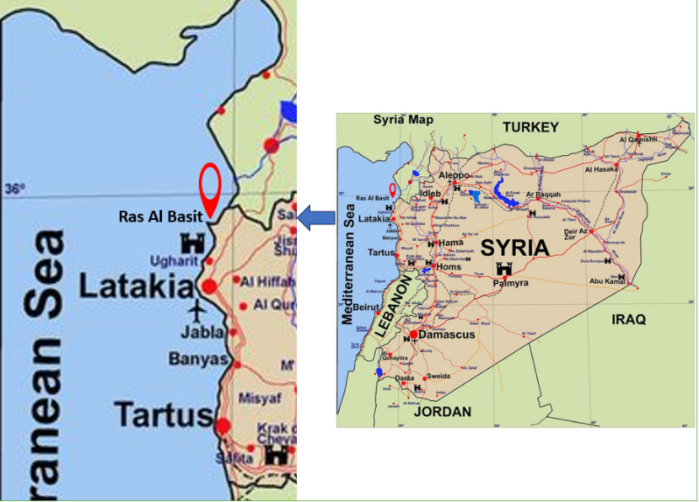
Fig. 1. Sampling site, Ras Al-Basit, Latakia, Syria.
2.1 Analysis Methods
Two methods were used to analyze the gut contents: frequency and point methods (Hyslop, 1980). Points were assigned based on the degree of fullness of the digestive tract, ranging from 0 for an empty tract to 50 when filled. The relative percentage of each food item was calculated based on the points awarded.

2.1.1 The Condition Factor was used to measure the efficiency of feeding, calculated using the formula: (Pravdin, 1966)0
K=$\frac{W×100}{l 3}$) W( is the total weight and) ℓ( is the standard length of the fish.

2.1.2 Food Frequency and Hunger Index :The frequency of food occurrence was calculated using the formula): (Pravdin, 1966)
Food Frequency=$\frac{Number of Occurrences×100}{Number of Fish Examined}$

2.1.3 The Vacuum Coefficient: (hunger index) was calculated using the formula:
Vacuum Coefficient=$\frac{Number of Empty Stomachs×100}{Total Number of Stomachs}$

2.1.4 The Feeding Activity: was calculated using the formula: (Gordon, 1977)
Feeding Activity=$\frac{Number of Feeding Fish×100}{Total Number of Fish Examined}$

2.1.5 Relative Importance Index (IRI%) was calculated for each food item using the formula: (Stergiou, 1988)
IRI%= (O×P%/ΣP% ×ΣO%) ×100
O% is the frequency of occurrence and
P% is the point method percentage.

3. results and discussion
3.1 Seasonal Changes in Stomach Vacuity Index and Feeding Activity:
The study was conducted on 1200 individuals with Sardinella maderensis, of whom 380 individuals had empty stomachs, representing 31.67%. The highest rate of empty intestines was recorded during winter, with the stomach vacuity index reaching 39.67%, coinciding with the lowest feeding activity value of 60.33%. Conversely, the highest feeding activity was observed in summer, gaining 77.33%, which may be attributed to the decreased activity during winter due to lower temperatures and a reduced availability of plankton and nutrients.
The stomach vacuity index gradually decreased to its lowest value in summer (22.67%), which coincided with the highest feeding activity (77.33%). (Tables 1 and 2).

Table 1. Stomach Vacuity Index and Feeding Activity Seasonally in S.maderensis during the 2021-2023 Study:
Season | Number of Fish | Full Stomach | Empty Stomach | Number of Recorded Points | Feeding Activity (%) | Stomach Vacuity Index (%)
Autumn | 300 | 195 | 105 | 3735 | 65 | 35
Winter | 300 | 181 | 119 | 2585 | 60.33 | 39.67
Spring | 300 | 212 | 88 | 3475 | 70.67 | 29.33
Summer | 300 | 232 | 68 | 5470 | 77.33 | 22.67
Table 2. Stomach Vacuity Index and Feeding Activity Monthly in S.maderensis during the Study Period:
Month | Number | Empty (%) | Trace | ¼ (%) | ½ (%) | ¾ (%) | Full (%) | Overfilled (%) | Number of Recorded Points | Stomach Vacuity Index (%) | Feeding Activity (%)
Oct-21 | 50 | 24 | 13 | 4 | 6 | 13 | 0 | 0 | 600 | 48 | 52
Nov-21 | 50 | 17 | 8 | 13 | 4 | 4 | 2 | 2 | 550 | 34 | 66
Dec-21 | 50 | 17 | 5 | 13 | 9 | 5 | 1 | 0 | 555 | 34 | 66
Jan-22 | 50 | 32 | 2 | 7 | 6 | 3 | 0 | 0 | 290 | 64 | 36
Feb-22 | 50 | 23 | 10 | 8 | 5 | 0 | 0 | 0 | 230 | 46 | 54
Mar-22 | 50 | 19 | 4 | 6 | 8 | 3 | 0 | 0 | 330 | 38 | 62
Apr-22 | 50 | 14 | 3 | 7 | 16 | 8 | 1 | 0 | 685 | 28 | 72
May-22 | 50 | 16 | 4 | 5 | 11 | 13 | 1 | 0 | 720 | 32 | 68
Jun-22 | 50 | 17 | 10 | 12 | 5 | 5 | 1 | 0 | 430 | 34 | 66
Jul-22 | 50 | 19 | 2 | 5 | 5 | 7 | 2 | 0 | 900 | 38 | 62
Aug-22 | 50 | 14 | 12 | 14 | 8 | 2 | 0 | 0 | 420 | 28 | 72
Sep-22 | 50 | 22 | 13 | 4 | 11 | 0 | 0 | 0 | 325 | 44 | 56
Oct-22 | 50 | 18 | 13 | 4 | 6 | 9 | 0 | 0 | 465 | 36 | 64
Nov-22 | 50 | 16 | 2 | 8 | 6 | 9 | 5 | 3 | 830 | 32 | 68
Dec-22 | 50 | 14 | 15 | 6 | 5 | 10 | 0 | 0 | 535 | 28 | 72
Jan-23 | 50 | 19 | 9 | 4 | 6 | 10 | 0 | 0 | 520 | 38 | 62
Feb-23 | 50 | 14 | 16 | 7 | 8 | 5 | 0 | 0 | 455 | 28 | 72
Mar-23 | 50 | 21 | 6 | 8 | 8 | 7 | 0 | 0 | 480 | 24 | 76
Apr-23 | 50 | 15 | 6 | 12 | 10 | 7 | 0 | 0 | 560 | 30 | 70
May-23 | 50 | 12 | 10 | 6 | 9 | 5 | 5 | 2 | 700 | 24 | 76
Jun-23 | 50 | 9 | 11 | 3 | 9 | 7 | 10 | 1 | 940 | 18 | 82
Jul-23 | 50 | 2 | 1 | 1 | 8 | 7 | 15 | 16 | 1805 | 4 | 96
Aug-23 | 50 | 7 | 5 | 10 | 11 | 6 | 9 | 2 | 975 | 14 | 86
Sep-23 | 50 | 8 | 9 | 5 | 5 | 13 | 6 | 2 | 965 | 16 | 84
Average | 50 | 16.21 | 7.88 | 7.17 | 7.71 | 6.58 | 2.42 | 1.17 | 636.04 | 31.67 | 68.33

3.2. Food Composition and Prey Classification of S.maderensis:
The dietary components found in the intestines of S.maderensis during the study period were diverse. They fell into seven main groups: phytoplankton, crustaceans, fish, polychaete worms, detritus, mollusks, and foraminifera. The results indicated variability in the relative importance of these food groups based on the Index of Relative Importance (IRI%), frequency of occurrence, and quantity (points).
Crustaceans ranked first, with a relative importance of 46.95%, a frequency of 45.67%, and a total of 7832.50 points. This group included various types, such as copepods (e.g., Calanoidea and Cyclopidae) and malacostracans, including Euphausiacea, Mysidacea, Decapoda (Penaeus and Crab megalopae).
Detritus ranked second, with a relative importance of 19.60%, a frequency of 17.77%, and 2243.50 points. Phytoplankton followed, ranking third with a relative importance of 15.23%, a frequency of 13.55%, and 4158.88 points.
Fish ranked fourth, with a relative importance of 8.95%, a frequency of 12.75%, and 2513 points. This group consisted of three species: Anguilliformes, Ophidion rochei, Trachurus trachurus, and partially digested fish remains.
Polychaete worms showed a low contribution, with a relative importance of 0.75%, a frequency of 2.18%, and 255 points. Foraminifera contributed 0.32%, with a frequency of 1.02% and 71 points. Mollusks, represented by a single Octopoda individual, had the lowest contribution, with a relative importance of 0.01%, a frequency of 0.15%, and 20 points.

3.3. Comparison with Previous Studies:
Comparison of these findings with studies conducted in different regions revealed similarities in the primary diet of S.maderensis. A study in Morocco (Baali et al., 2020) found that crustaceans, particularly copepods, were the main food source, along with detritus. Similarly, Gushchin & Corten (2015) reported that crustaceans, phytoplankton, and detritus are the primary components in Mauritanian waters. In the Adriatic Sea, crustaceans, especially Decapoda and Mysidacea larvae, dominated the diet (Hure & Mustac, 2020). In Senegal, Diouf (1996) found crustaceans and fish to be the main dietary components. Recent studies in Nigeria indicate that small crustaceans, particularly copepods, are the most abundant food source in the stomach of this species, in addition to diatoms of the genus Melosira, which constitute an important part of its diet (Chukwu & Orlu, 2024). West African studies confirm that S. maderensis exhibits moderate dietary selectivity related to the availability of plankton, especially copepods and microplankton, highlighting the sensitivity of this species' diet to environmental and climatic changes (Diatta et al., 2016).

Fig. 2. The Relative importance of nutrients in the diet of S.maderensis.

Table 3. Relative importance, frequency, and points scored for groups of nutrients in S.maderensis diet:
groups of nutrients | frequency % | Points | Relative importance IRI%
Crustaceans | 45.67 | 7832.50 | 46.95
Calanoidea | 7.36 | 1944.02 | 8.48
Crab megalopae | 7.57 | 1432 | 8.18
Penaeus | 6.85 | 1206 | 7.43
Mysidacea | 7.50 | 1373 | 7.39
Euphausia | 5.54 | 1051 | 6.33
Amphipoda | 4.08 | 2232.37 | 3.96
Isopoda | 3.50 | 555 | 2.58
Cyclopidae. | 2.33 | 1684.61 | 2.51
Zoea | 0.95 | 98 | 0.09
Detritus | 17.77 | 2243.50 | 19.60
Phytoplankton | 13.55 | 4158.88 | 15.23
Fish | 12.75 | 2513 | 8.95
Ophidion rochei | 5.17 | 985 | 4.63
Anguilliformes | 3.86 | 860 | 2.86
Trachurus trachurus | 2.33 | 495 | 1.26
fish Pisces | 1.38 | 173 | 0.20
Digested food | 6.92 | 891.50 | 8.19
Annelida | 2.18 | 255 | 0.75
Foraminifera | 1.02 | 683.84 | 0.32
Octopoda | 0.15 | 20 | 0.01

3.4. Seasonal Variations in Dietary Components:
No qualitative differences in dietary components were observed across the four seasons, but quantitative variations were significant (Figure 2). In autumn, phytoplankton was the primary component (35%), followed by crustaceans (14%), detritus (29%), and fish (1%). In winter, phytoplankton constituted 32%, detritus 30%, crustaceans 6%, and fish 1%. In spring, detritus dominated at 45%, followed by crustaceans (15%), fish (37%), and phytoplankton (2%). In summer, crustaceans were the dominant component (52%), followed by detritus (19%), and fish (8%), while polychaete worms, mollusks, and foraminifera each contributed 1%.

Fig. 3. Seasonal changes in food components in S.maderensis fish according to the repetition method.
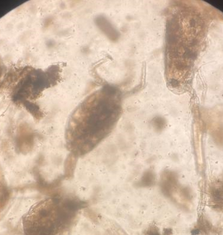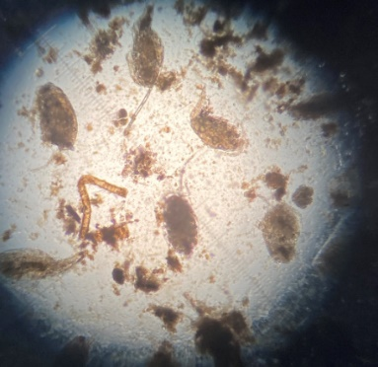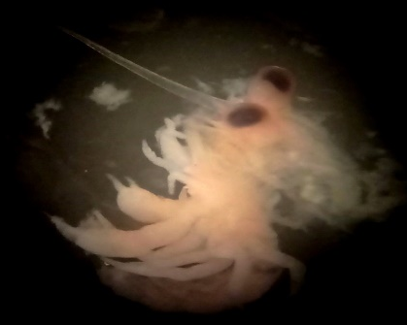
A B C
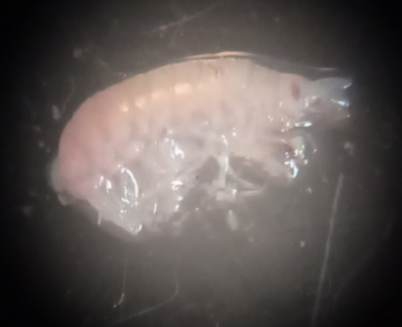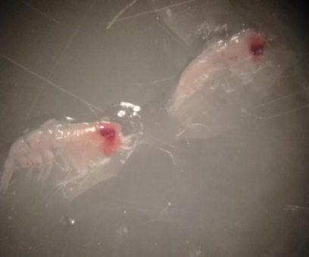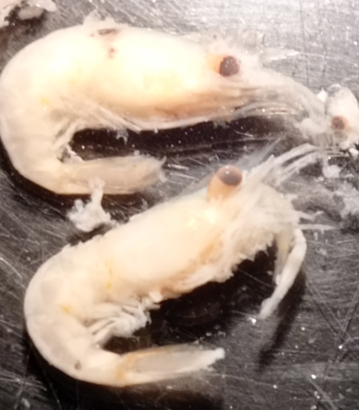
D E F
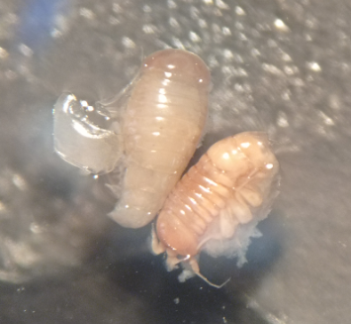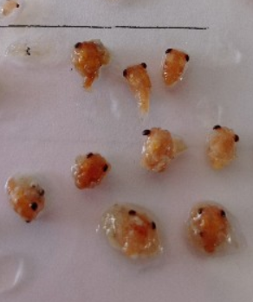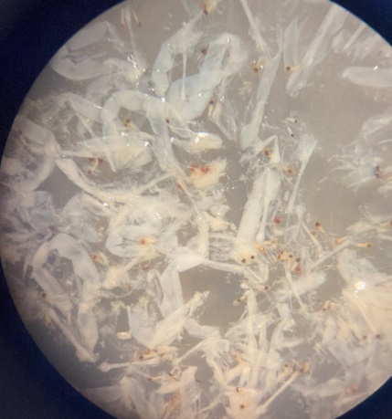
G H I
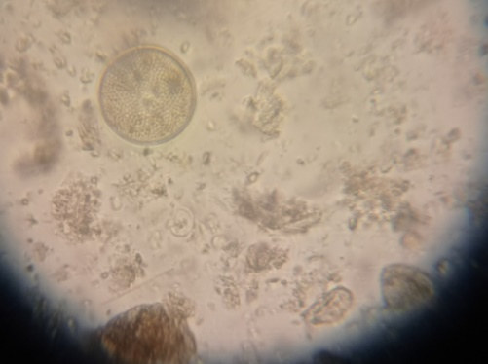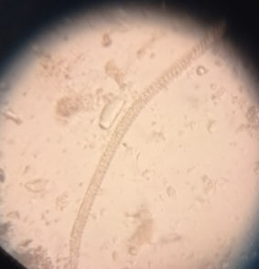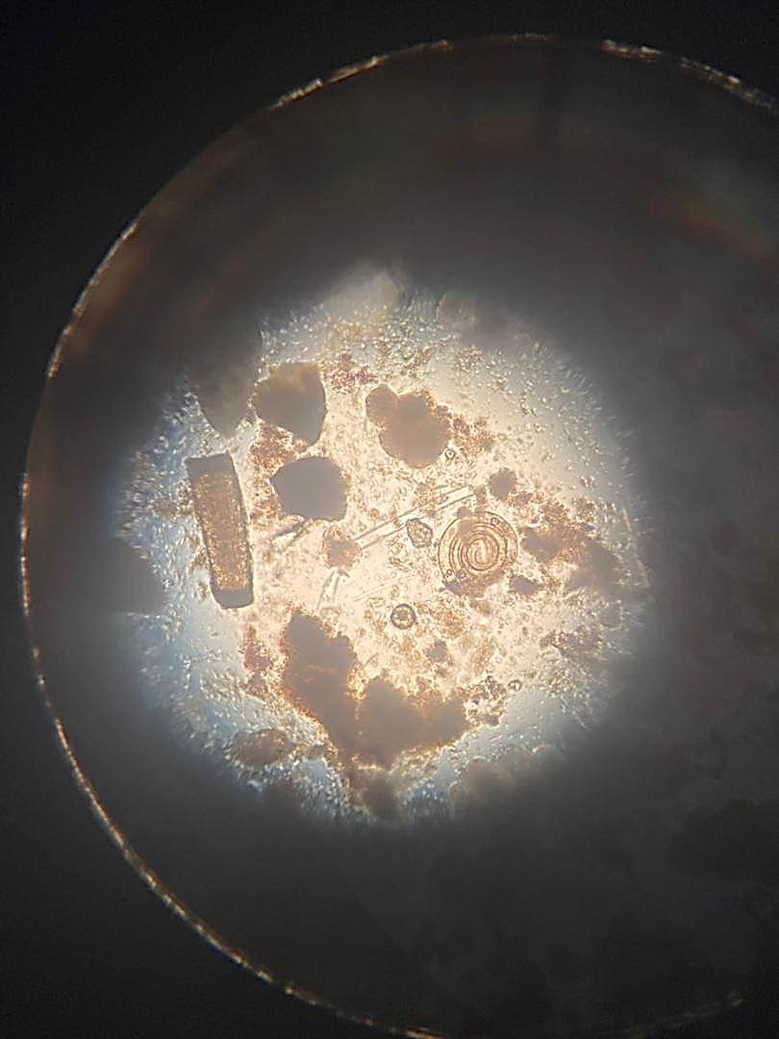
J K L
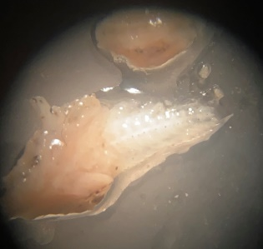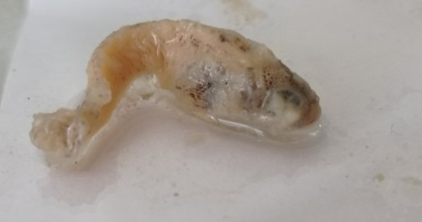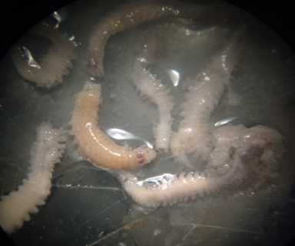
M N O

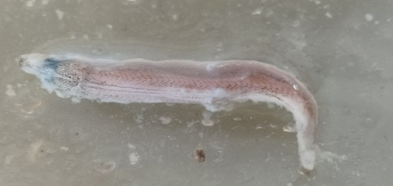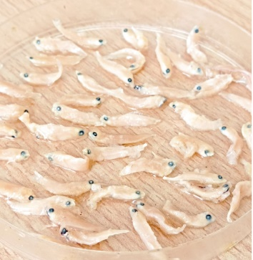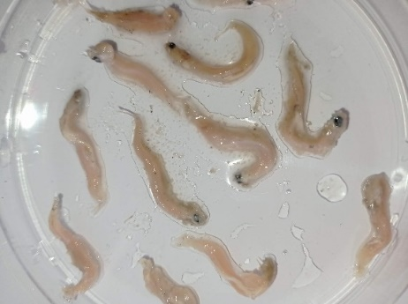
P Q R
Fig. 4. Samples of prey found inside the stomach of Sardinella maderensis during the research period:
A: Zoea , B: Calanoidea, D: Penaeus C: Cyclopidae , E: Euphausiacea , F: Amphipoda, G: Mysidacea , H: Crab Megalope, I: Isopoda, J: Foraminifera, L&K: Phytoplankton , M: Annelida, N: trachurus trachurus, O: fish remains, P: Ophidion rochei , Q: fish larvae, R: Anguilliformes.

4. Conclusion
S.maderensis is a planktivorous species with a diverse diet that feeds on 15 planktonic species categorized into seven major groups: Crustaceans ranked first, with a relative importance of 46.95%, a frequency of 45.67%, . This group included various types, such as copepods (e.g., Calanoidea and Cyclopidae) and malacostracans, including Euphausiacea, Mysidacea, and Decapoda (Penaeus and Crab megalopae). Detritus ranked second, with a relative importance of 19.60%, Phytoplankton followed, ranking third with a relative importance of 15.23%. Fish ranked fourth, with a relative importance of 8.95%. This group consisted of three species: Anguilliformes, Ophidion rochei, Trachurus trachurus, and partially digested fish remains. Polychaete worms showed a low contribution, with a relative importance of 0.75%. Foraminifera contributed 0.32%. Mollusks, represented by a single Octopoda individual, had the lowest contribution, with a relative importance of 0.01%. Crustaceans emerged as the primary dietary component, underscoring their key role in the feeding ecology of this species.
These findings highlight the significance of dietary studies in understanding marine food web dynamics. They also provide valuable insights for sustainable fisheries management and the conservation of aquatic biodiversity. However, further research is needed to examine how environmental changes influence dietary patterns, ensuring effective long-term species management

DISCLAIMER (ARTIFICIAL INTELLIGENCE)
Author(s) hereby declare that NO generative AI technologies such as Large Language Models (ChatGPT, COPILOT, etc) and text-to-image generators have been used during the writing or editing of this manuscript.

Ethical approval
Not applicable

References
- Adewale, T. A. (2023). Assessing The Effects Of Climatic Variability And Anthropogenic Activities On The Flat Sardinella (Sardinella Maderensis) Fishery Of Ibeju-Lekki, Lagos (Doctoral dissertation, University of Cape Coast). https://ir.ucc.edu.gh/xmlui/handle/123456789/11623
- Amednah, M., Bilassé, Z., & André, K. T. J. (2018). Growth parameters estimate of Madeiran sardenella (Sardinella maderensis) exploited from artisanal fisheries and landed at the Nouakchott fishmen's beach in Mauritania. https://journalissues.org/ibme/wpcontent/uploads/sites/5/2018/12/Mahfoudh-et-al.pdf
- Baali, A., Chahdi Ouazzani, K., Touhami, F., El-Achi, A., & Amenzoui, K. (2020). Diet composition of round sardinella (Sardinella aurita) and flat sardinella (Sardinella maderensis) in the South of Atlantic Moroccan coast. Egyptian Journal of Aquatic Biology and Fisheries, 24(7-Special issue), 73-91. https://journals.ekb.eg/article_119032_94cbd80e73aab3d961f3c43dcaaf421c.pdf
- Borutskii, P. (1974). Ecology of Marine Fish Feeding. Leningrad: Nauka Publishing, 120 pages.
- Chukwu, K. O., & Orlu, G. A. (2024). Food and Growth of Sardinella maderensis from New Calabar River, Rivers State, Nigeria. Research Journal of Pure Science and Technology, 7(5), 49–55. https://iiardjournals.org/get/RJPST/VOL.%207%20NO.%205%202024/Food%20and%20Growth%204955.pdf?utm_source=chatgpt.com
- Diatta, Y. ., Badji, L. B. ., & Tidiane BA, C. . (2016). Etude du régime alimentaire de Sardinella aurita (Valenciennes, 1847) et de S. maderensis (Lowe, 1841) de la côte occidentale de l’Afrique. INSTM Bulletin : Marine and Freshwater Sciences, 43, 21–37. https://doi.org/10.71754/instm.bulletin.v43.252
- Diouf, P.S. (1996). Les peuplements de poisson des milieux estuariens de l’Afrique de l’ouest : l’exemple de l’estuaire hyperhalin du Sine-Saloum. (Doctoral thesis, University of Montpellier II, France). Retrieved from http://www.documentation.ird.fr/hor/fdi:010008130.
- El-sayed, E., Hassanen, G., Faisal, R., & El-Aiatt, A. (2023). STUDY OF SOME BIOLOGICAL AND DYNAMIC CHARACTERISTICS OF THE MEDEIRAN SARDINELLA FISH SARDINELLA MADERENSIS OF EASTERN MEDITERRANEAN (NORTH SINAI COAST EGYPT). Sinai Journal of Applied Sciences, 12(3), 433-444. doi: 10.21608/sinjas.2023.205104.1198 https://sinjas.journals.ekb.eg/article_311190.html
- Gordon, R. (1977). Feeding Ecology of Marine Fishes. Marine Biology, 43(4), 299–310.
- Gosner, K. L. (1971). Guide to Identification of Marine Zooplankton. New York: John Wiley & Sons, 300 pages.
- Gushchin, A.V. and Corten, A. (2015). Feeding of pelagic fish in waters of Mauritania: 1. European anchovy Engraulis encrasicolus, European sardine Sardina pilchardus, round sardinella Sardinella aurita, and flat sardinella Sardinella maderensis. Journal of Ichthyology, 55: 77-85. https://www.researchgate.net/publication/272886646_Feeding_of_pelagic_fish_in_waters_of_Mauritania_1_European_anchovy_Engraulis_encrasicolus_European_sardine_Sardina_pilchardus_round_sardinella_Sardinella_aurita_and_flat_sardinella_S_maderensis
- Hure M, Mustać B. 2020. Feeding ecology of Sardina pilchardus considering co-occurring small pelagic fish in the eastern Adriatic Sea. Marine Biodiversity 50: 40–52. doi: 10.1007/s12526-020-01067-7
- Hyslop, E. J. (1980). Stomach content analysis: A review of methods and their application. Journal of Fish Biology, 17(6), 695–704. https://doi.org/10.1111/j.1095-8649.1980.tb02775.x
- Lalli, C., & Parsons, T. R. (1997). Biological oceanography: an introduction. Elsevier.
- Pikitch, E. K., Santora, C., Babcock, E. A., Bakun, A., Bonfil, R., Conover, D. O., ... & Sainsbury, K. J. (2004). Ecosystem-based fishery management. Science, 305(5682), 346-347.
- Pravdin, I. F. (1966). Methods of Fishery Biology. Moscow: VNIRO Publishing.
- Stergiou, K. I. (1988). Relative Importance Index (IRI) for Marine Species. Marine Ecology Progress Series, 47(1), 1–10.
- Tossavi, N. D., Gandé, J. G. J., Togla, A. I., Bouko, B., Aboki-Onzo, A. A., Sinaré, Y., & Ibikounlé, M. Comparison of Parasite Prevalence in Marine Fish Sardinella maderensis (Teleostei: Clupeidae) According to Different Length and Fish Sex in the Waters Near the Coast of Benin. https://www.researchgate.net/profile/Nounagnon-Tossavi-2/publication/388740023_Comparison_of_Parasite_Prevalence_in_Marine_Fish_Sardinella_maderensis_Teleostei_Clupeidae_According_to_Different_Length_and_Fish_Sex_in_the_Waters_Near_the_Coast_of_Benin_West_Africa/links/67b460d196e7fb48b9c5f7ae/Comparison-of-Parasite-Prevalence-in-Marine-Fish-Sardinella-maderensis-Teleostei-Clupeidae-According-to-Different-Length-and-Fish-Sex-in-the-Waters-Near-the-Coast-of-Benin-West-Africa.pdf
- Wootton, R. J. (2012). Ecology of teleost fishes (Vol. 1). Springer Science & Business Media.

