Attitude towards Research among Research Scholars of Science and Arts Stream: Special Reference to Gender

.
ABSTRACT

The present study aims to assess the overall level of research scholars’ attitude towards research. Further, it aims to examine the significance difference if any regarding the attitude towards research between the science and arts stream research scholars with respect to gender. Descriptive survey method was used in this study. The sample consisted of 215 research scholars who are pursuing doctoral program in north-eastern hill university, shillong. Data were gathered utilizing a standardized scale called attitude scale towards research. The 42 items on the scale are divided into four categories: 1) general aspects of research and research process, 2) usefulness of research in professional career, 3) relevance of research in personal-social life, 4) difficulties in research and research anxiety. Data were analysed by using mean values, standard deviation, and t-statistic with the help of spss-26 software. The results of this study indicated that over half of research scholars had an unfavourable to extremely unfavourable attitude towards research. Further, the findings of this study showed no significant gender-based difference in the attitude towards research of science scholars as well as arts scholars. Similarly, no significant difference was found between arts and science research scholars’ attitude towards research. The results of this study are anticipated to offer valuable information for supervisors, universities and policymakers for developing specific research training, enhancing academic support systems, and strengthening the overall research culture.

Keywords: Research Scholars, Attitude towards Research, Stream, Gender

1. INTRODUCTION

Attitude is very crucial to succeed in any aspects of life including academic and research endeavours. Ajzen and Fishbein (2000) define attitudes as a psychological assessment such as good-bad, interesting-uninteresting, harmful-beneficial, likable-dislikable and pleasant-unpleasant. In the context of research, attitude generally refers to a thorough study of a person’s thoughts, feelings and behaviours regarding research. It also describes how an individual behaves in the field of research and how much value he gives on the different aspects of research. According to Antonio et al. (2023), students who have a favourable attitude towards research are very likely to undertake research in the future and achieve academic success. Research indicates that attitudes towards research are generally negative (Levine, 2007). This could be contributed by perceived difficulties, lack of relevance and study related anxiety (Papanastasiou, 2005; Hernandez et al., 2022). As a result, this could affect the amount of effort, time, and dedication they decide to invest in their studies (Papanastasiou, 2005).
Gender differences have also been studied. In this regard, studies reported that the Male and Female students’ Attitudes towards Research were not significantly different (Bachhar & Mondal, 2021; Majumder & Sarkar, 2017; Prashad & Qasim, 2021; Shaukat et al., 2014). Additionally, research has shown no significant distinction between the Arts and Science streams scholars in the attitude towards research (Prashad & Qasim, 2021). But according to Bachhar and Mondal (2021), there are significant differences between social science and science research scholars' attitude towards research, with science scholars having more positive attitude towards research.
Now a days, many universities, research institutes, and students are participating actively in research endeavours. However, this raises the critical issue of whether those students’ attitude towards research are truly positive or the result of external influences. Thus, it is essential to assess attitudes towards research to foster a positive attitude in them and consequently support their learning (papanastasiou, 2005). Therefore, the purpose of the current study is to examine the research scholars’ attitude towards research across arts and science stream based on gender. The results of this study are anticipated to offer valuable information for supervisors, universities and policymakers for developing specific research training, enhancing academic support systems, and strengthening the overall research culture.

Objectives
- To assess the level of attitude towards research of research scholars of north-eastern hill university, shillong.
- To determine whether there is a significant difference in attitude towards research between science and arts research scholars with respect to gender.

Hypotheses
- There is no significant mean difference regarding attitude towards research between male and female research scholars of science stream.
- There is no significant mean difference regarding attitude towards research between male and female research scholars of arts stream.
- There is no significant mean difference regarding attitude towards research between arts and science stream research scholars.

2. material and methods

Method: In the current study, the descriptive survey method was employed.
Sample: Sample of the study comprised of 215 research scholars of North-Eastern Hill University, Shillong. Disproportionate stratified random sampling technique is applied in this study.

Figure 1: Distribution of Research Scholars by Discipline and Gender

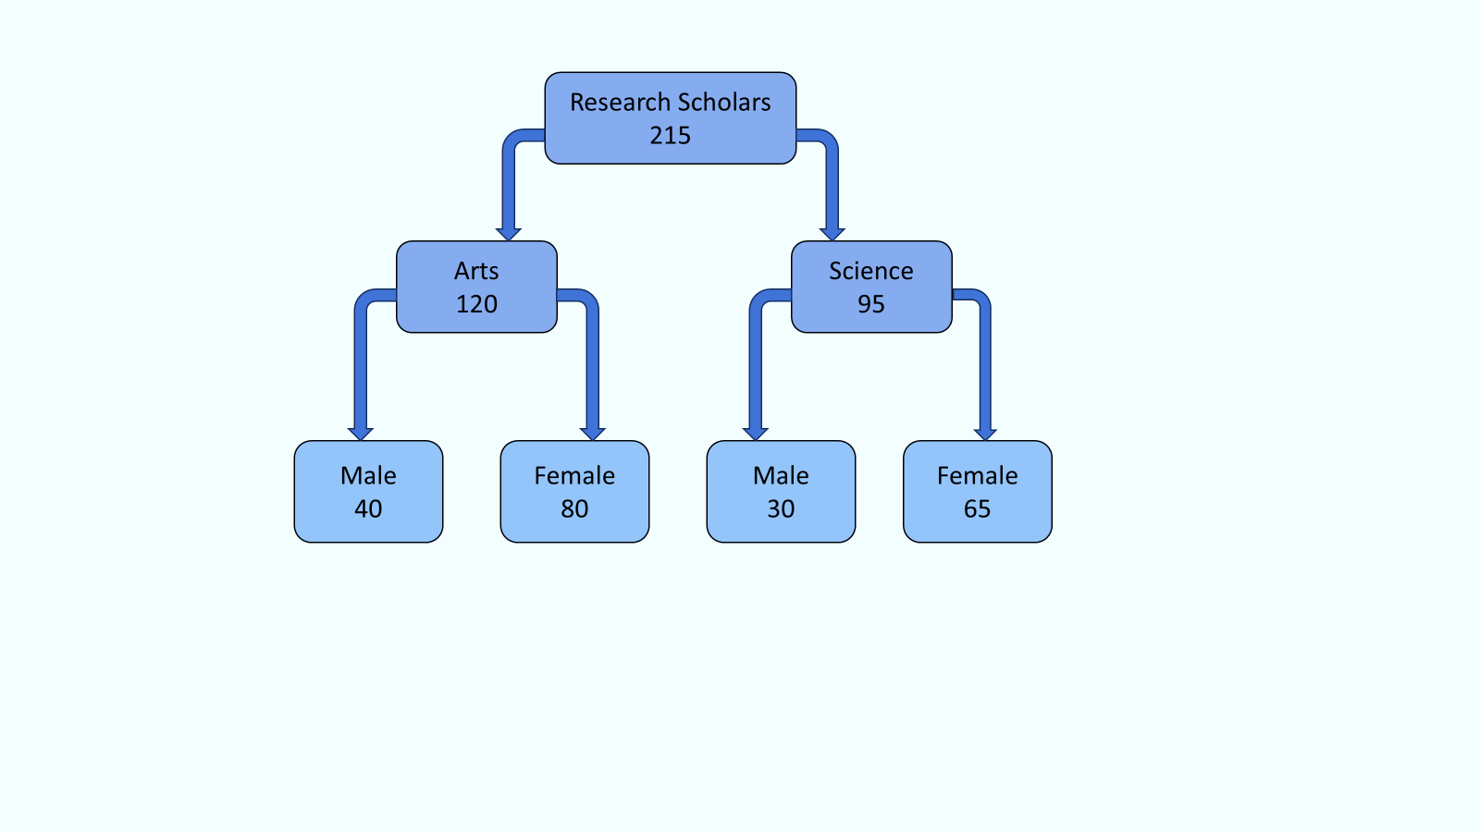

Data collection procedure
To gather the necessary data, the researcher employed the Attitude scale towards research which was developed by Vishal Sood and Y K Sharma. The purpose of the scale is to evaluate research scholars' attitudes towards research. The scale includes 42 items and divided into four categories: 1) general aspects of research and research process, 2) usefulness of research in professional career, 3) relevance of research in personal-social life, 4) difficulties in research and research anxiety. The scale demonstrated good reliability with test-retest values of 0.739 and Spearman-Brown reliability of 0.773, both of which were significant at the 0.01 level. At the beginning the researcher built a rapport with the participants. After this the scale was distributed and necessary guidance were provided.

Data analysis technique
Data were analysed by using mean values, standard deviation, and t-statistic with the help of spss-26 software. For the analysis a significance level of p < 0.05 was used.
3. results

Based on the objectives and hypotheses the data were analysed and interpreted.
Objective 1- To assess the level of Attitude towards Research of Research Scholars of North-Eastern Hill University, Shillong.

To assess the level of research scholars’ attitude towards research, frequency and percentage were used to analysed the data. As indicated in table 1 and figure 2, revealed that 1.40% of the research scholars have extremely favourable attitude towards research, 1.86% research scholars exhibited highly favourable attitude towards research, 7% of the research scholars displayed above average favourable attitude towards research, 36.74% of the research scholars are under moderately favourable attitude towards research, 29.77% of the research scholars having unfavourable attitude towards research. Again 17.21% of the research scholars have highly unfavourable attitude towards research and lastly 6.05% of the research scholars have extremely unfavourable attitude towards research. As a result, majority of research scholars (36.74%) had a moderately favourable attitude towards research. However, over half of research scholars have an unfavourable to extremely unfavourable attitude towards research.

Table 1- Research Scholars’ level of Attitude towards Research
Score range | Frequency | Percentage (%) | Level of Attitude towards Research
196 and above | 03 | 1.40% | Extremely Favourable
184 - 195 | 04 | 1.86% | Highly favourable
172 – 183 | 15 | 7% | Above Average favourable
156 – 171 | 79 | 36.74% | Moderately favourable
144 – 155 | 64 | 29.77% | Unfavourable
132 – 143 | 37 | 17.21% | Highly Unfavourable
131 and below | 13 | 6.05% | Extremely Unfavourable

Figure 2: Attitude towards Research of Research Scholars

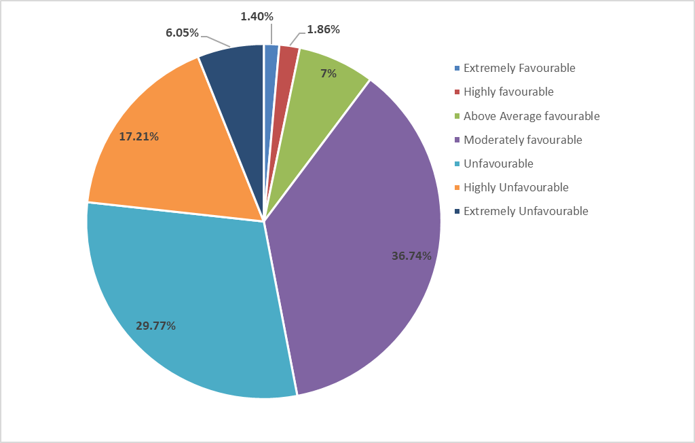

Objective:2- To determine whether there is a significant difference in attitude towards research between science and arts research scholars with respect to gender.

H_{o1}: There is no significant mean difference regarding attitude towards research between male and female research scholars of science stream.

To test the hypothesis, mean, standard deviation, and t – ratio have been computed. The analysis has been performed on a total of 95 Science stream Research Scholars, which comprises 30 Male and 65 Female.

Table No. 2 demonstrated that the computed value of "t" with df=93 is 1.497, which is lower than the table value of t = 1.98 at the 0.05 level. So, it is not significant at 0.05 level. Thus, the stated null hypothesis, “There is no significant mean difference regarding attitude towards research between male and female research scholars of science stream” has failed to reject. Additionally, the computed ‘t’ values for General aspects of Research and research process, Usefulness of Research in Professional Career, Relevance of research in Personal-social life and Difficulties in Research and Research anxiety are 1.671, 2.271, 1.094 and .363 respectively which indicating a significant difference in the attitude between Male and Female Research Scholars of Science regarding the usefulness of research in professional career. Also, there was no significant difference in their attitude towards general aspects of research, Relevance of research in personal-social life and difficulties in research and research anxiety. Figure 3 displays the graphical representation of the same.

Table 2- Attitude of Male and Female Research Scholars of Science Stream towards Research
Variable | Gender | n | Mean | SD | t-ratio | Remark
General aspects of research and research process | Male | 30 | 49.40 | 7.477 | 1.671 | Not Significant
General aspects of research and research process | Female | 65 | 51.65 | 5.343 | 1.671 | Not Significant
Usefulness of research in professional career | Male | 30 | 30.83 | 4.488 | 2.271* | Significant
Usefulness of research in professional career | Female | 65 | 32.78 | 3.590 | 2.271* | Significant
Relevance of research in personal-social life | Male | 30 | 30.03 | 4.460 | 1.094 | Not Significant
Relevance of research in personal-social life | Female | 65 | 30.94 | 3.377 | 1.094 | Not Significant
Difficulties in research and research anxiety | Male | 30 | 40.23 | 5.157 | .363 | Not Significant
Difficulties in research and research anxiety | Female | 65 | 39.85 | 4.681 | .363 | Not Significant
Overall Attitude towards Research | Male | 30 | 150.50 | 17.240 | 1.497 | Not Significant
Overall Attitude towards Research | Female | 65 | 155.22 | 12.698 | 1.497 | Not Significant
* Significant at 0.05 level

Figure 3- Mean score of Attitude of Male and Female Research Scholars of Science stream towards Research

H_{o2}: There is no significant mean difference regarding attitude towards research between male and female research scholars of arts stream.
The mean, standard deviation and t – ratio was computed to test the hypothesis. The analysis has been performed on a total of 120 Arts stream research scholars, which comprises 40 Male and 80 Female.

Table 3 revealed that in the overall attitude towards research, the computed value of ‘t’ with df 118 is 1.191, which is lower than the critical value of t = 1.98 at the 5% level of significance. So, it is not significant at 0.05 level. Thus, the null hypothesis stated “there is no significant mean difference regarding attitude towards research between male and female research scholars of arts stream” has failed to reject. The computed values of ‘t’ for the four dimensions: - general aspects of research and research process (.570), usefulness of research in professional career (1.263), relevance of research in personal-social life (1.875) and difficulties in research and research anxiety (.407) indicates no significant difference in attitude of male and female research scholars of arts in their attitude across these dimensions. Figure 4 displays the graphical representation of the same.

Table 3- Attitude of the Male and Female Research Scholars of Arts stream towards Research
Variable | Gender | n | Mean | SD | t-ratio | Remark
General aspects of Research and research process | Male | 40 | 48.83 | 6.457 | .570 | Not Significant
General aspects of Research and research process | Female | 80 | 49.60 | 7.285 | .570 | Not Significant
Usefulness of research in professional career | Male | 40 | 32.05 | 4.472 | 1.263 | Not Significant
Usefulness of research in professional career | Female | 80 | 33.11 | 4.278 | 1.263 | Not Significant
Relevance of research in personal-social life | Male | 40 | 30.93 | 3.799 | 1.875 | Not Significant
Relevance of research in personal-social life | Female | 80 | 32.33 | 3.884 | 1.875 | Not Significant
Difficulties in Research and Research anxiety | Male | 40 | 40.28 | 3.755 | .407 | Not Significant
Difficulties in Research and Research anxiety | Female | 80 | 40.67 | 5.614 | .407 | Not Significant
Overall Attitude towards Research | Male | 40 | 152.65 | 14.806 | 1.191 | Not Significant
Overall Attitude towards Research | Female | 80 | 156.43 | 17.089 | 1.191 | Not Significant
*Significant at 0.05 level

Figure 4: Mean Score of Attitude of Male and Female Research Scholars of Arts stream towards Research

H_{o3}: There is no significant mean difference regarding attitude towards research between arts and science stream research scholars.
The mean, standard deviation, and t – ratio was computed. The analysis has been performed on a total of 215 research scholars, which comprises 120 scholars from arts stream and 95 from scholars from science stream.

Observation of table 4 indicated that, with df= 213, the calculated t value is .675, which is lower than the table value of t = 1.97 at 0.05 level of significance. So, it is not significant at 0.05 level. Thus, the null hypothesis stated “There is no significant mean difference regarding attitude towards research between arts and science stream research scholars” has failed to reject. Thus, it can be concluded that research scholars in the arts and scientific streams do not significantly differ in their attitudes toward research. Additionally, the calculated t values for the four dimensions: - general aspects of research and research process (.247), usefulness of research in professional career (.009), relevance of research in personal-social life (.569) and difficulties in research and research anxiety (.543), indicated no significant difference between arts and science stream research scholars in any dimension of attitude towards research. Figure 5 displays the graphical representation of the same.
Table 4- Arts and Science stream Research Scholars Attitude towards Research
Variable | Gender | n | Mean | SD | t-ratio | Remark
General aspects of research and research process | Arts | 120 | 50.517 | 7.130 | .247 | Not Significant
General aspects of research and research process | Science | 95 | 50.295 | 5.716 | .247 | Not Significant
Usefulness of research in professional career | Arts | 120 | 32.500 | 4.331 | .009 | Not Significant
Usefulness of research in professional career | Science | 95 | 32.495 | 4.034 | .009 | Not Significant
Relevance of research in personal-social life | Arts | 120 | 31.192 | 4.088 | .569 | Not Significant
Relevance of research in personal-social life | Science | 95 | 31.495 | 3.593 | .569 | Not Significant
Difficulties in Research and Research anxiety | Arts | 120 | 40.125 | 5.065 | .543 | Not Significant
Difficulties in Research and Research anxiety | Science | 95 | 40.495 | 4.813 | .543 | Not Significant
Overall Attitude towards Research | Arts | 120 | 155.167 | 16.398 | .675 | Not Significant
Overall Attitude towards Research | Science | 95 | 153.726 | 14.364 | .675 | Not Significant
*Significant at 0.05 level

Figure 5- Mean Score of Arts and Science stream Research Scholars Attitude towards Research

4. dISCUSSION

The findings demonstrate that research scholars’ attitude towards research vary widely, with the majority (36.74%) demonstrating a moderately favourable attitude towards research. However, more than half of research scholars falls within unfavourable to extremely unfavourable attitude towards research which illustrates underlying difficulties. Additionally, it showed that just a small proportion of research scholars have favourable to extremely favourable attitudes toward research, suggesting that the sample usually does not have highly favourable attitudes toward research. This finding is consistent with the findings of levine (2007) which stated that attitude towards research is generally not positive. This could be caused by perceived challenges, anxiety related to study, and a lack of significance (papanastasiou, 2005; hernandez et al., 2022). This finding highlights the need of focused measures such as research training, workshops and lectures on the importance of research to foster favourable attitude towards research. Also, the findings demonstrated that the male and female research scholars of science stream do not differ significantly in terms of their overall attitude towards research. This could be due to the fact that both male and female scholars have equal access to research-related materials, equivalent exposure to research technique courses, and equal academic standards, all of which lessen gender disparities in attitudes. However, there was a significant difference between male and female research scholars from science stream in terms of the usefulness of research in professional career. This may result from differences in how each gender perceives the professional importance of research, as well as differences in professional expectations, career possibilities in science-related fields. Similarly, the findings suggest that male and female research scholars of arts stream do not differ significantly regarding attitude towards research. This study supported by previous research which stated no significant difference between male and female students’ attitudes towards research (bachhar & mondal, 2021; majumder & sarkar, 2017; prashad & qasim, 2021; shaukat et al., 2014). Further, the findings revealed no significant distinction between the arts and science stream research scholars in attitude towards research which is similar to the findings of prashad and qasim (2021). This implies that research scholars from the arts and science background may receive similar institutional support, research opportunities and guidance. However, bachhar and mondal (2021) reported that there are significant variations between the attitudes of social science and science research scholars regarding research, with science scholars having a more positive attitude.

4. Conclusion

This study provides insight on certain vital aspects that will assist the academic community in understanding attitude towards research. The results of this study indicated that over half of research scholars had an unfavourable to extremely unfavourable attitude towards research. It emphasizes how crucial it is to provide encouraging academic support, improved research exposure and mentoring in order to strengthen research scholars attitude towards research. Also, the results revealed no significant gender-based difference regarding the attitude towards research of science and arts research scholars. Further, no significant difference was found between arts and science research scholars’ attitude towards research. However, male and female research scholars from science stream demonstrated a significant difference in the dimension of usefulness of research in professional career. Overall, this study provides the foundation for successful policies and intervention that can improve research scholars attitude towards research and foster a more supportive and encouraging academic atmosphere which will improve their success and research atmosphere.

Disclaimer (Artificial intelligence)
Authors hereby declare that NO generative AI technologies such as Large Language Models (ChatGPT, COPILOT, etc.) and text-to-image generators have been used during the writing or editing of this manuscript.

References

Antonio, G. J., Alipio, C. D., Reginaldo, L. A., & Abun, D. (2023). The Effect of Students’ Attitude toward Research on the Intention to Conduct Research. Divine Word International Journal of Management and Humanities (DWIJMH) (ISSN: 2980-4817), 2(2), 348–368. https://doi.org/10.62025/dwijmh.v2i2.26
Ajzen, i., & fishbein, m. (2000). Attitudes and the Attitude-Behavior Relation: Reasoned and Automatic Processes. European Review of Social Psychology, 11, 1-33.
Bachhar, S., & Mondal, A. (2021). Attitude, Awareness and Barriers in Research: A Study on the Post-Graduate Students and Research Scholars in West Bengal. ENSEMBLE, 2(2), 37–50. https://doi.org/10.37948/ensemble-2020-0202-a005
Hernandez, R. M., Montes-Valer, E., Mamani-Benito, O., Ortega-Pauta, B. I., Saavedra-Lopez, M. A., & Calle-Ramirez, X. M. (2022). INDEX OF ATTITUDE TOWARDS SCIENTIFIC RESEARCH IN PERUVIAN PSYCHOLOGY STUDENTS. International Journal of Education and Practice, 10(2), 204–213. https://doi.org/10.18488/61.v10i2.3046
Levine A (2007). Educating researchers. Retrieved from http://www.edschools.org/EducatingResearchers/educating_research ers.pdf
Majumder, M. B., & Sarkar, B. (2017). Attitude of Students towards Research in Higher Studies International Journal of Research Attitude of Students towards Research in Higher Studies. Article in International Journal of Research, 4(9), 1173–1179. https://edupediapublications.org/journals
Papanastasiou, E. C. (2005a). FACTOR STRUCTURE OF THE “ATTITUDES TOWARD RESEARCH” SCALE 6. Statistics Education Research Journal, 4(1), 16–26. http://www.stat.auckland.ac.nz/serj
Prashad, N. M., & Qasim, S. H. (2021). Attitude Towards Research among the Research Scholars of Science and Arts Stream. Science, Technology and Develoment, 10(7), 737–744. https://www.researchgate.net/publication/353601575
Shaukat, S., Siddiquah, A., Abiodullah, M., Ali Akbar, R., & Professor, A. (2014). Postgraduate Students’ Attitudes towards Research. Bulletin of Education and Research. 36 (1), 111-122.

