Technical Employment Preparedness of Grade 12 ICT Students Specializing in Computer Systems Servicing

.
ABSTRACT

This study aimed to examine the job readiness of Grade 12 Information and Communications Technology (ICT) students specializing in Computer Systems Servicing (CSS) under the K to 12 Curriculum. It focused on four core skills: installing and configuring systems, setting up networks, setting up servers, and maintaining or repairing systems and networks. The research, conducted in a public Senior High School in Cagayan de Oro City, Philippines, during School Year 2024–2025, used a descriptive-quantitative design with 50 purposively selected students.
Data were gathered through surveys and performance ratings based on the Technical Education and Skills Development Authority’s National Certificate II standards. Reliability testing yielded a coefficient of 0.703, confirming acceptable consistency. Results indicated that students performed well in hardware installation and network setup, while server setup posed a greater challenge. Self-assessments revealed that most students felt “Prepared” across all skill areas, with mean scores ranging from 2.87 to 3.17. However, gaps were identified in advanced troubleshooting, documentation, and the handling of unexpected issues.
Based on these findings, the study concludes that Grade 12 ICT-CSS students are generally ready for technical employment. Still, additional hands-on practice, peer mentoring, and stronger industry linkages are recommended to further enhance overall preparedness. This research underscores the importance of targeted, competency-based training in senior high school programs to effectively bridge the gap between academic instruction and the demands of the ICT industry.

Keywords: Information and communications technology; computer systems servicing; curriculum

1. INTRODUCTION

The Philippine educational system saw major changes with the Enhanced Basic Education Act of 2013 (Republic Act 10533). This act introduced the K to 12 Program. The reform extended Senior High School by two years to focus on skill-based strands and improve employability (Official Gazette, 2013). A key aspect is the Technical-Vocational-Livelihood (TVL) track. This track equips students with practical skills for work and technical projects, aligned with Technical Education and Skills Development Authority (TESDA, 2024) standards. Within the TVL track, the Information and Communications Technology (ICT) strand—especially the Computer Systems Servicing (CSS) specialization—prepares students to install, set up, and maintain computer systems and networks. This helps them enter the technology workforce immediately.
Even with a structured framework, questions remain about graduates’ readiness for real-world jobs. The Department of Education (DepEd) designed the SHS program to help students find work even without a college degree (DepEd, 2015). A recent study by Alinea et al. (2024) found that while TVL students are workforce-ready, they need to improve their technology literacy and technical skills. Hao et al., (2024) similarly note that maintaining computer systems requires a range of skills. Limited government funding, such as for the Joint Delivery Voucher Program (JDVP), means not all students receive training for the critical National Certificate II (NC II) (ExamsPinas, 2024). This study aims to assess how prepared CSS students are for technical jobs. It also seeks to identify which skills need further support.
To address this problem, this study systematically assessed the technical employment preparedness of Grade 12 ICT students specializing in CSS. The research focused on the four core competencies of the CSS NC II qualification (TESDA, 2024):
- Installing and configuring computer systems
- Setting up computer networks
- Setting up computer servers
- Maintaining and repairing computer systems and networks
To accomplish these objectives, the study used a descriptive, quantitative design. It analyzed students' academic ratings and surveyed their self-assessed preparedness. The team adapted a TESDA checklist as the instrument, grounding the assessment in industry-standard competencies.
This research underscores the importance of targeted, competency-based training in senior high school programs to effectively bridge the gap between academic instruction and the demands of the ICT industry (Mor, Laks & Hershkovitz, 2016).This work benefits key groups in education. School administrators apply the findings to make better decisions about resources, lab improvements, and industry partnerships. Programs like the DepEd Computerization Program (DCP) demonstrate this in practice. ICT teachers get clear guidance to improve their teaching, especially in troubleshooting and documentation. The study mainly serves students. Many come from families earning under 10,000 pesos a month, and many plan to work after graduation. This research aims to ensure the CSS program truly prepares them with the skills and confidence needed to succeed in today's tech-focused job market.

2. methodology

2.1 Research Design and Respondents

A descriptive and quantitative research design was utilized to assess the technical employment preparedness of Grade 12 ICT students. This approach was suitable for gathering quantifiable data to statistically characterize the sample population (Dovetail Editorial Team, 2023; City University of Seattle, 2024). The study sample consisted of 50 Grade 12 ICT students specializing in Computer Systems Servicing (CSS) from a public senior high school in Cagayan de Oro City during the 2024-2025 academic year. Purposive sampling was implemented to ensure that the group represented the entire population of graduating CSS students, all of whom had direct exposure to the competencies under evaluation. The demographic characteristics of the respondents are presented in Table 1.

Table 1. Demographic Profile of the Grade 12 ICT-CSS Respondents (n=50)

Demographic Variable | Category | Frequency | Percentage (%)
Age | 18 and below | 28 | 56
 | Above 18 | 22 | 44
Marital Status | Single | 48 | 96
 | Married | 1 | 2
 | Live-in | 1 | 2
Family Monthly Income | Below PHP 10,000 | 31 | 62
 | PHP 10,000 - 15,000 | 7 | 14
 | Above PHP 15,000 | 12 | 24
Plan After SHS Graduation | Work | 10 | 20
 | College | 40 | 80
 | Business | 0 | 0

2.2 Research Instruments and Data Collection

Two primary instruments were used for data collection. First, academic performance data (grades) for the four core CSS competencies were gathered from official school records. These grades were based on the DepEd Order No. 36, s. 2016, Academic Excellence Award system, as shown in Table 2.

Table 2. CSS Performance Rating Scale (DepEd D.O. 36, s. 2016)

Performance Rating | Description
98 - 100 | With Highest Honors
95 - 97 | With High Honors
90 - 94 | With Honors
75 - 89 | Passed
74 & below | Failed

Second, a survey questionnaire was created using the TESDA (2024) CSS NC II competency checklists as a guide. Following discussions with ICT teachers, the TESDA tools were modified and simplified to better match the needs of senior high school students. This resulted in a questionnaire using a 4-point Likert scale to measure students' preparedness across the four competencies. Table 3 shows the scoring matrix used to interpret the results.

Table 3. Scoring Matrix for Level of Technical Preparedness

Point | Numerical Range | Qualitative Indication | Descriptive Preparedness
4 | 3.25 - 4.00 | Always | Very Prepared
3 | 2.50 - 3.24 | Often | Prepared
2 | 1.75 - 2.49 | Sometimes | Less Prepared
1 | 1.00 - 1.74 | Rarely | Not Prepared

Data collection began after obtaining approval from the school principal and then collaborating with ICT teachers. Once approval was secured, informed consent was collected from all student participants. Academic grades were retrieved from school records, and the survey was administered during a regular CSS class.

2.3 Validity, Reliability and Ethical Considerations

The survey was based on standardized TESDA competencies, thereby ensuring its content validity. In support of this, a pilot test showed a Cronbach's Alpha of 0.703, confirming acceptable reliability (Research Rundowns, 2025). Moreover, the study followed the university's Research Ethics Board-approved guidelines. All participants provided informed consent, and their privacy and data were protected in accordance with Republic Act No. 10173 (Data Privacy Act of 2012).

3. results and discussion

This section presents and explains the study's findings, focusing on students' academic performance and their self-perceived preparedness in technical skills.

3.1 Academic Performance in Core Competencies

To illustrate this, students showed different levels of mastery across the four main CSS skills. In the first area, Installing and Configuring Computer Systems for Grade 11, first semester, most students (68%) earned high honors with scores between 95 and 97, which suggests they have strong basic skills (see Table 4).

Table 4. Performance Rating in Installing and Configuring Computer Systems (n=50)

Performance Rating | Frequency | Percentage (%)
98 - 100 (With Highest Honors) | 7 | 14
95 - 97 (With High Honors) | 34 | 68
90 - 94 (With Honors) | 4 | 8
75 - 89 (Passed) | 5 | 10
74 & below (Failed) | 0 | 0

Students performed best in Setting up Computer Networks (Grade 11, 2nd Semester), with 72% earning the highest honors. In contrast, Setting up Computer Servers (Grade 12, 1st Semester) was the most difficult, with no one reaching the top bracket and 38% in the passing range. Meanwhile, in Maintaining and Repairing Computer Systems and Networks (Grade 12, 2nd Semester), 46% earned the highest honors, but 44% were still in the passing range.

3.2 Perceived Technical Preparedness for Employment

Students generally felt technically prepared, and their perceptions matched their academic results. For all four competencies, the average scores placed them in the ‘Prepared’ range (2.50 to 3.24). Table 5 below provides a detailed breakdown of preparedness levels for each competency.

Table 5. Students' Perceived Level of Technical Preparedness by Competency

Competency | Very Prepared | Prepared | Less Prepared | Not Prepared
Installing and Configuring | 26% | 58% | 14% | 2%
Setting Up Networks | 28% | 54% | 16% | 2%
Setting Up Servers | 24% | 54% | 20% | 2%
Maintaining and Repairing | 22% | 54% | 22% | 2%

A detailed analysis of mean scores by area revealed key insights.

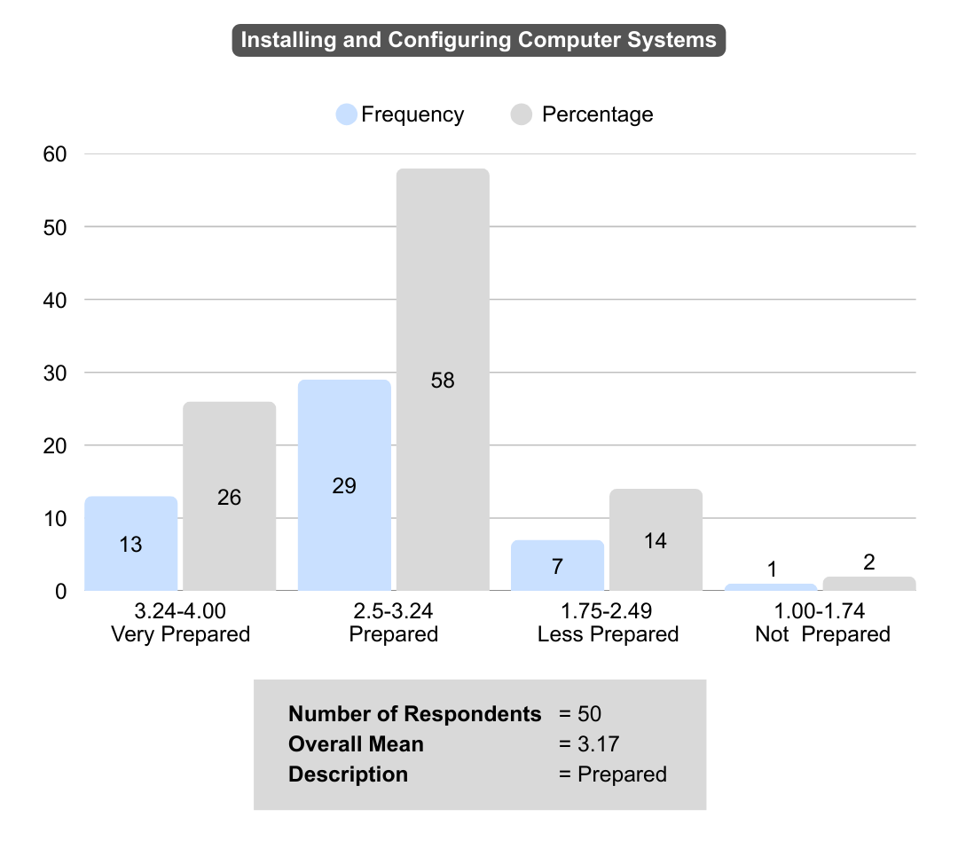

Fig. 1. Technical Preparedness Levels for Installing and Configuring Computer Systems
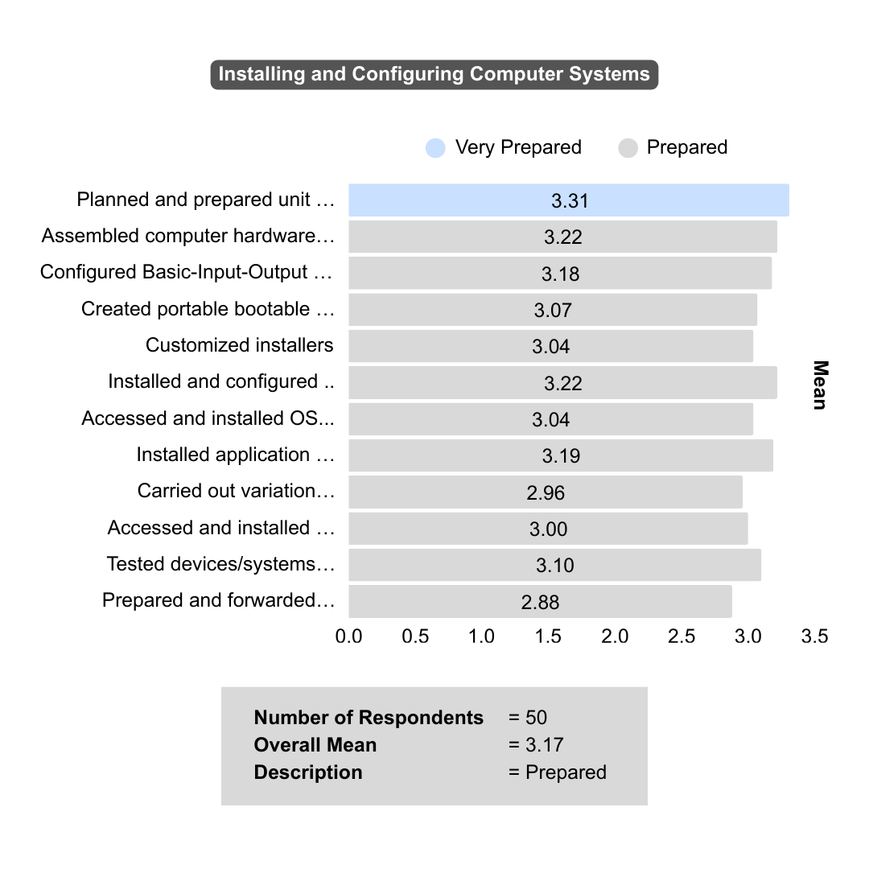

Fig. 2. Mean Scores of Technical Competencies in Installing and Configuring Computer Systems

For Installing and Configuring Computer Systems (Overall Mean=3.17), students felt most confident in planning and preparing unit assembly (Mean=3.31, Very Prepared). However, scores were lower for implementing software variations (Mean=2.96) and preparing documentation (Mean=2.88), though still within the "Prepared" range. This pattern highlights the need to strengthen students’ adaptability and documentation skills, as both are essential for effective knowledge transfer and maintaining IT system integrity (Pelayo et al., 2025).

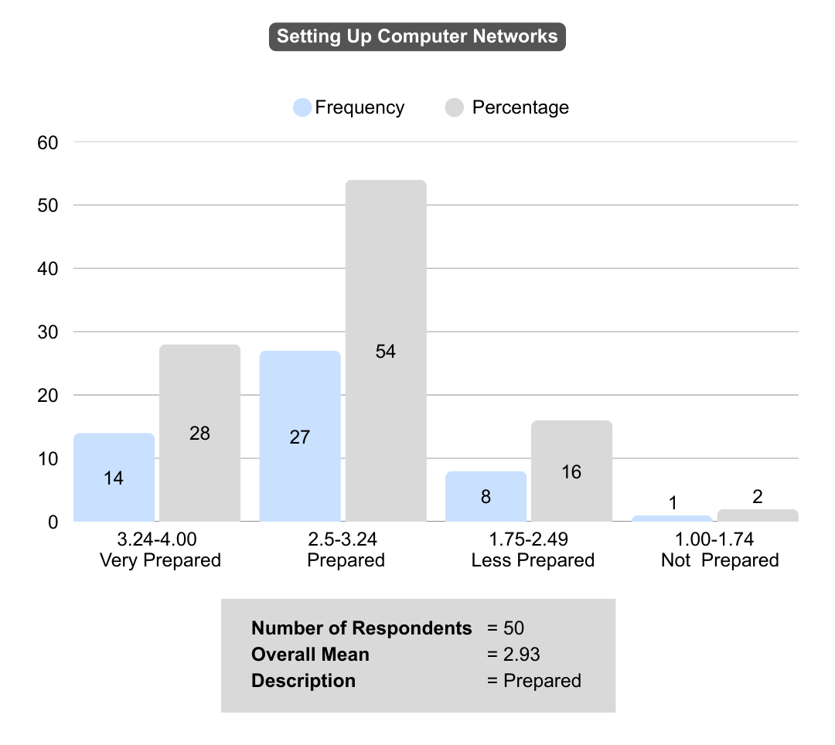

Fig. 3. Technical Preparedness Levels for Setting Up Computer Networks

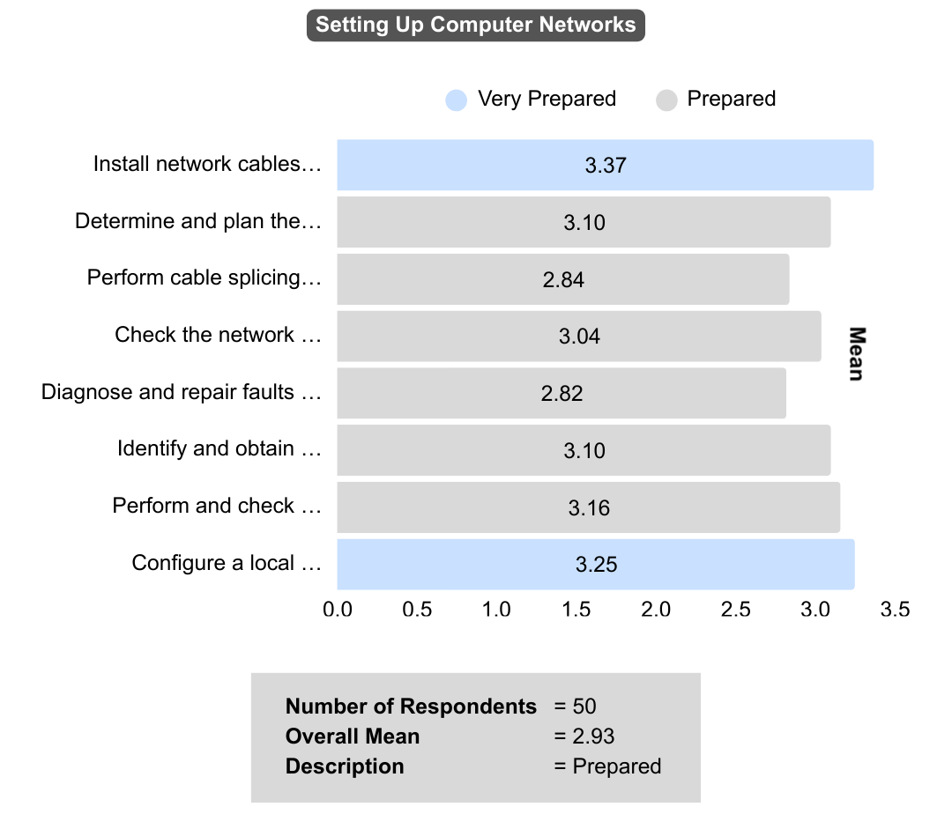

Fig. 4. Mean Scores for Technical Competencies in Setting Up Computer Networks

For Setting up Computer Networks (Overall Mean=2.93), students reported high confidence in physical tasks, such as installing network cables (Mean=3.37) and configuring a local area network (Mean=3.25). However, there appears to be a potential gap in higher-order problem-solving, as diagnosing and repairing network faults received the lowest score (Mean=2.82) in this competency. This observation aligns with the findings of Alinea et al. (2024), who noted that TVL students need to focus more on technical skills, particularly those involving troubleshooting and critical thinking. Thus, the deficit in troubleshooting remains a common challenge, as it requires students to integrate conceptual knowledge with practical, often unpredictable, problem-solving.

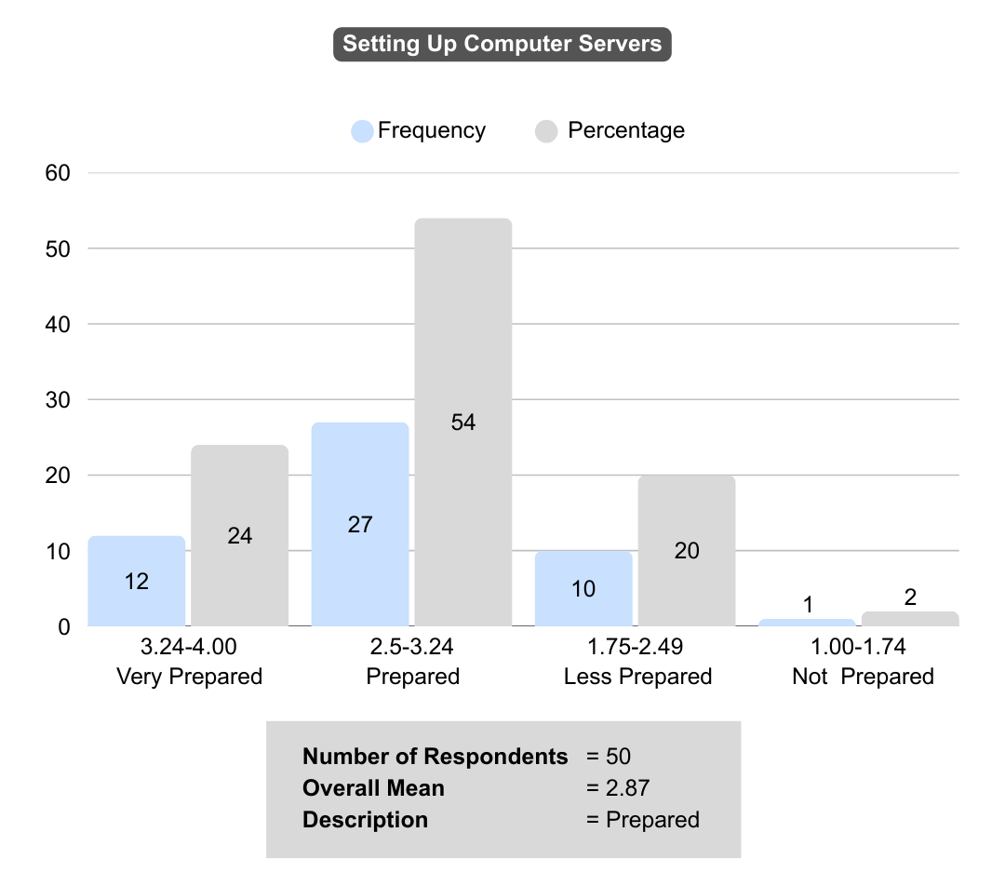

Fig. 5. Technical Preparedness Levels for Setting Up Computer Servers
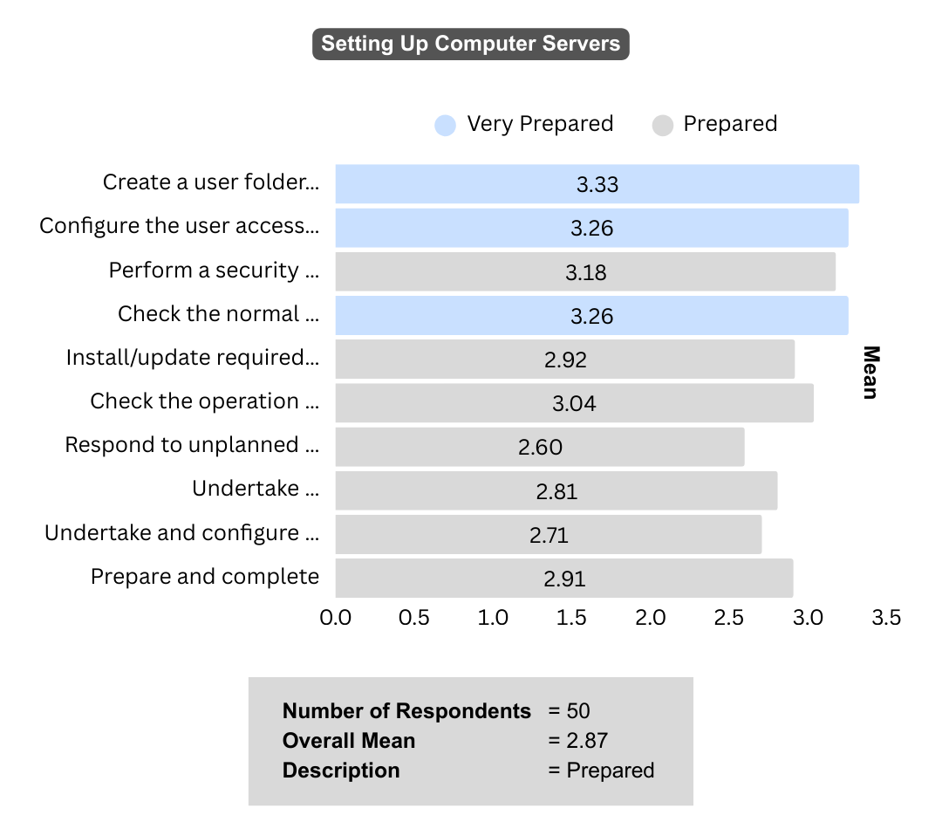

Fig. 6. Mean Scores for Technical Competencies in Setting Up Computer Servers
The competency on Setting up Computer Servers (Overall Mean=2.87) showed a similar pattern. Students felt "Very Prepared" for routine administrative tasks such as creating user folders and configuring access levels. However, responding to unplanned events or server incidents received the lowest score (Mean=2.60) across all indicators. This highlights a critical vulnerability in students' skills. The ability to manage crises and unexpected downtime distinguishes novices from competent IT professionals (Hao et al., 2024). The lack of hands-on experience with real-world server failures in controlled school environments likely contributes to this lack of confidence, since simulations rarely replicate the pressure of live outages.
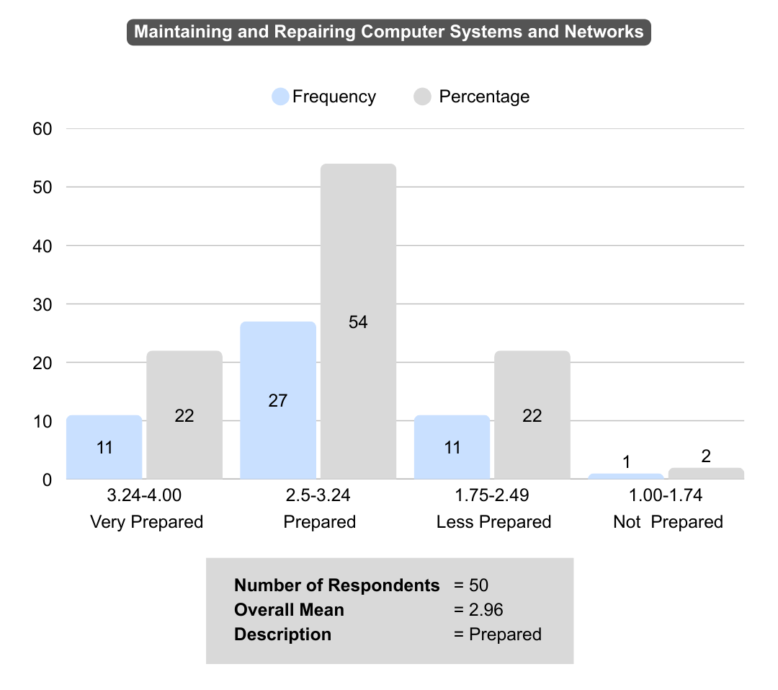

Fig. 7. Technical Preparedness Levels for Maintaining and Repairing Computer Systems and Networks

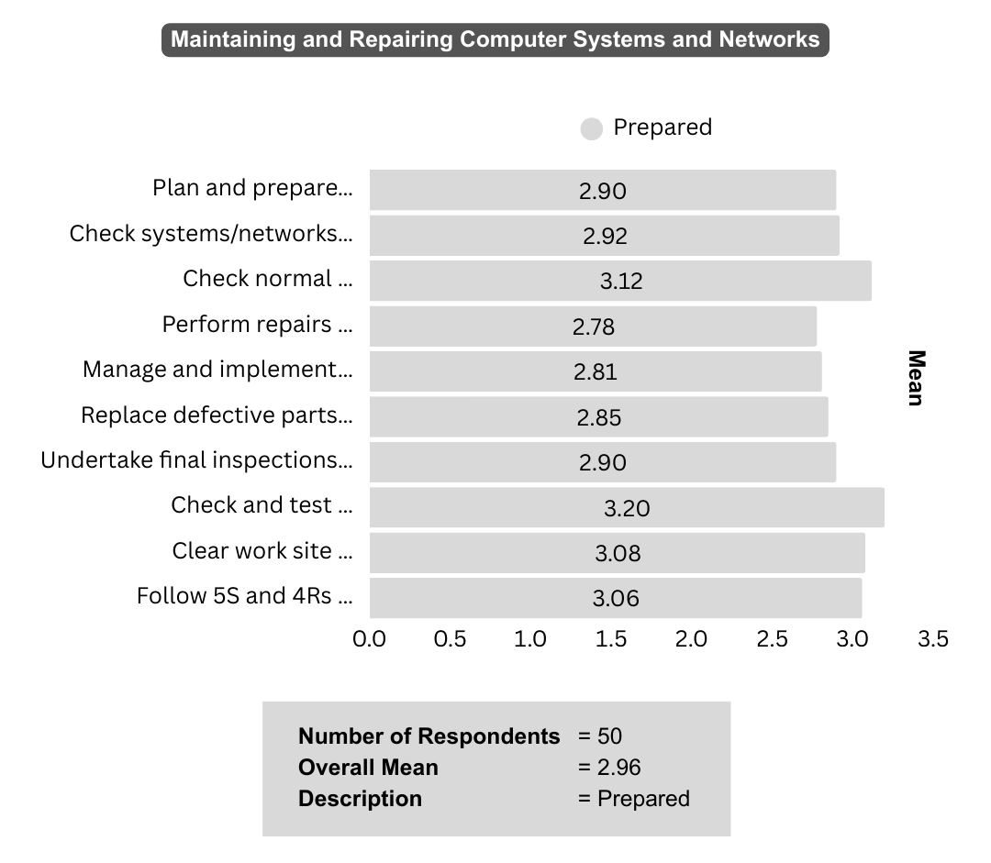

Fig. 8. Mean Scores for Technical Competencies in Maintaining and Repairing Computer Systems and Networks

In Maintaining and Repairing Computer Systems and Networks (Overall Mean = 2.96), students showed the most confidence in checking and testing systems (Mean = 3.20). They felt least confident about performing repairs and replacements (Mean = 2.78) and managing contingency measures (Mean = 2.81). This suggests that students have stronger diagnostic abilities but are less prepared to implement physical and logical repairs. This underscores the requirement for more intensive, hands-on practical exercises. Empirical studies in vocational and technical education consistently demonstrate that hands-on engagement—such as project-based or practical learning—is critical for developing procedural skills and enhancing learners’ confidence in executing technical tasks (Dounas-Frazer & Lewandowski, 2017; Le et al., 2022). The gap between diagnosis and execution highlights the weakness of relying only on theoretical instruction. More experience-based learning is needed to improve overall technical skills and confidence among ICT students (Suominen et al., 2021).

3.3 Synthesis: Bridging the Gap Between Performance and Industry Readiness

Overall, these findings show that Grade 12 ICT-CSS students are strong in basic, hands-on tasks like hardware assembly, network setup, and cable installation. However, they still face challenges with higher-level skills such as troubleshooting, problem-solving, and crisis management (DepEd, 2019; TESDA, 2024; Suominen, 2021). Research on vocational education confirms that while students do well with routine work, they often have trouble applying what they know to new, unpredictable situations that call for flexibility, critical thinking, and problem-solving (Jatmoko et al., 2023; Engelhardt et al., 2021; Llorens et al., 2025). These issues are often linked to gaps in the current curriculum and traditional teaching methods, which rarely give students real-world practice in high-pressure settings (DepEd, 2019; TESDA, 2024; Kaysi, 2025). Recent studies highlight the benefits of using simulations and problem-based learning to help technical-vocational students build adaptability, teamwork, and critical thinking (Llorens et al., 2025; Kaysi, 2025). Vocational high school students’ readiness for employment in technology enterprises is shaped not only by mastery of vocational competence but also by their internship experiences and job interests (Mudhifatul Jannah, Suswanto & Nur Handayani, 2016). To close the gap between routine skills and true industry readiness, the curriculum needs to change by adding industry-based simulations and ongoing skill assessments. This will help ICT-CSS graduates meet the changing needs of the workplace (TESDA, 2024; DepEd, 2019).

4. CONCLUSION

The technical employment preparedness of Grade 12 ICT students specializing in Computer Systems Servicing was evaluated through both objective academic performance and subjective self-assessed readiness. Results demonstrate that students generally possess foundational competencies necessary for entry-level technical employment, particularly in hardware installation, basic network setup, and system administration. These outcomes are consistent with findings from related research on senior high school work immersion programs, which report improvements in technical skills and adherence to workplace health and safety standards resulting from immersive ICT training (Chummani, Galima, & Mina, 2025; Alinea et al., 2024).
However, the analysis indicates that preparedness is not consistent across all domains. Skill gaps remain in higher-order areas, including advanced troubleshooting, network fault diagnosis, incident response, hands-on repair procedures, and technical documentation (Roble, 2021; Vandenberg & Laranjo, 2021). Comparable deficiencies have been reported internationally, with troubleshooting, adaptability, and problem-solving skills frequently identified as areas requiring targeted intervention in ICT vocational curricula (Suominen, 2021; Oswald-Egg & Renold, 2021; Asian Development Bank, 2021).
These disparities may result from the structured nature of school-based environments, which often prioritize routine technical tasks rather than complex, unpredictable problem-solving. Additionally, research indicates that workplace-based immersion programs enhance student confidence and real-world employability. However, translating these experiences into long-term career resilience necessitates bridging the gap between academic instruction and industry requirements (Chummani et al., 2025; Valdez et al., 2015).
To improve technical-vocational education, policies should focus on better use of digital technologies, strong technical support, and clear leadership in schools. Policymakers need to invest in scalable infrastructure, regular teacher training, and solutions for issues like poor hardware and maintenance, which remain common problems worldwide (Bingimlas, 2009). These steps help make technology reliable and accessible, supporting better teaching and learning. It is also important to raise the status of technical-vocational education so it is seen as a strong career choice, not just a backup, alongside traditional academic paths (Edralin, 2023; Angara, 2024).

5. RECOMMENDATIONS

Secondary schools are encouraged to build partnerships with tech companies and industry groups to set up structured apprenticeships or work-based mentoring programs. These efforts can follow successful examples from New Zealand and Poland (UNESCO-UNEVOC, 2023). Schools can also use public-private partnerships and look for new ways to fund training, helping more students access quality ICT education, as the World Bank suggests (2025). Instructional learning materials specifically developed for Computer Systems Servicing in Senior High School play a critical role in shaping both competence and job readiness among ICT students (Cardano & Ibis, 2023). Regularly updating the curriculum and using AI in teaching can help students gain skills for the future and better connect what they learn in school to real workplace needs (Zheng et al., 2016).

DISCLAIMER (ARTIFICIAL INTELLIGENCE)

The authors hereby declare that generative AI technologies such as Large Language Models, etc. have been used during the writing or editing of manuscripts. This explanation will include the name, version, model and source of the generative AI technology and as well as all input prompts provided to the generative AI technology.

Details of AI usage are given below:
- Grammarly was used for grammar checking, spell checking, and to improve verbal flow and clarity.
- ChatGPT (OpenAI, versions GPT-3.5 and GPT-4) was employed to assist in brainstorming and identifying potential references and sources for the research.
- Perplexity AI (Perplexity AI, versions including the Pro model) was utilized to locate and summarize relevant academic journals and articles, and to aid in the construction and refinement of specific sentences.
- DeepSeek was used for generating suggestions for sentence restructuring and improvement.

Ethical Approval and consent:

the study followed the university's Research Ethics Board-approved guidelines. All participants provided informed consent, and their privacy and data were protected in accordance with Republic Act No. 10173 (Data Privacy Act of 2012).

References

Alinea, J. M., Garcia, C., Lagado, S., & Noblefranca, S. M. (2024). Employability skills of senior high school Tech-Voc students: A measure of industry preparedness. *Interdisciplinary Research Review,19*(4). https://ph02.tcithaijo.org/index.php/jtir/article/view/250933
Angara, S. (2024, November 21). DepEd and TESDA intensify efforts to elevate techvoc education. Department of Education, Philippines. https://www.deped.gov.ph/2024/11/22/deped-and-tesda-intensify-efforts-to-elevate-techvoc-education/
Asian Development Bank. (2021). Technical and vocational education and training in the Philippines in the age of Industry 4.0. https://doi.org/10.22617/TCS210084
Hao, K., Huang, Y., Hou, B., & Yu, J. (2024). Factors Affecting Computer System Maintenance Skills Improvement of Information Technology Students. Journal of Computer Science and Technology Studies, 6(1), 131-140.
Biddix, J. P. (n.d.). Instrument, validity, reliability. Research Rundowns. https://researchrundowns.com/quantitative-methods/instrument-validity-reliability/
Bingimlas, K. A. (2009). Barriers to the successful integration of ICT in teaching and learning environments: A review of the literature. Eurasia Journal of Mathematics, Science and Technology Education, 5(3), 235-245.

Cambridge University Press & Assessment. (n.d.). Preparedness. In Cambridge English dictionary. Retrieved from https://dictionary.cambridge.org/us/dictionary/english/preparedness
Cardano, R.P., Ibis, N.V. (2023): Instructional Learning Materials in Computer Systems Servicing (CSS) for SHS: Basis for Development and Evaluation, IRE Journals, 7(1), 528-540.
Catilogo, M. I. U. (2024, August 16). PSA: P13,873/month budget for basic needs enough for family. Philippine Daily Inquirer – Business. https://business.inquirer.net/475138/psa-p13873-month-budget-for-basic-needs-enough-for-family
Chummani, W., Galima, J., & Mina, J. (2025). The perceived impact of TVL-ICT senior high school work immersion program on middle-level employment readiness and tertiary education preparation. Student Journal of Technology and Educational Research, 2(1), 150–161.
City University of Seattle Library. (n.d.). Quantitative research methods. Research Methods and Design. https://library.cityu.edu/researchguides/researchmethods/quantitative
Department of Education. (2018, April 7). Special report: Jobs a hit or miss for senior high school graduates. https://www.deped.gov.ph/2018/04/07/special-report-jobs-a-hit-or-miss-for-senior-high-school-graduates/
Department of Education. (2023). Department of Education Order No. 6, s. 2023 [PDF]. https://www.deped.gov.ph/wp-content/uploads/DO_s2023_006.pdf
DepEd. (2019). Computer Systems Servicing NC II Curriculum Guide. Department of Education, Philippines. https://www.deped.gov.ph/wp-content/uploads/2019/01/Computer-Systems-Servicing-NC-II-CG.pdf
Dounas-Frazer, D. R., & Lewandowski, H. J. (2017). Electronics lab instructors’ approaches to troubleshooting instruction. Physical Review Physics Education Research, 13(1), 010102. https://doi.org/10.1103/PhysRevPhysEducRes.13.010102
Dovetail Editorial Team. (2023, February 5). Descriptive research: Design, methods, examples, and FAQs. Dovetail. https://dovetail.com/research/descriptive-research/
Engelhardt, L., Kube, E., & Annen, A. (2021). Development and evaluation of a framework for the assessment of ICT skills. Frontiers in Education, 6, Article 668860. https://doi.org/10.3389/feduc.2021.668860
Jatmoko, D., Nurtanto, M., & Wijaya, M. B. R. (2023). The factors influencing digital literacy practice in vocational education: A structural equation modeling approach. European Journal of Educational Research, 12(2), 567–582.
Kaysi, F. (2025). Investigating the impact of simulation software on students’ engagement and problem-solving in technical vocational education. International Journal of Education and Research, 13(4), 210–225.
Le, S. K., Hlaing, S. N., & Ya, K. Z. (2022). 21st-century competences and learning that technical and vocational training. Journal of Engineering Researcher and Lecturer, 1(1), 1–6. https://doi.org/10.58712/jerel.v1i1.4
Llego, M. A. (n.d.). Employability of DepEd Senior High School (SHS) graduates. TeacherPH. https://www.teacherph.com/employability-deped-senior-high-school-shs-graduates/
Llorens, A., Cerezo, R., Fernández, C., & Pons, M. (2025). Soft skills development in ICT students: Effective teaching models and methodologies. Cogent Education, 12(1), 2437906. https://doi.org/10.1080/2331186X.2024.2437906
Mor, D. Laks, H., Hershkovitz, A.(2016): Computer Skills Training and Readiness to Work with Computers, Interdisciplinary Journal of e-Skills and Lifelong Learning, 12: 95-112.
Mudhifatul Jannah U.; Suswanto H; Nur Handayani, A. (2016): Vocational high school student’s readiness to work in internet service provider enterprise: Based on mastery vocational competence, internship and job interest, AIP Conf. Proc. 1778, 030044
Mukuze, K., Ndhlovu, P., Chirasha, V., Samanga, N., Darangwa, I., & Kurehwa, C. M. (2023). The impact of marital status on work-life balance considering COVID-19 pandemic at Midlands State University. Global Journal of Economics & Business, 13(5), 437-448.
Oswald-Egg, M. E., & Renold, U. (2021). No experience, no employment: The effect of vocational education and training work experience on labour market outcomes after higher education. Economics of Education Review, 80, 102065.
Republic Act No. 10533, An Act Enhancing the Philippine Basic Education System by Strengthening its Curriculum and Increasing the Number of Years for Basic Education, Appropriating Funds Therefor and for Other Purposes, § (2013). Retrieved from https://www.officialgazette.gov.ph/2013/05/15/republic-act-no-10533/
Roble, D. M. L. (2021). Competency level, employers’ expectations and work immersion performance of senior high school technical-vocational and livelihood (TVL) students. Asia-Pacific Journal of Education. https://ajpe.feu.edu.ph/index.php/ajpe/article/view/7657
Suominen, S. (2021). New vocational school students’ basic ICT skills self-assessment. Eurasia Journal of Mathematics, Science and Technology Education, 17(8), 1-13.
Suominen, S., Ikonen, K., & Asikainen, M. (2021). New vocational school students’ basic ICT skills self-assessment. EURASIA Journal of Mathematics, Science and Technology Education, 17(11), em2035. https://doi.org/10.29333/ejmste/11193
Technical Education and Skills Development Authority. (2024). Assessment and certification. https://www.tesda.gov.ph/About/TESDA/25
TESDA. (2024). Training Regulations for Computer Systems Servicing NC II. Technical Education and Skills Development Authority, Philippines. https://www.tesda.gov.ph/Downloadables/TR%20Computer%20Systems%20Servicing%20NC%20II%20.pdf
UNESCO-UNEVOC. (2023, December 31). Innovative and promising practices in TVET. https://unevoc.unesco.org/home/Promising+Practices+in+TVET
Valdez, E. J. C., Alcantara, S. S. B., Pamintuan, C. A., & Castillo, R. (2015). Contributions of on-the-job training program to the skills, personal qualities and competencies of tourism. ResearchGate. https://www.researchgate.net/publication/288807944_Contributions_of_On-theJob_Training_Program_to_the_Skills_Personal_Qualities_and_Competencies_of_Tourism_Graduates
Vandenberg, L., & Laranjo, J. (2021). Vocational training and labor market outcomes in the Philippines. International Journal of Educational Development, 87, 102501. https://doi.org/10.1016/j.ijedudev.2021.102501
World Bank. (2025, January 20). Innovative financing: A catalyst for success in secondary vocational education and training. https://blogs.worldbank.org/en/education/Innovative-financing-a-catalyst-for-success
Zheng, B., Warschauer, M., Lin, C.-H., & Chang, C. (2016). Learning in one-to-one laptop environments: A meta-analysis and research synthesis. Review of Educational Research, 86(4), 1052–1084.

